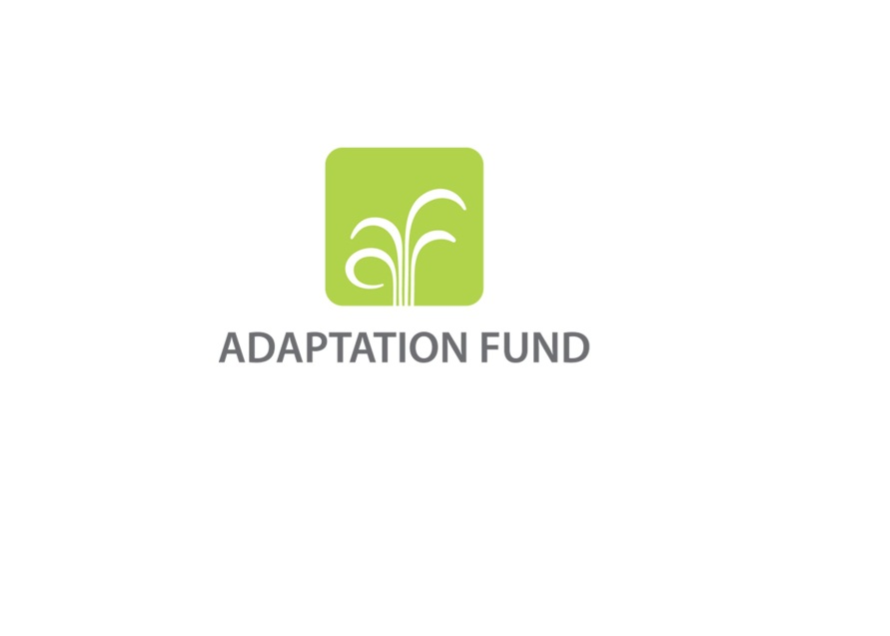

|  |
| --- |
|  |
|  |

Adaptation Fund Board

**ADAPTATION FUND**

**POLICY FOR Project/Programme Delays**

**(UPDATED IN OCTOBER 2019)**

***Introduction***

1. This document outlines a policy for project delays for the Adaptation Fund (the Fund). The policy outlines procedures for communicating and addressing delays in the planned schedule for implementing projects and programmes financed by the Fund. The policy is intended to build on the Fund’s existing policies, operating procedures, and project cycle.

***The policy for project/programme delays***

*Signing of legal agreement*

1. The first milestone for a project/programme comes after the Adaptation Fund Board (the Board) approval, with the signing of the legal agreement between the Board and the implementing entity. The Board established a standard of a maximum time lag of four months from the date at which the Board notifies an implementing entity of a project/programme approval, and the signing of the legal agreement. The Operational Policies and Guidelines specify:

*If* *an implementing entity does not sign the standard legal agreement within four (4) months from the date of notification of the approval of the project/programme proposal, the funds committed for that project/programme will be cancelled and retained in the Trust Fund for new commitments (OPG para 58)*.

*Project start*

1. The Board has set a target of six months from the first cash transfer[1] to project/programme start[2]. Each implementing entity has its own internal project cycle with different definitions for various milestones, including project start dates. Some may consider project start to be the date the Board approves the implementing entity’s project, others the date of first disbursement, still others the date of signing the legal agreement with the Board.
2. For concrete adaptation projects/programmes the Board decided to consider the start date the first day of the project/programme’s inception workshop (Decision B.18/29).
3. For project formulation grants (PFGs) project start should be considered to be the date of first disbursement towards an activity related to the grant.
4. For projects implemented through readiness grants for technical assistance and project formulation assistance (PFA), project start[3] is considered to be the date when the first contract between the implementing entity and a consultant or service provider was signed, or the date when the first disbursement towards an activity related to the grant was made, whichever occurs first.
5. For projects implemented through readiness grants for South-South cooperation, project start is considered to be the date of the project inception meeting held by the implementing entity with the recipient of peer support.
6. Notification of project/programme start to the Board by the implementing entity for a concrete adaptation project/programme should be considered as the submission of the inception workshop report by the entity to the secretariat.
7. For the PFG, a notification of project start should be sent to the secretariat not more than one month after the project start date. The notification should be sent using the template in Annex C to this document.
8. For readiness projects implemented through technical assistance grants, South-South cooperation grants, and project formulation assistance grants, the Board decided that the implementing entity should send a notification of project start to the secretariat using the approved template (Decision B.29/42). The notification of project start should be sent not more than one month after the project start date.
9. For all projects/programmes financed by the Fund, implementing entities can work to mitigate delays by working with the government, during project/programme design, to ensure a mutual understanding and commitment on how to proceed once a project/programme is approved. There are, however, many factors that are situation-specific and may be outside the control of the implementing entity. The six-month target is therefore an average target for the Fund’s portfolio. If a project/programme is not expected to start within six months of the first cash transfer, the implementing entity must send a notification to the Board through the secretariat with an explanation of the delay and an estimated start date using the form in Annex D to this document (Decision B.34/45)The implementing entity must also notify the Designated Authority (DA) with an explanation of the delay and an estimated start date.

*Reporting on project*/programme *performance*

1. The secretariat will report to the Board through the Annual Performance Report (APR) on any project/programme start delays.[4] The Board may decide, on a case-by-case basis to cancel a project/programme if start-up delays are significant.

*Performance Reports for Concrete Adaptation Projects/Programmes*

1. For concrete adaptation projects/programmes, once a project/programme is approved and the first funds are transferred for the project/programme, an implementing entity is required to submit a project/programme performance report (PPR) on an annual basis to the Ethics and Finance Committee (EFC) through the secretariat.[5] The PPRs should be submitted on a rolling basis, one year after the start of project/programme implementation (date of inception workshop) and the last report should be submitted six months after project/programme completion. This last report will be considered the project/programme completion report.[6]
2. PPRs are due no later than two months after the end of the reporting year. The Board made the decision to link the disbursement schedule to the submission of the PPR (Decision B.16/21). Once the PPR is submitted, the secretariat reviews the report and upon its clearance, requests the Chair of the Board to authorize the transfer of additional funds as per the disbursement schedule of the project/programme. To further enhance efficiency and reduce delays, the Board decided to delegate to the secretariat its authority to approve the technical review and clearance of PPRs prior to authorization by the Board Chair of the cash transfer of funding tranches, and requested the Secretariat to notify the Board accordingly (Decision B.28/47)
3. Delays in the submission of complete PPRs will result in delays of subsequent funding tranches to the project/programme.

*Project monitoring reports for projects implemented through readiness grants*

1. For projects implemented through readiness grants, once a project is approved by the Board and project implementation starts[7], the implementing entity is required to submit a monitoring report to the Board through the secretariat (Decision B.29/42). Monitoring reports for projects implemented through readiness grants are due six months from the project start date, and every six months thereafter from the date of the previous monitoring report.
2. Implementing entities should notify the secretariat of delays in the implementation of readiness grants approved by the Board by capturing the reasons for project delay in the project monitoring report and stating the revised expected project completion dates in that report.

*Project completion*

1. For all projects funded by the Fund, indicative project/programme completion time must be included in project/programme proposals for funding. These are usually general estimates and expected completion dates will depend on when a project/programme starts implementation. For this reason, in the first PPR submitted to the secretariat for concrete adaptation projects/programmes, the implementing entity should include, if applicable, a revised expected project/programme completion date. The revised date will be reviewed and cleared by the secretariat during its PPR clearance procedure. The date included in the first PPR will be the date that the project/programme will be tracked against.
2. If there are any project/programme implementation delays, these should be reported through the PPR for concrete adaptation projects/programmes, and the implementing entity must submit a request for project/programme extension.
3. If for a concrete adaptation project/programme the implementing entity expects that additional time would be required to close the project/programme, the implementing entity must submit a request for extension using the template in Annex A to this document. The request for extension should be submitted as soon as it becomes clear that there are obstacles to the project/programme closing on time and no later than six months prior to the expected project/programme completion date. All project/programme extensions must be approved by the Board.
4. An implementing entity may request for a project/programme extension beyond the original completion date for up to 18 months for a concrete adaptation project/programme if (i) no additional funds are required; (ii) the project/programme’s originally approved scope will not change; and (iii) the entity provides reasons and justifications for the extension. The DA must be notified of an extension request. Additional time beyond the 18 months stated above may be granted under exceptional circumstances.
5. For the PFG, if there is a delay in completion of work, a revised completion date, including the reasons why the implementing entity could not submit a full proposal to the Board 12 months of PFG disbursement (Decision B.12/28), should be submitted to the secretariat using the notification of delay in project completion template in Annex B to this document. The notification should be submitted to the secretariat not less than two months before the project completion date that was communicated by the implementing entity to the secretariat in the notification of project start. A notification of delay in project completion for PFGs is not required if the implementing entity submits a full project/programme document to the Board 12 months after disbursement of the PFG. In such case, any relevant information regarding the PFG is expected to be captured in the project/programme fully developed project/programme document.
6. Any delays in the completion of the PFG should be communicated to the secretariat as per paragraph 15 above. No request for extension would be required.
7. For projects implemented through readiness grants, revised project start and project completion dates should be indicated in the notification of project start that is sent to the secretariat by the implementing entity. The dates included in the notification of project start will be the dates that the project will be tracked against.
8. Any delays in the completion of projects implemented through readiness grants should be reported through the project monitoring report approved by the Board (Decision B.29/42). Explanations should be given as to the reason(s) for the delays and the proposed new completion dates should be stated. No request for extension would be required.
9. For PFGs and for projects implemented through readiness grants, an implementing entity may report an extension of the completion date of up to 12 months if (i) no additional funds are required; (ii) the project/programme’s originally approved scope will not change; and (iii) the entity provides reasons and justifications for the extension. The implementing entity should also notify the DA. The implementing entity should submit requests for additional time beyond 12 months for approval by the Board and such requests may only be granted under exceptional circumstances.
10. For concrete adaptation projects, in addition to the project/programme completion report, due six months after the project/programme has closed, as described in the standard legal agreement a final audited financial statement of the implementing entity grant account, prepared by an independent auditor or evaluation body, must be submitted to the Ethics and Finance Committee through the secretariat within six (6) months of the end of the implementing entity’s financial year during which the project]/programme is completed. Finally, from section 7, 7.01 “…a final evaluation report, prepared by an [independent] evaluator selected by the [Implementing Entity]. The final evaluation report shall be submitted within nine (9) months after [Project]/ [Programme] completion. Copies of these reports shall be forwarded by the [Implementing Entity] to the Designated Authority for information.”
11. An implementing entity which does not submit the requested reports on time will temporarily be non-eligible to apply for funding from the Board. The non-eligibility can be lifted once the reports are submitted to the secretariat and cleared.

**ANNEX A: REQUEST FOR EXTENSION OF CONCRETE ADAPTATION PROJECT/PROGRAMME**

*Request for extension of project/programme completion date*

|  |  |  |  |
| --- | --- | --- | --- |
| **Implementing Entity Name:** | | | |
| **AF Project/programme ID:** | | | |
| **Project/programme Title:** | | | |
| **Country**: | | | |
| **Project/Programme Approval** (date) |  | | |
| **Expected Project/programme Completion** (date) |  | **Proposed Revised Completion** (date): |  |

*Reasons/justifications for the extension of project/programme completion*:

|  |
| --- |
|  |

*Implementing Entity certification*

|  |  |
| --- | --- |
| This request has been prepared in accordance with Adaptation Fund policies and procedures, has been agreed by participating executing entities, and the designated authority (DA) has been notified. | |
| *Name & Signature*  Project/programme contact person | |
| Date: *(Month, Day, Year)* | Tel. and Email: |

**ANNEX B: NOTIFICATION OF DELAY IN PROJECT COMPLETION FOR THE PROJECT FORMULATION GRANT**

**NOTIFICATION AT LEAST TWO MONTHS BEFORE PROJECT COMPLETION DATE FOLLOWING THE FIRST DISBURSEMENT OF THE GRANT BY THE NIE**

**Adaptation Fund Project ID:**

**Country:**

**Title of Project/Programme:**

**Grant Type:** [Project Formulation Grant]

**Implementing Entity Name:**

**Executing Entity/ies:**

|  |  |  |  |
| --- | --- | --- | --- |
| **List of Proposed Project Preparation Activities** | **Expected Output of the PFG Activities** | **Output Achieved/Not Achieved** | **Comment/Explanation (also explain any deviation from initial plan)** |
|  |  |  |  |
|  |  |  |  |
|  |  |  |  |
| **Budget** | State whether overall expenditure due to the delay is expected to be over or under the planned budget and give brief explanation for material changes in budget. | | |
| **Overall outcome** | State the reasons why the full project document cannot be submitted to the Board within 12 months of disbursement of the PFG and state the proposed new completion date. | | |

**General Comment:** [any comment on process or to the secretariat]

**Implementing Entity Contact Person: ________________________ Email: _________________________**

**ANNEX C:** **NOTIFICATION TEMPLATE FOR START OF PROJECT FORMULATION GRANT IMPLEMENTATION**

Implementing entity address

Address

[*Date*]

The Adaptation Fund Board

1818 H Street NW

MSN N7-700

Washington DC, 20433

USA

Email: [afbsec@adaptation-fund.org](mailto:afbsec@adaptation-fund.org)

**Subject: Notification of Project Formulation Grant (PFG) inception**

This letter is to inform you that implementation of the PFG approved by the Adaptation Fund Board on [*Date*] for formulation of a concrete adaptation project/programme has officially started. Details of the project inception are below:

**Implementing Entity:**

**Country:**

**Description of Concrete Adaptation Project:** [*Title of Project*] in [*name of country*]

**PFG Start Date:** [*Date*]

**Expected PFG Completion Date:** [*Date*]

Sincerely

[*Name*]

[*Position*]

[*Email*]

[*Telephone*]

**ANNEX D:** **NOTIFICATION OF DELAY OF PROJECT OR PROGRAMME INCEPTION**

*Notification of delay of project/programme start (As per Decision B.18/29, f*or concrete adaptation projects/programmes, the Board decided to consider the start date to be **the first day of the project/ programme’s inception workshop**)

|  |  |  |  |
| --- | --- | --- | --- |
| **Implementing Entity Name:** | | | |
| **AF Project/programme ID:** | | | |
| **Project/programme Title:** | | | |
| **Country(ies)**: | | | |
| **Project/Programme Approval** (date) |  | | |
| **Expected Project/programme Start** (date) |  | **Proposed Revised Inception** (date): |  |

1. *Reasons/ justification for delay in the project’s/programme’s inception and the number of months of delay from the project approval date*

|  |
| --- |
|  |

1. *Approaches/ mitigation measures to ensure the start of implementation*

|  |
| --- |
|  |

1. *Challenges (in addition to those mentioned in section 1) that may extend the project/ programme completion date)*

|  |
| --- |
|  |

*Implementing Entity certification*

|  |  |
| --- | --- |
| This notification for delay on project/programme inception has been prepared in accordance with Adaptation Fund policies and procedures, and delay on project/programme start has been agreed by participating executing entities and has been notified to the designated authority(ies) (DA). | |
| *Name & Signature*  Project/programme contact person | |
| Date: *(Month, Day, Year)* | Tel. and Email: |

1. This would be the first cash transfer from the Trustee of the Adaptation Fund to the implementing entity
2. Established through the *Annual Performance Report* as part of the Fund level management effectiveness and efficiency indicators
3. Project start is the same as project inception and the terms can be used interchangeably
4. Whilst the secretariat may alert the Board to any delays outside of the APR and the project monitoring report, it should be noted that for concrete adaptation projects/programmes, implementing entities must provide an update at least once a year on project/programme status through the PPR, and for projects implemented through readiness grants, must provide an update at least twice a year on project status through the project monitoring report.
5. An annual report is the minimum requirement. There may be cases where the Board requests more frequent reporting or additional reports, as for example through requirements linked to the accreditation of an implementing entity.
6. The standard legal agreement requires a project/programme completion report: “including any specific [Project]/[Programme] implementation information, as reasonably requested by the Board through the Secretariat, within six (6) months after [Project]/[Programme] completion.”
7. Project implementation begins on the date of project start