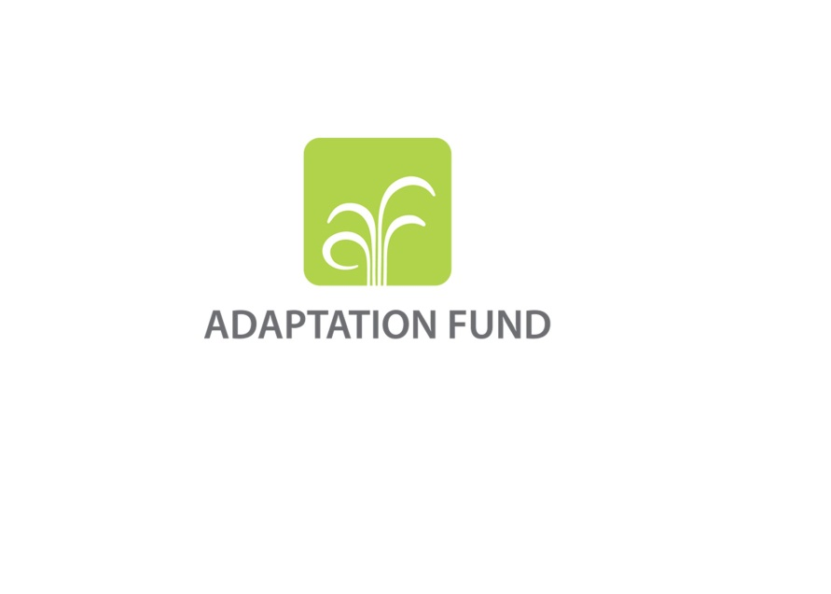

|  |
| --- |
|  |
| AFB/B.29/Inf.3  9 March 2017 |

Adaptation Fund Board

Twenty-nineteenth meeting

Bonn, Germany, 14-17 March 2017

**List of OBSERVERS**

(As of 9 March 2017)

***Association la Voûte Nubienne***

**Ms. Amarys Preuss**

Development Manager

***CABEI***

**Mr. Randall Hooker**

Institutional Relations Analyst

***Climate Policy***

**Ms. Ritika Tewari**

Climate Policy Analyst

***CMCCC Foundation***

**Dr. Guilia Galluccio**

Sr. Scientific Manager

***Germanwatch***

**Mrs. Julia Grimm**

Policy Advisor Climate Finance

**Mr. David Eckstein**

Policy Advisor

**Mr. Jean Paul Brice Affana Affana**

Policy Advisor

**Mr. Marc Beckmann**

Volunteer

**Mr. Mario Manuel Wetzel**

Intern

**Ms. Amina-Aya El Alami**

Intern

**Ms. Eva Wanek**

Intern

***Green Climate Fund***

**Mr. Daniel Buckley**

Climate Policy Specialist

***Ministry of Environment and Ecology***

**Mr. Desire Florentin Ngaibona**

Manager of Environment

***SOGESID technical unit at Italian Ministry of the Environment***

**Mr. Alessandro Giuliano Peru**

Coordinator

***Spanish Agency of International Cooperation and Development***

**Dr. Maria-Teresa Martin-Crespo**

Head of Environment and Climate Change Unit

***Transparency International EU***

**Dr. Lisa Elges**

Head, Climate Policy

***UN HABITAT***

**Ms. Katharina Rochell**

International Consultant

***WMO***

**Mr. Jean-Paul Gaudechoux**

Sr. Programme Manager

***WFP***

**Mr. Rupak Manvatkar**

Program Policy Officer