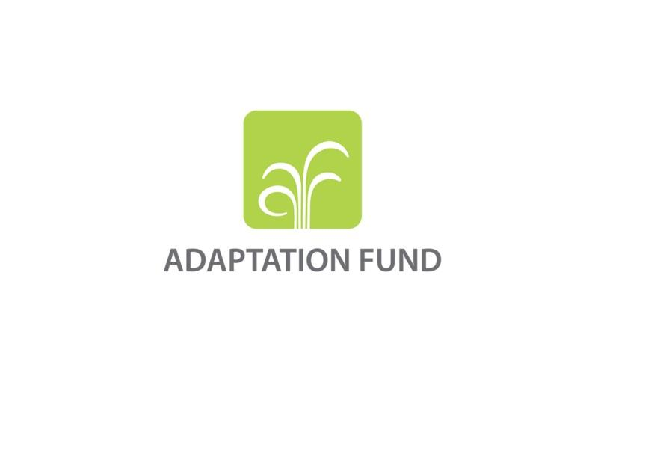

**REQUEST FOR PROJECT/PROGRAMME**

**FUNDING FROM THE ADAPTATION FUND**

The annexed form should be completed and transmitted to the Adaptation Fund Board Secretariat by email or fax.

Please type in the responses using the template provided. The instructions attached to the form provide guidance to filling out the template.

Please note that a project/programme must be fully prepared (i.e., fully appraised for feasibility) when the request is submitted. The final project/programme document resulting from the appraisal process should be attached to this request for funding.

Complete documentation should be sent to:

The Adaptation Fund Board Secretariat

1818 H Street NW

MSN P4-400

Washington, D.C., 20433

U.S.A

Fax: +1 (202) 522-3240/5

Email: afbsec@adaptation-fund.org



**PROJECT/PROGRAMME PROPOSAL TO THE ADAPTATION FUND**

**PART I: PROJECT/PROGRAMME INFORMATION**

Project/Programme Category: Regular

Country/ies: Bhutan

Title of Project/Programme: Harnessing Alternative Renewable Energy Resources for Enhancing Community Resilience and Sustainable Food Security for Adaptation to Climate Change

Type of Implementing Entity: National Implementing Entity

Implementing Entity: Bhutan Trust Fund for Environmental Conservation (BTFEC)

Executing Entity/ies: Ministry of Economic Affairs and Ministry of Agriculture & Forests

Amount of Financing Requested: USD 10,000,000 Million (in U.S Dollars Equivalent)

**Project / Programme Background and Context:**

*Provide brief information on the problem the proposed project/programme is aiming to solve. Outline the economic social, development and environmental context in which the project would operate.*

The Kingdom of Bhutan is a [landlocked mountainous country](https://en.wikipedia.org/wiki/Landlocked_country) in [South Asia](https://en.wikipedia.org/wiki/South_Asia) located in the [Eastern Himalayas](https://en.wikipedia.org/wiki/Eastern_Himalayas) and bordered by [Tibet Autonomous Region](https://en.wikipedia.org/wiki/Tibet_Autonomous_Region) of China in the north & west and India in the south & east. Its pursues the Gross National Happiness (GNH) as its development philosophy, a new development paradigm shift from use of classical Gross National Product (GDP) as indicator to GNH as more holistic development progress indicator. It reflects its deep values and strong commitment for preservation of rich cultural heritage, pristine environment, and promotion of balanced sustainable development and good governance. All development policies and programmes are pursued if they demonstrate strong linkages to the principles and embodiment of GNH as its end goals. Guided by this GNH Philosophy and motivated by its success in maintaining the integrity of its pristine environment, the Royal Government of Bhutan (RGoB) has committed to remain carbon neutral to the international community and in fact, Bhutan is the only carbon negative Country in the world, which absorbs more emission than it emits. Resounding its resolute to remain carbon neutrality, the RGoB continues to make conscious effort to develop its hydropower resources with the motivation to meet not only its growing energy demand within the Country but also to export surplus power to neighboring country India to help reduce emission reduction in the region, which is dependent mostly on thermal power plants to serve its base load.

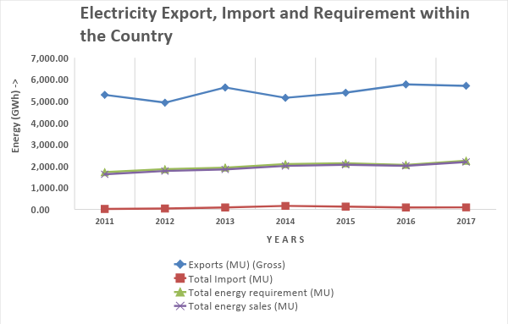

*Fig 1: Total energy generated and export/import of electricity*

Currently, 99% of electricity generation in the Country comes from hydropower resources, with current installed capacity of 1,606 Megawatt (MW) and three mega projects totaling 3700 MW are under construction. All these hydropower plants are run-of-the-river schemes that are built mostly along the north south flowing rivers, largely fed by the small East-West or West-East flowing small rivers and streams. Since the hydropower plants are run-of-the-river schemes without reservoirs, the hydropower generation capacity runs extremely low during the lean season as shown in the figure-1 often requiring to import the deficit power from India.

One of the prime reasons for the industrial developments taking place in the Country is attributable to the availability of its competitive electricity tariff in the region USD 34,308/Million Unit. However, due to low hydropower power generation capacity during the lean season and when supply cannot meet the demand, the deficit power is imported from India at the average cost of USD 40,000/Million Unit. For the same reason, the industrial development has been restricted by its limited firm power. Therefore, if industrial growth is to be allowed, the farm power capacity has to be ramped up as fast as the industrial development rate. However, if the ramping up power supply is dependent solely on hydropower resources alone and not diversity the source, the risks will sustain as its generation will depend on precipitation.

However, in the recent times, drying up of spring water sources used for drinking and irrigation purposes has been reported from different parts of the Country. Since these small river streams feed large river systems where hydropower plants have been built, any hydrological regime change triggered either by climate change and/or long stretch of drought could have significant impact on two very important aspects that the Country critically depend on for its socio-economic progress namely (i) the hydropower generation capacity and hence the nation’s revenue earning potential to support its socio-economic development and (ii) Agriculture production and productivity where 60% of the population depend for their livelihood sustenance.

Bhutan is predominantly an agriculture-based society and therefore agriculture has been identified as one of the Five Jewels that has significant growth potential in the Economic Development Policy 2016. However, due to increasing food demand, rapid urbanization, economic transformation, rising rural-urban migration and climate change, the agriculture sector productivity potential is highly constrained by the adverse effects of climate to meet the growing demand. The agriculture products and productivity are highly sensitive to climate condition and calls for availability of adequate perennial streams and seasonal rainfall and appropriate temperature levels. Therefore, drying up of spring water sources being reported from multiple pockets of the Country is recognized as a serious indicator calling for proactive and appropriate interventions to contain them before it is too late.

Further, development of renewable energy resources like solar and wind technologies is recognized as environmentally benign interventions that do not pollute and rather serve as natural choice for pursuing green economy development pathways. The RGoB has already achieved 100% electrification rate by 2017 and development of grid-connected solar and wind energy technologies has the potential to assure reliability power supplies and avoid the rural people use fuel-wood for meeting their cooking and heating requirements. The impact of less dependence on fuel-wood, in turn, will reduce the pressure on the forest cover and hence contribute in maintaining the carbon sequestration capacity as committed by the Nation to the International Community. The motivation for promoting alternative renewable energy resources like solar and wind energy at the national level is to use the results and lessons learned obtained from the pilot project to scale up to meet all its domestic energy demand in the long run not impacted by the change of precipitation regime.

The 3 MW Solar Power Plant is proposed to develop at Shingkhar under Bumthang district as shown in figure 2. The population of Bumthang district is 17,820 as of 2017 (Population and Housing Census of Bhutan, 2017). Out of 17,820 persons, 9,396 are male (52.7%) and 8,424 are female (47.3%). The total area is 2,667 Sq. Km and the population density is about 7 persons per Sq. Km. The unemployment rate for the district is 1.6% as of 2017. The site has potential to accommodate 35 MW of solar plant and current proposed capacity is aimed to help in scale-up to develop the full potential based on the lessons learned.

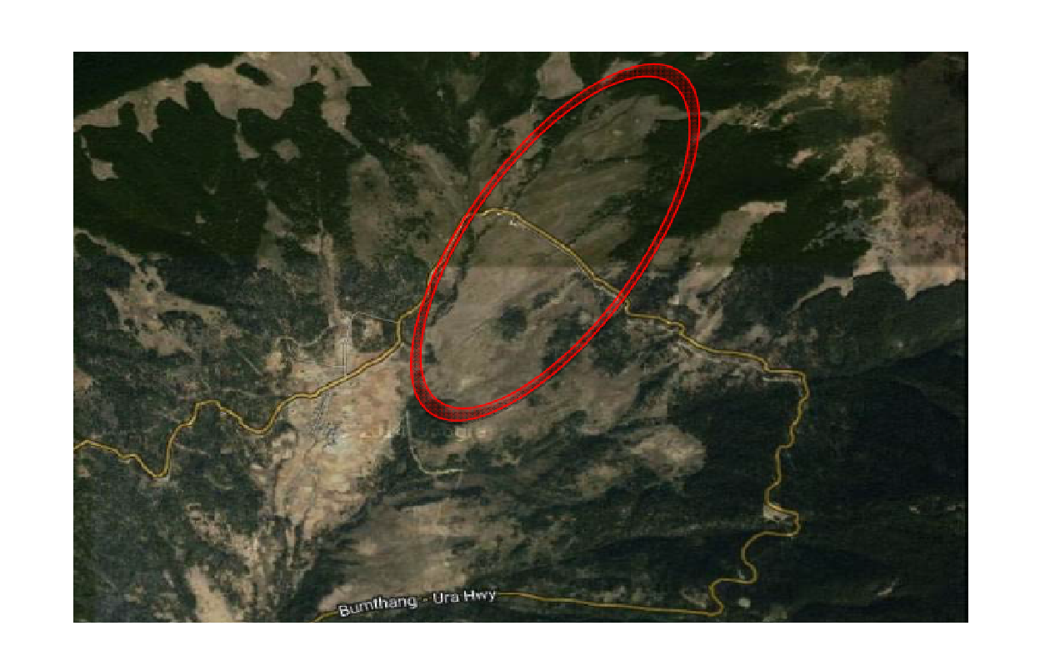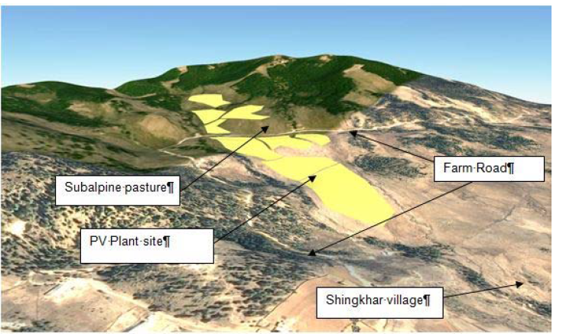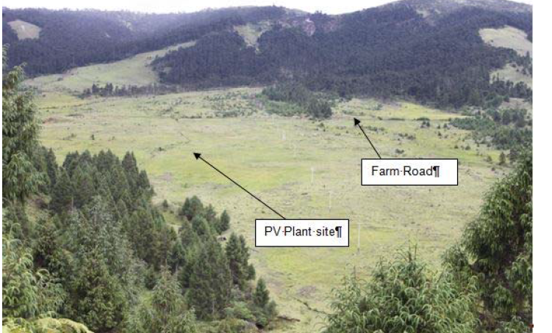

*Figure 2: Solar Project site at Shingkhar, Bumthang*

The 2.4 MW wind power plant is proposed to develop at Rubesa under Wangdue Phodrang district as shown in figure 3. The population of Wangdue Phodrang district is 42,186 as of 2017 (Population and Housing Census of Bhutan, 2017). Out of 42,186 persons, 24,302 are male (57.6%) and 17,884 are female (42.4%). The total area is 4,029 Sq.Km and the population density is about 10 persons per Sq. Km. The unemployment rate for the district is 1.5% as of 2017. The site has the potential to accommodate 8 to 12 MW of capacity and proposed capacity is only to help scale-up the development to harness the full potential in future.

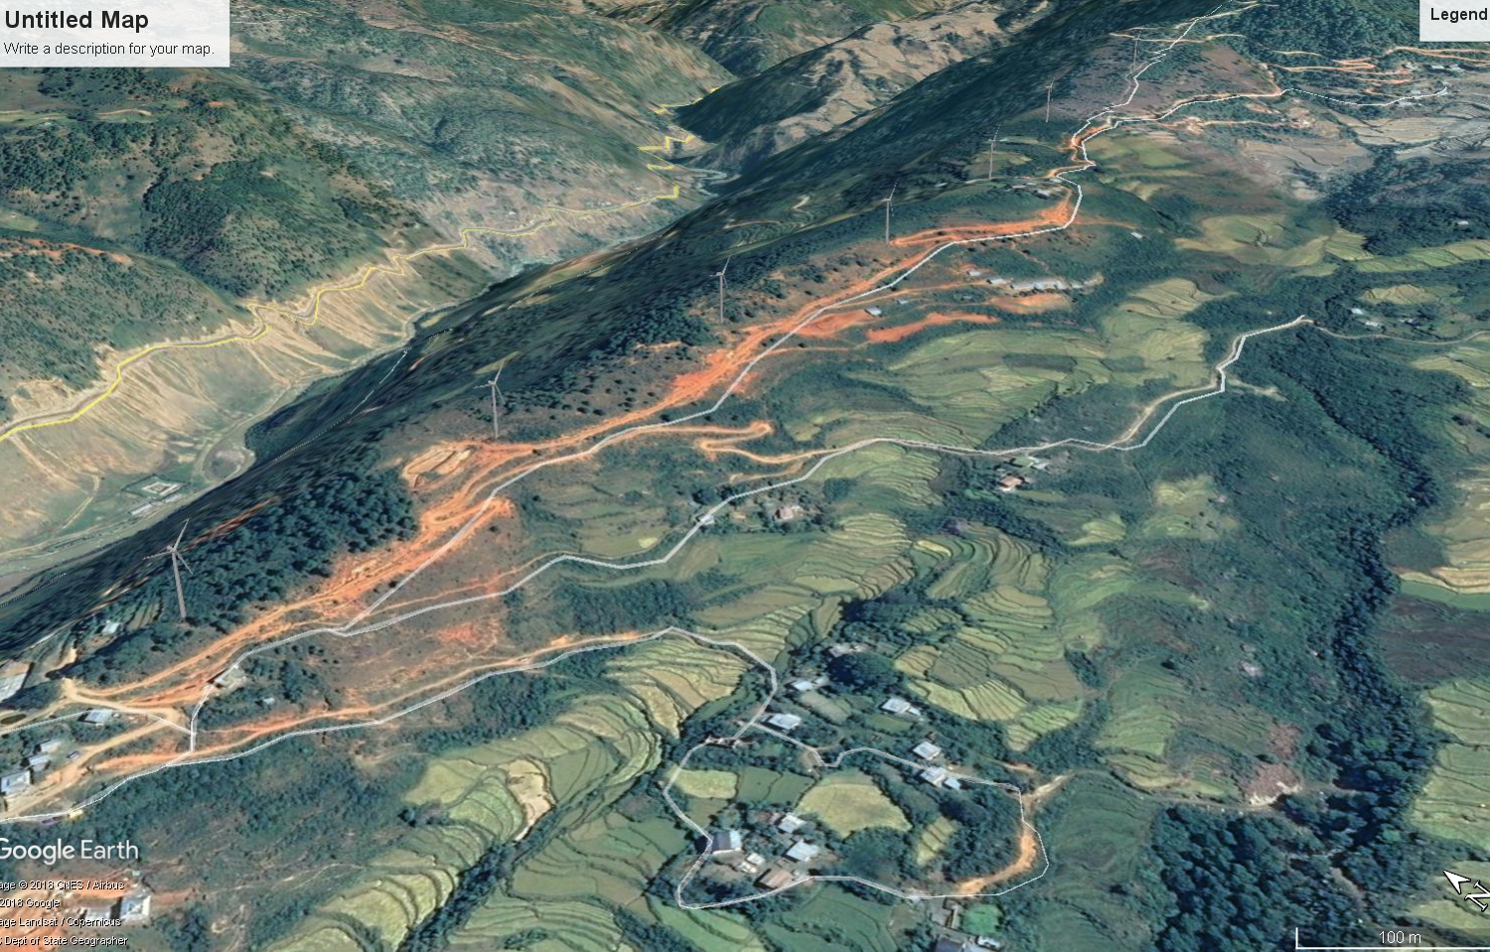

***Figure 3: Wind Power Site at Rubesa***

Energy is needed at every stage of food chains. The relationship between energy and food production have evolved and grown stronger over the time as agriculture has become increasingly reliant on irrigation and mechanization. Post production activities such as food storage, cooling, processing and distribution are also energy intensive. Consequently the cost of energy have direct impact on the production costs of the agriculture sector and food process, in particular in the case of medium to large farms, therefore, the integration of renewable energy into food production chain will give better opportunity for the farms as well as towards adaptation to climate change effects. A safe integration of food and energy production may be one of the best ways to improve national food and energy security and simultaneously reduce poverty in a climate smart way.

The enhancement of agriculture production and productivity at the community will entail deployment of advanced Smart Greenhouse Technologies powered by the alternative renewable energy resources like solar PV, Solar Thermal, Energy-storage systems. Light Emitting Diodes (LEDs) and smart control system, that are not impacted by the climate change in its operation and production. The location of these Smart Greenhouse technologies will be piloted under Bumthang and Wangdue Phodrang districts. The energy requirement for these Smart Greenhouse technologies will be supplied from captive and stand-alone alternative renewable energy systems developed for the same.

Therefore, the primary purpose of the captioned Project under Adaptation Fund, is to develop (i) grid connected 3 MW solar and 2.4 MW wind power plants to enhance national energy security during the lean season and to (ii) enhance agriculture production and productivity at the selected community level using alternative renewable energy resources.

In preparation for the Country to tackle the climate change impact, it has been strategically proposed to pursue climate change impact adaptation at two levels, national and community level. At the national level, it is aimed at securing the energy security by diversifying its supply-mix using alternative renewable energy resources and other at the community level, where climate resilient agriculture production and productivity, can be piloted by using Green Smart Technologies powered by alternative renewable energy resources.

**Project / Programme Objectives:**

*List the main objectives of the project/programme.*

The objectives of the project are;

1. Diversification and exploration of Alternative Green Energy Resources using solar and wind energy to build up the national climate resilience.
2. Enhance crop production and productivity for food security and import substitution through adoption of climate resilient smart farming technologies.
3. Encourage and establish enterprise development opportunities for communities especially for the youth and vulnerable households in organic agriculture and renewable energy to create meaningful job opportunities.

**Project / Programme Components and Financing:**

*Fill in the table presenting the relationships among project components, activities, expected concrete outputs, and the corresponding budgets. If necessary, please refer to the attached instructions for a detailed description of each term.*

*For the case of a programme, individual components are likely to refer to specific sub-sets of stakeholders, regions and/or sectors that can be addressed through a set of well defined interventions / projects.*

|  |  |  |  |
| --- | --- | --- | --- |
| **Project/Programme Components** | **Expected Concrete Outputs** | **Expected Outcomes** | **Amount (US$)** |
| Component 1: Diversification and Exploration of Alternative Green Energy Resources | Efficient and alternative green energy power plant installed and commissioned | Guaranteed energy supply for households and contribute to energy security | 10,000,000 |
| Component 2:  Enhance crop production and productivity for food security and import substitution | Protected cultivation structures, storage and processing structures established | * Demonstrated effective use of RE for intensive farming (for climate control, irrigation, processing, heat supply, etc.) * Enhanced year round production of high value crops for domestic and export market. | 3,500,000 |
| Component 3: Encourage and establish enterprise development opportunities for communities | * Enhanced knowledge and skills of the stakeholders * Establish business community centre | Business opportunity created for private enterprises or youth in agriculture. | 400,000 |
| 6. Project/Programme Execution cost | | | 250,000 |
| 7. Total Project/Programme Cost | | | **14,150,000** |
| 8. Project/Programme Cycle Management Fee charged by the Implementing Entity (if applicable) | | | 850,000 |
| **Amount of Financing Requested** | | | **15,000,000** |

N.B.: The above costs are indicative figures and detailed cost estimates including the implementation framework will be worked out under the project formulation assistance sought under Adaptation Fund. The scope of the preparatory works and the resources required are projected in the project formulation assistance application form submitted along with this concept paper.

**Projected Calendar:**

*Indicate the dates of the following milestones for the proposed project/programme*

|  |  |
| --- | --- |
| **Milestones** | **Expected Dates** |
| Start of Project/Programme Implementation | January 2019 |
| Mid-term Review (if planned) | July 2021 |
| Project/Programme Closing | December 2023 |
| Terminal Evaluation | March 2024 |

**PART II: PROJECT / PROGRAMME JUSTIFICATION**

1. *Describe the project / programme components, particularly focusing on the concrete adaptation activities of the project, and how these activities contribute to climate resilience. For the case of a programme, show how the combination of individual projects will contribute to the overall increase in resilience.*

The published data on impacts of climate change is limited. However, several cases across the Country have reported the drying up of spring waters, which serve as critical water source for drinking and irrigation purposes for the communities and hydropower generation at the national level. Further, with rising population, increasing demand for food, rapid industrialization and economic transformation, increasing rural-urban migration and the changing global climate, the country is confronted with number of challenges, which are exacerbated by the adverse impacts of climate. For example, the farm productions are highly dependent on perennial streams and timing of the monsoons and hydropower production critically depends on the availability of adequate water in our river system. Any adverse change in hydrological precipitation regime has significantly makes the County highly vulnerable. To address these issues, ensuring secured, reliable and affordable energy system is seen as the robust national strategy to build up the climate resilience both at the level of community through the introduction of climate smart farming system by harness alternative energy sources and at the national level by diversifying the energy supply mix using alternate source of energy. Climate proofing becomes feasible only when there is access to energy that is affordable, reliable and secured and allows to adoption of appropriate technologies.

Bhutan is endowed with enormous water resources draining 2238 m3/sec annually but precipitation and surface runoff are the main sources of water (DoA, National Irrigation Master plan 2016) which are highly susceptible to changes in seasonal water availability, floods, and landslides which in turns are influenced by anticipated changes in climatic parameters like rainfall and temperature. As a result, it is expected that climate change may not only negatively impact rain-fed agriculture, but also irrigated agriculture production and Bhutan’s energy source (Hydro power). Further, about three forth of the agriculture land in Bhutan is rain-fed and depend almost entirely on monsoon rains for crop production. Hence the impact of climate change on Bhutan’s overall agriculture production will be severe. It is predicted that agriculture production may decline by 4 to 10% in the future if appropriate measures are not taken to mitigate or adapt to climate change. Changes in weather and climate are already having an impact on regional ecosystems, evident by significant losses in the size and distribution of Himalayan glaciers, as well as the decreased water availability for irrigation, agriculture, hydropower and household uses (Shrestha et al. 2012).

Temperature and precipitation are two key climatic variables most influenced by climate change, which is predicted to affect seasonal water availability having greater impact on country’s overall economy. Hydro-meteorological data projections point out a change in climatic variables with overall increase in temperature and large spatial and temporal variations in rainfall (TA 8623 R5, 2016). Bhutan’s annual average temperature is likely to increase by 1oC from 2010 to 2039, and by 2oC from 2040 to 2069 and project changes in the amount and seasonality of precipitation, with wetter conditions in the warm monsoon months, and slightly drier conditions in dry winter months (BMCI, 2016). The change in the amount and seasonality of precipitation will likely affect not only the hydropower and domestic water sector of Bhutan, but also the water used for irrigation.

Although Bhutan has not experienced severe water shortages in the past, reports of dwindling water sources are increasing, and climate change may render the country much more vulnerable. All districts have noted the issue of acute water shortages for drinking and attributed such recent issues, as increasing fallowing of agricultural land in the rural communities, to the drying of water sources. The increasing demand for water flowing in from all the country means that adaptation measures are necessary for the efficient use of water, and also deal with impacts of climate change on water resources.

Therefore, it is envisaged that the project will not only look at adaptation measures at the local project site but would have far reaching implication at the national level because of its dependence on water resources for hydro power generation that is the backbone of national economy.

TheAF project proposes three specific components that focuses on (i) diversification and explode productivity to ensuring food security and (ration of alternate energy resources, (ii) Enhance crop production and (iii) establishment of production infrastructures powered by alternative energy system.

**Proposes Activities**

**Component 1: Diversification and exploration of Alternative Green Energy Resources**

* 1. **Rationales for specific project site selection**

Renewable Energy (RE) cannot be installed anywhere unless the specific site is assessed to be technically feasible, candidate project is socio-economically justifiable and environmentally favorable. Under ADB TA, the detailed technical study has been carried out Shingkhar. The study report has revealed that the site has the potential to develop 30MW of solar and has recommended this potential be harnessed in three phases so that the lesson learned from first phase could be used to scale up the project development. Therefore, the proposed project size of 3 MW is being proposed under AF fund as fraction of larger capacity proposed to be piloted and use the lessons learned to scale up the development to harness the full potential. In other words, the proposed solar site is being identified based on the detailed study report.

Wind power project at Rubesa under Wangdi district has been proposed based on experience of developing 2x300 KW wind power plant at the vicinity of the proposed site where the performance of the wind turbines were found to be very encouraging. The proposed site, through the observation, is found to be ideal place for developing wind farms. While the proposed capacity is about 2 MW, the site has the potential for 8 to 12 MW depending on the size of the turbine being used. The larger the turbine size, the greater will be the generation capacity.

The agriculture site has been chosen based on the vulnerability of the population at the project site of the renewable energy project sites - Shingkhar and Rubesa. The data shows that Shingkhar, Ura has a total population of 1,724 with 229 households who are dependent on rain fed agriculture with poor resilience to any climate change. Similarly, Rubesa has a total population of 2,179 with 209 households who are dependent on again the rain fed agriculture mainly paddy cultivation. The project site is windy and dry leading to high evapotranspiration of water in the selected site leading to high requirement of water for agriculture purposes. In both the sites, the households being dependent on agriculture are highly vulnerable to the climate change. The project targets at least 50 percent of the households for climate resilient activities in terms of agriculture productivity.

The following activities will be carried out under Component 1:

**1.1 Installation and commissioning of 3 MW solar power plant at Shingkhar**

1.1.1 Finalization of 3 MW solar power design

1.1.2 Procurement of equipment

1.1.3 Installation and commissioning of 3 MW solar power plant

1.2 **Installation and commissioning of 2 MW wind power plant at Rubesa**

1.2.1 Finalization of project design

1.2.2 Procurement of equipment

1.2.3 Installation and commissioning of 2 MW wind power plant

1.3 **Installation of captive solar power plant**

1.3.1 Identification of sites

1.3.2 Design of the infrastructural and energy requirements

* + 1. Procurement of equipment
    2. Installation and commissioning of captive solar power plant at the identified sites

**Component 2:** E**nhance crop production and productivity for food security and import substitution**

The following activities will be carried out under Component 2:

**2.1. Integration of renewable energy in agriculture production system**

2.1.1. Making availability of irrigation water for the community of Rubesa - Pumping water from nearby perennial river or water source with use of energy generated from wind power plant proposed in Rubesa, Wangdue Phodrang for the community as the community faces acute water shortage for agriculture production.

2.1.2. Promotion of climate resilient crop varieties (stress tolerant crop varieties), water harvesting structures, water use efficient irrigation systems and organic agriculture production systems in both the project pilot sites.

2.1.3. Establishment of cold storage facility with energy supplement from wind power plant – Wangduephodrang, Punakha, Tsirang and Dagana districts are major vegetable producing districts in the country during normal season with total production of 20,921.7 MT (Metric tonnes) of vegetables in 2017. Besides vegetables, Wangdue Phodrang district is the major potato producing districts in the country with total production of 17,001 MT in 2017. Therefore, establishment of cold storage facility (about 20-50 MT capacity) in that area powered by energy obtained from wind power plant managed by the community/cooperatives will have huge benefits for the farming households as a whole for the districts in West Central part of the country for storage, preservation and marketing during the off season.

2.1.4. Solar energy for heating, drying and processing in Shingkhar, Bumthang – Promotion of household level polyhouse dryer and processing with energy supplement from the solar plant. The community are mostly involved in mushroom and medicinal plants which requires proper drying and processing to maintain the quality of the final product.

**2.2. Establishment of production infrastructure (Greenhouses) powered by renewable energy**

The integration of renewable energy with agriculture production system will have better opportunity to realize the aim of national food and energy security. As a pilot program, Smart Greenhouse Technologies powered by the alternative renewable energy resources like solar PV, Solar Thermal, Energy-storage systems. Light Emitting Diodes (LEDs) and smart control system that are not impacted by the climate change in its operation and production will be implemented as follows with the aim to produce year round production especially focusing on the high value vegetable production under protected cultivation with water use efficient technologies (smart irrigation system). The major vegetables that will be grown under the protected cultivation will be on temporarily import banned vegetables (Chili, Beans, Cauliflower) and vegetables that are imported in huge quantities especially during winter season (like Tomato, Onion). Besides these vegetables, export potential and high value vegetables will be produced.

2.2.1. Establish small size (100 m2) at household level – with fabricated poly-houses (5x10 m), drip & fertigation system installed, insect proof net and energy required for the system (especially pumping of water for drip irrigation) met from solar energy by installing solar PV and solar thermal system for energy and heat generation. Promotion of poly-house dryer and processing plants at household level.

2.2.2. Establish medium size (500 m2), which will be focused in farmer groups or youth groups. Forced ventilated fan and pad system Greenhouses with controlled temperature and humidity, misting/fogging system, air heating, insect proof net.

2.2.3. Establish large scale (>1000 m2) will be established in Farm Machinery Corporation Limited (FMCL) farms. Installation of Hi-Tech Greenhouse (Multi span forced ventilated fan and pad system with all the climate control system).

**Component 3: Encourage and establish enterprise development opportunities for communities**

3.1.1. Establish community centre

3.1.2. Training workshop for youth and project beneficiaries on organic vegetable farming

3.1.3. Workshops with stakeholders

3.1.4. Documentation and dissemination of best practices & lessons learnt to other areas/communities

1. *Describe how the project / programme provides economic, social and environmental benefits, with particular reference to the most vulnerable communities, and vulnerable groups within communities, including gender considerations. Describe how the project / programme will avoid or mitigate negative impacts, in compliance with the Environmental and Social Policy of the Adaptation Fund.*

Agriculture, responsible for growing food, is major user of water (more than 70% of all water use globally) and energy. Freshwater, once abundant, is undergoing stresses due to increased demand for competing uses and growing uncertainty due to climate change in most of South Asia. There are also several reported cases of spring water getting dried up in different parts of Bhutan mostly attributable to climate change and partly to human induced activities, which adversely affect the food production and hydropower generation capacity. The relationships among food, energy and water are dynamic. Actions in one area usually have impacts in one or both of the others, with profound economic, environmental, and social implications. Use of renewable energy technologies like solar PV, solar thermal system and light emitting diodes is expected to be more cost effective in promoting climate smart farming system and ensure food security under impending climate change scenario.

Due to unfavorable climate condition, the farming activities are seasonal and hence the produces are insufficient to meet the growing demand despite best effort by the Government. During off-season, the food supplies like vegetables are imported from the neighboring countries, which are unsustainable for the Country. Therefore, reliance on green technologies for growing all-year-round food crops would go a long way in building up the national climate resilience and self-reliance. The introduction of green energy smart farming technologies at three strategic level of production scale is expected to address the following:

1. State-owned-enterprise: The large-scale green energy smart farming technology is proposed to pursue by engaging state-owned-enterprises like FMCL. Currently FMCL takes unutilized land on lease and undertake large scale farming activities. Introduction of green energy smart farming technology under state-owned-enterprise will allow large-scale vegetables to meet the high volume demand in the urban centers and cities. The impact of this intervention would be the reduction of food imports, enhanced availability of organically homegrown food supplies and economic well being of the Country.

2. Cooperatives/Youth Groups: The medium–scale green energy smart farming technology is proposed to take up with village cooperatives and youth groups. These will allow production of farm produces to feed the local regional demand. The impact of this intervention at the community level will be the increase farm produce; more income generated from sale of surplus produce, and enhanced economic independence.

3. Progressive and vulnerable farmers: The small-scale green energy smart technologies will be pursued through progressive farmers who are willing to take up and focusing on vulnerable groups of farmers. The impact of such intervention will be enhanced level of food sufficiency at the household level, more income through sale of surplus product, more nutritious intake, better health, more content life and build up resilience to climate change impacts.

4. Installation of grid connected 3 MW solar power plant will ensure 1500 families being guaranteed power supply from solar power in the event that hydroelectricity cannot meet the demand due to constrained power generation owing to climate change.

5. Installation of grid connected of 2 MW will ensure 1000 families of guaranteed power supply from the wind in the event that hydroelectricity cannot meet the growing demand due to adverse effects of climate change.

6. Capacity building measures would ensure enhancement of the institutional strength to sustain the project benefits and to build up the national resilience against the adverse effects of the climate change.

The beneficiaries for this proposed project are at two levels. One is at the national level in which the renewable energy will be injected into the national grid from solar and wind farms and supplied to the people of Bhutan via the national transmission and distribution system. This injection of power from the alternative energy sources will be highly valued in the event the hydropower generation dips down due to hydrological regime change triggered by the climate change. The other is beneficiaries will be at the community level through the introduction of alternative energy based agricultural production technologies. The introduction of RE based green house technologies is expected to motivate the communities to switch farming practices from conventional methods to more climate smart technologies.

The project will target the following beneficiaries;

Rubesa:

Most vulnerable - 10 percent of the households

Vulnerable – 30 percent of the households

Others - 70 percent of the households

Shingkhar, Ura:

Most vulnerable - 15 percent of the households

Vulnerable – 25 percent of the households

Others - 60 percent of the households

It may also be noted that this project is not aimed at addressing only specific section of society. The larger aim of the Project is to address the national-level issues under which, women, marginalized and vulnerable groups are adequately taken care in a systemic manner.

As far as the compliance with the environmental, social and gender policy of the fund is concerned, the existing laws of the land assure the fulfilment. For example, the Environment Act of Bhutan requires the environmental clearances are secured before implementation or execution of the Project on the proposed site. The competent authority only issues the environmental clearance if the concerned local governments and communities have issued their consent for the proposed project. In view of above, noncompliance to above policy requirements of the fund is not anticipated.

The Electricity Act of Bhutan requires the licence to generate power and distribute power in the Country. Therefore, these proposed renewable power plants (solar and wind) shall be built by engaging Bhutan Power Corporation-the only licensed utility company in the Country. After the project is completed, the operation of the project will be handed over to Bhutan Power Corporation. The tariff approved by the electricity regulating authority called Bhutan Electricity will ensure that approved tariff covers the cost of operation, maintenance, spare parts and other requirement as per the law of the land.

1. *Describe or provide an analysis of the cost-effectiveness of the proposed project / programme.*

The import of vegetables takes place mostly in the winter season when there is not much production from within the Country. The major vegetables imported are tomato, onion, cabbage, lettuce, chilies and legumes and are mostly imported from India across the border. The annual import of vegetables has been in increasing trend and on an average from 2006 to 2017 the country has been importing 11,683 MT of vegetables with an outflow of Bhutanese Ngultrum (Nu.) 178.58 million. The 2017 data indicates that there was import of 10,587.25 MT of vegetables worth Nu. 213.59 million. The trend shows steady growth as the demand continues to grow in the country. If these interventions are not pursued at the earliest, increased imports are anticipated, which will not be sustainable in the long run. These interventions will enable to grow food crops under any climate condition and indicating the clear case of climate resilience for sustaining the socio-economic growth in the long run.

Further, electricity supply in the Country is supplied from the hydropower plants. However, to ensure energy security to pursue green economy in the Country amid drying up of spring water sources that feed large river system where large hydropower plants have been built, the development of solar and wind farms is assessed to be more strategic intervention. Considering the gestation period of such renewable energy farms being short compared to hydropower plants, which takes over decade, the development of solar and wind farms are seen to be cost effective.

|  |  |  |
| --- | --- | --- |
| **S#** | **Component details** | **Indicative cost (USD) Million** |
| **(i) Diversification and exploration of alternate Energy Component** | | |
| **1** | **Solar Sub-Component** |  |
| 1.1 | Solar modules and accessories | 4,500,000.00 |
| 1.2 | Project execution | 250,000 |
|  | Total for solar PV-component | 4,750,000 |
| **2** | **Wind Power Sub-component** |  |
| 2.1 | Wind turbines and accessories 2 MW | **7,000,000.00** |
| 2.2 | Power Evacuation network | **150,000.00** |
| 2.3 | Project execution | **220,000.00** |
|  | **Total for wind power component** | **7,370,000.00** |
| **3** | **Decentralised Solar System** |  |
| 3.1 | Solar PV and other accessories | 800,000.00 |
|  | **Total for decentralized system** | **800,000.00** |
| **(ii) Enhancing crop production and Productivity** | | |
|  | **Crop production and productivity** | **800,000.00** |
|  | **MoAF to elaborate** |  |
|  |  |  |
| **(iii) Encouragement and establishment of enterprise opportunities** | | |
|  | **Enterprise development activities** | **900,000.00** |
|  | **MoAF to elaborate** |  |
|  |  |  |
|  |  |  |

The cost of developing 3 MW of solar power plant is estimated at USD 4.7 Million, while the cost of developing 2 MW of wind is estimated at USD 4.6 Million. It may be noted that the development of 5 MW of RE entails, site development, control rooms, dedicated power evacuation lines since this type of projects are being developed for the first time. Nevertheless, the cost estimates are within the expected price considering the scale and other local logistical constraints. The greenhouse cost and production technologies are expected to cost another USD 2.5 Million (t.

In the neighbouring states, India is one country where renewable energy projects are being promoted in massive scale. Since these RE projects (solar and wind) are being developed in several MW capacities, the cost of renewable energy projects in Bhutan, which is just below 5 MW, cannot be compared. However, with the lessons learned from this AF Project, the Country hopes to be able to scale up the project to its full potential.

It is to be noted that the proposed project approach aims to address the key adaptation challenges that go beyond identification of other viable alternatives and justifying the cost effectiveness. Having secured, reliable and affordable energy supply system forms is seen to be one of the most important and effective adaptation measures for the Country. Whether for adapting to colder or the hotter climate conditions or the production or storage of food supplies, adequate energy is required to be secured. Therefore, the proposed project makes an attempt to contribute to diversifying the energy supply mix that capitalizes the adversity of climate change by switching energy from conventional sources to non-conventional renewable energy sources like solar and wind. This project is also aimed to contribute in understanding the RE development issues and frame better enabling environment to mainstream renewable energy development for building national climate resilience.

1. *Describe how the project / programme is consistent with national or sub-national sustainable development strategies, including, where appropriate, national or sub-national development plans, poverty reduction strategies, national communications, or national adaptation programs of action, or other relevant instruments, where they exist.*

The unique concept of GNH is being pursued by the Royal Government of Bhutan as its development philosophy, which reflects its sensitivity towards the preservation of its rich cultural heritage and pristine environment while ensuring economic growth and overall well being of its people. The 12th Five Year Plan (FYP) covers the period 1st July 2018 to 30th June 2023. The Plan objective and the National Key Results Areas have been anchored and drawn on from the timeless vision and wisdom emanating from the Golden Throne through His Majesty’s addresses at different occasions over the last ten years as well as the aspirations and mandates from the Constitution of Bhutan. Additionally, they are also based on the international and regional goals and commitments like the Sustainable Development Goals, to which Bhutan is a party and desk reviews of vision documents like the Vision 2020, Strategy for GNH etc. The 12 National Key Result Areas of 12th Plan is provided in table 1.

**Table 1: National Key Result Areas of the 12th plan**

|  |  |  |  |
| --- | --- | --- | --- |
| 1. Macroeconomic Stability Ensured | 1. Healthy Ecosystem Services Maintained | 1. Efficiency and Effectiveness of Public Services Improved | 1. Democracy and Decentralization Strengthened |
| 1. Economic Diversity and Productivity Enhanced | 1. Carbon Neutral, Climate and Disaster Resilient Development Enhanced | 1. Gender Equality, Women and Girls Empowered | 1. Healthy, Safe and Caring Society Sustained |
| 1. Poverty and Inequality Reduced | 1. Quality of Education and Skills Improved | 1. Productive and Gainful Employment Created | 1. Livability and Sustainability of Human Settlements Improved |
| 1. Culture and Traditions Preserved and Promoted | 1. Food and Nutrition Security Enhanced | 1. Corruption Reduced | 1. Justice Services Improved |

The objective of the 12th FYP is “Just, Harmonious and Sustainable Society through enhanced Decentralization” and the proposed project is linked to following Sustainable Development Goals (SDGs), National Key Results Areas (NKRAs) and Agency Key Result Areas (AKRAs) of the 12 Five Year Plan (2018-2023) of RGoB.

The project is aimed towards achievement of the following 4 SDGs and linkages with other SDGs prioritized by Bhutan out of the 17 SDGs:

Goal 1: No Poverty

Goal 7: Affordable and Clean Energy

Goal 13: Climate Action

Goal 15: Life on Land

Out of 16 NKRAs identified for 12 FYP, the proposed project is directly linked to the following 7 NKRAs:

NKRA 1: Macroeconomics Stability Ensured.

NKRA 2: Economic Diversity and Productivity Enhanced.

NKRA 3: Poverty Eradicated and Inequality Reduced.

NKRA 6: Carbon Neutral, Climate and Disaster Resilient Development Enhanced.

NKRA 8: Water, Food and Nutrition Security Ensured.

NKRA 9: Gender Equality Promoted, Women and Girls Empowered.

NKRA 10: Productive and Gainful Employment Created

The proposed project is linked to the following AKRAs of Ministry of Agriculture and Forests;

AKRA 1: Enhanced National Food Self Sufficiency.

AKRA 2: RNR (Renewable Natural Resources) Marketing and Value Chain Development Enhanced.

AKRA 4: Enhanced Climate Smart and Disaster Resilient Development.

AKRA 5: Increased RNR sector Contribution to National Economy.

Similarly the project is linked to the following AKRAs of Ministry of Economic Affairs;

AKRA 1: Economic Growth Sustained.

AKRA 2: Jobs created.

AKRA 3: Promote clean and renewable energy through climate mechanism

In order to realize the SDG 7 (Affordable and clean energy), contribute to NKRA 6(Carbon neutral, climate & disaster resilient development enhanced) and contribute to AKRA 3 (promote clean and renewable energy through climate mechanism), the Ministry has proposed for development of 3 MW solar power plant, 2 MW wind power plant and other relevant technologies in the 12 FYP.

Among others, the INDCs submitted by the Royal Government of Bhutan has identified (i) promotion of clean renewable and climate resilient energy generation by diversifying energy supply mix through promotion of renewable energy (solar, wind, small hydro, biomass) and creating investment opportunities and (ii) promotion of climate resilient agriculture to contribute towards achieving food and nutrition security. Therefore, the proposed project is in full alignment with Country’s NDCs to Paris Agreement and NAPA.

1. *Describe how the project / programme meets relevant national technical standards, where applicable, such as standards for environmental assessment, building codes, etc., and complies with the Environmental and Social Policy of the Adaptation Fund.*

From the construction of the Greenhouse sheds, no environmental impact is foreseen irrespective of the sizes. However, for the installation and commissioning of the solar and wind power plants, the Environment Impact Assessment will be carried out in line with Environment Assessment Act 2000 and the Regulation for the Environment Clearance of the Projects (RECP 2002).

The RGoB has already installed 2 numbers of 300 KW wind power plant at Rubesa, Wangdi, which is at the vicinity of the proposed wind power project site. The technical specifications are in place and follows international standard. However, depending upon the logistical convenience to transport the wind turbines, larger turbine capacity will be explored to optimize the benefit. As for solar power plant is concerned, it is a mature technology and will be following the international standards. While 15 km long 11 KV lines will required to be constructed from the wind farm to the nearest subs-station for evacuating the power generation, the solar power project will only require the desired power conditioning unit to synchronize with the grid power. However, for agriculture component, distributed solar power system will be installed for powering the greenhouse technologies and processing plants that are not connected to grid electricity.

1. *Describe if there is duplication of project / programme with other funding sources, if any*.

The activities proposed in this project will not have any duplication with other projects or initiatives. Rather, there might be several programs and projects the executing agencies might implement in which the proposed project will seek complementarity. The table below shows some of the projects that are planned for implementation during the 12 FYP.

|  |  |  |  |  |  |
| --- | --- | --- | --- | --- | --- |
| S# | Project description | Objective | Units | Baseline | Target 12 FYP |
| 1 | National Biogas Programme | Reduce LPG imports | Nos | 5000 | 4400 |
| 2 | Improved Cook stoves | Reduce fuel-wood consumption | Nos | 14000 | 3000 |
| 3 | Solar water heating system | Reduce electricity consumption | System | 12 | 65 |
| 4 | Installed capacity of solar Power | Diversity supply mix | kW | 82 kW | 3,000 KW |
| 5 | Installed capacity of wind power | Diversify supply mix | kW | 600 kW | 2,000 kW |
| 6 | Agriculture programme | ….. | … |  |  |

It may be noted that above projects have more than one objectives but only primary objective have been reflected in this Report.

1. *If applicable, describe the learning and knowledge management component to capture and disseminate lessons learned.*

The project on “Harnessing Alternative Renewable Energy Resources for Enhancing Community Resilience and Sustainable Food Security for Adaptation to Climate Change” will be implemented as pilot project under the banner of flagship programme. The Ministry of Agriculture & Forests and the Ministry of Economic Affairs will be the executing agencies taking lead on its relevant components. The lessons learned from this AF project will capture through progress, annual and evaluation reports that will be tabled at the Project Steering Committees for deliberation on regular basis.

The dissemination of knowledge will be done through national workshops and meetings. Also, the national broadcasting service will be invited at the project sites for capturing the project activities and broadcasting at national level. NIE will ensure experience sharing through newsletter and forums to other related parties.

1. *Describe the consultative process, including the list of stakeholders consulted, undertaken during project preparation, with particular reference to vulnerable groups, including gender considerations, in compliance with the Environmental and Social Policy of the Adaptation Fund.*

The consultation process has undertaken at three different levels. The first level of consultation has been between the Ministry of Agriculture & Forests and the Ministry of Economic Affairs on this project concept. The second level of consultation has been between the respective ministries and their sister agencies like FMCL, cooperatives/groups and Bhutan Power Corporation Limited. The third level of consultation has been with the Ministry and the people at the project sites. As for development of wind and solar power plants, communities have been consulted and their consents have been obtained. Currently, solar meteorological station and 50 m wind mast have been installed to measure the solar and wind resource data at the project sites.

It is to reiterate that the initial consultations have been carried out with the concerned local district administration and communities of Shingkhar under Bumthang district where 3 MW solar power plant is being proposed. The same has also been carried out with the concerned local administration and community at Rubesa, Wangdi where 2 MW of wind power plants are being proposed.

Thorough consultations with the relevant stakeholders and the communities will also be carried out once the project concept is approved by the Adaptation Fund.

1. *Provide justification for funding requested, focusing on the full cost of adaptation reasoning.*

Possibly due to demographical changes and adverse impacts of climate change, the import of off-season vegetables is on increasing trend, which is not only unsustainable but also makes the nation more vulnerable to external shocks of geo-economic politics. While efforts are being made at all possible levels to enhance the food self sufficiency, adverse effects of climate change continue to pose serious challenge to attain this self-reliance goal unless new technologies are embraced.

Further, Bhutan’s ability to export electricity is declining trend due to increased energy consumption within the Country and is expected to continue if there is no capacity addition or there is hydrological regime change resulting low water flows in the river system. There has been several reported case of spring water getting dried up in different parts of the Country mostly attributable to climate change and partly to human induced activities. Since spring water system feed to the larger rivers where large hydropower plants have been built, drying of water sources or extended period of draught would have significant effect on the hydropower generation capacity, hence the revenue generation and Country’s economic vulnerability.

Therefore, as a national contingency plan and to sustain the economic growth under impending climate change, there is an urgent need to diversify the energy supply mix using other forms of renewable energy that are not water dependent. If corrective measures are not taken in time, the import electricity might become necessary and have adverse impact on the competitiveness of our local industries.

Following are expected scenario :

1. The continuously drying up of spring water, which serves as critical and important source of water for drinking, irrigation and hydropower production, will have significant impact on the live and livelihood of the people for not being able to grow adequate food nor bank of adaptation technologies as more affordable power supply would be required.
2. The hydropower generation would decline due to low levels of water in the river system where large hydropower plant have been built and hence not able to generate much energy that would be needed to power the technologies (heating, cooling, storage systems) to enhance the adaptive capacity.
3. This would potentially lead to import of energy from outside Bhutan. Increased dependence on imported energy would make the country economically more vulnerable.
4. Presently agriculture being dependent on rain fed system, the project will attempt to establish protected agriculture that will have limited climate change influence in its production due to controlled environment.

Therefore, this project is aimed to address the above issues by diversifying energy supply mix and harness alternate renewable energy resources for enhancing community resilience for sustainable food security.

1. *Describe how the sustainability of the project/programme outcomes has been taken into account when designing the project / programme*.

Sustainability has been considered as the guiding principle from the very beginning when defining objectives, expected outcomes, outputs and activities of the project. The sustainability of the project outcomes will be ensured through a close collaboration with communities/beneficiaries and make sure that their needs in terms of adaptation to climate change and variability have been properly considered. In order to ensure proper O&M of the equipment, wherever possible, domestic firm/companies will be encouraged to participate for supply of equipment and construction. Capacity development at multiple levels (institutions and communities) would ensure that the programme results sustained in the long run. The design of the project will ensure that there is high acceptance by the local community and in fact community themselves becomes the part of the project ownership. Therefore, their involvement from the beginning is critical to achieve this objective. During the consultation process, the social conditions will be carefully analysed and strategies defined to achieve long-term acceptance and support by the local community.

In particular, the grid connected solar PV and wind power generation facilities will be operated and maintained by a licensed utility company called Bhutan Power Corporation. The Bhutan Electricity Authority, which is regulatory agency, will ensure that the approved tariff covers the cost of operation, maintenance, spare parts and labour cost stretching to its economy life.

It is also to state that the initial investment cost required for the proposed project is proposed to finance by the AF. However, the Government will cover cost of operation and maintenance and sustain the plant through the cost recovery mechanism from the sale of electricity to the citizens in the country.

1. Provide an overview of the environmental and social impacts and risks identified as being relevant to the project / programme.

|  |  |  |
| --- | --- | --- |
| **Checklist of environmental and social principles** | **No further assessment required for compliance** | **Potential impacts and risks –further assessment and management required for compliance** |
| *Compliance with the Law* | The project will be implemented in compliance with applicable national and international laws | None |
| *Access and Equity* | Access inequalities issues will not arise | None |
| *Marginalized and Vulnerable Groups* | None | Impact on these groups will be positive and they will be strongly involved during the implementation of the project |
| *Human Rights* | The project will be implemented in compliance to human right | None |
| *Gender Equity and Women’s Empowerment* | None | There will be no gender inequality, however, women will be targeted for empowerment |
| *Core Labour Rights* | The project will be implemented as per the national labour law | None |
| *Indigenous Peoples* |  | The target will be for indigenous people |
| *Involuntary Resettlement* | The resettlement issue will not arise | None |
| *Protection of Natural Habitats* | The natural habitats will be protected | None |
| *Conservation of Biological Diversity* | Biological diversity will be conserved | None |
| *Climate Change* | None | The project will reduce GHG level |
| *Pollution Prevention and Resource Efficiency* | None | The project will have positive impact on pollution |
| *Public Health* | None | The health of general public will be improved through organic farming |
| *Physical and Cultural Heritage* | Cultural heritage will not be affected | None |

**PART III: IMPLEMENTATION ARRANGEMENTS**

1. Describe the arrangements for project / programme implementation.

The Department of Renewable Energy, Ministry of Economic Affairs, Royal Government of Bhutan and the Department of Agriculture, Ministry of Agriculture and Forests will be the executing agencies for respective components and the implementing agencies will be its subsidiary/relevant agencies like Bhutan Power Corporation for the Solar and Wind power projects and Agriculture Research and Development Centers, Farm Machinery Corporation Limited and Agricultural cooperatives for the Green Energy Smart Farming Technology component.

**Project Steering Committee (PSC)** will be established, which will oversee and provide strategic guidance for the implementation of the project. The PSC will be chaired by the Director, Gross National Happiness Commission and Co-chair by the Director, Bhutan Trust Fund for Environmental Conservation and will be composed of representatives from relevant agencies.

**The Project Management Units (PMU)** will be established with in the implementing agencies for the day-to-day implementation, coordination and monitoring the project.

1. *Describe the measures for financial and project / programme risk management.*

The table below identifies the main risks that the project management may face during the implementation of the project and provides possible mitigation measures to address these risks.

|  |  |
| --- | --- |
| **Risk** | **Mitigation measures** |
| Delays in the disbursement of fund may affect the project progress | Appropriate mechanism will be in placed for the timely release of fund |
| Ineffective management of project funds may affect project implementation. | Trained staff in relevant field will be assigned for the project |
| Loss of private farming land | Compensation at the market price |
| Lack of coordination among executing and implementing agencies may affect the progress of the project | Periodic meetings among the agencies will be held to fast track the project implementation. |
| Long term sustainability of the project | The executing and implementing agencies will make sure that local communities will be engaged and enhance their capacities |

1. *Describe the measures for environmental and social risk management, in line with the Environmental and Social Policy of the Adaptation Fund.*

As mentioned above, from the construction activities of Greenhouse shed, no environmental damage is foreseen and hence requirement of environmental risk management is not felt.

In general, the development of renewable energy is considered as environment friendly project contributing to reduction of GHG emission. However, since the development involve various activities including construction, Environment Impact Assessment will be carried out. The environmental management plan will also be prepared as an integral part of the project to set out the procedural framework for ensuring the implementation of all mitigation measures. The environmental monitoring plan will include description of type of monitoring parameters, risk involved and scheduled for monitoring to ensure implementation of mitigation measures.

1. *Describe the monitoring and evaluation arrangements and provide a budgeted M&E plan.*

Monitoring and evaluation (M&E) will be part of the regular M&E system and will be carried out in line with the guidelines of the Bhutan Trust Fund for Environmental Conservation and the adaptation fund. M&E activities will be carried out based on the logical results framework, which will be developed at the next stage of the proposal.

A mid-term evaluation will be carried out on the effectiveness and efficiency and where necessary, corrective action will be taken for successful implementation of the project. The Final Evaluation will occur at the end of the project and will be based on the same approach as the mid-term evaluation. An ex-post evaluation will be undertaken, that would provide on assessing the sustainability of project results, lessons learned including best practices for replication

*E. Include a results framework for the project proposal, including milestones, targets and indicators.*

|  |  |  |  |  |
| --- | --- | --- | --- | --- |
| **Objective/ Output/ Outcome** | **Indicator** | **Baseline** | **Target** | **Means of verification** |
| To diversify alternative green energy resources to enhance climate resilience and sustainable food security for adaptation to climate change | Capacity of alternative renewable energy | 600 kW | 5 MW | Installation and commissioning report |
| -Area under protected cultivation powered by alternative green energy  - No of post production facilities | None  None | - Progress household level (10,000m2)  - Cooperates/Youth group (2500 m2)  - State owned enterprise (2000m2)  3 Nos | Project completion report |
| **Component 1: Diversification and exploration of Alternative Green Energy Resources** | | | | |
| **Outcome 1:** Guaranteed energy supply for households and contributed to energy security | Capacity of alternative renewable energy | Wind- 600kW  Solar – 82 kW  Small scale solar – 82 kW | Solar – 3 MW  Wind – 2 MW  Small scale solar- 1.2 MW | Installation and commissioning report |
| **Output 1.1:** Solar power plant installed and commissioned | Capacity of solar power plant | 82 kW | 3 MW | Installation and commissioning report |
| **Output 1.2:** Wind power plant installed and commissioned | Capacity of wind power plant | 600 kW | 1 MW | Installation and commissioning report |
| **Output 1.3:** Captive solar power plants installed and commissioned | Capacity of solar captive power plant | 82 kW | MW | Installation and commissioning report |
| **Component 2: Enhance crop production and productivity for food security and import substitution** | | | | |
| **Outcome 2.1:** Demonstrated effective use of RE for intensive farming (for climate control, irrigation, processing, heat supply, etc.) | Area under protected cultivation powered by alternative green energy | None | - Progress household level (10,000m2)  - Cooperates/Youth group (2500 m2)  - State owned enterprise (2000m2) | Project completion report |
| **Outcome 2.2:** Enhanced year round production of high value crops for domestic and export market | Number of post-production facilities | None | 3 Nos |  |
| **Output 2**: Different level of protected cultivation structures established. | Area under protected cultivation powered by alternative green | None | - Progress household level (10,000m2)  - Cooperates/Youth group (2500 m2)  - State owned enterprise (2000m2) |  |
| **Component 3: Encourage and establish enterprise development opportunities for communities** | | | | |
| **Outcome 3:** Business opportunities created for private enterprises or youth in agriculture | Number of youth in business activities | 0 | No. of youth | Project completion document |
| **Output 3:** Knowledge and skills of all the stakeholders enhanced | Number of youth trained | 0 | No of youth | Project completion document |

1. *Demonstrate how the project / programme aligns with the Results Framework of the Adaptation Fund*

|  |  |  |  |
| --- | --- | --- | --- |
| **Project Objective(s)[1]** | **Project Objective Indicator(s)** | **Fund Outcome** | **Fund Outcome Indicator** |
| To diversify alternative green energy resources to enhance climate resilience and sustainable food security for adaptation to climate change | - Capacity of alternative renewable energy  - Area under protected cultivation powered by alternative green energy  - No of post production facilities | **Outcome 4:** Increased adaptive capacity within relevant development and natural resources | 4.2 Physical infrastructure improved to withstand climate change and variability-induced stress |
| **Project Outcome(s)** | **Project Outcome Indicator(s)** | **Fund Output** | **Fund Output Indicator** |
|  |  |  |  |
| **Outcome 1:** Guaranteed energy supply for households and contributed to energy | Capacity of alternative renewable energy | **Output 4:**Vulnerable physical, natural, and social assets strengthened in response to climate change impacts, including variability | 4.1.2. No. of physical assets strengthened or constructed to withstand conditions resulting from climate variability and change (by asset types) |

|  |  |  |  |  |
| --- | --- | --- | --- | --- |
| **Outcome 1:** Guaranteed energy supply for households and contributed to energy | Capacity of alternative renewable energy | **Output 4:**Vulnerable physical, natural, and social assets strengthened in response to climate change impacts, including variability | 4.1.2. No. of physical assets strengthened or constructed to withstand conditions resulting from climate variability and change (by asset types) | 10,000,000 |
| **Outcome 2.1:** Demonstrated effective use of RE for intensive farming (for climate control, irrigation, processing, heat supply, etc.) | Number of post-production facilities | **Output 4:**Vulnerable physical, natural, and social assets strengthened in response to climate change impacts, including variability | 4.1.2. No. of physical assets strengthened or constructed to withstand conditions resulting from climate variability and change (by asset types) | 3,500,000 |
| **Outcome 2.2:** Enhanced year round production of high value crops for domestic and export market | Area under protected cultivation powered by alternative green | **Output 4:**Vulnerable physical, natural, and social assets strengthened in response to climate change impacts, including variability | 4.1.2. No. of physical assets strengthened or constructed to withstand conditions resulting from climate variability and change (by asset types) |
| **Outcome 3:** Business opportunities created for private enterprises or youth in agriculture | Number of youth trained  Number of youth in business activities | **Output 2.1**: Strengthened capacity of national and regional centres and network | 2.1.1. No. of staff trained to respond to, and mitigate impacts of, climate-related events | 400,000 |

1. *Include a detailed budget with budget notes, a budget on the Implementing Entity management fee use, and an explanation and a breakdown of the execution costs.*

To be detailed at the next stage of the proposal.

1. *Include a disbursement schedule with time-bound milestones.*

To be provided at the next stage of the proposal.

**PART IV: ENDORSEMENT BY GOVERNMENT AND CERTIFICATION BY THE IMPLEMENTING ENTITY**

1. ***Record of endorsement on behalf of the government[2]*** *Provide the name and position of the government official and indicate date of endorsement. If this is a regional project/programme, list the endorsing officials all the participating countries. The endorsement letter(s) should be attached as an annex to the project/programme proposal. Please attach the endorsement letter(s) with this template; add as many participating governments if a regional project/programme:*

|  |  |
| --- | --- |
| *(Enter Name, Position, Ministry)* | Date*: (Month, day, year)* |

**B. *Implementing Entity certification*** *Provide the name and signature of the Implementing Entity Coordinator and the date of signature. Provide also the project/programme contact person’s name, telephone number and email address*

|  |  |
| --- | --- |
| I certify that this proposal has been prepared in accordance with guidelines provided by the Adaptation Fund Board, and prevailing National Development and Adaptation Plans (……list here…..) and subject to the approval by the Adaptation Fund Board,commit to implementing the project/programme in compliance with the Environmental and Social Policy of the Adaptation Fund and on the understanding that the Implementing Entity will be fully (legally and financially) responsible for the implementation of this project/programme. | |
| *Name & Signature*  Implementing Entity Coordinator | |
| Date: *(Month, Day, Year)* | Tel. and email: |
| Project Contact Person: | |
| Tel. And Email: | |

1. The AF utilized OECD/DAC terminology for its results framework. Project proponents may use different terminology but the overall principle should still apply
2. 6. Each Party shall designate and communicate to the secretariat the authority that will endorse on behalf of the national government the projects and programmes proposed by the implementing entities.