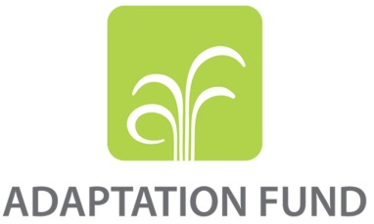

REQUEST FOR PROJECT/PROGRAMME
FUNDING FROM THE ADAPTATION FUND

The annexed form should be completed and transmitted to the Adaptation Fund Board Secretariat by email or fax.

Please type in the responses using the template provided. The instructions attached to the form provide guidance to filling out the template.

Please note that a project/programme must be fully prepared (i.e., fully appraised for feasibility) when the request is submitted. The final project/programme document resulting from the appraisal process should be attached to this request for funding.

Complete documentation should be sent to:

The Adaptation Fund Board Secretariat
1818 H Street NW
MSN P4-400
Washington, D.C., 20433
U.S.A
Fax: +1 (202) 522-3240/5
Email: afbsec@adaptation-fund.org

CONTENT
REQUEST FOR PROJECT/PROGRAMME 1
PART I: PROJECT/PROGRAMME INFORMATION 4
Project / Programme Background and Context: 4
Project / Programme Objectives: 17
Project / Programme Components and Financing: 18
Projected Calendar: 19
PART II: PROJECT / PROGRAMME JUSTIFICATION 19
A. Project components 19
B. Describe how the project / programme provides economic, social and environmental benefits, with particular reference to the most vulnerable communities, and vulnerable groups within communities, including gender considerations. Describe how the project / programme will avoid or mitigate negative impacts, in compliance with the Environmental and Social Policy of the Adaptation Fund. 88
C. Describe or provide an analysis of the cost-effectiveness of the proposed project / programme. 99
D. Describe how the project / programme is consistent with national or sub-national sustainable development strategies, including, where appropriate, national or sub-national development plans, poverty reduction strategies, national communications, or national adaptation programs of action, or other relevant instruments, where they exist. 115
E. Describe how the project / programme meets relevant national technical standards, where applicable, such as standards for environmental assessment, building codes, etc., and complies with the Environmental and Social Policy of the Adaptation Fund. 120
F. Describe if there is duplication of project / programme with other funding sources, if any. 123
G. If applicable, describe the learning and knowledge management component to capture and disseminate lessons learned. 125
H. Describe the consultative process, including the list of stakeholders consulted, undertaken during project preparation, with particular reference to vulnerable groups, including gender considerations, in compliance with the Environmental and Social Policy of the Adaptation Fund. 128
I. Provide justification for funding requested, focusing on the full cost of adaptation reasoning. 135
J. Describe how the sustainability of the project/programme outcomes has been taken into account when designing the project / programme. 138
K. Provide an overview of the environmental and social impacts and risks identified as being relevant to the project / programme. 143
PART III: IMPLEMENTATION ARRANGEMENTS 183
A. Describe the arrangements for project / programme implementation. 183
B. Describe the measures for financial and project / programme risk management. 185
C. Describe the measures for environmental and social risk management, in line with the Environmental and Social Policy of the Adaptation Fund. 187
D. Describe the monitoring and evaluation arrangements and provide a budgeted M&E plan. 201
E. Include a results framework for the project proposal, including milestones, targets and indicators. 207
F. Demonstrate how the project / programme aligns with the Results Framework of the Adaptation Fund 213
G. Include a detailed budget with budget notes, a budget on the Implementing Entity management fee use, and an explanation and a breakdown of the execution costs. 215
Ecuador 223
H. Include a disbursement schedule with time-bound milestones. 225

PROJECT/PROGRAMME PROPOSAL TO THE ADAPTATION FUND

PART I: PROJECT/PROGRAMME INFORMATION

Project/Programme Category: | Regular Project/Programme
Country/ies: | Ecuador
Title of Project/Programme: | Increasing adaptive capacity of local communities, ecosystems and hydroelectric systems in the Río Blanco upper watershed (Toachi-Pilatón watershed) with a focus on Ecosystem and Community Based Adaptation and Integrated Adaptive Watershed Management.
Type of Implementing Entity: | Regional Implementing Entity (RIE)
Implementing Entity: | CAF Latin America Development Bank
Executing Entity/ies: | Ministry of Environment of Ecuador (MAE)
Amount of Financing Requested: | 2,489,373.00 (in U.S Dollars Equivalent)

Project / Programme Background and Context:
- The proposed project aims at strengthening the adaptive capacity of vulnerable populations in the Río Blanco upper watershed and develop a model of adaptation to climate change that can be replicated in similar context in the country and in the region.

Overview Río Blanco upper watershed
- The Toachi-Pilatón (Río Blanco upper watershed) water system, a 2,154.42 km2 drainage basin with a total population of approximately 74,000 people (Table 1), is a system of two drainage units that originate in the steep western slope of the Andes, and flows downhill to merge in the Blanco river. It is the southernmost sub-basin of the Esmeraldas river watershed (Ecuador ´s fourth largest watershed), covering 10% of the Esmeraldas drainage basin.
- The Toachi drainage unit has four sub-basins (Map 1 in Annex 3). The Toachi river is formed by several tributaries, most of them originating in the paramos (> 3,000 meters above sea level) within the Ilinizas Ecological Reserve (e.g., river Las Juntas, river Negro, river Sarapullo). The Pilatón drainage unit is about a fourth of the size of the entire system. The Pilatón river is also formed by high altitude tributaries, some of them also originate in the Ilinizas reserve (e.g., river Negro). However, both the Toachi and Pilatón rivers have a large contribution from tributaries that accumulate and channel water from the forests located on the steep hills.

Drainage unit | Province | Canton | Parrish | Total population in the Parrish | Population within the drainage unit
Toachi | Cotopaxi | Latacunga | Toacaso | 7,685 | 7,685
Toachi | Cotopaxi | Pujili | Guangaje | 8,026 | 8,026
Toachi | Cotopaxi | Pujili | Zumbahua | 12,643 | 12,643
Toachi | Cotopaxi | Sigchos | Chugchilan | 7,811 | 7,811
Toachi | Cotopaxi | Sigchos | Isinlivi | 3,227 | 3,227
Toachi | Cotopaxi | Sigchos | Las Pampas | 1,943 | 1,943
Toachi | Cotopaxi | Sigchos | Palo Quemado | 1,030 | 1,030
Toachi | Cotopaxi | Sigchos | Sigchos | 7,933 | 7,933
Toachi | Pichincha | Mejía | El Chaupi | 1,456 | NA
Pilatón | Pichincha | Mejia | Aloag | 9,237 | NA
Pilatón | Pichincha | Mejia | Manuel Cornejo Astorga (Tandapi) | 3,661 | 3,661
Pilatón | Santo Domingo de los Tsachilas | Santo Domingo | Alluriquin | 9,725 | 9,725
Total population in 2010 |  |  |  | 74.377 | 53.959
NA = Not available, but it is known to be very small

Table 1: Population in the Río Blanco system (Source: Ecuador Population and Housing Census 2010.)

- The lower part of the system is humid with annual precipitation above 2,000 mm/year (Table 2). In contrast, the upper part of the Toachi drainage unit is much drier. In Sigchos, the annual rainfall in 2012 was about 1,130 mm. There are two marked seasons, a rainy season between December and May, and a dry season between June and October (Figure 1).
Station | Data series (years) | Annual precipitation (mm/year) | Monthly minimum (mm/month) | Monthly maximum (mm/month)
Toachi AJ Pilatón | 1967-1985 | 2,745.8 | 64.8 | 451.7
Palo Quemado | 1965-1995 | 2,126.8 | 55.5 | 326.4
Las Pampas | 1985-2006 | 2,126.8 | 33.9 | 353.0
Sigchos | 2012 | 1,130.4 | 5.2 | 247.60
Table 2: Precipitation in four meteorological stations of the Río Blanco (Toachi-Pilatón watershed) system (Source: INAMHI meteorological yearbooks)
- Two provinces and six cantons share the elements of the Río Blanco upper watershed water system. Local communities depend mostly on extensive farming characterized by low productivity, sub-optimal use of economic resources and ecosystems, and negative impact on ecosystems and community vulnerability to climate change. Extensive practices are indeed not only inefficient but they also contribute to deforestation, overexploitation of water sources and sedimentation, reduction of soil quality and further, exposing smallholders to climate hazards.
Indeed due to ecosystems degradation and low economic return, smallholders have lower adaptive capacities resulting in higher climate vulnerability.
Vulnerability is not even among groups: women, with higher poverty level and lower access to income generating activities, have fewer coping mechanism and hence they are more exposed to climate change.
- On the Toachi side, the main activities are subsistence agriculture and extensive livestock farming. In the area of Palo Quemado, farmers cultivate sugarcane to produce panela (unrefined whole cane sugar); there are about 450 ha of sugarcane plantations, 98% of the harvest is used to produce panela (GADPRPQ, 2013). 28% of population is engaged in the production of panela. According to primary data collection there are associations in the area composed of women in their entirety. Those are San Pablo Association with 6 women, Marianita de Jesús en Las Pampas composed by 18 women and Flor de Caña Association with 47 women. Panela is more profitable than other activities, but its artisanal production is based on the use of local trees for firewood. Each farmer uses about -three trees per week- to cook and reduce the sugarcane juice, contributing to deforestation, soil erosion and increasing climate vulnerability. Moreover traditional production of panela can contribute to negative heath impact, due to the respiration of inorganic compounds, and local air pollution.
- The project will focus on but not be limited to work with women associations, aiming to improve production, supporting sustainable management of ecosystems and reducing women’s vulnerability. Moreover, the project will seek replication in other communities where adequate and that includes other vulnerability groups such as children and older adults.
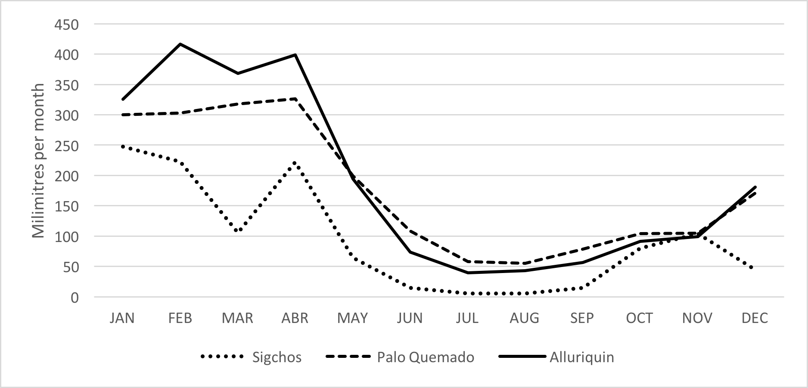
- On the Pilatón side, extensive livestock farming and subsistence agriculture is common. Commerce and small family restaurants predominate along the Aloag – Santo Domingo road (part of route E20). This is the main road which connects the country´s highlands and the coast; it runs along the west bank of the Pilatón river. Extensive livestock farming contributes to deforestation, increasing climate vulnerability, and reducing soil quality. Moreover extensive livestock farming is economically inefficient, becoming profitable for larger properties, and hence contributing to support socio-economic inequality. The project aims to support intensification of livestock production, integration of livestock production with ecosystem conservation, e.g silvopasture production, fodder plants; resulting in economic inclusion of smaller farmers and the reduction of their climate vulnerability.
Figure 1: Monthly precipitation in three stations of the Toachi – Pilatón system (Río Blanco upper basin). Sigchos is located in the upper part of the Toachi unit (2,880 masl) (precipitation data from 2012). Palo Quemado is in the lower part of the Toachi unit (ca., 1,100 masl).

The Toachi-Pilatón hydropower station
- Rural communities, agriculture practices and ecosystems strongly depend on water access and use. To understand present and forecasted water availability is hence of major importance.
- A hydropower plant is being built in the lower part of the Toachi-Pilatón system (i.e., HIDROTOAPI), and it is expected to initiate operation during 2019. It has two turbine systems, one based on the Toachi – Alluriquin confluence planned to produce ca. 204 MW, and the other based on the Pilatón – Sarapullo confluence planned to produce ca. 49 MW (Map 1). The total energy production will be 254.4 MW.
- The Toachi Pilatón Hydroelectric Project in its initial studies dates back to 1963 when the National Institute of Electrification (INECEL) began a strategic policy of evaluating hydroelectric projects at various scales throughout the national territory. At the time the economic feasibility of the project was already demonstrated, however for decades it remained in plans.
- In 1965, experts from the National Electricity Company of Chile (Endesa), proposed a development of a 108 megawatts (MW) installation. Later, in 1973 and 1974, the Swiss Consultant Motor Columbus revised the scheme and recommended to transfer the waters of the Pilatón River to the Toachi basin and install a 225 MW system, building a dam at 180 m downstream of the confluence of the Sarapullo and Toachi rivers. At the end of the 1980s with technical and financial assistance from the Canadian Government, studies were reviewed recommending a 190 MW installation. The last study in 1996 of the Egesco Consortium under the supervision of Harza Engeneering confirmed the characteristics of the project.
- In 1997, through Executive Decree No. 18, the Provincial Council of Pichincha was granted the authority to carry out the 190 MW Toyo Pilatón Hydroelectric Project. The Provincial Council initiated a series of validations and requirements to be able to start the construction process, which ended with a neutral assessment that did not support the start of the project.
- In 2002, the Pichincha Province Assembly resumed updating the feasibility studies in order to carry out the project, and equally carried out studies on legal, operational, administrative and technical issues of the project.
- On August 25, 2005, the Honorable Provincial Council of Pichincha, by means of a public deed and with full powers for the formation of a corporation, subscribed the document of constitution of the denominated Hidrotoapi SA, whose main object consists in the design, construction, installation, operation and maintenance of power generation plants.
- According to the latest Electrification Master Plan of the Ministry of Electricity and Renewable Energies (MEER) for 2016-2025, the plant will start production in 2019.
- While the power plant will certainly have a direct impact on the socio-economic situation in the project’s area of operation, and upon start of production will benefit directly from a sustainable and integrated watershed management as proposed.
It is considered a co-beneficiary of the projects intended outcomes and outputs and is not expressively targeted by the project’s activities. This is due to the current situation of progress of its construction and delays in recent years which led to delays in its start of operations. However, formal agreements are ongoing (Annex 1) and an environmental social risk analyses was elaborated for improving the knowledge about impact between the project and the hydroelectric central, (Annex 7).
- Additionally, given its expected benefit generated through the implementation of the proposed project, the Hidrotoapi is identified as potential contributor to the planned establishment of an Investment Fund, and for those reasons CELEC- Hidrotoapi as consider part of the Technical Committee as support during the implementation of the project. The Investment fund targets the sustainability and development of adaptive capacity of vulnerable populations as well as the restoration and conservation of vegetational cover in the watershed and would – once the Hidrotoapi started its production – hence benefit the power plant directly.
- In Annex 7, potential impacts of the operation of the hydrological station are presented, that will affect the ecosystems adversely and will have to be monitored closely, as suggested on a monthly basis, among others:
- Determination of the recommended minimum ecological flow rates, i.e. the minimum flow rate recommended by the old regulation has been adopted, as 10% of the average annual flow rate through the Toachi and Pilatón rivers at the dam sites. This study will need to be updated and respective ecological flow rate regimes need to be established.
- The actual implementation of management systems of the hydrological power station is out of the direct scope of the project, but will nevertheless be considered in the implementation of the project and resulting activities, primarily by the establishment of an investment fund, where the Hidrotoapi is expected to play a vital role by contributing to its establishment as part of the power plant’s ESMP.

The socio-economic situation of local communities
- The population has very high levels of poverty in terms of unsatisfied basic needs. Four parishes located in the upper part of the Toachi unit had poverty levels above 98% and highest level of agriculture dependency, according national census 2010:
Parish | Main Activity | Second activity | Poor Index | GINI
Aloag | Agriculture 24,2% | Manufacture industries 15,2% | 28% | 31%
El Chaupi | Agriculture 61,3% | Manufacture industries 7,3% | 41% | 29%
Manuel Cornejo Astorga (Tandapi) | Agriculture 47,8% | 11,8% Commerce | 64% | 27%
Sigchos | Agriculture 68,6% | Manufacture industries 5,9% | 62% | 29%
Chugchilán | Agriculture 85,7% | Teaching 2,0% | 83% | 26%
Las Pampas | Agriculture 65,0% | Manufacture industries 21,7% | 52% | 26%
Palo Quemado | Agriculture 46,8% | Manufacture industries 28,8% | 59% | 26%
Table 3: Main activities by locality, based upon data from National Census (2010)
- Even parishes with more developed economic activities like Palo Quemado, Manuel Cornejo Astorga and Aloag had poverty levels well above the national average. Poverty is a gender uneven reality, affecting more women than men.
In 2013, number of females, from the age of 20 to 59 years, living in poor households was higher than that of men, leading to a feminity index in poor households of 117.6 (CEPAL, 2013). Lack of personal income is one of the main reasons behind high poverty ratios among women, since more than one out of every three women (35.1% from age 15 and above) do not have any sort of personal income (and no access to education beyond primary), compared to 9.1% of men (CEPAL, 2014).
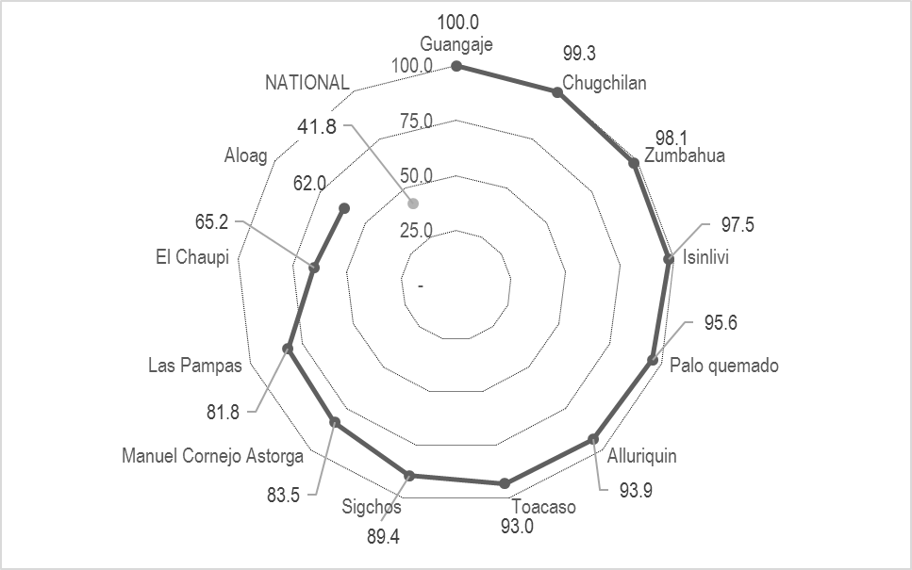
- In the same line, the levels of illiteracy are above the national level (see figure 2). The highest levels of illiteracy are also concentrated in the upper part of the Toachi unit.
- Women have higher illiteracy rates, compared to men, 21.6% compared to 19.2% respectively. Moreover, in these communities, men have more years of schooling: with on average 4.7 years of schooling for men and 4.4 years for women. This gendered bias in literacy is also present at the national level, with a wider gap in rural areas (Table 4).
Figure 2: Poverty by unsatisfied basic needs in the parishes of Río Blanco water system (2010 census).

Illiteracy rates |  |  | Functional illiteracy rates |  | Digital illiteracy rates
Urban |  | Rural | Urban | Rural | Urban | Rural
Men | 3.2% | 4.6% | 7.0% | 20.2% | 18.6% | 34.4%
Women | 10.7% | 15.2% | 8.9% | 25.6% | 24.7% | 43.2%

Table 4: Illiteracy rates, Functional illiteracy rates and digital illiteracy rates (Source: Women and Gender Equality National Agenda, 2014 – 2017, based upon data from INEC (2013))

- As per different parishes, the following figure provides an overview in the area of the project, showing the great differences and educational heterogeneity between the different parishes. This great dispersity will be taken into account when developing the awareness raising, information sharing as well as capacity building solutions within the project.

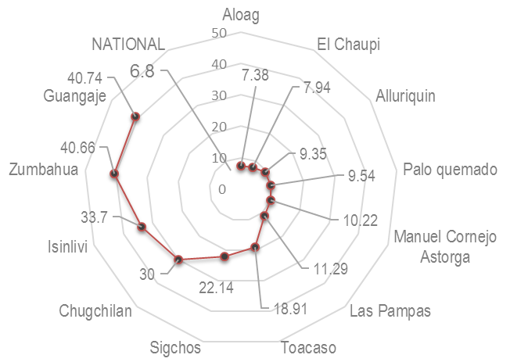
- Illiteracy also affect the level of financial literacy of vulnerable propulations, usually limiting the capacity to embrace the basics of investment decision, especially with respect to the decision of investing in new technologies. Therefore, the project will also address basic components of economic analsys of suitable adaptation measures.
- A major focus will be laid on the capacity development of women as household leaders to disseminate a deep understanding of adaptation economics and this is especially important, as women play a vital role in ensuring and managing access to water and the household’s food security (see annex 9).
Figure 3: Percentage of illiteracy in the parishes of the Río Blanco water system (2010 census).

Climate change effects
- Climate change will affect local communities in the Río Blanco water system by reducing water provision for human consumption, farming production and hydroelectric energy production. Women are forecasted to be more vulnerable to these changes. They are usually indeed in charge of domestic chores, such as harvesting water and food safety, and most of the times they also do most of agricultural work. This uneven allocation of water dependent activities between men and women, exposes women to higher risks concerning lack of water provision (UNEP, 2011).
- Figure 4 summarise the situation and the interaction with human pressures.
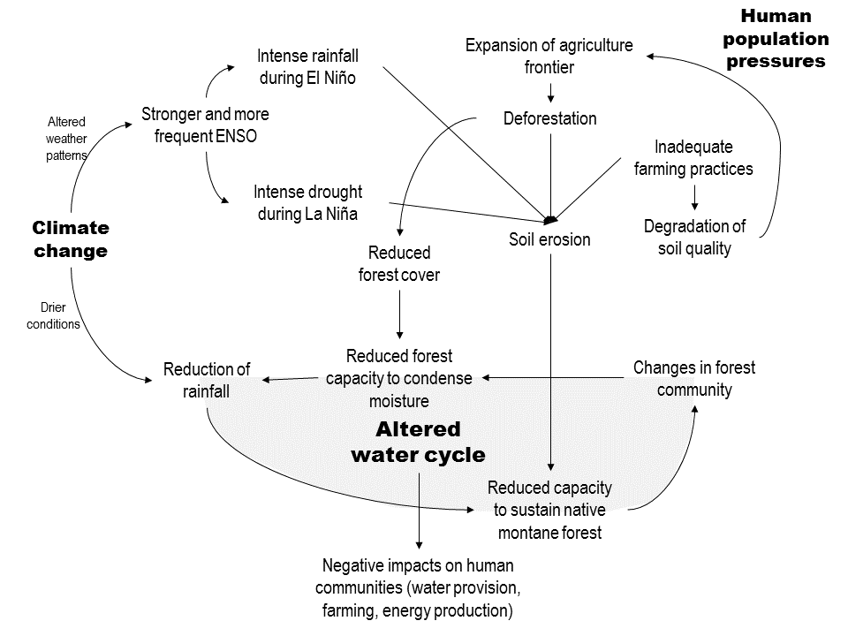
Figure 4. Conceptual diagram of climate change impacts on the water cycle of the Río Blanco water system.

Climate vulnerability of local communities
- In the lower part of the drainage system, mainly along the hillsides, it is common to have frequent landslides mainly during the rainy season. The area along the Pilatón river has high risk of both landslides and flooding (Jiménez, 2013; Proaño, 2015). Landslides are frequent along the Aloag – Santo Domingo road. Younes & Erazo (2016) found that landslide susceptibility along this road is related to active erosive processes, soil condition and rainfall between 1,500 and 1,750 mm. Road closures and traffic restrictions produce important economic losses and access problems to local communities. On April 2015, the road was closed for 20 days and isolated the locality of Tandapi. Landslides and flooding are aggravated during El Niño conditions.
- During the 2015 / 2016 El Niño, there were frequent and large landslides along the Aloag – Santo Domingo road. Only in April 2016, there were about 25 landslides.
- The hillsides in the lower part of the drainage system maintain large areas of natural and intervened montane cloud forest, which are important for the water cycle and biodiversity (Annex 3-Map 2). The rest of the system is mostly used for agriculture and extensive livestock farming.
- The forest cover is mostly included in two Protected Forests: (1) Toachi – Pilatón (BP156) and (2) Sarapullo (BP165). The Toachi – Pilatón Protected Forest was created in 1987, and is a large area of about 212,000 ha. The Sarapullo Protected Forest (BP165) was created in 1986, it covers 21.585 ha. In addition, there are several private reserves that are trying to develop services like trail hiking and bird watching. The forest area has a high biodiversity conservation value. There are populations of puma (Puma concolor) and the spectacled bear (Tremarctos ornatus), which are classified, respectively, as vulnerable and endangered in Ecuador´s IUCN red list of threatened species. The main threat to these species are habitat loss caused by deforestation, and hunting by farmers. In addition, a major part of the drainage system is an Important Bird and Biodiversity Area (IBA).

Climate change effects on the Hydropower station
- The Ministry of Environment (MAE) has found that the Río Blanco water system will be strongly affected by climate change, it is foreseen that future changes in climate conditions will result in an overall marked reduction of rainfall.
In addition, it is anticipated that climate change will produce stronger and more frequent El Niño–Southern Oscillation (ENSO) events (Cai et al., 2014; Cai et al., 2015). Therefore, during El Niño conditions heavy rainfall will exacerbate landslides, erosion, river sedimentation and floods. But, during La Niña conditions, there will be severe drought. These changes, alone, will be sufficient to alter the structure of the native montane cloud forests, which capture cloud moisture and feed streamflows. However, ongoing human pressures will exacerbate the impacts of climate change. The two main drivers are deforestation and soil erosion.
- In 2014, MAE analysed the climate change risk in the watersheds where major hydroelectric plants are based. In the Río Blanco system it was found that:
- The change in rainfall patterns projected into future scenarios under the effects of climate change in the watershed’s recharge zone has a clear downward trend, indicating and resulting in a clear reduction of water volumes (Map 3, Annex 3).
- Today, the main drivers of deforestation and degradation in the basin are the expansion of pastures for livestock and small-scale agriculture. The changing trends in land use and land cover in the watershed due to human pressures such as deforestation and expansion of the agricultural frontier scenarios point toward soil degradation in the basin, which produces, under the effects of climate change, an altered hydrological cycle with its resulting lower retention of sediments under extreme weather events, as well as a clear and observable increase of sediments in the basin in future periods (Map 4, Annex 3).
- For the previously mentioned diagnostic and projection of climate change study in the areas of interest, MAE used two lines of climate modelling:
- An assemblage of about 23 global models provided under the CMIP5 project (MAE, 2015), and
- The regional model REMO adjusted by the CIIFEN-MAE 2014.
- In order to capture smaller-scale processes, limited area climate models, nested within global models ("downscaling"), were used in such a way that it is assumed that local phenomena are based on large-scale patterns resolved in global models. This work employs the regional high resolution climate model REMO-RCM (Max Planck Institute for Meteorology in Hamburg) under the framework of the CORDEX project. The modelling was carried out within three analysis periods (2016-2035; 2046-2065; 2081-2100). The climate scenarios analysed with the REMO model are the three representative pathways of concentration which, in order of emissions levels, are: CPR2.6, RCP4.5, and RCP8.5.
- The periods and scenarios studied pointed towards a marked reduction in rainfall, which will result in a significant reduction in the flow available at the intake points of the hydroelectric plant.
- The results obtained for temperature and precipitation readings in the feeder watershed were used as inputs for modelling flow and sediment through the Soil and Water Assessment Tool (SWAT) model. The modelling indicates that the sediments, under the effects of future climate change scenarios, will increase to about twice the current level in the hydropower station’s water intakes.
- Reduction of water availability, soil and ecosystems degradation, and extensive farming practices requiring higher volume of water, further expose local communities to food insecurity and poverty traps.
- Climate change will hence contribute to worsen the already fragile conditions of communities living in the area.
- Moreover monitoring capacity for weather or climate is poor in watersheds. The Toachi basin has indeed a bad monitoring system: with few meteorological stations, minimum gauging stations and no sediment stations. Therefore, it is not possible to track the flow and sediment and it is not possible easily anticipate with certainty the events.
- In the lower part of the water system, deforestation is caused by expansion of extensive agriculture and livestock farming. Farmers invade the forests and riversides mainly to expand grazing areas for livestock and subsistence agriculture. Another factor which contributes to deforestation is that sugarcane farmers depend on firewood for artisanal panela production.
- In general, farmers use inadequate agriculture practices which produces soil depletion, this reduces production and motivates further expansion of the agriculture frontier. All this contributes to soil degradation, soil erosion, and a reduction of vegetated areas.
- As observed in other regional contexts, economic poverty regularly induces ecosystem degradation, while ecosystem degradation generates and maintains poverty traps. For example, low technification of agriculture practices leads to over-exploitation of agriculture frontier lands, while soil degradation reduces agriculture yields (leading to expansion), reduces soil cover and hence exposes plots to higher vulnerability to temperature and rain variability.
- The foreseen reduction in runoff and the increase in sediments (from hillside erosion) will also affect HIDROTOAPI. MAE has estimated that its susceptibility may lead to a decrease of > 25% of its current annual projected generation capacity, and it may be exposed to greater risk due to reduced water flow and increased sediments.

Effects on local communities
- Adaptation to climate change is a major challenge for local communities. The main barriers that limit adaptation in the lower basin of the Río Blanco water system are:
  - Local population are not fully aware of climate-related impacts. The interviews with local stakeholders revealed that there is no clear understanding of the probable impacts to be generated by the climate change. The future climate scenarios and the probable worsening of existing risks are not in the common dialogue. This contributes to the fact that local population does not demand that elected authorities address adaptation as a priority matter.
  - Local development plans do not incorporate adaptation measures. Local plans (i.e., parishes and municipalities) mention climate change, but do not have specific actions to adapt living conditions to the future scenarios nor to take action to address key drivers like deforestation, land use change and invasion of riversides. Regularly, these plans do not take a gender perspective into consideration, leaving women more exposed to climate change.
  - Local production is based on extensive farming practices. Most farmers have small plots (<20 ha per plot) with very low yields and, in general, apply inadequate agriculture practices. Primary data collection allowed to identify relevant associations in the project area, developing economic activities in agriculture and animal husbandry (mainly livestock farming). These associations are currently involving groups of women, due to their active role in subsistence agriculture activities, their sensitivity for changes observed in the ecosystems, and also for their leadership role in their families.
- Table 5 shows the important role of women in the project area, as well as their influence to develop activities related to climate change adaptation:
Parish | Association | Number of women respondents | Number of women owning land | Main economic activities | Type of crops produced
Palo Quemado | San Pablo | 6 | 6 | Panela production | sugarcane
Palo Quemado | Flor de Caña | 47 | NA | Panela production | sugarcane
Palo Quemado | Marianita de Jesús | 18 | 18 | Agriculture | sugarcane
Las Pampas | Las Marianitas | 19 | 19 | Livestock silage | pastures
Las Pampas | Naranjito | 7 | 7 | Livestock farming for meat production | sugarcane, pastures
Las Pampas | Aso Ganaderos | 12 | 12 | Livestock farming for meat production | sugarcane, pastures, naranjilla
Las Pampas | Asopam | 15 | 15 | Panela production | sugarcane, pastures
Las Pampas | Sembrando un futuro | 5 | 5 | Livestock farming for meat production | sugarcane, pastures, naranjilla
Las Pampas | Campo Verde | 6 | 6 | Livestock farming for meat production | sugarcane, pastures
Table 5: data collected during group discussions in workshops presentation and discussion of final project proposal (see Annex 4, C)
- In Palo Quemado ca. 50% of the farmers only have subsistence production. Livestock farmers use extensive grazing; livestock produce about 7 litres of milk / day. It is common to clear forests to expand the grazing and agriculture areas. Sugarcane farmers clear forests to obtain firewood for panela production. At the same time these producers indicate, that the availability of the required firewood is increasingly limited, hence a more efficient and sustainable production of panela is welcome by the target co-executors of the project.
  - Forest areas are not protected. The large protected forests, that are public property, are not managed and guarded. Therefore, extensive areas have been invaded and cleared to establish farms. Land tenure is an additional related issue, because invaders claim possession rights to the municipal and central governments. Private landowners of forest areas also face pressure from illegal farmers. The extent of the invaded area is unknown. Conservation Bio-corridor will be implemented as a strategy for conservation of biodiversity, land management and sustainable development in the project area that includes an improvement of land tenure. Part of the project includes watershed population training with at least 50% of women participation. Evidence shows that women participation in forest protection mechanisms (committees, meetings, forest management and guards) leads to higher control rates. Hence, it is important to train women to be part of forest protection personnel, to assure forest protection.
  - Limited climate-related information. The monitoring of hydro-meteorological variables within the watershed has limitations in terms of quality and availability, generating less understanding of the behavior of water flows and sediments in the basin. The National Meteorological and Hydrological Institute (INAMHI) has eight meteorological stations in the Río Blanco water system (Map 5), but only two (i.e., M0362 Las Pampas, M0363 Sigchos) are operational.

Project design
- The present project will contribute to address these barriers by developing practical adaptation actions to strengthen the resilience of local communities in the upper and middle basin of the Toachi – Pilatón water system located at the Río Blanco upper watershed (i.e., subbasins 1, 2 and 3 indicated in Annex 3):
- To conserve forest cover, to sustain the hydrological cycle and prevent as much as possible a reduction of rainfall, and to protect hillsides from erosion.
- To introduce sustainable farming practices to increase the yield per hectare, in order to introduce land use efficiency and sustainability and in consequence reduce the expansion of the agriculture frontier, as well as to limit soil erosion and deforestation.
These activities can be a useful mean to empower women or women’s groups within their communities, and to serve as development model for sustainable community development.
- To mainstream adaptation into local development plans and engage the local population by increasing awareness of the impacts derived from climate change as well as for potential adaptation strategies.
- Table 6 summarises specific actions to address the key barriers that have been identified.

Main barriers that limit adaptation | Project actions to address the main barriers
Local population are not fully aware of climate-related impacts. | To implement a public communication and education plan on the six parishes of the upper and middle basin of the Toachi – Pilatón water systems (Río Blanco upper basin) (output 7).
Local development plans do not incorporate adaptation measures. | To work with parish councils to mainstream climate change adaptation, with a gender perspective, into the parish development plans of the six parishes of the upper and middle basin of the Río Blanco water systems (output 6). The six parishes are: (1) Manuel Cornejo Astorga, (2) Aloag, (3) El Chaupi, (4) Palo Quemado, and (5) Las Pampas (6) Sigchos
Local production is based on extensive farming practices. | To work with local farmers, women and men, to introduce best practices to reduce deforestation, land degradation and improve adaptive capacities (outputs 1 and 3). The key groups to work with are livestock and sugarcane producers. Female farmers will be specifically targeted.
Forest areas are not protected. | To strengthen the means to conserve forest and vegetation cover in the watershed. Act on two fronts:  - To work with local landowners to incentive the conservation of ca., 1000 ha of native vegetation (output 1). It will be necessary to provide incentives; the idea of establishing an investment fund (output 5) to support investment in adaptive capacities for the communities.  - To strengthen the means to conserve the vegetation of the two existing protected forests and new areas under the Bio-corridor and ACUS categories (Toachi – Pilatón and Sarapullo, about 230,000 ha in total) (output 2).
Limited climate-related information. | To generate and disseminate hydro-meteorological information by potentiating and expanding INAMHI’s hydro-meteorological network (output 6)  Diffusion of best adaptive practices thanks to appropriate training (output 8), institutional learning (output 4), and diffusion of best practices through education, knowledge transfer (output 8) and lessons learnt in the project thanks to knowledge management platforms (output 9).
Difficulty of access to credit for sustainable productive activities | To work with at least 2 financial institutions supporting them to introduce specific solutions to finance adaptation (output 4). Systematically include in the credit assessment the evaluation of climate and environmental risks, aiming to integrate sustainable and climate adapted practices in the whole operations of financial institutions. Development smart incentives for finance adaptation.

Table 6: Proposed actions to address the key barriers that limit adaptation in the lower basin of the Toachi – Pilatón water system (Río Blanco upper basin)
- The project targets to develop, test and implement solutions which will be established beyond the duration of the proposed project to ensure a sustainable approach to community- and ecosystem-based adaptation to climate change. To that end, it will incorporate successful solutions tested in comparable projects or programs in the region and elaborate solutions which can be replicated within Ecuador and beyond.

Project / Programme Objectives:

- The proposed project general aims at strengthening the adaptive capacity of vulnerable populations, ecosystems and hydroelectric systems in the Río Blanco upper watershed and develop a model of adaptation to climate change that can be replicated in similar context in the country and in the region. The specific objectives of the Project are:
- Reduce the impact of climate change on the hydrological cycle under integrated watershed management

- Promote sustainable agricultural practices adapted to the new conditions of climate change and efficient technology in production processes supported by credit.
- The proposed project aims to develop multi-stakeholder coordination and implementation mechanisms to foster ecosystem- and community-based adaptation of vulnerable communities in the Río Blanco upper watershed.
- The project focuses on key drivers that will create adverse impacts from climate change or generate opportunities that concern the most vulnerable populations. The expected mid-term impacts are improved enabling conditions to sustain forest cover and sustainable small-scale farming in the area, with a gender perspective. In the long-term, it is expected that the project’s activities will result in improved adaptive capacity of the target farmers, ecosystems and hydroelectric systems. The farmers, as well as their communities, are understood as co-executors of the project and its key target.
- Learning generated in the proposed project will be structured to be replicable and provide marketable solutions that can be applied in other watersheds or regions in the country and even beyond.
- It is the explicit aim of both implementing as well as executing agency to integrate lessons learned from similar initiatives in the region and globally and combine proven solutions in a new set-up to strengthen the global learning process on successful ecosystem-based adaptation to climate change.

Project / Programme Components and Financing:

Project/Programme Components | Expected Outcomes | Expected Concrete Outputs | Amount (US$)
1.Conserve vegetation cover | 1. At least 230,000 ha of native vegetation is conserved to reduce the impact of climate change on the hydrological cycle under integrated watershed management | 1. 1,000 ha of native vegetation is conserved by sustainable forest management and conservation mechanisms. | 500,000
1.Conserve vegetation cover |  | 2. Improved management of existing protected forests and private conservation areas (ca. 230,000 ha) | 450,000
2. Adapt farming practices to new climate change conditions and enable their sustainable climate smart financing | 2. Sustainable farming practices and livestock adjusted to local realities are being introduced and implemented with assistance of financing mechanisms for adaptation measures | 3. 250 ha of pasture and 250 ha of crops apply sustainable farming practices | 340,000
 |  | 4. At least 2 institutions have introduced specific solutions and credit assessments to support the disbursement of credits for adaptation, integrating environmental and climate risks in their operations. | 80,000
 | 3. At least 1 long term financing mechanisms has been piloted or introduced | 5. One investment fund to promote sustainable development is set up and operational | 420,000
3. Strengthen local capacities and share lessons | 4. Local population and parish governments with increased capacity to implement climate change adaptation measures. | 6. At least 6 parishes being built capacities and prepared to manage and use meteorological information. | 160,000
3. Strengthen local capacities and share lessons |  | 7. Six development plans of local parishes incorporate measures for ecosystem-based adaptation to climate change. | 80,000
3. Strengthen local capacities and share lessons |  | 8. Strategic plan of communication, education, knowledge transference and scheme of replica, including demonstration farms and markets. Plus training on adaptation finance to financial institutions. | 120,000
3. Strengthen local capacities and share lessons |  | 9. Systematisation of information gathered during the whole project design and implementation using existing informatics platforms | 40,000
Total Component Cost |  |  | 2,190,000
Project/Programme Execution cost |  |  | 180,000
Total Project/Programme Cost |  |  | 2,370,000
Project/Programme Cycle Management Fee charged by the Implementing Entity (if applicable) |  |  | 119,373
Amount of Financing Requested |  |  | 2,489,373

Projected Calendar:
Milestones | Expected Dates
Start of Project/Programme Implementation | 01/2019
Mid-term Review (if planned) | 01/2021
Project/Programme Closing | 12/2022
Terminal Evaluation | 12/2022

PART II: PROJECT / PROGRAMME JUSTIFICATION

A. Project components

- The project strategy focuses on implementing actions that will minimize, as much as possible, the foreseen impacts of climate change in the Río Blanco water system as presented in Part I. The main conceptual frameworks will be a sustainable livelihoods approach (Chambers & Conway, 1991; Scoones, 1998), Ecosystem-based Adaptation (EbA), Community based Adaptation (CbA), and watershed management approach for climate change adaptation with a gender perspective.
- The main rationality to base the intervention on ecosystem and community based strategies is that: ecosystems have strong influence on the vulnerability of (especially poor rural) communities, while communities naturally use to develop coping strategies to reduce their vulnerability. Rural communities depend on the conservation of ecosystem and the direct participation of communities to adaptation strategies is key to support sustainable intervention in the realm of climate change adaptation. Hence, this project aims to support adaptation through conservation of ecosystem and capitalizing on local knowledge and participation of local communities.
- The project is organized into three components and four outcomes. 9 concrete outputs will be produced. The multiyear work plan will be developed during project preparation.
- Conservation practices that reduce the impacts of climate change on the Río Blanco upper basin flows are based on the maintenance and management of public and private conservation areas, as well as the increase of 1,000 ha of native vegetation.
The private conservation categories must comply with the technical studies and a management plan and it will not necessary be formally part of the SNAP (National System of Protected Areas) meanwhile the public declarations, in addition to the management plan and technical studies, it must be formalized through a declaratory from the local governments, this can be part of the SNAP. As a basis, the, Bio-corridors and ACUS scheme and the exclusive competences of land use granted to the municipal governments (GAD, for its Spanish abbreviation of “Gobiernos Autonomos Decentralizados, “autonomous decentralized governments”) will guide adaptation activities in respect to the conservation of the vegetation cover.
- The following chart and subsequent paragraphs provide an overview on the main adaptation categories and strategies that will guide the project’s activities:
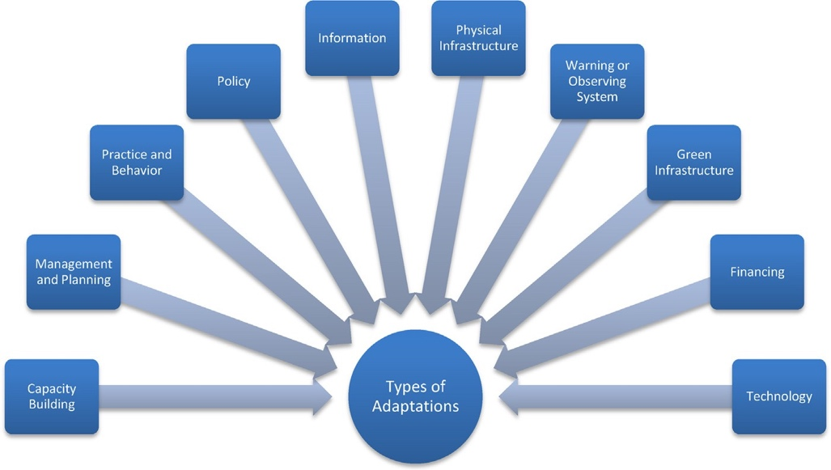
Figure 5: Adaptation to Climate Change categories, adapted from GEF, (2014).

- The above presented adaptation categories can be specified as presented in the following table:
Adaptation category | Description | Examples of actions in category | Similar classiﬁcation in literature
Capacity Building | Developing human resources, institutions, and communities, equipping them with the capability to adapt to climate change | Training/workshops for knowledge/ skills development, public outreach and education, dissemination of info to decision makers/stakeholders, Identiﬁcation of best practices, training materials. | Educational/informational (Smit and Skinner, 2002; Wilbanks and Kates, 1999; Huq et al., 2003; Smit et al., 2000; Carter et al., 1994; Tompkins et al., 2010)
Adaptation category | Description | Examples of actions in category | Similar classiﬁcation in literature
Management and Planning | Incorporating understanding of climate science, impacts, vulnerability and risk into government and institutional planning and management | Developing an adaptation plan, livelihood diversiﬁcation, drought planning, coastal planning, ecosystem- based planning, changing natural resource management | Administrative/institutional/ organizational (Smit and Skinner, 2002; Wilbanks and Kates, 1999; Huq et al., 2003; Smit et al., 2000; Carter et al., 1994; Tompkins et al., 2010) Behavioral (Smit and Skinner, 2002; Wilbanks and Kates, 1999; Huq et al., 2003)
Practice and Behavior | Revisions or expansion of practices and on the ground behavior that are directly related to building resilience | Soil/land management techniques; climate-resilient crops or livestock practices, post-harvest storage, rainwater collection, expanding integrated pest management | Behavioral (Smit and Skinner, 2002; Wilbanks and Kates, 1999; Huq et al., 2003)
Policy | The creation of new policies or revisions of policies or regulations to allow ﬂexibility to adapt to changing climate | Mainstreaming adaptation into development policies, land-use speciﬁc policies, improvement of water resource governance, revised design parameters, ensuring compliance with existing regulations | Legislative/Legal (Smit et al., 2000; Carter et
Information | Systems for communicating climate information to help build resilience towards climate impacts (other than communication for early warning systems) | Decision support tools, communication tools, data acquisition efforts, digital databases, remote communication technologies | Infrastructural/structural (Smit et al., 2000; Carter et al., 1994) Educational/informational (Smit and Skinner, 2002; Wilbanks and Kates, 1999; Huq et al., 2003; Smit et al., 2000; Carter et al., 1994)
Physical infrastructure | Any new or improved hard physical infrastructure aimed at providing direct or indirect protection from climate hazards | Climate-resilient buildings, reservoirs for water storage, irrigation systems, canal infrastructure, sea walls | Infrastructural/structural (Smit et al., 2000; Carter et al., 1994)
Warning or observing systems | Implementation of new or enhanced tools and technologies for communicating weather and climate risks, and for monitoring changes in the climate system | Developing, testing and deploying monitoring systems, upgrade weather or hydro-meteorological services | Research and development (Smit et al., 2000; Carter et al., 1994)
Adaptation category | Description | Examples of actions in category | Similar classiﬁcation in literature
‘‘Green’’ infrastructure | Any new or improved soft, natural infrastructure aimed at providing direct or indirect protection from climate hazards | Revegetation, afforestation, woodland management, increased landscape cover | Infrastructural/structural (Smit et al., 2000; Carter et al., 1994)
Financing | New ﬁnancing or insurance strategies to prepare for future climate disturbances | Insurance schemes, microﬁnance, contingency funds for disasters | Financial (Smit and Skinner, 2002; Wilbanks and Kates, 1999; Huq et al., 2003; Smit et al., 2000; Carter et al., 1994); Market mechanisms (Smit et al., 2000; Carter et al., 1994)
Technology | Develop or expand climate-resilient technologies | Technologies to improve water use or water access, solar energy capacity, biogas, water puriﬁcation, solar salt production | Technological (Smit and Skinner, 2002; Wilbanks and Kates, 1999; Huq et al., 2003; Smit et al., 2000; Carter et al., 1994)
Table 7: Overview adaptation categories

- The proposed project intends to address all these relevant adaptation dimensions, though to differing extents in the actual implementation.

Adaptation concept and indicators for Adaptive Capacity

- The adaptive capacity of vulnerable populations defines their vulnerability against adverse climate change impacts as a function of their exposure and sensitivity to such impacts. Figure 6 visualizes the dynamics between these components. Vulnerability results as the sum of Exposure plus Sensitivity minus Adaptive Capacity. By ”vulnerability”, we mean the propensity or predisposition to be adversely affected; by “exposure” we mean a “fixed” reality consisting in climate hazards, temperature, precipitation, soil type, etc.; by “sensitivity” we mean a “variable” reality consisting of the inherent sensitivity of the economic activity to specific exposure, as for crop sensitivity to temperature oscillations; by “adaptive capacity”, we refer instead to the ability of a system to adjust to climate change (including climate variability and extremes), to moderate potential damages, to take advantage of opportunities, or to cope with the consequences, namely how are exposure and sensitivity managed.
- Being exposure external and sensitivity inherent to the economic practice, ecosystem based adaptation works on increasing adaptive capacities to decrease community and ecosystem vulnerability as presented in Figure 6.
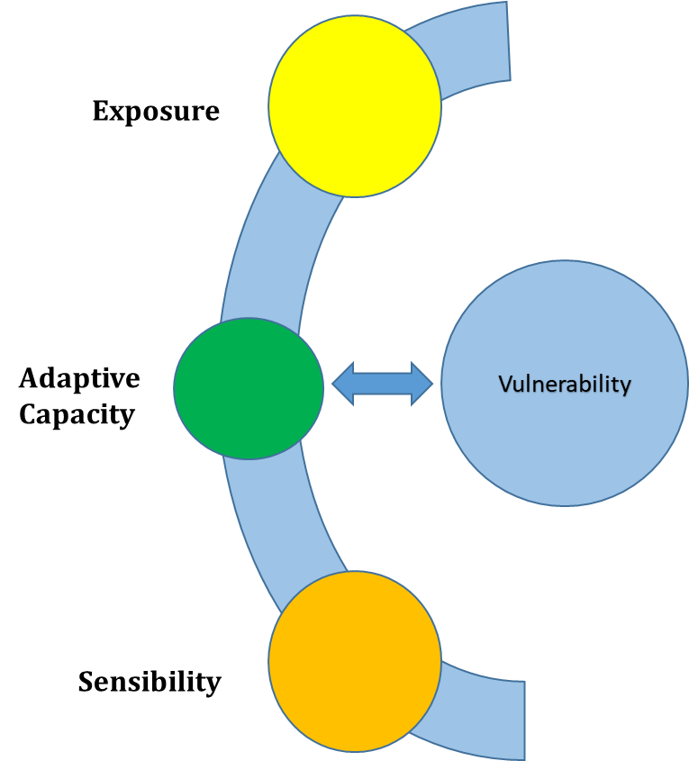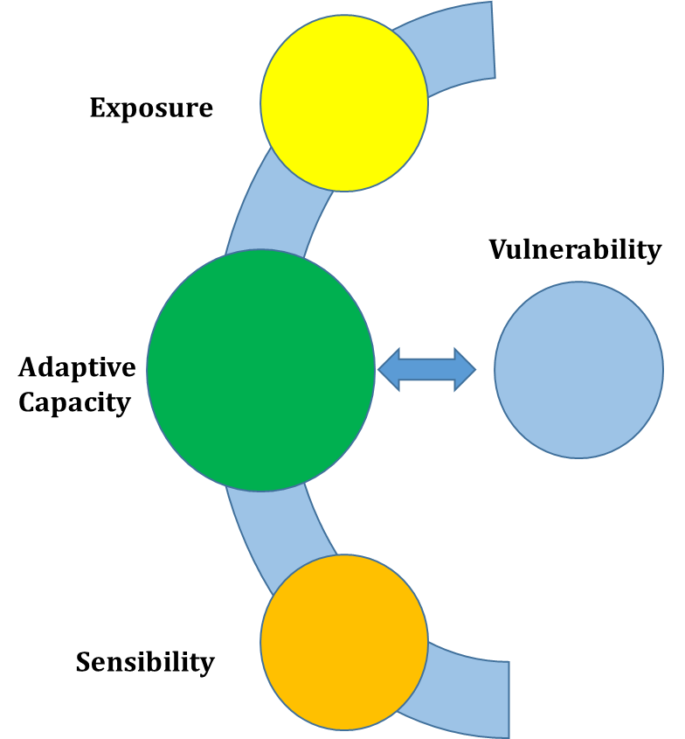
Figure 6: Influence of adaptive capacity on climate change vulnerability. Source: Engle (2011). Adapted from: Aguirre et. al. (2015).

- The project will integrate the measurement of the adaptive capacity via established indicators that will be developed or drawn from similar approaches in the region and the national vision (MAE), mainly The National Adaptation Plan and current projects in Ecuador. Set of tools that promote the Evaluation & Monitoring and Measuring, Reporting and Verification (MRV). The present project will capitalize on such experience and define the adaptations indicators tailored to the target population and ecosystem for the project.
- In the framework of its National Adaptation Plan, the country is developing a proprietary system for Monitoring and Evaluation of adaptation measures which will be taken into consideration, and if applicable, form the basis for the project’s monitoring and evaluation activities.
- These indicators will assess the evolution of the adaptive capacity of smallholder farmers over time. The project will promote their inclusion into day-to-day operations of project stakeholders and promote the creation of crowd-sourced insights into the target communities’ adaptive capacity.
- If applicable, and depending on subsequent coordination, the project will coordinate and include in its field activities the application and integration into operational processes of international best practices to measure the adaptive capacity of vulnerable populations, especially small farmers and cattle ranchers.
- An example is the EbA capacity index developed by the UN Environment’s MEbA project, that allows institutions addressing the target populations as mentioned above to gather relevant data in three dimensions to generate an index that expresses a given unit’s (productive unit, household) capacity to confront climate change based on Ecosystem-based Adaptation principles in three dimensions:
- Socio-economic dimension: assessing available infrastructure and services, financial situation and social or community integration
- Productive dimension: assessing the productive reality of the agricultural production with respect to soil quality, farming practices and integration into agricultural value chains
- Environmental dimension: assessing the farm’s or household’s management of water, waste and pests among others
- The gathering of relevant data will be integrated into field operations and processes wherever the project interferes with the target populations via
- Financing activities and credit assessment
- Provision of technical assistance to strengthen productive processes
- Monitoring and Evaluation activities
- Based on this data analysis process, the project will not only be able to sistemize and quantify its Monitoring and Evaluation activities across all field operations, but establish a system that allows for a monitoring of the evolution of farming practices in the area of the project over time, during and after the project implementation phase.
- Resulting insights will be used to inform the communities in the area of the project via the channels and media presented in Component 3, and hence contribute to generate relevant knowledge to be shared with the communities in the upper Rio Blanco watersheds.
- The capacity building resulting from such knowledge sharing will be focusing on informing target populations on:

- EbA conform and efficient agricultural practices that strengthen the health of ecosystems as the basis for sustainable agricultural production systems
- Statistical analysis of effective agricultural practices under adverse climate change impact influence by combining data from weather stations in the watershed and data on applied agricultural practices s resulting from field data gathering activities described above
- Cost-benefit analysis resulting from a close monitoring of yield levels as a function of implemented farm practices
- Perceptions within the community on adverse climate change impacts as well as preferred adaptation measures being implemented or carried out following the generation of crowd-sourced insights

Criteria for selecting project activities and beneficiaries

- The selection criteria for project activities to the different components was based on a triangulation methodology, which results from the interaction between documentary information, a review of the regulatory framework, and validation of actions with co-executors in field workshops, in general this component will considerate gender equality and empowerment of women, the project will encourage the participation of women and vulnerable groups during project activities, trough the gender actin plan (Annex 9). Summarized in the following diagrams:

Figure 7-A: Methodology to define project actions

- For the beneficiaries selection the process includes the support of technical study (Annex 10), which includes an analysis of the social and environmental conditions of the basin based in the 2016 Population Census. To define the beneficiaries of the project, the following aspects will be considered:
- Location of defined villages to participate.
- Obtain population data of each point in relation to the census sector where it is located.
- Vulnerable areas.
- Location of the measurements.
- Deforestation 2014-2016 and
- Data of the 2010 population census (INEC).

Summarized in the following diagram:

Figure 8-B: Methodology to define beficiaries

- The criteria for prioritizing beneficiaries are analyzed with respect to vulnerability to climate change and social vulnerability that includes the socio - demographic - economic factors facing the beneficiary population. By linking the characteristics of the population such as: poverty, indigenous groups, minorities, disabled people and gender.
- The social vulnerability index is a measure proposed by the UNDP that refers to the sum of the circumstances that affect population groups, which limits their ability to fend for themselves. The factors associated with social vulnerability expressed as demographic indicators that make up the IVS are the following:
- The number of illiterates is an indicator of the level of delay in the educational development of a society, especially in the case of the most vulnerable groups of the population; hence the importance of associating this indicator with variables such as residence, ethnicity, age group and sex.
- Malnutrition is a multi-causal phenomenon directly associated to: deficiencies, excesses or imbalances in the diet; inadequate cultural habits; precarious health services; to a poverty that limits access and capacities to acquire food; as well as marginalization that does not allow access to food, among other factors
- The incidence of poverty refers to the deprivation of people or homes in the satisfaction of their basic needs.
- Infant mortality, that is, the probability that children have to die during their first year of life.
- Ethnicity refers to the cultural values ​​and practices that distinguish groups or communities.

Summarized in the following diagram:

Figure 9-C: Methodology to define beneficiaries

Criteria for selecting project EbA measures

- EbA measures are generally cost-effective. In addition to their role in reducing vulnerability and increasing the resilience of biodiversity, they tend to generate valuable additional benefits; among them: disaster risk reduction, maintenance of livelihoods and food security, carbon sequestration, water availability. On the types of agricultural practices that will be considered for the deployment in the target areas, the selection criteria of adaptation to climate change based on Ecosystems will be taken with the purpose of:
- Reduce the pressure on the ecosystems and the services they provide.
- Increase the social or economic resilience of human populations vulnerable to climate change.
- Reduce risks associated with climatic events in productive activities.
- In its implementation, protect, restore or use biodiversity and ecosystems of sustainable way.
- Have a positive impact on the economy of people in the short term.

The following adaptation measures have been reviewed and identified as potential solutions to be implemented with local populations in the Río Blanco upper watershed. Their selection has been done on an “a priori” basis and was drawn from the UN Environment MEbA project’s catalogue of 40 EbA measures as published on the respective website. View Annex 12.A
Figure 10-D: EbA measures Catalog (40)

According with the methodology (phase two contrast with similar initiatives) and evaluating the current conditions of how the Project Area is located, some impacts were identified in the base in the EbA conceptualization, as detailed below:

IMPACT OF CLIMATE CHANGE IN AGRICULTURE
Variables and Affectation | Adaptation Alternatives EbA |  |  |  |  | Alternative description of adaptation
Temperature, precipitation, CO2, Radiation Affectation Optimal development (water cycle, carbono). | EBA Ecosystems  Conservation Agriculture |  |  |  |  | Indicators  Tracking unit:  Area under conservation agriculture (ha).  Impact unit:  Production (t / ha). Spending reduction  in agricultural inputs ($)
IMPACT OF CLIMATE CHANGE ON DISASTER RISKS
Variables and Affectation |  | Adaptation Alternatives EbA |  |  |  | Alternative description of adaptation
Variables  Temperature, Precipitation  Affectation  Landslides  Erosion |  | Infrastructure: Agricultural terraces that will increase the resilience of the system, consists in making cuts to the steep slope to establish cultivated terraces supported by a stone wall.  Ecosystem EBA |  |  |  | Indicators  Tracking unit:  Linear distance of built walls (m).  Impact unit:  Production area and protected housing (m2 and #, respectively).
IMPACT ON FOOD SECURITY
Variables and Affectation |  |  | Adaptation Alternatives EbA |  |  | Alternative description of adaptation
Affectation  Soil quality  Pest Increase |  |  | EBA Ecosystems  Crop Diversification |  |  | Indicators  Tracking unit:  Surface sown in mixed schemes  (he has). Associated varieties planted per unit of crop (#).  Impact unit:  Income ($). Varieties produced (#, t).
IMPACT OF DEFORESTATION

Variables and Affectation |  |  | Adaptation Alternatives EbA |  |  | Alternative description of adaptation
Variables  Logging of trees  Affectation Sustainable forest management promotes the development of local communities, while retaining the biodiversity, capture carbon and can even eliminate deforestation and restore forest cover. |  |  | EBA Ecosystems  Sustainable Forest Management |  |  | Indicators  Tracking unit:  Area under sustainable forest management  (he has).  Impact unit:  Wood production (m3). Income by worker ($). Conserved surface (ha).
EROSIÓN

Variables and Affectation |  |  |  | Adaptation Alternatives EbA |  | Alternative description of adaptation
Variables  Climate, vegetation, leaf litter, soil type, topography, flow velocity, land use.  Affectation  The degradation of the soil, as a consequence of erosion, affects the fertility of the soil and, ultimately, the production of the crops. |  |  |  | EBA Ecosystems  Soil Conditioning: It consists of applying a series of techniques to restore the optimal conditions of organic matter, nutrients, biological activity and other essential elements for agricultural production. |  | Indicators  Tracking unit:  Surface with conditioning floors (ha).  Impact unit:  Increase in crop productivity (t / ha). Decrease in fertilizer spending  ($ / ha).
IMPACT OF MICROFINANCE ON THE POPULATION
Variables and Affectation |  |  |  |  | Adaptation Alternatives EbA | Alternative description of adaptation
Variables  Indexed insurance.  Microfinance.  Affectation  Accurate of the existence of a structure effective financial  It is not usually accessible to the most vulnerable groups |  |  |  |  | Financial: Actions regarding the provision of resources and financial incentives to share and transfer risks or improve the social and ecological bases of vulnerable systems.  Credit access | EbAcapacity index adaptation based on ecosystems. The procedure consists of gathering information on the socioeconomic, productive and environmental dimensions of the agricultural unit through an interview with the farmer. The interview is linked to the credit evaluation process, either ex-ante, when the client requests the credit, or ex-post, as part of the follow-up to the disbursement.  # credits
Table 8: General impacts in the basin of the Toachi – Pilatón water system (Río Blanco upper basin)

- Implementing agents, according with the arrangements (Part III, B): Ministry of the Environment, Undersecretariat of Climate Change and Undersecretary of Natural Heritage; Water Secretariat (SENAGUA); CELEC Hidrotoapi; local GADs; and local productive organization. Additionally, different institution have key role for the success of the project, institutions such as Agriculture Ministry, Consortium of Provincial Councils of Ecuador (CONCOPE) and National Meteorological Institute (INAMHI), which the project will establish strategic relations during the implementation.

Component 1: Conserve vegetation cover

- Component 1 focuses on the conservation of vegetation cover on an area of 230,000 ha, supported by the introduction of the active sustainable forest management and conservation technologies.
The methodology mentioned in figure 7, for the component 1 (Protection of Natural Coverage) the proposal of measures related to forest conservation, afforestation and climate monitoring, result from the studies "Analysis of the vulnerability of the hydroelectric power plants prioritized for the effects of climate change, Toachi Pilaton hydroelectric power plant ", developed by the Ministry of the Environment. Next phase the forestry regulatory framework and similar initiatives analyzed and finally the proposal contrasted with the workshops developed on the 24th and 25th July in the upper and lower basin of the Toachi and Pilatón River (Annex 4 A, B).

The steps that described below documentary information for the selection of activities: In the study of vulnerability to climate change of the hydroelectric power, a series of activities related to adaptation are defined that maintain and improve the provision of ecosystem services in the upper basin of the Blanco River (Annex 12A).

The adaptation recommendations identified in the study in question have the following characteristics:

Manage in an integrated manner and conserve the forests and protective vegetation, as well as anthropized ecosystems corresponding to the upper basin of the Blanco River, contributing to the Toachi and Pilatón hydroelectric plant to reduce vulnerability to climate change, contributing to:
    - Control of erosive processes and sediment flows.
    - Regulate the ecological cycle to optimize the available water resources and its hydroelectric use.
    - Sensitize and strengthen the capacities of local governments and related communities.
    - Make the socio-economic development of the sub-basins compatible with the preservation of water resources. Promote the restoration and enrichment of the páramos and forests, maintaining a continuity of the Andean ecosystems and their ecological services.

Ecosystem considerations
Figure 11. Key Concepts identified with the local communities for the component 1.

- Analysis of regulatory frameworks: The identification of areas of intervention will be defined following methodologies which the Ministry of the Environment has developed in recent years through the Operational Manual of the program Socio Bosque and are formally disseminated through the ministerial agreements: N° 130 on 28 June 2011.
- The agreements define criteria for threats, eco-system services and socio-economic characteristics of the area, in the present case the previously established threats will incorporate the climatic threats arising from the effects of climate change, the criteria for component 1 are described below:
- Threat levels defined through the proximity to access roads;
- Historical patterns of deforestation;
- Climate threats to the biophysical components of the basin (droughts, floods);
- Environmental services: biodiversity refuge, hydrological regulation, carbon storage;
- Poverty level.
- In addition, information and similar interventions in the territory will be identified as they emerge to complement project activities as well as not to duplicate efforts. There is evidence of previous work by Socio Bosque (Table 8) and interventions of the GADs within the scope of their competencies that will be complemented with the proposal of Biocorredor and ACUS of this proposal.

Surface (ha) under Socio Bosque Mechanism | Characteristics | Number of beneficiaries in the zone with SB | Average surface per beneficiary
10959,83 | Individual beneficiaries | 93 | 117 ha/beneficiary
Table 9: SocioBosque interventions in the Rio Blanco watershed

- The proposed project will coordinate with the following key stakeholders the execution of component 1 that have been identified and engaged in the project planning and preparation phase (see Annex 4 on the workshops executed).
Stakeholders | Functions | Project Implementation Role
Ministry of Environment (MAE) | Lead institution of the environment sector. Local staff of the PAs Unit are responsible for planning, management, vigilance and control within PAs. | Project executing agency. Will lead project activities in relation to the formulation of norms and strategies, the clarification of institutional roles for forest and APe management and conservation, support to GADs in processes of territorial land use planning, and support to incentive systems.
Ministry of Agriculture and Livestock  (MAG) | Regulation, facilitation, control and evaluation of management of agriculture, livestock, promotion of actions which allow rural development and further the sustainable growth of the production and productivity of the sector. | Provision of training, technical assistance and monitoring of sustainable agriculture and livestock production
National Planning Ministry (SENPLADES) | Coordination of National Decentralized System for Participatory Planning, promotion of integrated development. | Coordination and consultation regarding the project’s support to territorial land use planning processes and the GADs.
Stakeholders | Functions | Project Implementation Role
GADs | Generation of development and land use plans, for environmental management, declaration of parish and municipal protected areas, formulation of local environmental norms and the implementation of sustainable natural resource management projects. | Key targets for strengthening due to their responsibilities for environmental management at parish and municipal levels.  Promote and support the investment fund as constituents
National Police Environmental Unit | Control of compliance with environmental norms in order to avoid its degradation of disappearance. | Guidance on application of legislation: involvement in multi-stakeholder strengthening of governance conditions.
SENAGUA | Water management authority, is an essential partner for the basin committees conformation and the investment fund. | Promoter on the River basin council.
Local communities and associations. | River basin management and zoning plans under an Integrated Watershed Management | River basin planning and implementation of Project activities.
INAMHI | Authority in the climate information generation. | Hydro-meteorological and decentralized monitoring system development.
Table 10: Key stakeholders in the Rio Blanco watershed
- Component 1 will focus on two outputs according to a single outcome targeted.
Outcome 1. At least 230,000 ha of native vegetation is conserved to reduce the impact of climate change on the hydrological cycle under integrated watershed management
- This component will generate one outcome to be built from two outputs.
- The objective of this outcome is the encourage conservation of the existing forest cover by promoting the conservation of 1,000 ha of native vegetation (output 1) and strengthening the management of the existing protected forests (ca., 230,000 ha) (output 2) based on two existing and proven mechanisms developed in the country: ACUS and Socio Bosque (Annex 13).
Output 1: 1,000 ha of native vegetation is conserved by sustainable forest management and conservation mechanisms.
- The activities targeting this output will promote the conservation of 1,000 ha of native vegetation that contribute to the regulation of the hydrological cycle, and which are not currently guarded by any protective measure. An initial governance analysis will be performed in order to include all relevant stakeholders within the relevant activities of this component, promote cooperation and facilitate dialogue among each other. Strengthening governance among different actors and within the area of intervention is a key factor to firstly promote sustainability and secondly to empower the local communities. At the beginning of the project, they will play a role as beneficiaries, but the long-term intention is that they become active participants and lead the conservation process by themselves.
- This component is based on the advancing and holistic landscape approaches implemented by the Ministry of Environment in Protect Areas (PA), nowadays called Areas of Conservation and Sustainable Use (ACUS) under the Bio-corridor category. The concept will be widely applied in the proposed concept with the active participation of local stakeholders.
These local stakeholders will mainly be the municipal governments (GAD) that execute the exclusive competence with regards to land use and communities.
- The total biocorridor surface is 230.000 ha under a conservation category (ACUS) includes (1,000 ha) of hydrological and ecosystem importance, sities identified preliminarily according to the Territorial Organization Plans (PDOT for its Spanish abbreviation -table 11) and the vulnerability to climate chage analyses (CHECC). The main idea of the component 1 is to promote the biological and functional connectivity, -is important to mention that the hydroelectric plan is downstream (figure 12,13) of the project intervention area:

Protected area name | Area in the Project (ha) | PDOT | Main Activities | Indicator
GAD Sigchos-Las Palmas  Conlindaciones de Sarapullo, Triunfo Bajo, Monte El Triunfo secondary Forest | 356 | Non-available | Updating of several Plans in the area according the National Laws (ACUS)  -Execution-Management Plan  -Management Model  -Finance strategy | Management Plan and ACUS
GAD Sigchos Restoration in  Palo Quemado | 117 | ACUS proposed | restoration | ACUS
GAD Sigchos rural areas | 127 | Recuperation Area | restoration | restoration
GAD Mejia –Tandapi | 200 | ACUS | restoration | Laws and ACUS
GAD Mejia –El Chaupi | 75 | ACUS | restoration | Laws and ACUS
GAD Mejia –Aloag | 125 | ACUS | restoration | Laws and ACUS
Table 11: Priority interventions ACUS in the Rio Blanco watershed

  - In figure 12, map 1, we can see the location of the project area that was obtained from a section of hydrographic area 1529 and from the parishes. Map 2 and 3 show the methodology of identifying the priority restoration areas that give us the result of biocorridors, which will allow community productive activities to generate ecological connectivity without impacting the territorial approach. An approximate restoration cost was obtained from the Ecological Restoration Program and Forest Partner of the Ministry of the Environment. Approximately $ 261 dollars per hectare of which 50% plants and 50% of labor. Contract reference for public contracts "https://www.compraspublicas.gob.ec/ProcesoContratacion/compras/PC/informacionProcesoContratacion2.cpe?idSoliCompra=s5Xjz-TRyFJVtcU1izyH34QsUIMTqDixab9qMOzQO6c".

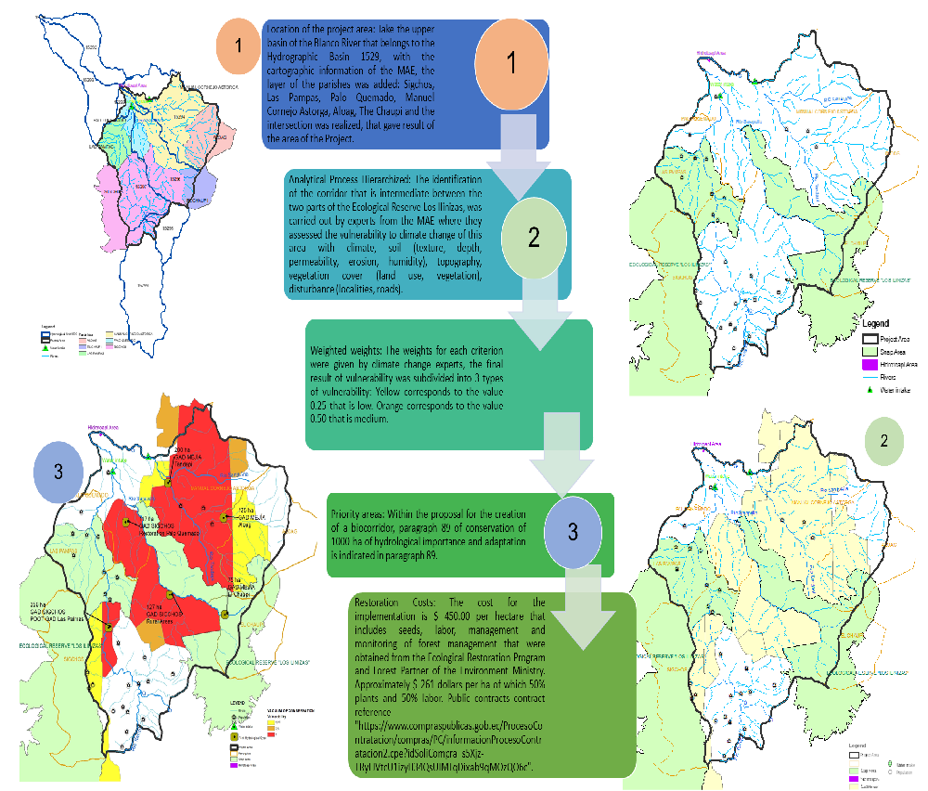
Figure 12: Biocorridor scenarios: localization, vulnerability and ecosystem selection, cost.

- In general, the zones proposed have had an important deforestation process. Thus, in the period 2008 - 2014 the deforestation surface was 5891,33 ha., and the following period 2014 - 2016 the deforestation increased by 2200,14 ha. In total 8091 ha (2008 – 2016) have been affected in the watershed (Figure 13), the project will promote the restoration and recuperation of importance areas thought the component 1.
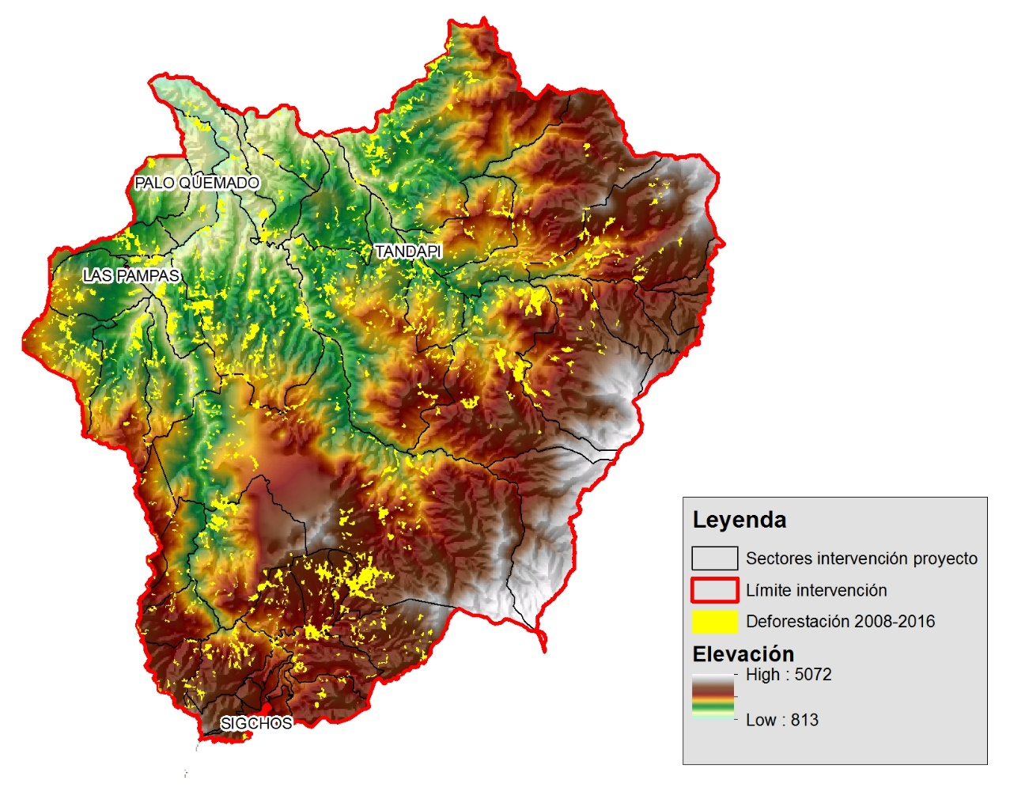 | 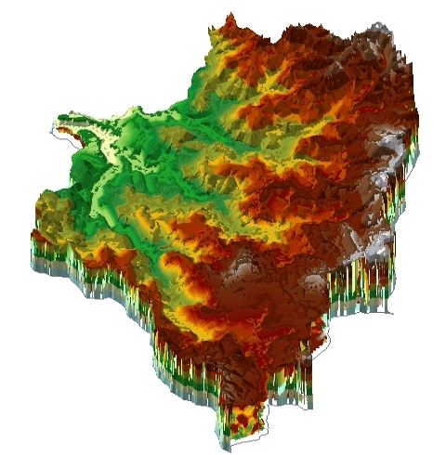  Hydroelectric  Downstream

Figure 13: Accumulated Deforestation 2006 – 2016 and ramp in the Río Blanco upper watershed
- The main way forward the output is the Municipal – Parish PAs, covering 1,000ha, in buffer zones and corridors identified as critical for reducing the impact of climate change on the watershed´s hydrological cycle. The new areas for conservation will be identified in order to develop protector forest management plans and formalize through signed agreements. The plan will include ravine and shore protection activities. The intention besides protecting some areas is to recover some degraded areas where necessary.
- The project team, working closely with MAE representatives at central and local levels, will provide local authorities (GADs) with guidance on the establishment of such reserves, in accordance with the Norm on the Subsystem of Decentralized Autonomous Governments (GADs) – Municipal Protected Areas. This guidance will cover aspects of location and design, in order to maximize the potential of these reserves to contribute to the connectivity and habitat value of the areas located by exploring and highlighting commonalities between local interests and conservation objectives, such as the potential benefits for local water supply and the avoidance of environmental risk that may be generated through the establishment of municipal reserves to protect riparian forests and those around water sources.
- The control capacities in wildlife and forest traffic will be strengthened in the Tandapi point of control and another point of control will be included in accordance with the National Police and Protected Areas MAE. The ratings of management effectiveness tracking tool and PGOA will be increased by applying some planning instruments such are Management Effectiveness Tracking Tools (METT) evaluation and Annual Operational and Management Plan in Protected Areas (PGOA).
- The Management Effectiveness Tracking Tool (METT) has been developed by a cooperative effort of the WorldBank and the World Wildlife Fund (WWF) and is a simple, cost-efficient and flexible tool that can give a quick overview of the effectiveness of protected area management without requiring expensive consultants or taking up too much time for managers, rangers or others responsibles for governance. In Ecuador the application was introduced in 2008. The METT is usually run as a qualitative assessment and relies to a large extent on the judgment and honesty of the assessors, for Ecuadorian reports the areas: Planning, Control, Public Use, Tourism and Biodiversity management are widely used. Nowadays, the METT system is institutionalized and reported - updated every year, being accessible to the public users through the Mae website link System of Biodiversity SIB.
- This component will be complementary to Socio Bosque program which at the moment is focused on conservation, -but it does not intend to finance SB program-. Instead, given the holistic and participatory approach applied in the ACUS and Bio-Corridors, it is expected that it can be useful to demonstrate and exemplify the benefits of applying a sustainable land management approach, so that it can motivate the current beneficiaries of Socio Bosque to gradually adopt or replicate this approach in the near future.
- The use of wood to produce “panela” at the moment represents the main driver of deforestation in the area. In this component, the approach about alternative forest energy to reduce pressures on native forest resulting from sugarcane production will be carried, for this purpose the governance mechanisms were addressed with the aim of reducing local peoples’ motivations to destroy the forest in unsustainable manners. Instead, through the ACUS approach, it will focus on the improvement of sustainable forest use, introduce alternative and innovative technologies, e.g. equipment such as efficient sugar mills and ovens, in order to demonstrate their technical viability, financial sustainability; including supporting the access to markets to commercialize their production and ecofriendly characteristics, set of activities that have interaction with the other components supporting the strategy of improvement: the forest management, the livelihoods and sustainable production activities to climate change effects.
- Farm plans will be developed, promoting always at least 50% of women’s active participation. It is necessary within this component to strengthen local communities’ capacities on planning strategies, conservation practices and climate change, for this purpose a cross-sector program for awareness raising and communication is considered as detailed under component 3.
- This component will work also on strengthening the hydro-meteorological system of the Río Blanco upper basin. At the moment there are 11 hydro-meteorological stations, from which, only 2 are working properly. The intention will be to strengthen and improve the existing equipment determining its priorities and the purchase of four automatic hydro meteorological new equipment, will be considered under technical criteria in coordination with INAMHI and CELEC; the strategic localization will be responding the final design of the integral climate monitoring system. The managing of the hydro-meteorological system and use of the information generated, form part of output 6.
Output 2: Improved management of existing protected forests and private conservation areas (ca. 230,000 ha)
- This output will strengthen the institutional and legal frameworks to manage the Toachi – Pilatón (ca., 212,000 ha) and Sarapullo (ca., 21,000 ha) protected forests, as well as existing private reserves.
Currently these areas do not have management strategies and are under pressure to be converted into extensive farming lands. Due to their particular natural conditions and location, the mentioned forests are vulnerable to adverse climate change effects, resulting in possible desertification and water caudal reduction.
- To protect these areas, the status of the protected forests will be assessed, and safeguarding strategies will be designed with local partners interested in supporting the conservation of the standing forests. It is expected that interested parties contribute to the long-term conservation of these areas. This point will be complemented, where considered appropriate with other existing programs such as Socio Bosque and its different components trying to change the paradigm of conservation though concepts and tools such as inversion watershed fund, replications and finance. Possible partners may include parish governments, municipalities, provincial governments, HIDROTOAPI, water companies, SENAGUA and the Ministry of Environment. As mentioned before, the feasibility of establishing an investment fund was analysed during project preparation.
- From the perspective of ecosystem and communities based adaptation, it is necessary to strengthen the conservation of areas that remain in good condition as an adaptation measure with a lower long-term cost.

The conservation of protected forests and private reserves contribute to maintaining connectivity between local and national conservation areas, both public and private, and all related climate and hydrological regulation services, such as sediment retention, infiltration and interception of horizontal rain, ravine and shore protection, very important in these mountainous areas.
- In this activity, the project will support a paradigm shift in the management of the Protected Areas system from the existing site-focus to one that adopts an integrated landscape-watershed integrate management approaches under the bio-corridor concept, that improves habitat and conservation of natural heritage in benefit of the caudal in the Toachi-Pilaton Hydroelectric project, trying to improve the internally fragmented and disconnected across the broader landscape, with negative implications for water resources.
- This paradigm shift will be expressed in the application of two key concepts in the management of protected áreas the Ecuadorian government is currently promoting:
- The integration of the “advancing landscape approaches” for the conservation of biodiversity in protected areas, promoting the conservation of biodiversity through the generation of normative instruments, capacity building and monitoring, biological monitoring of flora and fauna, creation of conservation areas and generation of sustainable productive activities. The approach was recently introduced with support of the Global Environment Facility (GEF) in the project “Advancing Landscape Approaches in Ecuador's National Protected Area System to Improve Conservation of Globally Endangered Wildlife”. In addition, the Socio Bosque National Program in its new vision for the 2017-2022 period, changes the conventional concept of conservation for the landscape management approaches, focusing on three main drivers such as: a) Conservation b) Governance and c) Community landscape management.
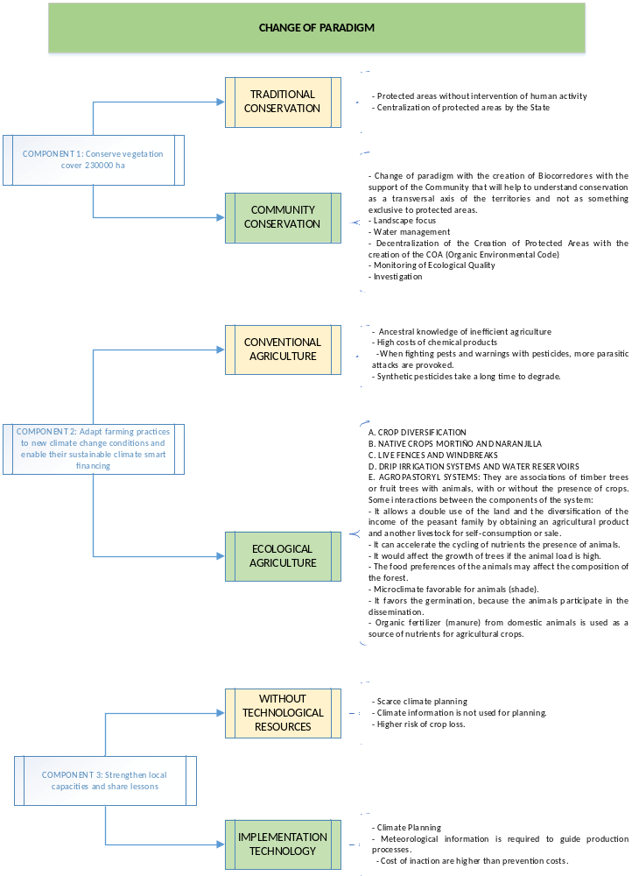
Figure 14. Parading concept, conventional practices and sustainable practices
- The processes of decentralization in the creation of protected areas and their management (ACUS) through local governments, allows to standardize mainstream the criterion of landscape management, the strengthening of local capacities and the deconcentration of competences in the environmental management while ensuring a more efficient way to create the respective protected areas. Especially for the Ecuadorian state entities the concept supports the efficient use of available resources. It changes the centralized approach to protected area management by a territorial approach, a process that is ratified in ministerial agreement No. 083 of August 30, 2016 on "Procedures for declaration and management of protected areas in Ecuador ".
- By transfering more competencies to the local GADs in determining protected areas and ensuring capacity building of respective management, the project is aligned with the general orientation of the government while building its activities upon tested and proven methodologies and activities.

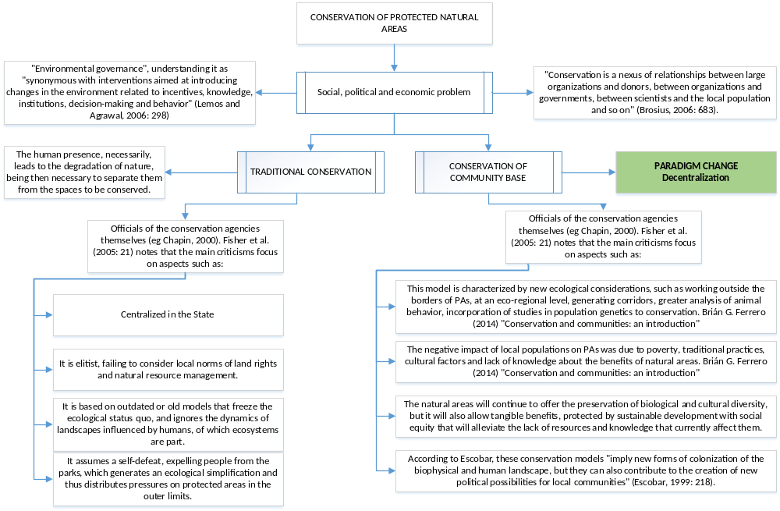
Figure 15. Parading concept, conventional conservation and decentralized conservation

- The component will further strengthen the capacities of PA institutions and local governments to apply an integrated the landscape and watershed management approach for forest conservation into their management procedures and planning processes focusing in the formal conservation categories.
The project will work with the existing programs and categories of the law on bio-corridors and ACUS, with the aim of promoting the channeling of additional resources to private land owners for the creation, restoration and/or protection in areas of importance for biological, productive and water regulation importan.

- According with the Territorial Land Use Plans (PDOT) of the local governments the areas proposed are:

Protected area name | Area in the River Basins (ha) | Areas in the project (ha) | Date of creation (dd-mm-yyyy) | Manage-ment plan date | Main Activities | Indicator
Los Ilinizas Ecological Reserve | 29,672 | 8,901 | 11-12-1996 | 2008 | Implementing Management Plan | METT 70/100
Los Ilinizas Ecological Reserve | 12,234 | 3,670
Bosque protector Sarapullo | 21,585 | 17,268 | 30-07-1986 | N/D | Actualization of Management Plan | METT  70/100
Bosque protector Toachi Pilatón | 212,000 | 169,600 | 14-09-1987 | N/D | Actualization of MP | METT 70/100
GAD Sigchos | 16,307 | 16,307 | Degraded | ND | restoration | # of ha
GAD Mejia | 5,021 | 5,021 | Moderate forest intervention | ND | conservation priority | # of ha
GAD Tandapi | 2,5042 | 9,232 | Conservation priority area | ND | conservation priority | # of ha
Table 12: Protected Areas according local PDOT in the Rio Blanco watershed

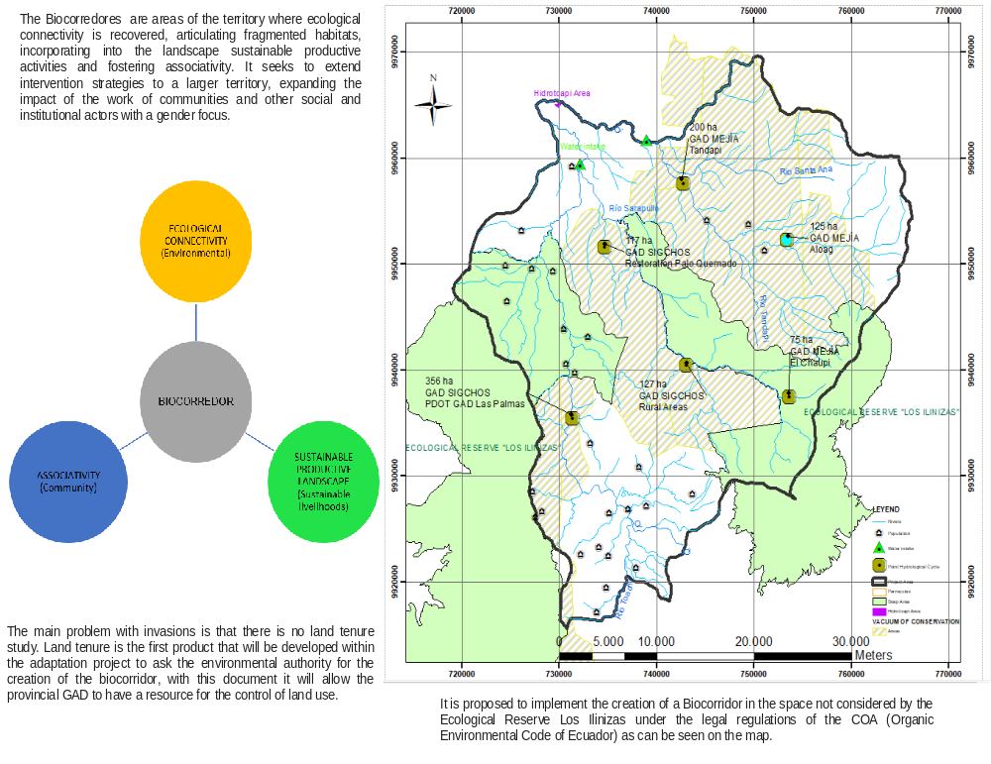
Figure 16. Biocorredor 230.000 ha concept

      - To avoid the driving component of deforestation and invasions, three aspects are managed:

  - Regulations: The Organic Code of the Environment (hereinafter, "COA") is currently the most important norm in the country in environmental matters, enters into force on April 12, 2018 addresses issues such as climate change, protected areas, life wild, heritage, land use, among others. Regarding invasions in protected areas, the regulations stipulate the creation of biocorridors where ecological connectivity, a sustainable productive landscape and the associativity of communities can interact.
  - Internalization of the damage caused by the invasions to the communities of the project area: They will help the care and control of land use.
  - Knowledge generation: Component 3 will strengthen learning.

- The component 1 hence has a direct relationship between conservation and forest management in priority areas, mainly the areas with a high natural forest and low inhabitants index, under an integral concept of Bio-corridor and watershed management located in the upper part of the river basin. The priority areas are shown in the following map:

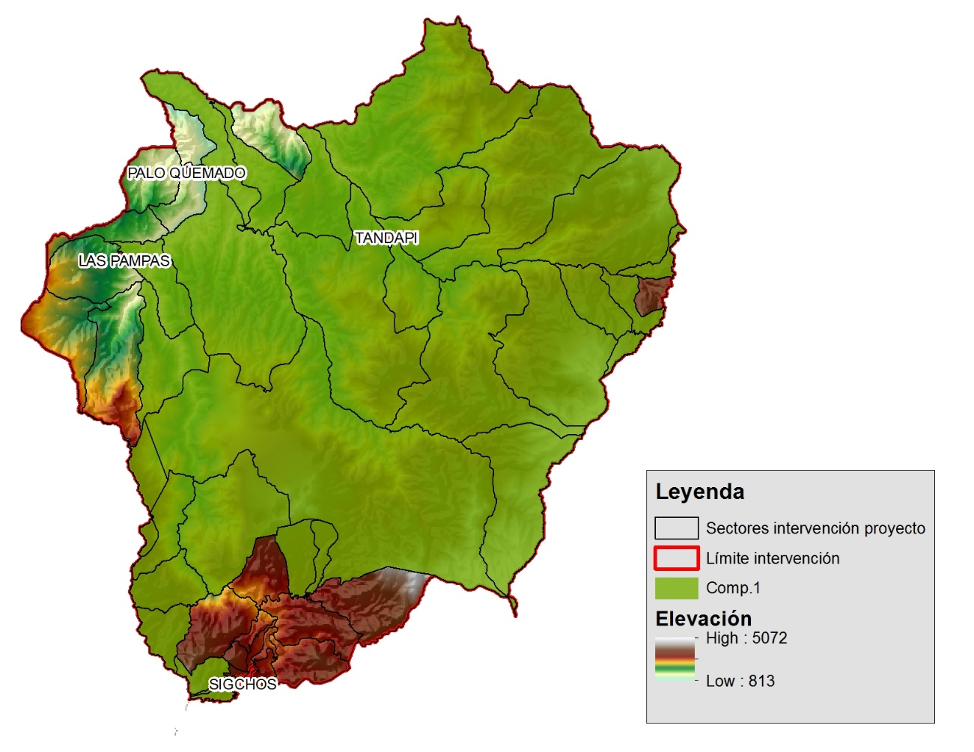 | 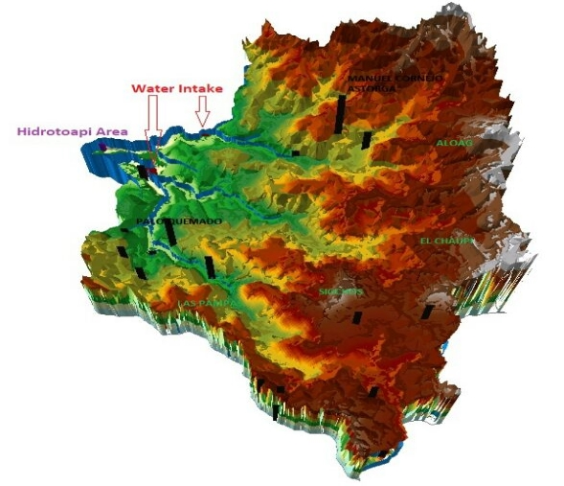  Project intervention Areas

Figure 17: Priorities areas for the component 1, conservation and forest management in the Río Blanco upper watershed.
- The Environmental Protection Unit (UPMA) of the National Police has undertaken a review of the focuses on control and regulation of the forest management and use: the entities of the central government that are involved in the control of illegal hunting and logging are the Ministry of Environment (MAE) through the Forestry Control and Wildlife Unit and the Interior Ministry (National Police) about illegal sales and use of woods in markets are further controlled through the forest control point located in Tandapi in coordination between MAE and UPMA. Despite these investments and efforts, the effectiveness of control and regulation is still severely limited, due to -in part- gaps and contradictions in the legal framework and in part due to limited cooperation between different institutions.
- The installation of new specialized equipment (control point) and the
strengthening of the Tantapi control allow the reduction of illegal wood and wildlife traffic. The project will work to achieve “automatization, control point strengthening and community participation” to conservation and sustainable forest and wildlife management through a combination of awareness-raising and community-level governance.
- These actions will directly reduce pressures on forest from unsustainable and illegal cutting, thereby reducing the need for control and vigilance; they will also lead to increased willingness by community members to collaborate with institutions of central and regional governments mainly CELEC Hidrotoapi, UPMA and MAE provincial directions thereby reducing the need to invest in “vertical” control and vigilance.
- The project will implement a verification system to verify the proper conservation of the designated areas and the river basin management every three months through satellite images of high resolution, which will be useful to monitor and avoid future deforestation.
- Through the preservation mechanisms ACUS, the private and public protected areas will develop and/or to update a management plan which must include a sustainable financial strategy with time horizon of 20 years similar Socio Bosque mechanism and for ACUS. This strategy must be in line to the investment fund (see Annex 12.C) proposed in output 5 of component 2. Part of the financial resources generated by the mechanisms of the fund will be dedicated to support forest conservation in the present outcome. The fund will also support the maintenance and operation of the control and vigilance infrastructure.
- Regarding the number of co-executors, given that this is a component of conservation and forest management, the sectors selected are those with a higher remoteness, low population density and high pressure for deforestation. The reference coverage used in this case was the so-called "Priority Zones” defined by best-known process develop for Socio Bosque and MAE such as: a) threat levels defined through the proximity to access roads; b) historical patterns of deforestation; c) climate threats to the biophysical components of the basin (droughts, floods); d) environmental services: biodiversity refuge, hydrological regulation, carbon storage; and e) poverty level. As result, a total of 33 sectors were selected from a total of 61 existing in the project intervention area (see Table here below). In the selected areas a total of 5,620 inhabitants are living. It is estimated that a total of 840 people will benefit directly from the activities of this component.

Component | Men | Women | Total indirect co-executors | Elderly | Total direct co-executors
Conserve vegetation cover | 2987 | 2633 | 5620 | 515 | 840
Table 13: Potential beneficiaries in the project

Summary Component 1: Objectives and activities
- The following table shows the priority areas for intervention under the component 1, the objectives of the two outcomes as well as activities carried out under each.
Objective | Activity
1. 1,000 ha of native vegetation is conserved by sustainable forest management and conservation mechanisms | In the context of the river basin conservation corridor, at least 1,000 priority conservation acres will be declared as conservation areas and sustainable use ACUS through formal agreements with the local governments (GAD). As part of the bio-corridor they will count on management plans, financial sustainability strategy and a management model to be operative by the end of the project. The core of the component will be the sustainable forest management, shore river protection, water sources conservation, set of activities under the adaptation to climate change and integrated watershed management.
1.1 Functional conservation areas as part of the Toachi Pilaton (Río Blanco upper basin) basin bio-corridor have been established | The sustainable management of created conservation areas will be strengthen, such as the Bombolí, Hesperia, Otonga, Sarapullo, Toachi - Pilaton reserves with a landscape, integrated watershed management and biological connectivity approaches
1.1.1 Technical, biological and zoning file analysis has been carried out | According with ministerial agreement No. 083 of August "Procedures for declaration and management of protected areas in Ecuador ", as first phase the project will develop the Management Plan that includes planning, tenure land and zoning of ACUS-Biocorridors.
1.1.2 ACUS management plan- conservation bio-corridor have been developed | Second phase includes in accordance with the Art.13 (agreement 083 AP), the GADs and project will
 | carry out the administration and management of the protected area in order to ensure its conservation; implement the mechanisms established in the national law; Comply with the Management Plan of the ACUS, especially with the conservation conditions established there; ensure compliance with the land use (zoning) established in the Management Plan of the protected area
1.1.3 Financial and operational sustainability strategy has been developed | As a chapter of Management Plan, the Financial strategy will be develop together with the initial consultancy (PM), the resources in this activities will guarantee the financing and sustainability of the protected area through the respective budget or the resource management mechanisms provided by the respective Government Autonomous Decentralized and the Investment fund from the project with a time horizon 20 years.
1.1.4 Management and operation model has been developed | Through the Unit Project, day-day work will be systematized (UP); compliance of the Management Plan of the protected will be shared with the Environmental Authority National, in the terms to reports the achievements and barriers; in addition, the UP provides information required by the National Environmental Authority on protected areas for monitoring and evaluation; furthermore, implement coordination mechanisms and instruments of management will be develop between MAE, UP and GAD.
Objective | Activity
1.2 Increase in # of Decentralized Autonomous Governments (GAD) with planning, regulatory and normative instruments for ACUS | The Project will promote the creation of new conservation areas and strengthen the local governments’ capacities regarding the implementation of an integrated water and landscape management approach as means to adapt to climate change. Through local ordinances and planning instruments the indexes of Good local governance on conservation and climate change issues will be evaluated.
1.2.1 Key habitats, restrictions and monitoring programs, and agreements for their implementation have been identified by PA authorities and GADs | The technical unit in coordination with the project stakeholders (GAD) will define areas of importance for conservation, using the tools defined by the MAE in participatory process.
1.2.2 Standards and practices for protecting forest and implement integrated watershed management have been included in land-use planning processes | Strengthen local capacities through the generation of tools for the creation of ACUS, climate change adaptation measures and GAD administrative-environment management; the project unit will transfer knowledge to the communities involved in the project. The progress of this component will be evaluated through Good Local Governance Index
1.2.3 Municipal ordinances on conservation, land use practices, and ACUS have been agreed and published | Formalize (ordinances) and communicate the declaration of ACUS protected areas to the corresponding levels of government of the corresponding jurisdiction, for supporting the national order and planning the territory (Bottom-up);
1.3 Increase sustainable livelihoods alternatives that reduce pressure on forests. | The provision of adequate and sustainable livelihoods that count on the support and follow-up of the academy and the project management unit, will diversify the family income and increase resilience to the effects of climate change. These elements improve the Basin management in general and the adaptation to climate change
1.3.1 Incentive systems for set-asides on private and community lands based on ACUS have been strengthened | In this component, the sustainable production actions will be implemented according to the reality of each part of the Basin. For the “Pilaton” area, a change of technology with efficient kilns in the panela production process will be promoted, as well as the reduction in the use of forest in at least 30%. For the lower part, the creation of urban gardens will be promoted, sustainable productive alternatives and actions that include the participation of women and vulnerable groups.
1.3.2 Municipal PAs have been gazetted, covering 1,000ha, in buffer-zones and corridors identified as critical for the hydrological cycle | This activity will allow monitoring of the protected areas (ACUS) and to produce reports to different levels of government. Priority will be given to determine the high importance areas for regulation of the hydrological cycle and sediments reduction.
1.3.3 Promotion of habitat and connectivity-friendly production options has started | This component is aimed at the realization of sustainable livestock production activities, in coordination with the Ministry of Agriculture, with the objective of diversifying the family income and managing the livestock conflict which is the fact that wildlife species appear in the project intervention area. These actions will allow to improve wildlife conservation and to improve the living conditions of the communities, which translates into the implementation of the landscape approach for conservation.
Objective | Activity
1.3.4 Programs for reduction of human/wildlife conflicts in association with the Ministry of Agriculture have been introduced | This activity complements the productive actions that will promote income diversification and conservation of the wild fauna described in the c.1 item.
1.4 Increase in # of families in communities adjoining conservation areas in target ACUS, participating in productive activities demonstrated to reduce pressures on forest with at least 50% of women participate | The effective participation of women in decision making, farm planning and sustainability strategies process within their productive activities will generate autonomous processes of adaptation to climate change. This activity is complemented by component 1 and will be evaluated with the number of farms plans that have at least 50% of participation of women and vulnerable groups.
1.4.1 Planning and zoning of the river basin with a participatory and inclusive approach has been introduced | At both, the farm within the biocorredor level and ACUS of conservation level, it will be carried out planning and zoning, which will allow the access to credits and the strengthening of the local capacities. This activity will be mainly promoted by women.
 | Promote dialogue, coordination and technical support at local level
1.4.2 Inclusion of governance activities with active women participation has started | The governance mechanisms of the productive activities, the declaration of protected areas and the functionality of the investment fund will count on the active participation of women.
1.4.3 Technology transfer agreements for sustainable practices and environmental conservation has been established with national universities. | It requires the support of a specialized legal team in order to formalize the agreements and follow up on them.
1.5 Strengthening of the hydro-meteorological system of the Río Blanco upper basin. | The purchase of climate monitoring equipment will be done in case of determining it is necessary. Given that at the moment, from the 11 existing meteorological stations in the area, only 4 are working, the purpose will be to strengthen and improve the existing ones under the integrated monitoring system, being the core of the purpose to transfer the technology and knowledge to municipal government and the administrative management to CELEC; all these elements with the support of INMAHI
1.5.1 Monitoring and evaluation as well as analysis capacities has been strengthened | This activity intends to improve the knowledge on climate topics, prevention of disasters and the use of information. The support of INAMHI is considered transversal for this component. The ultimate goal is to have an integrated climate monitoring system to be used by the co-beneficiaries; CELEC, local governments and the communities.
2. At least 230,000 ha of native vegetation is conserved to reduce the impact of climate change on the hydrological cycle under integrated watershed management | The component will strengthen the capacities of PA institutions and local governments to integrate the landscape, watershed integrated management approaches for forest conservation. The project will work with the existing Bio-corridor and ACUS modalities, with the aim of promoting the channeling of additional resources to private land owners for the creation, restoration and/or protection of set-asides in areas of importance for connectivity. And water cycle.
Objective | Activity
2.1 Reduction in the use of forest wood for productive activities in the Upper and Middle Basin of the Toachi River (Landscape Las Pampas and Palo Quemado), through promoting technology change and improvement of the production process of the panela production. | During workshops with communities it was identified that the main source of income over 50 years has been the cultivation of sugar cane and its use as “panela”, this has implied the use of the forest, an average of 3 trees per month, which has resulted in deforestation processes.
 | To avoid this problem, it is considered appropriate to change the technology in the productive process with the improvement of ovens and Cooking Systems to reduce at least 30% the use of wood.
 | The farms plans allowed a change of paradigm about the conservation and sustainable forest use. In particular for the productive alternative (panela) the wood required for this process will be obtained from energy forest banks (zoning) created for sustainable use purposes and will be complemented by the program use one tree and plant another with 89 families integrated in the proposed from the Palo Quemado and las Pampas communities and 89 families from Tandapi in sustainable alternative production under a global scheme of Bio corridor
2.1.1 Farm’s zoning and plan elaboration. | This activity has a close relationship with item 1.4, because it requires the improvement of planning at a farm level with the active participation of women. These components and their interaction intend to benefit at least 840 people.
2.1.2 Financial strategy for the implementation of the framework (in coordination with the PA financing project) | Once that the financial strategy and the sustainability mechanisms in component one have been defined, replication tools for other localities, such as publications, will be developed within this activity.
2.1.3 Information management and decision support system based on updated and reliable data and traditional knowledge about the panela process | This component will allow the dissemination of the results and the communication of goals, mainly considering the communication strategy of the project.
2.1.4 Technology change (ovens change to promote efficiency in the production of panela) | This activity complements the investment component of the project, for the sustainable production actions will be implemented according to the reality of each part of the Basin. For the “Pilaton” area, a change of technology with efficient kilns in the panela production process will be promoted, as well as the reduction in the use of forest in at least 30%. For the lower part, the creation of urban gardens will be promoted, sustainable productive alternatives and actions that include the participation of women and vulnerable groups.
2.1.5 Definition of permitted uses and activities in different management categories, in relation to conservation. | This activity allows to hire technical staff that will be in charge of evaluating in the day to day the most suitable actions in the conservation biocorridor.
2.1.6 Strengthen capacities | This activity is related to the financing of the different workshops that will be carried out in the execution of the project which are related to the M&E plan, inception workshop and report.
Objective | Activity
2.1.7 Governance analysis performed to provide recommendations. Governance and dialogue to provide alternatives to existing barriers. | This activity pretends to provide recommendations of improvement in regard to the governance dynamic existing in the area and the possible existing conflicts related to the use of water among the different stakeholders and to promote dialogue and coordination among them. In this activity also the existing governance tools will be updated, taking into account any possible change that the declaratory of protected areas could happen in complement to the M&E plan.
2.1.8 Assessment, monitoring and evaluation of farms to perform and provide technology transfer | This activity is related to the monitoring of the project both internally, as well as by external evaluators according to the M&E plan and the measurement of means of verification of project results.
2.2 Priority conservation areas maintenance through the creation of the Toachi Pilaton Bio-corridor. | The conservation bio-corridor is an instrument approved by the Ecuadorian laws. An update will be performed to the existing lands, its use, planning, and zoning and to the Bio-corridor Management Plan.
 | Equally, a financial sustainability strategy of the conservation area will be developed. It will have resources for strengthening the protected area.
 | As a final product, a management model will be developed to operate within the framework of the basin's conservation bio-corridor and supported by formal agreements with the local governments (GAD).
2.2.1 Monitoring and evaluation arrangements (table 10) | Activities that allow to have a team that is in charge of the review of progress in the framework of the M & E / Mid-term Evaluation / Final Evaluation.
2.2.2 Apply and holistic landscape approach to define new Areas of Conservation and Sustainable Use (ACUS). Expanded PA management plans to include forest conservation, landscape approaches, watershed management and new zoning for dispersal corridors within Pas | This activity is related to the implementation of activities in charge of the project unit, as well as the day-to-day work within the framework of the monitoring arrangements. M & E / Mid-term Evaluation / Final Evaluation
2.2.3 Planning and zoning of the river basin with a participatory and inclusive approach. Promote dialogue, coordination and technical support at local level | This activity complements the Inception Workshop and the M&E Report, and allows the incorporation of the actor’s perspectives in relation to the initiation of the project. It must be done two months after the start of the Project.
Objective | Activity
2.2.4 Management plan of the protector forest, including ravine and shore protection activities. | This activity finances the important monitoring milestones; Mid-term Evaluation / Final Evaluation.
2.2.5 Cross-sector program for awareness raising and communication | This activity will finance several workshops that allow the dissemination of results and to consolidate political and strategic alliances that contribute to the sustainability of the project.
2.3 Increase in the process of planning and zoning of farms in which at least 50% of women participate | The Project will start a territory planning process at a farm level to achieve protection, adaptation to climate change and sustainable use of resources, activities that are strongly linked to women’s participation.
2.3.1 develop farm and management plans including adaptation to climate change criteria | A unit team that will carry out different activities that allow the transfer of knowledge, as well as the development of local capacities.
2.3.2 Train farmers in conservation practices and climate change | Workshops to be held during the implementation of the project.
2.3.3 Training to farmers in planning techniques and considerations | Field visits to strengthen capacities.
2.4 Increases in ratings of Management Effectiveness Tracking Tool and PGOA | The management of Protected Areas will be evaluated through the application of the METT effectiveness management assessments and the application of the Operational Management Plans of Protected Areas of Ecuador PGOA. The revision will be annual. Strengthening and replication mechanisms of the improved and protective cover management will be established in the Toachi River basin.
2.4.1 Improve practices to manage Protected areas and METT evaluation | Strengthening of the monitoring system from the PA planning tools, activities for the annual update of the METT and investments for the improvement of the protected areas management.
2.4.2 Application of PGOA and evaluation | Investments for the improvement of the PAs and ACUS management, financing of different reporting activities of PGOAs
2.5 Increases in control capacities in wildlife and forest traffic | Through the strengthening and functionality of the Tandapi control point and the creation of a mobile control post in “Las Palmas”, the control process of natural resources in the area will be improved. In the same way, this activity will be complemented with training processes for the population. The National Police has an important role in this activity.
2.5.1 Equipment for environmental control mainly forest and wildlife with supporting UPMA | Strengthening of the monitoring system, investments in studies and preliminary agreements
Objective | Activity
2.5.2 Strengthen Tandapi control point | Purchase of equipment for the retention of wood and Wildlife, improvement of existing infrastructure.
2.5.3 Install a control point in las Pampas, equipment in coordination with the Police | Purchase of equipment for the fixed control post in the Pampas, which includes; control camper, registration computers, wood and wildlife retention equipment, office furniture, fuel.
2.5.4 Monitoring system, newsletter and decentralization of information. | Work equipment for capacity building on climate change and risk management, prevention of wood and wildlife traffic.
Table 14: Key activities in the component one

- Theory of change for avoving the deforestation driver component 1: The ACUS conservation mechanism offers an integral approach in terms of combining land preservation activities but also taking into account supporting the livelihoods of local inhabitants. An enhanced land management allows combining preservation measures, farming practices, provision of ecosystem services while at the same time preserving biodiversity and improving the livelihood conditions of farmers located in the forests. As mentioned before, currently the main economic activity of local inhabitants is the production of panela which has caused a high level of deforestation due to the large amount of fuelwood that is used in an unsustainable way.
- For this reason, the project is proposing to strengthen farmer’s capacity in agricultural and productive sustainable practices which will produce better yielding but at the same time preserve their forest. Improving crops and production yielding implies always a risk of expansion to continue growing their incomes. That is why the project at the same time presents a strong capacity building component to train local farmers in parallel about the importance of ecosystems and its preservation and to raise awareness about the risks that implies degradation exacerbated by climate change. It is important to mention that this process will be closely and constantly adviced and guided by project technicians. The constant guidance together with a strong and effective monitoring and evaluation mechanism will minimize the risk of encorachment. A well-designed mechanism with this integral approach that contributes to improve agricultural management practices and at the same time promotes conservation has a great potential of causing multiple benefits.
- In a region where a high percentage of the population lives in poverty, to provide help for conservation is necessary, but what would create a long-term larger impact is to provide them with economic alternatives to improve their socio-economic conditions. Based on the type of activities that communities have been practicing until now, it is clear that their main priorities remain related to improving their socio-economic conditions.

Component 2: Adapt farming practices to new climate change conditions and enable their climate smart financing

- To assure the sustainability of ecosystem conservation it is of major importance that communities are aware of the importance of ecosystems for their livelihood agricultural productive systems and that they develop income generating activities through ecosystem conservation, particularly in face of climate change. Component 2 is intended to provide the basis for this objective.
- This component will generate the conversion to crop management in an environmentally sustainable and climate-smart way for at least 500 ha. Traditional forms of cultivation are rooted in conventional agricultural practices.
Although there are some isolated efforts to apply cultivation methods in a different way, either by applying live fences (such as "quiebrabarriga and yucaraton"), or the implementation of silvopastoral systems, these have not been widespread or considered interesting alternatives for conventional agriculture.
Those who have implemented these practices have done so, motivated by a personal attachment to the conservation of their environment, the ecosystems on which they depend, rather than economic motivations.
Although many farmers in the project's areas of influence consider it appropriate and important to implement measures to adapt to climate change in their crop management activities, their intentions are not put into practice due to the lack of knowledge on their implementation and the fear of assuming a risk that would affect their income and overall spending and payment capacity.
The selection of activities was made under the previously described triangulation scheme (figure 7-A) that results from the interaction between the documentary information, the revision of the normative-economic framework and the validation of the actions with the co-executors in the field workshops.
- The importance of the economic viability of sustainable crop management and the implementation of adequate adaptation measures hence cannot be underestimated. Farmers need to be convinced that the implementation of such measures translates into concrete and tangible benefits, especially economically. If smallholder farmers are not informed and convinced that adaptation to climate change is possible, they are not likely to decide for investments for their adaptation and productivity enhancement. Such limitation in awareness and capacity increases the reluctance of small landholders to embark on the path to increased climate resilience and adaptive capacity.
- Documental Review: For the selection of suitable adaptation measures to be promoted and implemented with target populations, the project will apply the Ministry of Environment’s (MAE) methodology for Cost Benefit Analysis, Cost Effectiveness Analysis and Multi-criteria Analysis for adaptation measures recently developed in cooperation with the German Development Cooperation (GIZ) as well as methodologies developed in the UN Environment’s MEbA project (see Annex 12.A).
Findings will be applied for prioritized adaptation measures suitable for the area and included in the respective awareness raising campaigns and monitoring and evaluation mechanisms for their verification over time. Complement to the documental review in the component, a cost-benefit analysis was carried out (Annex 14).
The importance of the economic viability of sustainable crop management and the implementation of adequate adaptation measures hence cannot be underestimated. Farmers need to be convinced that the implementation of such measures translates into concrete and tangible benefits, especially economically. If smallholder farmers are not informed and convinced that adaptation to climate change is possible, they are not likely to decide for investments for their adaptation and productivity enhancement. Such limitation in awareness and capacity increases the reluctance of small landholders to embark on the path to increased climate resilience and adaptive capacity.
- For example, the implementation of irrigation systems, either by sprinkling or dripping, the construction of water reservoirs or introduction of crop rotation and intercropping systems, are generally not identified by the farmers when discussing possible sustainable and resilient agricultural practices. Though, the increase in productivity of crops and livestock per hectare, are considered essential elements of sustainability by local communities. This fact motivates the merging of local adaptation knowledge and practices according to international best practices and methodologies. The project’s objective is to capitalize on the communities’ experience, combine it with proven solutions and empower vulnerable populations with sound adaptation practices. Instead of focusing on specific adaptation practices, the project will introduce methodologies that enable the different stakeholders to promote adaptation and sustainable agricultural and livestock practices on an ongoing basis: adaptation to climate change will always be a process rather than a punctual activity and hence requires the change in agricultural practices on an ongoing basis.
- Many farmers and ranchers agree that ecosystems in the areas of the Río Blanco upper basin are being permanently threatened by logging, in part by the constant expansion of the agricultural frontier and livestock ranches. They argue to ignore the feasibility alternatives to apply them. If communities, highly dependent on these economic activities, have convincing alternatives to sustainable agriculture and livestock, there will be a gradual migration towards these farming methods.
- At the same time, artisanal forms of panela production, prevalent in the project’s area, that are intensive in the use of wood for the combustion of their boilers, will be included in the effort to obtain means of subsistence that do not degrade the ecosystems of the zone. Promoting a technological leap, integrating boilers that use alternative energy sources (such as bagasse) and increase overall energy efficiency, under the "Best Available Technology" (BAT) approach, will relieve the pressure on surrounding forests, harmonizing with other measures to protect the ecosystems and forests of the project's areas of influence. This industrial upgrade aspect will be considered as an integral part to change the paradigm of current artisanal production, matching and complementing sustainable agriculture and livestock practices. These activities are directly related with forest preservation efforts of component 1 of the present project due to the extensive use of firewood.
Finally, suggestions were validated and collected during the field workshops (July 24 and 25, 2017). In relation to component two, the actors identified the main activities that are summarized in the following diagram:

Figure 18. Main concept identified for the component 2
The adaptation measures correspond to local needs and meet the criteria of applicability, cost benefit and are in accordance with the regulatory framework of Ecuador:
- The establishment of family farms, which helps especially women as head of household to enhance the daily diet of family members and even generate additional family income by selling surplus on local markets.
- Crop diversification, which not only helps to increase biodiversity but also promotes risk mitigation of family income, where applicable relying on native varieties.
- Local native varieties will be promoted such as mortiño (Vaccinium floribundum) and naranjilla (Solanum quitoense).
- Live fences and windbreaks
- Silvopastoril and Agrosilvopastoril systems, among others eligible.
- Drip irrigation systems and water reservoirs

The following is a summary of the activities suggested by the local actors that are adapted to component two of the project:

Figure 19. Main activities identified with the communities for the component 2

- Hence, selection criteria for the identification of suitable adaptation measures for individual farmers need to be flexible and take into account each farmer’s specific situation, such as:
- Access to important infrastructure such as roads
- Inclination of plots or grazing grounds
- Soil texture and quality
- Actual crops cultivated or livestock bred, including varieties and types
- Availability of critical inputs
- Pricing of inputs in each area
- The combination of these critical productivity drivers will not only determine the productivity of farmers under business-as-usual scenarios in face of adverse climate impacts, but also define what actual adaptation measures promise not only the optimum results but also if their implementation is feasible at all. For example, if certain inputs for the implementation of adaptation measures are not available, cannot be transported to the farm due to the lack of access roads or are prohibitively priced, must be analyzed on a case by case basis.
- The project will seek the cooperation with the UN Environment’s Microfinance for Ecosystem-based Adaptation project, which has identified a set of 40 EbA measures specifically suitable for the implementation by smallholder farmers. The MEbA project has so far implemented almost 10,000 EbA measures (for a total financing of over USD 12 million, exclusively provided by the microfinance institutions’ own funds and paid by the farmers) in cooperation with 5 microfinance institutions in Colombia and Peru and is assessing the implementation of its solutions in Ecuador. The MEbA project is funded by the German Federal Ministry of Environment via its International Climate Initiative.
- The MEbA project has developed tools that support the individual assessment and prioritization of EbA measures to be applied with small farmers as part of operational processes of institutions interacting with small farmers as input or service (such as technical assistance or finance) providers.
- The project will hence promote with the communities the application of proven interventions able to:
- Improve agricultural productivity and in consequence socio-economic resilience,
- Conserve ecosystems and hence sustainably support agricultural production systems,
- Increase climate resilience of vulnerable populations and the ecosystems they depend on.
- The approach of adaptation will be introduced with at least 250 local smallholder farmers, to reduce the pressure of farming and livestock activities on native forests and ecosystems.
- Working with farmers´ organizations and other potential multipliers such as input and finance providers, best practices will be introduced to increase production using a reduced area of agricultural land. The main lines of work will be (i) cattle and pasture management, and (ii) sugarcane production. Nonetheless, other crops will also be addressed (e.g., mortiño, naranjilla,), also against the background of crop diversification as an ecosystem-based adaptation to climate change via the diversification of agricultural activities to mitigate resulting productive and economic risks. Agricultural intensification, i.e. the technologies to produce more (and of better quality) on less land, is of fundamental importance to stop deforestation and resources over-exploitation.
- The Project will build upon existing infrastructure and processes of partner institutions to generate sustainable mechanisms targeting investments into adaptation measures. Local input providers and financial institutions will be engaged to improve their respective knowledge and awareness to engage them to participate in the activities of the project in a more proactive way. Capacity building will be implemented and reinforce such stakeholders’ understanding of the risks and opportunities to include adaptation solutions in their operations.
- In addition, an investment fund will be built to support the respective finance of adaptation investments. This financial instrument offers a mean to involve different actors on a long-term basis.
Outcome 2: Sustainable farming practices adjusted to local realities are being introduced and implemented with technical assistance of innovative financing mechanisms for adaptation measures.
- The geographical scope of the project is broad, the participation of different cantons and parishes is confirmed.
The project area of operation comprises high Andean parts with paramo ecosystems and Andean cloud forests, down to zones with sub-tropical climate. In the same way, the topography in which the activities of agriculture and livestock are being executed is varied, comprising farms located in sites with pronounced slopes as well as farms in places with reduced slope and close to the rivers.
- Consequently, it is not possible to define an established set of sustainable agriculture and livestock adaptation measures ex-ante. Instead, adaptation and ecosystem conservation strategies will be defined and designed during early stages of the project, considering the particularities of the different types of crops managed in the area (sugar cane, naranjilla, mortiño, among others), topographic and (micro)climate conditions, local climate change perceptions of vulnerable populations, agricultural practices implemented as well as existing experiences in the different parishes. Furthermore, the cultivation of native species (e.g. mortiño, naranjilla) in a sustainable way will fit within the biotrade (Biocomercio) initiatives that have been developed in the country and are of interest to the Ministry of Environment under the bio-economics approach.
Definition of adequate adaptation measures
- To facilitate acceptance of proposed adaptation strategies, it is suggested to identify existing experiences with adaptation practices in the Río Blanco upper watershed and surrounding areas. Initiatives focusing on climate resilience of small landholders will be identified and evaluated, targeting the identification of already adopted adaptation strategies in local areas. Based on a set methodology, these strategies will be standardized and adjustment criteria (e.g. for different crops or climate regions) be identified. Lessons learned from other initiatives will be documented, systemized and integrated into the strategy formulation for their replication in the project. The objective is to increase acceptance in production changes by the farmers and their communities.
- Insights drawn from such an exercise will help to develop quick wins for participating key stakeholder, i.e. defining products which can be quickly introduced by replicating existing strategies already adopted.
Furthermore, the selection methodology as presented in Annex 12 from the UN Environment’s MEbA project will be applied for the customized prioritization of suitable EbA measures at an individual farmer’s level with complement tools such cost benefits analysis and multicriteria matrix (Annex 14).
- Powerful means to further support the introduction of adaptation measures will be the promotion of trial or partial introduction, where possible with leading producer within the community. Trial or partial introduction of innovative adaptation solutions allows the farmers to limit their investment on one hand, while enabling them to observe concrete benefits with their own eyes in the other hand. In such a set-up, only a minor part of a farmer’s plot is managed using the new practice, while the remainder is managed in a traditional way. During harvest, and of course over the development of the crop, the performance is being monitored and documented, especially with respect to yield levels. Such implementation approaches have been shown to increase acceptance especially in remote communities.
Financing of adequate adaptation measures
- A major limitation for successful adaptation is the availability of financial resources for adaptation investments. Traditional financial service providers limit their exposure to the most vulnerable populations and focus on traditional agricultural practices for those farmers eligible for financing. Furthermore, in many cases no reliable agricultural service providers provide the required inputs (agricultural inputs as well as capacity building) and consequently do not limit the technological risks of innovative adaptation methodologies. Hence many of the smallholder farmers in the project area are trapped in a poverty cycle they are unable to solve by own means. Hence, the project will also be working with the service ecosystem focusing on smallholder farmers and apply a twofold strategy to support investments into adaptation as described below.
- Where appropriate, technical assistance will be accompanied by temporary economic assistance and capacity building to convert financially excluded target populations into credit worthy clients. Being more resilient, having implemented adaptation measures, will enable these populations to receive credits and in consequence enable them to finance more important investments, with higher opportunities for increased economic return and climate resilience.
- Communities in the target area have a certain access to credit. Nevertheless, credits do not target investments in adaptation practices, but credit is provided to traditional practices, which regularly contribute to ecosystems degradation and climate vulnerability.
- The volume of credits, the number of beneficiaries, and the degree of financial inclusion, vary among the geographical areas targeted by the project. For example, in Las Pampas, in December 2014, USD 3,239,340 were granted in 534 lending operations, resulting in an average loan of USD 6,000. In Mejía, in 2013, USD 30,470,353 were invested in microcredit, delivered mainly by banks (61.09%) followed by cooperatives (38.91%). In Palo Quemado, 44% of the population has access to credit.
- The intervention of the project will hence take into account the level and scope of financial inclusion among the various communities, with the aim to propose adapted solutions for each of them. While access to finance is a reality, however, expanding the credit supply is one of the elements of development that forms part of the planning of GAD's.
The project hence will promote to channel the existing credit supply towards adaptation investments assuring economic return for farmers, conservation for ecosystems, reduction of climate vulnerability for the communities, and financial return for financial institutions.
This strategy will therefore support a triple bottom line of economic, social, and environmental return for all involved stakeholders.
- To realize such achievement the project will take into consideration the lessons learnt in two of the most innovative projects in the area of smallholder adaptation finance, that have been operated in LAC: the MEbA (see reference 1 of annex 12) and CAMBio (see reference 2 of annex 12) projects.
- Strategies are proposed to allow a holistic approach to promote investments oriented to adaptation to climate change by providing technical and economic assistance (where needed) and financial resources directly to the farmers (via credits) on the one hand, and on the other, by creating the conditions for the development of financial mechanisms that work in the project area in the long term.
- Financial institutions assisting farmers and ranchers in the area, do not yet have lending tools to facilitate, nor promote, a transition to sustainable agriculture and livestock management models.
- Capacity building through the intensive training of its commercial staff at the operational and management levels, as well as the appropriate tools to facilitate the assimilation of new concepts into their credit risk assessment, are crucial to generate the interest and expectations alienated from adaptation to climate change within the financial institutions.

Output 3. 250 ha of pasture and 250 ha of crops apply sustainable farming practices

- As previously explained, communities living in geographical zones targeted by the project, are threatened by a multitude of challenges, including poverty traps, low agricultural productivity, lack of access to water, adverse climate impacts, and environmental degradation.
To foster community adaptation capacities, it is of main importance to define, develop and implement agricultural practices that can at once generate higher income, reduce climate vulnerability and conserve ecosystems.
- Introducing best adaptation practices in agriculture and livestock management, will be one step forward from the conventional farming towards resilient and sustainable agriculture.
The approach of (ecosystem-based) adaptation will be introduced on at least 250 local smallholder farms, to reduce the impacts of farming and livestock raising on native forests, ecosystems and land degradation. Working with farmers´ organizations and other potential multipliers such as input providers or financial service providers, best practices will be introduced to increase production using a smaller area of agricultural land.
- As examples the following practices have been identified based on the initial analysis executed, further suitable adaptations strategies will be identified according to local realities, following the methodology presented in Annex 12.A:
- The establishment of family gardens, which helps especially women as head of household to enhance the daily diet of family members and even generate additional family income by selling surplus on local markets.
- Crop diversification, which not only helps to increase biodiversity but also promotes risk mitigation of family income, where applicable relying on native varieties.
- Local native varieties will be promoted such as mortiño (Vaccinium floribundum) and naranjilla (Solanum quitoense).
- Live fences and windbreaks
- Silvopastoril and Agrosilvopastoril systems, among others eligible.
- Drip irrigation systems and water reservoirs
- The application of sustainability measures in agriculture and livestock is not new in the country, there are projects in which comprehensive management of farms, as a way to improve the productivity of farmers while reducing the impacts on the ecosystem.
- In Annex 12 are some measures that can be considered part of the repertoire of actions to be implemented within a comprehensive farm managed in a sustainable way.
These EbA practices were drawn from the catalogue for EbA practices developed in the project (“MEbA Options, costs and benefits”, UN Environment, 2013), and will be combined with ongoing initiatives in Ecuador such as the Ministry of Agriculture’s Planification of Integrated Farm Management in the framework of the program Productive Transformation Agenda of the Amazonas.

Implementation strategy
- The activities, as presented in Annex 12 only provide a framework and not a final solution. In particular, the possibility to include existing local agriculture practices into Ecosystem based Adaptation practices, will be assessed in detail during the first phase of the project. These will promote local practices that have already proven more resilient, and support the introduction of Community based Adaptation strategy into the overall strategy of the project.
- As previously mentioned, a two step strategy will be implemented to introduce adaptation measures with local communities. The underlying principal is to focus on gradually upgrading vulnerable populations that are currently not having access to market-based solutions for inputs, capacity building or finance via direct and subsidized support. Once these farmers have reached a certain development level, they will become eligible clients for service providers and hence will receive
- Under the first approach, the construction of sustainable management solutions in farming will focus on but not be limited to the most vulnerable populations, with specific target on women individually, or women associations where applicable. Specific vulnerability criteria for their proper selection will be defined in the early phase of the project.
Such vulnerable population will be supported only for adaptation investments that can be reached with low investment and limited capacity building effort, but allowing for interesting economic return. The project will identify suitable adaptation measures to that end following the details presented in Annex 12.
- Moreover, the economic and technical assistance provided to build the farms in a sustainable way, at this segment, will go together with a plan to strengthen their financial literacy. So that, once the farm is reaching a state of greater resilience and hence becoming credit eligible, the respective farmers are empowered to take sound financial and investment decisions, expenses and revenues and net profits. The intention is to prepare them for managing some basic points to take care in order to get a suitable and timely loan. For vulnerable groups this step by step proposal will be the best chance to gradually become creditworthy and go on with their business in an individual way.
- The second approach is addressed to those farmers who already have access to micro loans. For these farmers, the project will facilitate the link with financial institution that have been previously trained to disburse credit for adaptation. Such credit worthy population will take advantage of the possibility to establish more profitable EbA investments but that at the same time required more upfront capital, in this case provided by a tailored microcredit, and longer return time. Moreover, credit worthy farmers will also have the advantage to have access to more extensive training on EbA, and the training on more involved adaptive practices, tailored to their ability.
- In the case of vulnerable groups economic resources for implementation will not have any cost and will be transferred to the suppliers in benefits of the farmers and livestock ranchers immersed in this activity. In addition, a performance bonus will be granted to those participants who, within a period of 6 months, maintain the crops according to the established sustainability model previously defined. This performance bonus will be delivered on two occasions, six months after implementation and at 12 months. Other disbursement time can be defined after a first assessment at the beginning of the project.
- Regarding the selection of suppliers, the availability of their services to the target populations must be assesssed as a lack of access to such inputs could increase farms’ vulnerability if the provision of new inputs to maintain the sustainable farms, are not available.
- Regarding the intervention of Financial Institutions in Ecuador trough micro lending approach this include all credit operations addressed to small business coming from different sector: service, production, commercial and agriculture, whose maximum consolidates debts is not larger than USD 50,000 and annually sells not over USD 100.000. Personal guaranties are the most common collateral.
- For a better understanding of the current situation, a short survey with the participants of the socialization workshops was done, where 46% of the attendees have credit with a broad range of amounts going from USD 1,500 the minimum to USD 15,000 the maximum. Which means that the different financial institutions (mentioned more forward) are reaching these zones and disbursing credits. For now and with high confidence, these loans are addressed to reinforce farming activities in an unsustainable way.
- The monitoring and supervision of the fulfillment of investment plan, is a crucial stage in both cases to ensure the implementation of measures and avoid diversion of funds resources, for that reason the money will go directly to the suppliers of the technology applied, using traditional means such as: transferences or certified checks. For this end, suppliers will be selected regarding the experience, reputation, prices and diversified stock of the inputs required for implementation.
- In the areas for intervention the associations to be include in the project will be selected including criteria of gender equity and vulnerable groups mainly and under of the responsibility of autonomous governments representatives. Land tenure and child labour avoidance are social aspects to be included in the selection criteria.
- Assuming common agricultural areas of 2 hectares per crop, and an investment in adaptation practices of around 50% of the plot, the project will reach till 250 have farmers to reach 250 ha, while for livestock an average of 20 hectares is estimated, considering that only small part of the plot will be invested at first for EbA activities, this allows the inclusion of 125 farmers for this activity, considering that only 10% of the farm will be invested in EbA practices. 50% of women both agriculture and livestock farmers chosen for this stage. The openness to show the results and the close disperction of the farms are aspects to be deeply valued before the farms´s selection.
- Finally, is worth to take into consideration that the given figure of 2 hectares does not mean that farms which have more extension will be automatically rejected. A case by case analysis will be applied.
- The direct beneficiaries of the intervention are estimated to be between 250 and 375 according to acceptance rate and plot size. Including the rural fertility rate of 2.7 per women that means 4.7 members per family, it is estimated that the project will reach between 1,175 and 1,763 indirect beneficiaries.
- Due to the development of a two-step strategy presented above, that consist in distinguishing between the most vulnerable people and the ones that are credit worthy, it is of major importance to establish clear criteria for this.
- To avoid this the community will be mobilize to commonly define the criteria. Moreover, as presented above, both group will have different benefits not provided to the other group and tailored to its own capacity.
- This strategy aim at once to include the most vulnerable of the community, and on the other side support less vulnerable farmers with adapted interventions allowing them to capitalize on their experience. This strategy will assure social inclusion and financial sustainability at long term.
- Figure 20 provides a schematic presentation of the intended implementation approach:
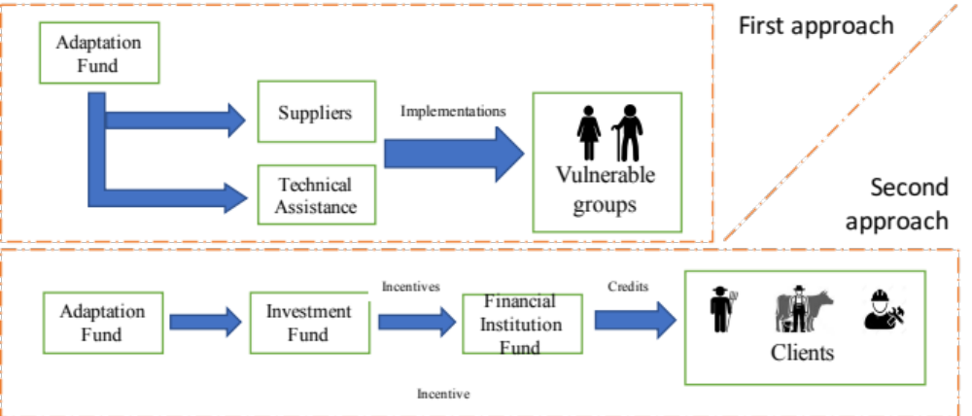
Figure 20: implementation approach

- Details on activities to be carried out with financial institutions to support the second approach presented above, will be detailed in the next section.

Output 4. At least 2 institutions have introduced specific solutions and risk assessment methodology to support the disbursement of credits for adaptation, integrate sustainable and climate smart criteria in their whole operations.
- The participation of the financial institutions, which have infrastructure and client portfolio in the areas of project design, can become catalysts of adequate financial resources to promote a gradual migration towards sustainable agriculture models.
- However, the creation of appropriate financial mechanisms and products, which are attractive to both farmers (and final customers) and to the business model of the financial institution, requires prior and detailed work. Financial solutions appropriate to the credit methodology of each institution, appropriate for the segment of clients they attend and harmonic with the institutional objectives are important aspects to consider.
- The introduction of such lending products, drawing from lessons learned in projects such as CAMBio or MEbA, regularly requires broad internal awareness raising and training campaigns and a strong support in strengthening lending processes. Nevertheless, it holds the promise to find strong partners that are serving the last mile in rural areas, and channel critical financial resources targeting adaptation directly to end beneficiaries. Furthermore, these institutions usually collect data on the socio-economic and productive reality from these clients and can hence be key partners in increasing the understanding of the most vulnerable populations.
- This project will support financial institution thanks to training provision and tools development. In particular the project aim to train financial institutions active in the region to understand, recognize, manage and offset when possible the climate and environmental risks of their portfolio. Specific climate smart lending methodology will be developed that will allow to include climate and environmental risk in credit assessment and disbursement. Risk management tool at client and portfolio level will be developed. Such innovative solutions will allow the financial institutions to increase their institutional knowledge of potential clients, and develop the correct price-risk policy for the EbA activities promoted by the project.
- The development of investment catalogues that include EbA measures through information collection in the areas that would participate in the project would be an additional incentive for the financial institutions especially if they are not in charge for it. Intervention will include the detail of measures to be financed, the incorporation of software that facilitates the process of evaluation, qualification and monitoring, the construction of the reporting processes, the training of its commercial staff, and its clients, are the potential benefits for institutions that are encouraged to participate in the project.
- The acquisition of long-term investments and a suitable interest rate for the financial institutions may also be considered as the incentive to request, in return, the placement in adaptation credits to the agricultural sector identified in the previously mentioned catalogs. The delivery of these resources will be through the Investment Fund for the Sustainable Development of the Río Blanco upper basin. This fund, once its equity has reached a suitable amount, will have the administrative and economic capacity to address these resources efficiently and well defined. So, this approach is linked with the output 5.
- The strategy to encourage investments to consolidate more sustainable agriculture and livestock and to boost technological leaps that reduce the pressure on forests (panela producers) will go in two directions: one oriented towards the financial institutions to promote the disbursements of credits, and the other one, towards the client that the investment is concrete. For the latter case mechanisms will be structured to provide economic incentives through concessional credits including differential characteristics in the term and guarantees. As know-how on the concrete EbA actions increases via innovative and data-based information management, and productivity enhancement become more obvious, the project will gradually reduce the provision of economic incentives. In future financing, after the project’s end, economic incentives will be provided to the clients in the following way:
1. Farmers can invest into EbA via specific credit lines
2. By investing into productivity enhancing EbA options and obtaining better economics, accompanied with a proper communication strategy (see output 8), sceptical actors will be guided to understand the investment logic via adjusted financing.
3. Financing institutions will be incentivized and enabled to introduce risk-adjusted pricing, which will favour better adapted smallholder farmers further decreasing interest rates and hence providing economic incentives.
4. Financial institutions expand their range of financial products for adaptation and mitigation of climate change.
- The application of benefits in the granting of credits, must be clearly explained to the clients. Its application would be temporary and unique since, once the farmers have reached a good level of knowledge of crop management with EbA measures and their yields are sufficient to maintain the continuity of agricultural production itself, access to credit would be in a conventional way onwards.
- From the financial institution point of view the positive aspects to implement specific credit liens for adaptation will be:
- The verification and documentation of the use of funds is vital to generate trust of interested investors as well as satisfy their “Know Your Client (KYC)” requirements. There exists an increasing appetite in international financial markets for triple-bottom line investments, i.e. providing financial, social and environmental returns that can be strongly addressed via the financing of adaptation activities, if these are documented.
- Reducing overall operational costs and risk, and improving beneficiaries’ knowledge will result in an overall gain for the participating institutions and communities. The project will identify and engage a software solution provider capable of providing solutions that are especially designed to reduce cost and capitalize institutional understanding and strategies on monitoring.
- To assure the financial sustainability of the project financial institutions will be included and incentivized to provide financial support to smallholders.
- During the project two financial institutions will be involved: one public and the other private. The present project does not aim per se to provide the credit lines to the financial institutions, while it will work with the financial institutions to channel part of their existing funds, or to have access to international funds such as GCF, towards smallholders. The incentive of the present project would be:
- Provision of climate risk management methodologies and tools to the financial institutions able to reduce their risk in agriculture lending and reduce their operational cost to assess and monitor agriculture credits
- Provision of tailored technical assistance to financial institutions aiming to train them on environmental and climate risk, and the implementation of dedicated credits for smallholders, based on best and proved international standards for green lending.
- Currently, there are few financial institutions that include aspects of sustainability in their operations. 10 private banks in Ecuador adhered to the Sustainable Finance Protocol promoted by the Association of Banks (ASOBANCA), in the area of cooperatives, there is still no such initiative.
- The proposal at the national level for the management of financial sustainability approach rests on three specific aspects:
- Internal environmental management: measurement of the consumption of resources inside the financial institutions to elaborate baseline, establish actions of mitigation and compensation. It involves the training of all the staff of the institution and the creation of internal mechanisms to identify the main direct and indirect environmental impacts and the way in which they must be managed. The launching of internal committees and environmental management policies are part of this process.
- Environmental and Social Risks Assessment (ESRA): It consists of the implementation of mechanisms to identify environmental risk in the economic activities that are financed. Manage them by requesting additional requirements or even rejecting the loan if proper corrective measures are not taken to mitigate the environmental impact. This mechanism and its evaluation processes will be harmonized, as far as possible, with financial institution's credit methodology, and will be incorporated into screening process and decision-making activities (credit committee).
- Green lending: this is a new element in the financial mechanisms of the country, very few financial institutions have specific tools to address issues of environmental protection, energy efficiency and renewable energy. The main obstacle is the lack of awareness of the opportunities of this market.
- In addition, another effort in the same direction has been developed in the country, the Environmental and Social Management Programme for Financial Institutions (“Programa de Gestión Ambiental y Social para Instituciones Financieras” - PGASIF).
An initiative headed by the CAF since 2012 and mainly oriented to share lessons and provide technical assistance to improve the environmental aspects inside the whole financial operations. Important steps have been taken in Ecuador with the PGASIF support, such as the Financial Sustainability Protocol, an initiative promoted and implemented by CAF together with with the National Banking Association ASOBANCA. So far, 10 leading banks have ratified the protocol.
- To assure the environmental impact of the project, smart incentives will be implemented. A possible scheme will be: the farmers are required to invest in their farms through a credit, after a defined period of time the sustainable agriculture investments will be verified by an external party. If it is confirmed that investment have been realized appropriately and that the agricultural practices are being implemented properly as well as in line with environmental sustainability criteria, a percentage of the investment will be returned to the farmers as ecosystem incentive. This allows to align incentives between farmers and financial institutions and to provide a financial subsidy of the credit only for successful implementation of the adaptive practice.
- Proyecto CAMBio, as presented in the Reference 2 in Annex 12, has first developed such incentives in the region and it will be used as framework to establish consistent and adapted ecosystem incentives for the present project.
The financial institutions’ environment
- In Ecuador 696 cooperatives are active and 26 commercial banks. With about 22% market coverage Ecuador is far above international benchmarks in financing smallholder farmers. The cooperatives are divided into segments, and distributed accordingly, as follows:
Segment | Total assets (USD) | #
1 | Greater than 80,000,000 | 26
2 | From 20,000,000 to 80,000,000 | 33
3 | From 5,000,000 to 20,000,000 | 84
4 | From 1,000,000 to 5,000,000 | 183
5 | Up to 1,000,000 | 370
5 | Savings bank and associations, communal banks | unknown
- The project has identified the following institutions as being active in or around the Río Blanco upper watershed. Potential partners in that activity already identified therefore could be:
- Cooperativa CACPECO: Segment 1 cooperative
- Cooperativa Manantial de Oro: Segment 3 cooperative
- Cooperativa Maquita Cushunchig Ltda.: Segment 2 cooperative
- Cooperativa San Miguel de Sigchos: Segment 4 cooperative
- Cooperativa Unidad y Progreso: Segment 3 cooperative
- BanEcuador: state-owned rural development bank
- Banco Pichincha: market-leading commercial bank with a microfinance subsidiary (“Credife”)
- In Manuel Cornejo Astorga there also are present:
- Banco Solidario, specialised in microlending
- Cooprogreso, segment 1 cooperative
- Further institutions identified are:
- Las Pampas livestock ranchers´ association to introduce improved livestock and pasture management practices in 250 ha.
- Flor de Caña Association (sugarcane producers) to introduce improved practices for sugarcane production in 250 ha and to explore forms to improve panela production units to reduce the use of firewood.
- The association of producers from Quinticusig who grow and process mortiño (Vaccinium meridionale Swartz).
- The Women association Marianita de Jesús en Las Pampas composed by 18 women
- The project will foster data-smart process management (provision and financing) to create a multi-stakeholder support ecosystem that will be attractive to financing from market players. Details on respective activities are being presented below.
- Direct beneficiaries of the respective activities will be two financial institutions with established presence of operations in the area.
Mechanism for lending approach:
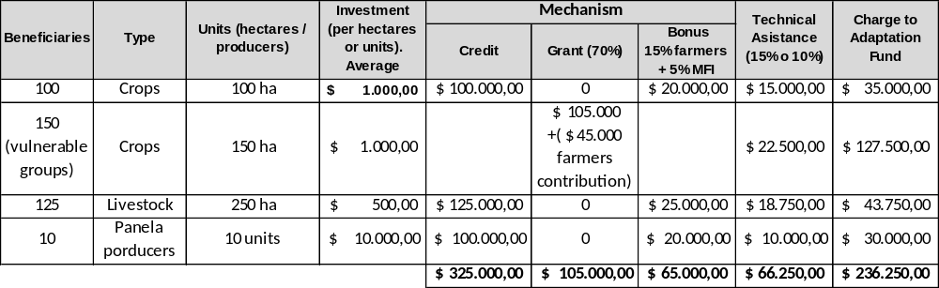
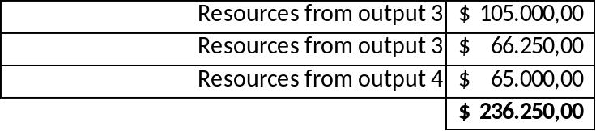
- In order to achieve the goal of 500 hectares managed sustainably for agriculture and livestock and including the production of panela, we have the expected number of hectares (in the case of agriculture / livestock) and units (in the case of manufacturers). The average investment for sustainability measures per hectare is estimated at around USD 1,000 per crop, USD 500 for livestock ranches. It is assumed, that only 10% of the cattle ranch area will be dedicated to new measures; and that USD 10,000 of average amount of investment for the artisanal manufacture of panela will be necessary. For farmers with access to credit, a 20% incentive is proposed, 15% over the capital borrowed and 5% for the capital lent by financial institution. For the case of sustainable crops of vulnerable groups (including entrepreneurs of this group) the grant mechanism is used in a much focused way, the investment in sustainable measures will be addressed 70% assumed by the grant as incentive and the remaining 30% as beneficiary contribution (workforce).
- In the case of livestock and the manufacture of panela is contemplated granting donations because the nature of their business shows that the entrepreneurship itself would be costly without applying even sustainable measures. On average, the cattle ranch requires 20 hectares, which leaves little room for entrepreneurs. Therefore in this case we will apply a similar 15% performance bonus (105 livestock rancher and 5%MFI) on the principal of the credit as a unique mean of incentive.
- The case of the panela producers is similar, usually these businesses are already constituted and with a certain trajectory. For them, investments of USD 10,000 are estimated, to invest in the most efficient furnaces (which use another source of fuel like bagasse) and if the investment plan is fulfill a 20% bonus is applied with similar structure mentioned above.
- In all cases technical assistance amount is estimated and added to the resources needed, however, this aspect is part of output 3 budget together with amount for grants. The resources of credit implementation under the figure of bonus is part of the budget of output 5 realized by the establishment of an investment fund.
- The figures estimated are conservative and leave a room for the inclusion of more participants, as the intention is at least to reach 500 hectares with sustainable management but if possible even more areas could be introduced.
- The methodology to manage climate lending risk and to develop financial instruments like green lending expected to be introduced in the two financial institutions is not intended only to be used in the scope of the current adaptation project, but in all operations at national level.
- Two institutions will be supported via specific consultancy as well as training measures. Where possible, the project will seek the coordination and the cooperation with the UN Environment project microfinance for Ecosystem-based Adaptation to climate change (MEbA) and participate in workshops and knowledge sharing lessons organized by CAF’s PPGASIF project and other similar initiatives.

Implementation with financial institutions
- The component will be outsourced to a specialized consulting company for microfinance or south –south cooperation, where possible in coordination with the UN Environment’s MEbA project. UN Environment’s office in Panama is currently assessing to replicate the MEbA project in Ecuador, where several institutions have expressed their interest to gain access to the project’s developed solutions (see Annex 12.C for more details on these solutions).
- The following details as well as implementation plan for these activities over time is presented below. The implementation of climate-smart lending and EbA financing product development will be organzied in different phases with their own activities which are laid out below and summarized with different activities in the work plan.
- Phase 1 - Initial screening
The initial screening serves as starting point and targets the review of a partner institution’s existing data available, experience in green inclusive finance as well as existing lending products and processes.
Based on these findings, a project framework or strategy is defined and a detailed work plan elaborated.
- Phase 2 - Framework definition
During phase 2 the general framework is developed, with a specific focus on the identification and engagement of strategic partners such as training or input providers, if applicable. Term sheets to guide a future cooperation agreements are elaborated together with the partner institutions and then discussed and negotiated with identified prospect strategic partners.
Once the partnership set-up is agreed upon with one or several partners, respective cooperation agreements are drafted and finally signed.
- Phase 3a - Implementation awareness and capacity
During this phase, suitable EbA options are being identified according to available information and experience in the local markets and based on the EbA options and methodologies presented in Annex 12, among others. The selection of suitable EbA options follows the Cost-Benefit Analysis in detail and prioritization methodology presented in that same Annex 14. Other criteria to be considered are previous experiences with EbA activities in the area of the proposed project, the Rio Blanco upper watershed.
Based on the defined options, training materials are being developed as well as internal employees and external agents trained in the overall set-up as well as the promotion and capacity building offers of specific EbA options.
- Phase 3b - Implementation lending support
Lending support will be promoted via specific lending software. The supporting, cooperation or consulting firm to be selected will ensure the versatility of such lending software to incorporate future developments in best practices in lending and EbA. The software solution will work on mobile devices in order to allow for on-site data gathering in a structured way.
Resulting crowd-sourced insights, i.e. insights gained by a multitude of co-executors (farmers) based on data gathered via different channels, will feed into the
- Phase 3c - Implementation financial products
Once the initial EbA options to be promoted are defined, the product design is to be developed. It is assumed that MEbA products (i.e. the financial product financing EbA options) will follow the same rules than “traditional” generic agricultural lending products, focusing on either input finance or asset investments.
Hence most focus around the product design will be on the development of marketing materials and adjusted manuals and procedures.
- Phase 4 - Pilot review and adjustments
Based on a predefined pilot protocol, including key performance indicators to monitor targeted outcomes such as handling and processing times as well as data quality, the pilot is started in dedicated pilot branches. Pilot assessments will be monitored and observation documented to enable ex-post assessment and adjustments if needed.
- Phase 5 - Roll-out
Once the pilot has been concluded necessary adjustments are worked into the standard documentation as well as the lending support software are being worked in.
- Phase 6 - Final evaluation and closing phase
After project activities have terminated, a final evaluation of the project will be performed. Results will be shared with UNEP ROLAC, potential donors providing financing.
The project activities to introduce climate-smart lending and EbA oriented financial products will take 12 months with each institution as presented in the below workplan.

- Workplan
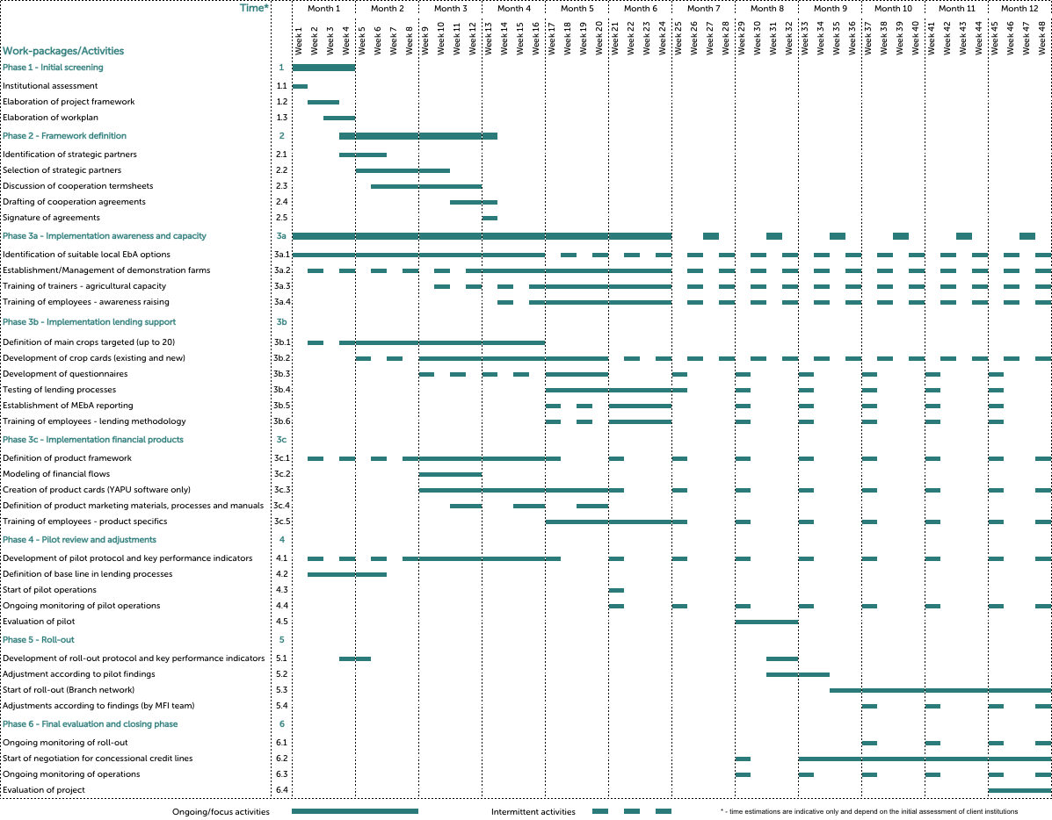

Outcome 3. At least 1 long term financing mechanisms has been piloted or introduced
- A sustainable development fund will be a useful mechanism to integrate contributions from public and private stakeholders and ensure long-term management. Ecuador has a strong experience developing and using similar schemes such as water funds and is hence in a good position to introduce such mechanisms. For instance, a leading experience is the “Fondo de agua para la conservación de la cuenca del río Paute (FONAPA)”. This fund is related to the Paute hydroelectric power station. The constituents include Cuenca´s water company (ETAPA), HIDROPAUTE (a state-owned hydroelectric company), ELECAUSTRO (the electric company that provides service to Cuenca and surrounding areas) and the national company in charge of providing electricity along the country (CELEC). In addition, CORPEI CAPITAL is an investment fund that only operates to assist the financial needs of micro and small and medium enterprises. An interesting set of financial tools are used to this end, such as: factoring, grants, investment in equity and conventional lending
- The fund for sustainable development (FODES) of the Río Blanco upper watershed will operate under the securities market laws, since it will work through the constitution of a trust, and will be a long-term financial scheme. The resources contributed by the project will be seed capital so that more adherents join the fund. The interaction between FODES and financial institutions operating in the area will be desirable and complementary in order to underpin the financing of initiatives aimed at improving the resilience of agricultural and livestock farms and also to promote dual mitigation / adaptation projects.
- It is worth emphasizing, in line with the consolidation of FODES, and in accordance with what is proposed in output 4, the financial institutions will build their integral environmental management systems, strengthening their institutional capacities, and becoming the ideal partners in the fund for the channeling of resources through the offer of adaptation and mitigation credit lines. In this way, resources are used efficiently, since the financial institutions operating in this place already have the necessary infrastructure (premises, staff and methodology) for the successful placement of this type of green loans.
- Another important fact to take into consideration is that several GADs have stated in their development planning, the importance of promoting financing tools according to the needs of the inhabitants of the area, so it is very likely to have their involvement, commitment and support.

Output 5. One investment fund to promote sustainable development is set up and operational
- The creation of an investment fund to promote the sustainable development of the area of influence of the Río Blanco upper basin will use the best-known structure in the national context, such as water funds to project its operation. The intention is that, using seed money from USD 420,000 coming from the project, the first year the operatives funds will be used to set up the fund with the initial contribution of two people (a specialist and an assistant), with the infrastructure and basic equipment to do their job. USD 80.000 will be kept in very liquid financial instruments to be use for the lending incentive mentioned before. The remaining USD 327,600 will be used as assets for investments that will strengthen its capital over time.
- This initial capital USD 420,000 will be invested in financial instruments available in the market with an interest rate of not less than 7.76%. It is worth mentioning that the “Fondo de Manejo de Páramos y Lucha contra la Pobreza (FMPLPT)” is currently invested in 20-year State Bonds with an interest rate of 8.45% per annum. The financial instruments, in which the equity is going to be invested, the interest rate, the term and the frequency of payment of interest will be the main responsibility of the director who will act under the strict supervision and authorization of the Board of Directors of the sustainable development investment fund.
- In addition, the door will be open in the medium term to work in conjunction with financial institutions operating in the area covered by the project for investments in certificates of deposit or other financial investment mechanisms.
Although the interest of these investments is important to the fund, an important component of such investments will be the counterpart's commitment to direct resources to the same extent towards adaptation credits in the agricultural sector.
- This mechanism has already been used in the country. For example, in 2013 CORPEI CAPITAL (a known investment fund) made a long term deposit in a private bank in the country for around of USD 500,000, under the condition to address these resources exclusively to the promotion of Bio-trade (Biocomercio) through microloans
- Even though there are many similitudes between water funds and this proposed mechanism, we must leave clear that the scope and boundaries for action of the investment fund is broader than conventional water funds. So that, the range of potential investments to allocate the equity will include those that, even if they are not so profitable than other options, have a significant impact in the protection of the ecosystems and the rivers basin.
- An important aspect to consider before implementation is that the contributions of constituents or adherents to the fund will be as important as the returns on their investments. The involvement of provincial, municipal and parochial governments through the regular allocation of resources is a task of political and commercial management. If there is no certainty that the contributions will materialize, the profitability of the fund will not be able to support its structure of expenses generating a gradual weakening. As equity strengthens, its economic sustainability will be more assured as will its investments in projects related to ecosystem and community-based adaptation.
- The resources for the payment of the economic incentives addressed to the farmers who have acceded to credit, and to the IFIs that have disbursed it, will be handled through the fund of sustainable development. These resources are not a contribution to capital but rather short-term and will be transferred to the beneficiaries in the time that the project goes on with farmers. In a conservative scenario, the fund will be capable to address USD 30,000 for protection projects since the begging of the third year increasing to USD 35,000 for the fourth year and so on. In the case of that interest rates obtained are higher than expected in the current feasibility analysis, the incentives will be adjusted accordingly.
- A diagram is presented in the following figure to illustrate the financial dynamics and flows of the investment fund:
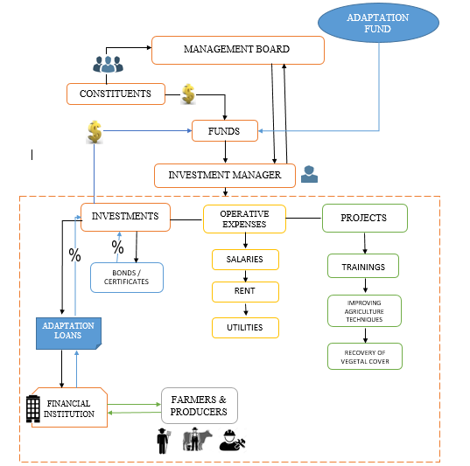
Figure 21: Financial dynamics and flows of the investment fund

- In Annex 8 a deeper analysis is shown, an analysis of the feasibility of the fund is indicated.
- Direct beneficiaries: Parroquial and municipal governments of Las Pampas, Palo Quemado, Manuel Cornejo Astorga, Aloag, El Chaupi y los GAD Municipales de Sigchos y Mejia. 49,367 total population of the basin.

Summary Component 2: Objectives and activities
- The following table shows the priority areas for intervention under the component 1, the objectuives of the two outcomes as well as activities carried out under each.
Objective | Activity
3. 250 ha of pasture and 250 ha of crops apply sustainable farming practices | Selection of farmers to reach at least 500 ha of sustainable cropping and livestock. Inside the group selected will be include vulnerable and women groups splited in groups to be assistance by grants and to be beneficiaries by credit lines.
3.1 Identification of adequate adaptation measures in the project area | Selection of the technical team to be in charge of identifying and defining the most suitable sustainable measures for farming and livestock; regarding micro climate, types of crops and availability of inputs to construct sustainable farms for the two main target populations.
3.2 Selection of eligible co-executors for subsidized implementation of adaptation measures | Notification of the selection process to select the participants to be part of the 500 ha of sustainable farms. Inside the group selected will be at least 150 beneficiaries who will receive grants for implementation of 75% of the investment. The remaining 25% will be counterpart contribution.
3.3 Selection of input and servcie provider to provide inputs for the implementation of adaptation option | Identification of the suppliers under criteria of access, stock and prices in order to ensure easy access to items for implementation of sustainable farms with better prices.
4.At least 2 institutions have introduced specific solutions and credit assessments to support the disbursement of credits for adaptation, integrating environmental and climate risks in their operations | There are several public and private financial institutions operating in the zone, however their lending criteria has not adaptation approach at all, thus the credits disbursed for agriculture are, in many cases, to promote non sustainable practices.
4.1 Selection of suitable consultancy providers, definition of general framework with financial institutions and initial institutional analysis. | To build the technical team with financial background to establish the suitable, tools to finance credits oriented to adaptation
4.2 Development of the methodological framework for climate-smart lending management and the introduction of adaptation finance | Construction of the climate risk assessment for all credit portfolio addressed to economic activities, based on software for structured data gathering and including state-of-the-art data analytics solutions; IT tools to facilitate identification, qualification and report of the credits disbursed to adaptation
4.4 Capacity building for partner institutions | Development of internal governance structures and procedures; development of financial products; Disbursement of adaptation credit addressed to sustainable farming. At least 235 people will benefit of this resources; Reporting of green lending oriented to promote sustainable measures in agriculture.
Objective | Activity
5. One investment fund to promote sustainable development is set up and operational | To build an investment fund to gather financial resources and transfer them into sustainable project in the zone. The permanent flow of resources will persist in the long term to the project.
5.1 Selection and constitution of the trust | Obtaining legal opinion of current regulation; definition of legal framework to be applied; constitution of the fund;
5.2 Identification and renting of premises and other infrastructure | Prepare the physical set-up of the fund management, inlcuding office space, qeuipments and vehicles,
5.3 Recruitment of the basic personnel of the fund | At least a central manager as well as an adminsitrative assistant will be recruited;
Table 15: Key activities component 2

Component 3: Strengthen local capacities and share lessons

- Component 3 presents the approach to strengthen the local capacities of the six rural parishes located in the project area and share lessons learnt during the implementation of the project. A plan of action and a set of core activities were defined to achieve the expected results during project execution and that they are also sustainable in the long term. The main objective of component 3 is to increase the local capacity to implement climate change adaptation measures and enhance the project’s impact thanks to capacity and knowledge transfer to the community. By institutionalizing climate change adaptation within six parishes the project aims to foster the scale of adoption of practices and procedures for climate change adaptation, and to assure the sustainability and the continuity of the project after its end. Component 3 has a particular focus on women empowerment. Indeed, because women are on average more vulnerable to climate change, by targeting women we assure higher adaptive capacity of the community and more sustainable reduction of community’s vulnerability.

Figure 22. Key activities for the component 3 identified with the local communities

- The two main tools used in Component 3 are: training provision and awareness raising. These will be addressed to the local actors, including but not limited to: public institutions, communities’ representatives, vulnerable groups (with special attention on women), local micro and small enterprises, financial institutions. The action plan includes training local actors in key topics, including: ecosystem conservation, water sources management, sustainable agriculture and livestock, access to funding, climate smart rural and agriculture practices, organizational development of associations and vulnerable groups located in the project area. Training will be provided through specific intervention per each stakeholder, or during focus groups or groups discussions, or dedicated events. Awareness raising will be assured thanks to public events, workshops, one to one discussions, media communications, demonstration farms, taylor-made communicational products and dedicated internet platforms (details section G).
- The training will focus on strengthening measures to adapt to climate change so that the population has appropriate living conditions under the concept of resilience. The trainings will focus on: identification of treats, definition of better coping mechanisms, and implementation of climate change adaptation initiatives. Communities will be taught how to use meteorological information and implement climate smart agriculture investments. Component 3 promotes the use of new technologies to involve local actors in the implementation of measures in an effective and sustainable manner highlighting the importance of association and community organization to improve emporement and future sustainability.
- The training will also be directed at parish GADs, who have the responsibility to ensure compliance with article 14 of the Constitution, which guarantees the right of the population to live in a healthy, environmentally balanced environment that guarantees sustainability and Good living, Sumak Kawsay. In component three training will be provided also to financial institutions on climate vulnerability and environmental impacts.
- To financial institutions it will be explained how to detect climatic and environmental risks within their portfolio, how these risks can manifest as credit risks, and what are effective coping strategies. By including climatic and environmental considerations within credit processes the aim is to align better financial performance, with ecosystem conservation and reduction of climatic vulnerability.
- Environmental and climatic criteria will be introduced into financial institutions’ processes and procedures, training them to recognize environmental and climatic risks and support the financing of agriculture investments that are at once more profitable, but that also better preserve ecosystems and reduce climatic vulnerability for clients and financial institutions. Demonstration farms will be implemented as well.
- The rationality is that explicit examples are more convincing than theory. Demonstration farms will show to community’s members how to implement an efficient and climate proof farm, and what are the related advantages in term of: yields, vulnerability, ecosystems. Demonstration farms will play both the role of awareness raising, but also of capacity transfer. Hence, farmers from the community will be able to receive trainings on sustainable farming directly at the demonstration farm and compare the results of their farms with the ones of the demonstration farm to understand where and how to improve.
- In addition, parish GADs will be able to include data and information related to climate change adaptation measures, with emphasis on gender and vulnerable groups, within their development and spatial planning plans. These documents currently have relevant information to articulate and coordinate priority local development actions, so it is possible to include aspects of climate change, as established in the current ministerial agreement number 147. The agreement is based on the following general guidelines:
- General Data on the Autonomous Government Decentralized GAD and the Plan of Development and Territorial Ordering (PDOT).
- Identify climate threats and sources of information.
- Identify the trends of the sectors related to emissions in the GAD territory.
- Summarize the findings on the vulnerability of the PDOT programs and projects.
- Summarize the findings on mitigation opportunities in the PDOT programs and projects.
- Suggest modifications to the PDOT's vision and development objective.
- Define a prioritized list of mitigation and adaptation measures.
- Draw up fact sheets of the measures.
- Strengthening local capacities allows the population and parish GADs to share the lessons learned through on-site visits, use of technology tools, and exchange workshops in each parish. Efficient mechanisms to share lessons learned will be key to assure multiplier effects, and foster the instauration of learning processes within the community. This is of fundamental importance to reduce the opportunity-cost of community members that would like to get engaged into climate adaptation practices. By capitalizing on the project experiences, the risks of new coming actors will be considerably lower. This will finally allow to scaling up the project and propose to new comers sustainable and climate proof practices already locally experimented and with known outcomes.
- For the implementation of component 3, 4 outputs have been established (key), in order to comply with the priorities defined in the logical framework of this project and the allocated budget.
Outcome 4: Local population and parish governments with increased capacity to implement climate change adaptation measures.
- The present outcome is based on four concrete outputs described further below. The outcome 4 has the objective to transfer capacity for climate change adaptation both directly to local population, but also to parishes’ institutions, and hence supporting the establishment of an enabling environment for climate change adaptation for community members.
Output 6: at least 6 parishes being trained to take care and use meteorological information generated by meteorological stations currently installed.
- The main function of meteorological stations is to provide climatological information to the parishes located in the project area. These stations provide information on temperature, precipitation, relative humidity and wind speed, to establish climate scenarios and improve decision making. This information is useful for socio-economic activities carried out by the population located in the Río Blanco upper basin, including agriculture and livestock, and improving the quality of life of the population. This approach match very closely with output 2. The understanding and inclusion of climatic data into decisions and activities related to agriculture is of major importance.
Climate influences when and what to plant, the expected yields, production risk for smallholders and credit risks for the financial institutions, and the decision of which practices or investments to implement being economically more convenient and less vulnerable.
For example, information on temperature and precipitations: trends, averages, and oscillations allow to establish the climatic and production risk per crop, define appropriate cooping mechanisms for the farmers, and adapted risk management strategies for the financial institutions.
- INAMHI is responsible for the installation and operation of the meteorological stations. For this project, it will be necessary to enable and maintain the stations in strategic locations in order to ensure adequate coverage.
- In addition, INAHMI will be responsible for transferring the operation of the stations and for providing the necessary technical knowledge to the GADS personnel to take control of the operations and the appropriate maintenance, from the execution of the project.
- The weather stations have technical specifications, such as: data logger to store data, modem to transmit data, a power system and sensors. The data generated at each station must be stored and transmitted to a central server for interpretation. This climate information management becomes indispensable to adapt to climate change.
- Local actors will be trained to interpret data obtained from meteorological stations. This training will be carried out in the field and will have as beneficiaries at least 500 people, from component one and two, of which at least 55% will be women. To train the target population focus groups, one to one trainings will be organized. The training will include the provision of generic climatic knowledge, and technical aspects on the meteorological stations.
Dedicated materials, in term of didactical guides or infographics and technical simplified guideline for the meteorological stations, will be defined and distributed during trainings.
- The climatological information will be integrated with the technological platforms of the Ministry of the Environment and will be presented online and in an interactive way to facilitate the knowledge about the climate to all the population including associations of women, senior citizens and other vulnerable groups.
The information will be transmitted in the form of bulletins to be delivered through the mobile phone services network in coordination with INAMHI.
- The climate information generated by the meteorological stations will be also included in the tools and methodology developed for the assessment of climate risks for financial institutions (output 4), to improve the predictability of software solutions used to assess the credits. In such a way output 6 will also contribute to strengthen the EbA investments done by the communities and the EbA credits provided by the financial institutions.
Output 7: Six development plans of local parishes incorporate measures for ecosystem-based adaptation to climate change.
- The Territorial Planning and Development Plans (PDOTs) are planning instruments foreseen by the Constitution, and the Organic Codes for Territorial Organization, Autonomies and Decentralization and the Planning and Public Finance Plan COOTAD and COPFP, in force since October 2010, The GADS develop the concerted management of their territory, oriented to harmonious and integral development.
- Article 41 of the COPFP states: "Development plans are the main guidelines of the GAD regarding strategic development decisions in the territory. These will have a long-term vision and will be implemented through the exercise of their powers assigned by the Constitution of the Republic and the Laws, as well as those transferred to them as a result of the decentralization process. "
- PDOTs are a tool used by the GADs located in the project area and are based on the approach of good living proposed by the government, in which nature has rights. Aspects of climate change are included in the ministerial agreement 137.
- Therefore, incorporating measures for ecosystem-based adaptation to climate change in the PDOTs, is very natural and will benefit the communities in the parishes, including women, associations, vulnerable groups and the community at large. Ecosystem based adaptation measures assure the alignment between ecosystem conservation and climate change adaptation. By conserving the local ecosystems, agriculture production is strengthened as well as community resilience to climate change. The opinion of vulnerable groups regarding changes in the ecosystem will be heard and considered.
- Moreover the inclusion of ecosystems based adaptation will be beneficial to the most vulnerable population that are the ones that are more exposed to ecosystem degradation and climatic events. Ecosystem-based adaptation will hence support inequality reduction and poverty alleviation. The inclusion of ecosystem-based adaptation to climate change in development plans will be backed by the local community thanks to the organization of community workshops.
- During the workshops the main aspects of ecosystem based adaptation will be introduced, and then the existing ecosystem adaptation practices already in use in the community will be collected and presented by local farmers already implementing them. This will support knowledge transfer among members of the community and the possibility to adapt best international standards to what has revealed as already working. Hence a catalogue of local practices will be defined and used as base for the introduction of ecosystem based adaptation within the PDOTs.
- The PDOT will include a guide to priority actions to address climate change. This document will help to monitor and evaluate the results and impacts achieved in a transparent manner.
- Once finalized the PDOTs will be introduced and explained to the local actors, those interested in the project and the community in general. The document will be available in digital format from the parish GAD website, to guarantee the larger as possible spreading. Once the community actors will be trained on ecosystem based adaptation, the PDOT will be used both as strategic tool to foster adaptation, but also as monitoring and reporting tool for rural development.
By introducing elements of climate change adaptation into PDOT the aim is to assure that climate change consideration will be included into parishes’ development plan.
Output 8: Strategic plan of communication, education, knowledge transference and scheme of replica
- The strategic communication plan will ensure that the activities carried out in the project are knowledgeable for all stakeholders. In such a way, that there is an effective and fluid communication of information on the activities that are carried out in the project.
- Communication will be done using three different approaches: through the project unit, where the project team will socialize information with the local communities on a day-to-day basis whenever they are in the field; through local strategies, where the project unit will work one to one or through focus group with key stakeholders and representatives from local organizations and institutions; and through the traditional media being MAE website and its social network Facebook and Twitter, community radio and local print media whenever considered relevant. Moreover educational material on ecosystem based adaptation, including infographics, actual examples based on the local community experience, and interactive learning material will be developed. In the plan for communication and knowledge transfer the actors that participate in the project will be included as much as possible to support community to community training and exchange. The interactive and participatory methodology will be privileged, if possible games illustrating ecosystem based adaptation will be developed or adapted and used for knowledge transfer.
- The data and information generated in the project will be published on the website of the main technology platform of the project implemented in output 9 and on the website of the parish GADs.
- The training will be directed according to the requirements of the population and based on the training activities established in this project, components 1 and 2, which include topics such as: Forest Protection, Water Sources, Climate Change Adaptation, Environment, Financial Access, Organizational and Associative Development.
- Specifically with output three of component one, there is a close link, since farmers, farmers and producers of panela, who will be part of the productive sustainability project, must approve modular courses of 9 sessions, of which 4 will be in classroom and the remaining 5 will be in the field. Participation in these courses will regard gender equity and access to vulnerable groups. The trainings will be the base to later implement the demonstration farms which will be implemented in areas where points of critical social, environmental and economic vulnerability are identified.
- This point includes the selection of six demonstration farms with measures of agricultural, livestock and production of panela. These farms would include the adaptation measures implemented, the monitoring of the productive performance and the recording of the financial dynamics including all financial movements such as sales, cost of sales, expenses, income, family consumption, final balance.
The objective of demonstration farms is to show various possible solutions and combination of solutions that could at once increase yields, reduce climatic vulnerability and conserve ecosystems. The demonstration farms aim to provide to the smallholders a real example of what their farm could look like and what are the main advantages. They aim to stimulate a feeling of proximity with adaption practices and how they can be actually implemented: translating from abstract wording into actual experiences.
- It is important to remark that technical assistance and the means of access to financial resources mentioned in output 3 go hand in hand with this process of strengthening the capacities of farmers and producers,
- The content of the information will be designed in an interactive format, according to the target population, including: children, youth, women and vulnerable groups. They are interested in being considered and informed of all the projects that are carried out under the Río Blanco upper basin.
- Output 8 will also promote Exchange site visits among parishes participating in the project, as part of the exchange and replication of knowledge.
- Moreover output 8 will contribute to strengthen the capacity of financial institutions to introduce climate and environmental aspects into their portfolio. This is of key importance to assure the medium term financial sustainability of the project. Indeed awareness raising and direct capacity building will be provided to financial institutions to assess environmental and climatic risks for clients and portfolio, and develop and finance ecosystem based adaptation farm investments.
- Tailored training on environmental strategies and climate risks will indeed be provided to the management team and loan officers of financial institutions engaging in the project as per output 4. Generating the buy in of loan officers is key, because they are the one that actually interact with the clients and do the credit assessment and provide advices to the clients. Supporting capacity building of the management team is important as well, to assured that environment and climate are included in all the layers of procedures and assessment of the financial institution. Training will be provided during dedicated workshop and small group session. Guided round tables of discussion with loan officers and management team will be organzed.

Output 9: Systematisation of information gathered during the whole project design and implementation using existing informatics platforms

- The project will have a main technological platform, which will ensure the systematic capture and dissemination of data, information, lessons learned and good practices generated in the project.
- The platform will be implemented using disruptive technologies, such as: Cloud Computing and BIG DATA, to ensure the handling of a large amount of data and information of different formats and their online availability to all stakeholders and the general population.
- With Cloud Computing, data and information will be available online to be accessed from any mobile device and from anywhere within the project area.
- With big data methodologies, it will be possible to handle a large volume and variety of data, in a fast and agile way, with which it is possible to model and monitor climate information generated by meteorological stations and platforms used by the Ministry of Environment Promote adaptation measures to climate change.
- The platform will be integrated with the current technological platforms of the Ministry of Environment, and the Ministry will have a main role for the technical integration of the platforms.
- The integration of the platforms will allow access to the stakeholders in a centralized way to the data and information generated by the meteorological stations, parish GADs, and the Ministry of the Environment.
- The use of the software solutions for credit and risk assessment of financial institutions (output 4) of farmers’ practices will contribute to generate data that will be shared through the above-mentioned platform. This will hence contribute to transfer the institutional learning of financial institutions to the community and support replication of the present project to other locations and with other financial institutions in the country.
- The following activities and beneficiaries are targeted by the component:

Summary Component 3: Objectives and activities
- The following table shows the priority areas for intervention under the component 3, the objectives of the two outcomes as well as activities carried out under each.

Objective | Activity
6. At least 6 parishes being built capacities and prepared to manage and use meteorological information. | Climate and meteorological data is key to identify suitable adaptation options as well as identify potential threats. Activities will focus on creating the necessary capacities with communities and GADs
6.1 Capacity building of GADs | Training in use and maintenance of meteorological stations for technical staff of each GAD.
6.1.2 Governance of climate data management | Changing administrative operations (decentralization) from INAMHI to GAD technical personal staff.
6.1.3 Capacity building for communities | Training 500 families in the use of climate data and their application in activities, such as: agriculture and livestock. This training will be address for 55% percent of women. Including field visits, food and transportation. An appropriate mechanism to transmit climate information to the population will be developed.
6.1.4 Development of training and information material | Designing of interactive content, infographics and generation of newsletters to training GAD population in the area including women associations, older adults and vulnerable groups. Policy briefs will be elaborated for policy makers.
Objective | Activity
6.1.5 Developing a communication strategy | Integrating the digital media technologies for communication plan and addressed it to the population in general including women, older adult, youth people and children’s.
7 Six development plans of local parishes incorporate measures for ecosystem-based adaptation to climate change. | Acquired know-how and capacity will translate into concrete application in the GADs
7.1 Selection of suitable adaptation options | Conducting a technical study to determinate which climate change adaptation measures that must be added for development and territorial planning plans.
7.2 Integration of adaptation options into territorial development plans | Gathering information on climate change adaptation measures to be added like indicators and statistics into the development and territorial planning plans. The indicators should include gender information and vulnerable groups for climate change.
7.3 Elaboration adjusted development plans | Developing new development and territorial planning documents adding climate change statistics and information and also including gender and vulnerable group’s climate change issues.
7.4 Training to producer associations | Training for population including associations, organizations and other stakeholder of the project about climate change adaptation measures incorporated in the PDOTs.
7.5 Communication of new PDOTs | Socialize new PDOTs documents with the population of the project area including associations, organizations and the population in general.
8. Strategic plan of communication, education, knowledge transfer and scheme of replica, including demonstration farms. Plus training on adaptation finance to financial institutions. | Findings of developments throughout all components will be shared with communities to empower them to make informed (adaptation) decisions; supporting activities will be defined.
8.1 Development of a communication strategy | Developing a communication plan addressed for stakeholders in the project including specific women associations and organizations.
8.2 Integration of ICT solutions and social media | Integrating the digital media technologies and different approaches for communication plan and addressed it to the population in general including women, older adult, youth people and children’s.
8.3 Establishment of demonstration farms | Sharing lessons learned and experiences with project stakeholders, and replicate knowledge to other similar projects in the country through demonstrative farms applying sustainable methods for agriculture, livestock and panela production and market access.
Objective | Activity
8.4 Development of training materials of sustainable agricultural practices | Training modular courses on sustainable agriculture and good agricultural practices, open to associations and selected farmers to participate. 12 modules, 6 theorists, 6 in the field and an on-site supervision within 6 months of completing the course. 50% women
8.5 Training of microfinance institutions | Training for all Microfinance Institution (MFI) staff participating in climate risk, green credit and climate change issues with a focus on microfinance
8.6 Certification of agricultural practices | Certification of organic crops or good agricultural practices for the production of panela, mortiño wine or crops of sugar or naranjilla, of those graduates with better performance in their crops.
9. Systematization of information gathered during the whole project design and implementation using existing informatics platforms | The project will interact with a multitude of actors and gather data on the productive reality in the field; data will be gathered electronically to enable its further processing to several ends, such as identifying suitable adaptation practices over time
4.4.1 Development of a technological platform | Developing a technological platform to manage knowledge and information about climate change adaptation, using disruptive technologies like: big data and cloud computing.
4.4.2 Integration of platforms - existing and project | Integrating technological platform into others technological platforms used by the Ministry of Environment.
4.4.3 Awareness raising on the new platform | Sociability of the technological platform with all stakeholders in the project including associations and organizations.
Table 16: Key activities in the component three

B. Describe how the project / programme provides economic, social and environmental benefits, with particular reference to the most vulnerable communities, and vulnerable groups within communities, including gender considerations. Describe how the project / programme will avoid or mitigate negative impacts, in compliance with the Environmental and Social Policy of the Adaptation Fund.

- The ecological vulnerability of the watershed supposes also a socioeconomic vulnerability of the societies living in these areas especially those already vulnerable like women, children and indigenous people (vulnerable groups). By historical and socioeconomic issues these groups are the most exposed in any society and particularly in those of frontier where social life depends of direct natural resource extraction. In this understanding the climate change phenomenon and the expected impacts on nature and society will particularly affect watersheds and women and indigenous people as the most vulnerable in natural and social environments.
- Considering the issues of social and natural vulnerability and the expected effects of climate change, the annex 9 and the following paragraphs present a quick concept to identify the benefices to vulnerable groups by the different project activities (figure 23) pointing the situation of the rural jurisdictions in which lie the critical part of this area and identifying stakeholders and their perceptions regarding weather and climate change issues as presented below.

Beneficiaries

- Direct beneficiaries or co-executors are defined as those residents, organizations or institutions that will receive a transfer of resources or technology from the project’s funds. Within this group of principal beneficiaries are:
- Parish governments of Las Pampas, Palo Quemado, El Chaupi, Aloag and Manuel Cornejo Astorga and Municipal govermment of Sigchos that will mainstream the climate change variable and adaptation measures in their planning and land use zoning. It is also expected to mainstream adaptation, with a gender perspective, into the plans for the rural area of Sigchos. These parishes will also have improved forest conservation, better agriculture production, access to hydro-meteorological information, and enabling conditions for multi-level dialogue and collaboration. The population in the rural areas is about 10,542; and 6,167 in populated area, with a very similar proportion between men and women.
- At least 30 technical staff, promoting women’s participation to reach at least 50%, of partcipants, from the parish governments and municipality of Sigchos will benefit from training on adaptation to climate change.
- At least 200 stakeholders will benefit from the exchange of experiences. Women’s groups and/or organizations will be identified and targeted to benefit from these activities.
- At least 375 farmer families will benefit sustainable farming and livestock practices and the river basin management. Female-headed households and female-led farms will be identified and targeted to benefit from these activities. If needed, extra training will be provided to level access for women.
- Vulnerability groups identified in the Stackholders (2016) and Gender analizes (2017).

- Indirect beneficiaries are those persons or institutions that will participate in the project’s activities without directly receiving project funds. Within this group the principal beneficiaries are:
- Water users, particularly women, from the Río Blanco drainage basin.
- About 49,367 incuding people who live in rural areas and populated spots of the drainage basin.
- HIDROTOAPI hydroelectric plant and the users of the electricity it will generate.

On the next table a set of activities and benefices to vulnerable groups is detailed:
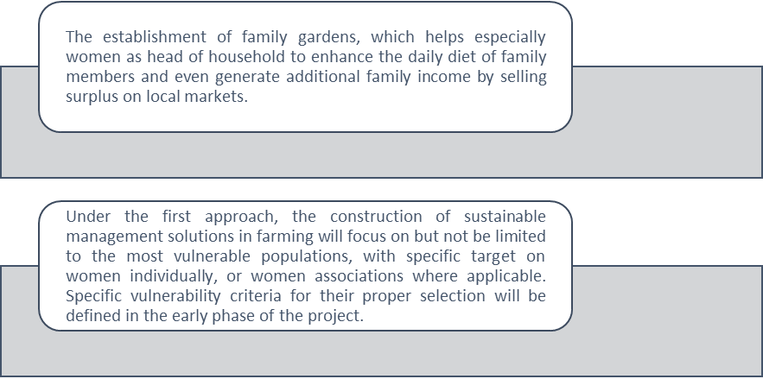
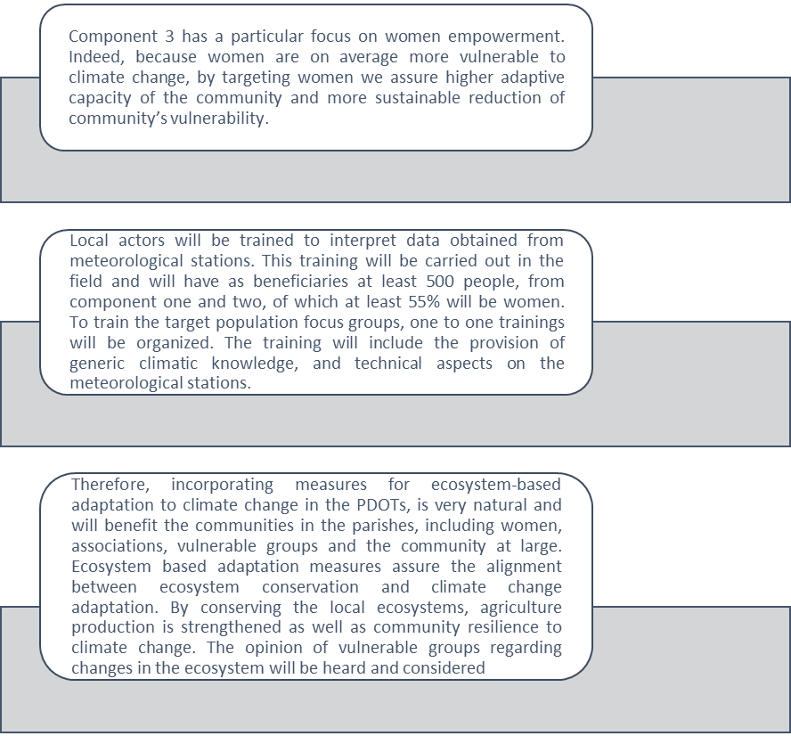
Figure 23. Key activities and benefices to vulnerable groups

- Moreover the project is designed to support broader impact within the ecosystems and the communities. The project targets indeed key actors in the communities able to generate multiplier effects with positive impact on the full commnunity and the ecosystems it depends on. For this reason it will work also with technical providers, financial institutions, agronomists, value chains actors in agriculuture, private and public local institutions, with the aim to generate systemic changes towards sustainble and adapted practices.
Economic benefits
- Farmers that apply sustainable farming practices will benefit from an increased yield and income, and at the same time will reduce the risk of losses due to agricultural practices not adapted to adverse climate impacts. It is expected that these farmers will catalyse the use of improved practices by a larger number of producers.
- As the respective adaptation options will be selected following the methodology presented in Annex 12, only activities that will increase the farming household’s economics will be promoted, ensuring a sustainable increase in household income. By gradually increasing the livelihoods of subsistence farming units to make them subjects of lending eligibility, will help to further strengthen their economic development and diversify as well as strengthen economic income activities.
- While strengthening of ecosystems is usually defined as an environmental benefit, it also bears an economic dimension: as studies show
- Furthermore, enhanced hydro-meteorological information will support and contribute to prevent adverse effects in agriculture and livestock, and give relevant climate information to be considered into the development plans (PDOT).
- HIDROTOAPI will benefit from ensuring sufficient water flow for power generation and will avoid a significant increase in maintenance costs due to increased frequency in changing out parts or doing major maintenance or overhauls due to the expected increase in suspended solids.
- The parishes will benefit of a growing rural economy, able to attract financial service providers and scaling up sustainable practices for the entire community.
Environmental Benefits
- The conservation of a large vegetation cover will sustain the water cycle by ensuring condensation in the cloud forest and related flora. In addition, these areas will continue to support local biodiversity (including high-value conservation species) and connectivity among diverse habitats and ecosystems.
- The Andean Cloud Forests are vital in the uptake and regulation of water within the hydrological cycle. They capture moisture from the cloud cover, acting like a sponge that absorbs and retain water during the wet season and release it during the dry season. This is why maintaining the most possible forest cover is crucial to withhold the impacts of the foreseen climate change.
- Conserving the vegetation cover of the Río Blanco upper watershed will also contribute to protect valuable biodiversity. The Andean Cloud Forest on the western slopes of the Ecuadorian Andes is very rich in biodiversity. There is limited information about the cloud forest of the project area, but an in-depth analysis in a close area identified 1,640 species of vascular plants. In the Rio Guajalito Reserve about 2,800 vascular plant species have been reported; of these about 100 species are endemic.
- In the Río Toachi-Chiriboga IBA, 450 bird species have been reported. The area host threatened species like Pachyramphus spodiurus and Ognorhynchus icterotis (both classified Engangered in the IUCN Red List). In addition, in Rio Guajalito Reserve about 40 species of mammals have been reported, including the spectacled bear (Tremarctos ornatus) and the pacarana (Dinomys branickii) – both classified Endangered in the Ecuadorian Red List --, and the neotropical otter (Lontra longicaudis) (classified Vulnerable in the Ecuadorian Red List).
- In the Reserva Ecológica Los Illinizas y alrededores IBA, about 257 bird species have been reported. The area host threatened species that are endemic of the cloud forests like Grallaria gigantea, Grallaria alleni (both classified Vulnerable in the Ecuadorian Red List), and Haplophaedia lugens (classified Near Threatened in the Ecuadorian Red List). The area also host threatened mammals like the spectacled bear, the puma (Puma concolor) (classified Vulnerable in the Ecuadorian Red List), the collared peccary (Pecari tajacu) (classified Near Threatened in the Ecuadorian Red List), and the endemic Ecuadorian spiny pocket mouse (Heteromys teleus) (classified Endangered in the Ecuadorian Red List).
- The project will promote two main implementation strategies, on one hand supporting forest conservation, and on the other hand fostering the development of more sustainable agricultural activities making a responsible use of ecosystems
- Hence the community will appreciate ecosystems not only as landscape but also as a basis for their production, a mean to reduce their vulnerability. This will contribute to sustain the protection of ecosystems and to strengthen community links needed for their economic and social development.
Social Benefits
- Stakeholders from the lower part of the water system will benefit from increased social capital. This can be a powerful catalyst for further action to improve the livelihoods of local groups. The improved dialogue, networking, and collaboration among stakeholders will be a major contribution to local development.
- Farming families will benefit from improved practices. The project will pay particular attention to the role of women and other family members (e.g. children and the elderly) in local farms to adapt, as much as possible, the new sustainable farming practices to the dynamics of the farming families. Female farmers will be specifically targeted to benefit from all project activities.
- Local communities will also benefit from an inclusive approach. All project actions will be, to a feasible extent, gender and age sensitive and will consider the needs of persons with disabilities
- Mainstreaming adaptation into daily actions and decision making will also generate major benefits for local communities. This will allow them to adjust their lifestyles and livelihoods to the impacts to be generated by climate change.
- Better hydro-meteorological information provided to the early warning systems will contribute reduce the risk of impacts from landslides and flooding.
- In the long-term, HIDROTOAPI´s greater stability in electrical generation is an additional benefit at a national level.
- Climate Change Gender Action Plans (ccGAPs) build on a country’s national climate change policy, plan or strategy, delving into gender-specific issues by priority sector and creating innovative action plans to enhance mitigation, adaptation and resilience-building efforts for women and men in every community. In the project context, the National Climate Change Strategy (MAE, 2012) establish the gender and vulnerable groups as a priority sector. In Annex 9 you can review the analysis of the group of vulnerable groups and gender, the document consists of:
- Introduction where the national and international legal part is detailed.
- Conceptual framework: Impact of climate change on women, vulnerable groups. Table 1 shows the index of femininity in the last census in 2010 for Ecuador. Table 2 Income of the economically active population. Table 3 Population in the Project Area differentiated by gender. Table 4 The disaggregation of population data in the project area.
- Gender analysis: Description of Social, Economic and cultural characteristics by 2018
- Gender Action Plan
- Participatory processes that take into account gender: Participation was a gender focus in the workshops held with the communities as can be seen in annex 4.A of July 15, 2016, the participation of women was active and Included in the decision making of the activities of components 1,2, and 3. Of 40 participants, 22 men and 18 women. The workshop was held in the communal house of the Unión del Toachi locality.
- Initial Gender Assessment: Annex 9. Table 6 Comparison of Population Censuses from 2001 to 2010 in the Sigchos Parish. Table 7 illiterate by parish. Table 8 ethnic self-identification by cantons. Table 9 Education by cantons. Table 10 Labor Market. Table 11 Poverty for unsatisfied basic needs in Canton. Table 12 single mothers. Table 13 The data disaggregated by gender and economically active population by parish. Table 14 Cantonal productive activities. Table 15 Women by associations and productive activities
- Baseline of the project disaggregated by sex: In Annex 4.B you can see the details of the Feedback Workshop of the components of the Project held on July 24, 2017, with a total of 89 assistants, of which 40 men and 39 women. From these workshops began to raise awareness of the impact of climate change and experiences of future beneficiaries consolidated the final document, having a baseline of vulnerable groups as you can see the model of the surveys that were applied (see page 9 - 11, Annex 4B)
- Training activities and capacity development: Corresponding to component 2 and 3.
- Governance mechanisms: National and international legislation.
- Financing of products with a gender approach: Thanks to the support of the Adaptation Fund for the Adaptation Project in the upper basin of the Río Blanco with a gender focus.

- As a result of this Gender and Vulnerable Gropus Analysis (Annex 9), gender entry points for project Log Frame have been identified (section E part III). To monitor project implementation, some gender-sensitive indicators have been suggested to be incorporated in the table 39 and figure 37 (M&E), the concept is below shown and the activities are described in the following paragraphs:

- -Initial Gender Assessment: to be presented before first disbursement. It should contain the following: (i) gender analysis of farming and agricultural value chains, including an assessment of gender division of labor in local farming and agricultural practices (land preparation, ploughing, manuring, seed purchase, sowing, weeding, harvesting, processing, grain storage, folder collection, water collection, feeding, cleaning/bathing, milking cows, milk processing, dung collection, marketing). Include assessment in terms of use, access and control of natural resources differentiated by gender; (ii) gender assessment of existing differentiated needs and demands of farmers and local producers to benefit from project, this part should also mention how existing risks and problems affect differently to men, women and vulnerable groups. To stablish the needs and demands the day-to-day activities of men and women should be clearly stated. Include the dynamic and use of time from children or other vulnerable groups, which will be usefull to asses time availability of women for future planned training; (iii) identification of existence of gender-specific crops and products.
    - Sex-disaggregated project baseline: containing, at least: heads of households; land owners; farm owners; farm workers.
    - Gender-responsive participatory processes, as part of the project communications plan with communities, should recognize women as primary users of forest resources in project design, implementation and evaluation. These mechanisms should effectively engage both men and women in decision making processes, additional training targeted to women may be needed in order to ensure their full and effective contribution. Also, gender-responsive processes may include the use of women-only interviews and gender-specific focus groups and group consultations (UNREDD 2013).
    - Training and capacity building activities to be implemented under project components, with either local farmers, general population, parishes and other public officers, should promote women’s participation and be gender-sensitive, taking into consideration specific demands (location, adequate schedules, childcare facilities and/or other special arrangements that may encourage women’s assistance).
    - Land titling processes: if such mechanisms are to be established through project implementation, joint tenure of land should be promoted. Also, it should be assessed whether widowers and single women face additional restrictions to own land, and introduce corrective measures to lift these barriers.
    - Financing products: when new financing products, such as credit schemes and guarantees, are to be implemented as project outputs, they should be designed taking into consideration differentiated gender needs. Women tend to have less access to credit, usually due to lack of collateral, but also to lesser understanding of finance concepts, and may prefer collective credit schemes. These special needs should be taken into account when designing these products, to ease access for women to participate.
    - Institutional governance mechanisms to be created under project implementation, such as committees for a Water Fund and/or for a Seed Fund, should incorporate a female quota (i.e. 20%) in their structure. Also, gender-sensitive hiring procedures should be taken into account. The participation of women in decision-making processes should be promoted and documented.
    - When sourcing staff and consultants, gender equality will be a guiding principle. Using gender-sensitive language in hiring procedures; determining a quota (i.e. 30%) or facilitating training for women so as they can access traditionally male-dominated positions, are some of the measures that could be implemented. Also, these procedures can be included as requirements for contractors to be hired to do the works.
    - It would be advisable to design and implement local development plans (for the parishes) to be gender-sensitive.
    - Also, if other studies and assessments need to be made, it is recommended that they incorporate a gender perspective.

Summary of benefits by component
Component/  Benefits | Social benefit | Key Indicator | Economic benefit | Key Indicator | Environmental benefit | Key Indicator
Componente 1 At least 230,000 ha of native vegetation is conserved to reduce the impact of climate change on the hydrological cycle under integrated watershed management | Improvement of quality of life, the data have been obtained from the web page forestmanagement and wizetime indicates that: 22 trees are required to supply the oxygen demand of a person per day. 0.41 hectares with trees (1 hectare is equivalent to 10,000 square meters, let's say an urban block), produces enough oxygen per day for 18 people. | 6/6 GADs in target bio-corridor with TLUP that incorporate specific provisions for Bio-corridor of conservation  Indicator:  # GADs that Biocorredor has incorporated / 6 *100 | Natural persons with property equal to or less than 20 ha, will receive a value of up to USD $ 60 / ha / year. Equal or less than 50 hectares will receive the maximum value of USD $ 30 / ha / year. With an area of up to 100 ha, they receive as an incentive the maximum value of USD $ 30 / ha / year for the first 50 ha, and of USD $ 20 / ha / year for the next 50 ha. Between 101 and 500 ha, they will receive USD $ 30 / ha / year for the first 50 ha; USD $ 20 / ha / year for the next 50 ha; and, USD $ 10 / ha / year for all additional ha between 101 and 500 ha. The same mechanism will be applied for the following categories. The returns for the same hectare of land could grant US $ 2 per year for grazing uses, for a one-time US $ 1035 sale of commercial timber. If no action is taken to reduce emissions, each tonne of carbon emitted will cause a loss of US $ 85 in the world economy. | 30% of reduction of current use of wood  Indicator:  # has been destined for wood use / # has deforested * 100 | Within the National Forest Control System Project presented to SENPLADES by the Ministry of the Environment indicates the environmental benefits of the conservation of plant cover indicates that the price of carbon fixed per hectare is $ 134.  17% of deforestation and forest degradation accounts for almost 17% of global greenhouse gas emissions (GHG). In 2006 a study called by the Treasury of the United Kingdom (http://www.hm-treasure.gov.uk/sternreview_index.htm) concludes that reducing deforestation offers the best alternative to reduce emissions at relatively low cost. The study showed that in eight countries, responsible for 70% of the total emissions, due to land use change, one hectare of forest can be valued as US $ 25,000 in terms of carbon sequestered at a carbon price of US $ 30 to US. $ 50 | # of ha of forest conserved in the Bio-corridor  Indicator:  # ha Biocorridor / # has total conservation * 100
Component/  Benefits | Social benefit | Key Indicator | Economic benefit | Key Indicator | Environmental benefit | Key Indicator
Componente 2  Adapt farming practices to new climate change conditions enable their sustainable climate smart financing | The increase of the agricultural production and of the income will bring an improvement of the living conditions of the producers. Experiences in other sectors tell us the benefit as it is: Good agricultural practices help improve farmers' incomes in Lao RDP supported by FAO by 50% than by applying conventional agriculture. | 50% women and 50% men including also vulnerable groups.  #women involved / total of the beneficiary population * 100 | The gender perspective promoted by the project will improve self-consumption, small-scale income generation (agricultural activities, preparation and sale of products, off-farm work) and care of the family production unit. In the Comparative Study of production costs in organic and conventional agriculture indicates that conventional farming techniques are invested 12.7% more in raw materials, while labor costs are 13.8% higher in organic farming, this has an impact on 1.9% on variable costs and 3% on total costs. | # institutions have trained their personnel on sustainability topics, including EbA and Climate Change/  Indicator  # total of institutions * 100 | Erosion risks will be avoided in the occurrence of heavy rains causing the decapitation of the surface horizon and the exposure of the low permeability layers, lower content of organic matter, increase of pests.  In an irrigation trial conducted in Chillán (central-southern Chile) during 16 years of wheat rotation with legumes and oats, in which nitrogen was never applied as fertilizer, we can highlight the higher yield of wheat rotation with legumes or oats, 31% more than the yield observed in a wheat monoculture. | At least 250 ha of pasture and 250 ha of crops apply sustainable farming practices  Indicator  # has sustainable agriculture / # has total * 100
Component/  Benefits | Social benefit | Key Indicator | Economic benefit | Key Indicator | Environmental benefit | Key Indicator
Componente 3  Strengthen local capacities and share lessons | Incorporation of the perspective of gender and indigenous peoples through the participation and dedication quotas foreseen in the project. The growth of the sector depends on the expansion of the consumption of biological products; In this sense, it is women who decide and acquire up to 90% of food, which means that they must be considered as protagonists in the decision making of food consumption. The work of Allen and Sachs (1992) is a pioneer in the analysis of the production of organic foods from the point of view of gender, in which the authors highlight the need to question and analyze the aspects of class, race and gender. in relation to sustainable agriculture so that it does not constitute only an agriculture capable of reducing environmental impacts. | At least 500 families trained in the use of climate date, with at least 55% women's participation  Indicator  # families trained climate change / # families affected by the project * 100 | Increased capacity to develop and implement approaches to efficient adaptation to climate change that leads to the protection of farmers' property and income. In 2017, farmers have benefited from the purchase of the MAGAP agricultural kit, which includes a subsidy of 40% from the Ministry and 60% financing from BanEcuador B.P. Similarly, the credit for coffee, cocoa, corn and rice is still valid to promote the development of this sector of the national economy. | At least 6 trainings provided on adaptation finance and 6 training for climate risk in two financial institution  Indicator  # training on adaptation financing / 8 * 100 | Greater knowledge and awareness of climate change and its impacts will help raise awareness about environmental protection.  Within national policies, the topic of Mitigation and Adaptation to Climate Change is addressed. Framework for the preparation of the IDB's 2012-2017 Strategy in Ecuador in line with climate change mitigation, PNBV includes the following goals: a) Increase the 5% of the territory under conservation or environmental management; b) Reduce the rate of deforestation by 30%. The experience in Ecuador indicates that the annual rate of deforestation has been reduced, in the year 205 it was 1.74, 2013 in 1.22 in the year 2015. | 7 hydro-meteorological stations providing climatic data in a regular bases and located accordingly to technical criteria by INAMHI
Table 17: Benefits and indicator by components

C. Describe or provide an analysis of the cost-effectiveness of the proposed project / programme.

- Within the project area, the current Business-As-Usual (BAU) agricultural development model has encroached upon forest and riverside areas. The production methods applied within the local agricultural and livestock sector remain traditional and have not been optimized for efficiency. Any growth of the local agricultural sector therefore entails a growth of its land use. Against a backdrop of climate change increasingly affecting the area, non-intervention carries a high cost of opportunity. While it is true that some GADs have incorporated isolated adaptation measures into their development plans, their impact has been extremely limited.
- The proposed project, in turn, will directly benefit about 553 families (2,600 people) in the project area. Additionally, it will indirectly benefit the local parishies communities (ca14,000) and entire population of the Río Blanco upper watershed system (ca. 49,367 people). The project will contribute to strengthening the adaptive capacity of local stakeholders reducing the level of future impacts generated by climate change.

Component | # of Beneficiaries (families) | Assumption(s) | Activity | Target | Investment | Cost per unit target
C1. Conserve vegetation cover | 178 | 50% from highlands and 50% lower basin | Improve management of protected forest. | 230,000 ha | USD500,000 | USD2.17/ha
C1. Conserve vegetation cover | 178 | 50% from highlands and 50% lower basin | Increase conservation area | 1,000 ha | USD450,000 | USD450/ha
C2. Adapt farming practices to new climate change conditions, enabled by sustainable climate smart financing | 375 (250 for crops and 125 for livestock) | 1 hectare will be dedicated to this project per farmer and 10% of the average extension (20 ha) per livestock farm | Sustainable farming practices and livestock adjusted to local realities are being introduced and implemented with assistance of financing mechanisms for adaptation measures | 500 ha  375 fam | USD420,000  USD420,000 | USD840/ha  USD1120/fam
 | 375 (250 for crops and 125 for livestock) |  | At least 1 long term financing mechanisms has been piloted or introduced | 553 familias | USD420,000 | USD759.5/fami
Component | # of Beneficiaries (families) | Assumption(s) | Activity | Target | Investment | Cost per unit target
C3. Strengthen local capacities and share lessons | 553 directly  14000 indirectly local communities  49367 indireddly in river basin | Beneficiaries both component 1 and component 2 | At least 6 parishes being built capacities and prepared to manage and use meteorological information. | 6 parishes | USD160,000 | USD26,666/parish
C3. Strengthen local capacities and share lessons |  | Beneficiaries both component 1 and component 2 | Six development plans of local parishes incorporate measures for ecosystem-based adaptation to climate change. | 14,000 people | USD80,000 | USD5,75/people
C3. Strengthen local capacities and share lessons |  | Beneficiaries both component 1 and component 2 | Strategic plan of communication, education, knowledge transference and scheme of replica, including demonstration farms. Plus training on adaptation finance to financial institutions | 553 families | USD120,000 | USD217/families
C3. Strengthen local capacities and share lessons |  | Beneficiaries both component 1 and component 2 | Systematisation of information gathered during the whole project design and implementation using existing informatics platforms | 553 families | USD40,000 | USD72/families
Table 18: Cost per unit target by components

- The project will use existing structures (such as relevant Ecuadorian laws and regulations) and actors to implement all interventions. Relevant best practices in the national and/or regional context will also be leveraged (e.g. ACUS, Socio Bosque).
- A core element of realizing the projects’ target benefits lies in impacting farming practices. To achieve this, farmers will be equipped both with specific know-how and best practices pertaining to their area of activity in their local context as well as with the physical tools required for this purpose. As many factors influence this equation, it is evident that cost-benefit analysis needs to be conducted on an individual level to achieve maximum impact. On a project level, the focus will thus lie on putting the tools in place to efficiently conduct this case-by-case analysis and monitor relevant micro-indicators over the project duration.
- In terms of the tools, selection multicriteria for the identification of suitable adaptation measures for individual farmers need to be flexible and take into account each farmer’s specific situation based in the ABC methodology (MAE-GIZ 2017) , such as:
- Access to important infrastructure such as roads,
- Inclination of plots or grazing grounds,
- Soil texture and quality,
- Actual crops cultivated or livestock bred, including varieties and types,
- Availability of critical inputs.
- Pricing of inputs in each area, and
- Conventional panela production

- The combination of these critical productivity drivers will not only determine the productivity of farmers under business-as-usual scenarios in face of adverse climate impacts, but also define what actual adaptation measures promise not only the optimum results but also if their implementation is feasible at all. For example, if certain inputs for the implementation of adaptation measures are not available, cannot be transported to the farm due to the lack of access roads or are prohibitively priced, this must be analyzed and the impact taken into account on a case-by-case basis.
- In order to take advantage of the best relevant practices, the project carried out a multicriteria analysis of the key activities to be developed, followed by a cost-benefit analysis. During the implementation of the project will seek cooperation with Microfinance of the Environment of the United Nations for Ecosystems Adaptation project, which has identified a set of 40 EbA measures specifically suited for implementation by small farmers.

Multi-criteria analysis for the definition of key activities in each of the components:

- The Cost-effectiveness analyses, was based on four concepts, which results from the interaction between documentary information, determination of Cost per key unit target, evaluation on keys activities and finally the multi-criteria and cost benefit by component summarized in the following diagram:

Cost-Benefit Analysis Component 1

- For the analysis of component 1 it has been considered an initial investment of $760.000, total beneficiaries of 2800 families which gives an approximate of 14.000 people covering a total surface of 230.000 hectares, a 30% level of drought affectation and the average inflation of 4.3%. The annual maintenance cost is $19.000 which corresponds to 2.5% of the initial investment.
- The implementation of measures detailed in component 1, are expected to diminish the impact of drought and deforestation as well as the consequent economic losses to farmers this could imply, by increasing its crops yielding by 3%. For this analysis the three principal components to be preserved were considered conservation and carbon, and the cost of preserving sediments until a healthy level.

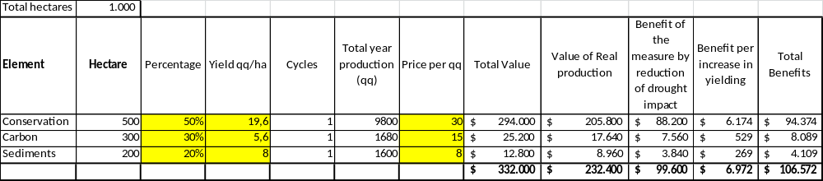
Table 19: Cost – benefits component 1
Source and methodology: MAE, 2016.

- The result of the cost-benefit analysis with the aforementioned data shows that the project is profitable as it has an internal return rate of 5% which is a very reasonable number considering that this is a conservation project focused on protecting and preserving ecosystem services. This amount is without taking into account the possible increases in yield or co-benefits in other areas of agriculture for the implementation of other adaptation measures that are considered within this component addressed to improve livestock management and the improvement of ovens for panela production.

- With the conventional panela production system, the time spent for the process is roughly six hours/580 liters of cane juice (MAGAP 2017), the new technology and measures proposed help to reduce the hours of work invested by farmers for the panela production, collecting water and in implementing inefficient low-yielding practices (four hours/580 l)1 that could threat their surrounding landscape and ecosystem services. This last point is a non-monetary benefit that could increase their life quality since they can invest their remaining time to other productive or family activities.
- The conservation value was calculated based on the fixed rates that Socio Bosque program has established for its operation, the amount of carbon has been determined accordingly to the price paid per hectare in the carbon market (estimated) and the sediment value has been calculated considering the established price in referential projects to dredge due to sedimentation accumulation using as a reference the national system of public hiring Sercop: CONPC-APG-001-2014.

- The result of the cost-benefit analysis with the aforementioned data shows that the project is profitable as it has an internal return rate of 5% which is a very reasonable number considering that this is a conservation project focused on protecting and preserving ecosystem services. This amount is without taking into account the possible increases in yield or co-benefits in other areas of agriculture for the implementation of other adaptation measures that are considered within this component addressed to improve livestock management and the improvement of ovens for panela production. At the same time, the implemented measures help to reduce the hours of work invested by farmers in collecting water and in implementing inefficient low-yielding practices that could threat their surrounding landscape and ecosystem services. This last point is a non-monetary benefit that could increase their life quality since they can invest their remaining time to other productive or family activities.

10 years time horizon | r=3% | r=5% | r=10%
Net present value of benefits | $1.128.332 | $1.034.310 | $ 848.624
Net present value of costs | $ (961.163) | $(944.400) | $ (911.295)
Net present value (NPV) | $ 167.169 | $ 89.910 | $ (62.671)
Cost/Benefit relation | 1,17 | 1,10 | 0,93
Internal rate of return (IRR) | 8%
Table 20: Internal rate of return component 1

- The following table 21, shows that the initial investment with 3% of discount rate will have a return of $1´128.332 USD from which we deduct the costs of 961.163 and the result of the NPV is $167.169, which shows that the project is profitable under this rate of discount.

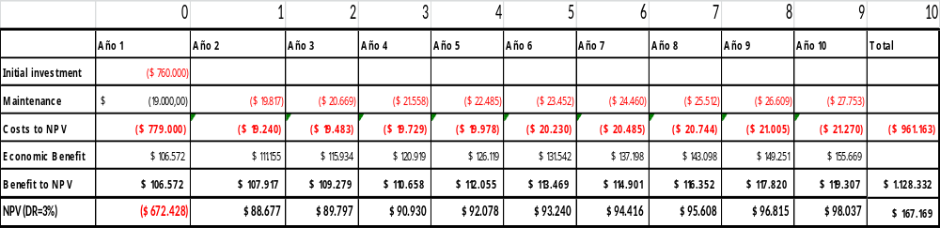
Table 21: DR3% component 1

- The following table 22, shows that the initial investment with 5% of discount rate will have a return of $1´034.310 USD from which we deduct the costs of 944.400 and the result of the NPV is $89.910, which shows that the project is profitable under this rate of discount.
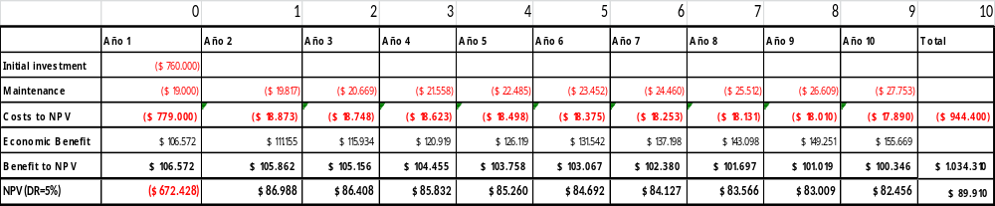
Table 22: DR5% component 1

- The following table 23, shows that the initial investment with 10% of discount rate will not be profitable under this rate given that the profitability of this component will be of 8% as demonstrated by IRR, but this is a project that not only brings economic results but many benefits derived from conservation and preservation of ecosystem services in the long term, that not all of them are necessarily quantified here.
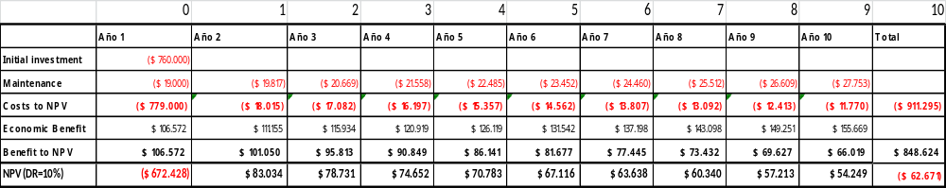
Table 23: DR10% component 1
- The payback graphic shows that the investment will be recovered in approximately 8 years with a discount rate of 3%, in 9 years with a discount rate of 5%.

Figure 24. Investment and payback component 1
- The following figure, allows to evidence that the contribution of the project in conservation and improving of management practices, makes preservation measures profitable, because it allows the farmers to have economic and non-economic benefits in 10 years, by reducing losses when taking measures in the face of drought and constant threat of deforestation, and the potential increase in yield due to the incorporation of techniques that improve agricultural management and forest preservation.

Figure 25. Comparative scenarios component 1

Multicriteria analysis

- To analyze the measures not only from a quantitative but from a qualitative perspective as well, a multi-criteria analysis was performed. A set of criteria was established with some indicators that will allow comparing which criteria has more weight while implementing the preservation measures. This analysis is performed given that there are several benefits that are not always easy to quantify in monetary terms.

N. | Criteria | Indicators
1 | Environmental: Conservation of natural landscapes | # of ha of forest conserved in the Bio-corridor
2 | Economic: Reduction in the use of wood | 30% of reduction of current use of wood
3 | Social: Planning and PDOT | # of Decentralized Governments (GAD) with planning, regulatory and normative instruments for ACUS
Table 24: Multicriteria analysis component 1

- A relative weight in a numeric scale is given to each criterion to determine what is more important at the moment of implementing adaptation measures, and at the same time, three benefits were chosen to make a comparison between them.
- In relation to Table 24 generated as a result of the multicriteria analysis, it can be evidenced that the main criterion for the implementation of adaptation measures in at least 2800 families gives a higher weight to the social aspect as the principal factor for its benefit and implementation.
- The practice of “improving sustainable production alternative to reduce pressure on forests” gives an equal weight to the three criteria meaning that all of them are important for this activity. And the third measure, establishment of functional conservation areas as part of the toachi/Pilaton corridor gives as well a higher weight to the social aspect, highlighting once more the importance of local planning to achieve the expected conservation results to benefit the population of the intervention area. So the component will bring benefits to the local population not only in terms of economic benefits from conservation of landscape and from the reduction of wood use, but also social benefits in terms of improving their capacities to plan and improve their practices with a holistic approach and with a long-term vision.

Figure 26. Multicriteria approach component 1

Cost-Benefit Analysis Component 2

- For the analysis of component 2 a total beneficiaries of 375 families (families are conformed by 5 or 7 people) has been considered with an average of 1,33 hectares, a 20% level of drought affectation due to the natural characteristic of the area that presents many slopes and an average inflation of 4.3%.
- The following practices have been identified based on the initial analysis executed. They will be the basis but will not be restricted only to them, in case it is considered necessary to implement complementary measures during the implementation. The amount of annual maintenance value $7,933 comes from adding the annual individual values of the following measures:

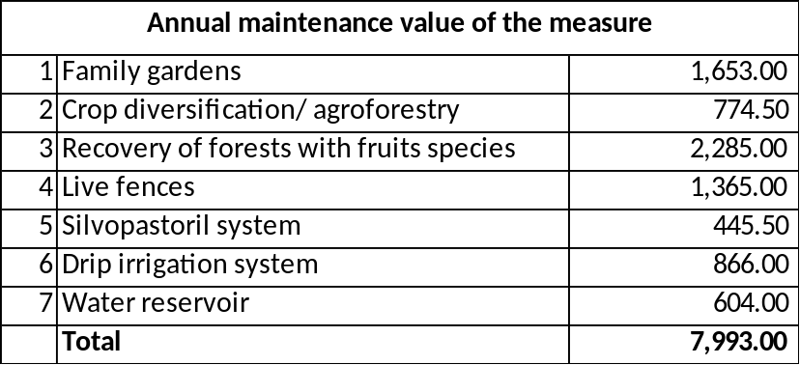
Table 25: Imputs cost – benefits component 2
Source: CEDIR (2015) , MAGAP

- The implementation of these measures is expected to diminish the impact of drought and the consequent economic loses to farmers by increasing its crops yielding by 3%. For this analysis the three principal crops of the area were considered.

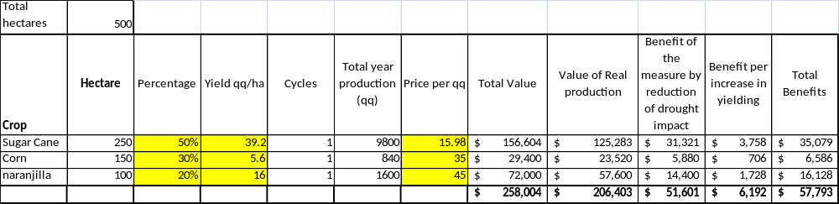
Table 26: Cost – benefits component 2
Source and methodology: MAE, 2016.

- The total production of the target area was estimated taking into account the year production cycles and the yielding (quintals per hectare) to finally determine the potential of implementing the adaptation measures. The analysis was made under the reasoning that a hectare produces that yield. Given that some lands are farms and most of them are slopes in order to be more efficient they have to diversify their crops and take the most out of their lands.
10 years time horizon | r=3% | r=5% | r=10%
Net present value of benefits | 611,883 | 560,896 | 460,200
Net present value of costs | (384,626) | (377,574) | (363,648)
Net present value (NPV) | 227,257 | 183,322 | 96,553
Cost/Benefit relation | 1.59 | 1.49 | 1.27
Internal return rate (IRR) | 18%
Table 27: Internal return rate (IRR) component 2

- The result of the cost-benefit analysis with the aforementioned data shows that the project is profitable for each of the three discount rates analyzed (3%, 5%, 10%), without taking into account the possible increases in yield or co-benefits in other areas of agriculture such as cattle ranching. At the same time, the measures implemented help to reduce the hours of work invested by farmers in collecting water and in implementing inefficient low-yielding practices.
This last point is a non-monetary benefit that could increase the life quality of local farmers since they can invest their remaining time to other productive or family activities.
- The following table 28, shows that the initial investment will have a return of $611.883, from which we rest $384.626 from maintenance cost, resulting a NPV of 227.257, which shows that the project is profitable under the rate of discount 3%. The internal return rate is 18% which is very reasonable number.
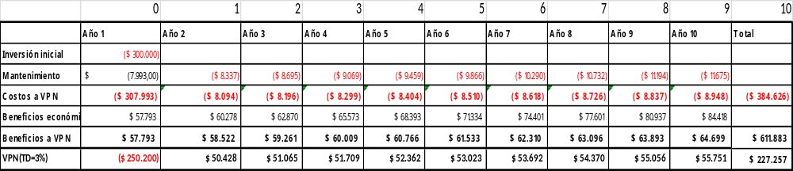
Table 28: DR3% component 2

- The following table 29, shows that the initial investment will have a return of $560.896, from which we rest $377.574 from maintenance cost, resulting a NPV of 183.322, which shows that the project is profitable under the rate of discount 5%.

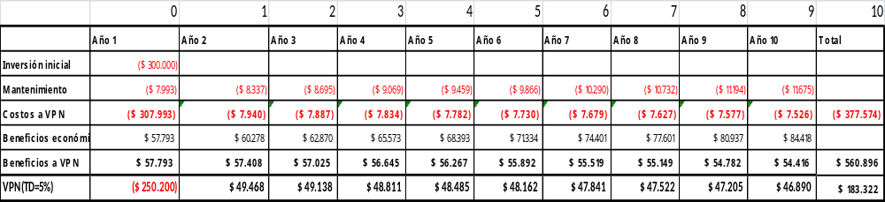
Table 29: DR5% component 2

- The following table, shows that the initial investment will have a return of $460.200, from which we rest $363648 from maintenance cost, resulting a NPV of 96.553, which shows that the project is profitable under the rate of discount 10%.
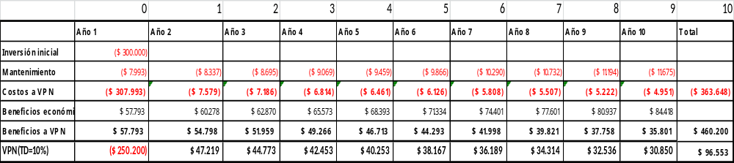
Table 30: DR5% component 2
- The payback graphic shows that the investment will be recovered in 6 years with a discount rate of 3 and 5%, and in seven years with a discount rate of 10%.

Figure 27. Investment and payback component 2
- The graph of inaction vs. action, allows to evidence that the contribution of the project in agricultural crops, makes adaptation measures profitable, because it allows farmers to have economic in 10 years, by diminishing the risk of losses when taking measures to face of drought and inefficiency, and the potential increase in yield due to the incorporation of techniques that improve agricultural and irrigation management.

Figure 28. Comparative scenarios component 2

Multicriteria analysis

- To analyze the measures not only from a quantitative but from a qualitative perspective as well, a multi-criteria analysis was performed. A set of criteria was established with some indicators that will allow comparing which criteria has more weight while implementing adaptation measures.

 | Criteria | Indicators
1 | Sustainability of the resources | Number of adaptation measures implemented focused on improving agricultural management
2 | Increase in productivity | Product yield per unit area
3 | Finance and social intelligence and planning | Number of people who have received reimbursable and non-reimbursable funds to implement measures based on their planning.
Table 31: Multicriteria analysis component 2
- A relative weight in a numeric scale is given to each criterion to determine what is most important at the moment of implementing adaptation measures, and at the same time, three adaptation measures were chosen to make a comparison between them.
- In relation to the graph generated as a result of the multicriteria analysis, it can be evidenced that the main criterion for the implementation of an adaptation measures is sustainability in the use of resources, since the adaptation measures will allow improving agricultural practices to use resources efficiently and sustainably, seeking their long-term preservation. The result of improving practices leads us to the second priority criterion, which is the increase in productivity, since the improvement in farmers' income is directly related to the improvement in their quality of life. Last, but not least, is the criterion of intelligence and financial and social planning, since the implementation of measures must always be accompanied by an adequate planning that allows its successful implementation and access to economic resources is vital to achieve the implementation of planning.
- At the same time the graphic shows that the measure irrigation systems has a higher influence in increasing productivity, the measures incentives to reduce pressure on forest and sustainable productive practices have the same tendency but in less intensity.


Figure 29. Multicriteria approach component 2
- As previously mentioned, in the area of implementation of the project the main economic activity is the cultivation of sugar cane and its transformation to “panela” in an artisanal way, using as source of energy the burning of wood which causes deforestation. Due to the importance of this activity, it is contemplated within component one and two to change the technology in the productive process with the improvement of ovens and Cooking Systems. This measure does not intend to expand sugar cane cultivation in surface but to provide a more sustainable management of the crop, of the forest and to improve the efficiency of the transformation process.
- The ovens will be constructed with a chimney that will contribute to increase the concentration and storage of heat. The chimney will be made of brick with specific technical dimensions and will be built together with two or more metallic stainless steel pan for cooking the sugar cane juice. Previous experiences from implementing this measure, demonstrates that before the measure was implemented approximately 1/2m³ of wood were required to cook 580 liters of juice, and after the construction of the ovens only 1/6m³ of wood was needed, representing a diminish of 60% in the use of wood. The estimated cost of implementation of an oven is of $20.000, plus $400 in hand labor for its construction.
- This measure presents several benefits: economic because the transformation of the product gives an added value to it, allowing families to increase their economic incomes, but it also has benefits in terms of improving their life quality for having more free time to be dedicate to other productive activities, and in environmental terms contributing to mitigation to climate change by reducing deforestation and the pressure on forests.
- Additionally, the project implementation will seek the supporting of the MEbA methodology and experiences. Considering, the MEbA project has so far implemented almost 10,000 EbA measures (for a total financing of over USD 12 million, exclusively provided by the microfinance institutions’ own funds and paid by the farmers) in cooperation with 5 microfinance institutions in Colombia and Peru and is assessing the implementation of its solutions in Ecuador. The MEbA project is funded by the German Federal Ministry of Environment via its International Climate Initiative.
- The MEbA project has developed tools that support the individual assessment and prioritization of EbA measures to be applied with small farmers as part of operational processes of institutions interacting with small farmers as input or service (such as technical assistance or finance) providers.
- For an overview of EbA measures and the related tool set, please refer to Annex 12.
- It is assumed that all proposed EbA options have clear and measurable benefits for the health of ecosystems and the services they provide. Additional scientific data gathering will form part of the project. Its purpose is twofold:
- Firstly, to obtain granular (i.e., farm-level) data that can be leveraged to drive individual cost-benefit analysis for a given intervention. As per the nature of the benefits involved (monetizable as well as non-monetizable), this cost-effectiveness analysis will use either a Multi-Criteria or a Cost-Efficiency approach.
- Secondly, low-level data will enable periodic reviews for Monitoring and Evaluation to support the still limited availability of academic studies on the actual impact of EbA.
- Local and regional service providers (e.g. financial institutions) will be leveraged to collect this data.
- The proposed mechanism for intervention, channeling funds to local farmers through the local MFI networks and an investment fund (see also sections Component 2, paragraphs), will also be instrumental in achieving cost-efficient results. The underlying principle of incorporating the entire farmer community (as opposed to only a sub-segment) according to its level of vulnerability will assure broad impact. Creating different products for those members of the group who do not have access to market-based solutions for inputs and financing and for those who do is a necessary precondition of this approach.
The former need a stronger focus on subsidized components, while the latter can afford to take on more of the intervention’s cost in form of a credit.
- Careful incentive design will be in place to assure that the more vulnerable groups can be brought into the market as far as feasible. Across groups, the program’s objectives and individual incentives are aligned by providing adequate performance bonuses for all farmers.
- By aligning incentives, leveraging market forces where possible and assuring long-term support through the proposed investment fund, cost-effectiveness will be markedly higher than in comparable projects with a stronger focus on subsidies.
- After performing the cost benefit analysis, a comparison of the internal rate is made in 6 different management scenarios: SENPLADES Ecuadorian project, 10% bank interest rate in Ecuador, 8.68% fixed term of the Bank, 4.28% Ecuador Climate Change and Water Project (PACC), 7.22% FORECCSA Agriculture and Adaptation Project, 26% Livestock Project (Ecobona Ecuador), the project selection were focusing adaptation climate change initiatives.

Summary of scenarios
Internal Return Rate (TIR) | Ecuadorian Project SENPLADES  10% | Ecuadorian bank interest rate  8.68% | Bank fixed term  4,28% | Climate change and water project Ecuador (PACC)  7,22% | Agriculture and Adaptation Project  FORECCSA  26% | Livestock project (Ecobona Ecuador)  14,29%
C1 Conserve vegetation cover  5% | 5% | 5% | 5% | 5% | 5% | 5%
C2 Adapt farming practices to new climate change conditions 18% | 18% | 18% | 18% | 18% | 18% | 18%
Average Project | 11.5% | 11.5% | 11.5% | 11.5% | 11.5% | 11.5%
Table 32-B: Summary of scenarios

D. Describe how the project / programme is consistent with national or sub-national sustainable development strategies, including, where appropriate, national or sub-national development plans, poverty reduction strategies, national communications, or national adaptation programs of action, or other relevant instruments, where they exist.

- One of Ecuador’s advantages in relation to climate change is the articulation of public policies at all levels.
The project is aligned directly with current national environmental regulations. The Constitution of the Republic of Ecuador (2008) contains two articles, 413 and 414, relating to climate change management in the country. Article 414 establishes that “the state will adopt appropriate and transverse measures to mitigate climate change, by limiting emissions of greenhouse gases, deforestation and atmospheric pollution; also will take measures for the conservation of forests and vegetation and will protect the population at risk.” In addition, the Constitution recognizes the need to "oversee land use planning of watersheds and encourage the creation of watershed councils, in accordance with the law."
- The Constitution of the Republic of Ecuador (20th October 2008) contains a number of important provisions of relevance to this project:
- Right of the population to live in a healthy environment Art. 14, 66.
- Recognition of water as a Human Right: All citizens have the right to have safe water in sufficient quantity and quality. Articles 3, 12, 15, 32, 318, 396 and 413.
- Considers water as a strategic resource: It is the support of food sovereignty and sustainable development of the country. Articles 12, 14, 71, 72, 73, 74, 397, and 411.
- Considers water as the Right of Nature and Source of life. Articles 281 and 282.
- Finally, it recognizes water as a heritage resource: Water can not be privatized since it is part of the national heritage considered strategic for the development of the country and for public use. Articles 85, 95, 318, 319 and 419.
- The Constitution of the Republic of Ecuador, which establishes in Article 414 that "The State shall adopt appropriate and transversal measures for the mitigation of climate change, by limiting emissions of greenhouse gases, deforestation and air pollution ; will take measures for the conservation of forests and vegetation, and will protect the population at risk ".
- In addition, the 2008 constitution is an institutional umbrella under which safeguards are addressed and respected. It provides a context for the implementation of a rights-based approach associated with REDD + UNFCCC safeguards and incorporates environmental variables into production activities, ecosystem management, citizen participation in environmental discussions and climate change adaptation (Policies 2,3 and 5 ).
- The National Development Plan, (named during the present period of the Government “the National Plan Lifetime 2017-2021) establishes policies and strategic guidelines related to climate change, such as:
- Objective 3: Guarantee the rights of nature for current and future generations
Policy 3.3: Promote good environmental practices that contribute to the reduction of pollution, to conservation, to mitigation and adaptation to the effects of climate change, and promote them at the global level.
- Proposed Goals for indicator homologation and construction of information: Reduce the Vulnerability Index from high to means, population, livelihoods and ecosystems, in the face of climate change and natural disasters.
- Objective 5: Promoting Productivity and Competitiveness for Sustainable Economic Growth in a Redistributive and Solidarity way indicates that the rural population must strengthen the capacities of social interaction, that strengthens cooperation and networks collaborative as well as the resistance capacities, which respond to adverse scenarios caused by natural effects and climate change.
- Territorial guidelines for territorial cohesion with environmental sustainability and risk management. second. Habitat management for sustainability environmental and integral management risks in b.2. Promote integral and co-responsible management of water heritage to protect its quality, availability and proper use, with recovery actions, conservation and protection of water sources, recharge zones, aquifers and groundwater, considering the equitable access of water for consumption, irrigation and production
- The Ministry of the Environment of Ecuador also considers a specific policy for the management of climate change in its "Policy 3: Management of adaptation and mitigation to Climate Change to reduce social, economic and environmental vulnerability".
- The National Law on Water Resources, Uses and Exploitation 2014 (Water Law), aims to develop the human right to water, as well as regulating the authorization, management, preservation, conservation, use and use of water, included within the national territory in its different phases, forms and physical states, in order to guarantee Sumak Kawsay or good living. In this sense, the management through hydrographic basins is regulated:
- Articles 2, 7 and 17, recognizes the strategic nature of water, the participatory and community nature of its management, as well as the consideration of ecological flows in all forms of use and exploitation to achieve sustainable development.
- Articles 12 and 65, the protection and conservation of sources is the responsibility of the State, the Single Water Authority, the decentralized autonomous governments, users, communes, communities, peoples, nationalities, peasants and property owners where water sources are located , they will be responsible for sustainable and Integrated management, as well as for the protection and conservation of said sources, considering the integrated management approach of resources as cross-cutting.
- Article 64, propose strategies for the conservation of resources in their sources, catchment areas, regulation, recharge, outcrop and natural water channels, in particular, snow-capped mountains, glaciers, páramos, wetlands and mangroves.
- Article 83, promotes the adoption and promotion of measures regarding adaptation and mitigation to climate change to protect the population at risk, the development of mechanisms to encourage and encourage the efficient use and exploitation of water through the application of appropriate technologies in irrigation systems
- The national development plan (SENPLADES, 2013) states in its general objective 7 that climate change is a multi-sector problem of national scope that should be approached with programmatic actions which generate results in the short and medium term.
Specific objective 7.10 focus on implementing measures to mitigate and adapt to climate change to reduce the economic and environmental vulnerability with emphasis on priority groups. In addition, specific objective 7.6 focus on managing water resources in a sustainable and participatory manner, with a focus on watersheds and ecological flows to ensure the human right to water.
- The project is in line with the National Climate Change Strategy (MAE, 2012), in particular with specific objectives 2 and 4. The first, focus on initiate action so that the performance levels of productive and strategic sectors and the country's infrastructure are not affected by the effects of change climate. Also 5, 6, and 8 the national strategy covers the period 2012 – 2025. It defines eight priority sectors for climate change adaptation. The present project is in line with the specific objectives of the adaptation line of work:
- Specific objective 2. The performance levels of the productive and strategic sectors and the country's infrastructure are not affected by the effects of climate change:
Action 1. Strengthen and consolidate the development of projects in the productive, strategic and infrastructure sectors with criteria of adaptation to climate change.
Action 2. Consolidate the actions that increase the resilience of the infrastructure in the face of extreme climate events attributed to climate change.
- Specific objective 4. To manage the water heritage with a comprehensive and integrated approach by the Hydrographic Unit, to guarantee the availability, sustainable use and quality of the water resource for different human and natural uses, in the face of the impacts of climate change:
Action 1. Consolidate the integral management of the water heritage, ensuring its availability, sustainable use and quality for the various human and natural uses in the face of the impacts of climate change.
- Specific objective 5. Conserve and sustainably manage the natural heritage and its terrestrial and marine ecosystems in order to contribute with its capacity to respond to the impacts of climate change:
Action 1. Consolidate and strengthen the implementation of measures that increase the capacity of species and ecosystems to respond to the impacts of climate change.
Action 2. Ensure that the Heritage of Natural Areas of Ecuador contributes to the response capacity of species and ecosystems in the face of the impacts of climate change
- Specific objective 6. Take measures to ensure access of priority attention groups and priority attention to the resources of the response to the impacts of climate change:
Action 1. Promote timely access to health, nutrition and infrastructure resources for the population, especially for groups defined as vulnerable and priority attention, which contribute to the response capacity of these groups in the face of the impacts on the population attributed to the change climate.
- Specific objective 8. Implement measures to increase the response capacity of human settlements to deal with the impacts of climate change. Within this objective, the project will contribute to three key actions:
Action 2. Promote public participation and social organization to facilitate the implementation of response measures to deal with extreme climate events related to climate change.
Action 3. Promote the generation of specific information and its access to the GAD on possible impacts of extreme weather events under possible climate change scenarios.
- The project will contribute to strengthen the development and land use plans of parish governments. COOTAD 2010, through the creation of Biocorridors and ACUS as alternative to conservation.
- The Organic Environmental Code (COA) is an advanced law, articulated to our Constitution, which recognizes nature as subject of rights, responds to current needs. He is optimistic, that is, he looks with pleasure on the use of natural rights in an intelligent rational and responsible way. Not the environmentalist look of the 70s or 80s where there was talk of preserving what it was not to touch. Today we say to the communities that live in the páramos, mangroves, fragile ecosystems, that we want them there to be our partners, conserving those beautiful ecosystems that serve all Ecuadorians.
- The COA deals with the ownership and possession of community lands within the National System of Protected Areas; of the conservation, use and sustainable management of biodiversity and natural resources; of the protection, maintenance and development of collective knowledge associated with biodiversity; and of the practical knowledge, ancestral and cultural traditions contemplated in the 282 articles of the COA.
- Finally, the international instruments with which the proposal is made:

- Kyoto Protocol on climate change
- International Convention for the Elimination of All Forms of Racial Discrimination
- Convention for the Protection and Promotion of Diverse Cultural Expressions
- Convention for the Elimination of Discrimination against Women
- Convention for Biological Diversity
- Convention to Safeguard Intangible Cultural Heritage
- United Nations Macro Convention on Climate Change - Decision 1 / CP.16
- Convention on Biological Diversity - Decision XI / 19

E. Describe how the project / programme meets relevant national technical standards, where applicable, such as standards for environmental assessment, building codes, etc., and complies with the Environmental and Social Policy of the Adaptation Fund.

- MAE is the national environment authority and administer (i) the environmental impact evaluation system, (ii) forest use, (iii) protected forests, and (iv) the national system of protected areas. The project intervention will comply with the environmental regulatory framework established by the Environmental Management Law (Law 37 of 1999, coded in 2004), the environmental impact evaluation system (Executive Decree 061 of 2015), the Forestry and Conservation of Natural Areas and Wildlife law (Law 2004-017 coded in 2004) and complementary regulations.
- The project will seek to take advantage of the recently adopted Organic Law on rural land and ancestral territories (signed on March 2016). This law establishes that rural lands must serve social and environmental functions (articles 11 and 12). The social function refers to be productive, and the environmental function refers to apply sustainable practices and conserve key habitats. It is relevant to the present project that the law:
- The law recognises that private or communal rural land fulfils the environmental function when is dedicated to conservation of renewable natural resources, including forest protection and production, conservation incentives (e.g., Socio Bosque), ecotourism and recreation. There will be incentives to those who fulfil the social and environmental functions.
- The law states that rural state land cannot be claimed by possessors or invaders (article 18); this opens a line of action to solve certain land-tenure issues.
- The law forbids the expansion of the agriculture frontier into fragile and threatened ecosystems (article 50), including cloud forests. However existing subsistence agriculture activities will be respected.
- The project infrastructure will be minimal (i.e., artisanal sediment retention dams) and may not require an environmental impact assessment. Nonetheless, the design and construction will comply with pertinent building regulations.
- The meteorological stations will comply with INAMHI´s required specifications and will be integrated into the national monitoring system.

- About the national technical standards, the project has relation with several local laws, the process for evaluating the national standard consist in the following 4 steps, as shown below:

The technical standards that will be applied in the Project are those that are in step 4 of figure 30 that corresponds to Norms for the Sustainable Forest and Technical norms INEN Ecuador.

- Component 1 would apply TECHNICAL STANDARD OF MAIN TOURIST ACTIVITIES AND ACCESSORIES Ministerial Agreement 75 Official Registry Supplement 105 of February 25, 2009. (https://www.turismo.gob.ec/wp-content/uploads/2016/06/NORMA-TECNICA-DE-ACTIVIDADES-TURISTICAS-PRINCIPALES-Y-ACCESORIAS.pdf);
Manual for the Operative Management of the Protected Areas of Ecuador (http://suia.ambiente.gob.ec/documents/10179/346515/Manual-para-la-Gesti%C3%B3n-Operativa-de-las-%C3%81reas-Protegidas-de-Ecuador.pdf/d313841d-e30d-4edf-a387-c42309147482)
- Component 2: For agriculture there is a technical standard for pesticides, fertilizers, seeds, fertilizers (INEN 330:98, INEN 2331; INEN 1761:2012; NTE INEN - ISO 25119-2)

Figure 30. Four steps for evaluated the National technical standards evaluation

F. Describe if there is duplication of project / programme with other funding sources, if any.
- No duplication with other funding sources was found. However, the project will have synergies with a number of initiatives.
- The project will complement the Socio Bosque Programme, by promoting with local partners the development of long-term mechanisms to provide conservation incentives to local landowners.
- The project will use the results of the following projects:
- Enhancing Resilience of Communities to the Adverse Effects of Climate Change on Food Security (FORECCSA). This project is funded by the Adaptation Fund (AF), the implementing agency is the World Food Programme, and the project partners are MAE, the Ministry of Agriculture, Livestock, Aquaculture and Fisheries (MAGAP), the Jubones River Basin Public Consortium, and the Provincial Government of Pichincha. The present project will use the experience and lessons on mainstreaming gender in rural communities for food security and adaptation to climate change.
- Adaptation to Climate Change through Effective Water Governance (PACC). This is a GEF sponsored project (GEF ID 2931) under implementation. The executing agency is MAE, and the GEF implementing agency is UNDP. It does not cover the present area of intervention, but its lessons will be useful to the present project. The present project will use the experience and lesson on mainstreaming water climate risk in local planning and application of water saving measures by farmers.
- Analysis of the vulnerability of flagship hydropower plants to the effects of climate change (CHECC), in particular the results for the Toachi-Pilatón hydropower plant. The present project is using the results of the watershed vulnerability analyses.
- Third National communication (3NC) and First Biennial Update Report (BUR). This is a GEF funded project (GEF ID 5478) under implementation in Ecuador. The executing agency is MAE, and the GEF implementing agency is UNDP.
The project objective is to prepare the third national communication on climate change and the first biennial update report. The present project will use the results of 3NC, in particular the outcomes of the climate change models and the guidelines for climate change adaptation.
- The present project will aim for collaboration and synergies with HIDROTOAPI´s Environmental Management Plan (EMP) which focus on those communities located in the direct area of influence of the hydropower plant. Actions include strengthening the provision of basic services, education, health and production development. The last element includes improving livestock and agriculture management, promoting tourism microenterprises, and afforestation and reforestation.
- Summarized relevant indicatives in relationship between climate change and territory following table and figure:
Initiative | Sponsor | Objective | Intervention zone | Outputs | Synergy
Enhancing Resilience of Communities to the Adverse Effects of Climate Change on Food Security (FORECCSA). 2017 | Funded by the Adaptation Fund (AF), the implementing agency is the World Food Programme | Adapting to climate change and ensuring food security in the highlands of Ecuador | Jubones River Basin in Loja and Azuay provinces(33 parishes); Pichincha province in Cayambe and Pedro Moncayo cantons | Vulnerability assessment methodology with emphasis on food security and climate change in the Pichincha province and Jubones River basin 2014. | Vulnerability assessment tools, adaptation measures experiences in others territories
Adaptation to Climate Change through Effective Water Governance (PACC) 2015 | Funded by the Global Environmen Facility (GEF), the implementing agency is UNDP | Reduce vulnerability to climate change through effective water resource management | Watersheds of Paute, Jubones, Catamayo, Chone, Portoviejo and Babahoyo | Vulnerability to climate risks in the water sector, rivers Paute, Jubones, Catamayo, Chone, Portoviejo and Babahoyo.  Risk to droughts, frosts and other impacts of climate change that may affect the agricultural sector in Ecuador. | Publications and experiences in adaptation measures
Analysis of the vulnerability of flagship hydropower plants to the effects of climate change (CHECC), Currently | Public ecuadorian funds | Analyze the vulnerability to climate change of hydroelectric plants and propose measures at the level of watersheds that can be adopted to minimize the impacts of global warming on energy supply | Ecuadorian Hydroelectric, includes Toachi Pilaton watersheds | Analysis of the vulnerability of flagship hydropower plants to the effects of climate change (CHECC), in particular the results for the Toachi-Pilatón hydropower plant | Both projects CHECC and AF share the same territory, and the current initiative is based in the vulnerability information of CHECC project
The Adaptation to the Impact of Rapid glacier Retreat in the Tropical Andes (PRAA), through the Andean Community of Nations (CAN) | Funded by the Global Environment Facility (GEF), | Strengthen the resilience of ecosystems and local economies to the impacts of the glacial retreat of the tropical Andes | Napo province | Vulnerability and Adaptation Measures to Climate Change in Antisana, Quijos, Jeringa, and Papallacta Rivers. | Vulnerability assessment tools and adaptation measures experiences
Socio Bosque Programme  Currently | Public ecuadorian funds | financial incentives to individual and community landowners who voluntarily commit to conserve native forests for a 20-year period | In the river Blanco basin cover 10959,83 ha with 93 beneficiaries | Conservation areas in the zone of intervention. Methodology and mechanism to forest conservations | Territory and Mechanism to forest protection based in Payments for Environment Services.
Sustainable Development of the Ecuadorian Amazon: integrated management of multiple use landscapes and high value conservation forests, Currently | Funded by the Global Environment Facility (GEF), the implementing agency is UNDP | Catalyze the transformation of land use planning and management in the Ecuadorian Amazon (CTEA) by building a governance and sustainable production framework based on a landscape approach | Provinces: Orellana, Morona Santiago, Sucumbíos, Zamora Chinchipe | In execution from 2018 to 2022 | Adaptation to climate change in territories different to the currently initiative. However, the methodology to implement adaptation measures and experiences are similar
Priming Financial and Land-Use Planning Instruments to Reduce Emissions from Deforestation, Currently | Funded by the Green Climate Fund (GCF), the implementing agency is UNDP | Investment to control agricultural expansion into forest areas; optimize existing financial, economic mechanisms to  Implement agricultural and livestock production practices that reduce deforestation; | North Amazonia, Middle Amazonia Centro, and South Amazonia that includes Bosques Secos in Loja Province | In execution from 2018 to 2022 | Currently investments to control agricultural expansion into forest areas.
Promotion of climate-smart livestock management integrating reversion of  land degradation. Currently | Funded by the Global Environment Facility (GEF), the implementing agency is UNDP | To reduce soil degradation, increase adaptive capacity to climate change, and mitigate GHG emissions by implementing cross-sectorial policies and  Climate-smart livestock management. | Provinces: Loja, Manabí, Guayas, Santa Elena, Imbabura, Napo, Morona Santiago. | Social, environmental and economics vulnerability in seven provinces in Ecuador | Currently sustainable livestock production
Table 33: Initiatives portfolio with relations to climate change
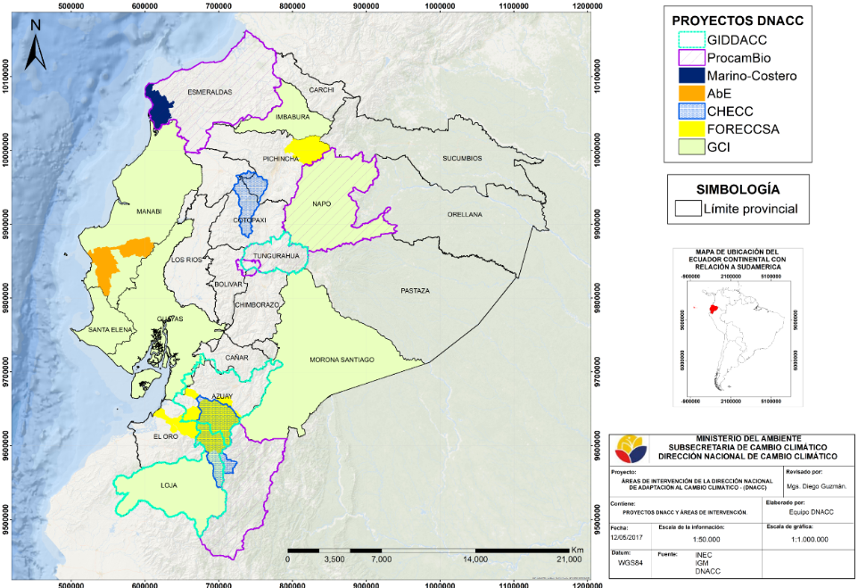
Adaptation Fund P.

Figure 31. Adaptation climate change initiatives 2018

G. If applicable, describe the learning and knowledge management component to capture and disseminate lessons learned.
- The proposed Project was built on the experience and lessons learned primarily from the CHECC project, which are valuable as many stakeholders in the proposed Project remain the same, but also new players are being incorporated. In this respect, considering the lesson learned that careful, early-planned partnerships with key stakeholders increase the viability and chances of Project success. The Project is supporting Government priorities in sectors where alliances at different levels (national, sub-national, local) have already been formed and multi-sector planning activities are already on their way. The project will build on the success obtained by stakeholders analysis (Annex 5) including scientists, decision-makers, water utilities, farmers and community members.

- According to the experience of MAE from implementing previous projects at local and national level, the ability of countries to increase their CC resilience is directly linked to their capacity promote local solutions to address common problems and challenges with a holistic, cross-boundary and participatory approach.

The proposed Project has embedded local vision-activities into the design of main components. Activities in the component 3 will foster local exchanges and cross learning, systematization, taylor-made products and the understanding of opportunities for replication and up-scaling.

- The Component 3 of the project focus on learning and knowledge management. It comprises one outcome (i.e., outcome 3) and four outputs (i.e., outputs 6, 7, 8 and 9).
- The backbone is the public communication and education plan that will (i) raise public awareness and engagement, (ii) facilitate communication and collaboration among stakeholders and project partners, and (iii) enable dissemination of information and lessons through taylor-made communicational products. For the context of the community it has been determined that the mass media that has bigger reception within the community is the radio, therefore radial wedges will be developed to disseminate awareness messages and promote the activities of the project to motivate more people to join this efforts. In addition, the project intends to produce infographics to show how some improved agricultural practices have to be implemented and also to give maintenance to the improved stoves. These infographics will be placed in the community meeting space.

Figure 32-A. Communications plan
- The project will disseminate information and results through MAE´s website and the social networks it uses (e.g., Facebook, Twitter). MAE´s policy is to upload all the information within the so-called unique system of information SUIA (for its acronym in Spanish) that belongs to MAE and in the corresponding sections of its main portal. MAE´s communications office will ensure that information will be channelled to local and national media to reach a wider audience.

- The project team will systematically document and record the advances, best practices, challenges and lessons learned, which will derive in recommendations for future replication of the experience. A monthly electronic information bulletin will be prepared and disseminate to inform the stakeholders and interest groups. It is envisioned to produce communicational material and documents like infographics of good practices and procedures to be used by local communities and stakeholders and policy briefs to provide recommendations to policy makers at different levels.
- In the following table, the activities of Components 1 and 2 with the Knowledge Management of the Communities and the Strengthening of learning are shown:

Component 1: Component 1: At least 230,000 ha of native vegetation is conserved to reduce the impact of climate change on the hydrological cycle under integrated watershed management

Outputs of the project | Learning and knowledge management
ha of forest conserved in the Bio-corridor | Learning - doing one of the ways in which protected areas interact with communities, the community can take care of it, with the creation of Biocorridor, community participation with a gender approach is promoted, for decision making and responsibilities in the activities of tourism, organic production, reforestation, integration in the development of Management Plans for Protected Areas. Prepared in Component 3, a technological team that aims to transfer knowledge and capabilities of natural resources to communities.
Decentralized Governments (GAD) with planning, regulatory and normative instruments for ACUS | Implementing Territorial Land Use Plans (TLUP) that incorporate specific provisions to climate change effects and it apply regulatory or normative instruments in relation to conservation and ACUS declaration, will be free access information that can serve as a replica for the implementation of other GADs
7 hydro-meteorological stations providing climatic data in a regular bases and located accordingly to technical criteria by INAMHI | The previously existing equipment improved and the proper functioning will be reinforced with a hydrometeorological monitoring system that works correctly in the data reported by the hydrometeorological stations to manage the data efficiently for sustainable agricultural planning.
Component 2. Adapt farming practices to new climate change conditions enable their sustainable climate smart financing
Outputs of the project | Learning and knowledge management
Sustainable farming practices and livestock adjusted to local realities are being introduced and implemented with assistance of financing mechanisms for adaptation measures | At least 250 ha of pasture and 250 ha of crops apply sustainable farming practices and will include 50% women and 50% men including also vulnerable groups, will strengthen the capacities and skills of producers, producers through training in leadership, formulation of productive projects , ecological agriculture. When the project starts, the best MEBA proposals to implement in each farm will be decided depending on the location, economic situation, the beneficiary families will transfer the knowledge to their descendants.
Producers that implement better technology to decrease use of firewood of panela | At least 10 artisanal panela producers applying best available technology (BAT), could obtain better results in panela production, their income would be seen, and the pressure on the forest will be reduced. Knowledge and trust, so that the groups of producers interested in working jointly integrate their efforts (exchange of knowledge) with the purpose of executing projects that complement their productive capacities and thus obtain economic advantages in the short and medium term. (Capacity building). Infographics will be developed in this component.
Institutions have introduced specific solutions and risk assessment methodology to support the disbursement of credits for adaptation, integrate sustainable and climate smart criteria in their whole operations | Financial institutions incorporated into their business operations financial sustainability issues, including climate smart lending methodology and tools, who introduced specific EbA-focused lending products, the elements of learning and experiences will be used to promote the integration and participation of local actors. Through the learning of these new financial methodologies by the Institutions, they can be replicas for the rest of the country.
Table 34: Keys activities and knowledge

H. Describe the consultative process, including the list of stakeholders consulted, undertaken during project preparation, with particular reference to vulnerable groups, including gender considerations, in compliance with the Environmental and Social Policy of the Adaptation Fund.

- During preparation of the project concept, there was consultation with local groups and relevant government organizations. The consultation process started in 2015 by sharing the project idea and receiving feedback, impressions and recommendations from local stakeholders. The following workshops during 2016, gathered a bigger number of representatives and in 2017 the same actors were invited but also the invitation was broadened to a bigger number of local stakeholders and to more communitie’s representatives. It has been a gradual process where the intention was to involve each time more and more relevant actors. During 2017 workshops, a great enphasis was made on ensuring the presence of vulnerable gropus’ organizations or representatives (women, the elderly, the disabled, migrants, etc.) to ensure the inclusion of their opinion and the roles that they will have during the implementation of the project. During workshops, several factors were taken into account to be more time-effective, for instance to provide a confortable environment in terms of ensuring that men and women would feel free to talk, establish a schedule of workshops that would not intervene with their normal labor activities, consider if women can bring their children to the workshop or ensure that there is an appropriate place to leave them undercare and to make separate groups by sub-basin to have specific feedback. This approach of building together with local actors the project activities based on their needs and challenges was useful to inform the design of the project, ensure they will have a role and to ensure the participation not only from vulnerable groups but from the different and relevant stakeholders from different sectors. Some indicators and means of verification were defined to ensure and monitor this participation during implementation. More details are provided on the following paraghraphs.
- Local stakeholders were approached during 2015 to discuss the project idea (Annex 5). As a result from this the communities made their suggestions and expressed their expectations saying that they would be interested in a project that can protect the water sources especially in the higher basins, promote a change in production patterns especially near the rivers, identify and preserve the water springs and to strenghthen association and participation processes. During this phase the local governments of Manuel Cornejo Astorga (Tandapi, Pichincha province), Palo Quemado (Cotopaxi province), Pampas de Aguilla (Cotopaxi province), recognized the project idea and expressed their will of supporting this in the near future.
- During June 2016, the intervention area was visited to identify key stakeholders and gather initial information about their perspectives and needs. This information served to prepare the inception workshop.
- On 15 July 2016, an inception workshop was held in Unión del Toachi (Annex 4). Participatory rural appraisal techniques were used to gather local perceptions, views and opinions.

  - Thirty-nine people participated (14 were female, 35.8%), including the main farmer´s organizations, all the parish governments, the two main municipalities (Sigchos and Mejia), local NGOs, and key government entities (e.g., MAGAP, SENAGUA, INAMHI, MAE). Transportation was provided to facilitate attendance of remote participants. Some areas are quite retired, with limited access to public transportation. Participants from Sigchos (the most distant site) had to travel for about three hours to attend the meeting. The memoir of the workshops (including list of participants) is in Annex 4 and 10.

The workshop had the following main elements:

- The existing knowledge about future weather conditions in the area, and the probable impacts of climate change were presented. The results of MAE´s analyses were handed in printed maps. Participants were motivated to clarify doubts and present their views and experience.
- The initial ideas of a project concept (i.e., draft results framework and budget allocation) were presented. Participants were motivated to comment and provide initial recommendations.
- Two groups were formed, corresponding to the major sub-basins (Pilatón and Toachi). Each group prepared a participatory situation analysis, identifying the key issues, probable causes and groups involved. In plenary, priority issues were selected for each subbasin.
- The Toachi group presented among its main results a severe deforestation problem, agricultural expansion in forest areas, low yielding in farming production, weak protection of forests. Farmers have expressed that they would be incentivized to preserve the forest if they receive support for increasing their yields and they have agreed that it is important to improve the access to climate information.
- The Pilaton group highlighted the importance of strenghthening the connectivity of habitats and ecosystems, to work in risk areas prone to landslides and flooding and improve meteorological information given the current lack of stations.
- The same groups identified priority actions and probable sites and local actors. The Toachi group identified in maps the potencial areas that need to improve preservation, the already existing protected areas that need to improve its management and the first steps to be taken in order to improve agricultural practices and the potential partners, they also prioritized the need to improve climate information and to include environmental training within schools. The Pilaton group identified in a talking map the location of water springs that will need to be potentially intervened first, the need to improve maps to better identify other priority areas for the project and the actors that will intervene. In plenary, proposals were reviewed and adjusted. Also, farmer organizations and parish governments confirmed their interest to contribute to project design and execution. There were recommendations of other key groups that need to be approached.
- To close the workshops, participants outlined a set of agreements for adjustments of the project concept, and pending elements to be addressed in the following months (e.g., prepare maps using more recent information on land use and forest cover, analyse land tenure and conflicts in protected forests).

  - As a result of the aforementioned consultation process and based on the needs and recommendations expressed there by the local institutions and communities, the project concept was adjusted and specific targets were set.

  - After the inception workshop, a stakeholder analysis was prepared (Annex 4). Semi-structured interviews were applied to groups in all locations of the watershed.
  - Mining companies, with concessions in the area of Palo Quemado and Las Pampas, are a stakeholder that had been overseen. Mining operations are initiating; therefore, this actor can have strong influence in the social and economic dynamics of the lower basin. The role of mining companies and their integration into the project will be assessed during project preparation.

- To continue working on project preparation and with the consultation process: on tuesday July 11 and Wednesday, July 12 of 2017, a meeting was held with representatives of the municipal governments of Sigchos and Mejía, and the parish governments of Las Pampas, Palo Quemado and Manuel Cornejo Astorga. On Friday, July 21, a meeting was held with representatives of the parish government of Aloag. During these visits, which lasted an average of one hour, ideas and concerns about the project were collected and also were informed about the progress. Attendees were also anticipated about socialization workshops scheduled for Monday, July 24 and Tuesday, July 25 remarking the importance of participation of women and vulnerable groups. Memories of the event are located in Annex 4.B.
- The session plan that was developed for the workshops to work closely with the stakeholders, also exclusive sole space of time of about 30 to 40 minutes was included in the agenda to work only with women and vulnerable groups. In this time period a personal survey was carried out to better understand of their impressions regarding the project.
- On Thursday, July 20, a visit was made to the INAMHI facilities to update their new staff members on the progress of the project. Information was also collected on the weather stations in the Toachi river area.
- On Thursday 20 July 2017, in conjunction with a CAF official, telephone calls were made to the principal representatives of the Municipal and Parish GADs, emphasizing the importance of the assistance of groups of women and vulnerable groups to the workshops.
- On Friday, July 28, 2017, a visit was made to SENAGUA facilities to inform the new personnel about the progress of the project and to know the implications of a water fund in the context of the Water Law.
- On Monday, July 24, 2017, a socialization workshop was held in the municipality of Sigchos. The event started at 10:00 a.m. and lasted 7 hours. The round trip transport was facilitated for the assistants of Palo Quemado and the Pampas. This group analyzed in detail the implications of the project for the Toachi River basin. There was an attendance of 38 of which the 42% were women. Food was provided to all attendees.
- On July 25th, the socialization workshop was held at the meeting hall of the parish government of Manuel Cornejo Astorga (Tandapi). This workshop started at 10:00 a.m. and had a 6 hour address. This group analyzed in detail the implications of the project for the Pilatón river basin. There was an attendance of 49 people of whom 43% were women. Food was provided to all attendees.

The workshops had the following elements:

  - A brief introduction and contextualization of the project by the authorities of the CAF, MAE and local authority.
  - Power point presentation was made, reinforcing the conceptual basis of the adaptation project, emphasizing the effects of climate change on the region and addressing the environmental degradation problem in the Río Blanco upper basin.
  - The presentation of the components, "outcomes" and "outputs" of the project with the respective allocation of resources is carried out. In addition, a printed document with the data of the logical framework of the project was given to everyone.
  - Subsequently, work groups were set up to carry out a component analysis, then three groups were formed, accompanied by a moderator from the group of consultants. Big papers and markers were given to summarize and present the main points.
  - Color maps were given to each of the groups and maps printed in A1 format were placed on the walls of the room, so that the participants could be located geographically by themselves.
  - Each of the groups gave a presentation of the relevant topics of discussion and group analysis. Comments and suggestions have been considered for the final version of the project.
  - At the same time, an anonymous survey on conditions of access to credit was passed to the attendees
  - Finally, we work independently with the groups of women and vulnerable groups with whom the information of a given survey is individually filled. Survey format Annex 4.

- The definition of activities in the territory was carried out through the execution of work meetings in the basin of the Pilato River and the communities of influence and another one in the basin of the Toachi River, the measures of July 24 and 25 respectively. 87 people participated in the meetings, 43% of them were women, the calls to the workshops promoted the participation of vulnerable groups, women and the elderly; during the execution of the workshops an activation of these characteristics is evidenced and their criteria, expectations and suggestions were reflected in the definition of activities and products. The following is a summary of the working methodology for the definition of activities by the communities participating in the project:

  - Watershed Pilatón:

1. Relevant information about the project, macro activities and estimated budgets for each activity was exposed
2. Each of the participants was asked to detail their knowledge of the environment, support maps were used.
3. Each participant was asked to share their successful experiences regarding productive and environmental issues they have developed, considering their livelihoods.
4. The facilitators shared a set of guiding questions on the subject of gender, work of vulnerable groups and associativity.
5. In the working groups it was agreed that the women would lead the work table and present the findings around the proposals for the components in the plenary.
6. During the working plenary, the women were given the floor and they commented on the proposals for the conservation of the vegetation cover in the basin.
7. It is important to mention that the working groups identified indicators and means of verification that promote the participation of women, so, the zoning and planning of farms in this project must be executed with the participation of at least 50% of women, considering their close relationship with the environment and livelihoods in the area.

Below is a brief outline of the proposals made in the Pilaton work group:

Figure 32-B. Community consultation evidence

  - Watershed Toachi:

1. Relevant information about the project, macro activities and estimated budgets for each activity was exposed
2. Each of the participants was asked to detail their knowledge of the environment, support maps were used.
3. The facilitators shared a set of guiding questions on the subject of gender, work of vulnerable groups and associativity.
4. Due to the participation of the Municipal GAD of Mejía and Mgtr. Jorge Campaña, specialist in linkage MAE with GADs exposed experiences at the national level for the creation of conservation areas (ACUS) biocorredores and other conservation categories that Ecuador has now undertaken.
5. In the working groups, it was agreed that the women would lead the worktable and present in the plenary the findings on proposals for the component
6. The participants proposed that, initially, the conservation bio-corridor should been declared, which should include:

- Study of land tenure
- Environmental Management Plan
- Financial Strategy for the sustainability of the proposed Biocorridor
- Management model

7. In the working group it was considered to formalize the constitution of the Conservation Areas and the Biocorridor through the support of the GADs and that in the Biocorridor priority areas are defined under existing criteria of the MAE for the 1000 ha in order to maintain the flow of the Toachi river and the reduction of sediments.
8. The need to establish fixed positions of forest control and improvement of the hydrometeorological monitoring system was highlighted.

Below is a brief outline of the proposals made in the Toachi work group:

Figure 33. Community consultation evidence Toachi

I. Provide justification for funding requested, focusing on the full cost of adaptation reasoning.

- The present project will allow to mainstream adaptation into local communities and implement actions to address specific threats and barriers. The AF contribution will allow to implement three key adaptation measures within a watershed perspective: (i) to conserve vegetation cover, (ii) to reduce pressure from farming activities, and (iii) to engage the local population into climate change adaptation.

Component 1. Conserve vegetation cover
Baseline
- The two existing protected forest (Toachi – Pilaton and Sarapullo), cover a large area of the water system (ca., 230,000 ha) to safeguard the water cycle. MAE´s Forestry National Directorate is responsible for managing these forest. However, these areas are not being managed and guarded. Farmers have invaded and cleared extensive areas to establish grazing areas and extensive farming systems. Some invaders have claimed possession rights to the municipal and central authorities, creating a severe land tenure issue, it will be resolved with the biocorridor process. The extent of the invaded area is unknown.
- Some landowners have established private reserves to conserve biodiversity. There are at least three private reserves covering about 2,800 ha.
There are limited incentives to maintain forest areas in natural condition. The Socio Bosque programme was an interesting option, but after a promising start ran into financial problems. Private landowners of forest areas also face pressure from illegal farmers.
- It is foreseen that climate change will reduce rainfall in the Río Blanco upper water system and produce stronger and more frequent ENSO events. Deforestation and forest degradation will exacerbate climate change impacts. The reduction in water availability will affect farmers, household water use, water companies and HIDROTOAPI hydroelectric plant.

With Adaptation Fund investment
- The project will support the protection of forest cover to mitigate, as much as possible, the impacts from climate change. The key premise is that a large forest will better withstand changes in weather conditions and will continue to capture moisture and feed river streams.
- The project will allow to:
- Develop and implement a system of incentives to finance the conservation of the existing protected forests and to provide incentives to landowners that voluntarily commit to the conservation and protection of their native forests and vegetation. The investment fund that will be established in the project contributes to finance incentives for adaptive investments providing contributions for a better water use and invest in forest conservation (e.g., incentives to landowners, protection, reforestation), training, technical assistance, ect.
- Strengthen the institutional and legal framework to manage and protect the Toachi – Pilaton and Sarapullo protected forest and private reserves.

Component 2. Adapt farming practices to new climate change conditions

Baseline

- Local farmers contribute to forest degradation. Their production is based on extensive and subsistence farming and the application of inadequate practices that contribute to soil degradation and erosion. The main pressures come from livestock producers and sugarcane farmers. Livestock producers clear forests and invade river margins to establish grazing grounds. Sugarcane farmers, mainly based in Las Pampas and Palo Quemado parishes, clear forests to expand the production area and to obtain firewood for the artisanal production of panela. Each family furnace consumes about three trees per week.
With Adaptation Fund investment
- AF support will allow to introduce sustainable farming practices to increase production per unit area, therefore reducing the need to clear forest to expand farming areas.
- Improved farming practices will be introduced in at least 250 ha of livestock production and 250 ha of crops of sugarcane, mortiño and naranjilla, and Sustainable productions alternatives will be implanted The project will work with farmers´ and women organizations in Las Pampas and Palo Quemado parishes mainly.
- Panela production will be analysed and upgrading to the furnaces will be introduced to improve efficiency (less energy and equal or more production) and reduce the consumption of fire wood.
- Dedicated methodology and software solution will be developed for financial institutions providing credits for agriculture activities in the area, supporting them to understand climatic risk and environmental impacts, and incorporating in their credit assessment sustainability criteria and climatic issues.

Component 3. Strengthen local capacities and share lessons
Baseline
- The local population and stakeholders are not fully aware of the climate-related risks, and are not engaged into taking action to increase their adaptation capacities. Parish plans mention climate change, but do not incorporate concrete actions to implement adaptation measures.
- INAMHI has eight meteorological stations in the area, but only one is functioning. Therefore, weather monitoring is very limited and the local population do not have access to sound information for decision making. In addition, INAMHI has serious financial limitations to sustain the operation of a network of meteorological stations in the area.

With Adaptation Fund investment
- With AF support a public communication and education plan, grounded on the parish governments. It will cover about 2.035 people (553 families) of the six parishes that are part of the Río Blanco water system. In addition, the project will directly support parish governments to mainstream climate change into the local development plans. All this will allow to engage local stakeholders into climate change adaptation action, and will be a valuable catalyst to increase local resiliency and build social capital. Training will be provided also to farmers to implement adaptive investment and to financial institutions to understand climatic and environmental risks and opportunities.
- The project will also allow to update and expand INAMHI’s hydro-meteorological network in the area. Sediment samplers will be installed to monitor sediment load. Partnerships will be developed to sustain the operation of the hydro-meteorological network and to feed the information to local stakeholders. An option is to include these costs into the water fund that is being considered.

J. Describe how the sustainability of the project/programme outcomes has been taken into account when designing the project / programme.

- The project will have positive environmental impacts. There will be actions to contribute to maintain vegetation cover and to reduce pressures from deforestation and expansion of the agriculture frontier.
- The sustainability of actions has been planned based on three criteria: i) concordance with the regulatory framework; ii) availability of resources and economic criteria; 3) communities empowerment.

Figure 34-A. Initial sustainably concept in the project

Sustainability in all its manifestations is the life capacity of an action or process over time, which has environmental, social, economic and technological scope that its implementation will be during the 4 years of the Project, and then the beneficiaries must appropriate , which is understood as the transformation of beneficiaries into owners, incorporating the actors as assets and social capital and not as social charges, this will be achieved by giving access to resources, self-management, employment, promoting mechanisms of social and economic organization and their participation in decision-making processes, including the vulnerable group, as well as their insertion in the market economy.

Figure 34 - B. Sustainability environmental, social ans economic

In the design of the project the concept of sustainability is outlined as achievable by taking the development in an integral way through the capacity building that is addressed in component 3 of the Adaptation Project. Evaluation: It is proposed as monitoring and evaluation instruments: monthly reports of the technicians, forms of progress records, attendance record in workshops, training.

Figure 34 - C. Transversal Sustainability

- The project has foreseen to have an integral approach in terms of promoting sustainability with different actors from different stages:

- The capacity building process established in component 3 will strenghten the capacities of local communities in terms of conservation, improve agricultural and productive practices and empower communities by promoting association and support a better access to markets. The project will support and accompany the process of promoting association through a better organization and through institutionalizing more frequents spaces of dialogue and interchange between them until they can consolidate these engagement and interchange spaces that will make them stronger. The fact of empowering communities, enhancing their knowledge, improving their yields through more sustainable practices and promoting association gives a leverage to ensure sustainability of these practices in the long term.
- The credit mechanism is sustainable with the investment fund, it is foreseen that parish governments and other project partners will integrate actions into their institutional budgets to ensure post-project sustainability.

Figure 35. Final sustainably concept in the project
- Based on the aforementioned, a sustainability strategy is proposed for each component as described below:
Component | # of Beneficiaries (families) | Activity | Regulatory Framework | Economic management | Community Empowerement +
C1. Conserve vegetation cover | 178 | Improve management of protected forest. | Environmental Organic Code art, 42. Establishment of a financial strategy for the management of conservation areas (Biocorredor) | Development of a financtial sustainability model: Art. 42 COA  Operation of the investment fund. | A functional biocorridor management model with the participation of communities.
C1. Conserve vegetation cover | 178 | Increase conservation area | Socio Bosque mechanism | Payment for Environmental Services | ACUS – Biocorridor Management Plants
C2. Adapt farming practices to new climate change conditions, enabled by sustainable climate smart financing | 375 (250 for crops and 125 for livestock) | Sustainable farming practices and livestock adjusted to local realities are being introduced and implemented with assistance of financing mechanisms for adaptation measures | COOTAD Law,  Good Living National Plan  Sustainable Development ObjectivesObjtives principe 4 | Productivity increase and marketing skills improvement. Advice on access to markets and commercialization. | CommunitiesCommiunuities organization
 | 375 (250 for crops and 125 for livestock) | At least 1 long term financing mechanisms has been piloted or introduced | National Water Law for Investment Fund | Operative financial mechanism mecanism | Effective credit access and incentives
C3. Strengthen local capacities and share lessons  C3. Strengthen local capacities and share lessons | 553 directluy  14000 indirectly local communities  49367 indireddly in river basin  553 directluy  14000 indirectly local communities  49367 indireddly in river basin | At least 6 parishes being built capacities and prepared to manage and use meteorological information. | National Climate Change Strategy and COOTAD | Avoided costs of inaction in adaptation | Effective participatory planning
 |  | Six development plans of local parishes incorporate measures for ecosystem-based adaptation to climate change. | National Climate Change Strategy | Avoided costs of inaction in adaptation | Effective participatory planning
 |  | Strategic plan of communication, education, knowledge transference and scheme of replica, including demonstration farms. Plus training on adaptation finance to financial institutions | National Climate Change Strategy | Improvement of productive and knowledge practices | Knowledge management
 |  | Systematisation of information gathered during the whole project design and implementation using existing informatics platforms | National Climate Change Strategy | Replica to other initiatives | Knowledge management
Table 35: Sustainability strategy matrix

- In the year 2017, Ecuador issues the Organic Environmental Code that defines the guidelines for the operation of the conservation areas in Ecuador, so, in its article 42 about The management tools defined for the protected areas are: 1. - The Strategic Plan of the National System of Protected Areas; 2.- Management Plans; 3.- Operational Management Plans; 4.- Management Effectiveness Evaluations; 5.- The Strategies of Financial Sustainability; and, 6.- The others determined by the National Environmental Authority.
- To promote an active participation in the conservation processes and at the same time in the evaluation of the state of conservation as an element of control over the actions taken in the project, the elements of Financial Sustainability Strategy and Management Effectiveness, which have been included in the present project, are important.
- Similarly, the conservation areas (1000 ha) are based on the concept and mechanism of Socio Bosque, however it will be managed and developed by the project with the support of the project implementation agencies, although it has the concept of Socio bosque, it does not include transfer of direct economic resources to the state program Socio Bosque. During the execution of the project, a post-closure strategy will be developed that will propose as an alternative that the conservation areas under the project be included in the Socio Bosque state program so that the initiated process remains 20 years in the future, such as the original mechanism.
- Social sustainability will be based on the participatory approach and the integration of key stakeholders, where women’s participation plays a major role.
Engaging both men and women to participate in decision making processes could result in a greater likelihood of sustained change (UN-REDD, 2013); however, additional training targeted to women may be needed to ensure their full contribution mainly the planning farms. The project will promote multi-level dialogue, networking and collaboration to build social capital in support of watershed conservation. The capacity building process established in component 3 will strenghten the capacities of local communities in terms of conservation improve agricultural and productive practices and empower communities by promoting association and support a better access to markets. The project will support and accompany the process of promoting association through a better organization and through institutionalizing more frequents spaces of dialogue and interchange between them until they can consolidate this engagement and interchange spaces that will make them stronger. The fact of empowering communities, enhancing their knowledge, improving their yields through more sustainable practices and promoting association gives a leverage to ensure sustainability of these practices in the long term.
- Social and economic sustainability will be complemented by strengthening capacities and providing advice to the project beneficiaries in access to markets and commercialization. This is a necessary complement because after receiving training to improve their farming, production and conservation practices, their products needs to successfully reach consumers in order to increase their economic incomes contributing thus to improve their life quality.
- The project is anchored in pertinent local and national authorities responsible for local development and climate change adaptation. Parish governments are the centrepiece of the project, but it will also involve municipal and provincial governments, pertinent sectoral authorities (e.g., MAGAP, SENAGUA) and community organizations (e.g., Flor de Caña). It is foreseen that through this networking the core elements of the project will continue in the institutional agendas. To ensure this continuity the project will seek to sign agreements of cooperation or letters of commitment between the local governments and the Ministry of Environment (during the initial consultations local governments provided a letter where they recognized the project idea and their will to support), which will provide detail of the activities that they will commit to do in the present and in the future to ensure sustainability.
- An investment fund is considered as a financial and technical mechanism to sustain critical elements like forest conservation, technical support to local farmers and weather monitoring. It is expected that water users (especially GADs) will be motivated to contribute to the investment fund to maintain long-term key actions. The viability of this instrument will be assessed during project preparation. The project will motivate and promote the engagement of other actors like the hydroelectric to contribute to this purpose once the project is running. However, as the hydroelectric has faced some delays on the construction process, it has not started yet its activities. At the moment it is a government institution which is in charge of it and start working, the project team will work to promote their contribution for this purpose. The project will contribute to ensure that the minimum requirements to have the fund working are always in place, envisioning its permanence and it will develop long term plan for this purpose. This activity is an important step to improve the ecosystem of promoting sustainability and formal credit mechanisms for this area and at the same time an opportunity to gradually incorporate the private sector in these efforts.

K. Provide an overview of the environmental and social impacts and risks identified as being relevant to the project / programme.

- The Adaptation Fund´s Environmental and Social Policy (ESP) (AF, 2013) aims to avoid unnecessary environmental and social harms because of AF-funded projects and programmes. The ESP requires that the projects are screened for risks against the AF´s 15 principles of environmental and social safeguarding, and categorised accordingly to the level of potential negative impacts. Projects that present environmental and social risks must undergo a risk/impact assessment, and prepare an Environmental and Social Management Plan (ESMP). The ESMP establish the measures to be taken to mitigate or avoid adverse environmental and social risks and impacts.
- The present final project was screened and assessed as required by the ESP. The results of the screening process are presented in Annex 7.
- The principle on gender equity and women´s empowerment has to be considered transversal in all project outputs. During project preparation, it will be necessary to assess that actions on forest conservation and improved farming practices, do not overload the workload of women and other family members. It has been seen that local men are opting for paid jobs in Santo Domingo (capital of the de Santo Domingo de los Tsáchilas province). Therefore, tending for the farm and animals is being delegated to other family member. In addition, it will be necessary to ensure that the adaptation actions to be mainstreamed into the local development plans and the communication and education actions are gender and age sensitive and do consider the needs of persons with disabilities, set of elements integrated in the environmental and social impacts and risks ESMP Annex 7.
About the Annex 7, was developed based on the Manual of Basic Environmental and Social where environmental and social risks are identified, impacts are assessed and prevention and mitigation used as required, are identified and are required and based on the 15 principles of the adaptation.

The Annex (inform), consolidate the information demonstrating compliance with the ESP in a single document. The document is divided in five sections, related with: 1. Summary description of the project, 2. risk identification and categorization, 3. Environmental and social management plan. 4. Monitoring and evaluation arrangements and 5. Grievance mechanism, following the sheme:
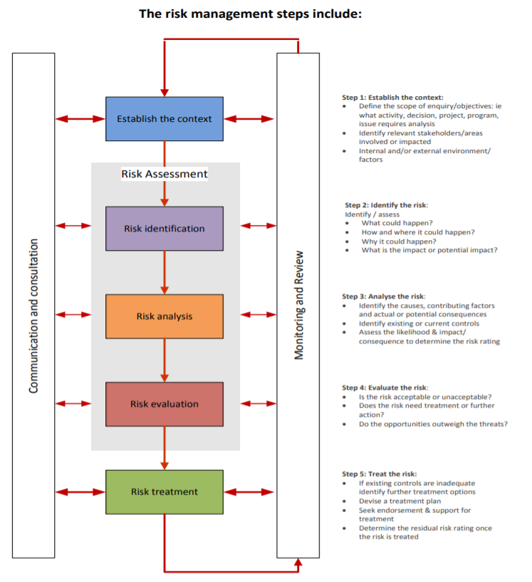
ESP Risks Identification

The following checklist shows the compliance with the economical and social principles in force in this project. Each principle compliance is evaluated by answering with YES or NO the questions identified for each principals. The questions answered with NO indicate a potential risk for the compliance of project principals, which translates into associated risks of the project. Therefore, principals whose questions have been answered with YES, don’t present associated risks, on the other hand, principals whose questions haven been answered mainly with NO, activate the associated risk indicated in the checklist.

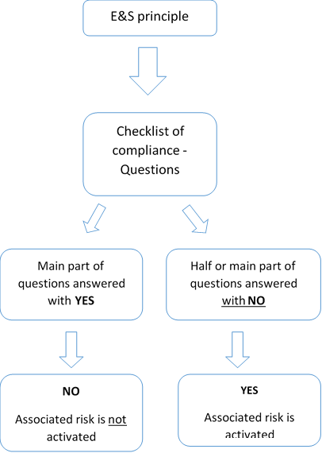

- In addition, screening was done using CAF´s preliminary environmental and social risk analysis matrix (instrument FR-086 as presented, which is part of CAF´s environmental and social management system). As stated in ESP´s article 8 “implementing entities that use a different but functionally equivalent system of categorization can continue to use that system and still meet the requirements of the policy".
- The project execution may generate few and minor potential environmental and social impacts and risks that should be reversible and easy to avoid or mitigate. Therefore, the project is categorized as Category B, according to the categories established in the ESP.
- A brief overview of the project compliance with the expected outcomes of the 15 environmental and social principles is presented in the following paragraphs.

Principle 1: Compliance with the Law.
- The Bio-corridor and investment fund in the project that will require a specific coordination with the national laws about Protected Areas and Watershed Committees. The responsible for public declaratory (GAD still to be defined) will require a participative process according with the Environmental Ministry, on the other hand the water investment fund will be adapted to the national regulations in coordination with SENAGUA

Principle 2. Access and Equity.
- An initial stakeholder analysis was prepared (Annex 5). Key stakeholders were identified, as well as existing or potential conflicts that might affect project execution. The analyses found no evidence of opposition to the project proposal, or conflicts that could affect project execution.
- In general, the project actions will promote access to basic services and land rights.
However, it is noted that measures need to be taken to ensure that local groups are adequately informed of the project intervention, mainly the actions to conserve the forest cover and the mainstreaming of adaptation measures into the local development plans.
- During workshops that took place on Monday 23 and Tuesday 24 at Sigchos and Tandapi respectively, all the information about logical framework, outcomes and outputs were presented to all attendants. Also there were groups work to analyse deeper the way of it implementation must be done, their participation and all the suggestion about improvements. Al, this information was gathered by consultants and recorder in the Annex 4.
A space for intervention of women and vulnerable groups was provided, based on a survey with specific question, which helped to identify the opinion and doubts of these groups about the project.

Principle 3. Marginalized and Vulnerable Groups.
- No vulnerable or marginalized populations will be negatively affected by the project scope. Rather the project aims to empower vulnerable communities. However the project needs to be very carefull that all the activities work with marginalized and vulnerable groups.

Principle 4. Human Rights.
- Ecuador has ratified the core international human rights treaties. The US Department of State Country Reports on Human Rights Practices for 2015 indicate that the principal human rights problems in Ecuador are: excessive force and isolated unlawful killings by security forces; arbitrary arrest and detention; and delays and denial of due process. Violence and discrimination against women, children, minority groups, and the lesbian, gay, bisexual, transgender, and intersex (LGBTI) community; trafficking in persons; and child labour persisted.
- Despite the general context, in the area of work no specific issues concerning human rights were identified that could be exacerbated by the project intervention.

Principle 5. Gender Equality and Women’s Empowerment.
- Ecuador ranks high in the Global Gender Gap Index. Ecuador has almost complete equality in educational attainment and health and survival, and a high level in economic participation and opportunities, but a major gap in political empowerment (WEF, 2015). The stakeholder analysis (Annex 5) found that there is strong women leadership in local organizations and parish governments. Also, women have an important role in businesses like commerce and restaurants. The condition of women in the Río Blanco upper watershed is similar to other Ecuadorian rural areas.
- Illiteracy rates are higher for women, particularly in rural areas, and tend to have completed less years of formal education (see Gender Analysis, Annex 9). Also, female labor force participation is lower than men’s (57% against 81%), which is consistent with a high proportion of women lacking any source of personal income (35%), in comparison with men (9%). There is an earnings gender gap: female’s average monthly earnings represent 78% of male’s average monthly earnings. Feminity index in poor households was 117.6 in 2013, meaning there were more females than males living in poor homes in Ecuador.
- The project will promote women´s participation in project activities. However, it has to be considered that men are increasingly seeking payed jobs in Santo Domingo, the nearest large city. This, in turn, increases the workload for women to tend for the farm and the animals. In rural areas, women tend to work more average weekly hours than men, 82h and 59h, respectively, most of this difference is explained by non-remunerated activities (such as domestic chores and care-taking tasks). Therefore, the project will have to be cautious to implement actions in support of gender equality and women´s empowerment, and to prevent overloading women activities (outputs 1, 2 and 4). Also, it will be needed to ensure that the adaptation actions to be mainstreamed into the local development plans (output 7) and the communication and education actions (output 9) are gender and age sensitive and do consider the needs of persons with disabilities.

Principle 6. Core Labor Rights.
- Ecuador has ratified the eight core labor conventions. The project intervention has no implication with the four fundamental principles and rights at work.

Principle 7. Indigenous Peoples.
- ILO convention 169 is in force in Ecuador. There is no indigenous population in the project area.
The intervention will not affect the indigenous groups or territories. Nevertheless, Ecuador in its Constitution of 2008 recognizes both indigenous peoples’ land rights and livelihoods and the rights of nature. The Constitution’s third part titled Rights, Duties, and Guarantees declares collective rights as they pertain to indigenous peoples. Article 84 states that the State shall recognize and guarantee indigenous peoples rights, in conformity with the Constitution, the law, human rights and collective rights.

Principle 8. Involuntary Resettlement.
- There is no resettlement of communities in the project area, the proposal of component 1 is the creation of biocorridors that allow the interaction of ecological connectivity, sustainable productive landscapes, the association of biodiversity and landscape.
- Ecological connectivity: Ecological connectivity seeks to counteract the fragmentation and loss of habitats, linking protected areas and areas with important biodiversity, as well as increasing the long-term survival possibilities of species in the area. Ecological connectivity can link protected areas or areas with great biodiversity, these parts of the SNAP or not, through a corridor or linking them through sustainable production zones that reduce the pressure on conserved areas

- Sustainable productive landscapes: Sustainable productive landscapes to restore the original conditions of the ecosystems and fulfill their ecological function through productive practices friendly to the environment. Supporting community development, through the identification of emblematic products from biodiversity and agrobiodiversity, with prospects for market access.

- Associativity: The associativity facilitates the articulation and the organization of the producers and local actors in the processes of integration of the territories. To help the processes participate in sustainable development processes by establishing strategic alliances, favoring clean production and fair and solidary trade. The partnership has been achieved with a high degree of participation at local and regional level and through the commitment of community organizations. The associativity is based on cultural affinities (historical processes and shared visions); economic (common products and processes, technological problem versus technology or markets, etc.) and environmental (to collaboratively overcome the fragmentation of ecosystems and structure the biocorridor).

With the aim of achieving the impact under the territorial approach, at the beginning of the project a participatory territorial planning process will be carried out in order to identify priorities and carry out the land use planning plan.

Principle 9. Protection of Natural Habitats.
- The project will strengthen the Illinizas protected area and will improve other conservation areas. Additionally, it will be important to ensure that the role of natural habitats is integrated into the adaptation measures to be mainstreamed into the local development plans (output 7).
The project seeks to reduce the main sources of deforestation and degradation, rescuing natural spaces and habitats that previously existed and that are now necessary for the recovery of flora and fauna biodiversity in the sector. It also seeks to protect forests that provide multiple benefits to communities and production sectors.
It is recognized that sustainable management, protection, conservation, maintenance and rehabilitation of natural habitats and their biodiversity and associated ecosystem functions are fundamental to UNDP efforts to support developing countries and implement sustainable development pathways. The area of action of this project is in the Toachi Pilatón and Sarapullo protective forests, as well as part of the Ilinizas Ecological Reserve, whose national declaration allows activities to be carried out for the protection and preservation of them, thus ensuring that the project will have a positive influence in the ecosystem of the place.

Principle 10. Conservation of Biological Diversity.
- Ecuador has signed and ratified the Convention on Biological Diversity and have a recently updated National Biodiversity Strategy. The project will not intervene areas with high value biodiversity or introduce invasive species. On the contrary, project actions will contribute to conserve forests and vegetation cover.

The Project will contribute to overcoming the barriers that limit the adaptation capacity of the lower Río Blanco basin by strengthening local communities through:
- Conservation of the forest area to maintain the hydrological cycle, prevent rainfall reduction and avoid erosion on the slopes of the mountains;
- Introduction of sustainable practices to increase production per hectare, concentrate production in smaller spaces and thus reduce the expansion of the agricultural frontier, soil erosion and deforestation;
- Mainstreaming of adaptation to climate change in territorial development plans and involvement of the population by increasing their knowledge of the impacts of climate change.

Principle 11. Climate Change.
- The project does not include activities that involve a significant increase in emissions of greenhouse gases or other climate change stressors. On the contrary the implementation of sustainable agriculture practices will reduce greenhouse gas emission, contributing to climate change mitigation. Moreover, reducing community vulnerability thanks to EbA practices, the project will also contribute to support climate change adaptation for the community.
Additionally, the projects seeks to strengthen local capacities in climate change by enforcing local capacities in the use of meteorological information provided by hidro-meteorological stations. The understanding of hidrometeorological information is essential for the development of local risk reduction strategies as for example the formulation and implementation of contingency and emergency plans and early warning systems.

Principle 12. Pollution Prevention and Resource Efficiency.
- The project does not include activities that will use large quantities of energy, water or other natural resources. Nor they will generate large quantities of residues, emissions and discharges. Nonetheless, as indicated before, CAF will require that building contractors implement a PAAS to prevent negative impacts during construction works (mitigation measures 1 and 17). The project will contribute to improve the efficient use of energy and natural resources.
The project seeks to improve the mechanism (oven and mills) for panela production in order to reduce the emission of greenhouse gases and other noxious gases for human health and vegetation. Nowadays, as a result of the lack of maintenance of the mills motors, which leads to failures in the combustion system, smoke is produced in the production of panela. Also, in the evaporation process realized in the oven, bagasse is used which contributes to higher levels of pollutions and low resource efficiency. Because of the low efficiency of bagasse, people (producers) are forced to include other combustible materials, such as wood, tires and coal in the production process, which have an additional negative impact on the climate, environment and human health.

Principle 13. Public Health.
- The project does not imply negative impacts on public health. Moreover supporting the use of efficient cooking systems for panela, as well as the promotion of family gardens, the project will contribute to reduce negative health impacts.

Principle 14. Physical and Cultural Heritage.
- Ecuador is a party of the World Heritage Convention. The project will not affect or intervene physical and cultural heritage.

Principle 15. Lands and Soil Conservation.
- The project action will contribute to soil conservation.
- During project preparation, a detailed stakeholder and gender analysis will be prepared and details on the role of women in the farms and local organizations will be obtained. This will serve to adjust project actions to be gender, age and cultural sensitive.
- Also, during project preparation, the project´s Environmental and Social Management Plan will be prepared.
- The hydroelectric power plant is not part of the present project, but it is worth mentioning that it has an Environmental Impact Assessment, an Environmental License, and an Environment and Social Management Plan. Its construction did not involve displacement of indigenous or vulnerable groups. The plant is under construction; it is expected to begin operation during 2019.
The Toachi Pilatón Hydroelectric Power Plant is within the Adaptation Project Area, although there are two different work fronts, the analysis of the associated risks of the Hydroelectric Power Plant during the construction and operation phase has been carried out with the risks identified in the Project area before its implementation.

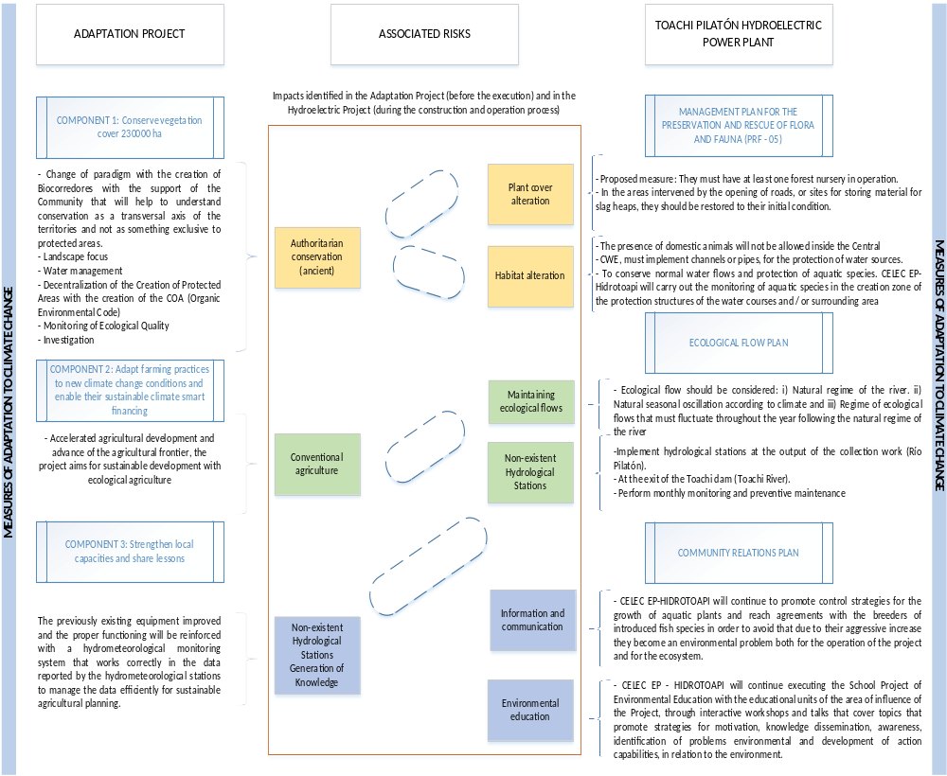

Table 36 A: Associated risks of the Adaptation Project and the Hydroelectric Power Plant

According to the checklist, the experience of the work team and the workshops held with the community benefited from the risks aligned with the 15 social and environmental principles of the Adaptation Fund

Checklist of environmental and social principles | No further assessment required for compliance | Potential impacts and risks – further assessment and management required for compliance
Compliance with the Law | X
Access and Equity |  | X
Marginalized and Vulnerable Groups |  | X
Human Rights | X
Gender Equity and Women’s Empowerment |  | X
Core Labour Rights | X
Indigenous Peoples | X
Involuntary Resettlement | X
Protection of Natural Habitats |  | X
Conservation of Biological Diversity |  | X
Climate Change | X
Pollution Prevention and Resource Efficiency | X
Public Health | X
Physical and Cultural Heritage | X
Lands and Soil Conservation | X
Table 36.B Checklist for environmental and social principles.

Checklist of environmental and social impacts and risks of the project.

 |  |  | Evidence Base Risk Identification
Checklist of E&S Principles | Questions | Yes / No |  | Evidence Base Identification | Comments
1.Compliance with the law | - Has the project identified all the specific, applicable domestic and international laws, regulations, standards, procedures and permits that apply to any of its activities? | YES |  | If you identified all the laws and things, you can find Sections D and E; Prg 352 The technical standards that will be applied in the Project are those that are in step 4 of figure 30 that corresponds to Norms for the Sustainable Forest and Technical norms INEN Ecuador, figure 30 | The project has been designed to comply with current environmental regulations detailed in figure 30  The project ensures that the activities of each component does not reduce or  prevent communities in the area from accessing basic health services, drinking water and sanitation, energy, education, housing, safe work and degradation and land rights, by including the names of students in the Project, updating their focused PDOTs in the principles of the adaptation fund and ESMP. The project also guarantees equal access to equipment, infrastructure and services, especially taking into account the marginalized and vulnerable groups, namely women, youth and communities. Gender equity, integration of youth, active participation of women and men in equal rights to achieve environmental sustainability.  In the annexes 5 and 6 the participants and social actors that would be involved in the project of the upper basin of Río Blanco are detailed, the participation is of all the communities that are in the study area due to their high social vulnerability
1.Compliance with the law | - Does the Project demonstrate any incompliance with any applicable national law? | NO |  | According to the analysis of the legislation in section D, it does not violate any applicable national law in the project activities.
1.Compliance with the law | - Has the project identified activities that may require prior permission (such as planning permission, environmental permits, construction permits, permits for water extraction, emissions, and use or production or storage of harmful substances) | YES |  | If it has been identified in component 1, with the creation of the Biocorridor that will be under the regulations of the Organic Environmental Code (COA), while agricultural activities will be based on the standards found in figure 30.
1.Compliance with the law | - Has the project identified environmental and social safeguarding requirements, other than those of the AF (e.g. national or of co-financing entities). | NO |  | CAFs IAS (Environmental and Social Inform) and UNDP Risk identification has not identified other or additional safeguarding requirements.
- Access and Equity | - Has the project identified benefits and its geographical area of effect? | YES |  | The environmental, social and economic benefits were identified by component in table 17 and the identification of the area can be seen in figure 12 and 13. | The vulnerable and marginalized groups that are in the project area have been identified in the socialization workshops that are in annexes 5 and 6 but there is the possibility that in the meetings held not all those involved have been present, for the Compliance with the principle establishes that they will have priority access to the activities that were developed in the 3 components, such as biocorridors, climate-smart agricultural techniques, EbA and active participation in the generation of knowledge.
- Access and Equity | - Has the project identified any marginalized or vulnerable groups among potential project beneficiaries? | YES |  | The identification was made based on field workshops, so we have:  Annex 5. Stakeholders, interests and socioeconomic situation 2015  Annex 6. Stakeholders gender and vulnerable pre 2017
- Access and Equity | - Has the project identified the existing risk to access to the essential services and rights indicated in the principle? | YES |  | The Project will not prevent access to basic services and rights to each principle was identified in the literal K.
- Access and Equity | - Has the project described the mechanism of allocating and distributing project benefits, and how this process ensures fair and impartial access to benefits? | YES |  | The Criteria for selecting project activities and beneficiaries is described in Figure 7A, Figure 8-B: Methodology to define beficiaries; Figure 9-C: Methodology to define beneficiaries
- Access and Equity | - Has the project developed stakeholder and local authorities’ consultations? | YES |  | If you have developed field workshops that can be visualized in:  Annex 4. A. Memoir of inception workshop in 2016  Annex 4. B. Memoir of visits to GADs and workshops 2017 Annex 4. B. Memoir of visits to GADs and workshops 2017
- Access and Equity | - Has the project presented a mechanism to ensure participation of communities, marginalized, vulnerable groups, stakeholder and local authorities’? | NO |  | With the workshops carried out, vulnerable groups have been pre-identified, but to ensure this principle, at the beginning of the Project, the study must be updated, which is expected to be implemented as part of the Mitigation Plan found in table 11 of Annex 7B, the responsible will be Specialist Management, Monitoring And Evaluation.
- Marginalized and Vulnerable Groups | - In the influence area of the project has there been identified the presence of marginalized or vulnerable groups, including but not limited to children, women and girls, the elderly, indigenous people, tribal groups, displaced people, refugees, people living with disabilities and people living with HIV/AIDS? | YES |  | The identification was made based on field workshops, so we have:  Annex 5. Stakeholders, interests and socioeconomic situation 2015  Annex 6. Stakeholders gender and vulnerable pre 2017 | The Constitution of the Republic of Ecuador, in the preamble invites us to build: "a society that respects, in all its dimensions, the dignity of people and communities." For this reason, it creates the Sub-secretariat of Democratic Guarantees that contemplates its mission: "to promote and coordinate the design of policies and their implementation that allow the exercise of democratic guarantees". Ecuador has ratified the main international human rights laws. The National Reports of the United States Department of State on Human Rights Practices for 2015 indicate that the main human rights problems in Ecuador are: excessive force and isolated illegitimate homicides by the security forces; arbitrary arrest and detention; and delays and denial of due process. Violence and discrimination against women, children, minority groups and the lesbian, gay, bisexual, transgender and intersex (LGBTI) community; traffic of people; and persistent child labor. The activities of the program will not participate in any activity that could lead to the violation of the right of any person during the implementation.
- Marginalized and Vulnerable Groups | - Has the project described the characteristics of any marginalized or vulnerable groups, identifying their particular vulnerabilities that would or could make them disproportionately vulnerable to negative environmental or social impacts caused by the implementation of the activities of the project? | NO |  | An update of the study of vulnerable and marginalized groups will be made as detailed in The mitigation plan found in Table 11 of Annex 7B, responsible for the Management, Monitoring and Evaluation Specialist.
- Human Rights | - Has the host countries been cited in any Human Rights Council Special Procedures, being on the list of thematic or country mandates? | NO |  | In special procedures, no, but we adhere to the legislation of:  - Thematic mandates of the special procedures of the Human Rights Council  - The national mandates of the special procedures of the Human Rights Council  - ILO Declaration on Fundamental Principles and Rights at Work | The Constitution of the Republic of Ecuador, in the preamble invites us to build: "a society that respects, in all its dimensions, the dignity of people and communities." For this reason, it creates the Sub-secretariat of Democratic Guarantees that contemplates its mission: "to promote and coordinate the design of policies and their implementation that allow the exercise of democratic guarantees". Ecuador has ratified the main international human rights laws. The National Reports of the United States Department of State on Human Rights Practices for 2015 indicate that the main human rights problems in Ecuador are: excessive force and isolated illegitimate homicides by the security forces; arbitrary arrest and detention; and delays and denial of due process. Violence and discrimination against women, children, minority groups and the lesbian, gay, bisexual, transgender and intersex (LGBTI) community; traffic of people; and persistent child labor.  The activities of the program will not participate in any activity that could lead to the violation of the right of any person during the implementation.
- Human Rights | - Is there a risk that rights-holders do not have the capacity to claim their rights? | NO |  | In order to safeguard the rights of the actors, in the Management Plan found in Annex 7B, the grievance mechanism presented in the ESMP is detailed.
- Human Rights | - Has the project covered human rights issues during stakeholder consultations during project formulation? | YES |  | The workshops that took place in the field were carried out by addressing human rights as the main axis of all activities, with active participation and recognition of priorities for marginalized groups, vulnerable women's empowerment. It can be seen in Annex 4A and 4B.
- Human Rights | - Has the project included the findings of the consultations on human rights issues in the project document? | YES |  | The concerns of the population with the theme of human rights are included and materialized in the adaptation actions that are incorporated in the local development plans (product 7) and the communication and education actions (product 9) take into account the gender and age and the needs of people with disabilities
- Gender Equity and Women’s Empowerment | - Has the project identified activities that are known to exclude or hamper a gender group based on legal, regulatory or customary grounds? | NO |  | The institutional gender policy (2016 - 2019) establishes that both men and women and opportunities. | Ecuador ranks high in the Global Gender Gap Index. Ecuador has almost complete equality in educational attainment and health and survival, and a high level in economic participation and opportunities, but a major gap in political empowerment (WEF, 2015). The stakeholder analysis (Annex 5,6) found that there is strong women leadership in local organizations and parish governments. Also, women have an important role in businesses like commerce and restaurants. The condition of women in the Río Blanco upper watershed is similar to other Ecuadorian rural areas.  The project will promote women´s participation in project activities. However, it has to be considered that men are increasingly seeking paid jobs in Santo Domingo, the nearest large city. This, in turn, increases the workload for women to tend for the farm and the animals. In rural areas, women tend to work more average weekly hours than men, 82h and 59h respectively, most of this difference is explained by non-remunerated activities (such as domestic chores and care-taking tasks). Therefore, the project will have to be cautious to implement actions in support of gender equality and women´s empowerment, and to prevent overloading women activities (outputs 1, 2 and 4). Also, it will be needed to ensure that the adaptation actions to be mainstreamed into the local development plans (output 7) and the communication and education actions (output 9) are gender and age sensitive and do consider the needs of persons with disabilities. Further assessment will be required to be a part of each activity of the Programme.
- Gender Equity and Women’s Empowerment | - Has the project conduct or consult a gender analysis of the supported area, describing the current situation of the allocation of roles and responsibilities in the area? | YES |  | The current situation of the population, both male and female, can be found in: Annex 5. Interest groups, interests and socioeconomic situation 2015  Annex 6. Gender and vulnerable interest groups before 2017
- Gender Equity and Women’s Empowerment | - Has the project identified elements that maintain or exacerbate gender inequality or the consequences of gender inequality? | NO |  | Gender inequality in the field occurs for cultural reasons as mentioned in paragraph 418, which will be minimized with the activities proposed in the Project.
- Gender Equity and Women’s Empowerment | - Has the project identified particular vulnerabilities of men and women that would or could make them disproportionately vulnerable to negative environmental or social impacts caused by the outputs / activities of the project? | NO |  | The vulnerability for men and women is equally. For this reason this Project is presented to give an alternative of adaptation to climate change of the entire population of the identified area.
- Core Labour Rights | - Has the project determined if the host country has ratified the eight ILO core conventions | YES |  | Ecuador has ratified the eight fundamental labor agreements. The intervention of the project has no incidence whatsoever with the four fundamental principles and rights at work. | Component 1 and 2 will create jobs that allow vulnerable groups, including unemployed youth and women to increase their income. The relevant national labor laws will be followed, guided by ILO labor standards during the implementation of the project.
- Core Labour Rights | - Has the project reviewed the latest ILO assessments of application of the standards in the country? | YES |  | Ecuador has ratified the eight fundamental labor agreements. The intervention of the project has no incidence whatsoever with the four fundamental principles and rights at work.
- Core Labour Rights | - Has the project identified how the ILO core labour standards are incorporated in the design and the implementation of the outputs / activities’ project? | YES |  | All the procurement process will follow the EE - UNDP Financial Regulations and Rules (2012) as well as a sustainable procurement process including core labour rights. UNDP follow four key principles related with procurement practices: 1. Best value for money; 2. Fairness, integrity and transparency; 3. Effective international competition and 4. The interest of UNDP.
- Core Labour Rights | - Has the project describe the common labour arrangements in the sector(s) in which the project will operate, with particular attention to all forms of child labour and forced labour. | YES |  | The Project will not involve child labor in any of its activities. The prohibition of child labor will be part of the agreement with the beneficiaries and will be a non-negotiable act.
- Indigenous Peoples | - Has the project identified if indigenous peoples are present in the area of influence? | YES |  | The 2010 censuses of Ecuador have been analyzed, and in the study area there are no people who identify themselves as indigenous, all are considered as mestizos, it is not an area of virgin settlements. | ILO convention 169 is implemented in Ecuador. There is no indigenous population in the project area.  As project does not involve any particular indigenous group, this aspect does not seem to be of relevance in terms of further assessment for ESP compliance.
- Indigenous Peoples | - Has the project quantify the groups identified of indigenous peoples? | NO |  | There are no indigenous settlements in the study area.
- Indigenous Peoples | - Has the project determined if there are provisions for a realistic and effective Free, Prior, Informed Consent process, giving a community the right to give or withhold its consent to proposed projects that may affect the lands they customarily own, occupy or otherwise use? | NO |  | There are no indigenous settlements in the study area
- Indigenous Peoples | - Has the project provided a summary of any reports, specific cases, or complaints that have been made with respect to the rights of indigenous peoples by the Special Rapporteur on the rights of indigenous peoples and that are relevant to the project? | NO |  | There are no indigenous settlements in the study area
- Involuntary Resettlement | - Has the project determined if it is voluntary or involuntary resettlement? | NO |  | There will be no involuntary resettlements, because the creation of biocorridors will take place. | The project will focus on land already used to implement component 1 and 2 activities, they already have  Access roads and currently used for agricultural purposes. In component 1, the biocorridors that will unite the 2 protected areas found in the study area were created, the subprojects found in these areas are being carried out with the communities that are in the sector, generating employment with line to sustainability environmental, while component 2 works with the land of the beneficiaries applying organic farming. When the Project was initiated by the social security specialist, due process is respected so that  the people who are in the areas of the biocorridor are informed of their rights,  consulted about their options, and technically offered activities that can be developed within this area. Component 2 the project will improve sustainable production alternatives that reduce pressure on forests, by elaborating a plan of zoning for productive areas.
- Involuntary Resettlement | - Has the project identified stakeholders whose livelihoods may be affected, directly or indirectly? | NO |  | There will be no involuntary resettlements, because the creation of biocorridors will take place.
- Involuntary Resettlement | - Has the project identified stakeholders whose assets or access to assets may be affected, directly or indirectly, and if this may lead to resettlement and its consequences including indemnification, compensation, etc. | NO |  | For component 2, the land of the beneficiaries will be occupied.
- Protection of Natural Habitats | - Has the project identified all the critical natural habitats in the region that may be affected?  The area considered should be large enough to be credible and be chosen in function of the impact generating agent (e.g. noise) and an appreciation of its propagating ability. The habitats to be considered include all those recognized as critical in any way, be it legally (through protection), scientifically or socially. | YES |  | The reforested areas and the area that connects the Reserve with the Park were identified, so it is proposed to create biocorridors | The project in its activities will have a positive impact on principle 9 of the Adaptation Fund AF, the project seeks to improve the mechanism (furnace and mills) for the production of panela in order to reduce the use of wood as combustible material. Technification (modernization) reduces up to 60% of the wood needs for panela production. This measure helps to reduce the pressure on the remaining forests and the emission of greenhouse gases.  In component 2 in order to ensure the participation of the population in sustainable agricultural and livestock practices, the project will realize the workshops were at least 375 families engaged in sustainable productive activities. And as a result 250 ha of pasture and 250 ha of crops apply sustainable agriculture practices  The poor surveillance capacity in watersheds. The Toachi basin has the worst monitoring system (some meteorological stations, minimum gauging stations and sediment information stations). Therefore, it is not possible to know the occurrence of natural disasters and climate change that can lead to impacts on natural habitats, so it will develop the hydrometeorological monitoring system in the river basin  Strengthening of the 7 existing stations located in the area, which at the moment are not working properly.
- Protection of Natural Habitats | - Has the project identified for each critical natural habitat, the mechanism by which it is particularly vulnerable? | YES |  | The vulnerable area is identified for the creation of biocorridors, which serve as connectivity.
- Protection of Natural Habitats | - Has the project considered all the activities to identify actual risks for each of the natural habitats identified taking into account the specific characteristics of the activity (location, dimension, duration etc.) and the vulnerability mechanism(s) of each habitat identified. | YES |  | Yes, the two areas that are going to work, that n the creation of biocorredores that corresponds to component 1 and the plans of farms that is property of the beneficiaries and that corresponds to component 2
- Conservation of Biological Diversity. | - Has the project identified all the elements of biodiversity interest in the region that may be affected?  The area considered should be large enough to be credible and be chosen in function of the impact generating agent and an appreciation of its propagating ability. It is important in the identification of the elements of biodiversity interests not to limit this to the species level but to include all elements of biodiversity interest, including landscapes, ecosystem processes, habitats, and hydrological cycles, processes of erosion and sedimentation and interactions between taxa. Include all elements enjoying local or international protection | YES |  | The implementation of the project does not represent any risk for the reduction or loss of biological diversity or the introduction of known invasive species. | With planned activities the impact will be positive. Ecuador has signed and ratified the Convention on Biological Diversity and has a recently updated national biodiversity strategy. The project will not intervene areas with high biodiversity value or introduce invasive species. On the contrary, the actions of the project will contribute to conserving forests and vegetation cover.  The project will strengthen the protected areas with the creation of the biocorridors that will allow connectivity, in addition, it will be important to ensure that the role of natural habitats is integrated into the adaptation measures to be integrated into the local development plans (output 7).
- Conservation of Biological Diversity. | - For each identified biodiversity element, has the project identified the mechanism by which it is particularly vulnerable? (Changes in flow regime or water quality for a seasonal wetland or disruption of migration routes). | YES |  | The deforested area that is intended to be minimized with a Territorial Plan, which will be carried out at the beginning of the Adaptation Project, has been identified from the vulnerable area.
- Conservation of Biological Diversity. | - Has the project identified the potential of introducing – intentionally or accidentally – known invasive species? | YES |  | The implementation of the project does not represent any risk for the reduction or loss of biological diversity or the introduction of known invasive species.
- Conservation of Biological Diversity. | - Has the project identified the use of living modified organisms resulting from modern biotechnology? | NO |  | The implementation of the project does not represent any risk for the reduction or loss of biological diversity or the introduction of known invasive species.
- Climate Change | - Has the project determined if it belongs to a sector mentioned in the Guidance document for which a greenhouse gasses emission calculation is required?  - Energy, transport, heavy industry, building materials, large-scale agriculture, large-scale forest products, and waste management. | NO |  | No calculation of greenhouse gas emissions is necessary. It is a project of adaptation to climate change. | The project does not include activities that involve a significant increase in emissions of greenhouse gases or other climate change stressors. On the contrary the implementation of sustainable agriculture practices will reduce green house gas emission, contributing to climate change mitigation. Moreover, reducing community vulnerability thanks to agriculture best practices, the project will also contribute to support climate change adaptation for the community.
- Climate Change | - Has the project carry out a qualitative risk identification for each of the following drivers of climate change:  - Emission of carbon dioxide gas from the use of fossil fuel and from changes in land use  - methane and nitrous oxide emissions from agriculture  - emission of hydrofluorocarbons  - perfluorocarbons  - sulphur hexafluoride  - other halocarbons, aerosols, and ozone. | NO |  | It is not necessary. It is a project of adaptation to climate change.
- Climate Change | - Has the project carry out a qualitative risk identification of any impact on carbon capture and sequestration capacity. | NO |  | It is not necessary. It is a project of adaptation to climate change.
- Pollution Prevention and Resource Efficiency | - Has the project identified activities with preventable waste or pollution production? | NO |  | There are no activities that generate waste. | The project does not include activities that will use large quantities of energy, water or other natural resources. Nor will it generate large quantities of residues, emissions and discharges. Nonetheless, as indicated before, CAF will require that building contractors implement a PAAS to prevent negative impacts during construction works. The project will contribute to improve the efficient use of energy and natural resources.
- Pollution Prevention and Resource Efficiency | - Has the project determined the nature and quantity of the waste, as well as those of possible pollutants that may be produced? | NO |  | There are no activities that generate waste.
- Pollution Prevention and Resource Efficiency | - Has the project determined if the concept of minimization of waste and pollution production has been applied in the design phase and if this will be effective during implementation? | NO |  | There are no activities that generate waste.
- Public Health | - Has the project identified using an appropriate health impact screening tool (check list) potentially significant negative impacts on public health generated? | NO |  | No evidence of this aspect. | The project does not imply negative impacts on public health. Moreover supporting the use of efficient cooking systems for panela, as well as the promotion of family gardens, the project will contribute to reduce negative health impacts. On the other hand, the implementation of the improved ovens for the production of panela reduces labor force from 6 to 4 hours for the production of 580 liters of panela, which reduces possible heath impacts over the population.
- Physical and Cultural Heritage | - Has the project determined if the host country has ratified the 1972 UNESCO Convention Concerning the Protection of the World Cultural and Natural Heritage? | YES |  | Convention concerning the Protection of the World Cultural and Natural Heritage. Paris, 16 November 1972. 16 June 1975 – Acceptance.  https://en.unesco.org/countries/Ecuador/conventions | Ecuador is a party of the World Heritage Convention. The project will not affect or intervene physical and cultural heritage.
- Physical and Cultural Heritage | - Has the project identified the national and local legal and regulatory framework for recognition and protection of physical and cultural heritage? | YES |  | If you identified all the laws and things, you can find Sections D and E
- Physical and Cultural Heritage | - Has the project described in the influence zone all the elements of the cultural heritage, their location and their vulnerabilities?  The area considered should be large enough to be credible and be chosen in function of the impact generating agent (e.g. vibrations, landscape elements) and an appreciation of its propagating ability. Include all elements enjoying local or international protection. | NO |  | No evidence of this aspect.
- Physical and Cultural Heritage | - Has the project determined if any of the heritage elements included in the List of World Heritage in Danger is in the influence zone? | NO |  | No evidence of this aspect.
- Physical and Cultural Heritage | - Has the project considered all the activities to identify actual risks for each of the heritage elements identified taking into account the specific characteristics of the activity (location, dimension, duration etc.) and the vulnerability mechanism(s) of each heritage element identified? | YES |  | No evidence of this aspect.
- Lands and Soil Conservation | - Has the project identified the presence of fragile soils within the influence area? | YES |  | You can visualize in annex 3 the maps of the area of ​​influence. | The project action will contribute to soil conservation.  During project preparation, a detailed stakeholder and gender analysis will be prepared and details on the role of women in the farms and local organizations will be obtained. This will serve to adjust project actions to be gender, age and cultural sensitive.
- Lands and Soil Conservation | - Has the project identified activities that could result in the loss of otherwise non-fragile soil? | NO |  | You can visualize in annex 3 the maps of the area of ​​influence.
- Lands and Soil Conservation | - Has the project identified productive lands and/or lands that provide valuable ecosystem services within the influence area? | NO |  | You can visualize in annex 3 the maps of the area of ​​influence.
- Lands and Soil Conservation | - Has the project identified activities that may lead to land degradation? | NO |  | You can visualize in annex 3 the maps of the area of ​​influence.

Table 36 C. Checklist of environmental and social impacts and risks of the project.

Risk Evaluation
Significance of the Risk
Checklist of E&S Principles | Risks Identified per E&S Principles | Impact and Probability (1-5) | Significance  Low, Moderate, High
2. Access and Equity | Risk (low): local land owners not adequately informed of the proposed use of economic incentives (Socio Bosque, Biocorredor, ACUS). If not adequately informed, the local land owners may believe that the project will affect their land rights. | 3 / 3 | Moderate
3. Marginalized and Vulnerable Groups | There is a risk that the project will have adverse impacts on marginalized and vulnerable groups, including children, women and girls, the elderly, indigenous people, displaced persons, refugees or persons with disabilities, if the nose is adequately studied of marginalized and vulnerable groups that should be updated at the start of the Project | 3 / 3 | Moderate
5. Gender Equity and Women’s Empowerment | There is a risk that women or men have unequal opportunities to participate, without taking into account their living, social and economic conditions. This refers to Component 1, Component 2 and Component 3. The probability is high because of the macho culture that exists in the country.  Women with increased work load. No specific factors will impede or limit women´s participation. However, some farmers are opting for paid employment in Santo Domingo. This increases the responsibility of  tending the farm and rural property to women and other family members.  The communication channels and messages are not gender and age sensitive and do not consider the needs of persons with disabilities. | 4 / 3 | Hight
9. Protection of Natural Habitats | Ensure that the role of natural habitats is considered while mainstreaming adaptation measures in local development plans (output 6).  The project intervention does not involve unjustified reduction or loss of biological diversity or the introduction of known invasive species. On the contrary, project actions will motivate the conservation of existing vegetation cover. (Positive impact) | 2 / 3 | Moderate
10. Conservation of Biological Diversity | As the decision of which species will be used, this Unidentified Sub Project will need to undergo detailed screening, a consultation process, the development of safeguard measures and a strict approval method developed.  For the above there is a risk of not avoiding significant or unjustified reduction or loss of biological diversity or the introduction of unknown invasive species. This is referred to in Component 1.  The project intervention will not intervene areas with high value biodiversity. Project actions will occur in existing farmland, componet 2. | 2 / 3 | Moderate

Table 36 C. Risk Evaluation

ESP Risks Identification for activity

Activity Identified risks in accordance to AF’s E&SP and Impact
Activity | Identified risks in accordance with AF’s E&SP | Potential E&S Impacts if risks materialize
- Prepare Technical, biological studies. | E & SP 2. There is a risk that not all the community will know the studies that are carried out and will not be disseminated. | If the community does not communicate properly or participate in the updating process, their local knowledge has not been recorded.
- Prepare zoning file studies. | E & SP 2. There is a risk that not all the community will know the studies that are carried out and will not be disseminated. | If the community does not communicate properly or participate in the updating process, their local knowledge has not been recorded.
- Prepare ACUS Management Plan of Conservation Bio-corridor (MPCB). | E & SP 1. There is a risk that the procedure does not exist in the COA | If there are delays in the approval of the COA procedures there will be delays for the declarations.
- Prepare studies Financial and Operational Sustainability Strategy according with the investment fund. | E & SP 9. There is a risk that there is no budget in the GADs | If there is no annual budget for the protection of bio-correctors, the population must create economic activities that help sustain them.
- Prepare studies for implementing, monitoring the Biocorredor Management Model. | E & SP 1. There is a risk that the procedure does not exist in the COA | If there are delays in the approval of the COA procedures there will be delays for the declarations.
- Develop the Plans of Decentralized Governments (GAD) with planning, regulatory and normative instruments for ACUS that includes: the joint identification (PA authorities and GADs) of key habitats, restrictions and monitoring programs, and agreements for their implementation; inclusion in land-use planning processes of specific standards and practices for protecting forest and integrated watershed management; and Municipal ordinances on conservation, land use practices, and ACUS. | E & SP 2. There is a risk that not all the community will know the studies that are carried out and will not be disseminated. | If the community does not communicate properly or participate in the updating process, their local knowledge has not been recorded.
- Develop a Plan to strengthen the incentive systems for the sieges on private and community lands starting from ACUS | E & SP 5. That women can not participate actively. | Women must empower leadership and decision making.
- Develop the monitoring and supporting the Municipal PAs gazetted, covering 1,000ha, in buffer-zones and corridors identified as critical for water hydrological cycle. | E & SP 2. There is a risk that the community does not know theoretical issues. | That the population benefits unpaid due to lack of knowledge.
- Develop through workshops the promotion of habitat and connectivity-friendly production options and programs for reduction of human/wildlife conflicts in association with the Ministry of Agriculture. | E & SP 10. Use of conventional agricultural practices | The lack of interest of the population in the use of new techniques of organic farming.
- Apply conservation programs in the field to reduce pressures on forests, with at least 50% of women participating. | E & SP 5. That women can not participate actively. | Women must empower leadership and decision making.
- Perform the maintenance of hydrometeorological stations to strengthen the hydrometeorological monitoring system in the basin of the Toachi-Pilaton river. | E & SP 2. There is a risk that the community does not know theoretical issues. | That the population benefits unpaid due to lack of knowledge.
- Carry out productive activities for the reduction in the use of the forest in the High and Middle Basin of the Toachi and Pilaton rivers (Landscape Las Pampas and Palo Quemado), through technology change in the process of panela production , that includes planning, assessment and monitoring of the process | E & SP 10. The objective is to reduce the use of firewood, but there will be a risk of deforestation. | If there is adequate awareness, the impact of the forests would be internalized and their use improved.
- Installation of ovens to promote efficiency in panela production | E & SP 13. If there is no education, supervision of the use of new machinery can increase greenhouse gases. | The lack of knowledge of the operation of the equipment can produce greater contamination in air quality.
- Conduct the planning and zoning of the river basin with a participatory and inclusive approach. Promote dialogue, coordination and technical support at the local level and improvement of the protector forest. | E & SP 2. There is a risk that not all the community will know the studies that are carried out and will not be disseminated. | If the community does not communicate properly or participate in the updating process, their local knowledge has not been recorded.
- Implementation of Management Plan of the protective forest, including ravine and shore protection activities. | E & SP 2 There is a risk that the Plan will not be disseminated to the population. | If it did not spread, you can not create awareness of the effects of climate change.
- Develop workshops where women are empowered with the planning and zoning of farms. | E & SP 5. That women can not participate actively. | Women must empower leadership and decision making.
- React the use, management and monitoring training of the tools for monitoring the effectiveness of management and PGOA | E & SP 9. There is a risk that there is no budget in the GADs | If there is no annual budget for the protection of bio-correctors, the population must create economic activities that help sustain them.
- Install a control point in the Pampas, equipment in coordination with the Police; and monitoring system, newsletter and decentralization of information | E & SP 3. That the technician does not involve vulnerable groups. | That the technician does not have the ability to impart his knowledge.
- Develop the selection of experts in sustainable agricultural management and climate-smart livestock; Incorporation of an industrial technician with technical background to identify improvement options in technology for panela producers. | E & SP 2. That there is no access to information. | That the population is not a sea correctly informed of the findings.
- Develop field visits by specialists to collect information on the type of crop, microclimate, vulnerabilities and resilience; Documentation: Definition of appropriate adaptation measures for farming and production areas; Monitoring visits and documentation of the progress of adaptation measures. Identification of problems, grants for implementation. | E & SP 2. That there is no access to information. | That the population is not a sea correctly informed of the findings.
- Develop the selection: Identify, through the defined procedures and actors, the participants for the construction of sustainable farms; The project management board reviews the profiles of participants entering into vulnerable groups for approval; Subsidy for 150 beneficiaries of vulnerable groups receive 75% of the cost and implementation of adaptation measures as grant. 25% they will put it as counterpart (labor); Delivery to the qualified suppliers of the values for the implementation by means of transference or certified check | E&SP 2. That not all beneficiaries can access the grant. | That the priority group for the sub-grant is not clearly identified.
- Develop the identification Suppliers; Announcement for all suppliers interested in participating for the delivery of inputs for the construction of sustainable farms. Interesting stock, good experience and reputation is a plus; Visits each of the suppliers to verify the information provided and the prices offered. | E&SP 2. Due to lack of knowledge, local actors do not present proposals. | That the providers are not part of the group of beneficiaries.
- Develop the selection of consultants who will work on the development of output 2 and 3. Knowledge and good experience in the field of software-based green lending or climate financing will be required; Identification of adequate EbA and other adaptation emasures for target customers of participating financial institutions; | E&SP 3. That technicians do not have patience to deal with vulnerable groups. | Risk that technicians do not have to transfer their knowledge to the population and that they do not have the charisma to deal with people.
- Develop the ICT solution to automatically and systematically collect data in the field, software to facilitate the identification, qualification, monitoring and reporting of adaptation credits. | E&SP 3. That technicians do not have patience to deal with vulnerable groups. | Risk that technicians do not have to transfer their knowledge to the population and that they do not have the charisma to deal with people.
- Development of climate smart lending management, for different crops and to be implemented in lending processes of financial institutions; Development of policies and procedures of climate risk management in the institution; Development of financial products, product design including loan terms; | E&SP 3. That technicians do not have patience to deal with vulnerable groups. | Risk that technicians do not have to transfer their knowledge to the population and that they do not have the charisma to deal with people.
- Determine the economic incentives for eligible lending customers that will invest into EbA and other adaptation options | E&SP 2. That not all beneficiaries can access the grant. | That the priority group for the sub-grant is not clearly identified.
- Training 500 families in the use of climate data and their application in activities, such as: agriculture and livestock. This training will be address for 55% percent of women. Including field visits, food and transportation. | E & SP 5. That women can not participate actively. | Women must empower leadership and decision making.
- Designing of interactive content and generation of newsletters to training GAD population in the area including women associations, older adults and vulnerable groups. | E & SP 2. There is a risk that the community does not know theoretical issues. | That the population benefits unpaid due to lack of knowledge.
- Integrating the digital media technologies for communication plan and addressed it to the population in general including women, older adult, youth people and children’s. | E & SP 2. There is a risk that the community does not know theoretical issues. | That the population benefits unpaid due to lack of knowledge.
- Conducting a technical study to determinate which climate change adaptation measures that must be added for development and territorial planning plans. | E & SP 2 Lack of knowledge of documents and reports that will be created for the benefit of the population, and people do not have access to information. | That the information collected is not sociabilized to all the beneficiaries.
- Gathering information on climate change adaptation measures to be added like indicators and statistics into the development and territorial planning plans. The indicators should include gender information and vulnerable groups for climate change. | E & SP 2 Lack of knowledge of documents and reports that will be created for the benefit of the population, and people do not have access to information. | That the information collected is not sociabilized to all the beneficiaries.
- Developing new development and territorial planning documents adding climate change statistics and information and also including gender and vulnerable group’s climate change issues. | E & SP 2 Lack of knowledge of documents and reports that will be created for the benefit of the population, and people do not have access to information. | That the information collected is not sociabilized to all the beneficiaries.
- Training for population including associations, organizations and other stakeholder of the project about climate change adaptation measures incorporated in the PDOTs. | E & SP 2 Lack of knowledge of documents and reports that will be created for the benefit of the population, and people do not have access to information. | That the information collected is not sociabilized to all the beneficiaries.
- Socialize new PDOTs documents with the population of the project area including associations, organizations and the population in general. | E & SP 3 There is a likelihood that vulnerable groups will not be found in socialization. | Risk that communication in socialization does not become clear to the beneficiaries.
- Developing a communication plan addressed to stakeholders in the project including specific women associations and organizations. | E & SP 2. There is a risk that not all the community will know the studies that are carried out and will not be disseminated. | If the community does not communicate properly or participate in the updating process, their local knowledge has not been recorded.
- Developing a technological platform to manage knowledge and information about climate change, using disruptive technologies like: big data and cloud computing. | E & SP 2. There is a risk that not all the community will know the studies that are carried out and will not be disseminated. | If the community does not communicate properly or participate in the updating process, their local knowledge has not been recorded.

Table 36.D ESP Risks Identification for activity

The initial impact analysis was performed based on annexes 4,6,9 in Table 8: General In the basin of the Toachi - Pilatón water system (Río Blanco upper basin) you can visualize its identification. While the risk analysis in greater detail can be visualized in Annex 7, a pre-identification was made taking into account all the activities presented in the Project aligned with the 15 principles of the Adaptation Fund.

PART III: IMPLEMENTATION ARRANGEMENTS

A. Describe the arrangements for project / programme implementation.
- CAF will be the implementing agency and MAE will be the responsible entity. The project will be implemented following CAF’s administrative and financial regulations as agreed with the Adaptation Fund.

Implementation Modality
- The project will be implemented over a four-year period, under the National Implementation with CAF as the FA Implementing Agency (IA) and the Ministry of Environment (MAE) as Implementing Partner. In this role MAE will undertake full programmatic and administrative-financial control and responsibility for supervising the project, and will be responsible for approving deliverables prior to their reporting to FA by CAF. Capacity building priorities will be addressed at all times.

Implementing Agency
- As FA implementing agency, CAF is ultimately accountable and responsible for the delivery of results, subject also to their certification by MAE, as Implementing Partner. CAF shall provide project cycle management services as defined by the AF Council, that will include the following:
- Providing financial and audit services to the project
- Overseeing financial expenditures against project budgets,
- That activities including procurement and financial services are carried out in strict compliance with FA procedures,
- Ensuring that the reporting to FA is undertaken in line with the requirements and procedures,
- Facilitate project learning, exchange and outreach within the FA - CAF family,
- Contract the project mid-term and final evaluations and trigger additional reviews and/or evaluations as necessary and in consultation with the project counterparts.
- At the request of the Government of Ecuador, CAF shall also provide Direct Project Services (DPS) specific to project inputs according to its policies and convenience. These services, and the costs. In accordance with FA requirements, the costs of these services will be part of the executing entity’s Project Management Cost allocation identified in the project budget. CAF and the Government of Ecuador acknowledge and agree that these services are not mandatory and will only be provided in full accordance with CAF policies on recovery of direct costs.
- CAF will provide Project Assurance, supporting the Project Board Executive by carrying out objective and independent project oversight and monitoring functions.
- The project partners are the parish governments of Manuel Cornejo Astorga (Tandapi), Aloag, El Chaupi, Palo Quemado, and Las Pampas, the municipal government of Sigchos, MAGAP, INAMHI, SENAGUA and CELEC. Complementary collaboration agreements will be signed with the provincial governments of Cotopaxi and Pichincha, HIDROTOAPI and relevant local organizations through following mechanisms:
- The Project Board is the project coordination and decision making body. It will meet quarterly to review project progress, approve project work plans and approve project deliverables. The responsibility of the Board is to see that project activities lead to the required outcomes as defined in the project document. The Board will oversee project implementation, approve work plans and budgets as supplied by the National Coordinator, approve any major changes in project plans, approve major project deliverables, arbitrate any conflicts which might arise, be responsible for the overall evaluation of the project. The Board may be convened extraordinarily by the Chair, on the request of individual members.
- The Project Board will play a critical role in facilitating inter-ministerial coordination, project monitoring and evaluations by quality assuring these processes and products, and using evaluations for performance improvement, accountability and learning. It will ensure that required resources are committed and will arbitrate on any conflicts within the project or negotiate a solution to any problems with external bodies. In addition, it will approve the appointment and responsibilities of the National Coordinator and any delegation of its Project Assurance responsibilities. Based on the approved Annual Work Plan, the Project Board will also consider and approve the quarterly plans and will also approve any essential deviations from the original plans.
- The Board will consist of the following members:
- The Executive, who will chair the Board. This role will be filled by MAE or his/her representative.
- A representative of the Senior Supplier, who will provide guidance regarding the technical feasibility of the project. This role will be filled by CAF.
- Senior Beneficiaries SENAGUA, institution will represent the interests of those who will ultimately benefit from the project and ensure the realization of project results from the perspective of project beneficiaries.
- The Technical Support will advise on ensuring coordination between the project and other related initiatives such as the GAD, Communities representatives, National Adaption Direction (MAE), CELEC and MAG.
- The structure proposed will be reviewed and potentially adjusted in the project’s early stage and Operations Manual, detailing roles and responsibilities for the functionality of the Project Boar and Technical Committee, will be developed.

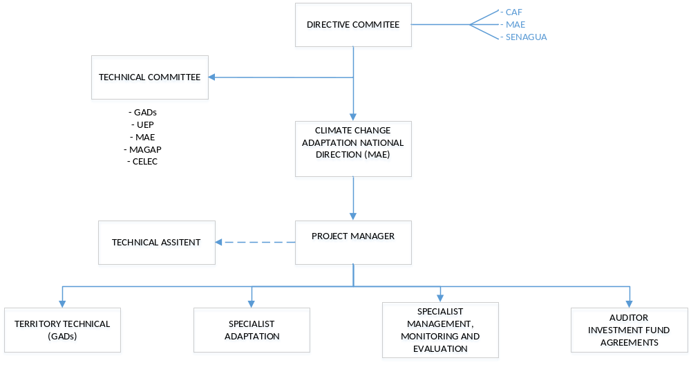

Figure 36: Organizatiuonal structure of the project

B. Describe the measures for financial and project / programme risk management.
- The following risk have been identified for a successful project implementation. In the early stages of the project, the analysis will be updated and constantly monitored:

Project risks

Description | Type | Impact & Probability level | Mitigation Measures | Responsible | Status
Change of central government in Ecuador. The new president took office in 2018, delays were caused in the development of the final project proposal. | Political | P = 5  I = 3 | Present the project to new authorities in MAE | CAF | Reducing
Change of municipal government in Ecuador. The new authorities will take office in 2019. | Political | P = 5  I = 3 | Present the project to new authorities | MAE and CAF | No change
Change of in regulatory or legal stipulations might require the adjustments of critical project components for their compliance. | Financial | P = 5  I = 3 | Present the project to new authorities; to promote formal agreements | MAE and CAF | No change
Grant not being delivered and/or not being delivered on time mainly with local inclement weather problems | Financial | P = 2  I = 3 | CAF’s cash flow would allow to respond to disbursements in case of delays. National funds | MAE and CAF | Increasing
Increase in budget due to costs miscalculations, and/or due to overprices during project implementation. | Financial | P = 2  I = 3 | Agreement signed with local counterparts to guarantee the project execution. | MAE and CAF | No change
Effect of La Niña in precipitation and local weather conditions. | Environmental | P = 3  I = 3 | Monitor information and alerts in national meteorological entities, NOAA, and World Meteorological Organization | CAF | Increasing
The project intends to include a variety of stakeholders that need to be coordinated and engaged. There is a risk that changes in governments or management members, as well as conflicting interests put the project execution at risk. | Organizational | P = 3  I = 3 | Engage stakeholder and key actors early on; provide information on project activities and clarify concrete benefits for each stakeholder; | MAE, CAF and Project Unit | Increasing
Baseline studies are not up to date (climate change information dynamics) | Operational | P = 2  I = 3 | Adjustment of existing designs, incorporating the climate change factor; to promote synergies with other climate change initiatives | MAE | Increasing
Lack of understanding of the project, and hence opposition from the local inhabitants. | Social | P = 3  I = 3 | Effective communication strategy (C3) contemplates socialization of the project with the local communities. | MAE, Project Unit | No change
Table 37: Details project risks

C. Describe the measures for environmental and social risk management, in line with the Environmental and Social Policy of the Adaptation Fund.
- The project presents a categorization B, which corresponds to a moderate risk, which can be identified in the risk assessment included in Annex 7.B, in the same annex the safeguard measures can be observed. All the activities are to guarantee the participation of women during the activities of capacity building, with the aim of reaching a participation of at least 50% of women during all activities. On the other hand, all activities proposed within the framework of the project take into consideration the protection of human rights and environmental sustainability. The implementation of energy efficient furnaces for panela production reduces: the CO2 pollution caused by the deforestation of the wood, the loss of natural habitat and the pressure on the remaining primary forests.

- Annex 7 contains the mechanisms for monitoring, control, and complaints mechanism.The following table presents the measures for identified risks:

Activity Identified Mitigation measures for management of environmental and social impacts and risks
Activity | Identified risks in accordance with AF’s E&SP | Potential E&S Impacts if risks materialize | Mitigation Measure | Responsible for Verification
- Prepare Technical, biological studies. | E & SP 2. There is a risk that not all the community will know the studies that are carried out and will not be disseminated. | If the community does not communicate properly or participate in the updating process, their local knowledge has not been recorded. | Communication management refers to a systematic plan to implement and monitor the channels and contents of a company's communication, both internally among its members, and externally with other companies or organizations. The technician should consider these questions: 1. What information?  2. Who needs it?  3. When is the information needed?  4. What is the format of the information?  5. Who will be responsible for transmitting the information? | Territory Technical (GADs)
- Prepare zoning file studies. | E & SP 2. There is a risk that not all the community will know the studies that are carried out and will not be disseminated. | If the community does not communicate properly or participate in the updating process, their local knowledge has not been recorded. |  | Territory Technical (GADs)
- Prepare ACUS Management Plan of Conservation Bio-corridor (MPCB). | E & SP 1. There is a risk that the procedure does not exist in the COA | If there are delays in the approval of the COA procedures there will be delays for the declarations. | The procedures found in Annex 6 of the Unified Text of Environmental Legislation (TULAS) will be used. | MAE  Project Manager
- Prepare studies Financial and Operational Sustainability Strategy according with the investment fund. | E & SP 9. There is a risk that there is no budget in the GADs | If there is no annual budget for the protection of bio-correctors, the population must create economic activities that help sustain them. | The investment fund must be sustainable and sustainable, so an investment specialist will be hired. | Auditor Investment Fund Agreements
- Prepare studies for implementing, monitoring the Biocorredor Management Model. | E & SP 1. There is a risk that the procedure does not exist in the COA | If there are delays in the approval of the COA procedures there will be delays for the declarations. | The procedures found in Annex 6 of the Unified Text of Environmental Legislation (TULAS) will be used. | MAE  Project Manager
- Develop the Plans of Decentralized Governments (GAD) with planning, regulatory and normative instruments for ACUS that includes: the joint identification (PA authorities and GADs) of key habitats, restrictions and monitoring programs, and agreements for their implementation; inclusion in land-use planning processes of specific standards and practices for protecting forest and integrated watershed management; and Municipal ordinances on conservation, land use practices, and ACUS. | E & SP 2. There is a risk that not all the community will know the studies that are carried out and will not be disseminated. | If the community does not communicate properly or participate in the updating process, their local knowledge has not been recorded. | Communication management refers to a systematic plan to implement and monitor the channels and contents of a company's communication, both internally among its members, and externally with other companies or organizations. The technician should consider these questions: 1. What information?  2. Who needs it?  3. When is the information needed?  4. What is the format of the information?  5. Who will be responsible for transmitting the information? | Territory Technical (GADs)
- Develop a Plan to strengthen the incentive systems for the sieges on private and community lands starting from ACUS | E & SP 5. That women can not participate actively. | Women must empower leadership and decision making. | The Gender Plan is presented in Figure 37. Monitoring and evaluation concept includes gender keys | Territory Technical (GADs)
- Develop the monitoring and supporting the Municipal PAs gazetted, covering 1,000ha, in buffer-zones and corridors identified as critical for water hydrological cycle. | E & SP 2. There is a risk that the community does not know theoretical issues. | That the population benefits unpaid due to lack of knowledge. | The backbone is the public communication and education plan that will (i) raise public awareness and engagement, (ii) facilitate communication and collaboration among stakeholders and project partners, and (iii) enable dissemination of information and lessons through taylor-made communicational products.  The Communication Plan is presented in Figure 32-A. Communications plan | Territory Technical (GADs)
- Develop through workshops the promotion of habitat and connectivity-friendly production options and programs for reduction of human/wildlife conflicts in association with the Ministry of Agriculture. | E & SP 10. Use of conventional agricultural practices | The lack of interest of the population in the use of new techniques of organic farming. | Farm plans will be developed with ecological agricultural practices. | Specialist Adaptation
- Apply conservation programs in the field to reduce pressures on forests, with at least 50% of women participating. | E & SP 5. That women can not participate actively. | Women must empower leadership and decision making. | Encourage the creation of community-based committees.  Update the identification and quantification report of marginalized and vulnerable groups and a description of their risk of disproportionate adverse impacts with the help of community-based committees. | Territory Technical (GADs)
- Perform the maintenance of hydrometeorological stations to strengthen the hydrometeorological monitoring system in the basin of the Toachi-Pilaton river. | E & SP 2. There is a risk that the community does not know theoretical issues. | That the population benefits unpaid due to lack of knowledge. | The backbone is the public communication and education plan that will (i) raise public awareness and engagement, (ii) facilitate communication and collaboration among stakeholders and project partners, and (iii) enable dissemination of information and lessons through taylor-made communicational products.  The Communication Plan is presented in Figure 32-A. Communications plan | Territory Technical (GADs)
- Carry out productive activities for the reduction in the use of the forest in the High and Middle Basin of the Toachi and Pilaton rivers (Landscape Las Pampas and Palo Quemado), through technology change in the process of panela production , that includes planning, assessment and monitoring of the process | E & SP 10. The objective is to reduce the use of firewood, but there will be a risk of deforestation. | If there is adequate awareness, the impact of the forests would be internalized and their use improved. | With the territorial analysis it will be possible to define the areas that will be destined for the cultivation of wood and its use in the production of panela. | Territory Technical (GADs)  Specialist Adaptation
- Installation of ovens to promote efficiency in panela production | E & SP 13. If there is no education, supervision of the use of new machinery can increase greenhouse gases. | The lack of knowledge of the operation of the equipment can produce greater contamination in air quality. | Training workshops for the proper use of the new machinery. | Specialist Management, Monitoring And Evaluation
- Conduct the planning and zoning of the river basin with a participatory and inclusive approach. Promote dialogue, coordination and technical support at the local level and improvement of the protector forest. | E & SP 2. There is a risk that not all the community will know the studies that are carried out and will not be disseminated. | If the community does not communicate properly or participate in the updating process, their local knowledge has not been recorded. | Communication management refers to a systematic plan to implement and monitor the channels and contents of a company's communication, both internally among its members, and externally with other companies or organizations. The technician should consider these questions: 1. What information?  2. Who needs it?  3. When is the information needed?  4. What is the format of the information?  5. Who will be responsible for transmitting the information? | Territory Technical (GADs)  Specialist Management, Monitoring And Evaluation
- Implementation of Management Plan of the protective forest, including ravine and shore protection activities. | E & SP 2 There is a risk that the Plan will not be disseminated to the population. | If it did not spread, you can not create awareness of the effects of climate change. |  | Territory Technical (GADs)  Specialist Management, Monitoring And Evaluation
- Develop workshops where women are empowered with the planning and zoning of farms. | E & SP 5. That women can not participate actively. | Women must empower leadership and decision making. | The active participation of women has been included in all the activities, gender workshops will be developed so that women can empower themselves and take the lead in the proposed actions. | Territory Technical (GADs)
- React the use, management and monitoring training of the tools for monitoring the effectiveness of management and PGOA | E & SP 9. There is a risk that there is no budget in the GADs | If there is no annual budget for the protection of bio-correctors, the population must create economic activities that help sustain them. | Equipment for environmental control mainly forest and wildlife with supporting UPMA; Strengthen Tandapi control point; Install a control point in the Pampas, equipment in coordination with the Police; and Monitoring system, newsletter and decentralization of information. | Specialist Management, Monitoring And Evaluation
- Install a control point in the Pampas, equipment in coordination with the Police; and monitoring system, newsletter and decentralization of information | E & SP 3. That the technician does not involve vulnerable groups. | That the technician does not have the ability to impart his knowledge. | Incorporation of an industrial technician with technical background to identify options of improvement in the technology for the panela producers. | Specialist Adaptation
- Develop the selection of experts in sustainable agricultural management and climate-smart livestock; Incorporation of an industrial technician with technical background to identify improvement options in technology for panela producers. | E & SP 2. That there is no access to information. | That the population is not a sea correctly informed of the findings. | The backbone is the public communication and education plan that will (i) raise public awareness and engagement, (ii) facilitate communication and collaboration among stakeholders and project partners, and (iii) enable dissemination of information and lessons through taylor-made communicational products.  The Communication Plan is presented in Figure 32-A. Communications plan | Territory Technical (GADs)
- Develop field visits by specialists to collect information on the type of crop, microclimate, vulnerabilities and resilience; Documentation: Definition of appropriate adaptation measures for farming and production areas; Monitoring visits and documentation of the progress of adaptation measures. Identification of problems, grants for implementation. | E & SP 2. That there is no access to information. | That the population is not a sea correctly informed of the findings. | Documentation: Definition of appropriate adaptation measures for farming and production areas; Monitoring visits and documentation of the progress of adaptation measures. Identification of problems, grants for implementation. | Specialist Management, Monitoring And Evaluation
- Develop the selection: Identify, through the defined procedures and actors, the participants for the construction of sustainable farms; The project management board reviews the profiles of participants entering into vulnerable groups for approval; Subsidy for 150 beneficiaries of vulnerable groups receive 75% of the cost and implementation of adaptation measures as grant. 25% they will put it as counterpart (labor); Delivery to the qualified suppliers of the values for the implementation by means of transference or certified check | E&SP 2. That not all beneficiaries can access the grant. | That the priority group for the sub-grant is not clearly identified. | The project management board reviews the profiles of participants entering into vulnerable groups for approval; Subsidy for 150 beneficiaries of vulnerable groups receive 75% of the cost and implementation of adaptation measures as grant. 25% they will put it as counterpart (labor); Delivery to the qualified suppliers of the values for the implementation by means of transference or certified check | Specialist Management, Monitoring And Evaluation
- Develop the identification Suppliers; Announcement for all suppliers interested in participating for the delivery of inputs for the construction of sustainable farms. Interesting stock, good experience and reputation is a plus; Visits each of the suppliers to verify the information provided and the prices offered. | E&SP 2. Due to lack of knowledge, local actors do not present proposals. | That the providers are not part of the group of beneficiaries. | Visits each of the suppliers to verify the information provided and the prices offered. | Specialist Adaptation
- Develop the selection of consultants who will work on the development of output 2 and 3. Knowledge and good experience in the field of software-based green lending or climate financing will be required; Identification of adequate EbA and other adaptation emasures for target customers of participating financial institutions; | E&SP 3. That technicians do not have patience to deal with vulnerable groups. | Risk that technicians do not have to transfer their knowledge to the population and that they do not have the charisma to deal with people. | Knowledge and good experience in the field of software-based green lending or climate financing will be required; Identification of adequate EbA and other adaptation emasures for target customers of participating financial institutions. | Auditor Investment Fund Agreements
- Develop the ICT solution to automatically and systematically collect data in the field, software to facilitate the identification, qualification, monitoring and reporting of adaptation credits. | E&SP 3. That technicians do not have patience to deal with vulnerable groups. | Risk that technicians do not have to transfer their knowledge to the population and that they do not have the charisma to deal with people. | Verify the functionality and knowledge of the beneficiary population of the electronic platform. Training workshops were developed. | Territory Technical (GADs)
- Development of climate smart lending management, for different crops and to be implemented in lending processes of financial institutions; Development of policies and procedures of climate risk management in the institution; Development of financial products, product design including loan terms; | E&SP 3. That technicians do not have patience to deal with vulnerable groups. | Risk that technicians do not have to transfer their knowledge to the population and that they do not have the charisma to deal with people. | Development of policies and procedures of climate risk management in the institution; Development of financial products, product design including loan terms. | Auditor Investment Fund Agreements
- Determine the economic incentives for eligible lending customers that will invest into EbA and other adaptation options | E&SP 2. That not all beneficiaries can access the grant. | That the priority group for the sub-grant is not clearly identified. | Communication management refers to a systematic plan to implement and monitor the channels and contents of a company's communication, both internally among its members, and externally with other companies or organizations. The technician should consider these questions: 1. What information?  2. Who needs it?  3. When is the information needed?  4. What is the format of the information?  5. Who will be responsible for transmitting the information? | Territory Technical (GADs)  Specialist Management, Monitoring And Evaluation
- Training 500 families in the use of climate data and their application in activities, such as: agriculture and livestock. This training will be address for 55% percent of women. Including field visits, food and transportation. | E & SP 5. That women can not participate actively. | Women must empower leadership and decision making. | The active participation of women has been included in all the activities, gender workshops will be developed so that women can empower themselves and take the lead in the proposed actions. | Territory Technical (GADs)
- Designing of interactive content and generation of newsletters to training GAD population in the area including women associations, older adults and vulnerable groups. | E & SP 2. There is a risk that the community does not know theoretical issues. | That the population benefits unpaid due to lack of knowledge. | The backbone is the public communication and education plan that will (i) raise public awareness and engagement, (ii) facilitate communication and collaboration among stakeholders and project partners, and (iii) enable dissemination of information and lessons through taylor-made communicational products.  The Communication Plan is presented in Figure 32-A. Communications plan | Territory Technical (GADs)  Specialist Management, Monitoring And Evaluation
- Integrating the digital media technologies for communication plan and addressed it to the population in general including women, older adult, youth people and children’s. | E & SP 2. There is a risk that the community does not know theoretical issues. | That the population benefits unpaid due to lack of knowledge. | Communication management refers to a systematic plan to implement and monitor the channels and contents of a company's communication, both internally among its members, and externally with other companies or organizations.  The technician should consider these questions:  1. What information?  2. Who needs it?  3. When is the information needed?  4. What is the format of the information?  5. Who will be responsible for transmitting the information?  The backbone is the public communication and education plan that will (i) raise public awareness and engagement, (ii) facilitate communication and collaboration among stakeholders and project partners, and (iii) enable dissemination of information and lessons through taylor-made communicational products.  The Communication Plan is presented in Figure 32-A. Communications plan | Territory Technical (GADs)  Specialist Management, Monitoring And Evaluation
- Conducting a technical study to determinate which climate change adaptation measures that must be added for development and territorial planning plans. | E & SP 2 Lack of knowledge of documents and reports that will be created for the benefit of the population, and people do not have access to information. | That the information collected is not sociabilized to all the beneficiaries. |  | Territory Technical (GADs)  Specialist Management, Monitoring And Evaluation
- Gathering information on climate change adaptation measures to be added like indicators and statistics into the development and territorial planning plans. The indicators should include gender information and vulnerable groups for climate change. | E & SP 2 Lack of knowledge of documents and reports that will be created for the benefit of the population, and people do not have access to information. | That the information collected is not sociabilized to all the beneficiaries. |  | Territory Technical (GADs)  Specialist Management, Monitoring And Evaluation
- Developing new development and territorial planning documents adding climate change statistics and information and also including gender and vulnerable group’s climate change issues. | E & SP 2 Lack of knowledge of documents and reports that will be created for the benefit of the population, and people do not have access to information. | That the information collected is not sociabilized to all the beneficiaries. |  | Territory Technical (GADs)  Specialist Management, Monitoring And Evaluation
- Training for population including associations, organizations and other stakeholder of the project about climate change adaptation measures incorporated in the PDOTs. | E & SP 2 Lack of knowledge of documents and reports that will be created for the benefit of the population, and people do not have access to information. | That the information collected is not sociabilized to all the beneficiaries. |  | Territory Technical (GADs)  Specialist Management, Monitoring And Evaluation
- Socialize new PDOTs documents with the population of the project area including associations, organizations and the population in general. | E & SP 3 There is a likelihood that vulnerable groups will not be found in socialization. | Risk that communication in socialization does not become clear to the beneficiaries. | Socialization workshops will be held. | Territory Technical (GADs)
- Developing a communication plan addressed to stakeholders in the project including specific women associations and organizations. | E & SP 2. There is a risk that not all the community will know the studies that are carried out and will not be disseminated. | If the community does not communicate properly or participate in the updating process, their local knowledge has not been recorded. | The backbone is the public communication and education plan that will (i) raise public awareness and engagement, (ii) facilitate communication and collaboration among stakeholders and project partners, and (iii) enable dissemination of information and lessons through taylor-made communicational products.  The Communication Plan is presented in Figure 32-A. Communications plan | Territory Technical (GADs)
- Developing a technological platform to manage knowledge and information about climate change, using disruptive technologies like: big data and cloud computing. | E & SP 2. There is a risk that not all the community will know the studies that are carried out and will not be disseminated. | If the community does not communicate properly or participate in the updating process, their local knowledge has not been recorded. |  | Territory Technical (GADs)

Table 38: Mitigation Plan environmental and social risk management

D. Describe the monitoring and evaluation arrangements and provide a budgeted M&E plan.
- Project-level monitoring and evaluation will be undertaken in compliance with standard CAF requirements as agreed with the Adaptation Fund. It is expected to prepare annual Adaptation Fund Project Performance Reports that include the Adaptation Fund Results Tracker. Monitoring and evaluation of progress in achieving project results and objectives will be done based on the targets and indicators established in the Project Results Framework. The project Monitoring and Evaluation Plan has been budgeted at USD 100,000 (see Table 10). Monitoring and evaluation activities will be undertaken in compliance with standard CAF requirements as agreed with the Adaptation Fund. The monitoring and evaluation system will also facilitate learning and replication of project results and lessons in relation to integrated management of natural resources.
- In addition to these mandatory CAF and AF monitoring and evaluation requirements, other M&E activities deemed necessary to support project-level adaptive management, and the exact role of project target groups and other stakeholders in project M&E activities, will be finalized during the Inception Workshop and will be detailed in the Inception Report.
- The monitoring and evaluation roles and responsibilities specifically described in the Monitoring and Evaluation Plan (table 39) will be undertaken through: (i) day-to-day monitoring and project progress supervision missions (PM); (ii) technical monitoring of indicators to measure the introduction of good practices, and the surface covered by incentive mechanisms, and the number of people trained in good practices; (iii) specific monitoring plans for implementation of good practices (component 2); (iv) mid-term and final evaluations (independent consultants and CAF Evaluation Office); and (v) monitoring and supervision missions (MAE).
- The day-to-day monitoring of the Project implementation will be the responsibility of the PM and team and will be driven by the preparation and implementation of an AWP. The preparation of the AWP will represent to National Committee, these tool will have actions proposed for the coming project year and provide the necessary details on output targets to be achieved. Specific inputs to the AWP will be prepared based on participatory planning and progress review with all stakeholders and coordinated through the PM and technical committee.
- To monitor project outputs and outcomes including contributions to global environmental benefits, specific indicators have been established in the Project Results Framework (see annex 7). The Project Results Framework indicators and means of verification will be applied to monitor both project performance and impact. Following CAF-MAE monitoring procedures and progress reporting formats, data collected will be sufficiently detailed that can track specific outputs and outcomes, and flag project risks early on.
- The CAF Country Office in Ecuador will retain all M&E records for this project for up to seven years after project financial closure in order to support ex-post evaluations that might be undertaken. There will be an independent mid-term review and a terminal evaluation to assess progress and lessons.
- The budgeted monitoring and evaluation plan is presented as follows:
Monitoring and Evaluation action | Primary responsibility | Indicative cost  (USD) | Key indicator | Time frame
- Inception Workshop | CAF | 20,000 | Local stakeholder participation all components | Within two months of project document signature
- Inception Report | Project Manager | None | NA | Within two weeks of inception workshop
- Monitoring progress of project indicators | Monitoring and Evaluation specialist | None | Gender analyses C1 y C2 | Measured biannually
- Quarterly and annual reports (PPR) | Project Manager  Responsible Entities  CAF | None | Gender analyses  # number of ha under conservation for all components | PPR submitted every year (no later than two months after the end of the reporting year). First PPR must be submitted one year after the start of project implementation (date of inception workshop). The last PPR shall be submitted no later than two months after the end of the reporting year.
- Oversight missions | CAF | None | Visita a organizaciones de mujeres involucradas en el C1 y C2 | Annually
- Audit | CAF | 25,000 | NA | Annually
- Independent mid-term review | CAF  Project team | 15,000 | Farming plans elaborated C1 and C2 | Year 2
- Independent terminal evaluation | CAF  Project team | 20,000 | Farming Plans Implemented  which at least 50% of women participate all components | Year 4. Three months before project closure
- Translation of mid-term review and terminal evaluation reports into English | CAF | 5,000 | NA
- Final project report | Project team  CAF | None | Initiatives systematization all components | One month before project closure
- Project Board closure meeting | CAF | 15,000 | Number of communities participating | Last month of project execution
Total indicative cost |  | 100,000
Table 39: Budgeted monitoring and evaluation plan.

The project will be monitored through the following M& E activities. The M& E budget is provided in the table above.

- Inception Workshop:

A Project Inception Workshop will be held within the first 2 months of project start with those with assigned roles in the project organization structure, stockholders advancing approach, CAF country office and where appropriate/feasible regional technical policy and programme advisors as well as other stakeholders. The Inception Workshop is crucial to building ownership for the project results and to plan the first year annual work plan, stockholders definition-participation includes gender, beneficiaries and vulnerable groups.

The Inception Workshop should address a number of key issues including:
-Assist all partners to fully understand and take ownership of the project. Detail the roles, support services and complementary responsibilities of CAF and MAE staff vis à vis the project team. Discuss the roles, functions, and responsibilities within the project's decision-making structures, including reporting and communication lines, and conflict resolution mechanisms. The Terms of Reference for project staff will be discussed again as needed.

-Review and agree on the indicators, targets and their means of verification, and recheck assumptions and risks with gender considerations. Provide a detailed overview of reporting, monitoring and evaluation (M&E) requirements. The Monitoring and Evaluation work plan and budget should be agreed and scheduled. Discuss financial reporting procedures and obligations, and arrangements for annual audit.
-Plan and schedule Project Board meetings. Roles and responsibilities of all project organisation structures should be clarified and meetings planned. The first Project Board meeting should be held within the first 12 months following the inception workshop.

- Annually:
Monitoring progress of project indicators: This key report is prepared by the Project Coordinator to monitor progress made since project start and in particular for the previous reporting period. The Monitoring progress of project indicators includes, but is not limited to, reporting on the following:
Quarterly and annual reports (PPR): Progress made toward project objective and project outcomes - each with indicators, baseline data and end-of-project targets (cumulative), PPR submitted every year (no later than two months after the end of the reporting year). First PPR must be submitted one year after the start of project implementation (date of inception workshop). The last PPR shall be submitted no later than two months after the end of the reporting year.
Project outputs delivered per project outcome (annual); Lesson learned/good practice; Gender analyze; Risk and adaptive management.

- Oversight missions, periodic Monitoring through site visits:
CAF and MAE will conduct visits to project sites based on the agreed schedule in the project's Inception Report/Annual Work Plan to assess first hand project progress. Other members of the Project Board may also join these visits.

- Mid-term evaluation:
The project will undergo an independent Mid-Term Evaluation at the mid-point of project implementation (insert date). The Mid-Term Evaluation will determine progress being made toward the achievement of outcomes and will identify course correction if needed. It will focus on the effectiveness, efficiency and timeliness of project implementation; will highlight issues requiring decisions and actions; and will present initial lessons learned about project design, implementation and management. Findings of this review will be incorporated as recommendations for enhanced implementation during the final half of the project’s term. The organization, terms of reference and timing of the mid-term evaluation will be decided after consultation between the parties to the project document. The Terms of Reference for this Mid-term evaluation will be prepared by the MAE and CAF based on guidance from FA.

- Final evaluation:
An independent Final Evaluation will take place three months prior to the final Project Board meeting and will be undertaken in accordance with CAF and FA guidance. The final evaluation will focus on the delivery of the project’s results as initially planned (and as corrected after the mid-term evaluation, if any such correction took place). The final evaluation will look at impact and sustainability of results, including the contribution to capacity development and the achievement of global environmental benefits/goals.

During the last three months, the project team will prepare the Project Terminal Report. This comprehensive report will summarize the results achieved (objectives, outcomes, outputs), lessons learned, problems met and areas where results may not have been achieved. It will also lay out recommendations for any further steps that may need to be taken to ensure sustainability and replicability of the project’s results.
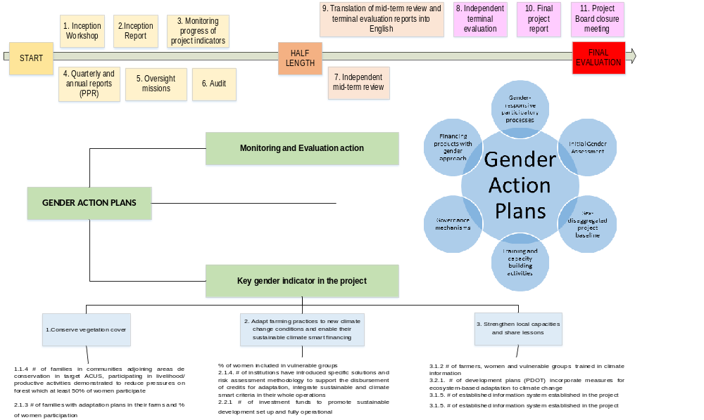

Figure 37. Monitoring and evaluation concept includes gender keys

E. Include a results framework for the project proposal, including milestones, targets and indicators.
Project Program Component | Component 1: At least 230,000 ha of native vegetation is conserved to reduce the impact of climate change on the hydrological cycle under integrated watershed management
Expected Outcome | Indicator | Baseline | Target by project end | Sources of verification | Assumptions
C1.1. 1,000 ha of native vegetation is conserved by sustainable forest management and conservation mechanisms. | 1.1.1 # of ha of forest conserved in the Bio-corridor | The forest and conservation areas of the Río Blanco upper basin have outdated management plans. | Establishment of functional conservation areas as part of the Toachi-Pilaton corridor | Ha under conservation categories with formal agreements. | The economic activity and the area of use increases. Farm plans and formal protection agreements are required.
 |  |  |  | Satellite images of high resolution to monitor conservation areas.
 | 1.1.1 # of ha of forest conserved in the Bio-corridor |  | Bio-corridor working with at least 1,000 ha of conservation to regulate the hydrological cycle. | Administrative records of different project actors. | All the relevant actors are willing to cooperate and coordinate among them.
 | 1.1.2 # of Decentralized Governments (GAD) with planning, regulatory and normative instruments for ACUS | -0/6 target GADs have Territorial Land Use Plans (TLUP) that incorporate specific provisions to climate change effects | 6/6 GADs in target bio-corridor with TLUP that incorporate specific provisions for Bio-corridor of conservation, ACUS and climate change adaptation harmonized with the national norm, with associated budgetary provisions. | Territorial Land Use Plans of the target provinces (PDOT) | The GADs are willing and incentivized by MAE to participate in the activity strengthening their management capacities in line with the project's objective, planned outcomes and outputs.
 |  | -0/6 J6GADs in project landscapes have or apply regulatory or normative instruments in relation to conservation and ACUS declaration |  | Territorial Land Use Plans of the target provinces (PDOT)
 | 1.1.3 Percentage (%) reduction of wood used for panela production: | To be determined in the first year of the project | Improve sustainable production alternatives that reduce pressure on forests | Farm’s zoning and plan elaboration. | The communities in the Rio Blanco upper watershed are interested in participating.
 |  | To be determined in the first year of the project | 30% of reduction of current use of wood | Technical folder (IBA). | Financing mechanisms for efficient knils will be implemented and are productive, inputs and equipment are available.
 |  |  |  | # of efficient knils installed accoridng to administrative records of the project, financing institutions and servcie providers;
 |  |  |  | Governance analysis developed to identify relations among actors and avoid possible conflicts | Monitoring activities provide measurable results to verify baseline and enhancements introduced by the project.
 | 1.1.4 # of families in communities adjoining areas de conservation in target ACUS, participating in livelihood/productive activities demonstrated to reduce pressures on forest which at least 50% of women participate | To be determined, once target families are identified. | - At least 178 families participate in sustainable productive activities. | Field inspections in target communities | If to many target commuities are joining the project, spot-sampling methodology will be applied.
 |  | No planning is made for farms or the river basin. | - At least one technology transfer agreement signed with universities. | Questionnaires and/or focus groups to verify links of production and reductions in pressures on forest | National universities are interested and can hence be engaged in joining the project
 | 1.1.5. # of properly performing stations located in the river basin. | Four stations partially working. | 7 hydro-meteorological stations providing climatic data in a regular bases and located accordingly to technical criteria by INAMHI | Previously existing equipment improved and working properly. | No price increases for existing spare parts or identified equipment will occur.
 |  |  |  | Hydro-meteorological monitoring system working correctly.
 |  |  |  | Data reported by hydro-meteorological stations.
C1.2. At least 230,000 ha of native vegetation is conserved to reduce the impact of climate change on the hydrological cycle under integrated watershed management | 2.1.1 Percentage of reduction in the use of forest wood for productive activities in the Upper and Middle Basin of the Toachi River | From the concept note 3 trees per month are being used for firewood. | 30% of reduction of current use of wood for productive activities in the Upper and Middle Basin of the Toachi River through promoting technology change and improvement of the production process of the panela production | Farm’s zoning and plan elaboration. | The economic activity and the area of use increases. Farm plans and formal protection agreements are required.
 |  |  | Governance analysis performed | Technical folder (IBA). | Technical folder are available for all actors.
 |  |  |  | # of farms that have experienced technology change/transfer. | All the relevant actors are willing to cooperate and coordinate among them.
 |  |  |  | Governance analysis developed to identify relations among actors and avoid possible conflicts
 | 2.1.2 # of ha of priority conservation areas maintenance through the creation of the Toachi Pilaton Bio-corridor. | Toachi-Pilaton and Sarapullo protected forest already exist. | 230,000ha protected in the watershed that includes ACUS, GADs areas, protected forests. | # of acres under conservation categories through formal agreements. | Administrative records and satelite image will be available for verification.
 |  |  |  | # of ha recovered
 |  |  |  | Updated management plan.
 | 2.1.3 # of families with adaptation plans in their farms and % of women participation | There are 0 farm plans in the project area developed with families and communities | At least 178 family farms including adaptation to climate change measures within their operation and with at least 50% of women participation | # of farm and management plans developed, verified by administrative records of the project. | Communities are willing to engage in the project's activities.
 |  |  |  | Inventory of farms with adaptation plans given to the management project unit.
 | 2.1.4 Ratings of Management Effectiveness Tracking Tool and PGOA | Average total METT score in Illinizas PAs is 50 out of a possible 100 | Reach an average total score of PAs: 70 out of a possible 100 | METT evaluation carried out by the project | n/a
 |  | PGOA developed | PGOA by 60% implemented in Illinizas | PGOA report | The project team will verify the implementation of the PGOA.
 | 2.1.5 # and quality of control points in wildlife and forest traffic | There is one control point in Tandapi. | -one additional control point implemented | Audit and monitoring report; project adminsitrative records | The respective authorities will comply with their initial statement of engaging with the project.
 |  | There is one control point in Tandapi. | -Tandapi control point strengthened | Training and participants' list
 |  |  |  | Statistics of controls made in both points
Project / Program Components | Component 2. Adapt farming practices to new climate change conditions enable their sustainable climate smart financing
Expected Outcomes | Indicator | Baseline | Targets by project end | Sources of verification | Assumptions
C2.1. Sustainable farming practices and livestock adjusted to local realities are being introduced and implemented with assistance of financing mechanisms for adaptation measures | 2.1.1. # of ha of pasture and # of ha of crops apply sustainable farming practices. | Application of sustainable farming practices is non existent or sporadic at best. | At least 250 ha of pasture and 250 ha of crops apply sustainable farming practices and | Inspection report of MAG officials. | Partners document gender of applicants/participants/ clients
 |  |  |  | Adminsitrative records of project partners for sugar cane, mortiño and naranjilla, livestock describing men and women participation | Partners document gender of applicants/participants/ clients
 | 2.1.2 % of women included in vulnerable groups | Number of women dedicated to agricultural practices | 50% women and 50% men including also vulnerable groups. | Application requests for implementation of sustainable practices. | Goups of women well informed about this initiative and willing to participate
 |  |  |  | Adminsitrative records of project partners such as training or finance providers. | Partners document gender of applicants/participants/ clients
 |  |  |  | Report of the selected farmers to be included in the project | Promotinon of women participation coming from GAD´s
 | 2.1.3 # of panela producers that implement better technology to decrease use of firewood. | 0 efficient knils are being used in the project area | At least 10 artisanal panela producers applying best available technology (BAT) | Invoices with description of the machinery | Partners document gender of applicants/participants/ clients
 |  |  |  | Monitoring report of the project/ adminsitrative records of partners and suppliers | Partners document gender of applicants/participants/ clients
 | 2.1.4. # of institutions have introduced specific solutions and risk assessment methodology to support the disbursement of credits for adaptation, integrate sustainable and climate smart criteria in their whole operations | 0 institutions in the project area has up-to-date smart-lending methodologies or green inclusive finance products | 2 financial institutions incorporated into their business operations financial sustainability issues, including climate smart lending methodology and tools. | Climate and Environmental risk assessment reports, inlcuding operational audit report | Participation of financial institutions that show first steps towards sustainability issues
 |  |  | 2 institutions have introduced specific EbA-focused lending products | Climate and Environmental risk assessment reports, inlcuding loan portfolio reports
 |  |  | 2 institutions have trained their personnel on sustainability topics, including EbA and Climate Change | Review of training materials and participants' lists
C2.2 At least 1 long term financing mechanisms has been piloted or introduced | 2.2.1 # of investment funds to promote sustainable development set up and fully operational | No investment fund for sustainable development is active in the project area and hence has no assets | The investment Fund for the care of the upper basin of Río Blanco sustainable development is active an | Constitutional documents of the fund; Audited financial statement for the period 2019-2021 | The Toachi-Pilatón hydroelectric plant in full operation since 2019
 | 2.2.2 Assets of the investment fund in USD |  | A total of USD 462,314 in assets has been generated
Project / Program Components | Component 3. Strengthen local capacities and share lessons
Expected Outcomes | Indicator | Baseline | Targets by project end | Sources of verification | Assumptions
C3 Local population and parish governments with increased capacity to implement climate change adaptation measures. | 3.1.1 # of GADs trained to use meteorological information generated by meteorological stations currently installed. | 0 GADs trained | 6 GADs being trained to take care and use meteorological information generated by meteorological stations currently installed. | Training and participants' list | Integration of captured data by meteorological stations in a central point.
 | 3.1.2 # of farmers, women and vulnerable groups trained in climate information | 0 farmers from 6 parishes have been trained in use of climate information | At least 500 families trained in the use of climate date, with at least 55% women's participation | Training and participants' list | Storage and processing data to make sure is understandable for the population and other stakeholders.
 | 3.2.1. # of development plans (PDOT) incorporate measures for ecosystem-based adaptation to climate change | 0 PDOT | 6 GADs PDOTs incorporate measures for ecosystem-based adaptation to climate change. | Development and territorial planning plans published on the website of the parish GAD. | Elaboration of development and territorial planning plans on a regular basis.
 | 3.3.1 # of communication, education knowledge transfer and replication events organized | 0 events carried out | 12 events over the liftime of the project carried out | Events' participants' list | Technological platform available for training and communication processes
 | 3.2.1 # of training provided to financial institutions. | 0 institutions trained | At least 6 trainings provided on adaptation finance and 6 training for climate risk in two financial institution | Training and participants' list | Financial institutions have been identified and engaged.
 | 3.2.2 # of demonstration farms established | 0 demonstration farms in project area | At least 2 demonstration farms established | Reports on demonstration farm planning and implementation | Suitable plots by public or provate actors identfied
 | 3.2.3 # of training events on EbA carried out | 0 raining events on EbA carried out | At least 12 training events carried out in 6 parishs with at least 50% women participation | Workshop participants' list | Training materials have been developed in a modular approach
 | 3.1.5. # of established information system established in the project | 0 technological platforms implemented by Ministry of Environment. | At least 1 information platform collecting lessons learnt by the project and supporting knowledge sharing | Continue access and availability of technological platform for training and communication, or search data and information.

F. Demonstrate how the project / programme aligns with the Results Framework of the Adaptation Fund
Project Objective(s) | Project Objective Indicator(s) | Fund Outcome | Fund Outcome Indicator | Grant Amount (USD)
To strengthen the adaptive capacity of the local population in the Río Blanco water system | Number of people (men and women) with improved adaptive capacity [target 2600 people] | Outcome 2: Strengthened institutional capacity to reduce risks associated with climate-induced socioeconomic and environmental losses | 2. Capacity of staff to respond to, and mitigate impacts of, climate-related events from targeted institutions increased | 120,000
 |  | Outcome 3: Strengthened awareness and ownership  of adaptation and climate risk reduction processes at local level | 3.1. Percentage of targeted population aware of  predicted adverse impacts of climate change, and  of appropriate responses | 160,000
 |  | Outcome 5: Increased ecosystem resilience in  response to climate change and variability-induced stress | 5.1. Number of natural resource assets created, maintained or improved to withstand conditions resulting from climate variability and change (by type and scale) | 475,000
 |  | Outcome 6: Diversified and strengthened livelihoods  and sources of income for vulnerable people in targeted areas | 6.1 Percentage of households and communities having more secure access to livelihood assets | 110,000
Outcome 1. At least 230,000 ha of native vegetation is conserved to reduce the impact of climate change on the watershed´s hydrological cycle. | Surface (ha) under improved management. [target 230,000 ha] | Output 5: Vulnerable ecosystem services and natural resource assets strengthened in response to climate change impacts, including variability | 5.1. Number of natural resource assets created, maintained or improved to withstand conditions resulting from climate variability and change (by type and scale) | 950,000
Outcome 2. At least 500 ha of agriculture land apply sustainable farming practices appropriate to the foreseen impacts of climate change | Production area (ha) under improved management [target 500 ha]  Number of people (men and women) who implement sustainable farming practices [target >300] | Output 6: Targeted individual and community livelihood strategies strengthened in relation to climate change impacts, including variability | 6.1.1. Number and type of adaptation assets (tangible and intangible) created or strengthened in support of individual or community livelihood strategies | 840,000
Outcome 3. Local population and parish governments with increased capacity to implement climate change adaptation measures. | Number of strengthened local development plans [target 6]  Number of staff (men and women) of local governments and pertinent entities trained on adaptation to climate change [target >25]  Number of people (men and women) who have participated in awareness activities and events. [to be defines]  Number of visitors to the project´s website [to be defined] | Output 2: Strengthened capacity of national and subnational centres and networks to respond rapidly to extreme weather events | 2.1.1. Number of staff trained to respond to, and mitigate impacts of, climate-related events (by gender)  2.1.2 Number of targeted institutions with increased capacity to minimize exposure to climate variability risks (by type, sector and scale) | 400.000

G. Include a detailed budget with budget notes, a budget on the Implementing Entity management fee use, and an explanation and a breakdown of the execution costs.
Output | Responsible entity | Canton / Parrish | Budget description |  | Year 1 |  | Year 2 |  | Year 3 |  |  | Year 4 |  | Total |  | Budget note |  | Details
1. 1,000 ha of native vegetation is conserved by sustainable forest management and conservation mechanisms. | MAE | All cantons & parishes | Contractual services company (ACUS management plan- conservation bio-corridor) |  | 46,500 |  |  |  |  |  |  |  |  | 46,500 |  | 1.1 |  | Contractual services company for the establishment of functional conservation areas as part of the Toachi Pilaton Basin Bio-corridor, the consultancy includes: Technical, biological and zoning file studies; ACUS Management Plan of Conservation Bio-corridor (MPCB).
 | MAE | All cantons & parishes | Local consultants (Financial and operational sustainability strategy) |  |  |  | 23,333 |  | 23,333 |  |  | 23,333 |  | 70,000 |  | 1.2 |  | Local consultants for the Financial and Operational Sustainability Strategy according with the investment fund;
 | MAE | All cantons & parishes | Contractual services individual (Management and operation model) |  | 5,375 |  | 5375 |  | 5375 |  |  | 5375 |  | 21,500 |  | 1.3 |  | Contractual services individual for implementing, monitoring the Biocorredor Management Model
 | MAE | All cantons | Contractual services company (Increases in # of Decentralized Governments (GAD) with planning, regulatory and normative instruments for ACUS) |  | 3,500 |  | 3,500 |  | 3,500 |  |  | 3,500 |  | 14,000 |  | 1.4 |  | In support of the Increases in # of Decentralized Governments (GAD) with planning, regulatory and normative instruments for ACUS that includes: the joint identification (PA authorities and GADs) of key habitats, restrictions and monitoring programs, and agreements for their implementation; inclusion in land-use planning processes of specific standards and practices for protecting forest and integrated watershed management; and Municipal ordinances on conservation, land use practices, and ACUS
 | MAE | All parishes | Equipment and furniture (Strengthen incentive systems for set-asides on private and community lands based ACUS and technology change) |  | 62500 |  | 62500 |  | 62500 |  |  | 37500 |  | 225,000 |  | 1.5 |  | Strengthen incentive systems for set-asides on private and community lands based ACUS
 | MAE | All cantons | Local consultants (Municipal PAs gazetted, covering 1,000ha, in buffer-zones and corridors identified as critical for water hydrological cycle) |  | 3,000 |  | 3,000 |  | 3,000 |  |  | 3,000 |  | 12,000 |  | 1.6 |  | Technicians in monitoring and supporting the Municipal PAs gazetted, covering 1,000ha, in buffer-zones and corridors identified as critical for water hydrological cycle.
 | MAE | All parishes | Equipment and furniture (Promotion of habitat and connectivity-friendly production options) |  |  |  | 20000 |  | 20000 |  |  | 20000 |  | 60,000 |  | 1.7 |  | Equipment for the promotion of habitat and connectivity-friendly production options and programs for reduction of human/wildlife conflicts in association with the Ministry of Agriculture
 | MAE | All cantons & parishes | Contractual services individual (Increases in # families in communities adjoining conservation areas in target ACUS which at least 50% of women participation) |  |  |  | 667 |  | 8667 |  |  | 8666 |  | 18,000 |  | 1.8 |  | Technicians in support the increases in # families in communities adjoining conservation areas in target ACUS, participating in livelihood /´productive activities demonstrated to reduce pressures on forest which at least 50% of women participation
 | MAE | All parishes | Equipment and furniture (Strengthening of the hydro-meteorological monitoring system in the Toachi-Pilaton river basin.) |  |  |  | 8000 |  | 25000 |  |  |  |  | 8,000 |  | 1.9 |  | Equipment for strengthening of the hydro-meteorological monitoring system in the Toachi-Pilaton river basin that includes maintenance of hydro-meteorological stations
 |  |  | Subtotal |  |  |  |  |  |  |  |  |  |  | 500,000
2. Improved management of existing protected forests and private conservation areas (ca. 230,000 ha) | MAE | All parishes | Contractual services individual (Reduction in the use of forest wood for productive activities in the Upper and Middle Basin) |  | 17,875 |  | 17875 |  | 17875 |  |  | 17875 |  | 71,500 |  | 2.1 |  | Contractual services individual in support of the target: reduction in the use of forest wood for productive activities in the Upper and Middle Basin of the Toachi and Pilaton Rivers (Landscape Las Pampas and Palo Quemado), through technology change in the process of the panela production, that includes planning, assessment and monitoring of the process
 | MAE | All parishes | Equipment and furniture (Technology change (ovens change to promote efficiency in the production of panela) |  | 43,720 |  | 43,720 |  | 43,720 |  |  | 43,840 |  | 175,000 |  | 2.2 |  | Equipment and furniture such as technology change (ovens change to promote efficiency in the production of panela); forest planning and productive alternatives
 | MAE | All cantons | Contractual services company (Planning and zoning of the river basin with a participatory and inclusive approach. Promote dialogue, coordination and technical support at local level) |  | 10,333 |  | 10,333 |  | 10,333 |  |  |  |  | 31,000 |  | 2.3 |  | Planning and zoning of the river basin with a participatory and inclusive approach. Promote dialogue, coordination and technical support at local level and improvement of the protector forest.
 | MAE | All parishes | Contractual services individual (Management plan of the protector forest, including ravine and shore protection activities.) |  |  |  | 10000 |  | 10000 |  |  | 5000 |  | 25,000 |  | 2.4 |  | Implementation of Management Plan of the protector forest, including ravine and shore protection activities.
 | MAE | All parishes | Contractual services individual (Train farmers in conservation practices and climate change) |  | 4,000 |  | 4,000 |  | 4,000 |  |  | 4,000 |  | 16,000 |  | 2.5 |  | Increase in the process of planning and zoning of farms in which at least 50% of women participate
 | MAE | All cantons & parishes | Equipment and furniture (Increases in ratings of Management Effectiveness Tracking Tool and PGOA) |  | 15,000 |  | 15,000 |  | 15,000 |  |  | 15,000 |  | 60,000 |  | 2.6 |  | Equipment and furniture relationships with increases in ratings of Management Effectiveness Tracking Tool and PGOA
 | MAE | All cantons | Equipment and furniture (Increases in control capacities in wildlife and forest traffic) |  | 35,750 |  | 35,750 |  |  |  |  |  |  | 71,500 |  | 2.7 |  | Increases in control capacities in wildlife and forest traffic that includes: Equipment for environmental control mainly forest and wildlife with supporting UPMA; Strengthen Tandapi control point; Install a control point in las Pampas, equipment in coordination with the Police; and Monitoring system, newsletter and decentralization of information.
 |  |  | Subtotal |  |  |  |  |  |  |  |  |  |  | 450,000
3. 250 ha of pasture and 250 ha of crops apply sustainable farming practices | MAE | All cantons & parishes | Contractual services individual |  | 10,000 |  | 15,000 |  |  |  |  |  |  | 25,000 |  | 3.1 |  | Building of the team: Selection of experts in sustainable agricultural management and climate-smart livestock; Incorporation of an industrial technician with technical background to identify options of improvement in the technology for the panela producers; Field visits by specialists to collect information on the type of crop, microclimate, vulnerabilities and resilience; Documentation: Definition of appropriate adaptation measures for farming and production areas; Monitoring visits and documentation of the progress of adaptation measures. Identification of problems
 | CAF/GADs | All cantons & parishes | Grants for implementation |  | 20,000 |  | 25,000 |  | 130,000 |  |  | 125,000 |  | 300,000 |  | 3.2 |  | Grants for implementation; Selection: Identify, through the defined procedures and actors, the participants for the construction of sustainable farms; The project management board reviews the profiles of participants entering into vulnerable groups for approval; Subsidy for 150 beneficiaries of vulnerable groups receive 75% of the cost and implementation of adaptation measures as grant. 25% they will put it as counterpart (labor); Delivery to the qualified suppliers of the values for the implementation by means of transference or certified check
 | MAG | All cantons & parishes | Suppliers identification |  | 5,000 |  | 10,000 |  |  |  |  |  |  | 15,000 |  | 3.3 |  | Suppliers identification; Announcement for all suppliers interested in participating for the delivery of inputs for the construction of sustainable farms. Interesting stock, good experience and reputation is a plus; Visits each of the suppliers to verify the information provided and the prices offered.
 |  |  | Subtotal |  |  |  |  |  |  |  |  |  |  | 340,000
4. At least 2 institutions have introduced specific solutions and credit assessments to support the disbursement of credits for adaptation, integrating environmental and climatic risks in their operations. | MAE | All cantons & parishes | Contractual services individual |  | 5,000 |  | 5,000 |  | 5,000 |  |  |  |  | 15,000 |  | 4.1 |  | Selection of consultants who will work on the development of output 2 and 3. Knowledge and good experience in the field of software-based green lending or climate financing will be required; Identification of adequate EbA and other adaptation emasures for target customers of participating financial institutions;
 | MAE | All cantons & parishes | Contractual services company |  | 5,000 |  | 10,000 |  |  |  |  |  |  | 15,000 |  | 4.2 |  | ICT solution to automatically and systematically collect data in the field, software to facilitate the identification, qualification, monitoring and reporting of adaptation credits.
 | MAE | All cantons & parishes | Contractual services company |  | 15,000 |  | 15,000 |  | 10,000 |  |  | 10,000 |  | 50,000 |  | 4.3 |  | Development of climate smart lending management, for different crops and to be implemented in lending processes of financial institutions; Development of policies and procedures of climate risk management in the institution; Development of financial products, product design including loan terms;
 |  |  | Subtotal |  |  |  |  |  |  |  |  |  |  | 80,000
5. One investment fund to promote sustainable development is set up and operational | CAF / CFN | Sigchos | Trust expenses |  | 21,000 |  |  |  |  |  |  |  |  | 21,000 |  | 5.1 |  | Legal study for the set-up of the fund
 | GAD SIGCHOS | Sigchos | Renting premise |  | 3,600 |  |  |  |  |  |  |  |  | 3,600 |  | 5.2 |  | Office rent for first year
 | GADs SIGCHOS Y MEJIA | All cantons & parishes | Recruitment |  | 31,200 |  |  |  |  |  |  |  |  | 31,200 |  | 5.3 |  | Recruitment of personnel of first year
 | GADs SIGCHOS Y MEJIA | All cantons | Vehicle, equipment and furniture |  | 26,000 |  |  |  |  |  |  |  |  | 26,000 |  | 5.4 |  | Physical infrastructure of the investment fund
 | GAD SIGCHOS | Sigchos | Miscellaneous expenses |  | 3,600 |  |  |  |  |  |  |  |  | 3,600 |  | 5.5 |  | Office supplies, administrative expenses
 | GADs SIGCHOS Y MEJIA | Sigchos | Invetsment in sustainable development investment trust |  | 109200 |  | 109200 |  | 109200 |  |  | 109200 |  | 327,600 |  | 5.6 |  | Seed investment for the set-up pof the fund
 | GAD SIGCHOS | Sigchos | Economic incentives for adaptation disbursements tools |  | 2000 |  | 2,000 |  | 2,,000 |  |  |  |  | 6,000 |  | 5.7 |  | Economic incentives for eligible lending customers that will invest into EbA and other adaptation options
 | GAD SIGCHOS | Sigchos | Reporting |  |  |  |  |  |  |  |  | 1,000 |  | 1,000 |  | 5.8 |  | Ekaboration of reporting per year, including monitoring visits of financed custoemrs;
 |  |  | Subtotal |  |  |  |  |  |  |  |  |  |  | 420,000
6. At least 6 parishes being trained to take care and use meteorological information generated by meteorological stations currently installed. | INAHMI / GADs | All parishes | Miscellaneous expenses |  |  |  |  |  | 10,000 |  |  | 10,000 |  | 20,000 |  | 6.1 |  | Training in use and maintenance of meteorological stations for technical staff of each GAD.
 | INAHMI / GADs parishes | All parishes | Contractual services individual |  |  |  | 10,000 |  | 10,000 |  |  | 10,000 |  | 30,000 |  | 6.2 |  | Changing administrative operations from INAMHI to GAD technical personal staff.
 | INAHMI / GADs parishes | All parishes | Miscellaneous expenses |  |  |  |  |  | 40,000 |  |  | 40,000 |  | 80,000 |  | 6.3 |  | Training 500 families in the use of climate data and their application in activities, such as: agriculture and livestock. This training will be address for 55% percent of women. Including field visits, food and transportation.
 | INAHMI / GADs parishes | All parishes | Audiovisual & print production costs |  |  |  |  |  | 5,000 |  |  | 5,000 |  | 10,000 |  | 6.4 |  | Designing of interactive content and generation of newsletters to training GAD population in the area including women associations, older adults and vulnerable groups.
 | INAHMI / MAE | All parishes | Contractual services individual |  |  |  | 6,666 |  | 6,667 |  |  | 6,667 |  | 20,000 |  | 6.5 |  | Integrating the digital media technologies for communication plan and addressed it to the population in general including women, older adult, youth people and children’s.
 |  |  | Subtotal |  |  |  |  |  |  |  |  |  |  | 160,000
7. Six development plans of local parishes incorporate measures for ecosystem-based adaptation to climate change | GADs | All parishes | Local consultants |  | 10,000 |  |  |  |  |  |  |  |  | 10,000 |  | 7.1 |  | Conducting a technical study to determinate which climate change adaptation measures that must be added for development and territorial planning plans.
 | GADs | All parishes | Local consultants |  | 5,000 |  | 5,000 |  | 5,000 |  |  | 5,000 |  | 20,000 |  | 7.2 |  | Gathering information on climate change adaptation measures to be added like indicators and statistics into the development and territorial planning plans. The indicators should include gender information and vulnerable groups for climate change.
 | GADs | All parishes | Local consultants |  |  |  | 10,000 |  | 10,000 |  |  | 10,000 |  | 30,000 |  | 7.3 |  | Developing new development and territorial planning documents adding climate change statistics and information and also including gender and vulnerable group’s climate change issues.
 | GADs | All parishes | Miscellaneous expenses |  |  |  | 3,333 |  | 3,333 |  |  | 3,333 |  | 10,000 |  | 7.4 |  | Training for population including associations, organizations and other stakeholder of the project about climate change adaptation measures incorporated in the PDOTs.
 | GADs | All parishes | Miscellaneous expenses |  |  |  | 3,333 |  | 3,333 |  |  | 3,333 |  | 10,000 |  | 7.5 |  | Socialize new PDOTs documents with the population of the project area including associations, organizations and the population in general.
 |  |  | Subtotal |  |  |  |  |  |  |  |  |  |  | 80,000
8. Strategic plan of communication, education, knowledge transference and scheme of replica, including demonstration farms. Plus training on adaptation finance to financial institutions. | GADs | All parishes | Contractual Individual Services |  | 5,000 |  | 5,000 |  | 5,000 |  |  | 5,000 |  | 20,000 |  | 8.1 |  | Developing a communication plan addressed for stakeholders in the project including specific women associations and organizations.
 | Project Manager / GADs | All parishes | Contractual Individual Services |  | 3,750 |  | 3,750 |  | 3,750 |  |  | 3,750 |  | 15,000 |  | 8.2 |  | Integrating the digital media technologies for communication plan and addressed it to the population in general including women, older adult, youth people and children’s.
 | Project Manager / GADs | All parishes | Miscellaneous expenses |  | 6,250 |  | 6,250 |  | 6,250 |  |  | 6,250 |  | 25,000 |  | 8.3 |  | Sharing lessons learned and experiences with project stakeholders, and replicate knowledge to other similar projects in the country trught demostrative farms applying sustainable methods for agriculture, livestock and panela production
 | Project Manager / GADs | All parishes | Miscellaneous expenses |  | 5,000 |  | 5,000 |  | 5,000 |  |  | 5,000 |  | 20,000 |  | 8.4 |  | Training modular courses on sustainable agriculture and good agricultural practices, open to associations and selected farmers to participate. 12 modules, 6 theorists, 6 in the field and an on-site supervision within 6 months of completing the course. 50% women
 | Project Manager | All parishes | Local consultants |  | 5,000 |  | 5,000 |  | 5,000 |  |  | 5,000 |  | 20,000 |  | 8.5 |  | Training for all Microfinance Institution (MFI) staff participating in climate risk, green credit and climate change issues with a focus on microfinance
 | Project Manager | All parishes | Local consultants |  | 5,000 |  | 5,000 |  | 5,000 |  |  | 5,000 |  | 20,000 |  | 8.6 |  | Certification of organic crops or good agricultural practices for the production of panela, mortiño wine or crops of sugar or naranjilla, of those graduates with better performance in their crops.
 |  |  | Subtotal |  |  |  |  |  |  |  |  |  |  | 120,000
9. Systematisation of information gathered during the whole project design and implementation using existing informatics platforms | MAE | All parishes | Contractual services individual |  | 15,000 |  | 5,000 |  | 5,000 |  |  |  |  | 25,000 |  | 9.1 |  | Developing a technological platform to manage knowledge and information about climate change adaptation, using disruptive technologies like: big data and cloud computing.
 | MAE | All parishes | Contractual services individual |  | 10,000 |  |  |  |  |  |  |  |  | 10,000 |  | 9.3 |  | Integrating technological platform into others technological platforms used by the Ministry of Environment.
 | MAE / GADs | All parishes | Contractual services individual |  | 2,500 |  | 2,500 |  |  |  |  |  |  | 5,000 |  | 9.4 |  | Sociability of the technological platform with all stakeholders in the project including associations and organizations.
 |  |  | Subtotal |  |  |  |  |  |  |  |  |  |  | 40,000
Total project cost |  |  |  |  |  |  |  |  |  |  |  |  |  | 2.190,000
Project/Programme Execution cost |  |  |  |  |  |  |  |  |  |  |  |  |  | 180,000
Details | CAF | Ecuador | Direct Project Services Coordination Unit | 26000 |  | 28000 |  | 28000 |  |  | 38000 |  | 120000 |  |  | Section H |  |  | Direction Services
Details | CAF | Ecuador | Direct Project Services Miscellaneous expenses | 12000 |  | 12000 |  | 12000 |  |  | 12000 |  | 60000 |  |  | Section H |  |  | Direction Services
Total project cost |  |  |  |  |  |  |  |  |  | 2,370,000
Project/Programme Cycle Management Fee charged by the Implementing Entity (if applicable) |  |  |  |  |  |  |  |  |  |  |  |  |  | 119,373
Details | CAF | Ecuador | Financial administration. | 6250 |  | 6250 |  | 6250 |  |  | 6250 |  | 25000 |  |  | Section H |  |  | Financial administration of project funds and accounting services.
Details | CAF | Ecuador | Procurement and miscellaneous expenses | 9600 |  | 9600 |  | 9600 |  |  | 9600 |  | 38400 |  |  | Section H |  |  | Procurement of goods, works and services and contract administration. Including management of project personnel and consultants.
Details | CAF | Ecuador | Project oversight. | 6250 |  | 6250 |  | 6250 |  |  | 6250 |  | 25000 |  |  | Section H |  |  | Project oversight. Including visits to project sites to verify quality of deliverables, and overseeing independent evaluations.
Details | CAF | Ecuador | Reporting |  |  | 5162 |  | 5162 |  |  | 5162 |  | 15486 |  |  | Section H |  |  | Reporting. Including technical, administrative and financial reports to the Adaptation Fund. Preparation of annual Project Performance Report (PPR)
Details | CAF | Ecuador | Support services to the project´s management unit within CAF | 3871 |  | 3871 |  | 3871 |  |  | 3874 |  | 15487 |  |  | Section H |  |  | Provide office space and support services to the project´s management unit within CAF
TOTAL |  |  |  |  |  |  |  |  |  | 2,489,373

H. Include a disbursement schedule with time-bound milestones.

Disbursement Schedule

Description | Year 1 | Year 2 | Year 3 | Year 4 | Total
Date | 15 Januay 2018 | 15 Januay 2019 | 15 Januay 2020 | 15 Januay 2021 | Total
Project funds | $678.341,5 | $593.773,5 | $593.773,5 | $504.111,5 | $2.370.000
Implementing Entity management fee | $25.971,00 | $31.133,00 | $31.133,00 | $31.136,00 | $119.373
Total | $704.312,5 | $624.906,5 | $624.906,5 | $535.247,5 | $2.489.373

Output | Responsible entity | Canton / Parrish |  | Budget description |  | Year 1 | MILESTONE |  | Year 2 |  | MILESTONE |  | Year 3 |  | MILESTONE |  | Year 4 | Total and Budget note
1. 1,000 ha of native vegetation is conserved by sustainable forest management and conservation mechanisms. | MAE | All cantons & parishes |  | Contractual services company (ACUS management plan- conservation bio-corridor) |  | 46,500 | ACUS Management Plan according Bio corridor for the conservation elaborated. |  |  |  |  |  |  |  | ACUS model implemented |  |  | 46,500 |  | 1.1
 | MAE | All cantons & parishes |  | Local consultants (Financial and operational sustainability strategy) |  |  | Improvement land tenure |  | 23,333 |  | Financial and operational sustainability strategy elaborated |  | 23,333 |  |  |  | 23,333 | 70,000 |  | 1.2
 | MAE | All cantons & parishes |  | Contractual services individual (Management and operation model) |  | 5,375 | Technicians for application of Management Model |  | 5375 |  |  |  | 5375 |  | M&E |  | 5375 | 21,500 |  | 1.3
 | MAE | All cantons |  | Contractual services company (Increases in # of Decentralized Governments (GAD) with planning, regulatory and normative instruments for ACUS) |  | 3,500 | Joint identification (PA authorities and GADs) of key habitats |  | 3,500 |  |  |  | 3,500 |  | PDOT implemented |  | 3,500 | 14,000 |  | 1.4
 | MAE | All parishes |  | Equipment and furniture (Strengthen incentive systems for set-asides on private and community lands based ACUS and technology change) |  | 62,500 | Strengthen incentive systems for set-asides on private and community lands based ACUS |  | 62500 |  |  |  | 62500 |  | Ha under conservation category |  | 37500 | 225,000 |  | 1.5
 | MAE | All cantons |  | Local consultants (Municipal PAs gazetted, covering 1,000ha, in buffer-zones and corridors identified as critical for water hydrological cycle) |  | 3,000 |  |  | 3,000 |  | Proposed for monitoring Municipal PAs covering 1,000ha, in buffer-zones |  | 3,000 |  | M&E |  | 3,000 | 12,000 |  | 1.6
 | MAE | All parishes |  | Equipment and furniture (Promotion of habitat and connectivity-friendly production options) |  |  | Initial studies |  | 20000 |  | Training communities for promotion of habitat and connectivity-friendly production options |  | 20000 |  |  |  | 20000 | 60,000 |  | 1.7
 | MAE | All cantons & parishes |  | Contractual services individual (Increases in # families in communities adjoining conservation areas in target ACUS which at least 50% of women participation) |  |  | Technical support |  | 667 |  | Technicians for Planning and zoning of the river basin and productive alternatives |  | 8,667 |  |  |  | 8,667 | 18,000 |  | 1.8
 | MAE | All parishes |  | Equipment and furniture (Strengthening of the hydro-meteorological monitoring system in the Toachi-Pilaton river basin.) |  |  | Initial studies |  | 8000 |  |  |  | 25000 |  | Equipment for strengthening of the hydro-meteorological monitoring system |  |  | 33,000 |  | 1.9
 |  |  |  | Subtotal |  |  |  |  |  |  |  |  |  |  |  |  |  | 500,000
2. Improved management of existing protected forests and private conservation areas (ca. 230,000 ha) | MAE | All parishes |  | Contractual services individual (Reduction in the use of forest wood for productive activities in the Upper and Middle Basin) |  | 17,875 | Technicians for community training, planning and Reduction in the use of forest wood for productive activities |  | 17875 |  |  |  | 17875 |  |  |  | 17875 | 71,500 |  | 2.1
 | MAE | All parishes |  | Equipment and furniture (Technology change (ovens change to promote efficiency in the production of panela) |  | 43,720 |  |  | 43,720 |  | Technology change (ovens change to promote efficiency in the production of panela) and sustainable production |  | 43,720 |  |  |  | 43,840 | 175,000 |  | 2.2
 | MAE | All cantons |  | Contractual services company (Planning and zoning of the river basin with a participatory and inclusive approach. Promote dialogue, coordination and technical support at local level) |  | 10,333 | Governance analysis performed to provide recommendations |  | 10,333 |  | M&E |  | 10,333 |  | M&E |  |  | 31,000 |  | 2.3
 | MAE | All parishes |  | Contractual services individual (Management plan of the protector forest, including ravine and shore protection activities.) |  |  |  |  | 10,000 |  | Assessment, monitoring and evaluation of farms to perform and provide technology transfer |  | 10,000 |  | 5,000 |  |  | 25,000 |  | 2.4
 | MAE | All parishes |  | Contractual services individual (Train farmers in conservation practices and climate change) |  | 4,000 | Technical staff |  | 4,000 |  | Assessment, monitoring and evaluation of farms to perform and provide technology transfer |  | 4,000 |  |  |  | 4,000 | 16,000 |  | 2.5
 | MAE | All cantons & parishes |  | Equipment and furniture (Increases in ratings of Management Effectiveness Tracking Tool and PGOA) |  | 15,000 | Increases in ratings of Management Effectiveness Tracking Tool and PGOA |  | 15,000 |  |  |  | 15,000 |  |  |  | 15,000 | 60,000 |  | 2.6
 | MAE | All cantons |  | Equipment and furniture (Increases in control capacities in wildlife and forest traffic) |  | 35,750 | increases in control capacities in wildlife and forest traffic; Strengthen Tandapi control point |  | 35,750 |  | Equipment for environmental control mainly forest and wildlife with supporting UPMA |  |  |  |  |  |  | 71,500 |  | 2.7
 |  |  |  | Subtotal |  |  |  |  |  |  |  |  |  |  |  |  |  | 450,000
3. 250 ha of pasture and 250 ha of crops apply sustainable farming practices | MAE | All cantons & parishes |  | Contractual services individual |  | 10,000 | Technical staff |  | 15,000 |  |  |  |  |  |  |  |  | 25,000 |  | 3.1
 | CAF/GADs | All cantons & parishes |  | Grants for implementation |  | 20,000 | First group of participants must have been selected and initiated the training (output8) |  | 25,000 |  | 2th group of participants selected and trained. Investment plan verified |  | 130,000 |  | 3th group of participants selected and trained. Investment plan verified |  | 125,000 | 3000,000 |  | 3.2
 | MAG | All cantons & parishes |  | Suppliers identification |  | 20,000 | Goods for sustainable practices |  | 10,000 |  | M&E |  |  |  |  |  |  | 30,000 |  | 3.3
 |  |  |  | Subtotal |  |  |  |  |  |  |  |  |  |  |  |  |  | 220,000
4. At least 2 institutions have introduced specific solutions and credit assessments to support the disbursement of credits for adaptation, integrating environmental and climatic risks in their operations. | MAE | All cantons & parishes |  | Contractual services individual |  | 10,000 | Technical support |  |  |  | 5,000 |  |  |  |  |  |  | 15,000 |  | 4.1
 | MAE | All cantons & parishes |  | Contractual services company |  | 10,000 | Personnel trained (output 8) |  | 5,000 |  |  |  |  |  |  |  |  | 15,000 |  | 4.2
 | MAE | All cantons & parishes |  | Contractual services company |  | 12,000 | 1) Catalog of adaptation measures developed; 2) Personnel trained (output 8) |  | 16,000 |  | 2) Personnel trained (output 8) |  | 11,000 |  |  |  | 11,000 | 50,000 |  | 4.3
 |  |  |  | Subtotal |  |  |  |  |  |  |  |  |  |  |  |  |  | 80,000
5. One investment fund to promote sustainable development is set up and operational | CAF / CFN | Sigchos |  | Trust expenses |  | 21,000 |  |  |  |  |  |  |  |  |  |  |  | 21,000 |  | 5.1
 | GAD SIGCHOS | Sigchos |  | Renting premise |  | 3,600 |  |  |  |  |  |  |  |  |  |  |  | 3,600 |  | 5.2
 | GADs SIGCHOS Y MEJIA | All cantons & parishes |  | Recruitment |  | 31,200 | The trust is legally constituted |  |  |  |  |  |  |  |  |  |  | 31,200 |  | 5.3
 | GADs SIGCHOS Y MEJIA | All cantons |  | Vehicle, equipment and furniture |  | 33,000 | Staff hired |  |  |  |  |  |  |  |  |  |  | 33,000 |  | 5.4
 | GAD SIGCHOS | Sigchos |  | Miscellaneous expenses |  | 3,600 |  |  |  |  |  |  |  |  |  |  |  | 3,600 |  | 5.5
 | GADs SIGCHOS Y MEJIA | Sigchos |  | Investment in sustainable development investment trust |  | 109200 | Staff, premises and equipment’s must be complete |  | 109200 |  | Investment fund |  | 109200 |  | Operating investment fund |  | 109200 | 327,600 |  | 5.6
 | GAD SIGCHOS | Sigchos |  | Economic incentives for adaptation disbursements |  | 2,000 | First group of participants must have been selected and initiated the training (output8) |  | 2,000 |  | 2th group of participants selected and trained. Investment plan verified |  | 2,000 |  | 3th group of participants selected and trained. Investment plan verified |  |  | 6,000 |  | 5.7
 | GAD SIGCHOS | Sigchos |  | Reporting |  |  |  |  |  |  |  |  |  |  |  |  | 1,000 | 1,000 |  | 5.8
 |  |  |  | Subtotal |  |  |  |  |  |  |  |  |  |  |  |  |  | 420,000
6. At least 6 parishes being trained to take care and use meteorological information generated by meteorological stations currently installed. | INAHMI / GADs | All parishes |  | Miscellaneous expenses |  |  |  |  |  |  |  |  | 10,000 |  | 50% parishes trained in meteorological stations |  | 10,000 | 20,000 |  | 6.1
 | INAHMI / GADs parishes | All parishes |  | Contractual services individual |  |  |  |  | 10,000 |  | 2 GADs operating meteorological stations |  | 10,000 |  | 4 GADs operating meteorological stations |  | 10,000 | 30,000 |  | 6.2
 | INAHMI / GADs parishes | All parishes |  | Miscellaneous expenses |  |  |  |  |  |  |  |  | 40,000 |  | 50% families trained in climate data |  | 40,000 | 80,000 |  | 6.3
 | INAHMI / GADs parishes | All parishes |  | Audiovisual & print production costs |  |  |  |  |  |  |  |  | 5,000 |  | Interactive content developed and delivered |  | 5,000 | 10,000 |  | 6.4
 | INAHMI / MAE | All parishes |  | Contractual services individual |  |  |  |  | 6,666 |  | Data send from meteorological station to MAE platforms |  | 6,667 |  | Data send from meteorological station to MAE platforms |  | 6,667 | 20,000 |  | 6.5
 |  |  |  | Subtotal |  |  |  |  |  |  |  |  |  |  |  |  |  | 160,000
7. Six development plans of local parishes incorporate measures for ecosystem-based adaptation to climate change | GADs | All parishes |  | Local consultants |  | 10,000 | Technical study finished |  |  |  |  |  |  |  |  |  |  | 10,000 |  | 7.1
 | GADs | All parishes |  | Local consultants |  | 5,000 | climate change measures defined |  | 5,000 |  | climate change measures defined |  | 5,000 |  | climate change measures defined |  | 5,000 | 20,000 |  | 7.2
 | GADs | All parishes |  | Local consultants |  |  |  |  | 10,000 |  | PDOT published |  | 10,000 |  | PDOT published |  | 10,000 | 30,000 |  | 7.3
 | GADs | All parishes |  | Miscellaneous expenses |  |  |  |  | 3,333 |  |  |  | 3,333 |  |  |  | 3,333 | 10,000 |  | 7.4
 | GADs | All parishes |  | Miscellaneous expenses |  |  |  |  | 3,333 |  | Trained population |  | 3,333 |  | Trained population |  | 3,333 | 10,000 |  | 7.5
 |  |  |  | Subtotal |  |  |  |  |  |  |  |  |  |  |  |  |  | 80,000
8. Strategic plan of communication, education, knowledge transference and scheme of replica, including demonstration farms. Plus training on adaptation finance to financial institutions. | GADs | All parishes |  | Contractual Individual Services |  | 5,000 | events of communication delivered for all population |  | 5,000 |  | events of communication delivered for all population |  | 5,000 |  | events of communication delivered for all population |  | 5,000 | 20,000 |  | 8.1
 | Project Manager / GADs | All parishes |  | Contractual Individual Services |  | 3,750 | plan communication delivered using media technologies |  | 3,750 |  | plan communication delivered using media technologies |  | 3,750 |  | plan communication delivered using media technologies |  | 3,750 | 15,000 |  | 8.2
 | Project Manager / GADs | All parishes |  | Miscellaneous expenses |  | 6,250 | Sharing lessons learned |  | 6,250 |  | Sharing lessons learned |  | 6,250 |  | Sharing lessons learned |  | 6,250 | 25,000 |  | 8.3
 | Project Manager / GADs | All parishes |  | Miscellaneous expenses |  | 5,000 | Trained farms in sustainable agriculture |  | 5,000 |  | Trained farms in sustainable agriculture |  | 5,000 |  | Trained farms in sustainable agriculture |  | 5,000 | 20,000 |  | 8.4
 | Project Manager | All parishes |  | Local consultants |  | 5,000 | trained staff of finance institutions |  | 5,000 |  | trained staff of finance institutions |  | 5,000 |  | trained staff of finance institutions |  | 5,000 | 20,000 |  | 8.5
 | Project Manager | All parishes |  | Local consultants |  | 5,000 | certificated organic crops |  | 5,000 |  | certificated organic crops |  | 5,000 |  | certificated organic crops |  | 5,000 | 20,000 |  | 8.6
 |  |  |  | Subtotal |  |  |  |  |  |  |  |  |  |  |  |  |  | 120,000
9. Systematization of information gathered during the whole project design and implementation using existing informatics platforms | MAE | All parishes |  | Contractual services individual |  | 15,000 | platform developed, installed and operating |  | 5,000 |  | platform maintenance and operation |  | 5,000 |  | platform maintenance and operation |  |  | 25,000 |  | 9.1
 | MAE | All parishes |  | Contractual services individual |  | 10,000 | platform integrated to IT MAE Systems |  |  |  |  |  |  |  |  |  |  | 10,000 |  | 9.3
 | MAE / GADs | All parishes |  | Contractual services individual |  | 2,500 | 50% of population with access to platform |  | 2,500 |  | 100% of population with access to platform |  |  |  |  |  |  | 5,000 |  | 9.4
 |  |  |  | Subtotal |  |  |  |  |  |  |  |  |  |  |  |  |  | 40,000
Total project cost |  |  |  |  |  |  |  |  |  |  |  |  |  |  |  |  |  |  | 2,190,000
Project/Programme Execution cost |  |  |  |  |  |  |  |  |  |  |  |  |  |  |  |  |  |  | 180,000
Details | CAF |  | Ecuador |  | Direct Project Services Coordination Unit | 36000 |  | Project Unit consolidation | 24000 | Midterm Review support |  |  | 24000 |  | Final Evaluation support | 36000 |  | Support Exit Strategy | 120000
Details | CAF |  | Ecuador |  | Direct Project Services Miscellaneous expenses | 12000 |  | Project Unit consolidation | 12000 | Contract services support |  |  | 24000 |  | Communication plan support | 12000 |  | Goods and services delivery | 60000
Total project cost |  |  |  |  |  |  |  |  |  |  |  |  |  | 2,370,000
Project/Programme Cycle Management Fee charged by the Implementing Entity (if applicable) |  |  |  |  |  |  |  |  |  |  |  |  |  |  |  |  |  |  | 119,373
Details | CAF |  | Ecuador |  | Financial administration. | 6250 |  | Project Unit account | 6250 | Financial oversight |  |  | 6250 |  |  | 6250 |  | Operational oversight | 25000
Details | CAF |  | Ecuador |  | Procurement and miscellaneous expenses | 9600 |  | Project Unit | 9600 | Office supplies and support |  |  | 9600 |  | Office supplies and support | 9600 |  | Office supplies and support | 38400
Details | CAF |  | Ecuador |  | Project oversight. | 6250 |  | Inception support | 6250 | Middle Term Review support |  |  | 6250 |  | Gender report support | 6250 |  | Final Evaluation support | 25000
Details | CAF |  | Ecuador |  | Reporting |  |  | Inception report and translation | 5162 | Annual report and translation |  |  | 5162 |  | Annual report | 5162 |  | Final Report | 15486
Details | CAF |  | Ecuador |  | Support services to the project´s management unit within CAF | 3871 |  | Project Unit support | 3871 | Project Unit support |  |  | 3871 |  | Project Unit support | 3874 |  | Operational process and closure | 15487
TOTAL |  |  |  |  |  |  |  |  |  |  |  |  |  | 2,489,373

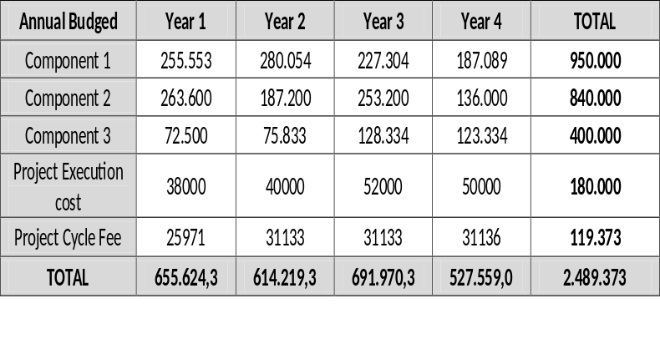 | 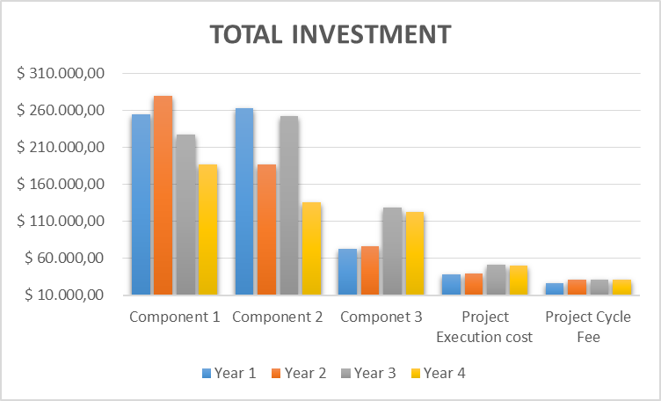
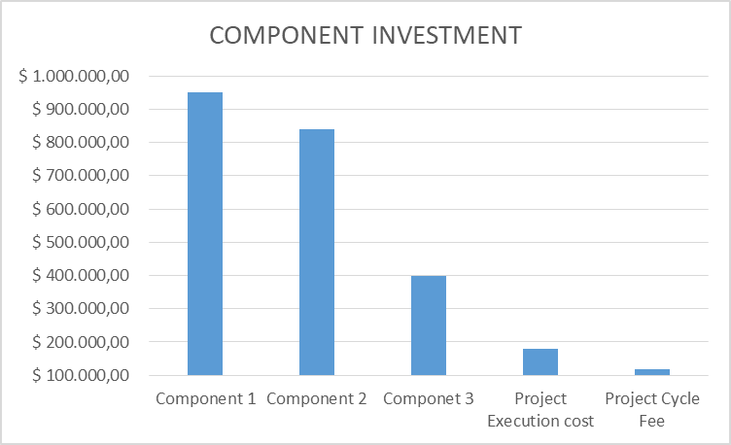 | 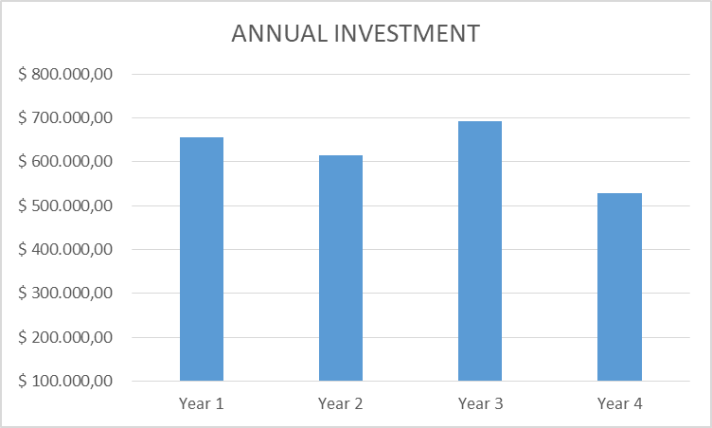

Table 40: Annual budged disbursement

Overview Annexes
Annex 1.A | Ecuador Letter of Endorsement National
Annex 1.B | Implementing Entity Certification - National Project Ecuador
Annex 2. | Abbreviations and Bibliography
Annex 3. | Maps
Annex 4.A | Memoir of inception workshop in 2016
Annex 4.B | Memoir of visits to GADs and workshops 2017
Annex 5. | Stakeholders, interests and socioeconomic situation 2015
Annex 6. | Stakeholders gender and vulnerable pre 2017
Annex 7. | Environmental Social Risk Screening and Management Plan ESMP
Annex 8. | Investment Fund feasibility assessment
Annex 9. | Gender and vulnerable groups analysis
Annex 10. | Definition of beneficiaries of the Río Blanco upper basin
Annex 11.A | Alternative approaches considered but not adopted in the project
Annex 11.B | Buenas Prácticas CC
Annex 12.A | Overview adaptation measures and selection methodology
Annex 12.B | Agricultura andina frente al cambio climático
Annex 12.C | Microfinanzas
Annex 13. | Socio Bosque and ACUS mechanisms
Annex 14.A | Cost benefit analysis component 1
Annex 14.B | Cost benefit analysis component 2
Annex 14.C | Multicriteria Analysis component 1
Annex 14.D | Multicriteria Analysis component 2
Annex 15. | Project Budget

part iV: endorsement by government and certification by the Implementing Entity

- Record of endorsement on behalf of the government Provide the name and position of the government official and indicate date of endorsement. If this is a regional project/programme, list the endorsing officials all the participating countries. The endorsement letter(s) should be attached as an annex to the project/programme proposal. Please attach the endorsement letter(s) with this template; add as many participating governments if a regional project/programme:

(Enter Name, Position, Ministry) | Date: (Month, day, year)

B. Implementing Entity certification Provide the name and signature of the Implementing Entity Coordinator and the date of signature. Provide also the project/programme contact person’s name, telephone number and email address
I certify that this proposal has been prepared in accordance with guidelines provided by the Adaptation Fund Board, and prevailing National Development and Adaptation Plans (……list here…..) and subject to the approval by the Adaptation Fund Board, commit to implementing the project/programme in compliance with the Environmental and Social Policy of the Adaptation Fund and on the understanding that the Implementing Entity will be fully (legally and financially) responsible for the implementation of this project/programme.
Name & Signature
Implementing Entity Coordinator

Date: (Month, Day, Year) | Tel. and email:
Project Contact Person:
Tel. And Email:

Information from the Hidrotoapi website at https://www.celec.gob.ec/hidrotoapi/
The femininity index in poor households compares the percentage of poor women and men from the age of 20 to 59 years. Poor households typically gather a higher proportion of women in an age of a bigger productive and reproductive demand. The index shows how many times the incidence of poverty (indigence) is greater among women than among men. A figure greater than 100 means that poverty (indigence) is higher among women; a figure less than 100, the inverse situation.
CEPALSTAT, Gender indicators.
Executive summary, Final Environmental Impact Study, Toachi - Pilatón hydroelectric project
Women at the frontline of climate change. Gender risks and hopes. UNEP, 2011.
Protected Forest are areas established by the Ministry of Environment with the main purpose to conserve watersheds and water sources and to contribute to protect wildlife. These can be public or private land, and managed by public entities or private landowners. The protected forests are not considered a protected area, and do not integrate the national system of protected areas.
The Pilatón drainage unit is part of the Rio Toachi – Chiriboga IBA (EC044) which cover 68,000 ha (Birdlife International, 2016). The area houses about 450 bird species, including Pachyramphus spodiurus which is endangered. The lower part of the Toachi drainage system is part of the Reserva Ecológica Los Ilinizas y alrededores IBA (EC045) which cover 150,900 ha (Birdlife International, 2016a). This IBA house about 257 bird species.
Irregularly periodical variation in winds and sea surface temperatures over the tropical eastern Pacific Ocean, affecting much of the tropics and subtropics. The warming phase is known as El Niño and the cooling phase as La Niña.
Project “Analysis of the vulnerability of flagship hydropower plants to the effects of climate change” (CHECC). The project was executed by MAE in collaboration with Ministry for Coordination of Strategic Sectors (MICSE), Ministry of Electricity and Renewable Energy (MEER), National Water Secretariat (SENAGUA), National Meteorological and Hydrological Institute (INAMHI), and the Electric Corporation of Ecuador (CELEC).
According to the Ecuadorian legislation, riversides are public domain and cannot be used in order to protect the water sources.
Bio Corredores are the main strategy of the Ministry of Environment of Ecuador’s approach to landscape management, biodiversity and sustainable development.
Ecosystem-based adaptation uses biodiversity and ecosystem services in an overall adaptation strategy. It includes the sustainable management, conservation and restoration of ecosystems to provide services that help people adapt to the adverse effects of climate change (CBD, 2009).
Community-based adaptation (CbA) “is a form of adaptation that aims to reduce the risks of climate change to the world's poorest people by involving them in the practices and planning of adaptation” - Tim Forsyth, LSE - (see for example UNDP, GEF
Legal instrument of territorial planning
ACUS – Areas de Conservación y Uso Sostenible, areas of conservation and sustainable development, a main instrument of the Ministry of Environment of Ecuador to landscape management.
Partially taken from Christoph Jungfleisch’s presentation “MEbA – Understanding Climate (Change) Risks, Financing Adaptation“.
See here an overview: http://unepmEbA.org/fileadmin/user_upload/english/EbA_capacity_indexeng.pdf
Referencia: Acceso 17/12/17: http http://unepmEbA.org/fileadmin/user_upload/Indice_de_capacidad_EbA.pdf
http://sociobosque.ambiente.gob.ec/files/MANUAL%20OPERATIVO%20SB%20UNIFICADO%202012.pdf
PDOT GAD Las Palmas
Analysis of the vulnerability of flagship hydropower plants to the effects of climate change (CHECC), in particular the results for the Toachi-Pilatón hydropower plant
Agreement No. 168, MAE, Official Register 319 of 12th November 2010 (Norm on the Subsystem of Decentralized Autonomous Governments (GADs) – Municipal Protected Areas).
Management Effectiveness Tracking Tools Matrix developed for Protected Areas by The United Nations Development Programme GEF adopted by Ecuador Government for AP management: http://suia.ambiente.gob.ec/documents/10179/346525/Gu%C3%ADa-Metodol%C3%B3gica-Evaluaci%C3%B3n-de-EfectividadManejoPatrimonio%C3%81reas-PG.pdf/8cd4223b-954a-42df-8b73-3490831a61c2
Acronym in Spanish for Annual Operational and Management Plan in Protected Areas
METT tracking tools for Ecuador system: http://suia.ambiente.gob.ec/documents/10179/346525/Gu%C3%ADa-Metodol%C3%B3gica-Evaluaci%C3%B3n-de-EfectividadManejoPatrimonio%C3%81reas-PG.pdf/8cd4223b-954a-42df-8b73-3490831a61c2
On the first screening three private reserves were identified: [1] Reserva de Bosque Integral Otonga (1,000 ha), [2] La Hesperia Reserva Natural (814 ha), and [3] Reserva Florística Río Guajalito (1,000 ha). During project preparation an in-depth analysis will be done, because it is very likely that more private protected areas exist.
http://www.undp.org.ec/licitaciones/2014/001/Anexo1-PM%20ILINIZAS.pdf
PDOT GAD Sigchos 2015.
Farming Plans, reference ATPA Program avaible: http://www.agricultura.gob.ec/agenda-de-transformacion-productiva-amazonica-reconversion-agroproductiva-sostenible-en-la-amazonia-ecuatoriana/
Men and women in stadistics III, INEC and ONU Waomen. 2010
Sigchos is a canton formed by four rural parishes (i.e., Chugchilán, Isinlivi, Las Pampas and Palo Quemado) and an urban parish (Sigchos). The urban parish is very large, but the urban centre is small. In 2010, the canton had 21,900 people, 91.1% was rural population. Rural parishes have a parish government, but the urban parish is managed by the municipality.
http://www.fao.org/in-action/good-agricultural-practices-help-raise-farmers-incomes-in-lao-pdr/es/
https://www.banecuador.fin.ec/noticias-banecuador/boletines-de-prensa/banecuador-financia-adquisicion-kits-agricolas-entrega-credito-siembra-maiz/
Multicriteria Analysis. Environment Ministry - GIZ 2017
Environment Ministry (MAE) and Cooperación Internacional Alemana (GIZ). 2016. Policy Brief, Manual para la valoración económica de medidas de adaptación y mitigación del cambio Climático en el Ecuador. 8. P. Mafla, S; Chiriboga, M-V; Guzmán, D; Fuertes, F; Albuja, M-V; Arroyo, J-A; Gavilanes, C.
Carbon Market Reference: https://www.sendeco2.com/es/precios-co2
SERCOP: CONPC-APG-001-2014: https://www.eluniverso.com/noticias/2014/05/10/nota/2940221/fiscalizacion-dragado-canal-aun-adjudicar
CEDIR. (2015). Guía para la elaboración de planes de mantenimiento y operación de las medidas de adaptación al cambio climático de los proyectos PACC. PNUD; Environment Ministry. Cuenca.
MAGAP/GIZ (2017), Buenas prácticas agrarias para enfrentar el Cambio Climático en Ecuador, Agriculture Ministry/ Gesellschaft für Internationale Zusammenarbeit (GIZ) GmbH.
Environment Ministry (MAE) y la Cooperación Internacional Alemana (GIZ). 2016. Policy Brief, Manual para la valoración económica de medidas de adaptación y mitigación del cambio Climático en el Ecuador. 8. P. Mafla, S; Chiriboga, M-V; Guzmán, D; Fuertes, F; Albuja, M-V; Arroyo, J-A; Gavilanes, C.
MAGAP/GIZ (2017), p. 33, 34.
https://www.bce.fin.ec/index.php/component/k2/item/148-tasas-de-inter%C3%A9s
http://www.ambiente.gob.ec/proyecto-pacc/
http://suia.ambiente.gob.ec/proyecto-foreccsa
Thesis Livestock project pg 132, available: http://www.dspace.uce.edu.ec/bitstream/25000/1974/1/T-UCE-0005-351.pdf
Environmental Organic Law. Available in: http://www.asambleanacional.gob.ec/sites/default/files/private/asambleanacional/filesasambleanacionalnameuid-29/Leyes%202013-2017/102-ambiente/ro-cod-ambiente-ro-s-983-12-04-2017.pdf
i.e., Convention concerning Indigenous and Tribal Peoples in Independent Countries.
Environmental, Financial, Operational, Organizational, Political, Regulatory, Strategic, Other
1 = low / 5 = high.
Over, reducing, increasing, no change.
During the first year of project implementation.
In the mid-term of Project execution.
In Ecuador, La Niña produces dryer conditions. Currently, La Niña is favoured to develop during August - October 2016, with about a 55-60% chance of La Niña during the fall and winter 2016-2017 (NPC, 2016).
Does not include personnel.
Charged to the project cycle management fee.
^{6.} Each Party shall designate and communicate to the secretariat the authority that will endorse on behalf of the national government the projects and programmes proposed by the implementing entities.

