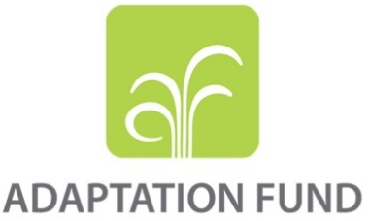
CONCEPT NOTE FOR REGIONAL PROJECT/PROGRAMME PROPOSAL

PART I: PROJECT/PROGRAMME INFORMATION

Title of Project/Programme: Integrated climate-resilient transboundary flood risk management in the Drin River basin in the Western Balkans
Countries: Albania, the Former Yugoslav Republic of Macedonia, Montenegro
Thematic Focal Area: Disaster risk reduction and early warning systems
Type of Implementing Entity: Multilateral Implementing Entity (MIE)
Implementing Entity: UNDP
Executing Entities: UNDP, Global Water Partnership
Amount of Financing Requested: US$9,927,750 (in U.S Dollars Equivalent)

Project / Programme Background and Context:

- The Drin River Basin (DRB) is a transboundary river basin, which is home to 1.6 Million people and extends across Albania (30% of basin area, 27% of total country area, 37% of basin population), Kosovo (23% of basin area, 42% of total country area, and 35% of basin population), the Former Yugoslav Republic Macedonia (17% of basin area, 13% of total country area, and 11% of basin population), Montenegro (22% of basin area, 32% of total country area, and 17% of basin population) and Greece.

- Climate change and climate variability have been increasing the frequency, intensity and impact of flooding in the basin. Historical flood data from the Western Balkans suggests a more frequent occurrence of flood events, attributed to an uneven distribution of precipitation and torrential rain, particularly over the last decade. More and larger areas and, therefore, a greater population numbers are being affected by flooding with a strong impact on national economies. Future climate scenarios project a further increase in the likelihood of floods as well as in their destructive nature. The proposed project will enhance resilience of the DRB countries and communities to climate-induced flood risks.

Geographical and Development Context - Regional and Country Perspective:

- The Drin River a transboundary river in Southeastern Balkan peninsula which hosts over 1.6 million people, living in 1,453 settlements, and encompasses several complex eco-systems that provide unique habitats for many indigenous species important from both European and global conservation perspectives. Besides the three big natural lakes – Prespa, Ohrid and Skadar/Shkodër – the basin includes several large water reservoir cascades along the Black Drin River in FYR Macedonia and the Drin River in Albania.
- The Drin River, 335 km long, runs through mountainous areas (highest peaks on the Dinaric Alps of over 2,500 masl) in the south-western Balkans towards the Adriatic Sea, draining a topographic area of 20,311 km² and providing the third greatest river discharge into the European Mediterranean. The Drin River has two distributaries one discharging into the Adriatic Sea and the other one into the Buna River. The basin has four main sub-basins and several lakes (Figure 1).
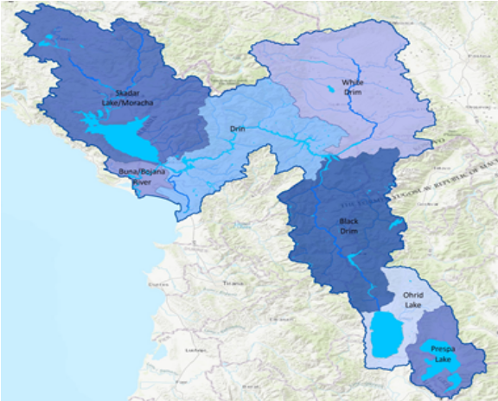
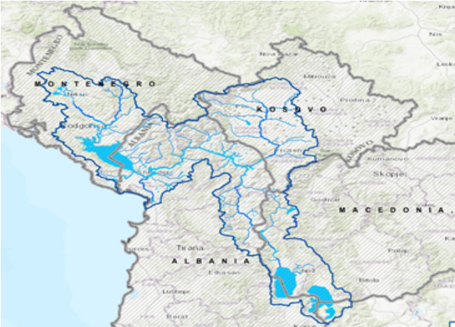
Figure 1: Drin basin, showing main rivers, lakes and Riparian Country boundaries (left) and sub-basin boundaries (right)
- The Black Drin (Crn Drim/Crn Drini) outflows from Lake Ohrid (controlled outflow since 1962), in FYR Macedonia, and flows north through Albania, draining the eastern, mainly mountainous, region of Albania. The total area of the Black Drin basin is 4,472 km² (3,295 km² of which is in FYR Macedonia) or 22.4% of the DRB. It has an annual discharge of 1,502 million m³. Two large reservoirs (Globochica and Spilje) have been constructed in this river basin on FYROM side, another 4 dams and 3 reservoirs (Fierze, Komani and Vau I Deje) at the lower Drim in Albania – all with the main purpose of hydroelectric power (providing over 90% of Albanian electricity). The Black Drin crosses near Debar the border to Albania.

- The White Drin surfaces in Kosovo and flows into Albania where it meets the Black Drin at the town of Kukës to form the Drin River. The White Drin drains a karstic region of nearly 3,780 km₂ in Kosovo and 522 km² in Albania, resulting in total area of the sub-basin of 4,292 km², or 21.5% of the DRB. The Kosovo flow of the White Drin River receives many relatively long tributaries. In the Albanian section of the river there are practically no settlements.

- Drin River flows from Kukës in Albania westward (in the initial section) and southward through northern Albania. The total area of the Drin River equals 4,237 km², or 21.2 % of the DRB area. The Gjadri and Kiri rivers join the Drin downstream of the Vau i Dejës dam. Further downstream the river splits into two arms, one which flows directly to the Adriatic Sea southwest of the town of Lezhë (at the Bay of Drin), and the other which flows into the Buna/Bojana River downstream of the Skadar/Shkodër Lake. The Drini-Buna River Basin is characterized by groundwater appearances. A number of aquifers exist, often with complex groundwater-surface-water interaction and interdependency. The channel of Drin that flows directly to the Adriatic carries only a relatively small discharge, while most of the Drin flow joins Buna/Bojana River. The Drin Delta which is a complex of relatively intact coastal lakes, marshes and forests, has been recognised as an Important Bird Area of international importance by designation under the BirdLife International Convention.

- The Lake Prespa sub-basin comprises the two lakes of Small Prespa and Prespa that are linked together through a channel. A large part of Small Prespa is in Greece, while Prespa Lake is shared between FYR Macedonia and Albania. Lake Prespa drains into Lake Ohrid through underground karst cavities of Galichica and Mali I Thatë mountains. The area of the sub-basin is 1,410 km² (not including Small Prespa) or 7% of the total DRB area. Prespa Lakes are the highest tectonic lakes in the Balkans. The area is especially important for water birds, notably the largest breeding colony of Dalmatian pelicans in the world and they are also part of Ramsar List of Wetlands of International Importance.

- Shkodra Lake, a Ramsar site, is the largest lake in the Balkan Peninsula with a surface area varying between 370 km² and 530 km². It is one of the largest bird reserves in Europe, having 270 bird species, among which are some of the last pelicans in Europe.
- Lake Ohrid is one of Europe’s deepest and oldest lakes and the largest by water volume in South-East Europe, with estimated volume of 55,500 million m³. It is the deepest lake of the Balkans, with maximum measured depth of 288 m (mean depth 155 m). The lake is shared between FYR Macedonia (272.8 km²) and Albania (84 km²). The total area of the Ohrid Lake sub-basin is 919 km², or 4.6% of the entire DRB. The lake preserves a unique aquatic ecosystem with more than 200 endemic species. Because of this importance, in 1979 it was declared a World Heritage site by UNESCO.

Development Outlook
- All of the Riparian countries of the Drin basin are developing middle-income economies. Kosovo*, FYR Macedonia, and Montenegro are successor states of the former Yugoslavia, declaring their independence in 2008, 1991 and 2006 respectively. Since the early 1990-ties, all Riparian countries have gone through successful transition from centralized economies to market-based economies and have Human Development Indices of 0.764 for Albania (Rank 75), 0.807 (rank 48) for Montenegro and 0.748 (Rank 82) for FYR Macedonia. Despite this, public debt in Albania and Montenegro remains high (71 and 68% GDP respectively), while in FYR Macedonia it is at 38.70% of GDP, relatively low compared to its Western Balkan neighbors and the rest of Europe. Unemployment remains high (14% in Albania, 17% in Montenegro and 21.6% in FYR Macedonia) as does the percentage of population living below the poverty line - 14% to 9% and 21% Albania, Montenegro and FYR of Macedonia respectively. The percentage of rural population is 40% in Albania and FYR Macedonia and 33% in Montenegro with urbanization rates of 1.69%, 0.45% and 0.54% respectively. Socio-economic outlook of the Drin Riparian Countries is presented in the Annex 2.

Land Use
- Forests accounts for 32.83%, scrub and open spaces for 35.58% and arable land accounts for 21.25% of the total area of the Drin basin. Inland waters which include natural lakes, rivers, water reservoirs and wetlands, accounts for 6.4% of the area. Urban fabric and Pastures account for 1.9% and 1.8% respectively.
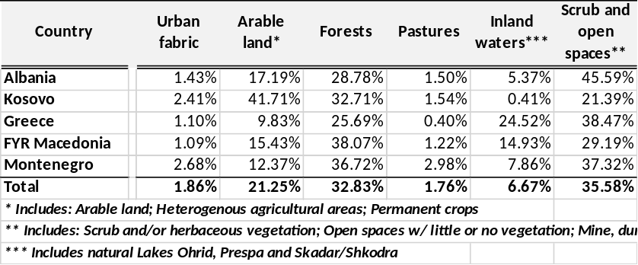

- The interconnected watershed bodies and the ecosystems and communities of the Drin Basin deliver a steady stream of benefits to its residents. All Drin riparian countries rely on the extended Drin River Basin waters and use of its resources for agriculture, energy, water supply and sanitation, mining and industry, environment, fisheries, and tourism.

Climate Change and Flood Risk Context:

- Climate change is already having an impact and is likely to intensify in the future. According to the national communications to UNFCCC from Albania, Montenegro and the Former Yugoslav Republic of Macedonia, as well as to the report ‘The state of water in Kosovo’, climate change will have serious negative impacts in the Drin river basin including increased frequency and intensity of floods and droughts, increased water scarcity, intensified erosion and sedimentation, increased intensity of snow melt, sea level rise, and damage to water quality and ecosystems. Moreover, climate change impacts on water resources will have cascading effects on human health and many parts of the economy and society, as various sectors directly depend on water such as agriculture, energy and hydropower, navigation, health, tourism – as does the environment.

- The DRB countries are increasingly exposed to the impact of climate change. They are experiencing increased periods of extreme heat in the summer months and increased rainfall during the cooler seasons. According to long-term projections, the average annual temperature will increase by 2° C to 3° C by 2050 and precipitation will decrease in the summer, resulting in longer dry periods followed by more sudden heavy rainfalls. This combination increases the likelihood of floods as well as their destructive nature.

- Historical flood data from the Western Balkans suggests a more frequent occurrence of flood events, characterised by more extreme and more rapid increase in water levels, attributed to an uneven distribution of precipitation and torrential rain, particularly over the last decade. More and larger areas and, therefore, a greater population numbers are being affected by flooding with a strong impact on national economies.

- In Albania, climate change predictions indicate the intensification of heavy precipitation and an increase in the frequency of heavy rains with longer duration, causing flooding and economic damages. There is already evidence of increasing frequency of high intensity rainfall, which is increasing pluvial or flash flooding which inundates the floodplain in a matter of hours. In winter, longer duration rainfall causes flooding which lasts for several weeks during the winter period while long-duration spring rainfall combines with snowmelt to cause flooding. Flood risk is a combination of river flooding and coastal flooding due to sea water inundation (storm surges), both of which are increasing with climate change.

- According to available climate change projections for Montenegro, there will be a sharp increase in variability of river flow, characterized by increased frequency and intensity of flooding and hydrological drought. In addition, coastal flooding and storm surges will also significantly increase. During this period the area of low air pressure develops in the coastal region of Montenegro and has a wide impact causing maximum precipitation in the southern areas. In the karst areas, during spring, there are periodic floods due to longer periods of precipitation, melting snow and high groundwater levels. Such floods have impacted the Cetinje plain several times and have caused severe damage to the buildings there.

- The First and Second National Communications on Climate Change for FYR Macedonia outlined a number of scenarios related to water resources. The findings included a projection of a 15% reduction in rainfall by 2050, with a drastic decrease in runoff in all river basins. Although the long-term projection is for increased temperatures and a decrease in sums of precipitation, the past period studied shows significant climate variability, with increased precipitation. The proportion of winter precipitation received as rain instead of snow is increasing. Such shifts in the form and timing of precipitation and runoff are of concern to flood risk.

Flood risk and underlying vulnerability in the individual Drin Basin countries

- Flood risk in riparian countries of the Drin Basin have been an important disaster factor since 2010, as can be seen in Table 1, the frequency of floods has been observed to be increasing over time. The socioeconomic vulnerability is high due to the high (9-21%%) poverty rate of the Riparian countries. Poverty and unemployment are particularly widespread in rural and mountainous areas of the basin. Vulnerability factors also include poor urban planning, unsustainable water management and agricultural practices, deforestation, industrial pollution and poor waste management in areas highly exposed to flooding.

Table 1: Recorded flood events in the Riparian countries of the Drin Basin since 2010
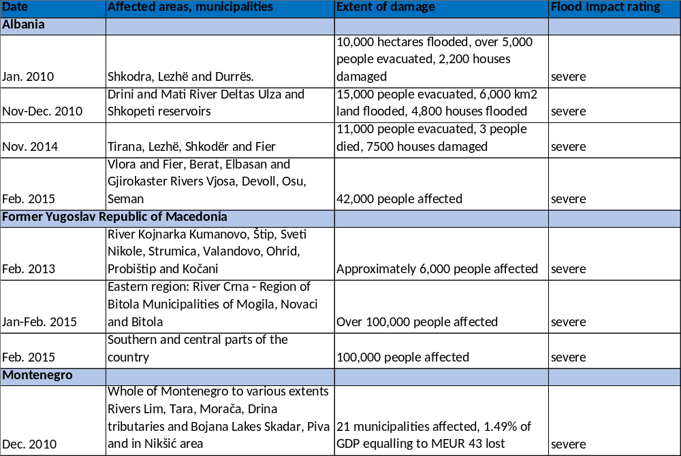
August 2016 | City of Skopje and the suburbs | 22 dead, state of emergency declared | severe

- According to Disinventar Disaster database, floods and flashfloods in Albania account for 15% of deaths and 25% of damage and destruction of houses from disasters in Albania. The years with highest recorded incidents of hydro-meteorological disaster are 1995, 1996, 2003, 2004, 2005, 2006, 2007, 2010, 2012, 2013 and 2014. In Albania, flooding affects 130 000 hectares of land and is generally pluvial in origin, occurring in the period of November – March, when the country receives about 80-85 % of annual precipitation. The largest floods have occurred in the low western area of the country but small rivers and the torrents cause flash flooding and causes high economic damages. As the urban development of the floodplain increased, the damage caused by flooding also increased. Following the devastating floods of 1962-63, flood defenses were built to the 1% return period in some rivers, but such standards of protection are decreasing due to climate change. In January and December 2010, floods caused major damage and disruption over a wide area. The flooding of January 2010 in the district of Shkodra was at the time considered the biggest emergency event which inundated 10,400 ha of land and about 2500 houses and 4800 people were evacuated. As a result of increasing rainfall, the Drin river flow rapidly increased the water level in three hydropower reservoirs, which were forced to release water, increasing discharge to 2450 cubic metres per second into the Buna River which has a maximum capacity of only 1600 cubic metres per second. The Albanian government declared the flood a "natural disaster" and deployed the army and police forces to help evacuate people.

- The socio-economic vulnerability to climate change in Albania is centered on 4 sectors: agriculture, water, population and tourism. In the 2010 flood which is the largest on recent record, losses reached nearly 0.15 % of the GDP of the country. The average expected losses per year is estimated to be around 370 million of LeK (3.2 million USD), with a maximum of 4 billion LeK (35.2 million USD) arising from the Shkodra flood in 2010. Hydropower is the main source of electricity in Albania, with supply growing by 45.2% in 2015-2016, mainly due to an increase by about 43.4% of hydropower production, from construction and the operation of several small hydropower plants. The country is therefore heavily dependent on hydrological conditions. The Drin is the longest and largest river in Albania and the dams constructed along its way in the Albanian territory, produce hydropower contributing to around 90% of the total electric capacity in the country. Climate change and the increases in risk of both floods and droughts will impact the hydropower sector in Albania.

- The Third National Communication (TNC) makes the following recommendations for enhanced management of climate-induced flood risk in Albania: maintain efficiency of water evacuation systems; deepen and manage Drin, Mat and Ishëm river flow so that their waters run to the sea; clean, deepen and maintain primary, secondary and tertiary collectors (canals) and draining systems; install and maintain hydrovores during the entire rainfall season; install high power and efficiency pumps for the evacuation of waters from particularly important structures; continuously monitor canals and pipes for the evacuation of communal and industrial waters; plant fast-growing trees to protect river embankments and to mitigate flood risk and soil degradation, and to contribute to climate change mitigation; increase professionalism and efficiency of rescue units (training of existing and new staff); strengthen the role of regional emergency and civil protection units.

- Historic data on flooding in Montenegro shows that in the period 1979-1997 there were 5 major flooding events; but in the six years, 2004-2010, floods occurred 6 times (and twice in 2010-January and November - December). Floods are the most frequent natural hazard. Intensive precipitation and snow melting in the northern part of Moraca basin, combined with high tide in Buna/Bojana river due to the strong south wind and high discharge of Drin resulted in the increase of the water level in Shkoder/Skadar Lake (10.44 m a.s.l.) in December 2010. The December 2010 flood resulted in unprecedented water levels, extent of flooded areas and damages. Total country-wide damages and losses exceeded € 40 million (1.3% of GDP), impacting largely rural areas. Transport routes, electricity supply and communication lines between the northern region and the rest of the country were obstructed for a certain period of time and 1.5% of the population had to be evacuated. Flood damages in areas Golubovci and Tuzi to the north of Shkoder/Skadar Lake reached an amount of ~2.14 million euros (1.462.500 euros on construction objects and 682,800 euros in agricultural crops). An assessment undertaken by FAO of the 2010 floods, estimated that around 30 000 hectares of agricultural land was flooded. The most affected was the area around the Zeta river valley and the area around Lake Skadar, specifically the territory of Golubovci, where most of the national vegetable production occurs. Total damages and losses were estimated at over € 13 million, of which over € 6 million in damages and over € 7 million in losses.

- Given the geo-morphological characteristics of the territory of Montenegro, floods could jeopardize settlements, agricultural areas, forests and other land and transport routes in river plains and valleys. Vulnerability to flooding in Montenegro is due to the location of many towns and settlements on large river banks which makes them potentially more vulnerable to the overflow of water from watercourses. Around Skadar Lake and the Bojana River, as well as on the Cetinje and Nikšić plains the large areas of agricultural land, assets and urban zones are susceptible to flooding from all sources, including grdounwater. Over 60% of Montenegro’s territory is comprised of carbonate rock. One of the problems facing karst terrains in Montenegro is frequent flooding in karst fields and in the plains of the Zeta Valley, the area surrounding Skadar Lake, and along the courses of the Bojana and Lim Rivers. Extreme floods were registered in late 2010 in the Zeta Valley and along the course of the Bojana River, with maximum levels in Skadar Lake of 10.44m. The floods were exacerbated by reservoirs in Albania (Vaus Deis, Kumana, Fierza), that released 3,000 m³/s of water into the Bojana River which has a capacity of around 1,700 m³/s, while the overall flow from the Skadar Lake Basin was around 7,000 m³/s.

- Since 2002 storms and flash floods have become more frequent in The Former Yugoslav Republic of Macedonia and are causing considerable damage. The severe flooding that hit much of the country in January and February 2015 caused widespread damage and economic losses in 44 municipalities. Frequent floods occur in the Ohrid coastal zone (Crn Drim basin) that, because of the importance of the region from ecological and tourist point of view, is considered significant. For managing the water level fluctuation and controlling the flooding of coastal area, a regulating gate has been established at the Crn Drim river outflow in Struga.

- The two National Communications proposed the following priority measures for adaptation to climate change in the water resources sector and flood risk management: modernization of the hydro-meteorological network; improvement of data availability and the establishment of data monitoring and processing; rehabilitation and reconstruction of existing hydropower and water management structures and systems; development and implementation of effective water management plan; implementation of priority measures related to water supply and irrigation systems, flood and drought control, as well as protection strategies for controlling erosion and sedimentation; restriction of urban development in flood-risk zones; measures aimed at maintaining dam safety, afforestation and other structural and non-structural measures to avoid mudflows; construction of dikes; adjusting operation of reservoirs and lakes (e.g. multiple use of reservoirs to include flood alleviation); land use management; implementation of retention areas; improve drainage; structural measures such as temporary dams, building resilient housing and modifying transport infrastructure; migration of people away from high-risk areas.

- The Third National Communication highlights the need for the country to continue accumulating experience to cope with droughts and floods and make best use of existing technologies in water supply and irrigation used in the country. To coordinate these measures more effectively, the report recommends steps be taken to enhance the role of the National Climate Change Committee. The TNC also emphasizes the need for transboundary cooperation to increase the resilience of water resources shared with other countries. Such cooperation will further create opportunities for sharing knowledge and experience and will allow for the exploration of more cost-effective measures. Legislative, regulatory and economic measures can all benefit from a joint transboundary approach.

Indicative flood hazard of the Drin Basin

As part of concept preparation, very rough 2D flood hazard modelling has been undertaken for the Drin basin using the ALOS Dem for the basin and routing floods of different sizes through the basin sub-catchments. The map below shows the indicative flood map for a 3,000 cumecs flood routed through the basin. The indicative map shows that, in addition to expected flooding around the lakes, there is high flood risk on the White Drin and restricted, but high risk along the valley of the black Drin affecting several settlements. In the downstream part of the basin where there is a high concentration of settlements, and extensive flooding. This indicative map does not include other sources of flooding such as groundwater, pluvial and coastal flooding which will also need to be taken into account and flood hazard and risk modelling and mapping.

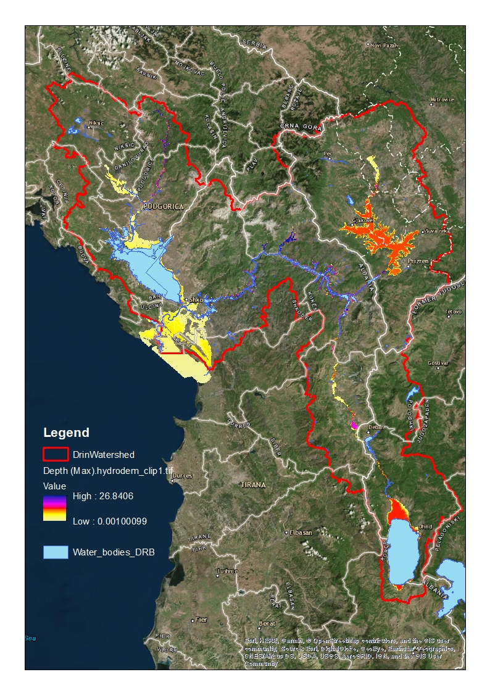
Figure 2: Indicative flood map of the Drin for 3000 cumecs maximum discharge
Non-climate drivers of vulnerability
- The impacts of climate-induced flooding are exacerbated by the anthropogenic pressures including rapid urbanization and unplanned development in the floodplain; deforestation; poor solid waste management; unsustainable use of land and water resources; intensive agriculture, forestry and mining activities; unsustainable tourism. Diverse and often conflicting uses and unsustainable management approaches applied in the Drin Basin exert severe pressures on the Basin’s ecosystems leading to their degradation. Some of these key pressures are: solid waste & marine litter; wastewater; unsustainable use of water resources; hydro-morphological interventions including the construction of dams; extraction of minerals/mining; intensive agriculture and forestry; uncontrolled and often illegal fishing and hunting; erratic land use and urban development; unsustainable tourism; increasing climate variability. These pressures lead to a wide range of impacts such as: deforestation, pollution of surface and ground waters, accelerated soil erosion; salinisation and salt water intrusion; loss of valuable ecosystems and biodiversity; greater exposure to floods; increasing health risks, and increased flood risk. These non-climate factors are being analyzed and addressed in the sub-region through a regional GEF supported project “Enabling Transboundary Cooperation and Integrated Water Resources Management in the Extended Drin River Basin” (GEF Drin Project) implemented by UNDP that supports the implementation of the Drin MoU for the coordinated management of the Drin Basin. However, the GEF-supported project and the on-going baseline sub-regional initiatives cannot comprehensively address climate change adaptation needs of the riparian countries and establish a comprehensive basin level climate risk and flood risk management, which needs to include: (1) exchange of flood risk knowledge and climate information; (2) basin level climate change adaptation and flood risk management strategy and plans; (3) combination of structural and non-structural flood risk reduction interventions; (4) institutional capacity.

Dams on the Drin
- There are more than 110 irrigation reservoirs in Drin River Basin. There are five big operational hydropower plants on Drin River: Globocica and Shpilje with a total installed capacity of 126 MW, Hydropower Plant (HPP) “Fierza” HPP “Koman” and HPP “Vau i Dejës” with a total in-stalled capacity of 1350 MW. Furthermore, a concessionary contract has been concluded for “Ashta” hydropower plant on Drin river with an installed capacity of 48.2 MW. There are currently 22 small Hydro-power Plants (SHPPs) in operation. The dams have changed the hydrological, hydraulic and sediment regime of the river considerably.
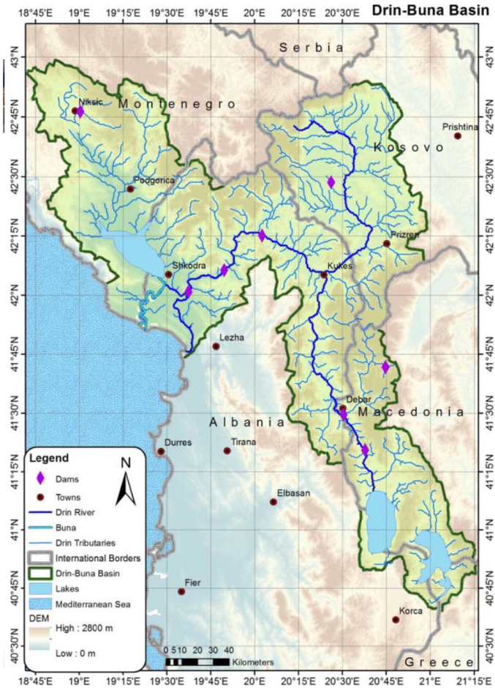
- Due to the retained volume of the dams the overall hydrological regime changed for low flow and small flood events (1-10 years). Small flood events are particularly important to maintain the dynamic braided river zones and its specifically adapted flora and fauna. There is no evidence that the dams change extreme flood events, however the magnitude of impact can be more dangerous further downstream after releasing large flood waves. Due to the retention volume it is estimated that floods of about 5,000 m³/s can be reduced to about 2,000 m³/s downstream of the last dam (if the dams are not filled with water). The sediment regime is also considerably impacted by the presence of the dams due to the retention of coarse substrate, mostly gravel and bedload in the reservoirs although there is no data on this effect. Typically, dams on gravel reaches can show decrease of bedload transport after construction of dams of up to 90% with only suspended load being transported during flood through the dams. This results in significantly reduced coarse sediment transport and limits the erosion forces of the channels, which is further exacerbated by missing small flood events (1-10 years). This lack of sediment in the Bojana-Buna delta over time is increasing coastal erosion and salt water intrusion.

- The Hydropower dams in the Drin basin and their reservoirs are of great importance to the economy of the riparian countries. They are the main sources of electricity in Albania and contribute to electricity production in the Former Yugoslav Republic of Macedonia. They could be used for seasonal and long-term regulation of river flow. In this regard they can have a positive effect on or exacerbate river flooding in case reservoir operation don’t integrate climate risk information. The Hydropower sector will therefore be an important stakeholder as well as beneficiary of the climate risk information and basin level climate risk management that the project will implement.

- Dams, by their very nature, create risks, which may increase substantially under climate change. Poor maintenance could lead to reservoir sedimentation which would reduce flood storage and change channel morphology and can thus exacerbate flooding. Poor maintenance or catastrophic hydrometeorological events could ultimately lead to catastrophic failure or breaching of dams, and this risk will increase with climate change.

- The operation of hydropower dams and reservoirs within the basin will be included in the flood risk assessment, modelling and mapping. Based on climate risk information, the project will assess the current and long-term ability to operate dams in a flood alleviation role. This will require the involvement of dam owners and operators in the development and eventual implementation of the overall flood management plan for DRB, and the development of individual operating rules for each dam during floods, which meets the dam safety requirements, and which also fits into the DRB basin flood management plan. This will therefore involve optimisation of the dam operations for multiple uses including power generation, flood alleviation and dam safety. At the very least, it should be ensured that dams are operated in a manner which avoids exacerbation of the flood risk, and which takes account of the increasing risks they pose due to climate change.

- The engagement of the dam owners and operators will be sought actively at the project preparation phase and then later during the project with the aim to have them closely and extensively engaged in all activities to which they can contribute. A stakeholder analysis will lead to the development of a stakeholder engagement and communication plan during the project implementation. The engagement and communications plan will highlight to the hydropower companies the potential benefits from their participation in the activities towards enhanced flood risk management supported under the project e.g. optimisation of dams operation taking into consideration climate change as well as the operation of cascade of dams in neighboring Riparians. As the hydropower companies are among the most important stakeholders, the project will strive to include them in the consultations and discussions with national authorities towards the empowerment of the institutional arrangement through the Expert Working Group on Floods which has been established in the framework of the Drin Core Group, for effective flood risk management. In addition, in developing risk financing mechanisms the project will seek to engage the private sector including the hydropower sector and will conduct willingness-to-pay surveys and detailed consultation, to better understand how the hydropower (and other sectors) will contribute to and benefit from comprehensive basin FRM.

Existing legislative and institutional framework and technical capacities for flood risk management in Drin Riparian countries

- A recent review of the institutional and legal framework for water management in the DRB found that national legislation is not fully aligned with the EU Acquis; there is high fragmentation of competencies, overlapping/conflicting responsibilities of institutions; no basin management plans addressing climate risks; limited monitoring; non‐reliable, non‐harmonized and limited sharing of data among institutions within and between countries; no basin water cadastre; water management investment was not supported by robust analysis, no investment plans and no comprehensive financial risk transfer mechanisms. The report recommends: (i) alignment of the national legislation with the EU Acquis, especially EUFD; (ii) clear assignment of responsibilities among institutions; (iii) strengthened mandates of local government; (iv) drafting and implementing river basin management plans (RBMPs) and flood management plans based on flood risk maps; and (v) cooperation among DRB countries on FRM preventing and responding to floods through co-development of flood management plans based on comprehensive flood risk maps.

- There is currently no formal basin level flood risk management in place for the Drin basin but the current practices in each Riparian country which constitute the baseline for FRM for the Drin Basin has been elaborated. In addition, there are bilateral agreements between Riparians which include cooperation on water management, as well as informal arrangements, which are described below.

Albania

- Water Management falls under the responsibility of the National Water Council, chaired by the Prime Minister, as the highest authority for water policy-making. In its effort to ensure a comprehensive cross sectorial water resources management the Government established in January 2018 the Agency for Water Resources Management with central and local presence. The councils for basin management are turned into offices for basins management s (European Union (EU) Pronews project supporting these activities).

- National Hydrometeorological Service in Albania was set up in 1949 with a limited number of the stations mainly comprising water level monitoring of the country's main rivers. The network was gradually expanded over time and in 1962, the Hydrometeorological Service became the Hydrometeorological Institute and in 1972 it became part of the Academy of Sciences of Albania. By the 1990’s the Institute had more than 90 staff including more than 20 technicians dealing with this activity and observation data processing. After 1990 the NHMS was seriously damaged and the number of the stations was reduced. In 2008, within the framework of the reform of science merges and reduction in the number of the research institutions occurred and the former Hydrometeorological Institute now Institute of Geoscience, Energy, Water and Environment is placed under the Polytechnic University of Tirana and IGEWE was significantly reduced in all aspects. Currently it has 12 personnel and no technical staff (for maintenance, monitoring and data processing). The last hydrological yearbook dates in 1987. The number of existing hydrological stations located in the Drin Basin (River Drin and tributaries) in Albania is about 52. Nine of them are located in the Buna catchment. A former World Bank project supported digitisation of 10-year meteorological and 20-year of hydrological observations (paper) data the identified missing data sets are being digitalized by the EU supported project. Currently there are 76 meteorological and precipitation stations existing in the Drin Basin. IGEWE produces a general forecast for 24 hours, and a 3-, 5- and 10-day outlook. IGEWE`s operational forecasting is based on use of printed analysis and forecast products from international forecasting centers and from the Montenegrin National Meteorological and Hydrological Service (NMHS). KESH have set up its own monitoring network, which is not accessed by the NHMS.

- Disaster Risk Management and EWS in Albania was supported by the EU ProNews project, implemented until the end of 2017, which has been working with the Ministry of Defence, Directorate for Civil Protection (CP) and Prefectures. Prefectures are responsible for civil protection at local level and responsible for Emergency Planning. ProNews project financed the improvements in the EWS for flood prevention. Under Component 1 - Emergency Planning and Improvement of civil protection and EWS FRM legal frameworks – the project worked at local and national levels, unified all emergency plans taking into account national and international legislation. Under Component 2 the project developed flood hazard maps for areas potentially susceptible to flood risk, based on the flood susceptibility index. The work didn’t include modelling or climate change. The hotspots for future hazard mapping were identified. Under Component 3 the hydrometric stations were installed, and data management systems for EWS were established. Forecasts are based on EFAS, ECMWF, WMO partners. Digitisation of historical data was also undertaken. World Bank project (2011-13) upgraded the hydrometric network and data management, installing 40 stations across Albania. Stations have not been maintained since installation. WMO with IGEWE conducted assessments of all stations and identified needs for civil works, additional sensors, etc. The 40 stations are owned by CP (not IGEWE) although CP has no legal mandate to own the stations. IGEWE uses the data but do not have capacities to maintain them and cannot legally do maintenance.

- The first EWS and forecasting platform was created for Albania in 2010. It included radar for now casting and established a database for historical losses and damages (in 2013 DesInventar was implemented and is maintained by CP). Awareness raising programmes for cities (Shkodra, Tirana and Vlora) have been established and FLOODIS App for EW developed, which allows users to send pictures and reports of flooding to CP which can be used with Google Earth layers and in EWS platform. Legal improvements of CP law were completed in March 2018 and are currently under consultation. A National law on EWS is being developed.

- The former Technical Water Secretariat now the Agency for Water Resources Management has developed a costed national action plan for water management which includes the following goals relevant to flood risk management:

  - Goal 11 - Reducing the risk of flooding for the loss of life threatening residents, damage to economic assets, public works, cultural assets and environmental values of people, businesses and communities
  - Goal 12 – Dam rehabilitation and maintenance in accordance with technical requirements, according to International Commission on Large Dams (ICOLD)’s recommendations aiming at increasing safety and reducing the possible effects caused by their injury.

- The Flood Risk Management Plan for Shkodra region 2012-2018 aims at improving Flood Risk Management (FRM) focusing on non-infrastructure measures, such as warning systems, preparedness and spatial planning. This includes consideration of all types of measures for preparation, disaster management and recovery phases, as well as the development of a regional flood risk management framework that includes local flood risk management plans. The plan does not include climate change considerations.

- Climate Change Adaptation: Recognizing that reducing Albania’s vulnerabilities to climate change requires greater investments and greater integration of Climate Change Adaptation (CCA) and Disaster Risk Reduction (DRR) into on-going development programs, the Government took strides to start to coordinate climate adaptation efforts at the national level. The Council of Ministers decision no. 155 (2014) called for the establishment of an Inter-Ministerial Working Group on Climate Change (IMWGCC). This body led the finalization of the Third National Communication to the UNFCCC. This body is chaired by the Deputy Minister of Environment and includes representations from all line ministries. This body has the mandate to draft policies related to climate change, promote institutional coordination across ministries, and contribute to UNFCCC processes on behalf of Albania. The role of the IMWGCC was further reinforced through the official launch of the National Adaptation Process in 2015. In its effort to ensure a comprehensive cross sectorial water resources management the Government established in January 2018 the Agency for Integrated Water Resources Management with central and local presence.

Montenegro

- In Montenegro the Ministry of Agriculture and Rural Development (MARD) and its Directorate for Water Management is in charge of operations related to water management policy, water supply and exploitation, protection of water against pollution, planning of water and water courses and protection from the flood effects. The Ministry is responsible for transposition, implementation and enforcement of all water-related EU Directives in the country. The Water Administration is a body with executive powers under the MARD, responsible for the implementation of water legislation. There is also a Water Council, which has an advisory role to the MARD. Other institutions devolved with responsibilities in the water sector in the country include: Ministry of Sustainable Development and Tourism; Agency for Nature Protection and Environment; Ministry of Health; Ministry of Interior; Ministry of Economy; etc.

- Protection from water related hazards and disasters in Montenegro is the responsibility of the Ministry of Agriculture and Rural Development (Directorate for Water Management) and Water Administration in cooperation with the Directorate for Emergency Situations of the Ministry of Interior, the Institute of Hydrometeorology and Seismology, the Agency for Nature and Environmental Protection, municipalities and other legal entities entrusted with, or in charge of maintaining the facilities for protection against water related disasters. Reports on the hydrological situation, warnings and forecasts produced by the Institute of Hydrometeorology and Seismology are communicated to the Head of Department for protection from water related hazards.

- The legislative and policy framework for flood risk management is comprised of a number of sectoral laws, policies and strategies including the following:
- The Law on water, which requires the Directorate for Water Management and the Ministry of Agriculture and Rural Development, to develop an annual operational plan for the protection against water related hazards, which includes preventive works and measures in the period of high waters for protection from floods and erosion; method of institutional organization of protection; duties and responsibilities of the manager for protection; method for monitoring and recording data; method for early warning.
- The laws on “Hydro meteorological services” and on “hydrographic services” define the tasks of the Institute for Hydrometeorology and Seismology of Montenegro of Montenegro (IHMS).
- The Law on protection and rescue establishes the legal framework for the development and strengthening of national capacities to combat the harmful effects of natural and other disasters, the role of regional and international cooperation with regard to prevention and mitigation activities, and the rights and obligations of municipalities in the area of protection and rescue. It also includes the collection and consolidation of data on potential risk, the establishment of information and early warning systems and the implementation of preventative activities, such as risk assessments as well as the development of protection and rescue plans.
- The Water Management Strategy for the period 2016-2035, which emphasizes the importance of risk assessment as part of the management of flood risks and flood control measures and the need to include climate change and its impacts on water flows, surface and groundwater that contribute to flood risk. It includes various goals to reduce the risks of floods and its adverse impacts including effective and coordinated action for flood protection, efficient and continuous monitoring and forecasting of floods, regular maintenance and control of watercourses, drainage, anti-erosion protection and soil conservation.
- The Strategy for Disaster Risk Reduction (DRR) with Action Plan for the period 2018-2023 is aimed at reducing the disaster risks and their main causal factors, proper land management and environmental protection, lowering exposure to hazards as well as vulnerability of people and property and improving overall preparedness for disasters.

- Montenegro recently signed a bilateral agreement with Albania - Framework Agreement between the Council of Ministers of the Republic of Albania and the Government of Montenegro on cooperation in the field of Transboundary Water Management, to develop direct and long-term cooperation in the field of water management. The agreement relates to waters of common interest, interventions in facilitating the management of water facilities (of which the hydroelectric power plant and plans for the management of the Skadar Lake, the rivers Drim, Bojana and Morača rivers are of particular importance), activities and events that have or can, from the water management point of view, have an impact on water, water facilities and water use devices, in particular: 1) water balance; 2) protection against water related hazards and disasters; 3) water treatment and maintenance; 4) protection of transboundary waters against pollution; 5) use and management of common water facilities; 6) use of all waters of common interest (of which the waters of Skadar Lake, the rivers Drim, Bojana, Moraca, Grncar and Cijevne are of particular importance); 7) research into the impact of interventions on water management activities on the environment; 8) exchange of opinions, information, consultation and exchange of experiences and cooperation at regional and other levels of organization and networking in the area of water.

- The Institute of Hydrometeorology and Seismology (IHMS) in Montenegro is under the Ministry of Sustainable Development and Tourism. It consists of six different sectors which are subdivided into departments. The IHMS has clearly defined organizational structures and responsibilities. About 12 hydrological stations are located in the Drin Basin in Montenegro. The main parameters measured are water level and water discharge, in some of them water temperature as well. Analysis of water quality is done according to the Water Law by IHMS / Sector for Analysis of water and air quality. Analyses are done every year on all water bodies in Montenegro (rivers, lakes and sea), following the Annual programme prepared by Water Administration. Altogether nine stations are actually in operation, all of them are online stations with automatic data transmission. The IHMS has a responsibility to produce non-scheduled meteorological and hydrological information and warnings in situation before disasters; organize emergency observation and measurement of the hydrological stations profiles and provision of emergency information; monitor weather and waters; collect and analyse data; prepare forecast; inform and alert responsible agencies. The Institute for Hydrometeorology and Seismology of Montenegro issues information on status and weather forecasting, climate and water in the text form, in writing, in the form of tables, charts and graphs through networks of electronic or postal traffic, or in the print and electronic media in the form of regular press releases. The hydrometric network of Montenegro is well developed and is receiving further upgrade and rehabilitation from various projects. Funding is already secured for the installation of 20 new meteorological and hydrological stations which will increase the network from 30 to 50 stations across the country, i.e. in Adriatic and Black Sea basins. While this will nearly complete the required network some additional stations are required, particularly in the Drin sub-basin. In addition, the O&M plan including the O&M financing plan is not developed for the new stations and needs to be addressed.

- The IHMS has been involved in the basin-wide flood forecasting and early warning system (FFEWS) being developed by GIZ and has been trained in the use of the system. Further training in the use of the hydrological, hydraulic and flood forecasting and early warning modelling and decision support systems as well as upgrades to computer equipment for running models are needed. During the AF project consultations, the Montenegrin Hydrometeorological Services (IHMS) identified the needs for the development of modelling capacity within the department and for a better cooperation and coordination of HMS activities. Currently coordination among HMSs in the Riparian countries is being undertaken through informal (person to person) contacts, relying on interpersonal relationships as well as new formal bi-lateral arrangements. There are difficulties in coordination due to different statuses of National Hydrometeorological Services (NHMS) in the different Riparian countries. For example, the Albanian NHMS is currently part of a university department with limited resourcing capacity, as well as functional capacity for effective national HMS activities. Development of a coordinating structure for cooperation on flood risk management in the Drin Basin will be important. There is a need for smooth data exchange and prioritised cooperation on data sharing. Dams management in Albania also needs to be addressed as operation of dams in Albania posed potential risks to flooding in Montenegro.

- Local preparedness plans for communes in Shkodra and Lezha in Albania have been developed by GIZ, as well as in Montenegro but the plans need to be updated using the new climate risk information to be developed through the modelling and in case of Albania the new territorial administrative reform has reduced the number of local government units from 375 to 61 affecting the existing plans.

- The Directorate for Emergency Management (DfEM) within the Ministry of Interior is responsible for Disaster Risk Reduction and for implementation of the Sendai framework in Montenegro. It has elaborated the DRR strategy for Montenegro in line with Sendai Framework. DfEM prepared the plan for protection and rescue for floods. An important requirement for implementation of the plans is risk assessment which is currently missing as there is no hazard and risk mapping for any of the hazards in Montenegro. In addition, there is no Loss and Damage database for Montenegro and no harmonised methodology for collecting loss and damage information at the national level. Municipalities have local commissions for damage and loss data collection, but there is no mechanism for providing or using the information centrally. There is no centralised damage and losses database. In accordance with Sendai, Montenegro needs a standardised damages and losses assessment methodology at local and central levels and a centralised disaster database. 112 Centre is established in Montenegro with the Operation Centre (OC) housed in the Directorate for Emergency Management. At the local level, there is no EWS established for any hazards and no equipment such as sirens. GIZ project established local plans and undertook awareness raising campaigns. There is good communication between IHMS and DfEM. Structural and non-structural measures have been identified by DfEM which has established a catalogue of measures.

- In Montenegro SNC recommendations for addressing climate-induced flood risks include:
- strengthening the hydro-meteorological network;
- better coordination between the government, the Agency for Nature and Environment Protection and the Institute for Hydrometeorology and Seismology (IHMS) on hydrometric data archiving, establishment of a water information system;
- enhanced data sharing;
- harmonization of data set standards;
- clarification of roles, responsibilities and “ownership” of hydrometric data;
- improvements in flood forecasts;
- regular maintenance and reconstruction of constructed flood protection structures;
- mapping and updating a cadastre of hydrogeological phenomena and speleological units;
- restoring, modernising and expanding the network of water-measurement stations on karst watercourses;
- mapping surfaces endangered by high waters, analysing options enabling the IHSM and the relevant municipal services monitoring priority watercourses;
- defining erosion potential of watercourses.
- implementing regional projects on the regulation of Skadar Lake, Drim and Bojana Rivers and on the establishment of an appropriate operation regime for hydro-power plants on the Drim River and in the Niksic Field in order to prevent frequent flooding in the territories of Montenegro and Albania (Zeta Valley, Skadar Valley, valleys along the Bojana River, etc). The proposed project would also assist the government of Montenegro to implement priorities defined by the Strategy for Disaster Risk Reduction for the period 2018-2023 and its associated Activity Plan including local level resilience building measures.

- UNDP supported the Directorate for Emergency Management and municipalities in the creation of a GIS based platform for flood hazard mapping for 12 of the flood prone municipalities of Montenegro following the extensive floods in 2010. These maps are based on recorded flooding and not on the flood modelling, so they do not consider floods of various return periods, and do not take climate change into account. However, it is a starting point and a base for further consolidation of data, to the extent it is recorded and available, from past floods.

Former Yugoslav Republic of Macedonia

- The Macedonian Law on Waters defines waters as a common good (property of the state) and sets water management and protection rights and obligations. The direct obligations for water management, lies with several governmental institutions with the competencies shared among the following six ministries: Ministry of Environment and Physical Planning; Ministry of Agriculture, Forestry and Water Economy; Ministry of Transport and Communications; Ministry of Health; Ministry of Economy; and Ministry of Education and Science. In addition, the Hydrometeorology Directorate and the Public Health Institute, as separate Governmental institutions, are also included.

- The institutional framework for FRM in FYR Macedonia suffers from a lack of clearly defined responsibilities, competency and authorisation to enforce legislation relevant to flood hazard and risk management, national legislation which is not fully aligned with the EU Acquis (EU WFD, EUFD). In addition, there is limited, fragmented and overlapping technical and financial institutional capacities including limited monitoring, non‐reliable, non‐harmonized and limited sharing of data among institutions, no basin water cadastre; and flood risk financing and investment is not supported by robust assessment of benefit and costs, no investment plans and no comprehensive financial risk transfer mechanisms for dealing with the losses and damages from flooding.

- The legislative framework for flood management in the Republic of Macedonia is comprised of several sector laws focusing on various aspects related to flood management. The system encompasses elements of prevention of damage caused by floods, protection by taking measures to reduce the likelihood of floods, information system about flood risks and in event of a flood, as well as emergency response and mitigation of the impacts on the affected population. The key pieces of legislation are:
- the Law on Waters which incorporates Flood Risk Management as part of the basin district management principles and includes provisions for the development of a programme of protection’;
- Law on Crisis Management governs the crisis management system which includes gathering of information, assessment, situation analysis, objectives and tasks determination, development and implementation of the necessary actions for prevention, early warning and handling of crises;
- The Law on hydro-meteorological activities which governs the functioning of the National Hydro-meteorological Service in the Republic of Macedonia and responsibilities of the Service and establishes a single meteorological and hydrological observation system and also sets obligations for warning and notice of extreme weather conditions;
- The law on local self-government which regulates inter alia the competencies of the municipalities which have responsibility for execution, preparations and undertaking of activities for protection and rescuing of citizens and goods against war destruction, natural and other disasters as well as against the consequences caused by them;
- The law on water management enterprises which regulates the management, utilization, operation and maintenance of hydro-systems and irrigation and drainage systems;
- The Law on Spatial and Urban Planning which regulates the issues on planning of the space, defining the types and contents of various plans.
- The Law on Protection and Rescue regulated the responsibilities and organization of the protection and response to disasters in the country, including floods.

- The Hydrometeorological Service is a part of the Ministry of Agriculture, Forestry and Water Economy and is responsible for issuing weather forecasts, meteorological, climatological and hydrological data and warnings of extra ordinary weather phenomena in the country. The National Hydrometeorological Service of FYR Macedonia has 3 manual and 6 automatic functioning hydrological monitoring stations (water level) out of a total of 25 stations, and 6 functioning meteorological stations out of 20 in the Crn Drim (Black Drin) sub-basin (See Map 1 in Annex 2). Some of the available time series of daily discharge exhibit considerable gaps. A number of stations stopped operation since about 2003. Besides the HMS, additional stations near dams are operated by dam agencies. In the case of Drini River, hydrological and meteorological data is available with the national power production company, ELEM. Data from manual rain gauge stations are sent to WMO Global Telecommunications System (GTS) every month, while the last 3 hours of data from automatic rain gauge stations are available on the web at any given time. The National HMS is currently way under capacity with only 3 hydrologists/engineers to perform all technical tasks nationally. Current skills are limited in the use of modern modelling methods and tools. There are limited budgets for operations and maintenance of the hydrometric network, which limits the ability to replace spare parts for automatic stations and devices for old (40-50 years old) manual stations for which devices are obsolete. A significant monitoring gap exists at high elevations which precludes the ability to systematically monitor snow fall and melt, which are becoming more variable with climate change, and which are important flood risk variables for the basin. Even without expected climate change impacts, there is a need to rehabilitate and extend the hydrometric observation network, to enable effective monitoring, management, forecasting and early warning of hydro-meteorological events at the appropriate spatial and temporal scale. There is also a need to upgrade the observation network with increased automation. Climate change is increasing the need for a modern, fully functioning, denser network supported by modern technology and skilled practitioners.

- Flood Hazard and Risk Mapping is fairly advanced but incomplete in Macedonia. In 2009 UNDP Macedonia developed “Guidelines for Development of Methodologies for Assessment of Risks and Hazards and their Implications” which provides general guidance on approaches to assessing all types of hazards in Macedonia. It does not provide detailed specification for floods and makes no mention of the EU flood directive or its underlying methodologies. National guidelines in line with the EUFD for flood hazard and risk modelling and mapping is needed for harmonised flood risk assessment in all basins. More recently, UNDP Macedonia has undertaken flood hazard and risk modelling and mapping for its major river basins (Strumica and Vardar) and sub-basins (Crna, Polog), but not for the Crn Drim. A baseline assessment of hazard and risk mapping in Macedonia identified the following needs: 1) To support the improvement of a data sharing policy framework among national and international institutions; 2) to promote cooperation among the various institutions involved in risk mapping, also with the scientific support of academic excellence in this field; 3) To support the improvement of standards for geospatial data in compliance with the INSPIRE Directive and for hazard-related standards (e.g. for floods these standards should also be in line with the Water Information System for Europe (WISE) system); 4) To promote the development of hazard-related studies and risk maps in line with EU guidelines and directives; 5) To promote the connection among existing DRR platforms and geoportals and to favor the link with the National Spatial Data Infrastructure NSDI and participation in the IMPLUS project.

- Damage and loss accounting for floods is still done manually and records are in paper format and not accessible or useable in detailed damage and loss assessment. The existing disaster loss data system is being expanded to include floods and already contains a large dataset on exposure and vulnerabilities that will enable the assessment and modelling of flood risk, vulnerability and damages in the future. IPA (2017) identified the need to support the upgrade of existing legislation on Disaster Loss Data collection and to harmonize existing methodology; and to support the clarification of roles and responsibilities of different institutions and information flow from local to national level and to identify a coordinating institution that will establish a unique national database accessible to all relevant institutions.

Cooperation over water resources management in the Drin Basin

- Drin Coordinated Action was established through a Shared Vision for the sustainable management of the Basin and the related MoU (Tirana, 2011) signed by the Ministers of the water and environment of the Drin Riparians: Albania, the Former Yugoslav Republic of Macedonia, Greece, Kosovo and Montenegro. The main objective of the Drin MoU is to promote joint action for the coordinated integrated management of the shared water resources in the basin. The Drin MoU provides the political framework for cooperation among the riparians and identifies short-, medium- and long-term actions to address problems affecting sustainable development in the DRB. Integrated DRB Management Plan is the long-term objective.
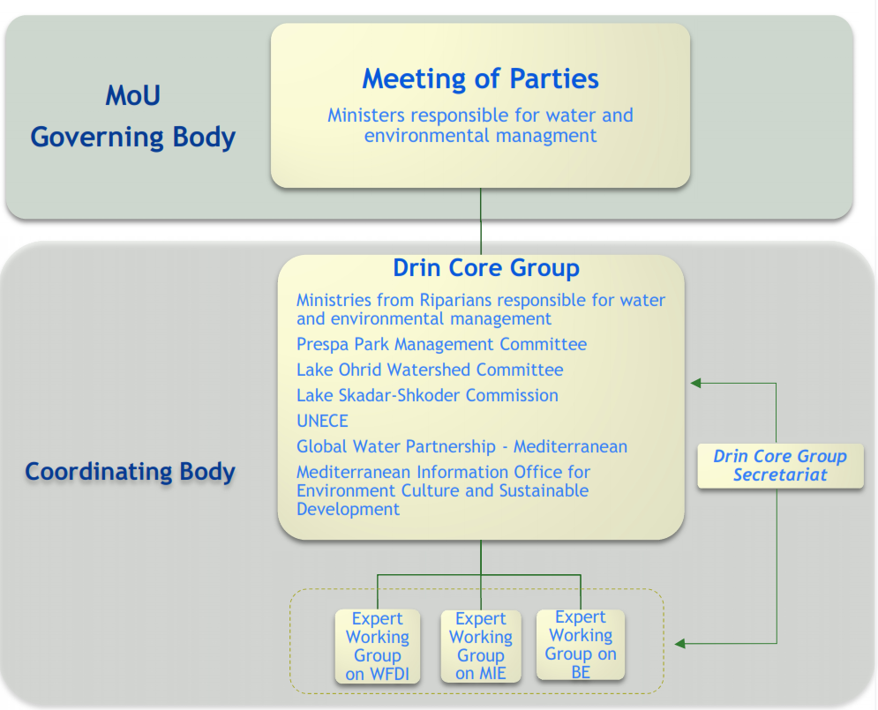

Figure 4: Institutional Framework for the management of the Drin Basin established under the Drin MoU
- The following institutional set up supports the Drin Coordinated Action (Annex 1, fig. 3): (i) The Meeting of the Parties; (ii) The Drin Core Group (DCG) coordinates implementation of the MoU; (iii) Expert Working Groups (EWGs), an EWG on Floods is being established; (iv) DCG Secretariat hosted by the Global Water Partnership–Mediterranean (GWP-Med). The UNDP/GEF Drin Project executed by GWP-Med assists in building consensus among countries on key transboundary concerns and drivers of change, including climate variability and change, and in reaching an agreement on priority actions.

- There are also existing bi-lateral agreements between pairs of Riparian countries, such as the newly signed agreement between Montenegro and Albania on water management, including flood management.

Flood forecasting and early warning in the Drin Basin

- An essential FRM tool is a fully-integrated FFEWS for the basin, which integrates regional, national and community-based systems and provides last-mile flood forecasts, based on EUFD standards and in line with WMO standards.

- The GIZ-funded project “Climate change adaptation in the Western Balkans” (2012-2018) has been providing advisory services and support to Albania, Kosovo*, the Former Yugoslav Republic of Macedonia and Montenegro for enhanced flood and drought risk management in DRB focusing on five key areas: (i) establishing a regional flood EWS; (ii) drafting CC adaptation strategies; (iii) local flood and drought management plans; (iv) transboundary water resource management concepts; (v) integrating CCA into urban planning for Tirana, Podgorica and Belgrade. In Albania and Montenegro FRM plans have been drawn for 31 municipalities and local implementation capacities were enhanced. The rain and stream gauging networks have been extended for flood forecasting with 33 water level and rainfall stations rehabilitated and upgraded. A DRB hydrological model has been developed.

- The project “South-East European Multi-Hazard Early Warning Advisory System” – USAID/OFDA is aiming to develop a regional multi-hazard early warning advisory system – consisting of information and tools for forecasters at National Meteorological and Hydrological Services (NMHSs) and harmonized national early warning systems. The project is being implemented in the whole of SE Europe including the DRB countries.

- Hence, through donor and government funded projects there has been gradual modernization of the hydrometric network in the DRB and under an MoU between the national hydrometeorological institutions there is cooperation and data exchange for flood warning. Warnings are currently based on regional forecasts, European Flood Awareness System (EFAS) and Flash Flood Guidance (SEE FFG). GIZ has recently implemented an EWS for the DRB which is now operational in the Riparian countries.

Adaptation alternative – Preferred Solution

- The AF project will build resilience of communities and livelihoods in the Drin Basin to climate-induced floods by catalyzing a shift to a holistic basin-wide climate-responsive flood risk management and adaptation approaches based on enhanced climate information, risk knowledge, flood forecasting and early warning.

- The proposed integrated approach to climate resilient flood risk management will encompass:
  - increased technical, human and financial capacities of relevant institutions within each Riparian country, with responsibility for flood risk monitoring, forecasting and management to enable implementation of climate resilient Integrated Flood Rik Management (IFRM). This would include strengthening of the hydrometric monitoring network, risk mapping, flood hazard and risk modelling capacity;
  - an enhanced policy and risk financing framework for flood risk management based on enhanced understanding of climate risks;
  - strengthened national flood forecasting and EWS;
  - climate-proof and cost-effective investment into flood protection through enhanced capacities to design and implement structural and non-structural flood risk management measures, and to provide effective flood risk reduction measures to the population;
  - enhanced awareness, response and adaptation capacity of the population; engaging private sector into climate information management and risk reduction investment.

Barriers to Basin Level integrated flood risk management:

- The increasing risk posed by climate change coupled with anthropogenic activities are leading to increased vulnerability of the populations of the Drin River Basin which calls for increased international collaboration in river basin flood management and sound adaptation measures as a focus area of sustainable water management. However, there a number of barriers to effective basin-level flood risk management which need to be addressed to ensure effective integrated flood risk management for the basin.

- Lack of financial, technical and human capacities within the national Hydrometeorological Services, insufficient technologies, equipment, data and tools for flood hazard, risk and vulnerability assessments:

- Gaps remain in the hydrometric observation network of all Riparian countries of the Drin, despite several projects and initiatives that have attempted to rehabilitate and upgrade national networks in the past, as well as projects that have taken a basin view of hydrometric needs.
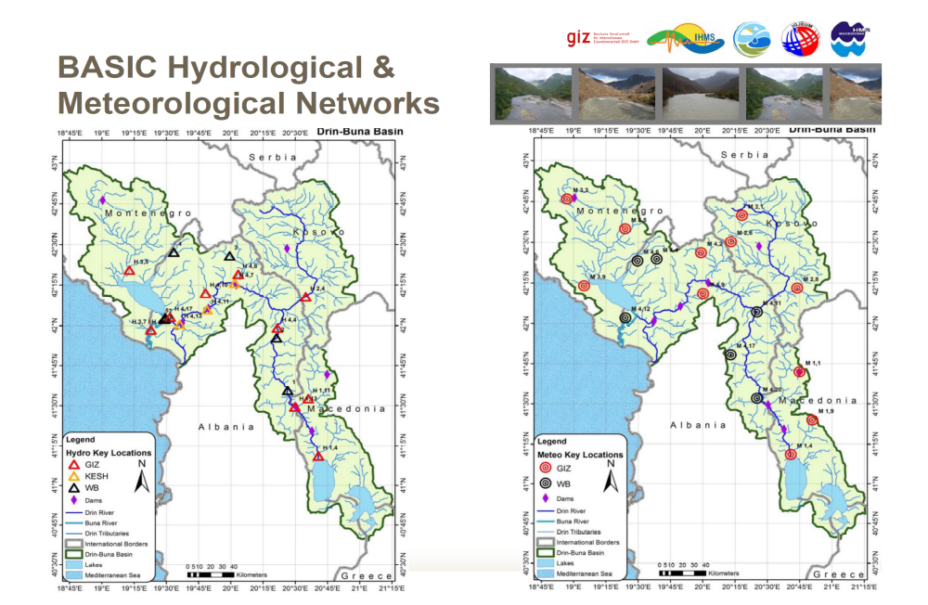
Figure 5: Hydrometric Network of the Drin Basin
- For example, there are gaps in the hydrometric network at high elevations, which limits the ability to provide sufficient lead times for flood forecasting, and also limits the ability to include snow fall and melt monitoring. It is important to be able to monitor these variables at high elevations, given their increasing variability with climate change. Existing equipment suffers from lack of financing for operations and maintenance, leading to a large number of existing installed stations being non-functional. Financial, human and technical capacities for operations and maintenance differ for each riparian country but remains inadequate, leading to hydrometric stations falling into dis-repair even within a few years of installation. Previous projects which have rehabilitated or installed new equipment have not addressed sustainability of the equipment, nor have riparian governments.

- Digitization, archiving and systematization of historical data remains ad hoc and project-based despite national and basin level attempts to address this issue. Hydrometric networks under private ownership are largely disconnected from the formal centralised hydrometric networks nationally and at basin level due to missing strategies, protocols and mechanisms for data sharing. Human capacities are a major challenge in at least two of the riparian countries. In Albania, the mandate and functional capacity of the NHMS is limited by its status of a severely understaffed and underbudgeted department within a Polytechnic University. It therefore lacks the capacity to execute the necessary functions of an NHMS. In FYR Macedonia, there are only 3 hydrologists in the Hydrometeorological Service for the entire national network and budgets, equipment and technical capacities are limited.

- These severe gaps in National Hydrometric Service Capacities results in a lack of comprehensive and readily available data for flood hazard risk and vulnerability modelling and mapping and for effective basin-wide flood forecasting. There are, as yet no definitive flood hazard, risk or vulnerability mapping for the Drin basin and the technical and financial capacity to undertake such mapping is lacking. Furthermore, there is a lack of relevant capacities for risk, damages, losses, exposure and vulnerability assessments. The socio-economic information required to assess climate induced flood damages, losses, exposure and vulnerability is not currently available and is not collected systematically. Existing methodologies and procedures for collection of damages and losses information currently carried out by the municipalities and or dedicated commissions, varies in approach and quality of data from one municipality to the next and between Riparian countries. This represents a barrier to effective flood hazard and disaster risk management in the basin and needs to be addressed in order to enable risk-informed decision-making on which the socioeconomic future of Riparian countries depend and reduce the risk to acceptable levels.

- Climate-induced flood risk information is not being systematically used to inform national, sectoral and local planning, mainly due to the lack of comprehensive and definitive national hazard and risk mapping. Hence activities within key sectors in Riparian countries such as water management, energy, transport, agriculture, forestry, spatial planning, are not risk-informed and to not take account of climate change. There is limited technical capacity and risk knowledge in flood hazard and risk assessment, due to a lack of standardised hazard, and risk assessment, modelling and mapping methods and technologies for such assessments. To date, only limited, small-scale site-specific modelling and mapping has been undertaken at discrete locations in the basin, which have not taken a river basin perspective, to include the hydrological and hydrological linkage of upstream conditions and processes to downstream, nor have they included climate change. There is therefore no single source of definitive climate-induced hazard mapping of the appropriate technical specification and level of detail for all users to provide the basis for risk-informed decisions and risk-informed activities such as spatial planning, floodplain management policy and emergency response for the basin. Furthermore, there is limited technical capacity and experience of responsible Riparian institutions to produce such. Importantly, previous risk assessments have not explicitly included the dams of the DRB or the effect of their operations on flood risk and water management. There are no platforms for the coordination and dissemination of climate-risk information across all sectors such as a centralised flood risk information system to enable systematic use of climate-risk information in decision making and importantly, in the management and reduction of climate-induced flood risks across all sectors in Riparian countries. At present, strategic planning for flood risk management not climate-risk informed and do not take a river basin perspective.

- Limited capacities and insufficient policy framework for basin-level coordination, cooperation and joint basin-level strategic action on flood risk management

- There is currently limited basin-level coordination and cooperation on flood risk management. Under an MoU between the national hydrometeorological institutions there is cooperation and data exchange for flood warning, based on regional forecasts, European Flood Awareness System (EFAS) and Flash Flood Guidance (SEE FFG).

- As discussed above, the Drin Coordinated Action was established to promote joint action for the coordinated integrated management of the shared water resources in the basin, based on the political framework for cooperation provided for in the Drin MoU. While the MoU has identified actions to address problems affecting sustainable development in the DRB, it does not currently specifically address joint actions required for cooperation on flood risk management. The Integrated DRB Management Plan which is currently being developed, will also not specifically include a basin flood risk management strategy or plan.

- As part of the institutional set up which supports the Drin Coordinated Action an expert working group on floods has been recently established, which will support technical consultations related to basin-wide flood risk management. However, institutional capacities at the regional, national and sub-national level across the basin are insufficient to secure climate-resilient FRM.

- The existing coordination and bilateral agreements are insufficient for a truly transboundary river basin approach to flood risk management. What is missing is a basin-level integrated climate change adaptation and flood risk management strategy and plan and a multi-lateral Framework Agreement for the DRB in the field of flood risk management in which all Riparian countries are Party and which establishes the institutional and legal basis for cooperation, with the international legal capacity, necessary for exercising its functions and clear roles and responsibility for decision-making, cooperation or coordination. Decision making of this nature requires a legal basis and processes and procedures to enable adoption of recommendations and decisions that are of binding character for all the Parties. Such a framework agreement also needs to provide conditions for effective FRM and conditions for financing basin-level FRM activities.

- Flood risk reduction, including flood protection measures, do not adequately integrate climate risk information, ecosystem-based and non-structural approaches to climate resilience

- The newly developed basin FFEWS system is incomplete in terms of the stations for which digitized historical data is provided which limits the underlying model calibration and the accuracy of forecasts that are provided. Missing high elevation stations also do not allow for snowfall and snowmelt to be sufficiently factored into forecasts. A significant gap to be addressed for any effective FFEWS is related to the “last mile” communication and delivery of the warnings to the local communities and an enhanced community-based risk reduction. There is currently no comprehensive community-based EWS, where these might be more appropriate than sole reliance on a centralised EWS, this is particularly important where warning times are short. Additionally, the system does not currently include a comprehensive treatment of flash flood forecasting, particularly important for upstream communities.

- Flood Forecasting and early warning system established for the basin is not providing impact-based forecasts which will enable focused preventative and response measures. Warnings are not tailored to user needs and, as forecasts do not always indicate the area at potential risk, the messages are not geographically-specific. Moreover, warnings do not contain specific information on the potential impacts. Studies to assess how warnings are accessed and interpreted are lacking and are needed. Forecasting and advisory products targeted to key sectors such as agriculture (e.g. drought, frost and other weather and climate forecasts, related to planting/crop and irrigation calendars, etc.) are missing.

- Key sectors at risk from flooding in Riparian countries currently lack the sector resilience and preparedness plans which would enable them to manage hazards and minimise the impacts to people, critical infrastructure, and normal economic activity within the sectors. Seasonal forecasts are not systematically provided to important sectors such as energy, water management, forestry and agriculture. Strategic planning for flood preparedness and response are not climate-risk informed and do not take a river basin perspective.

- In the Riparian countries of the DRB, flood defence and flood risk management is done in a reactive manner and as budgets allow. Relevant institutions have limited annual budgets to address urgent issues, and currently do not take a climate risk-informed strategic approach (e.g. river basin approach) to flood risk management interventions. During the Socialist era, flood management relied on flood defence construction almost exclusively, but many defences have exceeded their design life and have not been upgraded or maintained and are therefore now largely ineffective. In the modern era, flood risk management should be a mixed approach, which combines both structural and non-structural measures. Non-structural measures include, early warning systems, agro-forestry, climate proofing, watershed management etc. There is limited use of modern eco-system-based flood risk management approaches and approaches which combine both structural and non-structural measures as part of FRM, due to a lack of knowledge and application of non-structural measures and ecosystem-based approaches (EbA) to flood risk management. There is also limited knowledge and capacities among local communities on climate resilient livelihoods for coping with climate-induced hazards.

Project / Programme Objectives:

- The objective of the project is to assist the riparian countries in the implementation of an integrated climate-resilient river basin flood risk management approach in order to improve their existing capacity to manage flood risk at regional, national and local levels and to enhance resilience of vulnerable communities in the DRB to climate-induced floods. The countries will benefit from a basin-wide transboundary flood risk management (FRM) framework based on: improved climate risk knowledge and information; improved transboundary cooperation arrangements and policy framework for FRM and; concrete FRM interventions.

- As a result, the Adaptation Fund project will improve the resilience of 1.6 million people living in the DRB (direct and indirect beneficiaries).

- The project will work with partners to strengthen the current flood forecasting and early warning system to ensure an end-to-end fully-integrated flood forecasting and early warning system (FFEWS) is operational within the basin. In this regard, the project supports the further development the system to provide impact-based forecasting and dissemination of warnings within a common platform which importantly includes enhanced last mile connectivity to at risk communities. The project will develop and implement a transboundary integrated FRM strategies providing the national authorities with robust and innovative solutions for FRM, DRR and climate adaptation, including ecosystem-based gender sensitive participatory approaches. In addition, the project will develop the underlying capacity of national and regional institutions to ensure sustainability and to scale up the results. It will support stakeholders by providing guidance, sharing climate information, knowledge and best practices. The project will also invest in the priority structural and community-based non-structural measures. Importantly, the project is aligned with and will support the implementation of the EU Floods Directive (EUFD) in DRB countries.

- The AF project will build upon experience of Regional UNDP/GEF Drin project (see baseline initiatives section above) and other projects, in the region and will include the following innovations:1) introduction of international best practice in flood hazard and risk assessment, modelling and mapping in line with EUFD; 2) comprehensive FFEWS introducing state of the art forecasting technology and addressing institutional arrangements, communications and response; 3) innovative mix of structural and non-structural interventions based on climate risk-informed design; 4) agro-forestry measures and community-based flood resilience schemes. The socio-economic benefits include reduced damages and losses and improved food production (through protection of agricultural land). This will have direct and indirect livelihood protection and potentially income generation benefits. Environmental benefits include improved ecosystem functions through better spatial planning and agro-forestry.

Project / Programme Components and Financing:

Project/Programme Components | Expected Outcomes | Expected Outputs | Countries | Amount (US$)
1. Component 1  Hazard and Risk Knowledge Management Tools | Improved climate and risk informed decision-making, availability and use of climate risk information | Output 1.1. Strengthened hydrometric monitoring networks in all riparian countries based on a unified optimized basin-scale assessment of monitoring needs | Albania, the former Yugoslav Republic of Macedonia, Montenegro | 2,150,000
1. Component 1  Hazard and Risk Knowledge Management Tools |  | Output 1.2. Improved knowledge of CC-induced flood risk and risk knowledge sharing through the introduction of modelling tools and technologies for strategic flood risk assessment based on EUFD and development of basin flood hazard maps |  | 2,150,000
1. Component 1  Hazard and Risk Knowledge Management Tools |  | Output 1.3. GIS-based vulnerability, loss and damages assessment tools and database established to record, analyse and predict flood events and associated losses |  | 2,150,000
2. Component 2 Transboundary institutional, legislative and policy framework for FRM | Improved institutional arrangements, legislative and policy framework for climate-resilient FRM, and development of CCA and FRM strategy and plans at the basin, sub-basin, national and sub-national levels | Output 2.1. Drin River Basin FRM Policy Framework and improved long term cooperation on FRM | Albania, the former Yugoslav Republic of Macedonia, Montenegro | 950,000
 |  | Output 2.2. Regional, national and sub-national institutions (including meteorological and hydrological sectors) are trained in climate-resilient FRM, responsibilities clarified and coordination strengthened |  | 950,000
 |  | Output 2.3. Drin River basin Integrated CCA and FRM Strategy and Plan developed |  | 950,000
3. Component 3  Community-based climate change adaptation and FRM interventions | Strengthened community resilience through improved flood forecasting and early warning, implementation of structural and non-structural measures and enhanced local capacity for CCA and FRM | Output 3.1. Improved flood forecasting and early warning at the transboundary level through the establishment of a DRB FFEWS | Albania, the former Yugoslav Republic of Macedonia, Montenegro | 5,400,000
 |  | Output 3.2. Design and construction of structural risk reduction measures in prioritized areas using climate risk information and cost-benefit appraisal methods |  | 5,400,000
 |  | Output 3.3. Strengthened community resilience to flooding through the participatory design and implementation of non-structural community-based resilience, adaptation and awareness measures |  | 5,400,000
6. Project/Programme Execution cost  7. Total Project/Programme Cost  8. Project/Programme Cycle Management Fee charged by the Implementing Entity (if applicable) |  |  |  | 650,000
 |  |  |  | 9,150,000
 |  |  |  | 777,750
Amount of Financing Requested |  |  |  | 9,927,750

Projected Calendar:

Indicate the dates of the following milestones for the proposed project/programme
Milestones | Expected Dates
Start of Project/Programme Implementation | June 2019
Mid-term Review (if planned) | June 2022
Project/Programme Closing | June 2024
Terminal Evaluation | Sept 2024

pART ii: Project / programme JUSTIFICATION

- Describe the project / programme components, particularly focusing on the concrete adaptation activities, how these activities would contribute to climate resilience, and how they would build added value through the regional approach, compared to implementing similar activities in each country individually. For the case of a programme, show how the combination of individual projects would contribute to the overall increase in resilience.

Component 1 – Hazard and risk knowledge management tools
Outcome 1: Improved climate and risk informed decision-making, availability and use of climate risk information

- Key to the strategic management of climate-induced flood risk is to have appropriate density and frequency of monitoring of important hydrometeorological variables. Given the importance of accurate historical hydrometeorological records in the assessment of flood risk, it would be important to ensure that the hydrometric network is spatially optimised and centrally managed, and that data is made available to all flood management practitioners. The DRB is characterised by large spatial and temporal variability in rainfall and flow and it is therefore necessary to have sufficient spatial coverage (number and distribution of rain and flow gauges) to provide accurate flood forecasts and long lead-times to respond to flooding.

Output 1.1 – Strengthened hydrometric monitoring networks in all riparian countries based on a unified optimized basin-scale assessment of monitoring needs.

Based on a review of the status and adequacy of existing monitoring networks in riparian countries, the optimized network required for basin-scale flood risk monitoring and management will be identified, based on which, the project will design, purchase and implement new/rehabilitated monitoring network throughout the basin. The hydrometric network design document will be prepared covering network design, prioritised station list, condition of those stations, equipment options, rehabilitation / new installation plan, institutional assessment, operation and maintenance procedures and preliminary costing for rehabilitation and O&M. As part of the PPG and in consultation with the NHMS in each Riparian, the numbers and location of required hydrometric monitoring stations required within the Drin basin are being identified. These will be confirmed and prioritized as part of the hydrometric network optimization exercise during implementation.

- The project will develop a basin operational plan for the optimised hydrometric network as well as an Institutional capacity development plan for hydrometric network O&M, based on which training of hydrometric specialists with responsibility for operation and maintenance of the hydrometric network in all riparian countries, will be undertaken. The project will establish a unified basin-scale hydrometric database and data sharing protocols across all riparian countries. To ensure sustainability of the rehabilitated hydrometric network, the project will develop financing mechanisms, establishing and safeguarding riparian government long-term commitment of network maintenance, national capacity building for design, installation and maintenance of monitoring networks, linkages to basin and regional monitoring networks, community-managed gauging stations. This will also include the development of innovative financing mechanisms that would seek to engage the private sector (hydropower, tourism, agriculture) for which willingness-to-pay surveys will be conducted during project development, and local government and beneficiary communities (e.g. through engaging local people to assist in maintenance of stations), where possible, to complement government financing.

Output 1.1 – Indicative Activities

- Review the existing coverage, physical condition and data collection procedure including the quality of data. Collect data from the relevant Riparian Institutions to get the current station coverage, equipment installed, data period and data collection procedure.
- Undertake an assessment of the monitoring network requirements for effective monitoring for strategic flood risk management, flood forecasting and early warning in the future and optimise the stations coverage.
- Undertake an assessment of the existing telecommunications infrastructure to support the telemetered and automated stations.
- Digitise all relevant historical paper format data for DRB and systematise and store within the hydrometric database. Establish guidelines, procedures, data sharing protocols and user’s manuals for the new hydrometric database.
- Assess the institutional arrangements and capacity for the operation and maintenance of the hydrometric network and develop Institutional capacity development plan for hydrometric network O&M detailing manpower and financial requirements, and training needs, for the efficient O&M of all the stations in each Riparian country. Assess existing roles and responsibilities and the capacity of staff responsible for operating and maintaining the hydrometric network. Assess the existing protocols for the collection, transmission, sharing, storage, management and use of the observed data.
- Establish mechanisms for population and maintenance of centralised basin hydrometric database
- Prepare an operational plan for the hydrometric network including transmission of data, data management, data analysis and reporting procedures. The maintenance plan will cover manpower, technical capacity, material and finance requirements.
- Provide detailed specification and design including costs of all equipment and each component of the hydrometric network specified including the detailed design and bid document for the stations for future rehabilitation / new installation.
- Provide technical and financial assistance to improve hydrometric monitoring network (undertake procurement and installation of equipment).
- Review existing financing of hydrometric network O&M in each riparian country. Identify resourcing, and training needs as well as institutional arrangements for the management of the proposed new hydrometric network.
- Develop and implement O&M financing mechanisms for the hydrometric network.

Output 1.2 - Improved knowledge of climate change induced flood risk, and risk knowledge sharing through the introduction of modelling tools and technologies for the strategic flood risk assessment based on EUFD and development of basin flood hazard maps.

- The project will assess current level of implementation of the EUFD in each riparian country and review data availability for the detailed strategic basin-wide flood hazard and risk modelling and mapping. The project will commission/purchase essential datasets and surveys to enable flood risk mapping throughout the basin and will undertake detailed topographic surveys of the river channel through high risk areas in riparian countries, including major infrastructure across the river (e.g. bridges, dams etc.) and along river banks (e.g. flood walls, levees etc.). A unified basin approach to flood hazard modelling based on EUFD will be established and implemented. Using the most appropriate modelling techniques, the project will establish and/or amend existing numerical hydrological and hydraulic models of the basin based on detailed surveys of the physical characteristics of the river basin and produce high resolution flood hazard inundation maps in line with the EUFD, suitable for use in land use planning, development zoning, flood risk mitigation design, establishment of flood insurance criteria, raising public awareness, and emergency planning. These definitive basin hazard maps will be produced for a number of different return periods and for a range of climate change scenarios and will be the basis of climate risk information for use on climate risk management of the basin. Climate information sharing platforms, protocols and dissemination mechanisms will be strengthened across member countries.

Output 1.2 – Indicative Activities:
- Establish Spatial Data Initiative and data management system for project
- Undertake detailed topographic surveys of the river channel through high risk areas including all major infrastructure across the river (e.g. bridges, dams etc.) and along river banks (e.g. flood walls, levees etc.).
- Acquire/purchase/commission high resolution topographic data for the floodplain areas through high risk areas. Aerial photographs or LiDAR sources would be recommended in order to obtain a high-resolution DEM covering the whole basin.
- Using the most appropriate modelling techniques, establish numerical hydrological and hydraulic models of the DRB based on detailed surveys of the physical characteristics of the river basin, and produce high resolution flood hazard inundation maps suitable for use in land use planning, development zoning, flood risk mitigation design, establishment of flood insurance criteria, raising public awareness, and emergency planning. Maps will be produced for a number of different return periods and for a range of climate change scenarios. Flood modelling and mapping will cover all relevant flooding mechanisms within the basin.
- Undertake capacity assessment of relevant institutions for flood risk assessment and modelling and develop a long-term capacity development plan and training needs.

Output 1.3 - GIS-based vulnerability, loss and damages assessment tool and database established to record, analyze, predict and assess flood events and associated losses

- The project will fully map the socio-economic conditions within the basin, which will contribute to a body of data on which vulnerability and risk assessment will be based. Methods, tools and protocols will be established and implemented for the strategic collection of socio-economic data, for the systematic long-term updating of socio-economic flood receptor information (property, land use, economic data, socio-economics information etc.) and community-based risk mapping for the basin. The project will develop and implement a GIS-based basin-wide socio-economic risk model which integrates various spatial socio-economic data with the flood hazard maps, performs vulnerability assessment, and produces high-resolution vulnerability maps for the whole basin which will include damages losses, and loss of life estimates for floods of different return period. The model will enable damage and loss modelling, impact-based flood forecasting, cost-benefit analysis and the appraisal of FRM interventions based on cost-benefit analysis, and development of financing mechanisms for long-term FRM. Using the GIS-based risk model, the project will complete a cost-benefit options analysis for the Drin basin, to identify options that maximise benefits.

- To complement the GIS-based risk model the project will develop tools, methods, guidelines and procedures for recording flood events, undertaking post-event surveys and assessing vulnerability to flooding as well as assessing the effectiveness of flood mitigation measures in reducing vulnerability and damages. The project will establish a basin-wide damage and loss database for recording historical flood damage information (systematic collection of flood depth, damage and loss data, collection, storage and systematisation of historical flood reports across all riparian countries). DisInventar database is currently implemented in Albania, and Kosovo. The project intends to implement the same in FYR Macedonia and Montenegro, both of which have expressed an interest in having this as the standard centralised D&L data base.

Output 1.3. Indicative Activities

- Develop and codify methods and tools for undertaking socio-economic surveys to collect necessary information to fully map the socio-economic conditions of within the basin.
- Undertake socio-economic and vulnerability assessment to fully map existing vulnerability within the DRB, in order to identify the most appropriate adaptation options to reduce vulnerability within the s basin.
- Develop a GIS-based flood risk model which integrates various spatial socio-economic data with the flood hazard maps, calculates flood risk, performs vulnerability assessment, produce vulnerability maps which will include damages and loss of life estimates and to test flood management options.
- Implement the DisInventar database in Riparian countries for the systematic recording of damage and loss.
- Develop harmonised methods, guidelines and procedures in line with Sendai Framework, for recording flood events, undertaking post-event surveys and assessing vulnerability to flooding as well as assessing the effectiveness of flood mitigation measures in reducing vulnerability and damages.
- Undertake cost-benefit options analysis using the vulnerability loss and damages model to identify options that maximise benefits as the basis for the development of the Integrated FRM strategy and plan for the basin

Component 2 – Transboundary FRM institutional, legislative and policy framework
Outcome 2: Improved institutional arrangements, legislative and policy framework for FRM, and development of climate change adaptation and flood risk management strategy and plans at the basin, sub-basin, national and sub-national levels

- Institutional and legal framework for flood risk management in the Riparian countries of the DRB are highly fragmented in terms of competencies and suffer from overlapping/conflicting responsibilities of institutions. Mandates need to be clarified at national and sub-national levels, with clear assignment of responsibilities among institutions. The AF project will consolidate and extend current flood risk management efforts by DRB countries through the establishment of a dedicated coordination mechanism on flood risk management with the necessary political support and resourcing from the Riparian countries to comprehensively address missing formalized and effective cooperation on FRM.

- The project will engage the hydropower and other relevant sectors in flood risk management of the DRB. The project will also develop the basin policies for basin-wide climate responsive flood risk-informed flood risk management.

Output 2.1 – Drin River Basin FRM Policy Framework and improved long-term cooperation on flood risk management
- The Drin Core Group will be given responsibility for the coordination of the flood management at the Drin Basin level as part of its overall mandate to coordinate the Riparians for the management of the Basin along with the other bilateral cooperation arrangements. In this regard, the project will support the operation of the DCG Expert Working on Floods (Drin EWG Floods) during project implementation and will help identify and establish the long-term financing mechanism of the working group as part of the Drin Core Group operation. The Drin Core Group will be the Steering Committee of the project activities of regional nature and will assist in the coordination among countries for the activities of transboundary importance to be implemented at national level. The Drin Core Group with the assistance of the Drin EWG Floods will coordinate the implementation of joint periodic surveys, conferences, workshops, co-working activities.

- The project will review existing FM policy and enabling environments in each riparian country and develop basin FRM policies for the implementation of FRM legislative and policy framework in line with relevant EU directives. A key policy to be implemented will be basin wide floodplain zoning/development policy based on detailed hazard and risk maps. In addition, the project will explore and recommend a basin-wide policy for risk transfer mechanisms such as flood insurance (identify appropriate regional insurance model such as Europa Re or develop basin specific flood insurance model based on hazard, risk and damages and losses modelling and mapping – to be explored during the AF project development phase). The project will establish harmonised basin wide sector FRM policies for priority sectors (e.g., agriculture, energy, forest, water management, natural resource use, catchment management).

Output 2.1 Indicative Activities
- Review existing FM policy and enabling environments in each riparian country and develop basin FRM policies for the implementation of FRM legislative and policy framework in line with relevant EU directives.
- Develop basin risk transfer mechanisms. To include: Development of risk financing and risk transfer mechanisms strategy to include private sector engagement strategy for long-term implementation of risk financing and risk transfer mechanisms for national-level flood risk financing and resilience strategy. Also to include identification or public-sector risk financing mechanisms for flood risk management. Risk financing and transfer mechanisms products and tools identified (if existing) and/or developed based on detailed socio-economic risk, damages and losses assessment (to be undertaken in Output 1.3). Undertake feasibility studies of all identified and shortlisted risk financing mechanisms, development of a basin flood insurance model for the assessment of premiums and payouts of flood events of different return periods. Development of basin flood insurance scheme.
- Sector FRM policies (at least 2 – energy, agriculture) - Undertake detailed technical studies (including modelling) on climate change impacts on the identified sectors (energy and agriculture) in the DRB. Consult with national sector leaders and relevant stakeholders on findings of study and invite comments on recommendations through the floods working group. Develop and codify detailed methodologies for incorporating climate-change responsive flood risk considerations into risk assessments, strategies, policies and plans for the energy and agriculture sectors. Develop and finalise robust sector FRM policies and any necessary enabling guidelines and/or tools for effective implementation of new policies.

Output 2.2 – Regional, national and, sub-national institutions (including meteorological and hydrological sectors) are trained in flood risk management, roles and responsibilities clarified and coordination mechanisms strengthened for effective climate-resilient FRM
- The project will develop a DRB Stakeholders Analysis and the Governance Analysis focusing on Flood management based on the Stakeholders Analysis and the Governance Analysis done as part of the GEF Drin Project. This will include the following: (i) define all institutions at basin, national, sub-national level involved in water and flood risk management or institutions with activities that impact on flood risk (e.g. forestry, mining, town and country planning, mining, dam owners, and community organisations), including the role of NGOs/CBOs, donors, private sector, women’s organisations; (ii) conduct functional analysis of the institutions; (iii) analyze existing resources (staffing and budgetary) including sufficiency of staffing levels, existing capacity and tools; (iv) analyze existing policies, procedures and protocols, national guidance documents or codes of practice; (v) analyze interaction between institutions (e.g. information sharing, cooperation on functional activities, reporting between institutions); (vi) assess access to data and risk knowledge sharing among decision makers, practitioners, government, private sector and civil society, (vii) assess coordination mechanisms and implementation arrangements organised at basin, national and sub-national levels.

- Based on the analysis, the effectiveness of institutional arrangements in individual riparian countries towards basin-scale flood risk management will be analysed and if necessary, the ToR of the Drin EWG Floods will be revisited in terms of mandate, membership, resource requirements, technical capacity and technical enabling environment; data sharing and data access and technical means and tools for coordination. In consultation with riparian countries and the DCG a strategy and a five-year work program of the Drin EWG Floods will be developed and implemented. It will describe above all: DRB institutional capacity development plan including, plans for individual riparian countries, the resources, tools, technology, technical guidelines, procedures, protocols and codes of practice for comprehensive basin-scale FRM, the role of the DCG and the EWG in the preparation and implementation of the Drin River Basin Integrated CCA and FRM Strategy.

Output 2.2 - Indicative Activities
- Institutional mapping to identify the current relevant national and sub-national government departments with functions in flood risk management in each Riparian country.
- Institutional capacity assessment and gap analysis to include functional, resourcing, technical and financial capacity assessment. Development of long-term Institutional capacity development plan addressing resourcing, technical, and financial needs in each Riparian. Develop training programme for climate risk management and flood risk management and embed in relevant national/regional institutions to improve the technical capacity and knowledge base for climate risk management and a long-term adaptation planning for flood risk management.
- The ToR of the Drin EWG Floods will be revisited in terms of mandate, membership, resource requirements, technical capacity and technical enabling environment; data sharing and data access and technical means and tools for coordination. In consultation with riparian countries and the DCG a strategy and a five-year work program of the Drin EWG Floods will be developed and implemented.
- Deliver prioritised training to practitioners, decision-makers and communities to include the following:
    - Flood hazard and risk modelling and mapping methods (hydrological and hydraulic modelling). During the basin flood model development, training will be provided (to custodians, users and managers of the flood model and who will undertake the modelling in each Riparian country) in all aspects of flood risk modelling.
    - Hydrometric network design and O&M to include the planning, design, establishment and upgrade of monitoring stations to meet a range of needs, optimisation of the hydrometric and integration of monitoring networks of different agencies (such as HPP networks) where possible to ensure network complementarity and that regular data exchange; training of sub-national staff in equipment maintenance.
    - Flood risk assessment: Training in conducting post-event flood damages and losses assessment and Post-Disaster-Needs-Assessment (PDNA) surveys based on the harmonised PDNA methodology to be developed in Output 1.3.
    - Training of communities in FRM adaptation methods based on the community-based adaptation interventions identified in the basin and sub-basin FRM strategy and national plans
    - Training of practitioners and communities in the development of community-based early warning systems to enable the communities and practitioners to jointly develop early warning systems, elaborating the components of a system, how they can be set up, options for response to an early warning, etc.
    - Design of climate-resilient structural and non-structural flood protection measures.

Output 2.3 – Drin River Basin Integrated CCA and FRM Strategy and Plan Developed
- The Drin River basin FRM strategy (FRMS) and plan (FRMP) will be developed for the long-term management of flood risk in the basin. The strategy will outline the high-level basin wide policies for the long-term climate resilient management of flood risk and will be based on detailed strategic climate and flood risk assessment. FRM plan will outline the detailed actions that will be taken to address flood risk at the basin scale and within each riparian country, which will be detailed in national FRMPs. It will include a combination of structural and non-structural approaches which will best address flood risk at the basin scale and will involve developing an inclusive list of potential options for alleviating flood risk. The project will seek opportunities to attain the right balance between structural (or hard-engineering) and non-structural (or soft-engineering) flood risk management options.

Output 2.3 – Indicative Activities
- Development of an integrated basin flood risk management plan for the DRB with participation of all relevant stakeholders. The plan will take a bottom-up, multi-stakeholder, consensus-based approach. This activity will be mainstreamed into the national on-going work on the development of the river basin management plans through the relevant national authorities. From the basin plan, and sub-national plans will be developed. Development of the basin level plan will follow these steps:

Component 3 – Priority community-based climate change adaptation and FRM interventions

Outcome 3: Strengthened resilience of local communities through improved flood forecasting and early warning, implementation of structural and non-structural measures and the strengthened capacity for CCA and FRM at the local level

Output 3.1 – Improved flood forecasting and EWS at the transboundary level to reduce climate-induced disaster risks in vulnerable communities through the establishment of a Drin basin flood forecasting and early warning system
- Flood early warning systems offer a solid ground for future integrated warning systems as further advancements in forecasting emerge. Good practice of early warning consists of four key elements: (i) risk knowledge, (i) monitoring and warning services, (iii) dissemination and communication, and (iv) response capabilities. Effective flood emergency response relies on effective flood forecasting and warning, knowledge of where flooding will occur (high risk areas identified by flood mapping), key players in the response, actions to be taken by each individual (or groups of individuals) and an evacuation plan.

- The project will review any existing flood forecasting programmes, or elements of FFEWS in Drin Basin, assess current institutional arrangements and capacity for basin-scale flood forecasting, flood emergency response and develop an institutional arrangement plan for FFEWS. Telecommunications studies to determine the requirements to support monitoring and telemetry system as well as warning dissemination system will be undertaken, particularly in relation to proposed new stations to be procured by this project at high elevations, to enhance forecasting capacity. Where necessary, the project will support, with complementary activities, the on-going projects to ensure the provision of a fully integrated FFEWS based on a design to include centralised and community-based Early Warning systems.

Output 3.2 – Development, design and construction of flood risk structural adaptation and mitigation measures in prioritized areas using climate risk information, and cost-benefit appraisal methods.
- The project will undertake feasibility, outline design and detailed design or implementation of structural options. The project will assess new structural measures such as the provision of flood storage, the provision of new embankments and walls, local land raising to elevate development areas above the extreme flood level, local improvements to channel capacity and stability, channel diversions, flow control structures (including pumping and flow diversions), increased maintenance and improvements to channels, e.g. de-silting and dredging.

- As part of the development of the FRMS, a long list of options will be examined and qualitatively assessed in terms of the socio-economic, environmental, engineering and hydrological impacts of the options, and will form the basis of the short-listing process to be carried out in consultation with stakeholders. An initial appraisal of the short-listed options will be carried out to determine technical performance in terms of flood damages reduction in the basin. Changes in flood levels against the baseline scenario will also be investigated and the effects of such changes assessed. The reduction in damages resulting from an option (as compared to the baseline) represents the option benefits. A range of options will be directly compared and ranked in order to identify the most economically advantageous options or the economically preferred option(s) for the basin. Feasibility outline and detailed design studies will be carried out on each preferred option/flood alleviation scheme. The activity will meet relevant national technical standards, where applicable, such as standards for environmental assessment, building codes, etc., and comply with the Environmental and Social Policy of the Adaptation Fund.

- During concept development, some Riparian countries provided structural measures that have already been prioritised for implementation which will be considered further during full proposal development and confirmed/further developed and designed during project implementation, should they be considered feasibility following detailed climate-risk based options assessment using the tools, mechanisms and procedures for appraisal-led options design that the project is implementing.

Output 3.3 - Strengthened local community resilience to flooding through the participatory design and implementation of non-structural community-based resilience, adaptation and awareness measures

- In order to ensure participatory and long-term sustainable community resilience the project will provide training to selected municipalities/communities on maintenance of non-structural intervention measures. Non-structural options will include a suit of measures for management of hillslope and floodplain vegetation to enable greater rainfall infiltration and transmission and reduce erosion. This may include reforestation and the use of seasonal cropping, agroforestry, the use of vegetative bundles to build flood defences etc., floodplain agro-forestry systems. Flood risk management measures will promote the re-establishment of natural floodplain functionality including: floodplain reconnection; selective bed raising / riffle creation; washlands/wetland creation; re-meandering straightened rivers; land and soil management activities to retain/delay surface flows; creation or re-instatement of a ditch network to promote infiltration (swales, interception ditches, etc); In-channel vegetation management growth to maximise channel roughness. Income generating ecosystem-based adaptation and FRM measures (e.g. agro-forestry) will be implemented in priority areas throughout the basin. These schemes will form part of the non-structural interventions to be implemented and will be subjected to the same assessment and appraisals of structural interventions as described above.

- The project will develop local government response capacity, training first and second responders for flood emergencies through drills and role play exercises and provide training in the operation of EWS where community-based EWS will be established. Training will be provided for communities on roles and responsibilities during flood emergency procedures. Community-based resilience and adaptation will be built using participatory methods of risk assessment and community resilience planning. Community-based response roles and responsibilities will be defined and training of local communities undertaken. Community-managed flood forums will be established.

- As part of the FFEWS, community managed EW systems will be established and training undertaken in the operation of such systems to increase capacity of local communities in the maintenance of non-structural intervention measures and the monitoring and issuing of flood warnings in line with established protocols. Information dissemination to reach all beneficiaries will be established, awareness raising and education, and gender mainstreaming approaches established.

- Describe how the project /programme would promote new and innovative solutions to climate change adaptation, such as new approaches, technologies and mechanisms.

- To date, flood risk management in the DRB has been dealt with in an ad hoc and reactive manner, relying on measures such as hard structural protection measures which are not informed by climate risk-formed flood hazard information and are therefore not climate proofed; post-disaster emergency response, with limited reliance on forecast of the event or satisfactory prior warning of the population and post event compensation to victims. Furthermore, FRM within the DRB has been largely undertaken unilaterally by each Riparian country without consideration of the wider basin perspective.

- The AF project being developed will address the barriers to establishing and implementing a fully integrated basin flood risk management approach aimed at supporting the commitment of the Riparian governments to avoid losses of lives and to reduce economic and infrastructure losses caused by climate-induced flooding.

- With the AF project, there will be strengthened technical, institutional and financial capacities to implement and maintain a fully integrated basin FRM, clear institutional arrangements and responsibilities for key national institutions, comprehensive and definitive flood risk maps and information as well as strengthened legislative and policy framework to address existing weak land use, spatial planning and sectoral flood resilience and risk management, leading to reduced exposure of communities to damages, losses and loss of lives. In addition, institutional and financial capacities and introduction of modern methodologies and technologies will enable the design of climate risk informed flood mitigation measures. The basin-level approach to the identification of flood risk management intervention measures will ensure that the most vulnerable communities at risk from flooding will have the coping capacities and adaptation strategies at community and individual level to adapt to climate change and to manage and minimise their exposure and resilience.

- Specifically, the project will introduce the following innovations and technologies:

- Improved accuracy and representative measurement of hydro meteorological variables through improving the observation density of the monitoring to capture the large spatial and temporal variability in hydro meteorological processes.
- Introduction of flood hazard and risk assessment, modelling and mapping methods and technologies and building of long-term institutional capacity for such assessments. Importantly, it development the comprehensive single source of definitive flood and risk hazard mapping of the appropriate technical specification and level of detail for all uses.
- support the development of platforms for regional coordination and cooperation on flood risk management and the dissemination and sharing of flood risk information using existing information systems.
- the project will address the lack of socio-economic data and relevant capacities for risk, damages, losses, exposure and vulnerability assessments by developing and harmonising methodologies and technologies for the systematic collection of socioeconomic information required to assess climate induced hazard damages, losses, exposure and vulnerability. It will address the lack/absence of methods and tools for at municipal and community levels by introducing and standardise methods of damage and loss assessment and PDNA assessment.
- the project will address the limited capacity and resources to implement cost-effective climate-induced strategic flood risk reduction and adaptation activities by strengthening national capacities for developing and implementing FRM plans, based on hazard and risk information and through the detailed design and implementation of priority risk reduction structural measures. Thus, directly increasing resilience in targeted areas and will enable long-term FRM investment planning of intervention measures.

- Describe how the project / programme would provide economic, social and environmental benefits, with particular reference to the most vulnerable communities, and vulnerable groups within communities, including gender considerations. Describe how the project / programme would avoid or mitigate negative impacts, in compliance with the Environmental and Social Policy of the Adaptation Fund.

- The project is a direct response to the priorities that have emerged from the National Communications of the Riparian Countries and the priorities identified in light of recent significant flooding in the basin. The project is designed to respond to the flood risks to the most vulnerable communities in the Drin river basin, by transferring best available technologies for climate resilient flood risk management. In so doing it will directly benefit at least 250,000 people estimated to be at risk from extreme floods in the Riparian countries. Indirectly the project will also benefit all of the 1.6 people living in the DRB by improved basin-level flood risk reduction and consequent social, economic and environmental benefits.

- The project will improve the knowledge base on flood risk through fully developed modelling and flood mapping. This, as well as the efforts to increase institutional capacity, will lead to improved strategic management of flood risk and improved flood forecasting and warning. In particular, the population of the DRB will benefit from improved lead warning times to flood events due to improvements in the hydrometric monitoring network which underpins the forecasting and early warning systems. Implementation of spatial planning policies which include zoning of economic activities and development away from high flood risk areas, will lead to reduced exposure of the target population in the DRB. Overall vulnerability of communities in DRB to flooding will be reduced due to increased awareness and direct engagement of local communities in flood risk management. Adaptation of climate resilient landuse practices by communities will increase their adaptive capacity and reduce exposure and safeguard their assets. Targeted training in FRM functions will further increase adaptive capacities within municipalities.

- The project will have sustainable development co-benefits including ecosystem services protection, rural income generation, livelihood enhancement and job creation, improved access to education and training opportunities, and improved resilience of physical assets of communities. The main economic co-benefits from the project investment are derived from the avoided socio-economic losses from flood disasters. Under climate change, economic losses are expected to increase, which could significantly impact and reverse socio-economic development gains of the Riparian countries. Avoided losses to sectors such as hydropower could be significant. Climate flood risk informed sectoral planning will help build national and regional resilience. Climate risk information will also safeguard assets such as transportation networks which are critical to the economic development and functioning of communities. Economic co-benefits will also be realised in all productive sectors within Riparian countries due to prevention of losses.

- The project will have significant gender co-benefits and will embed nationally appropriate gender consideration in each Riparian country. The project will therefore safeguard local communities and their assets from flood disasters with particular attention to women and other vulnerable groups. Environmental co-benefits mainly relate to strategies which will provide water retention functions; regulation of hydrological flows (buffer runoff, soil infiltration, groundwater recharge, maintenance of base flows); natural hazard mitigation (e.g. flood prevention, peak flow reduction, soil erosion and landslide control); increased streambed stabilization resulting in decreased erosion, habitat preservation, and reforestation which will be derived mainly from non-structural measures to be implemented.

- Describe or provide an analysis of the cost-effectiveness of the proposed project / programme and explain how the regional approach would support cost-effectiveness.

- The proposed project builds upon lessons learned and success of the past and on-going interventions, existing data/information, institutional and management frameworks and capacities and, communications and coordination mechanisms being built under the GEF Drin project and Drin MOU instrument.

- Comparable efforts (EWs, climate information, and community-based DRM) have shown effective impact related to saving of lives, assets, and livelihoods. In Nepal, the community based EWS directly benefit over 80,000 people in communities around river basin systems. Advanced EWS systems are estimated to be 100% effective in reducing loss of life by cyclones, 60% effective for floods, and 20% effective in case of drought. (Teisberg and Weiher (2009)). In Bhutan, EWS project has enhanced capacities of district and local level authorities and communities in disaster risk and climate risk management.

- The project offers a cost-effective alternative to conventional/baseline reactive approaches to risk management that builds around ad-hoc recovery investment and compensations, predominance of large scale hard defense infrastructure and limited community engagement. The AF project will catalyze shift to more cost-effective and efficient approaches to resilience building. The new approach is based on enhanced risk knowledge that allows proactive action to reduce exposure of people and economic assets to hazardous events, enhanced design of risk reduction investments, a combination of structural and non-structural measures, enhancing adaptive capacities of local communities. The regional cooperation and coordination on flood risk management and climate risk information management is another factor of the AF project efficiency.

- Describe how the project / programme is consistent with national or sub-national sustainable development strategies, including, where appropriate, national or sub-national development plans, poverty reduction strategies, national communications, or national adaptation programs of action, or other relevant instruments, where they exist. If applicable, please refer to relevant regional plans and strategies where they exist.

- The project is consistent with the climate change adaptation priorities outlined in the National Communications of Albania, FYR Macedonia and Montenegro. All three beneficiary countries launched their National Adaptation Planning (NAP) processes recognizing above all climate risks and vulnerability of their economies and communities to climate-induced floods.

- The National Strategy for Development and Integration (NSDI) of Albania for the period from 2014 – 2020 presents both the government’s vision for national goals for the social and economic development of Albania, as well as sector-specific plans for achieving this vision over the period. Most of the sector strategies under the NSDI include acknowledgement of the impacts of climate change. The Environment cross-cutting strategy under the NSDI, fully integrates climate change and highlights the lack of institutional and individual capacities to evaluate climate change impacts and need for adaptation action particularly in coastal zones and river basins, where tourism is a large economic driver and urban and transportation infrastructure and agriculture land is especially at risk from climate impacts such as flooding. The proposed AF project will support Albania’s newly established Agency of Integrated Water Resources Management and the Ministry of Tourism and Environment to ensure a comprehensive watershed management in Drini River that accounts for the growing renewable energy industry, land use planning as well as road, urban, and other infrastructure.

- The National Adaptation Process was launched in Albania in 2015 with the support of GIZ and UNDP. A preliminary roadmap for NAP implementation was formulated and validated by representatives. The Government of Albania will be developing a detailed NAP strategy action plan with the support of the Green Climate Fund and UNDP. Vulnerability to climate induced flood risks and the needs to increase the resilience to floods is recogniced in te NAP documents and process.

- The Former Yugoslav Republic of Macedonia priorities and development needs are reflected in the Government Programme 2017-2020. The project will contribute to the implementation of the Government priorities from the abovementioned programme, particularly the goals set for the following sectors: protection of the environment and nature, agriculture, forestry and water economy, as well as foreign affairs and European integration. More specifically the Strategy for environment protection and climate change 2014-2020 prepared by the Ministry of Environment and Physical Planning in 2015 will be an important instrument for the future vision on integrated river basin management plan.

- The project will support the intention of the Government to introduce an integrated system of water management, including establishment of a database for all water resources. Also, the project will directly contribute the Government’s idea to initiate the development of operational plans for flood protection and public educational campaign for flood risk protection country wide.The clearest contribution of the project will be linked to the support of the Government efforts for the development of a contemporary hydro-meteorological system, particularly in the agricultural regions, and establishment and operationalization of an early warning system on the whole territory of the country. Strengthening of the water monitoring systems, and implementation of the EU Water Framework Directive and the EU Flood Directive are one of the priorities of the Strategy for environment protection and climate change 2014-2020. This Strategy also calls for an integrated river basin management and establishment of a system for flood risk assessment, and flood risk management.

- The first Nationally Determined Contribution (NDC) under the Paris Agreement of Montenegro states that “The region of South East Europe, including Montenegro, is highly vulnerable to the impacts of climate change thus avoiding dangerous climate change is of paramount importance for the country.”

- The Montenegrin National Strategy of Sustainable Development until 2030 (NSSD) established a comprehensive framework addressing challenges the country is facing on its path towards sustainable development by 2030, while considering the EU accession requirements. In this context, the NSSD also sets the platform for translating Agenda for sustainable development into the national framework. The management of natural resources (including waters) and corresponding sectorial strategies and financial frameworks have to be aligned with the NSSD 2030.

- The Water Management Strategy defines long-term directions of water management and includes the assessment of the current situation in water management, goals and guidelines for water management, measures to achieve the established objectives and the projection of the development of water management. The overall objective of the Strategy is to achieve a uniform and fully harmonized water regime of Montenegro both in Adriatic and Danube basin.

- The National Strategy with Action Plan for transposition, implementation and enforcement of the EU acquis on Environment and Climate Change (NEAS) 2016-2020 was adopted to achieve gradual and complete transposition of the entire EU acquis for Chapter 27-Environment and Climate Change into the legal system of Montenegro. In November 2013 based on the Screening Report presented by the EC, Council decided that Montenegro needs to fulfill the opening benchmark to open the negotiations with the EU for Chapter 27 (Environment and Climate Change).

- The Strategy for Disaster Risk Reduction (DRR) with Action Plan for the period 2018-2023 is based on reducing the disaster risks and their main causal factors, proper land management and environmental protection, lowering exposure to hazards as well as vulnerability of people and property and improving overall preparedness for disasters. The DRR strategy highlights that the frequency of the meteorological and hydrological hazards and the damage they have been causing is increasing.

- Describe how the project / programme meets relevant national technical standards, where applicable, such as standards for environmental assessment, building codes, etc., and complies with the Environmental and Social Policy of the Adaptation Fund.

- All activities of the AF project, except for activities under the Outputs 3.2 imply implementation of soft, non-structural measures that do not require any government licenses and permits. For hydrometric and other equipment to be procured under the Outcome 1 the project will analyze and choose optimal locations for the new observation equipment to minimize the risk of damages to the extent possible. Siting of gauging stations will follow international standards which will consider the safety of stations.

- Flood defence structures that will be constructed/rehabilitated under the Output 3.2 will adhere to all national technical standards and building codes according to the Environmental Legislation of the three beneficiary countries. All works will be subject to design and will meet local technical environmental and social laws and standards. Where relevant, local regulations will be followed. The project will ensure the adherence of all construction activities to national standards as well as to the Environmental and Social Policy of the Adaptation Fund and to the UNDP safeguards policies.

- During the full AF proposal development, the Social and Environmental Screening Report and the Environmental and Social Management Framework will be developed.

- Describe if there is duplication of project / programme with other funding sources, if any.

- During the development of this Concept Note an analysis of the baseline projects and initiatives relevant to the proposed AF project implementation has been conducted in order to avoid duplication and secure strong synergies and coordination. The following projects and programmes are relevant to the AF initiative.

- Enabling transboundary cooperation and integrated water resources management in the extended Drin River Basin: The GEF-funded UNDP Drin Project promotes joint management of the shared water resources of the transboundary Drin River Basin, including coordination mechanisms among the various sub-basin joint commissions and committees. The Project assists to: (i) build consensus among countries on key transboundary concerns and drivers of change, including climate variability and change, reached through joint fact finding; (ii) update the shared vision; (iii) reach an agreement on a program of priority actions deemed necessary to achieve the vision; (iii) strengthening technical and institutional capacities; (iv) operationalize the institutional structure of the Drin Coordinated Action, rendering it capable of undertaking its coordinative and executive role. The Project is implemented by UNDP and executed by the Global Water Partnership-Mediterranean (GWP-Med). The Drin Core Group is the Steering Committee (SC) of the Project.

- The project has the following expected outcomes:

- Component 1: Consolidating a Common Knowledge Base
  - Outcome 1 - Consensus Among Countries on Key Transboundary Concerns, Including Climate Change and Variability, Reached Through Joint Fact Finding.
- Component 2: Building the Foundation for Multi-Country Cooperation
  - Outcome 2 - Visioning Process Opens the Way for Systematic Cooperation in the Management of the Transboundary Drin River Basin.
  - Outcome 3 - Countries and Donors Commit to Sustain Joint Cooperation Mechanisms and to Undertake Priority Reforms and Investments
- Component 3: Institutional Strengthening for Integrated River Basin Management (IRBM).
  - Outcome 4 - The Operationalization and Strengthening of the Institutional and Legal Frameworks for Transboundary Cooperation will Facilitate Balancing of Water Uses and Sustaining Environmental Quality throughout the Extended Drin Basin.
- Component 4: Demonstration of Technologies and Practices for IWRM and Ecosystem Management.
  - Outcome 5 - Benefits Demonstrated on the Ground by Environmentally Sound Approaches and Technologies New to the Region.
- Component 5: Stakeholder Involvement, Gender Mainstreaming and Communication.
  - Outcome 6 - Public Support and Participation to IWRM and Joint Multi-Country Management Enhanced Through Stakeholder Involvement and Gender Mainstreaming.
  - Outcome 7 - Political Awareness at All Levels and Private Sector Participation Strengthened through Higher Visibility of the Project’s Developments and Targeted Outreach Initiatives

- South-East European Multi-Hazard Early Warning Advisory System – USAID/OFDA 565,000.00 CHF. The project includes development of a regional multi-hazard early warning advisory system – consisting of information and tools for forecasters at National Meteorological and Hydrological Services (NMHSs) and harmonized national early warning systems. The first phase of the SEE-MHEWS-A project in 2016-2017 was supported by the U.S. Agency for International Development (USAID), Office of U.S. Foreign Disaster Assistance. SEE-MHEWS-A will provide operational forecasters with effective and tested tools for forecasting hazardous weather events and their possible impacts in order to improve the accuracy of warnings and their relevance to stakeholders and users. On a single virtual platform, the system will collect existing information, products and tools for the provision of accurate forecasts and warnings to support hazard-related decision-making by national authorities. Furthermore, the system will function as a cooperative platform where forecasters from different countries can work together on the identification of potential hazards and their impacts, especially when impending weather hazards may have potential impacts in many countries

- During the inception phase, a detailed Implementation Plan was developed that provides guidelines for development of the technical part of the system and for all activities necessary to establish advisory system operations by mid-2023. In addition, the plan considers the governance structure and other management aspects of the project implementation. The plan was developed as a joint effort between WMO, NMHSs of the region, and numerous collaborators, including WMO Regional Specialized Meteorological Centers, research institutions, numerical weather prediction consortia, and European and US meteorological and/or hydrological service.

- IPA DRAM – Programme for Disaster Risk Assessment and Mapping in Western Balkans and Turkey: IPA DRAM is addressing the need to further strengthen capacities in the field of civil protection and general risk management in the Western Balkans region, and coordination both within the region and with sister agencies in EU-countries. The Programme for Disaster Risk Assessment and Mapping (IPA DRAM) further contributes to enhancing the capabilities of the partner countries to strengthen disaster risk management by creating an open platform for the development and improvement of national disaster loss databases, enhancing the coherence among the national systems and methodologies, and consistency with existing EU regulations, guidelines and good practices.

- GIZ-implemented project “Climate Change Adaptation in Transboundary Flood Risk Management, Western Balkans” (CCAWB is working closely with partners and pursuing a multi-level approach, support is provided mainly by means of capacity development, advisory services, and procurement of equipment.

- The project has achieved the following, according to the Fact Sheet:

- Riparian countries have agreed on data exchange to further improve flood early warning and trans-boundary flood risk management. As a result, an estimated 30.000 people potentially affected by floods can be warned in advance.
- 20 additional sensors are providing online data to the Hydro-meteorological services in the four countries.
- Hydrological flood forecasting model of the whole basin is developed.
- 12 professionals of the four national Hydro-meteorological Services are trained and enabled produce regular flood forecasts.
- More than 50 professionals from local authorities from Albania, Macedonia and Montenegro are trained in the use of GIS software for more effective flood risk management.
- Flood risk areas are defined and mapped at basin level, in line with the EU Flood Directive, and a catalogue of measures for transboundary flood risk management is created for the Basin.
- At least 10 km of drainage channels in Shkodra region are being cleaned up to reduce the risk and severity of floods.
- Civil emergency structures are supported with know-how, tools and equipment to better perform their work.
- Students and teachers of at least 18 schools inthe risk areas ofAlbania and Montenegro will benefit from awareness campaigns on flood preparedness and reaction.
- The National Adaptation Plan and its financing strategy are finalised for Albania.

- GIZ, under the project “Adaptation to Climate Change in transboundary Flood Risk Management, Western Balkans” is planning to extend its current activities on flood risk management of the Drin basin to include the following:

- Further implementation of the EU Flood Directive. The project will support pilot experiences on generating flood hazard and risk maps, and replication of the hazard and risk mapping process in other parts of the Drin basin, and in other risk areas of the countries.

- The project will support the Drin riparian countries in delivering effective and timely end-to-end early warnings. In addition to further refinement and training on the use of the Flood Forecasting Model developed for the basin (PANTA RHEI), the project will strengthen capacities at local, national and regional levels to improve end-to-end, people-centred flood early warning (including institutional arrangements, roles and responsibilities, SOPs, etc.). Simulation exercises in vulnerable communities will be carried out.

- Furthermore, the project will support the partner institutions at local and national level, on strengthening their capacities to better coordinate flood risk management. Systematic strategic and institutional advice, exchange of expertise, among different level actors (local, national and regional), together with expert advice on the EU Flood Directive, will be in the focus of the project. Flood risk management measures as have been identified and prioritised by the partners will be implemented.

- While having achieved some discernible change in flood risk management, these baseline initiatives need to be consolidated and built upon in order to achieve transformative change in resilience of, existing and emerging, climate-induced flood risk to the population of the Drin Basin.

- Given the number of on-going regional initiatives on flood risk management in the Drin basin, the project will look to coordinate activities to avoid duplication and overlap. Consultations are on-going with all key existing and planned project implementors to develop a clear strategy for coordination and cooperation by the full proposal stage. A review will be undertaken of all previous and ongoing relevant national and regional studies to identify lessons learned which this project can build upon. The Ongoing GIZ project in the Drin basin will provide opportunities for coordination of efforts, however, further consultations are needed to ascertain the scope of planned activities to identify synergies and areas for cooperation. The proposed AF project is unique in its scope and provides an opportunity to consolidate and build upon experience to date. It will be the first project to implement a comprehensive integrate flood risk management approach for the Drin basin and will be critical to providing a benchmark for how the Riparian countries undertake flood risk management in other basins.

- If applicable, describe the learning and knowledge management component to capture and disseminate lessons learned.

- The knowledge management (KM) of the project will have the following key aims:
- To ensure access to data and information generated by the project as well as long-term access to data on which stakeholders’ essential institutional functions rely and/or data and information that can be used for evidence for policy and practice advice (connecting people to information and knowledge)
- Connect key stakeholder groups, practitioners and experts to ensure that key learning and experience is shared within and across sectors (connecting people to people)
- Ensure staff in the stakeholder institutions know about effective and relevant KM techniques so that knowledge is shared, captured and retained by the institutions and shared within and across the sector (institutional KM improvement)
- By developing and promoting KM as a tool for continuous and sustainable improvement and ensuring that KM tools generated by the project will be systematically used and maintained within the stakeholder institutions (Developing and embedding KM tools and practices).

Connecting people to Information and knowledge
- The project will build on the foundation of previous knowledge. New knowledge gained on the project will be captured and stored appropriately for others to access and learn from. The following series of tools and techniques will be employed to enable people to find information and knowledge more effectively throughout the project.
  - Case Study – At least 5 case studies will be generated per year of the project
  - Rapid Evidence review – Project inception studies will establish the project baseline which will be updated throughout the project as it progresses and published in various technical and non-technical documents.
  - Knowledge Banks (web databases) – The project will develop a knowledge and data management website for all project, stakeholder and beneficiary staff

Connecting people to people
- The following series of tools and techniques describe how knowledge management will enable people to connect to people more effectively.
  - Community of Practice (CoP/Knowledge network/professional network) – The project will set up a number of technical working groups, riparian countries’ interagency working groups as well as regional working groups to enable practitioners (CoP) to interact and share experiences
  - Peer Assist – The project will engage a range of local and international experts who will provide technical assistance to the project. For long-term peer assist, the project will help establish relationships between institutions and local as well as international universities and research centres
  - Knowledge café – This will be achieved through the meetings of the technical working groups and through bi-lateral meetings between individual stakeholder organisations
  - Knowledge marketplace – This will be provided by project experts who will be identifiable by their area of expertise and will provide support to the project and stakeholders. In the long-term, a ‘directory’ of experts can be developed to fill this need.

Institutional KM improvement
- Summarising lessons learnt and experiences and sharing them with others can help build and retain knowledge. The following series of tools and techniques describe how the project knowledge management will enable improvement through impact assessments, evaluations and people management.
  - Gone well/not gone well - All significant project events/activities will be subject to a debrief to capture good/bad points and lessons learned
  - After Action review (AAR) formative evaluation - All significant project events/activities will include formal minutes which will be made available on project portal
  - Retrospective review (summarise evaluation) - A formal project lessons learned document will be available for all project staff to complete (managed by PM) online
  - Knowledge Exchange - All project staff will have as final deliverable a summary report to include knowledge transfer information and other lessons learned
Developing and embedding KM tools and practices

- During project formulation and planning, the number and types of Knowledge Management tools that will be developed will be further detailed.

- As far as possible, all KM tools will be provided as project deliverables and, importantly, through the project it is intended that by using these tools with the stakeholders, the KM practices will be embedded within their organisations in the future.

- In addition to the above the project will provide many opportunities for formal learning, awareness raisings and capacity building cut across almost all outputs and activities. These sets of measures will catalyse longer-term learning and short-term professional training/retraining programs targeting all stakeholders, including vulnerable communities, local governments, schools and universities and, relevant authorities.

- All knowledge products, generated within the project including technical reports, methodological guidelines, regulatory and policy, planning and outreach materials will be available on-line, and all project knowledge products and documents will be collected and archived on e-library on multi-hazard disaster risk management

- Describe the consultative process, including the list of stakeholders consulted, undertaken during project / programme preparation, with particular reference to vulnerable groups, including gender considerations, in compliance with the Environmental and Social Policy of the Adaptation Fund.

- At Concept development stage, stakeholder consultations in the four Riparians. Missions were conducted in each Riparian country to meet with key stakeholders. The aim of the missions was as follows:
- To gain an understanding of the current status of the institutional frameworks and capacities for FRM in each country
- To determine requirements within each country to strengthen FRM, particularly within the Drin Basin and identify national priorities
- To gain an understanding of current regional/basin cooperation on FRM and identify areas for strengthening cooperation in line with the proposed project outcomes.
- To identify and collect necessary data for the development of the project proposal
- To understand previous and ongoing initiatives on FRM by institutions and partners, to ensure synergy and avoid duplication/overlap of effort
- To identify potential co-financing

- The project idea was presented to the Drin Core Group in June 2018 and the national delegations from the DCG countries supported the further development of the proposed project. Annex 6 provides a list of stakeholder consultations undertaken in each country including participants at each meeting:

- Provide justification for funding requested, focusing on the full cost of adaptation reasoning.

- The programme costs are additional to other costs associated with flood risk management activities carried out by the beneficiary countries and other parties. The proposal aims to build on existing platforms to meet the additional costs of adaptation. The project will fund the full costs of adaptation, such as policy and institutional frameworks, technology transfer, capacity development for promoting climate resilient transboundary flood risk management and demonstration of community-based low cost flood risk reduction. The project is structured to allow a high proportion of funds to flow into capacity building, policy development and institutional activities associated with the promotion of climate resilient flood risk management.

- As such, the components are expected to result in a significantly higher adaptation benefit than would otherwise be the case under a baseline scenario. A significant share of community vulnerability to climate-induced floods remains structural in nature and requires investment in a combination of structural and non-structural flood protection measures to build awareness of best practice and change behavior both among policy makers and agricultural communities. Further cost of adaptation reasoning is set out below.
Component 1 – Hazard and risk knowledge management tools

Without AF Intervention
- The existing hydrometric network of the DRB is currently inadequate and in some cases, is owned and operated by disparate agencies/institutions (for example hydropower companies) and data collected is not centrally stored or accessible to the relevant institutions. In addition, not all data is available in electronic format.

- Currently flood risk management in the Drin basin is being done without climate-risk informed flood hazard and risk maps for the basin, against which to identify risks, vulnerability and appropriate risk reduction and management measures. This is due to a lack of experience of hazard, risk and vulnerability modelling and mapping and its application to integrated Flood Risk Management approaches and points. There is a need for capacity building and financial resources, to enable the effective application of such approaches for adaptive flood risk management among the agencies responsible for flood management in the Riparian countries. Expertise in flood risk assessment using tools such as hydrological models is limited particularly within government organizations and there is limited knowledge of how to integrate climate change considerations into flood risk assessments.

- Currently, flood management is missing the assessment of vulnerability and the use of appraisal methods to test the effectiveness of adaptation measures evaluate the cost-effectiveness of one measure against another and to prioritise measures. The information required to assess vulnerability is not currently available and is not collected systematically, nor are there up-to-date methodologies for collection of information and assessment of damages. This leads to inefficiencies, ineffectiveness and potential mal-adaptation.

With AF intervention

- The project will optimise the hydrometric network for all required uses including strategic FRM monitoring, flood forecasting and early warning and procure and install new equipment. The project will also establish the institutional arrangements for operation and maintenance of the optimise network. To ensure sustainability, the project will identify, and implement appropriate O&M financing mechanisms for the hydrometric network.

- The project will establish and implement a unified basin approach to flood hazard modelling based on EUFD to undertake flood hazard, risk and vulnerability modelling and mapping to establish the definitive, accurate climate risk flood maps which will be suitable for use in land use planning, development zoning, flood risk mitigation design, establishment of flood insurance criteria, raising public awareness, and emergency planning. Climate information sharing platforms, protocols and dissemination mechanisms will be strengthened across member countries.

- The project will develop and implement a GIS-based basin-wide socio-economic risk model to provide high-resolution vulnerability maps for the whole basin which will include damages losses, and loss of life estimates for floods of different return period. This will facilitate impact-based flood forecasting, cost-benefit analysis and the appraisal of FRM interventions based on cost-benefit analysis, and development of financing mechanisms for long-term FRM.

Component 2 – Transboundary FRM institutional, legislative and policy framework

Without AF Intervention

- Institutional and legal framework for flood risk management in the Riparian countries of the DRB are highly fragmented in terms of competencies and suffer from overlapping/conflicting responsibilities of institutions. Mandates need to be clarified at national and sub-national levels, with clear assignment of responsibilities among institutions. Flood risk management in the Riparian countries of the DRB does not currently take a basin-wide strategic approach and as such the national legislative and policy frameworks and sectoral policies and plans do not currently incorporate such approaches, nor do they incorporate climate change considerations in the management of flood risks. Implementation of EU Floods Directive, which should catalyst a shift toward basin strategic flood risk management, is at different stages in each riparian country and national legislation is not yet fully aligned with the EU Acquis.

- There is no integration of flood risk considerations into national sectoral policies and development programmes. Due to the fragmented nature of the legislative and institutional framework in each Riparian country, national sector policies are failing to adequately include flood risk and climate change considerations in their formulation and as a result, their current formulations perpetuate or exacerbate the risk of climate induced flooding and its consequences and will continue to do so if not addressed. A key example is the Hydropower sector which is important to all Riparian countries of the DRB, but which appears to be largely disconnected from the flood risk management both at the national and basin levels.

- There are is no basin-level assessment of flood risk for the Drin basin and no comprehensive definitive flood hazard maps for the basin aligned with the EUFD. There is also no basin flood risk management strategy or plan addressing climate-induced flood risks. Flood risk management investment was not supported by robust climate-risk informed analysis, and there are no investment plans and no comprehensive financial risk transfer mechanisms to address flooding.

- Weak NHMS are lacking the technical, resourcing and financial capacities to systematic monitor key hydrometeorological variables or generate essential climate risk data and information. There is limited sharing of data among institutions within and between countries and lack of coordinating mechanisms or protocols for such data sharing.

- Formal coordination and cooperation among the Riparian countries on flood risk management is currently limited in the DRB. Coordination on water management has recently been strengthened through the Drin Coordinated Action which was established by the GEF-funded UNDP but it does not currently specifically address joint actions required for cooperation on flood risk management. The institutional set up which supports the Drin Coordinated Action has recently established an expert working group on floods, which will be key to basin coordination and cooperation on flood risk management. Under an MoU between the national hydrometeorological institutions there is currently cooperation and data exchange for flood warning, based on regional forecasts, European Flood Awareness System (EFAS) and Flash Flood Guidance (SEE FFG). Currently coordination also includes existing bi-lateral agreements between pairs of Riparian countries, such as the newly signed agreement between Montenegro and Albania on water management, including flood management.

- There is limited to no involvement of the private sector in climate risk financing, despite the large damages that have been and would be incurred to the private sector from flooding, and the significant commercial benefits that a functional integrated flood risk management system would provide to private sector. In addition, private sector (in particular hydropower, forestry and agriculture) has a role in flood risk management and therefore needs to engaged in its financing. Risk transfer mechanisms are not well developed and currently post-event compensation and reliance on external donor recovery funds, are the main approaches to dealing with the economic shocks of flooding disasters.

With AF intervention

- With AF funds, the current efforts at coordination and cooperation will be consolidated and extended through the establishment of a dedicated coordination mechanism on flood risk management with the necessary political support and resourcing from the Riparian countries to comprehensively address missing formalized and effective cooperation on FRM.

- The AF project will work to develop a basin level coordination mechanism between various Riparian institutions and authorities in all areas of flood risk management and will provide a policy foundation for flood risk management at basin level, including the mechanisms and coordination lines. The project will also support integration of FRM into national sectoral policies and development programmes ranging from the local communities to the state level. Through the coordination platform, the project will facilitate a shift in focus flood risk reduction through policy actions and the development of a priority sector plan.

- An aim of the project will be to engage the hydropower and other relevant sectors in flood risk management of the DRB. Key to this will be to include HPP companies in the basin Floods EWG. A long-term aim will be to fully include HPPs in FRM through agreement on operations of their systems during flood events.

- Another aim of the project will be to develop the basin policies for basin-wide climate responsive flood risk-informed flood risk management. This will include policies on land use and spatial planning (including flood zoning and development control), which will ensure that land use and development decisions within each Riparian country take account of basin-wide flood risks (using established basin flood management tools and procedures), flood protection measures identification, prioritization, co-design and co-financing (particularly important where cross-border measures are needed), hydrometric services cooperation (strengthening existing agreements as necessary) and joint monitoring, data sharing and exchange, cooperation on civil protection, the operation of flood control structures the role of private sector in flood risk management and flood risk financing.

Component 3 – Priority community-based climate change adaptation and FRM interventions

Without AF Intervention (baseline)

- The GIZ-funded project “Climate change adaptation in the Western Balkans” (2012-2018) has been providing advisory services and support to Albania, Kosovo, the Former Yugoslav Republic of Macedonia and Montenegro for enhanced flood and drought risk management in DRB focusing on five key areas: (i) establishing a regional flood EWS; (ii) drafting CC adaptation strategies; (iii) local flood and drought management plans; (iv) transboundary water resource management concepts; (v) integrating CCA into urban planning for Tirana, Podgorica and Belgrade. In Albania and Montenegro FRM plans have been drawn for 31 municipalities and local implementation capacities were enhanced. The rain and stream gauging networks have been extended for flood forecasting with 33 water level and rainfall stations rehabilitated and upgraded. A DRB hydrological model has been developed for all sub-basins and hydraulic models have been developed and included in the model. The Drin flood EWS is currently functioning and sits within the NHMS in each Riparian country, for generating national early warnings. Practitioners in all Riparian countries have been trained. It has not yet been possible to undertake a review of the system and consultation with NHMS suggests varying satisfaction/uptake/use of the system.

- Without AF intervention, the Riparian countries of the DRB, will continue to limited expensive flood defences as budgets allow. Such defences will fail to address catchment management issues which are also contributing to and exacerbating flood risk and will not provide the long-term sustainability due to the need to likely need to build more defences with increasing capital and maintenance costs.

With AF intervention

- The project will support the further development of the existing FFEWS with complementary activities, to establish a fully integrated FFEWS based on a design to include centralised and community-based Early Warning systems which will include necessary partners such as the Energy sector (for inclusion of the operation of hydropower dams in the forecasting model), and the generation of sector specific flood forecast information for seasonal and event-based preparedness and response planning.

- The project will implement a series of priority structural measures such as the provision of flood storage, the provision of new embankments and walls, local land raising to elevate development areas above the extreme flood level, local improvements to channel capacity and stability, channel diversions, flow control structures (including pumping and flow diversions), increased maintenance and improvements to channels, e.g. de-silting and dredging.

- In addition to priority structural measures, the project will also implement non-structural measures to include hillslope and floodplain vegetation, reforestation and the use of seasonal cropping, agroforestry, the use of vegetative bundles to build flood defences etc., floodplain agro-forestry systems. Flood risk management measures will promote the re-establishment of natural floodplain functionality including: floodplain reconnection; selective bed raising / riffle creation; washlands/wetland creation; re-meandering straightened rivers; land and soil management activities to retain/delay surface flows; creation or re-instatement of a ditch network to promote infiltration (swales, interception ditches, etc); In-channel vegetation management growth to maximise channel roughness. Income generating ecosystem-based adaptation and FRM measures (e.g. agro-forestry) will be implemented in priority areas throughout the basin.

- The project will develop local government response capacity, training first and second responders for flood emergencies through drills and role play exercises and provide training in the operation of EWS where community-based EWS will be established and response roles and responsibilities will be defined. Community-managed flood forums will be established.

- As part of the FFEWS, community managed EW systems will be established and training undertaken in the operation of such systems to increase capacity of local communities in the maintenance of non-structural intervention measures and the monitoring and issuing of flood warnings in line with established protocols. Information dissemination to reach all beneficiaries will be established, awareness raising and education, and gender mainstreaming approaches established.

- Describe how the sustainability of the project / programme outcomes has been taken into account when designing the project / programme.

- Investment in human resources and institutions: the project is focused on developing the institutions that have skilled human resources, information, tools and technologies to effectively pursue their mandate in flood risk management. The project investments will improve availability of risk information and create effective response mechanisms. The establishment of methods and tools for developing basin flood risk management strategies and plans, the introduction of risk assessment methods, standards and tools within relevant institutions, backed by the definition of these in guidance, legal and policy documents, makes this project highly replicable in other basins within the Riparian countries. Regional cooperation and intended partnership with ongoing projects makes this project highly complementary. As detailed above, this project plans to attract private sector involvement and investment in FRM.

- Investment in natural capital: To achieve long-term resilience and safeguard investments and communities against climate induced flood disasters, functional and protected river basin eco-systems are essential. Creating stable and well-managed natural capital is an investment in long term sustainability of social and economic assets that the project will create in the face of climate change.

- Operational and financial sustainability (Operations and Maintenance): In order to ensure sustainable O&M of the hydrological monitoring equipment and EWS, under the Outcome 1 the project will will assess the institutional arrangements and capacity for the operation and maintenance of the hydrometric network and develop Institutional capacity development plan for hydrometric network O&M detailing manpower and financial requirements, and training needs, for the efficient O&M of all the stations in each Riparian country. The project will assess existing roles and responsibilities and the capacity of staff responsible for operating and maintaining the hydrometric network, establish mechanisms for population and maintenance of centralized basin hydrometric database and prepare an operational plan for the hydrometric network including transmission of data, data management, data analysis and reporting procedures. The maintenance plan will cover manpower, technical capacity, material and finance requirements. The project will also review existing financing of hydrometric network O&M in each riparian country, identify resourcing, and training needs as well as institutional arrangements for the management of the proposed new hydrometric network, and develop and implement O&M financing mechanisms for the hydrometric network.

- Provide an overview of the environmental and social impacts and risks identified as being relevant to the project / programme.

- The project envisages implementation of small scale structural and non-structural flood protection measures. The project is expected to have moderate environmental and social impacts, although these with be spatially and temporally restricted. Based on the scope, severity and number of potential risks, all of which are limited in nature and easily mitigable, the project is likely to be considered Category B.

- In reference to project activities, there are no direct environmental and social risks associated with capacity building, or training activities. Legislative support, particularly the introduction of basin zoning policies, has a small risk of restricting access to certain types of land use in the high-risk areas. The non-structural interventions combined with expansion of existing hydrometeorological network are unlikely to have medium risk impacts. The project will ensure that all the equipment purchased meets international environmental, safety and technical standards.

- Other limited adverse impacts relate to potential investments in small-scale structural flood protection pilot sites or community-level activities under the Outcome 3. These will all be subject to environmental safeguards review during the full project development phase. The moderate environmental and social impacts are likely only as a result of the structural interventions. The non-structural community resilience measures, including agroforestry and floodplain/watershed restoration will have limited environmental and social impact. The project will carefully assess and select plant species during the design phase in terms of their conservation and economic values that are of local provenance and have high survival rate, etc. Moreover, during reforestation/afforestation activities, small scale sediment movement may happen and measures have to be taken to control erosion. Overall, community resilience measures will create temporary jobs for local community members, including women that can be considered as a short-term positive social impact.

- All structural interventions include sediment removal from water course and any earth excavation works will be undertaken by heavy machinery. These activities may create such environmental and social impacts which may result in deletrous short term and spatially restricted impacts including dust, traffic and noise, pollution of land, water and air from vehicle exhausts, used oils, excavated soil, river bank and bed erosion and degradation of floodplain vegetation and landscapes. The environmental and social management framework (ESMF) will be developed during the full proposal development stage and will include measures that will be implement to control adverse impacts. The ESMF will also require the contractors to undertake all activites and adhere to environmentally sound site management practices, by planning and implementing activities in a way to reduce traffic, keep strongly the site boundaries/limits, not carry out earth and construction works during rainy days, install soil erosion control structures (embankments, collectors, etc.). Further, where necessary site rehabilitation measures will be implemented, including re-vegetation at some sites after completion of construction works. Necessary measures have to be taken to avoid over-surface runoff and drainage of soil and turbid water into natural water bodies by stabilizing the soil piles and by avoiding construction works during rainy days. Major wastes that would be generated during construction phase would be unused soil and leftover concrete and boulder. Where possible, this material should have a beneficial reuse option, including using good material for agricultural purposes. Where this is not possible, any materials should be disposed on specially allocated land plots, pre-agreed with local authorities or could be distributed among local farmers for various beneficial uses.

- Negative social impacts during construction phase may arise from work place injuries as well as during transporting construction materials or construction crew. Traffic and workplace safety precautions should be taken by construction crew, including all construction staff wearing PPE and complying with national laws, technical norms and standard while dealing with machinery and equipment. ESMF will envisage for crews to always have the medical kits on-site as well as to assign wardens among them in order to contact relevant rescue and medical teams in case of emergencies. Overall, the crew should follow rules and procedures of the emergency management plan outlined in the ESMF. The project will avoid all physical and economic displacement.

- During construction phase temporary jobs for locals can be created as a short-term positive impact. However, the long-term sustainable positive social and environmental impacts of the project and in particular, flood defence structures will be avoided losses in human lives, assets, agricultural lands and ecosystems.

- A grievance redress mechanism will be set up for the project according to the UNDP and AF safeguards policies. In case stakeholder concerns and complaints are detected during monitoring/inspection visits or otherwise communicated to the project or project partners, these concerns should be addressed properly in a writing form within to the grievance redress mechanism.
- Detailed screening of environmental and social impacts and risks will be provided with the full project proposal
Checklist of environmental and social principles | No further assessment required for compliance | Potential impacts and risks – further assessment and management required for compliance
Compliance with the Law |  | V
Access and Equity | V
Marginalized and Vulnerable Groups |  | V
Human Rights | V
Gender Equity and Women’s Empowerment | V
Core Labour Rights | V
Indigenous Peoples | V
Involuntary Resettlement | V
Protection of Natural Habitats |  | V
Conservation of Biological Diversity |  | V
Climate Change |  | V
Pollution Prevention and Resource Efficiency |  | V
Public Health | V
Physical and Cultural Heritage | V
Lands and Soil Conservation |  | V

pART iiI: Implementation arrangements

- Describe the arrangements for project / programme management at the regional and national level, including coordination arrangements within countries and among them. Describe how the potential to partner with national institutions, and when possible, national implementing entities (NIEs), has been considered, and included in the management arrangements.

- The project will be implemented by UNDP with the UNDP Direct Implementation Modality (DIM) in line with the UNDP’s Programme and Operations Policies and Procedures and executed in cooperation with the Global Water Partnership Mediterranean. UNDP, as Implementing and Executing Entity, will be involved at several levels of project activities and supervision, and will provide technical assistance and oversight.

- National activities will be implemented directly through the UNDP Country Offices in beneficiary countries (Albania, the Former Yugoslav Republic of Macedonia, Montenegro). The Global Water Partnership Mediterranean (GWP-MED) will be engaged for the implementation of regional activities. GWP-MED is responsible for the execution of the GEF-funded UNDP-implemented Drin River Basin TDA/SAP programme; in this capacity GWP-MED will ensure coordination of the AF adaptation project with the design and implementation of the sub-regional DRB TDA/SAP.

- At the regional transboundary level, the Drin Core Group (DCG) and its Expert Working Group on Floods, will be the Steering Committee of the AF project fulfilling the coordination and cooperation with the institutions and stakeholders in the basin. The Project Board will be responsible for making management decisions for the project when guidance is requested by UNDP acting as the Project Implementing Partner. The Project Board will:
- Provide overall leadership, guidance and direction in successful delivery of outputs and their contribution to outcomes under the regional programme, ensuring the project remains within any specified constraints;
- Make strategic decisions, including the approval of project revisions (i.e., changes in the project document);
- Authorize any major deviation from the project document and agreed annual plans;
- Meet at least once a year (either in person or virtually) to review project implementation, management risks, and other relevant issues;
- Review annual progress reports;
- Review and recommend for UNDP approval of end project report;
- Address project issues as raised by UNDP and make recommendations on follow-on actions;
- Provide guidance on new project risks and agree on possible countermeasures and management actions to address specific risks.

- The DCG will also be the focal point for data sharing and dissemination through its existing transboundary coordination functions and links with the national structures. At the national level, UNDP Country Offices will be the link to National Hydrometeorological Services (NMHSs) and other national and local institutions in charge for FRM, and will provide technical assistance to disseminate the programme results towards the related Ministries in charge of flood risk management. The NMHSs and other national FRM entities will act as focal points for the technical activities. The network of GWP country partners (NGOs, CBOs etc.) will be engaged to disseminate and mainstream the programme results at local level.

- Project assurance: UNDP Istanbul Regional Hub (IRH) will support project implementation by assisting in monitoring project budgets and expenditures, project implementation and achievement of the project outcomes/outputs and ensuring the efficient use of donor funds. Project Assurance is the responsibility of each Project Board member, however the role can be delegated. The Project Assurance role supports the Project Board by carrying out objective and independent project oversight and monitoring functions. This role ensures appropriate project management milestones are managed and completed. Project Assurance role will be held by the IRH Quality Assurance Team.

- Project Manager (PM) will be an international professional designated for the duration of the project. The PM’s prime responsibility will be to ensure that the project produces the results specified in the project document to the required standard of quality and within the specified constraints of time and cost.

- The PM will be supported by a core technical and support staff and by other supporting organizations to execute the project activities, including day-to-day operations of the project, and the overall operational and financial management and reporting.

- Describe the measures for financial and project / programme risk management.

- The following table summarizes the preliminary risks identified through the initial consultative process. During the development of the project proposal and subsequent project document, the risks will be further analyzed and included in a Project Risk Log.

Risk | Level | Mitigation Strategy
Government change and/or administrative reforms in the beneficiary countries result in changing priorities that are not fully aligned with the expected results of the project | Medium | The project objective is in line with the intergovernmental cooperation goals under the Drin MOU and will be pursued by the DCG. The project has strong work components at community level. Regardless of government change and the priorities set at national level, the community focus will be maintained. Component 2 of the project will also be aligned with the National Adaptation Planning to ensure that project results are integrated in the government planning and policy frames for longer term implementation and monitoring. The project will have constant consultations with high-level government representatives and will carry out lobbying and advocacy campaigns in support of CC adaptation, EWS and DRR. This will reduce the impact of the risk to the minimum level.
Unexpectedly strong extreme climatic events threaten/destroy hydrometeorological and/or flood defence infrastructure | High | Research and monitoring will facilitate a greater understanding of the causes of the impacts of these threats, facilitating an improvement in the action plans to adapt to them. The project will develop and implement emergency management/contingency plan in line with UNDP requirements. During the design and constructing of relevant infrastructure disaster risks will be taken into consideration or in other words, climate proofing will be carried out. These activities will reduce the level of impact and probability that the infrastructure will be destroyed to minimum level. The location for the hydrometeorological observation equipment will also be defined taking into account the assessment of disaster and climate risks.
Absorption and operational capacities of national project beneficiaries stay inadequate to properly run and maintain modeling, forecasting and EWS | Medium | The project will pay high attention to the capacity building of all relevant agencies through carrying out training of trainers, on-the-job and field trainings of the staff of relevant agencies, introducing/strengthening internship mechanisms within beneficiaries, developing technical guidelines, methodologies and sustainable operations and maintenance plans for established the modeling, forecasting and EWS. Altogether will reduce probability and impact of the risk to minimum level.
Changes and turn over in government staff | Medium | The project, through its component 2, will work on knowledge management and ensuring the establishment of systematic institutional memory of the Project at the short and long term, so that the new government staff can continue building on this information.
Local communities are not interested to be engaged in community based flood risk reduction measures and EWS | Low | The risk is overall low. The project will conduct awareness campaign at grassroots’ level on the climate-induced natural hazards, vulnerabilities and risks and benefits for reducing these risks. It will also make significant efforts to mobilize and empower local communities.
No finances are available for proper operation and maintenance of the upgraded hydrometeorological network, EWS and flood protection structures | Medium | The project will assess the institutional arrangements and capacity for the operation and maintenance of the hydrometric network and develop Institutional capacity development plan for hydrometric network O&M detailing manpower and financial requirements, and training needs, for the efficient O&M of all the stations in each Riparian country. The project will asess existing roles and responsibilities and the capacity of staff responsible for operating and maintaining the hydrometric network, establish mechanisms for population and maintenance of centralised basin hydrometric database and prepare an operational plan for the hydrometric network including transmission of data, data management, data analysis and reporting procedures. The maintenance plan will cover manpower, technical capacity, material and finance requirements. The project will also review existing financing of hydrometric network O&M in each riparian country, identify resourcing, and training needs as well as institutional arrangements for the management of the proposed new hydrometric network, and develop and implement O&M financing mechanisms for the hydrometric network.

- Describe the measures for environmental and social risk management, in line with the Environmental and Social Policy of the Adaptation Fund.

- During the preparation of the Full Project Proposal, all relevant issues related to environmental and social risks will be identified. The UNDP Social and Environmental Safeguards Procedure (SESP) will be completed along with all related requirements under the Adaptation Fund and recommendations made for appropriate action for the project implementation stage. The Social and Environment Screening Report and the environmental and social risk management framework will be developed.

- Describe the monitoring and evaluation arrangements and provide a budgeted M&E plan.

- Project monitoring and evaluation (M&E) will be in accordance with established UNDP procedures and will be carried out by the Project team and verified by UNDP IRH and Country Offices in three beneficiary countries. Dedicated support by the technical adaptation teams in the UNDP Istanbul Regional Hub and UNDP-GEF New York will be provided on a regular basis.

- A comprehensive Results Framework for the project will define execution indicators for project implementation as well as the respective means of verification. A Monitoring and Evaluation system for the project will be established based on these indicators and means of verification.
- Targeted M&E activities for the proposed project include the following:
- A Project Inception Workshop will be conducted within two months of project start up with the full project team, relevant government counterparts and UNDP. The Inception Workshop is crucial to building ownership for the project results and plan the first-year annual work plan. A fundamental objective of the Inception Workshop will be to present the modalities of project implementation and execution, document mutual agreement for the proposed executive arrangements amongst stakeholders and assist the project team to understand and take ownership of the project’s goals and objectives.
- Another key objective of the Inception Workshop is to introduce the project team which will support the project during its implementation. An Inception Report will be prepared and shared with participants to formalize various agreements decided during the meeting.
- A UNDP risk log will be regularly updated in intervals of no less than every six months in which critical risks to the project have been identified.
- Quarterly Progress Reports will be prepared by the Project team and verified by the Project Board.
- Project Performance Reports (PPR) will be prepared to monitor progress made since project start and for the previous reporting period. These annual reports include, but are not limited to, reporting on the following:
  - Progress made toward project objective and project outcomes - each with indicators, baseline data and end-of-project targets (cumulative);
  - Project outputs delivered per project Outcome (annual);
  - Lessons learned/good practices;
  - Annual expenditure reports;
- Reporting on project risk management.
- Government authorities, members of Steering Committee/Project Board and UNDP staff will conduct regular field visits to project sites based on the agreed schedule in the project's Inception Report/Annual Work Plan to assess first hand project progress.
- The project will undergo an independent Mid-Term Evaluation (MTE) at the mid-point of project implementation, which will determine progress being made toward the achievement of outcomes and identify course correction if needed. It will focus on the effectiveness, efficiency and timeliness of project implementation; will highlight issues requiring decisions and actions; and will present initial lessons learned about project design, implementation and management. Findings of this review will be incorporated as recommendations for enhanced implementation during the final half of the project’s term.

- Final External Evaluation will be conducted no later than 3 months before project closure.
- The budgeted Monitoring & Evaluation plan will be submitted with the full proposal.

- Include a results famework for the project / programme proposal, including milestones, targets and indicators.

- The Results framework with the milestones, targets and indicators will be submitted with the full proposal.

- Demonstrate how the project / programme aligns with the Results Framework of the Adaptation Fund

Project Objective(s) | Project Objective Indicator(s) | Fund Outcome | Fund Outcome Indicator | Grant Amount (USD)
To assist the riparian countries in the implementation of an integrated climate-resilient river basin flood risk management approach in order to improve their capacity to manage flood risk at regional, national and local levels and to enhance resilience of vulnerable communities in the DRB to climate-induced floods. | To be defined in the full proposal | Outcome 1: Reduced exposure at national level to climate-related hazards and threats | 1. Relevant threat and hazard information generated and disseminated to stakeholders on a timely basis | 9,927,750
 | To be defined in the full proposal | Outcome 2: Strengthened institutional capacity to reduce risks associated with climate-induced socioeconomic and environmental losses | 2.2. Number of people with reduced risk to extreme weather events
Project Outcome(s) | Project Outcome Indicator(s) | Fund Output | Fund Output Indicator | Grant Amount (USD)
Improved climate and risk informed decision-making, availability and use of climate risk information | To be defined in the full proposal | Output 1: Risk and vulnerability assessments conducted and updated at a national level | 1.1. No. and type of projects that conduct and update risk and vulnerability assessments  1.2 Development of early warning systems | 2,150,000
 | To be defined in the full proposal | Output 2.1: Strengthened capacity of national and regional centres and networks to respond rapidly to extreme weather events | 2.1.1. No. of staff trained to respond to, and mitigate impacts of, climate-related events | 2,150,000
Improved institutional arrangements, legislative and policy framework for climate-resilient FRM, and development of CCA and FRM strategy and plans at the basin, sub-basin, national and sub-national levels | To be defined in the full proposal | Output 2.2: Targeted population groups covered by adequate risk reduction systems | 2.1.2. Capacity of staff to respond to, and mitigate impacts of, climate-related events from targeted institutions increased | 950,000
 | To be defined in the full proposal | Output 7: Improved integration of climate-resilience strategies into country development plans | 7.1. No., type, and sector of policies introduced or adjusted to address climate change risks | 950,000
Strengthened community resilience through improved flood forecasting and early warning, implementation of structural and non-structural measures and enhanced local capacity for CCA and FRM | To be defined in the full proposal | Output 2.2: Targeted population groups covered by adequate risk reduction systems | 2.2.1. Percentage of population covered by adequate risk-reduction systems | 5,400,000
 | To be defined in the full proposal | Output 3: Targeted population groups participating in adaptation and risk reduction awareness activities | 3.1.1 No. and type of risk reduction actions or strategies introduced at local level | 5,400,000
 | To be defined in the full proposal | Output 4: Vulnerable physical, natural, and social assets strengthened in response to climate change impacts, including variability | 4.1.2. No. of physical assets strengthened or constructed to withstand conditions resulting from climate variability and change (by asset types) | 5,400,000
 | To be defined in the full proposal | Output 5: Vulnerable physical, natural, and social assets strengthened in response to climate change impacts, including variability | 5.1. No. and type of natural resource assets created, maintained or improved to withstand conditions resulting from climate variability and change (by type of assets) | 5,400,000

- Include a detailed budget with budget notes, broken down by country as applicable, a budget on the Implementing Entity management fee use, and an explanation and a breakdown of the execution costs.

- To be developed during the full proposal development and submitted with the full proposal.

- Include a disbursement schedule with time-bound milestones.

- To be developed during the full proposal development and submitted with the full proposal.

part iV: endorsement by governmentS and certification by the Implementing Entity

- Record of endorsement on behalf of the government Provide the name and position of the government official and indicate date of endorsement for each country participating in the proposed project / programme. Add more lines as necessary. The endorsement letters should be attached as an annex to the project/programme proposal. Please attach the endorsement letters with this template; add as many participating governments if a regional project/programme:

Albania  Blendi Klosi,  Minister of Tourism and Environment | Date: 24 January 2018
Montenegro  Pavle Radulovic,  Minister of Sustainable Development and Tourism | Date: 16 January 2018
The former Yugoslav Republic of Macedonia  Sabulla Duraki  Minister of Environmentand Physical Planning | Date: 1 February 2018

B. Implementing Entity certification Provide the name and signature of the Implementing Entity Coordinator and the date of signature. Provide also the project/programme contact person’s name, telephone number and email address
I certify that this proposal has been prepared in accordance with guidelines provided by the Adaptation Fund Board, and prevailing National Development and Adaptation Plans (including National Communications to the UNFCCC, national adaptation strategies, disaster risk reduction strategies and action plans etc.) and subject to the approval by the Adaptation Fund Board, commit to implementing the project/programme in compliance with the Environmental and Social Policy of the Adaptation Fund and on the understanding that the Implementing Entity will be fully (legally and financially) responsible for the implementation of this project/programme.
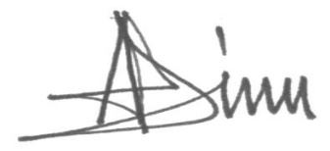

Adriana Dinu
Director, Sustainable Development (Environment) a.i.
Executive Coordinator, Global Environmental Finance
Bureau for Policy and Programme Support
United Nations Development Programme
Date: 3 August 2018 | Tel. and email:adriana.dinu@undp.org  +1 (212) 906 5143
Project Contact Person: Natalia Olofinskaya, Regional Technical Advisor, UNDP IRH
Tel. and Email: nataly.olofinskaya@undp.org; +90 (543) 532-3046

Annex 1. Letters of Endorsement from the national Designated Authorities

  - Albania
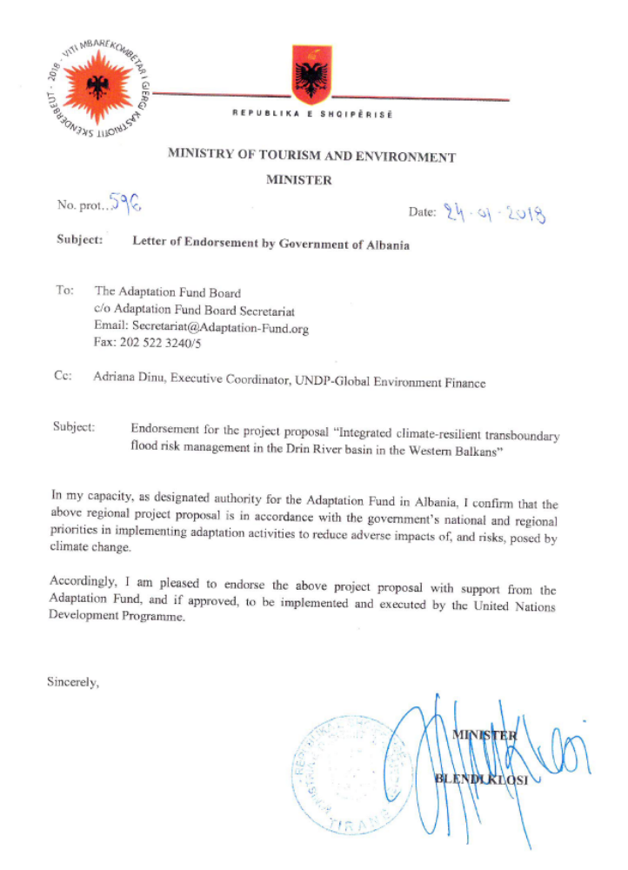
  - FYR of Macedonia
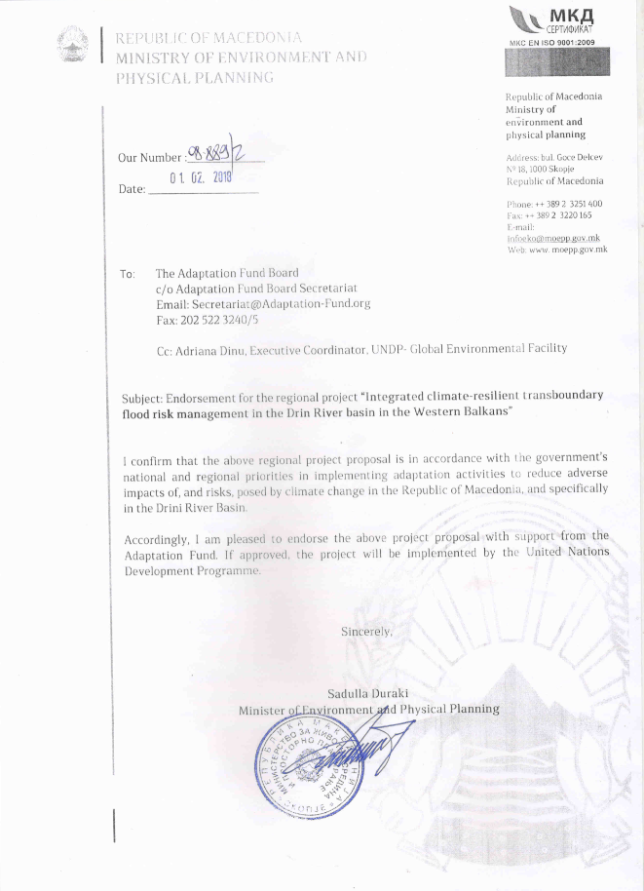
  - Montenegro

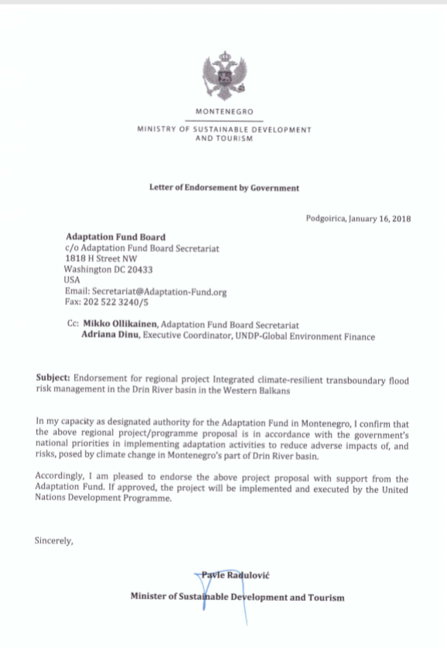

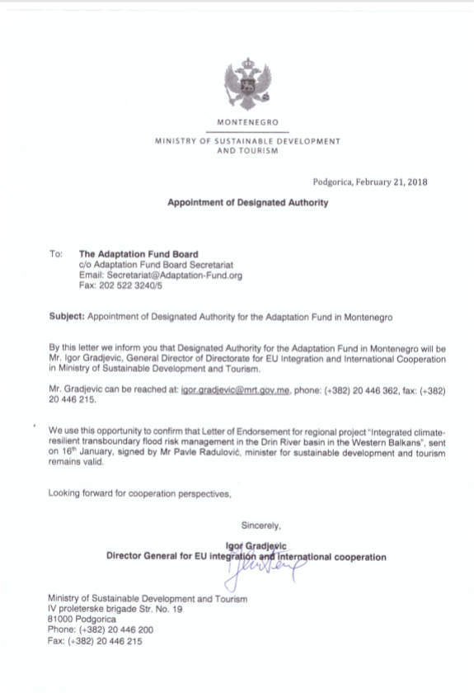
Annex 2.
Socio-economic context

All riparian countries of the Drin River Basin are parliamentary democracies and are developing (upper) middle-income economies which have transitioned from centralized economies to market-based economies.

Albania
Economy: Albania has made economic progress from the poorest nation in Europe in the early 1990s to middle-income status in 2008, due its successful transition from a centrally planned to a market-oriented economy, helped by abundant international aid and other strategic assistance over the past decades. Although Albania's economy has shown steady growth since 2014 (economic growth was 3.8% in 2017), growth has slowed, and the country is still one of the poorest in Europe. A large informal economy and a weak energy and transportation infrastructure remain obstacles. Close trade, remittance, and banking sector ties with Greece and Italy make Albania vulnerable to spillover effects of possible debt crises and weak growth in the euro zone. Remittances, a significant catalyst for economic growth, declined from 12-15% of GDP before the 2008 financial crisis to 5.8% of GDP in 2015, mostly from Albanians residing in Greece and Italy. GDP (PPP) is at 35.87 Billion and GDP per capita is $12,500. Despite tax and judiciary reforms undertaken in 2015/16, to increase tax compliance and bring more businesses into the formal economy, Public Debt in 2017 was 71.3% of GDP, slightly down from 72% in 2016 but still exceeding its former statutory limit of 60% of GDP in 2013, however inward FDI has increased significantly. Unemployment in 2017 was 14% with 14.2% of the population living below the poverty line.

Agriculture and Industry: The agricultural sector, which accounts for more than 40% of employment and 22.6% of consumption, is limited primarily to small family operations and subsistence farming, because of a lack of modern equipment, unclear property rights, and the prevalence of small, inefficient plots of land. Main agricultural production includes wheat, corn, potatoes, vegetables, fruits, olives and olive oil, grapes; meat, dairy products, sheep and goats. Industry accounts for 23.8% of GDP production (a 3.5% growth in 2017), accounts for 11% of employment and comprises: food, footwear, apparel and clothing; lumber, oil, cement, chemicals, mining, basic metals, hydropower. Almost half the population (46.8%) is employed in the Service sector and accounts for 53.7% of GDP.

Energy: Energy from fossil fuel makes up 5.2% of consumption. Hydropower accounts for 94.4 94.8% of total installed energy capacity (2015 est.), making Albania one of the few countries that are almost 100 percent reliant on renewable energy. Other sources of renewable energy are biomass, solar, wind and geothermal potential. Albania’s electricity supply is uneven despite upgraded transmission capacities with neighboring countries. However, the government has recently taken steps to stem non-technical losses and has begun to upgrade the distribution grid. Better enforcement of electricity contracts has improved the financial viability of the sector, decreasing its reliance on budget support.

Montenegro

Economy: Montenegro's economy is transitioning to a market system. Around 90% of Montenegrin state-owned companies have been privatized, including 100% of banking, telecommunications, and oil distribution. Montenegro has a GDP of $10.86 Billion, a growth of 3.5% (2017), and GDP per capita of $17,400 (2017). Unemployment is currently at 17.1%, and 8.6% of the population live below the poverty line. Cheaper borrowing costs have stimulated Montenegro’s growing debt, which currently sits at around 70% of GDP (68.4% of GDP in 2017), with a forecast, absent fiscal consolidation, to increase to 80% by 2019.

Sectors: Industry which comprises steelmaking, aluminum, agricultural processing, consumer goods, tourism, accounts for 21.2% GDP consumption and employs 17.9% of the labor force. Tourism, which accounts for more than 20% of Montenegro’s GDP, brings in three times as many visitors as Montenegro’s total population every year. In addition to tourism, energy and agriculture are considered two distinct pillars of the economy. The government recognizes the need to the business environment and open the economy to foreign investors. Net foreign direct investment in 2017 reached $848 million and investment per capita is one of the highest in Europe, due to a low corporate tax rate. The biggest foreign investors in Montenegro in 2017 were Norway, Russia, Italy, Azerbaijan and Hungary. Services accounts for 70.5% of GDP consumption and employs 76.8% of the labor force while agriculture accounts for 8.3% consumption and employs 5.3% and comprises tobacco, potatoes, citrus fruits, olives and related products, grapes; sheep, wine.

Infrastructure: Montenegro is currently planning major overhauls of its road and rail networks, and possible expansions of its air transportation system.

Energy: Fossil fuel accounts for 24.8% of energy while hydropower accounts for 75.2%. Only 20% of Montenegro’s hydropower potential is utilized. Montenegro plans to become a net energy exporter, and the construction of an underwater cable to Italy, which will be completed by the end of 2018, will help meet its goal.

Former Yugoslav Republic of Macedonia

Economy: Since its independence in 1991, The Former Yugoslav Republic Macedonia has made progress in liberalizing its economy and improving its business environment. Its low tax rates and free economic zones have helped to attract foreign investment, which is still low relative to the rest of Europe. Corruption and weak rule of law remain significant problems. Some businesses complain of opaque regulations and unequal enforcement of the law. GDP is $31.55 Billion, with a growth of 2.5% (2017), and GDP per capita of $15,200 (2017). Unemployment is currently at 23.4.1%, and 21.5% of the population live below the poverty line. Public debt is 47.3% of GDP, relatively low compared to its Western Balkan neighbors and the rest of Europe.

Sectors: Agriculture employs 16.2% of the labor force, Industry 29.2% and Services 54.3%

Energy: The Former Yugoslav Republic Macedonia has a technical hydropower potential of 5,500 GWh, of which only about 1,500 GWh is currently utilised, representing a total installed capacity of 674 MW. Most of its currently operational stations are located in the mountainous north-west, near to the Albanian border. 64.3% electricity in The Former Yugoslav Republic Macedonia is from fossil fuels, 32.8% from hydropower and 2.9% from other renewable.

Annex 3.
Approach to flood hazard, risk and vulnerability modelling

General Approach
The approach to flood hazard assessment, modelling and mapping will be in line with EU floods directive approach. Flood Hazard maps provide spatially distributed information on flood extent, water depths or water levels, and flow velocity or relevant water flow direction and other information. Flood hazard maps will be produced by numerical modelling of the hydrological and hydraulic routing processes of the catchment.

The hydrological and hydraulic models will enable an understanding of flood response of the catchment and sub-catchments, and will inform the design of flood management/defense options and flood forecasting and emergency response systems. The project will develop a modelling tool that may be utilized for present and future flood risk assessment. This will be ensured by:
- Developing the modelling tool in consultation with the relevant government agencies in riparian countries
- Using appropriate methods given existing limitations on data availability and quality, while taking care that methods will allow for future model development should better/more data become available;
- Creating a tool that may be scaled to include other river basins in the future; and
- Including the ability to model flood risk under baseline, as well and climate change, landuse change and other scenarios
Hydrological Modelling
The purpose of the hydrological analysis will be to model the response of the catchment and sub-catchments to rainfall and to derive flood hydrographs of different return periods (magnitudes). The approach will be tailored to the available data following the initial data review in the proposal development stage. The potential impacts of climate change will need to be considered by modelling a range of climate change scenarios. Rainfall-runoff models of all upstream catchments that feed into the basin will be developed to simulate the runoff response (i.e. hydrograph shape) of these catchments. Rainfall-runoff modelling will be based on catchment physical data (topography, land use, soils, geology) and rainfall event characteristics (observed rainfall timeseries data of specific events, and statistical rainfall parameters when modelling design rainfall). Catchment-scale topographic data is needed to provide catchment physical parameters such as area, slope, stream length etc. for input to the rainfall-runoff model. For this purpose, topographic data of relatively coarse resolution (coarse compared to what is needed for floodplain hydraulic modelling) can be used. This is likely to be freely available global datasets. Rainfall-runoff modelling requires long records of historical meteorological (precipitation, temperature etc.), and hydrological (flow and water level) data at the appropriate spatial and temporal scale (preferably sub-daily). For rapidly responding sub-catchments (flash-flood prone), rainfall-runoff modelling requires sub-daily rainfall and flow data (e.g. hourly) for calibration. Sub-daily rainfall data is also required for development of design rainfall parameters. Hydrological model calibration will be approached by adjusting hydrological parameters that control the percentage runoff, time to peak and rate of runoff as well as baseflow and comparing modelled and observed hydrographs.

Design rainfall is rainfall that defines events of given probability or chance of occurrence (for example the 1 in 100year rainfall or rainfall with a 1% chance of occurring). For design rainfall-runoff modelling, historical rainfall data will be analysed statistically to derive the depth-duration-frequency (DDF) curve which will give the rainfall depth for different return period storms of different durations (or existing DDF curves will be reviewed and used if appropriate). Here, sub-daily data is most appropriate as it allows the derivation of storms of all durations. If sub-daily rainfall data is not available for this analysis, a standard distribution can be used to derive the hyetographs for rainfall-runoff modelling. A rainfall-runoff approach (as opposed to only a statistical approach) is proposed for the development of design flood hydrographs, as it will ensure that account can be taken of the influence of floodplain storage within catchments. Also given the influence of groundwater in some sub-catchments, it will be important to ensure that the rainfall-runoff model is a continuous moisture accounting model which effectively represents the continuous baseflow recharge, which could have a significant impact of the size of the flood. Rainfall-runoff modelling is also best suited to investigating climate and land use change impacts, and for exploring factors such as the travel time of flood peaks, which are important for designing flood forecasting and early warning systems, and for informing disaster response planning which rely on accurate estimates of time of arrival of peak flows. Importantly, rainfall-runoff modelling is most appropriate for modelling the influence of the many reservoirs within a catchment. Statistical analysis of hydrometeorological records will also be undertaken. The hydrographs generated by the rainfall-runoff model will be scaled to match flood peaks derived from a statistical analysis of historical gauge data if data of sufficient length and quality is available to develop an appropriate statistical analysis of flood peaks. If gauged data for the study catchment is limited there may be a need to adopt a regional approach by first extending the analysis to include gauges for hydrologically similar catchments outside of the Drin basin. The resulting runoff hydrographs will be used as input to the hydrodynamic model described in the following section.

Well established hydrological models such as Hec-HMS, US SCS, Probability Distributed Moisture (PDM) model will be reviewed and considered at project inception stage. It is envisaged that Hec-HMS will be used for undertaking the hydrological modelling.

Hydrodynamic Modelling
A hydrodynamic model of each floodplain will be developed to route the flood hydrograph through the channel and floodplain of the study basin. To develop such a model, the main data requirement is high resolution topographic data of the channel and floodplain. Channel topography would ideally be provided by undertaking channel cross-sectional surveys. A topographic survey of the river channel will be conducted, to capture the main changes in the longitudinal and cross-sectional river profile along key reaches. Survey density (cross-section spacing) would normally vary depending on whether the area is highly populated or more rural to ensure that the highest risk areas are well covered. Whether an area has historically flooded is also a key factor, as well as future flood risk under climate change. Hence in the unpopulated and low risk parts of the basin, cross-sections survey spacing can be sparse, while in densely populated areas or areas of historical flooding, or likely to flood in the future, it would be desirable to have cross-sections more closely spaced. These guidelines can be tempered by the variability of the channel profile in these areas. It may be necessary to forego cross-section surveys in some areas altogether and extract the data from the floodplain DEM for constructing the model in these areas. Alternatively, if the channel profile is changing very rapidly, closer spacing might be required. In some low-lying areas, where floodplain flow dominates or where the channel bed is exposed during floodplain DEM surveys, cross-section surveys can also be foregone (but not in high risk and heavily populated areas which tends to be on these low-lying floodplains), if DEM data of an appropriate resolution and accuracy is available for floodplain modelling. It should be noted that any cross-section surveys that may be carried out as part of this study will be a ‘snap-shot’ in time of the channel profile. Given the geomorphologically active nature of the river, this survey will become out of date in time and in some cases, it would be important to ensure that a programme of regular channel surveys is implemented particularly at gauging stations, critical infrastructure and along active reaches. Any existing survey or as-built drawings for existing structures, as well as any reports on the original design would be useful to help to characterise structures such as bridges, and other structures across the river, as well as any linear structures such as existing river walls. Typically channel topographic surveys could take months to be completed, particularly for large areas and where seasonal weather conditions might hamper surveys. A detailed scope of the channel surveys will be developed at the start of the project and surveys will be scheduled based on the order in which basins are to be modelled.

Higher resolution DEM data for detailed hydraulic modelling of floodplain flows. The intention is to acquired Light Detection and Ranging (LiDAR) data the floodplains, the cost and feasibility of which will be assessed at concept stage. This high-resolution DEM would provide significantly enhanced accuracy for the hydraulic modelling in comparison other sources. Using all topographic datasets, baseline models of the floodplain of the river basins will be developed, that represents the current catchment conditions, including current operation and maintenance practices for any structures on the main channel and floodplain as well as linear flood defences that influence the movement of water between the channel and floodplain as well as all reservoirs in the basin. The baseline model will be used to assess the existing standard of protection (i.e. the minimum size of the event for which flooding occurs) within the catchment, provide clarity on the current flooding mechanisms, and serve as a baseline against which the economic appraisal of proposed interventions can be made. The baseline model will need to utilize a mixture of 1D and 2D modelling techniques, based on the combined topographical datasets (i.e. floodplain DTM, channel and hydrographic survey data, if available). Appropriate channel, floodplain frictional resistance values can be estimated from photographs, land-use maps and site visits. Key structures of significance to flow conveyance will be identified for inclusion in the model, and data on operational control of dams and other gated structures will be utilized. The hydraulic model will need to be calibrated and verified in tandem with the hydrological model by varying channel and floodplain frictional resistance and structure discharge coefficients values until good agreement is obtained between modelled and observed levels and flows at key gauging locations or observed flood extent maps derived from historical flood surveys and satellite imagery. Calibration to historical events will need to be undertaken in the hydrological model, ensuring that the modelled runoff hydrographs fit the observed as closely as possible. Depending on the availability of data, calibration of the hydraulic model will be done to fit observed flood levels and extents at key locations for which observations are available. This will include anecdotal information from the communities affected by flooding, which will be collected as part of the community surveys. Anecdotal information will also be collected using participatory GIS methods where possible. All data available for calibration will be reviewed and ascertained during the early stage of the project to confirm this approach. The extent of the detail with which the system can be represented will depend on the available data, including data that can be realistically collected during the study period. It is envisaged that the level of detailed representation within the model will vary along the various reaches within the catchments and from sub-catchment to sub-catchment. The hydraulic model will be created to ensure that the urban and important agricultural areas and those identified as significant to the cause and/or effect of flooding, are well represented. Where necessary, less significant reaches and sub-catchments may be modelled using simple routing models which will link into the more detailed hydraulic reaches. Should risks be identified or more detailed information (like channel surveys) become available for the reaches designated as less critical at this time, the model could be easily updated to enable full hydraulic modelling along these reaches. It is important to note that model accuracy will be dependent on the quality of the input data, the extent of detailed topographical representation and the accuracy of modelling assumptions. Three significant sources of error may be the accuracy and spatial resolutions of the topographic data used to build the model, choice of model parameters such as roughness (frictional resistance) and discharge coefficients, particularly for over bank flows. The calibrated and verified hydraulic model will be used to run design events of different annual probability (return period) of occurrence, to produce flood maps.

There is currently a wide array of commercial modelling packages, for example, Info works (1D and 2D by Innovyze, formerly HR Wallingford), MIKE (DHI), HEC-RAS 1D and 2D (USACE), Tuflow, SOBEK 2D and Flo2D packages to name a few. These and other tools typically provide a map-based interface to the underlying models, and survey data, models, time series data and asset information can easily be added as it becomes available. The choice of modelling software will be agreed among the riparian countries and will consider any existing modelling software being used, as well as regional modelling approaches.

Risk and Vulnerability Modelling and Mapping
The approach to risk and vulnerability assessment, modelling and mapping will be in line with EU floods directive approach. Baseline socio-economic assessment and preparation of flood vulnerability map will be based on baseline hazard mapping, combined with infrastructure (bridges, roads and buildings), land use (settlements, agriculture, grazing lands, and conservation areas), property and socio-economics data, to assess the socio-economic impacts of all hazards and produce vulnerability maps for the river basin. This vulnerability map, based on the accurate hazard mapping of the current situation will form the baseline. In order to develop vulnerability maps, a GIS-based risk modelling tool will integrate the various spatial socio-economic data with hazard maps, and produce vulnerability maps which will include economic losses and damages and loss of life estimates. Large hydro meteorological events often result in losses to infrastructure, particularly roads and water supply, losses to agriculture and damage to property, along with concomitant social effects associated with loss of potable water and agricultural productivity. The baseline socio economic appraisal will concentrate on these and other sectors. Agricultural damage per unit of area will be calculated based on land use, typical crop yields and current market values. The loss of dwellings will be valued based on the type of structure. For example, for temporary dwellings the cost of building materials, the number of days labour for rebuilding will be important whereas damage to permanent buildings will be based on an average value, established through local consultation and proportional damage by flood depth to buildings and their contents will be estimated.

The probability of the loss of life and injury will be valued based on the density of population, average hazard severity (e.g. flood depth and velocity). This will then be multiplied by a reference valuation for the statistical economic loss of a life, which will be derived through local consultation, and also included within the economic appraisal. Costs for the rebuild of damaged major infrastructure will be included, as well as the costs for post event aid relief, based on the historic records for previous events. Care will be taken to include but not double count, the gender effects of disasters. It is known that the consequences for the balance between productive and reproductive activities of women is severely altered during and post the hazardous event. This has impacts on the household income and the resilience of the household.

It will be important though challenging, to assess the macro economic effects of hazards on the basin economy and that of each riparian country. All sources of damage and loss will be incorporated through mapping to generate Economic Vulnerability maps. As discussed above, this will involve land use, density of population, agriculture and major infrastructure and buildings. From these maps, the potential damages caused by a range of severity of events can be produced for the baseline condition, by comparison with the maximum hazard extent/severity. This baseline assumes that nothing is done over and above current the ‘business as usual’ approach to prevent the hazard and that any defences likely to fail have failed. From the range of events, a statistical Annual Average Damage and Present Value of Damage will be produced for this baseline. This will be based on an agreed appraisal period, e.g. 50 years, with an approved discount rate. Once this baseline is confirmed, then the hazard mitigation options and their damages avoided can be considered. Although there are many contributing factors to economic loss caused by a hazard or combination of hazards, it will be the aim of the analysis to capture the largest contributors to this loss, which can be most readily valued. This will provide a reliable basis from which to make decisions. The use of appraisal summary tables, which will set out principle receptors impacted by hazards, the scale of the impact and the level of quantification required will ensure that all aspects, both quantifiable and unquantifiable are still considered in the decision-making process. This decision process will be assisted by Multi Criteria Analysis to give comparative weight to all impacts whether measured in monetary terms or not. The results of this assessment will be used in the appraisal of intervention options.

Under the GEF project the basin socio-economic data has been collected and analysed with GIS and this will be an important starting point for the analysis of flood risk and vulnerability. During project proposal develop and project inception phases, any necessary additional data collection will be determined, before developing and implementing the GIS-based flood risk and vulnerability model as described above.

Annex 4
Potential Risk Financing Mechanisms

Risk financing in riparian countries, is mainly from central and local government budgets, which suffer from limited financial resources compared to the annual average damages and losses that can be incurred from flood events and the expected increase in damages and losses under climate change. The lack of financial capacity undermines ability to carry out statutory central and government functions and the ability to enforce regulations against harmful practices and activities, such as development in the floodplain, the uses of flood resilient building codes for houses and other structures, thus increasing exposure and vulnerability of people, structures and economic activity in built areas and agricultural and natural landscapes. There is limited to no involvement of the private sector in climate risk financing in riparian countries, despite the large damages that would be incurred to the private sector from flooding.

A key barrier to the establishment of adequate climate risk financing is the lack of climate risk information to quantity likely damages and losses under current and climate change conditions as well as the ability to undertake the economic analyses to fully understand the investment priorities to address the risks. The project will address this barrier by establishing basin level socio-economic assessment, risk planning and risk financial and investment planning for addressing flood risk. Furthermore, the project will provide the means for identifying the necessary budget requirements for addressing flood risks, and for national and local level private sector engagement in establishing risk financing schemes.

The main risk transfer mechanism that will be considered is flood insurance. In 2008, the World Bank launched the regional lending program to support the establishment of a regional catastrophe reinsurance company with the aim to contribute to the development of a catastrophe insurance market in Southeast Europe and Caucasus that would provide homeowners and small and medium-sized enterprises (SMEs) with the opportunity to purchase affordable catastrophe and weather risk insurance coverage to address the high vulnerability to natural disasters in SE Europe. In 2009, in order to implement the World Bank program of lending and technical assistance for the development of the regional catastrophe insurance market, the countries of the region created Europa Reinsurance Facility Ltd. (Europa Re) - a special catastrophe and weather risk reinsurance company. Albania, the former Yugoslav Republic of Macedonia and Serbia are the major shareholders of the company. The project, through the development and establishment of climate risk information, will assist the Riparians in developing the policy and enabling environments to fully participate in the Europa Re insurance and the local communities that reside in high flood risk areas to benefit from the provided services. The project will also examine whether Payment for Eco-system Services (PES) schemes will be relevant, particularly associated with the agro-forestry and other community-based schemes being implemented.

Annex 5.
Stakeholder Consultations at Concept Development stage

Albania

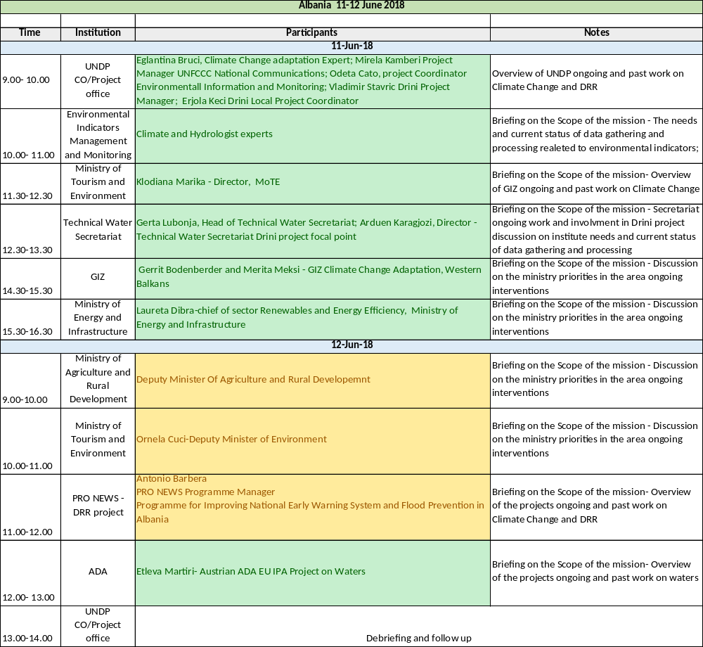

Montenegro

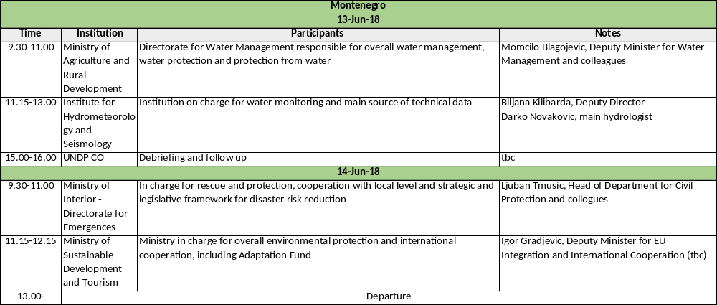

Kosovo

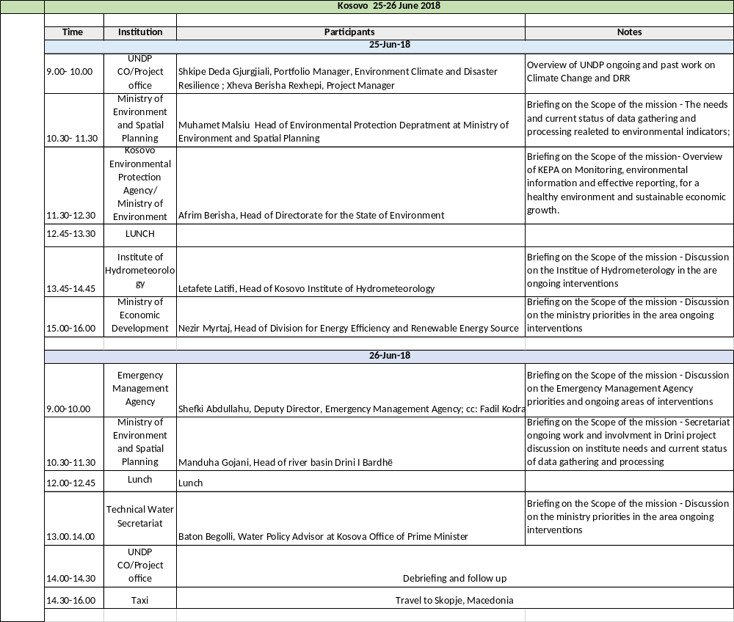

FYR Macedonia
AGENDA
Scoping mission for the regional project
“Integrated climate-resilient transboundary flood risk management in the Drin River basin in the Western Balkans”
Margaretta Ayoung, International Consultant
27/28 June 2018

27 June 2018, Wednesday
09:00 – 09:45 Introductory briefing
Anita Kodzoman, Head of Energy, Environment and Disaster Risk Reduction Unit
Venue: UNDP premises

10:00 – 12:00 Meeting with the Ministry of Environment and Physical Planning (MoEPP)
(Teodora Obradovic Grncarovska, UNFCCC Focal Point, Ljubica Teofilovska, Cabinet of the Minister, Pavlina Zdraveva, Climate Change Project Manager, Dejan Panovski, UNDP GEF Drini River project)
Venue: MoEPP premises

12:00 – 13:00 Launch break

13:30 – 16:00 Meeting with the Cabinet of the Deputy Minister in Charge of Economic Affairs
(Sandra Andovska, Daniel Josifovski, Ana Tunevska)
Venue: Government premises

16:00 – 17:30 Meeting with the Energy, Environment and Disaster Risk reduction team
Venue: UNDP premises, Conference room

28 June 2018, Thursday
09.30 – 11.00 Meeting with the Ministry of Agriculture, Forestry and Water Economy
Lidija Cadikoska, Director of the Water Economy and his team)
Venue: UNDP premises

11:00 – 12:00 Work on consolidation of the MKD input

12:00 – 13:00 Meeting with Ljupka Zajkov, Ministry of Environment and Physical Planning, Water Department

13:00 – 14:00 Launch break

14:30 – 16:30 Meeting with HydroMet Service
Ivica Todorovski, Nina Aleksova, Vasko Stojov
Accompanied by Anita Kodzoman and Pavlina Zdraveva
Venue: HydroMet Service premises

16:30 – 17:15 Debriefing with Louisa Vinton, UNDP Resident Representative
Narine Sahakyan, Deputy Resident Representative
Anita Kodzoman, Head of Unit
Venue: UNDP premises

Thematic areas are: Food security; Disaster risk reduction and early warning systems; Transboundary water management; Innovation in adaptation finance.
References to Kosovo shall be understood to be in the context of Security Council Resolution 1244 (1999)
FLOOD PREVENTION AND MANAGEMENT: Gap analysis and needs assessment in the context of implementing the EU Floods Directive, September 2015, European Commission
http://datazone.birdlife.org/site/factsheet/drini-delta-iba-albania
Limni Mikri Prespa (Greek); Prespa e Vogël (Albanian); Malo Prespansko Ezero (Macedonian).
Also called Great Prespa Lake: Prespansko Ezero (Macedonian); Liqeni i Prespës (Albanian); Megáli Préspa (Greek).
Ohridsko Ezero (Macedonian); Liqeni I Ohrit (Albanian).
With the exception of Greece which is a developed country, but not included in this proposal.
When the Socialist Federal Republic of Yugoslavia dissolved in 1992, Montenegro joined with Serbia, creating the Federal Republic of Yugoslavia and, after 2003, shifted to a looser State Union of Serbia and Montenegro. In June 2006, Montenegro formally restored its independence from Serbia
See Annex 1 for Socio-economic profile of the Riparian countries
Based on the analysis done in “GEF Project “Enabling Transboundary Cooperation and Integrated Water Resources Management in the Extended Drin River Basin - Thematic Report on Socio-Economics of the Extended Drin River Basin” which uses European Environment Agency (EEA), CORINE (Coordination of information on the environment) from 2012.
Trans-Boundary Waters and Integrated Water Resource Management in the Western Balkans Region, 2007
Flood Prevention and Management – Gap analyses and needs assessment in the context of implementing the EU Floods Directive”, September 2015, funded by the Wester Balkans Facillity Infrastructure Project, Technical Assistance 4 (IPF 4)
The Albanian Power Corporation (Albanian: Korporata Elektroenergjitike Shqiptare - KESH) is the largest electricity producing company in Albania. KESH operates the most important electricity generating plants in the country. They include: The Drin River Cascade hydropower plants (Fierza HPP, Komani HPP and Vau i Dejës HPP), with an installed power capacity of 1,350 MW, and the Vlora TPP, with an installed power capacity of 98 MW. The cascade, built on the Drin River, is the largest in the Balkan region by installed capacity, as well as by the size of the hydropower plants.
European Flood Awareness System
European Centre for Medium-range Weather Forecasts
World Meteorological Organisation
More detail is provided here: http://www.bedrin.eu/be-drin-blog/59-floodis-application-in-shkodra-the-be-drin-synergy-with-unesco
Developed in the frame of the project “Climate Change Adaptation in Western Balkans” Implemented by GIZ
Projects for this purpose have already been designed to implement emergency measures including the cleaning of the Bojana River bed and the building of an embankment along the watercourse bed, SNC
“Enabling transboundary cooperation and integrated water resources management in the extended Drin River Basin” approved by the GEF in 2014. The GEF Drin project includes five components: (1) Consolidating a common knowledge base; (2) Building the foundation for multi-country cooperation; (3) Institutional strengthening for Integrated River Basin Management (IRBM); (4) Demonstration of technologies and practices for IWRM and ecosystem management; (5) Stakeholder Involvement, Gender Mainstreaming and Communication Strategies.
https://giz.de/en/worldwide/29000.html
AF-funded, UNDP Implemented project, “Developing climate resilient flood and flash flood management practices to protect vulnerable communities of Georgia”
GEF-funded, UNDP Implemented project, “Technology transfer for climate resilient flood management in Vrbas River Basin” in BiH
River water level and flow stations, meteorological station, associated telecommunications equipment.
Note, the GEF project has designed and will implement a basing Information system which should be appropriate for this purpose
See Annex 3 for Outline of proposed modelling approach
A data repository which will provide a structured environment to enforce data integrity and support data auditing, versioning and data quality. Audit trails, as well as structured and categorised schemas, will make data collation, manipulation and analysis more manageable throughout the project
See Annex 4
By full proposal the project formulation will examine existing activities, particularly being undertaken by GIZ to better understand implemented Drin FFEWS to avoid duplication of effort, and ensure synergy.
https://practicalaction.org/docs/region_nepal/early-warning-saving-lives.pdf
]http://cfapp2.undp.org/gef/documents/1/g3722/g2_16676/Final%20Technical%20Review%20and%20Social%20IMpact%20Assessment%2EGLOF%20FSP%2Epdf).
It should be noted that there is, as yet, no technical specification for the proposed activity so it has not been possible to ascertain whether this activity will meet the flood hazard, risk and vulnerability modelling and mapping being proposed by this AF project. Efforts will be made to clarify this by full proposal.
It has not been possible to review the flood forecasting and early warning system that has been developed for the basin or to ascertain the current status of the system due to a lack of technical documentation of the system. It is hoped that this will be clarified by full proposal
See Annex 5
Technical documentation of the system was requested from GIZ, but these are ‘in preparation’ and were therefore not available
The AF utilized OECD/DAC terminology for its results framework. Project proponents may use different terminology but the overall principle should still apply
^{6.} Each Party shall designate and communicate to the secretariat the authority that will endorse on behalf of the national government the projects and programmes proposed by the implementing entities.
With the exception of Greece which is a developed country, but and not included in this proposal.
CIA World Fact Book https://www.cia.gov/library/publications/the-world-factbook/geos/mk.html

