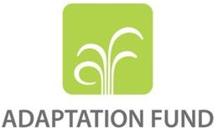

REQUEST FOR PROJECT/PROGRAMME

FUNDING FROM THE ADAPTATION FUND

The annexed form should be completed and transmitted to the Adaptation Fund Board Secretariat by email or fax.

Please type in the responses using the template provided. The instructions attached to the form provide guidance to filling out the template.

Please note that a project/programme must be fully prepared (i.e., fully appraised for feasibility) when the request is submitted. The final project/programme document resulting from the appraisal process should be attached to this request for funding.

Complete documentation should be sent to:

The Adaptation Fund Board Secretariat
1818 H Street NW
MSN P4-400
Washington, D.C., 20433
U.S.A
Fax: +1 (202) 522-3240/5
Email: afbsec@adaptation-fund.org

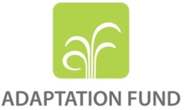
PROJECT/PROGRAMME PROPOSAL TO THE ADAPTATION FUND

PART I: PROJECT/PROGRAMME INFORMATION

Title of Project/Programme: Urban water harvesting and flood management nexus in Nowshera and Rawalpindi
Country: Pakistan
Type of Implementing Entity: Multilateral
Implementing Entity: United Nations Human Settlements Programme
Executing Entities: National level:
- Ministry of Climate Change – through establishment of PMU; NDMA
- Ministry of Water Resources
Local level:
- Concerned provincial and district departments including Provincial and district disaster management authorities
- Municipal Corporation Rawalpindi and Municipal Committee/Tehsil Municipal Administration Nowshera
Community level:
- SheherSaaz NGO
- Concerned Union Councils/administration
- Community based organizations and citizen groups in target communities
Amount of Financing Requested: USD 6,1 million

- Project Background and Context

Approach of the proposal: problem and need

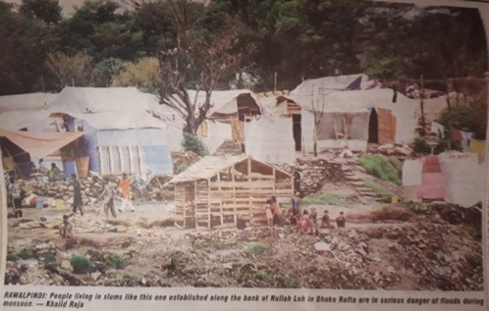
Reducing flood and drought (i.e. water scarcity) issues are evolving as a government top-priority. Therefore, the government of Pakistan (through the AF designated authority) requested UN-Habitat to align project objectives and targets with government priorities, especially those in the new National Water Policy (2018) and National Flood Protection Plan (2016). Even though flood impacts and water scarcity issues are often particularly severe in high density (i.e. urban) areas, a national approach / strategy to address this specifically in urban areas does not exist in Pakistan. Besides that, there is a lack of approaches that deal with flood impacts and related water scarcity issues in a comprehensive manner and water harvesting techniques are often not effective.
Figure 1: News article July 2018. Heading: Rawalpindi: people living in slums like this one established along the banks of Nullah Let in Dhoke Ratta are in serious danger of floods during monsoon

As highlighted in Pakistan’s Intended Nationally Determined Contributions (INDC): ‘There is a huge potential for adaptation in Pakistan, particularly in strengthening and fortifying the flood infrastructure, including water reservoirs and water channels. This would involve enhancing resilience of local communities to the adverse impacts of climate change.’

To enable the Pakistan government to respond to above issues, this project will focus on developing a national urban strategy focused on addressing climate change impacts, especially flood and drought-related, in urban areas, also through spatial planning strategies. At the district, city and community level, a comprehensive approach will be taken to reduce flood risks and water scarcity issues at the same time. Innovative techniques will be used to do this.

Geographic / demographic context

Pakistan has a common border with China, India, Afghanistan and Iran. Pakistan is well known for its geographic as well as climatic variability. A high altitude mountainous region, with several peaks over 8,000 meters, and deserts cover around 14 percent of the country’s total landmass. The coastline in the south stretches about 990 kilometres. The presence of 5,000 glaciers makes it one of the most glacially populated regions in the world outside the polar region.

With the current (2018) population estimated to be around 207 million, Pakistan is the fifth-most-populous country of the world.The population has grown with 80 million people since 2000 and could double again by 2050, putting catastrophic pressure on water, sanitation, health services, etc. Aspirations for social mobility and search for better opportunities have already turned Pakistan into the second-most rapidly urbanizing country of South Asia with city dwellers accounting for 36 percent of the total population. In coming years this trend is set to continue.

Pakistan’s Human Development Index (HDI) value for 2018 is 0.550, which is in the low human development category - positioning the country at 147 out of 188 countries and territories.The Economic Survey 2018 revealed Pakistan’s percentage of people living below the poverty line has fallen to 24.3 percent in 2015-16, with 6.1 percent of the Population living below income poverty line, PPP $1.90 a day (%) and 37.1 of the population Working poor at PPP $3.10 a day (% of total employment).

Figure 2: Incidence of poverty by district Figure 3: Population density
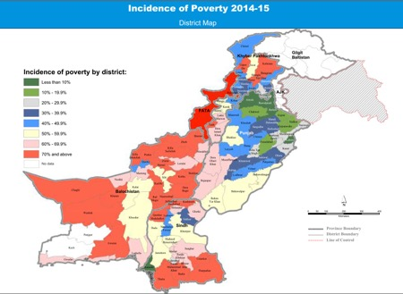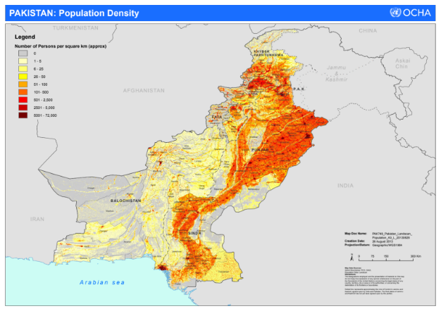
Geographic and demographic context and climate change: In light of the climate change projections, expected impacts and vulnerabilities (as discussed below), the high percentage of poverty combined with the rapid urbanization trend will lead to more people living is urban areas being at risk of climate change impacts. The reason is that most of the ‘newcomers’ are poor and therefore often have no choice but to reside in unplanned, informal and unsafe areas, such as close to rivers, drainage channels and on steep slopes.

Economic context

At an average economic growth rate of 4.9 percent from 1952 to 2015, current (2016) gross domestic product (GDP) of Pakistan stands at nearly US$ 278 billion. This classifies Pakistan as a lower middle-income country. With reference to current economic output categories, 58.8 percent is accounted for by services (mainly energy, gas and petroleum), 20.9 percent by agriculture and 20.3 percent by industry (of which 65.4 percent is contributed by manufacturing, 14.4 percent by mining and 12 percent by construction). Investments in power generation, energy distribution and ‘China-Pakistan Economic Corridor’ (CPEC) are expected to provide significant boost to the economy. Several large-scale infrastructure investments, energy and industrial growth projects currently in the pipeline, are expected to further accelerate the targeted economic growth.

Economic context and climate change: In light of the climate change projections, expected impacts and vulnerabilities (as discussed below), public funds are being drained from essential social requirements towards disaster management. For instance, extreme climate events between 1994 and 2013 have resulted in an average annual economic loss of almost US$ 4 billion.Even though funds are moved to disaster management, the government lacks the financial and technical capacity to protect high density areas and especially informal settlements and rural areas and related services and infrastructure, as shown by the devastating impacts of the floods between 2010-2014, which resulted in monetary losses of over US$ 18 billion.

Social context

Pakistan’s new poverty index reveals that four out of ten Pakistanis live in multidimensional poverty. The average intensity of deprivation, which is 50.9 percent, shows that each poor person, on average, is deprived in almost half the indicators considered for MPI calculation. However, as can be seen in figure 2 there are blatant differences in poverty incidences throughout Pakistan, where the regions like former Federally Administered Tribal Areas (FATA) and provinces of Balochistan and Sindh are especially poor, with the last two areas also known for high population densities along the country’s main rivers (see figure 3). However, even in the relatively richer areas, poverty incidences in informal communities in urban areas are often very high.

The Pakistan Vision 2025, which makes a commitment to make economic growth inclusive and sustainable in order to eliminate poverty, needs measures to achieve its goals, which are also linked to SDGs. To eradicating extreme poverty and hunger, interventions need to focus on the poorest groups; to promote gender equality and empower women, women’s traditional livelihoods and tasks (e.g. collection of drinking water) are threatened by climate change as they depend to a very large extent on climate sensitive resources (e.g. water). Regarding reduced child mortality and improved maternal health, more efforts are desired in service and infrastructure delivery, especially in emerging towns, where rural migrants settle, often informally and without access to basic services; regarding combatting HIV/AIDS, malaria and other diseases, outbreaks of dengue and other diseases in the country threaten progress being made. With 60 percent of the population being younger than 30, development efforts should focus on this group.
Social context and climate change: As mentioned in Pakistan’s INDC: ‘The livelihoods of the poor and the underprivileged segments of society are particularly at risk from the ever increasing exposure to natural calamities, such as flash floods, riverine overflows, heavy monsoons, cyclones, droughts and heat waves.’ Although, according to Vision2025, the government plans to expand and improve basic services and infrastructure in the country, it lacks the financial resources and technical capacity to do this in towns and villages, especially in informal areas and in a climate sensitive way. In particular, the impacts of floods on basic services, including water contamination, need to be addressed in order for poor communities to escape poverty and reduce disease related mortality, malnutrition, stunting and associated health care and productivity loss related costs.

Environmental context

Pakistan is a large, geographically diverse country, with a number of significant ecological features, including extensive mountains, deserts, riverine, wetlands and coastal ecosystems, supporting distinct, diverse biological communities. Its forest cover is very low (only 4 percent). It has a vast glacial area, which covers about 15,000 square km comprising 5,000 glaciers, which are in rapid retreat. The rate of this retreat has gone up by 23 percent in the previous decade. Protecting the country’s environment is necessary because:

- Pakistan loses almost 6 percent of GDP per annum due to environmental degradation;
- More than half of the population depends on the use of natural resources for its livelihood;
- Pakistan is a signatory to several Multilateral Environmental Agreements (MEAs), such as the Montreal Protocol on Substances that Deplete the Ozone Layer; the United Nations Framework Convention on Climate Change; the United Nations Convention on Biological Diversity; United Nations Convention to Combat Desertification; Kyoto Protocol; and the Stockholm Convention on Persistent Organic Pollutants.
Environmental context and climate: deforestation remains a challenge, especially with its rapid urbanization, which increases the demand for wood, and also because of the increased risks of flooding. The same accounts for coastal ecosystems. Climate change will exacerbate this and also other extreme weather risks.

Climate change: observation, projections, impacts and vulnerabilities

Pakistan is among the most severely threatened countries in terms of climate-induced challenges. Individual areas face unique stresses, which can be quite different depending on the geographical location and rate of urbanization of the individual administrative units within Pakistan. This requires a multifaceted approach to climate change at the national level, as well as active engagement with sub-national representatives.

For Pakistan, adaptation to the adverse impacts of climate change is inevitable and likely to become critical in future. Due to geo-physical conditions, climatic extremes and high degrees of exposure and vulnerability, Pakistan has become a disaster-prone country. Frequent exposure to extreme climate-induced events such as droughts, floods, landslides, cyclonic activities, recession of glaciers, glacial lake outburst flooding (GLOF) and heat-waves have led the country to rank amongst top ten most climate-affected countries on the Global Climate Risk Index.
Editorial Daily Dawn (03 Aug 2018)
Observational facts and trends
‘In the last 50 years, the annual mean temperature in Pakistan has increased by roughly 0.5°C. The number of heat wave days per year has increased nearly fivefold in the last 30 years. Annual precipitation has historically shown high variability but has slightly increased in the last 50 years. Sea level along the Karachi coast has risen approximately 10 centimetres in the last century.’

Figure 4: Area weighted mean temperature (1960-2010)
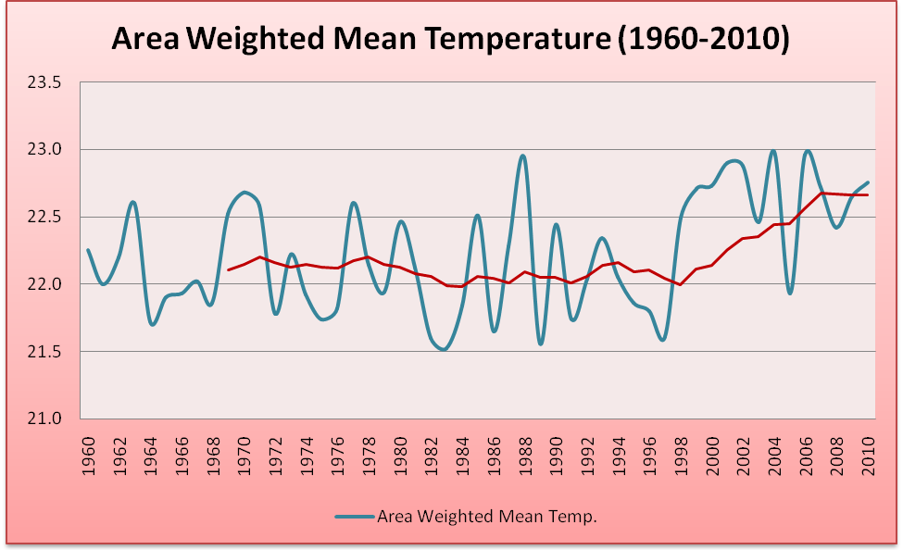

Source: Government of Pakistan (2013, p3) Framework for implementation of climate change policy

Figure 5: All Pakistan rainfall monsoon (1901-2010)
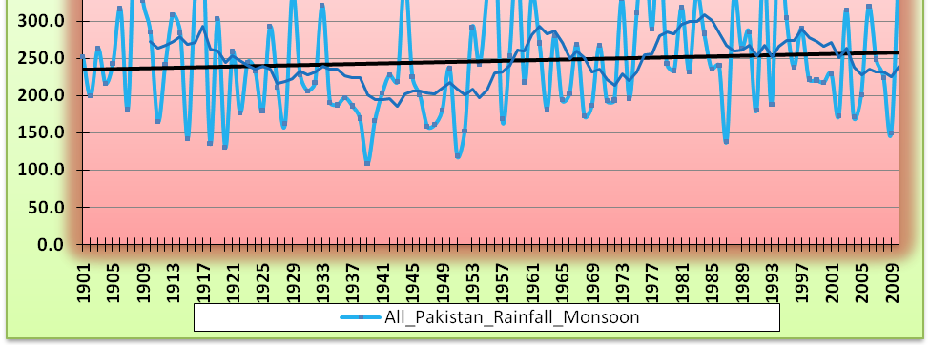

Source: Government of Pakistan (2013, p4) Framework for implementation of climate change policy

Projections
‘By the end of this century, the annual mean temperature in Pakistan is expected to rise by 3°C to 5°C for a central global emissions scenario, while higher global emissions may yield a rise of 4°C to 6°C. Average annual rainfall is not expected to have a significant long-term trend but is expected to exhibit large inter-annual variability. Sea level is expected to rise by a further 60 centimetres by the end of the century and will most likely affect the low-lying coastal areas south of Karachi toward Keti Bander and the Indus River delta.’

Table 1: All Pakistan Climate Projections (2011- 2050)
Pakistan | Precipitation  (mm/Decade) |  |  | Temperature  (°C / Decade)
Pakistan | A2 | A1B | B1 | A2 | A1B | B1
Pakistan | +1.73 | +1.26 | -0.89 | +0.51 | +0.41 | +0.24
Source: IPCC Special Report Emission Scenarios (SRES) and GCISC & PMD and joint report on climate change 2007

Table 2: Regional Climate Projections (2011- 2050)
Region | Precipitation  (mm/Decade) |  |  | Temperature  (°C / Decade)
Region | A2 | A1B | B1 | A2 | A1B | B1
Northern areas | +4.6 | +2.9 | -1.3 | +0.76 | +0.63 | +0.39
Potohar & Upper KPK | +6.1 | +3.8 | -0.5 | +0.01 | -0.34 | -0.01
Central / Southern Punjab & Lower KPK | -2.98 | -1.78 | -3.5 | +0.63 | +0.71 | +0.05
High Balochistan | +1.48 | +0.92 | -0.57 | +0.15 | +0.26 | +0.03
South-Eastern Sindh | +5.1 | +3.0 | -0.1 | 0.00 | -0.1 | +0.01
Sindh & Lower Balochistan | -1.8 | -0.98 | +0.5 | +0.5 | +0.27 | +0.01
Source: IPCC Special Report Emission Scenarios (SRES) and GCISC & PMD and joint report on climate change 2007

It can be seen in the above table that most regions in Pakistan are showing a positive trend in temperature for the period mentioned. Maximum rise is expected in Northern Areas of the country and Central-Southern Punjab and Lower KPK. However, there are mixed trends of increase and decrease of precipitation in different regions.

Impacts
‘Under future climate change scenarios, Pakistan is expected to experience increased variability of river flows due to increased variability of precipitation and the melting of glaciers. Demand for irrigation water may increase due to higher evaporation rates. Yields of wheat and basmati rice are expected to decline and may drive production northward, subject to water availability. Water availability for hydropower generation may decline. Hotter temperatures are likely to increase energy demand due to increased air conditioning requirements. Warmer air and water temperatures may decrease the efficiency of nuclear and thermal power plant generation. Mortality due to extreme heat waves may increase. Urban drainage systems may be further stressed by high rainfall and flash floods. Sea level rise and storm surges may adversely affect coastal infrastructure and livelihoods.’

Table 3: IPCC Projected Climate Change Impacts for Pakistan
Impacts (IPCC Group II Summary for Policy Makers) | Likelihood (based on SRES) Scenarios | Project Sectoral Vulnerabilities to Climate Change in Pakistan
Over most land areas, fewer cold days / nights, warmer and more frequent hot days / nights. | Virtually Certain | Water: Increased water demand due to frequent heat waves; widespread stress on water availability during drought; higher temperature may adversely affect HKH glaciers reserves, which are the main source of water supply in Indus river system (IRS); increased salt water intrusion in Indus delta.  Agriculture: Warmer temperatures in some areas may result in higher yields, but higher evapotranspiration and water deficit may affect crop yield in other areas. Warmer environment would increase the incidence of pest and disease. Increased extreme weather events would cause crop losses and land erosion in floods and reduced crop yields in droughts.  Energy: Increased energy demand because of higher temperatures. Decreased hydropower potential due to reduced water availability in long term.  Human Health: Increased risk of vector-borne disease (e.g. malaria, dengue) and heat related mortality due to warmer temperatures. Increased risk of deaths and injuries from extreme weather events and diarrheal outbreak due to reduced access to clean drinking water.  Ecosystem: Increased risk of extinction of many species due to the synergistic effects of climate change and habitat fragmentation: Increased threat to the stability of wetlands, mangroves and coral reefs.
Warm spells/ heat waves, frequency increase over most areas. | Very likely
Heavy precipitation events, frequency increased over most areas. | Very likely
Areas affected by drought increase. | Likely
Increased incidence of extreme high sea level. | Likely

Specific water availability concerns and vulnerabilities

‘With rapidly growing population, Pakistan is heading towards a situation of water shortage and by corollary, a threat of food insecurity. Per capita surface water availability has declined from 5,260 cubic meters per year in 1951 to around 1,000 cubic meters in 2016. This quantity is likely to further drop to about 860 cubic meters by 2025 marking Pakistan’s’ transition from a “water stressed” to a “water scarce” country (The minimum water requirement to avoid food and health implications of water scarcity is 1,000 cubic meters per capita per year).’
Some specific issues concerning the water sector are:
- The geographic location of Pakistan places the country in the heat surplus zone on Earth, putting it high on the vulnerability scale of climate change with considerable increase in frequency and intensity of extreme weather events and erratic monsoon rains (as demonstrated by the unprecedented floods of 2010);
- Fresh water being a finite resource is progressively becoming scarcer due to persistent increases in its competing demands;
- Water scarcity can adversely affect the health and well-being of the people of Pakistan and must be resolutely addressed especially since it has serious implications for the nation’s food and energy security;
- Different regions in the country are endowed differently with water in terms of precipitation, surface flow and ground water and there is increased stress on the sharing of water resources;
- Bulk of drinking water requirement is met by groundwater which is depleting, and its quality is deteriorating;

Some specific issues concerning flooding:
‘In 2010, Pakistan was hit by one of the worst natural disasters - floodwaters inundated 38,600 km2 area in all four provinces and affected an estimated 20 million people, mostly by destruction of property, infrastructure and lands of livelihood, with a death toll close to 2,000. The resulting damages of about $10 billion were unprecedented in scale and magnitude-they were nearly half the cumulative total damages in the last 60 years.
Figure 6: combined flood and drought hazard risk map Figure 7: rivers of Pakistan
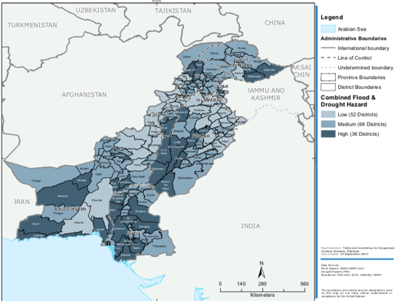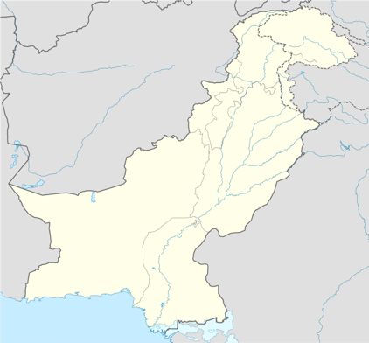
Source: NDMS (2017) Integrated Context Analysis (ICA) on Vulnerability to Food Insecurity and Natural Hazards

The extent of damages is all the more intriguing as total flooded area during was less than the floods of 1956, 1973, 1976 and 1992. The reason is the growth of villages and settlements in the floodplains, almost twofold in 15 year period, along with development of roads and other infrastructure at increased cost, caused the flood damages to rise to this level and brought home the point that in order to reduce flood damages, the activity in the floodplains must be regulated.

Above climate change threats are exacerbated by the rapid expansion of urban areas. In order to meet the growing demands of the urban areas, agriculture patterns will change, deforestation will rise, fuel consumption will go up, and groundwater levels will go down, among many other issues. In turn, due to deforestation, erosion and construction in or close to flood plains and drainage channels, the intensity of floods affecting urban areas will increase even more.

The brunt of droughts and floods mostly falls on the poorest people of the country who reside in smaller and informal settlements where the infrastructure and construction are of poor quality. According to the National Disaster Management Authority (NDMA) and UN-Habitat, it became evident that communities are vulnerable to various hazards due a number of reasons: geographically, areas along riverbanks or drainage channels are at high risk of flooding. Furthermore, mountainous regions, especially areas below the mountain slopes are prone to landslides. The infrastructural quality is weak and shelters in the region are not disaster resilient and hence cannot withstand floods, winds, and landslides, causing massive destruction. This destruction further aggravates the conditions as services are hampered, water, sanitation, and hygiene (WASH) services become ineffective, resulting in spread of diseases and the already affected households do not have the capacity to cope with the massive losses. In areas of drought, longer dry spells make household vulnerable as access to water is minimum, resulting in domestic and agricultural problems.

In order to enable the population of Pakistan to become climate change and disaster resilient and improve their adaptive capacity, especially of those living in urban disaster-prone areas, it is necessary to identify the characteristics of a “climate-fit” community in the context of Pakistan, and how to improve the resilience of the population considered to be “climate-weak”. Geography plays a major role as disaster-prone areas are more challenging and usually have higher endemic disease rates. However, increased population pressures force people to live in more disaster-prone areas such as along riverbanks, drainage channels, low-lying areas and below mountain slopes. The type, weaknesses, and strong points of a community and their service requirements, especially of women, children, elderly and disabled people, are the main elements to develop disaster resilience plans targeted at that specific community.

Table 4: Historical Flood Damages in Pakistan, 1950-2014
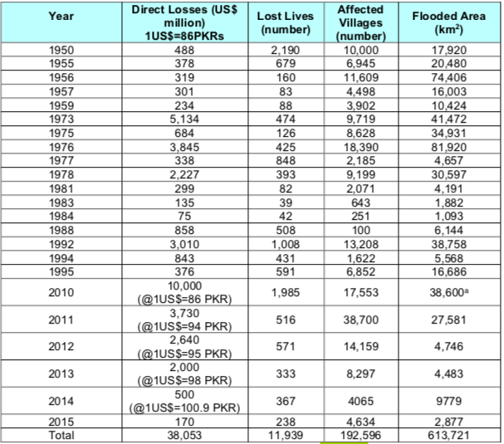Source: 2015-Annual Flood Report of Federal Flood Commission, Islamabad.

Target areas and population

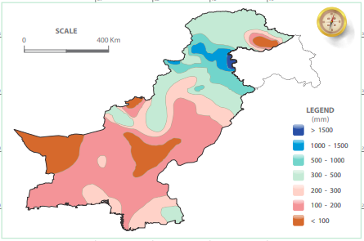
Target communities in Nowshera and Rawalpindi are characterized by a high exposure to floods and droughts / water scarcity (see also annex 3). Climate sensitivity in the city is underpinned by rapid urbanization and population growth, leading to people residing in high-risk flood areas. Underlying vulnerabilities are extreme poverty, informality and limited access to basic services, especially clean water (often due to water contamination caused by floods), gender inequalities and environmental degradation. Moreover, the adaptive capacities at household, community and governance level are barriers for change.

The selection of Nowshera and Rawalpindi cities and target communities is based on a combination of above criteria (especially flood and drought risks), government preferences, geographic locations that allow for upstream, higher elevation (versus flat surface) water harvesting and rooftop water harvesting options.
Figure 8: Rainfall in Pakistan

Rawalpindi city

Flood risks and impacts
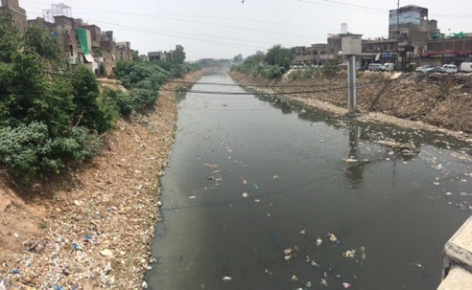
Rawalpindi city is located in the downstream catchment basin of Lai Nallah (with hills and mountains in the north), which used to be a fresh water stream a few decades ago. It is now the main channel carrying the sewage and storm water of Islamabad and Rawalpindi. Lai Nallah is fed by a number of channels that serve as the main sources of drainage for the twin cities.

In Rawalpindi city, the Lai Nallah bisects the city dividing it into areas administered by Rawalpindi Municipal Corporation and those administered by Cantonment Administration. Over the years, in absence of any land use regulations and control, both banks of Lai Nallah have been populated and now some of Rawalpindi mostly densely populated residential and important commercial centres are located here and hence are vulnerable to recurrent flooding in Lai. It is recommended by the national government that a permanent solution of the problem must be evolved as early as possible.
Figure 9: Lai Nallah in Rawalpindi

Rawalpindi’s population density around the Nullah Lai is about 4,200 persons per km2 (2012). Due to land scarcity, people have even constructed their houses in the bed of Nullah Lai. Floods start when water levels of the Nullah Lai exceed 5.5 meters, which is usually during the monsoon season (July to September). The Tehsil Municipal Administration blows a siren in low-lying areas when the water level reaches the alert level of 4.8 meters. Those most affected by flooding in Rawalpindi live in slums and low-lying areas. Annually, some 400,000 people are affected by floods in the city.

Drought and Water Scarcity risks and impacts
Over the years Rawalpindi has turned into a water scarce city. Currently there are three main water supply sources, Rawalpindi city depends upon. These include Rawal Lake located in Islamabad Capital Territory (ICT), Khanpur Dam located in neighboring Khyber Pakhtunkhwa province and more than 200 operative tube wells. The approximate supply of water from these three sources is 43 mgd. In 1990 the total yield from Rawal Lake was around 42 mgd, which is estimated to decline to 30.85 mgd in 2020 largely due to siltation if the water inflow remains the same. This trend translates into more dependence on ground water sources, which are already depleting fast. The excessive exploitation of ground water sources through ever increasing number of tube wells is pressing hard the water table. The unavailability of municipal piped water supply; in numerous new housing schemes and in areas of Rawalpindi, where municipal piped water supply is not sufficient; leaves households with no other option but to make their own arrangement mostly in the shape of installation of domestic pumps for extraction of ground water or to get water from other neighbourhoods. The heavy reliance on ground water resources is causing water table to fall alarmingly. For instance, in 1980 the average water table in Rawalpindi was 40 ft which has gone down since to 150 ft or even more in some cases, making further extraction uneconomical. If the existing trends continue the ground water sources will be depleted further at much faster pace.

Population
As per the preliminary results of National Housing and Population Census 2017, Rawalpindi district has a total population of 5,405,633 distributed in 888,765 households. Of this population 2,875,516 or 53 percent resides in urban settlements of the district. Of the total urban population 2,098,231 is concentrated in Rawalpindi city alone. The annual growth rate is 2.75 percent. The average household size is around 5,8 persons per household. The religious distribution is that 96.8 percent are Muslim, 2.47 percent Christian and 0.73 percent belong to other religious groups. The main industries of the city include oil refineries, gas processing, steel manufacturing, iron mills, railroad yards, textiles, leather goods production, etc. Because of these industries, it is regarded as one of the most polluted cities in the world.

Target communities and population
For the implementation of the AF project, the following communities in Rawalpindi city are proposed to be targeted:

Table 5: target communities in Rawalpindi and estimated population
Union Council (UC) No. | UC Name (area) | Estimated Population as on 31 Dec 2016* | Estimation by UC representative 2018
UC # 1 | Ratta Amral | 29,149
UC # 2 | Dhoke Ratta | 28,883
UC # 4 | Dhoke Mangtal | 33,390 | 43,000
UC # 5 | Dhoke Hassu North | 20,544 | 38,700
UC # 6 | Dhoke Hassu South | 19,980 | 34,000
UC # 12 | Dhok Najju | 28,152 | 40,000
UC # 37 | Dhoke Dalal | 24,310
Total |  | 184,408 | 155,000
*Source: Punjab Development Statistics, 2016; Punjab Planning and Development Department

Community consultations and women focus group discussions took place in the most flood and water scarcity affected communities: UC 4, 5 and 6. Within these communities the most vulnerable and poorer households, and especially women and youth, will be targeted for household-level water harvesting activities.

Overview UC 4, 5 and 6

Poor 60 % (depend upon daily wage labour)
Average Household size: 7
Access to electricity: 100%
Access to clean water: Contamination is a widespread issue.
Types of Water Supply:
- Tap water: 65-70%
- Hand pumps: 2%
- Boreholes: 25%
- Wells: 1-2%
- Water vendors: 5%
Access to sanitation 100% (poor though)
WASH Many areas do not have an underground sewerage system and instead depend upon open sewers in the streets.

Target communities and their populations, of which youth and children are highly represented, are mostly affected by interrelated water scarcity, water borne diseases and floods. Floods can be as high as 4 meters above the ground, affecting houses, but also enter boreholes, wells, hand pump, contaminating groundwater. Women and children are especially hit hard by floods, diseases and water scarcity (see above). Poverty is rampant. Men resort to daily wage labor while women contribute in household incomes by working as domestic servants or undertaking works like sewing/tailoring in their homes. Although flood reduction is a priority need, community members fear that government flood protection measures will lead to the removal of encroachments from Lai Nallah's banks and thus to their displacement. The community has a strong sense of togetherness. Women mentioned that they and their households would be ready to contribute their labor in any community led interventions. Many people know construction skills as men work as masons and construction labor. These skills can be harnessed for community based/community led initiatives involving simple construction skills. Overall, the community has a strong urge to improve their living conditions. This urge can be harnessed to mobilize the community for community-based initiatives.

The project will focus on communities/areas and households that are affected by flood, water scarcity and related diseases, especially those dependent on groundwater / boreholes that are polluted. Women and youth will be promoted as agents of change, while specific needs especially of children, but also other vulnerable groups, will be considered.

Figure 10: Target communities and flood risks in Rawalpindi
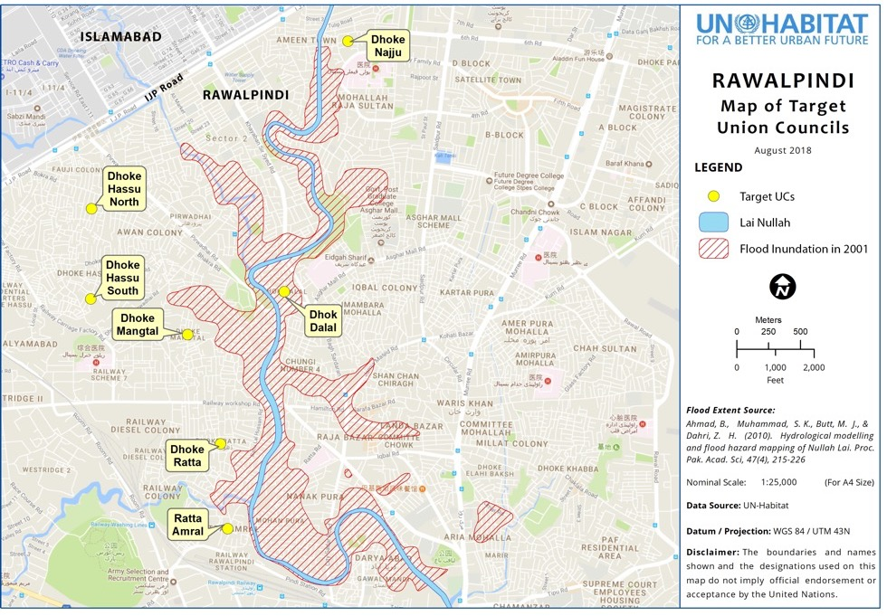

Table 6: target communities and population, main climate change hazards and effects, barriers to adapt and possible resilience building interventions (based on consultations (see Part II.H and annex 1)
Community | Population / beneficiaries  (Disaggregated) | Main climate change hazards and impacts | Effects on community / underlying vulnerabilities | barriers to adapt | Possible resilience building interventions identified (and which may be feasible)
Dhoke Mangtal (UC 4)  Dhoke Hassu North (UC 5)  Dhoke Hassu South (UC 6)  Dehook Najju (UC 12) | 43,000 (2018 estimation)  38,700  34,000  40,000  Total: 155,700  - Female: 47%  - < age14: 37%  - age 15-24: 21%  - age 25-60: 39 %  - > age 60: 3%  - Disabled: 2%  - Some Afghan refugee families | - Water scarcity | - The poor households are most affected as they cannot afford to bear the cost of installing a borehole and neither can pay for availing the facility from private water vendors.  - Getting water for poor households which make up more than half of the community cost them considerable portion of their meager incomes  - Collection of water largely rests with women and children. Sometimes they spend hours in this activity  - Lack of water availability also compromise hygiene needs, which in turn affect health.  - Scarcity of water is also a source of feuds among neighbors.  Gender (women) specific:  - Women have to travel almost two kilometers to bring drinking water from two nearby water sources--private boreholes (in Dhok Najju). | - Dependence on groundwater, which is polluted and for which water tables have dangerously gone down  - For a borehole, households have to dig as deep as 300 feet and even more, which is costly  - Absence of water sector planning at various levels.  - Lack of awareness and technical support  Gender (women) specific:  - Women are not involved in any community-based decision making  - The respondent women had little idea of water harvesting techniques and how they may affect their lives  - Since they are poor they would not be able to invest in rainwater harvesting technology. | - Rainwater harvesting  - Construction of new dams  - Rehabilitation of existing tube wells
 |  | - Water borne diseases | - Contaminated water is a source of number of water borne diseases including diarrhea, gastro and hepatitis to name a few.  - The poor households are among the most affected as they prefer quantity over quality  Gender (women) specific:  - The prevalence of water borne disease and epidemics especially affects younger children. Taking care of them primarily comes to women increasing their burden and affecting their productive time.  Disability among children is especially high. | - People do not have a control on quality of water being supplied through municipal authorities as well as water vendors.  - General lack of awareness and absence of options  - Households who can afford have installed water filters while some also practice boiling of water before consumption for drinking purposes.  Gender (women) specific:  - Women are not involved in any community-based decision making | - Laying of water supply pipes in a manner that they are not close to sewerage system.  - Installation of water filtration plants and their regular maintenance  - Boiling/disinfection of water before consumption.  - Awareness campaigns
 |  | - Flooding from Nallah Lai and other drains | - Absence of land use planning and control has also contributed in localized flooding. The natural drainage channels as well as Lai Nallah have been encroached leading to narrowing of their traditional right of ways.  - In absence of an effective solid waste management system, waste ends up in local drains and Lai Nalla causing high levels of pollution.  - Although floods affect all, they affect most to those households who are located just next to the Lai Nalla and other drains.  - During rainy season the houses located next to Lai Nallah and other drains get affected almost annually.  Gender (women) specific:  - Women being responsible for housekeeping have to put a lot of effort and time in cleaning their houses whenever these are affected by floodwaters.  - The monsoon season brings fear and especially women have to stay extra conscious spending sleepless nights. | - Dense area and little options to move away from risk areas  - Households located next to Nallah Lai and other drains largely keep their ground floors free of furniture and other hard to move objects especially during the flooding season.  - At some places, people have constructed small embankments, walls to remain safe from flooding. However, this strategy rarely helps.  Gender (women) specific:  - Women are not involved in any community-based decision making | - Construction of new dams  - Other proposed interventions are (partly) being done by the government)

Figure 11: drainage channels closed-in by houses and filled with waste in target communities in Rawalpindi – flood levels reach four meters above the channel banks, which is the 2nd floor of houses.
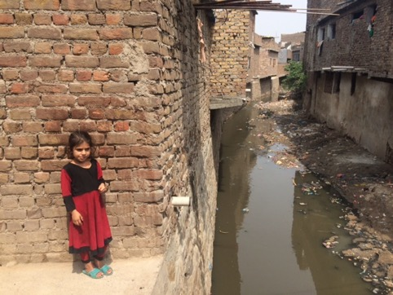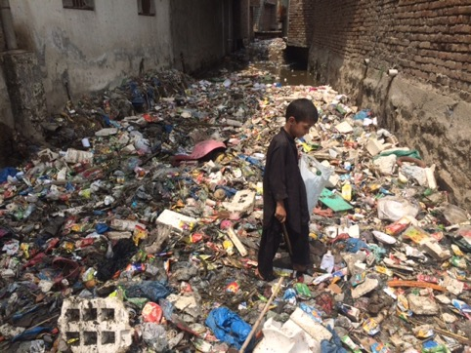
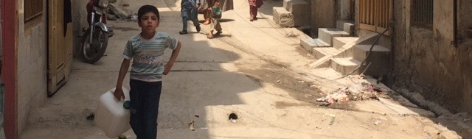
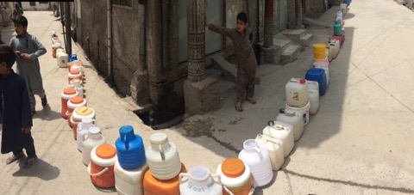
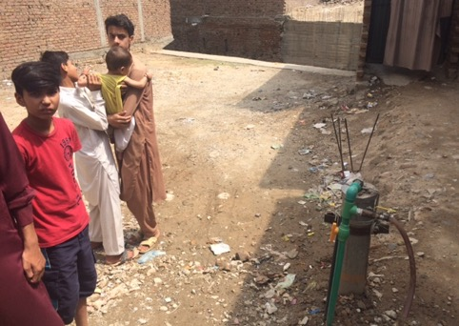
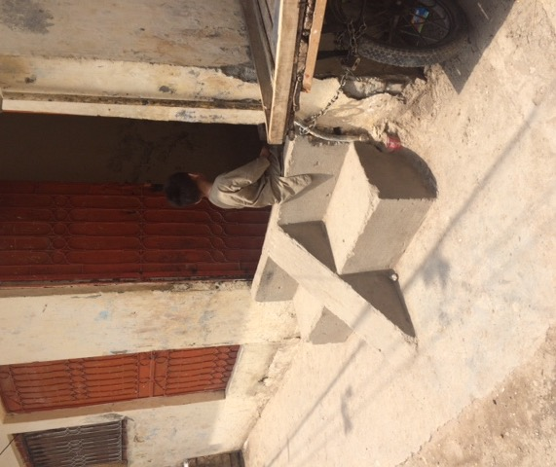
Figure 11: Flood and drought coping mechanisms – ground water gets polluted because boreholes (see pump) gets flooded. Water is collected from other neighbourhoods a few times a day.
Nowshera city
Floods risks and impacts
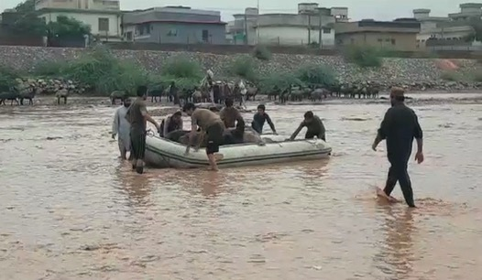
Nowshera city is located along the River Kabul and north of a small mountain range. Within a stretch of about 15 km, between M1 Kabul River Bridge and Nowshera, Kabul River is primarily a confluence area for 7 major river courses, which makes this region very vulnerable to flood hazards. In absence of any formal land use planning effort, the city has expanded uncontrolled. Many residential neighbourhoods, public buildings like schools, hospital and even government offices and commercial areas are located close to the river, so much so that the boundary walls of these structure now act as embankments for the river. There are a number of hill torrents locally called Khawaar, which drain into the River Kabul. Some of these pass through the city. Due to uncontrolled development of the city and its adjoining areas, building structures have been constructed in the ways of these torrents. This situation also results in localized flooding. City’s waste water is directly drained into the river Kabul. Flash flooding is a common phenomenon in district Nowshera; due to the mountainous terrain in the southern parts of district and due to encroachment in the urban centre of Nowshera City, flash flooding is increasing. The urban Centre/ Nowshera City, Nowshera Cantt, Pabbi, Akora Khattak, Jahangira and rural area of Khesgi Payan, Kheshgi Bala, Akbar Pura, Pir Sabak, Nizampur,Kaka Sahab, Cherat, and surrounding areas are all prone to flash floods.
Figure 13: Rescue from floods in Nowshera

Drought and Water Scarcity risks and impacts
While Nowshera generally does not have a scarcity of water, it does widely suffer from contamination of drinking water. The District Disaster Management Plan 2014 notes, “In District Nowshera water samples were collected from different sources such as tube wells, dug wells and hand pumps. Most parameters were found to be much higher than what are considered permissible levels by the WHO. More than 60 percent of the samples were found to be unfit for drinking. The results indicated water quality in Nowshera deteriorated due to the floods in 2010. The areas where water quality issues were severe included parts of Mohib Banda, Dheri Mian Ishaq, Tetaray, Khush Maqam, Jabba, Nowshera Kalan, Azakhel Payan, Bara Banda, Amankot, Hakeem Abad, and Dag Besood.”

Population
According to National Housing and Population Census 2017, Nowshera district has a total population of 1,518,540. The average household size is 7.6 persons. 197,673 people live in Nowshera City. The religious distribution is that Muslims comprise 99 percent; Christian 0.5 percent; Ahmadi 0.3 percent and Hindu 0.1 percent. The main clans are Khattak, Durranis, Kakakhels, Yousafzai, Afridi. Economically speaking, 22 percent of the population relies on agriculture while majority of the people are in other profession or in government service.Nowshera City is further divided into three larger portions: Nowshera Kalan (or area being administered by Nowshera Municipal Committee); Nowshera Cantonment and Risalpur Cantonment. Both cantonments are managed by their respective cantonment boards. Nowshera Kalan, or older part of Nowshera, has a total population of 83,567. This area is targeted for the project.

Overview Nowshera Kalan

Poor 50 % (depend upon daily wage labour)
Average Household size: 6.7
Access to electricity: 100%
Access to clean water: Contamination is a widespread issue.
Types of Water Supply:
- Tap water: 27%
- Hand pump: 22%
- Motor pump: 47%
- Dug well: 2%
- Other: 2%
Access to sanitation 97% (poor though)

Target communities and their populations, of which youth and children are highly represented, are mostly affected by interrelated water scarcity, water borne diseases and floods. Floods mainly come from the river, but also from channels sourced from the mountains, affecting houses, but also enter dug wells, hand pump, and motor pumps, contaminating groundwater. Women and children are especially hit hard by floods, diseases and water scarcity (see above). Poverty is rampant. The male members of households in many households earn their living through menial labor in Nowshera and other places in Pakistan. Nowshera's construction workers are famous for their skills in plastering. The other livelihood sources include government jobs, jobs in small scale industry, shop keeping etc. Very few females are in paid employment. Mostly the educated women work as teachers in government schools.

The project will focus on those communities/areas and households that are affected by flood, water scarcity and related diseases, especially those dependent on groundwater / boreholes that are polluted. Women and youth will be promoted as agents of change, while specific needs of especially children, but also other vulnerable groups, will be considered.

Figure 14: Target communities in Nowshera
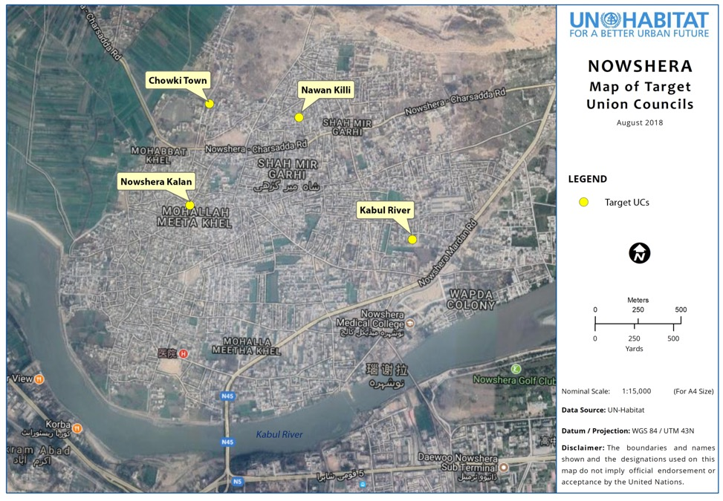

Table 7: target communities and population, main climate change hazards and effects, barriers to adapt and possible resilience building interventions (based on consultations (see Part II.H and annex 1).
Community | Population / beneficiaries  (Disaggregated) | Main climate change hazards and impacts | Effects on community / underlying vulnerabilities | barriers to adapt | Possible resilience building interventions identified (and which may be feasible)
Nowshera Kalan | 83,567  - Female: 48%  - < age14: 38%  - age 15-24: 20%  - age 25-60: 40 %  - > age 60: 2%  - Disabled: 2%  - Nowshera district had once sheltered a very large number of Afghan refugees. (As per UNHCR report March 2018, registered refugees are 36,675 in the district) In recent years it became one of the main areas where IDPs from trouble hit tribal areas and Swat took refuge. However, the exact population of this refugee population in Nowshera Kalan is not known. | 1. Drought / scarcity of clean water | - The available water from municipal supplies stinks and is highly contaminated.  - The ground water up to the depth of 100 ft is not fit for human consumption.  - The poor households not being able to afford water purification/filtration systems are compelled to consume contaminated water | - Citizens consider that supply of water is responsibility of government.  - Especially poor and lower middle income households can’t afford to install boreholes to extract groundwater from safer depths  - Households generally are not aware of household level low cost water treatment technologies as is apparent from lack of availability of these technologies.  - Water harvesting at community and household levels has never been considered as an option. Most of the respondents had not heard of them even. | - City's water distribution system should be overhauled.  - Water filtration plants should be installed in every neighborhood and these plants should be regularly maintained.
Nowshera Kalan |  | 2. River flooding | - Over the years, the haphazard and unplanned growth of the city resulted in encroachment of river banks. Whenever river overflows the surrounding localities are inundated.  - Besides River Kabul a number of natural water channels that drain into River Kabul also pass through the city. During rainy season, these channels also cause flooding inundating neighboring areas.  - Settlements located in close proximity to River Kabul and water channels that drain into the river are among the most vulnerable areas. The poor households that make up the majority of these settlements are little prepared to reduce their vulnerability to recurrent flooding events. | - The communities are not familiar with community-based flood management measures.  - Flood resilient building codes and practices and land use controls are not in place.  - Like River Kabul, the natural water channels that pass through the city have also been encroached. At certain locations, buildings have been erected even in the beds of water channels. When rainwater flows in these channels it causes damage to these structures.  - The city has a poor drainage system  - The river and the water channels have been turned into dumping points for city's solid waste. This situation chokes them and obstructs the free flow of flood waters. | - Construction of retaining walls and embankments.  - Construction of check dams and water storage ponds  - Installation of an effective flood early warning system.
Nowshera Kalan |  | 3. Diseases/epidemics | - There is high prevalence of diseases like dengue, gastro, diarrhea, choler and hepatitis. Local residents attribute them to poor sanitary conditions of the city.  - The disease outbreak intensifies in flooding seasons.  - Kabul River has been turned into a dumping site for solid waste of the city besides its being the disposal point for city’s sewage.  - People of all ages and all sexes are affected. However, it is the poor households and children who are most affected from water borne diseases  - The burden of disease not only causes health problems but also causes economic losses by reducing the productive time available to poor families.  - Poor households have to allocate a considerable portion of their meager incomes on healthcare.  - Incidences of diarrhea are high among the infants and younger children | - The municipal authorities neither have financial resources nor have technical skills at their disposal to address city's chronic water contamination challenge.  - Many households have installed hand pumps as main source of water supply. However, these too do not deliver clean drinking water  - Concerned authorities have so far been unsuccessful in launching effective public health awareness campaigns and preventive measures to control outbreak of dengue, malaria and diarrhea. | - Concerned authorities should design an effective waste management plan for liquid and solid waste to stop the contamination of drinking water from them.

Figure 15: Flood impact in Nowshera. Source: Aug. 3, 2010 (U.N. photo by Amjad Jamal).
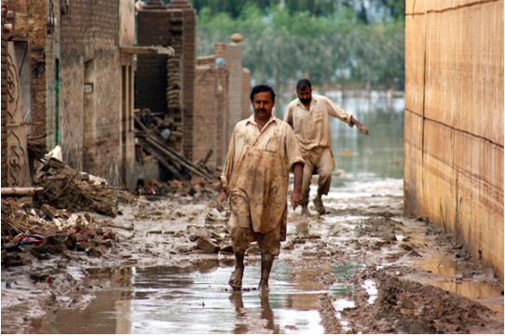
Figure 16: Man drinking water from a hand pump in Nowshera
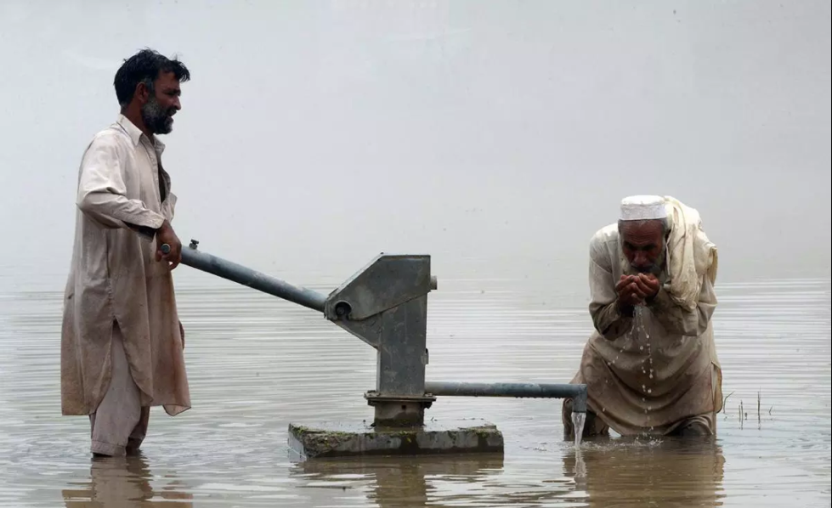
Source:www.bostonglobe.com. A Majeed/AFP/Getty Images

- Project Objectives

The main objective of the proposed project is to enhance community and local and national-level government capacities to address climate change-interrelated urban flood and water scarcity issues. This will be achieved through the following proposed sub-objectives:

Community level:
- Enhance community- and household-level flood resilient water harvesting and purification technology and facilities and strengthen capacities to plan, construct, operate, maintain and duplicate these.

District / City level:
- Enhance city and district-level up-stream water harvesting facilities (that also reduce flood impacts down-stream) and strengthen government capacities to plan, construct, operate, maintain and duplicate these in areas suitable for tackling flood and drought issues at the same time.

National level:
- Strengthen national-level capacity to guide / direct city-level development considering climate change and disaster risks and impacts, especially floods and droughts.

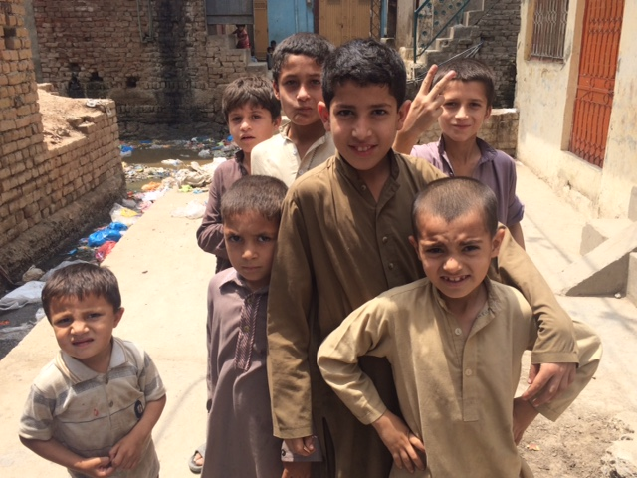

- Project Components and financing

Table 8: project components and financing
Project Components | Expected Concrete Outputs | Expected Concrete Outcomes | Amount (US$)
Component 1  Community level activities:  Enhance community- and household-level flood resilient water harvesting and purification technology and facilities (using innovative techniques) and to strengthen capacities to plan, construct, operate, maintain and duplicate these. | Output 1.1. (concrete)  5000 community / household level flood resilient water harvesting and purification technology and facilities constructed, using innovative techniques | Outcome 1.1.  Increased adaptive capacity within the water sector at community level – 35,000 people benefitting directly from water harvesting facilities and purification technology (7 people per household) and around 200,000 indirectly  In line with AF outcome 4 | 2 million
 | Output 1.2.  8 union council-level community plans developed, community members (especially women and youth) trained and practical guide developed to plan, construct, operate, maintain and duplicate water harvesting facilities and purification techniques in ‘safe’ areas at community level, and to reduce waste through piloting of solid waste resource centres | Outcome 1.2.  Strengthened awareness and ownership of flood and water risks and impacts and how to address these at community level  In line with AF outcome 3 | 800.000
 | Total |  | 2.8 million
Component 2  District / city level activities  Enhance city and district-level up-stream water harvesting facilities (that also reduce flood impacts down-stream) and strengthen capacities to plan, construct, operate, maintain and duplicate these | Output 2.1. (concrete)  40 district / city-level water harvesting facilities (small reservoirs) constructed (or smaller number if bigger reservoirs are possible) | Outcome 2.1.  Increased adaptive capacity within the water sector at district / city level – all inhabitants along downstream drainage channels benefit from the intervention  In line with AF outcome 4 | 1.2 million
 | Output 2.2.  Two city-level spatial planning strategies developed considering climate change risks and impacts, especially floods and droughts, and including comprehensive water harvesting plans and solid waste management plans | Outcome 2.2.  Strengthened urban level government capacity to reduce climate change related flood risks  In line with AF outcome 2 | 200,000
 | Output 2.3.  50 government officials trained and guide developed to plan, construct, operate, maintain and duplicate flood resilient water harvesting facilities and to develop spatial plans |  | 100.000
 | Total |  | 1,5 million
Component 3  National level activities:  Strengthen national-level capacity to guide / direct city-level development considering climate change and disaster risks and impacts, especially floods and droughts. | Output 3.1.  100 government officials (women men) trained to guide / direct urban development considering climate change and disaster risks and impacts, using especially spatial planning tools. | Outcome 3.1.  Strengthened national level government capacity to reduce climate change related risks and impacts in urban areas  In line with AF outcome 2 | 300,000
 | Output 3.2.  One National urban strategy / plan focused on climate change / disaster risk reduction developed  One set of National guidelines for spatial / urban planning considering climate change / disaster risks developed | Outcome 3.2.  Policies and plans improved to respond to urban climate change risks and impacts  In line with AF outcome 7 | 488,801
 | Total |  | 7.88.801
5. Total components |  |  | 5,088,801
6. Project/Programme Execution cost |  |  | 534,101
7. Total Project/Programme Cost |  |  | 5,622,120
8. Project/Programme Cycle Management Fee charged by the Implementing Entity (if applicable) |  |  | 477,880
Amount of Financing Requested |  |  | 6,100,000

Projected Calendar:
Milestones | Expected Dates
Start of Project/Programme Implementation | 06-2019
Project/Programme Closing | 06-2024
Terminal Evaluation | 09-2023

pART ii: Project / programme JUSTIFICATION

- Project components

In order to achieve the overall project objective to “enhance community and local and national-level government capacities to address climate change-interrelated urban flood and water scarcity issues,” the project combines horizontally and vertically interrelated activities: spatial strategies and concrete innovative interventions focused on reducing flood and water scarcity risks and impacts at the city and community level combined with the establishment of a national policy and regulatory framework for adaptation action at the urban level.

A specific approach to respond to the needs of women, children and youth will be taken while also considering the needs of other vulnerable groups. This is achieved through a ‘gender’ baseline and approach which requires a data baseline and the engagement of representatives of these groups in consultations– and where groups are formed and sustained throughout all stages of the project and through which communities participate in project implementation: in planning and executing activities and monitoring. Below, the rationale for the need of the different components is discussed.

Component 1: Community level activities

In line with AF outcomes 3 and 4 and Pakistan’s government priorities (see section D), this component will focus on enhancing community and household-level flood resilient water harvesting and purification technology and facilities (using innovative techniques) and to strengthen capacities to plan, construct, operate, maintain and duplicate these.

This will be done through a detailed community level spatial analysis of flood and drought risks and impacts to inform and develop community level plans, to train community members (especially women and youth) and to develop practical knowledge management products. Water harvesting techniques used will be a combination of traditional techniques improved with (inter) national good practices to ensure water is clean / safe. The focus area will be on poor and informal areas that are dependent on non-piped water sources, such as boreholes, that get contaminated by flood waters and poor drainage and sewerage systems. This will be done through the following outputs:

  - 4500 of community / household level flood resilient water harvesting and purification technology and facilities constructed, using innovative techniques
  - 8 union council-level community plans developed, community members (especially women and youth) trained and practical guide developed to plan, construct, operate, maintain and duplicate water harvesting facilities and purification techniques in ‘safe’ areas at community level, and to reduce waste through piloting of solid waste resource centres (see more info in annex 5)

The proposed activities are required to increase community-level climate change-related awareness of flood and drought impacts and capacity and ownership to develop, operate and maintain interventions in target communities, which is important for the sustainability of the project, as well as the appropriate response to local needs. The proposed concrete interventions (i.e. water harvesting) are also needed to provide ‘prove’ for best practice / replication for effective innovative water harvesting and purification techniques at the community and household level.

Component 2: District / city level activities

In line with AF outcomes 2 and 4 and Pakistan’s government priorities (see section D), this component will focus on enhancing district and city-level up-stream water harvesting facilities (that also reduce flood impacts down-stream) and strengthen capacities to plan, construct, operate, maintain and duplicate these in areas suitable for tackling flood and drought issues at the same time. Moreover, government capacities will be strengthened to avoid people moving into high-risk areas.

This will be done through the development of spatial planning strategies / plans that consider flood and drought risks and impacts, to train district and city level officials in target areas and to develop knowledge management products. Comprehensive rain water harvesting plans will be part of the spatial planning strategies, which will include the following focus / assessments: watershed areas, settlements including mushroom growth of informal settlements and planned sectoral areas, existing and proposed land use, undertaking hydro geological survey, carrying out study of the supply of water to planned and un planned settlements identifying their sources, treatment facility, waste water treatment facility, etc.

Water harvesting techniques used will focus on up-stream water harvesting / flood reduction. International good practices will be used to ensure water can be used as ‘grey’ water. This will be done through the following outputs:

  - 40 district / city-level water harvesting facilities (small reservoirs) constructed (or smaller number if bigger reservoirs are possible)
  - Two city-level spatial planning strategies developed considering climate change risks and impacts, especially floods and droughts, and including comprehensive water harvesting plans and solid waste management plans
  - 50 government officials trained and guide developed to plan, construct, operate, maintain and duplicate flood resilient water harvesting facilities and to develop spatial plan

The proposed activities are required to sustain the interventions at district and city level and to provide ‘proof’ for best practice / replication for effective innovative up-stream water harvesting (and flood reduction) techniques and strategies at the district and city level.

Component 3: National level activities

In line with AF outcomes 2 and 7 and Pakistan’s government priorities (see section D), this component will focus on strengthening national-level capacity to guide / direct city-level development taking into account climate change and disaster risks and impacts, especially floods and droughts.

This will be done by improved policies and regulations that support reducing climate change urban-related flood and drought risks and impacts. This in turn will be done by developing a national urban strategy / policy and national guidelines for spatial planning strategies and building codes that take into account climate change and disaster risks and impacts, especially floods and droughts (but also heat stress and storms). Moreover, recommendations will be made about how to enforce the river act in terms of reducing people moving into high risk areas. This will be done through the following outputs:

  - 100 government officials (women and men) trained to guide / direct urban development considering climate change and disaster risks and impacts, using especially spatial planning tools.
  - One National urban strategy / plan focused on climate change / disaster risk reduction developed
  - One set of National guidelines for spatial / urban planning considering climate change / disaster risks developed

The proposed activities are required to guide local urban development from the national level and to sustain the project at the national level by anchoring best practices, lessons and approaches to national strategies and programmes.

Technical interventions component 1 and 2

Household level water harvesting and purification techniques

Figure 17: possible domestic water harvesting technique with elevated storage tank.

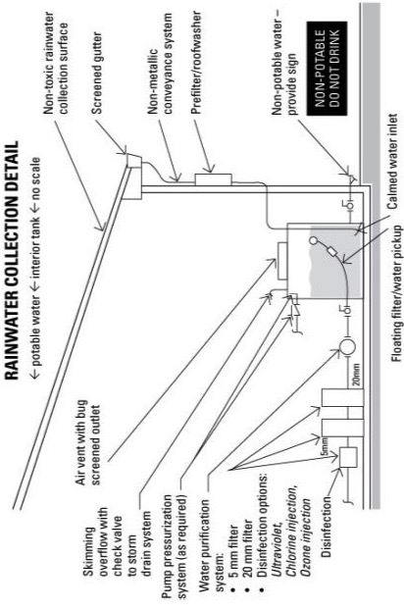
Different International techniques are used to clean the water for drinking purposes, including 1) Boiling, 2) Adding solutions, tablets or crystals, 3) Adding chlorine, 4) Using water filters, 5) Using RO water filtration plants, 6) Iodine treatment, 7) Zonation, 8) Solar Disinfection, 9) Using cloth to filter, 10) Clay vessel filtration, 11) Flocculation, 12) Aeration, 13) Sand pressure filtration, 14) Desalination plants, 15) Sedimentation, 16) Slow sand filters. Internationally, wastewater is also treated to use water for drinking. See annex 4 for more info water harvesting techniques / options on water cleaning techniques.

Based on feasibility (costs, context, etc) and community preferences, appropriate techniques will be selected during the full proposal phase.
District / city-level water harvesting techniques and locations
With respect to the development of new water reservoirs that could serve dual purpose of water storage to address the issue of seasonal flooding as well as to meet cities growing water needs, the following optional locations have been identified at this stage. However, it is pertinent to mention that identification of and development of water reservoirs and their cost estimation require thorough technical and feasibility studies and environmental and social impact assessments, which will be conducted at the full proposal development phase. The Pakistan team will consult the Federal Flood Commission, Punjab Small Dam Organization, Capital Development Authority and municipal institutions of Rawalpindi and Nowshera to further discuss in detail the exact sites and estimated costs for developing small reservoirs that could serve the intended purpose. For the sake of project budgeting, the UN-Habitat Pakistan team found that the average cost given by Punjab Small Dams Organization for a small dam is around USD 30.000. Depending on the feasibility and environmental and social impact assessments, which will be conducted during the full proposal development phase, the dams could be designed larger or smaller.

Potential sites for small dams, reservoirs and lakes for Rawalpindi/Islamabad:
- On Saidpur khas at the foothills of Margallah hills
- On Tenawali Khas at the foothills of Margallah hills
- On Bedarawali khas at the foothills of Margallah hills

These tributaries feed into the main stream of Nullah Lai and also cause localized flooding.

Figure 18: potential sites of small dams around Rawalpindi / Islamabad
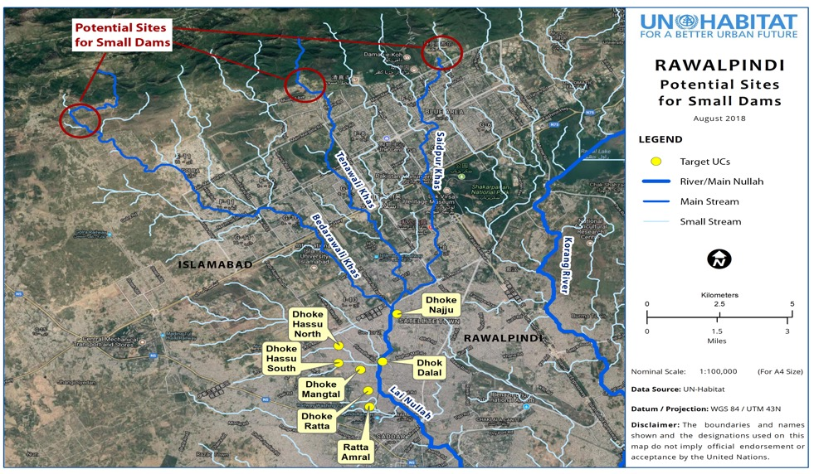
Various streams coming down the Margallah Hills are perennial which supply water continuously throughout the year. During the rainy season, the volume of water increases which flow in to the Korang River and Lai Nallah and finally to Soan River—a minor tributary of River Indus. This water goes unutilized and is wasted ultimately in to the sea. If some suitable types of storage tanks/lakes or dams are constructed over these perennial streams, this could be used for direct water harvesting purposes or for recharging the ground water thus raising the water table down the stream. For security purposes such tanks/lakes can be built inside large units like Naval Headquarters, Pakistan Air force Headquarters, Faisal Mosque, International Islamic University, Marghuzar Zoo, Japanese garden, other public land, etc., wherever feasible. Similarly minor water storage projects could be identified in the PNS Hafeez Naval Hospital, Air University, Bahria University. A few mini dams have also been constructed by local population in surrounding villages which can be used as sample for this project. Examples of such intervention does exist in NUST campus area in Islamabad. They have developed 4 artificial lakes which meet the requirement of campus water by recharging the ground water for the tube well (see section D).

Potential sites for small dams, reservoirs and lakes for Nowshera:

The foothills of the Cherat Mountains over Bachai Khwar,Urmanda Khwar and Nur Gul Baba Khwar and springs along the water courses (Khwar). The options are highlighted below.

Figure 19: potential sites of small dams around Nowshera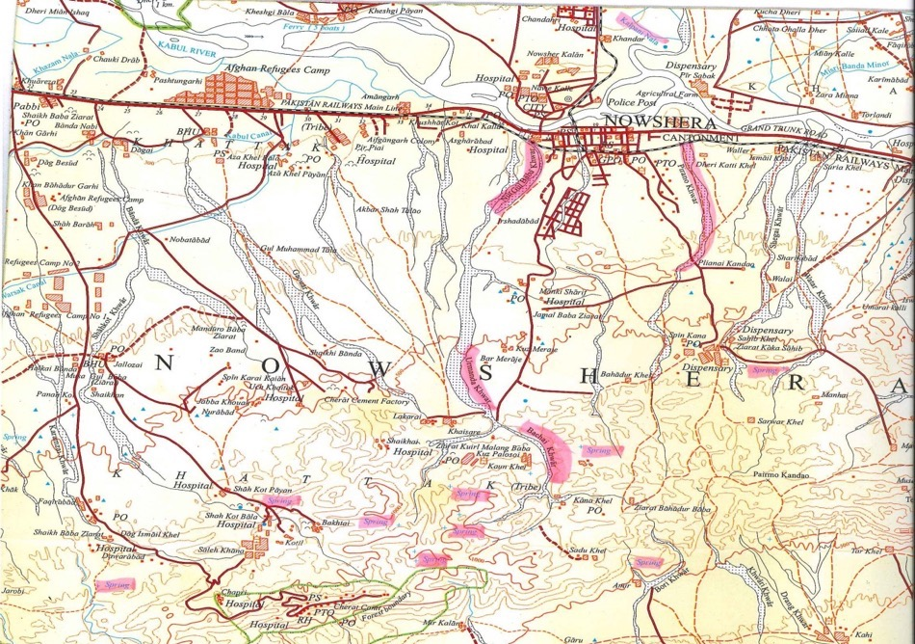

- Economic, social and environmental benefits

The fundamental benefit of the project is to save human lives, protect community assets and increase water security through flood protection and water harvesting measures. Further, the project will produce co-benefits in terms of water-related-livelihood protection and income security, improved quality of human life, community capacity-building and women and youth empowerment, and reduction of environmental degradation, as follows:

Table 9: Expected economic, social and environmental project benefits
Type of benefit | Baseline | With/after project
Economic | Climate change is already leading to economic losses and inefficiency of water collection caused by floods and droughts, which impact households, assets, markets, boreholes, etc. | Component 1:  - Interventions will reduce lloss of assets for the most flood vulnerable communities and groups (poor, informal, women) and in that way reduce negative economic effects  - Interventions will reduce water scarcity vulnerability of communities and groups (poor, informal, women) and in that way reduce time to collect water / enhance economic efficiency  - Interventions will reduce health issues (through clean water) and related reduced productive time available for poor families  - Interventions will reduce high costs for poor families to get water and for medical care  Component 2:  - Strategies will reduce negative flood and drought impacts in target districts and cities, which will reduce negative effects on urban and community economies  Component 3:  - Government budget and resources for disaster relief activities during and after a potential disaster will be reduced and saved
Social | Climate change is already leading to negative social impacts, especially caused by floods and droughts, leading to rural –urban migration and social tension and incoherent development. | Component 1:  - Concrete interventions will contribute to social well-being, especially for vulnerable groups (poor, informal, women, children) – Especially water-related health issues will be reduced  - Plans will be gender sensitive, which means specific needs of vulnerable groups (poor, informal, women) will be included  - Community and household self-help will be improved  Component 2:  - Concrete interventions will contribute to social well-being, especially for vulnerable groups (poor, informal, women, children)  - Spatial plans will be gender sensitive, which means specific needs of vulnerable groups (poor, informal, women) will be included  Component 3:  - National strategies will be gender sensitive, which means specific needs of vulnerable groups (poor, informal, women) will be included
Environmental | Climate change is already leading to negative environmental impacts, especially differences in temperature and precipitation, leading to floods and droughts, which in turn leads to erosion, deforestation, etc. | Component 1:  - Community awareness of flood impacts, also on the environment and the relation between flood and health issues will be improved  Component 2:  - Natural water sources such as streams, underground water tables and ground wells will be better managed to reduce negative environmental impacts  Component 3:  - Natural water sources such as streams, underground water tables and ground wells will be better managed to reduce negative environmental impacts

Approach to ensure equal distribution of benefits to the most vulnerable

In annex 2, a gender approach and baseline is included. This is a ‘work-in-progress’ annex, which means all details will be provided during the full proposal development phase. At this stage a ‘basic’ approach and baseline for women is provided, but more details will be included, including specific approaches for children and youth

- Cost effectiveness

The National Economic & Environmental Development Study (NEEDS) shows that the average cost of adaptation to flood disasters in Pakistan ranges between US$ 2.0 - 3.8 billion per annum, depending on the frequency and intensity. Through spatial planning and protective infrastructure, costs associated with damage and loss, especially caused by floods will be reduced, especially if this spatial model will be replicated in other settlements in Pakistan.

UN-Habitat analysed both individual proposed interventions and the total package of proposed interventions from a cost-perspective point of view (besides other activity selection criteria related to sustainability and potential environmental and social risks) to maximize the beneficiaries reached and impacted. Although larger upstream water harvesting / flood reduction interventions may be more cost-effective than multiple community / household level flood resilient water harvesting facilities, this project proposes to set-up both. The reason is that community / household level flood resilient water harvesting facilities will provide direct benefits to the most vulnerable people in the most vulnerable communities and because it will allow the testing of community / household-level innovative techniques that can be replicated elsewhere.

Cost-effective rationale component 1: setting-up community- and household-level flood resilient water harvesting facilities is a cost-effective way of supplying clean water in areas where drinking water (from boreholes) is contaminated by floods and poor drainage and sewerage systems, which is often in informal areas, especially if innovative techniques will be replicated elsewhere.

Alternative water supply options are boreholes, piped water, etc. As for boreholes, the risk of water contamination still exists. Regarding piped water, this could be designed in a flood resilient manner (e.g. pipes above flood levels), but installation is a challenge in the dense target areas and management would not be done by the direct beneficiaries, which could lead to unforeseen user costs.

Community-level capacity building is proposed to ensure ownership and sustainability of the project and proposed activities, including establishing operation and maintenance arrangements, which in turn will avoid costs when infrastructure is not used and maintained properly.

Alternatively, interventions are planned from state or municipal level, but this would reduce ownership of the project and interventions and thus have negative effect on sustainability and related costs.

Cost-effective rationale component 2: Land use planning strategies are considered to be one of the most cost-effective ways to understand and respond to climate change risks and vulnerability, especially to avoid future development in risk areas (and cost associated with this potential risk, such as destroyed houses and assets. Besides that, proposed larger upstream water harvesting / flood reduction interventions are cost-effective because these will address flood and water scarcity issues at the same time and for a large area.

Alternatively, infrastructure interventions, such as strengthening of drainage channels and construction of resilient assets and houses in areas at risk of floods could be proposed, but this would be costlier in the dense target areas.

From a sustainability point of view, capacity building of government institutions will improve the long-term impact of the project, including associated avoided costs related to floods and drought impacts.

Cost-effective rationale component 3:
Similar to land use planning strategies, at the district/city level, the development of National strategies to reduce flood and drought impacts, especially when considered comprehensively, in urban areas, can be considered to be a cost-effective way to avoid flood and drought-related costs throughout the country – it will allow government institutions to make strategic choices, also from a cost-effective point of view.

Table 10: Cost-benefit analysis of proposed interventions
Interventions / activities |  | Target  Community | Estimated nr of beneficiaries | Estimated cost  (US$) and cost-effectiveness of direct beneficiaries
Priority investments | Detailed activities | Target  Community | Estimated nr of beneficiaries
Component 1  Community level activities: | Output 1.1. (concrete)  4500 of community / household level flood resilient water harvesting and purification technology and facilities constructed, using innovative techniques | Rawalpindi: especially UC 4,5 and 6, but also 1,2, 12 and 37  Nowshera Kalan (including UCs namely Nowshera City, Kabul River, Chowki Town and Nawan Kallaey) | Direct: 35000  Indirect: around 200.000 | USD 57 pp
Component 1  Community level activities: | Output 1.2.  8 union council-level community plans developed, community members (especially women and youth) trained and practical guide developed to plan, construct, operate, maintain and duplicate water harvesting facilities and purification techniques in ‘safe’ areas at community level, and to reduce waste through piloting of solid waste resource centres | Rawalpindi: especially 4,5 and 6, but also 1,2, 12 and 37  Nowshera Kalan (including UCs namely Nowshera City, Kabul River, Chowki Town and Nawan Kallaey) | 200.000 | USD 4 pp
Component 2  District / city level activities | Output 2.1. (concrete)  40 district / city-level water harvesting facilities (small dams) constructed (or smaller number if bigger dams are possible) | Rawalpindi: especially UC 1,2, 4,5, 6, 12 and 37 + whole of Rawalpindi  Nowshera Kalan + other parts of Nowshera District | Direct: 200.000 (for floods)  Estimations for water use to be made | USD 6 pp
Component 2  District / city level activities | Output 2.2.  Two city-level spatial planning strategies developed considering climate change risks and impacts, especially floods and droughts, and including comprehensive water harvesting plans and solid waste management plans | Rawalpindi City  Nowshera City | 2 million  200.000 | USD 0,00009 pp
Component 2  District / city level activities | Output 2.3.  50 government officials trained and guidelines developed to plan, construct, operate, maintain and duplicate flood resilient water harvesting facilities and to develop spatial plans | Rawalpindi City  Nowshera City | Direct: 50 | USD 400 pp for training only
Component 3  National level activities: | Output 3.1.  100 government officials (women men) trained to guide / direct urban development considering climate change and disaster risks and impacts, using especially spatial planning tools. | Concerned federal and provincial government officials | Direct: 100 | USD 400 pp for training only
Component 3  National level activities: | Output 3.2.  One National urban strategy / plan focused on climate change / disaster risk reduction developed  One set of National guidelines for spatial / urban planning considering climate change / disaster risks developed | Federal and Provincial Governments | Not relevant | Not relevant

Altogether, the project will be cost-effective by:

- Avoiding future costs associated with damage and loss due to climate change impacts (especially floods and drought) and to ensure the interventions are sustainable;
- Efficient project operations because of ‘in-house’ technical support options and capacity building expertise and because of direct partnering with government institutions and university (thereby building their capacity as well as reducing costs);
- Community involvement through community capacity building
- Selected technical options based on cost-, feasibility and resilience/sustainability criteria

- Consistency with national or sub-national strategies

With its highly sensitive ecosystems and recent history of frequent natural disasters, Pakistan has placed great emphasis on climate change policy, planning and implementation. Pakistan’s response has been closely aligned with its strategies for sustainable development, environmental protection, achieving the sustainable development goals (SDGs) (to which Pakistan’s “Vision 2025” is linked) and objectives of the Convention on Climate Change. Adoption of the National Climate Change Policy (2012) and National Disaster Risk Reduction Policy (2013) provided a comprehensive framework for policy goals and actions towards mainstreaming climate change, especially in economically and socially vulnerable sectors of the economy. A follow-up to these policies was the launch in 2013 with the Framework for Implementation of the Climate Change Policy (2014-2030), which outlines the vulnerabilities of various sectors to climate change and identifies appropriate adaptation and mitigation actions. The Framework document was developed to serve as a catalyst for mainstreaming climate change concerns into decision-making at national and sub-national levels and to create an enabling environment for an integrated climate-compatible development process. International communication to the UNFCCC followed with the Nationally Determined Contribution in 2016. Most recently, the National Flood Protection Plan (2016) and National Water Policy have been launched (2018), which propose actions for (climate change related) flood management and recognize water scarcity as an emerging (climate change related) priority.

This project has been designed to align with above national, sub-national and sectoral development policies, strategies and plans on development, climate change and disaster resilience. To respond to the most current government priorities, this proposed project is especially aligned with the National Flood Protection Plan and National Water Policy.

Table 11: summary of the main climate change related policies and national and sectoral policy priorities that align with this project
Policy/Document | Year submitted/ratified | Policy priorities that align with this project
Climate change priorities
Pakistan NEEDS study | 2011 | Adaptation assessment:  Water resources (flooding and water demand):  - Flood plain management along the flood corridor to ensure minimum damage to human lives and infrastructure during floods.  - Climate proofing of future infrastructure investments to cater to the threats of climate induced disasters such as floods.
National Climate Change Policy | 2012 | The National Climate Change Policy states a number of priority areas:  - Water resources  - Agriculture and livestock  - Human health  - Forestry  - Biodiversity  - Disaster preparedness  - Socioeconomic issues (poverty, gender)
Framework for implementation of the climate change policy (2014-2030) | 2013 | Relevant sectors, objectives and strategies:  Water sector:  Objective 1: Conserve water  Strategy 1.2. Local rainwater harvesting measures  Objective 3: Integrated water resource management  Objective 6: Develop resilient water infrastructure  Strategy 6.1. Water storage capacity  Strategy 6.2. Irrigation infrastructure  Disaster preparedness sector:  Objective 3: Develop integrated hazard mitigation strategies  Objective 4: assess future likely flood levels in Indus river system  Objective 5: natural disaster information and early warning  Objective 6: develop resilient infrastructure  Health sector:  Strategy 1.4. Clean drinking water  Urban planning sector:  Objective 1: Introduce innovative town planning  Strategy 1.4. Hazard mapping and zoning
Nationally Determined Contribution | 2016 | The NDC focuses primarily on mitigation issues, but outlines a number of relevant adaptation priorities:  Short term  Strengthen adaptation planning capacity  Strengthen disaster risk management capacity  Medium term  Improving irrigation  Water resource management  Climate resilient infrastructure
National development priorities
National Sustainable Development Strategy: Pakistan’s pathway to a sustainable & resilient future. | 2012 | NSDSS has primary focus on promoting 'green economy' and outlines environment sustainability as a key pillar. Under that it focuses on:  - Preparing for climate change and its accompanying uncertainties through comprehensive adaptation and mitigation planning and concrete implementation measures  - Improve environmental governance at all levels and enhance community-level environmental management by strengthening the capacity of union councils, tehsil municipal administration and district governments (local level).  - Undertake strategic adaptation responses at the policy, management / operational and community levels with a focus on facilitating bottoms up adaptation with maximum localized ownership. The inevitable climate adaptation response should be driven by a focused adaptation program and plan.
Pakistan 2025 | 2014 | Blueprint for growth (recognizes global warming and climate change as  one of the priority areas): In the physical domain, the major threat is  posed by climate change, associated with increased frequency and  intensity of floods and hurricanes, prolonged droughts and growing  water stress shift of disease vectors, and the frightening possibility of  the melting of the Himalayan icecap (page 16).
Sectoral priorities
National Environmental Policy | 2005 | It provides an overarching framework for addressing the environmental issues facing- Pakistan, particularly pollution of fresh water bodies and coastal waters, air pollution, lack of proper waste management, deforestation, loss of biodiversity, desertification, natural disasters and climate change
National Disaster Risk Reduction Policy | 2013 | Relevant Policy objectives:  2.4.1. Creating an integrated national capacity to identify and monitor vulnerability and hazard trends including potential climate change impact  2.4.3. Strengthening an integrated disaster preparedness and response capacity from the local to the national level  2.4.4. Promoting development planning that considers and addresses disaster risks alongside environmental and climate change concerns  2.4.5. Strengthening the structural and non-structural resilience of key infrastructure and lifelines in Pakistan  2.4.6. Strengthening capacity at national and provincial levels to facilitate and provide support to the implementation of DRR policies, plans and programs across sectors and in high-risk areas  2.4.7. Strengthening Local Level Risk Reduction capacity focusing upon communities, and supportive linkages with Union Councils, tehsils and districts  2.4.8. Ensuring DRR is systematically integrated into recovery and reconstruction programming, “building better, safer and stronger” and informing DRR mainstreaming in general
National flood protection plan | 2016 | Relevant planning strategy  The plan recognised the National Water Policy as an important strategy to be implemented in parallel:  The planning strategy has thus following relevant elements:  - Reducing flood:  - Dams and reservoirs  - High flow diversions  - Channel improvement  - Reducing susceptibility to damage:  - Flood Forecasting and Early Warning  - Construction of flood protection and river training works i.e. levees, dikes, spurs etc.
National water policy | 2018 | Most relevant policy objectives:  2.2. Augmentation of the available water resources of the country through judicious and equitable utilization via reservoirs, conservation and efficient use;  2.3. Improving availability, reliability and quality of fresh water resources to meet critical municipal, agricultural, energy, security and environmental needs;  2.4. Improving urban water management by increasing system efficiency and reducing non-revenue water through adequate investments to address drinking water demand, sewage disposal, handling of wastewater and industrial effluents;  2.7. Providing food security and expanding water availability to help adapt to climate change, population and other large-scale stresses;  2.12. Flood management to mitigate floods and minimize their damages;  2.13. Drought management with emphasis on long term vulnerability reduction;  2.15. Promoting appropriate technologies for rain water harvesting in rural as well as urban areas;  2.16. Regulating groundwater withdrawals for curbing over-abstraction and promoting aquifer recharge;  2.21. Profitable use of flood water towards promotion of local irrigation practices;  2.27. Climate change impact assessment and adaptation for sustainable water resources development and management;  Most relevant priorities:  - Storage: The most important instrument of mitigation against the impact of climate change on water resources is storage. If the pattern of rainfall becomes erratic with more than average rain in one year and a drastic reduction in the next years’ rainfall, the only to conserve the surplus rainwater in wet years is to store it and release it in dry years, when required. For storage and new irrigation projects a national master plan must be developed which must cater for storage, floods, arid areas, irrigation, urban water and tariff rationalization.  - Leveraging Technology: Adoption of new technologies is urgently needed  Relevant water conservation needs:  - It is recognized that the large annual and seasonal variability of fresh-water availability makes it necessary to:  - Build small and medium dams for local and regional use;  - Build check dams and delay action dams for recharge of aquifers and to reduce the flow velocities and erosion;  - Recharge the underground aquifers during floods and surplus water flow periods for later use.  - Provide subsurface dams, wherever feasible.  7.4. The Water Conservation Plans shall include:  - Adoption of rainwater harvesting technology.  - Adoption of water conservation techniques/technologies at the farm level.
National Sanitation Policy | 2006 | - The sanitation policy covers solid waste management, to which this project will align
Sub-national priorities
Rawalpindi and Nowshera Development and Strategic Plan |  | The project is in line and will ensure consistency with:  - Annual plans  - Structure plan  - Local plans  - Sectoral plans
The flood management plan of Rawalpindi  And  Rawalpindi district disaster risk reduction plan | 2009 | The following areas are identified as being most vulnerable to floods:  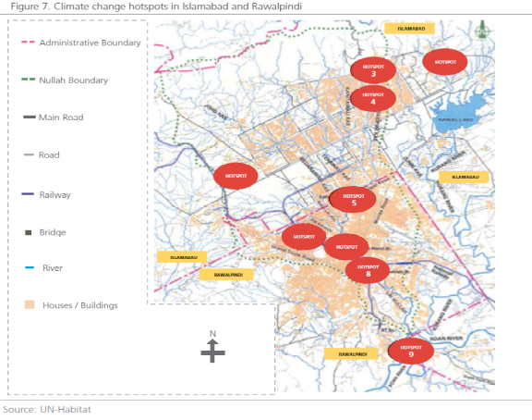  - Dhoke Najju  - Zia ul Haq Colony  - New Phagwari  - Mohallah Raja Sultan  - Dhoke Ratta  - Ratta Amral  - Gawalmandi  - Javed Colony  - Chamanzar  - Tipu Road  - Dhoke Ellahi Bakhash  All these localities are located along Lai Nallah.
Nowshera district disaster risk reduction plan | 2014 | Priority Areas:  - Established the institutional and legal system for disaster management  - Prepare disaster management plans at various levels  - Conduct multi-hazard, vulnerability and risk assessment  - Establish multi-hazard early warning and evacuation systems  - Promotion of Training, Education and Awareness in relation to DM  - Strengthen programs on disaster risk reduction at local level  - Infrastructure development for disaster risk reduction  - Mainstreaming disaster risk reduction into development  - Establish District Emergency response System  - Capacity Development for Post Disaster Recovery

- Compliance with relevant national technical standards

Environmental and social impacts assessment requirements and procedures
Promulgation of an Ordinance in 1983 followed by the Pakistan Environmental Protection Act, 1977, made EIA a legal requirement. For enabling the project proponents in designing EIAs, the Pakistan Environment Protection Agency (Pak-EPA) first developed an elaborate form, and later completed guidelines and regulations. Presently, EIAs are conducted for all large developmental projects. Devolution of environmental matters to the provinces has caused uncertainty about the Environmental Act and the role of Pak-EPA.

Projects Requiring an EIA (Screening)
Section 12 of the Federal and Punjab Acts require filing of an EIA for projects that are likely to cause adverse environmental effects. The term “adverse environmental effect” means impairment of, or damage to, the environment and includes: (a) impairment of, or damage to, human health and safety or to biodiversity or property; (b) pollution; and (c) any adverse environmental effect as may be specified in the regulations (§ 2 (i)). Primarily, the statutes require Rules/Regulations to provide for lists of projects requiring an IEE/EIA. As per the requirement of the Statutes, the Regulations 2000 (Regulation 3 and 4, Schedule I and II) list categories of projects requiring either IEE or EIA. For an overview see annex 5.
Under this regulation, proposed activities under output 2.1. require an IEE- Regulation 3:
- Water management, dams, irrigation and flood protection
- Dams and reservoirs with storage volume less than 50 million cubic meters of surface area less than 8 square kilometres
- Irrigation and drainage projects serving less than 15,000 hectares.
- Small-scale irrigation systems with total cost less than Rs.50 million.

The IEE will be prepared during the full proposal development phase following Federal government and sectoral guidelines and following steps / processes as described in the 2014 Government of Pakistan and International Union for Conservation of Nature and Natural Resources. Environmental Impact Assessment Handbook for Pakistan.However, it will also assess potential risks and impacts in line with the AF ESP and GP considering the 15 AF principles. This will be not only done comprehensively for output 2.1., but also for all other activities.

Table 12: overview of relevant national technical standards and how the project complies to these
Expected concrete output/intervention | Relevant rules, regulations, standards and procedures | Compliance, procedure and authorizing offices
Output 1.1. (concrete)  5000 community / household level flood resilient water harvesting and purification technology and facilities constructed, using innovative techniques | - Minimum drinking water quality standards proposed by WHO  - Applicable national and provincial drinking water quality standards  - Building byelaws applicable in Rawalpindi and Nowshera  - Applicable standards and guidelines by Rawalpindi Water and Sanitation Agency (RWASA) and Tehsil Municipal Administration Nowshera  - Guidelines as enshrined in National Drinking Water Policy | The project team will ensure due consultation with MoCC, Provincial Environmental Protection Agencies (EPAs) of Punjab and Khyber Pakhtunkhwa, Rawalpindi Water and Sanitation Agency (RWASA) and Tehsil Municipal Administration of Nowshera besides involving respective communities to select appropriate household level water harvesting technologies.  In the due course, input will also be taken from National Disaster Management Authority and respective provincial and district disaster management authorities to incorporate resilience to disasters and climate change elements in this intervention. The community level interventions will be steered by Shehersaaz by taking along respective Union Councils and community based organizations.
Output 1.2.  8 union council-level community plans developed, community members (especially women and youth) trained and practical guide developed to plan, construct, operate, maintain and duplicate water harvesting facilities and purification techniques in ‘safe’ areas at community level, and to reduce waste through piloting of solid waste resource centres | - Punjab Local Government Act and Khyber Pakhtunkhwa Local Government Act call for preparation of Union Council Level development plans. The prescribed requirements for preparation of these plans will be followed.  - NDMA’s guidelines for working with vulnerable communities and groups.  - Planning guidelines from Punjab and Khyber Pakhutunkhwa Planning and Development Departments  - Applicable national and provincial laws  - Annual Development Plans of Rawalpindi Water and Sanitation Agency, Rawalpindi Municipal Corporation, Nowshera Tehsil Municipal Administration | Integrated union council level plans will be developed with active participatioin of elected representative of concerned union councils and their administration; officials and elected representatives of Nowshera and Rawalpindi’s municipal corporations; target households and their community based organizations. This process will be steered by Shehersaaz with input from Project Steering Committee. All efforts will be made to keep these UC level plans aligned with Annual Development Plans of Rawalpindi WASA, Rawalpindi Muncipal Corporation, and Nowshera Tehsil Municipal Administration.  National Disaster Management Authority’s Children and Gender Cells guidelines, where applicable, and Community Based Disaster Risk Management Guildelines will also be followed to ensure the participation of men, women, elderly, children and youth, transgender and members of religious and ethnic minorities.
Output 2.1. (concrete)  40 district / city-level water harvesting facilities (small reservoirs) constructed (or smaller number if bigger reservoirs are possible) | - National and Provincial Environmental Protection Acts  - Applicable national and provincial laws for natural and artificial water bodies and water supply schemes  - Land use / master plans of Rawalpindi, Nowshera and Islamabad  - Relevant water sector development plans and strategies of federal government, Punjab, Khyber Pakhtunkhwa, and Rawalpindi and Nowshera Districts. | By taking into account legal and planning requirements; detailed assessments and feasibility studies will be undertaken by hiring the services of water sector development experts through a transparent and competitive bidding process. UNHABITAT will take lead in this regard in due consultation with Project Steering Committee. Technical input will be sought from Federal Flood Commission, Ministry of Water Resources, Punjab Small Dam Organization, Islamabad Capital Territory Administration, Capital Development Authority, Rawalpindi Municipal Corporation, Nowshera Tehsil Municipal Administration and Pakistan Council of Research in Water Resources (PCRWR).
Output 2.2.  Two city-level spatial planning strategies developed considering climate change risks and impacts, especially floods and droughts, and including comprehensive water harvesting plans and solid waste management plans | - Urban Planning Guidelines from Punjab Urban Unit and Khyber Pakhtunkhwa Urban Unit.  - Urban Planning Guidelines and requirements by provincial Planning and Development Departments of Punjab and Khyber Pakhtunkhwa.  - Local Government Acts of Punjab and Khyber Pakhtunkhwa (both provide for and emphasize on preparation of Master / Land use/Spatial Plans for urban centers  - National, Provincial and District Disaster Management Plans  - Good practices by UNHABITAT and Shehersaaz  - Annual Development Plans for Punjab, Khyber Pakhtunkhwa, Rawalpindi and Nowshera Districts.  - Incumbent master plans for Nowshera and Rawalpindi at the time of implementation of the project | UNHABITAT will take a lead and will extend technical and financial support to concerned municipal/local government institutions for preparation of these plans. Broad based consultation and participation from stakeholders including citizens and vulnerable groups will be ensured. All efforts will be made to make these plans incorporate resilience to climate induced risks.  This intervention will capitalize upon the fact that currently no long term urban development plans are in place either for Nowshera nor for Rawalpindi cities. Further the respective local government acts for Punjab and Khyber Pakhtunkhwa provinces provide for preparation of master plans for urban areas.
Output 2.3.  50 government officials trained and guide developed to plan, construct, operate, maintain and duplicate flood resilient water harvesting facilities and to develop spatial plans | Not relevant | UNHABITAT will take a lead and develop training and operational manuals based upon project’s interventions and learning for the concerned local government officials of Nowshera and Rawalpindi. The training sessions will be delivered by experience trainers while inviting the project’s staff to share their experiences with the trainees.
Output 3.1.  100 government official (women men) trained to guide / direct urban development considering climate change and disaster risks and impacts, using especially spatial planning tools. | Not relevant | UNHABITAT will take a lead and develop training and operational manuals based upon project’s interventions and learning for the concerned local government officials of Punjab and Khyber Pakhtunkhwa. The training sessions will be delivered by experience trainers while inviting the project’s staff to share their experiences with the trainees.
Output 3.2.  One National urban strategy / plan focused on climate change / disaster risk reduction developed  One set of National guidelines for spatial / urban planning considering climate change / disaster risks developed | - Pakistan Vision 2025  - National Climate Change Policy and Implementation Plan  - National Disaster Risk Reduction Policy  - National and Provincial Disaster Management Plans  - National Water Policy  - National Environment Policy  - National Sanitation Policy  - National Housing Policy  - National Building Codes  - Work done by Provincial Urban Units  - Habitat III | UNHABITAT along with other project partners will initiate the process for formation of National Urban Policy and strategy as required by New Urban Agenda to which Pakistan is a signatory. Considering the fact that, urban development is a provincial subject in Pakistan and MoCC is the focal agency for Habitat III in Pakistan; the project will organize urban dialogues inviting all the stakeholders. With inputs from these dialogues, consultative meetings will be organized in all the provinces and regions of Pakistan. With inputs from these consultative meetings; UNHABITAT will work with MoCC to draft a National Urban Policy and strategy. All efforts will be made to make this policy sensitized to urban resilience. Comments will be invited from all stakeholders including citizens on the draft policy before its presentation to Federal Cabinet for approval.

- Duplication with other funding sources

The target areas selected for this project were chosen because of their high vulnerability and inability to adapt to climate change, as well as because the Government of Pakistan has identified as a priority area. However, the target sites are also characterised by minimal other work by development partners in climate change (other donor initiatives were discussed during national and local consultations and are summarised in Section H).

Nevertheless, relevant projects have been identified through the consultation mission and through institutional knowledge of UN-Habitat, thanks to its long history of operations in Pakistan. Table 13 below summarises other relevant projects that are either ongoing, recently completed, or about to start in Pakistan. Historical projects are not included.

Table 13: Relevant projects / programmes, lessons learned and complimentary potential.
Relevant projects/programme, executing entity and budget | Relevant interventions and lessons learned | Complimentary potential and non-duplication
National
UNDP Adaptation Fund - Reducing Risks and Vulnerabilities from Glacier Lake Outburst Floods in Northern Pakistan (US$3.9m) – 2010 – 2015 | Focus on addressing GLOF impacts in the north  Lessons: use human cantered and livelihood strengthening approach. General approach: 80 percent of flood issues can be addressed through spatial planning and resilient building design / regulations. There is a huge need and scope for water harvesting, also in path of floods | Project is in other target area and focuses on GLOFS. As recommended (through consultation) take approach as recommended
UNDP Green Climate Fund - Scaling up of Glacial Lake Outburst Flood (GLOF) risk reduction in Northern Pakistan (US$37m)
ADB Promoting Urban Climate Change Resilience in Selected Asian Cities: Technical Assistance Report. Pakistan is part of the selection. 2015 | Activities and target cities not clear | Coordinate with ADB and government on developing a national urban strategy focused on climate change related risks and impacts
UNDP Water Project Pakistan 2011-2012 | Improve the water supply in flood-effected areas in twelve districts all over Pakistan. All in all 200 solar water pumping systems were installed to provide thousands of families and animals with clean and safe drinking water. Intervention is not very cost-effective. | Project was in other target areas. PV technique will be considered in feasibility studies.
Rawalpindi

UNDP Pakistan  Urban Poverty Alleviation Project (UPAP) in Rawalpindi 2007-2008 | According to local civil society organizations, the UPAP provided technical and financial support to local organizations for a variety of community based infrastructure development interventions including installation of tube wells, pavement of streets, construction of culverts, widening of drains etc. UNDP stopped it halfway without providing any details regarding the closure of the project | UPAP and REIP also covered some of those areas which are being proposed for this Adaptation Project.  Shehersaaz undertook a social audit of REIP and recalls that the project suffered from a variety of issues that contributed in under-performance of the project. Two of the key ones included limited engagement of local government institutions and local civil society groups in the planning and implementation of the project. This project will ensure all stakeholders are well consulted and involved.
Asian Development Bank  Technical support and financial assistance for Rawalpindi Environmental Improvement Project (REIP) | One of these was to improve the quantity and quality of drinking water in Rawalpindi City. Like UPAP, REIP was also closed without accomplishing its planned targets.
Japan International Cooperation Agency (JICA) under a follow-up cooperation worth Rs. 13 million has extended equipment to the Pakistan Meteorological Department (PMD), Islamabad for flood forecasting system of Lai Nullah and Improving the early warning system, deepening of Lai Nallah’s bed, construction of embankments etc. | Besides these measures, the local municipal institutionundertake annual cleaning of the Lai especially prior to the monsoon season.  These measures do have contributed in lowering the flooding risk as is evident from the testimonies of local residents. However the local administration has not been able to devise sustainable solution to floods and to stop the inflow of untreated domestic sewage and industrial waste water into Lai. | Projects in target areas will be well coordinated with JICA and government bodies.
Government of Pakistan, Ministry of water resources  1229 Construction of Chera Dam, Rawalpindi / Islamabad  USD 45 million | UNHABITAT has requested Ministry of Water Resources for provision of this project’s details. On receiving these details, the same will be highlighted in the detailed proposal
Rawalpindi Water and Sanitation Agency (WASA) is currently implementing the following relevant projects:  Lai Nallah Protection, Dredging/Desilting Work (Phase 1) (PKR 197.13 million)  Extension of Water Facilities in Extended Controlled Area Recently notified by Punjab Government (PKR 250 million) | UNHABITAT has requested Rawalpindi Water and Sanitation Agency for provision of this project’s details. On receiving these details, the same will be highlighted in the detailed proposal
NUST authoritiesthree small lakes known as NUST Lake for storing rain water by building a small wall.  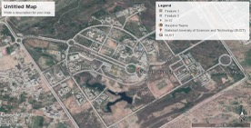 | These dams collect water from the rain falling within the campus over a small area as catchment area. These lakes are being used as Fish Ponds and as source for charging the ground water level of the Tube Well of the campus. This is a very good example of Water harvesting. | The stream known as Kacha Lei Nala starts from sector H-12 of Islamabad where campus of the National University of Sciences and Technology (NUST) has been constructed. This stream passes right through the campus. Overlap with this intervention will be avoided
World Vision  Financial support to communities in Rawalpindi for installation of water pumps for extraction of ground water for household consumption. | World Vision could not provide a sustainable solution to address drinking water scarcity crisis in the communities. The project was not well planned and suffered from a lack of engagement and capacity building of community based organizations. Moreover, groundwater was polluted in some areas | The project ended and should not focus on pumps for groundwater
Pakistan’s First Integrated Resource Recovery Centre in Islamabad Sector G-15  See annex 5 for more info | Project entailed an Integrated Resource Recovery facility with simple techniques that enabled communities to turn waste into resources through composting, recycling and bio-digestion close to the source of the waste. | Project was in Islamabad.  This approach can be used to reduce waste in streams, which will contribute to reducing flood impacts
Nowshera

Government of Pakistan, Ministry of water resources  1253 Remodeling of Warsak Canal System in Peshawar & Nowshera Districts  USD 94 million | UNHABITAT has requested Ministry of Water Resources for provision of this project’s details. On receiving these details, the same will be highlighted in the detailed proposal
International

UNDP Maldives  2010-2015 USD 9 million  Increasing climate resilience through an Integrated Water Resource Management | Output 1.2. focuses on rainwater harvesting schemes redesigned, interconnected and structurally improved to buffer climatic extremes and ensure equal water supply for all households during dry periods | Consult UNDP Maldives to extract lessons and recommendations for this project

No household or community level rainwater harvesting activities have been identified in Nowshera or Rawalpindi cities. Most of the people meet their water needs through extraction of ground water though the quality of groundwater is not fit for human consumption.

- Learning and knowledge management

It is aimed to ensure project compliance with AF and UN-Habitat standards for Knowledge Management (KM) and advocacy. The strategic framework for the KM, Advocacy & Communication Strategy (KMAS) specific to this project is based on aims, objectives and best practices of both organizations regarding knowledge management (KM), advocacy and communications.

Table 14: key KM Terminology
Knowledge | Is know-how, understanding, experience, insight, intuition  and contextualized information
Information | Is contextualized, categorized, calculated and condensed data
Data | Are facts and figures which relay something specific, but which are not organized in any way
Knowledge Management | Is the deliberate and systematic coordination of people, technology, processes and organizational structure to add value through reuse and innovation. This achieved through creating, sharing and applying knowledge as well as through feeding the valuable lessons learned and best practices into corporate memory to foster continued learning
Advocacy | Is set of targeted actions directed at policy and decision makers in support of a specific issue in order to influence decision-making at the local, national and international level to create positive change for people and their environment
Communication | Refers to the specific tools and platforms utilised to efficiently and effectively disseminate knowledge and information so that it reaches target audiences and the public

Throughout this project, a wealth of data, information, and valuable knowledge concerning community vulnerabilities, and especially those of women and youth (in line with the AF gender policy) and resilience to climate change will be generated at the community and city levels. To ensure that useful lessons and experiences gained are successfully captured, retained, utilized, and shared throughout the project, a clear KM, Advocacy & Communication Strategy (KMAS) accompanying actionable work plan will be formulated as a point of reference for all project staff and implementing partners. Adhering to this strategic framework and work plan will facilitate the effective coordination of resources and efforts at all stages of the project implementation, monitoring, and evaluation.

Knowledge Management at project level is achieved through the development of appropriate actions (gathering data; analysing processes, results, and personal experiences; generating and disseminating knowledge products and lessons learned, etc.) so that the knowledge captured and generated at the individual and project level is systematized and shared to reach the largest number of beneficiaries as quickly as possible.

A strong and actionable work plan allows effective knowledge sharing, advocacy and communications. Once knowledge products and lessons learned have been generated and developed, it is necessary to effectively communicate and share these with specific target groups and audiences as well as the public.

The core benefits of a successful KMAS within this project are outlined below:
- Improves visibility of project activities and results to raise awareness on climate change impacts and adaptation at multiple levels and especially for women and youth
- Enhances capacity for knowledge retention and reuse (at community, national and international level, including specific focus on women and youth)
- Enhances knowledge sharing and increases collaboration (within and across communities, relevant institutions, and organisations, including specific focus on women and youth)
- Improves learning (organisationally, locally, and globally)
- Strengthens accountability vis-à-vis project delivery and compliance with environmental, social, gender, youth, and human rights standards.
- Increases project impact through learning and access to information, including specific focus on women and youth
- Avoids duplication
- Facilitates modification of current and future projects based on lessons learned
- Strengthens stakeholder/knowledge networks, including specific focus on women and youth
- Contributes to normative work of the Government of Pakistan, provincial governments, and other stakeholders, and of the Adaptation Fund & UN-Habitat.

Implementation of KMAS is within each component and activities of this project to capture and share lessons.

The planned activities under component 1 will provide communities and households and especially women, with a better understanding / knowledge of how to construct, use and maintain flood resilient water harvesting systems, using innovative techniques. Participatory approach (involving communities in planning and implementation activities) will lead to increased local knowledge on climate change adaptation, especially related to urban floods and water scarcity issues. Educational and information material will be produced for community awareness and advocacy and will be used from the inception of community engagement. This contributes to better understand the climate related issues and best possible solutions that communities can adapt. The project will also use a participatory monitoring process, which will enable the beneficiary communities to work directly with the project’s M&E officer, to highlight issues in delivery and to strengthen adaptation benefits, including in replication and sustaining the project’s gains. Knowledge products will be developed for replication purposes in other communities.

The planned activities under component 2 aim at producing the same knowledge but then for government and city officials. Raising awareness of city/ district officials involved on issues related to community resilience, community actions and partnership approach etc., can generate greater commitment and support for addressing issues. Moreover, capacities for developing pro-active spatial plans considering flood and drought risks, will be strengthened. Such engagement of awareness raising will also pave the way for policy review to ensure the project’s sustainability and the development of a conducive policy environment. All relevant information should be fed back to the provincial and national governments when appropriate.

As for the planned activities under component 3, this is a strong knowledge production component focused on developing national policy and technical guidelines. This will address the technical capacity gaps in spatial planning and regulatory frameworks related to infrastructure development and urban development considering climate change risks and impacts.

Visibility of project activities including lessons will be communicated (As a UN protocol of Pakistan’s One UN System) using press releases and media events through UN Information Center (UNIC) of Pakistan and they shall disseminate the same with the other UN agencies, also the human-interest stories will be published in the UNIC run newsletters. The details of the project shall be projected on the country website and the social media campaigns.

At the regional level, the lessons, tools, methodologies and guidelines from the project will be consolidated and added to the regional knowledge database and shared with the Regional Climate Change focal point/team and other country offices through the Knowledge Management focal point within the UN-Habitat Regional office for Asia and the Pacific. Regional knowledge platforms, such as Asia Pacific Expert Group Meeting, Asia City Summit are other openings for dissemination of KPs.

At the international level, the lessons from the project will be shared with the UN-Habitat best practices unit within HQ through the Knowledge Management focal point for dissemination to all countries; and similarly, through the Regional Climate Change focal point/team with the Climate Change Planning Unit within the Urban Planning and Design Branch for consolidation of all knowledge products related to Climate Change. Thematic networking sessions and events in global events such as World Urban Forum will be targeted.

A specific approach to women and youth includes the following (see outcomes consultations Part II.H):

- Reading material and videos targeting women and youth will be prepared in local languages
- Ensure that women are being visibly engaged as agents of change at all levels of disaster preparedness, including education, communication, information and networking opportunities.
- Build the capacities of national and local women’s groups’ and provide them with a platform to be heard and to lead.

Table 15: learning objectives and knowledge products per output
Expected concrete output/intervention | Learning objectives (lo) & indicators (i) | Knowledge products
Output 1.1. (concrete)  5000 community / household level flood resilient water harvesting and purification technology and facilities constructed, using innovative techniques | (lo): involving community members and especially women and youth in construction and maintenance of facilities  (i) number of community members involved | See below
Output 1.2.  8 union council-level community plans developed, community members (especially women and youth) trained and practical guide developed to plan, construct, operate, maintain and duplicate water harvesting facilities and purification techniques in ‘safe’ areas at community level, and to reduce waste through piloting of solid waste resource centres | (lo): community members have the technical capacity to operate and maintain water harvesting facilities  (i) Trainings conducted and people attending them | Eight plans developed  Technical manuals produced  Video’s produced
Output 2.1. (concrete)  40 district / city-level water harvesting facilities (small dams) constructed (or smaller number if bigger dams are possible) | (lo): involve district and city officers in planning and design of facilities  (i) number of district and city officers involved | See below
Output 2.2.  Two city-level spatial planning strategies developed considering climate change risks and impacts, especially floods and droughts, and including comprehensive water harvesting plans and solid waste management plans | (lo): District and city government have capacity to plan, construct, maintain and replicate best practice water harvesting facility  (i): Manual published online and shared nationally through workshop | Spatial plans developed  Manual to plan, construct, maintain and replicate best practice water harvesting facility as part of spatial planning strategies
Output 2.3.

50government officials trained and guide developed to plan, construct, operate, maintain and duplicate flood resilient water harvesting facilities and to develop spatial plans
Output 3.1.  100 government official (women men) trained to guide / direct urban development considering climate change and disaster risks and impacts, using especially spatial planning tools. | (lo): Concerned government officers have capacity to guide / direct urban development considering climate change and disaster risks and impacts, using especially spatial planning tools.  (i): Manual published online and shared nationally through workshop | Manual for guiding / direct urban development considering climate change and disaster risks and impacts, using especially spatial planning tools.
Output 3.2.  One National urban strategy / plan focused on climate change / disaster risk reduction developed  One set of National guidelines for spatial / urban planning considering climate change / disaster risks developed | (lo): Concerned government officers have capacity to guide / direct urban development considering climate change and disaster risks and impacts  (i): National strategies and guidelines developed | National urban strategy / plan focused on climate change / disaster risk reduction developed  National guidelines for spatial / urban planning considering climate change / disaster risks developed

- Consultative process

The project has been designed based on the outcomes of consultations at the national-, district-, city- and community level. Consultations with UN agencies, NGO’s, etc. took place to understand climate change impacts in Pakistan, to identify potential focus and target areas and to identify potential risks for vulnerable groups and compliance to human rights, Labour standards, etc. At the national, district- and city-level, consultations further focused on ensuring that the project aligns with national and sub-national priorities. At the community level, consultations focused on understanding local climate change impacts and effects, barriers to adapt and possible interventions to address negative impacts. Consultations with community representatives and women took place to identify specific impacts and needs and to develop specific groups baselines and approaches to ensure equal distribution of benefits (see annex 2). Below table provides an overview of stakeholders consulted, consultation objectives, outcomes, conclusions and consultation evidence. During the full proposal phase, consultations will focus on fully identifying sub-projects and to identify all associated potential environmental and social risks and impacts through community consultations. For detailed surveys and attendance sheets, see annex 1.

Table 16: Initial consultation outcomes and conclusions
Stakeholder, incl. role/function | Objective | Outcome | Conclusion | Evidence
Mr. Khizar Hayat Khan  Federal Secretary  Ministry of Climate Change (MOCC) | - Align proposed project with national priorities | - Very welcoming to a project that addresses water scarcity (new priority) and flooding | - Focus on water scarcity and flood issues | 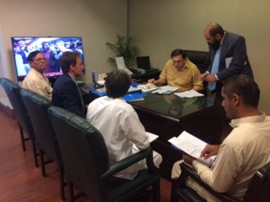  Date: 04-06-2018  Method: interview / discussion
Mr Irfan Tariq  DG and AF focal point  Ministry of Climate Change | - Align proposed project with national priorities  - Agree on way forward | - Priority issues: water scarcity (new priority) and flooding  - Name of ministry will be changed to climate change and human settlements – so more urban focus  - Request to develop a national urban policy  - Priority town: Nowshera  - Also, water scarcity issue in Islamabad and Rawalpindi – technique needed to conserve / harvest water + urban planning | - Focus on water scarcity and flood issues  - National urban policy and urban planning strategies to reduce climate change impacts (floods and droughts) part of project  - Focus on Nowshera if feasible. Consider Islamabad and Rawalpindi if vulnerable area | 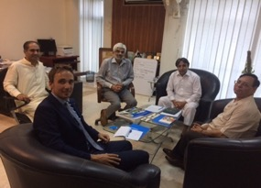  Date: 04-06-2018  Method: interview / discussion
Lt. Gen Omar Mahmood Hayat  Chairman  National Disaster Management Authority  MOCC | - Align proposed project with national priorities  - Understand main disaster / cc issues | - Cities are not planned for floods and water  - Land use plans and building codes needed to avoid people moving into risk areas and building codes to construct resilient houses  - Suggested to focus more south compared to donor focus on tribal / northern areas | - Include land use planning strategy and resilient building codes components in the project | 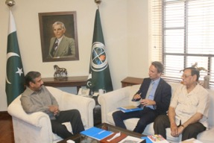  Date: 04-06-2018  Method: interview / discussion
Fiaz Hussain Shah
Director General
National Institute of Disaster Management
MOCC
Ms. Ingrid Christensen  Country head  ILO | - Identify main potential risks / issues to comply to ILO standards  - Understand main labour-related needs | - Ensure safety and health (155 and 187) are guaranteed during activities, especially for women  - Suggest promoting decent work / livelihood options (skills, protection, diversification) and build upon existing skills  - Ensure maintenance arrangements are institutionalised – work with provincial / district irrigation departments | - Ensure safety and health (155 and 187) are guaranteed during activities, especially for women  - Consider skill development, e.g. for resilient house design, in project  - Work with provincial / district irrigation departments | 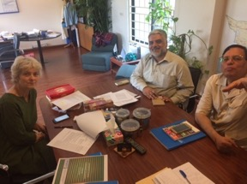  Date: 04-06-2018  Method: interview / discussion
Abid Niaz Khan
National programme coordinator
Mr. Shakeel Ahmad  Chief Development unit  UNDP | - Understand main disaster / cc issues  - Map lessons learned other projects | - In process of developing community of practice focused on ‘urban’  - One relevant rural water harvesting project  - One relevant flood project focused on livelihood recovery + AF and GCF GLOF projects  - Lessons: use human center and livelihood strengthening approach  - General approach: 80 percent of flood issues can be addressed through spatial planning and resilient building design / regulations  - There is a huge need and scope for water harvesting, also in path of floods | - Use lessons from projects  - Include spatial planning, building design / regulations and water harvesting components in the project |     Date: 04-06-2018  Method: interview / discussion
Amanullah Khan
Chief Environment and climate change
UNDP
Mr. Illango Pathchamuthu  Country director  World Bank | - Understand main disaster / cc issues  - Map lessons learned other projects | - Need of land use planning and building codes, especially in Punjab  - Need to address issue of water scarcity in Karachi (due to salt water)  - Use lessons from some 2-3 relevant flood-related projects | - Include land use planning and building codes component in project  - Use lessons learned from flood-related projectt | 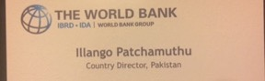  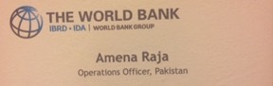  Date: 05-06-2018  Method: interview / discussion
Amena Raja
Operations officer
World bank
Mr. Ahmed Kamal  Chief Engineering Advisor & Chairman  Federal Flood Commission  Ministry of Water Resources | - Align proposed project with national priorities  - Understand main disaster / cc issues | - Most relevant policies / plans:  National flood protection plan and National water policy – priorities are water scarcity and floods  - ADB, JICA and WWF (GCF) interested in flood plan  - Suggest combining local water harvesting knowledge / techniques with world and regional best practices to improve system and clean water  - Suggest developing a city water management model and to raise public awareness about water scarcity / conservation needs  - Co-funding from government is option | - Fully align with National flood protection plan and National water policy  - Avoid overlap with ADB and JICA projects  - Focus on combining local water harvesting knowledge / techniques with world and regional best practices to improve system and clean water  - Consider developing a city water management model – perhaps as part of national urban policy  - Explore options of co-funding from government | 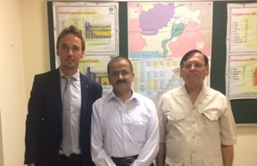  Date: 05-06-2018  Method: interview / discussion
Ms. Fareeha Ummar  Progamme specialist  UN Women | - Identify main potential gender related risks  - Understand main gender needs in Pakistan | - Legal status: consider potential risk of ‘violence against women (domestic) and harassment.  - Religious / cultural status: misinterpretation but often dependent on men (also in decision-making), which can be a problem with e.g. rescue work, especially when women are not registered – key challenges: mobility, social norms and mindsets  - Women are generally water ‘handlers’  - Suggest working with national commission ‘status of women’ and gender focal points within NDMA and departments  - Suggest focussing on skills + capacity development | - Ensure safety and health are guaranteed during activities  - Include women in decision-making processes, where possible  - Focus on women with water-related activities – also with skills and capacity focus  - Work with national commission ‘status of women’ and gender focal points within NDMA and departments  - Consider working with Lahore women university | 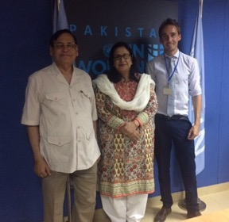  Date: 05-06-2018  Method: interview / discussion
Mr. Hussain Ullah  Head of preparedness unit  OCHA | - Identify main potential human right risks  - Understand main issues and needs when it comes to disaster preparedness and response | - Main issue: water scarcity – there is no proper water and floods management system and the most vulnerable are hit hardest  - Punjab has good data  - Sindh has a governance gap  - Balochistan has some good water scarcity coping strategies – but question is how to purify water  - Suggest to carefully study landscape requirements for water harvesting  - NDMA has good report identifying most hazard impacts vulnerable areas | - Focus on water scarcity issue  - Identify areas appropriate for water harvesting (with slope)  - Use NDMA data to identify target area with above | 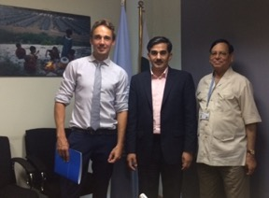  Date: 05-06-2018  Method: interview / discussion
Ms. Almas Saleem  Executive director  SheherSaaz NGO | - Identify main urban climate change and disaster issues  - Identify potential target areas based on assessments  - Discuss cooperation options | - Main issues floods and water scarcity  - Suggest focussing on Nowshera and Rawalpindi as both (flash) floods and water scarcity are issues  - SheherSaaz in only NGO in Pakistan that focuses on urban issues in a comprehensive way  - Agreement on cooperation on consultations | - Assess Nowshera and Rawalpindi as best target areas  - Work together on consultations | 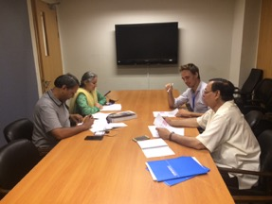  Date: 06-06-2018  Method: interview / discussion
Abdul Shakoor Sindhu
Chief Technical Advisor
SheherSaaz NGO
Initial local government and community representatives’ consultation  Nowshera | - Understand main climate change related impacts and specific effects and barriers to adapt  - Identify main issues and needs  - Understand main concerns  - Identify targets communities  - Identify possible interventions | - Concerns of the poor don’t reach the government  - Impact: 2-meter flood (river -north side - and flash – from mountains 10 km away – south side) leading to death and destruction  - Most difficult to adapt / recover: business, contaminated water, unhygienic situation  - Priorities / needs regarding floods: 1) safety, 2) water (contamination) and food, 3) housing, crops, cattle (destroyed)  - Water source: wells  - Need to build water reservoir dams and; need of rescue kits during floods and shelter after floods; need of gender approach (health, hygiene); need of training of carpenters, electricians, etc.  - Most affected communities: | - Consider inputs in project design. | 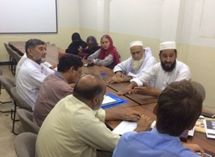  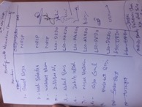  Date: 06-06-2018  Method: group discussion
Initial local government and community representatives’ consultation  Rawalpindi union council 4-5-6 | - Understand main climate change related impacts and specific effects and barriers to adapt  - Identify main issues and needs  - Understand main concerns  - Identify targets communities  - Identify possible interventions | - Impact: floods up to 1st floor (4 meters) in very dense area leading to death, destruction, diseases, electricity power cut (also outside flood period), etc. + water scarcity due to drought and contaminated water (year-round) due to floods  - Most difficult to adapt / recover: contaminated water (using boreholes – there is a lot of waste.  - Priorities / needs regarding floods: 1) safety (especially children falling and in and elderly, 2) water (contamination)  - Need to reduce flood water from source (as very dense area; need clean water year-round in communities;  - Most affected communities: union councils 4-8 + further along the channels (10 km) | - Consider inputs in project design. | 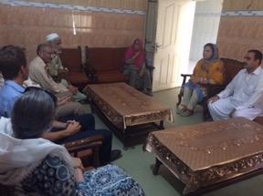  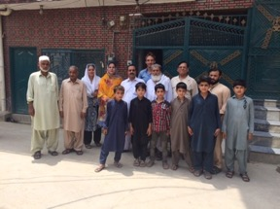  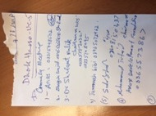  Date: 07-06-2018  Method: group discussion
Mr Irfan Tariq  DG and AF focal point  Ministry of Climate Change  With representatives from SheherSaaz | - Agree on main approach, components and target areas  - Agree on steps / way forward | - Agreement on main approach and components – will review document  - Agreement on main steps / way forward – will send letters to target municipalities to get their official buy-in  - Include Islamabad by-law on water harvesting in building design in project design | - See left | 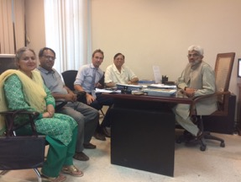  Date: 08-06-2018  Method: interview / discussion
Rawalpindi community consultations  Rawalpindi union council Union Councils 4-5-6 | - Understand climate change related issues and needs in target areas | - Flooding, diseases and droughts / water scarcity are all getting a lot worse and water scarcity is the most pressing issue  Water scarcity specific issues:  - The poor households are most affected, as they cannot afford to bear the cost of installing a borehole and neither can pay for availing the facility from private water vendors  - Getting water for poor households make up more than half of the community cost them socially as well as economically. In these households, collection of water largely rests with women and children. Sometimes they have to spend hours in this activity and hence to compromise their time which they can otherwise use for leisure or productive activities--education and employment.  - Scarcity of water is also a source of feuds among neighbors.  Diseases specific issues:  - Contaminated water is a source of number of water borne diseases including diarrhea, gastro and hepatitis to name a few.  Flood specific issues:  - Floods are recurrent phenomenon thanks to the close proximity of Lai Nallah and presence of some natural drains.  - Absence of land use planning and control has also contributed in localized flooding. The natural drainage channels as well as Lai Nallah have been encroached leading to narrowing of their traditional right of ways.  Barriers for adaptation:  - Dependence on (polluted) groundwater of which the water table has gone down dramatically  - Absence of water sector planning at various levels and lack of awareness and technical support.  - People do not have a control on quality of water being supplied through municipal authorities as well as water vendors  - Lack of waste management leading to more flood risks and groundwater pollution |  | 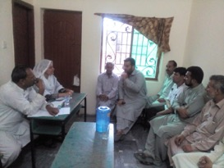  Date: 04-07-2018  Method: discussion and survey (see annex 1)
UN gender working group  UNIC  UNIDO  UNDP  UNDSS  UN-Habitat  Shehersaaz | - Understand main gender specific related issues and needs regarding climate change, also in target areas | Identified Challenges for women to adapt to climate change vulnerabilities  - Women are typically absent from the forum where Disaster Risk Reduction (DRR) decisions/ planning is made, so when priorities are established, the interests of women are often poorly represented.  - Women are often absent from trainings for disaster management.  - Difficulties in finding adequate shelter, food, safe water, and fuel for cooking, as well as problems in maintaining personal hygiene and sanitation, prevent women from performing their usual roles at home in disaster situations.  - Women also suffered from water crises due to the scarcity of clean drinking water. The majority of the women faced drinking water problem and communication problem due to damaged roads, culverts, and embankments.  - Mobility problems during floods  - There exists no mechanism to communicate with women groups | Measures Proposed for strengthening adaptive capacity of women  - Make them part of Awareness campaigns  - Prepare reading material and videos for them in local languages  - Train women to use technologies for water harvesting  - Ensure that women are being visibly engaged as agents of change at all levels of disaster preparedness, including in early warning systems, education, communication, information and networking opportunities.  - Improve the knowledge, skills and behaviours of vulnerable women for a good quality warning, evacuation, shelter and rehabilitation mechanism.  - Build the capacities of national and local women’s groups’ and provide them with a platform to be heard and to lead  - Development of a women volunteers team within each community to address women and girls special needs  - Mainstreaming gender into policy processes, programmes and projects can help ensure that such processes equitably benefit women and men while allowing optimal use of the unique knowledge and skills of women and men. By the same token, gender mainstreaming can advance social policy (including gender equality) while ensuring greater returns on adaptation and disaster risk reduction investments.  - Consider the level of women’s access to technology and finances, health care, support services, shelter and security in times of disaster. | 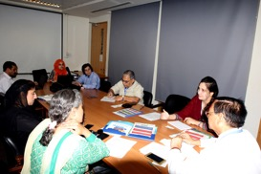  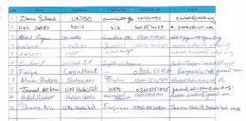  Date: 31-07-2018  Method: discussion
Rawalpindi women consultations  Rawalpindi union council Union Councils 4-5-6 | - Understand main gender specific related issues and needs regarding climate change in target communities | - Flooding, diseases and droughts / water scarcity are all getting a lot worse  Flood specific issues:  - Women being responsible for housekeeping put a lot of effort and time in cleaning their houses whenever they are affected by floodwaters.  - The monsoon season brings fear and especially women have to stay extra conscious spending sleepless nights.  Disease specific issues:  - The prevalence of water borne disease and epidemics especially affects younger children. Taking care of them primarily comes to women increasing their burden and affecting their productive time. Disability among children is especially high.  Water scarcity specific issues:  - Women have to travel almost two kilometers to bring drinking water from two nearby water sources--private boreholes.  Barriers for adaptation:  - Women are not involved in any community-based decision making.  - Poverty is rampant. Men resort to daily wage labor while women contribute in household incomes by working as domestic servants or undertaking works like sewing/tailoring in their homes.  - Most of the households are poor and disease burden is high. No social safety nets or subsidized healthcare facilities are available to households.  - Most of the households are poor. The meager earnings do not afford them the opportunity to invest in water filtration or other effective measures for having clean water for household uses.  - Generally, households do not have knowledge of household level low cost but effective water purification technologies.  Concerns:  - They fear that flood protection measures involving removal of encroachments from Lai Nallah's banks may lead to their displacement.  - Locality/neighborhood is densely populated having little space for water collection ponds. They were also of the view that since they were tenants and poor they would not be able to invest in household level rainwater harvesting technology.  Women skills, strengths and leaders  - The sense of togetherness can be transformed into effective women / community organization and can be encouraged to undertake community driven or community led initiatives. |  | 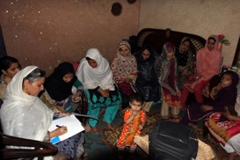  Date: 01-08-2018  Method: discussion and survey (see annex 1)
Nowshera community consultations  Nowshera Kalan | Understand climate change related issues and needs in target areas | - Flooding, diseases and droughts / water scarcity are all getting a lot worse and water scarcity is the most pressing issue  Water scarcity specific issues:  - The available water from municipal supplies stinks and is highly contaminated.  - The ground water up to the depth of 100 ft is not fit for human consumption.  - The poor households not being able to afford water purification / filtration systems are compelled to consume contaminated water  Flood specific issues:  - Over the years, the haphazard and unplanned growth of the city resulted in encroachment of river banks. Whenever river overflows the surrounding localities are inundated.  - Besides River Kabul a number of natural water channels that drain into River Kabul also pass through the city. During rainy season, these channels also cause flooding inundating neighboring areas.  Disease specific issues:  - Contaminated water is a source of number of water borne diseases including diarrhea, gastro and hepatitis to name a few.  Barriers for adaptation:  - Especially poor and lower middle income households can’t afford to Install boreholes to extract groundwater from safer depths  - Households generally are not aware of household level low cost water treatment technologies  - The communities are not familiar with community-based flood management measures.  - The river and the water channels have been turned into dumping points for city's solid waste. |  | 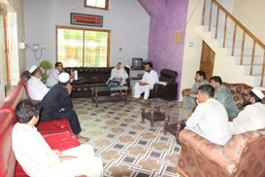  Date: 01-08-2018  Method: discussion and survey (see annex 1)
Mohammad Shakeel Malik  Federal Secretary  Ministry of Climate Change (MOCC) | - Get feedback on the proposal before final endorsement | - Include water purification and waste management approach in the proposal |  | Date: 06-08-2018  Method: discussion

- Justification

The proposed project components, outcomes and outputs fully align with 1) national and local government/institutional priorities and gaps identified, with 2) identified community and vulnerable groups needs and 3) with the Adaptation Fund outcomes. This alignment has resulted in the design of a comprehensive approach in which the different components strengthen each other and in which outputs and activities are expected to fill identified gaps of Pakistan’s’ and target cities’ current climate change response and corresponding institutional capacities. In fact, the selected interventions / activities are directly confirmed and / or proposed by the national, state and municipal governments and inhabitants of target communities through consultations, as reported in Part II.H above.

The project aims to maximizing the funding amount for concrete adaptation interventions: see outputs 1.1. and 2.1.; funding allocation to the other outputs is required to support the execution of these concrete interventions in a sustainable way as well as to respond to government priorities / requests. The table below provides a justification for funding requested, focusing on the full cost of adaptation reasoning, by showing the impact of AF funding compared to no funding (baseline) related to expected project outcomes.

Table 17: Overview of impact of AF funding compared to no funding (baseline) related to expected project outcomes
Expected concrete output/intervention | Baseline (without AF) | Additional (with AF) | Comment and alternative adaptation scenario’s
Output 1.1. (concrete)  5000 community / household level flood resilient water harvesting and purification technology and facilities constructed, using innovative techniques  Output 1.2.  8 union council-level community plans developed, community members (especially women and youth) trained and practical guide developed to plan, construct, operate, maintain and duplicate water harvesting facilities and purification techniques in ‘safe’ areas at community level, and to reduce waste through piloting of solid waste resource centres | Communities in target cities don’t have the capacity to plan, operate and maintain community and household-level water harvesting facilities, which are urgently needed to respond to clean water needs. | The proposed activities / interventions under component 1 will allow communities, and especially women and youth in target cities to plan, operate and maintain community and household-level water harvesting facilities, which are urgently needed to respond to clean water needs. | Alternative adaptation scenarios are the enhancement of boreholes or piped water. However, water from boreholes could get contaminated by flood water and piped water could also be at risk because of high flood levels.
Output 2.1. (concrete)  40 district / city-level water harvesting facilities (small dams) constructed (or smaller number if bigger dams are possible)  Output 2.2.  Two city-level spatial planning strategies developed considering climate change risks and impacts, especially floods and droughts, and including comprehensive water harvesting plans and solid waste management plans  Output 2.3.  50government officials trained and guide developed to plan, construct, operate, maintain and duplicate flood resilient water harvesting facilities and houses and to develop spatial plans | District and city government officials in target cities don’t have the capacity to plan, operate and maintain water harvesting facilities, taking into account flood and drought risks through spatial planning strategies, which is urgently needed to respond to climate change flood and drought risks | The proposed activities / interventions under component 2 will allow city government officials to plan, operate and maintainwater harvesting facilities, taking into account flood and drought risks through spatial planning strategies | Alternative adaptation scenarios are resettlement or the construction of larger drainage channels, which are not feasible from a cost perspective and environmental and social risks point of view and will also not have the benefit of water supply. Due to the severe historical flood impacts, community-level flood reduction interventions won’t reduce flood impacts enough.
Output 3.1.  100 government officials (women and men) trained to guide / direct urban development considering climate change and disaster risks and impacts, using especially spatial planning tools.  Output 3.2.  One National urban strategy / plan focused on climate change / disaster risk reduction developed  One set of National guidelines for spatial / urban planning considering climate change / disaster risks developed | There is no national strategy to deal with urban areas, especially taking into account climate change risks and impacts. Although spatial planning strategies are an effective tool to avoid people moving into high flood risk areas, national strategies focused on this are lacking. | The proposed activities / interventions under component 3 will allow the national government to guide / direct urban development considering climate change and disaster risks and impacts through different strategies | Alternative adaptation scenarios are a focus on the development of sub-national strategies, but this will reduce the complete government buy-in, including budgets.

- Sustainability

The project aims to sustain adaptation benefits achieved and replicate best practices (i.e. lessons) after the end of the project through a combination of anchoring activities into existing government programmes and strategies and community plans, including for infrastructure operation and maintenance and by sharing lessons and best practices (see part II.G).

Institutional sustainability
The project will pave the way for the national government and local authorities to sustain and up-scale the project to other districts and cities by developing relevant national strategies, which have been requested by the government and which will be anchored into existing ministry and municipal programmes. As per LOA/MOA, the Beneficiary Community or Govt. Department will be responsible for the Operation and Maintenance of Infrastructure and Technology.

Moreover, trainings will be conducted to strengthen relevant government capacities and best practices and lessons learned from all component outputs and outcomes will be shared at the national and sub-national level.

Social sustainability
By organizing and fully engaging community members and vulnerable groups in project activities, including assessments during project preparation and the development of plans/ strategies and monitoring, the project aims to achieve long-lasting awareness and capacities of community members. Moreover, communities will develop plans and community members will be trained to operate and maintain assets developed. Possible social risks and impacts will also be identified and assessed in detail and if needed, mitigation, during the full proposal development phase.

Economic sustainability
Investing in increasing the resilience of vulnerable assets is a sustainable economic approach. It will avoid future costs related to drought and flood impacts. The national strategies, as well as community plans will consider economic opportunities.

Environmental Sustainability
The national strategies, as well as community plans will also consider environmental impacts. Possible environmental risks and impacts will also be identified and assessed in detail and if needed, mitigation, during the full proposal development phase.

Financial sustainability
The proposed interventions are fully aligned with national and sub-national priorities and programmes and therefore, the government actively supports the project and interventions, including anchoring it to existing programmes.

Technical sustainability
The water harvesting facilities will be designed and constructed using resilience and building back better principles. This will enhance the durability/sustainability significantly. Besides that, a feasibility study and environmental and social impact assessment will be conducted for the planned facilities during the full project development phase and formal partnerships with target municipalities will be established for the maintenance of facilities.

Below table provides an overview of project outputs and arrangements to sustain / maintain these. Details for the arrangements will be identified during the full project development phase through consultations with DG, MOCC and Chairman Federal Flood Commission, concerned disaster management authorities, local municipal institutions in Rawalpindi and Nowshera and local civil society groups and communities.

Table 18: overview of outputs and arrangements to sustain / maintain these
Expected concrete output/intervention | Arrangements to sustain / maintain activities / interventions
Output 1.1. (concrete)  5000 community / household level flood resilient water harvesting and purification technology and facilities constructed, using innovative techniques | Development of community plans for operation and maintenance and agreement established between communities and municipal government about maintenance arrangement and built community-based skills on operation and maintenance. Guidelines/operational manual on the use and maintained of Rainwater Harvesting Systems will be developed in local languages
Output 1.2.

8 union council-level community plans developed, community members (especially women and youth) trained and practical guide developed to plan, construct, operate, maintain and duplicate water harvesting facilities and purification techniques in ‘safe’ areas at community level, and to reduce waste through piloting of solid waste resource centres
Output 2.1. (concrete)  40 district / city-level water harvesting facilities (small dams) constructed (or smaller number if bigger dams are possible) | As per LOA/MOA, the Beneficiary Community or Govt. Department will be responsible for the Operation and Maintenance of Infrastructure and Technology. Exact responsibilities and arrangements will be identified and agreed upon during the full proposal development phase
Output 2.2.  Two city-level spatial planning strategies developed considering climate change risks and impacts, especially floods and droughts, and including comprehensive water harvesting plans and solid waste management plans | Formally approve the plans as part of district / city development plans. During the preparation greater involvement of planning bodies (units) expected and promoted to enhance sense of ownership
Output 2.3.  50government officials trained and guide developed to plan, construct, operate, maintain and duplicate flood resilient water harvesting facilities and to develop spatial plans | Guide developed and widely used tools localized/updated to plan, construct, operate, maintain and duplicate flood resilient water harvesting facilities and to develop spatial plans
Output 3.1.

100 government officials (women men) trained to guide / direct urban development considering climate change and disaster risks and impacts, using especially spatial planning tools.
Output 3.2.  One National urban strategy / plan focused on climate change / disaster risk reduction developed  One National guidelines for spatial / urban planning considering climate change / disaster risks developed | Guidelines for spatial / urban planning considering climate change / disaster risks developed using internationally accepted tools and guidelines such as International Guidelines on Urban and Territorial Planning,

- Environmental and social impacts and risks

The proposed project seeks to fully align with the Adaptation Fund’s Environmental and Social Policy (ESP) and the Gender Policy (GP). Further to part II.E above on project compliance with national technical standards, outlined below is a summary of the findings of the initial (concept note stage) screening of all components and activities / interventions against the 15 AF principles to identify potential environmental and social risks and impacts. With this information, the entire project risk has been categorized.

Because of the nature of the proposed interventions (water harvesting facilities under output 2.1), the entire project is currently categorized as a medium risk (Category B) project. The proposed water harvesting facilities are concrete intervention with possible adverse environmental and social impacts. Specific concerns are related to equal access to water, land ownership and use of construction sites and negative impact on natural habitats, biodiversity and land and soil, etc. During the full project development phase, when detailed information of the location and design will be made available an environmental and social impact assessment will be conducted in line with national technical standards, which will provide information for a more accurate categorization. As for the activities under the other outputs, potential risks concerns are related to equal access to benefits and avoidance of adverse impacts on marginalized and vulnerable groups and women, but these risks will be mitigated.

During the full proposal development phase, detailed screening of all components and activities / interventions against the 15 AF principles will take place to identify all potential environmental and social risks, assess impacts in detail and propose mitigation measures when needed. This will be done by collecting detailed information on proposed activities /interventions, conduct feasibility studies of concrete interventions and assess environmental and social impacts of potential risks, all through studies in line with national technical standards and community and vulnerable groups consultations.

A ‘gender’ baseline and approach / strategy is under development (see annex 2) to reduce potential risks and maximize benefits for marginalized and vulnerable groups, including women, youth, elderly and disabled and to ensure that project benefits will be allocated equally, that discrimination nor favouritism in accessing project benefits can take place and that adverse impacts are avoided. Besides that, potential environmental and social risks and impacts are assessed in more detail in the ESP compliance annex (annex 2), which will include an ESMP.

Below table provides an overview of the 15 AF principles and a checklist if further assessment is required during the full project development phase. In the ESP compliance annex 1, screening outcomes of all project activities / interventions against the 15 AF principles are discussed in detail.

Table 19: checklist of the 15 AF principles:
Checklist of environmental and social principles | No further assessment required for compliance | Potential impacts and risks – further assessment and management required for compliance
Compliance with the Law |  | x
Access and Equity |  | x
Marginalized and Vulnerable Groups |  | x
Human Rights |  | x
Gender Equity and Women’s Empowerment |  | x
Core Labour Rights |  | x
Indigenous Peoples |  | x
Involuntary Resettlement |  | x
Protection of Natural Habitats |  | x
Conservation of Biological Diversity |  | x
Climate Change |  | x
Pollution Prevention and Resource Efficiency |  | x
Public Health |  | x
Physical and Cultural Heritage |  | x
Lands and Soil Conservation |  | x

part iV: endorsement by government and certification by the Implementing Entity

- Record of endorsement on behalf of the government

Muhammad Irfan Tariq, Directlor General, Minsitry of Climate Change, Government of Pakistan | Date: August 6, 2018
Ahmad Kamal, Chief engineer advisor / chairman FFC/CE(DSC), Ministry of Water Resources, Government of Pakistan | Date: August 1, 2018

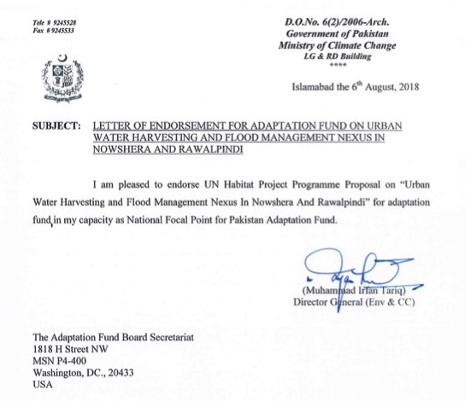

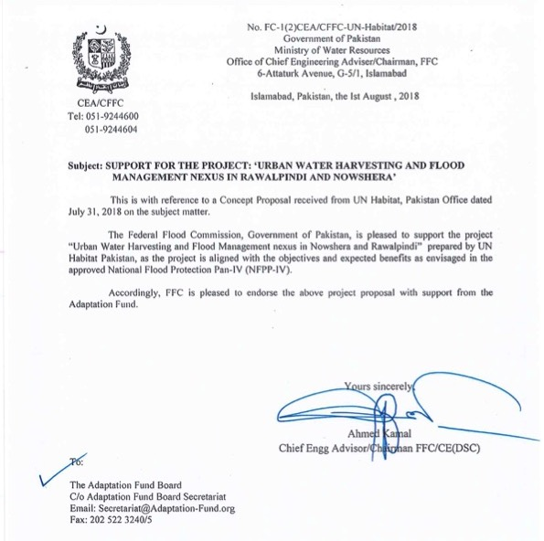

- Implementing Entity certification
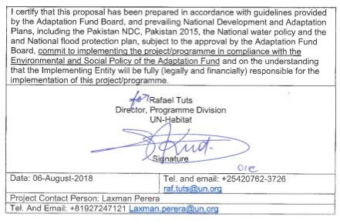

ANNEX 1: Detailed consultations reporting / evidence

Content:

- Rawalpindi community consultations
- Rawalpindi women focus group discussions
- Nowshera community consultations
- Rawalpindi women focus group discussions (to be included in full proposal)

Rawalpindi community consultations

RAPID COMMUNITY SURVEY
BUILDING URBAN CLIMATE RESILIENCE IN PAKISTAN
UN-HABITAT - ADAPTATION FUND
Focus: community level – union councils (most vulnerable communities in target areas)
Method: group discussion

Note: focus group discussionswere done with representatives of three union councils (UCs) in Rawalpindi City. The names of UCs are: Dhok Mangtaal (UC # 4); Dhok Hassu North (UC # 5); and Dhok Hassu South (UC # 6). Although the National Population and Housing Census was conducted in late 2017 in Pakistan; Pakistan Bureau of Statistics (PBS) has only released the preliminary census result and has yet to release the detailed disaggregated demographic figures. The recent UC wise detailed census data is yet not available. To compensate this deficiency, we have referred to the population estimates made by Government of Punjab’s Planning and Development Department (P&DD). According to P&DD) on 31 Dec 2016, the mentioned Union Councils had following estimated population figures:

Name of Community/Area | Estimated Population on 31 Dec 2016* | Population figures quoted by community representatives
Dhoke Mangtal (UC 4) | 33,390 | 43,000
Dhoke Hassu North (UC 5) | 20,544 | 38,700
Dhoke Hassu South (UC 6) | 19,980 | 34,000
Total Population | 73,914 | 115,700
*Source: Punjab Development Statistics, 2016; Planning and Development Department, Government of Punjab, Lahore

1. Basic assessment information
Name community leaders (e.g. chairpersonunion council) | - Waqas Ali (UC 6)  - Atta-ur-Rehman (UC 6)  - Muhammad Riaz (UC 5)  - Irfan Mughal (UC 5)  - Muhammad Tufail (UC 4)
Contact details and photo | See Part II.H
Date assessment conducted | 04 July 2018
Attendance sheet filled | See below
Photos of consultation made | See Part II.H

2. Community profile
Provincial, District and municipal name | Province: Punjab; District: Rawalpindi; Municipality: Rawalpindi Municipal Corporation
Community / union council name |  | Dhok Mangtaal (UC 4); Dhok Hassu North (UC 5); and Dhok Hassu (UC 6)
Location (on map) |  | Please see attached map
Total population (number) |  | Please see table above
Number or percentage  (please identify vulnerable groups in target areas – through discussion and data collection) | Female | 47%
 | < age 14 (children) | 37%
 | age 15-24 (youth) | 21%
 | age 25-60 | 39%
 | > age 60 (elderly) | 3%
 | (ex) Refugees / displaced (from where?) | An exact percentage is not known. However a number of Afghan refugee families reside in these communities. Besides a number of families have also moved from the tribal areas especially after the military operation against militants in Pakistan’s former Federally Administered Tribal Areas which have recently been merged in Khyber Pakhtunkhwa Province.
 | Informal people | Areas are informal
 | Indigenous people | Not known
 | HIV positive | Not known
 | Disabled population | 2%
 | Other relevant | N/A
Households (number) + average per household |  | Based upon official population estimates for 2016:  Number of Households: 11,371  Average Household size: 6.5 to 7  Based upon population figures provided by community representatives:  Number of households: 16,528  Average Household size: 7
Poverty rate (%) |  | Around 60% households can be placed in the category of poor as they depend upon daily wage labour.
Access to electricity (%) |  | 100%
Access to clean water (%) and type (borehole, piped) |  | Access to clean water: The quality of drinking water in these areas does not meet the prescribed standards as water contamination is a widespread issue.  Types of Water Supply:  - Tap water: 65-70%  - Hand pumps: 2%  - Boreholes: 25%  - Wells: 1-2%  - Water vendors: 5%
Access to sanitation (proper toilet) (%) |  | 100%
Main livelihoods / income in community |  | 60% households depend upon daily wage labour by working in nearby city markets or getting engaged in other menial labour. Only 12% households earn their living through formal sector employment. Around 10% individuals capable of earning are unemployed. The rest earn their living through trade, property rents, and manufacturing and different service sector jobs.
Issues | Floods (or risk areas) | Please see file titled meeting minutes
Issues | Droughts (or risk areas)
Issues | WASH (issues) | Regarding drainage of household waste water, many areas do not have an underground sewerage system and instead depend upon open sewers in the streets.  There is currently no facility for the treatment of sewage before its disposal to Lai Nallah.

Climate change – trends analysis

Expected outcome: Agreement on at least one or two climatic hazards, which have most impacted the community
Climate Change hazards | a) In the last 10 years, has the community been affected by: | Has this issue been getting:
Droughts (e.g. lack of clean water for household use, damage to crops) | i) Yes, a lot, ii) yes, a little, iii) no, iv) not relevant. v) can’t say. | i) a lot worse, ii) little worse, iii) same, iv) better, v) not relevant, vi) can’t say.
Extreme heat (e.g. resulting in electrical problems, health impacts, crop/fisheries damage) | i) Yes, a lot, ii) yes, a little, iii) no, iv) not relevant. v) can’t say. | i) a lot worse, ii) little worse, iii) same, iv) better, v) not relevant, vi) can’t say
River flood (directly from main river) | i) Yes, a lot, ii) yes, a little, iii) no, iv) not relevant. v) can’t say. | i) a lot worse, ii) little worse, iii) same, iv) better, v) not relevant, vi) can’t say
Flash flood (local flooding due to poor drainage) | i) Yes, a lot, ii) yes, a little, iii) no, iv) not relevant. v) can’t say. | i) a lot worse, ii) little worse, iii) same, iv) better, v) not relevant, vi) can’t say
Storms/cyclones (e.g. destruction to house or goods, disruption to services, etc. ) | i) Yes, a lot, ii) yes, a little, iii) no, iv) not relevant. v) can’t say. | i) a lot worse, ii) little worse, iii) same, iv) better, v) not relevant, vi) can’t say
Diseases (e.g. dengue, malaria, diarrhea) | i) Yes, a lot, ii) yes, a little, iii) no, iv) not relevant. v) can’t say. | i) a lot worse, ii) little worse, iii) same, iv) better, v) not relevant, vi) can’t say

Top 3 most problematic climatic hazards
Hazard | Occurrence between 2008 and 2018 (years) | Possible comment
1. Water Scarcity | Persistent hazard
2. Water Borne Diseases | Persistent hazard
3. Flooding in Nallah Lei and other drains | Recurrent hazard

Climate change – questionnaire

These questions help to analyze current and future climate risks, barriers to adaptation and factors/resources facilitating the coping strategies used by community and way of improving their resilience.

What problems / effects does your community face because of the one or two most problematic climatic hazards (see result trend analysis) and how do these affect men, women, elderly, youth, disabled people, (ex) refugees in your community?
Most problematic climatic hazard | Problems / effects (e.g. agriculture destruction, lack of water or food for cattle, drinking water scarcity, disease, death, damages of houses or other assets, need to move somewhere else, need to invest in protection, need to find other income) | Who (what group) is most affected? | How does hazard impact those most affected?
Water Scarcity | Water scarcity is the most pressing problem of the area. The municipal piped water supply does not meet household's needs. The water tables have drastically fallen. For boreholes, residents have to dig as deep as 300 feet. In various instances, even this effort fails. For a borehole, a household has to bear a cost of PKR 250,000 to 300,000 (US$ 2500 to 3000). Given high poverty rates in the area, all households do not afford to bear this cost. Hence they have to depend upon generosity of their neighbor to get water for domestic use. The public tube wells have been dug at the depth of 700 to 800 feet. Many public tube wells have gone dry. The local administration does not have funds to rehabilitate the existing ones or install new tube wells.  Water vendors have installed private filtration plants and deliver a 20 liter container of water for PKR 50 (US$ 0.5)  Water tankers also supply water in certain localities where they can move to. The official rate for a 10,000 liter water tanker is 400 PKR (US$ 4). However it is rarely available. People have to bribe for getting this facility. On average they have to pay PKR 1000 to 1500.  Private vendors have also installed their tube wells. They provide a water tanker for PKR 2200 to 2500 (US$ 25 to 30). Couple of months back, the Supreme Court of Pakistan banned the operations of private tube wells/water hydrants. This drive has escalated the cost of a private tanker to PKR 5000 (US$50). An additional problem with water tankers is that they cannot access every locality thanks to narrow streets and congested/encroached roads. | The poor households are most affected. As they cannot afford to bear the cost of installing a borehole and neither can pay for availing the facility from private water vendors. The official water tanker facility is rarely available and even if available, only the influential ones or those who can pay the bribe access this facility. | Getting water for poor households who make up more than half of the community cost them socially as well as economically. In these households, collection of water largely rests with women and children. Sometimes they have to spend hours in this activity and hence to compromise their time which they can otherwise use for leisure or productive activities--education and employment.  Cost of water is too high for poor households and it takes away a considerable portion of their meager incomes.  With water available in limited quantities, poor households also have to compromise their hygiene needs which in turn affect their health.  Scarcity of water is also a source of feuds among neighbors. While sharing of water shows local residents compassion, the consistent scarcity sometimes begin to tax these sentiments, resulting in weakening of community bonds.
Water borne diseases | The quality of drinking water available in the communities is also not up to the mark. The contaminated water is a source of number of water borne diseases including diarrhea, gastro and hepatitis to name a few. | The poor households are among the most affected as they prefer quantity over quality while getting water as charity from their well off neighbors.
Floods | Floods are recurrent phenomenon thanks to the close proximity of Lai Nallah and presence of some natural drains.  Absence of land planning and control has also contributed in localized flooding. The natural drainage channels as well as Lai Nallah have been encroached leading to narrowing of their traditional right of ways.  In absence of an effective solid waste management system, the household, commercial and industrial waste ends up in local drains and Lai Nalla causing high levels of pollution. The abundance of plastic waste dumped on the banks of Lai Nallah contributes to flooding. | Although floods affect all, they affect most to those households who are located just next to the Lai Nalla and other drains. During last few years, more than 20 houses have been destroyed by flooding events.  During rainy season the houses located next of Lai Nallah and other drains get affected almost annually.

The magnitude of barriers to adaptation

What stops your community from coping with current impacts of the most problematic climatic hazards (see result trend analysis)? These can be e.g. lack of knowledge / education, lack of skills, lack of money, lack of land tenure, lack of irrigation, lack of drinking water supply, health issues, bad infrastructure, lack of drainage system, lack of natural resources like forests, etc.).
Most problematic climatic hazard | - What is currently limiting your community from coping with or adapting to the impacts? (What makes it difficult for you to deal with them or makes it difficult to make changes to deal with them)  - in what ways has your community already adapted to deal with these issues? | Ranking most important factors
Water scarcity | The groundwater has become the major source of water supply in the area. Over the years, water tables have dangerously gone down. For a borehole, households hav to dig as deep as 300 feet and even more. In many cases even going to this much depth does not avail any result.  Since majority of households have very limited incomes, they can’t afford this investment. A very large number of households in the community (more than half) are actually tenents. For this status they cannot make an investment in water bores and hence have to depend upon their house owners.  The municipal authorities are of the view that unless there is made a major investment in water sector, they cannot provide a sustained supply of water to households. A proposal is still pending with National Assembly of Pakistan about drawing water from River Indus at the point of Ghazi Brotha located in neighboring Attock district. Besides requiring a huge investment then runs in tens of billions of rupees; drawing water from Indus for urban water supplies need a lot of political consensus and agreement among provinces-hence a very lenghty process.  Households have not thought of rainwater harvesting options at community or household level. This is largely due to lack of awareness and technical knowhow.  Adaptation:  In absence of an efficient municipal water supply, people have resorted to boreholes putting in huge investments.  Water vendors have emerged supplying water in large quantities as well as filtered water for drinking. This has generated new business opportunities.  People have installed suction pumps on water supply pipes. According to them without these pumps they do not get water from municipal water supply. This activity is illegal, but it is going on unchecked. | - Absence of water sector planning at various levels.  - Absence of large scale investments in water sector development  - Lack of awareness and technical support.
Water borne diseases | People do not have a control on quality of water being supplied through municipal authorities as well as water vendors. The drinking water quality standards are not followed. There is no regulatory body to ensure the quality of water from these sources. The general lack of awareness and absence of options are also contributing factors.  Adaptation.  Households who can afford have installed water filters while some also practice boiling of water before consumption for drinking purposes.
Floods | Efforts by the local authorities to launch annual cleaning drives for Nallah Lai have contributed in recurrence of flooding in Nallah Lai. However the dumping of solid waste in it is going unchecked. The communities, although themselves contributing in this problem, find them helpless in this regard. They argue that since a proper solid waste management system does not exit, they have to resort to open dumping of waste.  Adaptation:  Households located next to Nallah Lai and other drains largely keep their ground floors free of furniture and other hard to move objects especially during the flooding season. At some places, people have constructed small embankments, walls to remain safe from flooding. However this strategy rarely helps.

The priorities to be addressed in strengthening the adaptive capacity of the community.

What activities should take place or infrastructure constructed in order to improve your adaptive capacity to droughts / water scarcity, floods, landslides, heat, and diseases? What is most important for the community?
Most problematic climatic hazard | Activity and/or infrastructure | Ranking most important activity and/or infrastructure
Water Scarcity | - Construction of new dams  - Rehabilitation of existing tube wells  - Installation of new tubewells.  - Financial support to households for installation of hand pumps and boreholes.  - Drawing water from Kohala, a point at the confluence of Murree and Azad Jammu and Kashmir (AJK) where river Jehlum enters Punjab from AJK.  - Drawing water from Ghazi Brotha, a water works at River Indus in neighboring Attock district. | Rehabilitation of existing tube wells  Installation of new tube wells  Financial assistance to poor households for installation of hand pumps and boreholes.
Water borne diseases | - Replacement of ageing water supply pipes  - Laying of water supply pipes in a manner that they are not close to sewerage system.  - Installation of water filtration plants and their regular maintenance  - Financial assistance to poor households for installation of domestic water filtration systems.  - Boiling/disinfection of water before consumption.  - Awareness campaigns | All of these are priorities.
Flooding | Cleaning of Nallah Lai and other drains to make them free of solid waste  Construction of retaining walls and embankments  Deepening of the Lai Nallah’s course by at least 5 to 6 feet.  Realignment of Lai Nallah’s course

Rawalpindi community consultation attendance sheet
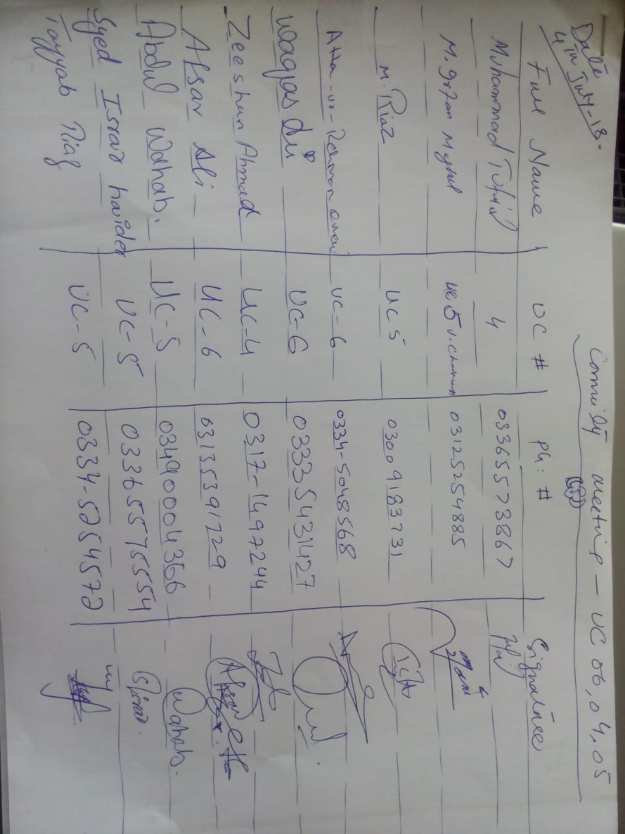

Rawalpindi women focus group discussions

RAPID COMMUNITY SURVEY
BUILDING URBAN CLIMATE RESILIENCE IN PAKISTAN
UN-HABITAT - ADAPTATION FUND
Focus: women groups
Method: focus group discussion

- Basic assessment information / contact person details
Name group representative | Iqbal Bibi
Contact details and photo | +92 331 509 1971  For photos please see the attached folder
Date assessment conducted | 01 Aug 2018
Attendance sheet filled | See below
Photos of consultation made | See Part II.H

Climate change – trends analysis

Expected outcome: Agreement on at least one or two climatic hazards, which have most impacted the community
Climate Change hazards | a) In the last 10 years, has the community been affected by: | Has this issue been getting:
Flooding (directly from Lai Nallah) | i) Yes, a lot, ii) yes, a little, iii) no, iv) not relevant. v) can’t say. | i) a lot worse, ii) little worse, iii) same, iv) better, v) not relevant, vi) can’t say
Diseases (e.g. dengue, malaria, diarrhea) | i) Yes, a lot, ii) yes, a little, iii) no, iv) not relevant. v) can’t say. | i) a lot worse, ii) little worse, iii) same, iv) better, v) not relevant, vi) can’t say
Droughts (e.g. lack of clean water for household use) | i) Yes, a lot, ii) yes, a little, iii) no, iv) not relevant. v) can’t say. | i) a lot worse, ii) little worse, iii) same, iv) better, v) not relevant, vi) can’t say.
Extreme heat (e.g. resulting in electrical problems, health impacts, crop/fisheries damage) | i) Yes, a lot, ii) yes, a little, iii) no, iv) not relevant. v) can’t say. | i) a lot worse, ii) little worse, iii) same, iv) better, v) not relevant, vi) can’t say

Top 3 most problematic climatic hazards
Hazard | Occurrence between 2008 and 2018 (years) | Possible comment
1. Flooding | Almost annually this community is affected by floods in Lai Nallah | Owing to its being located next to Lai Nallah, the community gets affected by flooding in Lai Nallah almost in every monsoon season. The risk of getting affected also remains intact during winter's rainy season.
2. Diseases | Persistent risk | The community suffers from poor sanitary conditions. The existing sewerage system consists of open street sewers that directly dispose sewage in Lai Nallah. Especially during flooding season, the street sewers get choked causing overflowing of household sewerage system.  The available drinking water is not fit for drinking and hence contributes to water borne diseases.  The overall poor sanitary conditions compounded by absence of an effective solid waste management system in the community also contribute to the disease burden.
3. Scarcity of clean water for drinking and household use | P  ersistent phenomenon | The available water for drinking and other household uses does not meet the minimum standards. Often the water being supplied by municipal water supply system stinks. The groundwater extracted through boreholes also is not of good quality.

Climate change – questionnaire

These questions help to analyze current and future climate risks, barriers to adaptation and factors/resources facilitating the coping strategies used by groups and way of improving their resilience.

What problems does your specific group (women, elderly / disabled, youth, (ex) refugees, etc.) face because of the one or two most problematic climatic hazards (see result trend analysis)
Most problematic climatic hazard | Problems / effects (e.g. agriculture destruction, lack of water or food for cattle, drinking water scarcity, disease, death, damages of houses or other assets, need to move somewhere else, need to invest in protection, need to find other income) | How does hazard impact your group specifically?
1. Flooding | Dhok Najju is located immediately next to Lai Nalla. An unplanned settlement, it has grown haphazardly over the years. Today it is a densely populated area. The consecutive governments and municipal authorities have not paid any heed for the planning and development of the area like many other older parts of Rawalpindi city. Thanks to these factors, flooding is a recurrent phenomenon that hits the locality almost annually. The floodwaters enter houses damaging the household items and hence causing financial losses to households besides affecting the housing structures. In many instances, the floodwaters also damage the household food stocks.  The community does not have dedicated storm sewers and drainage of storm and flood water is totally dependent upon the undulating terrain/topography of the area. The flood and rainwater undermines the sewerage system of the area, causing the sewers to overflow to an extent that even the human excreta flows into houses--a disgusting issue that troubles the household most. | Women being responsible for housekeeping have to put a lot of effort and time in cleaning their houses whenever these are affected by floodwaters.  The monsoon season brings fear and especially women have to stay extra conscious spending sleepless nights. In absence of any effective early warning system in place and lack of preparedness on part of households they have been caught unaware by the floods during late in the nights or early in the morning when households were asleep.
2. Diseases/  Epidemics | Epidemics are not uncommon and disease burden is high in Dhok Najju like many other localities having similar features. Diarrhea, dengue, malaria, hepatitis, dermatological ailments are common diseases in the area. The local residents consider the poor sanitary conditions and contaminated water as being responsible for this situation.  The concerned municipal institutions do not take any preventive measures to address this situation. Anti malaria and dengue campaigns involving fumigation of the area are occasionally launched. However so far these measures have not borne any fruits so far. | The prevalence of water borne disease and epidemics especially affects younger children. Taking care of them primarily comes to women increasing their burden and affecting their productive time.  Disability among children is especially high. One in every 15 to 20 households have one or more children suffering from some physical or mental disability.
3. Scarcity of clean water for drinking and other household uses | Dhok Najju suffers from an extreme shortage of clean water. The water supplied through municipal piped water supply stinks and is highly contaminated and hence is not used for drinking. Boreholes are not common. The piped water is supplied for two hours daily. | Women have to travel almost two kilometers to bring drinking water from two nearby water sources--private boreholes. Those women who can afford hire an auto rickshaw to haul the drinking water. Women who do not afford had to walk to perform this duty. This consistent strain involves lot of hassle and stress compromising women's leisure and productive time and energies.

The magnitude of barriers to adaptation

What stops specifically your group (women, elderly / disabled, youth, (ex-)refugees, etc.) from coping with current impacts of the most problematic climatic hazards (see result trend analysis)? These can be gender roles, illegal status affecting tenure, illegal status affecting employment options, lack of knowledge / education, lack of skills, lack of money, etc.
Most problematic climatic hazard | - What is currently limiting your group from coping with or adapting to the impacts? (What makes it difficult for you to deal with them or makes it difficult to make changes to deal with them). Please discuss Differentiated climate change impacts on women and their differentiated capacities do adopt to these, gender division of labor and gender-based power structures  - in what ways has your group already adapted to deal with these issues?
1. Flooding | - The location of Dhok Najju that makes it an immediate neighbor of Lai Nallah poses a persistent risk of flooding.  - Over the years, the community has encroached the banks of Lai Nallah and hundreds of households are compelled to live in the flood zone.  - The municipal authorities have not made any efforts so far to enforce building codes and land use control.  - A proper sewerage system does not exist. Household sewage flows in open street sewers before its final disposal in Lai Nallah.  - No effective early warning system exists.  - Community based flood management system is not heard about. The community and households are not prepared that lead to their consistent vulnerability to flood risks.  - Effective community based governance and decision making systems do not exist. Women are not involved in any community based decision making.  - Poverty is rampant. Men in many households resort to daily wage labor while women contribute in household incomes by working as domestic servants or undertaking works like sewing/tailoring in their homes.  Adaptation:  - During flood seasons, households normally remove easily removable household items from ground floors. However given smaller sizes of houses (many are one room houses) they have very little space to take this measures.  - Flood warnings are aired from loudspeakers of mosques. However these do not prove very effective.
2. Diseases/  Epidemics | - Most of the households are poor and disease burden is high. No social safety nets or subsidized healthcare facilities are available to households.  - In absence of interest from the local authorities, the community finds it helpless to address the causes that are contributing to poor sanitary conditions and disease burden of the community.  Adaptation  So far no visible adaptation measures are in place against this situation.
3. Scarcity of clean water for drinking and other household uses | - The community finds itself helpless against the persistent unavailability of clean water.  - Most of the households are poor. The meager earnings do not afford them the opportunity to invest in water filtration or other effective measures for having clean water for household uses.  - Generally households do not have knowledge of household level low cost but effective water purification technologies.  Adaptation:  Since water available from existing municipal supplies is not drinkable, especially women travel to nearby two water sources to fetch water for drinking.

The priorities to be addressed in strengthening the adaptive capacity of the group

What activities / interventions should take place to adapt to climate change hazard impacts (e.g. address floods or droughts / water scarcity? What is most important for the group?
Most problematic climatic hazard | Activity / intervention
1. Flooding | - Lai Nallah should be covered  - If Lai Nallah is not covered, its walls should be lined with retaining walls  - Government should install a proper sewerage system
2. Diseases/  Epidemics | - The community considers the proximity of Lai Nallah, poor sanitary conditions, absence of sewerage system, unavailability of clean drinking water as being the major cause of epidemics and disease burden. Hence government should take measure to address this situation, women believe.
3. Scarcity of clean water for drinking and other household uses | - Install community level water filtration plants  - Ensure the supply of clean water through municipal supplies.

If these activities, interventions (e.g. dam to reduce floods, water harvesting facilities at community or household level) are provided, what would be your main concern and needs (e.g. related to employment, health, water access, food security, tenure security, resettlement, etc.?)
Activity / intervention | Concerns and needs
Flood protection measures involving clearance of encroachments from Lai Nallah's banks | Concerns :  Displacement and resettlement  Needs:  Many households are tenants. In many instances a dwelling unit is occupied by as high as seven to eight families, each occupying one room while sharing the toilet facility. On average a household pays PKR 5000-6000 as monthly rent. This amount takes away major portion of their meager incomes. These households find them unable to financially contribute in any of the project activities. They also fear that flood protection measures involving removal of encroachments from Lai Nallah's banks may lead to their displacement. They further emphasize that they find it extremely difficult to get housing facilities within the city with low house rents that they can afford. The displacement, they fear, will only increase their difficulties.
Construction of dams/water reservoirs | The respondent women had little idea of these measures and how they may affect their lives. What they emphasize repeatedly is protection from recurrent floods.
Community level and household based rainwater harvesting | Women had not heard about these technologies. However on getting an idea of these interventions, they explained that their locality/neighborhood was densely populated having no space to serve as water collection pond. They were also of the view that since they were tenants and poor they would not be able to invest household level rainwater harvesting technology.

Group skills, strengths and leaders.
What is the group good at doing or what are the strengths? (e.g. committees, successful projects working together, construction or organizing skills, good connections outside community) | 1) How can this be used for addressing floods, water scarcity, etc.?  2) Who will be the leader for making this happen? (what community committees can help with this?)
The community has a strong sense of togetherness. Women mentioned that they and their households would be ready to contribute their labor in any community led interventions. | This sense of togetherness can be transformed into effective community organization and can be encouraged to undertake community driven or community led initiatives.
Many household know the construction skills as men work as masons and construction labor. | These skills can be harnessed for community based/community led initiatives involving simple construction skills.
The community has a strong urge to improve their living conditions | This urge can be harnessed to mobilize the community for community based initiatives.

Rawalpindi women focus group discussion attendance sheet
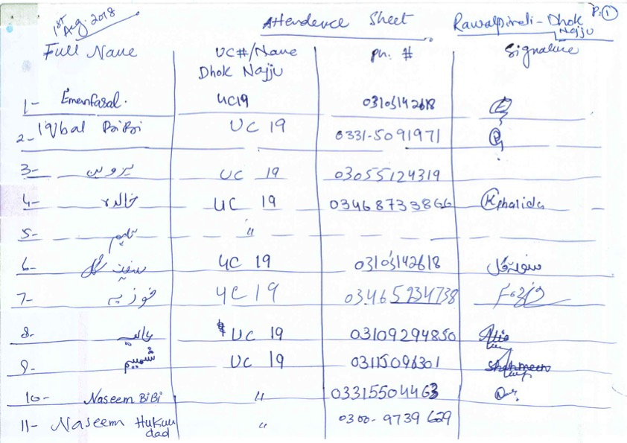
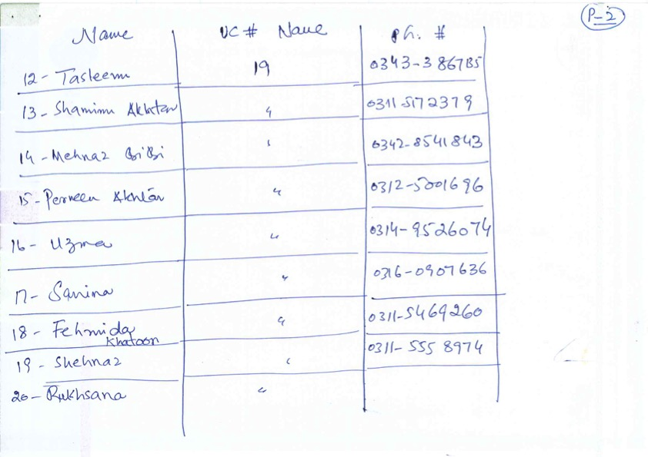

Nowshera community consultations

RAPID COMMUNITY SURVEY
BUILDING URBAN CLIMATE RESILIENCE IN PAKISTAN
UN-HABITAT - ADAPTATION FUND
Focus: community level – union councils (most vulnerable communities in target areas)
Method: group discussion

- Basic assessment information / contact person details
Name community leaders (e.g. chairperson union council) | Mr Aqeel Rehman  Area Supervisor, Tehsil Municipal Administration, Nowshera
Contact details and photo | +92 315 5879 619  For photos please see attached folder
Date assessment conducted | 01 Aug 2018
Attendance sheet filled | See below
Photos of consultation made | See Part II.H

- Community profile
Provincial, Districtand municipal name | Province: Khyber Pakhtunkhwa  District: Nowshera  Municipality: Tehsil Municipal Administration (TMA), Nowshera
Community / union council name |  | Union Council: Nowshera Kallan
Location (on map) |  | Please see attached map
Total population (number) |  | Nowshera Kalan--the area of the city proposed to be targeted with AF project has a total population of 83,567 as per the population census results of 2017. This population is distributed in 12, 445 households.
Number or percentage  (please identify vulnerable groups in target areas – through discussion and data collection) | Female | 48%
 | < age 14 (children) | 38%
 | age 15-24 (youth) | 20%
 | age 25-60 | 40%
 | > age 60 (elderly) | 2%
 | (ex) Refugees / displaced (from where?) | Nowshera district had once sheltered a very large number of Afghan refugees. In recent years it became one of the main areas where IDPs from trouble hit tribal areas and Swat took refuge. However the exact population of this refugee population in Nowshera Kalan is not known.
 | Informal people | Not known
 | Indigenous people | Not known
 | HIV positive | Not known
 | Disabled population | 2-3% of total population
 | Other relevant
Households (number) + average per household |  | Nowshera Kalan: 12445 Households as per population census of 2017. The average household size is 6.7 persons per household as per census 2017.
Poverty rate (%) |  | According to respondents, more than 50% households in Nowshera Kalan are poor.
Access to electricity (%) |  | 100%
Access to clean water (%) and type (borehole, piped) |  | Household water supply source in Nowshera city:  Tap water: 27%  Hand pump: 22%  Motor pump: 47%  Dug well: 2%  Other: 2%  (Source: Pakistan Social and Living Standard Measurement Survey (2014-15), Pakistan Bureau of Statistics, Government of Pakistan)
Access to sanitation (proper toilet) (%) |  | 97% households have a proper flush latrine facility (Source: Pakistan Social and Living Standard Measurement Survey (2014-15), Pakistan Bureau of Statistics, Government of Pakistan)
Main livelihoods / income in community |  | The male members of households in many households earn their living through menial labor in Nowshera and other places in Pakistan. Nowshera's construction workers are famous for their skills in plastering. The other livelihood sources include government jobs, jobs in small scale industry, shop keeping etc. Very few females are in paid employment. Mostly the educated women are serving as teachers in government schools.

Climate change – trends analysis

Expected outcome: Agreement on at least one or two climatic hazards, which have most impacted the community
Climate Change hazards | a) In the last 10 years, has the community been affected by: | Has this issue been getting:
Droughts/scarcity of clean water (lack of clean water for household use) | i) Yes, a lot, ii) yes, a little, iii) no, iv) not relevant. v) can’t say. | i) a lot worse, ii) little worse, iii) same, iv) better, v) not relevant, vi) can’t say.
River flood (directly from main river) | i) Yes, a lot, ii) yes, a little, iii) no, iv) not relevant. v) can’t say. | i) a lot worse, ii) little worse, iii) same, iv) better, v) not relevant, vi) can’t say
Diseases (e.g. dengue, malaria, diarrhea) | i) Yes, a lot, ii) yes, a little, iii) no, iv) not relevant. v) can’t say. | i) a lot worse, ii) little worse, iii) same, iv) better, v) not relevant, vi) can’t say

Top 3 most problematic climatic hazards
Hazard | Occurrence between 2008 and 2018 (years) | Possible comment
1. Drought/scarcity of clean water | Persistent problem | The available water from municipal supplies stinks and is highly contaminated.  The ground water up to the depth of 100 ft is not fit for human consumption. Going further deep one may get somewhat cleaner and purer water.
2. River flooding | Persistent risk. The biggest flooding event in the known history of Nowshera occurred in 2010. However settlements/neighborhoods located in immediate vicinity of River Kabul recurrently get affected even by low level floods in the river | River Kabul flows through the city. The old city (which is proposed to be targeted with this intervention) is located on the left bank of River Kabul. Over the years, the haphazard and unplanned growth of the city resulted in encroachment of river banks. Whenever river overflows the surrounding localities are inundated.
3. Diseases/epidemics | Persistent risk | There is high prevalence of diseases like dengue, gastro, diarrhea, choler and hepatitis. Local residents attribute them to poor sanitary conditions of the city. The disease outbreak intensifies in flooding seasons.

Climate change – questionnaire

These questions help to analyze current and future climate risks, barriers to adaptation and factors/resources facilitating the coping strategies used by community and way of improving their resilience.

What problems / effects does yourcommunity face because of the one or two most problematic climatic hazards (see result trend analysis) and how do these affect men, women, elderly, youth, disabled people, (ex) refugees in your community?
Most problematic climatic hazard | Problems / effects (e.g. agriculture destruction, lack of water or food for cattle, drinking water scarcity, disease, death, damages of houses or other assets, need to move somewhere else, need to invest in protection, need to find other income) | Who (what group) is most affected? | How does hazard impact those most affected?
1. Drought/  scarcity of clean water for human consumption | Despite being neighbor of River Kabul, Nowshera city suffers from scarcity of clean water for human consumption. In many areas of the city, the water is supplied by municipality. However in most the cases this water is found to be highly contaminated. For instance one of the main overhead water tanks is located just next to a waste dumping site. Local residents consider this situation as one of the factors contributing to contamination of water. Local residents also highlight that city waste water is disposed untreated into the river. This problem is further compounded by the fact that the city has three main slaughter houses. The waste generated from slaughtered animals is disposed directly into the river.  The water supply pipes and street sewer, at various locations, run parallel. This is also one of the main reasons for high incidence of water contamination.  Kabul River has been turned into a dumping site for solid waste of the city besides its being the disposal point for city sewage. The high level of contamination of Kabul River is one of the major reasons for contamination of water available for human consumption. | People of all ages and all sexes are affected. However it is the poor households and children who are most affected from water borne diseases. | Incidences of diarrhea are high among the infants and younger children.  The poor households owing to their not being able to afford water purification/filtration systems are compelled to consume the contaminated water. The burden of disease not only causes health problems but also causes economic losses by reducing the productive time available to poor families.  Prevalence of hepatitis is also very high. This situation has caused a number of deaths. Local residents attribute the poor quality of drinking water as being the main reasons for this situation.  Poor households have to allocate a considerable portion of their meager incomes on healthcare. Their limited financial affordability does not allow them to avail better quality healthcare. This situation makes them caught in a constant spiral of disease and poverty.
2. River flooding | Four union councils of Nowshera city are located immediately next to Kabul River. These union councils include Chowki Town, Nowshera City, Kabul River, and Nawan Kallae. Residents in these localities recurrently get affected from flooding in Kabul River. The super floods of 2010, made Nowshera capture newspapers' and news channels' headlines. The city stood among the most flood affected areas of Pakistan. In some localities, the floodwaters reached the height of more than 20 feet destroying and damaging a very large number of residential, commercial, institutional and industrial buildings. In areas of city where agriculture and livestock rearing is still practiced, these livelihood sources get recurrently affected by floods in Kabul River. | Neighborhoods located next to Kabul River are most vulnerable. In absence of any meaningful enforcement of building codes and land use control, city has grown along the River Kabul encroaching upon its banks. Hundreds of residential, commercial, institutional and industrial structures are located dangerously close to river Kabul. Besides River Kabul a number of natural water channels that drain into River Kabul also pass through the city. During rainy season, these channels also cause flooding inundating neighboring areas. | Settlements located in close proximity to River Kabul and water channels that drain into the river are among the most vulnerable areas. The poor households that make up the majority of these settlements are little prepared to reduce their vulnerability to recurrent flooding events.
3. Diseases/epidemics | Contaminated drinking water, poor sanitary conditions and hygiene practices are considered by the community as main causes of high prevalence of diseases. The disease outbreak intensifies especially during flooding season. During last few years, Nowshera had been among the areas of the province most affected by dengue outbreak. Dozens of individuals have so far lost their lives to dengue. | Poor households are among the most affected ones. Infants and younger children get most affected by water borne diseases. Prevalence of hepatitis is high among all age groups.

The magnitude of barriers to adaptation

What stops your community from coping with current impacts of the most problematic climatic hazards (see result trend analysis)? These can be e.g. lack of knowledge / education, lack of skills, lack of money, lack of land tenure, lack of irrigation, lack of drinking water supply, health issues, bad infrastructure, lack of drainage system, lack of natural resources like forests, etc.).
Most problematic climatic hazard | - What is currently limiting your community from coping with or adapting to the impacts? (What makes it difficult for you to deal with them or makes it difficult to make changes to deal with them)  - in what ways has your community already adapted to deal with these issues?
1. Drought/  scarcity of clean water for human consumption | - The local government/municipal authorities of Nowshera city are severely resource constraint having no substantial funds and technical capacity to address city's chronic problem of scarcity of clean water for human consumption.  - The community members find them helpless in getting rid of this issue.  - The elected representatives make promises at time of elections but have so far not taken any meaningful steps to fulfill citizens' demands.  - Citizens consider that supply of water is responsibility of government. Especially poor and lower middle-income households do not afford to Install boreholes to extract groundwater from safer depths  -Households generally are not aware of household level low cost water treatment technologies as is apparent from lack of availability of these technologies.  - Water harvesting at community and household levels has never been considered as an option. Most of the respondents had not heard of them even.  Adaptation:  People who can afford resort to use of bottled water as well as installation of household water filters. The poor however resort to consumption of contaminated water compromising their health.
2. River flooding | - The concerned institutions have so far not taken well planned flood mitigation measures arguing they do not have required financial resources.  - The communities are not familiar with community-based flood management measures.  - An effective early warning system and response mechanisms are not in place.  - Flood resilient building codes and practices and land use controls are not in place.  - The city has grown haphazardly in absence of any meaningful city development and management plans and strategies.  - The very location of the city places it perpendicular to River Kabul. When there is flood in the river, it forcefully hits the city. River Kabul drains into River Indus. When Indus is in high flood it blocks the flow of River Kabul causing flooding in the upstream Nowshera. Likewise, when there is flood in River Kabul, the floodwaters start flowing back in the channels that pass through the city and during normal days drain into River Kabul. This situation intensifies flooding in the city.  - Like River Kabul, the natural water channels that pass through the city have also been encroached. At certain locations, buildings have been erected even in the beds of water channels. When rainwater flows in these channels it causes damage to these structures.  - The city has a poor drainage system. During floods 2010, the floodwater stagnated in various low-lying areas of the city for many days.  - The river and the water channels have been turned into dumping points for city's solid waste. This situation chokes them and obstructs the free flow of flood waters.  Against this situation, the local residents find them helpless to take any meaningful measures on their own. The local administration has limited financial resources at their disposal. They are understaffed and lack technical capacity to deal with this challenge. So far, no effective disaster management plan or strategy has been chalked out for resilience of Nowshera. Whatever flood response measures are taken, are reactive in nature and normally comprise of evacuation and relief. The measures that could meaningfully reduce the vulnerability of the citizens and city and enhance their capacities are simply not in place.  Adaptation:  At certain points, the concerned authorities have constructed embankments or have constructed retaining walls for river lining. Although these measures have marginally contributed in controlling floods, the citizens do not consider them enough to control flooding on sustainable basis.  Households who can afford have moved to safer locations. However, the dwelling they have left/sold have been occupied by those who do not find safer alternatives.
3. Diseases/epidemics | - The city has an ailing municipal water supply system. The municipal authorities neither have financial resources nor have technical skills at their disposal to address city's chronic water contamination challenge. Many households have installed hand pumps as main source of water supply. However, these too do not deliver clean drinking water. To get somehow cleaner water, one has to dig more than 100 feet to install boreholes. Poor households do not afford this investment.  In the aftermaths of floods, the groundwater sources get further contaminated.  Concerned authorities have so far been unsuccessful in launching effective public health awareness campaigns and preventive measures to control outbreak of dengue, malaria and diarrhea. Official of local administration recall that only once in last five years they had managed to distribute mosquito nets in communities most affected by malaria and dengue.  City's public health system does not have capacity to fulfill citizens' health needs.  Adaptation:  - To suffer silently appears to be only adaptive strategy poor citizens have at their disposal.

The priorities to be addressed in strengthening the adaptive capacity of the community

What activities should take place or infrastructure constructed in order to improve your adaptive capacity to droughts / water scarcity, floods, landslides, heat, and diseases? What is most important for the community?
Most problematic climatic hazard | Activity and/or infrastructure
1. Drought/  scarcity of clean water for human consumption | - The concerned authorities should install deep tube wells to ensure cleaner supply of water.  - City's water distribution system should be overhauled.  - Water filtration plants should be installed in every neighborhood and these plants should be regularly maintained.  - Concerned authorities should design an effective waste management plan for liquid and solid waste to stop the contamination of drinking water from them.
2. River flooding | - Construction of retaining walls and embankments.  - Construction of check dams and water storage ponds  - Installation of an effective flood early warning system.
3. Diseases/epidemics | - Fumigation of city on regular basis.  - Construction of slaughter houses in a way that their waste is not disposed in the river.  - Introduction of an effective system for management of solid and liquid waste.

Nowshera community consultation attendance sheet
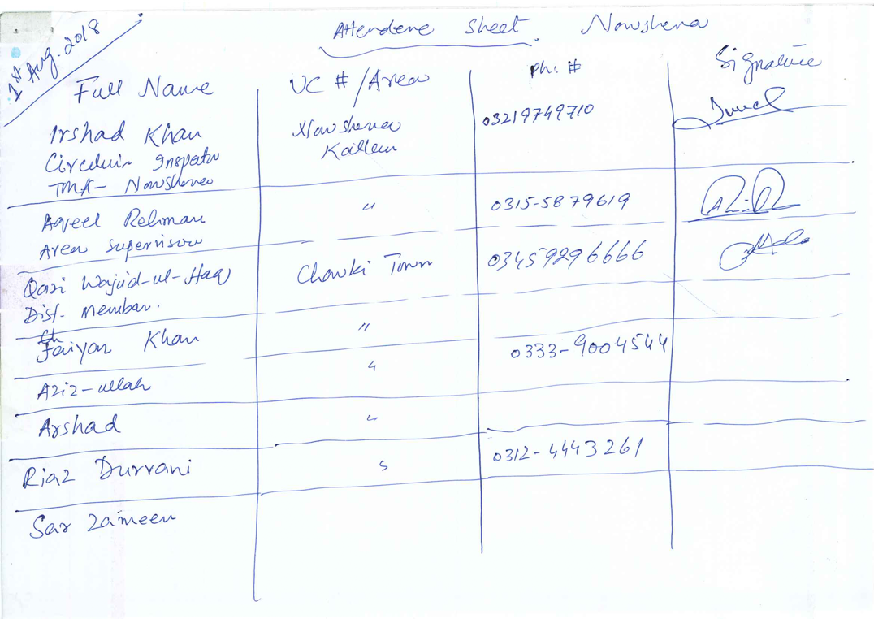

ANNEX 2: strategy to comply to the AF Environmental and Social Policy (ESP) and Gender Policy (GP)

Content:

- Introduction
- Environmental and social risks and impacts of the project and activities
- Environmental and Social Risks and Impacts Management Plan (ESMP)
- Specific gender approach and baseline

- Introduction
Purpose
The purpose of this annex is to demonstrate compliance of the project with the AF ESP and GP. In line with UN-Habitats Environmental and Social Management System and in line with the Adaptation Fund ESP and GP, UN-Habitat and partners need and will ensure that all proposed project activities and the project as a whole promote positive environmental and social benefits and mitigate or avoid adverse environmental and social risks and impacts and mainstreaming equal access among women and men, while building their resilience and capability to adapt to climate change impacts. This annex will be published for public consultation during the full proposal development phase. A summary of the project will then be included below.

Process to comply to the AF ESP and GP
At the full proposal phase, all project activities will be screened in detail against the 15 AF risk areas (i.e. safeguards) to identify potential risks and to assess potential environmental and social impacts. Besides that, an ESMP will be developed. At this stage (i.e. concept note), * an initial analysis / overview of the identified environmental and social risks and impacts and co-benefits and opportunities of the project activities with a special emphasis on gender is provided. In line with the GP, a gender approach and baseline are provided in a designated section. This is necessary in order to establish a data baseline at the project start against which implementation progress and results can be measured later. Data and analysis are provided based on community surveys, focus groups discussions, community planning and decision-making processes during the project proposal development phase.

*This annex is a ‘work in progress’ annex. Thus, more details will be provided during the full proposal development phase.

Summary of project
To be inserted at full proposal development phase.

- Environmental and social risks and impacts of the project and activities
Screening and categorization and environmental and social impact assessment
An initial screening has been carried out to identify potential environmental and social risks of proposed project activities and based on that, of the entire project. With this information, the entire project has been categorized. Because of the nature of the activities under component 2, the entire project is regarded as a medium risk (Category B) project. Therefore, an ESMP will be developed at the full proposal phase. Also, further details will be provided at the full proposal phase. For an overview of the outcomes of risk screening and impact assessment outcomes at the concept note phase, see table 20 below. For a description of the analysis see the section below the table.

Table 20: Overview of initial risk screening and impact assessment outcomes of project activities. For details, see below analysis per AF principle
Project activities |  | (Design) details |  |  |  | Risk screening outcome | Impact assessment
Component | Detailed activities | Location | Number of beneficiaries | Dimensions | Description | Risk screening outcome | Impact assessment
Component 1:  Enhance community- and household-level flood resilient water harvesting facilities (using innovative techniques) and to strengthen capacities to plan, construct, operate, maintain and duplicate these. | Output 1.1. (concrete)  5000 community / household level flood resilient water harvesting purification technology and facilities constructed, using innovative techniques | Rawalpindi: especially UC 4,5 and 6, but also 1,2, 12 and 37  Nowshera Kalan | Direct: 35000  Indirect: around 200.000 | See figure 15 (household level) | See figure 15 and annex 4 | Communities and vulnerable groups (especially women, youth, some Afghan families) need to be involved continuously; further, more details will be provided during full proposal phase for potential risks | Since the intervention is at household level and construction takes place at this level (roof) potential negative impacts are at this level and thus require full involvement of beneficiaries
 | Output 1.2.  8 union council-level community plans developed, community members (especially women and youth) trained and practical guide developed to plan, construct, operate, maintain and duplicate water harvesting facilities in ‘safe’ areas at community level | Rawalpindi: especially 4,5 and 6, but also 1,2, 12 and 37  Nowshera Kalan | 200.000 | 1 plan per  UC | A planning process will take place to involve groups equally and to develop plans and to train community members, especially women and youth | Vulnerable groups need to be consulted and involved equally | Although the activity does not entail an infrastructure interventions, it need to be ensured vulnerable groups are involved and benefit equally;  the number of direct training beneficiaries will be around 210 (30 per community)
Component 2  Enhance city and district-level up-stream water harvesting facilities (that also reduce flood impacts down-stream) and strengthen capacities to plan, construct, operate, maintain and duplicate these | Output 2.1. (concrete)  40 district / city-level water harvesting facilities (small dams) constructed (or smaller number if bigger dams are possible) | Rawalpindi: especially UC 1,2, 4,5, 6, 12 and 37 + whole of Rawalpindi  Nowshera District | Direct: 200.000 (for floods)  Estimations for water use to be made | Small dams / water reservoirs with costs of USD 30.000  Dimensions 10-100 meter | Small dams / water reservoirs will be constructed on public land | Communities and vulnerable groups in construction area and downstream impact area need to be involved continuously; further, more details will be provided during full proposal phase for potential risks related to human rights, core labour rights, protection of natural habitats, conservation of biological diversity, climate change, pollution prevention and resource efficiency, public health and land and soils conservation | The construction of the dam / water reservoir may have an impact flood impacts downstream and water availability. Because the intervention will not increase flood impact and increase water availability, it is not considered as high risks. However, the intervention can have some negative impacts on potential risk areas identified on the left.
 | Output 2.2.  Two city-level spatial planning strategies developed considering climate change risks and impacts, especially floods and droughts, and including comprehensive water harvesting plans and solid waste management plans. | Rawalpindi city  Nowshera city | 2 million  200.000 | One  strategy per  district / city | Vulnerable groups need to be involved in assessment, planning and development phases to identify specific needs and concerns and all potential risks to natural habitats, biodiversity, etc. considered.  See Annex 5 for Integrated Solid Waste Resource Centre | Strategies will comply with national laws, vulnerable groups need to be consulted and involved equally and potential risks and impacts of strategies / plans on vulnerable groups, nature, biodiversity, etc. considered. | Although the activity does not entail concrete / infrastructure interventions, it provides the ‘base’ to plan these for a large area with many inhabitants, which may have impacts on vulnerable groups, nature, etc.
 | Output 2.3.  50government officials trained and guide developed to plan, construct, operate, maintain and duplicate flood resilient water harvesting facilities and houses and to develop spatial plans | Rawalpindi city  Nowshera city | Direct: 50 | Not relevant | Government officials trained | Representation need to be gender sensitive
Component 3  Strengthen national-level capacity to guide / direct city-level development considering climate change and disaster risks and impacts, especially floods and droughts. | Output 3.1.  100 government officials (women men) trained to guide / direct urban development considering climate change and disaster risks and impacts, using especially spatial planning tools. | National government | Direct: 100 | Not relevant | Government officials trained | Representation need to be gender sensitive
 | Output 3.2.  One National urban strategy / plan focused on climate change / disaster risk reduction developed  One National guidelines for spatial / urban planning considering climate change / disaster risks developed | National government / whole country |  | Two national strategies | Needs of vulnerable groups Vulnerable groups need to be involved in assessment, planning and development phases to identify specific needs and concerns and all potential risks to natural habitats, biodiversity, etc. considered. | Strategies will comply to national laws, needs of vulnerable groups need to represented and potential risks and impacts of strategies / plans on vulnerable groups, nature, biodiversity, etc. considered. | Although the activity does not entail concrete / infrastructure interventions, it provides the ‘base’ to plan these for a large area with many inhabitants, which may have impacts on vulnerable groups, nature, etc.

Risk screening details 15 AF principles

AF principle 1: Compliance with the law
For all proposed activities, relevant rules, regulations and standards and procedures have been identified and procedures to comply to these (see part II.D). During the full proposal development phase, more details will be provided about how all proposed activities comply with national laws.

In line with national standards / requirements (see figure x below), an IEE- Regulation 3 will be conducted / prepared for output 2.1.: Water management, dams, irrigation and flood protection. Dams and reservoirs with storage volume less than 50 million cubic meters of surface area less than 8 square kilometres. Irrigation and drainage projects serving less than 15,000 hectares. Small-scale irrigation systems with total cost less than Rs.50 million.

The IEE will be prepared during the full proposal development phase following Federal government and sectoral guidelines and following steps / processes as described in the 2014 Government of Pakistan and International Union for Conservation of Nature and Natural Resources. Environmental Impact Assessment Handbook for Pakistan.However, it will also assess potential risks and impacts in line with the AF ESP and GP considering the 15 AF principles and potential earthquake and land slide risks. This will be done not only done comprehensively for output 2.1., but also for all other activities.

Figure 20: overview of projects that require an environmental and social impact assessment.
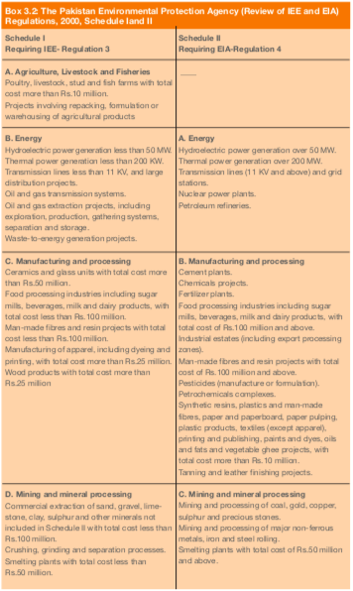 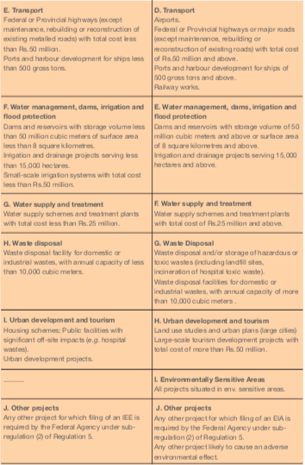Source: 2014 Government of Pakistan and International Union for Conservation of Nature and Natural Resources. Environmental Impact Assessment Handbook for Pakistan.
AF principle 2: Access and equity
The project will ensure that project benefits will be allocated equally and that discrimination nor favouritism in accessing project benefits can take place. This is done through detailed stakeholder mapping, including identification of specific concerns and needs of beneficiaries and specific groups, the development of a specific ‘gender’ approach and baseline, and to propose measure to avoid unequal access or favouritism. Although the basis for this has been set-up during the concept note development phase, detailed assessments will be conducted during the full proposal development phase, including consultations with vulnerable communities and groups focused on identifying and confirming potential risks and impacts of all proposed activities.

Risk identification at concept note phase: for all proposed project activities, there is a potential risk that project benefits are not allocated equally between beneficiaries. The project will therefore ensure equal representation of vulnerable groups during consultations, planning processes and for possible job opportunities.

AF principle 3: Marginalized and vulnerable groups
The project will ensure that possible adverse impacts of all project activities on marginalized and vulnerable groups are identified and avoided / mitigated. This is done through detailed stakeholder mapping, including identification of specific concerns and needs of beneficiaries and specific groups, the development of a specific ‘gender’ approach and baseline, and to propose mitigation measures, when needed, to reduce the risks. Although the basis for this has been set-up during the concept note development phase, detailed assessments will be conducted during the full proposal development phase, including consultations with vulnerable communities and groups focused on identifying and confirming potential risks and impacts of all proposed activities. All potential adverse impacts will then be identified, taking into consideration the specific needs, limitations, constraints and requirements of each group.

Risk identification at concept note phase: for all proposed project activities, there is a potential risk of adverse impacts on marginalized or vulnerable groups, especially internally displaced and refugee, as well as (undocumented) women and girls (see below). The project will therefore ensure equal representation of vulnerable groups during consultations, planning processes and for possible job opportunities, especially if it comes to water harvesting activities and trainings.

AF principle 4: Human rights
The project will ensure that possible human rights issues relevant to all proposed project activities are addressed. This is done through an identification and analysis of relevant human rights in the special procedures and by making human rights a subject during consultations. Human rights issues have been an explicit part of consultations during the concept note phase (see outcomes consultations in part II.H and annex 1 (especially consultations with ILO, UN Women and OCHA). At the full proposal phase, potential human rights issues relevant to all proposed project activities will also be explicitly part of community and vulnerable groups consultations.

Risk identification at concept note phase: an analysis of potential relevant human rights issues that are identified in the Special Procedures are included below, as well as a description of how the project will address potential risks related to these relevant human rights issues:

According to the Human Rights Council Working Group on the Universal Periodic Review, some challenges related to Human rights still exist in Pakistan: ‘In the pursuit of promotion and protection of human rights and fundamental freedoms, the Government continues to face challenges, including among others, combating terrorism, resource constraints, capacity building, awareness raising, effective enforcement of laws and policies, protection of vulnerable groups and natural disasters due to climate change, among others.’

A relevant convention that is not ratified is: The International Convention on the Protection of the Rights of all Migrant Workers and Members of Their Families and the International Convention for the Protection of All Persons from Enforced Disappearance. As mentioned by the Committee on the Elimination of Discrimination against Women there is lack of a national legal framework on refugees and a gender-sensitive approach to address the specific needs and risks of internally displaced and refugee, as well as undocumented, women and girls.

The project will ensure a gender-sensitive approach is taken (see below), especially to address the specific needs and risks of internally displaced and refugee, as well as undocumented, women and girls by ensuring representation throughout the project (see above) and by making reference toand agreement to comply to – universal human right in all contract and MoUs and AoCs used in the project.

As for output 2.1there is a potential risk that the area required to construct water harvesting facilities will cover agriculture land or land owned privately. If this is the case, it need to be ensured that land owners agree with the intervention and that appropriate compensation is provided.

AF principle 5: Gender

The project will ensure that gender equality and women’s empowerment is ensured for all project activities. This is done through detailed stakeholder mapping, including identification of specific concerns and needs of women, the development of a specific ‘gender’ approach and baseline, and to propose mitigation measures, when needed, to reduce the risks. Although the basis for this has been set-up during the concept note development phase (including women focus groups discussions), detailed assessments will be conducted during the full proposal development phase, including consultations with women focused on identifying and confirming potential risks and impacts of all proposed activities. All potential adverse impacts will then be identified, taking into consideration the specific needs, limitations, constraints and requirements of each group.

Risk identification at concept note phase: for all proposed project activities, there is a potential risk of unequal benefits to women. The project will therefore take a specific gender approach for women, children and youth (see below).The project will ensure equal representation of this group during consultations, planning processes and for possible job opportunities. Potential risks mitigation measures include reduce potential risks of violence against women (e.g. by organizing activities in groups) and by promoting women as agents of change, where possible, without risks.

AF principle 6: Core Labour rights

The project will ensure that possible core labour rights issues relevant to all proposed project activities are addressed. This is done through an identification and analysis of relevant national core labour rights and by making core labour rights a subject during consultations. Core labour rights have been an explicit part of consultations during the concept note phase (see outcomes consultations in part II.H and annex 1 (especially consultations with ILO). At the full proposal phase, potential core labour rights issues relevant to all proposed project activities will also be explicitly part of community and vulnerable groups consultations.

Risk identification at concept note phase: The Pakistan government did not ratify all governance and technical conventions and protocols. According to ILO representatives (see part II.H), the project should

- Ensure safety and health (155 and 187) are guaranteed during activities, especially for women
- Promoting decent work / livelihood options (skills, protection, diversification) and build upon existing skills

This will be done by making reference toand agreement to comply to – ILO standards, and especially safety and health (155 and 187) in all contract and MoUs and AoCs used in the project and by providing required signs and equipment to comply. The project will also promote decent work / livelihood options (skills, protection, diversification) and build upon existing skills through trainings focused on operation and maintenance of water harvesting facilities and housing.

AF principle 7: Indigenous people:

The project will ensure that possible adverse impacts of all project activities on indigenous people (if identified during full proposal phase) are identified and avoided / mitigated. This is done through detailed stakeholder mapping, including identification of specific concerns and needs of indigenous groups, the development of a specific ‘gender’ approach and baseline, and to propose mitigation measures, when needed, to reduce the risks. Although the basis for this has been set-up during the concept note development phase, detailed assessments will be conducted during the full proposal development phase, including consultations with vulnerable communities and groups focused on identifying and confirming potential risks and impacts of all proposed activities. All potential adverse impacts will then be identified, taking into consideration the specific needs, limitations, constraints and requirements of each group.

Risk identification at concept note phase: the project will ensure all indigenous groups in target areas are identified (if any) during the full proposal phase. At the concept note stage, no indigenous groups have been identified. If specific indigenous groups are identified, the project will therefore ensure equal representation of this group during consultations, planning processes and for possible job opportunities and to give groups to right to give or withhold its consent to proposed projects that may affect the lands they customarily own, occupy or otherwise use (in line with UNDRIP, and particularly with regard to Free, Prior, Informed Consent (FPIC)). Also, awareness about the rights of indigenous peoples and how it is a general principle in consultation will be raised if indigenous groups are identified. Analysis so far:

- Sudan is not mentioned by OHCHR.

AF principle 8: Involuntary resettlement

The project will ensure physical or economic displacement is avoided for each project activity.

Risk identification at concept note phase: output 2.1., which entails the construction of district / city-level water harvesting facilities in an area close to the target cities. If drainage-related interventions are required, this will only take place in or along existing channels and on public land. More details about land ownership, etc. will be provided during the full proposal development phase. Reference to and agreement to comply with human right related to avoiding involuntary resettlement will be made in all contract and MoUs and AoCs. No interventions will take place without the consent of inhabitants in the targeted area.

AF principle 9: Protection of natural habitats

The project will ensure no negative impacts on natural habitats will result from project activities.

Risk identification at concept note phase: which entails the construction of district / city-level water harvesting facilities in an area close to the target cities. No natural habitats have been identified in construction area. However this will be double-checked during the full proposal development phase.

AF principle 10: Conservation of biological diversity

The project will ensure no negative impacts on biological diversity will result from project activities.

Risk identification at concept note phase: According to IUCN red list Calomyscus baluchi may live in or around the target area. During the full proposal phase, possible impacts of project activities, especially related to output 2.1.,that may have effects on life in streams and surroundings, potential intervention impacts will be assessed. Under the UNESCO Man and the Biosphere Programme reserve, there are no ‘biospheres’ identified in target areas.

AF principle 11: Climate change

The project will ensure no negative climate change impacts will result from project activities, such as increases in the emissions of greenhouse gasses or in other drivers of climate change.

Risk identification at concept note phase: in line with internationally recognized standards, large interventions in the following sector require a greenhouse gas emissions calculation: energy, transport, heavy industry, building materials, large-scale agriculture, large-scale forest products, and waste management. In line with national standards, environmental and social impact assessments will be conducted for the proposed activities under output 2.1. These assessments will also consider potential greenhouse gas emissions as a result of use of building materials.

AF principle 12: Pollution Prevention and Resource Efficiency
The project will ensure pollution will be prevented and resources will be used efficiently for all project activities.

Risk identification at concept note phase: In line with national standards, environmental and social impact assessments will be conducted for the proposed activities under output 2.1.These assessments will also consider pollution prevention and resource efficiency. In principle the intervention promotes resource efficiency as it has a double function of flood prevention and water supply, thus avoiding multiple infrastructure interventions to establish the same.

AF principle 13: Public health

The project will ensure no negative public health impacts will result from project activities.

Risk identification at concept note phase: In line with national standards, environmental and social impact assessments will be conducted for the proposed activities under output 2.1. These assessments will also consider potential health impacts. To avoid potential negative health impacts for this activity and other activities safety signs and equipment will be provided in line with core labour rights (155 and 187).

AF principle 14: Physical and Cultural Heritage

The project will ensure no negative impacts on heritage sites will result from project activities.

Risk identification at concept note phase: UNESCO identified the following Heritage sites in Pakistan:
- Archaeological Ruins at Moenjodaro
- Buddhist Ruins of Takht-i-Bahi and Neighbouring City Remains at Sahr-i-Bahlol
- Taxila
- Fort and Shalamar Gardens in Lahore
- Historical Monuments at Makli, Thatta
- Rohtas Fort

These are not located in the target areas. However, identification of for the communities ‘important’ buildings in target areas will be part of community and vulnerable groups consultations during the full proposal development phase.

AF principle 15: Lands and Soil Conservation.
The project will ensure no negative impacts lands and soil conservation will result from project activities.

Risk identification at concept note phase: In line with national standards, environmental and social impact assessments will be conducted for the proposed activities under output 2.1. These assessments will also consider potential impacts on lands and soils by identifying fragile soils and valuable lands, if any, and to propose measures to reduce negative effects.

- Environmental and Social Risks and Impacts Management Plan (ESMP)
To be inserted at full proposal development phase. It will include:

- Risks management arrangements
- Risks monitoring and evaluation arrangements
- Grievance mechanism
- Overview of potential risks and mitigation measures and monitoring arrangements

- Gender approach and baseline
Purpose
The purpose of developing a specific gender approach and baseline is to provide an overview of what measures have been taken to ensure that women and men and vulnerable groups will have equal opportunity to build resilience, address their differentiated vulnerabilities and increase their capability to adapt to climate change impacts through project implementation (by providing a baseline with targets). Moreover, it also shows how, in this project, women and youth groups are recognized as “agent of change” in building community resilience.

Project preparation process
An UN-Habitat headquarter gender specialist is involved in the project preparation to ensure compliance with the Gender Policy. The project design and approach are ‘gender-responsive’ because, during the project preparation phase, gender equality and women’s empowerment have been considered during initial data collection focused on issues, needs and perceptions, activity prioritization and the identification and verification of specific ‘gender’ related risks and impacts. This has been done through desk research, surveys, focus group discussions and community decision-making processes.

Specific steps and considerations

- Determinants for gender-responsive stakeholder consultation

Focus group discussions with women have been conducted during the concept note development phase, especially to identify specific needs regarding proposed interventions. Focus group consultations with youth, children and migrants are also planned for the full proposal development phase (besides women) to further identify and assess specific needs regarding proposed interventions and possible and perceived risks and, where needed, mitigation measures. Besides that, the following stakeholders have been or will be consulted during the full proposal phase to understand specific gender issues and needs:

Table 21: Stakeholders (to be consulted) for gender approach
Type of stakeholder | Specific stakeholder
National government | To be done during full proposal phase)
UN agencies | UN women, UNIC, UNIDO, UNDP, UNDSS (gender working group)  (at concept note proposal development phase)
Community level | Women group in Rawalpindi target communities  Women group in Nowshera target communities (to be done during full proposal phase)
See part II.H and annex 1

- Initial Gender Assessment

The following has been or will be identified / determined:

- Data baseline – overview of disaggregated data (beneficiaries) in target areas. Per activities see Part II.C

Table 22: Data baseline – overview of disaggregated data (beneficiaries) in target areas
Population / beneficiaries
(Disaggregated)
Rawalpindi | Nowshera
Total: 155,700  - Female: 47%  - < age14: 37%  - age 15-24: 21%  - age 25-60: 39 %  - > age 60: 3%  - Disabled: 2%  - Some Afghan refugee families | Total: 83,567  - Female: 48%  - < age14: 38%  - age 15-24: 20%  - age 25-60: 40 %  - > age 60: 2%  - Disabled: 2%  - Nowshera district had once sheltered a very large number of Afghan refugees. In recent years it became one of the main areas where IDPs from trouble hit tribal areas and Swat took refuge. However, the exact population of this refugee population in Nowshera Kalan is not known.

- Differentiated climate change impacts on men and women and their differentiated capacities do adopt to these, gender division of labour and gender-based power structures.

According to the gender work group and women focus group discussions in Rawalpindi, impacts of floods and climate change related diseases especially affect women (but also children) in a specific way, including:

Flood specific issues:
- Women being responsible for housekeeping put a lot of effort and time in cleaning their houses whenever they are affected by floodwaters.
- The monsoon season brings fear and especially women have to stay extra conscious spending sleepless nights.
Disease specific issues:
- The prevalence of water borne disease and epidemics especially affects younger children. Taking care of them primarily comes to women increasing their burden and affecting their productive time. Disability among children is especially high.
Water scarcity specific issues:
- Women have to travel almost two kilometers to bring drinking water from two nearby water sources--private boreholes.

- Analysis of legal status of women in the country/region
  - Consider potential risk of ‘violence against women (domestic) and harassment.

- Analysis of cultural/religious status of women in the country/region
  - Misinterpretation but often dependent on men (also in decision-making), which can be a problem with e.g. rescue work, especially when women are not registered – key challenges: mobility, social norms and mindsets.
  - Women are typically absent from the forum where Disaster Risk Reduction (DRR) decisions / planning is made, so when priorities are established, the interests of women are often poorly represented.

- Opportunities for promoting a ‘women’ and ‘youth’ as agents of change
  - Women are generally water ‘handlers’ - Train women to use technologies for water harvesting
  - Build the capacities of national and local women’s groups’ and provide them with a platform to be heard and to lead - Suggest working with national commission ‘status of women’ and gender focal points within NDMA and departments - Development of a women volunteers team within each community to address women and girls special needs
  - Mainstreaming gender into policy processes, programmes and projects can help ensure that such processes equitably benefit women and men while allowing optimal use of the unique knowledge and skills of women and men.
  - Suggest focussing on skills + capacity development

Figure 21: consultations with women union in Rawalpindi
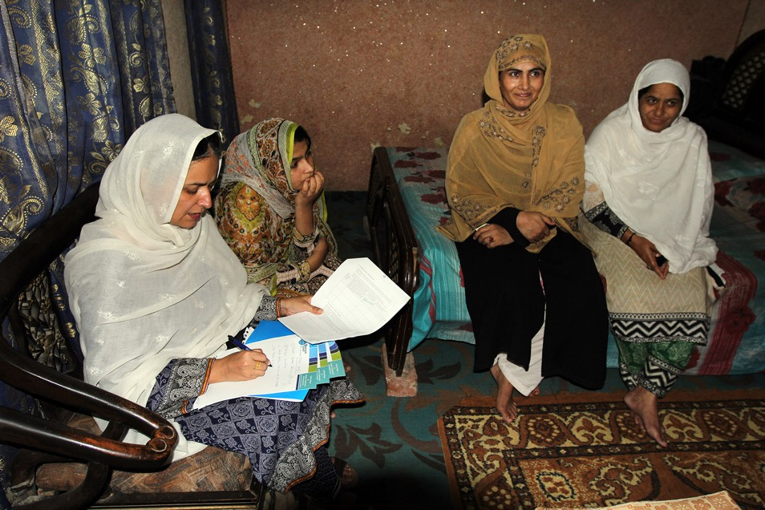

- Project planning and design

The following will be further identified / determined during the full proposal development phase:

- Program goals/objectives and target groups
- Key gender goals (to improve gender equality)
- Entry points to integrate gender considerations (how to empower women and youth)
- Suitable interventions to meet specific needs and built on women skills and knowledge

- Design of intervention activities:
- Promoting an enabling environment for gender equality
- Specific roles and needs women (and men) and youth
- Involvement women (and men) and youth in activities
- Additional activities needed to ensure gender perspective, incl. risk mitigation measures

Table 23: gender baseline, goals and roles
Scale | Disaggregated beneficiaries, gender specific issues and needs (see 2) / baseline | Key goals, entry points and suitable interventions (see 3a) | Specific roles and activities to ensure gender perspective (see 3b), incl. potential risk mitigation measures (see also ESMP)
State / municipal | No clear women focal points in ministries / municipality | Establish focal points
Focus area / community | Women have strong ties and communicate well | Target especially women, youth for trainings
(Concrete)  intervention | Women are usually water handlers | Include women in planning and execution

- Executing entities:
- Commitment to gender equality
- Capacity building objective

- Project outputs
- Specific for women and youth
- Measuring how the environment will enable gender equity

- Gender responsive indicators
- Indicators towards fulfillment of goals / objectives
- Gender disaggregated
- Targets toward equality

- Budget
- Allocation for mainstreaming?

Table 24: gender perspective, targets, indicators and budget
Component and outputs | Gender perspective selected executing entity (see 3c) | Specific ‘gender’ targets (when specific ‘gender’ output) (see 3d and e) | Specific ‘gender’ Indicators  (see 3e) | Budget required and allocated  (see 3f)

- Implementation
- Adaptive management
- Gender expertise and focal points
- Are partner organizations aware
- Sustainability of gender response/on-going engagement of women
- Strategy for capacity building for local women

- Performance Monitoring and Evaluation
- Gender responsive management response in place, including participatory monitoring?
- Methods, tools and budgets needed to collect ‘gender data’?

- Knowledge Management, Information Sharing and Reporting
- Gender considerations (inequalities, needs, etc.)
- Lessons learnt and best practices

ANNEX 3: Multi-hazard vulnerability matrix
Table 25: District wise monsoon hazard vulnerability matrix - Khyber Pakhtunkhawa province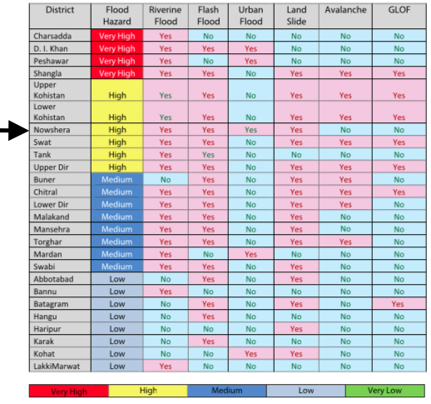
Source: National Monsoon Contingency Response Directive 2017 National Disaster Management Authority, Government of Pakistan

Table 26: Pakistan multi-hazard risk index 2018 - Khyber Pakhtunkhawa province
Province | District | Flood | Land Slide | Earthquake | Tsunami | Cyclone | Drought | Avalanche | GLOF | Total Risk
Khyber Pakhtunkhawa | Shangla | 5 | 4 | 5 | 0 | 2 | 4 | 5 | 5 | 30
Khyber Pakhtunkhawa | Sawat | 5 | 5 | 4 | 0 | 2 | 2 | 5 | 5 | 28
Khyber Pakhtunkhawa | Upper Dir | 4 | 5 | 4 | 0 | 2 | 2 | 4 | 5 | 26
Khyber Pakhtunkhawa | Batagram | 3 | 4 | 4 | 0 | 2 | 3 | 4 | 5 | 25
Khyber Pakhtunkhawa | Mansehra | 4 | 5 | 4 | 0 | 2 | 1 | 4 | 5 | 25
Khyber Pakhtunkhawa | Buner | 5 | 4 | 4 | 0 | 2 | 4 | 4 | 1 | 24
Khyber Pakhtunkhawa | Charsadda | 5 | 3 | 5 | 0 | 2 | 3 | 5 | 1 | 24
Khyber Pakhtunkhawa | Mardan | 5 | 5 | 5 | 0 | 2 | 1 | 5 | 1 | 24
Khyber Pakhtunkhawa | Nowshera | 5 | 4 | 5 | 0 | 2 | 3 | 4 | 1 | 24
Khyber Pakhtunkhawa | Abbottabad | 3 | 5 | 5 | 0 | 2 | 2 | 5 | 1 | 23
Khyber Pakhtunkhawa | Peshawar | 5 | 3 | 5 | 0 | 2 | 3 | 4 | 1 | 23
Khyber Pakhtunkhawa | Swabi | 5 | 3 | 5 | 0 | 2 | 2 | 5 | 1 | 23
Khyber Pakhtunkhawa | Lower Dir | 4 | 4 | 5 | 0 | 2 | 1 | 5 | 1 | 22
Khyber Pakhtunkhawa | Haripur | 3 | 5 | 4 | 0 | 2 | 1 | 4 | 1 | 20
Khyber Pakhtunkhawa | Kohistan | 3 | 4 | 3 | 0 | 1 | 1 | 4 | 4 | 20
Khyber Pakhtunkhawa | Malakand | 4 | 3 | 5 | 0 | 2 | 1 | 4 | 1 | 20
Khyber Pakhtunkhawa | Bannu | 4 | 2 | 5 | 0 | 2 | 4 | 1 | 1 | 19
Khyber Pakhtunkhawa | Hangu | 3 | 3 | 4 | 0 | 2 | 3 | 1 | 1 | 17
Khyber Pakhtunkhawa | Chitral | 3 | 4 | 2 | 0 | 1 | 1 | 2 | 3 | 16
Khyber Pakhtunkhawa | Tank | 4 | 1 | 3 | 0 | 2 | 4 | 1 | 1 | 16
Khyber Pakhtunkhawa | D. I. Khan | 5 | 1 | 2 | 0 | 2 | 2 | 1 | 1 | 14
Khyber Pakhtunkhawa | Kohat | 3 | 2 | 3 | 0 | 2 | 2 | 1 | 1 | 14
Khyber Pakhtunkhawa | Lakki Marwat | 3 | 1 | 3 | 0 | 2 | 1 | 1 | 1 | 12
Khyber Pakhtunkhawa | Karak | 2 | 2 | 2 | 0 | 1 | 1 | 1 | 1 | 10
Source: Pakistan Federal Flood Commission

Table 27: District wise monsoon hazard vulnerability matrix - Punjab province 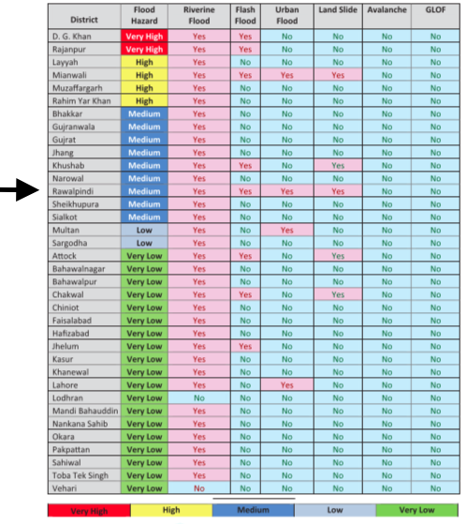
Source: National Monsoon Contingency Response Directive 2017 National Disaster Management Authority, Government of Pakistan

Table 28: Federal Flood Commission risk index 2018 - Punjab province
Province | District | Flood | Land Slide | Earthquake | Tsunami | Cyclone | Drought | Avalanche | GLOF | Total Risk
Punjab | Rawalpindi | 4 | 5 | 5 | 0 | 2 | 3 | 1 | 1 | 21
Punjab | Sheikhupura | 5 | 2 | 4 | 0 | 2 | 4 | 1 | 1 | 19
Punjab | Multan | 4 | 1 | 4 | 0 | 2 | 5 | 1 | 1 | 18
Punjab | Rahim Yar Khan | 5 | 1 | 3 | 0 | 2 | 5 | 1 | 1 | 18
Punjab | Gujranwala | 5 | 2 | 4 | 0 | 2 | 2 | 1 | 1 | 17
Punjab | Gujrat | 5 | 2 | 5 | 0 | 2 | 1 | 1 | 1 | 17
Punjab | Mianwali | 4 | 4 | 3 | 0 | 2 | 2 | 1 | 1 | 17
Punjab | Muzaffargarh | 5 | 1 | 3 | 0 | 2 | 4 | 1 | 1 | 17
Punjab | Okara | 3 | 1 | 5 | 0 | 2 | 4 | 1 | 1 | 17
Punjab | Nankana Sahib | 3 | 2 | 4 | 0 | 2 | 4 | 1 | 1 | 17
Punjab | Faisalabad | 3 | 1 | 4 | 0 | 2 | 4 | 1 | 1 | 16
Punjab | Jhang | 5 | 1 | 3 | 0 | 2 | 3 | 1 | 1 | 16
Punjab | Narowal | 5 | 1 | 5 | 0 | 2 | 1 | 1 | 1 | 16
Punjab | Sahiwal | 3 | 1 | 4 | 0 | 2 | 4 | 1 | 1 | 16
Punjab | Sialkot | 5 | 1 | 5 | 0 | 2 | 1 | 1 | 1 | 16
Punjab | Toba Tek Singh | 3 | 1 | 4 | 0 | 2 | 4 | 1 | 1 | 16
Punjab | Jhelum | 3 | 2 | 4 | 0 | 2 | 2 | 1 | 1 | 15
Punjab | Kasur | 3 | 1 | 4 | 0 | 2 | 3 | 1 | 1 | 15
Punjab | Khanewal | 3 | 1 | 3 | 0 | 2 | 4 | 1 | 1 | 15
Punjab | Khushab | 4 | 2 | 3 | 0 | 2 | 2 | 1 | 1 | 15
Punjab | Leiah | 5 | 1 | 2 | 0 | 2 | 3 | 1 | 1 | 15
Punjab | Lodhran | 3 | 1 | 3 | 0 | 2 | 4 | 1 | 1 | 15
Punjab | D. G. Khan | 5 | 1 | 2 | 0 | 2 | 3 | 1 | 1 | 15
Punjab | Sargodha | 4 | 2 | 3 | 0 | 2 | 2 | 1 | 1 | 15
Punjab | Rajanpur | 5 | 1 | 2 | 0 | 2 | 3 | 1 | 1 | 15
Punjab | Lahore | 3 | 1 | 4 | 0 | 2 | 2 | 1 | 1 | 14
Punjab | Mandi Bahauddin | 3 | 1 | 4 | 0 | 2 | 2 | 1 | 1 | 14
Punjab | Pakpattan | 3 | 1 | 3 | 0 | 2 | 3 | 1 | 1 | 14
Punjab | Vehari | 3 | 1 | 3 | 0 | 2 | 3 | 1 | 1 | 14
Punjab | Chiniot | 3 | 1 | 3 | 0 | 2 | 3 | 1 | 1 | 14
Punjab | Bahawalnagar | 3 | 1 | 2 | 0 | 2 | 3 | 1 | 1 | 13
Punjab | Hafizabad | 3 | 1 | 3 | 0 | 2 | 2 | 1 | 1 | 13
Punjab | Bahawalpur | 2 | 1 | 2 | 0 | 2 | 3 | 1 | 1 | 12
Punjab | Attock | 2 | 2 | 3 | 0 | 1 | 1 | 1 | 1 | 11
Punjab | Chakwal | 2 | 1 | 3 | 0 | 1 | 2 | 1 | 1 | 11
Punjab | Bhakkar | 3 | 1 | 2 | 0 | 1 | 1 | 1 | 1 | 10
Source: Pakistan Federal Flood Commission

ANNEX 4: water harvesting and drinking water cleaning techniques

RWH best practices

Singapore: The Republic of Singapore has a land area of 61,000 hectors. Water availability is poor. In spite of 50 per cent of land area being used as a water catchment area, almost 40-50 per cent of water requirements are imported. After considerable research and development, schemes of abstraction of ground water in Singapore include utilisation roofs of high rise buildings, use of run-off from airports for non-potable uses, integrated systems using combined run-off from industrial complexes, aquaculture farms and educational institutions.

A recent study of an urban residential area of about 742 ha used a model to determine the optimal storage volume of the rooftop cisterns, taking into consideration non-potable water demand and actual rainfall at 15-minute intervals. This study demonstrated an effective saving of four per cent of the water used, the volume of which did not have to be pumped from the ground floor. As a result of savings in terms of water, energy costs, and deferred capital, the cost of collected roof water was calculated to be S$ 0.96 against the previous cost of S$1.17 per cubic metre. The catchment areas, under utilisation, are relatively clean and as a result the raw waters are of good quality. Singapore has earmarked specific locations where pollution-contributing activities are prohibited. The growing need of water led to the establishment of Lower Seletar-Bedak Water Scheme in 1986. Control of Water Pollution and relevant technologies were the main priorities in the said scheme. Control of water pollution required great inter-departmental coordination which included government and quasi-government groups.

Besides interdepartmental planning for controlling water pollution, there are other important factors to be considered in the overall planning of such systems which include: hydrological simulation, water quality, trapping urban run-off, sediment removal etc. It has been established in Singapore that the utilisation of urban catchments is a reality that can be highly efficient if the system is well-planned and maintained. Additional research and development will help to optimise the reliable yield from such catchments and make the multiple uses of such catchments a truly working proposition.

A marginally larger rainwater harvesting and utilisation system exists in the Changi Airport. Rainfall from the runways and the surrounding green areas is diverted to two impounding reservoirs. One of the reservoirs is designed to balance the flows during the coincident high runoffs and incoming tides, and the other reservoir is used to collect the runoff. The water is used primarily for non-potable functions such fire-fighting drills and toilet flushing. Such collected and treated water accounts for 28 per cent to 33 per cent of the total water used, resulting in savings of approximately S$ 390,000 per annum.

The experience of Singapore shows that the concept of utilising small catchments has to be accepted. The system of rainwater harvesting can be adopted in all the airports. The airports can provide both larger surface run-off and roof water. For utilising urban catchments there is a need for proper coordination among various departments. This is very important to monitor qualitative and quantitative characteristics of the raw water.

China’s Gansu Province: Gansu Province lies on the Loess Plateau in central China and is one of the driest and poorest areas of the country with annual per capita incomes of around US $70-80 in rural areas. Traditionally, people have depended on rainwater as their main source of water supply, excavating 20m3 clay lined underground cisterns in the loses (check word) soil for storing surface runoff. In dry years, however, these could not always provide sufficient water and people were forced to trek long distances to rivers or to depend on government water trucks. In 1995, the region suffered its worst drought in 60 years. In response the Gansu Research Institute for Water Conservancy with the support of the Provincial Government launched the 1-2-1 project which was based on test trials, demonstrations and pilot projects carried out since 1988.

The 1-2-1 projects were so named because each family was provided with one clay tiled roof catchment area, two upgraded cement water cellars and plastic sheeting for concentrating rainwater runoff on one field. Traditional clay lined water cellars (Shuijiao) were upgraded by lining them with cement or concrete and small metal pumps were also attached. Proper tiled roof catchments and cemented courtyards replaced the bare earth catchments and strong plastic sheeting was placed over the rills on fields to concentrate runoff onto crops. Some households also used spare plastic sheeting to construct temporary greenhouses using wooden frames. A trench dug around these was used to collect any rainwater for watering the vegetables being produced.

Using these simple, effective yet inexpensive approaches, the project assisted over 200,000 families in 1995-1996 and ensured that around one million people were provided not only with sufficient water but also with food and through the production of cash crops some limited income. For a total cost of around US $12 million, half provided by the local government and half by community donations, the recipient families acquired upgraded water supplies and supplementary irrigation. The provision of labour and locally available materials by the community ensured that the total implementation cost for the project amounted to just US $12 per capita.

Changi Airport, Singapore
A marginally larger rainwater harvesting and utilisation system exists in the Changi Airport. Rainfall from the runways and the surrounding green areas is diverted to two impounding reservoirs. One of the reservoirs is designed to balance the flows during the coincident high runoffs and incoming tides, and the other reservoir is used to collect the runoff. The water is used primarily for non-potable functions such fire-fighting drills and toilet flushing. Such collected and treated water accounts for 28 per cent to 33 per cent of the total water used, resulting in savings of approximately S$ 390,000 per annum.

The experience of Singapore shows that the concept of utilising small catchments has to be accepted. The system of rainwater harvesting can be adopted in all the airports. The airports can provide both larger surface run-off and roof water. For utilising urban catchments there is a need for proper coordination among various departments. This is very important to monitor qualitative and quantitative characteristics of the raw water.

Rainwater Harvesting in Indore: The water supply to the town of Indore is 168 million litres per day as against the daily requirement of 320 million litres. A declining rainfall and the growing population has resulted in the gap increasing between demand and supply. This gap between demand and supply is met through tapping groundwater. As a result, the groundwater table is rapidly declining. Energised pumps are working overtime to meet water needs. Thus, when it comes to overexploitation of groundwater, Indore’s story is no different from other big and small towns across India.

What is different is the effort of the people to harvest rains. The Indore Municipal Corporation (IMC) and the city Mayor with the help of some media groups are involved in raising awareness and implementing rainwater harvesting. But rather than just complain, residents of the town are taking the matter into their own hands and are trying to alleviate the problem. Efforts to raise the groundwater level in the area have started through rainwater harvesting programmes. Infact, the proprietors of Nai Duniya, a newspaper group, agreed to deposit in a Nai Duniya Seva Trust a sum of five paise from each of the 1,30,000 newspaper copies sold everyday. So far, about Rs 75 lakh have been collected and will be used for development projects.

A rebate of six per cent on property tax has been announced for those who install rainwater harvesting in their house, bungalow or building. Three committees – technical, education and execution committees were set up by the Indore Municipal Corporation (IMC) for this purpose – the first of its kind in the country. For construction of new buildings on areas more than 250 square metres in size, rainwater harvesting is now compulsory. The Corporation has proposed to make rainwater harvesting mandatory for the existing buildings

Rain Water Harvesting planning and procedure Pakistan

To utilize the resources with less expenditure prior planning is the requisite of any project and is same for the rain water harvesting rather more than for Rural Housing, because owner will directly bear the money may be in most of the cases he will cut the food and other necessary budget and use for rain water collection.

Planning; check the house for potential harvesting of rain water.
Storage available, or anticipated. Obstruction/intervention like projections, intended extension and etc.
Decision of collection point; this is the most important point to be considered prior to gutter fixing. It is better to have one collection point for a single house, but seldom it is feasible to have one point collection especially for big and complex shaped houses. it will have extra initial and maintenance cost.

Initially people will use potable storage tanks, but in future they will construct tanks, when ever they will have money and spare time. So this is very important to consider land for permanent collection point if feasible.

Step by step procedure;

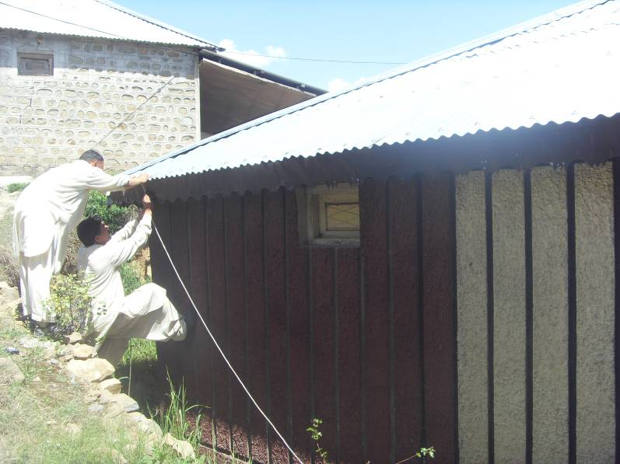

Mark the level at eve boarding and tie the string at mark point. This will give overview of slop and direction of flow.

In old houses or poor carpentry work roof edge is not in straight line. This will interrupt water flow.

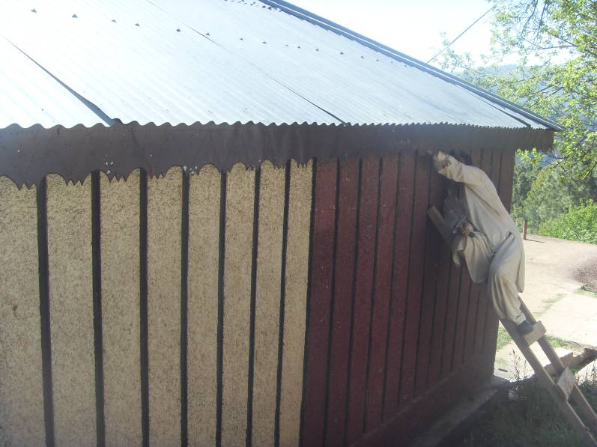
This point at roof is 2’’ humped and needs readjusting .

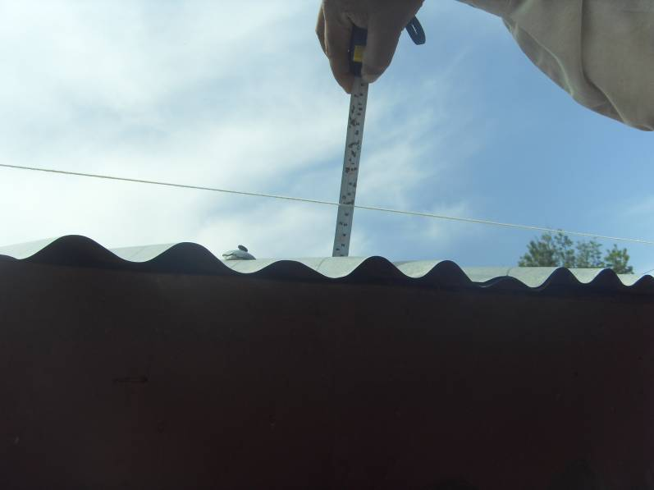
This point is 3’’ because of bending of purlin.

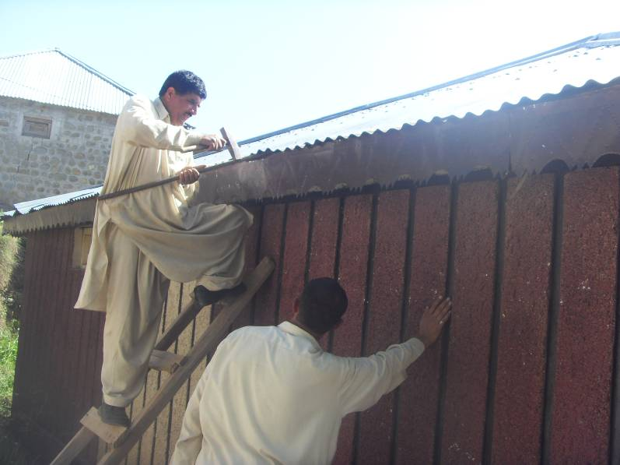

Readjustment.

Taking out nails;
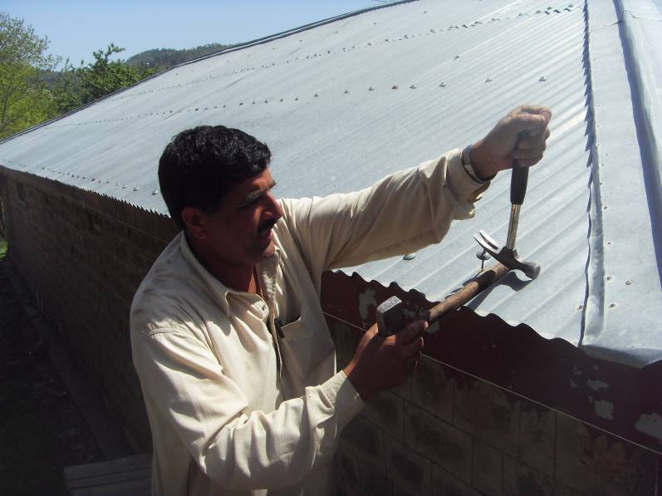
Use claw hammer and any round handle thicker than rise of corrugation, this will prevent damaging corrugations.

Cutting and molding gutter.

For house 2’’x 2’’ gutter is sufficient. This will give more cross sectional area upon fixing.
1 Nails are fixed 4’’ away from sheet edge (this is standardize practice of carpenters).
2 Sheet width is 3’ or 4ft available in market.
3 There always irregularities can be in roof fixing.
4 There should be minimum 2’’ gap between sheet and gutter edge to prevent blockade between contact point.
Keeping all these factors; it is recommended to use 18’’ wide sheet for gutter(2 piece per sheet of 3ft wide).

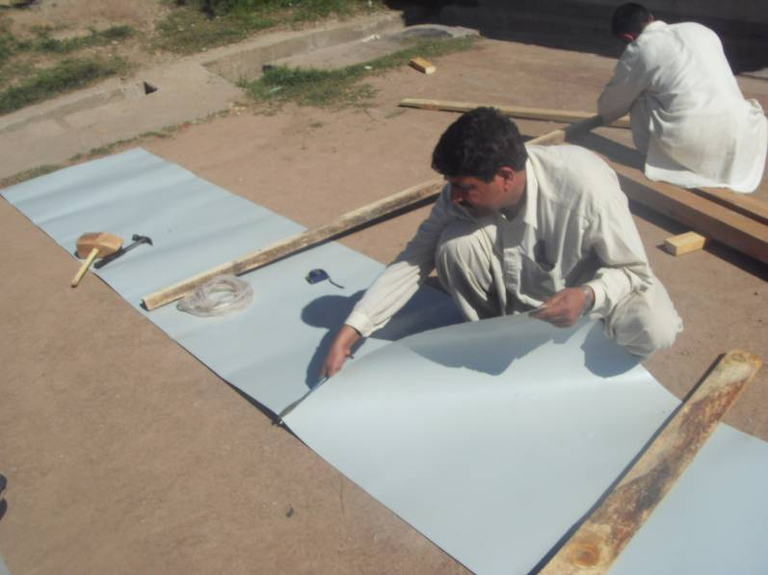

Cut the sheets in 10 ft piece.(10 ft gutter is easier to mould and fix)

Cut the sheet in two equal halves keeping line staright.

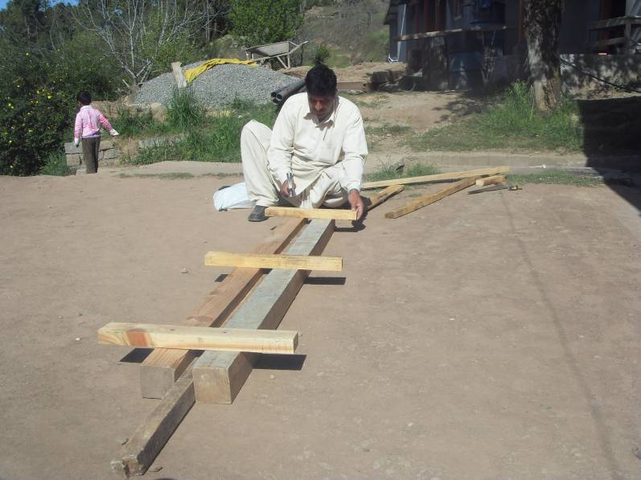
Making mould (Furma).

Use 2 nos 4’’X 4’’ battens, with defined sharp edges. Tie them with cross ties strongly, leaving 2-1/8’’ gap.(length8-10ft).

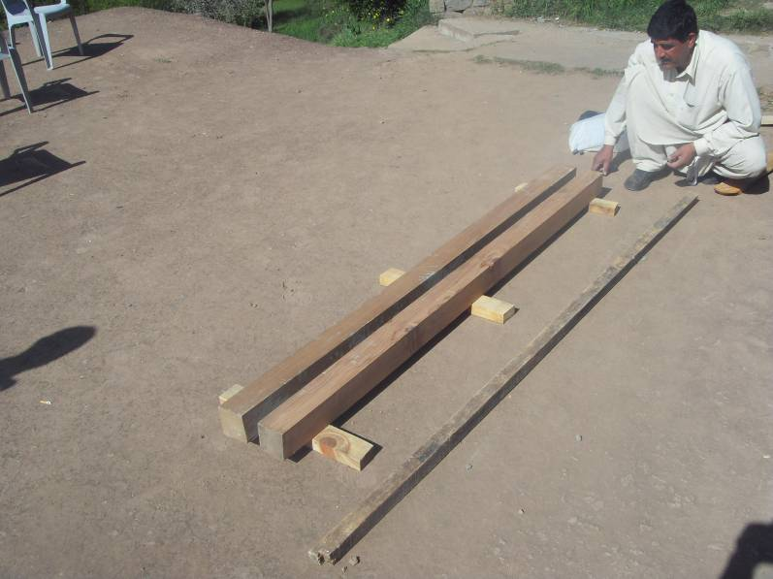

Turn over this, this is ready for use.

In this case wood was short in length, therefore additional piece were joined. It is better to have one long (10ft)

Place one purlin 2’’x2’’. It will determine depth. In this case 2’’ depth was required, and 4’’ deep batten were used therefore 2’’ purlin would be placed.

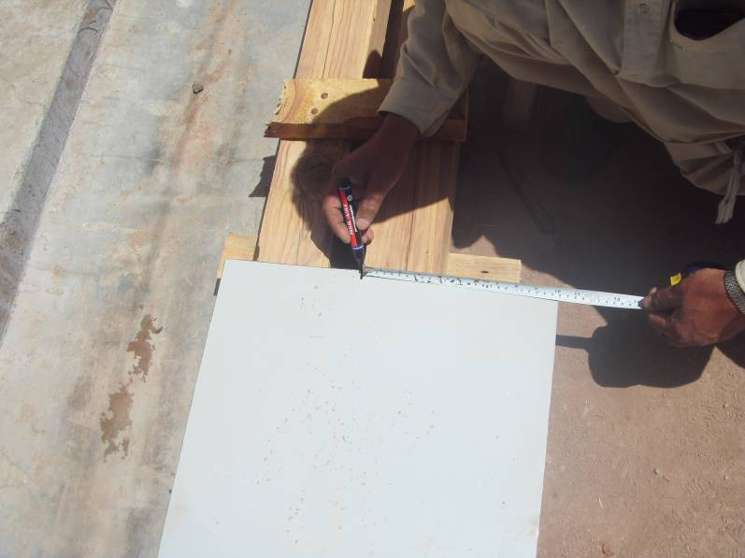
Mark the sheet. 10’’ and palce in mould as shown.

Picture of marking to be readied.

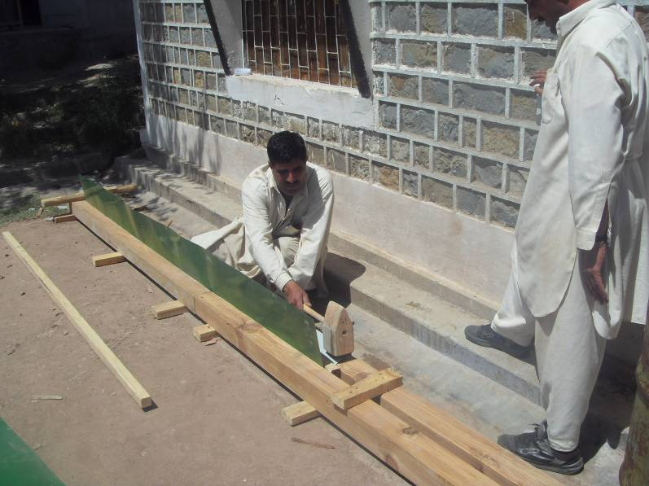

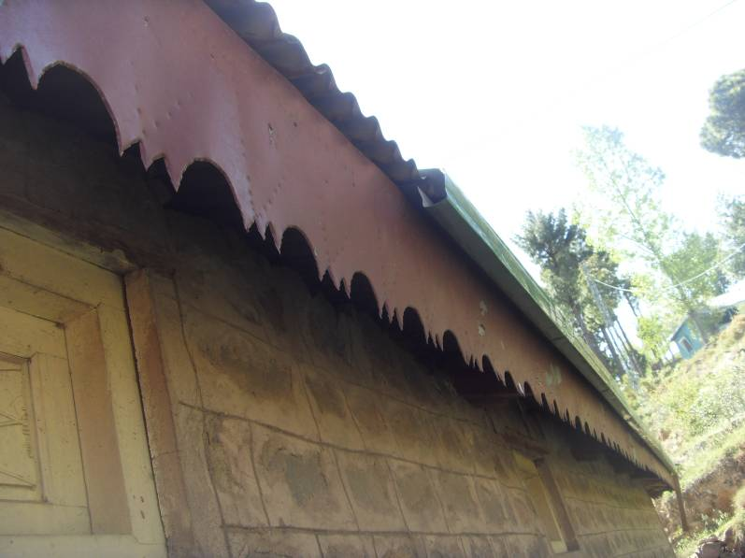

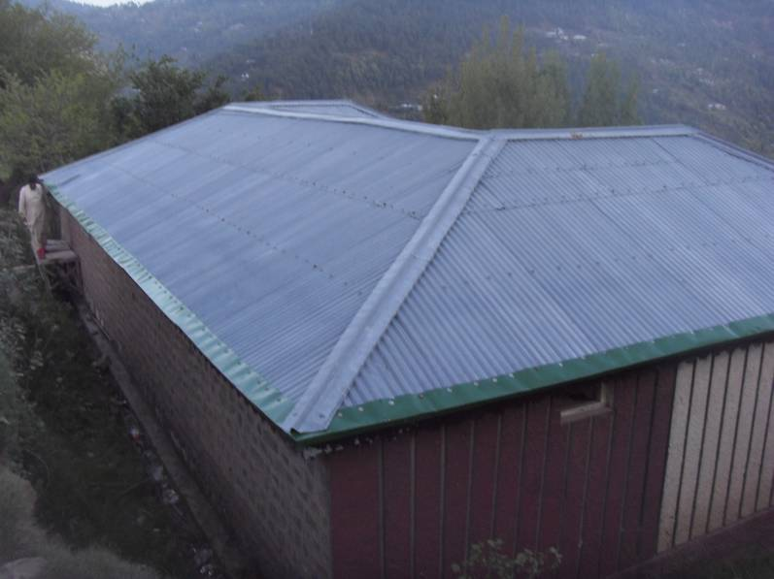

Removing Contaminants from Collected Rainwater

Rainwater falls free of contaminants from the sky, so as long as your roof is not covered in debris, the water can be used untreated in your garden. It is however best to use a so called first flush device to filter out any bird droppings, leaves, and dust etc that would otherwise fester in the water you save if you intend to collect a lot of rainwater and store it for long periods of time.
Undesirables tend to appear in the first flush of water coming down the down pipe from the roof when it starts to rain, and so for a large rooftop rainwater harvesting system that stores a lot of rainwater, the first fixed volume of rain collected should be diverted away from your clean water tank. If one gallon of water is diverted away for each 100 square feet of roof area, the water subsequently collected will be essentially free of debris and contaminants.
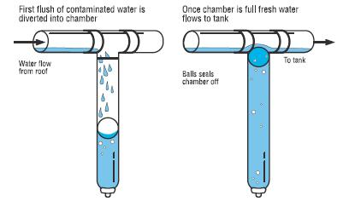

Grey water
As well as collecting rainwater it is also possible to collect and reuse grey water such as old bath water, water from the washing machine, and so on. This can be treated and used to irrigate plants in the garden helping you to save water.

First Flush System Rainwater Harvesting

Find out how dirt is kept out of rainwater harvesting tanks
There are two basic types of system employed to keep harvested rainwater clean. The first uses a filtration and settling tanks to prevent objects above a certain size getting through to the storage tank. Unfortunately these systems need to be regularly cleaned to prevent blockages forming, and not all dirt and bacteria can be filtered out. Therefore, in this article we will discuss basic first flush systems.

What is a First Flush System?
In a typical rainwater harvesting system rainwater is collected that lands on a roof and is then channeled down through guttering and pipe work to a storage tank. During dry periods of weather the roof gets covered in a fine coating of dust together with leaves, bird droppings, and other debris. When it starts to rain these objects are washed straight off the roof and down the guttering. After a certain quantity of rain has fallen the loose dirt and debris is virtually all washed away and the water coming down the pipe can be assumed to be clean.
A First Flush System dumps the water that comes down the pipe first since it may be contaminated, and only when the rainwater coming down the pipe is clean does it get directed into the storage tank.

Example of First Flush Systems
First flush systems are available commercially, but DIY systems can be put together using easily and cheaply available parts. The two commonest systems use either a floating ball or a tipping gutter to divert and/or store the first flush away from the storage tank.

Tipping Gutter First Flush System
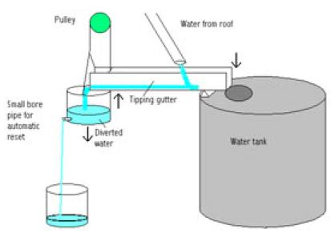
The tipping gutter first flush system (pictured above) is very simple to build, operate, and maintain. Water from the roof lands on a piece of guttering which is tipped down away from the water tank. Therefore the first rains and their debris pour away from the tank and into a storage vessel. The end of the guttering is attached via a pulley to the diverted water tank, and so as the diverted water tank gets fuller (and therefore heavier) it lifts up the end of the tipping gutter. Now the (hopefully) clean water from the roof is directed into the water tank.
The diverted water tank has a small bore pipe fitted near its bottom out of which the accumulated diverted water can escape. Over time the dirty water will leak out and the tipping gutter will reset ready for the next rain shower. Obviously if it is still raining by the time the diverted water tank has emptied, some water will be lost as the diverted water tank will have to be filled up again (this time with clean rainwater) before water is again allowed into the water tank.
A small amount of wastage is more than made up for by the simplicity and elegance of this first flush system. However, if water really is in very short supply then a tap can be fitted to the diverted water tank so that the dirty water can be released manually when the rain has stopped. This saves waste, however if the system is to be left for a few weeks unattended, contaminated water would get into the main clean water storage tank if it rained.

Floating Ball First Flush System
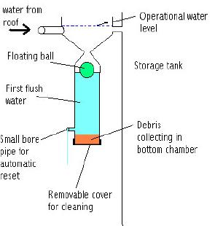
The floating ball first flush system (pictured above) is a little more complicated than the tipping gutter system discussed above although they have some similarities. When the rain starts to fall it accumulates together with any debris in a chamber with a conical top. As the chamber fills a ball floats on the collected water's surface. Eventually the ball becomes stuck in the conical chamber entrance blocking the bottom chamber and therefore redirecting subsequent collected rainwater into the main clean water storage tank.
As with the tipping gutter system, a small bore pipe is used to slowly drain the water from the lower chamber to automatically reset the first flush device. Again a tap can be used if water is at a premium since water dribbles out continuously when it is raining.

Setting Up a First Flush System
Every roof and every location is different. Basically, the larger the roof and the longer the periods between rain fall, the larger the quantity of water which must be disposed of in the first flush. In the case of the tipping gutter system this is achieved by using a suitably large diverted water tank and weighting the gutter to ensure that it tips when the required amount of water has been diverted. Again with the floating ball system, the bottom chamber of the first flush tank must be sized appropriately so that rainwater is only allowed into the storage tank after the first flush has been collected.

ANNEX 5: Pakistan’s First Integrated Resource Recovery Centre in Islamabad Sector G-15

Rapid urbanization has resulted in a corresponding increase in the volume and complexity of solid waste. In order to solve the problem it is imperative to shift from the conventional end-of-the-pipe waste management system towards a resource management approach. In close collaboration with the Ministry of Climate Change, the United Nations Economic and Social Commission for Asia and the Pacific (UN-ESCAP) and United Nations Human Settlements Programme (UN-Habitat) have a taken a step forward in this process by establishing Pakistan's first Integrated Resource Recovery Centre (IRRC), which is a facility that enable cities to turn waste into resources through composting, recycling and bio-digestion close to the source of the waste. IRRCs typically process 80-90% of waste streams, in proximity to the source of generation, and in a decentralized manner. Plants with a capacity to process between 2 and 10 tons of municipal solid waste per day have been established in cities in Cambodia, Sri Lanka and Viet Nam and, now in Pakistan within the scope of UN-ESCAP’s regional programme on “Pro-poor and sustainable solid waste management in secondary cities and town”. The IRRC, located in Islamabad’s Sector G-15, will receive 3 tons of municipal solid waste per day from surrounding local communities and nearby vegetable markets and produce compost and biogas. The facility will be inaugurated on-site by senior level officials from the Ministry of Climate Change, UN-Habitat and UN-ESCAP on 19 August 2015 and a Media Briefing will precede at the Ministry of Climate Change premises.

The IRRC in Sector G-15 is a pilot project that will test the feasibility of this model in Pakistan and its potential for replication to other sectors in Islamabad/Rawalpindi. In the medium term, it is envisaged the replication of this model to cities across the whole country. This project also highlights the direct engagement of the Capital Development Authority, Dr. Akhtar Hamid Khan Memorial Trust, Jammu & Kashmir Cooperative Housing Society, the Agricultural Extension Department of Arid Agriculture University of Rawalpindi. UN-ESCAP and UN-Habitat have been adopting a multi-stakeholder approach on their activities, and the participation of various partners and stakeholders are instrumental in the successful implementation of this IRRC model, as well as in capitalizing from the climate benefit of setting-up decentralized solid waste management systems.

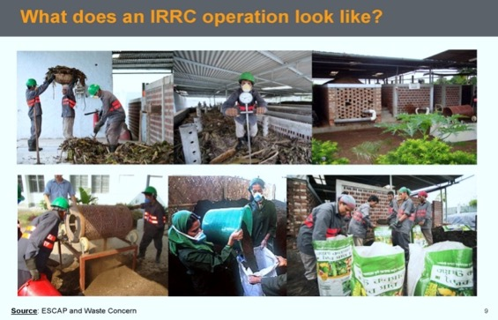
Distinctive features of the IRRCare: 1) use simple technology such as aerated box composting, 2) involvement of local community and 3) a business approach to ensure sustainability. Local organizations can quickly become familiar with this technology and adapt it to the local context. Using technology that requires little energy keeps operation costs low and equipment breakdowns are minimal. Besides, simpler technology is also more labor intensive, thus creating more job opportunities for the poor. A business plan with the aim to achieve, at a minimum, a revenue-cost balance has also been developed.
Benefits of IRRC:
Economic: Value derived out of waste while reducing and/or avoiding costs associated with end-of-pipe solutions.
Environmental: reduction of greenhouse gas emissions, avoid formation of leachate water and spread of bad odours.
Social:creation of jobs for urban poor, including waste pickers; reduction of diseases from untreated waste; increased community awareness to 3R principles.

See section D (analysis of national priorities / strategies and section H (outcomes consultations with government stakeholders).
Idem
According to government priorities – see section D and section H, adverse flood and drought impacts should be especially addressed in 1) flood plains and drainage areas in highly populated areas (i.e. in urban areas) and / or where livelihoods and assets are most affected, 2) areas where people have difficulty to protect themselves and recover from floods and where access to clean water is limited, especially when water is contaminated due to floods - thus mostly in poor and informal settlements.
Pakistan’s intended nationally determined contribution (PAK-INDC), p4
https://www.washingtonpost.com/world/asia_pacific/a-disaster-in-the-making-pakistans-population-has-more-than-doubled-in-20-years/2017/09/08/4f434c58-926b-11e7-8482-8dc9a7af29f9_story.html?noredirect=on&utm_term=.d316ea032af7
Pakistan’s intended nationally determined contribution (PAK-INDC), p7
http://hdr.undp.org/en/countries/profiles/PAK
https://profit.pakistantoday.com.pk/2018/04/26/pakistans-percentage-of-people-living-below-poverty-line-falls-to-24-3-percent-economic-survey-2018/
https://data.worldbank.org/country/pakistan
Pakistan’s intended nationally determined contribution (PAK-INDC), p7
Pakistan National Human Development Report, 2018; UNDP Pakistan
Pakistan’s intended nationally determined contribution (PAK-INDC), p5
https://germanwatch.org/en/download/20432.pdf
ADB (2017, p ix) Climate change profile of Pakistan.
Idem
Government of Pakistan (2013, p5) Framework for implementation of climate change policy
ADB (2017, p ix) Climate change profile of Pakistan.
National water policy (2018, p 1)
National water policy (2018, p 3-4)
National flood protection plan (2016)
National flood protection plan (2016, p 3)
NDMA (2017) Integrated Context Analysis (ICA) on Vulnerability to Food Insecurity and Natural Hazards and UN-Habitat Multi-Hazard and Vulnerability Risk Assessments (MHVRAs) conducted by UN-Habitat in Chitral
Pakistan government (2016, p 67) National flood protection plan
Excerpted from Sindhu, A.S.; Rawalpindi-Islamabad: Multi Hazard Risk Mapping; Plan International Inc. Pakistan; 2014
For this section three main sources have been cited: District Disaster Risk Management Plan Nowshera developed by District Disaster Management Unit of Nowshera, 2014; Nowshera City Multi Hazard Risk Assessment, developed for UNISDR in 2011; and views of the local residents as recorded during discussions with them.
District Disaster risk management plan Nowshera 2014
Idem
Pakistan’s INDC, p14
https://unfccc.int/files/adaptation/application/pdf/pakistanneeds.pdf
http://www.gcisc.org.pk/National_Climate_Change_Policy_2012.pdf
http://www.gcisc.org.pk/Framework%20for%20Implementation%20of%20CC%20Policy.pdf
http://www4.unfccc.int/ndcregistry/PublishedDocuments/Pakistan%20First/Pak-INDC.pdf
http://fics.seecs.edu.pk/Vision/Vision-2025/Pakistan-Vision-2025.pdf
http://www.ndma.gov.pk/Documents/drrpolicy2013.pdf
http://mowr.gov.pk/wp-content/uploads/2018/05/National-Flood-Protection-Plan-IV-NFPP-IV-1.pdf http://www.lead.org.pk/lead/Publications/Visual%20Guide%20National%20Flood%20Protection%20Plan-IV.pdf
https://drive.google.com/file/d/17VO_3ysV5s-dEmMeAfKlOxCnV5yBFvlq/view
http://cmsdata.iucn.org/downloads/niap___eia_handbook.pdf
http://cmsdata.iucn.org/downloads/niap___eia_handbook.pdf
Since Rawalpindi and Islamabad has a shared watershed and basin for Lai Nallah, the potential locations for upstream water reservoirs lie in areas that come under the jurisdiction of Capital Development Authority and Islamabad Capital Administration. Likewise the Federal Ministry of Capital Administration and Development also has a stake. Hence their officials will also be made part of project’s relevant interventions.
Knowledge Management in the United Nations system. 2016, Joint Inspection Unit. United Nations, Geneva
^{6.} Each Party shall designate and communicate to the secretariat the authority that will endorse on behalf of the national government the projects and programmes proposed by the implementing entities.
http://cmsdata.iucn.org/downloads/niap___eia_handbook.pdf
Idem
Twenty-eighth session 6–17 November 2017 - National report submitted in accordance with paragraph 5 of the annex to Human Rights Council resolution 16/21* Pakistan. Online: https://documents-dds-ny.un.org/doc/UNDOC/GEN/G17/256/99/PDF/G1725699.pdf?OpenElement
Idem XI. Challenges 78 (page 23)
https://tbinternet.ohchr.org/_layouts/TreatyBodyExternal/Treaty.aspx?CountryID=131&Lang=EN
Concluding observations on the fourth periodic report of Pakistan, adopted by the Committee at its fifty-fourth session (11 February–1 March2013): https://tbinternet.ohchr.org/_layouts/treatybodyexternal/Download.aspx?symbolno=CEDAW/C/PAK/CO/4&Lang=En
http://www.ilo.org/dyn/normlex/en/f?p=1000:11210:0::NO:11210:P11210_COUNTRY_ID:103166
http://www.ohchr.org/EN/Issues/IPeoples/SRIndigenousPeoples/Pages/SRIPeoplesIndex.aspx
http://www.iucnredlist.org/search
http://www.unesco.org/new/en/natural-sciences/environment/ecological-sciences/man-and-biosphere-programme
https://whc.unesco.org/en/list/

