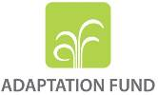

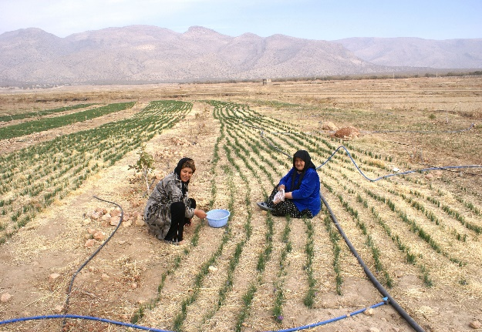

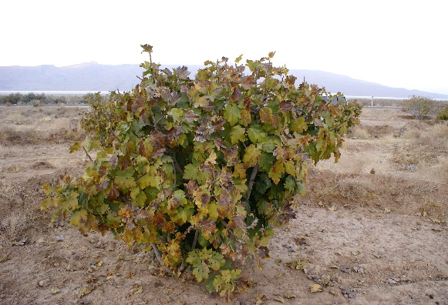

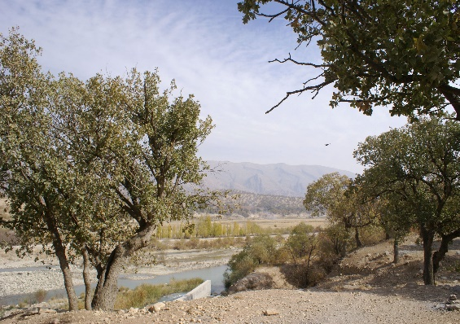

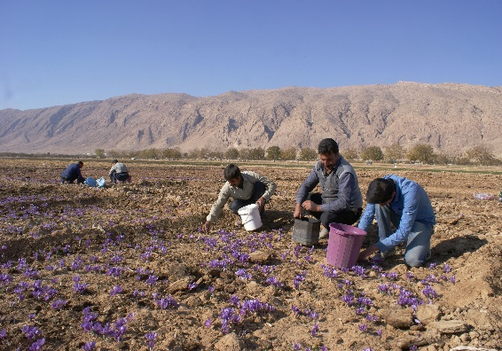

**Annexes dossier:**

Reducing vulnerability to climate change in the Lake Bakhtegan Basin.

annexES

Annex 1 - Current context in the Bakhtegan Basin 3

Annex 2 - Trends in climate, surface/sub-surface hydrology, fig production and wildlife in the Bakhtegan Basin 13

Annex 3 National Legal Framework related to addressing water mismanagement 23

Annex 4- Socio-economic conditions in the four zones in the Bakhtegan Basin 25

Annex 5 - Targeting of beneficiaries 27

Annex 6 - Background to SimCLIM and CLIMsystems 46

Annex 7 - SGP´s Eligibility Criteria for Grantees and Projects 48

Annex 8 - Report on Consultations in the Bakhtegan Basin 49

Annex 9 - Social and Environmental Screening Template 59

Annex 10 - Environmental and Social Management Framework 68

# Annex 1 - Current context in the Bakhtegan Basin

**Climate**

The most important meteorological systems in the region are the Sudanese low pressure system, the low pressure of the Mediterranean, the cold north high pressure, the low thermal pressure of India and the low pressure of Saudia Arabia. Local climate data have been gathered and analysed from 43 meteorological stations. Average annual precipitation varies from 139.1mm recorded at Abadeh to 853.6mm recorded at Choubkhale. Precipitation is distributed unevenly through the year with 24.5 percent in autumn, 58.3 percent in winter, 16.8 percent in spring and 0.6 percent in summer. All stations follow a similar rainfall pattern with rainfall beginning in October, peaking in November and continuing in December. The annual precipitation volume in the study area was estimated at 87.9 billion cubic meters[1].Temperatures vary seasonally and with altitude throughout the Bakhtegan Basin. A lowest absolute minimum temperature of -28°C has been recorded at Kafter. Average minimum temperatures of 6.6°C, 11.5°C and 7.7°C have been observed at Abadeh, Doroodzan and Zarghan Dam stations respectively with average maximum temperatures of 22.1°C, 23.9°C and 24.6°C recorded at the same sites. A daily maximum of 49°C has been recorded at Kafter station in July.

**Physical characteristics[2]**

According to elevation maps of the Bakhtegan Basin the most elevated areas (higher than 3400 masl) are located in the Zagros Mountains in the north and north-western parts of the basin, occupying 0.1 percent of the total basin area. The areas of lowest elevation (less than 1800 masl) occupy 29.5 percent of the basin and occupy the western and southern parts of the basin, including most of the Kor and Sivan sub-basin areas. The remainder of the basin is divided into four elevation classes ranging from 1800 to 3400 masl. 39 percent of the Kor and Sivand sub-basins are located in mountainous terrain which makes up about 11 percent of the Bakhtegan Basin. Sloping land (greater than 5 degrees) in the mountainous area in the north and north-west makes up approximately 50 percent of the basin. Most of the remainder of the basin is made up of different types of plains areas. These plains areas consist of the upper plateaus and terraces which make up about 13 percent, the flat plains which make up 6 percent and river sediment plains which make up 7 percent. Funnel drainage forms make up about 4 percent, with the other landforms covering about 4 percent. In general, about 75 percent of the basin is made up of lands with a slope of less than 12 degrees and the rest are steep slopes and the Bakhtegan and Tashk lakes.

*Table 1: Percentage land area of different slope classes in the Bakhtegan Basin*

|  |  |
| --- | --- |
| **Slope class** | **Percentage land area** |
| >12 degrees | 21.7 |
| 5-12 degrees | 32.1 |
| 2-5 degrees | 17.1 |
| 0-2 degrees | 24.2 |
| 0 degree (lake) | 4.9 |

Assessments of current land use and land use capability[3] indicate the need for adjustments in land use that are more in keeping with the potential of the land. Based on this information a total of 44.63 percent of the land area of the Bakhtegan Basin is identified as suitable for forestry and soil conservation measures. To achieve this potential would require a reduction of the current rangeland and irrigated land areas. The rangeland area would need to be reduced from the current 1,083,459 hectares (39.7 percent of the land area) to 844,935 hectares (31 percent of the land area). In contrast to the current irrigated land area of 580,064 hectares (21.3 percent of the land area), 15.1 percent and 3.9 percent of the basin is considered suitable for irrigated and rain-fed agriculture respectively. To achieve this would require removing 6.2 percent of the currently irrigated land area from irrigation and incorporating 2.3 percent of the current irrigated area into soil conservation land. The current total wetland area in the basin is about 138,014 hectares, with Tashk and Bakhtegan lakes covering a combined area of 59,424 hectares (Figure 1). According to the land use capability assessment about 135, 709 ha (4.9 percent of the area) is saline and flood plains with high restriction on use due to salinity and alkalinity.

|  |
| --- |
| land use in Bakhtegan basin  ***Figure 1****: Land use distribution in the Bakhtegan Basin* |

The BLB is divided into the Kor and Sivand sub-basins (Figure 2) which form the main catchment area for the Kor-Sivand sub-basin where Lake Bakhtegan is located. These sub-basins are further divided into 22 hydrologic units from which annual surface water discharge data have been collected from 1974-2007 (Figure 3).The annual water yield in the Kor sub-basin ranges from a low of about 42.7 million cubic meters (MCM) recorded from the Manjan gauge in the Tang-e-Bostanek river to 1144 MCM recorded at the Pol-e-Khan gauge in the Kor river. The minimum and maximum coefficient of variation is about 35.3 percent and 690.2percent in the White river at the Dehkadehsefid guage and in Sivand river at the Dashtebal guage respectively in the Sivand sub-basin. There are high seasonal variations in water discharge in both the Kor and Sivand sub-basins, with the highest discharges in winter and spring and the lowest in summer and autumn. Comparison of annual discharge from the Kor river at Pol-e-khan over two timeframes (1973-2006 and 1997-2006) shows a deficit of 167 MCM (1,144 MCM compared to 977 MCM) since 1997. This is attributable to increased water storage in the Doroodzan dam network and additional storage and distribution upstream of the dam.

|  |
| --- |
| ***Figure 2:*** *The main sub-basins in the Bakhtegan Basin* |
| ***Figure 3:*** *Hydrological units in the Bakhtegan Basin* |

**The socio-economic situation**

The Bakhtegan Basin includes parts of the provinces of Fars, Isfahan and Kohgiluyeh-o-Boyer Ahmad. It covers 14 districts, 31 sub-districts, 67 rural districts and also 717 settlements (recorded in 2006)[4]. These are made up of 16 urban and 701 rural settlements. Urban settlements include the towns of Marvdasht, Niriz, Estahban, Arsanjan, Abadeh-Tashk, Zarghan, Lapoui, Kharameh, Darian, Sa’adat Shahr, Beyza, Kamfirouz, Saydan, Safashahr, Gharabad. In 1956 there were 557 settlements with 552 villages and 5 towns. By 1976 there were 750 settlements including 743 villages and 7 towns. Increased urbanization was apparent in 1986, with only 712 villages and 8 towns. In the following decade there was expansion of both rural and urban areas, with 744 villages and 10 towns recorded in 1996. Since that time there has been a very strong trend towards increased urbanization. Despite this trend nearly 44 percent of the population (374,795 people) is still in rural areas (Figure 4), the majority of whom are dependent on subsistence agriculture and access to water for their livelihoods. At the same time the urban population (480,926) is highly dependent on provision of food and water from the rural areas. Overall the demands on the natural environment of the Bakhtegan Basin and vulnerability to drought and climate change is high.

*Table 2: Population in the Bakhtegan Basin*

|  |  |  |  |  |
| --- | --- | --- | --- | --- |
| **Number of families and urban and rural population figures in the Bakhtegan Basin (SCI, 2016)** | | | | |
| Settlement | Number of families | Population | | |
| Total | Male | Female |
| Urban | 143136 | 480926 | 245091 | 235835 |
| Village | 111424 | 374795 | 191972 | 182823 |
| Total | 254560 | 855721 | 437063 | 418658 |

*Figure 4: Urban and rural population distribution*

|  |
| --- |
| *Figure 5: Distribution of villages in the Bakhtegan Basin* |

**Agriculture and water use in the Bakhtegan Basin**

The current total area of irrigated agriculture[5] is about 580,000 hectares (21.2 percent of the Bakhtegan Basin area). About 35 percent of irrigated farmland is upstream of the Doroodzan and Sivand dams and about 48.5 percent of irrigated farmland is located below the dams. The first area, upstream of the dams includes the Marvdasht, Zarghan, Beyza, Karbal, Kharameh, Murghab and Daryan plains. The second area, below the dams, includes Aspas, Kamifrouz, Sadeh, Khosrow -o- Shirin, Bekan, Kafter, Nemdan, Khorrami and Ghader Abad. This middle elevation plains area has a much shorter history of agriculture than the upper plains area and has experienced rapid development in recent years. The remainder of irrigated farmland, 16.5 percent of the total area, is located in Arsanjan, Farooqh, Abadeh-Tashk, Estahban and Nayriz. These overlook the Bakhtegan Lake and are considered as marginal areas.

Arable land in the Bakhtegan Basin[6] is comprised of 79.8 percent cereal, 4.7 percent industrial and 2.4 percent forage crops, and 2.4 percent in horticulture. Orchards, beans, vegetables and fruits make up the remainder, occupying 3.7 percent, 3.2 percent and 0.8 percent, respectively. The most extensive crop area is cereal, mostly wheat, covering 53.9 to 96.7 percent of the land area in different locations. The area dedicated to other crops also varies, for example with orchards covering as much as10.2 percent in some parts and 1.3 percent other areas. Water availability is one of the most important factors determining the extent of different crops. Cereals are the most commonly grown crops in water short areas. Where water is readily available high water demanding crops such as rice are grown, such as in the Kamfirouz plain. Thus, greater diversity and more intensive cropping patterns are found in the areas where agricultural water supply is not severely restricted.

Water rights are divided into dry and wet years in the Korbal-Kharameh plain. A very intense drought was experienced in 2006 which resulted in water being released from Doroodzan dam on only 13 days of the year, amounting to a total of 61 MCM. Twelve years of observation data (1994-2006) also show that the extent of cereal production fluctuated from 19,577 to 33,592 hectares and from zero to 17,809 hectares for vegetables due to fluctuations in agriculture water availability. The most drought impacted area is mainly located in the lower elevation plains, e.g. Korbal-Kharameh and other lands which surround the Bakhtegan Lake; which are also affected by windblown salt particles and dust from the now mostly dry lake bed. Droughts then progress to the middle elevation plains. Overall, the impact of drought is observed in the rangeland and rain-fed lands first, then on the irrigated farmlands and orchards. However, there are insufficient data on the number of people that are affected by drought and the impacts that they experience.

**Wildlife**

Wildlife populations in the Bakhtegan Basin have declined dramatically during the last 50 years as a result of habitat degradation and reduced extent[7]. However, it has also been reported that the wildlife status is a bit better compared to other similar areas in Iran due to proper monitoring by the DOE. The basin is rich in fauna due to its large size and high habitat diversity. More than 51 species of mammals have been identified from 17 families. Important species include *Caracal*, Persian leopard, Capra, Rueppell's fox, jungle cat, sand cat, brown bear, black-tailed gazelle, mouflon, and wild goat. Eight species are classified in the IUCN, eight species in the CITES attachments, and eight species are protected by Iranian rules in the list of protected species. There are 51 species of reptiles and amphibians including 18 species of lizards, 26 species of snakes, 3 turtle species and 4 species of amphibians. One species is listed with the IUCN, two species are listed under CITES and four species are protected in accordance with Iranian rules. Most of the above wildlife is restricted to protected areas under DOE management due to destruction of their habitats and lack of presence in others. DOE protected areas (Figure 6) include: Bakhtegan national park, Mambou national park, Margoun waterfall protected area, Tang-e-Betanak protected area, Basiran hunting forbidden area and Kouhsiah-e-Arsanjan hunting forbidden area.

|  |
| --- |
| national parks and hunting forbidden areas  *Figure 6: Location of national parks, protected area and hunting forbidden areas in the Bakhtegan Basin* |

**Vegetation**

The major part of the Bakhtegan Basin is located in the Iran and Turanian vegetative region which is the largest vegetative region of Iran. *Pistacia atlantica* and *Amygdaluss coparia* form the two dominant forest species. These are found in pure stands of each species, or either or both of these species mixed with *Acer monspessulanum*. There are also some forested areas dominated by Iranian oak with the Kor sub-basin. The importance of the various pure and mixed forest types in the Iranian and Touranian vegetative region in Iran, and in Bakhtegan Basin in particular, require special attention to ensure their protection from existing pressures and also under climate change conditions.

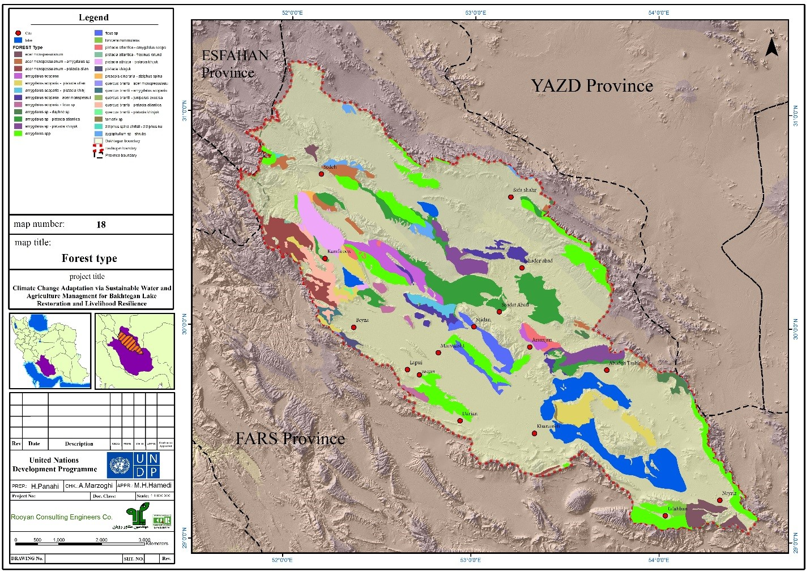

*Figure 7: Main forest types in the Bakhtegan Basin*

**Comparing land-use change in 1956 to 2006 based on image processing and**

**aerial photo analysis**

|  |  |  |  |  |  |
| --- | --- | --- | --- | --- | --- |
| Land-Use | 2006 | | 1956 | | Change(ha) |
| Area(ha) | Percentage | Area(ha) | Percentage |
| Barren | 37348 | 1.37 | 31128 | 1.142 | -6220 |
| Rain-fed | 59424 | 2.18 | 247125 | 9.070 | 187701 |
| Irrigated | 580063 | 21.29 | 223593 | 8.206 | -356470 |
| Forest | 742023 | 27.23 | 744631 | 27.330 | 2608 |
| Lake | 138014 | 5.07 | 173259 | 6.359 | 35245 |
| Wet land | 2609 | 0.10 | 46150 | 1.694 | 43541 |
| Rangeland | 1083445 | 39.77 | 1225466 | 44.978 | 142021 |
| River bed | 863 | 0.03 | 863 | 0.032 | 0 |
| Saline land | 74616 | 2.74 | 31138 | 1.143 | -43478 |
| Residual | 6187 | 0.23 | 1239 | 0.045 | -4948 |
| Total | 2724592 | 100 | 2724592 | 100 | 0 |

**Number of Wells in the Bakhtegan Basin from 1956 to 2006**

1956

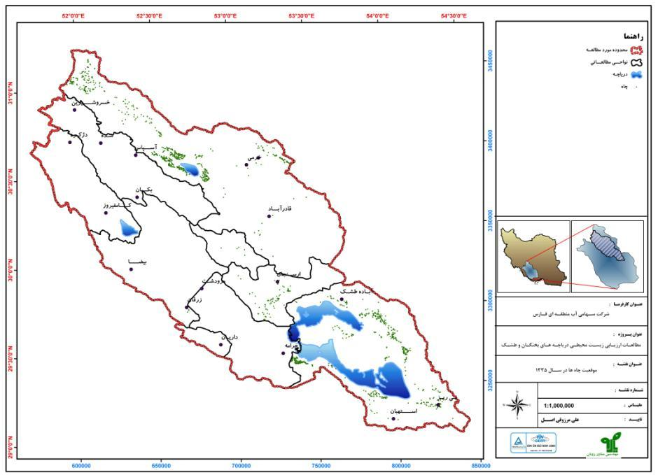

1966

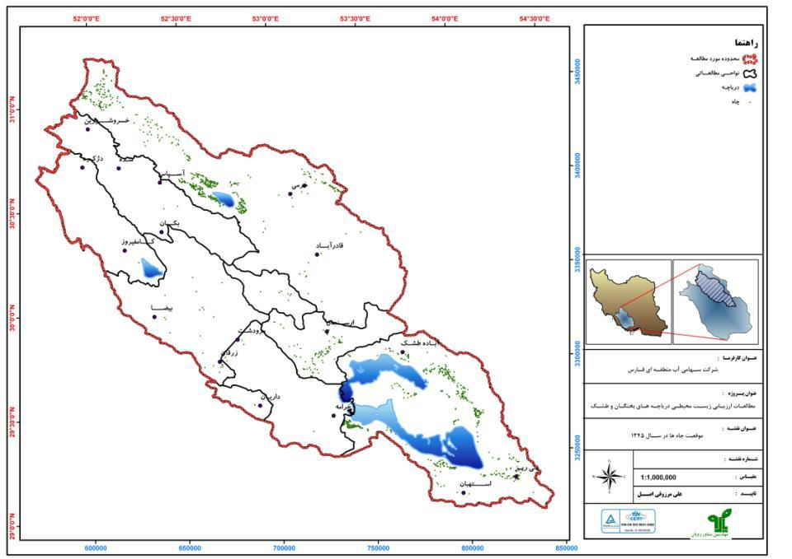

1976

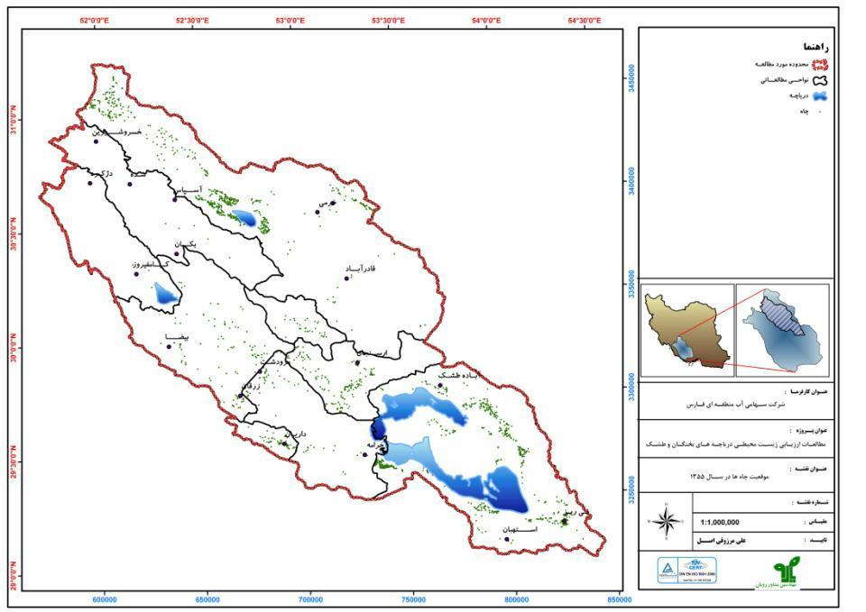

1986

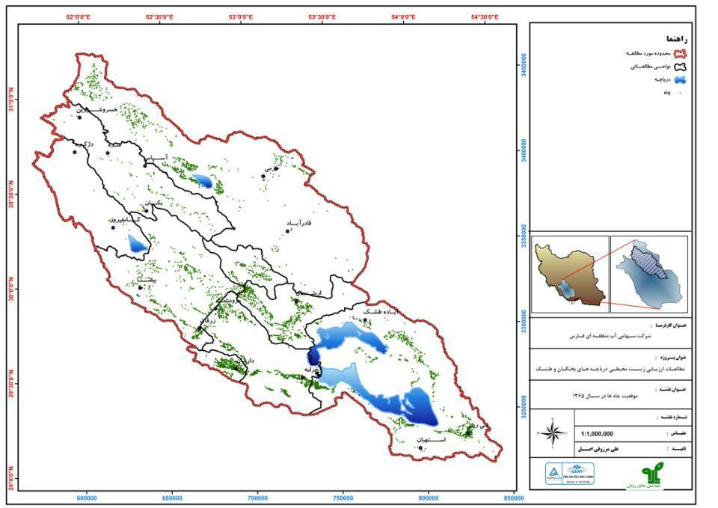

1996

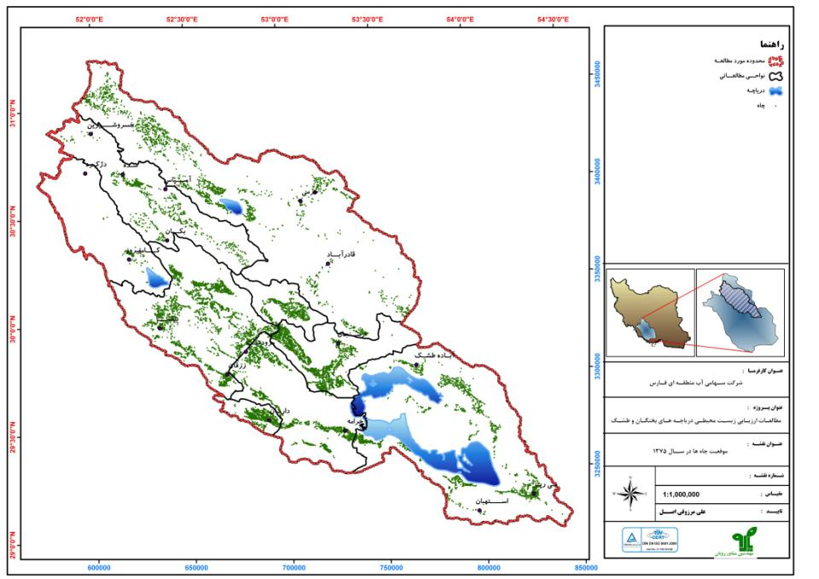

2006

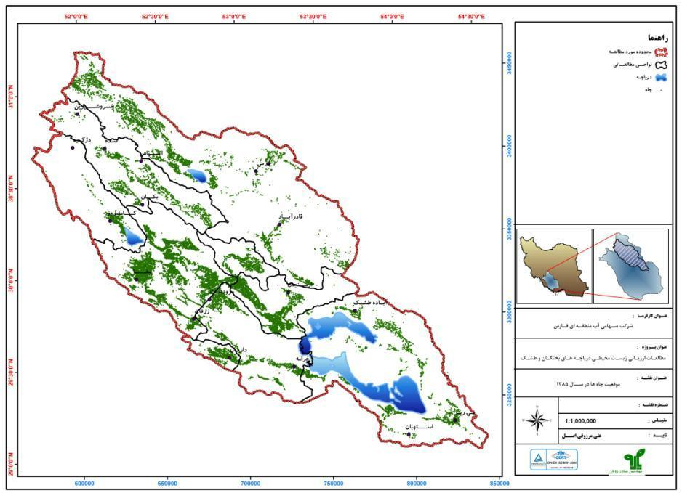

# Annex 2 - Trends in climate, surface/sub-surface hydrology, fig production and wildlife in the Bakhtegan Basin

**Climate Zoning[8]**

The climatic zoning of the target area was carried out using the Trewartha - Koppen classification method because of high precision in determining the boundaries of temperature and precipitation. The selected classification method also has a high ability to distinguish ecological zones based on temperature and precipitation indices. Climatic zoning has been used network data from CCAFS-Climate Data Center with five-minute spatial resolution under theA2, B2 and A1B scenarios of HadCM3 model for the base time period of 1982 to 2012 the projected periods 2030s, 2050s, and 2080s.

The climate of Bakhtegan Basin is classified to seven types. The temperate class (D) is covered about 51% which is divided to four sub-classes: humid moderate, arid-hot moderate with winter precipitation regime, hot dry moderate and cold dry moderate that are covers 30%, 12.5%, 8.5% and 0,2% respectively. The semi-arid class (B) is dominated 30% of Bakhtegan Basin that are divide two sub-classess; cold and warm semi-arid climate sub-classes. The cold semi-arid class is expanded in western part of the Bakhtegan basin near to Yazd province and the warm semi-arid class dominated in south eastern part near to Kerman province. The subtropical with dry summer is the seventh climate class that is dominated about 18.7% of Bakhtegan Basin.

The detection of climate change was projected based on A2, B2 and A1B climate scenarios for seven existing climate classes. The projected results are summarized in table and figure 1 based on A1B scenario.

*Table1: Comparing the spread changing of climate types in current period to the 2030s, 2050s and 2080s based on A1B scenario*

| Climate Type | Current Period | Based on A1B scenario | | |
| --- | --- | --- | --- | --- |
| 2030s | 2050s | 2080s |
| Warm semi-arid | 21.7 | 49.9 | 33.3 | 35.7 |
| Cold semi-arid | 8.3 | 31.7 | 17.7 | 11.3 |
| Arid hot | - | 1.9 | 40.4 | 49.4 |
| Arid cold | - | - | 8.0 | 3.1 |
| Subtropical with dry summer | 18.7 | 6.1 | - | - |
| Hot dry moderate | 8.5 | 6.1 | - | - |
| Cold dry moderate | 0.2 | - | - | - |
| Arid-hot moderate with winter precipitation | 12.5 | - | - | - |
| Humid moderate | 30 | 4.3 | 0.5 | 0.5 |

*Figure 1: Comparing the spread changing of climate types in current period to* *the 2030s, 2050s and 2080s based on A1B scenario*

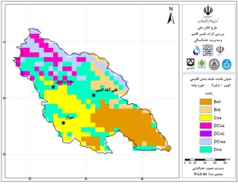

Current period (1983 – 2012)

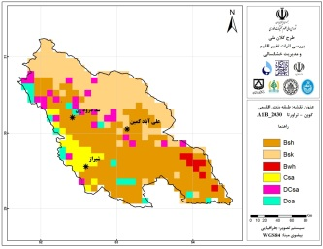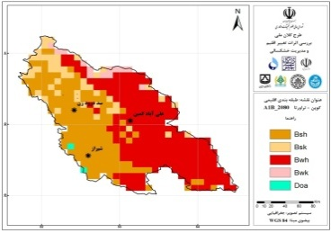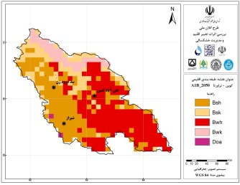

2030s 2050s 2080s

**Daily (Diurnal) Temperature Range (DTR)**

The difference between daily maximum and minimum temperatures — the diurnal temperature range — is one measure of changes in daily temperature distributions. These changes are affected by minimum and maximum temperature variations. The incremental trend of this index may be due to the increase in the maximum temperature or the decreasing of the minimum temperature and/or the simultaneous effect of these two factors both. In some cases, while one of the above two factors work inverse then we are faced with an increasing trend of DTR. Figure 2 is illustrated the slope and trend of DTR in Bakhtegan Basin.

*Figure 2: The slope and trend of changes in DTR in Bakhtegan basin during the 1983-2012*

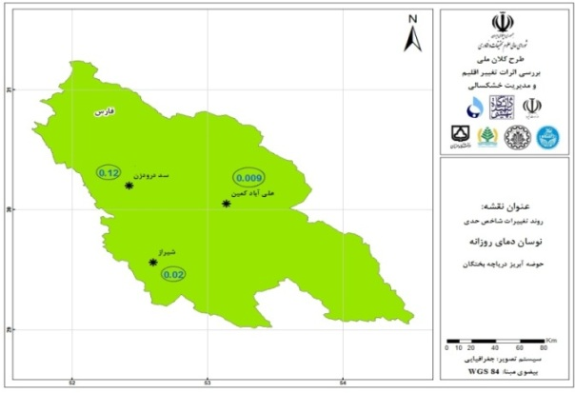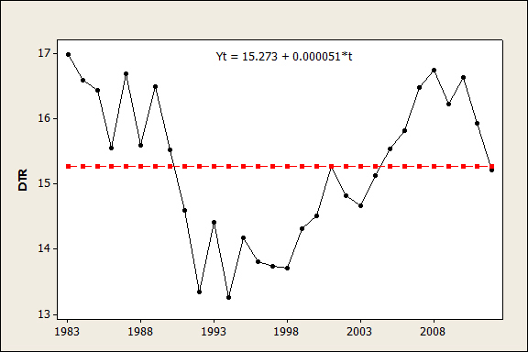

The results of the Pettitt test shows that the DTR has a downtrend in 1990 in Bakhtegan basin during the observational period (1983-2012). Accordingly, the average daily temperature before 1990 was 16.23 ° C and then 14.84 ° C.

Statistical analyzes indicate that the DTR is decreasing in all three (A2, B2 and A1B) scenarios in observed time periods in Aliabad rain gauge station. This indicator shows incremental trends in all time horizons in scenario A1B, A2 and B1 at the Doroodzan Dam rain gauge in the western part of the Bakhtegan basin.

**Aridification**

A study**[9]** mapping drought hazards using SPI index and GIS in Fars province, based on data compiled by weather stations in the province provide an insight of the extent of the drought overtime since 1994 to date.

The Standardized Precipitation Index (SPI) to measure drought has the following values associated to drought category classification:

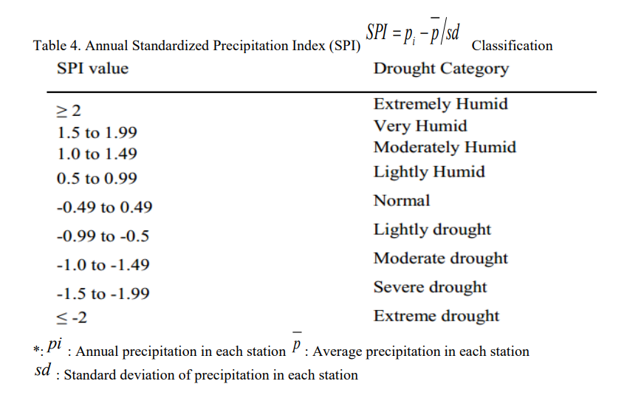

Based on data from 10 weather stations from 1994-2011 and from 7 stations from 2007-2011, the SPI index was calculated as follows:

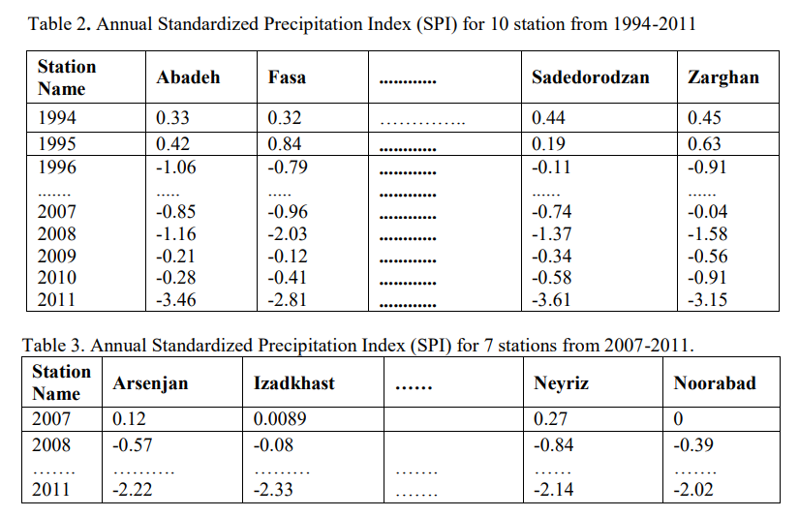

ArcGIS coupled with drought index (SPI) is vital tool for drought monitoring and mitigation. ArcGIS supports visualization of scientific based results important for decision making process. Based on the results above, drought maps from Fars province have been developed that clearly demonstrate the extended severe to moderate drought that Fars province has been enduring for the past decade. It important to point out that the SPI only take into account climate and hydrological variables, therefore it’s clear to affirm that drought is driven by climate factors.

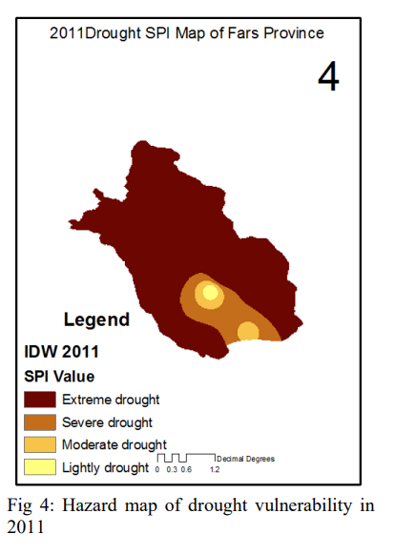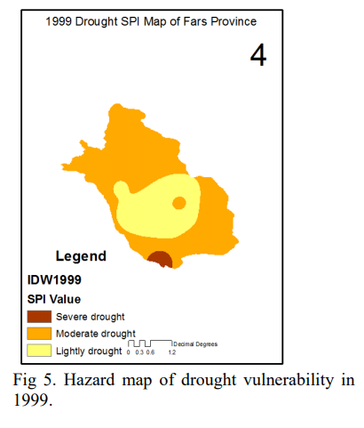

**Climatic and surface/sub-surface water hydrologic trends**

Trend of sub-surface water level changes analyzed based on MoE’s observation data in nine plain areas in Bakhteagan Basin from 2006 to 2016. It has been observed no severely change in ground water level in all selected plains in Bakhtegan basin.

The river discharge has been shown the negative trend in four selected gauges; Tang e Bolaghi, Khsrow shirin, Sad e droudzan and Pol e khan. The highly dramatic reduce is observed in the above discharge gauges during last decade.

The average maximum and minimum temperature climate detection are also shown the negative trend from 1969 to 2015. The analysis has been done based on “Optimal Fingerprint Detection and Attribution” method (Hegerl et al, 1997)[10] in Bakhtegan basin. The analysis has been done in eight selected climatic gauges stations using the above method. The results are shown the positive trend in maximum and minimum average monthly temperature in Bakhtegan basin in observation period (1960 – 2015).





**Fig production trend in the Bakhtegan Basin**

* The area in fig production in the Bakhtegan Basin has increased from 22,000 hectares in 2004 to an average of approximately 23,500 hectares over the 5 year period from 2013-2017
* Total production (in Tonnes) declined to a third of previous production during the severe drought in 2007/2008, from approximately 30,000 tonnes to approximately 10,000 tonnes. Subsequently total production has been at least half of production levels prior to 2007/2008 due to the effects of sustained drought conditions.
* Average yield (tonnes/hectare) declined to nearly a quarter of previous yield levels during the 2007/2008 drought and yields have subsequently remained low compared to previous levels due to sustained drought conditions.

**Wildlife population trend in Bakhtegan Basin**

* The population of plain species have severely declined due to conflicts and scarcity of water resources, e.g. Zebra and Chinkara
* The mountainous regions species are not severely affected, e.g., the goat that is less conflicts with drought constraints
* The population of wild birds are severely reduced in Bakhtegan and Tashk lakes and majority have been migrated to the reservoir of Doroudzan dam.
* We have been observed a fairly good population of birds in Kamjan Lake.

# Annex 3 National Legal Framework related to addressing water mismanagement

**The Law of the** **6th Five-Year Development Plan of the Islamic Republic of Iran (enacted by the Islamic Consultative Assembly on 4 March 2017)**

**Article 35** - The government is required to take the following measures, in order to cope with the water crisis, release environmental water rights for land sustainability, sustainability and increased production in the agricultural sector, balance underground aquifers, and promote productivity and balance water levels to eleven billion cubic meters, in the year ending the implementation of the Law of the 6th Development Plan:

* 1. Increase yield per unit area and increase productivity in agricultural production with priority assigned to products with relative advantages and high export value; and products with low water consumption requirement and compatible with salt, drought resistant and observance of cropping methods compatible with the area

* 1. Development of new irrigation methods, implementation of water and soil operations (structural and non-structural), and development of floodgates and pond systems, at least six hundred thousand hectares per year

Note - For the development of new irrigation methods, at least 85% of expenditures are financed and paid by the government within the framework of annual budget.

* 1. Support the development of greenhouses and the transfer of cultivation from open to controlled space, and recycling of wastewater, unconventional water management and virtual water management
  2. Designing and implementing a cropping pattern with emphasis on strategic products and promoting water productivity in the framework of general policies of 'Resistive Economy' and providing resources and requirements within the framework of annual budget, and applying appropriate support and incentives only within the framework of the cropping pattern
  3. Revitalization, restoration and dredging of Qanats at an annual rate of 5% of the current situation during the implementation of the Law of the 6th Development Plan, with an emphasis on watershed management activities to revive Qanats
  4. Building the infrastructure needed to breed two hundred thousand fish in basins until the end of implementation of the Law of 6th Development Plan, and development of fisheries activities and establishment of infrastructure on major coasts of the country.
  5. Electrifying agricultural wells having exploitation licenses

Note - The resources required for the implementation of this clause shall be provided through saving fossil fuels subject matter of Article 12 of the Law on the Elimination of Barriers to Competitive Production and Enhancing the State Financial System, passed on 21.04.2015.

* 1. Installing smart and volumetric water meters on agricultural wells having exploitation licenses, together with provision of facilities from the administered funds until the end of implementation of the Law of 6th Development Plan.
  2. Using water extracted from dams, with priority assigned to supplying drinking water in the catchment basin of ​​the dam site.
  3. Providing farmers with irrigation right (the right of taking a fixed amount of water) from dams constructed on rivers, springs and aqueducts (Qanats).
  4. Re-structuring of water consumption in steel, alloys and minerals factories, and improving the systems of cooling and washing raw materials, by the end of the fourth year of implementation of the Law of 6th Development Plan
  5. The government is required to develop a cultivation pattern for all parts of the country by the end of the first year- and implement it during the years of, implementation of the Law of 6th Development Plan. The Ministry of Energy is required to allocate water to farmers in accordance with the cultivation pattern.

**Ministry of Energy’s Water Strategy**

MoE’s Water Strategy endorsed in May 2013 have clear guidelines related to the promotion of integrated management of water resources and re allocation of water rights as follows:

* Devising and implementing a comprehensive national document on managing water resources in collaboration with all stakeholders and authorities
* Recognizing that the past efforts to manage and preserve water resources in the long run, including a program introduced in 2004 as part of the country's Fourth Five-Year Economic Development Plan, have been insufficient or poorly implemented.
* Plans to restore balance to underground water reserves and help curtail drawdown of underground waters by 8 billion cubic meters
* Iran must take meaningful steps toward preserving its precious water resources in the face of a long spell of drought and dwindling rainfall by recycling wastewaters,
* Dam Construction Revisited: to revisit an excessive and imprudent trend of dam construction in the past several decades.
* New dam projects, which are being designed or constructed, will be reassessed based on hydrological changes, environmental impacts and economic feasibility.
* Plans to upgrade dilapidated irrigation systems in an agriculture sector that is responsible for more than 90% of Iran’s annual water consumption.

# Annex 4- Socio-economic conditions in the four zones in the Bakhtegan Basin

**Socio-economic and environmental status of the area in each of the four zones:**

Zone1: the branches of the Kor River, which originate from Mount Bel in Eghlid, are located in this zone. Kaftar wetland, the first entry point for aquatic migratory birds, is located in Zone 1 and has been dry due to the drought since 2007 and the biodiversity of this wetland has completely disappeared. On the other hand, the livelihood of the villagers in the region was dependent on the fishery, which is why there is no livelihood source at the moment. Reduction of precipitation in this area and uncontrolled water exploitation from the upstream areas of Kaftar wetland (Dasht-e-Nemdan) caused drought and decline in groundwater levels in zone 1. In this zone, the Siwand dam is built on the Siwand River and Mulla Sadra on the Kor River. The Sivand River is dry and Kor River has water in the rainy years. These cases in zone 1 are summarized as follows:

**Environmental conditions:**

1. Dried Kaftar wetland
2. Reduction of flow into dams of Molla Sadra and Sivand
3. Reduction of biodiversity in the upstream
4. Reduction in precipitation and increased temperature, Evaporation and transpiration
5. Increased conflicts between wildlife and residents of the catchment area

**Socioeconomics conditions:**

1. Reduced income from aquaculture
2. Reduced farmer and dairy farmers' income
3. Increased unemployment
4. Increasing mental and psychological problems
5. Increased divorce rate
6. Increased migration from villages to the city margins
7. Increased poverty

Zone2. Although in the counties of Zone 2, water flow in water resources has decreased in recent years due to decreased precipitation, but compared to other parts of the basin, there is no crisis. However, rice farms and fish farming are threatening the water resources of this basin. Due to the size of the area under cultivation, wildlife habitats being captured and harvesting of forest products, there is conflict with hogs and bears. These cases in Zone 2 are summarized as follows:

**Environmental conditions:**

1. Decreased precipitation
2. Decreased water flow into the Doroodzan dam
3. Drozden dam lake became an alternative habitat for aquatic birds of the region
4. Increased water exploitation from water resources
5. The conflict between farmers and gardeners

**Socioeconomic conditions:**

1. Increased rice farms
2. Villagers preference to cultivate rice and have fish ponds
3. Conflict with downstream counties over water

**Zone3:**

In this zone the water scarcity and its impact on the region's agriculture are being revealed. Agriculture in Zone 3 is moving towards changing the cultivation pattern and growing safflower. The proximity of Bamu National Park to some villages where having livestock is prevalent has created conflicts between livestock breeders and leopards.in this zone Kor River, which joins the Siwand River at the Khan Bridge in Marvdasht, is dry most of the year.

These cases in Zone 3 are summarized as follows:

Environmental conditions:

1. Dried Kor river
2. Destruction of the habitats of birds, pond turtles and aphanius fishes
3. Decreased springs flow
4. Conflicts between livestock breeders and leopards

Socioeconomic conditions:

1. Conflict with upstream farmers in spring when the water for agricultural purposes are being shared
2. Dried wells
3. Migration to cities
4. Increased unemployment rates
5. Tendency to change the pattern of cultivation toward safflower

**Zone 4:**

This zone is the most damaged part of the basin. In this zone the Bakhtegan, Tashk and Kamjan wetlands are located. The Tashkh and Bakhtegan wetlands were dried since 2007 and the Kamjan wetland have dried up completely since the mid-1960s. Reduced rainfall amount in this zone, the physical changes in the basin, increased water harvesting, especially in the upstream, the construction of dams and upstream waterworks projects have caused severe crisis in the areas of biodiversity and economic in zone 4. Thousands of migratory birds used to come to these wetlands in winter, this population has been severely reduced or completely vanished over the past years. Wind erosion and dust storms in the area have damaged the crops and the health of the inhabitants of the wetland.

These cases in Zone 4 are summarized as the following:

Environmental conditions:

1. Reduced precipitations
2. Dried wetlands
3. Severely reduced migratory birds
4. Destruction of hatching habitats
5. Dried springs
6. The increased conflicts between farmers and birds
7. Wind erosion and increased dust storms

Socioeconomic conditions:

1. Unemployment
2. Increased migration
3. The growing trend of poverty
4. Increased divorce and crime rates
5. Decreased quality of farm crops and fruits such as fig
6. Increased rate of diseases(physical and mental)
7. Land destruction
8. Conflict with DOE, natural resources organization and water resources management organization

# Annex 5 - Targeting of beneficiaries

**Summary of targeted villages by Outputs and Zones**

|  |  |  |  |  |
| --- | --- | --- | --- | --- |
|  | Zone 1 | Zone 2 | Zone 3 | Zone 4 |
| Output 1.1 Integrated models for climate risks | All participating villages throughout the Bakhtegan Basin. | All participating villages throughout the Bakhtegan Basin. | All participating villages throughout the Bakhtegan Basin. | All participating villages throughout the Bakhtegan Basin. |
| Output 1.2  Land and water use planning framework | All participating villages throughout the Bakhtegan Basin. | All participating villages throughout the Bakhtegan Basin. | All participating villages throughout the Bakhtegan Basin. | All participating villages throughout the Bakhtegan Basin. |
| Output 1.3  Local Community Monitoring | All participating villages below | All participating villages below | All participating villages below | All participating villages below |
| Output 1.4 Education, capacity building, information and data management, communications | All participating villages below and throughout the Bakhtegan Basin | All participating villages below and throughout the Bakhtegan Basin | All participating villages below and throughout the Bakhtegan Basin | All participating villages below and throughout the Bakhtegan Basin |
| Output 2.1  Climate Smart Agriculture | Khosroshirin, Ali abad, Kaftar | Hossein abad, Haji abad, Bakyan, Bizjan Olya, Bidgol, Fotooh Abad, Hesar | Kuhak, Bandeamir | Sharghabad, Zin abad, Ali abadmalek |
| Output 2.2  Alternative Livelihoods | Emamzadeesmaiil, Kordeshul | Ali abad, Doroodzan | Bandeamir | Kamajan, Jamishi, Jazin, Khanekat, Shargh Abad |
| Output 3.1  Forests and Rangelands | Palangari, Bakian, Khaniman, Hajiabad, Allah Moradkhani, Dehdamcheh, Sarmast, Cham-e-riz and Bolaghi |  |  | Charghalat, Kenare, Zino (Mohamadabad), Chahrokni, Dochahi, Chahmaleki, Temshouli, Tang-e-hana, Ghasemabad, Koushkak and Jahanabad |
| Output 3.2 National Parks and Protected Areas (There are no communities in these areas). | Margoun waterfall protected area;  Basiran hunting prohibited area; Tang-e-bostanak hunting prohibited area |  | Bamou National Park; Kouhsiah-e-arsanjan hunting prohibited area | Kamjan Marshes; Bakhtegan National Park |
| Output 4.1 Education and public awareness | All participating villages throughout the Bakhtegan Basin. | All participating villages throughout the Bakhtegan Basin. | All participating villages throughout the Bakhtegan Basin. | All participating villages throughout the Bakhtegan Basin. |
| Output 4.2 Governance structure | All participating villages throughout the Bakhtegan Basin. | All participating villages throughout the Bakhtegan Basin. | All participating villages throughout the Bakhtegan Basin. | All participating villages throughout the Bakhtegan Basin. |

|  |
| --- |
|  |
| *The four zones identified for project targeting* |
|  |
| *Location of target villages and sites within the four Zones* |

|  |  |  |  |  |
| --- | --- | --- | --- | --- |
| Selected villages | | | | |
| No. | Village name | Zone | County | Output |
| 1 | Khosroshirin | 1 | Abade | 2.1 |
| 2 | Ali abad | 1 | Abade | 2.1 |
| 3 | Kaftar | 1 | Eghlid | 2.1 |
| 4 | Hossein abad | 2 | Marvdasht | 2.1 |
| 5 | Haji abad | 2 | Sepidan(Beyza district) | 2.1 |
| 6 | Bakyan | 2 | Marvdasht (Kor district) | 2.1 |
| 7 | Bizjan Olya | 2 | Marvdasht | 2.1 |
| 8 | Bidgol | 2 | Marvdasht | 2.1 |
| 9 | Fotooh Abad | 2 | Marvdasht | 2.1 |
| 10 | Hesar | 2 | Marvdasht | 2.1 |
| 11 | Kuhak | 3 | Shiraz | 2.1 |
| 12 | Bandeamir | 3 | Shiraz | 2.1 |
| 13 | Sharghabad | 4 | Arsenjan | 2.1 |
| 14 | Zin abad | 4 | Kherame | 2.1 |
| 15 | Ali abadmalek | 4 | Arsenjan | 2.1 |
| 16 | Emamzadeesmaiil | 1 | Eghlid | 2.2 |
| 17 | Kordeshul | 1 | Pasargad | 2.2 |
| 18 | Ali abad | 2 | Marvdasht | 2.2 |
| 19 | Doroodzan | 2 | Marvdasht | 2.2 |
| 20 | Bandeamir | 3 | Shiraz | 2.2 |
| 21 | Kamajan | 4 | Kherame | 2.2 |
| 22 | Jamishi | 4 | Kherame | 2.2 |
| 23 | Jazin | 4 | Neyriz | 2.2 |
| 24 | Khanekat | 4 | Estahban | 2.2 |
| 25 | Shargh Abad | 4 | Arsanjan | 2.2 |
| 26 | Palangari | 1 | Kamfirouz | 3.1 |
| 27 | Bakian | 1 | Kamfirouz | 3.1 |
| 28 | Khaniman | 1 | Kamfirouz | 3.1 |
| 29 | Hajiabad | 1 | Eghlid | 3.1 |
| 30 | Allah Moradkhani | 1 | Kamfirouz | 3.1 |
| 31 | Dehdamcheh | 1 | Marvdasht | 3.1 |
| 32 | Sarmast | 1 | Kamfirouz | 3.1 |
| 33 | Cham-e-zir | 1 | Kamfirouz | 3.1 |
| 34 | Bolaghi | 1 | Pasargad | 3.1 |
| 35 | Charghalat | 4 | Arsanjan | 3.1 |
| 36 | Kenare | 4 | Arsanjan | 3.1 |
| 37 | Zino (Mohamadabad) | 4 | Estahban | 3.1 |
| 38 | Chahrokni | 4 | Nayriz | 3.1 |
| 39 | Dochahi | 4 | Nayriz | 3.1 |
| 40 | Chahmaleki | 4 | Nayriz | 3.1 |
| 41 | Temshouli | 4 | Nayriz | 3.1 |
| 42 | Tang-e-hana | 4 | Nayriz | 3.1 |
| 43 | Ghasemabad | 4 | Nayriz | 3.1 |
| 44 | Koushkak | 4 | Nayriz | 3.1 |
| 45 | Jahanabad | 4 | Nayriz | 3.1 |

**Output 2.1 Climate smart agriculture**

**The criteria for the selection of villages for Output 2.1 (Climate smart agriculture):**

The selection of villages has been conducted on the basis of consultation with the county authorities, farmers, NGOs and also filed experiences. The following items were considered as well:

1. Successful experiences, such as low-water and drought resistant crop with high income: the villages that cultivate saffron, safflower and pistachio as an alternative for rice
2. Successful research and development experiences in reducing water consumption for agricultural purposes. We can have these villages’ farmers' cooperation in implementing sustainable agriculture projects.
3. Existence of potentials, including the support of village officials and the presence of leading farmers
4. The location of the villages and their impact on the surrounding villages

The most vulnerable communities:

The vulnerable communities are consisted of farmers, owners of processing industries, livestock breeders, owners of agricultural machinery and etc.

The most vulnerable community is farmers. They have lost their source of income due to the drought. The farmers in zone 2 are rice farmers and in the other zones have dry farms of wheat and barley. Among these farmers the farmers of zone 4 are the most damaged ones. In zone 1 and 3 the gardeners are from damaged groups from the drought.

The most vulnerable groups are Farm payday workers including rural women, Construction workers in the agricultural sector, owners of processing industries and agricultural inputs such as fertilizers, seeds, pesticides and etc. the rural women and children are the second most vulnerable groups. Teens and young people left school because of poverty. The increased diseases especially in zone 4 puts pressure on the families and especially women. Among livestock breeders, the ones in zone 1 and 4 are more damaged due to the loss of rangelands.

|  |  |  |
| --- | --- | --- |
| Village name: | Khosroshirin | |
| Zone: | 1 | |
| Population: | 2400 | |
| Households: | * | |
| Women population: | 1100 | |
| Children: | 330 | |
| Number of Farmers: | 950 | |
| Number of workers: | 150 | |
| Farm area(ha): | Water farms:3000ha  Dry farms: 7000 ha  700ha apple trees  10 ha walnut trees  200ha almond trees | |
| Animal husbandry | Cattle breeding/40 households  Sheep breeding/40 households | |
| alternative livelihoods that are being practiced | Carpet weaving/80 households  Leather sewing/20 households | |
| Number of women benefitting from Rural Women’s Trust Fund | None | |
| Sustainable agriculture techniques that has been already used | To use reduce water consumption, they cultivate beans | |
| Village name | | Ali abad |
| County/ zone: | | Abade/1 |
| Population: | | 175 |
| Household: | | 45 |
| Farm area: | | 180 ha grapes, almond, apricot, walnuts,  7 ha saffron  Water source: dredged qanat |
| Number of farmers: | | 45 |
| Sustainable agriculture techniques that has been already used | | Change in crop pattern  Saffron as an alternative crop |

Note: Ali abad villages are not the same as you can see; the zones and counties are different.

|  |  |
| --- | --- |
| Village name: | Kaftar |
| Zone: | 1 |
| Population: | 1700 |
| Households: | 450 |
| Women population: | 870 |
| Children: | 180 |
| Number of Farmers: | 450 |
| Farm area(ha): | 1920  (20 ha apple gardens,1900 ha farms) |
| Number of workers: | 200 |
| Animal husbandry | 50 households |
| households that are already practicing alternative livelihoods | 80 households |
| alternative livelihoods that are being practiced | Carpet weaving |
| Number of women benefitting from Rural Women’s Trust Fund | 30 women |
| Sustainable agriculture techniques that has been already used | Change in crop pattern |

|  |  |
| --- | --- |
| Village name | Hossein abad |
| County/ zone: | Marvdasht/2 |
| Population: | 1200 |
| Household: | 150 |
| Women: | 510 |
| Children: | 160 |
| Farm area: | 200 ha |
| Number of farmers: | 200 |
| Sustainable agriculture techniques that has been already used | Water rationing and natural fertilizers |

|  |  |
| --- | --- |
| Village name | Haji abad |
| County/ zone: | Beyza/ 2 |
| Population: | 381 |
| Household: | 131 |
| Women: | 170 |
| Children: | 67 |
| Farm area: | 400ha  Crops: wheat, barley, corn, rice  They do both the summer and winter cultivation on the same land |
| Number of farmers: | 134 |
| Number of workers: | 200 |
| Sustainable agriculture techniques that has been already used | none |

|  |  |
| --- | --- |
| Village name | Bakian |
| County/ zone: | Marvdasht/2 |
| Population: | 2100,  500 of which live there but work somewhere else |
| Household: | 430 |
| Farm area: | 700 ha rice, wheat  They do both summer and winter cultivation on the same land |
| Number of farmers: | 400 |
| Number of workers: | 100 |
| Sustainable agriculture techniques that has been already used | They ration water for their farms in this way: in 72 hours they just water their farms for 18 hours |

|  |  |
| --- | --- |
| Village name | Bizjan Olya |
| County/ zone: | 2 |
| Population: | 345 |
| Household: | 100 |
| Women: | 164 |
| Farm area: | 50ha –Rice, Wheat,Tomato |
| Number of farmers: | 110 |
| Sustainable agriculture techniques that has been already used | None |

|  |  |
| --- | --- |
| Village name | Bidgol |
| County/ zone: | 2 |
| Population: | 1100 |
| Household: | 286 |
| Women: | 526 |
| Farm area: | 1000ha- Rice, Wheat, Tomato, corn  5 ha Peach,Apple,Apricot garden |
| Number of farmers: | 292 |
| Sustainable agriculture techniques that has been already used | None |

|  |  |
| --- | --- |
| Village name | Fotooh Abad |
| County/ zone: | 2 |
| Population: | 834 |
| Household: | 234 |
| Women: | 352 |
| Farm area: | 800ha farms : Rice, Wheat,Tomato - 10 ha garden:Peach,Apple,Apricot |
| Number of farmers: | 230 |
| Sustainable agriculture techniques that has been already used | None |

|  |  |
| --- | --- |
| Village name | Hesar |
| County/ zone: | 2 |
| Population: | 1577 |
| Household: | 450 |
| Women: | 352 |
| Farm area: | 500 ha- Rice,Wheat,corn,Barley  350 ha garden:Almond,Walnut,Grape, Pomegranate |
| Number of farmers: | 440 |
| Sustainable agriculture techniques that has been already used | None |

|  |  |
| --- | --- |
| Village name | Kuhak |
| County/ zone: | Shiraz/ 3 |
| Population: | 380 |
| Household: | 70 |
| Women: | 190 |
| Farm area: | 1500 ha wheat, barley, alfalfa , safflower  3 ha pistachio |
| Number of farmers: | 77 |
| Sustainable agriculture techniques that has been already used | Changing crop pattern |

|  |  |
| --- | --- |
| Village name: | Bandeamir |
| Zone: | 3 |
| Population: | 1470 |
| Households: | 360 |
| Women population: | 742 |
| Children: | 210 |
| Number of Farmers: | 250 |
| Number of workers: | 350 |
| Farm area(ha): | 2360 ha agricultural lands  100 ha apple, pomegranate, pistachio trees |
| Alternative livelihoods that are being practiced | Carpet weaving/ 50 households  Mosaic workshops/ 1 households  Quail raising/ 3 households  Fisheries/ 2 households |
| Number of women benefitting from Rural Women’s Trust Fund | 100 |
| Sustainable agriculture techniques that has been already used | Change in crop pattern |

|  |  |
| --- | --- |
| Village name: | Sharghabad |
| Zone: | 4 |
| Population: | 780 |
| Households: | 232 |
| Women population: | 365 |
| Children: | 200 |
| Number of Farmers: | 150 |
| Number of workers: | 50 |
| Farm area(ha): | 200 ha agricultural lands  100 ha pomegranate trees |
| Animal husbandry | 102 households |
| alternative livelihoods that are being practiced | Carpet weaving/38  Sewing/5 households  Barbers/ 3  Beauty salon/3 |
| Number of women benefitting from Rural Women’s Trust Fund | None |
| Sustainable agriculture techniques that has been already used | none |

|  |  |
| --- | --- |
| Village name | Zin abad |
| County/ zone: | Kherame /4 |
| Population: | 243 |
| Women: | 153 |
| Children: | 33 |
| Farm area: | 1400 ha  Wheat, barley, Alfalfa, Safflower  1ha pistachio |
| Number of farmers: | 82 |
| Sustainable agriculture techniques that has been already used | Changing Crop pattern  Safflower as an alternative for wheat and rice |

|  |  |
| --- | --- |
| Village name | Ali abad malek |
| County/ zone: | Arsenjan/ 4 |
| Population: | 1878 |
| Household: | 600 |
| Women: | 885 |
| Children: | 330 |
| Farm area: | 900ha wheat, barley, corn, tomato  40 ha pomegranate, peach |
| Number of farmers: | 615 |
| Number of workers: | 230 |
| Sustainable agriculture techniques that has been already used | 0 |

**Output 2.2: Alternative livelihoods**

**The criteria for the selection of villages for Output 2.2 (Alternative livelihoods):**

The selection of villages has been conducted on the basis of consultation with the county authorities, NGOs and also field experiences.

The first criteria for selection of these villages was based on covering each of the four defined zones. The other criteria include:

1. **Signs of engagement and initiatives from the communities**, especially women. We can see initiatives for development in some of these villages as a few progressive people have started their own small enterprises although these enterprises are not providing them with enough income. Also a concern about their environment can be seen in these villages, as a local NGO has started working in Aliabad village and they were participating in other environmental projects and reporting environmental invasions to the DOE office.

2. **The location of the villages** and their impact on the surrounding villages.

3. **Capacity**, it seems that no other project is presently making demands on the villagers.

4. **Accessibility**, by road the villages are accessible by all vehicles throughout the year.

5. **Village management**, the selected villages have cooperative and accessible village chairmen.

6. **Biodiversity**, the impact of the villages’ livelihoods on their surrounding biodiversity was considered.

**Zone 1**

**Emamzade Esmail village**: the village has vast grape lands. They exploit forest resources (Zagros). There is a conflict between local community and wildlife (such as brown bear) due to the competition over food supplies. It can be predicted that the alternative livelihood in this village can be a help to the conservation of the forest and water resources.

**Kordshul**: this village which is located in Zone 1, Pasargad County, is damaged in agriculture section due to the reduction of the groundwater level.

**Zone 2**

**Aliabad:** this village is located in Marvdasht County, Kamfirooz district. This region is famous for rice cultivation but due to the overuse of water resources some of the villages such as Aliabad has faced difficulties in agriculture, their livelihood used to rely on rice cultivation.

**Doroodzan:** this village uses surface water resources (Kor River), ground water resources, fertilizers and pesticides. They cultivate water consuming crops and the downstream water right is used for unsustainable agriculture in this region. Reduction of the livelihood reliability of this village on agriculture is one of the reasons for its selection.

**Zone 3**

**Bande amir:** Similar to Doroodzanthis village uses surface water resources (Kor River), ground water resources, fertilizers and pesticides. They cultivate water consuming crops and the downstream water right is used for unsustainable agriculture in this region. Reduction of the livelihood reliability of this village on agriculture is one of the reasons for its selection.

**Zone 4**

**Kamjan, Jamishi and Jazin** are the downstream villages that are located in Zone 4 and their livelihoods which rely on agriculture, animal husbandry and buffalo raising are completely lost, in other words people has lost their income sources. In these villages even providing drinking water for the residents seems to be facing difficulties. Poverty, unemployment and migration is so obvious in these villages and their first priority is their livelihood. Earlier in Kamjan the alternative livelihoods were introduced to some extent so they are willing to cooperate in the upcoming relevant projects.

**Jazin**: it is located in Zone 4 and is selected due to its proximity to Tashk wetland. It is located in a situation between downstream villages and Zone 3 villages and the well water become saltine and the local community has turned into cultivating pistachio.

**Khane kat:** this village is close to Bakhtegan wetland and has lost its groundwater resources, its fig lands has been severely damaged and every year the villagers invade Bakhtegan wildlife shelter lands and turn these lands to their fig farms. This cause a major conflict between local community and DOE.

**Shargh** **abad**: the reason for the selection of this village is that the water resource of this village is Gomban spring while this spring is the only existing water resource for Tashk wetland and also the fact that they invade wetland lands for agricultural purposes. It was intended to consider alternative livelihoods besides sustainable agriculture, so their livelihood would be less dependent on agriculture.

|  |  |  |
| --- | --- | --- |
| Village name: | Kamjan | |
| Zone: | 4 | |
| Population: | 2100 | |
| Households: | 370 | |
| Women population: | 1234 | |
| Children: | 365 | |
| Number of Farmers: | 317 | |
| Number of workers: | 620 | |
| Farm area(ha): | 1100 | |
| **livelihoods** | **From** | **to** |
| Livestock | Sheep breeding: 50 households  Cattle breeding :110 households | 70 households  140 households |
| alternative livelihoods | Sewing /2 households  Mushroom production/25 households  Carpet weaving/35 households  Beekeeping/1 household  Guesthouse/ 1 household  Block building workshop/ 1 household  Homemade Tomato paste / 20 household  Homemade Pomegranate sauce/20 household  Local bread production/ 15 households  Local vegetable production/20 households  Local chicken production/10 households | 4  50  60  0  0  0  40  40  25  0  30 |
| Number of women benefitting from Rural Women’s Trust Fund | 43 | 300 |

|  |  |  |
| --- | --- | --- |
| Village name: | Jamishi | |
| Zone: | 4 | |
| Population: | 296 | |
| Households: | 86 | |
| Women population: | 90 | |
| Children: | 93 | |
| Number of Farmers: | 86 | |
| Farm area(ha): | 570 | |
| Number of stockmen: | 22 | |
| Stock | Cows- buffalos | |
| livelihood | From | To |
| Alternative livelihoods | Chicken and turkey breeding :24 | 40 |
| Carpet weaving: 0 households | 10 |
| Mushroom units: 0 | 5 |
| Number of women benefitting from Rural Women’s Trust Fund | None | 60 |

|  |  |  |
| --- | --- | --- |
| Village name: | Khanekat | |
| Zone: | 4 | |
| Population: | 1250 | |
| Households: | 340 | |
| Women population: | 600 | |
| Children: | 80 | |
| Number of workers: | 100 | |
| Number of Farmers: | 400 | |
| Farm and garden area(ha): | 610  (600 ha fig gardens, 10 ha farms) | |
| households that are already practicing alternative livelihoods | None | |
| alternative livelihoods that are being practiced | None | |
| Number of women benefitting from Rural Women’s Trust Fund | None | |
| Livelihood | From | To |
| alternative livelihoods | Products of fig(Sweet,Jam,sauce.etc): None | 100 household |
| Fig packing &sorting:None | 40 |
| Carpet weaving :None | 10 |

|  |  |  |
| --- | --- | --- |
| Village name: | EmamzadeEsmaiil | |
| Zone: | 1 | |
| Population: | 2500 | |
| Households: | 560 | |
| Women population: | 1180 | |
| Children: | 300 | |
| Number of Farmers: | 560 | |
| Farm area(ha): | 800 ha grape farms | |
| Number of workers: | 200 | |
| Animal husbandry | 60 households | |
| Livelihood | From | To |
| alternative livelihoods that are being practiced | Packaging beans:1household | 5 household |
| Carpet weaving : 20 households | 40 |
| Block building workshop: 1 household | 5 |
| Grain Sifting: 4 households | 8 |
| Sheep husbandry: 60 | 80 |
| Green Grape juice and raisin products: None | 20 |
| Number of women benefitting from Rural Women’s Trust Fund | None | |

|  |  |  |
| --- | --- | --- |
| Village name: | Jazin | |
| Zone: | 4 | |
| Population: | 753 | |
| Households: | 235 | |
| Women population: | 366 | |
| Children: | 105 | |
| Number of Farmers: | 100 | |
| Farm area(ha): | 80 ha pomegranate  30 ha pistachio  290 ha farm lands(Barley, wheat) | |
| Livelihood | From | To |
| alternative livelihoods that are being practiced | Carpet weaving:10 households | 20 |
| Block making unit: 1 | 2 |
| Pomegranate sauce : None | 20 |
|  | Pistachio processing: None | 10 |
|  | Wheat sifting : None | 2 |
| Number of women benefitting from Rural Women’s Trust Fund: None | 180 | |

|  |  |
| --- | --- |
| Village name: | Sharghabad |
| Zone: | 4 |
| Population: | 780 |
| Households: | 232 |
| Women population: | 365 |
| Children: | 200 |
| Number of Farmers: | 150 |
| Number of workers: | 50 |
| Farm area(ha): | 200 ha agricultural lands  100 ha pomegranate trees |
| Animal husbandry | 102 households |
| alternative livelihoods that are being practiced | Carpet weaving/38  Sewing/5 households  Barbers/ 3  Beauty salon/3 |
| Number of women benefitting from Rural Women’s Trust Fund | None |

|  |  |  |
| --- | --- | --- |
| Village name: | Kordeshul | |
| Zone: | 1 | |
| Population: | 1100 | |
| Households: | 220 | |
| Women population: | 540 | |
| Children: | 120 | |
| Number of Farmers: | 180 | |
| Farm area(ha): | 1800 ha | |
| Animal husbandry |  | |
| Livelihood | From | To |
| alternative livelihoods that are being practiced | Mushroom production: 1 household | 5 |
| Livestock food production:1 household | 10 |
| Salty Cucumber and pickles production: 2 household | 10 |
| Flux weed packing: None | 10 |
| Bean packing: None | 20 |
| herbal plants packing: None | 20 |
|  | 50 ha of herbal plants were cultivated but due to the lack of market the farmers are not willing to continue | |
| Number of women benefitting from Rural Women’s Trust Fund:0 | 180 | |

|  |  |  |
| --- | --- | --- |
| Village name: | Ali abad | |
| Zone: | 2 | |
| Population: | 1420 | |
| Households: | 387 | |
| Women population: | 387 | |
| Number of Farmers: | 215 | |
| Farm area(ha): | 435 ha  100ha has been dried  335 ha is already under cultivation  20 ha garlic | |
| Animal husbandry | 5 household | |
| Livelihood | From | To |
| alternative livelihoods that are being practiced | Carpet weaving: 3 household | 10 |
|  | Mushroom production: 1 household | 3 |
|  | Saffron packing : 0 | 2 |
|  | Garlic pickles: 0 | 10 |
| *Last year 2 households raised ducks but not this year | | |
| Number of women benefitting from Rural Women’s Trust Fund: None | 180 | |

|  |  |
| --- | --- |
| Village name: | Doroodzan |
| Zone: | 2 |
| Population: | 1860 |
| Households: | 700 |
| Women population: | 800 |
| Children: | 200 |
| Number of Farmers: | 1350 |
| Farm area(ha): | 900 |
| Number of workers: | 150 |
| Animal husbandry | 8 households |
| alternative livelihoods that are being practiced | 18 households/carpet weaving  Rice processing workshops/ 3 households  Mosaic workshops/1 household  Sewing/ 1 household  Local chicken breeding/10 households |
| Number of women benefitting from Rural Women’s Trust Fund | 50 |

|  |  |
| --- | --- |
| Village name: | Bande amir |
| Zone: | 3 |
| Population: | 1470 |
| Households: | 360 |
| Women population: | 742 |
| Children: | 210 |
| Number of Farmers: | 250 |
| Number of workers: | 350 |
| Farm area(ha): | 2360 ha agricultural lands  100 ha apple, pomegranate, pistachio trees |
| alternative livelihoods that are being practiced | Carpet weaving/ 50 households  Mosaic workshops/ 1 households  Quail raising/ 3 households  Fisheries/ 2 households |
| Number of women benefitting from Rural Women’s Trust Fund | 100 |
| Sustainable agriculture techniques that has been already used | Change in crop pattern |

|  |  |
| --- | --- |
| Village name: | Sharghabad |
| Zone: | 4 |
| Population: | 780 |
| Households: | 232 |
| Women population: | 365 |
| Children: | 200 |
| Number of Farmers: | 150 |
| Number of workers: | 50 |
| Farm area(ha): | 200 ha agricultural lands  100 ha pomegranate trees |
| Animal husbandry | 102 households |
| alternative livelihoods that are being practiced | Carpet weaving/38  Sewing/5 households  Barbers/ 3  Beauty salon/3 |
| Number of women benefitting from Rural Women’s Trust Fund | None |

**Output 3.1- Ecosystem conservation in the Bakhtegan Basin**

**The criteria for the selection of villages for Output 3.1 (*A range of watershed management measures are implemented in target areas aimed at increasing resilience to drought risks)***

**Zone 1**

**Palangari, Bakian, Khaniman, Hajiabad, Moradkhani, Dehdamcheh, Sarmast and Cham-e-riz villages under Marvdasht and Kamfirouz counties;** the aforementioned villages are located in the Zagros mountain forest area. The selected forest degraded area has been under various threats during the last few decades due to over/illegal harvesting and the recent drought due to climate change. Continuation of current trends will be lead to further destruction of forested areas in the Zagros Mountain. The suggested activities and improved management can help forest area survive and continue to sustain the livelihoods of people in the target village. Undeniably the forest also has a crucial role to play in conserving the soil and water resources as well as contributing to carbon sequestration.

**Bolaghi Village under Pasargad county**; the main land-use of this village is the rangeland in the hilly area. There is firstly, an issue of livestock overgrazing and secondly, a reduction of quantity and quality of the rangeland due to the dry climate conditions which have been faced by the targeted people under threat. Available existing social and technical capabilities for medicinal plantation in the aforementioned villages will require financial and technical support to reduce the high pressure on the rangeland. The targeted people currently have some small traditionally planted medicinal plantation areas.

**Zone 4**

**Charghalat & Kenare under Arsanjan county;** These two villages are located in the lowest south-eastern part of Bakhtegan wetland. Rainfall reduction and the recent prolonged drought are the most important challenges faced by local people in these villages. The steep slope and hilly terrain conditions of the upper marginal lands causes high intensity, short duration, rainfall, with rapid surface runoff. Construction of artificial surface water recharge and checkdams will enable surface runoff to penetrate the shallow and deep aquifers. The suggested activities can also help compensate for the very high reductions in well water levels in the targeted villages.

**Zino (Mohamadabad) village under Estahban county**; this village is located in an arid climate area which is under high pressure from the extended dry condition. The main land use is low quality rangeland and some small cultivated areas. The drought conditions have resulted in reduced income in the targeted village which has resulted in some villagers migrating to urban areas. Recently, the local farmers have planted rose flowers to help them survive economically and also to reduce the high pressure on ground water through cultivating a reduced area. The existing capabilities to develop the rose flower plantation in some rangeland and the arable areas is the main focus for this village.

**Chahrokni and Dochahi villages under Nayriz county;** these two villages are located in the side of the Bakhtegan wetland that has intensified desert conditions with degraded vegetation cover. The rehabilitation of the vegetation cover will help to reduce the intensity of desertification. The suggested hoeing-sowing and pitting activities will improve the quality and quantity of rangeland conditions in the targeted villages’ lands. The suggested activities will also rehabilitate the ecosystem conservation as well as the targeted farmers’ livelihoods.

**Chahmaleki, Temshouli, Tang-e-hana and Ghasemabad villages under Bakhtegan 1 county;** Traditionally these villages have planted fig and almond. Both fig and almond trees are resistant to dry climate condition with the local people adapting autonomously to the changing climate. The targeted villages have the knowledge to develop the above species and just need some technical and economic supports to provide the production inputs. The existing participatory approach between the targeted people is the main advantage that will also guarantee success with the suggested activities. The existing plantation and caretaking of the plantation areas are one the most success methods for water and soil conservation in the targeted villages.

**Koushkak and Jahanabad villages under Bakhtegan 2 county;** both targeted villages are located on the eastern side of the Bakhtegan wetland. The salinity, alkaline and heavy soils as well as the weak drainage system plus the prolonged dry period and drought conditions in the poor rangelands have resulted in non-productive plantations in the face of desertification. The targeted site will protect the targeted villages/people against wind storm/erosion. Haloxylone and Tamarix and some similar varieties to be suggested by the national experts will be planted to protect the targeted sites. Another aspect benefit will be improvement of the landscape of the targeted areas.

**Some more interpretations Output 3.1 activities and the relevant target villages**

|  |  |  |
| --- | --- | --- |
| Activity | Target Village(s) | Population |
| Executing the soil and water conservation with the Masonry Checkdams and Five water recharge ponds | Charghalat & Kenare Villages under Arsanjan County | Charghalat: 303 people  Kenare: 155 people |
| Rangeland rehabilitation by using:   * hoeing sowing in 100 ha * Pitting for rainfall detention in 250 ha | Dochahi & Chahrokni Villages under Nayriz County | Dochahi & Chahrokni: 70 and 40 households who are doing outdoor animal husbandry in the rangelands |
| Combat desertification with:   * Fig and Almond plantation in 200 ha * Non-productive tress plantation in 250 ha | Chahmahaki, Temshouli, Tang-e-hana, Ghasemabad, Abasabad and Bestroum under Bakhtegan1 County  Koushkak & Jahanabad under Bakhtegan 2 County | Chahmahaki: 1000 people  Temshouli: 1980 people  Tang-e-hana:1515 people  Ghasemabad: 2035 people  Abasabad:513 people  Bestroum:3187 people  Koushkak:1969 people  Jahanabad: 1576 people |
| Development the medicinal plants:   * Rose flower plantation in 200 ha * Prangos ferulacea (L.) Lindl plantation in 100 ha | Zino & Bolaghi villages under Estahban and Pasargad Counties respectively | Zino & Bolaghi: 1140 people |
| Protection and development of Zagros forest with:   * Seeding reforestation * Agro-forestry | Palangary, Bakian, Khaniman, Hajiabad, Moradkhani, Dehdamche, Sarmast, Chameriz and Dehdamche villages under Marvdasht County | Relevant villages total population: 10780 people |

**Output 3.2- Rehabilitation and conservation in protected areas**

**The criteria for the selection of villages for Output 3.2**

**Zone 1**

**Margoun waterfall protected area;** the Margoun waterfall protected area is located in the north-western mountain part of the Bakhtegan Basin. The targeted site totally depends on water resources that were negatively affected by water shortage resulting from drought and the extended dry period over the last decade. The waterfall is not only a unique landscape feature in the Bakhtegan Basin but also is the main livelihood source for local people. The serious water resource reductions due to last decade of drought has resulted in a fragmented condition of the target protected area. The suggested biodiversity monitoring will improve the stakeholders’ decisions and reactions towards following more resilience policies and management.

**Basiran hunting prohibited area;** the targeted area is located in the north-eastern part of the basin in a mountainous forest area. The extended drought period and the high frequency of hunting have increased the threats to wild life. Participatory engagement will local people, constructing the artificial wildlife watering, artificial wild feeding in the dry and hot summer and raising the level of protection from “prohibited hunting area” to “protected area”; are the main project activities to enhance the resilience of wildlife in the targeted area.

**Tang-e-bostanak hunting prohibited area;** is one of the important shelters for the wildlife in Bakhtegan Basin. The human offenses and the high intense water shortage are the main threats for the wildlife and biodiversity in this area. Protecting endangered wild species through construction of the artificial watering and feeding in summer and improving the biodiversity monitoring system are the main proposed adaptation activities. The suggested activities will also improve the level of protection from “prohibited hunting area” to “protected area”.

**Zone 3**

**Bamou national park;** Bamou national park (BNP) is categorized as a dryland ecosystem in the Bakhtegan Basin which has been affected by both human impacts and climate change. The engagement with local people in a participatory manner and raising the level of protection are the main two approaches to increase the level of the resilience in BNP. This approach therefore recognizes rural communities as key partners in biodiversity management and seeks their participation in social development and biodiversity conservation. Some analysis results from independent sources revealed a moderate general knowledge about MNP and environmental issues, the lack of interaction between local people and government authorities, eagerness to participate in the activities of BNP, general support for the conservation cause, and important differences among the surrounding villages.

**Kouhsiah-e-arsanjan hunting prohibited area;** is another shelter for the wildlife in Bakhtegan basin which is located in the highest dryland ecosystem compared to the previous hunting prohibited area. The suggested activities follow the same approach that was explained for the Tang-e-bostanak hunting prohibited area. The main outcome of the suggested activities will be to increase the resilience of the targeted area against the climate change through development of a bottom-up participatory management system.

**Zone 4**

**Kamjan wetland;** is one of the registered wetlands under the Ramsar convention which has been adversely affected by the expansion of agriculture area along with the aggregated droughts in Zone 4. Kamjan wetland has become one of the most important wildlife shelters for the migrant birds, buffalo husbandry by the local targeted people in the surrounding targeted villages. Once one of the biggest wetlands in the Bakhtegan Basin, Bakhtegan and Tashk wetland, is now completely dried. The suggested two activities include: i) biological treatment of drainage inputs to the wetland and also engagement with surrounding farmers to encourage reductions in agro-chemical usage; and ii) reformation work to the bed of the wetland to increase its depth and capacity, which will help the sustainable resilience of the wetland through dry periods.

**Bakhtegan National Park (BNP);** BNP consisted of the both aquatic and dryland ecosystems in the Bakhtegan Basin with the aquatic part now dry. The dryland ecosystem habitat is also nder serious threat and will require urgent rehabilitation work to sustaining it. The high competition between wildlife and livestock for limited water and food is one of the biggest challenges which will require engaging a bottom up participatory management system among the other suggested activities to build resilience of BNP against the now prevailing dryland conditions. These actions may help the survival of wildlife and assist the local people towards developing sustainable livelihoods.

# Annex 6 - Background to SimCLIM and CLIMsystems

**Background to SimCLIM and CLIMsystems**

SimCLIM is the only available scenario generator which uses CORDEX RCM data (all bias corrected) that is integrated directly with GCM data so that master ensembles of RCM and GCM data can be applied. The ability to access this many models and to rapidly build ensembles and thus conduct statistical analysis on the ensembles (90th and 10th percentile or any percentile of your choosing) is not available with any other tools. This follows IPCC best practice guidance.[11]

CLIMsystems, the company behind SimCLIM, are very transparent on the limitations of application of their software and data. They also have high quality daily extreme event analysis tools within the software that are driven off the results of daily GCM models.​ This is the only tool that permits such rapid assessment of extremes, not just rainfall but also heat events. These are site specific tools.

The only alternative approach to that available with SimCLIM is to do things from scratch, either by using GCM/RCM output data directly, or by following the methodology used in SimCLIM. Many researchers and consultants have developed their own software code to do this, but only for their own research or consultancy purposes. Working directly with RCM and GCM data is not advisable. Data first needs to be acquired and not just for a handful of models. The IPCC guidance recommends using as many models as possible. Then you need to check the data and clean it and process it using bias correction methodologies and so on. This is very time consuming and considerable expertise is required. It is very easy to make mistakes. Such work takes time, years in some cases, and a lot of bandwidth, computer storage and processing power.

A lot of the underlying work done by CLIMsystems over many years is documented in the following series of LinkedIn posts:

<https://www.linkedin.com/pulse/brief-introduction-how-apply-idf-information-chonghua-yin>  
<https://www.linkedin.com/pulse/small-note-updating-short-duration-idf-curves-under-climate-yin>  
<https://www.linkedin.com/pulse/do-get-confused-change-factor-method-bias-correction-when-yin>  
<https://www.linkedin.com/pulse/bias-correct-methods-used-statistical-adjustment-gcmrcmsdsm-yin>  
<https://www.linkedin.com/pulse/statistical-bias-correction-subdaily-daily-chonghua-yin>  
<https://www.linkedin.com/pulse/what-governs-decision-making-process-when-moving-from-chonghua-yin>  
<https://www.linkedin.com/pulse/analysis-extreme-precipitation-changing-climate-chonghua-yin>  
<https://www.linkedin.com/pulse/pathways-regionalized-climate-change-informaton-chonghua-yin>

Also note that CLIMsystems are on the following lists:

<http://www4.unfccc.int/sites/nwp/Pages/item.aspx?ListItemId=22964&ListUrl=/sites/nwp/Lists/MainDB>

<http://www4.unfccc.int/sites/NWP/pages/item.aspx?ListItemId=22991&ListUrl=/sites/nwp/Lists/MainDB>

<http://www4.unfccc.int/sites/nwp/Pages/item.aspx?ListItemId=22989&ListUrl=/sites/nwp/Lists/MainDB>

<https://www.ctc-n.org/network/network-members/climsystems-ltd>

If you go to the UNFCCC site and inputs risk assessment tools you get a list:

[http://www4.unfccc.int/sites/nwp/Pages/Search.aspx?k=risk%20assessment%20tools#](http://www4.unfccc.int/sites/nwp/Pages/Search.aspx?k=risk%20assessment%20tools)

Note that most on this list are service providers (consultants) and some of them are actually using SimCLIM and other CLIMsystem tools.

**Selected references**

Warrick, R.A., Ye, W., Kouwenhoven, P., Hay, J.E. & Cheatham, C. (2005). New developments of the SimCLIM model for simulating adaptation to risks arising from climate variability and change. In MODSIM 2005: International congress on modelling and simulation: advances and applications for management and decision making (pp. 551-558). Modelling and Simulation Society of Australia and New Zealand.  
  
Warrick, R A. Cambridge University  Press; 2009. From CLIMPACTS to SimCLIM: The development of an integrated model for assessing impacts and adaptation to climate change. In: Integrated Regional Assessment: Challenges and Case Studies / C Gregory Knight, Jill Jäger (eds): pp.280-311  
  
Amin, A. et al. (2017). Comparison of future and base precipitation anomalies by SimCLIM statistical projection through ensemble approach in Pakistan. Atmospheric Research 194:214-225.  
  
Li, Y.; Urich, P.B.; Yin. C. (2017). Review of Potential Methodologies for Perturbing Time Series Precipitation for King County: A Literature Review. CH2M. Pgs 20.  
  
Li, Y.; Urich, P.B.; Yin. C. (2017). St. Petersburg, Florida 15 Minute Precipitation Data Climate Change Perturbation Methodology. CH2M. Pgs. 20.  
  
Amin, A. et al. (2017). Regional Climate Assessment for Temperature and Precipitation in Southern Punjab (Pakistan) using SimCLIM Climate Model for Different Temporal Scales. Theor Appl Climatol. DOI 10.1007/s00704-016-1960-1.  
  
Amin, A. et al. (2017). Simulated CSM-CROPGRO-cotton yield under projected future climate by SimCLIM for southern Punjab, Pakistan. Agricultural Systems, <http://dx.doi.org/10.1016/j.agsy.2017.05.010>.  
  
Kouwenhoven, P.; Li, Y.; Urich., P. B. (2016). Chapter 5: How does Climate CHnage ffect Our Oceans. Ocean Solutions, Earth Solutions. 2nd Edition. ESRI Press. Pg 87-102.  
  
Urich, P., Yin, C., Li, Y. (2016). Climate Change Impacts on the Volta River Basin, Ghana. West Africa: Literature Review and Precipitation, Temperature and Drought Analysis Technical Report. P.63.  
  
Li, Y., Yin, C., Urich, P. (2016). Development of an integrated climate change impact assessment tool for urban policy makers (UrbanCLIM). APN Global Change Research. Final Report. p.77.

# Annex 7 - SGP´s Eligibility Criteria for Grantees and Projects

|  |
| --- |
| 1. **Organization carrying out the project**    1. Registered NGO or recognized CBO in the village    2. Existence and effectiveness of decision-making structures/ board    3. Existence of a bank account    4. Required administrative attachments    5. Description of past experience and lessons learned from them    6. Influence on and other groups in the village involved in the project    7. Grassroots ownership (potential tensions for ownership of the project?)    8. Identification of potential risks and barriers to the implementation    9. Scoping and designing an adaptation project    10. Engaging stakeholders in the adaptation process 2. **Local vulnerability and resilience analysis**    1. Identification of climate related risks and their drivers    2. Analysis of ecosystems and land practices current and future vulnerability    3. Analysis of community current and future vulnerability 3. **Adaptive capacity and resilience building**    1. Assessing vulnerability for climate change adaptation    2. Assessment of current and future adaptive capacity    3. Analysis of available coping strategies    4. Previous attempts to tackle environmental issues    5. Check if different options have been explored    6. Technical / scientific survey conducted    7. Viability of chosen option    8. Promotion of indigenous coping practices    9. Developing and formulating adaptation strategies 4. **Compliance of the goal with targeted environmental areas**    1. GEF focal areas [operational programme]       1. Climate Change adaptation under the countries CPS for the phase       2. CBA programme overall goal    2. Approved CBA Country Programme Strategy       1. Geographical sectors identified       2. Thematic areas identified    3. Other National and Local Policies that should be influenced and or promulgated out of the project experiences 5. **Benefits of the project**    1. Beneficiaries       1. Most vulnerable groups (youths, women, fishermen, other disadvantaged etc)       2. Future generations       3. Other secondary beneficiaries via capacity building / raising awareness activities       4. Respect of gender equality, balance between socio economic groups, human rights etc    2. Measurable benefits    3. Long term and immediate benefits    4. Sustainable livelihoods provisions both for immediate and long terms agenda    5. Provision of Global Environmental Benefits (GEB)-optional but highly recommended    6. Resilience building around and to promote these GEBs |

# Annex 8 - Report on Consultations in the Bakhtegan Basin

**The outputs of the consultative meetings in the downstream counties**

1. First workshop: 2017 December 15th

Venue: Kherame County (with the participation of both Kherame and Arsenjan counties stakeholders)

The participants profile:

|  |  |  |  |
| --- | --- | --- | --- |
| **Phone number** | **Position** | **Organization** | **Name** |
|  | County governor | Kherame County governmental office | Argive |
|  | Deputy | Kherame County government office | Alireza Ghaedi |
|  | head | district, named Central,governmental office | Khoram |
|  | head | district, named Korbal,governmental office, jihad-of-agriculture | Zarei |
|  | International consultant | UNDP | Gavin Kenny |
|  |  | UNDP | Reis Lopez |
| 09177157440 | deputy | Arsenjan County governmental office | Ahmad ali Zare |
| 0917291367 | chief | Arsenjan DOE | Hassan Ebrahimi |
| 09177287352 | deputy | Arsenjan jihad agricultural organization | Seyed Jafar Musavi |
| 09177097051 |  | The representative of the gardeners and farmers of Fars province | Omid Farvardin |
| 09171293255 | NGO  Secretary | Ghalat-e-sabz association | Seyed Zeynolabedin Hashemi |
| 09176848598 | deputy | Arsenjan Natural resources organization | Seyed Ahmad Hashemi |
| 093762333004 | NGO |  | Hamidreza Ebrahimi |
| 0912576092 | Project manager | Royan company  National consultant | Mohammad ali Hamedi |
| 09122095545 | general manager | Royan company  National consultant | Mehdi Zarekani |
| 09171383283 | expert | County Natural resources organization | Hossein Ranjbar |
| 09177173283 | expert | Kherame County governmental office | Masume Mohammadi |
| 09171106476 |  | The representative of the county council in the province council | Morteza Zare |
| 0917112829 | chief | The central districtcouncil | Hamid Karimi |
| 09177071998 | chief | The eslamic council of Kherame County | Mohammad Amin Bahmanpour |
| 09173309644 | chief | Kherame DOE | Mansour Shiravani |
| 09123264286 | expert | Rooyan Company  National consultant | Ali Marzoughi |
| 09123107715 | A member of the high council | Organization of Forests, Rangeland and Watershed Management | Hamidreza Soleymani |
| 09171884130 | Vice president | Agricultural trade union | Abdolhossein Dehghani |
| 09173101814 | chief | Agricultural jihad Organization of the county | Kavoosi Hemati |
| 09178357935 | A Village headman |  | Behbood Jameshi |
| 09177189040 | chief | Irrigation office of the county | Saiide Izadi |
|  | Facilitator (head of the wildlife monitoring department of Fars DOE) | Local consultant(Fars DOE) | Leila Julaie |
| 09171109134 |  | Local consultant | Pardis Valavi |
|  |  | Local consultant | Sirous Zare |
|  |  | DOE | Mehrasa Mehrdadi |

The first workshop was held in Kherame governmental office with the participation of the governmental and local stakeholders from Kherame and Arsenjan counties. It was requested from the participants to discuss the impacts of drought on the natural resources and their livelihoods.

Participants’ point of view on the impacts of climate change and drought on the cities and villages of the downstream of the basin:

1. Creation of new water rights from Kor river
2. Change in the local community livelihoods
3. Being obliged to have illicit jobs in the cities
4. Compulsory change of cultivation pattern
5. Conflicts between government and people
6. Water Conflicts among basin counties
7. not considering the environmental water rights in the allocation of water resources
8. Increase in divorce (according to available documents at the court counseling center), depression and crime rates
9. Increased dust winds
10. Increased water consumption(agriculture and household) due to low humidity because of lakes drying out
11. Increased digging new illegal wells
12. Increased agricultural production costs and lack of economic feasibility
13. Closure of the agricultural section
14. Farmers' debts to banks and compulsory escape from the region
15. Migration to shiraz
16. The loss of immigrants' social structure and culture can cause a grief reaction. Depressive symptoms including significant decline in self-esteem and self-identity can be seen among them.
17. Increased crime
18. Damages to conversion industries
19. loss of livelihood avenues in Korbal
20. students are forced to leave school due to poverty
21. loss of agricultural insurances
22. Change in the usage of dams from power generation to agricultural water supply
23. Land degradation and land use change
24. Increased skin diseases
25. loss of the wetland biodiversity
26. groundwater-level declines of approximately 200 meters
27. Saltwater intrusion
28. Decrease in agricultural productions
29. Cultural bereavement, a paramount aspect of the migrant's experience
30. The area under cultivation has been declined, for example in some areas it has been declined to 1500 hectares from 4300 hectares
31. Livestock reduction, Hassan Abad village is a case that can be mentioned as an example. This village was famous for its buffalos, and now the number of buffaloes has dropped from 1,000 to 230.
32. Changes in wetland area with high fluctuations
33. Reduced wet surfaces
34. Temperature fluctuations between night and day
35. Increasing desertification
36. Overgrazing and rangeland destruction and deterioration*
37. Indiscriminate exploitation of the forest products such as *Pistacia atlantica*, cumin and thyme*

* Management of Exploitation in rangelands and forests, monitoring forests and rangelands, and collaborative conservation are the proposed solutions for the conservation of forests and rangelands.

Proposed solutions by participants for Climate Adaptation in the Bakhteghan basin:

1. promote sustainable alternative livelihoods such as:

* sewing
* carpet weaving
* local chicken raising(local chicken farming)
* Local Bread Production
* Packaging workshops
* Local dairy production
* Ornaments and leather productions( they should be trained first)
* Horse training and launching riding clubs

1. Setting up rural small grants
2. Eco-tourism projects and attracting tourist considering the potentials of the region such as:

* A place named Qanat in Arsenjan
* Pomegranate festival in Arsenjan
* Bird watching
* Agro tourism and rural tourism
* local foods festivals
* traditional and religious ceremonies like Taaziee

1. establishing private hunting districts
2. planting *Carthamus tinctorius*

The challenges of implementing these suggested solutions were discussed to be:

* Incompatibility with existing laws
* Inconsistencies between executive authorities
* The lack of license for selling local productions Due to the lack of sanitary and standard permits

So with trainings for the development of home-based businesses, doing feasibility studies and creating a market for more sustainable alternative businesses, these challenges can be overcome.

1. The second workshop: 2017 December 16th

Venue: Estahban County (with the participation of both Estahban and Neyriz counties stakeholders)

The participants profile:

|  |  |  |  |
| --- | --- | --- | --- |
| **Name** | **Organization** | **Position** | **Phone number** |
| Ali Rahvar | Neyriz County governmental office | deputy |  |
| Hashem nia | district, named Central, governmental office | chief |  |
| Hossein Momtazian | Neyriz County governmental office | expert |  |
| Fereydoon Heydari | The water resources office of Neyriz county |  | 09173234887  Faridonheydari@gmail.com |
| Nader Ziyaee | district, named Roniz, governmental office | chief | 09171323150 |
| Mohammad ali Hamedi | Royan company National consultant | Project manager | 0912576092 |
| Hassan Baniasadi | Natural resources organization of Neyriz |  | 09173304503 |
| Hamid Elahi | The representative of Estahban county farmers |  | 09171300274  Elahihamid47@gmail.com |
| Somaye Ranjbar | The representative of Estahban county women and also a member of the county council |  | [Ranjbarsomayeh63@gmail.com](mailto:Ranjbarsomayeh63@gmail.com)  09174350266 |
| Mohammad Izade | The water resource office of Estahban county |  | 09163010459 |
| Mojahed Mehdi Alishahi | Natural resources organization of Estahban |  | 09173316475  Estahban.gis@gmail.com |
| Mehrzad Jangali | A member of Estahban council |  | 09172572658 |
| Rasool Hajibagheri | Goroohe-mardomi dideban Estahban | NGO | 09171305874 |
| Seyed Esmaiil Jalali | Agricultural jihad Organization of Neyriz |  | 09177182289 |
| Javad Mehdipoor | Neyriz DOE | chief | javadmahdepoor@yahoo.com |
| Mohammadhossein Malekhosseini | Agricultural jihad Organization |  | 09173328344 |
| Ali Marzoughi | Rooyan Company  National consultant | expert | 09123264286 |
| Mehdi Zarekani | Royan company National consultant | general manager | 09122095545 |
| Gavin Kenny | UNDP | International consultant |  |
| Reis Lopez | UNDP |  |  |
| Hamidreza Soleymani | Organization of Forests Rangeland and Watershed Management | A member of the high council | 09123107715 |
| Aliakbar Safaii | DOE of Estahban | chief | 09363637815 |
| Leila Julaie | Local consultant(Fars DOE) | Facilitator (head of the wildlife monitoring department of Fars DOE) |  |
| Pardis Valavi | Local consultant |  | 09171109134 |
| Sirous Zare | Local consultant |  |  |
| Mehrasa Mehrdadi | DOE |  |  |

Based on the comment of the international consultants, in the second workshop the focus was on Approaches to adaptation based on current conditions. In the beginning, the existing approaches which have been used by the stakeholders for dealing with the situation caused by drought had been discussed (With a focus on the local community livelihood and the supports that they receive from authorities). Then it was requested from the participants to submit their solution suggestions. The challenges for implementing these solutions were also discussed. The outputs of this session are provided in Table 1.

Table1. The outputs of the first section of workshop

|  |  |  |  |
| --- | --- | --- | --- |
| The existing approaches to climate change adaptation in Estahban and Neyriz counties | The received supports for implementing approaches | Solution suggestions | Challenges for implementing the suggested approaches |
| Production and planting of medicinal plants (Mormak)  *Commiphora molomo* | Getting loans from local small grants which is run by local communities(26 active grant boxes in the region) | Training (change in the consumption trend and putting new productions like mushroom in the household food basket | Lack of proper market for selling alternative crops and other local productions |
| Greenhouse cultivation of Cucurbitsand vegetables | Loans from aid committee (just for the supported members) | Organic productions | Lack of balance between supply and demand |
| At home jobs (Pomegranate sauce, dried herbs, sewing and cloth productions) | Labor office loans | Creating conversion and processing industries for fig | Dust is an obstacle in producing organic crops and it causes an increase in diseases and pests(tick) |
| Expanding the fig gardens in Neyriz | Omid(Hope)Entrepreneurship Fund | Preventing the expansion of gardens and farm lands | The failure of the local fund in Neyriz due to the inability of the recipients to pay the payments |
| Local dairy production (relying on rural small business loan) | Agricultural jihad organization loans for under pressure Irrigation | Dry farming in steep lands | Lack of Saffron Processing |
| saffron cultivation and its expansion |  | Processing industry for pomegranate in Neyriz? | Not having the license for selling local productions Due to the lack of sanitary and standard permits |
| Industrial production by using Fig separator machine in Sohl Abad village |  | Expansion of stone mining | The proximity of the villages with the National Park and the prohibiting rules for the establishment of small industries |
| Creating artificial habitat for the trapped in the dried wetland newborn flamingos |  | Neyriz white cement factory |  |
| Implementation of Desertification Project in Tom Shuli region |  | Using waste water in industry |  |
|  |  | Using Channel Terraces، to supply water and soil for figs |  |

In the second part of the workshop, the Governance status, the legislation and the impact of different levels (national, provincial, local) on decision making was illustrated as in the following diagram. It was concluded from this part that in the current managing structure, no place has been considered for native communities and NGOs.

National level

Parliament-Government

Provincial departments

Governmental organizations

Provincial governmental office

Provincial governor

Security Council*

County governors

Local units

Local units

In the final section, we tried to reach a management-executive approach to engage all stakeholders in decision making and implementation of projects for sustainable livelihoods and resilience of natural resources in drought-compliant conditions at selected sites. To reach a structure in which decisions will be made with the participation of the beneficiaries of the Bakhtegan Basin, participants agreed on a local-level structural formation in the catchment area consisting of representatives of government stakeholders, local communities and NGOs. It was emphasized that stakeholders from both the upstream and downstream of the basin should be involved in the committee or council.

The security council is under the supervision of the provincial governor. In cases where enforcing laws and Executive actions results in social conflicts, they will have a meeting in which proper decisions, sometimes with more flexibility than the existing laws, will be made.

National level

Local level

Catchment level

The Bakhtegan catchment area council:

* County governors
* The representatives of county governmental departments
* District chiefs, village headmen…
* NGOs
* Parliament representatives

Provincial level

The outputs of the meeting in the counties located in the upstream of the Bakhtegan Basin

1. The third workshop: 2017 November 18th

Venue: Marvdasht County with the participation of both Marvdasht and Pasargad counties stakeholders

The list of the participants:

|  |  |  |  |
| --- | --- | --- | --- |
| **Name** | **Organization** | **Position** | **Phone number** |
| ShahrokhRostami | The Kor district, of Marvdasht County, government office | The district mayor | 09173243599 |
| Mohammad GhasemGhasemi | The central districh of Marvdasht county, government office | The district mayor | 09173281636 |
| Mohammad aliZare | The Marvdasht county water resources organization | chief | 09173039693 |
| AbolhassanKeshavarz | Marvdasht county DOE | chief | 09171272191 |
| Hamid Rousta | Marvdasht county natural resources organization | chief | 0917720610 |
| HoseinPourkave | Marvdasht county agriculture of Jihad organization | expert | 09173280257 |
| Mehdi Baseri | Marvdasht county agriculture of Jihad organization | expert | 09171092291 |
| MehrzadMokarami | Maravdasht county DOE | expert | 09171271667 |
| Ali poursalehi | water resources organization | chief | 09176706060 |
| RahimeHemati | A NGO from Pasargad County |  | 09175576467 |
| AbdolahAlizade | NGO |  | 09171262862 |
| BabakSarvari | NGO |  | 09179287110 |
| Reis Lopez Rello | UNDP |  |  |
| Ali Marzoughi | national consultant |  | 09123364386 |
| HamidrezaSoleymani | The forests, rangelands and watersheds organization |  | 09123107715 |
| Majid Soufi | Local consultant |  | 09171100681 |
| SirousZare | local consultant |  | 09178191719 |
| GhasemZare | NGO |  | 09173366326 |
| MehrasaMehrdadi | DOE |  |  |
| Mojdekhalife | NGO |  | 09179672915 |

The next workshop of the advisory workshops on adaptation strategies for climate change in the Bakhtegan Basin was held in the upstream of the basin in Marvdasht governorate on November 18, 2017.

This workshop was held with the participation of the representatives of governmental organizations, local community, the representatives from UNDP, Gavin Kenny, the international consultant and Reis Lopez, Technical Director of Climate Change at UNDP Regional Office in Bangkok.

In this workshop each of the participants expressed their points of view on the existing problems of the upstream of the basin and the ways to adapt to climate change.

Challenges:

* Lack of water for agricultural purposes
* Major government policies for the employment of agriculture and horticulture
* The effects of under pressure irrigation projects are not clear for the farmers
* increased under cultivation area after saving water with drip irrigation
* the unsustainable development of agriculture
* consumption of water is 4 times more than the industrial production
* desertification in Ramjerd
* natural resources destruction
* Increased sediment load entering the Droodzan dam
* Land subsidence
* Cracked lands around cultural heritages (Persepolis and Naghsh-e-Rustam)
* Illegal well drilling (2000 illegal wells in the riverbed)
* Having different perspectives in water policies
* The conversion of dry farms to gardens (over 2 to 3 thousand hectares of Eghlid lands turned into gardens that caused the dryness of the Kor river)
* Unlimited issuance of greenhouse licenses
* Increased under cultivation agricultural lands (the under cultivation lands used to be fixed and everyone was satisfied with what they had. But now these lands are increased without considering the climate)
* high demand among farmers for drilling deep wells
* The lack of farmers awareness about the lack of water resources
* Cutting down trees for fuel in Kamfirooz, due to the lack of gas
* households relying on agriculture for their livelihoods
* The lack of market for alternative crops (currently over 14,000 hectares and 14 herbal species are cultivated by local people in Kamfirouz. unfortunately, the products are stored in warehouses due to low sales.)
* Removing agricultural joint stock companies, which leads to land fragmentation and increased water consumption

The currently used solutions:

* Livestock and dairy production
* Conversion industries such as: tomato paste, Pickled cucumber
* Installing volumetric meters on wells
* Cultivation of low-water plants such as: saffron, pistachios

Suggestions:

* Granting no-cultivation subsidies to farmers for livelihood
* Crop Pattern Change Program
* Restoration of agricultural corporations
* Using local human resources for job opportunities
* Restoring the biodiversity of the region
* Construction of watering places
* Creation of the garment industry in the Counties
* Creation of ecotourism and handicrafts( carpet, killim , stones and etc.) as an alternative job
* Construction of tourist cottages
* Using urban sewage for petrochemical consumptions
* Recycling industrial water
* Giving licenses to food conversion businesses ( pickles, tomato paste, salty cucumber )
* Developing handicrafts
* Subcultural training
* Using indigenous knowledge
* Development of household businesses
* Allocation of industrial stocks to farmers
* Restore and development of handicrafts
* Production workshops(processing, packaging, marketing)
* Low-water plants cultivation such as saffron and pistachio
* Local community training by agricultural Jihad organization
* Restoration of vegetation cover
* The presence of a sociologist in the region for training
* Watershed plans implementation
* Salt-tolerant plants cultivation
* Camel raising and breeding

# Annex 9 - Social and Environmental Screening Template

*The completed template, which constitutes the Social and Environmental Screening Report, must be included as an annex to the Project Document. Please refer to the* [*Social and Environmental Screening Procedure*](http://www.undp.org/content/undp/en/home/librarypage/operations1/undp-social-and-environmental-screening-procedure.html) *and* [*Toolkit*](https://intranet.undp.org/unit/bpps/DI/SES_Toolkit) *for guidance on how to answer the 6 questions.*

**Project Information**

|  |  |
| --- | --- |
| ***Project Information*** |  |
| 1. Project Title | Climate Change Adaptation via Sustainable Water and Agriculture Management for Lake Bakhtegan Restoration and Livelihood Resilience |
| 1. Project Number | 6190 |
| 1. Location (Global/Region/Country) | Iran |

**Part A. Integrating Overarching Principles to Strengthen Social and Environmental Sustainability**

|  |
| --- |
| **QUESTION 1: How Does the Project Integrate the Overarching Principles in order to Strengthen Social and Environmental Sustainability?** |
| ***Briefly describe in the space below how the Project mainstreams the human-rights based approach*** |
| The Bakhtegan Basin is located in the northeast of Fars Province in the south of Iran and is home to 854,093 people. It is the heart of Persian civilization and culture, with the ruins of Persepolis and other important archaeological sites located within the basin. The basin’s hydrological system is collapsing, resulting already in a situation that is complex with negative environmental, social and economic impacts. The social costs of the drying of the Bakhtegan Basin are already manifesting. Migration is an important issue. In parts of Kharimeh, in the lower part of the basin, 100 percent of jobs have been destroyed. Social cohesion has been lost, with displaced farmers and their families moving to urban fringe areas where they no longer have their self-respect.  In this context, the project preparation and planned implementation process follows a human-rights based approach. In the face of climate change impacts and unsustainable land and water management and agricultural practices, the project supports the Iranian government’s efforts to ensure access to sustainable livelihoods, water and productive land through integrated land and water resources management and restoration and conservation of critical ecosystems.  The project will directly benefit families who are especially vulnerable to the impacts of climate change, through the design and implementation of concrete adaptation measures for more efficient agricultural practices and use of water resources, along with diversification of livelihoods. Providing families with alternatives and improving community economic bases will also help reduce the migration of rural communities to urban fringe and the associated increase in crime, violence and drug use.  The main opportunity for this project therefore is to provide a foundation for building resilience to climate change in the basin through a holistic, integrated, watershed management approach. To achieve this will require a completely different way of thinking and acting, with a shift in thinking required from the current mind-set of high water dependence and use to the already new reality of a dryland environment with water scarcity. This can only be achieved through a process of participatory engagement with both the immediately affected vulnerable communities and those who are less vulnerable but are practising unsustainable water and land use and management practices to the detriment of all.  Potential project-related concerns and/or grievances of local communities will be addressed through a complaint’s register along with a Grievance Redress Mechanism consistent with the UNDP’s Stakeholder Response Mechanism: Overview and Guidance (2014). The Grievance Redress Mechanism will be designed in consideration of the specific local context and draws on existing processes and procedures for the resolution of complaints and grievances |
| ***Briefly describe in the space below how the Project is likely to improve gender equality and women’s empowerment*** |
| Communities within the Bakhtegan Basin, particularly in the rural areas, have strong social networks and support systems. However, the unfolding land and water crisis has had serious social impacts. The loss of rural livelihoods, in particular through lack of water, environmental degradation and declining production, has directly resulted in migration to urban areas, loss of self-esteem, increased divorce rates, increased drug use and addition and increased crime.  The project is designed to build on and enhance these existing social structures and initiatives and therefore has a strong foundation to work from to ensure the social sustainability of project outcomes. This will be achieved in two key ways. Firstly, the strong focus on education and capacity building in a participatory manner which builds long-term ownership will directly strengthen the social sustainability of participating individuals and communities. Secondly, the communication of project results widely to all people throughout the Bakhtegan Basin combined with an emphasis on sharing stories and fostering constructive dialogue between communities in different parts of the basin will provide enduring social benefits to the whole population.  Consultation workshops have been held within the Bakhtegan Basin, along with visits to potential project sites and villages. In each workshop there was an introductory presentation on the project followed by an overview from the local governor, and then a facilitated process with participants to identify issues and needs. The needs of women were specifically identified in the workshops. This included an extended discussion in the Estabhan workshop on the Rural Women’s Trust Fund, which is a mechanism for support women who are seeking to develop alternative livelihood practices. One of the main foci of this fund is gender equity, with the goal of empowering women. This discussion highlighted the fact that this fund has had successes and failures and that the project needs to learn from these lessons to ensure that it works effectively.  To ensure that the project does not exclude women, or increases the inequality gap, a gender analysis will be undertaken in the first phase of the project to assess divisions of labor and women’s role and access to resources and to develop recommendations on how project will promote women’s equality and empowerment, including participation in project decision-making. Measures will ensure that women receive an equitable share of benefits and that their status and interests are not marginalized.  Female representation in project decision-making bodies will be ensured. Participatory processes will include specially designed methodologies that enhance the participation of women and therefore enhance the inclusion of their views into the activities of the project, using existing mechanisms for representing women’s views, such as the Rural Womens’s Trust Fund and other women’s associations.  For monitoring, disaggregated and measurable data related to gender equality and empowerment of women will be incorporated. Furthermore, when possible, measures and techniques that can have a positive impact by closing the gap of inequality between men and women will be promoted. |
| ***Briefly describe in the space below how the Project mainstreams environmental sustainability*** |
| The current crisis in the Bakhtegan Basin is first and foremost an environmental crisis. The environmental issues in the basin are large, widespread and complex. This project cannot address them all and it cannot undo the progressive, and rapid, changes that have arisen since the 1960s that have resulted in the drying of the Bakhtegan Wetland and is now threatening the whole hydrological system of the basin.  The project has therefore been carefully designed to encompass what can be realistically achieved and sustained within a climate change adaptation context. Specifically, it is deliberately focused on the current dryland environment that is now prevailing. The rationale for this approach is that even if there is a climate shift in coming years towards wetter than average conditions which ease the situation, there will have been a significant raising of awareness and implementation of actions that are designed to conserve water and protect and enhance the environment. These actions will be supported by the strengthened institutional and technical capabilities which have been summarised above. |

**Part B. Identifying and Managing Social and Environmental Risks**

|  |  |  |  |  |  |  |
| --- | --- | --- | --- | --- | --- | --- |
| **QUESTION 2: What are the Potential Social and Environmental Risks?**  *Note: Describe briefly potential social and environmental risks identified in Attachment 1 – Risk Screening Checklist (based on any “Yes” responses). If no risks have been identified in Attachment 1 then note “No Risks Identified” and skip to Question 4 and Select “Low Risk”. Questions 5 and 6 not required for Low Risk Projects.* | **QUESTION 3: What is the level of significance of the potential social and environmental risks?**  *Note: Respond to Questions 4 and 5 below before proceeding to Question 6* | | | | **QUESTION 6: What social and environmental assessment and management measures have been conducted and/or are required to address potential risks (for Risks with Moderate and High Significance)?** | |
| ***Risk Description*** | ***Impact and Probability (1-5)*** | ***Significance***  ***(Low, Moderate, High)*** | ***Comments*** | | ***Description of assessment and management measures as reflected in the Project design. If ESIA or SESA is required note that the assessment should consider all potential impacts and risks.*** | |
| Risk 1: There a risk that duty-bearers do not have the capacity to meet their obligations in the Project | I = 3  P = 3 | **Moderate** |  | | Capacity building will be undertaken | |
| Risk 2: The Project could potentially reproduce discriminations against women based on gender, especially regarding participation in design and implementation or access to opportunities and benefits if not given adequate focus. | I = 3  P = 1 | **Low** |  | | The project will focus on having appropriate participation and involvement of women.  Implement ESMF and Gender Action Plan. | |
| Risk 3: Project activities are proposed within or adjacent to critical habitats and/or environmentally sensitive areas. | I = 1  P = 4 | **Low** | The Basin where the project is located is a sensitive area under duress, which is why the project has been formulated. | | Project activities aim to reduce existing (and future) pressures on the lake. So probability of activities occurring in sensitive area high (4) but degree of adverse impact low (1).  ESMF implementation will assist in avoiding impacts to sensitive areas. | |
| Risk 4: the Project involve harvesting of natural forests, plantation development, or reforestation | I = 2  P = 4 | **Moderate** |  | | Severely degraded habitats are to be revegetated. | |
| Risk 5: The potential outcomes of the Project could be sensitive or vulnerable to potential impacts of climate change | I = 2  P = 3 | **Moderate** |  | | The project is aiming to increase resilience of communities to climate change, however, the basin is already significantly impacted by both anthropogenic and climate impacts. The shift of livelihoods, particularly agricultural practices, will go a long way to increasing resilience, but none the less some risk of continuing climate change impacts exists. | |
| [add additional rows as needed] |  |  |  | |  | |
|  | **QUESTION 4: What is the overall Project risk categorization?** | | | | | |
| **Select one (see** [SESP](http://www.undp.org/content/undp/en/home/librarypage/operations1/undp-social-and-environmental-screening-procedure.html) **for guidance)** | | | | | **Comments** |
| ***Low Risk*** | | | **☐** | |  |
| ***Moderate Risk*** | | | **X** | |  |
| ***High Risk*** | | | **☐** | |  |
|  | **QUESTION 5: Based on the identified risks and risk categorization, what requirements of the SES are relevant?** | | | | |  |
| Check all that apply | | | | | **Comments** |
| ***Principle 1: Human Rights*** | | | **X** | |  |
| ***Principle 2: Gender Equality and Women’s Empowerment*** | | | **X** | |  |
| ***Principle 3: Environmental Sustainability*** | | | **X** | |  |
| ***1. Biodiversity Conservation and Natural Resource Management*** | | | **X** | |  |
| ***2. Climate Change Mitigation and Adaptation*** | | | **X** | |  |
| ***3. Community Health, Safety and Working Conditions*** | | | **☐** | |  |
| ***4. Cultural Heritage*** | | | **☐** | |  |
| ***5. Displacement and Resettlement*** | | | **☐** | |  |
| ***6. Indigenous Peoples*** | | | **☐** | |  |
| ***7. Pollution Prevention and Resource Efficiency*** | | | **☐** | |  |

**Final Sign Off**

|  |  |  |
| --- | --- | --- |
| ***Signature*** | ***Date*** | ***Description*** |
| Reis Lopez Rello  Regional Technical Advisor  QA Assessor | 14 May 2018 | UNDP staff member responsible for the Project, typically a UNDP Programme Officer. Final signature confirms they have “checked” to ensure that the SESP is adequately conducted. |
| Anne Marie Sloth  UNDP Resident Representative a.i.  QA Approver |  | UNDP senior manager, typically the UNDP Deputy Country Director (DCD), Country Director (CD)**,** Deputy Resident Representative (DRR), or Resident Representative (RR). The QA Approver cannot also be the QA Assessor. Final signature confirms they have “cleared” the SESP prior to submittal to the PAC. |
| Anne Marie Sloth  UNDP Resident Representative a.i.  PAC Chair |  | UNDP chair of the PAC. In some cases PAC Chair may also be the QA Approver. Final signature confirms that the SESP was considered as part of the project appraisal and considered in recommendations of the PAC. |

**SESP Attachment 1. Social and Environmental Risk Screening Checklist**

|  |  |
| --- | --- |
| **Checklist Potential Social and Environmental Risks** |  |
| **Principles 1: Human Rights** | **Answer  (Yes/No)** |
| 1. Could the Project lead to adverse impacts on enjoyment of the human rights (civil, political, economic, social or cultural) of the affected population and particularly of marginalized groups? | No |
| 2. Is there a likelihood that the Project would have inequitable or discriminatory adverse impacts on affected populations, particularly people living in poverty or marginalized or excluded individuals or groups? [12] | No |
| 3. Could the Project potentially restrict availability, quality of and access to resources or basic services, in particular to marginalized individuals or groups? | No |
| 4. Is there a likelihood that the Project would exclude any potentially affected stakeholders, in particular marginalized groups, from fully participating in decisions that may affect them? | No |
| 5. Is there a risk that duty-bearers do not have the capacity to meet their obligations in the Project? | Yes |
| 6. Is there a risk that rights-holders do not have the capacity to claim their rights? | No |
| 7. Have local communities or individuals, given the opportunity, raised human rights concerns regarding the Project during the stakeholder engagement process? | No |
| 8. Is there a risk that the Project would exacerbate conflicts among and/or the risk of violence to project-affected communities and individuals? | No |
| **Principle 2: Gender Equality and Women’s Empowerment** |  |
| 1. Is there a likelihood that the proposed Project would have adverse impacts on gender equality and/or the situation of women and girls? | No |
| 2. Would the Project potentially reproduce discriminations against women based on gender, especially regarding participation in design and implementation or access to opportunities and benefits? | Yes |
| 3. Have women’s groups/leaders raised gender equality concerns regarding the Project during the stakeholder engagement process and has this been included in the overall Project proposal and in the risk assessment? | No |
| 4. Would the Project potentially limit women’s ability to use, develop and protect natural resources, taking into account different roles and positions of women and men in accessing environmental goods and services?  *For example, activities that could lead to natural resources degradation or depletion in communities who depend on these resources for their livelihoods and well being* | No |
| **Principle 3: Environmental Sustainability:** Screeningquestions regarding environmental risks are encompassed by the specific Standard-related questions below |  |
|  |  |
| **Standard 1: Biodiversity Conservation and Sustainable** **Natural** **Resource Management** |  |
| 1.1 Would the Project potentially cause adverse impacts to habitats (e.g. modified, natural, and critical habitats) and/or ecosystems and ecosystem services?  *For example, through habitat loss, conversion or degradation, fragmentation, hydrological changes* | No |
| 1.2 Are any Project activities proposed within or adjacent to critical habitats and/or environmentally sensitive areas, including legally protected areas (e.g. nature reserve, national park), areas proposed for protection, or recognized as such by authoritative sources and/or indigenous peoples or local communities? | Yes |
| 1.3 Does the Project involve changes to the use of lands and resources that may have adverse impacts on habitats, ecosystems, and/or livelihoods? (Note: if restrictions and/or limitations of access to lands would apply, refer to Standard 5) | No |
| 1.4 Would Project activities pose risks to endangered species? | No |
| 1.5 Would the Project pose a risk of introducing invasive alien species? | No |
| 1.6 Does the Project involve harvesting of natural forests, plantation development, or reforestation? | Yes |
| 1.7 Does the Project involve the production and/or harvesting of fish populations or other aquatic species? | No |
| 1.8 Does the Project involve significant extraction, diversion or containment of surface or ground water?  *For example, construction of dams, reservoirs, river basin developments, groundwater extraction* | No |
| 1.9 Does the Project involve utilization of genetic resources? (e.g. collection and/or harvesting, commercial development) | No |
| 1.10 Would the Project generate potential adverse transboundary or global environmental concerns? | No |
| 1.11 Would the Project result in secondary or consequential development activities which could lead to adverse social and environmental effects, or would it generate cumulative impacts with other known existing or planned activities in the area?  *For example, a new road through forested lands will generate direct environmental and social impacts (e.g. felling of trees, earthworks, potential relocation of inhabitants). The new road may also facilitate encroachment on lands by illegal settlers or generate unplanned commercial development along the route, potentially in sensitive areas. These are indirect, secondary, or induced impacts that need to be considered. Also, if similar developments in the same forested area are planned, then cumulative impacts of multiple activities (even if not part of the same Project) need to be considered.* | No |
| **Standard 2: Climate Change Mitigation and Adaptation** |  |
| 2.1 Will the proposed Project result in significant[13] greenhouse gas emissions or may exacerbate climate change? | No |
| 2.2 Would the potential outcomes of the Project be sensitive or vulnerable to potential impacts of climate change? | Yes |
| 2.3 Is the proposed Project likely to directly or indirectly increase social and environmental vulnerability to climate change now or in the future (also known as maladaptive practices)?  *For example, changes to land use planning may encourage further development of floodplains, potentially increasing the population’s vulnerability to climate change, specifically flooding* | No |
| **Standard 3: Community Health, Safety and Working Conditions** |  |
| 3.1 Would elements of Project construction, operation, or decommissioning pose potential safety risks to local communities? | No |
| 3.2 Would the Project pose potential risks to community health and safety due to the transport, storage, and use and/or disposal of hazardous or dangerous materials (e.g. explosives, fuel and other chemicals during construction and operation)? | No |
| 3.3 Does the Project involve large-scale infrastructure development (e.g. dams, roads, buildings)? | No |
| 3.4 Would failure of structural elements of the Project pose risks to communities? (e.g. collapse of buildings or infrastructure) | No |
| 3.5 Would the proposed Project be susceptible to or lead to increased vulnerability to earthquakes, subsidence, landslides, erosion, flooding or extreme climatic conditions? | No |
| 3.6 Would the Project result in potential increased health risks (e.g. from water-borne or other vector-borne diseases or communicable infections such as HIV/AIDS)? | No |
| 3.7 Does the Project pose potential risks and vulnerabilities related to occupational health and safety due to physical, chemical, biological, and radiological hazards during Project construction, operation, or decommissioning? | No |
| 3.8 Does the Project involve support for employment or livelihoods that may fail to comply with national and international labor standards (i.e. principles and standards of ILO fundamental conventions)? | No |
| 3.9 Does the Project engage security personnel that may pose a potential risk to health and safety of communities and/or individuals (e.g. due to a lack of adequate training or accountability)? | No |
| **Standard 4: Cultural Heritage** |  |
| 4.1 Will the proposed Project result in interventions that would potentially adversely impact sites, structures, or objects with historical, cultural, artistic, traditional or religious values or intangible forms of culture (e.g. knowledge, innovations, practices)? (Note: Projects intended to protect and conserve Cultural Heritage may also have inadvertent adverse impacts) | No |
| 4.2 Does the Project propose utilizing tangible and/or intangible forms of cultural heritage for commercial or other purposes? | No |
| **Standard 5: Displacement and Resettlement** |  |
| 5.1 Would the Project potentially involve temporary or permanent and full or partial physical displacement? | No |
| 5.2 Would the Project possibly result in economic displacement (e.g. loss of assets or access to resources due to land acquisition or access restrictions – even in the absence of physical relocation)? | No |
| 5.3 Is there a risk that the Project would lead to forced evictions?[14] | No |
| 5.4 Would the proposed Project possibly affect land tenure arrangements and/or community based property rights/customary rights to land, territories and/or resources? | No |
| **Standard 6: Indigenous Peoples** |  |
| 6.1 Are indigenous peoples present in the Project area (including Project area of influence)? | No |
| 6.2 Is it likely that the Project or portions of the Project will be located on lands and territories claimed by indigenous peoples? | No |
| 6.3 Would the proposed Project potentially affect the human rights, lands, natural resources, territories, and traditional livelihoods of indigenous peoples (regardless of whether indigenous peoples possess the legal titles to such areas, whether the Project is located within or outside of the lands and territories inhabited by the affected peoples, or whether the indigenous peoples are recognized as indigenous peoples by the country in question)?  *If the answer to the screening question 6.3 is “yes” the potential risk impacts are considered potentially severe and/or critical and the Project would be categorized as either Moderate or High Risk.* | No |
| 6.4 Has there been an absence of culturally appropriate consultations carried out with the objective of achieving FPIC on matters that may affect the rights and interests, lands, resources, territories and traditional livelihoods of the indigenous peoples concerned? | No |
| 6.5 Does the proposed Project involve the utilization and/or commercial development of natural resources on lands and territories claimed by indigenous peoples? | No |
| 6.6 Is there a potential for forced eviction or the whole or partial physical or economic displacement of indigenous peoples, including through access restrictions to lands, territories, and resources? | No |
| 6.7 Would the Project adversely affect the development priorities of indigenous peoples as defined by them? | No |
| 6.8 Would the Project potentially affect the physical and cultural survival of indigenous peoples? | No |
| 6.9 Would the Project potentially affect the Cultural Heritage of indigenous peoples, including through the commercialization or use of their traditional knowledge and practices? | No |
| **Standard 7: Pollution Prevention and Resource Efficiency** |  |
| 7.1 Would the Project potentially result in the release of pollutants to the environment due to routine or non-routine circumstances with the potential for adverse local, regional, and/or transboundary impacts? | No |
| 7.2 Would the proposed Project potentially result in the generation of waste (both hazardous and non-hazardous)? | No |
| 7.3 Will the proposed Project potentially involve the manufacture, trade, release, and/or use of hazardous chemicals and/or materials? Does the Project propose use of chemicals or materials subject to international bans or phase-outs?  *For example, DDT, PCBs and other chemicals listed in international conventions such as the Stockholm Conventions on Persistent Organic Pollutants or the Montreal Protocol* | No |
| 7.4 Will the proposed Project involve the application of pesticides that may have a negative effect on the environment or human health? | No |
| 7.5 Does the Project include activities that require significant consumption of raw materials, energy, and/or water? | No |

# Annex 10 - Environmental and Social Management Framework

**Table of Content**

Executive Summary 61

1. Introduction 62

1.1 Overview of the Project 62

Summary of Activities 64

1.2 Potential Social and Environmental Impacts 68

2. Legal and Institutional Framework for Environmental and Social Matters 77

2.1 Legislation, Policies and Regulations 77

2.2 Environmental Impact Assessment Regulations 79

2.3 Multilateral Environmental Agreements 79

2.4 References, Standards, ToRs, and Guidelines 80

2.5 UNDP Social and Environmental Standards 81

3. ESMF Requirements and Procedures for Screening, Assessment and Management 82

3.1 Objectives and Requirements of the Environmental and Social Management Framework 82

3.2 Screening Procedures of the Environmental and Social Management Framework 82

3.3 Environmental and Social Assessment Procedures of the ESMF 83

3.4 Emergency Management Measures 83

3.4.1 Performance Criteria 83

3.4.2 Reporting 84

4. Stakeholder Engagement Plan 84

4.1 Introduction 84

4.2 Project Stakeholders 86

4.3 Stakeholder Engagement Program 86

4.4 Complaints Register and Grievance Redress 87

5. Implementation and operation 88

5.1 General Management Structure and Responsibilities 88

5.1.1 Administration of ESMF 89

5.1.2 Monitoring, review and auditing 89

5.2 Capacity building and training 89

5.3 Budget for ESMF Implementation 90

## 

## Executive Summary

A preliminary analysis and screening identified a number of limited potential social and environmental risks associated with the project activities. This Environmental and Social Management Framework (ESMF) has been prepared to address these risks during project implementation.

## Introduction

1. This Environmental and Social Management Framework (ESMF) has been prepared in support of the project titled “Climate Change Adaptation via Sustainable Water and Agriculture Management for Lake Bakhtegan Restoration and Livelihood Resilience in Iran” that UNDP has prepared together with the Government of Honduras.
2. The project has been reviewed with UNDP’s Social and Environmental Screening Procedure (SESP, see Annex 7). The screening and preliminary analysis found that certain project activities could generate a number of limited adverse social and environmental impacts. The screening resulted in an overall social and environmental risk categorization of “Moderate.” The ESMF is designed to avoid, and where avoidance is not possible, mitigate and manage these limited potential impacts.

### 1.1 Overview of the Project

1. The objective of the project is increase the resilience of communities and the natural environment of the Bakhtegan basin to climate variability and change through integrated watershed management.
2. The project objective will be achieved by the following components:
3. Knowledge of climate risk, climate change and the environmental situation is strengthened to support development of long-term climate resilience in the Bakhtegan Basin using a decision support system;
4. The resilience of communities in the Bakhtegan Basin is strengthened through implementation of climate smart agriculture and alternative livelihoods;
5. The resilience of the natural environment of the Bakhtegan Basin is strengthened;
6. Capacity at the local, regional and national level is strengthened for improved governance and decision making in relation to climate risk management and effective implementation of adaptation measures.
7. The situation in the Bakhtegan Basin is complex, involving the interplay of multi-decadal mismanagement of water, inappropriate land use, drought and climate change. As the heart of the Persian Empire, Fars Province has a very long history of water use for agriculture and other purposes. It is clearly evident that the hydrological system of the Bakhtegan Basin is in a state of collapse, with no surface water currently flowing to the middle and lower parts of the basin and extraction of ground water that is far in excess of recharge rates. There is now a serious threat of an irreversible situation that will lead to loss of livelihoods, environmental and human health and biodiversity. Without active intervention a worse case situation could develop where the basin becomes much less habitable leading to mass migration of people and permanent loss of natural ecosystems and the many plant and animal species they support.
8. The main opportunity for this project therefore is to provide a foundation for building resilience to climate change in the basin through a holistic, integrated, watershed management approach. This project seeks to implement such an approach through the following measures: a) strengthening knowledge of climate risk, climate change and the environmental situation to support development of long-term climate resilience in the Bakhtegan basin; b) strengthening the resilience of communities in the Bakhtegan Basin through implementation of climate smart agriculture and alternative livelihoods; c) strengthening the resilience of the natural environment of the Bakhtegan Basin through introduction of soil and water conservation measures in rangeland and forest areas, and supporting restoration and conservation of national parks and protected areas; d) strengthening capacity to support better governance and decision making in relation to climate risk management and implementation of effective adaptation responses at local, regional and national levels.

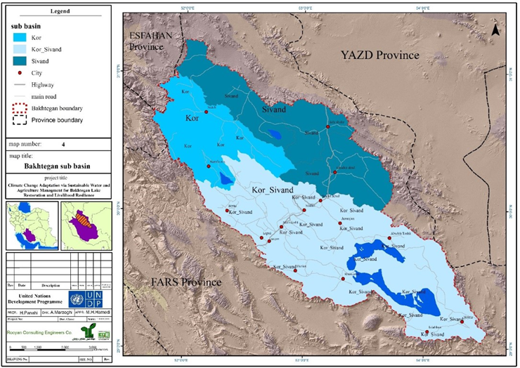

*Figure 1 – The three main sub-basins within the Bakhtegan Basin (target area)*

1. The project is compliant with the legislation, technical/implementation system under the Technical and Implementation System Bureau[15] (TISB), and associated national standards, under the Institute of Standards & Industrial Research of Iran (ISIRI)[16], the Water Industrial Standard[17] (WIS) and will seek to strengthen these by mainstreaming climate change adaptation guidelines as per the Third National Communication of climate change and the National Climate Change Policy for Iran.
2. There are various relevant laws and regulations for protection and improvement of the environment; Land and Coastal; water fair distribution; Regulations on rivers, anchors, mussels, marshes, natural ponds and water supply networks, irrigation and drainage and the general environmental policy under the supreme leader's announcement.

### Summary of Activities

1. The proposed project will have the following activities:

|  |  |  |
| --- | --- | --- |
| **Project Components** | **Expected Outputs** | **Project Activities** |
| **1. Knowledge of climate risk, climate change and the environmental situation is strengthened to support development of long-term climate resilience in the Bakhtegan basin using a decision support system** | | |
|  | 1.1 Integrated model for climate risk and climate change assessment | * The selected climate model will be customized for the Bakhtegan Basin. * Training in the data applied and selected climate model will be undertaken to facilitate assessments of climate change and climate risk for the Bakhtegan Basin * Application of selected climate and hydrologic models will focus on comprehensive modelling of climate change and climate risk in the Bakhtegan Basin, with a specific focus on surface and ground water resources under current and future climate conditions. |
|  | 1.2 Water and land use planning | * Public participation in planning process * Development of an integrated WLUP framework for the Bakhtegan Basin * Analysis of existing land-use and policies by using remote sensed data and GIS analysis * Analysis of existing water resources (surface and sub-surface) and systems * Analysis of data from existing water uses from both surface and ground water * Projections of future water supply and demands based on the results of the future climate projections that will be formulated in Output 1.1 * Identification, review and assessment (including costing) of water and land resource options * Identification review and assessment (including costing) of supply side and demand side options |
|  | 1.3 Local community monitoring | * Participatory engagement with targeted communities, farmers and households to identify and agree on a set of vulnerability and resilience indicators which will be used for local community monitoring. * Development of a mobile app to facilitate reporting on the agreed indicators and provision of this to all targeted communities and households. * Installation of a water monitoring system with participating farmers from Output 2.1 to measure and quantify water reductions from the introduction of climate smart practices. * Quarterly site visits to all participating communities to verify and review information provided through the mobile apps. * In conjunction with Output 1.4, development and dissemination of information based on the local community monitoring |
|  | 1.4 Data and information management for decision support | * Data and information management for decision support will focus on the development of a GIS platform that integrates all relevant data and information layers generated for and through the project. * Establishment of the information/data portal system (TIPS) to facilitate completion to disseminate the needs all the stakeholders based on the national, provincial and local scales. |
| **2. The resilience of communities in the Bakhtegan Basin is strengthened through implementation of climate smart agriculture and alternative livelihoods** | | |
|  | 2.1 Climate smart agriculture | * Development and implementation of Climate Smart Agriculture Plans * Market research, including value chain analyses, on alternative crops and cropping systems that are suited to a dryland environment under changing climate conditions. * Extension of existing knowledge and applied research results to participating farmers. * Development and implementation of a new applied research programme at the MOJA research station in Marvdasht. * Widespread extension of the results of the new research programme to farmers, particularly focusing on Zones 1, 2 and 3 where the greatest reductions in water use are required and there is an urgent need for climate smart agricultural practices. * Support for extension of existing certified organic agriculture initiatives in Zone 4, to encompass additional crops such as pistachio and other agricultural products from all other Zones. * Based on the results of the market research, development of a unique brand for the Bakhtegan Basin. |
|  | 2.2 Alternative livelihoods | * A qualitative and quantitative livelihood assessment, including development and implementation of a livelihood monitoring system. * Off-farm technical and vocational training for all participating household members * Development of small micro-enterprises * Attracting effective support for establishment and operation of small and microenterprises. * Provide access to savings and credit services in rural communities to facilitate livelihood activities and improved quality of life. * Provide hygiene and quality certificates for local food products, including negotiating with the related organizations and providing legal assistance to get the required certificates. * Marketing and advertising for local products including: markets for local products in big cities; introducing goods to national and international festivals, website design. * Work with government agencies, through the mechanism of the Bakhtegan Basin Council (Output 4.2) to review trade and market related legislation. * Provide advisory services to the private sector through studies, workshops, training, identifying appropriate technologies and quality systems, and developing linkages with markets. |
| **3. The resilience of the natural environment of the Bakhtegan Basin is strengthened** | | |
|  | 3.1 Ecosystem conservation in the Bakhtegan Basin | * Development and implementation of an Integrated Watershed Management (IWM) plan * Implementation of integrated watershed management adaptation activities by local people, with support from MOJA, involving a range of physical options and interventions. * A comprehensive extension, communication and education programme (through Output 1.4) to disseminate results and information as widely as possible throughout the Bakhtegan Basin. |
|  | 3.2 Rehabilitation and conservation in protected areas | * Participatory engagement with communities to develop rehabilitation, monitoring and management plans for all the above wetland, national parks, protected areas and hunting prohibited areas * Biodiversity monitoring in Margoun waterfall and Tang-e-Bostank protected areas and wildlife monitoring in both Basiran and KouhSiah-e-Arsanjan hunting prohibited area (depth, quality and biological parameters) * Rehabilitation and conservation work in the Kamjan Wetland      * Rehabilitation and conservation work in Bamou and Bakhtegan National Parks |
| **4. Capacity at the local, regional and national level is strengthened for improved governance and decision making in relation to climate risk management and effective implementation of adaptation measures** | | |
|  | 4.1 Communications, education and capacity building | * Education and capacity building will involve development of resource materials, training of facilitators, and facilitation of participatory workshops with all identified target groups and participating authorities * Communications will include the use of video to share stories within the basin and more widely, publication and dissemination of training materials, brochures and posters, sms messaging, television programmes and communication through the arts (e.g. poetry and painting) |
|  | 4.2 A functional framework for Bakhtegan Basin management | * Conducting a thorough review of existing national frameworks and policies relating to climate change adaptation and land and water resources planning and management. * Establish an integrated water and land management system that incorporates considerations of climate change and natural elements of the total water cycle alongside the realities of human resource use. * Development of a comprehensive plan for allocating water and land resources in a sustainable and climate resilient manner. * Promoting agricultural productivity while remaining attentive to the economic, security, and political concerns related to the harvesting and extraction, supplying, storage, and consumption of water in the Bakhtegan Basin. |
|  | 4.3 Bakhtegan Basin Council | * Establishment of a Bakhtegan Basin Council under existing Fars Province structures. |

### 1.2 Potential Social and Environmental Impacts

1. Preliminary analysis has identified a range of potential limited social and environmental impacts associated with various project activities. These potential impacts are summarized in the table below.
2. The project has been reviewed with UNDP’s Social and Environmental Standards Procedure (SESP). The Social and Environmental Screening Template was prepared (See Annex 5) and the project deemed to be a moderate risk (Category B) project. Discussions on the impact assessment are provided in the Social and Environmental Screening Template, which provided the rationale for the project being classified as a moderate risk. This ESMF provides further discussion below.

|  |  |  |  |  |
| --- | --- | --- | --- | --- |
| **Activity** | **Potential Social and Environmental Impact** | **Potential Project Benefit** | **Mitigation** | **Monitoring** |
| **Output 1.1 – Integrated model for climate risk and climage change assessment** | | | | |
| Customise appropriate climate model for the Bakhtegan Basin.  Training in the data applied and selected climate model will be undertaken to facilitate assessments of climate change and climate risk for the Bakhtegan Basin.  Application of selected climate and hydrologic models will focus on comprehensive modelling of climate change and climate risk in the Bakhtegan Basin, with a specific focus on surface and ground water resources under current and future climate conditions. | Selection of model - No physical impacts, but incorrect model will no provide reliable outputs  Potential bias if training not equitable.  Modelling does not have any physical or social impacts per se, however its use can have so models need to be appropriate, calibrated and tested | Appropriate modelling can provide those that have been trained with a powerful tool for planning and decision making. | Ensure training available to those that need it irrespective of gender or social status | Assessment of model prior to adoption  Mid-term review |
| **Output 1.2 Water and land use planning (WLUP)** | | | | |
| Public participation –in the planning, design and implementation of this Output.  Development of an integrated WLUP framework for the Bakhtegan Basin.  Analysis of existing land-use and policies by using remote sensed data and GIS analysis.  Analysis of existing water resources (surface and sub-surface) systems.  Analysis existing water uses data.  Projections of future water supply and demands based on the results of the future climate  Introduction of WLUP at the Bakhtegan Basin  Identification, review and assessment (including costing) of water and land resource options.  Identification review and assessment (including costing) of supply side and demand side options. | Potentially affected stakeholders, in particular marginalized groups, could potentially be excluded from fully participating in decisions that may affect them  Lack of data for meaningful data  Resistance to WLUP  Conflict between users | Improved buy-in/ownership through participation  Basin-wide approach to water and land management  Plans tailored to villages / sub-basins  Assessments based on real data (remote sensing / GIS) therefore decisions based on reality rather than here-say | All stakeholders, representing communities, authorities and industry, will be involved  Initiate data collection and review early to identify any gaps/weaknesses  Disseminate data widely  Ensure users know how to access and interpret data – capacity building  Bring groups together to share data, stories and issues to reduce tensions and conflict and encourage ownership of issues and solutions. | Consultation and capacity building workshops;  supervision  Mid-term review |
| **Output 1.3 Local Community Monitoring** | | | | |
| Participatory engagement with targeted communities, farmers and households to identify and agree on a set of vulnerability and resilience indicators which will be used for local community monitoring.  Development of a mobile app to facilitate reporting of indicators.  Installation of water monitoring system.  Quarterly site visits to verify and review information provided through the mobile apps.  Development and dissemination of information based on the local community monitoring. | Risk that if process not sufficiently inclusive that not all community adequately represented and full agreement with indicators may not be achieved. This could lead to bias.  App only available to those with access to appropriate technology.  Site visits are unlikely to have any adverse impacts – need to ensure appropriate sites are visited to minimise bias.  Information needs to be in a form that is easily understood by community. | Community buy-in on monitoring indicators  App will provide two way reporting.  Site visits will assist in maintaining veracity of reporting.  Community stays informed. Data and information will be accessible to all project stakeholders, from individual householders and farmers through to national level policy makers | Involve full range of stakeholders in agreeing indicators, design of app, and reporting.  Ensure app is designed for easy use by all stakeholders.  Site visits must capture range of communities/issues – ensure sufficient data is verified.  Develop reporting tools in consultation with end users. | Consultation and workshops;  Site visits  Annual reviews;  Mid-term review |
| **Output 1.4 Data and information management for decision support** | | | | |
| Development of a GIS platform.  Establishment of an information/data portal system (TIPS). | No adverse impacts anticipated from the development of GIS or TIPS as long as data is sufficiently accessible to users.  Not all users will have access to GIS software  Risk that needs of all users not met. | GIS gives a readily understood spatial representation of results/data. GIS is a universal tool, so can be up-scaled.  A multi-user platform will be developed so that information will be available to wide range of stakeholders. | Develop reporting tools in consultation with end users | Consultation  Mid-term review |
| **Output 2.1 Climate Smart Agriculture** | | | | |
| Development and implementation of Climate Smart Agriculture Plans and alternative livelihood practices.  Market research, including value chain analyses, on alternative crops and cropping systems that are suited to a dryland environment.  Research on new crops and cropping systems for dryland environments.  Extension of the results of the new research programme to farmers.  Development of a unique brand for the Bakhtegan Basin.  A comprehensive extension, communication and education programme. | Risk of non-acceptance of changes/alternate livelihoods.  New crops inappropriate  Misunderstanding of Bakhtegan Basin brand or failure to appropriately target brand | Maladaptive practices will be reduced/ceased.  Diversification of livelihoods  Reduced pressure on land and water resources.  Builds on existing initiatives.  New market chains developed and Basin brand developed enabling wider recognition of produce from the region.  Migration from rural areas reduced | Participatory engagement with farmers will be designed to ensure that they are committed to such changes - participation, empowerment and ownership building are keys to success.  Identify suitable markets in which to develop value chains. Ensure market chains get end-to-end support.  Research programme to be as action focused as possible.  Make Bakhtegan Basin brand something that local communities can relate to and be proud of, as well as meet marketing needs.  Establish working groups in each Zone. | Consultation workshops  Mid-term review  Market survey  Community survey |
| **Output 2.2 Alternative Livelihoods** | | | | |
| Qualitative and quantitative livelihood assessment and development/implementation of a livelihood monitoring system.  Off-farm technical and vocational training for all participating household members.  Development of small micro-enterprises and attraction of support for them, including access to savings and credit services.  Provide hygiene and quality certificates for local food products, including negotiating with the related organizations and providing legal assistance to get the required certificates.  Marketing and advertising for local products.  Work with government agencies to review trade and market related legislation.  Provide advisory services to the private sector. | Micro-enterprises can have physical impacts if not appropriately managed eg waste by-products, prevention of child labour etc  Access to credit if not adequately supported can lead to debt  There is a risk of potentially reproducing discrimination against women based on gender, especially regarding participation in design and implementation or access to opportunities and benefits | Communities will have a greater understanding of livelihood options available.  Capacity will be built.  Existing capacity will be drawn - ‘training the trainers’ and mentoring approach.  Access to finance will assist micro-enterprises to flourish  Communities will have more diversified economic bases  Appropriate technologies and quality systems introduced.  Linkages with markets improved.  Local brand recognition increased and markets expanded.  Migration from rural areas reduced, with consequent reduction in health issues and crime. | Adopt participatory approach, ensue vulnerable groups no excluded.  Assess village needs (eg. labour supply and demand)  Assess options, opportunities and capacities for livelihoods diversification at the local level.  Provide specific support to women eg via Rural Women’s Trust Fund  Support viable, up-scalable livelihood options  Enterprises will need to meet applicable laws and requirements so that they do not have negative social or environmental impacts. | Annual reviews  Mid-term review  Market survey |
| **Output 3.1 – Ecosystem Conservation in the Bakhtegan Basin** | | | | |
| Development and implementation of an Integrated Watershed Management (IWM) plan.  Implementation of integrated watershed management adaptation activities by local people, with support from MOJA.,  A comprehensive extension, communication and education programme to disseminate results and information as widely as possible throughout the Bakhtegan Basin. | Development of IWMP can have adverse impacts if the plan does not consider the needs of the wider community and particularly marginalised people.  Implementation of the IWMP will include a range of physical options eg small earth dams, check dams, groundwater recharge, revegetation and changed agricultural practices. These activities can have adverse impacts if not appropriately managed, this can be achieved through the development of environmental management practices or plans as part of the IWMP. | Development of plan will be participatory, which will result in a holistic plan that meets the expectations of the broader community.  An integrated, multi-faceted, approach will provide the necessary conditions to support conservation of the soil and water resources of the Bakhtegan Basin.  Enhancement of the natural environment - ecological service provided by Bakhtegan basin improved.  Awareness and ownership by communities of the need to continue protecting the natural environment | Develop IWMP in a participatory manner involving broad range of stakeholders, including women and vulnerable groups.  Revegetation to utilise appropriate species – avoid introduction of potential weed species.  Incorporate good environmental management practices into IWMP – develop separate ESMPs if required.  Improve agricultural practices eg contour and strip cropping, introduction of permits systems, cooperative grazing and rangeland conservation measures.  Communicate results regularly to communities | Annual reviews  Mid-term review |
| **Output 3.2 Rehabilitation and Conservation in Protected Areas** | | | | |
| Participatory engagement with communities to develop rehabilitation, monitoring and management plans for all the above wetland, national parks, protected areas and hunting prohibited areas  Biodiversity monitoring in Margoun waterfall and Tang-e-Bostank protected areas and wildlife monitoring in both Basiran and KouhSiah-e-Arsanjan hunting prohibited area (depth, quality and biological parameters)  Rehabilitation and conservation work in the Kamjan Wetland    Rehabilitation and conservation work in Bamou and Bakhtegan National Parks | Potential to exclude some members of community.  Not all community members may agree to required approach / solutions.  Risk of agrochemicals entering wetlands  Poor monitoring will lead to spurious data and may result in poor decision making  Physical disturbance of wetland bed | Internationally important (Ramsar) wetlands improved.  Community tensions reduced and collective understanding of solutions achieved | Ensure fully participatory approach that includes all relevant stakeholder groups.  Aim for consensus and buy in of management plan so community owns problems and solutions.  Select appropriate indicators for monitoring  Undertake biodiversity monitoring at appropriate time intervals dependent upon indicators  Training in monitoring techniques and dissemination of methodology so that consistency in approach is achieved between observers. | Consultation workshops  Annual reviews  Mid-term review |
| **Output 4.1 Eductation, capacity building and communications** | | | | |
| Education and capacity building  Communicate data and information relating to the project widely throughout the Bakhetegan Basin. | Potential to marginalise some stakeholders | Capacity of provincial officials, farmers, households and communities increased  All stakeholders in Basin have a deeper understanding of the issues and challenges they face and solutions required.  Results generated by project will be widely communicated | Assessment of training/capacity needs and identification of all target groups and participating authorities.  Conduct education and capacity building in a participatory manner  Communications to use multi-media platforms. | Mid-term reviews  Capacity building workshops  Supervision missions |
| **Output 4.2 A functional framework for Bakhtegan Basin management** | | | | |
| Review of existing national frameworks and policies relating to climate change adaptation and land and water resources planning and management.  Establish an integrated water and land management system that incorporates considerations of climate change and natural elements of the total water cycle alongside the realities of human resource use.  Develop a comprehensive plan for allocating water and land resources in a sustainable and climate resilient manner.  Promote agricultural productivity while remaining attentive to the economic, security, and political concerns. | No physical impacts associated with the undertaking of the activity, however the outcomes can result in adverse impacts if tasks not appropriately undertaken:  Risk of duplication or creation of bias or gaps if review is not comprehensive and considers interaction between various frameworks and policies.  Inequity of allocation of water and land resources if development of plan is not fully participatory.  Women may be excluded from decision-making or not adequately participate in the design/implementation of the project  Women might have unequal access to resources and/ or access to opportunities and benefits  If not appropriately informed, the IWLMS may fail to take into account appropriate climate, natural processes and economic realities. | Any deficiencies or weaknesses in national frameworks and policies will identified and amended as appropriate so that governance mechanisms are more efficient and effective.  IWLMS - This will involve the use of a “national spatial strategy plan” approach based on natural water basins. IWLS will guide and inform the provincial environmental working group under the Environmental High Council of Iran at the highest national scale.  Women receive an equitable share of benefits and that their status and interests are not marginalized  Promoting ag productivity - The main function of this activity is to ensure that agricultural water resources are used not only efficiently but in a socially, economically and climate resilient manner | Focus on identifying key gaps and needs, particularly in relation to the efficiency and effectiveness of current governance mechanisms from national level all the way through to local farmers.  Ensure development of IWLMS is fully participatory among all stakeholders in the Bakhtegan Basin.  IWLS plan to be work from the ground up, be informed by climate change and natural resource issues and constraints and the national policy and planning context.  Promotion of measures and techniques that reduce inequality between men and women  Participatory processes to include specially designed methodologies that enhance the participation of  Work village by village and between villages to develop water and land resources allocation plan | Capacity building workshops;  Annual reviews;  Gender assessment;  Use of disaggregated indicators related to gender equality and women’s empowerment;  Mid-term review |
| **Output 4.3 – Bakhtegan Basin Council** | | | | |
| Establish Bakhtegan Basin Council (BCC) under existing Fars Province structures. | BCC may not be given sufficient authority or be accepted.  Bakhtegan Basin Council may not be representative of all stakeholders  Potentially affected stakeholders, in particular marginalized groups, could potentially be excluded from fully participating in decisions that may affect them | Builds on existing Fars provincial structures and also the existing management plan for the Bakhtegan wetland.  Functions of taskforce will be extended to incorporate adaptation to climate change. | Ensure BCC has mandate to undertake necessary tasks.  BBC to take account of national, provincial and local realities eg alignment with national plans and policies, address the need for food and water security, need for protection of natural resources.  Promote inclusive consultation by Council  Build capacity of BCC members | Inception assessment;  mid-term review;  consultation workshops;  supervision missions |

## Legal and Institutional Framework for Environmental and Social Matters

### 2.1 Legislation, Policies and Regulations

1. The Islamic Republic of Iran has a semi-democratic political system established after the Islamic Revolution of 1979. The political system is based upon governance by an Islamic jurist.
2. The following legislation is relevant to the project:

|  |  |  |
| --- | --- | --- |
| **National Legislations** | **Objective/Relevance** | **Authority** |
| Constitution | “After the Islamic Revolution, the government enshrined environmental protection in the Constitution. "In the Islamic Republic of Iran protection of the environment, in which present and future generations should enjoy a transcendent social life, is regarded as a public duty," reads **Article 50**. "Therefore, economic and any other activity, which results in pollution or irremediable destruction of the environment is prohibited." | National Constitution |
| National Law of Conversation, Restoration and Management of Wetlands. 2017 | Any development activities that will cause pollution and destruction its non-compensable, completely prohibited and the reference organization to distinguish the destruction and pollution is DoE.  DoE has to determine the water needs of wetlands and ministry of energy is obligated to supply the water need based on an approved plan. | DOE |
| National Regulation for Conservation, Restoration and Management of Wetlands National Strategy2015 | Provides a definition of wetlands, water rights definition and supply, and preparation of integration of management plans for wetlands, and considering the plans within ministerial action plans. | DOE |
| Environmental Protection and Enhancement Law 1974 | The Environmental Protection Law specifies rules and measures for the protection and management of the environment. The objectives of this Law, consisting of 21 articles, are the protection and improvement of the environment. Appropriate measures must be taken by the department of Environment (DOE) and the High Council for Environmental Protection in order to: (a) Preserve the ecological balance; (b) Prevent and control waste and noise pollution considered harmful to the environment; (c) Establish a system of supervision and monitoring for wildlife and marine resources; (d) Conduct environmental scientific research aimed at protecting and improving the environment; (e) Adopt effective measures against polluting units in order to prevent air, water, and soil pollution; (f) Arrange public training courses in order to raise awareness about environmental protection and improvement; and (g) Establish limitations for hunting and shooting in some protected areas. | DOE |
| Regulations on Environmental Protection Law 1975. | These Regulations were adopted in accordance with article 21 of the Environmental protection Law. The text is divided into 9 Chapters. "National parks", "Natural resources", "Wildlife shelters", "Important protected areas" have been defined in Chapter I. Basic principles and rules, which govern these areas and their limitations, have been defined in Chapter II. Remaining chapters spell out provisions for strengthening the prevention, control on hunting, shooting, and grazing in these designated areas. Sections on regulations concerning inspection of polluting units, emphasis on promotion of environmental education and formulation of standards for improving environmental quality with cooperation of relevant organization are also included in this text. | DOE |
| Act on plant varieties registration, control and certification of seedlings 2003 | The Act sets up the Seed and Seedling Registration and Certification Research Institute, which supervises and regulates the identification of both new plant varieties and breeders' rights, as well as issue a patent for the newly certified registered seed and seedling varieties. Article 3 refers to non-improved and wild plant genetic resources, whose patenting procedures shall be restricted to the State. Further the Act establishes that varieties prevalent in the country shall be given priority in the registration process. | MOJA |
| Comprehensive Program of Public Education on Environment 2009 | The Act aims to reduce environmental degradation and increase the sustainable use of natural resources through training of various groups of population. | DOE |
| Executive By-Law on improved utilization of water in agriculture 1996 | This By-Law consists of 4 Chapters and 3 Annexes making provisions for the improved utilization of water in agriculture by presenting some methods on behalf of the Ministries of Agriculture (MOA) and Energy (MOE).Chapter 1, general description and issues: (a) Supplying a method for improvement in utilization according with Annex 3; (b) Establishment of expert committee with representatives from MOA and MOE; (c) Supplying a comprehensive agricultural and watershed management plan in each region after 3 months of approving this By-Law; (d) MOA will prepare a cultivation plan for each region taking into consideration national and regional policies; and (e) MOA commits to establish legal bodies for the land that is under the coverage of water delivery system. Chapter 2, delivery volumes in irrigation networks. The Regional Water Organization will deliver required water to consumers according to the new methods of consumption which can reduce water usage or limit delivery particularly during incidences of drought. Chapter 3, controlling water volume in deep and semi-deep wells. The Regional Water Organization is required to determine the exact water needs for agricultural land using deep and semi- deep wells 3 months following approval of this By-Law. | MOJA  MOE |
| Instruction of Assignment of National and Public Resources for Agricultural and Non-agricultural Purpose 2008 | The Instructions lay down provisions on assignment of national and public resources for agricultural and non-agricultural purposes. | MOJA |
| Iran Water Law and Methods of Nationalization of Water 1968 | The purpose of the Law is to nationalize all internal waters and recognize the Ministry of the Energy as a responsible authority for maintaining and exploiting of water resources. The Ministry is responsible to determine the permitted water consumption for domestic, agriculture and industry sectors, as well as to establish the official tariff for each. For any use of public water, as well as groundwater resources, a special authorization is required from the Ministry. | MOE |
| Iran Water Law and the manner of water nationalization 1968 | The Law provides for the nationalization of river basins and of other water resources, the public use of water resources, the concession of permits consenting use of aforesaid resources and the relative prescriptions. It also defines and set the charges due for water utilisation, the conditions involved in using water resources and for their protection from polluting and wasting. | MOE |
| Law on Agricultural Labour 1974 | The purpose of this Act, which consists of 40 articles, is to regulate obligations governing employment conditions in agricultural jobs. Thus, it provides comprehensive definitions for a number of basic relevant concepts, such as agricultural worker, agricultural job, agricultural employer, agricultural labour contract and wage. According to this Act, agricultural jobs include all jobs related to farming, gardening, animal husbandry, fishery, forestry and any related technical jobs. | MOJA |
| Law on Biosecurity 2009 | The Law, which consists of 11 articles, aims to regulate provisions on production, domestic or cross-border trans-shipment, importation, exportation, trade, supply and consumption of genetically modified organisms. | MOJA  MOE  MOH |
| Law on Conservation and Protection of Natural Resources and Forest Reserves of the Country 1992 | The Act aims to protect and rehabilitate the natural forests and resources. The Acts considers particular species of trees and plants as national forest reserves and prohibits their cutting. In case of necessity, these species may only be cut with permission obtained by the Ministry of Agriculture. Any violation of this Act shall be punished by imprisonment and fine. | MOJA |

### 2.2 Environmental Impact Assessment Regulations

1. Iran’s parliament (Majlis) on Thursday approved bills, mandating the administration to ensure the implementation of strategic environmental assessment (SEA) and environmental impact assessment (EIA).
2. Within the framework of the sixth five-year national development plan (2017-2021) are bills, mandating the administration to ensure the implementation of strategic environmental assessment (SEA) and environmental impact assessment (EIA).
3. SEA is a systematic decision support process, aiming to ensure that environmental and possibly other sustainability aspects are considered effectively in policy, plan and program making, while EIA is the assessment of the environmental consequences of a plan, policy, program, or concrete projects prior to the decision to move forward with the proposed action by individuals or companies in all aspects of the projects run by the private or the public sector.
4. . The Department of Environment (DoE) is the main government body in Iran responsible for assessing environmental impacts. The Department operates under the Environmental Protection and Enhancement Act (1972, as amended in 1991). Under Article 6 of the Guidelines on Environmental Impact Assessment (1997), the implementing bodies of major development projects should prepare an EIA report covering the points required by the DoE and related by-laws. Article 7 states that reports on EIA shall cover both the construction period and the operation period.
5. All project activities will be assessed for risk and the DoE consulted regarding the need for SEA or EIA, which will be undertaken if required.

### 2.3 Multilateral Environmental Agreements

1. Iran is a signatory to a number of international and regional agreements and conventions, which are relevant to the project. They include:

* 1992 United Nations Framework Convention on Climate Change
* 1997 Kyoto Protocol to the United Nations Framework Convention on Climate Change
* 1972 Convention Concerning the Protection of the World Cultural and Natural Heritage
* 1992 Convention on Biological Diversity
* 1971 Convention on Wetlands of International Importance (Ramsar)
* 2000 Cartagena Protocol on Biosafety on the Convention on Biological Diversity
* Paris Agreement 2015 - The Paris Agreement’s central aim is to strengthen the global response to the threat of climate change by keeping a global temperature rise this century well below 2 degrees Celsius above pre-industrial levels and to pursue efforts to limit the temperature increase even further to 1.5 degrees Celsius. Additionally, the agreement aims to strengthen the ability of countries to deal with the impacts of climate change. The Agreement also provides for enhanced transparency of action and support through a more robust transparency framework.
* 2008 Memorandum of Understanding concerning the Conservation of Migratroy Birds of Prey in Africa and Eurasia
* 2001 International Treaty on Plant Genetic Resources for Food and Agriculture
* 2001 Stockholm Convention on Persistant Organic Pollutants
* 1998 Memorandum of Understanding concerning Conservation Measures for the Siberian Crane
* 1998 Rotterdam Convention on the Prior Informed Consent for Certain Hazardous Chemicals and Pesticides in International Trade
* 1994 Memorandum of Understanding concerning Conservation Measures for the Slender-billed Curlew
* 1994 United Nations Convention to Combat Desertification in those Countries Experiencing Serious Drought and/or Desertification, particularly Africa.
* 1979 Convention on the Conservation of Migratory Species of Wild Animals
* 1973 Convention on International Trade in Endangered Species of Wild Fauna and Flora
* 1951 International Plant Protection Convention

### 2.4 References, Standards, ToRs, and Guidelines

1. The following are references, standards, Terms of Reference and guidelines that govern the implementation of climate change adaptation measures in the Bakhtegan Basin:

|  |  |  |
| --- | --- | --- |
| **References/Standards/ToRs/Guidelines** | **Issued by & Date** | **Subject** |
| Guideline to harvest the river bed material | WIS (2011) | Water and Environmental |
| Guideline for Environmental Impact Assessment (EIA) on River Engineering projects | WIS (1998) | Water and Environmental |
| Guideline for Environmental Impact Assessment (EIA) on water and sewage projects | WIS (1999) | Water and Environmental |
| Guideline for studying the big dam’s reservoirs | WIS (2011) | Water and Environmental |
| Guideline for monitoring surface water | WIS (2009) | Water and Environmental |
| Guideline for monitoring sub-surface water | WIS (2012) | Water and Environmental |
| Environmental criteria for reusing recycle and sewage water | WIS (2011) | Water and Environmental |
| Fundamental of environmental issues to design artificial recharge projects | WIS (2010) | Water and Environmental |
| Term of References for Soil and Watershed Management studies | WIS (1994 & 1996) | Water Resources Management |
| Term of References for Sub-surface water studies | WIS (2001) | Water Resources Management |
| Guideline for water sampling | WIS (1999) | Water Resources Management |
| Term of References for Water Artificial Recharge studies | WIS (2001) | Water Resources Management |
| Guideline for agricultural wells rehabilitation and restoration | WIS (2002) | Water Resources Management |
| Applied guideline for using GIS & RS in Hydrology studies in various Iranian water basins | WIS (2013) | Water Resources Management |
| Guideline to calculate Probable Maximum Flood (PMF) | WIS (2013) | Water Resources Management |
| [A Revision on the Current Studies of EIA,SEA and the Proposed Adaptive Needs](https://centralzagros.doe.ir/Portal/file/?636010/A-Revision-on-the-Current-Studies-of-EIA-SEA-and-the-Proposed-Adaptive-Needs.pdf) | CZM[18] (2015) | Environment Impact Assessment |
| The Guideline of Sustainable Agriculture | CZMP (2015) | Sustainable Agriculture |
| The Guideline on Sustainable Tourism | CZMP (2015) | Sustainable Tourism |
| The Guideline on Sustainable Use of Forests | CZMP (2015) | Sustainable Use of Forests |
| The Guideline on Sustainable Use of Rangelands | CZMP (2014) | Sustainable Use of Rangelands |
| The Guideline on Sustainable Use of Water Resources | CZMP (2014) | Sustainable Use of Water Resources |
| The Guideline on the Effluent Management in the Rural Areas | CZMP (2013) | Effluent Management in the Rural Areas |
| The Guideline on the Solid Waste Management of the Rural Area | CZMP (2013) | Solid Waste Management in the Rural Area |
| The Guideline on Sustainable Aquaculture | CZMP (2013) | Sustainable Aquaculture |

### 2.5 UNDP Social and Environmental Standards

1. UNDP’s Social and Environmental Standards (SES) have been applied during development of the project. The SES objectives are to: (i) strengthen the social and environmental outcomes of programmes and Projects; (ii) avoid adverse impacts to people and the environment; (iii) minimize, mitigate, and manage adverse impacts where avoidance is not possible; (iv) strengthen UNDP and partner capacities for managing social and environmental risks; and (v) ensure full and effective stakeholder engagement, including through a mechanism to respond to complaints from project-affected people.
2. UNDP will not support activities that do not comply with national law and obligations under international law, whichever is the higher standard (hereinafter "Applicable Law"). UNDP seeks to support governments to adhere to their human rights obligations and empower individuals and groups, particularly the most marginalized, to realize their rights and to ensure that they fully participate throughout UNDP’s programming cycle.
3. UNDP’s SES have been reviewed by the Adaptation Fund and it was determined that the SES address the requirements of the Adaptation Fund’s Environmental and Social Policy.
4. The project was screened with UNDP’s Social and Environmental Screening Procedure (see Annex 5) which resulted in a “Moderate” (e.g. Category B) overall project social and environmental risk categorization. It was determined that the following UNDP Social and Environmental Standards were particularly relevant to the project:

* Principle 1: Human Rights
* Principle 2: Gender Equality and Women’s Empowerment
* Standard 1: Biodiversity Conservation and Natural Resource Management
* Standard 2: Climate Change Mitigation and Adaptation
* Standard 3: Community Health, Safety and Working Conditions
* Standard 6: Indigenous Peoples
* Standard 7: Pollution Prevention and Resource Efficiency

## ESMF Requirements and Procedures for Screening, Assessment and Management

### 3.1 Objectives and Requirements of the Environmental and Social Management Framework

1. An ESMF is a management tool used to assist in addressing potential adverse social and environmental impacts associated with project activities. To ensure the environmental and social objectives of the projects are met and adverse impacts are avoided and/or mitigated, this ESMF will be used by the project implementers.
2. The ESMF identifies steps for screening potential social and environmental issues and impacts of particular project activities as their specific locations are further defined and for preparing and approving appropriate action plans for avoiding, and where avoidance is not possible, reducing, mitigating, and managing adverse impacts.
3. The environmental and social objectives of the project and ESMF are to:

* increase climate resilience and adaptive capacity of stakeholders in the Bahktegan Basin;
* protect forest, rangeland and important ecosystems related to water resources;
* implement on the ground adaptation measures for forest, land and water resources management in the targeted areas;
* improve national , regional and local capacities;
* strengthen knowledge, information management, and monitoring systems on climate change vulnerability and adaptive capacity;
* promote sustainable livelihoods and management practices in utilization of natural resources;
* adopt the best practicable means available to prevent or minimise environmental impact and ensure compliance with applicable laws, regulations and standards;
* describe monitoring procedures required to identify social and environmental impacts.

### 3.2 Screening Procedures of the Environmental and Social Management Framework

1. All project activities with a physical footprint will be screened and assessed according to DOE is responsible to assess any SEAs or EIAs that may be required.
2. No activities considered potentially “high risk” will be permitted.
3. In addition, project activities will be screened against the following “negative list”. The following subprojects or activities will be deemed ineligible for the Adaptation of Communities for the Bakhtegan Basin in Iran if they:

* Involve significant conversion or degradation of natural habitats and/or may cause measureable adverse impacts to critical natural habitats;
* Risk the introduction of alien and potentially invasive alien species;
* May negatively affect endangered species;
* Involve physical displacement of people;
* Could result in damage or loss to cultural heritage;
* Do not meet minimum design standards with poor design or construction quality, particularly  if located in vulnerable areas;
* Require or involve:
  + Production or trade in any product or activity deemed illegal under host country laws or regulations or international conventions and agreements;
  + Purchase, application or storage of harmful pesticides or hazardous materials;
  + Production or activities involving forced labor / harmful child labor;
  + Production or trade in wood or other forestry products from unmanaged forests;
  + Trade in wildlife or wildlife products regulated under CITES (Convention on International Trade in Endangered Species of Wild Fauna and Flora).

### 3.3 Environmental and Social Assessment Procedures of the ESMF

1. All project activities that are determined to present potential “moderate risks” will be assessed according to DOE environmental assessment regulations and procedures. Targeted forms of assessment are to be undertaken, addressing the specific potential social and environmental risks presented by the activity. No “high risk” activities are permitted.
2. All such project activities will be required to obtain the appropriate permits from the regulatory authorities.
3. The Project’s stakeholder engagement plan (section 4) will be fully implemented.
4. In addition, the following targeted assessments and mitigation/management measures will be required:

* Gender assessment in the initial phase of the project to assess divisions of labor and women’s role and access to resources in order to develop recommendations on how the project will promote women’s equality and empowerment.
* Marginalized and vulnerable groups assessment in the project inception to prioritize communities and groups for adaptation interventions.
* Appropriate erosion and sediment control for micro water infrastructure and will be undertaken during all stages of the project.
* There will be no release of pollution and/or chemicals as a result of the project activities.
* Appropriate waste management procedures will be followed.
* Community safety measures will be employed regarding construction and micro water infrastructure activities.
* No project activities will take place on lands and/or territories claimed by indigenous peoples without their Free, Prior Informed Consent (FPIC).

1. **Timing of assessments:** In all cases, social and environmental assessments and adoption of appropriate mitigation plans/measures must be completed, disclosed, and discussed with stakeholders prior to initiation of any project activities that may cause adverse social and environmental impacts.
2. The ESMF will be updated from time to time by the project team/PMU in consultation with the UNDP staff to incorporate any needed changes as particular project activities are designed in detail and any needed assessments are undertaken.

### 3.4 Emergency Management Measures

1. In the event of actions occurring which may result in serious health, safety and environmental damage, emergency response or contingency actions will be implemented as soon as possible to limit the extent of environmental damage.
2. The delivery organisation will need to incorporate emergency responses into the project complying with the requirements under the Occupational, Health and Safety Policy of the delivery organisation and the relevant Iranian legislation.

### 3.4.1 Performance Criteria

1. The following performance criteria are set for project construction activities:

* no incident of fire outbreak;
* no failure of water retaining structures;
* no major chemical or fuel spills;
* no preventable industrial or work related accidents;
* provide an immediate and effective response to incidents that represent a risk to public health, safety or the environment; and
* minimise environmental harm due to unforeseen incidents.

### 3.4.2 Reporting

1. Responsible authorities and UNDP staff must be notified immediately in the event of any emergency, including fire or health related matter including those that have resulted in serious environmental harm.

## Stakeholder Engagement Plan

### 4.1 Introduction

1. The Adaptation of Communities for the Bakhtegan Basin in Iran involves a wide range of stakeholder engagement activities. These are outlined below.
2. The project was discussed with a wide range of stakeholders including relevant government organisations, NGOs, and individual community members and approved by the Government. On-ground consultation has been undertaken during the design of the project, including:

|  |  |  |  |
| --- | --- | --- | --- |
| **Organisation consulted** | **Role/Responsibility** | **Issues addressed** | **Project components** |
| National Technical Committee (NTC) | Cross-departmental committee overseeing development of the AF proposal on behalf of the Iranian Government  Provided conceptual and technical guidance an input to the project development process | Identified the Bakhtegan Basin as the project location  Project scope and management arrangements  Feedback and comments on the project proposal | Components 1, 2, 3 and 4 |
| Department of Environment | Responsible for natural resources management, with a particular project focus on protected wetland areas | Provided technical input into the formulation of Component 3 | Components 1, 2, 3 and 4 |
| Ministry of Energy | Responsible for water resources management | Developed a pre-proposal that guided the formulation of Component 1 | Components 1, 2, 3 and 4 |
| Ministry of Jihad Agriculture | Responsible for agriculture and food security | Provided technical input into the formulation of Component 2 | Components 1, 2, 3 and 4 |
| United Nations Development Programme | Provided technical and administrative support during the proposal preparation, organised the project development mission to Iran and the Bakhtegan Basin | Input to project formulation and design  Contributions and support to the National Technical Committee  Project management and institutional arrangements | Components 1, 2, 3 and 4 |
| Fars Provincial Government | Responsible for the management of land and water resources in the Bakhtegan Basin  Provided an overview of the situation in the basin  Assisted in gathering requested data for the national consultants from stakeholders | Identification of issues and needs within the Bakhtegan Basin  Information on existing activities and initiatives | Components 2, 3 and 4 |
| Kharameh County Government and community representatives | Responsible for local decision making in relation to land and water resources management  Coordination between different County authorities and assisted with the workshops | Provided information of the issues being experienced in Kharameh County, actions that are already being taken and what additional support is required | Components 2 and 3 |
| Estabhan County Government and community representatives | Responsible for local decision making in relation to land and water resources management  Coordination between different County authorities and assisted with the workshops | Provided information of the issues being experienced in Estabhan County, actions that are already being taken and what additional support is required | Components 2 and 3 |
| Marvdasht County Government and community representatives | Responsible for local decision making in relation to land and water resources management  Coordination between different County authorities and assisted with the workshops | Provided information of the issues being experienced in Marvdasht County, actions that are already being taken and what additional support is required | Components 2 and 3 |
| Non-Governmental Organizations | Participation in consultative workshops | Provided information of the issues being experienced, existing livelihoods and alternative ones | Components 2 and 3 |

### 4.2 Project Stakeholders

The stakeholders in the table will continue to be informed and/or engaged by the project along with the following:

* Farmers and community producer associations
* Villagers
* Protected area managers
* Educational institutions
* International NGOs and partner organisations (i.e. World Vision, Habitat for Humanity, etc.)
* Agriculture schools
* Religious institutions
* Women’s groups
* Technology providers
* Financial institutions
* Produce markets and manufacturers
* Water associations
* Forestry cooperatives

### 4.3 Stakeholder Engagement Program

1. The Stakeholder Engagement Program seeks to set the procedures for ensuring consultation and stakeholder engagement during assessment, development of action plans, and monitoring of social and environmental impacts associated with specific project activities, including information disclosure requirements.
2. The UNDP and DOE will develop and release project-related information to communities, organisations and municipalities where the project is implementing its activities. In order to do so, the project will make use of:

* Newspapers, local radio podcasts, and local television
* Brochures, leaflets, non-technical summary documents and technical reports

1. In addition, UNDP information disclosure requirements are to be addressed. The draft UNDP Social and Environmental Screening Procedure (SESP) will be made available to project stakeholders prior to project approval, and the final SESP will be made available upon approval. If/when site-specific, targeted environmental and social assessments are required, the draft assessment and findings, including specific management measures, will be made available to project stakeholders for public comment. Final assessments and plans will be disclosed upon completion. Summary reports of assessment findings should be disclosed. Stakeholders will be notified on the availability of draft and final documents.
2. The project will ensure that women and other relevant groups such as indigenous groups, elderly, and youth receive an equitable share of benefits and that their status and interests are not marginalized. Participatory processes will include specially designed methodologies that enhance the participation of women and these other groups; therefore, it is expected to enhance the inclusion of their views into the activities of the project, using existing mechanisms for representing their views such as the municipal units and units, community-based organisations, community development associations, forestry cooperatives. The project does not foresee any change or negative impact on the current livelihood of indigenous groups or their natural resource base. In case any project activity requires a formal process of Free and Informed Prior Consent (FIPC), then the project will follow due process either under existing national mechanisms or current international standards, eg the 169 ILO Convention, the Declaration by United Nations on the Rights of Indigenous Peoples, and Jurisprudence produced by the Inter-American Human Rights system.
3. The Stakeholder Engagement Program will build on various activities and methods, including the promotion of participatory processes, joint decision-making, and partnerships undertaken with local communities, NGOs, and local governments. The project will support the operationalization and formalization of the Bakhtegan Basin Council, which is envisaged as a key multi-stakeholder coordination, consultations and information sharing mechanism involving national and municipal entities, as well as community based- and civil society organisations. The project will also support exchange visits, training, and capacity building initiatives.
4. . Stakeholder engagement activities and required technical assistances will be funded by the project’s budget as part of specific Outputs.
5. The project team will develop and release updates on the project on a regular basis to provide interested stakeholders with information on project status. Updates may be via a range of media (e.g. print, radio, social media or formal reports).
6. Key project materials are to be made available in Persian and local languages if appropriate.

### 4.4 Complaints Register and Grievance Redress

1. The project will include a complaints and grievance redress process. A publicized telephone number will be maintained throughout the project to serve as a point of contact for enquiries and concerns. All enquiries, concerns and complaints will be recorded on a register and the appropriate manager will be informed. Where there is a community issue raised, the following information will be recorded:

* time, date and nature of enquiry, complaint or concern;
* type of communication (e.g. telephone, letter, personal contact);
* name, contact address and contact number;
* response and investigation undertaken as a result of the enquiry, complaint or concern; and
* actions taken and name of the person taking action.

1. All enquiries, complaints and concerns will be investigated and a response given to the complainant in a timely manner. The National Project Coordinator will be responsible for undertaking a review of all enquiries, complaints and concerns and ensuring progress toward resolution of each matter.
2. Some enquiries, complaints and concerns may require an extended period to address. The complainant(s) will be kept informed of progress towards rectifying the concern.
3. Wherever possible, the project team will seek to resolve the complaint as soon as possible, and thus avoid escalation of issues.
4. Any complaint will be advised to the UNDP within 24 hours of receiving the complaint.
5. A summary list of complaints received and their disposition must be published in a report produced every six months.
6. The project complaints and grievance process has been designed to be problem-solving mechanism with voluntary good-faith efforts. The Grievance Redress Mechanism is not a substitute for the legal process. The Grievance Redress Mechanism will as far as practicable, try to resolve complaints and/or grievances on terms that are mutually acceptable to all parties. When making a complaint and/or grievance, all parties must act at all times, in good faith and should not attempt to delay and or hinder any mutually acceptable resolution.
7. In addition to the project-level and national grievance redress mechanisms, complainants have the option to access UNDP’s Accountability Mechanism, with both compliance and grievance functions. The Social and Environmental Compliance Unit investigates allegations that UNDP's Standards, screening procedure or other UNDP social and environmental commitments are not being implemented adequately, and that harm may result to people or the environment. The Social and Environmental Compliance Unit is housed in the Office of Audit and Investigations, and managed by a Lead Compliance Officer. A compliance review is available to any community or individual with concerns about the impacts of a UNDP programme or project. The Social and Environmental Compliance Unit is mandated to independently and impartially investigate valid requests from locally impacted people, and to report its findings and recommendations publicly.
8. The Stakeholder Response Mechanism offers locally affected people an opportunity to work with other stakeholders to resolve concerns about the social and environmental impacts of a UNDP project. Stakeholder Response Mechanism is intended to supplement the proactive stakeholder engagement that is required of UNDP and its Implementing Partners throughout the project cycle. Communities and individuals may request a Stakeholder Response Mechanism process when they have used standard channels for project management and quality assurance, and are not satisfied with the response (in this case the project level grievance redress mechanism). When a valid Stakeholder Response Mechanism request is submitted, UNDP focal points at country, regional and headquarters levels will work with concerned stakeholders and Implementing Partners to address and resolve the concerns. Visit [www.undp.org/secu-srm](http://www.undp.org/secu-srm) for more details. The relevant form is attached at the end of the ESMF.
9. See Appendix 1 for further guidance on accessing UNDP’s Accountability Mechanism.

## Implementation and operation

### 5.1 General Management Structure and Responsibilities

1. The proposed governance structure for the project and beyond is based on the existing management plan for the Bakhtegan-Tashk wetlands that has already been prepared by the DoE of Fars province and UNDP of Iran to combat drought. The intention to build on this existing mechanism represents a focus on ensuring participation of all relevant stakeholders to address the consequences of water and land resource mismanagement and adapt to the unfolding negative impacts of climate change in the Bakhtegan Basin. This includes working to ensure maximum participation from local people.

At the highest level in Fars Province the Fars provincial governor, as the highest local official, will oversee the project’s goal of building resilience to climate change in the Bakhtegan Basin. The Director General of the DOE in Fars Province will serve as the secretary. Under this provincial leadership there will be a working group that is headed by the Director General of the DOE from Fars province. The Provincial Working Group will be made up of county level representatives from Marvdasht, Arsanjan, Neyriz, Kherame, Estahban and Pasargad counties. From each county it will include the local governor, head of DOE, head of water and sewage system, MOJA and head of the natural resources office. Local NGOs will also be represented. Most importantly, a mechanism will be established for direct community input and engagement to ensure that decisions being made are workable and fully owned at the community level.

1. UNDP Iran will support project implementation by assisting in monitoring project budgets and expenditures, recruiting and contracting project personnel and consultant services, subcontracting and procuring equipment. UNDP Iran will also monitor the project implementation and achievement of the project outcomes/outputs and ensure the efficient use of donor funds through an assigned UNDP Programme Officer to support the Council to objectively and independently oversee and monitor the project.

### 5.1.1 Administration of ESMF

1. DOE (as national executing agency) will be responsible for the revision or updates of this document during the course of work.
2. The ESMF will be part of the project documentation.
3. UNDP is accountable for the provision of specialist advice on environmental and social issues to the delivery organisations (eg contractors and/or NGOs). During operations the delivery organisations will be accountable for implementation of the ESMF measures. Personnel working on the projects have accountability for preventing or minimising environmental and social impacts.
4. The delivery organisation (e.g. contractor) will maintain and keep all administrative and environmental records, which would include a log of complaints together with records of any measures taken to mitigate the cause of the complaints.
5. The delivery organisation will be responsible for the day to day compliance of the ESMF. Any incidents, including non-conformances to the procedures of the ESMF are to be recorded using an Incident Record and the details entered into a register. For any incident that causes or has the potential to cause material or serious environmental or social harm, the delivery organization shall notify the Project Manager as soon as possible. The delivery organisation/contractor must cease work until remediation has been completed.

### 5.1.2 Monitoring, review and auditing

1. The ESMF and its procedures are to be reviewed at least every 6 monthsby the Project Board/Steering Committee. The objective of the review is to update the document to reflect knowledge gained during the course of project delivery/construction and to reflect new knowledge and changed community standards (values).
2. The ESMF will be reviewed and amendments made if:

* There are relevant changes to environmental conditions or generally accepted environmental practices; or
* New or previously unidentified environmental risks are identified; or
* Information from the project monitoring and surveillance methods indicate that current control measures require amendment to be effective; or
* There are changes to environmental legislation that are relevant to the project; or
* There is a request made by a relevant regulatory authority; or
* Any changes are to be developed and implemented in consultation with UNDP Staff.

### 5.2 Capacity building and training

1. Delivery organisations have the responsibility for ensuring systems are in place so that relevant employees, contractors and other workers are aware of the environmental and social requirements for construction, including the ESMF.
2. All project personnel will attend an induction that covers health, safety, environment and cultural requirements.
3. All workers engaged in any activity with the potential to cause serious environmental harm (e.g. handling of hazardous materials) will receive task specific environmental training.

### 5.3 Budget for ESMF Implementation

1. The ESMF implementation will rely on funding from specific activities within the project’s total budget, and will be considered in the stakeholder or site-specific design of the activities. ESMF activities are also aligned with the Monitoring & Evaluation framework, particularly those for the inception assessment, mid-term and final reviews and site visits and supervision missions.

**Appendix 1**

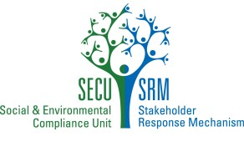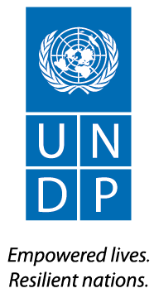

Guidance for Submitting a Request to the Social and Environmental Compliance Unit (SECU) and/or the   
Stakeholder Response Mechanism (SRM)

**Purpose of this form**

* **If you use this form, please put your answers in bold writing to distinguish text**
* **The use of this form is recommended, but not required. It can also serve as a guide when drafting a request.**

This form is intended to assist in:

1. Submitting a request when you believe UNDP is not complying with its social or environmental policies or commitments and you are believed you are being harmed as a result. This request could initiate a ‘compliance review’, which is an independent investigation conducted by the Social and Environmental Compliance Unit (SECU), within UNDP’s Office of Audit and Investigations, to determine if UNDP policies or commitments have been violated and to identify measures to address these violations. SECU would interact with you during the compliance review to determine the facts of the situation. You would be kept informed about the results of the compliance review.

and/or

1. Submitting a request for UNDP “Stakeholder Response” when you believe a UNDP project is having or may have an adverse social or environmental impact on you and you would like to initiate a process that brings together affected communities and other stakeholders (e.g., government representatives, UNDP, etc.) to jointly address your concerns. This Stakeholder Response process would be led by the UNDP Country Office or facilitated through UNDP headquarters. UNDP staff would communicate and interact with you as part of the response, both for fact-finding and for developing solutions. Other project stakeholders may also be involved if needed.

Please note that if you have not already made an effort to resolve your concern by communicating directly with the government representatives and UNDP staff responsible for this project, you should do so before making a request to UNDP’s Stakeholder Response Mechanism.

**Confidentiality** If you choose the Compliance Review process, you may keep your identity confidential (known only to the Compliance Review team). If you choose the Stakeholder Response Mechanism, you can choose to keep your identity confidential during the initial eligibility screening and assessment of your case. If your request is eligible and the assessment indicates that a response is appropriate, UNDP staff will discuss the proposed response with you, and will also discuss whether and how to maintain confidentiality of your identity.

**Guidance**

When submitting a request please provide as much information as possible. If you accidentally email an incomplete form, or have additional information you would like to provide, simply send a follow-up email explaining any changes.

**Information about You**

Are you…

1. A person affected by a UNDP-supported project?

Mark “X” next to the answer that applies to you: Yes: No:

1. An authorized representative of an affected person or group?

Mark “X” next to the answer that applies to you: Yes: No:

*If you are an authorized representative, please provide the names of all the people whom you are representing, and documentation of their authorization for you to act on their behalf, by attaching one or more files to this form.*

1. First name:
2. Last name:
3. Any other identifying information:
4. Mailing address:
5. Email address:
6. Telephone Number (with country code):
7. Your address/location:
8. Nearest city or town:
9. Any additional instructions on how to contact you:
10. Country:

**What you are seeking from UNDP: Compliance Review and/or Stakeholder Response**

You have four options:

* Submit a request for a Compliance Review;
* Submit a request for a Stakeholder Response;
* Submit a request for both a Compliance Review and a Stakeholder Response;
* State that you are unsure whether you would like Compliance Review or Stakeholder Response and that you desire both entities to review your case.

1. Are you concerned that UNDP’s failure to meet a UNDP social and/or environmental policy or commitment is haWHEREng, or could harm, you or your community? Mark “X” next to the answer that applies to you: Yes: No:
2. Would you like your name(s) to remain confidential throughout the Compliance Review process?

Mark “X” next to the answer that applies to you: Yes: No:

If confidentiality is requested, please state why:

1. Would you like to work with other stakeholders, e.g., the government, UNDP, etc. to jointly resolve a concern about social or environmental impacts or risks you believe you are experiencing because of a UNDP project?

Mark “X” next to the answer that applies to you: Yes: No:

1. Would you like your name(s) to remain confidential during the initial assessment of your request for a response?

Mark “X” next to the answer that applies to you: Yes: No:

If confidentiality is requested, please state why:

1. Requests for Stakeholder Response will be handled through UNDP Country Offices unless you indicate that you would like your request to be handled through UNDP Headquarters. Would you like UNDP Headquarters to handle your request?

Mark “X” next to the answer that applies to you: Yes: No:

If you have indicated yes, please indicate why your request should be handled through UNDP Headquarters:

1. Are you seeking both Compliance Review and Stakeholder Response?

Mark “X” next to the answer that applies to you: Yes: No:

1. Are you unsure whether you would like to request a Compliance Review or a Stakeholder Response? Mark “X” next to the answer that applies to you: Yes: No:

**Information about the UNDP Project you are concerned about, and the nature of your concern:**

1. Which UNDP-supported project are you concerned about? (if known):
2. Project name (if known):
3. Please provide a short description of your concerns about the project. If you have concerns about UNDP’s failure to comply with its social or environmental policies and commitments, and can identify these policies and commitments, please do (not required). Please describe, as well, the types of environmental and social impacts that may occur, or have occurred, as a result. If more space is required, please attach any documents. You may write in any language you choose
4. Have you discussed your concerns with the government representatives and UNDP staff responsible for this project? Non-governmental organisations?

Mark “X” next to the answer that applies to you: Yes: No:

If you answered yes, please provide the name(s) of those you have discussed your concerns with

Name of Officials You have Already Contacted Regarding this Issue:

|  |  |  |  |  |
| --- | --- | --- | --- | --- |
| First Name | Last Name | Title/Affiliation | Estimated Date of Contact | Response from the Individual |
|  |  |  |  |  |
|  |  |  |  |  |
|  |  |  |  |  |
|  |  |  |  |  |

1. Are there other individuals or groups that are adversely affected by the project?

Mark “X” next to the answer that applies to you: Yes: No:

1. Please provide the names and/or description of other individuals or groups that support the request:

|  |  |  |  |
| --- | --- | --- | --- |
| First Name | Last Name | Title/Affiliation | Contact Information |
|  |  |  |  |
|  |  |  |  |
|  |  |  |  |
|  |  |  |  |

Please attach to your email any documents you wish to send to SECU and/or the SRM. If all of your attachments do not fit in one email, please feel free to send multiple emails.

Submission and Support

To submit your request, or if you need assistance please email: [project.concerns@undp.org](mailto:project.concerns@undp.org)

1. Ibid
2. Ibid
3. ibid
4. Rooyan Consulting. 2007. *Studies on Environmental Challenges on Bakhtegan Lake*”, in Persian.
5. Rooyan Consulting. 2007. *Studies on Environmental Challenges on Bakhtegan Lake*”, in Persian.
6. Ibid
7. Rooyan Consulting. 2007. *Studies on Environmental Challenges on Bakhtegan Lake*”, in Persian.
8. Ministry of Energy. Macro-National Plan "Impact of Climate Change and Drought Management". Summary of Pilot Report of Lake Bakhtegan Basin (Detection of Climate Change and Drought Identification). Prepared by Shahid Beheshti University.
9. Bagheri, Fatemeh. (2016). Mapping Drought Hazard Using SPI index And GIS (A Case study: Fars province, Iran). International Journal of Environment and Geoinformatics. 3. 22-28. 10.30897/ijegeo.304419.
10. Hegerl, G., Hasselmann, K., Cubasch, U. et al. Climate Dynamics (1997) 13: 613. https://doi.org/10.1007/s003820050186
11. Knutti, R., G. Abramowitz, M. Collins, V. Eyring, P.J. Gleckler, B. Hewitson, and L. Mearns, 2010: Good Practice Guidance Paper on Assessing and Combining Multi Model Climate Projections. In: Meeting Report of the Intergovernmental Panel on Climate Change Expert Meeting on Assessing and Combining Multi Model Climate Projections [Stocker, T.F., D. Qin, G.-K. Plattner, M. Tignor, and P.M. Midgley (eds.)]. IPCC Working Group I Technical Support Unit, University of Bern, Bern, Switzerland.
12. Prohibited grounds of discrimination include race, ethnicity, gender, age, language, disability, sexual orientation, religion, political or other opinion, national or social or geographical origin, property, birth or other status including as an indigenous person or as a member of a minority. References to “women and men” or similar is understood to include women and men, boys and girls, and other groups discriminated against based on their gender identities, such as transgender people and transsexuals.
13. In regards to CO2, ‘significant emissions’ corresponds generally to more than 25,000 tons per year (from both direct and indirect sources). [The Guidance Note on Climate Change Mitigation and Adaptation provides additional information on GHG emissions.]
14. Forced evictions include acts and/or omissions involving the coerced or involuntary displacement of individuals, groups, or communities from homes and/or lands and common property resources that were occupied or depended upon, thus eliminating the ability of an individual, group, or community to reside or work in a particular dwelling, residence, or location without the provision of, and access to, appropriate forms of legal or other protections.
15. http://isiri.gov.ir/portal/home/?331765/ISIRI-Portal
16. http://sama.mporg.ir/sites/publish/SitePages/Home.aspx
17. http://www.waterstandard.wrm.ir/
18. These guidelines have resulted from the Central Zagros Mountain Project (CZMP)