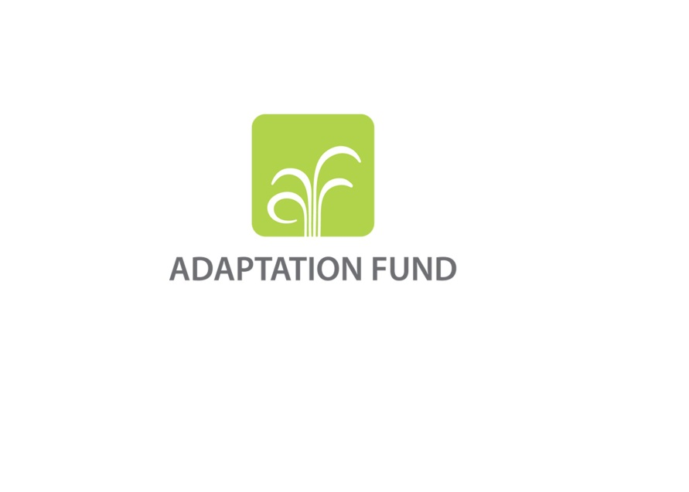

|  |
| --- |
| AFB/B.32/6  17 September 2018 |

Adaptation Fund Board

Thirty-second meeting

Bonn, Germany, 11-12 October 2018

Agenda item 11 a)

# StraTEGIC DISCUSSION ON OBJECTIVES AND FURTHER STEPS OF THE FUND: POTENTIAL LINKAGES BETWEEN THE FUND AND THE GREEN CLIMATE FUND

**Background**

1. The Adaptation Fund Board (the Board), at its thirty-first meeting, held a discussion on the topic of the potential linkages between the Adaptation Fund (the Fund) and the Green Climate Fund (GCF), as part of a series of discussions that have been taking place at two levels: (i) through dialogue between the AFB Chair and Vice-Chair with the Co-Chairs of the GCF Board, both exclusively and in the context of the annual dialogue among a larger group of climate funds; (ii) and through ongoing discussions between the secretariats of the Fund and the GCF on concrete activities in the areas of complementarity and coherence. Specifically, at the thirty-first meeting, the Board decided:

1. *To request the Chair and Vice-Chair, assisted by the secretariat to continue pursuing active engagement with the Green Climate Fund (GCF) Board through its co-chairs, with a view to exploring concrete steps to enhance complementarity and coherence, including at the forty-eighth sessions of the subsidiary bodies to the United Nations Framework Convention on Climate Change, in May 2018, in Bonn, Germany;*
2. *To request the secretariat:* 
   * + 1. *To continue discussions with the GCF secretariat to advance the collaborative activities identified at the Annual Dialogue in November 2017 and the Technical Workshop in February 2018 in order to enhance complementarity between the two Funds; and*
       2. *To continue the process toward accreditation with the GCF, including by seeking further information from the GCF on options for fund-to-fund arrangements, as described in pillar 1 in the GCF operational framework for complementarity and coherence, as contained in document GCF/B.17/08; and*
3. *To request the Chair and secretariat to report to the Board at its thirty-second meeting on the progress made in the activities described in subparagraphs (a) and (b).*

**(Decision B.31/33)**

2.This document is prepared in line with Decision B.31/33 to report on the actions taken and progress made and serve as background information for further discussions and decisions by the Board.

3. At its thirtieth meeting, the Board discussed the issue of *Potential linkages between the Fund and the Green Climate Fund* based on document AFB/B.30/6 which includes the information on the GCF’s adoption of an operational framework on complementarity and coherence with other funds.[1] The GCF framework consists of four operational pillars, one of which is board-level discussions on fund-to-fund arrangements. The document AFB/B.30/6 also indicated that ways of engaging with the GCF could include a memorandum of understanding (MOU), accreditation with the GCF, co-financing of projects or joint activities, such as for capacity building.

4. At its thirtieth meeting, the Board requested its secretariat to continue to work on a “two-track” approach vis-à-vis exploring linkages with the GCF. Having considered documents AFB/B.30/6 and AFB/B.30/6/Add.1 and the update provided by the secretariat, the Adaptation Fund Board (the Board) decided (decision B.30/43):

*(…)*

*(b) To request the secretariat:*

*(i) To initiate the process toward accreditation; and*

*(…)*

*(iv) To continue discussions with the GCF secretariat on the concrete activities in the area of complementarity and coherence identified by the Board in decision*

5. At its twentieth meeting the Green Climate Fund Board, in the context of the Annual update on complementarity and coherence, requested the Co-Chairs, with the support of the Secretariat, to engage with the Chair and Vice-Chair of the Adaptation Fund Board to better understand options for collaboration with the Adaptation Fund, and to report back to the Board at its twenty-first meeting.[2] The document GCF/B.20/05 includes the following information related to the Adaptation Fund:

* *In the case of AF, both secretariats are actively discussing and seeking to identify ways in which direct access entities (DAEs) to both funds can be better supported. The efforts seek to further align operations and reduce duplication of work and inefficiency in the climate finance architecture. Despite this effort, AF and GCF continue to overlap in their support for adaptation funding projects (generally in the GCF micro category/risk B-C) (para 15).*
* *Additionally, the AF Board at its thirtieth meeting mandated its secretariat to initiate the process for accreditation to GCF while also encouraging it to continue to advance complementarity and coherence. To this end, the Chair and Vice-chair of AF took the initiative to meet with the Co-chairs of the Board to discuss and explore options for collaboration, as disclosed in the report on the activities of the Co-chairs (para 16).*
* *Considering the existing duplication of work as well as the possible advantages and challenges of having such linkages with AF, GCF may wish to have a more targeted discussion with AF to explore options for cooperation in the interest of creating a more coherent climate finance landscape to serve vulnerable countries. Additional work by the Secretariat could assist the Board in understanding options for linkages with AF, including the feasibility of accreditation or other options, in a manner that increases efficiency, reduces costs, and maximizes impact, while also considering the benefits that having multiple options in the climate finance landscape may afford countries (para 17).*

6. On 4 May 2018, at the margins of the forty-eighth sessions of the subsidiary bodies to the United Nations Framework Convention on Climate Change (UNFCCC) in Bonn, the Chair and Vice-Chair of the AFB, Mr. Victor Viñas and Ms. Sylviane Bilgischer, met with the Co-Chairs of the GCF, Mr. Paul Oquist and Mr. Lennart Båge. The manager of the AFB Secretariat and the executive director of the GCF were present at the meeting, along with representatives of their staff.

7. Following the respective mandates given by the Boards of both Funds, the chairpersons discussed potential avenues for enhanced complementarity and coherence. The chairpersons, supported by their advisors and secretariats, provided brief updates on the recent developments in the respective Funds.

8. It was noted that the two Funds had their own distinct areas of focus. There was also difference in the scale of operations, and the size of the organizations. It was noted that the GCF had recently launched a Simplified Approval Process (SAP) for projects at the scale of finance resembling typical Adaptation Fund projects.

9. It was also noted that there had already been fruitful cross-learning between the two Funds, with the GCF having built on some of the earlier experiences of the Adaptation Fund, in areas such as accreditation and direct access. Many of the GCF accredited implementing entities had been fast-tracked due to their earlier accreditation with the Fund. There was a general sense that such mutual learning from one another could and should continue.

10. It was suggested that continuing collaboration might be easiest at the level of country programming. Options for jointly supporting countries in accessing the Funds resources were discussed, including readiness activities, joint programming and technical support in reviewing proposals, bearing in mind country needs and without imposing additional burden on countries. Enhanced direct access was mentioned as a possible area of collaboration. As a practical step, harmonizing project-related procedures of the Funds could help make the access easier.

11. The AFB Chair and Vice-Chair referred to the discussion within the AFB on coherence and complementarity, the existence of the ongoing cooperation between the two Secretariats for developing countries, and the topic of possible accreditation of the Adaptation Fund with the GCF. The GCF Co-Chairs indicated that the topic had not been discussed in detail at the GCF Board.

12. Based on the discussions, the Secretariats were tasked to work together to do an initial scoping of possible options for arrangements and collaboration between GCF and the Fund. The document was document prepared by the Fund and GCF Secretariat as informal input to GCF Co-chairs and Adaptation Fund Board Chair and Vice-Chair discussion.

13. Further, as part of its engagement with the GCF, the secretariat participated in a number of events organized by the GCF: (i) a Technical Expert Workshop on Climate Adaptation Finance held on 5–6 March 2018 in Songdo, Republic of Korea, to collect expert views on climate adaptation practices and approaches to adaptation finance, with the relevant implications and recommendations from the workshop to be used as inputs for the GCF Secretariat’s proposal for guidance on the approach and scope for providing support to adaptation activities; (ii) the First GCF Structured Dialogue with Latin America from 5 to 7 March in Bogota, Colombia, the objective of which was to develop a roadmap for articulating regional priorities and opportunities in the engagement with the GCF; (iii) the GCF Empowering Direct Access Workshop from 29 May–1 June 2018 in Songdo, Republic of Korea, aimed at addressing the capacity needs/challenges of all direct access entities and to help them facilitate in developing their pipeline projects.

14. As a follow-up to the meeting held in Bonn and in accordance with the mandate given by the GCF Board to its co-chairs at its twentieth meeting (decision B.20/05), a meeting was organized on 5 September 2018 during the Bangkok Climate Change Conference. Present at the meeting physically or remotely were the Chair and Vice-Chair of the AFB, Mr. Victor Viñas and Ms. Sylviane Bilgischer respectively, one of the Co-Chairs of the GCF, Mr. Lennart Båge along with his advisers and, in the absence of the other Co-Chair, Mr. Paul Oquist, as his representative, his adviser Ms. Dianne Black-Lane. The meeting was arranged and facilitated by the AFB and GCF Secretariats. The manager of the AFB Secretariat, and the Deputy Executive Director of the GCF who joined remotely, participated in in the meeting, along with members of their staff.

15. Specific options for arrangements and collaboration between the two Funds were analyzed, and it was decided to prioritize further development and assessment of the following options, while keeping in mind that the other options are still considered:

* Provision of technical assistance, readiness type assistance;
* Management of a funding envelope; and
* Cooperation between Secretariats.

16. The two sides agreed on indicative next steps to be taken and their timeline.

**Recommendation**

17. The Board may want to consider taking note of the ongoing efforts of enhancing complementarity between the Green Climate Fund and the Adaptation Fund and decide:

* + - 1. To continue discussions with the GCF secretariat to advance the collaborative activities identified at the Annual Dialogue in November 2017, the Technical Workshop in February 2018 and the informal meetings between the Chair and Vice-Chair of the AFB and the Co-Chairs of the GCF in May and September 2018; and
      2. To continue to explore the options for fund-to-fund arrangements, including the process toward accreditation with the GCF, as described in pillar 1 in the GCF operational framework for complementarity and coherence, as contained in document GCF/B.17/08.

1. <https://www.greenclimate.fund/documents/20182/751020/GCF_B.17_08_-_Operational_Framework_on_complementarity_and_coherence.pdf/55b8605f-518a-4b91-8362-02eaee5a566a>
2. GCF Board decision GCF/B.20/05.