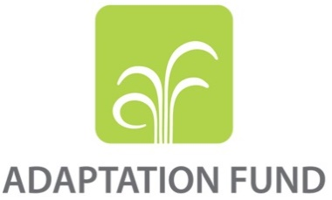

REQUEST FOR PROJECT/PROGRAMME
FUNDING FROM THE ADAPTATION FUND

The annexed form should be completed and transmitted to the Adaptation Fund Board Secretariat by email or fax.

Please type in the responses using the template provided. The instructions attached to the form provide guidance to filling out the template.

Please note that a project/programme must be fully prepared (i.e., fully appraised for feasibility) when the request is submitted. The final project/programme document resulting from the appraisal process should be attached to this request for funding.

Complete documentation should be sent to:

The Adaptation Fund Board Secretariat
1818 H Street NW
MSN P4-400
Washington, D.C., 20433
U.S.A
Fax: +1 (202) 522-3240/5
Email: afbsec@adaptation-fund.org

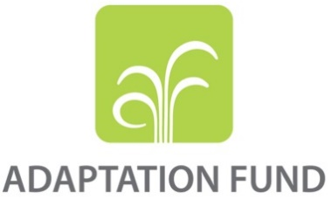
PROJECT/PROGRAMME PROPOSAL TO THE ADAPTATION FUND

PART I: PROJECT/PROGRAMME INFORMATION

Project/Programme Category: Regular project
Country/ies: Bangladesh
Title of Project/Programme: Adaptation Initiative for Climate Vulnerable Offshore Small Islands and Riverine Charland in Bangladesh
Type of Implementing Entity: MIE
Implementing Entity: United Nations Development Programme
Executing Entity/ies: Department of Environment, Ministry of Environment, Forest and Climate Change.
Amount of Financing Requested: US$ 9,995,369

Project summary

Bangladesh has a low-lying topography extremely exposed to sea level rise (SLR), cyclones, tidal surges, salinity intrusion, erratic rainfall, drought and floods, causing it to be one of the world’s most vulnerable countries to climate change. The vulnerable communities who live on chars — small alluvial islands in rivers and the Bay of Bengal are particularly at risk from climate change. These communities have already experienced a number of climate change impacts including frequent tidal surges, increasingly intense cyclones and salt water intrusion into fresh water and soil. Furthermore, climate change is projected to have an adverse impact on agriculture and other local livelihoods; fragile houses, access to drinking water and rural infrastructure, which includes existing cyclone protection embankments. The impacts of climate change also disproportionately affect the poor and are especially severe for women and children, who are forced to spend a greater portion of their time on livelihood and domestic activities. Current projections indicate, with a 2⁰C increase in global temperatures,50-year floods in the country’s three main river basins will become 40% more likely by 2025. The impacts of climate change on these islands are exacerbated by several baseline factors, including geographic remoteness, topographic position near sea-level, limited public and private infrastructure to withstand climate impacts, poverty of local communities and livelihood practices that are dependent on the availability of fresh water. On coastal chars (small offshore islands), the houses and livelihoods of communities are damaged by the increasingly frequent and intense cyclones, tidal floods and saline intrusion from climate change, with inadequate protection from the fragile embankment system. On the inland riverine islands (riverine charland), communities are experiencing increasingly erratic rainfall as a result of climate change, leading to changes in both floods and droughts that their current houses and livelihood practices are unable to withstand.

Resources sought from the Adaptation Fund (AF) will be invested in four components. Firstly, it will assist households to enhance the resilience of their houses and livelihoods to climate change-induced flooding, cyclones, saline intrusion and droughts. Secondly, it will improve community-level infrastructure, including embankments with modern climate-resilient technology and effective local management practices. Thirdly, it will assist the Bangladesh Cyclone Preparedness Programme (CPP) under Disaster Management Department, to enhance its activities in the remote coastal char targeted by the project, in order to provide timely early warnings and effective emergency response. This will be done by expanding the programme’s coverage in the area, modernising its equipment, and making it fully gender-sensitive. Finally, the technology, approaches and knowledge generated by the project will be used to build the capacity of the local and national government; and communities to make climate-resilient investments and policies.

The US$ 10 million sought from the Adaptation Fund (AF) will address the knowledge technical, financial and institutional barriers to climate-resilient housing, infrastructure and livelihoods. The project interventions will benefit an estimated ~341,000 people (~31,000 direct beneficiaries and 310,000 indirect beneficiaries) living on chars in the districts of Rangpur and Bhola. Spanning over five years, the project will be implemented by the Ministry of Environment, Forest and Climate Change following UNDP’s National Implementation Modality.

The project will contribute towards the achievement of the Government of Bangladesh’s national priorities as outlined in the Bangladesh Climate Change Strategy and Action Plan (BCCSAP) and Nationally Determined Contribution (NDC). Six of the ten near-term areas of intervention identified by the first NDC will be addressed by the project, namely: i) food security, livelihood and health protection, including water security; ii) comprehensive disaster management; iii) coastal zone management, including saline intrusion control; iv) flood control and erosion protection; v) climate-resilient infrastructure; and vi) increased rural electrification. Furthermore, the project is directly aligned with seven of the fourteen broad adaptation actions prioritised by the first NDC, namely: i) improved early warning systems; ii) disaster preparedness and shelters; iii) protection against tropical cyclones and storm surges; iv) provision of climate-resilient infrastructure and communication; v) provision of climate-resilient housing; vi) stress-tolerant crop variety improvement and cultivation; and vii) capacity building at individual and institutional level to plan and implement adaptation programmes and projects.

This project has been developed through extensive stakeholder consultations, including with communities in the selected islands, civil society and with the GoB (see Annex C). The design of the project has been reviewed as per the Government of Bangladesh’s internal process, led by the Adaptation Fund Designated Authority and involving relevant government ministries.

Project / Programme Background and Context:
Provide brief information on the problem the proposed project/programme is aiming to solve. Outline the economic social, development and environmental context in which the project would operate.

Geographic context

Bangladesh is a small and densely populated country with an extensive coastline of ~720 km to the south. Its land area is ~147,570km², consisting largely of flat, low-lying deltaic terrain. There are discrete elevated regions in the northwest and southeast, but approximately two-thirds of the country is less than 6m above mean sea level. The deltaic terrain of Bangladesh has been formed by the deposition of alluvial discharges from the Ganges (also known locally as the Padma), Brahmaputra (also known as the Jamuna), and Meghna Rivers (GBM); map in Figure 1 below. This depositional process has created an extensive network of islands and bars. These islands and bars are referred to locally as small coastal islands (coastal chars) or riverine char islands (riverine chars), depending on their proximity to the Indian Ocean.

Bangladesh is rated as one of the most susceptible nations to the impacts of both slow- and rapid-onset natural disasters because of its geographical location, major rivers and low-lying topography. These include climate-related disasters such as cyclones, storm surges, floods, extreme heat and droughts,as well as other disasters such as earthquakes. Climate-related disasters have accounted for ~95% of all major disasters in Bangladesh since 1990, and are becoming both more frequent and intense. This is because of increased ocean temperatures as well as a more variable and intense seasonal precipitation.

Socio-economic context

With a population of ~160 million, the small country of Bangladesh is one of the most densely populated nations in the world. The majority of this population is rural (~64%), but there is a strong urbanising trend and the rate of change from rural to urban is approximately 3% annually. Urbanisation has supported the rapid development of Bangladesh’s economy, which has grown at ~6% per year since 2008. In line with this rapid economic growth, Bangladesh has made concurrent improvements in its Human Development Index score. HDI. These improvements are evident in the country’s reduction in poverty from 48% of the population in 2000 to only24% in 2016. The development of industry as a result of urbanisation has also shifted the country away from its past economic reliance on agriculture. Major sectors currently contributing to GDP include services (~56%), industry (~29%) and agriculture (~14%). Despite no longer being the dominant sector in terms of GDP, agriculture in Bangladesh still provides employment to over 43% of the country’s workforce and 60% of all employed women. Furthermore, rural communities, who are disproportionately affected by poverty, still rely on agriculture as a primary livelihood.

Bangladesh has also made significant strides in reducing inequality and promoting gender equality, however, gender disparities continue to exist as a result of: i) traditional gender norms; ii) patrilineal and patriarchal kinship systems; iii) adherence to personal (religious) law; and iv) weak enforcement of laws protecting women. One domain where women have substantial representation in Bangladesh is in politics. Outside of politics, however, women are generally afforded lower access to healthcare, lower wages and fewer employment opportunities than men.

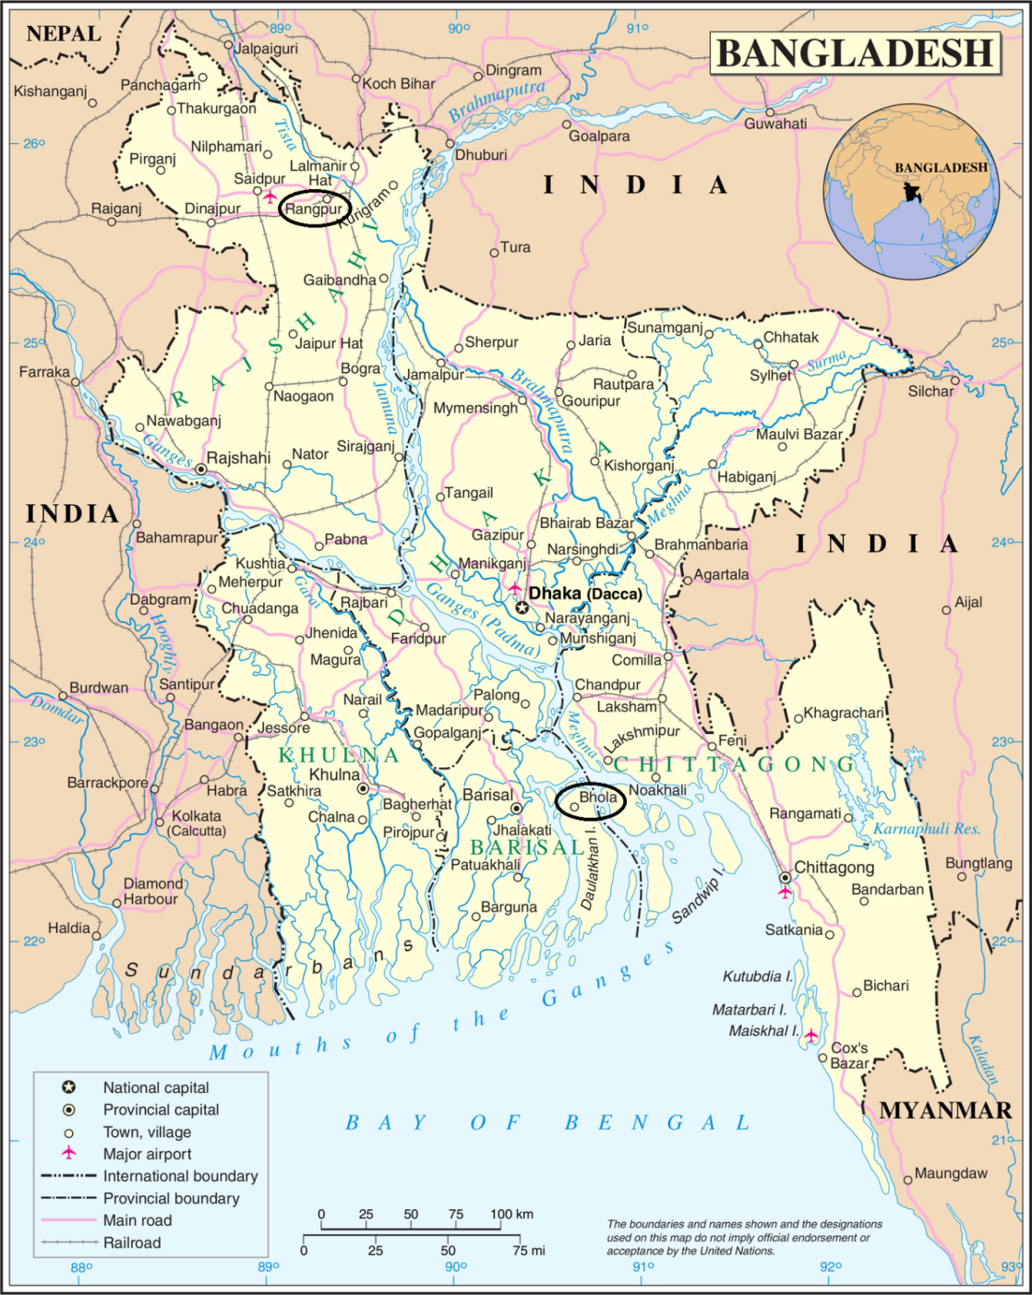
Figure 1. Map of Bangladesh, with the capitals of project target areas circled.

Climate profile

Bangladesh has a subtropical monsoon climate, with high levels of humidity and moderately warm temperatures ranging between 18°C and 28°C. The country experiences wide seasonal variations in precipitation, which can exceed 2000mm annually in most parts of the country. There are four meteorologically recognisable seasons, namely the: i) hot and humid pre-monsoon between March and May; ii) rainy and humid monsoon between June and September; iii) hot and dry post-monsoon between October and November; and iv) cool and dry winter between December and February. The monsoon season is the dominant climatic feature in Bangladesh and accounts for ~75% of the annual precipitation. Thereis also significant variability in the onset, amount and duration of precipitation during the monsoon season. This variability has profound impacts on water resources, electricity generation, agriculture, economics, ecosystems, and livelihoods in Bangladesh.

Current climate change vulnerability and impacts

Bangladesh is among the countries most vulnerable to future climate change. This extreme vulnerability is a result of: i) the country’s exposure to current and predicted climate change; ii) the economic impacts of climate-related natural disasters; iii) local dependency on agricultural livelihoods; and iv) low adaptive capacity within the government and population. These aspects of the country’s vulnerability are discussed in more detail below. For current climate change impacts, Bangladesh has been ranked as the fifth most affected country in the world when incorporating the impacts of slow and rapid onset climate-related natural disasters. These slow and rapid onset disasters are becoming both more frequent and more intense as a result of increased oceanic temperatures and greater variability and intensity of seasonal precipitation.

On average, climate-related natural disasters affect 5 million people annually in Bangladesh through loss of life, loss of livelihood, displacement and damage to property. Between 2006 and 2016 there were over 54 disaster-level events in the country (Figure 3). Combined, these events claimed more than 7,000 lives and caused more than US$29 billion in damages. The most destructive single event during this period was Cyclone Sidr in 2007, which claimed an estimated 3,500 lives, negatively impacted more than 2.5 million households and caused damage to property and assets in excess of US$ 1.7 billion.Historically, the deadliest tropical cyclone disaster ever recorded occurred in Bangladesh – the Bhola cyclone of 1970. At least 500,000 people lost their lives in this storm, primarily as a result of the storm surge that flooded much of the low-lying islands of the Ganges Delta.

The impacts of increasingly severe climate-related disasters are already affecting the livelihoods and health of the population of Bangladesh. For example, the drought in 2014 in northern Bangladesh and record flooding in 2017both resulted in decreased food production across the country. These events significantly impacted the livelihoods of rural communities who depend on agriculture by increasing: i) costs of staple foods such as rice and wheat; ii) strain on the government grain surplus; and iii) migration out of affected areas as households that lost their land could no service their existing debts.

Women and children are disproportionately affected by climate-related disasters. For example, during the 1991 cyclone in Bangladesh, 90% of the 140,000 fatalities were women, and during Cyclone Sidr in 2007,women still accounted for more than 80% of all fatalities. The effects of food shortages and disruptions in food production brought about by these events are also most keenly felt by young children and rural women. This is because women are the primary caregivers in Bangladesh and a significant proportion of Bangladeshi women rely exclusively on agriculture for their livelihoods. Overall, the increased vulnerability of women to natural disasters in Bangladesh is attributed to multiple factors including: i)family responsibilities – such as caring for children and the elderly; ii) less inclusion in decision-making practices; iii) lower levels of education and iv) a prevailing fear of harassment in storm shelters, which leads many women to avoid seeking shelter during disaster events,. Furthermore, women who are displaced or lose family members during natural disasters experience a much greater risk of abuse, harassment, trafficking or indentureship as they seek to recover or re-establish themselves in post-disaster settings.
Figure 2. Total deaths due to climate-related natural disasters in Bangladesh between 2006 and 2016.

Figure 3. Frequency of climate-related natural disasters in Bangladesh from 2006 to 2016.

Climate change projections

South Asia will experience significant climate change in the next century under all emissions scenarios. The expected climate change for the region is outlined in Table 1 below. In Bangladesh, increasing trends in precipitation and temperature are projected. The occurrence and severity of extreme precipitation events and extreme temperatures arealso predicted to increase.

Table 1. Future Climate Trends for South Asia
Precipitation | Temperature | Sea Level Rise
Increased rainfall under high emissions scenario by 2050 | Increase by >2°C by 2050 under high emission scenario | 26–55cmglobally under low-emissions scenario by 2080–2100
Increased rainfall at high latitudes under low emissions scenario by 2050, but no significant changes at low latitudes | Increase by >3°C by 2100 under high emissions scenario | 45–82cmglobally under high-emissions scenario by 2080–2100
Increased extreme rainfall events associated with monsoons | Increase by >2°C by 2100 under low emissions scenario
Increased extreme rainfall associated with cyclones making landfall | Increased frequency of hot days

Future climate change impacts and vulnerability

Future climate change scenarios project that Bangladesh will be exposed to a wide range of impacts by 2050, including increased: i) sea level rise and shoreline/soil salinity; ii) variability of seasonal precipitation; and iii) frequency and severity of cyclones that make landfall.

Floods, land loss, salinity and droughts

Flooding within the Bangladesh delta is predicted to increase in frequency because of climate change. Modelling of precipitation patterns and peak flow periods in the Ganges, Brahmaputra and Meghna rivers indicates that, with a 2°Cincrease in global temperatures, the current 20-year floods will likely occur at intervals of 13, 15 and 5.5 years respectively,. Similarly, the extreme 50-year floods are also likely to increase in frequency, with the recurrence interval for these floods decreasing to 30 years by 2025 and to 15 years by 2050.

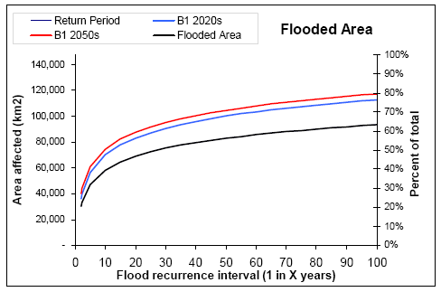
Figure 4.Increase in area and percentage of Bangladesh affected by floods. Black line = current situation, blue line = 2020s and red line = 2050s.

The frequency of droughts in the southwest and northwest regions of Bangladesh is predicted to increase under climate change. In particular the western parts of the country will be at greater risk of droughts during the pre-Kharif and Kharif seasons (July – October). This is expected to result in a decline in rice production by ~27% and wheat production by ~39% under a moderate climate change scenario. Under a severe climate change scenario, the area severely affected by drought in the Rabi season (October – March) is predicted to increase from 4,000 km² to 12,000 km², or approximately 15% of Bangladesh’s total arable land.

Projections indicate that drainage congestion in the southern region of Bangladesh will be impacted by rising sea levels, which will result in increased shoreline and soil salinity. Observed sea level rise (SLR) over the last 30 years in Bangladesh has ranged from 6 to 21 mm/year; SLR is expected to accelerate in accordance with global projections (Table 1). This projected SLR will result in approximately 4,700 km²ofBangladesh’s coastline being lost through inundation by the year 2080 under a severe climate change scenario,, disproportionately affecting offshore islands and areas without polders. Furthermore, the predicted increase in precipitation combined with SLR will reduce the land area of Bangladesh by a further ~55,000 km² during the monsoon period.

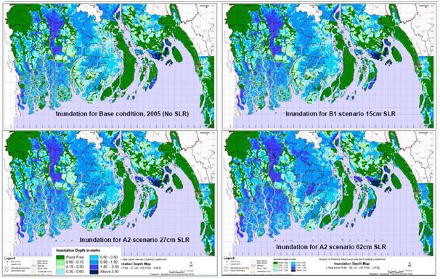
Figure 5. Inundation of the coastal region of Bangladesh for sea level rise of 15cm (B1 scenario), 27cm (A1 scenario) and 62cm (A2 scenario) during the monsoon season.
Shoreline and soil salinity in the southwest region are predicted to increase in inland areas of the delta as a result of climate change, with the most marked change in salinity associated with the dry season. The change in shoreline salinity will cause significant variations in the freshwater and brackish water zones within the delta, with negative impacts on agriculture, biodiversity and the provision of drinking water. Models accounting for salinity threshold values in relation to agriculture, drinking water and biodiversity predict increases in salinity in both the dry and monsoon seasons. During the dry season, salinity will increase by 6% for the A1 scenario and 9% for the A2 scenario. In the monsoon season, salinity will increase by 2% under the A1 scenario and by 6% under the A2 scenario. Saline intrusion is also predicted to extend far into the country’s interior under both B1 and A2 scenarios (Figure 6).
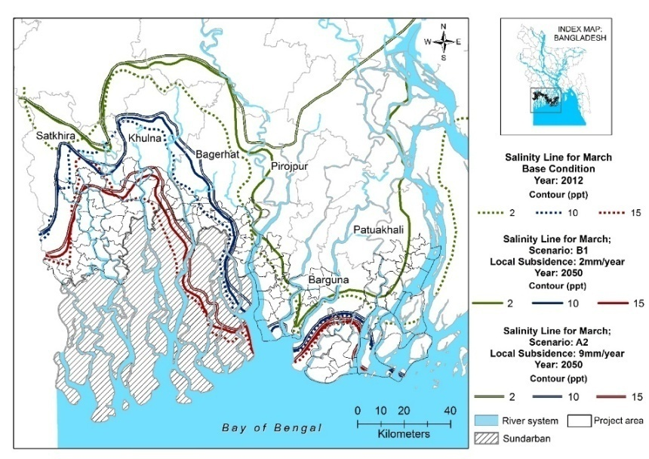
Figure 6: Projected river salinity in 2050 under two different climate change scenarios (A2 and B1)

Cyclones and storm surges

Between 1961 and 2013, a total of 61 cyclones struck Bangladesh. The south-western zone was affected by 28% of these cyclones. Storm surge flooding caused by cyclones is penetrating deeper inland after hitting the coastal islands and causing more extensive damage than previously. Historically, cyclones have had associated storm surges ranging from 1.5 to 10m in height. However, under a climate change scenario, projected increases in sea surface temperatures are expected to increase the intensity of tropical cyclones, which will result in greater wind speeds and higher storm surges. The overall frequency of tropical cyclones in Bangladesh is not likely to increase as a result of climate change, but the number of intense cyclones is expected to increase. Dynamic and regional climate models, project increased intensity of tropical storms by 2100 for the North Indian Ocean and increased frequency of the highest storm surges across the Bay of Bengal. Combined with SLR, Bangladesh is expected to face increasing tidal surge and inundation of coastal areas. By 2050, an additional 15% of the coastal area of Bangladesh is projected to be inundated by storm surges during cyclones. Storm surges from a 10-year return period cyclone (such as Sidr) could inundate an area 80% greater than what would be flooded presently. This would expose 9.7 million people to severe inundation (>3m), compared with 3.5 million in the no-climate-change scenario.

Site-specific vulnerabilities

The national climate change vulnerabilities described in the preceding sub-sections are more pronounced in both the coastal and riverine chars than on the mainland. This increased vulnerability is partly as a result of: i) limited capacity within local government; ii) poor infrastructure; iii) the specific geographic context; iv) environmental degradation; and v) socio-economic development deficits,.

A high level of exposure to natural disasters combined with limited access to the mainland contributes to char inhabitants lacking access to the majority of basic services. Although they have productive farmlands, char populations are often unable to access mainland markets,have poor access to basic water and sanitation, limited transportation services and low standards of living. There are few alternative livelihood opportunities and limited infrastructure has resulted in both education and skills deficits. This has brought about economic stagnation and a disproportionate dependence on climate-sensitive livelihoods such as agriculture. Char communities are, therefore, increasingly restricted in their ability to adapt to the adverse effects of climate change, including to both climate induced slow and rapid onset disaster events.

Riverine chars

Most inland riverine chars (islands)are exposed to severe levels of erosion and experience flooding at least once a year. This inherent geo-morphological vulnerability and exposure to climate impacts, combined with very limited livelihood opportunities,results in char communities being extremely vulnerable to climate change. The small size and geomorphological instability of the riverine chars further affects local adaptive capacity as ecosystem services are more easily disrupted and slower to recover after disruptions than in mainland areas.

Climate change is already impacting on riverine char communities in Bangladesh and these impacts are projected to increase in severity in the future. The main climate change factors impacting people on riverine chars are the increasing frequency and intensity of floods and droughts. Increasing temperatures combined with more erratic rainfall are increasing periodic water stress on riverine chars. In addition, the increasing frequency of floods will result in greater damage to assets and infrastructure and will reduce the interval period in which communities can recover from and prepare for subsequent disasters. The impacts of climate-induced disasters on riverine chars are exacerbated by the fact that, compared to coastal regions, riverine chars have been relatively neglected in post-disaster periods.The majority of government resources and aidhas been prioritised for rehabilitating coastal infrastructure and reinforcing coastal buffer zones, as opposed to supporting recovery efforts within the inland river areas where many riverine chars are located.

Coastal chars

Coastal chars (small offshore islands) are well known in Bangladesh for epitomising vulnerability to climate change, including rising sea levels, an increase in the number and intensity of cyclones, as well as ocean warming, acidification and saline intrusion. The extreme vulnerability of the coastal chars is because of a combination of social and geographical features.

When compared with inland regions at higher elevations, coastal chars are more sensitive to climate-related disasters. There are fewer natural buffers in coastal areas to reduce the climate change impacts of intensifying cyclones, storm surge, elevated water levels and soil salinity. Coastal chars also face development constraints as a result of their small size and geographical remoteness. They have low levels of institutional development, which has negatively impacted on the provisioning of educational and social support systems. Economic development has also been limited by these factors, and there are few economies of scale, which affects both economic competitiveness and household income levels. The adaptive capacity of coastal char communities is, therefore, significantly lower when compared with mainland populations that are in a similar socio-economic bracket or rely on similar livelihoods.

The vulnerability of the coastal and riverine chars of Bangladesh has been documented through initiatives like the Integrated Coastal Zone Management Plan (ICZMP) and the Char Development Settlement Project (CDSP) (these initiatives are described in Part II Section E). Many of the chars have, however, been neglected with regards to an adaptation needs assessment. The adaptive capacity of the char inhabitants and their ability to anticipate, absorb and develop adequate response strategies to the impacts of climate change has, similarly, not been evaluated.

Site selection criteria and process

A riverine char and a coastal char were selected as the target areas for the proposed project through a process involving remote sensing analysis using GIS, combined with vulnerability and hazard indexing. The first stage assessment of chars considered the following criteria: i) size; ii) connectivity to administrative centres; iii) existence of polders or embankments; iv) detachedness from the mainland; v) degree of vegetation coverage; vi) number of settlements and; vii) degree of agricultural development.This assessment was used to confirm that sites chosen for the second-stage assessment had both the greatest climate risk and supported populations with a low adaptive capacity.

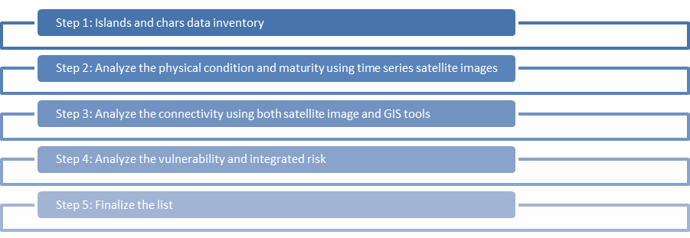
Figure 7. Site selection process

The multi-criteria GIS analysis prioritised chars of a medium size. To be eligible for selection, chars were also required to be: i) relatively remote from administrative centres; ii) detached from the mainland and have limited accessibility; and iii) populated by communities practicing agriculture-based livelihoods.

The complete list of chars that met these criteriawas then assessed against a risk database, which combined broad-level socio-economic vulnerability, climate change vulnerability and hazardexposure data. This multi-criteria risk assessment identified the Mujibnagar Union on Char Fasson as having the highest integrated risk index of any of the chars that met the inclusion criteria. Selecting a riverine char required extra consideration as the risk indices returned similar results based on the inclusion criteria. Char Lakshmitari was ultimately selected as it met all the necessary criteria, had a high vulnerability index, and was determined to be representative of the general risk index displayed by all riverine chars.

Field assessments for both of the target sites were then carried out. These assessments included broad-level: i) needs assessments; ii) hazard mapping; and iii) climate change modelling. The results of these assessments were then analysed, and a suite of appropriate intervention options was developed to effectively improve the adaptive capacity of the communities in the target sites. The assessment methodology and selection criteria are available in full in AnnexH and AnnexF, respectively.

Project Target Areas

Lakshmitari Union

Background context

The Lakshmitari Union is located in the northwest of Bangladesh. It is an inhabited char in the Teesta River basin and is one of the most disaster-prone unions of Gangachara Upazila,. The union is situated on broadly flat terrain and is intersected by the rain- and snowmelt-fed Teesta River. Local temperatures in Lakshmitari range between 11°C and 32°C and average annual precipitation in the region amounts to ~2,900mm, 80% of which occurs during the monsoon season. The union covers an area of ~2,700 ha and is governed under the regional administration of the Rangpur district, which is the most poverty afflicted district in Bangladesh. Lakshmitari’s total population is ~21,000, which comprises 2,128 households distributed over eight Mauzas and five villages, with a population density of 785 people per km². The literacy rate is ~47% and the majority religion is Islam.

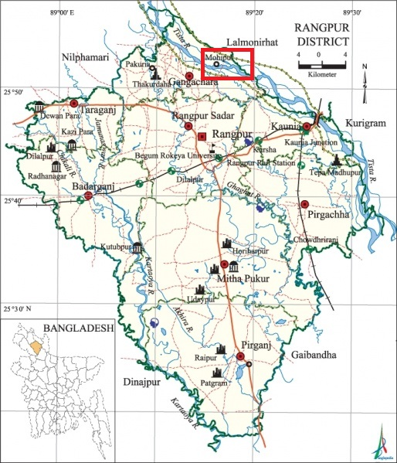
Figure 8. Map of Rangpur district, Bangladesh (with location of Lakshmitari Union indicated)

In Lakshmitari, there has been limited development of both publicly and privately funded infrastructure for: i) water supply; ii) sanitation; iii) health; and iv) transport. Approximately95% of the population relies on tube wells for water collection, with the remaining 5% utilising informal and unsafe water sources. In addition to limited water supply infrastructure, more than 55% of the population lacks access to any form of sanitation, including sealed and unsealed latrines. During flood events, both tube wells and unsealed latrines become inundated, which leads to the increased prevalence of water-borne diseases such as cholera and diarrhoea amongst the local population. Medical services are not readily available. There are only two community clinics for the provision of such services and only one NGO clinic to service the needs of the entire population. These clinics are open for two days each week and are staffed by two paramedic doctors. Transportation infrastructure is also limited on the char, where the majority of the local roads are unpaved (40 km of 43 km) and passage between the char and the mainland is only via 1 permanent bridge, 10 bailey bridges and 20 paved culverts.
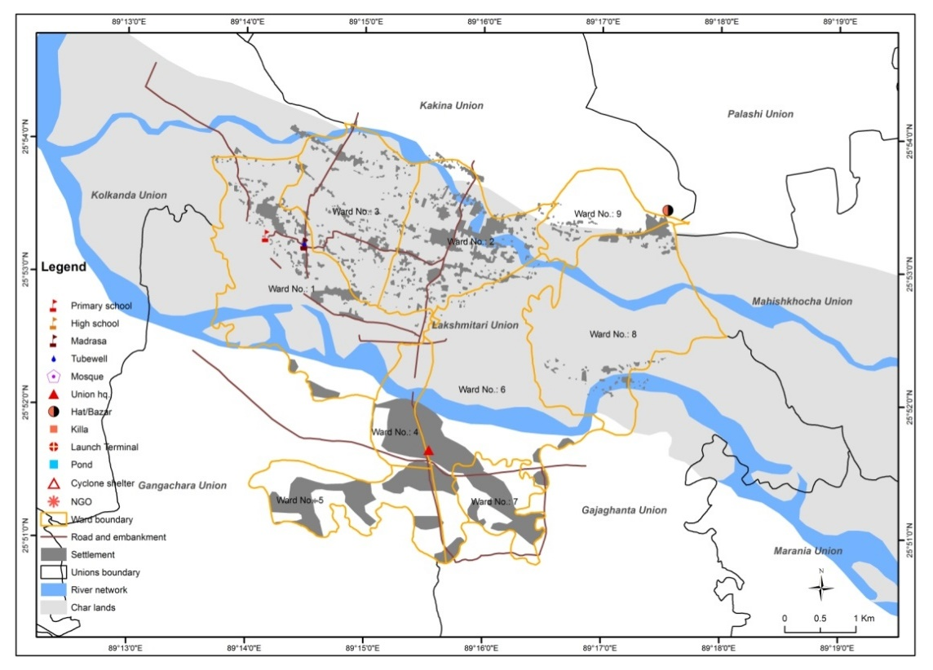
Figure 9. Map of Lakshmitari Union

Agriculture is the dominant economic activity in Lakshmitari and the arable land currently covers 2,340 ha. The agricultural produce includes ayush, amon, boro, wheat, potatoes, corn and nuts. There are ~4,900 farmers, of which ~50% are tenants. Each household also maintains its own livestock, which includescows, buffaloes, goats and sheep. There are very few livelihood opportunities outside of agriculture and only ~6,000 people are employed on a permanent basis (~28%).

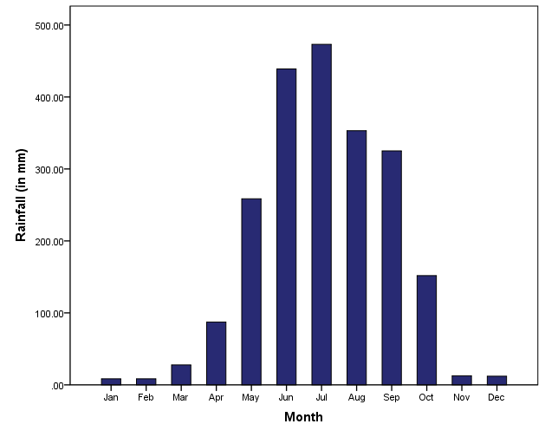
Figure 10.Mean monthly precipitation of Gangachara weather station (number 10208) in Lakshmitarifor 1948–2002.

Climate change and hazard exposure for Lakshmitari

Hydro-meteorological modelling has demonstrated that shifts in the spatial and temporal distribution of rainfall are occurring (and are expected to continue occurring) in Lakshmitari. These shifts include: i) an increase in seasonal monsoon precipitation, with a greater frequency and intensity of extreme precipitation events; ii) a decrease in precipitation for all other seasons; and iii) increasing seasonal drought during the dry season.

Currently, the drought risk in Lakshmitari is considered to be relatively low. However, this risk is projected to increase under future climate change scenarios because of the increasing variability of rainfall patterns.In addition to causing an increase in seasonal monsoon precipitation (as discussed above), such variability has resulted in a decrease in precipitation during the dry season. As a result of this decrease, there has already been a re-designation of the Rangpur district from a dry sub-humid zone to an arid zone,. In addition, the rural and predominantly agrarian economy is being affected by the increasing intensity of short duration heavy precipitation events during the monsoon, and conversely by water stress during the Rabi season.Future climate change scenarios suggest that the Rangpur district will experience: i)prolonged water-stressed periods; ii) reduced surface water supplies; iii) reduced groundwater replenishment; and iv) increased saltwater intrusion into groundwater supplies.

The increasing trend in extreme rainfall events will also increase the flood exposure of Lakshmitari. Most areas in the union are currently considered low risk with regards to flooding. These areas experience seasonal flooding that is rated between F0 (with flood levels of 0.3 m) and F1 (0.9 m). By 2050, the area affected by F1 flooding is expected to increase to encompass the entire union. The densely populated settlement in Ward 2 is predicted to experience a higher incidence of F2 (1.8m) floods by 2050. The increase from F1 to F2 flooding is expected to result in increased damage to households and loss of personal assets within Ward 2, specifically because these structures are not designed to withstand flooding of such a magnitude. In addition, the increased height and duration of floods is expected to result in greatly increased impacts on human health, because of the local prevalence of unsealed latrines and dependence on unsealed tube wells.

Overall, the integrated risk scenario for the Lakshmitari Union shows that the entire union is currently considered a high-risk region (Figure 10). The projections for 2050 indicate that this risk is expected to increase for some areas within the union and decrease for others. Notably, the impacts of climate change are expected to shift the risk indicators in Wards 8 and 9 from high-risk exposure to very high-risk exposure.

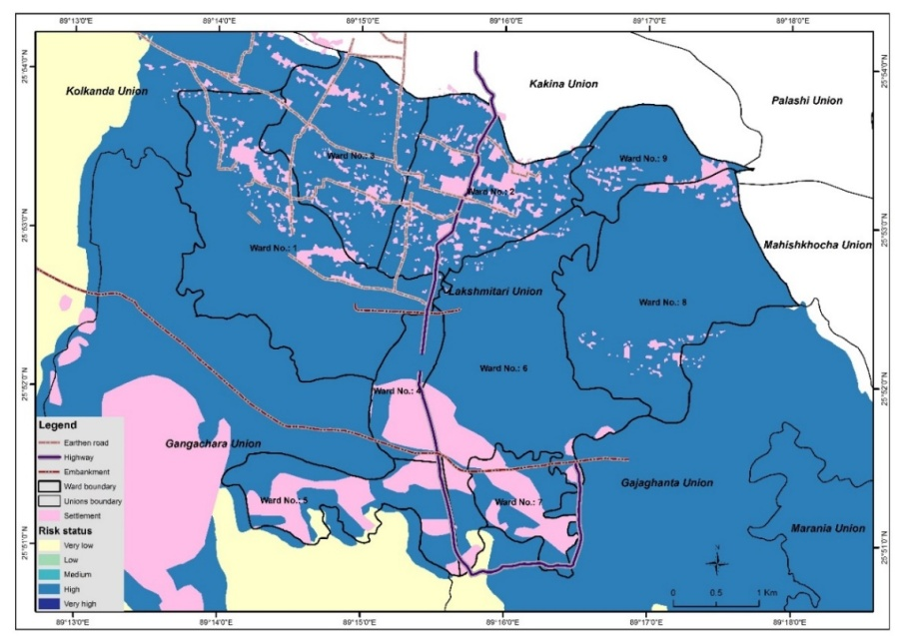
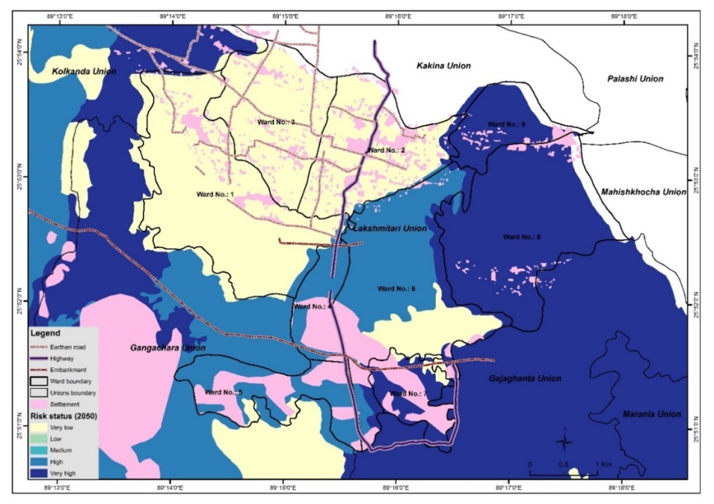
Figure 11.Top panel: Integrated Risk Exposure Map for Lakshmitari Union (Baseline),
Bottom panel: Integrated Risk Exposure Map for Lakshmitari Union (2050). Larger versions of these figures are provided in Annex H.

The decrease in food security, economic productivity, health and personal safety associated with droughts and floods in Lakshmitari will reduce the resilience and adaptive capacity of local communities. Without interventions to increase the climate resilience and adaptive capacity of these communities, they will be forced to act reactively to the impacts of climate change, as opposed to having the capacity to act proactively to protect and prepare for the increased risks brought about by a shifting climate.

Mujibnagar Union

Background context

Mujibnagar is a union of Char Fasson, which is an upazila of the Bhola District. The union is situated within the Bay of Bengal (Figure 11) and consists of four mauzas,which collectively occupy an area of 2,605 ha. Mujibnagar is positioned on the western bank of the Bura Gauranga River, which links with the Tentulia River and accounts for 15% of water discharge from the GBM system (Figure 12). The union has a population of ~10,500 with a population density of ~400 people/km² distributed amongst ~2,000 households. Literacy levels are low, at only 22%, and the majority religion is Islam.

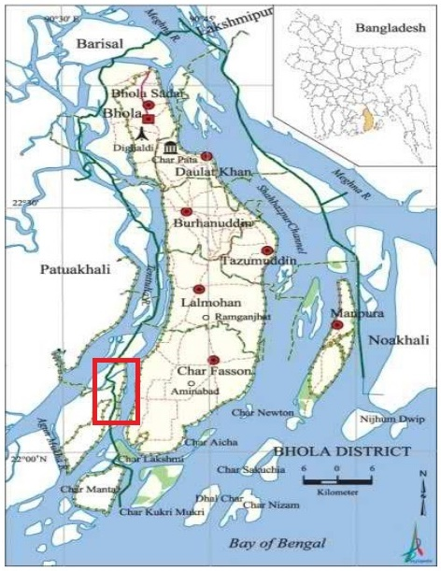
Figure 12. Map of Bhola District (location of Mujibnagar Union demarcated by red box)

Much like Lakshmitari Union, Mujibnagarhas limited infrastructure development for: i) water supply; ii) sanitation; iii) health; iv) transport; and v) energy. The existing traditional drinking water – ponds and shallow tube-wells – are affected by salinity, resulting in the majority of the population having to rely on informal and often polluted water sources such as canals and rivers. Sanitation infrastructure is also limited –only 16% of the population has access to traditional pit latrines, with the remainder practising open defecation. This limitation in sanitation infrastructure, when combined with the local dependence on open water storage (ponds and dams), poses a significant risk to human health during high water periods such as cyclone storm surges, monsoon floods or tidal floods. This is because open water storage facilities become contaminated with human waste during these climate events. Such contamination reduces the availability of clean water and increases the incidence of water-borne diseases.

In Mujibnagar, health and communication infrastructure is severely limited. There is only a single community clinic in the union, in which nine paramedic doctors provide emergency treatment and advice to inhabitants. In addition to water supply, sanitation and health, Mujibnagar is also limited in its transport infrastructure. The majority of the union’s transport network is unpaved (46 km of 50 km) and there are no bridges to the mainland, which can only be reached by boat. A further development deficit in Mujibnagar is electrification. Although the union was included in the rural electrification scheme in 2011, field surveys have indicated that few households in Mujibnagar have access to electricity.

As in Lakshmitari, agriculture is the dominant economic activity in Mujibnagar. There is currently ~2,400 ha of arable land available for farming in the union, of which approximately 2,200 ha is irrigated. Major crops produced include rice, wheat, potato and watermelon. Approximately 60% of currently farmed land is occupied by tenants, and landowners occupy the remaining 40%. Field surveys did not identify any livestock farms in Mujibnagar, but rather that individual families keep their own livestock. Alternative livelihood opportunities to agriculture are even more scarce in Mujibnagarthan in Lakshmitari, and only ~2,200 inhabitants (~22%)are reported to be formally employed.

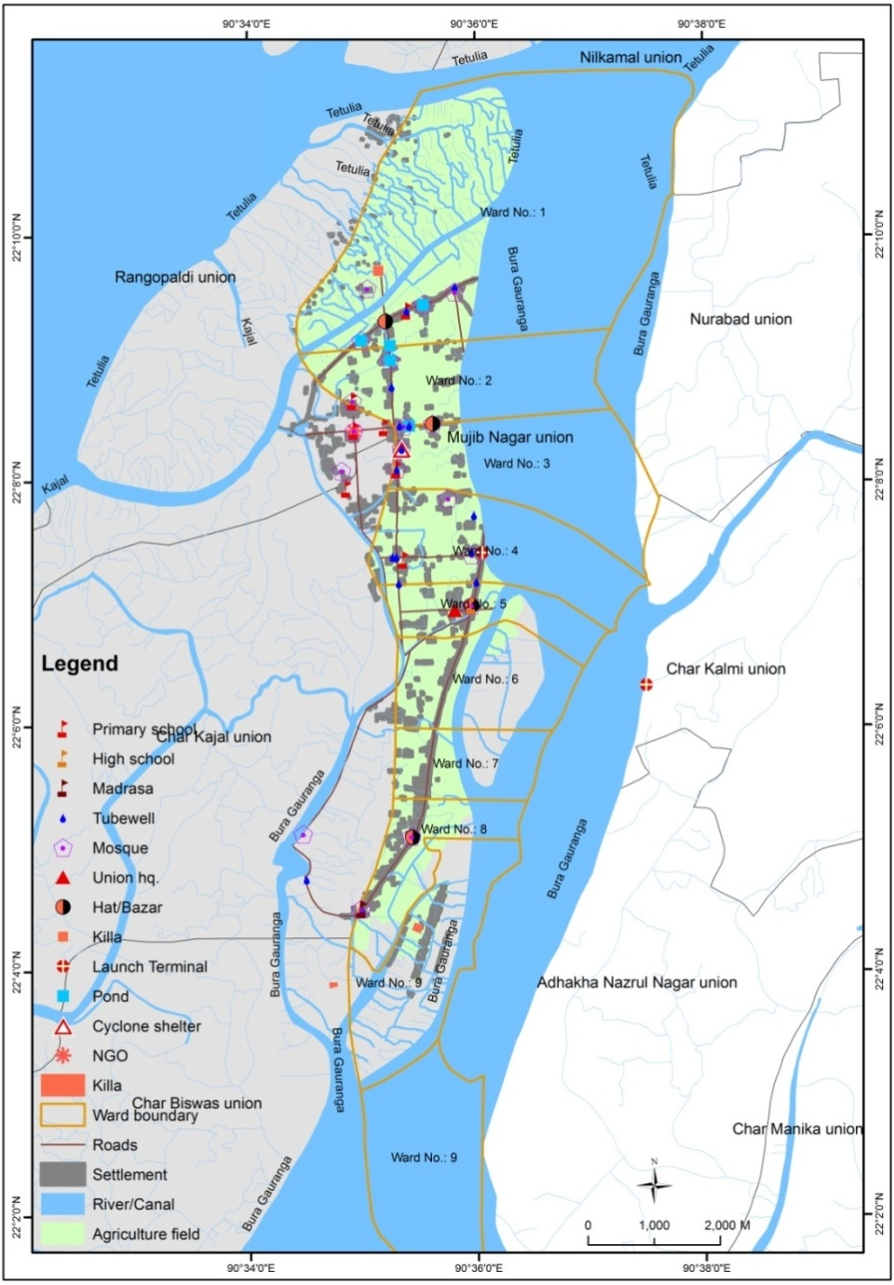
Figure 13.Map of Mujibnagar Union

Climate change and hazard exposure for Mujibnagar

Changes have already been observed in the local climate of Char Fasson, on which Mujibnagar is located. The mean annual temperature in the area showed an increasing trend from 1970 to 2010(Figure 13) and mean annual precipitation also increased over this period (Figure 14). In line with the rest of coastal Bangladesh, Mujibnagar’s climate is expected to continue to change in the following ways: i) average annual temperature will increase; ii) seasonal precipitation will become more variable; iii) mean annual precipitation will increase; iv) floods will increase in frequency and intensity; v) cyclones will become more intense; and vi) salinization of groundwater will increase as a result of sea level rise.

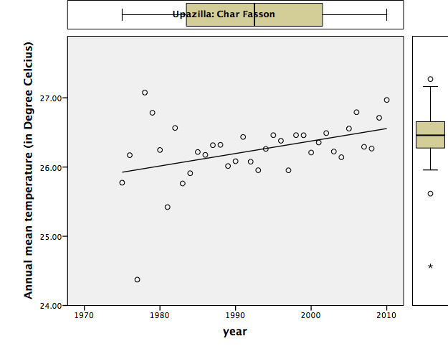

Figure 14. Historical trends in the mean annual temperature for Char Fasson

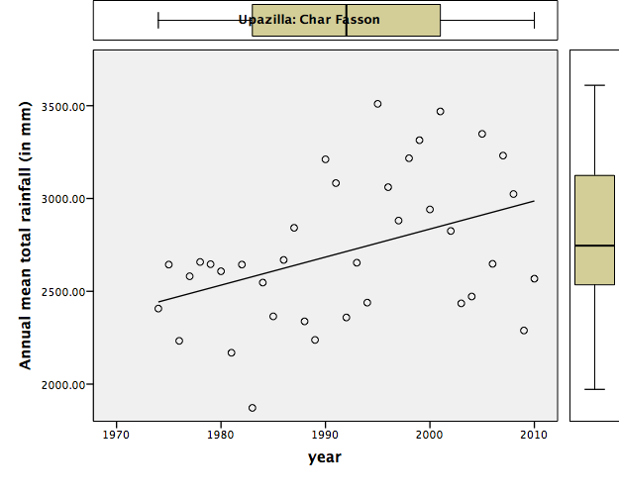
Figure 15. Historical trends in the mean annual precipitation for Char Fasson

Risk assessment

According to data obtained from the Upazila Climate Risk Atlas,Mujibnagar has a high integrated risk score(46). This represents the highest integrated risk score for any union in Char Fasson, as well as for any char assessed in the scoping report (see Annex F). In addition, Mujibnagar’s hazard exposure score(27) is projected to increase to 41with climate change. Disaggregated by hazard, and under the climate change scenario, Mujibnagar is projected to become increasingly exposed to: i) floods – where the number of inhabitants exposed to flood hazards is projected to increase to ~3,500 (34% of the current population) from 2,600 (25% of the current population); ii) storm surges –where the storm surge exposure score (69 km²) under a baseline scenario is projected to increase to 77 km² under the climate change scenario, resulting in more than 80% of the population (~8,200 people) being exposed to storm surges; and iii) soil salinization – where the soil salinity exposure score for Mujibnagar (41.7)is the highest of the chars assessed in the scoping report, and is projected to double as a result of climate change. A shift in soil salinity of this magnitude is predicted to affect almost the entire population (~98%) of Mujibnagar.

Taken together, the climate change hazards of increasingly severe floods, cyclone storm surges and salinization will have considerable impacts on the communities of Mujibnagar. In the absence of effective interventions to increase the resilience and adaptive capacity of these communities, climate change will have extremely negative impacts on inter alia food security, economic productivity, health and personal safety.

Problem that the proposed project will address

Vulnerable char communities in Lakshmitari and Mujibnagarhave limited capacity to adapt to the climate change impacts of increasing floods, erosion, cyclones, saline intrusion and water stress. To address this problem, the proposed project will focus on addressing the following challenges:
- limited access of communities to information about future climate change impacts, with awareness mostly of existing disaster risks;
- limited coverage and effectiveness of disaster preparedness programmes and early warning systems on chars;
- inadequate protection of life, livelihoods and assets against cyclones and floods because of fragile houses, limited number of disaster shelters and fragile embankment systems;
- limited knowledge and technical capacity/options among char communities to adapt livelihood practices to climate change;
- limited access to safe drinking water, sanitation and electricity, and the climate vulnerability of these services; and
- limited knowledge and capacity of local government for climate risk-informed planning.

Project Objectives:

The objective of the project is to enhance the climate resilience of vulnerable communities who live on coastal islands and riverine chars in Bangladesh. This objective will be achieved through the following four project outcomes:

- enhanced resilience of households through climate resilient housing, renewable sources of electrification and the provisioning of safe drinking water;
- increased climate resilience of communities through climate risk mapping, cyclone and flood preparedness that leaves no one behind and basic infrastructure that is resilient to cyclones and floods;
- improved income and food security of vulnerable households by innovating and introducing locally appropriate climate-resilient livelihoods practices; and
- enhanced knowledge and capacity of communities, government and policymakers to promote climate resilient development on riverine and offshore islands.

Project / Programme Components and Financing:
Fill in the table presenting the relationships among project components, activities, expected concrete outputs, and the corresponding budgets. If necessary, please refer to the attached instructions for a detailed description of each term.

For the case of a programme, individual components are likely to refer to specific sub-sets of stakeholders, regions and/or sectors that can be addressed through a set of well-defined interventions / projects.

Table 2. Project components, outputs, outcomes and financing.
Project/Programme Components | Expected Concrete Outputs | Expected Outcomes | Amount (US$)
Component 1.  Enhanced climate resilience of households through climate-resilient housing, electrification and climate-proof water provisioning | Output 1.1. Cyclone and flood resilient houses for the most vulnerable households are supported. ($1,551,000)  Output 1.2. Community-level nano-grids installed for electrification to enhance adaptive capacity. ($174,828)  Output 1.3. Locally appropriate rainwater harvesting systems forsafe drinking water and home-garden irrigation installed.($282,000) | Community infrastructure improved and adaptive capacity increased for vulnerable small island and riverine char communities to manage and plan for climate change impacts. | 2,007,828
Component 2.  Increased climate resilience of communities through climate-resilient infrastructure, climate risk mapping and inclusive cyclone preparedness. | Outcome 2.  Output 2.1. Climate-resilient infrastructure built to protect life and prevent asset loss. ($808,250)  Output 2.2. Embankments repaired and innovative model for community embankment management introduced. ($656,300)  Output 2.3. Climate-resilient investment on chars promoted through climate hazard maps and expanded cyclone early warning systems. ($16,000)  Output 2.4. Cyclone Preparedness Programme (CPP) modernised, made gender-responsive, and expanded to provide timely cyclone early-warning and response at scale. ($837,176) | Resilience of vulnerable small coastal island communities enhanced against climate-induced disasters through improved infrastructure, management practices and community-based emergency responses. | 2,317,726
Component 3:  Improved income and food security of communities by innovating and providing assistance to selected households for climate-resilient livelihoods practices | Output 3.1Climate-resilient agriculture implemented and supported at a community level. ($942,068)  Output 3.2 Diversified livelihoods developed and supported for the most vulnerable households. ($2,455,000) | Adaptive capacity of vulnerable communities improved through the dissemination of climate-resilient agricultural practices and the development of diversified livelihoods. | 3,397,068
Component 4.  Enhanced knowledge and capacity of communities, government and policymakers to promote climate resilient development on chars. | Outcome 4.  Output 4.1. Local government institutions are capable of climate risk-informed planning and implementation. ($37,500)  Output 4.2. Knowledge and awareness generated to promote climate resilient approaches and strategies. ($577,200) | Increased awareness and availability of information on climate change impacts and adaptation options for vulnerable communities, local level government and policymakers | 614,700
6. Project/Programme Execution cost |  |  | 875,000
7. Total Project/Programme Cost |  |  | 9,212,322
8. Project/Programme Cycle Management Fee charged by the Implementing Entity (if applicable) |  |  | 783,047
Amount of Financing Requested |  |  | 9,995,369

Projected Calendar:
Indicate the dates of the following milestones for the proposed project/programme
Milestones | Expected Dates
Start of Project Implementation | October 2019
Mid-term Review | April 2022
Project Closing | September 2024
Terminal Evaluation | December 2024

PART II: PROJECT/ PROGRAMMEJUSTIFICATION

Project / programme components
Describe the project / programme components, particularly focusing on the concrete adaptation activities of the project, and how these activities contribute to climate resilience. For the case of a programme, show how the combination of individual projects will contribute to the overall increase in resilience.

The project activities described in this section are built on lessons and best practices used in Bangladesh by various projects including those of UNDP. It has heavily used lessons from UNDP-MOEFCC implemented Coastal Afforestation project funded by GEF, Local Government Initiatives on Climate Change (LOGIC) of UNDP, Comprehensive Disaster Management Programme (CDMP) and Chars Livelihood Programme of DFID- Bangladesh.

Component 1. Enhanced climate resilience of households through climate-resilient housing, electrification and climate-proof water provisioning

Output 1.1. Cyclone- and flood-resilient houses for the most vulnerable households are supported.
Island households typically lack the financial and technical capacity to construct houses that are robust against the impacts of floods, cyclone winds and cyclone storm surges, all of which are becoming increasingly frequent and intense as a result of climate change. This output will assist the most vulnerable households in the char communities of Lakshmitari and Mujibnagar to retrofit their houses against these climate change impacts. Local construction workers will also be trained on climate-resilient building techniques for use in the broader community.

Activity 1.1.1. Co-designing resilient houses that combine modern and traditional technology

The 900 most vulnerable households in Mujibnagar and Lakshmitariwill be selected jointly by the project partner NGO, local government and community members, following a transparent beneficiary selection process that prioritises women-led households and poor people who are extremely vulnerable living close to or outside the embankments. For a description of the beneficiary selection process and criteria, see Annex B. The process will include identification of the hazards faced by each household and will prioritise identifying extremely vulnerable women- and poor led households. The specific needs for the retrofitting of each selected household will be assessed and this will determine the amount of assistance that will be provided to a household to enhance its resilience to cyclones/and or floods. In all cases, the design and construction will utilise no-fired bricks and materials with zero to low CO2 foot print, where appropriate. Assistance will be in the form of technical advice, labour, tools and materials facilitated by the project partner NGO, not as a direct financial grant to the household. The retrofitting will be owner-driven and will be supplemented by cash (where possible) and in-kind contributions from household members (e.g. labour and materials). Under this activity, household members will collaborate with the NGO technical advisers to design the most appropriate retrofitting interventions for each house, combining local techniques and appropriate materials with modern technical specifications. The retrofitting itself will be done under Activity 1.1.3. On the coastal char, the climate-resilient design features will include: i) cyclone resilient structural design, based on 100-year tidal surge and 215 km/hour wind safety measures; ii) provision for increased flood levels as a result of climate change; and iii) saline-resistant materials. On the inland riverine char, the design features will account for increased flood levels under climate change scenarios. Where local construction materials are used, they will meet the relevant technical standards.

Activity 1.1.2. Training local construction workers on cyclone- and flood-resilient construction techniques.

Local construction workers such as carpenters and masons will be trained to ensure the adoption of climate-resilient construction techniques and standards beyond the selected most vulnerable households. This training will be delivered through workshops held at the nearest existing vocational training institutions.

Activity 1.1.3. Retrofitting houses against cyclone winds, storm surges and flooding.

The NGO project partner will work with local construction workers and household members to retrofit houses, following the assessment and design under Activity 1.1.1. Retrofitting interventions will include raising houses on plinths to resist flooding and strengthening roofs against cyclone winds. The retrofitting interventions will meet climate-resilient design guidelines, as well as consider the specific local context, e.g. site conditions, locally available and appropriate materials. The NGO technical advisers will ensure that the retrofitting meets technical quality standards. In addition to the retrofitting, a part of the funds allocated to households will be used to provide or improve the sanitation and hygiene facilities of each house, in order to reduce water-borne diseases spread by climate change-induced flooding. Landless people will be assisted by the NGO to secure khas land (government-owned vacant land) for their houses, in consultation with the community to avoid land-use conflicts.

Output 1.2. Community-level nano-grids installed for electrification to enhance adaptive capacity
The communities in the chars of Lakshmitari and Mujibnagar have no, or very limited, access to electricity and are not connected to the national grid. This impedes socio-economic development in these communities, which in turn limits their capacity to adapt to climate change. Moreover, limited access to electricity also hampers communication, e.g. via mobile phone and radio, before, during and after climate-related disasters. The activities under this output will, therefore, increase electricity access in these communities by implementing decentralised nano-grids which are robust against floods and cyclones.

Activity 1.2.1. Assessing electricity demand and designing nano-grids powered by solar or wind energy.

The electricity need of households will be assessed, and nano-grids will be designed to provide electricity to small groups of houses. These nano-grids will each generate and distribute ~1.5–2 kW. The groups of houses that will have non-grids installed will be selected based on their vulnerability by the partner NGO, local government and community members, according to the beneficiary selection criteria described in Annex B.

Activity 1.2.2. Establishing community groups to operate and maintain renewable energy nano-grid infrastructure.

Community groups will be established from among the beneficiary households. These groups will be trained and equipped to operate and maintain the nano-grids. The participating households will pay a small fee to the community groups that will be used to cover some of the operation and maintenance costs. The remainder will be covered by project financing and by the local government once the project ends.

Activity 1.2.3. Installing nano-grid infrastructure to provide electricity to households.

Nano-grids will be installed for30 small clusters of houses. Each nano-grid will serve 15–20 households within a radius of 60–70 m, will be powered by a photovoltaic facility or wind turbine, and will include battery storage. The rooftops of one or two houses will be used for photovoltaic installation. An appropriate photovoltaic system may generate ~1.5–2 kW. The photovoltaic panels and the battery will be connected in series in such a way that the grid voltage is 220 V DC (nominal) to supply households with this voltage. The nano-grid systems will include a device in each household to manage the allocation of electricity to each household.

Output 1.3. Locally appropriate rainwater harvesting systems for safe drinking water and home-garden irrigation.
Local communities on chars have very limited access to safe drinking water. On Lakshmitari char they depend on tube wells that are often contaminated by flood waters during the monsoon season. In Mujibnagar, communities depend on unsafe surface water sources which are polluted by tidal floods and storm surges. In addition, saline intrusion also threatens the water resources of coastal chars. These factors lead to the spread of water-borne diseases and limit the water available for the irrigation of home gardens during the dry season. Household rainwater harvesting has been shown to be a feasible, cost-effective solution to these problems in Bangladesh,. Under this output, rainwater harvesting systems will be installed, with all cyclone and flood resistant features, in Lakshmitari and Mujibnagar. These systems will provide safe drinking water for households, as well as providing water for the irrigation of home-gardens to enhance food security of women and young children in particular. (Further details on the specific technologies used to clean and filter the water is available in Annex G.)

Activity 1.3.1. Assessing water demand and designing locally appropriate rainwater harvesting systems for households.

The water need of households will be assessed through surveys by the project partner NGO. Based on this need, rainwater harvesting systems will be designed with sufficient capacity to supply year-round household needs. The project partner NGO will provide the necessary technical expertise. The design will be based on international best practices and locally appropriate specifications (see Annex G). It will include provision for the increasingly erratic rainfall patterns as a result of climate change in the north-west of Bangladesh, where Lakshmitari is located, as well as for increasing saline intrusion in coastal areas. In addition, rainwater harvesting systems will be designed to withstand floods and cyclones. Lastly, the quality of the water from storage tanks will be ensured by installing two-filter systems, which will avoid the contamination problems sometimes experienced with stored rainwater.

Activity 1.3.2. Establishing community-based water-user groups for surface water preservation and distribution in water-stressed areas

Community members will be supported to establish water-user groups. These groups will be trained to: i) manage the preservation and distribution of surface water in areas that experience water stress during the dry season and/or because of saline intrusion; and ii) assist community members with the maintenance of rainwater harvesting systems. The training will be provided by the project partner NGO and will ensure that the water-user groups are capacitated to be self-sufficient before the end of the project period.

Activity 1.3.3. Installing home-based rainwater harvesting systems for drinking and gardening.

The project partner NGO will install rainwater harvesting systems for 500 selected households, in collaboration with household members. Beneficiary households will be the same as for the house retrofitting activities above. Household members will be trained to operate and maintain their rainwater harvesting systems.

Component 2. Increased climate resilience of communities through infrastructure that is resilient to cyclones and floods, climate risk mapping and inclusive cyclone preparedness.

Output 2.1. Climate-resilient infrastructure built to protect life and prevent asset loss.
Char communities are extremely exposed to cyclones and flooding, which are becoming increasingly frequent and intense because of climate change. In coastal areas, cyclone winds, storm surges and flooding cause loss of life and damage to livelihoods and assets. In inland chars, frequent and intense floods have similar negative impacts. The typical houses on chars are not able to withstand cyclone and flood disasters. For this reason, char communities require disaster shelters.

Activity 2.1.1. Constructing cluster houses for particularly vulnerable households that will function as emergency shelters during flooding and cyclones.

Twenty cluster houses (i.e. multiple houses in a single robust building) will be constructed by the project partner NGO. The locations of cluster houses will be determined through consultation with the community and local government and will be informed by the climate hazard maps presented in this proposal (see Annex H) as well as the maps developed under Output 2.3. The households most vulnerable to disasters will be selected as beneficiaries, following a transparent, inclusive selection process (see Annexes A and C). Selection criteria will prioritise households that: i) are led by women; ii) have elderly household members; iii) have disabled household members; and iv) are landless. Each cluster house will accommodate four households in non-disaster periods. During flood and cyclone disasters, one cluster house will accommodate up to 100 people and their valuable moveable assets (e.g. documents, seeds, utensils). The elderly and disabled community members who live in the cluster houses during non-disaster periods will already be in a safe space when disasters occur, rather than having to move to a distant shelter. The location of various cluster houses in different locations in the chars will also reduce the distance that particularly vulnerable people (i.e. the disabled and the elderly who are not residing in the cluster houses) have to travel to reach shelter. The cluster houses will be designed to be women- and children friendly, will include water, sanitation and hygiene (WASH) facilities, and will have solar lighting. For further specifications and illustrations of the proposed cluster house design, see Annex A.

Output 2.2.Embankments repaired and innovative model for community embankment management introduced.

Char lands need to be protected against monsoon floods, tidal flooding and cyclone storm surges, all of which are exacerbated by climate change-induced sea level rise. The existing embankments that should protect char lands against these climate impacts are lacking in places and fragile overall. In Lakshmitari, settlements and farmland are also threatened by river bank erosion. Activities 2.2.1 and 2.2.2 will repair damaged embankments, as well as strengthen embankments and river banks through a combination of grey and ecosystem-based adaptation measures. The fragility of and damage to embankments is in part because of inadequate maintenance and management of the embankments. Activity 2.2.3. will develop an innovative community-centred approach to embankment management that will serve as a model for upscaling by the government to other parts of Bangladesh.

Activity 2.2.1. Repairing damaged embankments in Mujibnagar.

Embankments around chars are a vital line of defence against floods and storm surges. In the target char in Mujibnagar14.5 km of embankment (including 1 km of breached embankment) will be repaired in collaboration with the Bangladesh Water Development Board (BWDB).Separate from this Adaptation Fund project, the Government of Bangladesh, through the BWDB, will construct a new embankment of 3.5 km in Lakshmitari to protect the area from floods. For the location of these embankments and the technical specifications of the repair work, see Annex G.

Activity 2.2.2. Strengthening embankments in Mujibnagar and riverbanks in Lakshmitari through the installation of geotextile and EbA measures such as planting mangroves, other trees and vetiver grass.

In Mujibnagar, 10 km of degraded embankments will be strengthened with a combination of geotextiles and the planting of vetiver grass and mangrove trees where appropriate. In Lakshmitari, 2 km of vulnerable riverbank will be strengthened with a combination of geotextiles and vetiver grass. Where required, trees will be used to further strengthen the degraded riverbanks. Embankments will be strengthened according to the established best practices in Bangladesh. The 3.5 km of new embankment constructed by the GoB will also be strengthened in this way. This activity will be conducted by the Bangladesh Water Development Board in collaboration with social forestry programmes and the community embankment management groups that will be established in the following activity.

Activity 2.2.3. Forming community embankment management groups with locally appropriate incentives.

The maintenance of embankments will be improved by increasing the involvement of local communities. This will be achieved by creating incentives for community involvement, such as fish farms or social forestry next to embankments. The community-based embankment management approach will serve as a model with the potential for up-scaling by the government.

Output 2.3. Climate-resilient investment on chars promoted through climate hazard maps and expanded cyclone early warning systems.
Many of the chars in Bangladesh are greatly affected by climate-induced disasters such as cyclones. This is because chars often lack the communication infrastructure that is commonly used to warn people about impending cyclones making landfall. These chars are also at a further disadvantage because they have not been mapped on a fine enough scale in terms of climate hazards and vulnerability. Without such maps, investments in infrastructure, housing and livelihood activities cannot be practiced in locations that have less exposure to climate hazards. Furthermore, without these maps communities do not understand the variable risk associated with different areas of their land and cannot, therefore, identify areas that would be safe during disaster events. This output will address this gap by developing a cyclone early warning system for Mujibnagarand the necessary maps for selected chars.

Activity 2.3.1. Developing climate hazard and vulnerability maps for selected chars in the Bay of Bengal and the Ganges-Brahmaputra-Meghna (GBM) basin.

Fine-scale climate hazard maps will be produced for ten selected chars. The hazard maps will be based on existing data from various sources, including from the Ministry of Environment and Forests (MoEF), Ministry of Water Resource (MoWR), Ministry of Agriculture (MoA), Ministry of Health and Family Welfare (MoHFW), Planning Commission, Ministry of Fisheries and Livestock (MoFL), Ministry of Disaster Management and Relief (MoDMR)and NGOs. The maps will be produced by combining socio-economic vulnerability assessments with climate hazard maps. The resulting maps will focus in particular on flooding, storm damage, and river erosion, as well as socio-economic characteristics, infrastructure, basic services and natural ecosystems that buffer against climate disasters. The vulnerability assessments will drawon studies by the BMD and other independent research institutes and non-governmental organisations and will also incorporate data from semi-structured interviews with community members in hazard-prone areas. The comprehensive risk and vulnerability atlas project of the CDMPwill serve as a basis for this activity. The climate vulnerability maps will improve the understanding of local perceptions of hazards, community resources to cope with extreme events, and strategies and courses of action adopted by the communities during disasters. These maps will be shared with local government officials, displayed in local public buildings and shared with communities during training events, including with farmer groups and water user groups. In this way, the maps will support the decision-making of communities, local government and other actors and promote climate-resilient investments. This will assist communities, the government and NGOs to make appropriate plans and decisions about disaster risk reduction and disaster responses. In this way the loss of life and assets from climate disasters will be decreased. By producing and disseminating climate vulnerability maps of other chars in addition to Mujibnagar and Lakshmitari, the project will facilitate the upscaling of its climate-resilient char development approach by the government in future.

Activity 2.3.2. Establishingan effective and inclusivecyclone early warning system

An enhanced cyclone early warning system will be established in Mujibnagar. This system will be operated through mobile phone networksto provide information to all inhabitants in the form of periodictext messageupdates. By providing periodic updates, char inhabitants will have a better understanding of how the cyclone risk is developing over time and will, therefore, be better equipped to respond. This will allow char inhabitants to receive advice and make an informed decision on whether they have time to evacuate, or whether they should stay in their own houses.

Output 2.4. Cyclone Preparedness Programme (CPP) modernised, made gender-responsive, and expanded to provide timely cyclone early-warning and response at scale.
The Cyclone Preparedness Programme currently does not provide sufficient coverage for the char communities in Mujibnagar. The activities under this output will consequently modernise and expand the CPP in this area to provide timely early warning of cyclones and adequate on-site responses at the necessary scale. This will include tailoring early warnings and cyclone preparedness to local requirements and using the local language. Additionally, the project will extend CPP activities, including the training of volunteers and provisioning of CPP equipment to a further six vulnerable small coastal island unions.

Activity 2.4.1. Engaging community members in the CPP multi-hazard volunteer programme.

Community members will be engaged in the CPP volunteer training programme on Mujibnagar and in the six additional unions. The training programmes will include search and rescue, water rescue, first aid and the use of light rescue equipment, and will incorporate gender, psycho-social and disability considerations. These CPP training programmes will seek to increase the representation of women in the volunteer corps by a further 25%. In addition to the above training, CPP volunteers will also be trained to assist with embankment repair and strengthening.

Activity 2.4.2Providing equipment for CPP volunteers and cyclone shelters.

The CPP volunteers will be equipped with the necessary personal equipment, including protective clothing, torches and signal flags. Existing cyclone shelters and the cluster houses constructed by this project will be provided with full sets of modern cyclone preparedness equipment. A complete list of the CPP equipment, including costing and technical specifications is provided in Annex E.

Activity 2.4.3. Providing and equipping a floating ambulance that is integrated with a mobile phone health system (M-health) to support stranded and critical patients during climate-induced disaster and post-disaster periods.

During climate disaster periods, health services are often unable to reach char areas on time to assist vulnerable and critical patients, such as cyclone or flood casualties and women in labour. To address this need, a floating ambulance will be designed and implemented through a partnership between the Ministry of Health and Family Welfare and NGOs. This ambulance will be permanently stationed in Mujibnagar so that itis already present in the area when disasters occur. During normal times, the floating ambulance will provide both primary and emergency health services to communities. The floating ambulance will be approximately 23 feet long and 11 feet wide in order to fit patients comfortably. Metal beams will allow column-free spaces and the boat will have flexible wooden floors, high ceilings and waterproof roofs outfitted with solar panels. The ambulance will be designed to handle the increased water turbulence of cyclone events. It will be staffed by trained healthcare workers. The ambulance will be equipped with mobile phones and radio so that it can be called by anyone with access to a mobile phone, as well as through the CPP system. During non-disaster periods, health care workers on the floating ambulance will also communicate with patients via mobile phone, i.e. through a Mobile Health Support System (M-Health). This system will allow health care workers to maintain contact with patients that have critical or chronic conditions. The floating ambulance will be integrated with the existing healthcare infrastructure in the region, including the community clinic on Mujibnagar and other clinics on Char Fasson.

Component 3: Improved income and food security of communities by innovating and providing assistance to selected households for climate-resilient livelihoods practices.

Output 3.1 Climate-resilient agriculture implemented and supported at a community level
Communities living on small coastal islands and char lands in Bangladesh typically rely on agriculture as their primary form of livelihood. These livelihoods are being threatened by the increasingly severe impacts of water stress, flooding, saline intrusion and cyclone storm surges as a result of climate change. This output will support the development of climate-resilient agricultural practices, improved irrigation and cold storage facilities. In this wayit will increase agricultural productivity, food security and the economic potential of farmlands.

Activity 3.1.1. Establishingfarmer field schools and training farmers for innovation and adoption of climate-resilient agricultural practices.

A farmer field school will be established at each of the local innovation and knowledge centres which will be establishedunder Output 4.2.1.The project will thus establish two farmer field schools inMujibnagar and two in Lakshmitari. These farmer field schools will be run by the permanent staff employed by the project at the innovation and knowledge centres. The farmer field schools will include demonstration plots to host workshops for local farmers to learn about proven innovative food production techniques, including on the use of: i) hydroponics; ii) fish farms; iii) vertical gardens; iv) the selection and use of climate-resilient cultivars; and v) other climate-resilient agricultural practices. The information disseminated by the farmer field schools will be drawn from existing knowledge in Bangladesh that is underpinned by proven results. The farmer field schools will further function as hubs for research on climate-resilient agriculture and will host visits for farmers from other chars and for agricultural researchers from universities andresearch centres in Bangladesh. These farmer field schools will benefit the farmers living in Mujibnagar and Lakshmitari by fostering collaboration between farmers and increasing their awareness of different climate-resilient agricultural techniques.

Activity 3.1.2. Establishing cold storage facilities for agricultural produce and fish.

Agriculture is the main livelihood in the target areas and impacted negatively by climate change, thus it is important to increase income from this livelihood in order to increase climate resilience. One of the ways to do this is to increase market access for farmers. To this end, two cold storage facilities will be established in Mujibnagar, as well as in Lakshmitari. The facilities will be located with the farmer field schools atthe local knowledge and innovation centres. This will ensure that staff from the innovation centres can monitor the management of the facilities, and that they arecentrally located andeasily accessible to community members. The cold storage facilities will be powered by small photovoltaic facilities or by small wind turbines. These facilities will reduce the wastage of harvested crops and fish and will increase food security at a local level during climate-induced disaster events. The increased capacity to store crops and fish will also have a positive impact on the livelihoods of char communities, as they will be able to stockpile crops and fish to transport to the mainland for sale.

Activity 3.1.3.Assessing irrigation needs and implementing solar irrigation systems in Lakshmitari to provide water during the dry season.

An assessment will be conducted in partnership with the Parishad of the Lakshmitari Union by IDCOL, a locally established NGO to determine the irrigation needs of farmers in Lakshmitari. Findings from this assessment will be used to calculate the area of cultivated land that can be successfully irrigated during the Rabi (dry) season. The irrigation systems will draw water from existing tube wells in Lakshmitari and will be powered by independent PV systems or by the nano-grids installed under Activity 1.2.3. The electrical water pump will be a 1.1kW unit, capable of pumping ~90,000 l per day. It is recommended that pumps only be used to irrigate non-rice crops (e.g. potatoes, vegetables, wheat) as it has been shown that applying solar irrigation to rice is not economically feasible. Each pump system will, therefore, be able to irrigate ~7 ha of wheat, or potentially ~15 ha of other vegetable crops.

Output 3.2 Diversified livelihoods developed and supported for the most vulnerable households
The communities living on small coastal islands and river char lands in Bangladesh are greatlydependent on climate senstive practices such as agriculture to support food securty and generate income. Both Lakshmitari and Mujibnagar have limited alternative livelihood options availabel for the majority of the population. This output will assist the most vulnerable households to develop alternative livelihoods by assessing opportunities and providing financial and technical assistance to develop new climate-resilient livelihoods. The livelihood approach will also include local enterprise development to make non-fired bricks, with technical assistance from Bangladesh the House Building Research Institute (HBRI).

Activity 3.2.1. Providing technology, skills and materials to selected households for making their incomes resilient to flooding, cyclones and saline intrusion.

Vulnerable households that will receive livelihood assistance will be identified through an assessment conducted in partnership with an established local NGO. This assessment will include consultations with the local community and will prioritise woman-led households and those caring for the disabled and the elderly. The partner NGO, equipped with local experience and an understanding of alternative livelihood options on char lands, will support the selected households to determine feasible diversified livelihood options. The partner NGO will then provide support to these households in the form of technology, training and material provisioning. This support will benefit the most vulnerable inhabitants of the chars by assisting them to gain skills and access income generation opportunities, thereby improving their overall adaptive capacity. Preliminary site level scoping studies on the development of alternative livelihoods, that specifically focus on the most vulnerable populations (i.e. women-led households and the landless), have already been conducted (see Annex K and Annex L).

Component 4. Enhanced knowledge and capacity of communities, government and policymakers to promote climate resilient development on chars.

Output 4.1. Local government institutions are capable of climate risk-informed planning and implementation.
Many of the local government institutions currently have limited capacity to conduct planning in a manner that explicitly and comprehensively considers climate risks. These institutions also have insufficient capacity to implement their activities in a fully climate-resilient way. The activities under this output will build the capacity of local government institutions, in support of the overarching, long-term vision of the Bangladesh Delta Plan.

Activity 4.1.1.Building the capacity of local government institutions, the Bangladesh Water Development Board and the Department of Agriculture extension service to promote climate-resilient approaches in char communities.

Firstly, local government representatives and staff will be trained on the relevant ecosystem-based and community-based adaptation measures so that they can facilitate the uptake of these measures among char communities. Secondly, staff from the Bangladesh Water Development Board will be trained to incorporate the community-based approach to embankment management into their activities and to plan fully for the increasing risks of climate disasters. Thirdly, extension staff from the Department of Agriculture will be trained to support communities in the adoption of climate-resilient agricultural techniques.

Output 4.2. Knowledge and awareness generated to promote climate resilient approaches and strategies
Generating new knowledge about climate disaster risk reduction and other climate-resilient practices in chars and disseminating this knowledge to communities and decision-makers is vital for adapting to the increasing impacts of climate change.

Activity 4.2.1. Establishing local innovation and knowledge centres to collect and disseminate innovative adaptation options.

Two innovation and knowledge centres will be established in each target area (two in Mujibnagar and two in Lakshmitari) to collect local best practices and adaptation innovations, and to disseminate this knowledge across each target area. These centres will host the farmer field schools established under Activity 3.3.1 and will promote innovation in climate-resilient agriculture, household-level food production and other adaptation measures. The centres will also communicate national best practices to community members in the target areas. Lastly, the centres will support the establishment of outreach mechanisms by the project staff and project partners. These outreach mechanisms will include inter alia: i) radio programmes; ii) project websites; iii) brochures; and iv) public events. The outreach mechanisms will be supported through social media to effectively communicate project news and widely disseminate information about climate change and adaptation options.

Activity 4.2.2. Collecting lessons learned and best practices on community-based and ecosystem-based adaptation interventions.

Throughout the implementation of this project, the lessons learned from interventions will be collected by project staff and by all the project partners and used for adaptive management of the project activities. Best practices developed during the project will also be collected systematically by the local knowledge centres as well as by project staff in general. These best practices and lessons learned will be disseminated widely through the activity below.

Activity 4.2.3. Disseminating information and knowledge products on a regular basis using arrange of modern and conventional media at local and national levels.

The sharing of project experience will be achieved by: i) supporting local stakeholders to attend national climate change and disaster risk management forums; ii) presentations at regional forums and meetings; iii) the organization of exchange visits between the communities participating in the project; and iv) the development of manuals and training materials.

Activity 4.2.4. Raising awareness about climate change among schoolchildren and other community members.

Teachers and religious leaders will be trained to disseminate climate change information to schoolchildren and other community members through schools and community awareness programmes in Mujibnagar, Lakshmitari and the surrounding areas. This will include information on the nature of climate change, its impacts in Bangladesh and local adaptation options.

- Economic, social and environmental benefits
Describe how the project / programme provides economic, social and environmental benefits, with particular reference to the most vulnerable communities, and vulnerable groups within communities, including gender considerations. Describe how the project / programme will avoid or mitigate negative impacts, in compliance with the Environmental and Social Policy of the Adaptation Fund.

Through on-the-ground climate change adaptation interventions in Bangladesh, the proposed project will directly benefit ~32,000 people from two vulnerable island communities. This includes ~10,500 direct beneficiaries in Mujibnagar (~48% women) and ~21,000 direct beneficiaries in Lakshmitari (~49% women). Indirect beneficiaries of the proposed project will total ~310,200 and will include the entire populations of Mujibnagar and Lakshmitari, as well as the populations of islands mapped under Output 2.3. The specific economic, social and environmental benefits expected from the project are presented below.

Economic Benefits

The economic benefits of the project include increased income benefits, increased assets, job and enterprise creation through different climate resilient interventions, and benefits of enhanced productivity from improved health. Project support increases the economic assets of the women and their households and spurs enterprise-development in the communities. The support to value-chain and market development creates income enhancing opportunities for upstream and downstream market actors and provides opportunities for job creation across the value-chains. Investments in safe drinking water supply and rural electrification through nano grid infrastructure also contribute to community-managed asset creation, jobs (such as caretakers for O&M), increases opportunities for private sector engagement in drinking water provision, and improves the overall health and resilience of the beneficiary communities.

Shifting women’s livelihoods to climate resilient options will reduce the likelihood of the need for social protection and social safety net pay outs. Provision of safe drinking water will reduce the potential costs of water-related illness, both for the household, and the country’s health system. High salinity in drinking water leads to increased cardiovascular disease incidence and intensity. This places a distinct financial burden on Bangladesh’s health system. By improving drinking water quality through rainwater harvesting systems, the incidence and intensity of cardiovascular disease in the targeted populations will decrease thus reducing the burden on the health system, freeing up government resources for other priority areas. Overall, climate resilient livelihoods, drainage facilities improvement along the embankment and drinking water interventions will improve the socio-economic status of the coastal communities and contribute to the local economies and long-term climate-resilient development of the country.

Flooding, cyclones, storm surges, saline intrusion and periods of water stress are increasing in frequency and intensity as a result of: i) increasing temperatures; ii) more erratic rainfall; and iii) more frequent extreme weather events. The livelihoods, assets and agricultural lands of char dwellers in Lakshmitari and Mujibnagar are vulnerable to such impacts, which are threatening their fragile homes, agricultural land, fish pond and livestock. By implementing climate change adaptation interventions in the Lakshmitari and Mujibnagar Unions, the climate resilience of some of the most vulnerable communities will be enhanced. This will be achieved by introducing the climate resilient agriculture and fisheries livelihoods, promoting alternative climate-independent proven traditional livelihoods and strengthening private and community-based infrastructure to protect assets and lives from increasingly extreme climate events.

The proposed project will generate economic benefits in several ways. Firstly, project activities will support the protection of primary household assets (Output 1.1), including homes, livestock and personal possessions. The development of hazard maps (Output 2.3) will assist households to plan for floods and cyclones, which will support the protection of lives and assets. In Mujibnagar, a cyclone early warning system will also be established which will assist households to prepare for imminent cyclones.

Secondly, the project will rehabilitate embankments and riverbanks (Output 2.2) through a combination of grey and ecosystem-based adaptation (EbA) interventions, which will protect valuable agricultural land against extreme flooding, erosion, storm surges and saline intrusion. Engaging communities in the management of this protective infrastructure will provide additional economic benefits through the development of alternative livelihood opportunities such as fish farms, climate resilient agriculture and social forestry.

Thirdly, the interventions under Component 3 will improve agriculture, fisheries and livestock productivity, and thus the incomes of beneficiaries will significantly increase in all the project areas. In addition, due to promotion of climate resilient innovative and proven livelihood interventions, almost all the people living in the project areas will be benefitted adopting the technologies. Agriculture is the main economic activity in these unions, and local populations rely almost exclusively on agriculture for their livelihoods. Agricultural productivity and farmer incomes will be increased through:i) training on the use of climate-resilient cultivars and best agricultural practices; ii) the implementation of climate-proof irrigation systems in Lakshmitari, which will support agricultural production during the Rabi (dry season); and iv) the establishment of cold storage facilities in both Lakshmitari and Mujibnagar, which will improve economic competitiveness by allowing farmers to store crop surpluses, thereby increasing their market access and income.

Finally, to advance the economic development of the most vulnerable people within communities in Mujibnagar and Lakshimitari, the project will support the identification and development of additional climate-resilient livelihoods. The interventions under Component 3 will prioritise woman-led households and support the disabled, elderly and landless people, all of whom are currently largely excluded from participating in livelihood interventions.

Social Benefits

The proposed project activities will build the climate resilience of the vulnerable communities in both target areas by improving their living conditions. This will be achieved by: i) building cluster homes for particularly vulnerable households, with priority being given to woman-led and landless families (Output 2.1); ii) strengthening and climate-proofing the physical structure of existing houses (Output 1.1); and iii) providing electricity, sanitation and safe drinking water to particularly vulnerable households within the community (Outputs 1.1, 1.2 and 1.3). By providing access to sanitation and safe water, the occurrence of water-borne diseases that are common in the target areas during high-water events (e.g. flooding) will be reduced. Under Component 2, the project will also establish and equip a mobile floating medical unit. This will ensure that even during climate-induced disaster events, medical services will remain available to attend to medical emergencies.

Component 3 of the project will increase agricultural productivity, develop alternative livelihoods and establish cold storage facilities. The activities under this component will strengthen food security, providing vulnerable households with improved year-round nutrition and equip them to better manage and survive post-disaster periods. Component 3 will, in particular, support women through improving their food security and providing alternative livelihood options, which will enhance their self-sufficiency in the local communities. Since, the climate resilient livelihood intervention targets women it will increase their income and therefore their autonomy and empowerment. This increase in autonomy and income will allow women to allocate a greater portion of their income towards education and the health for their households.

Component 4 of the project will improve local knowledge on climate change through awareness raising programmes. This will provide the next generation with the knowledge and skills necessary to increase their adaptive capacity within the context of increasingly frequent and intense climate-induced disasters. The project will also promote capacity building at an institutional level under this component. This will improve the incorporation of climate change considerations into local planning, ensuring that future infrastructure is developed to be climate-resilient. By developing climate--proof infrastructure, disruptions in medical and education services will be reduced during and after disaster events.

Environmental benefits

Maladaptive livelihoods, in particular, the poorly regulated large-scale switch to shrimp farming in the coastal districts of Bangladesh has had serious impacts on mangrove integrity, which has further exacerbated the salinization of soil. The environmentally sustainable adaptation measures financed by the AF will have the added benefit of changing baseline practices for the better. Recognizing that these development pathways in response to changing environmental conditions must be regulated and controlled to maintain ecosystem integrity, the project takes a proactive approach to shifting livelihood strategies while also building community and institutional capacity in sustainable agricultural and aquaculture practices.

In addition to building the climate resilience of the vulnerable populations in the Lakshmitari and Mujibnagarunions, the proposed project will provide environmental benefits under Output 2.2. These benefits include: i) mitigating the environmental impacts of erosion and saline intrusion brought about by flooding and storm surges; ii) reducing environmental degradation through the application of EbA for strengthening the existing embankments; and iii) carbon sequestration and biodiversity benefits, which will be achieved through the planting of mangrove trees under the EbA interventions in Mujibnagar Union. The dissemination of knowledge on the economic, social and environmental benefits of maintaining mangrove forests will further support the long-term sustainability of these benefits amongst local communities.

Climate resilient Project interventions will also play direct and indirect roles to increase and conserve biodiversity, reduce emissions through the use of non-fire brick production and application of EbA to strengthen embankments. Additionally, the use of environment friendly infrastructure (climate-resilient housing and the improvement of drainage facilities along embankments) and awareness raising programmes regarding environmental degradation will contribute to greater awareness among the people of the project areas as whole.

- Cost-effectiveness
Describe or provide an analysis of the cost-effectiveness of the proposed project / programme.

The cost-effectiveness of the project will be supported by taking a proactive approach to disaster risk reduction at a community level and by supporting climate-resilient planning at an institutional level. Studies have shown that employing preventative and proactive, rather than reactive measures, greatly increases the avoided loss of assets from natural disasters. Furthermore, combining climate resilience with disaster risk reduction and socio-economic development dramatically increases the benefits to countries and communities. While a proactive approach to disaster risk reduction is well developed at an institutional level in Bangladesh, communities generally lack the economic and technical capacity to take proactive measures to improve their climate and disaster resilience. Implementinga proactive approach of disaster preparedness at a community level will reduce the overall recovery time of affected communities resulting in further economic benefits through fewer disruptions to productivity. Climate-sensitive sectors like agriculture stand to benefit greatly from preventative measures. For example, once they have occurred certainclimate change impacts such as saline intrusion are reversible only through expensive, energy-intensive and time-consuming processes. Overall, the project will develop a new model for climate-resilient planning and for engaging communities in the management of disaster protection infrastructure.

The cost-effectiveness of the project will be supported by improving local capacity to prevent the worst impacts of climate-induced disasters and developing preventative measures at an institutional level by incorporating climate change considerations into disaster risk reduction strategies. This will be achieved through: i) climate-proofing houses (Output 1.1.), which will protect personal assets; ii) rehabilitating protective infrastructure (Output 2.2.), which will reduce the damage caused to agricultural land and recovery time; iii) increasing local knowledge on risk-prone areas and predicted hazards (Output 2.3.), which will improve the resilience of future institutional and local development; and iv) improving early warning systems (Output 2.3.), which will increase the time communities have to prepare for imminent disasters and will assist the GoB to develop new disaster management strategies.

Furthermore, the project interventions have been designed in an integrated manner to include: i) protection of assets and livelihoods (Outputs 1.1., 2.1. and 2.2.); ii) increased economic productivity (Outputs 3.1 and 3.2.); iii) improved access to services including medical support, safe drinking water and electricity (Outputs 2.4., 1.3. and 1.2.); and iv) increased knowledge on the climate change projections and the associated impacts (Output 2.3., 4.1. and 4.2.). This integrated approach combines both protective and supportive interventions, promoting the cost-effectiveness of the interventions by providing both kinds of benefits to the target populations. These benefits will result in a cumulative increase in the adaptive capacity of beneficiaries. This suite of interventions will havea greater impact and be more cost-effective overall when compared to the implementation of any one single intervention.

The benefits accrued by the project are expected to be sustainable, to extend beyond the end of the project funding period, and to potentially indirectly benefit communities beyond the target populations through upscaling. Thiswill be achievedby promoting a paradigm shift from standard disaster risk reduction strategies to climate-resilient planning and investment through institutional capacity building (Output 4.1.), the development of climate risk maps for various chars (Output 2.3.), and the integration of the project with the large-scale Cyclone Preparedness Programme (Output 2.4.). This paradigm shift will be achieved in the following ways. Firstly, capacity building at an institutional level will support the paradigm shift towards climate resilient planning and improve the overall adaptive capacity of the region. It will also ensure that future development is implemented commensurate with the increased risks and hazards associated with climate change. Secondly, by expanding the climate riskmaps to encompass eightnon-target chars,an increased number of communities and institutions will benefit from increased knowledge about climate-specific hazards, thereby improving their ability to plan for and respond to climate-change-induced disasters. Thirdly, the integration of interventions under the project with the large-scale CP Programme will strengthen the CP Programme overall and ensure that the target populations continue to accrue benefits from increased disaster event support beyond the end of the project funding period. The combination of these three integrated approaches will support the overall cost-effectiveness of the project by ensuring that: i) benefits extend beyond the target populations; ii)communities continue to benefit beyond the end of the project cycle; andiii) institutional bodies fully incorporate climate change considerations into future development and planning to reduce disaster risk.

- Consistency with other strategies
Describe how the project / programme is consistent with national or sub-national sustainable development strategies, including, where appropriate, national or sub-national development plans, poverty reduction strategies, national communications, or national adaptation programs of action, or other relevant instruments, where they exist.

The proposed AF-financed project is aligned with several of Bangladesh’s strategies, plans, programmes and reports, as described in the table below.

Table 3. Alignment with national strategies
National Priority | Alignment
Sustainable Development Goals (SDGs) | The proposed project is aligned with and will contribute towards achieving: i) SDG 1 – No poverty; ii) SDG 3 – Good health and well-being; iii) SDG 5 – Gender equality; iv) SDG 6 – Clean water and sanitation; v) SDG 7 – Affordable and clean energy; vi) SDG 11 – Sustainable cities and communities; vii) SDG 13 – Climate action; and viii) SDG 15 – Life on land.
National Adaptation Programme of Action (NAPA) | The project is aligned with and will therefore address several National Adaptation Programme of Action (NAPA) adaptation strategies, namely strategy: 2 – Providing drinking water to communities to combat the effects of climate change; 3 – Capacity building for integrating climate change into land-use planning, infrastructure design and conflict management; 4 – Disseminating climate change and adaptation information to vulnerable communities; 5 – Constructing flood shelters to cope with enhanced recurrent floods; 6 – Mainstreaming adaptation into policies and programmes in different sectors (focusing on disaster management, water, agriculture, health and industry); 8 – Enhancing resilience of urban infrastructure and industries to the impacts of climate change; 10 – Promoting research on drought, flood and climate-resilient crops to facilitate adaptation; 11 – Promotion of adaptation to coastal crop agriculture; and 15 – Exploring options for emergency preparedness measures to cope with enhanced climatic disasters.
Intended Nationally Determined Contribution (INDC) | Through its activities, the project is aligned with the INDC’s top five near-term priority areas, which are: i) improved food security, water security, and health and livelihood protection; ii) improved disaster management; iii) improved coastal zone management, including saline intrusion control; iv) improved flood control and erosion protection; and v) the development of climate resilient infrastructure. In addition, the project is directly aligned with five of the fourteenbroad adaptation actions prioritised by the INDC: i) improved EWS; ii) supporting climate resilient infrastructure; iii) tropical cyclones and storm surge protection; iv) stress-tolerant variety improvement and cultivation; and v) capacity building at individual and institutional levels to plan and implement adaptation programmes and projects.
Bangladesh Environment and Climate-Resilient Sustainable Development (Vision 2021) | Under the Bangladesh Environment and Climate-Resilient Sustainable Development (Vision 2021), it is anticipated that, by 2021, the livelihoods of Bangladesh’s population will be self-sustaining through development that ensures a healthy environment and the welfare of future generations. Climate change is a specific focus of this vision, whereby the vision focuses on: i) climate change adaptation in the agriculture sector; and ii) mitigating the natural hazards and threats imposed by climate change. By improving the capacity for adaptation as well as providing mitigation co-benefits, the project is consistent with Vision 2021.
The 7th Five Year Plan (7th FYP) (2016-2020) of Bangladesh | The 7th FYP outlines new strategies, institutions and policies, while strengthening the existing ones, to complete Bangladesh’s agenda of achieving the social and economic outcomes of the country’s Vision 2021. Several projects under the 7th FYP are consistent with the project and are specifically targeted to people living in chars. These projects include the: i) Char Livelihood Programme (CLP) – that has improved the livelihoods of people within the riverine areas of the Jamuna-Brahmaputra River in the northwest of Bangladesh; ii) Empowerment of the Poorest in Bangladesh (EEP) – that aims to improve the livelihoods of the poorest people in the country; and iii) Making Markets Work for the Jamuna, Padma and Teesta Chars (M4C) – that facilitates market access of agricultural products, improved business services and job creation.
Bangladesh Climate Change Strategy and Action Plan (BCCSAP) | BCCSAP is a document that has been built upon Bangladesh’s NAPA. It outlines nearly 50 programmes and projects to be implemented by the country over the short-, medium- and long-term. The AF project is tightly aligned with the seven strategic areas of the BCCSAP, because it aims to improve: i) food security; ii) social protection and health; iii) disaster management; iv) infrastructure; v) research and knowledge management; vi) low carbon development; and vii) capacity building and institutional strengthening.
National Plan for Disaster Management (NPDM) 2010 – 2015 | NPDM was developed to reduce the vulnerability of poor communities in Bangladesh to the effects of natural, environmental and human-induced hazards by: i) shifting disaster management practices away from being business-as-usual and towards incorporating climate change; and ii) strengthening the capacity of the government, relevant institutions and local communities in Bangladesh to respond to and recover from disasters. The AF project is aligned with the NPDM because its activities are targeted specifically at mainstreaming climate change into disaster risk responses as well as building the capacity of all stakeholders to implement such responses appropriately.
The Bangladesh Delta Plan 2100 Formulation Project (BDP 2100) | BDP 2100 aims to integrate sectors from across the country to come to a long-term (50 to 100 years), holistic and unified plan for the governance of the Bangladesh Delta. This long-term vision – by considering uncertainties in future developments in climate change, socio-economics and regional cooperation – allows planning to be adaptive and dynamic. The AF project is aligned with BDP 2100 because it aims to inter alia: i) enhance good governance through its focus on institutional strengthening, policy reform, coordination and cooperation, capacity building and transparency; ii) supply safe drinking water and irrigation for food security; iii) develop climate hazard maps and risk scenarios to support community-based climate risk management and preparedness planning; and iv) modernise and expand climate change preparedness programmes to provide early warnings for cyclones and floods.

- Project compliance with technical standards
Describe how the project / programme meets relevant national technical standards, where applicable, such as standards for environmental assessment, building codes, etc., and complies with the Environmental and Social Policy of the Adaptation Fund.

The project will comply with Bangladesh’s national technical standards (as outlined in its laws and regulations) as well as the Environmental and Social Policy of the Adaptation Fund.

Compliance with national technical standards

The protection and improvement of the environment and biodiversity are two fundamental principles of Bangladesh’s State Policy. Indeed, it is the constitutional responsibility of the state to preserve and safeguard the country’s natural resources – including its air and water resources, oceans, forests, and wildlife – for its present and future citizens. Consequently, the state is also responsible for monitoring environmental hazards and concerns that threaten such resources. To fulfil this responsibility, the GoB has developed and enforced several laws and regulations, each with their own technical standards, as outlined in the table below.

Table 4. Relevant environmental concerns, laws/regulations, enforcing agencies, and enforced/regulated items in Bangladesh.
Concern | Law/regulation | Enforcing agency/ies | Enforced/regulated item
Water pollution | - Environmental Conservation Act, 1995  - Environment Conservation Rules, 1997  - Environmental Court Act, 2000  - The Local Government Ordinance, 1983 | MoEF/DoE  UPs | - Promulgation of standards for water quality  - Promulgation of discharge limits  - Prosecution of offenders  - Control of Environmental sanitation in rural areas
Air pollution | - Environmental Conservation Act, 1995  - Environment Conservation Rules, 1997  - Environmental Court Act, 2000  - Brick Burning Control Act, 1989 (amended 1992)  - Motor Vehicle Act, 1983 | MoEF/DoE  BRTA/Police | - Promulgation of standards for air quality  - Promulgation of emission standards for Motor vehicles and industries  - Prosecution of offenders  - Prosecution of offending vehicles
Noise pollution | - Environmental Conservation Act, 1995  - Environment Conservation Rules, 1997 | MoEF/DoE | - Promulgation of standards for noise levels
Toxic, solid or hazardous waste pollution | - Environmental Conservation Act, 1995  - Environment Conservation Rules, 1997  - Nuclear Safety and Radiation Protection Ordinance, 2000 | MoEF/DoE  BAEC | - Promulgation of standards and management rules.  - Promulgation of standards and rules for themanagement of radioactive materials.
Marine pollution | - Environmental Conservation Act, 1995  - Environment Conservation Rules, 1997  - Environmental Court Act, 2000 | MoEF/DoE | - Promulgation of standards for water quality  - Enactment of discharge limits  - Prosecution of offenders
Pollution of fisheries | - The Protection and Conservation of Fish Act, 1950 | MoEF | - Promulgation of regulatory measures
Pesticides and fertilizers | - The Agricultural Pesticides Ordinance, 1971 | DA | - Approval of permissible pesticides
Forest conservation | - Environmental Conservation Act, 1995  - Environment Conservation Rules, 1997  - The Forest Act, 1927 | MoEF/DoE | - Declaration of Ecologically Critical Areas  - Reserve Forest, protected Forest, Village Forest
Wildlife conservation and national parks | - Environmental Conservation Act, 1995  - Environment Conservation Rules, 1997  - The Wildlife Preservation Act, 1974 | MoEF/DoE | - Declaration of Ecologically Critical Areas

In addition to considering the above concerns – as well as to abiding by the above laws and regulations – the project’s activities have been validated by national partners, including inter alia:
- Department of Environment (DoE);
- Ministry of Environment, Forest and Climate Change (MoEFCC); and
- Ministry of Planning (which will be done during government’s approval process of the project, which is done after a project is approved by donors);
- Bangladesh Forest Department
- Department of Agriculture Extension
- Department of Disaster Management
- Bangladesh Water Development Board

- Project duplication
Describe if there is duplication of project / programme with other funding sources, if any.

There are several adaptation projects being implemented in char communities in Bangladesh, the objectives of which include improving livelihoods, reducing the impacts of flooding and erosion, and building the resilience of local communities to extreme climate events such as cyclones. Large chars in particular, such as Hatiya and Maheshkhali, benefit from development initiatives funded by donor and national agencies. In contrast, small offshore islands do not usually receive adaptation finance. In addition, many development initiatives implemented among char populations do not incorporate climate change adaptation and may even result in an increase in local communities’ vulnerability to extreme climate events. The proposed project will complement three existing adaptation-focused initiatives. These are:i) ‘Piloting of Some Climate-resilient Development Initiatives at Char Kazal, Galachipa, Patuakhali: An Innovative Concept of Community-Based Adaptation to Climate Change’; ii) the ‘Chars Livelihoods Programme’; and iii) the ‘Char Development and Settlement Project’.

Brief outlines of these projects are provided below, as well as a description of a large coastal afforestation initiative undertaken by the Bangladesh Forest Department (BFD) to combat climate change-induced hazards. In addition to a brief overview of each project, justification is provided for why the proposed project will not be a duplication of the respective projects’ efforts. During implementation of project activities, a team will work closely with representatives of the projects described to identify the best possible opportunities for enhancing coordination.

The Piloting of Some Climate-resilient Development Initiatives at Char Kazal, Galachipa, Patuakhali: An Innovative Concept of Community-Based Adaptation to Climate Change project (January 2011–December 2012; budget: US$500,000) was developed by the Centre for Natural Resource Studies (CNRS). It aimed to enhance the capacity of local communities to adapt to future extreme climate events such as flooding and cyclones by implementing community-based adaptation approaches. The majority of land in Char Kazal is used for agricultural purposes, but the area is also extremely flood-prone, with more than half of the arable land degraded in the last 10–15 years because of sand carpeting and saline intrusion.

As the impacts of extreme climate events are predicted to worsen in Char Kazal, the project developed three specific objectives to help build the resilience of local communities to these impacts. These objectives were to: i) promote community-based adaptive capacity for communities in Char Kajal through piloting of adaptive agriculture practices; ii) renovate houses and boats to make them cyclone-resilient; and iii) conserve lands by promoting reforestation/afforestation of mangroves. The proposed project’s activities will not be a duplication of the efforts in Char Kazal as the project focuses on two other chars – one in Mujibnagar and the other in Lakshmitari. Lessons learned from the Char Kazal project, however, will inform activities of the proposed project with regards to the effectiveness of community-based adaptation interventions, developing climate-resilient livelihoods and constructing climate-proof houses.

The Chars Livelihoods Programme (CLP) is a programme executed by the Rural Development and Cooperatives Division of the Ministry of Local Government, Rural Development and Cooperatives within the Government of Bangladesh (GoB). Ended in 2015, the CLP aimed to substantially reduce extreme poverty on the chars in north-western Bangladesh using a combination of inter alia: i) public works; ii) asset transfers (cash/in-kind); iii) livelihoods-related training; iv) market development; and v) social development training. It was implemented in two phases, the first of which (2004–2010; budget: US$79 million) targeted the chars of the Jamuna River in five districts. This first phase directly targeted 55,000 of the poorest households to receive core support and is estimated to have delivered benefits such as flood protection, tube wells, and access to savings and credit schemes to ~900,000 island char residents.

Phase two of the CLP, entitled Alleviating Poverty on the Riverine Islands of North-west Bangladesh (2010–2016; budget: US$129 million), continued activities in three of the districts covered under phase one, while expanding to five new districts. The activities under phase two are estimated to have directly reached 67,000 core households, with more than a million island char residents benefitting overall. The CLP’s main disaster and climate resilience features include: i) focusing on reducing flood risks; ii) creating innovative social safety net mechanisms; iii) providing post-disaster relief and recovery support; and iv) building direct measurement of climate resilience outcomes into the programme’s monitoring and evaluation systems.

Duplication of the CLP’s activities will be avoided because the proposed project activities focus specifically on building the resilience of char communities to the increased impacts of disasters due to climate change, rather than on decreasing poverty through asset transfer and market development. The proposed project’s activities will, therefore, contribute to meeting the current need for post-disaster relief mechanisms characterised by the CLP. Lessons learned from the CLP, including the effectiveness of flood prevention techniques and social development training will, however, inform the activities of the proposed project.

The Char Development and Settlement Project (CDSP) is coordinated by the Bangladesh Water Development Board (BWDB) and consists of four phases, the last of which (CDSP IV) recently finished (2011–December 2018). The four phases represent a series of projects that have been supporting the development of newly-accreted land (chars) in Bangladesh for over two decades. This is an attempt to improve the economic situation and living condition of the population in the coastal areas of south-eastern Bangladesh, with a special focus on the poorest segment of the population. Underlying the broad objective of the project are activities divided into six specific components, namely: i) protection against climate change; ii) climate-resilient infrastructure; iii) land settlement and titling; iv) livelihood support; v) field level institutions; and vi) surveys and studies, operation and maintenance.

Duplication of CDSP’s activities will be avoided because the proposed project’s activities will be implemented in different geographical areas and will have a very strong focus on the additional negative impacts climate change has, and will have, on the poor people living on chars. Lessons learned from the CDSP will be used to inform project activities, including whether measures such as the building of embankments and drainage sluices without other measures are effective in protecting vulnerable communities from frequent flooding.

In addition to the specific projects described above, the BFD has been implementing an afforestation programme in the coastal areas of Bangladesh since 1960. By 2013, a number of projects under this afforestation programme had established a total of 192,395 ha of mangrove, 8,690 ha of non-mangrove, 2,873 ha of Nypa and 12,127 km of strip plantations in coastal areas. These plantations have been created with the goal to establish sustainable buffer zones that act as shelterbelts, prevent erosion, trap sediment and reduce the potential loss of lives and properties during disaster events.

The proposed project’s activities will complement this widespread afforestation initiative by developing climate hazard maps and risk scenarios which will highlight areas most at risk to the impacts of disaster events. Lessons learned from the coastal afforestation initiative will also be valuable for the proposed project. For example, the Plantation Trial Unit Division (PTUD) of the Bangladesh Forest Research Institute (BFRI) has been conducting research on coastal ecosystems in Bangladesh since 1985. This research includes determining the success of nursery and plantation techniques of different mangrove and non-mangrove species. Information such as this will contribute to activities under the proposed project which involve the repair and/or strengthening of degraded embankments.

- Knowledge management
If applicable, describe the learning and knowledge management component to capture and disseminate lessons learned.

Effective knowledge management – including the collection, generation and dissemination of information – is an important component of climate change adaptation. Access to current and detailed information on climate trends and adaptation techniques is essential for project stakeholders such as government agencies, agricultural extension services and local communities to effectively and sustainably implement prioritised adaptation interventions. Within the context of the proposed project, knowledge management will comprise an output under Component 4.

Knowledge will be generated, and information collected through Activity 3.1.1. Establishing farmer field schools and training farmers for innovation and research on climate resilient agricultural practices along with Activity 4.2.1. Establishing local innovation and knowledge centres to collect and disseminate innovative adaptation options. Under these activities, knowledge will be generated on both flood- and drought-resilient crop varieties as well as climate-resilient agricultural livelihood options. Such information will be collected through research and field trials.

Knowledge will be generated, collected, and disseminated through the activities in:
Output 4.2. Knowledge and awareness generated to promote climate resilient approaches and strategies. The activities under this output will build the capacity of:i) agricultural extension staff of the Bangladesh Water Development Board and the Department of Agriculture to promote climate-resilient agriculture in char land communities; and ii) local government representatives on the relevant ecosystem-based and community-based adaptation measures so that they can facilitate the uptake of these measures among char land communities. Lessons learned and best practices on community-based and ecosystem-based adaptation interventions will be collected and disseminated on a regular basis by the local knowledge centres established by the project, as well as by the project offices in each target area. Sharing of project experiences will be supported through: i) attendance of national and provincial climate change and disaster risk management forums; ii) presentations at regional forums and meetings; iii) the organisation of exchange site visits between participating communities; and iv) the development of manuals and training materials. Knowledge on climate change adaptation will be disseminated to schoolchildren and community members. This will be done by training religious leaders and school teachers to disseminate climate change information to schoolchildren and other community members through schools and community awareness programmes. School curricula will also be augmented to incorporate information on climate change. In addition, outreach mechanisms will be established, through inter alia: i) project websites; ii) brochures; and iii) public events. These outreach mechanisms will be supported through social media to effectively communicate project updates and disseminate information about climate change impacts and adaptation options.
To facilitate the dissemination of knowledge, there will be a broad range of knowledge products designed and developed, which are likely to include:

- local media news items, including TV, radio, online news websites;
- technical reports;
- briefing papers for policymakers;
- case studies, photo stories and short videos;
- booklets, posters and brochures;
- public and school presentations;
- climate hazard maps;
- evacuation mock drills to prepare for disaster scenarios;
- trainings, meetings, exchange visits and workshops for community members, community leaders, CBOs, and civil authorities regarding climate change and disaster risk reduction; and
- community briefs and guidelines on ecosystem-based adaptation options, rainwater harvesting mechanisms, solar irrigation systems, environmental awareness, and crop diversification.

- Consultative process
Describe the consultative process, including the list of stakeholders consulted, undertaken during project preparation, with particular reference to vulnerable groups, including gender considerations, in compliance with the Environmental and Social Policy of the Adaptation Fund.

A wide range of stakeholders have been consulted during the development of this project proposal.Firstly, the proposed project’s Executing Entity, the Ministry of Environment, Forest and Climate Change (MoEFCC) was consulted through the iterative process of refining the project design. Stakeholders that took part in the consultative process also included: i) Bangladesh Water Development Board (BWDB); ii) Housing and Building Research Institute (HBRI); iii) Local Government Engineering Department (LGED); iv) local-level Non-Governmental Organisations (NGOs); v) academic and research institutions; vi) relevant UN agencies; and vii) representatives from the private sector. There was a particular focus on consultation with communities in the target areas of Mujibnagar and Lakshmitari. These consultationsspecificallyincluded women and considered the voices of marginalised groups such as landless char dwellers (see Annex C for details of stakeholder consultations).

During the project preparation phase, consultations between national institutions proposing the project (see Annex C) and institutions and communities in the target areas of the project were carried out. Consultations were done through planning workshops, focus group sessions, and semi-structured interviews and meetings. The consulting process contributed to:i) clearly-identifying the roles and responsibilities of the principal participants in the project; ii) guaranteeing their full knowledge regarding the formulation of the project and its objectives; and iii) using the experience and input of participants in defining the project strategy and activities. The details of these consultations are further described below.

- Justification for funding
Provide justification for funding requested, focusing on the full cost of adaptation reasoning.

Component 1. Climate-resilient households

Baseline scenario (without AF resources)

Households in the char communities of Mujibnagar and Lakshmitari are extremely vulnerable to the climate change impacts of increasing cyclones, floods, saline intrusion and water-stress. This vulnerability is for a number of reasons. Firstly, most houses in these communities have not been constructed to withstand cyclones and floods. Secondly the char dwellers also lack the technical and financial capacity to strengthen their houses adequately. Thirdly, the majority of households do not have access to electricity, which: i) limits the economic opportunities available to char dwellers; and ii) hampers communication before and during climate disasters. These chars are not serviced by the national electrical grid and systemic poverty prevents people from obtaining off-grid solutions. Lastly, many households rely on unsafe drinking water sources, which are frequently contaminated during floods and storm surges as well as through saline intrusion. Overall, households in these char communities are likely to remain extremely vulnerable to climate change, unless they are assisted to make their households more climate resilient. Moreover, with the predicted increases in the impacts of climate change, these households will most likely become even more vulnerable in future.

Additionality (with AF resources)

Under the proposed project, AF resources will be used to assist the most vulnerable households in Mujibnagar and Lakshmitari to make their houses resilient against increasingly severe floods, cyclones, saline intrusion and water-stress. Households will receive technical and material support to strengthen their houses against cyclones and floods. In addition, AF resources will enable the installation of electricity for households from decentralised renewable energy sources, thereby increasing the general capacity of household members to adapt to various climate change impacts. Furthermore, rainwater harvesting systems will be installed to provide safe drinking water that cannot be contaminated by floods, as well as to irrigate home food gardens. For all these activities, AF resources will also be used to train community members to effectively maintain their houses, electricity supply and water systems, as well as to share their knowledge of these climate-resilient technologies and practices with other people in the community.

Component 2. Community-level adaptation interventions

Baseline scenario (without AF resources)

The communities who live on chars are highly exposed to increasingly frequent and intense cyclones and floods. However, there are not sufficiently large and robust shelters against cyclone and flood disasters, the embankments that should help to protect communities against flooding and storm surges are fragile, and the local cyclone preparedness programmes are inadequate in terms of local coverage. In addition, the spatial distribution of climate hazards and vulnerabilities on many chars has not been mapped and communities and local governments consequently do not have the necessary knowledge for climate-resilient planning. As a result, the char communities experience loss of life during cyclones and floods, with assets and livelihoods also impacted negatively. Extreme poverty and limited government capacity and resources means that the necessary infrastructure and services are not being implemented to address the vulnerability of communities to these climate disasters. Without these interventions, the char communities of Mujibnagar and Lakshmitari will remain greatly at risk of cyclones and floods, with the risks expected to increase further with future climate change.

Additionality (with AF resources)

Resources from the Adaptation Fund will be used to implement infrastructure and services that are critical for the reduction of cyclone and flood disaster impacts in Mujibnagar and Lakshmitari. Firstly, cluster houses that double as cyclone and flood shelters will be constructed. These cluster houses will provide permanent housing for the most disaster vulnerable households and will also provide shelter for many additional community members during major disasters. Secondly, AF resources will be used to repair and strengthen embankments and river banks, thereby protecting the char lands against floods, storm surges and river bank erosion. Embankment and river bank works will be combined with the development of a community-based approach to embankment management that can serve as a model for other parts of Bangladesh. Thirdly, comprehensive climate risk maps will be produced for the chars of Mujibnagar, Lakshmitari and six other selected chars/islands to inform climate change responsive planning by the government and communities. Lastly, the preparedness of communities in Mujibnagar for cyclone disasters will be enhanced through: i) the expansion and modernisation of the local Cyclone Preparedness Programme; and ii) implementing floating ambulances to rapidly reach critical patients during cyclones. Taken together, these AF-financed activities will greatly enhance the resilience of char communities against floods and cyclones under climate change conditions. Overall, the project will serve as a model for upscaling by the GoB by promoting a paradigm shift from standard disaster risk reduction to climate resilient development planning.

Component 3. Climate-resilient livelihoods

Baseline scenario (without AF resources)

Currently, char communities in Bangladesh are largely reliant on rain-fed agriculture for their livelihoods. These livelihoods are already vulnerable to water stress, flood events, storm surges and saline intrusion, all of which are predicted to increase in frequency and/or severity as a result of climate change. Communities do not currently have the capacity to implement climate-resilient agricultural practices, or to develop a more diversified livelihood base, because of lacking institutional support, limited local capacity and small economic resources. During climate-induced disaster events, institutional assistance is often limited because a large number of people are affected across the country. Lastly, the poor food security of the unions of Mujibnagar and Lakshmitari makes them extremely vulnerable during long-lasting climate disasters, and communities or individual households often have small food stores.

In Mujibnagar the current impacts of climate change include increased saline intrusion and inundation of agricultural land as a result of storm surges and rising sea levels. These impacts are projected to increase in severity and scale as a result of climate change. Increased soil salinity as a result of saline intrusion caused by SLR negatively impacts agricultural productivity, which is reducing the food security and the income-generation potential of the already vulnerable local farmers.

In Lakshmitari Union the socio-economic conditions faced by the local populations are similar to those in Mujibnagar Union; however, the climate change impacts differ. Increasingly erratic rainfall patterns are impacting negatively on agricultural productivity by exacerbating periods of water stress during the Rabi (dry season). Farmers depend on rainfall for their agricultural livelihoods and disruptions to agricultural productivity impact negatively on food security and overall health. This because of the existing vulnerability of these farmers, their small asset base and limited access to mainland markets. Local communities have neither the financial means nor the technical knowledge to establish irrigation systems. Moreover, these communities have limited access to electricity and any irrigation systems would need to be powered with diesel pumps.

As a result of low levels of education and limited financial and technical capacity, the populations of Mujibnagar and Lakshmitari are limited in their ability to adapt to climate change by developing climate-resilient agricultural practices or diversified climate-resilient livelihoods. Without addressing these problems, agricultural livelihoods, economic opportunities and food security will be increasingly affected by saline intrusion, storm surges and water stress under future climate change.

Additionality (with AF resources)

AF resources will be used to improve food security and economic productivity under climate change conditions by:i) developing climate-resilient agricultural practices in Mujibnagar and Lakshmitari through farm field schools that train farmers about climate-resilient cultivars and proven innovative agricultural practices; ii) implementing solar-powered irrigation systems in Lakshmitari; and iii) establishing cold storage facilities in Lakshmitari and Mujibnagar. This will improve both food security and economic productivity in the short-term, and better equip local populations with the knowledge, technical capacity and infrastructure required to maintain agricultural livelihoods as climate change impacts increase in scale and severity. AF resources will also be used to develop diversified livelihood options for particularly vulnerable community members, including those who are unable to engage in agricultural livelihoods because of physical disabilities, landlessness or age. By supporting the development of these livelihoods, AF resources will be used not only to develop the adaptive capacity of the most vulnerable community members but also to help develop alternative climate-resilient skills and industries that will improve the economic productivity of the Mujibnagar and Lakshmitari Unions as a whole.

Component 4. Knowledge management and learning

Baseline scenario (without AF resources)

Char communities have limited knowledge on climate change adaptation options, in particular with regards to the technical aspects of implementing such options. Local government and other agencies often have limited knowledge and capacity to train char communities on climate-resilient practices. These local governments also do not have sufficient knowledge and capacity to incorporate climate risks adequately into their plans and activities in char areas. Beyond the local level, knowledge of the best ways to help char communities adapt to the unique combination of climate vulnerabilities that confront them is also limited. If these knowledge deficits persist as the climate impacts on chars become more severe with future climate change, the responses of communities, government and other actors will become increasingly ineffective.

Additionality (with AF resources)

AF resources will be used for learning, capacity building and knowledge generation and dissemination in order to increase the climate resilience of char communities. This will include: i) building the capacity of local government institutions, the Bangladesh Water Development Board and the Department of Agriculture extension service; ii) establishing local knowledge and innovation centres and effective outreach mechanisms; iii) collecting lessons learned and best practices on community-based and ecosystem-based adaptation options; iv) disseminating knowledge products through a range of media; and v) raising awareness of climate change among school children and community members. Overall, char communities will be equipped with the knowledge to adapt effectively to climate change, and the government will be provided with the knowledge to upscale the approach developed by the project to other char areas.

- Project Sustainability
Describe how the sustainability of the project/programme outcomes has been taken into account when designing the project / programme.

The proposed project was designed through consultation with government agencies, NGOs, Community Based Organisation (CBOs), donor and partner agencies, and local communities, particularly targeting women and marginalized populations. Findings from household surveys, focus group discussions, key informant interviews, transect walks and participatory rapid appraisals (PRA) were combined with secondary research and analysis of past and ongoing efforts, best practices and lessons learned to inform project design. Based on this analytical groundwork and the pathways to replication and scale established by this project, GoB aims to sustain and scale the project impacts in other islands being targeted for hazard mapping under the project.

The sustainability of the proposed project will be supported by:i) emphasising the active participation of communities in the implementation and management of project interventions; ii) strengthening institutional and technical capacity at regional and community levels to ensure stakeholders have adequate knowledge and skills to maintain the benefits of the project interventions; iii) training communities extensively on climate-resilient agricultural techniques, rainwater harvesting, climate-resilient construction and locally appropriate climate-independent livelihood options; and iv) raising awareness on climate change and climate change adaptation amongst local community members, governments and other stakeholders.

Project interventions have been designed to incorporate both capacity building and physical interventions. All physical interventions have included considerations of sustainability beyond the end of the project funding cycle. Small-scale infrastructure development under the project has been designed to incorporate community-based organisations, which will be trained to maintain infrastructure within their communities. Large-scale infrastructure interventions (Activities 2.2.1, 2.2.2. and 2.4.2) also incorporate community-level management, but maintenance will be funded and supported through national level entities (e.g. BWDB), or through aligned projects (e.g. Cyclone Preparedness Programme).

Under Component 3, the dissemination of climate-resilient agricultural practices will be managed through farmer field schools. These field schools will operate continuously for the duration of the project. This will ensure that there will be scope for extensive training opportunities for the local communities and will support the continuous transfer of knowledge between trainers and farmers. It will also foster collaboration between local farmers attending the field schools, further supporting the transfer of knowledge and skills throughout local communities. To support the long-term sustainability of alternative livelihoods under this component, established local NGOs will be contracted to provide assessments and conduct training and skills development. Partnering with NGOs who have extensive experience working with the target communities will help ensure that the livelihoods are locally appropriate, thereby supporting their long-term sustainability.

To support the sustainability of improved adaptive capacity of the target communities, hazard risk maps will be produced under Component 2. The dissemination of these maps will help to inform communities on the hazards of specific areas. Under Component 4, capacity building activities (Output 4.1) will incorporate the hazard maps produced under Component 2 for increasing the knowledge base of local government on climate risk. In this way, both local communities and institutional bodies will have an improved understanding of the relevant climate hazards and on the areas that are at greatest risk. This will support the incorporation of climate risk factors into development planning and implementation at both institutional and local levels, thereby improving the adaptive capacity of the region as a whole. The project will also develop a strategy to augment local school curricula with climate-related topics. This will ensure that appropriate information on climate change is available for the youth, which will support a shift towards more climate-oriented thinking for subsequent generations of inhabitants within the project areas.

- Overview of environmental and social impacts and risks
Provide an overview of the environmental and social impacts and risks identified as being relevant to the project / programme.

While the proposed project interventions do not involve large-scale infrastructure developments – such as the construction of sanitary landfills, large-scale wastewater treatment plants, or major highways – they do involve the development and implementation of water management interventions, such as flood control embankments and emergency flood shelters. Since only a few of these water management interventions will be engineered, they are likely to cause only minor to moderate social and environmental impacts. Such impacts will be subject to several stages of screening, using both national- and fund-level standards.

At the national level, screening for the design and implementation of development projects in Bangladesh is guided primarily by the country’s Environment Conservation Rules (ECR, 1997). The ECR classifies projects into four groups, namely: i) green – the project is likely to have no significant impacts and the implementing agency is not required to submit an Initial Environmental Examination (IEE) or an Environmental and Social Impact Assessment (ESIA); ii) orange A – the project is likely to have low to medium impacts, which can largely be mitigated, and the implementing agency is required to submit a process flow diagram; iii) orange B – the project is likely to have low to medium impacts, which can largely be mitigated, and the implementing agency is required to submit an IEE report; and iv) red – the project is likely to have moderate to high impacts and the implementing agency is required to submit an ESIA report or management plan.

The Adaptation Fund categorises projects into three major classes: i) A – the project is likely to have significant impacts and the implementing agency is required to submit an ESIA report or management plan; ii) B – the project is likely to have site-specific impacts, that can be readily mitigated, and the implementing agency is required to submit an IEE; and iii) C – the project is likely to have minimal or no adverse impacts and the implementing agency is not required to submit any supplemental examinations or assessments (Figure 16).

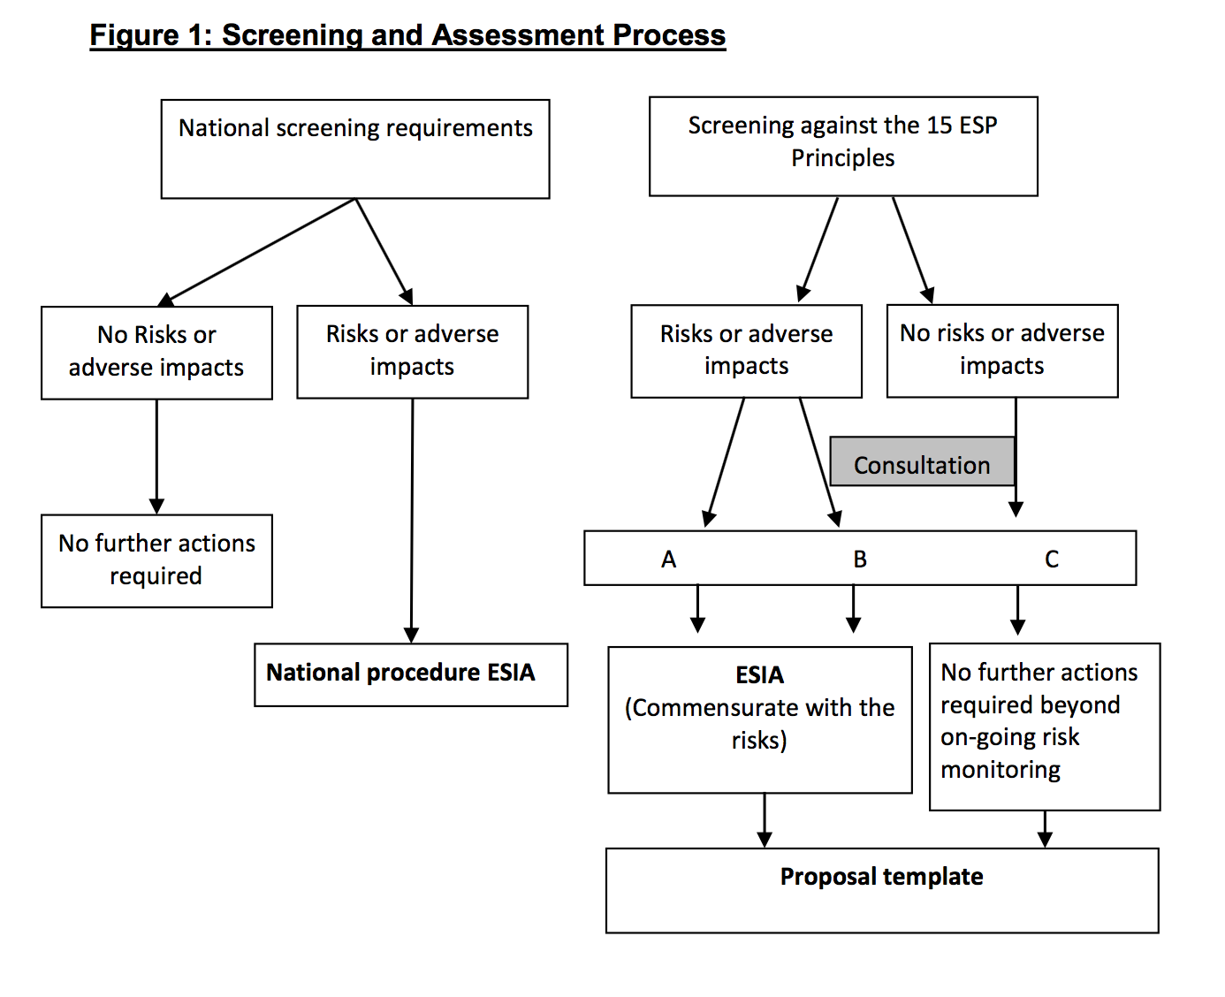
Figure 16. Categorisation of development projects based on environmental and social impacts (Source: Adaptation Fund Board).
Using Adaptation Fund and national criteria, an initial assessment of the project impacts is provided below in Tables 5 and 6. The social and environmental screening report is provided in Annex D, and the Initial Environmental Assessment (IEE) is provided in Annex J.

Following the UNDP Social and Environmental Screening Procedure, the project was assessed as Category B (Moderate), based on the aspects identified in the last column of the Checklist Table below. An Environment and Social Management Framework (ESMF) has been prepared to ensure that all risks are managed appropriately and therefore mitigated (the ESMF is presented in Annex J). A summary of the risks and the potential impacts for each item in the Checklist Table is provided in Section C.

Table 5.Initial screening criteria and assessment.
Checklist of environmental and social principles | No further assessment required for compliance | Potential impacts and risks – further assessment and management required for compliance
Compliance with the Law | X
Access and Equity | X
Marginalized and Vulnerable Groups |  | X
Human Rights | X
Gender Equity and Women’s Empowerment | X
Core Labour Rights | X
Indigenous Peoples | X
Involuntary Resettlement |  | X
Protection of Natural Habitats | X
Conservation of Biological Diversity | X
Climate Change | X
Pollution Prevention and Resource Efficiency | X
Public Health | X
Physical and Cultural Heritage | X
Lands and Soil Conservation |  | X

PART III: IMPLEMENTATION ARRANGEMENTS

- Implementation arrangements
Describe the arrangements for project / programme implementation.

The project will be implementing following UNDP’s National Implementation Modality (NIM).

As Multilateral Implementing Entity, UNDP will be responsible for independent project oversight and implementation support through specialized technical support services and quality assurance throughout the project funding cycle. Details of services covered by the MIE fee are listed in Annex N. UNDP provides a three-tier oversight and quality assurance roles, which will include: i) day-to-day oversight of project quality, timeliness and safeguard standards; ii) oversight of project completion; and iii) oversight of project accounting and reporting. This will ensure that appropriate project management milestones are managed and completed. Such oversight will be carried out by the UNDP Country Office in Bangladesh, the UNDP Global Environmental Finance Unit in the Bangkok Regional Hub, and the UNDP Headquarters in New York.

The Executing Entity for this project will be Bangladesh’s Department of Environment (DoE) under the Ministry of Environment, Forest and Climate Change (MoEFCC). The project will be executed in compliance with Government of Bangladesh and UNDP rules and regulations, policies and procedures, following the NIM/NEX guidelines/modalities. DoE under the MoEFCC will be responsible and accountable for the execution of the project, including ensuring that the objectives and components of the project are delivered, and for the effective use of project resources.
To assist with successfully delivering project outcomes and components, the following Responsible Parties will enter into agreements with DoE, MoEFCC:

Table 6. The Responsible Parties for each project component.
Components | Responsible Parties | Modality
Resilient housing | NGO/Firm | The National Project Director (NPD) in consultation with UNDP will award a contract to a competent NGO or Firm using Public Procurement Rules (PPR), 2006.
Nano-grid installation, solar storage and irrigation | NGO/ Firm | The National Project Director (NPD) in consultation with UNDP will award a contract to a competent NGO or Firm using Public Procurement Rules (PPR), 2006.
Rainwater Harvesting | NGO/Firm | The National Project Director (NPD) in consultation with UNDP will award a contract to a competent NGO or Firm using Public Procurement Rules (PPR), 2006.
Climate-resilient infrastructure/cyclone shelters | NGO/Firm | The National Project Director (NPD) in consultation with UNDP will award a contract to a competent NGO or Firm using Public Procurement Rules (PPR), 2006.
Embankments and local management arrangement | BWDB | DoE will enter into an LoA with BWDB and a community-based organisation.
Expansion of early warning | CPP/DDM | DoE will enter into an LoA with DDM.
Climate-resilient livelihoods including skills and technology | NGOs with support from LGIs | A committee will be formed under the NPD with representatives from MoEFCC, DoE, UNDP, DLS, DAE, LGIs and UNDP. NPD will award contract on the basis of the recommendation of the committee NPD will award a contract to a competent NGO following government rules and regulations.
Solar irrigation pumps, community level nano-grids | Firm | NPD will procure goods and services on the basis of public procurement rule (PPR), 2006 and/or UNDP’s procurement policy
Capacity of LGIs, BWDB, DAE | BWDB, DAE and National Institute of Local Government | Capacity-building/training will be provided by the NPD in consultation with PIC

NGO/Firm selection committee: A NGO/Firm selection committee will be formed, which will be headed by the NPD with representation from MoEFCC, BFD, BWDB, DDM, DAE, DLS, relevant local government institutions, experts and UNDP.

The project implementation will be governed by a National Project Steering Committee (NPSC) or National Steering Committee (NSC), which will consist of a group of representatives responsible for making consensus-based strategic, policy and management decisions for the project. The NPSC will oversee the project implementation, review compliance with the GoB, UNDP and AF requirements, and ensure the implementation of the management plan for the risks identified. Every six months – and/or earlier if an urgent strategic decision is to be made – the PSC will meet to discuss project progress and stakeholder performance. The NPSC will be comprised of (Figure 17) relevant stakeholders with following due procedures of the Government of Bangladesh.

- Secretary, Ministry of Environment, Forest and Climate Change will chair the National Project Steering Committee (NPSC) who will provide overall policy guidance regarding the implementation of the project.

- Responsible Parties will be the key partners of the govt who will support delivery of project components. Five key responsible parties will be (i) Bangladesh Water Development Board (BWDB), (ii) Cyclone Preparedness Programme(CPP) under Department of Disaster Management (DDM),(iii) Bangladesh Forest Department(BFD), (iv) Department of Agriculture Extension(DAE), and (v) Local Government Institutions(LGIs). They will ensure the realisation of project benefits and sustainability from the perspective of project beneficiaries.
- A Delivery Partner representative who will provide guidance regarding the technical feasibility of the project, compliance with development partners requirements and rules pertaining to the use of project resources. This role will be fulfilled by UNDP.
- A Project Assurance Team that will provide project guidance and oversight. This role will be fulfilled by MOEFCC and UNDP.
- Technical Advisory Committee will provide technical support to the National Project Steering Committee to ensure technical specification and quality of project’s development intervention. This committee will be headed by Director General, Department of Environment.
- Project Beneficiaries will be the beneficiaries of eight islands and they will be benefitted from the project intervention.
- A Project Management Unit (PMU) that will be responsible for the development and implementation of all the components of the project. The PMU will consist of:
  - A National Project Director, will be nominated from DoE by MoEFCC, who will be responsible for the overall direction, strategic guidance and timely delivery of project outputs;
  - A Project Manager, recruited by UNDP in consultation with NPD, who will manage the implementation and day-to-day operation of the project under the direct supervision of NPD and will be accountable to UNDP;
  - A Technical Team, recruited by UNDP in consultation with NPD, that will: i) develop programme standards; ii) provide technical support and guidance; iii) implement the policy research, dialogue and advocacy components of the project; iv) guide the implementation of social, gender, and environmental safeguards plans; v) implement capacity-building, knowledge management and communications activities; and vi) monitor project progress and support project M&E.
  - An Operations Team, recruited by UNDP in consultation with NPD, that will manage finance, general administration, procurement, internal auditing and risk management functions of the project. This role involves: i) managing funds; ii) programme quality assurance; iii) fiduciary risk management; iv) procurement; and v) the timely delivery of financial and programme reports to AF.

- Other Representatives which will include representatives from: i) Local Government Division; ii) Rural Development and Cooperatives Division; iii) Ministry of Agriculture; iv) Ministry of Fisheries and Livestock; v) Ministry of Planning; vi) Ministry of Finance; vii) Implementation, Monitoring and Evaluation Division; viii) Bangladesh Forest Research Institute; ix) Local Government Engineering Department; ix) Universities and Research Institutes, and x) NGO/private sector representatives.

Figure17. The National Project Steering Committee.

National Project Director
DoE
Project Management Unit at DoE
Field Offices based in
3 project sites

Beneficiary
Climate vulnerable com in 8 small islands
Chairperson, NPSC
Secretary, MoEFCC

Delivery Partner
UNDP

National Project Steering Committee (NPSC)
Project Manager-1
Finance Associate-1
M&E Associate-1
Administrative Assistant-1
Community Development Assistant-3
5 Responsible Parties
BWDB, DDM(CPP), BFD, DAE, LGIs,
Project Assurance
UNDP Bangladesh CO
AFB

Technical Advisory Committee

- Financial and project risk management
Describe the measures for financial and project / programme risk management.

Financial and project management will be conducted according to UNDP’s Programme and Operations Policies and Procedures to ensure that financial and project risks are mitigated. In addition, the Government of Bangladesh’s strong commitment to supporting the implementation of project interventions will limit the risks of the proposed project. However, there are several underlying project assumptions which, if not met, may contribute to the limited achievement of the project’s objectives. These assumptions are presented below.

Figure 18. Underlying assumptions that must be met for successful achievement of the project objective.

Detailed financial and project risks related to the above-mentioned assumptions, as well as associated mitigation strategies identified, are outlined in Table 7 below. During regular project review meetings, in which UNDP will be an active participant, all risks and mitigation measures will be reviewed and updated as per established practices.

Table 1. Financial and project risk management measures for the proposed project, including risk ratings.
Risk no. | Identified risk | Type | Risk rating | Mitigation measures
1. | Identifying climate-resilient livelihood options that are suitable to the condition of the vulnerable people. | Programme  Management | Medium | Success of the assignment will depend mostly on the identification of innovative livelihood options that will be suitable considering local, social, economic, ecological and climatic conditions and will be accepted by the local communities. Capacity of the vulnerable people will be carefully assessed and lessons from other projects will be reviewed and made available to the people to select from a range of options.
2. | Uncertainty regarding the intensity of climatic events that may affect the project interventions, including housing and infrastructure. | Strategic | Medium | The project will utilise all climate scenarios and invest in down-scaling them for the islands in the Bay of Bengal. The risk information will be used to design the interventions, especially for infrastructure and houses. Communities will be trained to switch their livelihoods depending on the changing climate. Local government and extension officials will also be trained.
3. | Current and predicted climate variability and/or extreme climate events negatively impact timeline of the project. | Operational | Medium | - The project will integrate the two outputs focusing on hazard risk scenarios and early warning communication to enable strong preparedness planning.  - Activities under relevant outputs will be implemented early in the project’s lifespan so that the potential impacts of extreme climate events are minimised. A business continuity plan will be in place.
5. | Influence of government and local political leaders in selection of beneficiaries. | Political | Medium | - In the project preparation phase, extensive consultation sessions have been conducted with government officials, including high-level officials of the ministries in Dhaka, confirming their commitment to the successful implementation of the project.  - Continuing stakeholder consultation and involvement will be undertaken to ensure that government agencies maintain their commitment to project implementation.  - Government will issue a guideline on selection criteria and a Grievance Redressal Mechanism will be established.
6. | Capacity constraints of local communities and other stakeholders may limit the ability to undertake the implementation of proposed interventions. | Institutional | Medium | - The proposed project focuses on a community-based and participatory approach.  - Human resource capacity will be developed in all targeted areas.  - Local adaptation measures will be specifically tailored to the communities which will implement them.

- Environmental and social risk management
Describe the measures for environmental and social risk management, in line with the Environmental and Social Policy of the Adaptation Fund.

Environmental and social impacts and risks have been identified for the proposed project (Part II: J). The table below describes risks and impacts management for the proposed project in accordance with the Environmental and Social Principles of the AF.

Table 8. Environmental and social risk management.
Checklist of environmental and social principles | Potential impacts and risks | Mitigation measures
Compliance with the Law | No appreciable risk | The involvement of government entities in the selection of adaptation interventions and technical design will ensure that all relevant laws will be considered during project implementation. Once implemented, the monitoring of adaptation interventions will provide a means of tracking their alignment with national laws for the duration of the project.
Access and Equity | The beneficiaries of the proposed project are poor people in vulnerable communities who are often not integrated into decision-making processes. There is, therefore, a risk that certain community members may benefit more than others. This may result in both intra- and inter-community conflicts. | This risk will be mitigated through the beneficiary selection approach (Annex B), and the incorporation of community consultation for all interventions that do not achieve complete coverage of the target populations. Furthermore, both beneficiary and non-beneficiary communities will be sensitised towards the approach of prioritising the support from the proposed project to the most vulnerable communities. A grievance mechanism (see Annex J) has also been developed to support any community members who feel they are experiencing discrimination.
Marginalised and Vulnerable Groups | There is a risk that vulnerable and marginalised groups will be excluded during the implementation of project activities and have insufficient access to the associated benefits. | The proposed project has been designed to ensure that marginalised and vulnerable groups – especially women and people living with disabilities – will not be adversely affected by, but will instead benefit from, relevant climate change adaptation activities.  Community consultations have been incorporated for all activities that do not achieve complete coverage of the target population. This will allow for the identification of marginalised and vulnerable households.
Human Rights | No activities are, or will be, included in the design of the proposed project that are not in line with established international human rights. Moreover, the proposed project will promote the fundamental human rights of access to food, water and information. | The project seeks to ensure that benefits of the project are shared broadly in a non-discriminatory, equitable manner through participatory processes and transparent selection criteria. Extensive stakeholder consultations were held during project preparation (Annex C) and will be continued throughout project implementation.
Gender Equity and Women’s Empowerment | The proposed project is targeting communities where men occupy the majority of the leadership positions. There is, therefore, a risk that women will not benefit equitably from the proposed project’s climate change adaptation and capacity-building interventions. | Gender equity and women’s empowerment were considered across all relevant design aspects of the proposed project and gender equity will be adhered to throughout the implementation period. To this end, a gender assessment was conducted during the development of the proposal to ensure that gender considerations were fully considered during project design (see Annex I). In particular, equal rights, responsibilities, opportunities and access of women to the benefits of climate change adaptation have been considered. For example, project activities that target the most vulnerable community members (Activities 2.1.1. and 3.2.1.) are prioritised towards women-led households. For technical assessments, as well as capacity-building activities, women will be strongly encouraged to participate.
Core Labour Rights | Local communities will be involved in the implementation and maintenance of climate change adaptation interventions. Therefore, local community members may be exposed to the risk of accidents while implementing the proposed project’s climate change adaptation interventions. | During implementation, the National Project Steering Committee and Management Units will ensure respect for international and national labour laws and codes, for any work that may be carried out in relation to the project. This includes the eight International Labour Organisation Convention (ILO) core labour standards related to fundamental principles and rights of workers, as well as ILO Convention No. 169, which concerns rights of indigenous and tribal peoples.  Prioritisation of women participation may be used to provide fair and equal opportunity for women to seek employment as labourers. All forms of negative discrimination in respect of employment and occupation will be eliminated. The proposed project will not engage in child labour in any of its activities. All forms of forced or compulsory labour will be eliminated.
Indigenous Peoples | No appreciable risk | No mitigation necessary.
Involuntary Resettlement | There is a low risk that houses have been constructed in areas that conflict with the infrastructure interventions under Component 2 (Specifically Output 2.1). This may result in temporary resettlement while infrastructure interventions are completed. | The project will ensure that in-depth consultations are conducted with any households that may be at risk of requiring resettlement. The possibility of involuntary resettlement has been considered for the repair of embankments and a resettlement policy has been prepared for this possibility (see Annex K). Any involuntary relocation or resettlement will only be conducted after extensive community consultation and negotiation with any affected households. Benefits including reimbursement for the cost of the house, further livelihood support and provisioning of new land will all be included in any negotiated package. A grievance mechanism has also been developed (see Annex J) and will be in place to address any concerns of affected community members.
Protection of Natural Habitats | On-the-ground adaptation interventions (specifically EbA) will include the planting of species for enrichment and/or restoration of ecosystems. This could lead to long-term alteration of natural habitats in terms of species assemblages and structure, which may result in various disturbances and negative environmental impacts.  Adaptation interventions involving hard infrastructure will also be constructed – for example, the rehabilitation of damaged embankments (Activity 2.1.2.). Such interventions may result in the disturbance of small areas of natural habitat. | The promotion of EbA interventions through the proposed project is more likely to result in the restoration, improved management and protection of natural habitats, as well as the strengthened supply of ecosystem goods and services. To ensure that this principle is adhered to, the consultation with and inclusion of relevant stakeholders (community and authority level) during project design and implementation is prioritised.  All necessary impact assessments will be conducted before the implementation of interventions. Furthermore, all national environmental laws will be respected during the selection and implementation of adaptation interventions.
Conservation of Biological Diversity | There is a low risk that adaptation interventions involving the construction of hard infrastructure – for example, the rehabilitation of damaged embankments (Activity 2.1.2.) could negatively impact biodiversity. | The project will ensure the conservation and sustainable use of biological diversity factors are considered in the process of finalising adaptation interventions. Adaptation intervention sites (specifically under Activity 2.1.1.) will be selected using a participatory approach and input from an environmental expert to ensure that activities do not cause significant loss of biological diversity.
Climate Change | No appreciable risk | No mitigation measures necessary
Pollution Prevention and Resource Efficiency | No appreciable risk | No mitigation measures necessary
Public Health | No appreciable risk | No mitigation measures necessary
Physical and Cultural Heritage | No appreciable risk | No mitigation measures necessary
Lands and Soil Conservation | Risks have been identified that are associated with the grey infrastructure interventions (Output 2.2.). These interventions include raising houses on plinths, repairing flood protection embankments and the construction of dual-purpose cluster house/storm shelters. | The project will ensure that all relevant environmental codes and standards will be followed during the design and construction of the grey infrastructure interventions. To comply with both national legislation and the Environmental and Social Principles of the Adaptation Fund, it is recommended that a comprehensive ESIA is undertaken at selected sites and an EMP commensurate with the identified impacts is developed prior to the construction of any greyinfrastructure.

Where required, an Environmental Management Plan for some of the project’s on-the-ground activities will be developed and implemented (see Part II Section J and Annex J). Appraisal of the project activities will be based on a detailed quality programming checklist – formulated and approved by national stakeholders – to ensure that all necessary, country-specific safeguards are addressed and incorporated into the project design.

Compliance with the Environmental and Social Policy of the Adaptation Fund
The project will comply with the Environmental and Social Policy of the Adaptation Fund as described in Part II: Section J. As the Adaptation Fund-accredited Implementing Agency, UNDP – together with the relevant national partners – will ensure that the project follows the procedures outlined in the Environment and Social Policy of the Fund. This includes, for example, the requirement that all project activities reflect local circumstances and needs and draw upon national actors and capabilities. The proposal has been screened according to the UNDP Social and Environmental Safeguards Procedure to ensure that necessary safeguards are incorporated into the project design. This includes quality assessment and social and environmental safeguards.

- Monitoring and evaluation arrangements
Describe the monitoring and evaluation arrangements and provide a budgeted M&E plan.

A comprehensive Monitoring and Evaluation (M&E) plan will be developed, which will be distributed and presented to all stakeholders during the Inception Workshop. To manage the M&E plan, anM&E Associate will be appointed in the Project Management Unit.The M&E plan will consist of four different elements of M&E which are outlined below:

- Impact M&E. Through impact M&E, information will be gathered as per Result and Impact Management System (RIMS) indicators, which include inter alia: i) increases in household assets; ii) enhanced food security; and iii) reduced malnutrition among children less than 5 years. RIMS surveys will be conducted three times –at the beginning of the project, in the mid-term review, and for the terminal evaluation.
- Outcome M&E. This monitoring and evaluation will gather information on log-frame indicators that are not covered sufficiently in the RIMS survey. This type of M&E is specifically aimed at collecting evidence of an effective ‘results chain’ that shows improvements in the physical environment after project implementation. Such improvements may include, for example: i) reduced flooding; ii) reduced soil salinity; iii) increased soil nutrients; and iv) improved access to and use of technologies, which together could result in:i) increased crop yields; ii) increased agricultural sales; iii) improved food security; and ultimately iv) reduced poverty.
- Process M&E. Through Process M&E, a system of participatory monitoring and evaluation (PME) will be developed to generate feedback from project beneficiaries. Such feedback will provide the project management team with valuable information on the efficacy of the implementation of project activities and the delivery of project outputs. This process monitoring will also include an assessment on the effectiveness of the project’s training and capacity-building efforts. Such an assessment will be executed through Knowledge, Attitude and Practices (KAP) surveys.
- Activity M&E. To assess the efficacy of each activity, the project management unit will produce progress reports. These reports will be based on all available information on project activities, which will be recorded regularly in a computerised MIS System. Every six months, a progress report will outline physical and financial progress against the project targets. An Annual Project Progress Review (PPR) will be prepared to monitor progress made since the project’s start.

Activity M&E shall include followings:

Project start:
A Project Inception Workshop will be held within the first 2 months of project start with those with assigned roles in the project organization structure, UNDP country office and where appropriate/feasible regional technical policy and programme advisors as well as other stakeholders. The Inception Workshop is crucial to building ownership for the project results and to plan the first year annual work plan.
The Inception Workshop should address a number of key issues including:
- Assist all partners to fully understand and take ownership of the project. Detail the roles, support services and complementary responsibilities of UNDP CO and RCU staff vis à vis the project team. Discuss the roles, functions, and responsibilities within the project's decision-making structures, including reporting and communication lines, and conflict resolution mechanisms. The Terms of Reference for project staff will be discussed again as needed.
- Based on the project results framework, finalize the first annual work plan. Review and agree on the indicators, targets and their means of verification, and recheck assumptions and risks.
- Provide a detailed overview of reporting, monitoring and evaluation (M&E) requirements. The Monitoring and Evaluation work plan and budget should be agreed and scheduled.
- Discuss financial reporting procedures and obligations, and arrangements for annual audit.
- Plan and schedule Project Board meetings or National Steering Committee meetings. Roles and responsibilities of all project organisation structures should be clarified and meetings planned. The first Project Board meeting should be held within the first 12 months following the inception workshop.
An Inception Workshop report is a key reference document and must be prepared and shared with participants to formalize various agreements and plans decided during the meeting.
Quarterly:
The following will be undertaken on a quarterly basis:
- Progress made shall be monitored in the UNDP Enhanced Results Based Management Platform.
- Based on the initial risk analysis submitted, the risk log shall be regularly updated in ATLAS. Risks become critical when the impact and probability are high. Note that for UNDP AF projects, all financial risks associated with financial instruments such as revolving funds, microfinance schemes, or capitalization of ESCOs are automatically classified as critical on the basis of their innovative nature (high impact and uncertainty due to no previous experience justifies classification as critical).
- Based on the information recorded in Atlas, a Project Progress Reports (PPR) can be generated in the Executive Snapshot.
- Other ATLAS logs can be used to monitor issues, lessons learned etc. The use of these functions is a key indicator in the UNDP Executive Balanced Scorecard.

Annually:
The project is required to submit a Project Performance Report (PPR) to the donor on an annual basis, one year after the start of project implementation (date of inception workshop) and the last such report should be submitted six months after project completion
The PPR completed template should be submitted to the secretariat in English and that all financial figures provided in the template should be in US dollars (USD). There are 8 sections in the template, as follows:
- Overview
- Financial information
- Procurement data
- Risk assessment
- Ratings
- Project indicators
- Lessons learned
- Adaptation Fund results tracker
Periodic Monitoring through site visits:
UNDP CO and the UNDP RCU will conduct visits to project sites based on the agreed schedule in the project's Inception Report/Annual Work Plan to assess first hand project progress. Other members of the Project Board may also join these visits. A Field Visit Report/BTOR will be prepared by the CO and UNDP RCU and will be circulated no later than one month after the visit to the project team and Project Board members.
Mid-term of project cycle
The project will undergo an independent Mid-Term Evaluation at the mid-point (in the third year) of project implementation. The Mid-Term Evaluation will determine progress being made toward the achievement of outcomes and will identify course correction if needed. It will focus on the effectiveness, efficiency and timeliness of project implementation; it will highlight issues requiring decisions and actions; and will present initial lessons learned about project design, implementation and management. Findings of this review will be incorporated as recommendations for enhanced implementation during the final half of the project’s term. The organization, terms of reference and timing of the mid-term evaluation will be decided after consultation between the parties to the project document. The Terms of Reference for this Mid-term evaluation will be prepared by the UNDP CO based on guidance from the Regional Coordinating Unit and UNDP-EEG. The management response and the evaluation will be uploaded to UNDP corporate systems, in particular the UNDP Evaluation Office Evaluation Resource Center (ERC).
End of Project:
An independent Final Terminal Evaluation will take place three months prior to the final Project Board meeting and will be undertaken in accordance with UNDP and AF guidelines. The final evaluation will focus on the delivery of the project’s results as initially planned (and as corrected after the mid-term evaluation, if any such correction took place). The final evaluation will look at impact and sustainability of results, including the contribution to capacity development and the achievement of adaptation benefits. The Terms of Reference for this evaluation will be prepared by the UNDP CO based on guidance from the Regional Coordinating Unit and UNDP-EEG
The Final Terminal Evaluation should also provide recommendations for follow-up activities and requires a management response which should be uploaded to PIMS and to the UNDP Evaluation Office Evaluation Resource Center (ERC).
During the last three months, the project team will prepare the Project Final Report. This comprehensive report will summarize the results achieved (objectives, outcomes, outputs), lessons learned, problems met and areas where results may not have been achieved. It will also lay out recommendations for any further steps that may need to be taken to ensure sustainability and replicability of the project’s results.
Audit
The audit would be performed under the UNDP financial regulations and rules applicable to audit policies on UNDP projects.
Learning and knowledge sharing:
Results from the project will be disseminated within and beyond the project intervention zone through existing information sharing networks and forums.
The project will identify and participate, as relevant and appropriate, in scientific, policy-based and/or any other networks, which may be of benefit to project implementation though lessons learned. The project will identify, analyze, and share lessons learned that might be beneficial in the design and implementation of similar future projects.
Finally, there will be a two-way flow of information between this project and other projects of a similar focus.
Communications and visibility requirements:
The AF logo should appear on all relevant publications of the Project, included within other logos, project equipment and other acquisitions with AF funds. Any citation in publications regarding projects funded by the AF should give recognition to the AF. The logos of the implementing agencies and enforcement agencies will also appear on all publications. Full compliance is required with UNDP’s Branding Guidelines. These can be accessed at http://intra.undp.org/coa/branding.shtml, and specific guidelines on UNDP logo use can be accessed at: http://intra.undp.org/branding/useOfLogo.html.
The M&E activities will make use of the Adaptation Tracking and Measuring Framework (ATM)developed by UNDP for theLoGIC project in Bangladesh. Periodic monitoring will be conducted through visits to the intervention sites undertaken by relevant staff from UNDP. Visits will be jointly conducted based on the agreed schedule to assess project progress first hand.

A summary of the M&E costs is provided in Table 9 below.

Table 9. Monitoring and evaluation costs of the proposed project. Note: The costs indicated here do not include the costs associated with UNDP staff.Such costs will be covered by the MIE fee.

Type of M&E activity | Responsible parties | Budget US$ (excluding project team time) | Total Cost US$ | Timeframe
Direct Project Monitoring and Quality Assurance including progress and financial reporting, project revisions, technical assistance and risk management | Project Managers | (supported from staff costs included in Project execution, and from IE fee) |  | Quarterly, half-yearly and annually and as needed
 | Finance cum Admin Associate |  |  | Quarterly, half-yearly and annually and as needed
 | UNDP |  |  | Quarterly, half-yearly and annually and as needed
 | External consultants – CTA |  |  | Quarterly, half-yearly and annually and as needed
Evaluations, assessments including terminal evaluation | Project Managers |  |  | During and end of project implementation
Evaluations, assessments including terminal evaluation | UNDP | 90,000 | 90,000 | During and end of project implementation
Evaluations, assessments including terminal evaluation | External consultants |  |  | During and end of project implementation
Terminal Report (Collection of lessons learned from the mid-term and terminal evaluations to be compiled in a report and disseminated to local-and-national-level government and policymakers) | Project Managers | 10,000 | 10,000 | At end of project implementation
 | UNDP | 10,000 | 10,000 | At end of project implementation
 | External consultants | 10,000 | 10,000 | At end of project implementation
NIM Audit as per UNDP audit policies | Project managers | Project site 1: 12,500 (2,500 annually) | 12,500 | Annually at year end
NIM Audit as per UNDP audit policies | UNDP | Project site 2: 12,500 (2,500 annually) | 12,500 | Annually at year end
Inception meeting, field visits and steering committee meetings | Project managers | Project site 1: 12,500 (2,500 annually) | 12,500 | Inception meeting within first 2 months and bi-annual PSC meetings
 | UNDP | Project site 2: 12,500 (2,500 annually) | 12,500
TOTAL indicative cost  Excluding project team staff time and UNDP staff and travel expenses |  | US$ 150,000 | 150,000

- Results Framework
Include a results framework for the project proposal, including milestones, targets and indicators.

Expected outcome/outputs | Output indicator | Baseline | Target | Sources of verification | Assumptions
Output 1.1. Cyclone and flood resilient houses for the most vulnerable households. | Number of houses made resilient against climate disasters (cyclones and floods) | 0 | 900 houses retrofitted in Mujibnagar and Lakshmitari | Registers of project beneficiaries at each site, site visits, household surveys and project reports. | Community preference and resilient technical design is within the project’s budget limit, and no significant increase of price of materials.
Output 1.2. Community-level nano-grids installed for electrification to enhance adaptive capacity | Number of nano-grids installed and operational. | 0 | 30 nano-grids installed and made operational to provide electricity to 300 – 450 houses. | Registers of project beneficiaries at each site, site visits, household surveys and project reports. | Collaboration between communities, project partner NGOs, local government and other stakeholders.  Community groups trained by project successfully operate and maintain the nano-grids.
Output 1.3. Locally appropriate rainwater harvesting systems forsafe drinking water. | Number of household rainwater harvesting systems installed and operational.  Number of water user groups established and trained. | 0 | 500 households provided with functioning and climate-resilient rainwater harvesting systems  10 water user groups established and trained | Registers of project beneficiaries at each site, site visits, household surveys and project reports. | Water user groups and household members trained by project successfully operate and maintain the rainwater harvesting systems.
Output 2.1. Climate-resilient mini-disaster shelter/cluster houses built to protect life and prevent asset loss. | Number of dual-purpose cluster house/disaster shelters constructed and in use. | 0 | 16 dual-purpose cluster house/disaster shelters constructed and in use. (Minimum 50% of beneficiaries will be women-led households) | Registers of project beneficiaries at each site, site visits, and project reports.  Project reports and site visits. | When Khas land is not available, community is willing to allocate the land.
Output 2.2. Embankments repaired and innovative model for community embankment management introduced. | Km of damaged embankments repaired/ strengthened.  Km of riverbank strengthened.  Number of community embankment management groups established | 0 | 12.5 km of embankments repaired/strengthened in Mujibnagar  14.5 km of riverbank strengthened in Lakshmitari  1 community embankment management group established at each project site. | Project reports and site visits. | The lessons from the community management practices of embankment are well documented and owned by Ministry of Water Resources for change in practice.
Output 2.3. Climate-resilient investment on chars promoted through climate hazard maps and expanded cyclone early warning systems. | Km² of char areas mapped  Number of householdsin Mujibnagar receiving periodic updates during cyclone risk periods | 0 | 8 climate hazard and vulnerability maps covering selected islands in the Bay of Bengal  Every household in Mujibnagarhas at least one member receiving periodic early cyclone warnings during cyclone risk periods. | Registers of project beneficiaries at each site, site visits, and project reports. | The community risk assessment and risk reduction plans are within the capacity of the local government to integrate into their plans and budget.
Output 2.4. Cyclone Preparedness Programme (CPP) modernised and expanded to provide timely cyclone early warning and response at scale. | Number of CPP volunteers trained  Existing cyclone shelters in Mujibnagar provisioned with CPP equipment | 0 | ~2,500 CPP volunteers trained in Mujibnagar (increase female representation in CPP by at least 25%)  10,000 CPP volunteers trained on six additional islands  7 existing cyclone shelters and 16 cluster houses provisioned with CPP equipment in Mujibnagar.  ~2,500 CPP volunteers provided with personal cyclone preparedness equipment  8 mobile floating medical unit procured and provisioned  6 additional islands equipped with CPP Equipment | Project reports and site visits. | Community engages in CPP and community members volunteer for the programme.
Output 3.1 Climate-resilient agriculture implemented | Number of field schools held  Number of people trained in climate-resilient agricultural practices  Number of cold storage units installed and operational  Hectares of agricultural land irrigated | 0 | Quarterly field school trainings held in Mujibnagar and Lakshmitari for a total of 64 field school trainings. (include at least 25% female representation, but aim is for minimum of 50%)  ~7,500 farmers trained on climate-resilient agricultural practices.  2 cold storage units installed in Mujibnagar and 2 cold storage units installed in Lakshmitari  80 hectares of land irrigated in Lakshmitari | Registers of project beneficiaries at each site, site visits, household surveys and project reports. | Collaboration between communities, project partner NGOs, local government and other stakeholders.
Output 3.2 Diversified livelihoods supported at the village level. | Number of people provided with technology, skills and materials to make their livelihoods climate resilient. |  | ~6,500 people provided with technology, skills and materials to make their livelihood climate resilient. (minimum 50% female beneficiaries) |  | Collaboration between women cooperatives, communities, project partner NGOs, local government and other stakeholders.
Output 4.1. Local government institutions are capable of climate risk-informed planning and implementation. | Number of staff from local government institutions, Bangladesh Water Board and Department of Agriculture trained. | 0 | 250 staff from local government institutions, Bangladesh Water Board and Department of Agriculture trained to incorporate climate risk into their decisions and activities. | Project reports
Output 4.2. Knowledge and awareness generated to promote climate resilient approaches and strategies | Number of adaptation innovation centres established  Number of people reached by awareness raising campaigns  Number of knowledge products developed | 0 | 2 Adaptation innovation centres established in each of the project locations  75% of the population in the target areas reached by awareness campaigns (minimum 50% women)  10 manuals and brochures developed. | Project reports. School visits, site visits and household surveys and national newspaper.

- Alignment with Adaptation Fund Results Framework
Demonstrate how the project / programme aligns with the Results Framework of the Adaptation Fund
Project Objective(s) | Project Objective  Indicator(s) | Fund Outcome | Fund Outcome Indicator | Grant Amount (USD)
To enhance the climate resilience of vulnerable communities who live on coastal and riverine chars in Bangladesh. | Enhanced climate resilience of vulnerable communities in the Mujibnagar and Lakshmitari Unions. | Outcome 1: Reduced exposure to climate-related hazards and threats | 1. Relevant threat and hazard information generated and disseminated to stakeholders on a timely basis | 9,995,369
 |  | Outcome 4: Increased adaptive capacity within relevant development sector services and infrastructure assets | 4.2. Physical infrastructure improved to withstand climate change and variability-induced stress | 9,995,369
 |  | Outcome 6: Diversified and strengthened livelihoods and sources of income for vulnerable people in targeted areas | 6.2. Percentage of targeted population with sustained climate-resilient alternative livelihoods | 9,995,369
Project Outcome(s) | Project Outcome Indicator(s) | Fund Output | Fund Output Indicator | Grant Amount (USD)
Outcome 1. Enhanced climate resilience of households through climate-resilient housing, electrification and climate-proof water provisioning | Number of households with increased resilience through strengthened houses, electrification and water provisioning. | Output 4: Vulnerable development sector services and infrastructure assets strengthened in response to climate change impacts, including variability | 4.1.2. No. of physical assets strengthened or constructed to withstand conditions resulting from climate variability and change (by sector and scale) | 2,007,828
Outcome 2. Increased climate resilience of communities through infrastructure that is resilient to cyclones and floods, climate risk mapping and inclusive cyclone preparedness | Number of people with increased resilience through strengthened disaster infrastructure. | Output 1.2: Targeted population groups covered by adequate risk reduction systems | 1.2.1. Percentage of target population covered by adequate risk-reduction systems | 2,317,726
Outcome 3. Improvedincome and food security of communities by innovating and providing assistance to selected households for climate-resilient livelihoods practices | Number of people with provided with improved climate resilient livelihoods | Output 6: Targeted individual and community livelihood strategies strengthened in relation to climate change impacts, including variability | 6.1.1.No. and type of adaptation assets (tangible and intangible) created or strengthened in support of individual or community livelihood strategies | 3,397,068
Outcome 4. Enhanced knowledge and capacity of communities, government and policymakers to promote climate resilient development on chars. | Number of people reached by knowledge products and awareness raising | Output 3: Targeted population groups participating in adaptation and risk reduction awareness activities | 3.1 No. of news outlets in the local press and media that have covered the topic | 614,700

- Detailed budget
Include a detailed budget with budget notes, a budget on the Implementing Entity management fee use, and an explanation and a breakdown of the execution costs.

Award ID: | TBA |  |  |  |  |  | Project ID: |  | TBA
Award Title: | ADAPTATION INITIATIVE FOR CLIMATE VULNERABLE OFFSHORE SMALL ISLAND AND RIVERINE CHARLAND IN BANGLADESH
Business Unit: | BGD 10
Project Title: | ADAPTATION INITIATIVE FOR CLIMATE VULNERABLE OFFSHORE SMALL ISLAND AND RIVERINE CHARLAND IN BANGLADESH
PIMS no. | 6172
Implementing Partner  (Executing Agency) | Ministry of Environment, Forest and Climate Change (MoEFCC)
Outcome | Responsible Party/ Implementing Agency | Fund ID | Donor Name | Budget Account Code | Budget Account Description | Amount |  | Amount |  | Amount | Amount |  |  | Amount |  |  | Total | Budget note
 |  |  |  |  |  | Year 1 |  | Year 2 |  | Year 3 | Year 4 |  |  | Year 5 |  |  | Total | Budget note
 |  |  |  |  |  | USD |  | USD |  | USD | USD |  |  | USD |  |  | USD | Budget note
Outcome 1. Enhanced climate resilience of households through disaster-resilient housing, electrification and climate-proof water provisioning | UNDP | 62040 | AF | 71300 | Local/National Consultants | 26,500 |  | 13,000 |  | 10,500 | 3,000 |  |  | 2,000 |  |  | 55,000 | 1C; 1E; 1G; 1J; 1L
 |  |  |  | 72100 | Contractual Services-Companies | 131,566 |  | 135,631 |  | 135,631 | 0 |  |  | 0 |  |  | 402,828 | 1D; 1I
 |  |  |  | 72300 | Materials and Goods | 612,000 |  | 459,000 |  | 459,000 | 0 |  |  | 0 |  |  | 1,530,000 | 1A
 | MoEFCC | 62040 | AF | 75700 | Training, Workshops and Conferences | 8,000 |  | 4,000 |  | 4,000 | 2,000 |  |  | 2,000 |  |  | 20,000 | 1B; 1F; 1K
 | Total Outcome 1 |  |  |  |  | 778,066 |  | 611,631 |  | 609,131 | 5,000 |  |  | 4,000 |  |  | 2,007,828
Outcome 2. Increased climate resilience of communities through disaster-resilient infrastructure, climate risk mapping and inclusive cyclone preparedness. | UNDP | 62040 | AF | 71300 | Local Consultant | 10,500 |  | 7,250 |  | 7,250 | 5,250 |  |  | 5,000 |  |  | 35,250 | 2B; 2F; 2G; 2M
 | MoEFCC | 62040 | AF | 72100 | Contractual Services-Companies | 352,040 |  | 566,420 |  | 508,040 | 8,400 |  |  |  | 2,400 |  | 1,437,300 | 2A;2C;2D;2H;2I
 | UNDP | 62040 | AF | 72300 | Materials and Goods | 119,435 |  | 119,435 |  | 119,435 |  | 119,435 |  |  | 119,435 |  | 597,176 | 2K;2N
 | MoEFCC& LGI | 62040 | AF | 75700 | Training, Workshops and Conferences | 49,500 |  | 49,500 |  | 51,500 |  | 51,500 |  |  | 46,000 |  | 248,000 | 2C; 2E
 | Total Outcome 2 |  |  |  |  | 531,475 |  | 742,605 |  | 686,225 |  | 184,585 |  |  | 172,835 |  | 2,317,726
Outcome 3. Improved income and food security of communities by innovating and providing assistance to selected households for climate-resilient livelihoods practices | UNDP | 62040 | AF | 71300 | Local Consultant | 32,500 |  | 38,000 |  | 38,000 |  | 38,000 |  |  | 38,000 |  | 184,500 | 3B; 3E; 3G
 | UNDP | 62040 | AF | 71400 | Contractual Services-Individuals | 47,427 |  | 40,285 |  | 40,285 |  | 40,285 |  |  | 40,285 |  | 208,568 | 3A; 3J
 | MoEFCC | 62040 | AF | 72100 | Contractual Services-Companies | - |  | 356,500 |  | 356,500 |  | - |  |  | - |  | 713,000 | 3C; 3D
 | MoEFCC | 62040 | AF | 72300 | Materials and Goods | 455,000 |  | 455,000 |  | 455,000 |  | 455,000 |  |  | 455,000 |  | 2,275,000 | 3I
 | MoEFCC& LGI | 62040 | AF | 75700 | Training, Workshops and Conferences | - |  | 4,000 |  | 4,000 |  | 4,000 |  |  | 4,000 |  | 16,000 | 3F; 3H
 | Total Outcome 3 |  |  |  |  | 534,927 |  | 893,785 |  | 893,785 |  | 537,285 |  |  | 537,285 |  | 3,397,068
Outcome 4. Enhanced knowledge and capacity of communities, government and policymakers to promote climate resilient development on chars. | UNDP | 62040 | AF | 71400 | Contractual Services-Individuals | 18,400 |  | 47,200 |  | 47,200 |  | 47,200 |  |  | 47,200 |  | 207,200 | 4F; 4H; 4I
 | MoEFCC& UNDP | 62040 | AF | 71600 | Travel | 6,400 |  | 6,400 |  | 6,400 |  | 6,400 |  |  | 6,400 |  | 32,000 | 4E
 | MoEFCC | 62040 | AF | 72100 | Contractual Services-Companies | 72,000 |  | 27,000 |  | 27,000 |  | 27,000 |  |  | 27,000 |  | 180,000 | 4B
 | UNDP &MoEFCC | 62040 | AF | 74200 | Audio Visual&Print Prod Costs | 39,600 |  | 14,850 |  | 14,850 |  |  | 14,850 |  |  | 14,850 | 99,000 | 4C
 | MoEFCC& LGI | 62040 | AF | 75700 | Training, Workshops and Conferences | 15,000 |  | 31,750 |  | 22,375 |  |  | 18,375 |  |  | 9,000 | 96,500 | 4A; 4D; 4G
 | Total Outcome 4 |  |  |  |  | 151,400 |  | 127,200 |  | 117,825 |  |  | 113,825 |  |  | 104,450 | 614,700
Project Management | UNDP | 62040 | AF | 71400 | Contractual Services-Individuals | 118,200 |  | 118,200 |  | 118,200 |  |  | 118,200 |  |  | 118,200 | 591,000 | PM1; PM2; PM3; PM4; PM5
Project Management | UNDP | 62040 | AF | 71600 | Travel | 10,000 |  | 10,000 |  | 10,000 |  |  | 10,000 |  |  | 10,000 | 50,000 | PM6
Project Management | MoEFCC | 62040 | AF | 72100 | Contractual Services-Companies | 5,000 |  | 5,000 |  | 45,000 |  |  | 5,000 |  |  | 65,000 | 125,000 | PM12
Project Management | UNDP | 62040 | AF | 72400 | Communic& Audio Visual Equip | 5,000 |  | 5,000 |  | 5,000 |  |  | 5,000 |  |  | 5,000 | 25,000 | PM10
Project Management | UNDP | 62040 | AF | 72500 | Supplies | 12,000 |  | 2,000 |  | 2,000 |  |  | 2,000 |  |  | 2,000 | 20,000 | PM7
Project Management | MoEFCC | 62040 | AF | 72800 | Information Technology Equipmt | 8,400 |  | 1,400 |  | 1,400 |  |  | 1,400 |  |  | 1,400 | 14,000 | PM8
Project Management | UNDP | 62040 | AF | 74100 | Professional services | 5,000 |  | 5,000 |  | 5,000 |  |  | 5,000 |  |  | 5,000 | 25,000 | PM11
Project Management | UNDP | 62040 | AF | 74500 | Miscellaneous | 5,000 |  | 5,000 |  | 5,000 |  |  | 5,000 |  |  | 5,000 | 25,000 | PM9
Project Management | 9212322Total PMC |  |  |  |  | 168,600 |  | 151,600 |  | 191,600 |  |  | 151,600 |  |  | 211,600 | 875,000
 | Project Total |  |  |  |  | 2,164,468 |  | 2,526,822 |  | 2,498,567 |  |  | 992,295 |  |  | 1,030,170 | 9,212,322
 | Grant Total (Project Total + IE Fee) |  |  |  |  |  |  |  |  |  |  |  |  |  |  |  | 9,995,369
Budget notes:

NOTE | Output | Budget code | Nature of Expense | Amount | Description
1A | Output 1.1. Cyclone and flood resilient houses for the most vulnerable households. | 72300 | Materials and Goods | 1,530,000 | Retrofitting of 900 vulnerable char houses @ US$1,700 per unit
1B |  | 75700 | Training | 10,000 | - Training workshops to train construction workers on climate/cyclone resilient approaches:10 workshops @ US$1000 per workshop (TS)
1C |  | 71300 | Local Consultant | 11,000 | - National consultants or technical specialists to conduct training workshops: 44 days @ US$250 per day (TS)
 |  | Total Output 1.1: |  | 1,551,000
1D | Output 1.2. Community-level nano-grids installed for electrification to enhance adaptive capacity | 72100 | Contractual Services-Companies | 147,828 | - 30 Solar Units + installation @ US$4,927 per unit
1E |  | 71300 | Local/National Consultants | 11,000 | - National consultants to conduct assessment of electricity needs: 44 days @ US$250 per day (TS)
1F |  | 75700 | Training | 5,000 | - Workshops to train community maintenance groups on maintaining solar units: 10 workshops @ US$500 per workshop (TS)
1G |  | 71300 | Local/National Consultants | 11,000 | - National consultants or specialists to conduct training workshops: 44 days @ US$250 per day (TS)
1H |  | Total Output 1.2: |  | 174,828
1I | Output 1.3. Locally appropriate rainwater harvesting systems for safe drinking water and home-garden irrigation. | 72100 | Contractual Services-Companies | 255,000 | 500 rainwater harvesting units + installation @ US$510 per unit
1J |  | 71300 | Local Consultant | 11,000 | - Assessment of water demand - national consultant: 44 days @ US$250 per day (TS)
1K |  | 75700 | Training | 5,000 | - Workshops to train community-based water-user groups 10 workshops @ US$500 per workshop (TS)
1L |  | 71300 | Local Consultant | 11,000 | - National consultants to conduct training workshops 44 days @ US$250 per day (TS)
 |  | Total Output 1.3: |  | 282,000
2A | Output 2.1. Climate resilient infrastructure built to protect life and prevent asset loss | 72100 | Contractual Services-Companies | 800,000 | - Cluster house construction materials + labour @ US$40,000 per unit
2B |  | 71300 | Local Consultant | 8,250 | - Engineer to provide support/assessments for location and construction of cluster houses 33 days @ US$250 per day (TS)
 |  | Total Output 2.1: |  | 808,250
2C | Output 2.2. Embankments repaired and innovative model for community embankment management introduced. | 72100 | Contractual Services-Companies | 375,000 | - Embankment repair @ US$30,000 per km (further information on technical details on the embankment repair are provided in annex G)
2D |  | 72100 | Contractual Services-Companies | 208,800 | - Embankment strengthening through EbA @ US$14,400 per km
2E |  | 75700 | Training | 24,000 | - Workshops to train community embankment management groups 12 workshops @ US$2,000 per workshop (TS)
2F |  | 71300 | Local Consultant | 5,500 | - National consultant to train communities on community management of embankments 22 days @ US$250 per day (TS)
2G |  | 71300 | Local Consultant | 5,500 | - National consultant or specialist to assess and develop livelihoods to be connected to embankment management and conduct trainings 22 days @ US$250 per day (permanent staff employed under output 3.1)
2H |  | 72100 | Contractual Services-Companies | 37,500 | Environmental management plan and environmental monitoring
 |  | Total Output 2.2 |  | 656,300
2I | Output 2.3. Climate-resilient investment on chars promoted through climate hazard maps and expanded cyclone early warning systems. | 72100 | Contractual Services-Companies | 16,000 | Contract company to develop/produce hazard maps for vulnerable char islands: 8 chars @ US$2000 per char
2J |  | Total Output 2.3: |  | 16,000
2K | Output 2.4. Cyclone Preparedness Programme (CPP) modernised and expanded to provide timely cyclone early warning and response at scale. | 72300 | Materials and Goods | 385,000 | - CPP Equipment: 7 packs @ US$55,000 per pack
2L |  | 75700 | Training | 224,000 | - CPP volunteer training workshops: 64 workshops @ US$3,500 per workshop (TS)
2M |  | 71300 | Local Consultant | 16,000 | - National consultant or CPP representative to conduct training workshops: 64 days @ US$250 per day (TS)
2N |  | 72300 | Materials and Goods | 212,176 | - Cost to procureand equip mobile ambulances: 8 ambulances @ US$26,522 per ambulance
 |  | Total Output 2.4: |  | 837,176
3A | Output 3.1. Climate-resilient agriculture implemented and supported at a community level | 71400 | Contractual Services-Individual | 28,568 | - Establish and maintain demonstration plots: 4 demonstration plots @ US$3,571 per plot
3B |  | 71300 | Local Consultant | 162,500 | - Farmer fieldschools: 65 workshopss @ US$2,500 per workshop
3C |  | 72100 | Contractual Services-Companies | 200,000 | - Cold storage facilities + installation: 4 facilities @ US$50,000 per unit
3D |  | 72100 | Contractual Services-Companies | 513,000 | - Solar powered pump and associated equipment (e.g. piping, drip irrigation systems): 6 units @ US$85,500 per unit
3E |  | 71300 | Local Consultant | 11,000 | - National consultants to assess water needs for irrigation in Lakshmitari 44 days @ US$250 per day (TS)
3F |  | 75700 | Training | 8,000 | - Workshops to train communities on maintenance of cold storage units 8 workshops @ US$1,000 per workshop (TS)
3G |  | 71300 | Local Consultant | 11,000 | - National consultants or specialists to conduct training workshops for cold storage units 44 days @ US$250 per day (TS)
3H |  | 75700 | Training | 8,000 | - Workshop to train communities on use and maintenance of solar irrigation 8 workshops @ US$2,000 per workshop (TS)
 |  | Total Output 3.1: |  | 942,068
3I | Output 3.2. Diversified livelihoods developed and supported for the most vulnerable households | 72300 | Materials and Goods | 2,275,000 | - Financial assistance to provide inputs for alternative livelihoods 6500 beneficiaries @ US$450 per beneficiary
3J |  | 71400 | Contractual Services-Individual | 180,000 | - 2 permanently employed national consultants or livelihood specialists to conduct needs assessment, develop alternative livelihoods as well as support and capacitate implementing NGO 120 months (5 years) @ US$1500 per month (TS)
 |  | Total Output 3.2: |  | 2,455,000
4A | Output 4.1. Local government institutions are capable of climate risk informed planning and implementation. | 75700 | Training | 37,500 | - Workshops to increase capacity of local government and extension officers 25 workshops @ US$1,500 per workshop
 |  | Total Output 4.1: |  | 37,500
4B | Output 4.2. Knowledge and awareness generated to promote climate resilient approaches and strategies. | 72100 | Contractual Services-Companies | 180,000 | Materials and construction of innovation centres 4 centres @ US$45,000 per centre
4C |  | 74200 | Audio Visual&Print Prod Costs | 99,000 | Cost of disseminating information (e.g radio broadcasts, public billboards, pamphlets)
4D |  | 75700 | Training, Workshop and conference | 27,000 | 6 presentations at regional workshops/seminars @ US$4,500 per presentation
4E |  | 71600 | Travel | 32,000 | 16 exhange vists between different communities 16 exhange visits @ US$2,000 per visit
4F |  | 71400 | Contractual Services-Individual | 129,600 | Knowledge management and communication consultant: 2 consultants for 54 month @ US$1200 per month (TS)
4G |  | 75700 | Training, Workshop and conference | 32,000 | Workshops to train teachers and community leaders on climate change information, impacts and adaptive strategies 16 workshops @ US$2,000 per workshop (TS)
4H |  | 71400 | Contractual Services-Individual | 57,600 | 1 Community facilitator to each manage innovation centres 192 months (4 years) @ US$300 per month (TS)
4I |  | 71400 | Contractual Services-Individual | 20,000 | National consultant to develop an advocacy startegy based on the lessons from project: 80 days @ US$250 per day (TS)
 |  | Total Output 4.2: |  | 577,200
PM1 | Project management | 71400 | Contractual Services-Individual | 200,000 | Recruitment of project technical staffs (project management and administrative staffs)  - Project Manager (1 Position)
PM2 | Project management | 71400 | Contractual Services-Individual | 88,500 | Recruitment of project technical staffs (project management and administrative staffs)  - Project Finance cum Admin Associate (1 Position)
PM3 | Project management | 71400 | Contractual Services-Individual | 90,000 | Recruitment of project technical staffs (project management and administrative staffs)  - M&E Associate (1 Position)
PM4 | Project management | 71400 | Contractual Services-Individual | 52,500 | Recruitment of project technical staffs (project management and administrative staffs)  - Admin Assistant (1 position)
PM5 | Project management | 71400 | Contractual Services-Individual | 160,000 | Recruitment of project technical staffs (project management and administrative staffs)  - Community Development Assistant (3 positions)
PM6 | Project management | 71600 | Travel | 50,000 | Field visits for monitoring and travel cost for project management unit.
PM7 | Project management | 72500 | Stationary & Supplies | 20,000 | - Office Equipment and supplies
PM8 | Project management | 72800 | Info. and technology equipt. / IT Equipment | 14,000 | - ICT Equipment and Supplies
PM9 | Project management | 74500 | Miscellaneous | 25,000 | - Operation and Maintenance
PM10 | Project management | 72400 | Communic & Audio Visual Equip | 25,000 | Communication costs
PM11 | Project management | 74100 | Professional services | 25,000 | Audit costs
PM12 | Project management | 72100 | Contractual Services-Companies | 125,000 | Project M&E (Inception meeting, steering committee meetings, technical meeting, Audits, Final evaluations)
 | Project management | Total PMC: |  | 875,000

- Include a disbursement schedule with time-bound milestones.

Table 10: Disbursement schedule including milestones.
 | Upon Agreement signature (US$) | After Year 1 (US$) | After Year 2 (US$) | After Year 3 (US$) | After Year 4 (US$) | Total
Scheduled date (tentative) | July 2019 | July 2020 | July 2021 | July 2022 | July 2023
Project funds | 2,164,468 | 2,526,822 | 2,498,567 | 992,295 | 1,030,170 | 9,212,322
Implementing Entity fee | 423,607 | 128,868 | 127,427 | 50,607 | 52,538 | 783,047
Total | 2,588,075 | 2,655,690 | 2,625,994 | 1,042,902 | 1,082,708 | 9,995,369

part iV: endorsement by government and certification by the Implementing Entity

Record of endorsement on behalf of the government
Provide the name and position of the government official and indicate date of endorsement. If this is a regional project/programme, list the endorsing officials all the participating countries. The endorsement letter(s) should be attached as an annex to the project/programme proposal. Please attach the endorsement letter(s) with this template; add as many participating governments if a regional project/programme:

Mr. Abdullah Al Mohsin Chowdhury  Secretary  Ministry of Environment, Forest and Climate Change (MoEFCC)  Building 6, Level 13, Room 1309  Bangladesh Secretariat, Dhaka 1000  Tel: +88-9540481  Cell: 8801729234991  Email: secretary@moef.gov.bd | Date: December 27th, 2018

B. Implementing Entity certification
Provide the name and signature of the Implementing Entity Coordinator and the date of signature. Provide also the project/programme contact person’s name, telephone number and email address
I certify that this proposal has been prepared in accordance with guidelines provided by the Adaptation Fund Board, and prevailing National Development and Adaptation Plans and subject to the approval by the Adaptation Fund Board,commit to implementing the project/programme in compliance with the Environmental and Social Policy of the Adaptation Fund and on the understanding that the Implementing Entity will be fully (legally and financially) responsible for the implementation of this project/programme.


Pradeep Kurukulasuriya,
Executive Coordinator
Global Environmental Finance
Bureau for Policy and Programme Support
United Nations Development Programme

Implementing Entity Coordinator

Date: January 8th , 2019 | Tel. and email:+66 87 017 8667; pradeep.kurukulasuriya@undp.org
Project Contact Person: Reis Lopez Rello
Tel. And Email:+6623049100 ext.5286; reis.lopez.rello@undp.org

The Bangladesh Cyclone Preparedness Programme is the world’s largest volunteer-based early warning dissemination and emergency response organisation.
31,000 is 100% of the population at the project’s target sites.
Together these three rivers are referred to as the GBM system
Sarker, M. H., Huque, I., Alam, M., &Koudstaal, R. (2003). Rivers, chars and char dwellers of Bangladesh. International Journal of River Basin Management, 1(1), 61-80.
(EGIS, 2000)
EM-DAT: The OFDA/CRED - International Disaster Database www.emdat.be Universitécatholique de Louvain Brussels - Belgium.
Asian Development Bank, 2018. Available at: https://www.adb.org/countries/bangladesh/poverty
IFAD, 2018
Inequality in Bangladesh, as defined by the Gini coefficient, has remained constant at ~32 since 2000.
UNICEF. (2011). A perspective on gender equality in Bangladesh. From young girl to adolescent: What is lost in transition.
The last two prime ministers in Bangladesh have been women, and one sixth of all parliamentary seats are reserved for women.
UNICEF. (2011). A perspective on gender equality in Bangladesh. From young girl to adolescent: What is lost in transition.
United Nations Map of Bangladesh. Source: https://en.wikipedia.org/wiki/Portal:Bangladesh/Map
Maplecroft, V. (2013). Climate Change Vulnerability Index 2014. Climate Change and Environmental Risk Atlas.
Ibid.
(IFRC, 2016.).
E.g. floods, river bank erosion, erratic precipitation, cyclones, heat waves, waterlogging, drought and salinity intrusion
Jahan, S., et al. (2015). Human development report 2015: Work for human development. UNDP: New York, USA.
EM-DAT. 2016. Country Profile. EM-DAT: The International Disaster Database. Available at:http://www.emdat.be/country_profile/index.html
Dastagir, M. R. (2015). Modeling recent climate change induced extreme events in Bangladesh: a review. Weather ClimExtrem 7: 49–60.
Ganges-Brahmaputra delta cyclone. Available at: https://www.britannica.com/event/Ganges-Brahmaputra-delta-cyclone
Reliefweb. 2014. Drought, food insecurity and radicalism in Northern Bangladesh. Available at: https://reliefweb.int/report/bangladesh/drought-food-insecurity-and-radicalism-northern-bangladesh
Reliefweb. 2017. Bangladesh: Flood situation. Available at: https://reliefweb.int/report/bangladesh/bangladesh-flood-situation-august-22-2017
Displacement is the single greatest impact of climate change in Bangladesh and will affect 1 out of every 7 people (~15% of the population), according to Comprehensive Disaster Management Programme’s 2012 mid-term review.
Neumayer, E., &Plümper, T. 2007. The gendered nature of natural disasters: The impact of catastrophic events on the gender gap in life expectancy, 1981–2002. Annals of the Association of American Geographers, 97(3), 551-566.
Until 2004, tropical cyclones were not named in the north Indian Ocean.IMD designation: BOB 01.
Ikeda, K. 1995. Gender differences in human loss and vulnerability in natural disasters: A case study from Bangladesh. Bulletin (Centre for Women's Development Studies), 2(2), 171-193.
agriculture accounts for over 60% of female employment in Bangladesh
Bureau for Crisis Prevention and Recovery. 2010. Gender and Disasters. United Nations Development Programme
Neumayer, E., &Plümper, T. 2007. The gendered nature of natural disasters: The impact of catastrophic events on the gender gap in life expectancy, 1981–2002. Annals of the Association of American Geographers, 97(3), 551-566.
Fisher, S. (2010). Violence against women and natural disasters: Findings from post-tsunami Sri Lanka. Violence Against Women, 16(8), 902-918.
Field, C. B., et al. (2014). Summary for policymakers. In Climate change 2014: impacts, adaptation, and vulnerability. Part A: global and sectoral aspects. Contribution of Working Group II to the Fifth Assessment Report of the Intergovernmental Panel on Climate Change (pp. 1-32). Cambridge University Press
Dastagir, M. R. (2015). Modeling recent climate change induced extreme events in Bangladesh: a review. Weather ClimExtrem 7: 49–60.
IPCC, 2014. Fifth assessment report, South Asia summary. Available at: https://cdkn.org/wp-content/uploads/2014/04/CDKN-IPCC-Whats-in-it-for-South-Asia-AR5.pdf
- Mirza, M. M. Q., et al. (2001). Are floods getting worse in the Ganges, Brahmaputra and Meghna basins? Global Environmental Change Part B: Environmental Hazards, 3(2), 37-48.
- The range of flooded area is predicted to be between 50,000 and 57,000 km² and result in inundation of 34% – 38.5% of the total area of Bangladesh, as classified by Mirza (2001)
For the A2 scenario (temperature increase of 6⁰C), the return period of the same frequency flood event will decrease ~3.4 times, ~2.3 times and ~8.5timesfor the three rivers respectively.
Mirza, M. M. Q., et al. (2001). Are floods getting worse in the Ganges, Brahmaputra and Meghna basins? Global Environmental Change Part B: Environmental Hazards, 3(2), 37-48.
Dastagir, M. R. (2015). Modeling recent climate change induced extreme events in Bangladesh: a review. Weather ClimExtrem 7: 49–60.
- Karim, Z., Hussain, S. G., & Ahmed, A. U. (1999). Climate change vulnerability of crop agriculture. In Vulnerability and adaptation to climate change for Bangladesh (pp. 39-54). Springer Netherlands.
The Rabi season is the normal ‘dry season’ in Bangladesh.
- Huq, S. U., Ahmed, A. U., &Koudstaal, R. (1996). Vulnerability of Bangladesh to climate change and sea level rise. In Climate change and world food security (pp. 347-379). Springer Berlin Heidelberg.
Assessment of Sea Level Rise on the Bangladesh Coast through Trend Analysis published by the Government of Bangladesh
A2 scenario - sea level rise of 62 cm.
- WARPO, 2005. Living in the Coast, Series 4: Urbanization, available at:http://www.warpo.gov.bd/rep/liv/living4.pdf
- Kroeker, K. J., et al. (2013). Impacts of ocean acidification on marine organisms: quantifying sensitivities and interaction with warming. Global change biology, 19(6), 1884-1896.
UNDP, 2017. GCF Funding Proposal: Enhancing adaptive capacities of coastal communities, especially women, to cope with climate change induced salinity.
Quadir, D.A. and Iqbal, M.A., (2008. Tropical cyclones: impact on coastal livelihoods: investigation of the coastal inhabitants of Bangladesh. IUCN Bangladesh Country Office; Joint Typhoon Warning Centre) and JTWC Best Track tropical cyclone data.
Brammer, H., 2014. Bangladesh’s dynamic coastal regions and sea-level rise. Climate Risk Management, 1, pp.51-62.
This prediction is supported by the latest models of cyclones in the Bay of Bengal: Gupta S. et al.., Jain I., Johari P., Lal M. 2019 Impact of Climate Change on Tropical Cyclones Frequency and Intensity on Indian Coasts. In: Rao P. et al..., Rao K., Kubo S. (eds) Proceedings of International Conference on Remote Sensing for Disaster Management. Springer Series in Geomechanics and Geoengineering. Springer, Cham
Unnikrishnan, A.S., Kumar, M.R. and Sindhu, B., 2011. Tropical cyclones in the Bay of Bengal and extreme sea-level projections along the east coast of India in a future climate scenario. Current Science, pp.327-331.
Emanuel, K., 2005. Increasing destructiveness of tropical cyclones over the past 30 years. Nature, 436(7051), p.686.Unnikrishnan et al. 2006, Emmanuel (2005)
World Bank 2010, Vulnerability of Bangladesh to Cyclones in a Changing Climate: Potential Damages and Adaptation Cost. Policy research working paper 5280, The World Bank, Washington, D.C
General Economics Division (GED) of the Bangladesh Planning Commission (BPC), 2017. Available at: http://www.deltacoalition.net/wp-content/uploads/2016/04/BDP-Brochure-Final-september-2015.pdf.
These include the dynamic formational processes normal to the GBM delta as well as extreme remoteness.
- EGIS – (Environmental and Geographical Information System), (2000). Environmental baseline of Gorai river restoration project, EGIS-II. Bangladesh Water Development Board, Ministry of Water Resources, Government of Bangladesh. Delft, the Netherlands 150 pp.
- Mia, A. H., & Islam, M. R. (2005). Coastal land uses and indicative land zones. Program Development Office for Integrated Coastal Zone Management Plan. Dhaka.
and are therefore unable to secure competitive prices for their agricultural produce
In this respect they differ considerably from permanent charland which are not subject to much erosion.
Which include strong dependency on subsistence activities that are influenced greatly by local environmental conditions, poor access to basic water and sanitation and transportation services and low standard of living.
- Gattuso, J. P., et al.(2015). Contrasting futures for ocean and society from different anthropogenic CO2 emissions scenarios. Science, 349(6243).
Although the function of mangroves as buffers against storm surges and cyclones is generally well-known in Bangladesh, mangrove forests on chars are often removed as populations expand, require wood and seek to increase their access to arable land.
Not all of these categories resulted in exclusion, but all were weighted and assessed to determine where interventions could achieve substantial results.
A complete list of eligible chars is provided inAnnex F
A union is the smallest public administrative structure in Bangladesh and is governed under a Union Parishad, or council, comprised of 12 members (3 reserved for women) and led by a publicly elected Chairman.
An upazila is a sub-district in the administrative structure of Bangladesh.
According to the multi-hazard/risk modelling compiled by national consultants at C3ER
Based on data from the Rangpur meteorological station
These are Buridangi, Char Isorkul, Char Ichli, JoyramOjha, KismatDukhia, Mahipur, MandrainPurbapara and Sankardaha.
Bangladesh Bureau of Statistics. 2011.
Banglapedia: the National Encyclopedia of Bangladesh. Available at: http://en.banglapedia.org/index.php?title=Main_Page
Including ponds, canals, and rivers
These diseases are particularly dangerous during disaster events, when access to the mainland and medical support is severely limited.
Map drawn by Centre for Climate Change and Environmental ResearchC3ER, BRAC University, Bangladesh,. 2017.
Ayush, amon and boro are seasonal rice varieties.
Bangladesh Bureau of Statistics. census 2011
Annex H – Climate change and risk and vulnerability assessment.
C3ER. "Upazila Climatic Risk Atlas." Comprehensive Disaster Management Programme (CDMP II). Ministry of Disaster Management and Relief, Oct. 2015. Web. 24 Jan. 2017.
Haque, M. E., &Tasnuva, A. (2016). Evaluation of Climate Change Impact And Groundwater Vulnerability Assessment In Rangpur District, Bangladesh. IOSR Journal of Environmental Science, Toxicology and Food Technology (IOSR-JESTFT)
Based on moisture index and humidity.
Haque, M. E., &Tasnuva, A. (2016). Evaluation of Climate Change Impact And Groundwater Vulnerability Assessment In Rangpur District, Bangladesh. IOSR Journal of Environmental Science, Toxicology and Food Technology (IOSR-JESTFT)
Ibid.
Further climate risk maps of Lakshmitari are available in Annex H
These are Char Lewllin, Char Manohar, Char Motahar and Char Sikder
Bangladesh Bureau of Statistics, 2011.
Banglapedia: the National Encyclopedia of Bangladesh. Available at: http://en.banglapedia.org/index.php?title=Main_Page
Map drawn by Centre for Climate Change and Environmental Research, C3ER. 2017. BRAC University, Bangladesh, 2017.
C3ER. "Upazila Climatic Risk Atlas." Comprehensive Disaster Management Programme (CDMP II). Ministry of Disaster Management and Relief, Oct. 2015. Web. 24 Jan. 2017.
For further details, see Annex F.
C3ER. "Upazila Climatic Risk Atlas." Comprehensive Disaster Management Programme (CDMP II). Ministry of Disaster Management and Relief, Oct. 2015. Web. 24 Jan. 2017.
For further details, see Annex F.
Groh, S., et al. (2015). Decentralized Solutions for Developing Economies. Springer International Publishing: Imprint: Springer.
Clarke, D., et al. (2015). Projections of on-farm salinity in coastal Bangladesh. Environmental Science: Processes & Impacts, 17(6), 1127-1136.
Islam, K. Z., et al. (2014). Low cost rainwater harvesting: an alternate solution to salinity affected coastal region of Bangladesh. American Journal of Water Resources, 2(6), 141–148.
Ferdausi, S. A., &Bolkland, M. W. (2000). Rainwater harvesting for application in rural Bangladesh. In WEDC Conference (Vol. 26, pp. 16-19).
Design specifications for saline intrusion will consider both the necessary capacity of storage tanks, as well as the corrosion of certain construction materials under saline conditions.
Centre for Climate Change and Environmental Research.Personal communication, Nandan Mukherjee, C3ER. BRAC University, July 2018.
For specifications of cluster houses, see Annex A.
Chrysopogonzizanioides
UNDP, 2017. Technical innovation in disaster risk reduction: Results from four studies. Dhaka.
Comprehensive Disaster Management Programme (CDMP II) of Ministry of Disaster Management and Relief
Early warning systems in Bangladesh have often failed to be effective because communities are distrustful of the accuracy of forecast data, and therefore do act as appropriate in the time between receiving a warning and the point at which a cyclone makes landfall.
Roy, C., et al (2015). The current cyclone early warning system in Bangladesh: Providers' and receivers' views. International journal of Disaster Risk Reduction, 12, 285-299. Available at: https://www.diva-portal.org/smash/get/diva2:812210/FULLTEXT01.pdf
The following unions have been prioritized to receive CPP support under the project: i) BhabanipurUnion and MadanpurUnion of DaulatkhanUpazila; ii)BadarpurUnion of LalmohanUpazila; iii)DakshinSakuchiaUnion of ManpuraUpazila; iv) Bara MalanchaUnion and Char JahiruddinUnion of TazumuddinUpazila under the Bhola District.
Cold storage for fish will be in the coastal area (Mujibnagar) only.
Locally appropriate cold storage facilities made from shipping containers and powered by photovoltaic systems have been developed in Bangladesh, see: http://idcol.org/download/Solar%20PV-Diesel%20Hybrid%20Mini%20Cold%20Storage%20for%20Rural%20Offgrid%20Areas%20of%20Bang....pdf
Groh, S., et al. (2015). Decentralized Solutions for Developing Economies. Springer International Publishing: Imprint: Springer.
to be identified during the implementation phase
Hallegatte, S. (2012). A Cost-Effective Solution to Reduce Disaster Losses in Developing Countries: Hydro-Meteorological Services, Early Warning, and Evacuation. Policy Research Working Paper; No. 6058. World Bank, Washington, DC. World Bank.
Thomalla, F. et al. (2006). Reducing hazard vulnerability: towards a common approach between disaster risk reduction and climate adaptation. Disasters, 30(1), 39-48. Available at: https://www.semanticscholar.org/paper/Reducing-hazard-vulnerability%3A-towards-a-common-and-Thomalla-Downing/652d129a706035054ce1b1b726ef9522874863ea
Shrivastava, P., & Kumar, R. (2015). Soil salinity: a serious environmental issue and plant growth promoting bacteria as one of the tools for its alleviation. Saudi journal of biological sciences, 22(2), 123-131.
UNDP, 2018. Available at:http://www.undp.org/content/undp/en/home/sustainable-development-goals.html.
Ministry of Environment and Forest Government of the People’s Republic of Bangladesh, 2005. National Adaptation Programme of Action (NAPA). Available at: https://unfccc.int/resource/docs/napa/ban01.pdf.
UNFCCC, 2015. Intended Nationally Determined Contributions (INDC): Bangladesh. Available at: http://www4.unfccc.int/ndcregistry/PublishedDocuments/Bangladesh%20First/INDC_2015_of_Bangladesh.pdf.
The remaining near-term priority areas are: 6) increased rural electrification, 7) enhanced urban resilience, 8) ecosystem-based adaptation (including forestry co-management), 9) community-based conservation of wetlands and coastal areas, and 10) policy and institutional capacity building.
The remainingbroad adaptation actions are (in priority order): ii) disaster preparedness and construction of flood and cyclone shelters; iv) inland monsoon flood-proofing and protection; vi) climate resilient housing; vii) improvement of urban resilience through improvement of drainage system to address urban flooding; viii) river training and dredging (including excavation of water bodies, canals and drains); x) research and knowledge management; xi) adaptation on local-level perspectives, etc.; xii) adaptation to climate change impacts on health; xiii) biodiversity and ecosystem conservation and xiv) capacity building at individual and institutional level to plan and implement adaptation programmes and projects in the country.
Bangladesh Environment and Climate-Resilient Sustainable Development: Vision 2021, 2010. Available at: http://ext.bd.undp.org/CCED/bgdp/BGDP%20Materials/Review%20Documents/Vision-2021.pdf.
Government of Bangladesh, 2015. The 7th Five Year Plan (7th FYP) (2016-2020) of Bangladesh. Available at: http://www.lged.gov.bd/UploadedDocument/UnitPublication/1/361/7th_FYP_18_02_2016.pdf.
Government of Bangladesh, 2009. Bangladesh Climate Change Strategy and Action Plan. Available at: http://www.bd.undp.org/content/bangladesh/en/home/operations/projects/environment_and_energy/inclusive-budgeting-and-financing-for-climate-resilience1/national-policies-and-strategies/bangladesh-climate-change-strategy-and-action-plan--bccsap--.html.
Government of Bangladesh, 2010. National Plan for Disaster Management (NPDM) 2010 – 2015. Available at: http://extwprlegs1.fao.org/docs/pdf/bgd146945.pdf.
General Economics Division (GED) of the Bangladesh Planning Commission (BPC), 2017. Available at: http://www.deltacoalition.net/wp-content/uploads/2016/04/BDP-Brochure-Final-september-2015.pdf.
Raza, W, Bhattacharjee, A and Das NC. 2011. Impact of char development and settlement project on improving the livelihood of char dwellers. RED Working Paper no. 17. Dhaka: BRAC.
Center for Natural Resource Studies (CNRS). 2010. Piloting of Some Climate-Resilient Development Initiatives at Char Kazal, Galachipa, Patuakhali: An Innovative Concept of Community-Based Adaptation to Climate Change.
Government of Bangladesh. 2004. Chars Livelihoods Programme: Reducing Extreme Poverty on the Riverine Islands of North West Bangladesh. Available at: http://clp-bangladesh.org/wp-content/uploads/2014/02/background-to-the-chars-livelihoods-programme-.pdf.
World Bank. 2013. Bangladesh's Chars Livelihoods Program (CLP): Case Study (English). Washington DC, World Bank. Available at: http://documents.worldbank.org/curated/en/248441468013823819/Bangladeshs-Chars-Livelihoods-Program-CLP-case-study
Ibid.
Char Development and Settlement Project Phase IV. Available at: https://cdsp.org.bd/
Islam, SA & Rahman M. 2015. Coastal afforestation in Bangladesh to combat climate change induced hazards. Journal of Science, Technology & Environment Informatics 2:13–25.
Hasan, DZ. 2013. Plants in mangroves and coastal afforestation in Bangladesh. Dewan House, Ukilpara, Naogaon-6500, Bangladesh, pp. 164.
See Annex C for a comprehensive list of stakeholders consulted during site visits.
Clarke, D., et al. (2015). Projections of on-farm salinity in coastal Bangladesh. Environmental Science: Processes & Impacts, 17(6), 1127-1136.
Szabo, S., et al. (2016). Soil salinity, household wealth and food insecurity in tropical deltas: evidence from south-west coast of Bangladesh. Sustainability Science, 11(3), 411-421.
Islam, A. R. M. T., et al. (2014). Drought in Northern Bangladesh: social, agroecological impact and local perception. International Journal of Ecosystem, 4(3), 150-158.
For the social and environmental screening report, please see Annex D.
LoGIC is a multi-donor collaborative initiative of GoB, UNDP, UNCDF, EU and SIDA. See http://www.bd.undp.org/content/bangladesh/en/home/operations/projects/environment_and_energy/local-government-initiatives-on-climate-change.html
The AF utilized OECD/DAC terminology for its results framework. Project proponents may use different terminology, but the overall principle should still apply.
^{6.} Each Party shall designate and communicate to the secretariat the authority that will endorse on behalf of the national government the projects and programmes proposed by the implementing entities.

