Annexure for AF Proposal: Adaptation Initiative for Climate Vulnerable Offshore Small Islands and Riverine Charland in Bangladesh

Annex A: Resilient Housing for Bangladesh coastal and north-western flood-prone areas

Climate-resilient design features make homes resilient to climate impacts, such that they maintain an acceptable level of functioning and structure. Community consultation is one of the key requirements for developing climate-resilient housing. Natural phenomena like cyclones or floods become disasters because of lack of knowledge on how to construct disaster- resilient houses with feasible technologies. Recurrent losses of housing and livelihood due to natural hazards such as cyclones, riverine and flash flooding, a rising sea level rise and river erosion have major impacts on rural dwellings, leading to repeated displacement and migration. These vulnerabilities are exacerbated by the absence of guidelines, standards and procedures that could support sustainable and resilient housing construction in rural areas.

Minimum requirements to achieve resilient housing:
1. Hazard identification and vulnerability assessment – Identification of potentially damaging physical events, phenomenon or human activity that may cause the loss of life or injury, property damage, social and economic disruption or environmental degradation.
2. Adaptations (otherwise referred to as “hazard mitigation”) – Structural and non-structural measures undertaken to limit the adverse impact of hazards.
3. Preparedness planning – Activities and measures taken in advance to ensure effective response to the impact of hazards, including the issuance of timely and effective early warnings and the temporary evacuation of people and property from threatened locations.

Salient features for resilient housing
Adequate housing means several aspects, i.e. legal security of tenure; availability of services, materials, facilities and infrastructure; affordability; habitability; accessibility; cultural adequacy and location. However, for the project outcome, the salient features for resilient housing can be defined as:
- Structural safety: cyclone resilient structural design, based on a 100-year tidal surge and 215 km per hour wind safety measures, saline proof structure etc.
- Adaptation interventions: renewable energy, rainwater harvesting, etc. Use of local / alternative construction materials with standard specification etc.
- Sustainable livelihood: In case of relocation of vulnerable to a safer cluster or habitat it should include e.g. aquaculture ponds, fishery supports, common production centre etc.
- Community-driven / community participatory approach: to be self-governed by local committees with project support.
Implementation Strategy
The project implementation will principally follow a “owner-driven reconstruction” approach. The project will be implemented in partnership with the beneficiaries, the Local Government, Department of Disaster Management, UNDP and its partner NGO. Vulnerable households will be identified through the local officials and representatives. UNDP’s role will be to mobilize donors to upscale the initiative; define with the government the broad parameters of the scheme, and help the designated authority design an effective and transparent monitoring mechanism. The arrangement will be supervised by local government with assistance from trained staff from UNDP. It will further involve monitoring and proactive management of social security in support of local administration. A crucial element of the project is land for the most vulnerable landless beneficiaries. For this purpose, the government will provide land, e.g. khas land.

Basic support provided to retrofit vulnerable or at-risk houses
- Reinforcement and expansion of vulnerable houses: Around 1700 USD/household which will include shelter materials, additional WASH facilities and labour cost.
- Technical assistance and guidelines for resilient housing.
- Advising on the procurement and technical adaptive use of alternative construction materials.
Dual-purpose resilient cluster-house/community shelter for children, elderly and disabled
Dual-purpose resilient cluster houses will be constructed that function as emergency shelters. The Resilient Habitat engages technology, physical and social infrastructure, local knowledge and social capital to complement the available resources to promote resilience through better living. In the event of major disasters, the at-risk communities protect themselves from mass displacement, destruction of assets, and the expensive rehabilitation or reconstruction afterwards. With the price of one cyclone shelter, the Resilient Community Habitat helps improve living conditions of a large number of the most vulnerable communities. However, availability of government khas land, land rights of the individual households in a particular community and their willingness for relocating to a habitation is a major challenge. A prototype design for accommodating approx. 500 people during cyclones could be used as a normal house for multiple families.

Principles/Standards towards resilient housing and adaptation techniques
- Standard 1 Security of tenure is guaranteed for a set period of time of at least 10 years
- Standard 2 Access to safe water and sanitation solutions are to be provided
- Standard 3 Use of materials and techniques should allow easy maintenance, repair
- Standard 4 All housing and sites are repaired and adapted to the local hazard profile to resist recurrent disasters over 10 years.
- Standard 5 Housing offers a comfortable and healthy internal climate
- Standard 6 Housing is adapted to special and specific needs of its inhabitants especially for women, children and the disabled etc.
- Standard 7 Housing is functional, culturally appropriate and adaptable.
- Standard 8 In case of relocation, individual house or cluster housing should be situated near to employment and education opportunities, medical and other social services.

Table 1: Technical Guideline towards resilient housing and adaptation technique
Local Practices | Resilient housing and adaptation technique
1. RCC post and metal/wooden frames are dominant in structure.  2. CGI/plain metal sheets are used as wall and roofing material for both house and latrines.  3. Timber used as door and window frames.  4. Both pucca and semi-pucca plinths are found in structure with not enough homestead and house plinth.  5. Bamboo mats/ tarpaulins are used under roofs in order to mitigate the heating. | Apart from local practices and shelter standards guidelines, following technicalities should be given due diligence while supporting the vulnerable households for a resilient housing repair.  Homesteads are raised at least 5’ above the level of the surrounding fields/ ponds.  The house and toilet plinth is to be at least 2’ above the Highest Flood Level known in the area.  The plinth is to be stepped, 2, 3 or more steps, stabilized soil with a minimum of 5% cement content (depending on affordability and soil type), or with Ferro cement finishing, or protected with compressed mud blocks or eco-friendly bricks walls.  The pillars can be wrapped with PVC pipe to avoid the harmful impact of saline weather.  Due to the salinity, the soil bonding in the mud wall is a problem. Promote the use of bamboo sticks as reinforcement along with jute fibre, cement and sand mix.  Use of alternative pre-cast Ferro cement slab as a wall and neat cement finishing protecting from humidity.  Use of rubber sheet; in lieu of bamboo fencing can be useful against salinity and as a float during future cyclone induced flood that could help the people as a lifeboat

Annex A-2: Cluster house design drawings
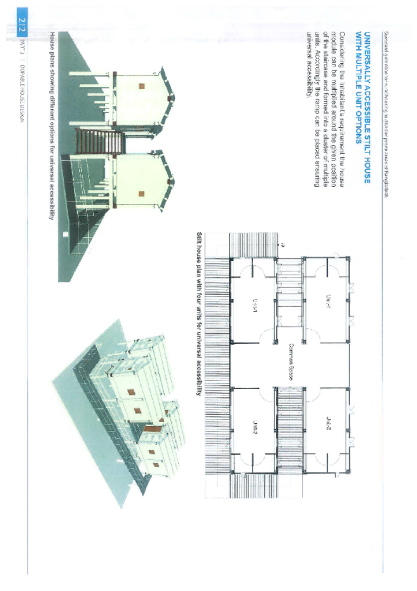

Annex B. Beneficiary selection

During project design, participatory exercises were conducted by UNDP to identify locations and beneficiaries for the implementation of project interventions. These interventions include: i) climate-resilient housing; ii) livelihood support; iii) drinking water solutions; iv) lighting solutions; and v) capacity-building. This process of identification accounted for current and future investments in climate resilience from the government and other development players, such as NGOs, so that duplication is avoided. The housing solutions will only be provided to households – and especially women-headed households – who are extremely vulnerable to climate change impacts because of their location and poor infrastructure. The livelihood solutions will be made available to those who are engaged in poorly adapted livelihoods, and that require support to shift towards climate-resilient livelihoods. The plinth-raise of cluster houses or mini-disaster houses will be provided where land is available for construction and where cyclone shelters are far away or unreachable. Successful resilience practices will be distributed as widely as possible through including all people in the targeted islands.

During the first phase of implementation, the final selection of beneficiaries will be based on the intersectional vulnerability of households, including prioritisation of: i) female-headed households; ii) households where an adolescent girl is solely responsible for household income; ii) households with indigenous people; and iii) households with people with disabilities. In addition, the selection will proportionally reflect the percentage of ethnic and religious minority households, to ensure that those with additional barriers to accessing resources are not further marginalised.

The final selection will prioritise the following beneficiaries:
- Gender: female-headed households (including those widowed, divorced or separated/abandoned).
- Age: for livelihoods, women between 18-49; for other support, households with children and the elderly.
- Income: households with income of less than US$1.25 per person per day.
- Household Status:
  - Women and girl beneficiaries from households where there are no able male members to earn livelihoods.
  - Women from households where there are a greater number of dependent members on the women (household members chronically ill; physically, mentally and/or visually impaired or disabled).
  - Indigenous (“Adivasi”) households.
- Land: for agricultural livelihoods, households that possess less than 30 decimals (1,214 m²) of previously usable agricultural land and possess less than 50 decimals (2,023 m²) of land in total. For housing support, priority will be given to people living on land exposed to extreme climatic events, people with only homestead land and landless people who arrange public land through official/customary process.
- Other requirements to assess eligibility:
  - Hindu minority households will be represented in proportion to their overall population in the wards.
  - The beneficiary cannot have been a recipient of GoB’s or any NGO’s schemes of similar nature and/or quantity of support within the last two years.

Annex C. Stakeholder consultations and inception workshop
Part A – Inception workshop

Inception Workshop: Developing a bankable project proposal on Adaptation Initiative for Climate Vulnerable Offshore Small Island and Char Land in Bangladesh
Date: 19 December 2016
Time: 06:00 PM to 8:00 PM
Venue: BRAC Inn, BRAC Centre, Mohakhali, Dhaka-1212

PARTICIPANTS

Sl No. | Name | Designation | Organization
1 | Nurul Quadir | Additional Secretary | MoEF
2 | Mirza Shawkat Ali | Director, Climate Change and International Convention | DoE
3 | Md. Ziaul Haque | Director | DoE
4 | Arif M Faisal | Programme Specialist | UNDP
5 | Dr. Ainun Nishat | Professor Emeritus and Advisor | C3ER
6 | Andrew Jenkins | Co-ordinator, RED | Consultant, C3ER
7 | Md Aminul Islam | Economist | Consultant, C3ER
8 | Md Zainul Abedin | Participatory Irr. Management Specialist | Consultant, C3ER
9 | Md Hasan Zubair | Water Resources and Institutional Expert | Consultant, C3ER
10 | Dr Nepal Chandra Dey | Senior Research Fellow | Consultant, C3ER
11 | Dr Sajidur Rahman | Assistant Professor | C3ER
12 | Roufa Khanum | Coordinator (Operations) | C3ER
13 | Ibrat Sharif | Research Associate | C3ER
14 | Nureen Faiza Anisha | Research Associate | C3ER
15 | Hasnaeen Zakir | Research Assistant | C3ER
16 | Mahjabeen Rahman | Research Assistant | C3ER
17 | Saw. Mu. Shamoel Haque | Research Assistant | C3ER
18 | Md Hafizul Hossain | DCO | C3ER

AGENDA
Agenda 1: Discussion on pre-concept note and result framework
Agenda 2: Discussion on validation of proposed components
Agenda 3: Dissemination of the Field Findings and completed activities
Agenda 4: Miscellaneous

Dr. Ainun Nishat welcomed all the members and initiated the discussion by a presentation on the concept of the project which included the selection of the chars, study area, field investigation, problems and proposed solutions (specific propositions) and template of the full proposal. After the presentation, there was an open discussion moderated by Dr. Nishat on various aspects of the project. The following reviews came up –

Mr. Nurul Quadir, Additional Secretary, MoEF:
He placed a query about implementing the body of the project. He also proposed that there should be an inter-ministerial meeting which may involve resource persons from different divisions. He thought that the concept of a floating house might not be well accepted in the context of Bangladesh and suggested that Killa could be a better idea.

Mr. Arif M Faisal, Programme Specialist, UNDP:
He maintained that it was decided upon the initial discussion that MoEF and DoE shall do the project implementation. He thought cleaner technologies like a non-fire brick, sunburnt brick, and green brick could be explored to build infrastructures like cyclone shelters or killas. He brought the example of floating houses in the Mekong delta, especially in Thailand and mentioned that floating houses could be introduced in Bangladesh, but the socio-economic acceptance of the intervention could be further explored. Also, he mentioned that the quantification of project components needs to be included in the resulting framework.

Mr. Mirza Shawkat Ali, Director, Climate Change and International Convention, DoE:
Mr. Ali thought that the implementation arrangement needs to be reorganized. He also thought that the proposal is too ambitious and the project is too diversified. Rather it could be much more focused and pinpointed towards the particularities of the proposition. He added that proposed housing options should be aligned with regional characteristics.

Mr. Md Zainul Abedin, Participatory Irr. Management Specialist, SMSP, BWDB-ADB:
According to Mr. Abedin, Union Parishad or LGED, any of the two could be a potential implementing body.
Mr. Mirza Shawkat Ali added to that asserting that in CDMP, TNO and UNO played a significant role in implementing and similar could be done here too.

Overall, the fund flow mechanism was discussed and according to the discussion, it requires more clarity in the proposal. Mr. Mirza Shawkat Ali added that as interventions, small embankments and road networks could be built. Mr. Arif Faisal said that innovative and feasible interventions with high impact need to be introduced and as an example, he mentioned about nano-grid and peer to peer technology. He also maintained that funding could be increased to US$15 Million and if partial financing can be managed from government's end, it would add to the advantage. But that shall require discussion with the government. About this issue, Mr. Mirza Shawkat Ali thought that although co-finance with the government could be an option, it is not necessary to obtain adaptation fund.
The idea of Compact Housing / Cluster housing came in the discussion where Mr. Hasan Zubair mentioned his experience in CDSP. CDSP tried introducing compact housing in its early phases but was not accepted by the communities and hence was excluded in the latest phase of CDSP. Nonetheless, here, this concept could be included and turned into a model -based option. Killa based sanitation option, space for livestock and pond was discussed. Also, capacity building of local people, dissemination of climate information and knowledge was thought to be an important component. In all the cases, stakeholder validation is required.

Summary/Decisions of the meeting:
- DoE shall organize a stakeholder validation meeting with the relevant ministries and resource persons from different divisions.
- Institution wise implementation issues need to be explored based on their experiences during CDSP, CDMP and similar projects.
- A steering committee meeting would take place headed by the secretary of MoEF
- The project shall be scaled down to do fewer innovative and high impact focused activities
- The options for earthen, timber, non-fire brick, sunburnt brick structures could be explored
- Afforestation could be kept as an optional activity
- The proposed project needs to be linked with National (e.g. 7th Five Year Plan) and Global (e.g. Sustainable Development Goal) policies
- The fund can be increased to US$ 15 Million
- It could be explored if MoEF can co-finance the project
- Options for cluster village and the compact village could be explored
- The feasibility of a floating house in the context of Bangladesh was questioned. Rather it was suggested that the activity window needs to scale down and focus on adding sanitation options.
- The idea if Killa was appreciated
- Result framework needs to quantify the specifications and baseline and indicators need to be elaborated.

Part B – Community consultations

Bhola
Date of visit: 23/11/2017
The team visited ward no 1, 2, 3, 4 and 9 of the Mujibnagar union. The following stakeholders were interviewed:
- Ward member of each ward (IDI)
- Agricultural officer (KII)
- BWDB Engineer (KII)
- Teacher (FGD)
- Religious leader, Imam (KII)
- Community people (FGD)
- Students (KII)
- Female representative (KII)
- UNO
- Shomaj Kollyan Officer (Social Welfare Officer) (KII)
Table 1 Bhola Field Visit: List of Audio/Visual Data Records for Transcription.
SI. No. | Type | Interviewer | Subject
1 | IDI | Mim | Development Deficit (Shankardah)
2 | IDI | Mim and Roaksana Nigar | Development Deficit and L&D (Niphamari)
3 | FGD | Roufa Khanom | Resource Mapping, Shankardah
4 | FGD | Roufa Khanom | Resource Mapping, Joyramojha
5 | KII | Mim and Aziz | Bablu Miah, (member)Joyramo jha
6 | FGD | Roufa Khanom | Resource Mapping, Shankardah
7 | FGD | Roufa Khanom | Resource Mapping, Joyramojha
8 | IDI | Mim and Aziz | Development Deficit (Joyramojha)
9 | IDI | Ibrat Sharif | Member (Loss and Damage, Joyramojha)
10 | IDI | Ibrat Sharif | Development Deficit and Resource Mapping (Joyramojha)
11 | IDI | Aziz | Elderly Resident Joyramojha (Life History)
12 | IDI | Aziz | Aziz (Farmer and Irrigation Supplier, Chollishal)
13 | IDI | Ibrat Sharif and Pantho | Fazlul Haque (Agriculture)
14 | IDI | Mim and Aziz | Sabina (Education, Health, Women)
15 | GD | Mim | Women (Chollishal)
16 | IDI | Ibrat Sharif | Mokhtarem (Agriculture, Health)
17 | IDI | Mim | Development Deficit (Chollishal)
18 | KII | Roufa Khanom | Health Issues with Women
19 | IDI | Mim | Member; Gender Issues, Religion, Overall Prospects of Area (Shankardah)
20 | IDI | Roaksana Nigar | Abdul Matin; Gender Issues, Religion, Overall Prospects of Area
21 | IDI | Roaksana Nigar and Pantho | Laili (Life History Analysis, Chollishal)
22 | FGD | Roaksana Nigar and Pantho | Water and Sanitation, Chollishal
23 | IDI | Sa’ad and Pantho | Mozammel (Riverbank Dweller and Stone Extraction day labourer)
24 | KII | Dr. Sajid | Agriculture Officer
25 | KII | Nandan Mukherjee | PIO of Upazila
26 | KII | Dr. Sajid | AC, Land
27 | KII | Dr. Sajid | Public Health
28 | FGD | Nandan Mukherjee | (Shankardah, Ward no.1, union: Laxmitary)
29 | FGD | Dr. Sajid | Seasonal Calendar + Agricultural Production loss (Joyramojha)
30 | IDI | Nandan Mukherjee | School Boy (Chollishal)
31 | IDI | Dr. Sajid | Mujibnagar Union Chairman
32 | FGD | Ibrat Sharif | Women, Agriculture and Health (Shankardah)
33 | FGD | Ibrat Sharif and Pantho | Health and Agriculture (Joyramojha)

Rangpur
Date of visit: 6/12/2017
The following Stakeholders were interviewed:
- Abashan Project (FGD, KII, IDI)
- Chairman, Gangachara Upazila (KII)
- Ward member (KII)
- Community People (2 FGD at two wards)
- BWDB Engineer (KII)
- Agriculture officer (KII)
- UNO
- Assistant Commissioner, Land
- Elderly group (FGD)
- Disaster Preparedness Officer

Table 2 Rangpur Field Visit: List of Audio/Visual Data Records for Transcription.
SI. No. | Type | Interviewer | Subject
1 | IDI | Sa’ad and Pantho | Elderly Resident Joyramojha (Life History)
2 | IDI | Sa’ad and Pantho | Sadiqul (Flood Affected Farmer)
3 | IDI | Sa’ad and Pantho | Rahima (Lost Child to Flood)
4 | IDI | Aziz | Aziz(Farmer and Irrigation Supplier, Chollishal)
5 | FGD | Sa’ad | Water and Sanitation, Chollishal
6 | IDI | Sa’ad and Pantho | Mozammel (Riverbank Dweller and Stone Extraction day laborer)
7 | KII | Dr. Sajid | Agricuture Officer
8 | KII | Dr. Sajid | PIO of Upazila
9 | KII | Dr. Sajid | AC, Land
10 | KII | Dr. Sajid | Public Health
11 | FGD | Nandan Mukherjee | (Shankardah, Ward no.1, union: Laxmitary)
12 | FGD | Nandan Mukherjee | Seasonal Calendar + Agricultural Production loss (Joyramojha)
13 | IDI | Nandan Mukherjee | School Boy (Chollishal)
14 | IDI | Nandan Mukherjee | Laxmitary Union Chairman
15 | FGD | Ibrat Sharif | Women, Agriculture and Health (Shankardah)
16 | FGD | Ibrat Sharif and Pantho | Health and Agriculture (Joyramojha)
17 | IDI | Ibrat Sharif and Pantho | Fazlul Haque (Agriculture)
18 | IDI | Ibrat Sharif | Sabina (Education, Health, Women)
19 | GD | Ibrat Sharif | Women (Chollishal)
20 | IDI | Ibrat Sharif | Mokhtarem (Agriculture, Health)
21 | IDI | Mim | Development Deficit (Chollishal)
22 | IDI | Mim | Development Deficit (Joyramojha)
23 | IDI | Mim | Member (Loss and Damage, Joyramojha)
24 | IDI | Mim | Development Deficit and Resource Mapping (Joyramojha)
25 | IDI | Mim | Development Deficit (Shankardah)
26 | IDI | Mim and Roaksana Nigar | Development Deficit and L&D (Niphamari)
27 | FGD | Roufa Khanom | Resource Mapping, Shankardah
28 | FGD | Roufa Khanom | Resource Mapping, Joyramojha
29 | KII | Roufa Khanom | Bablu Miah, (member) Joyramo jha
30 | KII | Roufa Khanom | Health Issues with Women
31 | IDI | Roaksana Nigar | Member; Gender Issues, Religion, Overall Prospects of Area (Shankardah)
32 | IDI | Roaksana Nigar | Abdul Matin; Gender Issues, Religion, Overall Prospects of Area
33 | IDI | Roaksana Nigar and Pantho | Laili (Life History Analysis, Chollishal)

Summary of Validation Workshop on ‘Adaptation Initiative for Climate Vulnerable Coastal and Riverine Small Islands in Bangladesh’
Date: 24 December 2018
Venue: Conference Room, Ministry of Environment, Forest and Climate Change, Bangladesh Secretariat, Dhaka
Chaired by: Mr. Abdullah Al Mohsin Chowdhury, Secretary, MoEFCC
Moderated by: Dr. SM Munjurul Hannan Khan, Additional Secretary, MoEFCC
Introduction
A validation workshop was held at the conference room of the Ministry of Environment, Forest and Climate Change (MoEFCC) on 24 December 2018 regarding the finalization and validation of project proposal titled “Adaptation Initiative for Climate Vulnerable Coastal and Riverine Small Islands in Bangladesh’.” Mr. Abdullah Al Mohsin Chowdhury, Secretary, MoEFCC presided over while Dr. S M Munjurul Hannan Khan, Additional Secretary, MoEFCC moderated the workshop. Among others Dr. Nurul Quadir, Additional Secretary (Climate Change), MoEFCC and Dr. Sultan Ahmed, Director General, Department of Environment was also present. A total of 30 representatives from the relevant ministries, line agencies, experts, NGOs, private sectors and relevant officials of the MoEFCC, DoE, UNDP Bangladesh, Centre for Climate Change and Environmental Research(C3ER) attended the workshop. List of Participants, programme schedule and presentation of proposal are attached in Annexes 1, 2 and 3 respectively.
Presentation of Project Proposal and Key Discussion
Dr. SM Munjurul Hannan Khan, Additional Secretary, MoEFCC welcomed participants and briefly discussed about the purpose and outcome of the validation workshop. He then requested Mr. Khurshid Alam, Assistant Resident Representative, UNDP Bangladesh to discuss about the project formulation process. Mr. Alam briefly discussed about chronology for formulation of the project. He also discussed about the consultation process and other meetings that were conducted during preparation of the project. He emphasized on the rationale of implementation of the project in offshore small riverine and coastal islands where development intervention is very limited, climate risks and vulnerability are high and communities coping capacity is too limited.
At this stage of the workshop the Chair requested Dr. Ainun Nishat, Executive Director of C3ER, BRAC University to present the project proposal. Dr. Nishat discussed about the background, rationale, major components, outcome, breakdown of budget and implementation arrangement of the project. He mentioned that this project is very timely since small islands are located in very remote areas where development support rarely reached. Moreover, islands community are most climate vulnerable among all communities in Bangladesh. He mentioned urgent and immediate action is required to improve coping capacity of islands communities since frequency of cyclone and storm surge is increasing in these islands. He added that project site was selected with rigorous selection criteria using GIS maps and comprehensive consultation with stakeholders and discussion with local Government representatives. No one influenced the selection of the two project sites-he added. He also discussed about results framework and resource requirement for accomplishment of proposed project activities. As capacity of the community is low, a capacity building and knowledge management framework is included, which is also mandatory requirement for Adaptation Fund Board (AFB). Presentation by Dr. Nishat is attached in Annex 3.
Mr. Arif M. Faisal, Programme Specialist from UNDP supplemented on implementation arrangements and requirement of other due diligence process for Adaptation Fund. He also discussed about the basic principles and requirements of Adaptation Fund. Mr. Faisal also mentioned that relevant line agencies, local Govt institutes, NGOs and private sector will be engaged to implement major interventions of the project. These agencies are Bangladesh Water Development Board for repair and maintenance of embankments, Department of Agriculture Extension (DAE) for promoting climate resilient agriculture and livelihoods, Cyclone Preparedness Programme (CPP) for providing preparedness tools and packages for early warning and climate information/services, Local Government Engineering Department and NGO/private sector for construction of climate resilient housing, Infrastructure Development Company Limited (IDCOL) or private company for setup of nano-grid and solar irrigation pumps, local Govt institutes for capacity building and research agencies/university for knowledge management. The MoEFCC will coordinate overall implementation.
Dr. Nurul Quadir, Additional Secretary (climate change), MoEFCC and Mr. Mirza Shawkat Ali, Director, DoE and member of AFB also discussed about the principles for funding mechanism and shared experience of international negotiation process. Mr. Mirza mentioned that Bangladesh never applied for accessing AF resources before and there are dedicated resources for each country and he urged to submit the proposal urgently to the AF by 7 January 2019 so that it can be considered for during the 33rd board meeting, which is scheduled to be held from 12-15 March 2019. He further mentioned many minor issues can be resolved even after submission of the project proposal to AF, which could be addressed along with the queries of adaptation fund. He requested the chair to consider submitting the proposal by 7th January, since proposal need to be submitted 9 weeks before the Adaptation Fund Board meeting. Dr. Quadir suggested excluding co-finance since it is not required as per funding requirement of accessing AF. He expressed that if we include co-finance it may become precedence for other poor and developing nations.
Feedback and suggestion from participants
- The proposed project should highlight some uniqueness and innovative actions on adaptation. This may be some innovation in design of houses, ecosystem-based adaptation or even innovative approach for capacity building.
- The proposed project may also consider the design of the climate resilient housing of Climate Technology Centre and Network (CTCN) Technical Assistance Project, which is designed by Green Technology Centre, Korea, with the technical support of Korean Institute of Civil Engineering and Building Technology (KICT).
- Capacity of Local Government Institution (LGI) on climate change and enhance resilience capacity at the location level to be strengthened towards implementation and monitoring of the Project activities.
- Budget to be increased for local level monitoring and evaluation of project implementation through enhancing capacity of LGI.
- Consultation with following relevant ministries and line agencies are required to get their endorsement for involvement in the project. These include 1) Department of Agriculture Extension under Ministry of Agriculture, 2) Bangladesh Water Development Board under Ministry of Water Resources, 3) Cyclone Preparedness Programme under Ministry of Disaster Management & Relief, 4) Department of Fisheries under Ministry of Fisheries and Livestock, 5) Sustainable Renewable Energy Development Authority under Ministry of Power, Energy and Mineral Resources, 6) Bangladesh Forest Department under MoEFCC, etc. However, implementation arrangement should be kept flexible to keep the available options within wide scope of engagement. Moreover, engaging LGI, NGOs, private firm, university can also be considered to keep the implementation and procurement flexible. However, activity-specific relevant implementing partner agency should be clearly specified in the TAPP and Project Document.
- The results framework of the project should clearly specify baseline and indicators and numbers of beneficiaries/household to be involved in each activity. Project Document needs to clearly specify all the activities along with the organizations responsibilities – who is responsible for what, who to do what, etc.
- Capacity building of local carpenters, masons, electricians on climate resilient construction skills will be one of the priority activities.
- Composition of the Project Steering Committee need further revision and should be written with detail explanation. Project board and senior supplier should be removed and include other relevant agencies like IMED, local Govt. representative (e.g. UNO, DC, etc.)
- There should be official agreement with the proposed implementation agencies which will be confirmed after endorsement of the project by AFB and this implementation arrangement will be clearly mentioned in the Project Document and TAPP.
- NGOs can be engaged in livelihood development and private firm/company can be engaged in installation of solar nano-grid & solar irrigation pumps while technical and other advisory support relating to specific livelihood options and energy options can be sought from relevant government departments (e.g. DAE, DoE, FD, SREDA, etc.)
- Ownership of Project benefits should lie with general people. So, capacity building of local beneficiaries on management of the Project on a sustainable basis (exit strategy) is important.
- Farmers, Fishers and other resource users should get important attention as those are the major livelihoods of island community.
- After endorsement of project by AFB, TAPP should highlight clearly the baseline situation and expected results both in quantitative and qualitative terms.
- To avoid the duplication, any kind of overlap with other Projects to be avoided (CDLP, CDSP IV, PROVATI, SUFAL, etc. However, it was agreed that the Project will adopt any possible lessons from other ongoing Projects.
- Soon after endorsement of the project by AFB, MoEF and UNDP will organize a meeting with the head of other implementing partners to get their official endorsement on their engagement and implementation arrangement in the project.
- There should be provision of local Monitoring Officer and site Engineer position in the PMU.
- The MoEFCC will be the chair while all other implementing agencies will be members of the Steering Committee.
- It is agreed that UNDP will prepare detailed terms of reference of all PMU staff and in consultation with the executing agency recruit them. However, ToR needs to be endorsed by MoEFCC
- The guideline shared in the recent CBD CoP on Ecosystem based adaptation and Ecosystem based disaster risk reduction need to be reviewed to examine the appropriateness of the approach of this Project.
- With respect to cash transfer provision for the beneficiaries, it was agreed that farmers and fisherman need some assistance from the project in terms of kind and cash to implement the knowledge they gather from different trainings. So, the beneficiaries of the Project will receive only US $ 325/ to spend for agricultural equipment and/or seeds, fishing nets, boats, etc.
- The workshop suggested including flash flood and riverbank erosion along with salinity intrusion, cyclone and SLR.
- Some participants suggested including all activities in 8 islands. However, MoEFCC opined that proposed two islands is adequate to include all project activities to show better impacts. They opined that instead of implementing proposed intervention in all 8 islands, the existing activity in selected two islands and expanding CPP in 6 additional islands will show better results. However, they proposed that it can be considered to increase number of islands and co-financing may be ensured after endorsement of the project by AFB.
- A committee headed by the Director General, Department of Environment shall be constitute to select NGOs/Firms/private Companies to execute livelihood support to local communities. The committee shall advice UNDP for engagement of such NGOs/firm/company for implementing particular activities following proper procurement process.
Decision
- MoEFCC will circulate meeting minutes to the relevant stakeholders by 27 December 2018. This urgency is to keep pace with the deadlines of the AFB.
- Composition of the Project Steering Committee will be revised. Project board and senior supplier will be removed. Project steering committee will be headed by Secretary and Project implementation committee would be headed by Director General, Department of Environment.
- The proposed project will be implemented by the Ministry of Environment, Forest and climate change, while Department of Environment will execute the project.
- The project implementation will follow the National Execution (NEX) Modalities.
- A committee shall be constituted for the selection of NGOs/local firms/private companies to execute particular activities at the local level following proper procurement process.
- The MoEFCC endorsed this project proposal in principle and agreed for submission of Project Proposal to the AFB by 7 January 2019 with incorporation of suggested revision provided in the validation workshop. However, detail implementation modality with implementing partner’s endorsement will be provided in the TAPP and Project Document after endorsement of the proposal by AFB.
- UNDP will submit final project proposal to MoEFCC by 3 January 2019.
- MoEFCC as the Designated Authority of Adaptation Fund in Bangladesh shall issue a Letter of Endorsement (LoE) to facilitate the formal submission of the proposed project to AF by 7 January 2019.

Lists of participants (not according to seniority)
- Mr. Abdullah Al Mohsin Chowdhury, Secretary, Ministry of Environment, Forests and Climate Change, Bangladesh Secretariat, Dhaka.
- Dr. SM. Munjurul H Khan, Additional Secretary (environment), Ministry of Environment, Forests and Climate Change, Bangladesh Secretariat, Dhaka.
- Dr. Nurul Quadir, Additional Secretary (Climate change), Ministry of Environment, Forests and Climate Change, Bangladesh Secretariat, Dhaka.
- Dr. Sultan Ahmed, Director General, Department of Environment, Agargaon, Dhaka
- Representative, Department of Disaster Management, Mohakhali, Dhaka
- Mr. Mirza Shawkat Ali, Director (Climate Change), Department of Environment, Agargaon, Dhaka
- Mr. Md. Ziaul Haque, Director, Director (Air Quality)), Department of Environment, Agargaon, Dhaka
- Mr. Mohammed Solaiman Haider, Director (Planning), Department of Environment, Agargaon, Dhaka
- Mr. Shamsur Rahman Khan, Deputy Secretary, Ministry of Environment, Forests and Climate Change, Bangladesh Secretariat, Dhaka.
- Dr. ANM Abdullah, Deputy Secretary, Ministry of Environment, Forests and Climate Change, Bangladesh Secretariat, Dhaka.
- Ms. Farjana Jahan, Senior Assistant Chief, Ministry of Environment, Forests and Climate Change, Bangladesh Secretariat, Dhaka.
- Dr. Md. Saifur Rahman, Senior Assistant Chief, Ministry of Environment, Forests and Climate Change, Bangladesh Secretariat, Dhaka
- Mr. SM Tariq, Deputy Secretary, Ministry of Fisheries and Livestock, Bangladesh Secretariat, Dhaka
- Mr. SM Imrul Hasan, Senior Assistant Chief, Ministry of Agriculture, Bangladesh Secretariat, Dhaka.
- Mr. Farid Uddin Ahmed, Executive Director, Arannayk Foundation, House# 21, Western Road, DOHS, Banani. Dhaka - 1206
- Dr. Ainun Nishat, Emeritus Professor, BRAC University, Mohakhali, Dhaka.
- Ms. Taniska Mum Tahina Billah, Management Trainee for GCF, Infrastructure Development Company Limited (IDCOL), UTC Building, 16th Floor, 8 Panthapath, Kawran Bazar, Dhaka.
- Md. Shafiqur Reza Biswas, Joint Secretary, Bangladesh Climate Change Trust, Mohakhali, Dhaka
- Dr. Mohammad Zahirul Hoque, ACCF, Bangladesh Forest Department, Agargaon, Dhaka
- Mr. Md Zafor Ullah Khan, Member, SPARRSO, Agargaon, Dhaka
- Mr. Md SK Farid, Deputy Director, Department of Agriculture Extension, Khamar Bari, Dhaka
- Ms. Sabrina Jahan, Research Assistant, IUCN, House B-138 (Level 5 & 6), Road 22, Mohakhali DOHS, Dhaka 1206
- Ms. Badrun Nahar, Director, WARPO, Green Road, Dhaka
- Mr. Md. Ali Akhter Hossain, SE(Planning), LGED, Dhaka
- Mr. Mohammad Rezaul Karim, Project Director, CDSP-IV, LGED, Agargaon, Dhaka
- Mr. Aminul Ishat, Programme Manager, BRAC, Mohakhali, Dhaka
- Mr. Khurshid Alam, Assistant Resident Representative, UNDP, IDB Bhaban, Agargaon, Dhaka
- Mr. Arif Mohammad Faisal, Programme Specialist (Environment Sustainability & Energy), UNDP, IDB Bhaban, Agargaon, Dhaka
- Dr. Rokeya Khatun, National Consultant, UNDP, Dhaka.
- Mr. Forhad Alam, Administrative Assistant, UNDP, IDB Bhaban, Agargaon, Dhaka
- Ms. Rumana Ferdous, Intern, UNDP, IDB Bhaban, Agargaon, Dhaka

Program Schedule
Time | Activity | Responsible Facilitator/Resource Person
01:00–1:30 | Registration and lunch | MoEFCC and UNDP
01:30–01.40 | Welcome address | Mr. Khurshid Alam, Assistant Country Director, UNDP
01.40–02.10 | Presentation on the project | Dr. Ainun Nishat, Professor Emeritus, BRAC University
02.10–03.30 | Open discussion: Stakeholder’s opinion on project proposal | Moderated by Dr. Munjurul Hannan Khan, Additional Secretary, MoEFCC
03.30-03.40 | Special remarks | Dr. Nurul Quadir, Additional Secretary (climate change), MoEFCC
03.40-03.50 | Special remarks | Dr. Sultan Ahmed, Director, DoE
 | Special remarks | Mr. Mirza Shawkat, Director, DoE
03:50–04:00 | Closing Remarks by the Chair | Mr. Abdullah Al Mohsin Chowdhury, Secretary, MoEFCC
04:00–04:10 | Vote of Thanks | Mr. Shamshur Rahman Khan Deputy Secretary, MoEFCC

Annex D. Social and Environmental Screening

The completed template, which constitutes the Social and Environmental Screening Report, must be included as an annex to the Project Document. Please refer to the Social and Environmental Screening Procedure and Toolkit for guidance on how to answer the 6 questions.
Project Information
Project Information
- Project Title | Adaptation Initiative for Climate Vulnerable Offshore Small Islands and Riverine Charland in Bangladesh
- Project Number | N/A
- Location (Global/Region/Country) | Bangladesh

Part A. Integrating Overarching Principles to Strengthen Social and Environmental Sustainability
QUESTION 1: How Does the Project Integrate the Overarching Principles in order to Strengthen Social and Environmental Sustainability?
Briefly describe in the space below how the Project mainstreams the human-rights-based approach

The project has a specific human rights approach to improve the adaptive capacity of the most vulnerable community members in two chars in rural Bangladesh and will focus on the most vulnerable socio-economic groups, i.e., women and the landless belonging to extremely poor households. It will improve the climate resilience and adaptive capacity of ~32,000 vulnerable char dwellers by improving their housing and provisioning them with clean water and electricity. The project will also support the improvement of agricultural livelihoods and the development of new climate resilient livelihood options. The majority of alternative livelihood support will be focused towards women, which will empower women, who, among other members of the rural Bangladesh society, are most susceptible to human rights violation in different spheres of their lives.

Through this approach, the project adopts the principle of positive discrimination and includes specifically the most discriminated, marginalized and the poorest people in the communities. Therefore, both in principle and in practical terms, human rights violation by the project are not possible. On the contrary, by including all of the most disadvantaged people in the community-based activities, they will be provided with an opportunity to assert their socio-political and economic rights.

Although, there are existing human rights issues in the project areas (e.g., discrimination against women), the project itself will not result in any violation of human rights. Instead, it is committed to addressing human rights violations as much as possible. The process of fostering gender equality and empowerment of women is expected to reduce the occurrence of the most common human rights violations in the area (i.e. violence against women). A grievance redress mechanism has also been developed for the project and is included in the Environmental and Social Management Plan prepared as part of the project (see Annex 5).
Briefly describe in the space below how the Project is likely to improve gender equality and women’s empowerment

This project incorporates gender considerations into all interventions, including for all training, support and awareness raising activities. Although the primary focus of the project is on households that have the greatest vulnerability, the position of women in Bangladesh – especially in relation to climate change impacts – makes them the most likely beneficiaries of the project interventions. The project interventions that focus on improving resilient infrastructure will benefit women in particular, as the twenty cluster houses will have women-led households as the prioritised beneficiaries. The use of these houses as shelters during cyclones and floods will also empower women, by positioning the owners of the cluster houses (i.e. women) as the authority governing these shelters for the duration of the cyclone or flood. This will also ensure that other women and girls are provided with safe shelters. The project will also focus on developing the livelihoods of the local communities, by improving agricultural knowledge and techniques and developing new alternative livelihood options. The development of alternative livelihoods (which will prioritise female beneficiaries) will empower women by providing them with the training and materials they require to become self-sufficient if they choose to. By improving the economic productivity and self-sufficiency of women through this activity, the project will support a shift towards greater empowerment of women. To support gender equality, the training and awareness-raising activities held at the knowledge and innovation centres will include a minimum of 50% female representation and will incorporate gender sensitivity training. This will include the training for the farmer field schools, community training for embankment management and community training for the maintenance of newly constructed infrastructure (i.e. nano-grids and rainwater harvesting systems).
Briefly describe in the space below how the Project mainstreams environmental sustainability
The project focuses on improving the social condition of the target populations, however, environmental sustainability is an important aspect of this. Environmental sustainability will be promoted by the project in a number of ways. Firstly, the project will generate environmental co-benefits through the establishment of solar energy for at least 600 houses. This will provide clean energy to the local communities, reducing the dependence on fuelwood or fossil fuels and avoiding the associated GHG emissions. The implementation of solar energy will also serve as a model for other rural areas of Bangladesh, thereby mainstreaming decentralised renewable energy solutions. Secondly, the project will incorporate environmental awareness-raising campaigns for local schools and communities. This will improve local understanding of climate change, but also of the importance of environmental sustainability and maintaining functional ecosystems. Thirdly, Ecosystem-based Adaptation measures, such as planting grass and mangrove trees, will be used to strengthen embankments and eroding riverbanks. This will provide biodiversity co-benefits that would not result from regular embankment construction, as well as providing some mitigation co-benefits through carbon sequestration by trees and mangroves in particular.
Part B. Identifying and Managing Social and Environmental Risks
QUESTION 2: What are the Potential Social and Environmental Risks?  Note: Describe briefly potential social and environmental risks identified in Attachment 1 – Risk Screening Checklist (based on any “Yes” responses). If no risks have been identified in Attachment 1 then note “No Risks Identified” and skip to Question 4 and Select “Low Risk”. Questions 5 and 6 not required for Low-Risk Projects. | QUESTION 3: What is the level of significance of the potential social and environmental risks?  Note: Respond to Questions 4 and 5 below before proceeding to Question 6 |  |  |  | QUESTION 6: What social and environmental assessment and management measures have been conducted and/or are required to address potential risks (for Risks with Moderate and High Significance)?
Risk Description | Impact and Probability (1-5) | Significance  (Low, Moderate, High) | Comments |  | Description of assessment and management measures as reflected in the Project design. If ESIA or SESA is required note that the assessment should consider all potential impacts and risks.
Risk 1: Plinths for retrofitted houses | I = 1  P = 1 | Low | The plinths raised for retrofitting houses may shift or subside during high water events. This may cause the plinths to sink during floods or to become unstable once waters have receded. |  | The plinths will be designed, raised and compacted according to design specifications and best practices (see Annex A) to ensure that collapses will not occur during flood events. Community members who are trained to assist with retrofitting will also receive training to conduct periodic assessments on the structural stability of the plinths.
Risk 2: Construction sites could pose a risk to community members | I = 1  P = 1 | Low | Certain project interventions will involve small earthworks, i.e. to raise plinths, to do excavations for repairing the embankments and constructing the cluster houses. Excess sediment may pose a risk post construction. The earthworks and construction sites for the cluster houses may also be hazardous during the night or other low visibility periods. |  | All construction activities will be conducted under the oversight of experienced professionals who will also train local staff on best construction practices. To ensure that sediment is not mobilised through current movement that will result in an impact, all excess sediment will be moved an acceptable distance from the construction site (see Annex 5). Further, any earthworks should be undertaken during the dry season and compacted sufficiently to reduce sediment movement. All construction sites will be properly demarcated to ensure that hazardous areas, such as holes, pits and exposed sharp objects do not pose a threat to nearby communities (i.e. areas will be fenced off or demarcated with reflective hazard tape)
Risk 3: Cluster houses may become structurally unsafe during extreme cyclone events | I = 3  P = 1 | Moderate | The cluster houses that function as disaster shelters could become structurally unsafe during extreme cyclone events due to the number of individuals taking shelter and the strength of the cyclone. |  | The cluster house cyclone shelters will be designed according to rigorous standards to ensure they can withstand the extreme impacts of high-powered cyclones (refer to Annex A). To reduce the risk of extensive structural damage, local community members will be trained to identify signs of structural weakening, and construction specialists will conduct periodic assessments of these structures, especially after cyclones.
Risk 4: Women could face abuse or harassment when taking shelter in the cluster houses during cyclones | I = 2  P = 1 | Low | There is a high incidence rate of women becoming the victims of harassment in cyclone shelters due to the general confusion, close proximity and lack of gendered washrooms in cyclone shelters. |  | The cluster houses that function as cyclone shelters will be designed to have separate wash facilities for women and for men. These cluster houses will also belong predominantly to women-led households, ensuring that women will, in general, hold the greatest authority over these shelters during cyclone events. The structure of the cluster houses will also ensure that if necessary there are multiple rooms where women and children could be separate from men during cyclone events.
Risk 5: The repair of embankments could be substandard leading to breaches during floods or cyclones. | I = 1  P = 1 | Low | The project will involve the repair of two embankments in the target areas. If they are not repaired according to design specifications (See Annex A) they could be breached during high water events, leading to damage to assets and livelihoods. |  | Prior to installation, a full site evaluation will be undertaken to assess each site. Appropriate measures will be taken to ensure that the repairs are conducted in line with best practice and meet the design specifications. Furthermore, the community training for embankment management will incorporate training to support community monitoring of embankment condition to support proactive embankment maintenance instead of reactive embankment repair.
Risk 6: Potential conflict regarding access to cold storage | I = 1  P = 1 | Low | As the cold storage units being established by the project will not be large enough to store the food produce of all community members it is possible that conflict over cold storage access could arise. |  | To support equal access to cold storage, the units will be located at the innovation centres at both of the target sites. Access to use the fridges will be determined through a beneficiary system based on assessed vulnerability for household-level food insecurity and need for short-term storage for crops intended for resale. The register will be managed by the project representatives at the innovation centres. Proportional access will be provided to store i) household food and ii) crops/fish intended for sale.
Risk 7: Beneficiary selection challenges | I = 1  P = 1 | Low | There is the potential for conflict to arise if community members feel that they should be prioritized for certain interventions. The beneficiary criteria will be based on vulnerability assessments, but subjective self-perceptions of vulnerability may be contradicted by the assessments. |  | The project is based on similar existing programmes currently being undertaken in Bangladesh. The project has developed a clear beneficiary selection process (Annex B) that will be communicated to target communities during the project inception. Furthermore, in the event that any community members feel they are being discriminated against, they can file a complaint through the project’s grievance redress mechanism (refer to Annex 5).
Risk 9: Interventions focusing on gender equality may cause conflict regarding traditional gender norms. | I = 1  P = 1 | Low | Interventions that focus on disaggregated gender targets and prioritise equal participation by both men and women may run counter to established gender norms. This may result in conflict between groups who have different perspectives on gendered roles and responsibilities. |  | Gender sensitivity will be incorporated into all trainings and community level interventions, including farmer field schools, innovation centre training and awareness raising campaigns. This will reduce the occurrence of any conflict arising from the difference in perspective regarding the attendance of women or men at specific trainings and the support of women for the development of livelihoods.
Risk 10: Discrimination against minority/religious/landless | I = 1  P = 1 | Low | Discrimination against minority groups is unlikely but possible as only very small numbers of minority groups are resident in the target areas, including the landless, women-led households and minority religions. |  | The selection criteria will ensure that selection is not based on any religious or other discriminatory reason but will be based solely on the vulnerability assessment and strict beneficiary selection criteria (see Annex B).
 | QUESTION 4: What is the overall Project risk categorization?
 | Select one (see SESP for guidance) |  |  |  |  | Comments
 | Low Risk |  |  | ☐
 | Moderate Risk |  |  | X |  | If the appropriate mitigation measures are put in place during the project, the project will have an extremely low environmental and social risk over the life of the project.
 | High Risk |  |  | ☐
 | QUESTION 5: Based on the identified risks and risk categorization, what requirements of the SES are relevant?
 | Check all that apply |  |  |  |  | Comments
 | Principle 1: Human Rights |  |  | ☐ |  | The project will provide support for the most vulnerable socio-economic groups, i.e., women, the elderly and the landless, especially those belonging to extremely poor households. The project adopts the principle of positive discrimination and includes specifically the most discriminated, marginalized and the poorest people in the community. Therefore, both in principle and in practical terms, the possibility of human rights violation by the project is not possible.
 | Principle 2: Gender Equality and Women’s Empowerment |  |  | X |  | In order to remove the long standing discrimination of women by the male-dominated Bangladesh society, aspects of the project are directly targeted towards women from vulnerable households. The results framework will also include disaggregated gendered results to ensure that women benefit equally from all interventions and trainings.
 | 1. Biodiversity Conservation and Natural Resource Management |  |  | X |  | The project does not have any components that will result in adverse impacts on the environment. Fish farms are, however, integrated into the community management of embankments (Output 2.2.), and fish farming will be developed in the innovation centres (Output 4.2.). These fish farms will be developed sustainably and in line with best practices for aquaculture.
 | 2. Climate Change Mitigation and Adaptation |  |  | X |  | The project interventions are designed in an integrated manner that will increase the adaptive capacity of vulnerable char communities in Bangladesh. These benefits will be geared towards assisting the most vulnerable members of the target communities. As no major infrastructure or resource utilization is included in the project interventions, there will be no large-scale emissions associated with the project. On the contrary, the establishment of solar power for 600 households will provide a small mitigation benefit in the form of reduced reliance on wood and fossil fuels.
 | 3. Community Health, Safety and Working Conditions |  |  | X |  | The project may create hazardous areas during the construction of cluster houses and the rehabilitation and repair of embankments. To mitigate this, best practice and national construction standards will be adhered to. All hazardous areas will be clearly demarcated with reflective tape and any excavations will be fenced off to protect communities in the vicinity of the construction sites. There is a further minor risk that the cluster houses, during their function as disaster shelters will be damaged during cyclones. To prevent this from occurring local community members will be trained to identify signs of structural weakening, and construction experts will conduct periodic assessments of the structures to ensure their stability.
 | 4. Cultural Heritage |  |  | ☐ |  | The project has no impact on cultural heritage.
 | 5. Displacement and Resettlement |  |  | X |  | Voluntary and temporary displacement of households is predicted to occur during the retrofitting of houses or the raising of plinths for increasing the climate resilience of houses. People who undergo voluntary and temporary resettlement, likely for only a few days, will either reside with neighbours or will be provided with local accommodation by the partner NGOs responsible for the retrofitting of the houses
 | 6. Indigenous Peoples |  |  | ☐ |  | The project has no impact on indigenous peoples.
 | 7. Pollution Prevention and Resource Efficiency |  |  | ☐ |  | The project will not result in increased pollution

Final Sign Off

Signature | Date | Description
QA Assessor |  | UNDP staff member responsible for the Project, typically a UNDP Programme Officer. Final signature confirms they have “checked” to ensure that the SESP is adequately conducted.
QA Approver |  | UNDP senior manager, typically the UNDP Deputy Country Director (DCD), Country Director (CD), Deputy Resident Representative (DRR), or Resident Representative (RR). The QA Approver cannot also be the QA Assessor. Final signature confirms they have “cleared” the SESP prior to submittal to the PAC.
PAC Chair |  | UNDP chair of the PAC. In some cases, PAC Chair may also be the QA Approver. Final signature confirms that the SESP was considered as part of the project appraisal and considered in recommendations of the PAC.

SESP Attachment 1: Social and Environmental Risk Screening Checklist

Checklist Potential Social and Environmental Risks
Principles 1: Human Rights | Answer  (Yes/No)
1. Could the Project lead to adverse impacts on enjoyment of the human rights (civil, political, economic, social or cultural) of the affected population and particularly of marginalized groups? | No
2. Is there a likelihood that the Project would have inequitable or discriminatory adverse impacts on affected populations, particularly people living in poverty or marginalized or excluded individuals or groups? | No
3. Could the Project potentially restrict availability, quality of and access to resources or basic services, in particular to marginalized individuals or groups? | No
4. Is there a likelihood that the Project would exclude any potentially affected stakeholders, in particular marginalized groups, from fully participating in decisions that may affect them? | No
5. Is there a risk that duty-bearers do not have the capacity to meet their obligations in the Project? | No
6. Is there a risk that rights-holders do not have the capacity to claim their rights? | No
7. Have local communities or individuals, given the opportunity, raised human rights concerns regarding the Project during the stakeholder engagement process? | No
8. Is there a risk that the Project would exacerbate conflicts among and/or the risk of violence to project-affected communities and individuals? | No
Principle 2: Gender Equality and Women’s Empowerment
1. Is there a likelihood that the proposed Project would have adverse impacts on gender equality and/or the situation of women and girls? | No
2. Would the Project potentially reproduce discriminations against women based on gender, especially regarding participation in design and implementation or access to opportunities and benefits? | No
3. Have women’s groups/leaders raised gender equality concerns regarding the Project during the stakeholder engagement process and has this been included in the overall Project proposal and in the risk assessment? | No
4. Would the Project potentially limit women’s ability to use, develop and protect natural resources, taking into account different roles and positions of women and men in accessing environmental goods and services? | No
Principle 3: Environmental Sustainability: Screening questions regarding environmental risks are encompassed by the specific Standard-related questions below
Standard 1: Biodiversity Conservation and Sustainable Natural Resource Management
1.1 Would the Project potentially cause adverse impacts to habitats (e.g. modified, natural, and critical habitats) and/or ecosystems and ecosystem services? | No
1.2 Are any Project activities proposed within or adjacent to critical habitats and/or environmentally sensitive areas, including legally protected areas (e.g. nature reserve, national park), areas proposed for protection, or recognized as such by authoritative sources and/or indigenous peoples or local communities? | No
1.3 Does the Project involve changes to the use of lands and resources that may have adverse impacts on habitats, ecosystems, and/or livelihoods? (Note: if restrictions and/or limitations of access to lands would apply, refer to Standard 5) | No
1.4 Would Project activities pose risks to endangered species? | No
1.5 Would the Project pose a risk of introducing invasive alien species? | No
1.6 Does the Project involve harvesting of natural forests, plantation development, or reforestation? | No
1.7 Does the Project involve the production and/or harvesting of fish populations or other aquatic species? | Yes
1.8 Does the Project involve significant extraction, diversion or containment of surface or ground water?  For example, construction of dams, reservoirs, river basin developments, groundwater extraction | No
1.9 Does the Project involve utilization of genetic resources? (e.g. collection and/or harvesting, commercial development) | No
1.10 Would the Project generate potential adverse transboundary or global environmental concerns? | No
1.11 Would the Project result in secondary or consequential development activities which could lead to adverse social and environmental effects, or would it generate cumulative impacts with other known existing or planned activities in the area?  For example, a new road through forested lands will generate direct environmental and social impacts (e.g. felling of trees, earthworks, potential relocation of inhabitants). The new road may also facilitate encroachment on lands by illegal settlers or generate unplanned commercial development along the route, potentially in sensitive areas. These are indirect, secondary, or induced impacts that need to be considered. Also, if similar developments in the same forested area are planned, then cumulative impacts of multiple activities (even if not part of the same Project) need to be considered. | No
Standard 2: Climate Change Mitigation and Adaptation
2.1 Will the proposed Project result in significant greenhouse gas emissions or may exacerbate climate change? | No
2.2 Would the potential outcomes of the Project be sensitive or vulnerable to potential impacts of climate change? | No
2.3 Is the proposed Project likely to directly or indirectly increase social and environmental vulnerability to climate change now or in the future (also known as maladaptive practices)?  For example, changes to land use planning may encourage further development of floodplains, potentially increasing the population’s vulnerability to climate change, specifically flooding | No
Standard 3: Community Health, Safety and Working Conditions
3.1 Would elements of Project construction, operation, or decommissioning pose potential safety risks to local communities? | Yes
3.2 Would the Project pose potential risks to community health and safety due to the transport, storage, and use and/or disposal of hazardous or dangerous materials (e.g. explosives, fuel and other chemicals during construction and operation)? | No
3.3 Does the Project involve large-scale infrastructure development (e.g. dams, roads, buildings)? | No
3.4 Would failure of structural elements of the Project pose risks to communities? (e.g. collapse of buildings or infrastructure) | Yes
3.5 Would the proposed Project be susceptible to or lead to increased vulnerability to earthquakes, subsidence, landslides, erosion, flooding or extreme climatic conditions? | No
3.6 Would the Project result in potential increased health risks (e.g. from water-borne or other vector-borne diseases or communicable infections such as HIV/AIDS)? | No
3.7 Does the Project pose potential risks and vulnerabilities related to occupational health and safety due to physical, chemical, biological, and radiological hazards during Project construction, operation, or decommissioning? | No
3.8 Does the Project involve support for employment or livelihoods that may fail to comply with national and international labor standards (i.e. principles and standards of ILO fundamental conventions)? | No
3.9 Does the Project engage security personnel that may pose a potential risk to health and safety of communities and/or individuals (e.g. due to a lack of adequate training or accountability)? | No
Standard 4: Cultural Heritage
4.1 Will the proposed Project result in interventions that would potentially adversely impact sites, structures, or objects with historical, cultural, artistic, traditional or religious values or intangible forms of culture (e.g. knowledge, innovations, practices)? (Note: Projects intended to protect, and conserve Cultural Heritage may also have inadvertent adverse impacts) | No
4.2 Does the Project propose utilizing tangible and/or intangible forms of cultural heritage for commercial or other purposes? | No
Standard 5: Displacement and Resettlement
5.1 Would the Project potentially involve temporary or permanent and full or partial physical displacement? | Yes
5.2 Would the Project possibly result in economic displacement (e.g. loss of assets or access to resources due to land acquisition or access restrictions – even in the absence of physical relocation)? | No
5.3 Is there a risk that the Project would lead to forced evictions? | No
5.4 Would the proposed Project possibly affect land tenure arrangements and/or community-based property rights/customary rights to land, territories and/or resources? | No
Standard 6: Indigenous Peoples
6.1 Are indigenous peoples present in the Project area (including Project area of influence)? | No
6.2 Is it likely that the Project or portions of the Project will be located on lands and territories claimed by indigenous peoples? | No
6.3 Would the proposed Project potentially affect the human rights, lands, natural resources, territories, and traditional livelihoods of indigenous peoples (regardless of whether indigenous peoples possess the legal titles to such areas, whether the Project is located within or outside of the lands and territories inhabited by the affected peoples, or whether the indigenous peoples are recognized as indigenous peoples by the country in question)?  If the answer to the screening question 6.3 is “yes” the potential risk impacts are considered potentially severe and/or critical and the Project would be categorized as either Moderate or High Risk. | No
6.4 Has there been an absence of culturally appropriate consultations carried out with the objective of achieving FPIC on matters that may affect the rights and interests, lands, resources, territories and traditional livelihoods of the indigenous peoples concerned? | No
6.5 Does the proposed Project involve the utilization and/or commercial development of natural resources on lands and territories claimed by indigenous peoples? | No
6.6 Is there a potential for forced eviction or the whole or partial physical or economic displacement of indigenous peoples, including through access restrictions to lands, territories, and resources? | No
6.7 Would the Project adversely affect the development priorities of indigenous peoples as defined by them? | No
6.8 Would the Project potentially affect the physical and cultural survival of indigenous peoples? | No
6.9 Would the Project potentially affect the Cultural Heritage of indigenous peoples, including through the commercialization or use of their traditional knowledge and practices? | No
Standard 7: Pollution Prevention and Resource Efficiency
7.1 Would the Project potentially result in the release of pollutants to the environment due to routine or non-routine circumstances with the potential for adverse local, regional, and/or transboundary impacts? | No
7.2 Would the proposed Project potentially result in the generation of waste (both hazardous and non-hazardous)? | No
7.3 Will the proposed Project potentially involve the manufacture, trade, release, and/or use of hazardous chemicals and/or materials? Does the Project propose use of chemicals or materials subject to international bans or phase-outs?  For example, DDT, PCBs and other chemicals listed in international conventions such as the Stockholm Conventions on Persistent Organic Pollutants or the Montreal Protocol | No
7.4 Will the proposed Project involve the application of pesticides that may have a negative effect on the environment or human health? | No
7.5 Does the Project include activities that require significant consumption of raw materials, energy, and/or water? | No

Annex E. Information on Cyclone Preparedness Programme (CPP) equipment packs

Technical Specifications of CPP equipment pack

The Goods and Related Services shall comply with following Technical Specifications:
Item No | Name of Item or Related Service |  | Technical Specification and Standards
1 | 2 |  | 3
Lot No A:
1. |  | Megaphone | Brand | To be mentioned by the bidder/supplier.
 |  | Megaphone | Model | To be mentioned by the bidder/supplier.
 |  | Megaphone | Country of origin | To be mentioned by the bidder/supplier.
 |  | Megaphone | Name of Manufacturer | To be mentioned by the bidder/supplier.
 |  | Megaphone | Power source | Dry cell Battery Operated ( D-size 1.5 v x 10= 15 volt)
 |  | Megaphone | Rated Output | Rated-30watt, max-45watt.
 |  | Megaphone | Battery Life | Minimum 16 hours.
 |  | Megaphone | Audible Range | Minimum 750 meter.
 |  | Megaphone | Signal sound | Whistle/Siren.
 |  | Megaphone | Finish | ABS resin.
 |  | Megaphone | Weight | Max. 3.75kg .
 |  |  | Text & Logo Screen Print | As per direction of the authority
 |  |  | Sample: | As per specification and sample must be submitted with tender.
Lot No A:
2. |  | Hand Siren | Brand |  | To be mentioned by the bidder/supplier.
 |  | Hand Siren | Model |  | To be mentioned by the bidder/supplier.
 |  | Hand Siren | Country of origin |  | To be mentioned by the bidder/supplier.
 |  | Hand Siren | Name of Manufacturer |  | To be mentioned by the bidder/supplier.
 |  | Hand Siren | Operating System |  | Hand Operated.
 |  | Hand Siren | Sound Rating |  | 110 -120 ±2dB (A) @1M.
 |  | Hand Siren | Output Frequency |  | 550-600 ±20Hz. (Dependent on Rotation Speed)
 |  | Hand Siren | Tone |  | Single Tone.
 |  | Hand Siren | Siren Range |  | 500 meter (min).
 |  | Hand Siren | Construction |  | Metal.
 |  | Hand Siren | Dimension |  | 186X186x179mm (Standard & Portable).
 |  |  | Weight |  | 1.2 kg
 |  |  | Screen print Logo & Text |  | As per direction of the authority
Sample: |  |  | Sample must be submitted with tender.

The Goods and Related Services shall comply with following Technical Specifications:
Item No | Name of Item | Technical Specification and Standards |  | Bidder offer
1 | 2 | 3 |  | 4
Lot No B:
2. | CPP Vest | Brand | To be mentioned by the bidder/supplier.
2. | CPP Vest | Model | To be mentioned by the bidder/supplier.
2. | CPP Vest | Country of origin | To be mentioned by the bidder/supplier.
2. | CPP Vest | Name of Manufacturer | To be mentioned by the bidder/supplier.
2. | CPP Vest | Basic fabrics: | Cotton (Gabardine)
2. | CPP Vest | a) Materials | 100% Cotton
2. | CPP Vest | b) Color | Orange
2. | CPP Vest | c) GSM | 130 ± 5
2. | CPP Vest | d) Pocket button | Metal
2. | CPP Vest | Measurements Size | (L) (XL)
2. | CPP Vest | a) length body | 69 cm 71 cm
2. | CPP Vest | b) chest | 57 cm 69 cm
2. | CPP Vest | c) Half solder | 15 cm 16 cm
2. | CPP Vest | d) opening neck | 18 cm 19 cm
2. | CPP Vest | e) neck droop | 18 cm 19 cm
2. | CPP Vest | f) 2zipper length all size | 34 cm 34 cm
2. | CPP Vest | g) arm hole curve | 28 cm 29 cm
2. | CPP Vest | h) back yoke | 34 cm 35 cm
2. | CPP Vest | i) chest pocket all size (Left &Right) | 15.5X16
2. | CPP Vest | j) front bottom pocket left side for all size as per sample | 18cm X 23cm
2. | CPP Vest | k) pocket zipper length all size as per sample | 17 cm
2. | CPP Vest | l) back length | 70 cm 72 cm
2. | CPP Vest | m) back pocket all size as per sample | 28 cm X 37 cm and zipper length 18 cm
2. | CPP Vest | Text & Logo Screen Print | Text & Logo Embroidery with design should be reflective as per sample shown in the office.
 |  | Sample | Everything as per sample & sample must be attached with tender.

Item No | Name of Item or Related Service | Technical Specification and Standards
1 | 2 | 3
Lot No D:
1. | Signal Flag | Brand | To be mentioned by the bidder/supplier.
1. | Signal Flag | Model | To be mentioned by the bidder/supplier.
1. | Signal Flag | Country of origin | To be mentioned by the bidder/supplier.
1. | Signal Flag | Name of Manufacturer | To be mentioned by the bidder/supplier.
1. | Signal Flag | Materials: | Polyester Cloth with water proof
1. | Signal Flag | Color: | Red & Black
1. | Signal Flag | Size: | Strictly as per sample shown in the office. Square shape, 23”x23” size (red colored cloth outer side), inside of the red colored cloth 11.5”x11.5” black cloth. Sizes mentioned here after stitching. Should have enough provision (made of same cloth) to knot the flag with flag mast.
1. | Signal Flag | Sample: | Everything as per sample & sample must be submitted with tender.
Lot No -D
2. | Signal Flag Mast | Brand | To be mentioned by the bidder/supplier.
2. | Signal Flag Mast | Model | To be mentioned by the bidder/supplier.
2. | Signal Flag Mast | Country of origin | To be mentioned by the bidder/supplier.
2. | Signal Flag Mast | Name of Manufacturer | To be mentioned by the bidder/supplier.
2. | Signal Flag Mast | Materials: | Made of GI Pole
2. | Signal Flag Mast | Size: | Outer Diameter 2”, thickness 3.00 mm to 3.25mm & 20 feet long.
2. | Signal Flag Mast | Hanging system | The provision on top to hang the rope of the flag and another provision at the bottom (5 feet from the bottom end and 6”X6” base plate thickness 3mm)
2. | Signal Flag Mast | Sample: | Sample must be submitted with tender.

Invoice for the "Supply, Installation and Commissioning of Cyclone Preparedness Equipment
SL | Description of supplied, Installation & Commissioning of Items | Quantity(Pcs/Nos) | Unit Price(BDT) | Total Amount(BDT) | Total Amount(US$)
1 | Supply, Installation & Commission of Megaphone | 1000 | 14,330.00 | 14,330,000.00 | 170,885.54
1 | Brand: TOA, Model: ER2230-W
2 | Supply, Installation & Commission of Hand Siren | 1000 | 6,300.00 | 6,300,000.00 | 75,127.63
2 | Brand: Tizohou Lion Signal Co. Ltd.
2 | Model: LK-100,
3 | Supply of CPP Vest as per your approved sample & specification | 1000 | 567.00 | 567,000.00 | 6,761.49
3 | Brand: As per sample
4 | Supply of Flag as per your approved sample & specification | 1000 | 243.00 | 243,000.00 | 2,897.78
4 | Brand: As per sample
4 | Orgin of Country: Bangladesh
5 | Supply, fitting & fixing of Signal Flag Mast | 1000 | 4,675.00 | 4,675,000.00 | 55,749.47
5 | Brand: UNION
5 | Orgin of Country: Bangladesh
6 | Motor Cycle | 40 | 150,000.00 | 6,000,000.00 | 71,550.38
6 | 100 CC
7 | Miscellaneous (lumpsum) |  |  |  | 2027.72
 | Grand Total |  |  |  | 385,000.00

Annex F. Selection of Chars and Islands for Developing a Bankable Proposal for Adaptation Fund

Bangladesh is a deltaic plain and formed by the deposition of discharges of the Ganges (Padma), Brahmaputra (Jamuna), and Meghna Rivers and their tributaries and sub-tributaries. Major rivers including these big three are very dynamic in nature. Islands and bars (chars) are common in Bangladesh and formed by the hydro-morphological processes of rivers(EGIS, 2000)(Sarker & Alam, 2003). These Islands are also known as Coastal Chars and Bars are also known as Riverine Chars.

The riverine chars can be defined as the sandbars emerging as an island within the river channel, or as attached land to the riverbanks which formed due to the dynamism of erosion and accretion in the rivers of Bangladesh, which often create new opportunities to establish settlements and pursue agricultural activities on them. In many studies, vegetated Islands within the riverbanks is defined as char(EGIS, 2000). On the other hand, Islands are the sediment deposited landmasses which formed in the estuary or coastal areas by the delta progression process and extremely active and dynamic in nature. Both chars and islands can be attached with or detached from the mainland. Figure 1-1 represents the chars and islands of Bangladesh. Generally, these areas are vulnerable to erosion, flooding (both tidal and monsoon) and other sorts of climatic and non-climatic incidences (Chowdhury, 2006). Except for the permanent chars and islands, most of the chars are exposed to severe erosion and flooded at least once each year. Poor and landless people live in these areas. So, the life and livelihoods of the dwellers of char areas are too much uncertain(EGIS, 2000).

Classification of Chars and Islands of Bangladesh
In different studies, it was tried to identify the total number of coastal Islands and chars as well as their location. But due to the nature of formation the location of chars and Islands, its number, and other characteristics are not always fixed like the mainland. In 2001 ICZMP (Integrated Coastal Zone Management Program) conducted a detailed survey of ‘Coastal & Estuarine Island and char lands’ inventory and found total 187 number of coastal Islands and riverine chars. Depending on the dynamism and formation process chars can broadly be classified as Riverine chars and coastal chars/islands. ICZMP classified Islands and Chars into three broad classes like i. Marine & Estuarine Island, ii. Detached Riverine Chars and iii. Chars attached to the mainland (Figure 2-2). Marine and estuarine islands are similar to the coastal islands. Some of the marine and estuarine islands are Sonadia, Maheshkhali, Charmatarbari, Kutubdia, Sandwip, Urir Char, Hatiya, Nijumdwip, Manpura, Bhola, Charfasson, Dhalchar, Charkukrimukri, Char Mantaz, Char Lakshmi, Rangabali etc. Attached chars are those which are accessible from the mainland without crossing the main channel. However, detached chars are those which can be reached from the mainland only by crossing the main channel even in the dry season (EGIS, 2000).

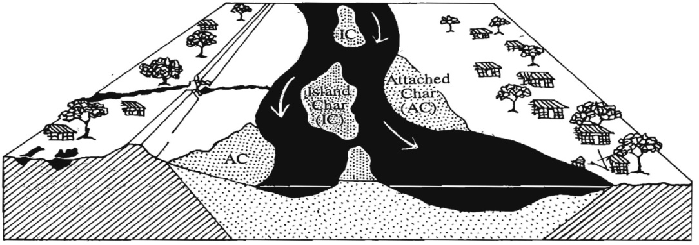
Figure 0-1 Islands and Attached Char(EGIS, 2000)

Morphological Phenomenon of Chars and Islands in Bangladesh
The formation process of chars and islands are very much complex and dynamic in nature. The characteristics and process of chars formation may vary in braided and meandering rivers as well as in the estuaries. Predominantly in the monsoon, rivers overflow and carry a substantial amount of silt towards downstream. The silt eventually deposits, a huge part of it settles in the shallow water along the river and coastal belt and ultimately leads to a new land formation in the form of riverine or coastal Chars (Wameq Raza, Anindita Bhattacharjee, Narayan Chandra Das, 2011). The Ganges-Brahmaputra-Meghna (GBM) river system keeps the deltaic floodplains active in the coastal region of Bangladesh making the coastal area the most geomorphologically dynamic in the country. On another hand, flood actions resulting in erosions keep the riverine chars, especially in Jamuna and Ganges, subjected to continuous morphological changes (Islam S. N., 2016). The high amount of sediments carried by the GBM river systems is hence subjected to dynamic processes, especially around the Meghna estuary, resulting in continuous accretion, erosion, formation and alteration of offshore islands (Figure 3-1). Out of the 60 islands and 177 char lands that are identified in Bangladesh most are located in the central coastal zone due to this the dynamic estuarine and coastal system (Islam M. R., 2004). In general upper stream are formed by coarse materials while the downstream comprises finer particles. Water level may vary depending on the annual water level variations. At the downstream, end of each island scouring the bed to produce deeper and narrow channels. The morphological stability of chars and islands depends on the duration of these newly formed lands (EGIS, 2000).

Selection of Chars and Island for the proposed project
The life and livelihood of Islands and chars dwellers vary due to the size (areal coverage) of chars and islands, accessibility to different types of life supporting and essential services, level and extent of exposureand vulnerability, morphological stability, the existence of polder, availability of agricultural land and other natural resources etc. To develop a bankable project proposal for the char and island dwellers under this UNDP funded project, chars and islands have been selected from the list provided by ICZMP. Some criteria for selecting Islands and chars are size, connectivity, the existence of polder. Another important criterion of chars and islands selection was attached or detachedness with the mainland. In this study, preference has been given to those which are separated from the mainland and suffering a lot due to lack of basic services i.e. access to education, income generating activities, health facilities, etc. Vulnerability and risk of these areas depending on the accessibility, i.e., how quickly and easily one can reach there to rescue or evacuate them.

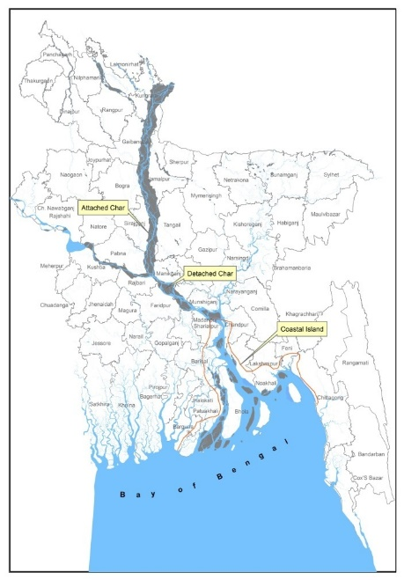
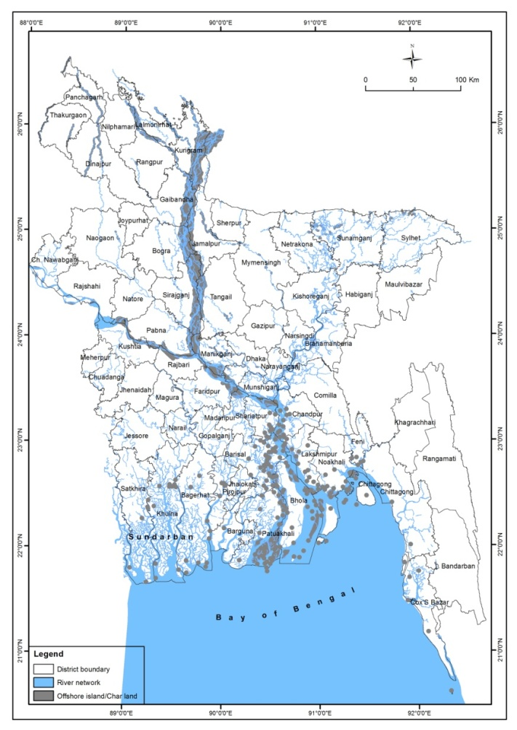
Figure 0-1 Chars and Islands of Bangladesh (Source: C3ER, BRAC University)
Figure 0-2 Classification of Chars

Steps Applied to Select Chars and Islands for this Project

The following steps have been applied to select the potential chars and islands for this project.

Figure 0-3 Steps Applied to Select the Chars and Islands

Selection of Chars and Islands
A GIS-based multi-criteria analysis and filtering procedure were conducted to select islands for this study. Some chars and islands excluded from the list as because of no physical existence and don’t have detail information recorded in BBS (Bangladesh Bureau of Statistics) and other resources. Using GIS analysis Islands and chars are separated into two groups: I) Islands and chars attached to the mainland; and ii) islands and chars detached from the mainland. According to the demands of the project, attached islands and chars are excluded from the list. Existing islands were then assessed according to a risk database and analyzed in GIS environment. Processed data then classified using multi-criteria analysis depending on area, vulnerability and integrated risk.
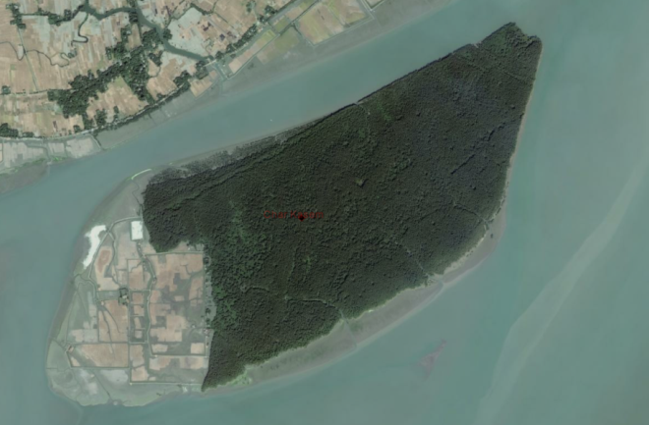 | 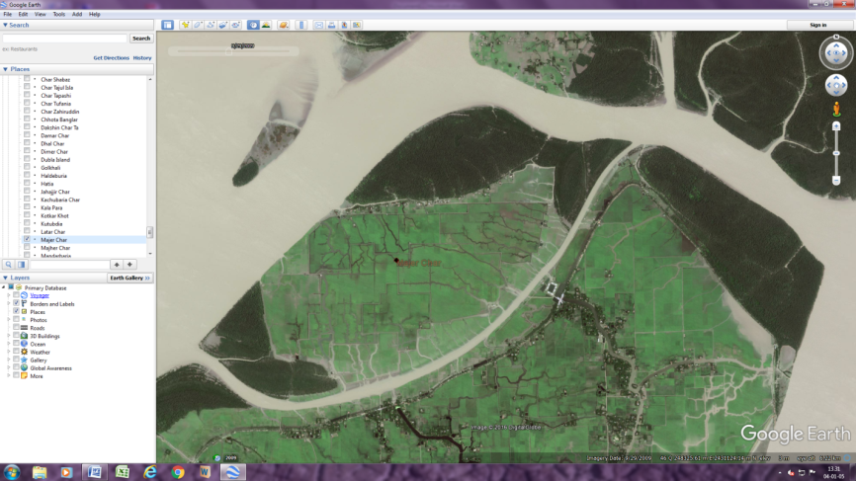
Figure 0-4 Analysis of vegetation and settlement coverage

Approximate areas of Islands and chars have been extracted using Landsat TM/ETM satellite images, and the population has provided from ‘Population and Housing Census 2011’, Bangladesh Bureau of Statistics. A time series of satellite images of different resolutions (Landsat MSS 80m, Landsat TM/ETM 30m, and Quick Bird (Google Earth) 2.4m) from 1973 to 2013 was used for selection. In the recent high-resolution satellite images, physical statuses of some medium and small islands and chars are clearly visible and found that in some Islands and chars there are no traces of settlements. The size of chars and islands has been classified into four classes depending on their physical area following the percentile filtering technique and GIS analysis.
- Type I. Very small chars (0-25 percentiles of total chars and islands)
- Type II. Small chars (26-50 percentiles of total chars and islands)
- Type III. Medium chars (51-75 percentiles of total chars and islands)
- Type IV. Large chars (76-100 percentiles of total chars and islands)

Considering many other things it was decided that the medium size islands are suitable for this study. In addition, another criterion of Island and char selection is whether it is environmentally or biologically protected or not. Char Kukri Mukri is a wildlife sanctuary, and due to this, it is excluded from the list. Based on the size, accessibility, environmental and ecological significance and physical existence, a list of chars and islands have been prepared for a secondary screening process. Detailed information about climate vulnerability and risk, maturity level, broad land use classes (especially the vegetation coverage), etc., on the shortlisted chars and Islands, are collected from various sources and provided in table 4-1. The maturity of islands has studied through visual observation using satellite images. Different stages of chars and islands such as a formative stage, pre-mature stage, and mature stage have been observed in a time series of images from 1973 to 2013. The distance of Islands and chars from the respective Upazila or nearest accessible Upazila has been calculated by using GIS tools. Depending on the mode of transportation, weather condition, and temporal dynamics, the accessibility of chars and Islands also classified into three classes (Easy to access, medium accessibility and hard to reach). Considering the criteria mentioned above, Mujib Nagar Union of the Char Fasson Upazila under the Bhola District as the representative of coastal char and Gajaghanta and Lakshmitari Union of the Gangachara Upazila under the Rangpur District can be selected as the representative of riverine charland for detailed field investigation.

Existing Problems of the Study Area

Considering the geophysical attributes of the coastal char study area, the region was found to be prone to natural hazards such as cyclones, storm surges and tidal flood etc. with sea level rise induced by climate change increasing the magnitude and frequency of these phenomena. Tidal flooding in the region has been observed to be worsening with locals reporting an increase in the highest flood level over the past years. This corresponds to the IPCC’s AR5 findings which indicate that the Average Sea Level has risen over the last century and establishes a correlation between Climate change and the increased highest tidal flood level in the study area. Apart from tidal flooding the increased frequency of extreme weather events like cyclones, hailstorms and storm surges also contribute to list of natural hazards that peril the human population of the study area in Mujibnagar. It is likely that monsoon flooding is increasing over the past few years in Rangpur. It can be noted here that the change in these climatic patterns corroborate with the findings of the IPCC in the recent annual report and as such can be attributed as being direct impacts of Climate Change upon the Char region.

Higher tidal/monsoon flood level has far reaching consequences from the inundation of roadways, causing damage to the existing earthen soiling road works, housing, schools and disrupting the normal flow of life for children and adults alike. Delving deeper into the nature of these natural hazards and their complex interrelationship with the developmental problems, the far-reaching impact they have upon the life of the people living there can be appreciated to an understandable degree of clarity.

The major livelihood of the char dwellers is agriculture which is affected by tidal or monsoon flooding, hailstorm, cold waves, heat waves, erratic rainfall etc. which leads to decline in crop yield, crop damage and ultimately causes a loss of agricultural production. The most extreme form of erosion is induced by tidal as well as monsoon flooding with erratic rainfall causing loss and damage to the agricultural land and crop production. In both the areas, damage to cultivable land and crop production leads to loss of economic and household assets, exacerbating farming livelihood risks. In 2016, Rice and Watermelon have been particularly damaged in Bhola. About 50% of the investments in rice have been lost due to tidal flooding which caused “chita” formation in the rice grains and damaged the paddy harvest. Watermelons and other Rabi crops have been damaged due to water intrusion. Storm surges and cyclones lead to sudden crop loss while extreme weather events such as cold waves and prolonged fog events harm crops such as chilies. In Rangpur, short periods of extreme temperature and changes in precipitation cause harm to agriculture and also dwindle the meager water resources available. This ultimately leads to drought and this predicted increase in temperature will create an adverse situation for the inhabitants of

Climatic events such as extreme temperatures, flood and drought also threaten the livestock in both the study areas. The fluctuation in temperature and precipitation facilitate the propagation of diseases specially vector borne diseases to the cattle. In 2016, cattle were washed away and died during the tidal floods in the coastal chars.

Non-climatic drivers such as a weak market structure, information asymmetry, and limited access to credit increase the vulnerabilities of Char inhabitants. In Bhola, it is the unavailability of agricultural inputs especially fertilizers due to syndication of fertilizer dealers decreasing the input efficiency of farmers in crop production. In both the areas, lack of modern technologies along with insufficient extension and support from the agriculture sector and inadequate land equipment results in high production cost for the crops which has far reaching consequences, chief among those being the loss in income. No strong or effective backward and forward market linkages were observed in the char areas. An ineffective early warning system which happens to be byproduct of the lack of road ways and communication networks is likely responsible for the loss of livelihood and household assets. While agriculturists are facing the direct consequences of the climatic stressors, the nonagricultural wage workers have become vulnerable due to the fluctuating nature of their livelihood which correlates with the status of the agriculture of the respective areas.

When considering infrastructure it is necessary to understand that the term encompasses a wide variety of sectors and as such has far reaching consequences upon the development as well as assessment of the adaptation need of the study regions. Considering the field of transport and communication infrastructure, the common observation in both the regions was the absence or lack of pucca roadways and other transportation modes to and from the mainland. The causes identified for these sectoral problems are irregular maintenance, lack of funding, lack of connectivity to the mainland, unavailability of construction materials and land for constructions. Delving further into the root of the problems, for example when considering the irregular and high cost of maintenance and the unavailability of construction materials and land for construction, inundation and erosion of roadways due to tidal flooding, storm surges and cyclones are key drivers. Changes in the intensity and frequency of these key drivers have been correlated to climate change in the IPCC’s 5th Assessment Report, which implies that climate change has been a contributing factor to the inadequacy of transportation and communication infrastructure. Apart from these climatic drivers we can attribute this inadequacy to excessive costs for excavation and filling of land in repair works, lack of donor interest and an insufficient budget which comes as part and parcel of being a low priority region. This lack of transportation facilities has a detrimental effect upon the development of trade infrastructure by restricting the access to the outside markets and limiting the number of marketplaces accessible to the char population. The power infrastructure was also found depended on renewable energy sources, ( predominantly solar power)

Moving on from transportation, observations regarding housing infrastructure revealed a case of frequent depredation of housing which in turn can be said to be an outcome of the housing units being constructed on low lands or the plinth not being elevated to an adequately safe level due to a lack of available resources or insufficient financial capability. Also, the cost of maintaining a safe plinth height imposes further costs associated with the need for regular maintenance (greater expenditure). Most of the residents in both the coastal and riparian Char Lands live in CI sheet housing or mud houses with CI sheet or thatched roofing. This low cost housing infrastructure for a majority of the population puts them at a greater risk of being harmed during disaster events. Looking at the climactic drivers for frequent depredation of housing, the major role is played by erosion cause by rising tidal flood level, storm surges and other water related disaster events.

The coastal study area of the Mujibnagar union (at Char Fasson, Bhola), which consisted of Char Motahar, Char Leulin and Char Manahar, has certain wards which fall outside the existing embankment/bund protection system which skirts the shores. This shows a distinct lack of coastal protection infrastructure in the region which is aggravated by the high cost of implementation of projects. However, the main cause behind the lack of this kind of infrastructure seems to be an inadequate number of embankments and the existing level of damage to the current ones, and here yet again the impacts of climate change are manifest in the drivers being tidal flooding, cyclones and storm surges.

The state of Water and Sanitation infrastructure in Mujibnagar was found to be poor, as is evident through the inadequacy of access to groundwater resources (very few number of tube wells) and use of surface water resources contaminated through open defecation practices in the absence of pit latrines. Lack of government intervention, poor maintenance, inundation and damage of water resources and sanitary facilities during storm surges and floods makes whatever meager sanitation faculties available not sustainable. In the chars of Rangpur, the water and sanitation infrastructure was more developed than what was observed for the coastal chars. However, the overreliance of the population upon groundwater through tube wells causes depletion of the water table and increases the chances of water contamination during monsoon season.

The educational infrastructure was also found to be lacking in both the char areas. The main climatic drivers behind this were found to be tidal and monsoon flooding along with storm events, contribute to a lack of usable approach roads, which makes school buildings inaccessible during the disaster period and also wreak heavy damage upon the structure. Non-climatic drivers were the remoteness of the community, inadequate transportation and communication facilities and the financial conditions of the local government and community. A major problem is the lack of high schools in both char areas which is associated with a lack of connectivity to the mainland.

Considering the healthcare facilities available to the riparian and coastal char dwellers, the inaction of the local government, inadequate NGO intervention, the remoteness of the area (which adds to the fact that it is low priority region with a small budget) and a disinterest on behalf of the assigned health workers seem to be the main driving forces behind the inadequacy and inaccessibility of medical and treatment facilities. Analyzing the overall condition of the Chars at Bhola and Rangpur, societal degradation was found to be interconnected with the absence of infrastructure as well as lack of required livelihood options. All these issues lead to socio political problems, unemployment, poverty, child labor, early marriage, migration, educational instability, social unrest and finally psychosocial incongruity worsening the misery of the people. It has been found that, in both the coastal and riverine chars the problem of children dropping out of school is a common scenario, albeit one that the local governmental agencies have failed to properly address. Parents are unsure whether to send their children to the schools located faraway. During extreme disaster events, roads are inundated and most of the students are unable to attend school. In both the chars, this high incidence of school dropouts, female students are getting married at an early age, causing health hazards that contribute to an increased mother and child mortality rate culminating in psychological trauma. Furthermore, due to the impacts of climate change like- the rise in sea level, erratic rainfall, tidal flooding, and monsoon flooding and river erosion etc. char dwellers lose their agricultural land and assets on a frequent basis and live from hand to mouth most of the times. In the search for livelihood security, some stop their children (mostly boys) from going to school and engage them in various household as well as agriculture-based work to supplement their monthly income. As a result of this child labor has been a grave problem in these areas

The most critical impacts of the problems observed at the chars are loss of livelihood and loss of income which brings instability into the economics of the char settlement. Here, poverty appears to be the biggest societal issue complicating the social and psychosocial dynamics with its far-reaching consequences. Losing livelihood and assets due to climatic and non-climatic factors combined, most char dwellers take loans and become indebted, and this often happens to be a contributing factor for their migration to different areas in the quest for work or a source of income only to come back to the char in order to repay the loan as well as to recover from the damages afflicted by a disaster event. Being in a state of debt, circumstances often lead to these indebted individuals engaging in criminal activity. This likely leads to a state of social unrest and fosters socio cultural dissonance in the area studied.

River erosion in both char’s shows, erosion and accretion of land commence a new societal conflict among the inhabitants. According to the East Bengal State Acquisition and Tenancy Act (EBSATA) of 1950, if any land is lost due to river erosion, the owner will get it back following few conditions like-

1. Land resurfacing must take place within 20 years,
2. By paying rent owner can get back the land settled by revenue officer,
3. Original owner will possess the land but not more than 375 bighas.

But unfortunately, no act or policy is being implemented at char owing to administrative mismanagement and self-advantage of the powerful political and non-political persons. Those who had land before but lost their land for river erosion are living a marginalized life and they expect to get their land back. This claiming of char land when it resurfaces in the river leads to an escalation of conflict between the neighboring land owners thereby contributing to societal anarchy and dispute which eventually culminates in litigation. Sometimes, the rightful parties get their land back though often, that is not the case. This litigation continues for years and many people are financially ruined.

Figure 5 Problems of the Study Area

References
Chowdhury, J. U. (2006). Issues in Coastal Zone Management in Bangladesh. Dhaka: IWFM, BUET.
Deltaic floodplains development and wetland ecosystems management in the Ganges–Brahmaputra–Meghna Rivers Delta in Bangladesh2016Sustainable Water Resources Management
EGIS. (2000). Riverine Chars in Bangladesh Environmental Dynamics and Management Issues. Dhaka: UPL.
Sarker, M. H., & Alam, M. (2003). Rivers, chars and char dwellers of Bangladesh. Intl. J. River Basin Management, 61-80.
Wameq Raza, Anindita Bhattacharjee, Narayan Chandra Das. (2011). Impact of Char Development and Settlement Project on improving the livelihood of Char dwellers. Bangladesh: BRAC.
Where Land Meets the Sea: A Profile of the Coastal Zone of Bangladesh2004DhakaThe University Press

Annex G. Design Feasibility Report

CHAPTER 1
Introduction

The United Nations Development Programme has undertaken a study for designing a project (with detailed feasibility study) to access global climate funds for addressing climate risks and vulnerability of the community leaving in the small and medium offshore islands and char lands of Bangladesh. For this purpose, a contract has been signed between UNDP and the Centre for Climate Change and Environmental Research (C3ER), BRAC University on 24 October 2016 to carry out the aforementioned feasibility study. According to the agreement, the study will assess socio-economic, demographic and poverty status along with climate risks and vulnerabilities of the small offshore islands and major vulnerable char lands of Bangladesh and provide a suite of recommendations for improving the climate resilience and adaptive capacity of the selected char islands.

Study Area

Lakshmitari Union, Gangachara Upazila
Gangachara Upazila, one of the important Upazila’s of Rangpur District, is bounded by Kaliganj of Lalmonirhat and JaldhakaUpazilas on the north, Rangpur Sadar and KauniaUpazilas on the south, Aditmari and Lalmonirhat Sadar Upazilas on the east, Kishoreganj (Nilphamari) and Taraganj Upazilas on the west. The Teesta River flowing west to east, divided the Upazila into two parts. That is why the influence of Teesta River on this Upazila is huge and unavoidable. This Upazila is affected by river bank erosion and frequent flooding during monsoon. The most vulnerable area of this Upazila is Lakshimatari union. Figure 1-1 shows Lakshimatari union and surrounding area which is considered for the current study.

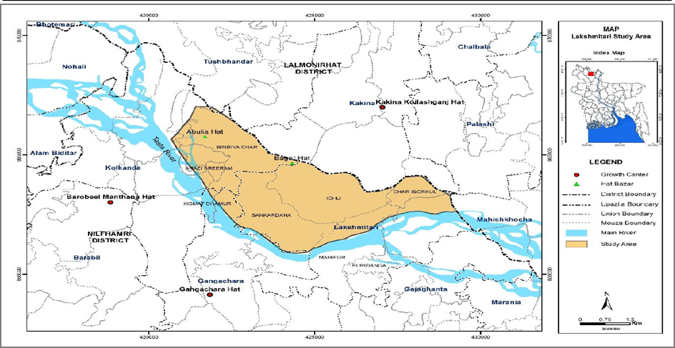
Figure 1-1: Study Area at Gangachara Upazila

Mujibnagar Union, Char Fasson Upazila
Almost all the coastal region of Bangladesh is enclosed by coastal embankment to prevent salinity intrusion and tidal flooding. These are commonly known as polders. Mujibnagar union of Char FassonUpazila under Bhola district belongs to a coastal polder. The embankment of this polder was constructed during the 1990s and within the past 25 years, the embankment was breached at numerous locations. Moreover, cyclones and tidal surges in the past have caused serious damage to many sections of the polder. At present, the embankment crest is lower than the original design specifications. The drainage canal inside the polder, which was designed to remove rainwater from the polder, has now been silted up. This Mujibnagar union and surrounding area are considered for the present study. Figure 1-2 shows the study area of Mujibnagar Union.

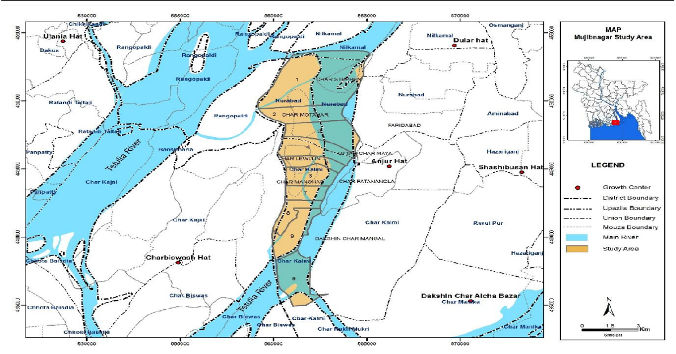
Figure 1-2: Study Area at Mujibnagar Union

- Cyclone and climate resilient house: Identify the houses which are structurally most vulnerable to the extreme climatic events. Assess the required repairing of the structure and retrofit where necessary.
- Nano-grid, rainwater harvesting: Identify the suitable households for installing the community based nano-grid facility and rainwater harvesting system. Provide detail design, specifications, cost estimates along with the operation and maintenance of the interventions.
- Cold storage, solar powered pump: Assess the demand of the study area and design cold storage and solar power pump to meet the demand. The design shall include details about the intervention and the associated equipment along with the cost estimations.
- Embankment: Identify the repairable portions of the embankment and provide adequate design for re-sectioning of the embankment. to protect the project area from flooding. The design shall include typical drawings, specification and cost estimates.
- Floating ambulance: Provide necessary information about the design and costing of the floating ambulance based on the requirement of the area. Details will also be provided on the operational costs for the floating ambulance.

CHAPTER 2
Background Information and Data Analysis

Existing Components Gangachara Upazila in Rangpur

The Lakshmitari Union under Gangachara Upazila of Rangpur district is one of the most river bank erosion vulnerable areas. Every year a huge amount of land is engulfed by the river. People are losing home and their agricultural land which consequences ultimate poverty. Riverbank erosion is a nightmare for the people living in this area. Moreover, flooding during the monsoon causes serious disaster in this area every year. There are neither flood protection measures nor erosion protection measures in this area. At downstream part of the union, a bridge is under construction which is likely to be completed by the next two years. The bridge consists of two guided revetment which will constrict the flow and expected to reduce the erosion of the riverbank at immediate downstream of the bridge. It was observed that there are two existing floodplain channels upstream of the Bridge, which has been silted up in the past 30 years and resulted in greater flows during peak flows, causing flooding.
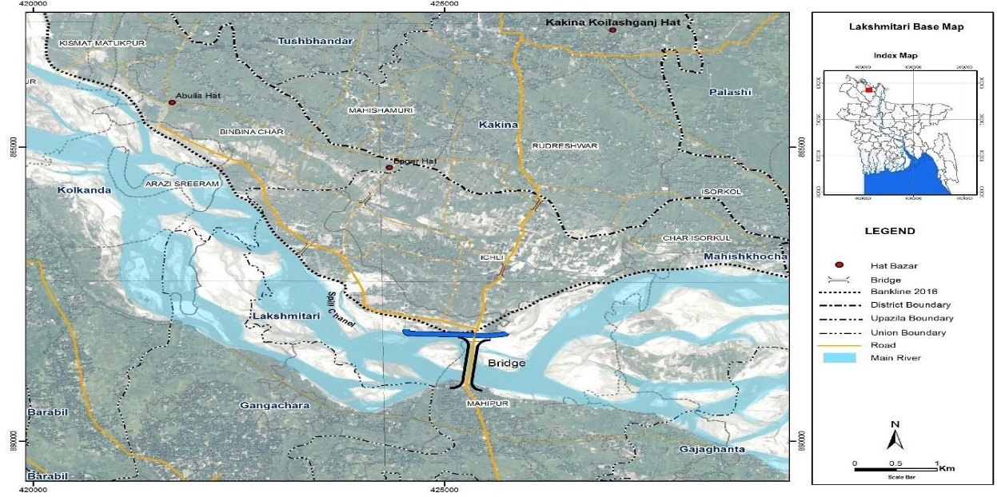
Figure 2-1: Gangachara Upazila Basemap

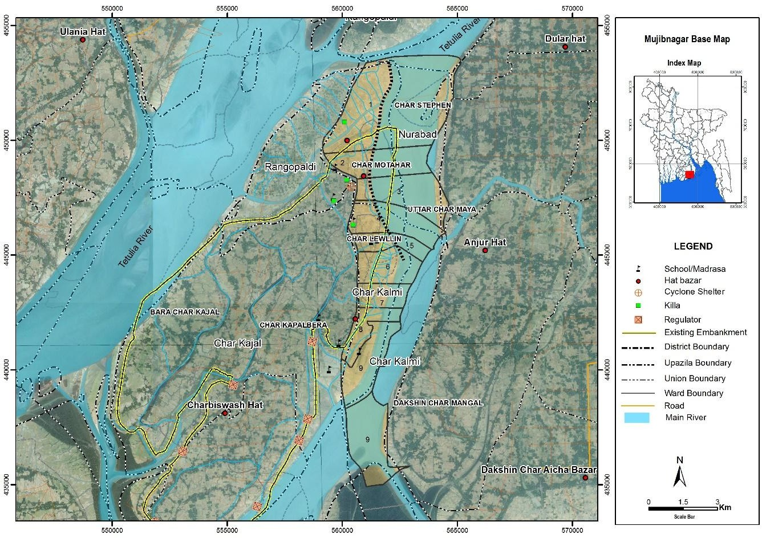
Figure 2-2: Mujibnagar Union Basemap

Existing Components in Mujibnagar Union of Bhola

Embankment
The existing embankment length in the polder is 66 km. It was constructed betweeen 1987 to 1992 under CEP (Coastal Embankment Project). The embankment was desingned to protect the polders against salinity and tide intrusion. The occurrence of recent cyclones accompanied by storm surge over the Coastal zone of Bangladesh and climate change scenario need to be considered in future designs. The Cyclone Sidr hit the South West Bangladesh Coast in the year 2007 with the storm surging 2 to 3m high. Another recent Cyclone Aila hit the South West coast of Bangladesh in the year 2009. Furthermore, river bank erosion has also engulfed the embankment in many places. Retired embankments were built in some places and other existing embankments have breaches. Considering the above factors, the embankment requires re-sectioning and retirement in multiple sections.

Drainage canal
The main function of the drainage channel is to safely drain out the design discharge or the drainage basin runoff volume generated by 5-day duration storm of 1 in 10-year frequency. The other function of the drainage canal is to drain out the surplus water from cropping lands, which is of ultimate importance for the satisfactory growth of crops. The total length of the drainage canal in this polder is 59 km. A significant portion of the existing drainage canal is silted up and blocked in many places. Excavating the drainage canal is recommended to improve the situation and to increase agricultural and fish production.

Drainage Structures
The original objective of constructing polder was to protect agricultural lands from salinity intrusion and to drain out excess precipitation from the polder area through drainage sluices. Later on, agricultural practices developed among the farmers to cultivate winter boro crops inside the polder area. For this winter agriculture, the farmers use to take fresh water into the polder during the monsoon/ post-monsoon and store in for late use. In view of the above, the sluices constructed only for drainage began to be used for both drainage and flushing. The types of sluices found in polder are commonly referred to as:
- Regulator/sluice: The function of this Structure is to drain out the excess water from the polder area to the river and also to allow the river water to enter into the polder area for various purposes. It is also either constructed with a reinforced concrete pipe or with reinforced concrete boxes of various sizes. In total nine regulators were found along the embankment. Most of them are in good condition excepting a few that show minor damage.
- Flushing Inlet: Its main function is to allow the river water to enter the polder area for various purposes. These inlets are also constructed from either reinforced concrete pipe or reinforced concrete boxes of various sizes. Limited drainage is also allowed through this type of structures. There are total 17 numbers of pipe inlets along the embankment and 12 of them are not functioning.

Available Water Level data

Water Level at Teesta River
BWDB is recording daily water level at different locations on Teesta River. Water level data of the nearest two gauge stations of Teesta River (Kaligonj SW 293 and Kaunia SW 294) were collected for Analysis. SW 293 is 8 km upstream and SW 294 is 28 km downstream of the study area at Gangachara Upazila. Collected Water level data is summarized in table 2.1.

Table 2-1 Collected Water Level Data Summary of Teesta
SL | Station ID | Station Name | Duration
1 | SW 293 | Kaligonj | 1980-2014
2 | SW 294 | Kaunia | 1980-2014

Water Level at Bhola
There is no water level measuring station at Char Fasson. The relevant water gauge station is SW 279 at Tozumuddin which is on the east side of Mujibnagar union and SW 20 at Amtoli which is west side. Historical water levels were collected from BWDB to perform water level analysis. A summary of water level stations is presented in Table 2-2.

SL | Station ID | Station Name | Duration
1 | SW 279 | Tozumuddin | 1980-2014
2 | SW 20 | Amtali | 1980-2014
Table 2-2: Collected Water Level Data Summary

Discharge of Teesta River
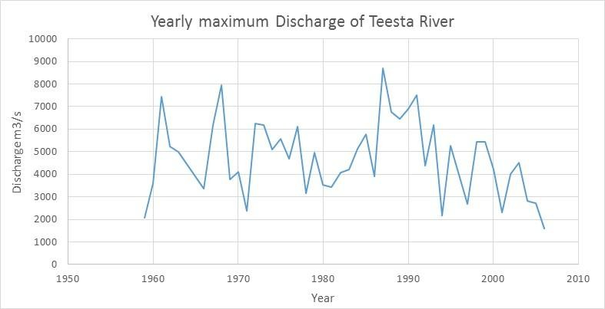
After originating from Pauhunri Glacier in Sikkim of India, the Teesta river flow was diverted by India at an upstream location and then by Bangladesh at a downstream location. For these reasons, the maximum flow of the river does not impact the downstream region where the project will be situated. However, during the monsoon, the peak flow causes serious erosion on both banks of the river at different sites. The maximum flow ranges from 2000 m3/s to 8000 m3/s and average maximum flow is 4500 m3/s. Figure 2-3 presents the yearly maximum discharge of the Teesta River at Teesta Bridge.
Figure 2-3: The Yearly Maximum flow of the Teesta River

Flow Velocity at Teesta
BWDB records velocity at Teesta Bridge location along with discharge. The average velocity of Teesta River at this location is 0.82 m/s where maximum velocity was observed 2.11 m/s and minimum velocity was observed as 0.16 m/s. For the design of river bank protection, a design was developed to allow a maximum velocity of 3.0m/s.

Flow Velocity at Bhola
There is no field measurement of flow velocity at Mujibnagar union of Bhola District. However, some records and studies were conducted in past from where we can take the velocity of this area. Moreover, during the design of the polders, an assessment of design velocity was performed. This area experiences semi diurnal tide and the velocity range lies in about 0 to 1.5 m/s. A design allowing for a maximum velocity of 1.76 m/s for the construction of this polder.

Frequency Analysis of Water Level at Teesta River
Frequency analysis was carried out for two water level stations namely SW 293 and SW 294. Two major distributions such as Log Pearson and Log-Normal were carried out to evaluate the value for different return period. Two different tests namely Chi-square and KS test were also carried out to select the best distribution. Results of frequency analysis of SW 293 are presented in Figure 2-4. The water level for different return period is furnished in Table 2-3.

Frequency Analysis of Water Level at Bhola
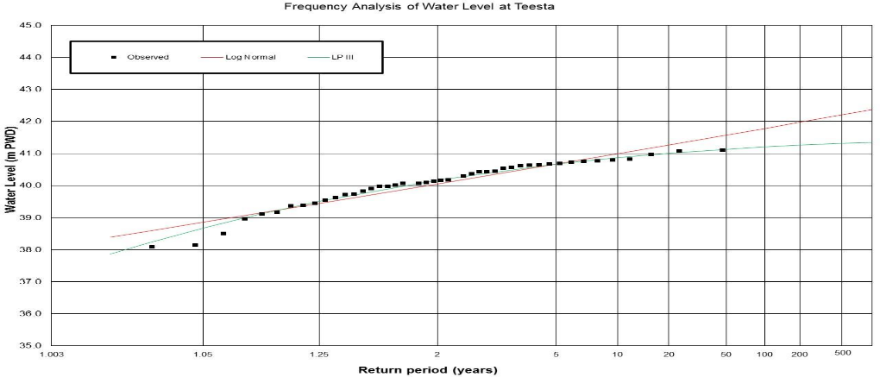
Frequency analysis was carried out for two water level stations namely SW 279 and SW 20. Two major distributions such as Log Pearson and Log-Normal were carried out to evaluate the value for different return period. Two different tests namely Chi-square and KS test were also carried out to select the best distribution. Results of frequency analysis of SW 293 are presented in Figure 2-5. The water level for different return period is also presented in Table 2 –4
Figure 2-4: Frequency Analysis of Water Level of Teesta River at SW 293

Table 2-3: Frequency Analysis of Water Level of Teesta
SL | Return Period (Year) | Log-Normal | Log Pearson III
1 | 2 | 40.05 | 40.18
2 | 5 | 40.67 | 40.67
3 | 10 | 41.00 | 40.87
4 | 20 | 41.27 | 41.01
5 | 50 | 41.58 | 41.13
6 | 100 | 41.78 | 41.21
7 | 200 | 41.97 | 41.26
8 | 500 | 42.20 | 41.32

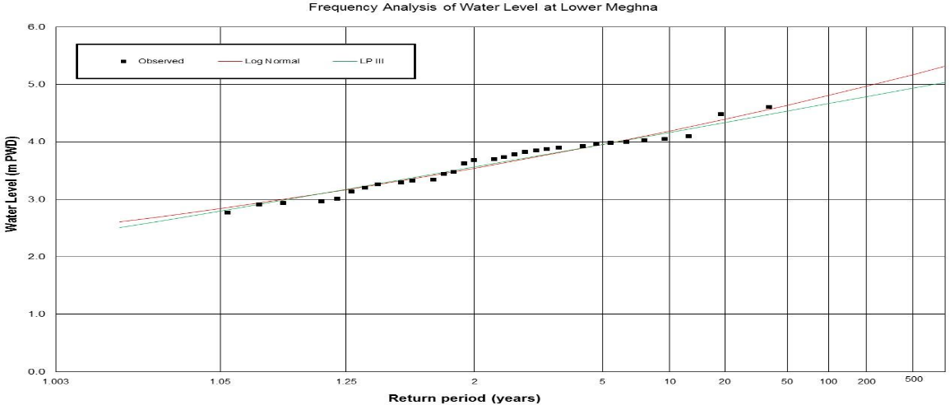
Figure 2-5: Frequency Analysis of Water Level at SW 279

Table 2-4: Frequency Analysis of Water Level of Lower Meghna at SW 279
SL | Return Period (Year) | Log-Normal | Log Pearson III
1 | 2 | 3.54 | 3.57
2 | 5 | 3.95 | 3.96
3 | 10 | 4.19 | 4.17
4 | 20 | 4.40 | 4.34
5 | 50 | 4.64 | 4.54
6 | 100 | 4.81 | 4.67
7 | 200 | 4.97 | 4.79
8 | 500 | 5.17 | 4.93

CHAPTER 3
Design of Cyclone and Climate Resilient Houses
General
The majority of the population of Bangladesh lives in rural area and their standard of living in terms of protection and safety is very low. Under difficult natural conditions, the country is extremely prone to natural disasters such as floods, cyclones and earthquakes which pose a great threat to life and property, especially in the rural areas where poverty is widespread. Apart from the physical damage that such disasters cause to the people’s property, they also have a great negative impact on the country’s economic situation.

In a context of non-engineered construction, construction expertise is often passed on from generation to generation and from one construction professional to another. Tried and tested over decades, in a particular context, non-engineered housing often holds a lot of inherent wisdom. Construction engineering knowledge on the other hand offers a formal understanding of how particular materials, techniques and designs react under certain circumstances. Moreover, it can offer alternative and innovative ways of addressing current and new challenges for safer construction. The combinations of tried local practices and engineering knowledge makes allows to formulate standards for safer housing for the different hazards impacting on the rural housing stock of Bangladesh. Through respecting the general design principles and minimum technical standards for specific threats presented below, the current rural housing stock in Bangladesh can be rendered substantially more resistant to future disasters.

Climatic Factors for Design Considerations
The generic and case specific climatic features of flood affected regions that can affect the design task are:
- Flood
- Lateral water pressure
- Intense Radiation
- Humidity
- Nor westerly
- River Erosion
- Sand Heat
- Driving Rain

Issues Identified in Char Lands
- Removable structure is needed for Char area owing to transient nature of the landscape.
- Issues like unavailability of course sand, quick removability of house structure calls for introducing prefabricated building elements.
- Durable structural members concerning issue of longer house lifespan.
- Structural members to be fastened to each other properly.
- Additional structural stability to be ensured by the means of introducing bracing elements at due strategic points.
- Mound raising should be undertaken to establish new settlements.

GENERAL DESIGN PRINCIPLES FOR DIFFERENT THREATS
Specific design principles are to be respected to counter the various threats a house may be exposed to. This section is based on a multitude of guidelines that have been produced in the context of previous disaster preparedness and response projects, both in Bangladesh as internationally, by a variety of housing actors. Since all rural areas in Bangladesh are exposed to a combination of hazards, in most cases, more than just one set of design principles will need to be adhered to. In those cases, the strictest principle across the different hazards is to be applied.

Ensure tie down from bottom to top
The house is to be firmly tied to the ground, to avoid it flying off, starting by connecting the roof well to the columns, the columns well to the foundation and anchoring the foundation well into the ground. The columns should be made using reinforced concrete to resist high lateral pressure (i.e., wind pressure, water pressure).

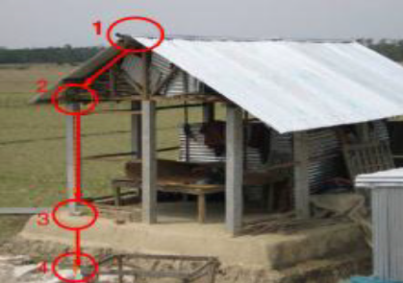 | 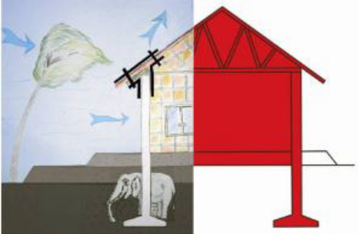
Figure 3-1: Strengthening of rural houses using ties (Source: IFRC BD Shelter Volunteer Training after cyclone Sidr)

Ensure cross-bracing in all planes of the house
All planes of the house are to be equipped with cross-bracing to resist the lateral winds impacting on the house, to avoid the house falling over.

Ensure that wind pressure cannot build up inside the house
There are two opposite strategies to avoid wind pressure building up inside the house:
- Ensure that wind can flow freely through the house, by ensuring openings on all opposite walls of the house, and by ensuring wind pressure can escape through the roof
- Ensure that no wind can enter the house, by closing it off completely, including impermeable walling and latched windows and doors
- In most rural housing, certainly when walls are of natural materials, the first strategy is the only possible one.

Ensure a qualitative plinth
The house plinth is to be 2 feet above the highest flood level, 2 or 3 stepped and finished with cement capping or other, to resist exposure to water.

Protect the lower parts of the house
By sufficient roof overhang, proper drainage, treatment of materials, alternative material choices: protect the lower parts of the structure and wall cladding from humidity and exposure to water

Apply foundation and bracing
Foundation of sufficient depth is required to resist soil being washed out from underneath the house. Bracing of the superstructure to resist lateral forces from the water and increase the overall stability of the structure.

Cost
The actual cost for strengthening a vulnerable house to make it cyclone/flood resilient can be estimated after conducting feasibility study. However, on an average USD $600 will be allocated for strengthening each house. Based on the feasibility study, required method will be identified and implemented to retrofit the vulnerable house. In the selected study areas total 900 houses will be identified which are more vulnerable to climatic disasters. If it is considered that each household consists of 6 members on average, then total beneficiaries from this intervention will be around 5400.

CHAPTER 4
Design of Community-Level Nano Grid Facility

General
The nano-grid idea is based on the fundamental concept of the Solar Home System, where the basic necessities of households are met, but at the same time some small-scale applications like irrigation can also be incorporated. This concept takes advantage of the fact that houses in Bangladesh are usually clustered together in rural areas in a group of 10-20 houses (within a diameter of less than 150m).. In the proposed nano- grid system, something like a 1.5–2 kWp PV system is installed in a small cluster of households within a radius of 60–70 m and power is distributed to 10-15 households from this system. The PV panels and the battery used in the proposed nano-grid will be connected in series in such a way that the grid voltage is 220 V DC (nominal) and the households are supplied with this voltage. Rooftop locations of one or two houses will be chosen for PV installation and the storage battery will be placed in a convenient location close to it. Considering the typical load in a household, the expected summer time (May to September) load is around 3 times the expected winter (November to March) household loads. This, as explained above, is due to the fact that there is expected to be high usage of fans in summer due to hot weather condition. The average typical household load in rural Bangladesh given below in Table 4-1 and Table 4-2. The demand for refrigerator is not considered at this stage as it goes beyond the affordability of the average households.

Table 4-1: During summer, estimated energy consumption is given below:
Description | Light | Fan | Television
Household (HH) | 20 | 20 | 5
No./HH | 3 | 2 | 1
Watt/unit | 5 | 20 | 30
Hrs of usage, h | 4.5 | 8 | 2
Diversity | 0.8 | 0.8 | 0.8
Energy/day, W-h | 54 | 256 | 48
Total/day, W-h |  | 358

Table 4-2: During winter, estimated energy consumption is given below:
Description | Light | Fan | Television
Household (HH) | 20 | 20 | 5
No./HH | 3 | 2 | 1
Watt/unit | 5 | 20 | 30
Hrs of usage, h | 4.5 | 0 | 2.5
Diversity | 0.8 | 0.8 | 0.8
Energy/day, W-h | 72 | 256 | 60
Total/day, W-h |  | 132

Solar PV based grid systems, less than 10 kW, named as a nano-grid, is provided as a recommended solution.
- Cost of the system and electricity and description of a model system is given below:
- Size of the PV—1.9 kWp (kilowatt peak)
- Size of the battery bank—480 AH (ampere hour) at 12 V
- One irrigation pump (AC) – 1.1kW (1.5HP)
- No. of households—10
- Summer load per household—360 W-h per day Winter load per household—135 W-h per day
- Estimated total cost of the system including installation and accessories is US$4927.

CHAPTER 5
Design of Locally Appropriate Rainwater Harvesting System

General
Rainwater Harvesting is a water collection method, which has been utilized by communities for a long time. This process is very simple, technically feasible, cost-effective and provides a safe drinking water supply system in geo-hydrologically disadvantaged areas. It can be considered a possible option to drinking water crisis in the saline zone in the coastal regions, areas prone to declining water table and having rocky/ stony layer in soil formation. The physical, chemical and bacteriological characteristics of harvested rainwater usually represent a suitable and acceptable standard of potable water.

Rainwater Harvesting System (RWHS) is an option, which has been adopted in many areas of the world where conventional water supply systems are not available or adequately meets requirement of the people. To provide safe drinking water to rural communities; some organizations implemented several pilot programs and developed range of technological options of RWHSs considering affordability of the general mass. These models of RWHS are from indigenous do-it-yourself models to high cost profile Ferro-cement models.

In the monsoon season, safe drinking water has been a primary concern. The existing shallow tube wells can serve water during the dry season, but in monsoon, the shallow layer of groundwater gets contaminated from the flooded water. Also, the existing tubewell becomes non-functional at the flooding condition. As a result, Water-related disease is common in the season. For this reason, an alternative source has become necessary in the area.

Rainwater Harvesting has a diverse range of uses. In dry areas of the world, designed systems have sufficient surface area available for water collection and adequate storage capacity to meet the full needs of the user. However, a wide variety of different users patterns or regimes exists, and there are many variables involved in the determination of various components of Rainwater Harvesting systems. The design of the main elements of an RWHS is described below:
    - Storage Tank
    - Catchments
    - Gutter
    - Flushing System
    - Water Collection Point

The large capacity community-based Rain Water Harvesting System will be designed as an underground facility. This type of system is suitable where a group of families live together and face a scarcity of safe drinking water. The community based underground RWHS will have a capacity of 25000 litres considering an average household size of 6 members in the offshore coastal islands in Mujibnagar and Lakshmitari Union. Total 300 units of RWHS will be made; 150 units for Mujibnagar Union and 150 Units for Lakshmitari Union. The total number of beneficiaries covered through this intervention will be 11,000-12,000 people.

Table 5. 2 Cost of RWHS (Community Based)
Storage capacity (Liters) | Size of the reservoirs | Minimum Catchment area (Sq. m) | Type of Catchment | Nos. of family members (No.) | Number of reservoir per system | Average total Construction Cost (USD)
25000 | Height: 2.44 m  Diameter: 3.66 m 150 mm wall thick | 55 - 57 | CI sheet,  Concrete,Tiles, | 55 - 60 | 1 | 625.00

Functional Criteria for RWHS
a. Could able to store adequate quantity of water having acceptable quality for certain period of time.
b. All necessary parts are in place.
c. Good, clean and effective catchment, gutter, down pipes, first flush system, platform, tank with lid are available.
d. Effective waste water disposal system is available.
e. Sanitary condition of RWHS and surrounding is satisfactory.

Construction of Underground RWHS (Community Based)
The concept of the construction of large capacity community based Rain Water Harvesting System had developed and practised from the ancient. The world largest community based RWH System constructed in Istambul. This type of RWHS is suitable where a grouped of family live in a compacted area and faced the scarcity of safe drinking water. This types of RWHS may be constructed that circumstances. The Community based underground RWHS may be different capacities such as 10000 litres, 15000 litres, 20000 litres, 25000 litres, 30000 litres, 35000 litres, 40000 litres and 50000 litres. It also one of the cheapest model of RWHS. The construction requirements of different capacity of community RWHS is described below:

Step –1: Preparing and construction of base
• Select a suitable place for the construction of subsurface Brick tank at one side of the house. The place should be relatively high and hard soil. Draw a circle with the outer dia of the tank on the soil and excavate soil in a depth so that about 1 – 6” of the tank remain above the ground.
• The bottom of the excavation should be like a inverted dome as per the mentioned dimension in the drawing.
• After digging level the bottom of the pit and compact the soil. Give a layer of brick flat soiling. Cutting and binding MS rod as per specification. Mix cement concrete (Cement: Sand: Khoa = 1:2:4) and pour mixed cement concrete on brick flat soling at 4 inch thick. Compact the cast of R.C.C before setting with hammering by wooden patent.

Step – 2: Construction of main body of tank
• Draw a circle with respect to the centre of Base considering the diameter of the tank least 12 hours after casting RCC at base.
• Construct a circular tank with 5" thick brick wall. The thickness of mortar should not be more than ½ inch thick and the joints of the brick wall should be filled mortar properly. The wall should be constructed up to the mentioned height of the tank.
• Provide 5”x6” lintel at the middle height of the tank.
• Keep steps inside the brick wall.

Step – 3: Plastering
• Warping wire meshes around the inner side of the tank wall and fixes the wire mesh with the brick wall.
• Plaster inner side of the tank (wall and bottom) with cement sand mortar (1:3) and the thickness of the plaster will be about 1 inch. cement finishing in the inner side of the wall.
• Rough plaster will be provided on the outer side of the tank.

Step – 4: Construction of cover slab
• Provide necessary and adequate shuttering for the construction of slab. Lay polythene sheets and seal the opening of the shutter. Cut and bind 9mm dia MS Rod @ 5" c/c in both direction. Keep a hole of 1'- 10" dia at the corner of the cover frame for placing manhole cover.
• Mix cement concrete (1:2:4). Before casting identify the location for placing pump, water level indicator, air vent pipe etc. Then pour cement concrete (1:2:4) with 5 inch thick keeping the frame of MS Rod at least 1” clear cover of cement concrete layer.
• To make a collar of outer ridge of the slab so that rainwater could drain out through one location of the slab.

Step – 5: Setting of manhole cover
• Place the manhole cover at the proposed local (hole) on the slab. Mix cement concrete (1:2:4), set the cover and cast a layer of cement concrete mixture 2" thick.
• Finish the cement concrete with mortar (1:4).

Step – 6: Setting of inlet and overflow pipe
• Place inlet and overflow pipe, the inlet pipe should be one inch below the bottom of the slab. The over pipe should be at least one inch below the inlet pipe.
• The joint between wall and pipe should be properly sealed and finish with cement mortar.

Step – 7: Setting of flushing system
• According to figure flushing system to be set with PVC pipe 75mm-dia elbow and "T".
• Flushing system would be joined with the nipple to inlet gutter and with inlet pipe.
• As per drawing a flushing box will be constructed with brick masonry work.

Step – 8: Tube Well setting
• A simple hand Tube well would be set on the slab as per the drawing. The legs of the pump should be properly fixed with slab with cement concrete.
• The pipe of the Tube well inside the tank would be tied with mortar so that it cannot move easily.

Step – 9: Construction of stair
• As per drawing construct stair for easily go on the roof the tank.
• Stair will be constructed with brick masonry work.
CHAPTER 6
Design of Cluster Houses

Background
Cluster houses can be good solution for the flood affected areas. Recently the government of Bangladesh has undertaken Community Climate Change Project (CCCP) under the Bangladesh Climate Change Resilience Fund (BCCRF) under which communities were supported to raise household plinths and provide opportunities for better and secured livelihood. The project focuses on the three most vulnerable climate zones in Bangladesh, composed of: saline affected coastal zones, flood-affected areas and charlands, and drought-affected or rain-scarce areas in north-western Bangladesh. Many of the homes in the clusters were raised by five feet on average based on highest flood level of that area to protect the families from being inundated with water. The plinths were designed to offer benefits inclusive of growing vegetables, rearing poultry and providing shelter for domestic animals in addition to providing safe shelter for resident. In its second year, the project already made a difference in flood affected regions. Beneficiaries did not have to migrate to distant high ground for shelter this year like before. Their crops are also being protected by elevation. Raising the plinths of their homes in clusters has helped more than 15,000 families escape floods, and they continued to earn their livelihoods by planting vegetables and rearing goats on raised ground.

Components of Cluster Houses
From the lessons learned from the CCCP project, this project will construct 20 cluster houses in the selected char lands; 10 cluster houses in Mujibnagar Union and 10 cluster house in Lakshmitari Union. Each of the cluster will consist of four houses. The plinth of the houses will be raised by five feet on average based on the highest flood level of that area to give protection from flood. The raised plinth will be used for facilities like hygienic sanitary latrine, safe drinking water source, small household livelihoods of poultry, livestock, and homestead garden. There will be provision for solar panels and improved cooking stoves in the households. Proper slope protection measures will be ensured to protect the raised platform. To protect slope from soil erosion naturally, various fruit trees and grass will be used. Also, A drainage channel will be provided below the slope to drain out the excess water.

Cost
The total cost for constructing each of the cluster houses will be USD $40,000 including the materials and labor cost. An engineer will be assigned to provide support/assessments for location and construction of cluster houses.

CHAPTER 7
Repair and Strengthening of Embankment

General

The coastal embankments were initially constructed during the 1960s. The purpose of the construction of embankments was to protect the cultivable land in the coastal areas against tide and saline water intrusion. These embankments were designed with no regard to cyclone surges. The crest height of the embankments was determined as the maximum normal high tide plus a freeboard of 5 feet. The design of the embankments was carried out using the design criteria followed by BWDB at that time. The recent cyclones accompanied by storm surge over the Coastal zone of Bangladesh and climate change scenario needs special attention to be considered in the design of embankments to serve the present need.In Mujibnagar Union which belongs to polder no 55/3, the main work comprises of the resectioning/reconstruction of the existing damaged or deteriorated embankments and in places construction of new/retired embankments, where the embankments are already breached or threatened to be breached in near future due to river/ wave action. On the other hand, at Gangachara Upazila of Rangpur district, there is no flood protection embankment in the proposed project location which causes serious flood every year.

For the detailed design of embankments, the basic data were gathered first from primary and secondary sources including satellite images. The physical features of both of the sites have been mapped and entered in the GIS. The rehabilitation/ improvement plan for embankment begins with an assessment of the current state of the site giving particular attention to
    - The physical condition of the embankment, whether the embankment is under attack by river erosion, wave action and threat or fact of overtopping by a previous storm surge.
    - Performance of drainage system, whether deficiencies are due to inadequate design, poor condition of structures etc.
    - Agriculture and fisheries activities
    - Population centres and settlements, livelihoods, socio-economic conditions and public infrastructure including the existence of cyclone shelters.

The proposed improvements to the embankments have been designed in such a way so that the physical and operational conditions in the polder are made satisfactory under the present conditions as well as under the future conditions taking into account climate change projections and changes brought about by other projects currently underway or being developed by the Government of Bangladesh.

Guideline for Designing a Stable Embankment
Embankment section is designed to fulfil the following criteria:
    - The countryside slope of the embankment should remain stable during steady seepage at design specifications
    - The side slope of the embankment on the riverside must be stable during rapid drawdown conditions, where the seprevail.
    - The phreatic line should be well within the downstream face so that no sloughing of the slope takes place.
    - A fill material of sufficiently low permeability should be selected from the available material.
    - Sufficient freeboard must be provided in the design specifications to avoid overtopping during maximum flooding.
    - The u/s and d/s slope should be flat enough. For this, a suitable factor of safety should be provided.
    - The riverside slope should be stable against wave run up in case no treatment is anticipated.

Selection of Location

Gangachara Upazila
Flooding is one of the major two disasters for the people of Gangachara Upazila. There is an existing road at the upstream area which acts as embankment during flood but the road is engulfed by the river downstream, and because of this the area is flooded during monsoon every year. To protect from flooding 3.5 km embankment is required in this area. Figure 3-1 shows the proposed embankment alignment.
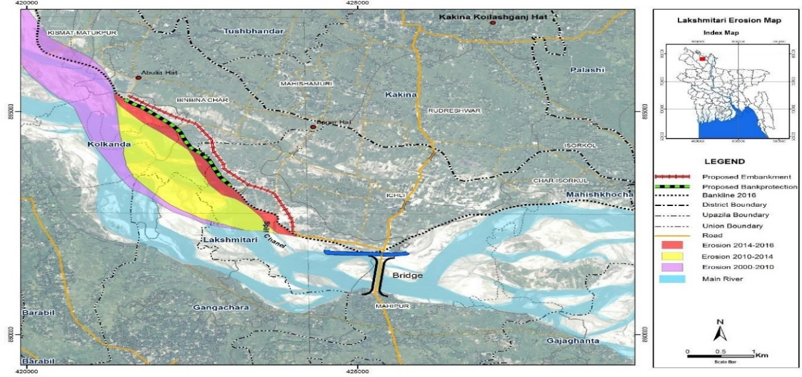
Figure 3-1: Proposed embankment alignment at Gangachara Upazila

Mujibnagar Union
Out of 66 km long embankment of polder 55/3, 15 km embankment belongs to Mujibnagar union. This 15 km embankment is damaged at many places and about 1 km length is currently breached. To protect this union from flooding 1 km new embankment is proposed to close the embankment. Another 8 km of existing embankment is proposed for resectioning or strengthening so that it can defend against flooding. Figure 3-2 shows the proposed alignment of new and resectioned or strengthened embankments.

Design Parameter
The following design parameters were considered during designing the Embankments.

Embankment Crest
The embankment at Mujibnagar union is designed to keep selected storm surges (with incident waves) and overtopping the polder. They must also withstand toe scour and slope erosion due to incident waves during stormy weather. At Mujibnagar union a return period of 25 years is considered for embankment design. On the other hand embankment at Gangachara Upazila is aimed to defend a 50 year return period flood with standard toe protection on the riverside. The design storm surge levels are obtained from 38 cyclone simulations based on 19 actual events and 19 additional events of the same magnitude and identical tracks but with their landfall occurring at exactly the opposite tidal phase to the corresponding actual storm. The 25 year return period storm surge levels are computed for cyclonic storms that would occur at the present situation.

Safety Margin
These values refer to climate change conditions and are based on previous specifications for embankment slope and roughness. The Climate Change Conditions refer to conditions in 2050 (IPCC predictions which will be revised from time to time. 2050 refers to 40 years after the base simulations in this study. Given that we are designing for 30 years, there is a ten-year factor of safety built in – which might be worthwhile because there has been a tendency for the sea level rise estimated to revised upwards more often than downwards. Although the crest levels are nominally based on a return period of 25 years, this return period is applicable only in (eg) 2035, whereas return period of the design will be higher in the earlier years, making for an additional margin of safety.

Design Crest Level
The considered design crest level at Gangachara Upazila: 42.10 m PWD
The considered design crest level at Mujibnagar Union: 4.90 m PWD
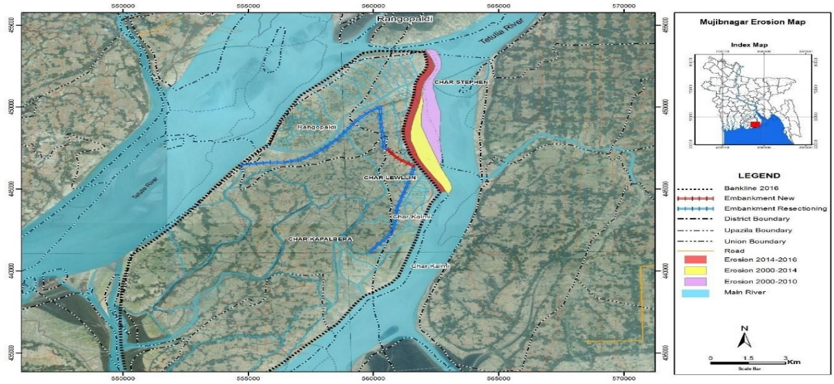
Figure 3-2: Proposed embankment alignment at Mujibnagar Union

Embankment materials
The materials required for the construction of embankments will be gathered from the nearest sources. It can be mentioned here that embankment materials cannot be collected from borrow pit (BWDB design Guideline 2010). It is highly recommended to construct the embankment with dredged material where available.

In Gangachara Upazila the embankment materials can be collected from the river bed where temporarily submerged chars are formed. The river bed material is mainly sand (medium to fine) and it can be used as the core material of embankment. To protect seepage a 20 cm thick clay layer is proposed to cover the top surface of the embankment (top and the sloped surface on both sides). This will reduce the amount of clay materials significantly and the nominal amount of clay can be collected from nearest sources. While in Mujibnagar Union: The embankment materials can be collected from riverside submergible char. The top layer of these chars is composed of silt and clay, which can be collected and used for the embankment.

Embankment Surface
A further protecting element is grass turfing or the planting of trees. In standard designs, this serves on the surfaces of the embankment for the protection against erosion resulting from rainfall.

Toe Protection
The cladding on the riverside embankment toe is susceptible to destruction from ploughing. To secure it against unintended damages during farming a 1.5m wide strip of land can be reserved and used to plant a suitable tree.

Ecosystem based Adaptation
Afforestation of embankment slopes was found to induce localised erosion problems in many cases in Bangladesh. This contradiction retarded the afforestation of embankment slopes as an effective means of erosion protection, provided turfing is ensured with grasses and systematic management is established. In practice, however, the embankments are not simply engineering structures, but the focus of complex land-use systems. This, combined with institutional shortcomings and funding shortages, has made a system of routine maintenance – in the engineering sense – impossible to establish. As a result maintenance has been restricted to major repairs or rehabilitation, generally carried out only when embankment is close to failure or has completely failed and caused serious losses. For a least developed country like Bangladesh, the most effective forms of erosion control should be vegetative protection combined with limited hard protection. Ecosystem based adaptation against erosion are the cheap and simple practical solution that must be:
- technically suitable: for different levels of exposure to erosion; for different soil types; for
- saline and non-saline condition,
- financially suitable: with respect to the cost of both initial construction and maintenance,
- environmentally suitable,
- people-oriented and sustainable: for routine maintenance.

Very recent experiences of the coastal greenbelt project and subsequent development made under the Coastal Embankment Rehabilitation Project (CERP) provide a sound footing for adopting the land-use approach for biological means of protection against erosion while providing various commodities for local communities. For controlling runoff erosion of embankments and for increased fodder production, a model has been developed, including vetiver (Vetiveria zizanioides) and associates like Napier grass (Pennisetum purpureum), Para grass (Brachiaria mutica), German grass (Echinoclora grousgali), in addition to other suitable plants like Ipil-Ipil (Leucaena leucocephala), Jhau (Casuarina equisetifolia), Akashmoni (Acacia auriculiformis) and the like. A model has also been developed combining mechanical and vegetative toe protection methods as a sufficiently low-cost alternative for sites where the embankment is not directly exposed to wave attacks and the toe erosion is moderate. CERP has made a breakthrough in organizing the embankment settlers for plantation on embankment slopes and toes in the country and at the seaside. Instead of being evicted from the embankment, the settlers are provided with shelters and other assistance, including leasing out a reach of embankment where they can make homestead gardens for vegetable production and even plant trees for timber, firewood and consumptive uses. This will ensure proper preventive maintenance of the embankments by the settlers on a regular basis, CERP suggests.
This project will adopt the strategies and knowledge from the CERP project and apply that to strengthen the embankments in the selected char lands. For the maintenance of the embankments, community management will be introduced. Community Based Organizations (CBOs) will be formed and trained to maintain the embankments properly. The envisaged vegetation pattern will have a short-term economic benefit for the settlers; grasses and bushes will provide quick benefits from the production of fodder and thatching material; the trees will start to be productive after four to ten years. Gradually local interest in embankment protection may also be engaged.

Cost

Embankment Construction/ Repair
For repairing or constructing of the embankments, approximately USD $75,000 will be required for per km of length. The total cost for this will be USD $1,162,500. This will include earthwork with mechanical compaction to attain >90% maximum dry density at optimum moisture content with reference to laboratory density test AASHTO modified hammer with borrowed earth as per technical specification.

Ecosystem based Adaptation
For EbA in the embankments, USD $12,500 will be required for per km length. The total cost for this intervention will be USD $192,200. Workshops will be arranged for the community people to provide training on embankment management. Also, a National consultant or specialist will assess and develop livelihoods to be connected to embankment management and conduct trainings. Total USD $35,000 will be required to conduct the workshops and assign the consultants.

General Notes for Embankment:
- All elevations are in meter (m) (PWD) unless otherwise mentioned in the drawing.
- Any ditch/drain within 50.00m from the C/S TOE shall be filled up to the ground level with available locals and/earth.
- Earth in embankment shall be placed in a horizontal layer of 150mm thick, clod breaking to a minimum size of 100mm and compaction is to be made to attain 90% dry density at optimum moisture content.
- Base of the embankment shall be stripped of not less than 150mm to remove vegetation, slushy earth and other soft materials to develop strong bondage between the base materials and borrowed earth for embankment, before re-sectioning of the embankment, benching the side slopes, removing roots and stumps of trees of girth upto 200mm from the ground. All sorts of organic and other foreign materials must be removed properly.
- Slopes and crest of the embankment shall be finally dressed and closely turfed (preferable vetiver gross) to retain earth from being washed away by rain and wind.
- If required, a smooth transition to be provided between higher & lower crest level and steeper & flatter slope of the embankment.
- The earth borrowed for construction of embankment must be free from grass & vegetation etc. Peat soil shall not be used in embankment construction.
- 150mm cambering at the centre of the of embankment should be provided.
- The earth shall not be removed from the crest of the embankment where the existing crest level is higher than the design crest level.
- c=5.00ka/m²& 0=18⁰ shall be attain for completed embankment.
- Shrinkage as per schedule shall be considered so that final crest level remains at design level after shrinkage.
- Dredged material from river bed shall be used as embankment material and 90% compaction must be attained at optimum moisture content and a clay blanket of 0.20 m must be used to cover the new section of the embankment.

CHAPTER 8
Design of Cold Storage Facility

The selected study areas are two of the most vulnerable places of the county in terms of climatic incidents. The Mujibnagar Union is a coastal region that suffers from flood, storm surges, salinity intrusion, etc. On the other hand the Lakshmitari Union is located in an area which subjected to both flood and drought. Both of the areas have high potentiality addition in the crop and horticulture sector. But the unfavorable weather, climatic disasters, inadequate water management, lack of availability of quality surface water for irrigation, lack of market linkage, lack of processing technology and storage system are the main challenges for the increased productivity in these areas. Despite many challenges, both the region has considerable potential for crop, horticulture, fishery, livestock and value chain enhancement. The region is largely dominated by medium high land which is suitable for different agricultural practices around the year.

Due to lack of proper post-harvest management and storage facility, the postharvest loss of produced vegetables is very high and farmers are bound to sale their products immediately which sometimes restrict farmers to get better price. modern storage of vegetables and fruits and is virtually absent in Bangladesh. Cold storage facility is only available for potato. However, from the last couple of years many research organization, development projects, government line departments are trying to replicate low cost farmers’ friendly natural cold storage which operates without energy or in some cases renewable energy like solar. After reviewing different organization’s initiatives for natural cold storage for vegetables were identified like one storage established at Atmul village under Shibgonj upazila of Bogra distric with capacity of 240 metric tons in 2015, another one is Baniachong sub-district of Habigonj district which capacity is 200 kg of vegetables by using vaporization technology. Farmers can store their vegetables in these natural cold-storage for 10 to 15 days. Prof Dr Monzur Hossain from Rajshahi University has also established an environment-friendly cold storage with 300 metric-tons capacity in Rajshahi city at a cost of around Taka 14 lakh where agricultural produce can store through the process of vaporization.

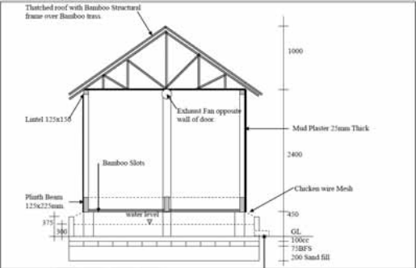
From the lessons learned from these projects, a non-electrical cold storage facility is proposed under this project. The cold storage will use vaporization process to preserve fruits and vegetables. The Improve Natural Storage unit is a brick walled, thatched roof building constructed over an open water reservoir using the concept of evaporative cooling to greatly reduce the temperature within the facility. Farmers and traders can easily store surplus or unsold vegetables at any time by paying minimum amount for two weeks to avoid seasonal clearing as well as to create bulk amount for selling in distanced markets. The large farmers or traders or any entrepreneur of the area can take initiative to establish this type of storage to store own produce or to sale the storage facilities. The 65 feet long and 40 feet wide rectangular storage is made of bricks, cement, bamboo, and thatch that can house 500 tons of produce. The vital part of the storage is the two parallel walls. The inner wall is made of brick and cement and the outer wall is constructed with concrete blocks and bricks. The gap between the two walls is three inches that is filled with sand. To allow sunlight inside the storage, there are two windows made of glass in the upper part of the storage. Four solar panels of 110 watt have also been set up to generate electricity to light the storage. The total cost is provided in the Table 8-1.
Figure 8-7: Sectional Layout the natural cold storage

Table 8-1 Cost of Cold Storage
Sl. No. | Item | Total Cost (BDT)
A | Land Lease for One year | 60,000
B | Design & Layout | 70,000
C | Materials Cost
1 | Bricks | 550,000
2 | Brick Chips | 160,000
3 | Sands (For Filling the Basement) | 230,000
4 | Sand for Bricks work and casting | 120,000
5 | Mud Plastering | 50,000
6 | M S Rod | 500,000
7 | Cement | 400,000
8 | Thatched roof | 70,000
9 | Wood for door | 70,000
10 | Bamboo (75 mm diameter) | 600,000
11 | Electric motors and cables | 80,000
12 | Pipeline for electrification, motor boring | 60,000
13 | Miscellaneous | 120,000
D | Machinery & Equipment | 60,000
E | Mason & Labor | 600,000
F | Solar panel (4 nos.) | 200,000
Total Material Cost |  | 4,000,000

CHAPTER 9
Design of Solar Powered Pump
The use of solar energy in irrigation is popular now owing to cost-effective financing and innovative business model. IDCOL has started to promote renewable energy since 2010 and promoted solar irrigation pumps. Already, over 600 solar irrigation pumps have been installed by IDCOL and more is to come to cut dependency on electricity and diesel used to operate more than 1.6 million tube wells and pumps for irrigation. In a bid to promote alternative energy, perhaps, Bangladesh has sped up installing solar-powered irrigation pumps in 2012. The success stories on solar irrigation pumps have brought light from the piloted upazilas of Dhaka, Chittagong, Rajshahi, Rangpur, and Khulna regions. In 2017, BASE Technologies Ltd, in collaboration with the Department of Agricultural Extension (DAE), launched Solar Irrigation Project in the village at the cost of Tk20 lakh. It was a Corporate Social Responsibility initiative and part of BASE’s sustainable agricultural development programme. The 7.5 horsepower solar pump can irrigate 30 bighas. About 100 farmers are reaping direct benefits of the project. This project will implement 6 solar irrigation pumps of 18.5 KW capacity, three in Mujibnagar Union and three in Lakshmitari Union. To install each solar irrigation pump USD $ 85,500.00 will be required.

Technical standard for Photovoltaic Module (PV Module) for mini-grid and irrigation projects
- The following are applicable standards for PV modules:
- International Electro-technical Committee (IEC) 61215:2005: Crystalline Silicon Terrestrial PV Modules Design Qualification and Type Approval
- IEC 61646: Thin Film Silicon Terrestrial PV Modules Design Qualification and Type Approval
- IEC 61701 Ed 2.0: Salt mist corrosion testing of PV Modules.
- IEC 61730 for safety equipment.
- The photovoltaic module should have a peak power output of at least 250Wp.
- All modules must be product tested and certified from IEC accredited laboratories. IEC 61215 (Or IEC 61646, whichever applicable) and IEC 61730 are mandatory for PV modules. IEC 61701 will be applicable for PV module installation in coastal areas.
- Each module must be factory equipped IP65 junction box with terminal strip that allows safe and long-lasting wiring connection to the module. Where applicable, protective diodes should be used to avoid the effect of partial shading. Factory test report of the PV module must be provided during supply of product.
- Each module must have permanent labeling indicating at a minimum: Manufacturer, Model Number, Serial Number, Peak Watt Rating, Voltage and Current at peak power, Open Circuit Voltage, Short Circuit Current and Cell Efficiency of each module.
- Power tolerance must be positive for each of the PV modules.
- Cell Efficiency (η%) should be minimum 15% at STC.
- Fill Factor (FF) should be more than 70%.

CHAPTER 10
Design of Floating Ambulance

Floating ambulance will be present there to provide emergency health support to the vulnerable people of Mujibnagar. The floating ambulance will be equipped with particular emphasis being made upon the design to reduce travel time between destinations. This will enable patients to receive treatment in time and also facilitate the dissemination of other emergency services. The boats will be approximately 23 feet long and 11 feet wide, to accommodate two to three patients at a time along with attendants. Standard medical equipment will be provided in the ambulance with provisions for the boat to be used as weekend clinics. The cost approximated for a floating ambulance is USD $26,522. For the boat USD $11,872.00 and for the necessary equipment and medicines, USD $ 14,650 will be required. For staffing the ambulance, UDS $1550 will be required for each month and the staff will be hired for 48 months preliminarily. Details costing is provided in Table 10.1 and Table 10.2.

Table 10.1 Costing of Equipment for Floating Ambulance
Serial No. | Name of Equipment | Cost (BDT) | Cost (USD)
1 | General medicine storage | 200,000.00 | 2,500.00
2 | Surgical medicines and necessary medicines for women | 100,000.00 | 1,250.00
3 | X-ray viewer | 50,000.00 | 625.00
4 | Balance | 15,000.00 | 187.50
5 | Microscope | 50,000.00 | 625.00
6 | Blood bank refrigerator | 200,000.00 | 2,500.00
7 | Surgeon stools | 20,000.00 | 250.00
8 | Bed (3) | 30,000.00 | 375.00
9 | ICU baby cot | 100,000.00 | 1,250.00
10 | Blood group testing kit | 50,000.00 | 625.00
11 | Fire extinguisher | 20,000.00 | 250.00
12 | Oxygen supplement (2 set) | 40,000.00 | 500.00
13 | Cabinet (2) | 10,000.00 | 125.00
14 | Stethoscope (5) | 25,000.00 | 312.50
15 | Surgery equipment | 20,000.00 | 250.00
16 | Saline stands | 5,000.00 | 62.50
17 | Machine (Pressure, height, weight) | 20,000.00 | 250.00
18 | Computer (2) | 100,000.00 | 1,250.00
19 | Chair and table | 50,000.00 | 625.00
20 | First aid box (2) | 2,000.00 | 25.00
21 | Suction machine (manual) | 60,000.00 | 750.00
22 | Orthopedic surgery equipment | 5,000.00 | 62.50
23 | Stretcher (2) | 20,000.00 | 250.00
Total |  | 1,192,000.00 | 14,900.00

Table 10. 2 Cost for staff of Floating Ambulance
Serial No. | Staff | Cost (BDT) | Cost (USD)
1 | Doctor (Medicine) | 28000 | 350
2 | Doctor (Surgeon) | 30000 | 375
3 | Doctor (Practice) | 20000 | 250
4 | Nurse (3) | 27000 | 337.5
5 | Staff | 14000 | 175
6 | Co staff | 5000 | 62.5
Total |  | 124000 | 1550

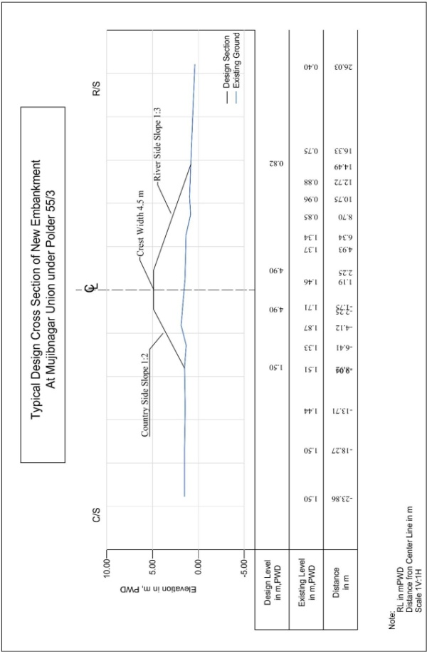
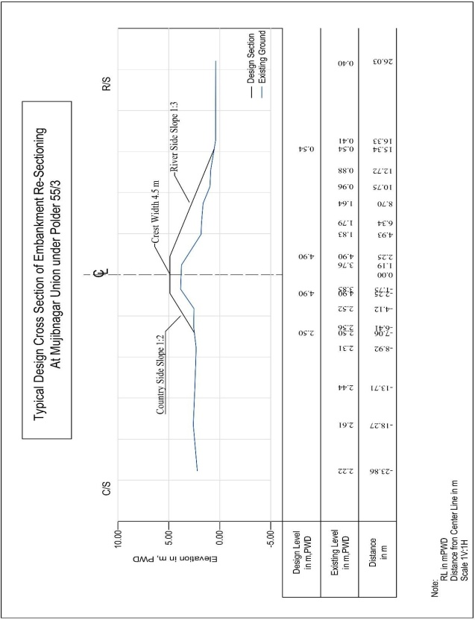
APPENDIX 1.
Design section of Embankment at Mujibnagar Union, Bhola District
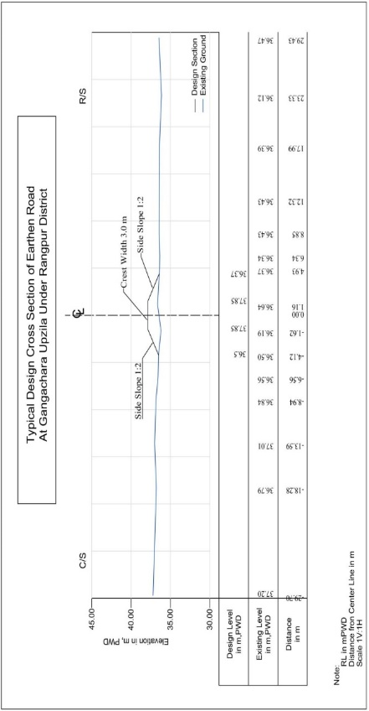

Design of Embankment at Gangachara Upzila, Rangpur District
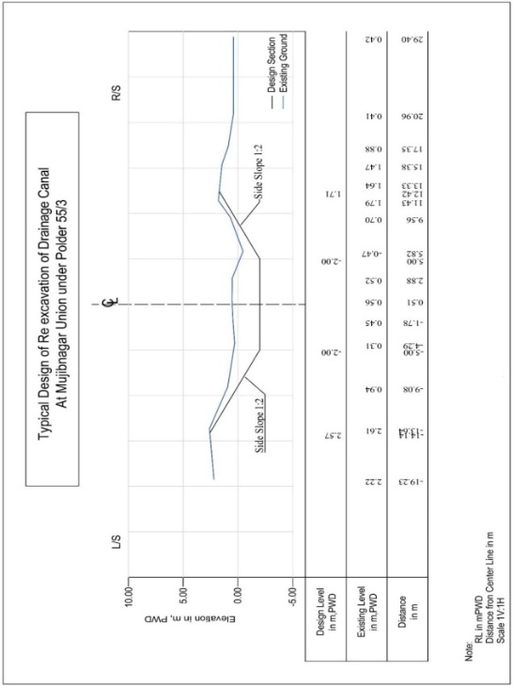
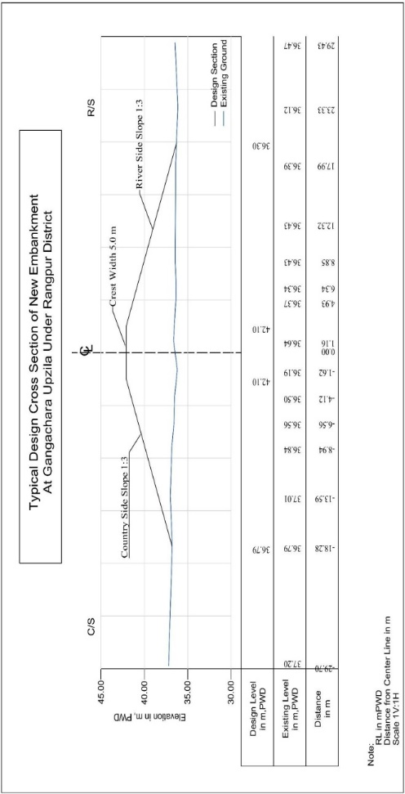

Annex H. Climate change risk and vulnerability assessment and feasible adaptation options

Bangladesh is considered one of the most vulnerable countries of the world in terms of climate change impacts due to its geographical location, flat and low-lying topography, high population density, and high level of poverty. The country is ranked sixth among the world’s top ten countries most affected by extreme events in the last 20 years according to the Global Climate Risk Index by think-tank Germanwatch in 2017.Bangladesh is affected by climate-induced disasters, namely flash floods, river floods, tidal floods, sea level rise, droughts, erosion, landslides, and lightning. Moreover, due to changing climatic pattern different health issues are also in the rise. Due to the geographic location the char lands are particularly vulnerable to floods, droughts and river erosion. In addition, Char households are sensitive to seasonal unemployment and are considered the most food insecure in Bangladesh. The main objective of the proposed project will be to comprehensively address the adaptation deficit, thereby seeking to reduce the impacts of climate change upon the Char regions –the impacts of increasing temperature, erratic rainfall, intensifying extreme weather events like flash floods, cyclones, storm surges and tidal flooding.

Climatic Projections According to the AR5

Fifth Assessment Report (AR5) of the United Nations Intergovernmental Panel on Climate Change (IPCC) is the fifth in a series of reports intended to assess scientific, technical and socio-economic information concerning climate change, its potential effects, and options for adaptation and mitigation. The report is the most exhaustive and presents detailed summary of the climate change situation ever undertaken, involving thousands of authors from dozens of countries, and states. A special report on Global Warming of 1.5° C was released in 2018 in which Bangladesh was identified as one of the vulnerable countries in terms of climate change impacts.

According to the projection of the Intergovernmental Panel on Climate Change (IPCC), Bangladesh would have high exposure to SLR in the 21st century using 1.5°C and 2°C scenarios. At the basin scale, Mohammed et al. (2017) found that floods are projected to be more frequent and flood magnitudes greater at 2°C than at 1.5°C in the Brahmaputra River in Bangladesh. In coastal regions, increases in heavy precipitation associated with tropical cyclones combined with increased sea levels may lead to increased flooding. In a groundwater-dependent irrigated region in northwest Bangladesh, the average groundwater level during the major irrigation period (January–April) is projected to decrease in accordance with temperature rise (Salem et al., 2017). For 1.5°C or 2°C stabilization conditions in 2200 or 2300 plus surges, a minimum of 44% of the Bangladeshi Ganges-Brahmaputra, Indian Bengal, Indian Mahanadi and Ghanese Volta delta land area (without defenses) would be exposed unless sedimentation occurs (Brown et al., 2018b).

Table 3 Future Climate Trends for South Asia
Precipitation | Temperature | Sea Level Rise
Increased rainfall under high emissions scenario by 2050 | Increase by >2° C by 2050 under high emission scenario | 26–55cm globally under low-emissions scenario by 2080–2100
Increased rainfall at high latitudes under low emissions scenario by 2050, but no significant changes at low latitudes | Increase by >3° C by 2100 under high emissions scenario | 45–82cm globally under high-emissions scenario by 2080–2100
Increased extreme rainfall events associated with monsoons | Increase by >2° C by 2100 under low emissions scenario
Increased extreme rainfall associated with cyclones making landfall | Increased frequency of hot days
Source: (IPCC, 2014)

Key future Impact and Vulnerability
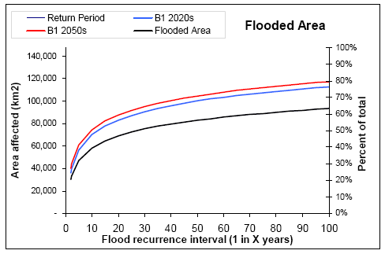
Flood is very likely to be more frequent in the coming years. (Mirza, Warrickb, Ericksenb, & Kenny, 2001)showed that a 20-yr return period flood event in the Ganges, Brahmaputra and Meghna River will be changed to 13-yr, 15-yr and 5.5-yr return period floods due to a possible increase in temperature by 2⁰C; which means the catastrophic flood events. For the extreme level rise in temperature by 6⁰C, return period of the same frequency catastrophic flood event will reduce by 3.4 times, 2.3 times and 8.5 times for the Ganges, Brahmaputra and Meghna rivers respectively. Another study by Tanner et al (2007) reaffirms that there will be uncertain rainfall changes, ranging from large decreases to large increases, as a result of which flooding in Bangladesh will also be extremely uncertain. Extreme peak river-discharges are likely to occur more frequently. For example, the recurrence interval for the devastating 1998 flood will reduce from roughly 50 years to 30 years in the 2020s and 15 years in 2050.
Figure 8 Increase in area and percentage of total area affected by flood from present situation (black line) to the 2020s (blue line) and 2050s (red line).

Drainage congestion in the southern region of Bangladesh is very likely to be exacerbated by climate change. Most of the rivers in south- western coastal regions of Bangladesh are going to become more congested due to sedimentation in the river bed related to bank embankments. Due to embankments on both the sides of the tidal rivers and obstructing the mouth of the tidal creeks, sedimentation takes place on the channel beds rather than dispersing on tidal flat and floodplain areas. As a result, the channel width and depth are decreasing day by day. Climate change is causing higher water level in the drainage systems, sea level rise and sedimentation in the flood plains which further accelerates drainage congestion. Permanent loss of land in the coastal region is likely to happen. Drainage congestion is already a growing problem in the southern region of Bangladesh and is likely to be exacerbated by sea level rise. Loss of land due to permanent inundation is another major threat posed by the rising sea level. WARPO (2005) study showed that an additional area of 4,69,000 ha (13% of land area of coastal region) will be remain inundated by the year 2080 due to 62cm sea level rise for highemission scenario (A2 scenario). The most vulnerable areas along the Bangladesh coastline are the areas without polders which encompasses most offshore islands. Increase in rainfall (10% increase in rainfall within Bangladesh) in addition to the 62cm sea level rise in 2080 will increase the permanent inundated area by 16% (5,515,000 ha) in the monsoon. The following figure shows the inundation of the coastal region of Bangladesh for 15cm (B1 scenario), 27cm (A2 scenario) and 62cm (A2 scenario) sea level rise during the monsoon. On the contrary, in the dry season due to 62cm sea level rise about 364,200 ha (10%) more area will be inundated (inundation more than 30cm) for the A2 scenario in the year 2080. However, the 15cm sea level rise has an insignificant impact on inundation in the dry season.

The intensity of cyclones in the Bay of Bengal is likely to increase. According to the IPCC, tropical cyclone frequency in Bangladesh is likely to decrease or remain the same, but the number of intense cyclones will likely increase . Dynamic and regional climate models project increased intensity of tropical storms by 2100 for the North Indian Ocean and increased frequency of the highest storm surges across the Bay of Bengal. Combined with sea level rise, the country is expected to face increasing tidal surge and inundation of coastal areas. By 2050, an additional 15% of the coastal area of Bangladesh is projected to be inundated by storm surges during cyclones. Storm surge from a 10-year return period cyclone (such as Sidr) could inundate an area 80% greater than what would be flooded presently, with a total of 9.7 million people (compared to 3.5 million in the no climate change scenario) expected to be exposed to severe inundation (>3m) . Between 1961 and 2013, a total of 61 cyclones hit Bangladesh, with the south-western zone affected by 28% of these cyclones . A study by the World Bank (WB 2000) indicated that usually cyclones are generated in the deep sea when sea surface temperature reaches the threshold value of about 27 degree Celsius. With increasing temperature, barometric pressure drops, and the additional energy is dissipated in the form of high-speed winds. A recently published study by IUCN stated the evidence of 3-4-degree Celsius increase in the sea surface temperature above the stated threshold and the IPCC have documented the probability of 5-10% increase in the wind speed by the year 2050.

The drought situation in the southwest and northwest region is very likely to aggravate. IPCC has also confirmed the probable increase of water stress condition in the south-Asian region. In Bangladesh, an earlier estimate suggests that the area severely affected by drought in Rabi season could increase from 4000 km2 to 12000 km² under severe climate change scenario (Huq et al., 1996). A geographical distribution of drought-prone areas under climate change scenarios shows that the western parts of the country will be at greater risk of droughts, during both the Kharif and pre- Kharif seasons. It was found that, under a moderate climate change scenario, Aus production would decline by 27 percent while wheat production would be reduced to 61 percent (Karim et al., 1998). The geographical distribution of drought-prone areas under climate change scenarios shows that the western parts of the country will be at greater risk of droughts, during the pre-Kharif and Kharif seasons (July – October). This could result in a decline in rice production by ~27% and wheat production by ~39% under a moderate climate change scenario. Under a severe climate change scenario, the area severely affected by drought in the Rabi season (October – March) is predicted to increase from 4000 km2 to 12,000 km2, further affecting agricultural productivity.

Salinity front in the south-west region is very likely to move upward. Due to change in salinity extent, there will be significant changes in the freshwater zone and brackish water zone. Considering the threshold value of salinity for agriculture, drinking water and biodiversity, changes in freshwater and brackish water area for dry and monsoon have been calculated from the model result. It is revealed that during the dry season, 2050 and 2080, for 27cm (A2) and 62cm (A2) sea level rise, brackish water area will be increased by 6% and 9% respectively. In the monsoon, an increase of brackish area will be 2% and 6% for 27cm and 62cm sea level rise.

In order to properly understand the climatic risk and vulnerability of the regions under consideration, it is essential to have a scientific and quantifiable basis for the assessment being carried out. Hazard analysis is the first step of risk assessment. Potential hazards of the country have been identified, and those are flood, drought, storm surge and soil salinity. The IPCC defines hazard as “The potential occurrence of a natural or human-induced physical event that may cause loss of life, injury, or other health impacts, as well as damage and loss to property, infrastructure, livelihoods, service provision, and environmental resources” (IPCC, 2012). Here, the term “potential” sets the key directive for hazard assessment, i.e., the probabilistic approach. The term ‘integrated’ used in the risk assessment approach is used to specify the joint probability of multiple or consecutive occurrences of natural hazards.

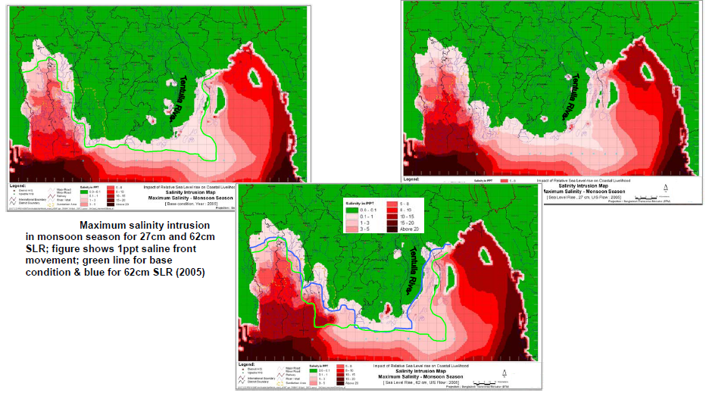
Figure 8 Salinity intrusion in monsoon season

Climate Change and Variability

Recently published fifth assessment report of the Intergovernmental Panel on Climate Change (IPCC) depicted an average increase in the warming of 0.85 [0.65 to 1.06] °C globally, over the period 1880 to 2012 (IPCC, 2014). However, the estimates vary at the local level, and precise estimation is not possible mainly due to the unavailability of the weather measurement stations in the area of interest. Under this circumstance, summary statistics are calculated from the nearest available meteorological stations to depict the changes and variability of the climatic parameters.

Temperature
Higher temperature or warming leads to a chain reaction of a wide range of impacts across different sectors. That is because increasing air temperature also affects the oceans, weather patterns, hydrological cycles, plants, and animals. Therefore, the warmer it gets, the more severe the impacts on people and the environment will be. Changes in the average yearly statistics of mean, maximum and minimum temperature are considered as a proxy for detecting changes in the climatic pattern.

Mujib Nagar Union, Upazila: CharFasson
Figure 3 shows the trend and the variability of the yearly average temperature anomaly from the climatic baseline (pre-1990). The mean temperature has increased by 0.284 °C in the post-1990 period and showing an increasing trend towards the recent period. The estimate is statistically significant at the 95-percentile level. The annual trend in the maximum daily maximum and minimum daily minimum temperature of each month also shows increasing and 0.53 trend respectively (see figure 3). It can be depicted that the maximum temperature is increasing by 0.029 °C per year, and the minimum temperature is increasing to 0.038 °C per year. It signifies the possibility of more heat waves during summer days and relatively warmer nights during the winter.
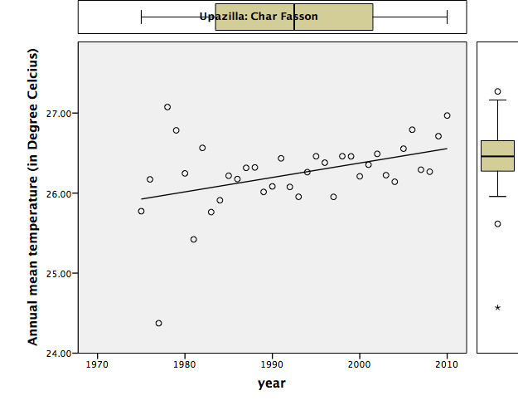
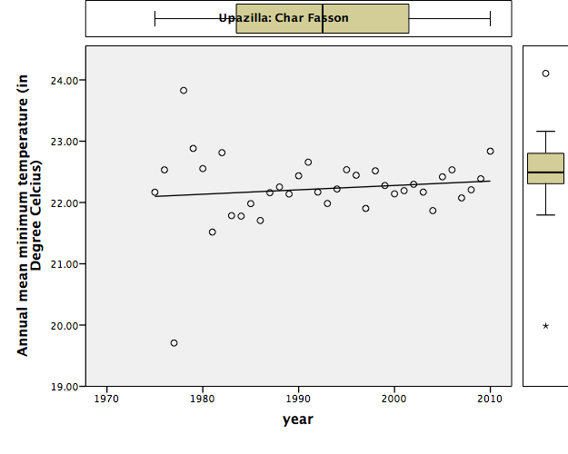
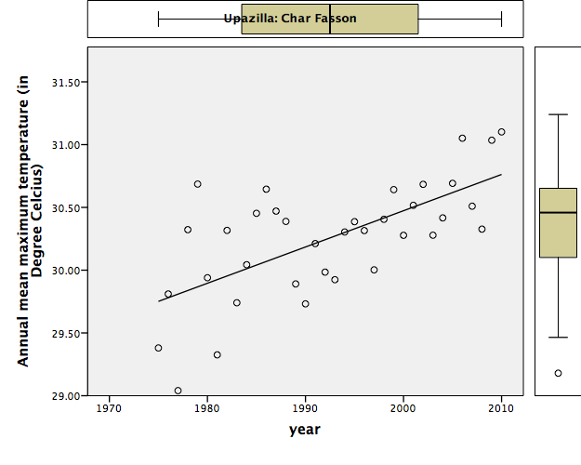
Figure 9. Historical trend in the mean average, minimum and maximum temperature for Char Fasson

Lakshmitari Union, Upazila: Gangachara
The meteorological station -10208 of Rangpur is the representative station for Gangachara Upazila. Figure 2.1, shows the usual average temperature in January varies from 16°C to 18°C. The average temperature of Gangachara Upazila increases gradually and reaches the highest in May. The average temperature in hot seasons varies from 26°C to 30°C in this Upazila. North-western region of Bangladesh is mostly vulnerable to drought. Within the last two decades (1994–2013), annual average maximum temperature has increased by 0.16 _C and the average minimum temperature is forecasted to be increased by 1.3 _C at the end of this century considering the four decadal (1964–2013) trend.

Figure 10Monthly average temperature of Station-10208 from the year 1948 to 2008

Rainfall
Changes of seasonal rainfall, shifting of the spatial and temporal distribution are triggered by the increase in the temperature. The monsoon seasonal rainfall might increase, and the dry seasonal rainfall might decrease projected by the IPCC’s fifth assessment report. At the same time, the rural agrarian economy is severely affected by the increasing intensity of short duration heavy rainfall events.

Mujib Nagar Union, Upazila: Char Fasson
Figure 5 shows the historical anomaly in the total annual rainfall with respect to the baseline period (1960- 1990). It is evident that the mean annual rainfall has increased from 2466.3 mm/yr to 2903.8 mm/yr. The mean annual rate of increase is assessed as 15.1mm.
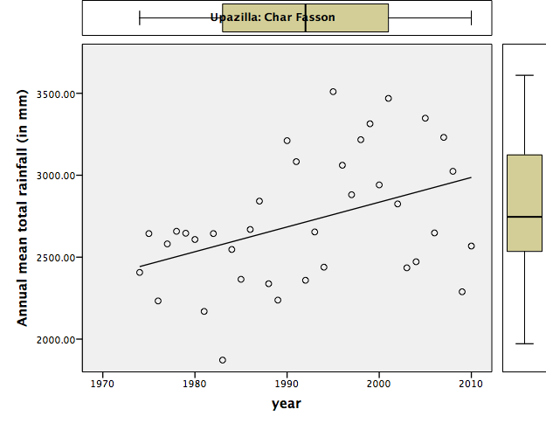
Figure 11 Historical annual rainfall anomaly

Laxmitary Union, Upazila: Gangachara
Mean annual rainfall estimated for Gangachara is 2157.31 mm. Figure 6 shows that there is hardly any rainfall from November to February (dry season). These four months contain less than 4% of the annual rainfall. The amount of rainfall increases rapidly from June to September (monsoon season) and reaches up to 1265 mm. Heavy rains throughout the monsoon leave thousands of people in northern Bangladesh homeless or in dire straits as the mighty Brahmaputra, Dharla and Teesta rivers burst their banks, spilling out over the countryside. In 2014 heavy monsoon rainfall in Bangladesh and river catchment areas pushed levels of several of the country’s major rivers and one of the worst affected districts was Rangpur. Over the last two decades i.e. 1994–2003 and 2004–2013, the annual average rainfall has calculated 151.50 and 138.09 mm, respectively. Rainfall has decreased quite significantly in the last decade. Northwestern region is an important agricultural hub of Bangladesh. Decrease in rainfall and its seasonal variability have made the region more dependent on ground water for irrigation. Spatial and trend analysis shows groundwater depletion trend is getting steeper in this region.

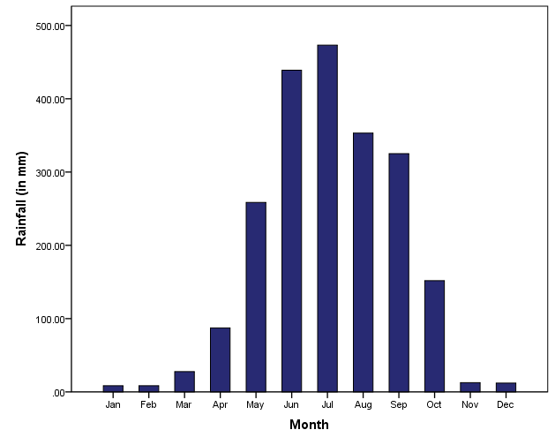
Figure 12Monthly rainfall of Station-10208 from year 1948 to 2002

Risk Assessment: Hazard exposure

Mujib Nagar Union, Upazila: Char Fasson
Overall flood exposure score for Char Fasson upazila for the baseline scenario is calculated as 194.8 km² that might increase to 260.5 sq km under the climate change scenario. Mujib Nagarhas a comparatively high exposure (score 27.4) which might rise to 40.8 sq. km. under the climate change scenario. More than 25% of people are exposed to flood under the baseline scenario for Mujib Nagar. Under climate change scenarios the population exposure will increase to values exceeding 33% people.

Overall storm surge exposure score for Mujib Nagar Union, considering the baseline scenario, is calculated as68.7sq km that might increase to 76.9sq km under the climate change scenario. More than 78% of people are exposed to storm surge under the climate changescenario. Depth adjusted storm surge exposure of the settlement area in the Char Fasson upazila is calculatedas 547.4 sq.km. which might increase to 684.5 sq. km. under the climate change scenario. Mujib Nagar has a fairly high level of exposure to storm surge with a base area of around 68.7 km² which can be expected to rise to 76.9 km².

Overall soil salinity exposure score for Char Fasson upazila for the baseline scenario is calculated as1366.3 sq km that might increase to 2732.6 sq km under the climate change scenario. Mujib Nagar yet again happens to be highly exposed (score 41.7) which might double to 83.3 sq. km. under theclimate change scenario. More than 436790.4 people are exposed to soil salinity under the climatechange scenario in Char Fasson, with 10,410 situated in Mujib Nagar Union. Multi-Hazard Risk, Salinity and Storm Surge Scenarios for the Baseline as wells as 2050 Prediction based on Climate Change Impacts have been attached as follows.
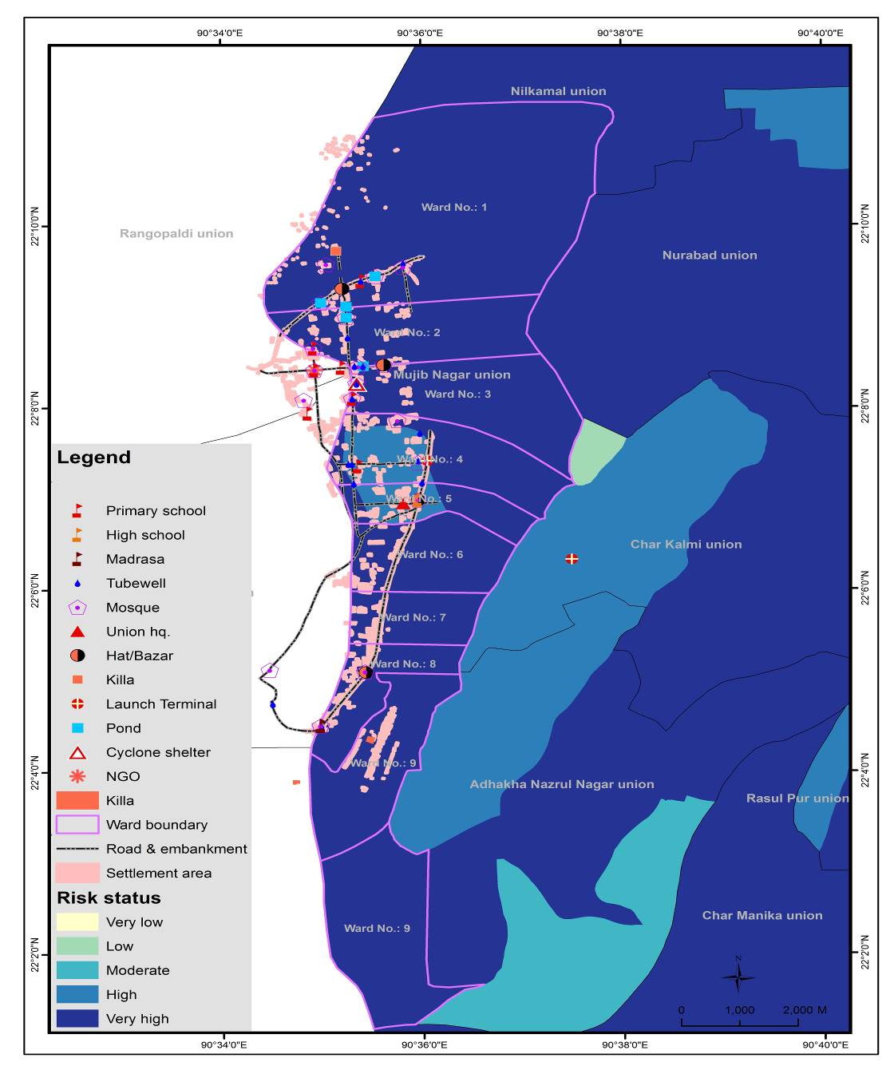
Figure 13 Multi-Hazard Risk scenario: Baseline (Mujib Nagar Union)
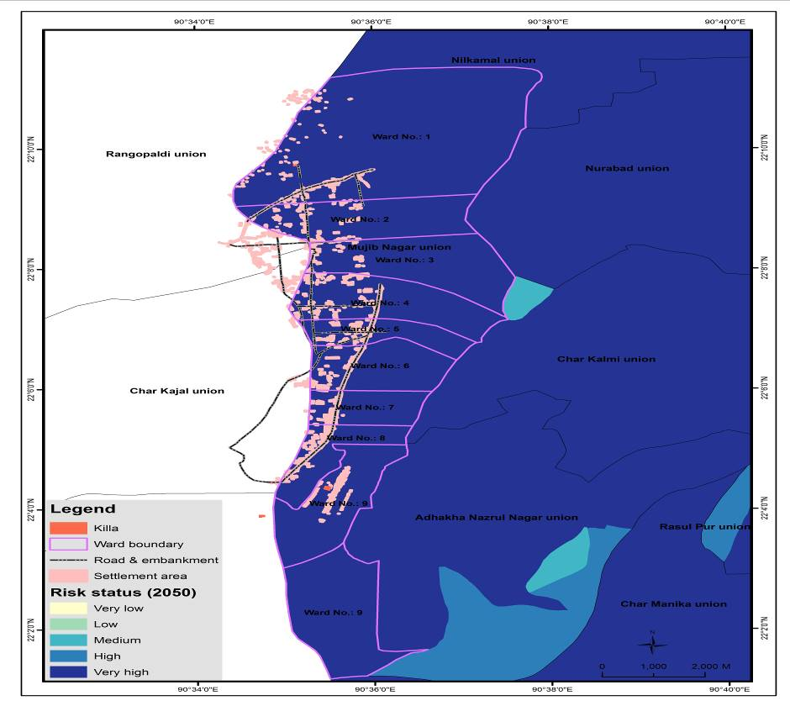
Figure 14 Multi-Hazard Risk Scenario: 2050 Prediction based on Climate Change Indicators (Mujib Nagar Union)
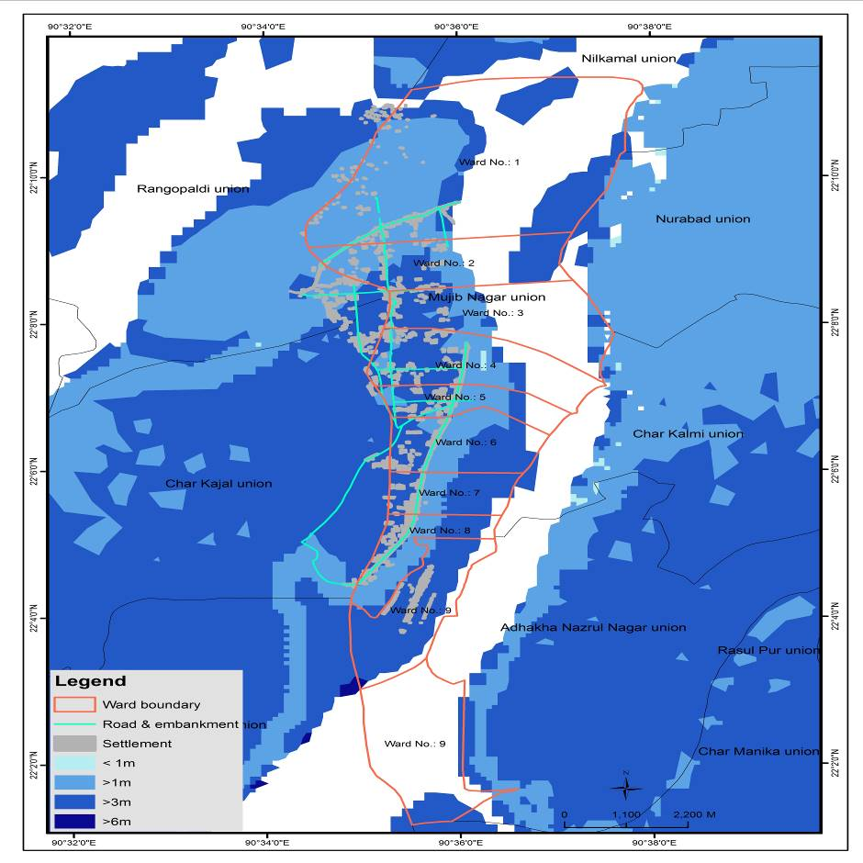
Figure 15 Storm Surge Risk Scenario: Baseline (Mujib Nagar)
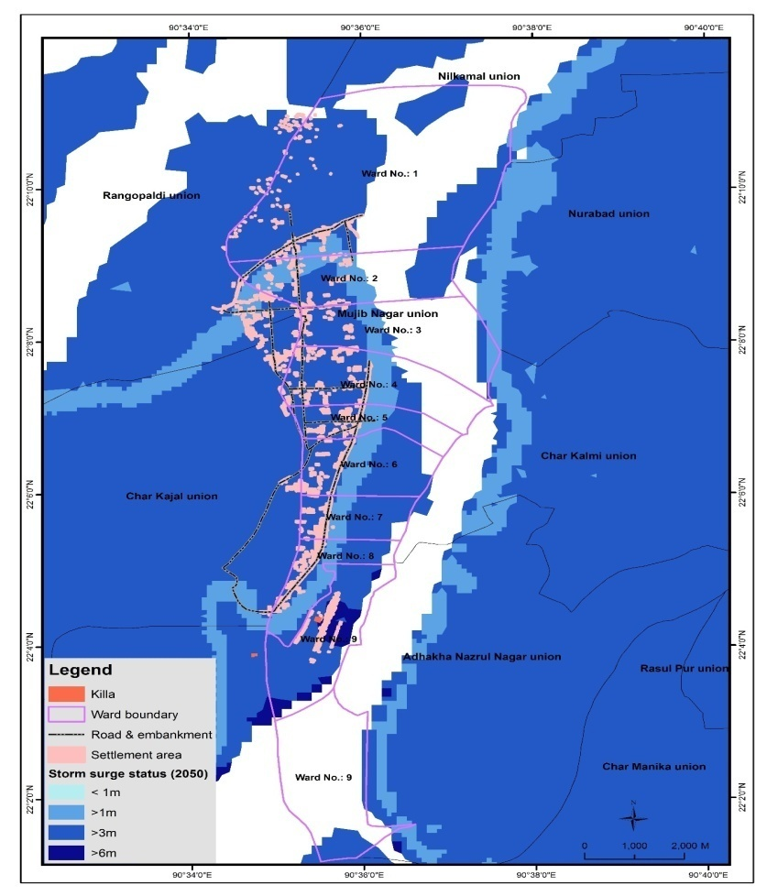
Figure 16Storm Surge Risk Scenario: 2050 (Mujib Nagar)
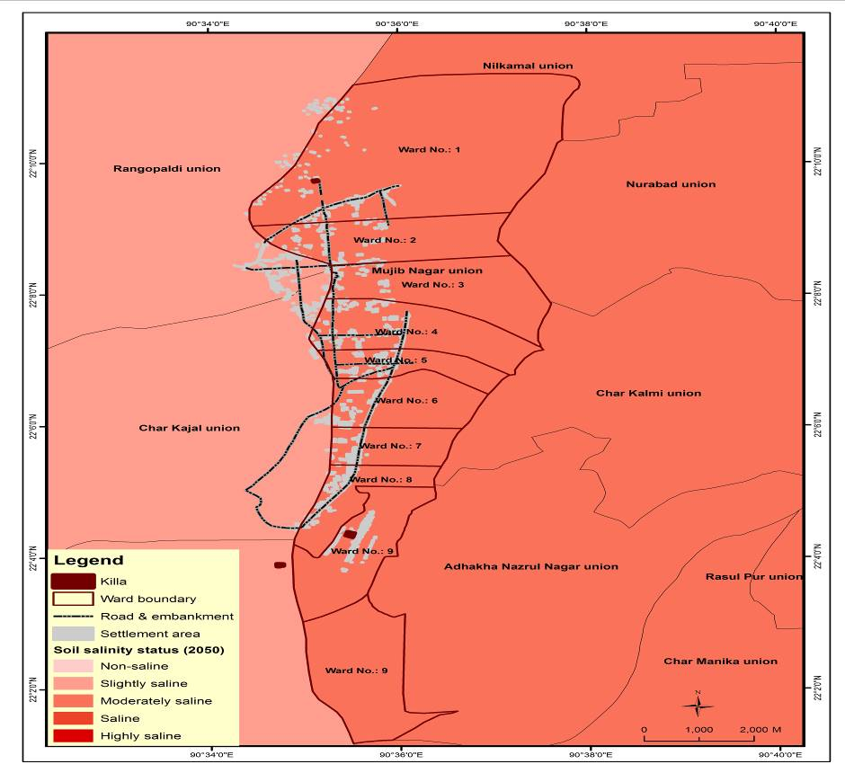
Figure 17 Salinity Risk Scenario: Baseline (Mujib Nagar)
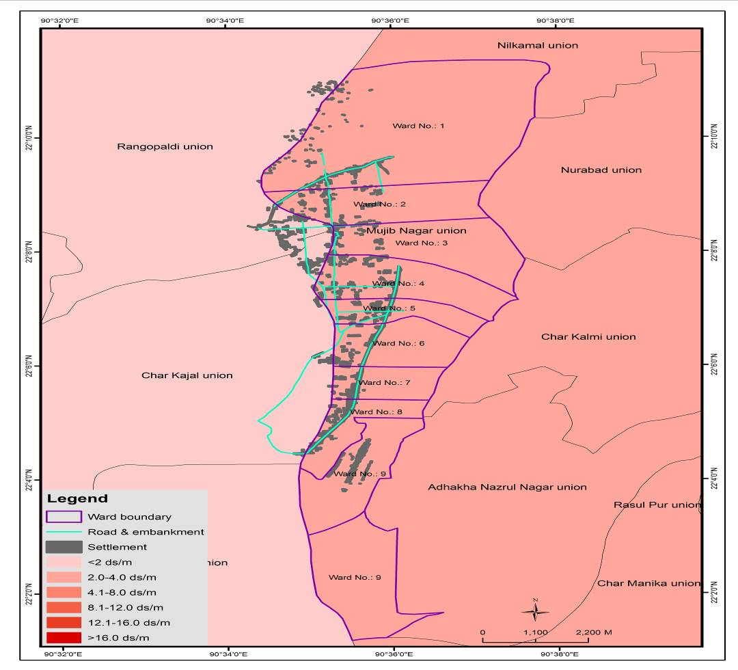
Figure 18Salinity Risk Scenario: 2050 (Mujib Nagar)

Laxmitary Union, Upazila: Gangachara
The table 2 quite clearly illustrates the vulnerability of the different sectors as observed in the Upazila of Gangachara.

The Flood Exposure map for the baseline situations shows that currently the most vulnerable wards are clearly 1, 6 and 8 with parts of 2 and 3 also being affected by flood levels of up to 0.9m. However, looking at the 2050 scenario considering the impacts of climate change it is evident that the risk increases for the whole of the union with 2 and 3 becoming more vulnerable and the currentlysafe ward 9 becoming a high-risk area. It is important to note here that the entire Union itself is susceptible to flood levels of 0.3m height. To put the situation into context with an example, the rather dense patch of settlement in ward 2 was found to in an F2 flood status zone in 2050 while being in an F1 zone for the baseline situation.

The integrated risk scenario for Lakhsimitari Union (baseline) shows the entire union to be a high-risk region considering the vulnerabilities and the risks associated, after they have been multiplied by their respective weights for the calculation of integrated risk (see figure 16). Looking at the 2050 scenario after consideration of the impacts of climate change, it appears that Wards 1 to 3 will no longer be exposed to high risk with the other wards of Lakhsmitari being more exposed to risk. The impacts of Climate change seem to aggravate the baseline situation in Wards 8 and 9 from high-risk exposure to very high-risk exposure.

Another problem in Gangachara Upazila is drought. A studyshowed that drought scenarios are now a day’s more frequent than the past. This is due to the lack of precipitation and high rate of evaporation in the dry season. The present period of drought is longer in extending than the past ones. Unstable weather situation has been reported as the causes of the situation. The drought situation is not very severe but is of moderate intensity and interrupting agricultural activities and threatening the food security of the entire country.

Normally from late October to March is being considered as the drought periods by the native peoples of the study area. If proper measures are not taken, drought scenarios may become worse in the near future. A research showed that there is an increasing trend of annual average maximum temperature in Rangpur which may turn agricultural lands into barren lands in future. Increasing trend in maximum temperature stimulating high evaporation as well as uncertainty of trans-boundary water movement is found to be strongly influencing the depletion of surface water level. These circumstances are making North-western region more vulnerable towards drought. Drought degrades fertility and moisture contents of soil which leads to the use of additional fertilizer and irrigation to maintain soil quality for cultivation. As a result, input costs are also expected to increase. Increasing input costs along with lesser soil fertility will cause less productivity of soil and thus will reduces benefits of the farmers in the region. As a result, farmers will become financially more vulnerable. Less production due to drought in the north-western districts may also influence the market price for food grains, and cause food insecurity among the poor and ultra-poor people of the country.

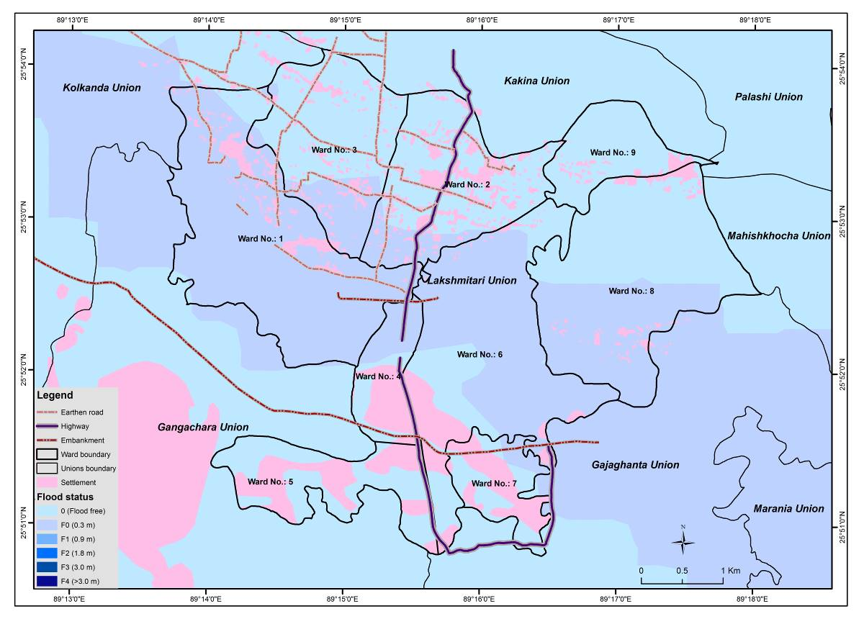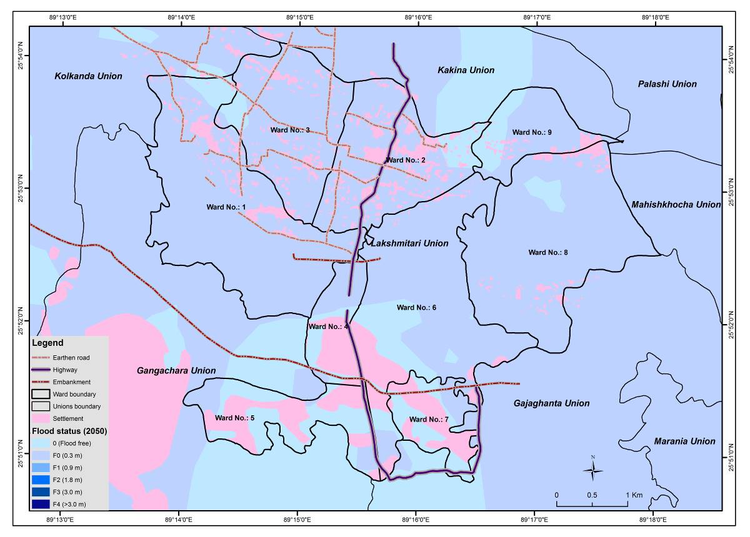
Figure 19Top: Flood Exposure Map for Lakhsmitari Union (Baseline),
Bottom: Flood Exposure Map for Lakhsmitari Union (2050)
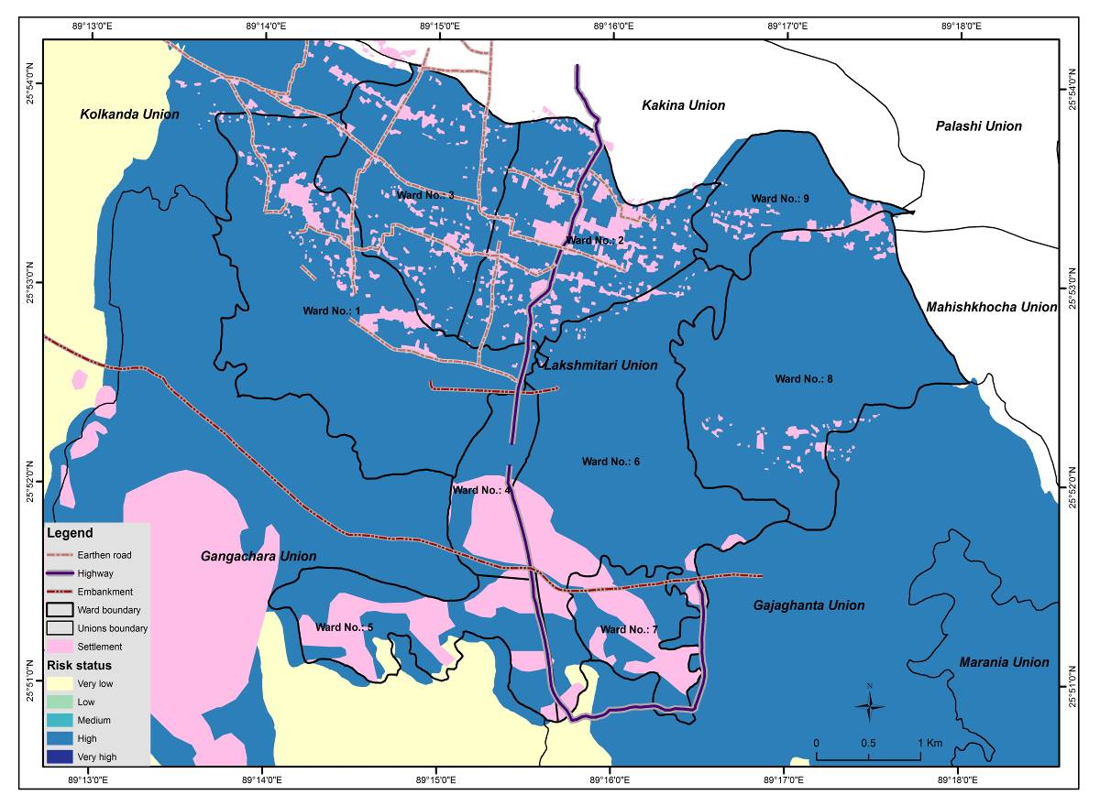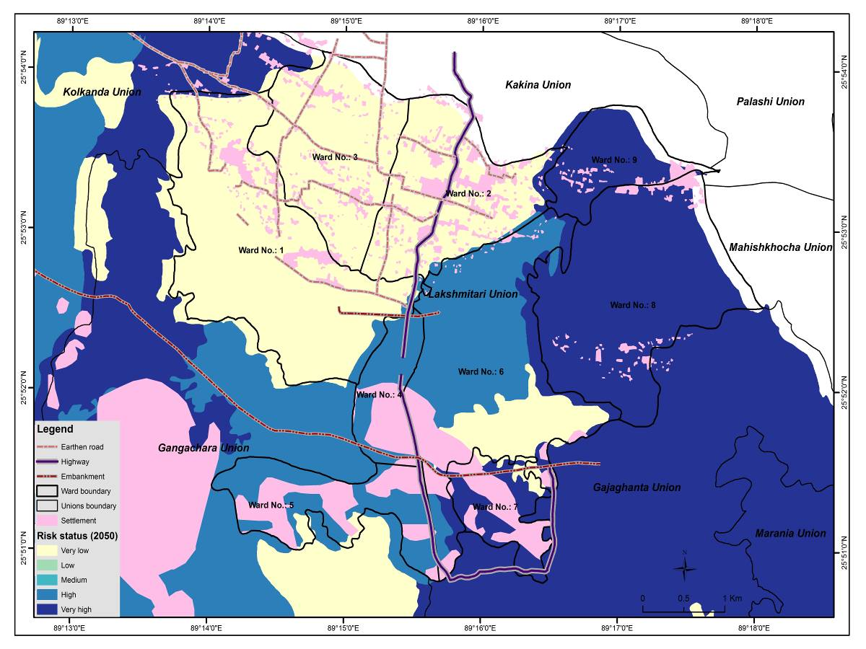
Figure 20Integrated Risk Exposure Map for Lakhsmitari Union (Baseline),
Bottom: Integrated Risk Exposure Map for Lakhsmitari Union (2050)

Table 4 Table Showing the Sector wise Vulnerability ranking for Gangachara Upazila, and associated weights for calculation of the Integrated Risk
Hazard Type | Physical vulnerability |  |  |  | Social vulnerability |  |  |  |  |  | Economical vulnerability |  |  |  |  | Environmental vulnerability
Hazard Type | Density | House type | Road Network | Total Physical | Household Size | Young dependents | Elder dependents | Illiteracy rate | House ownership | Total Social | Agricultural Land | Unemployment rate | Income Diversity | Electricity Coverage | Total Economical | Water Supply | Sanitation | Total Environmental
Expert Ranking (Average)
Flood | 7.14 | 7.14 | 7.43 |  | 6.57 | 8.00 | 6.86 | 5.71 | 5.43 |  | 8.29 | 6.86 | 6.29 | 6.00 |  | 8.00 | 7.43
Storm Surge | 6.86 | 8.00 | 8.29 |  | 6.86 | 7.71 | 8.00 | 5.71 | 7.14 |  | 8.57 | 8.00 | 7.14 | 6.57 |  | 9.14 | 8.29
Salinity | 5.71 | 2.29 | 2.29 |  | 4.29 | 4.57 | 4.00 | 3.71 | 3.71 |  | 8.29 | 5.43 | 6.00 | 2.29 |  | 8.86 | 4.00
Drought | 0.00 | 0.00 | 0.00 |  | 4.29 | 4.57 | 4.29 | 3.43 | 3.14 |  | 8.57 | 5.71 | 5.71 | 2.57 |  | 2.43 | 4.00
Individual Weight
Flood | 0.33 | 0.33 | 0.34 | 0.22 | 0.20 | 0.25 | 0.21 | 0.18 | 0.17 | 0.34 | 0.30 | 0.25 | 0.23 | 0.22 | 0.28 | 0.52 | 0.48 | 0.16
Storm Surge | 0.30 | 0.35 | 0.36 | 0.22 | 0.19 | 0.22 | 0.23 | 0.16 | 0.20 | 0.33 | 0.28 | 0.26 | 0.24 | 0.22 | 0.28 | 0.52 | 0.48 | 0.16
Salinity | 0.56 | 0.22 | 0.22 | 0.16 | 0.21 | 0.23 | 0.20 | 0.18 | 0.18 | 0.31 | 0.38 | 0.25 | 0.27 | 0.10 | 0.34 | 0.69 | 0.31 | 0.20
Drought | 0.00 | 0.00 | 0.00 | 0.00 | 0.22 | 0.23 | 0.22 | 0.17 | 0.16 | 0.40 | 0.38 | 0.25 | 0.25 | 0.11 | 0.46 | 0.38 | 0.62 | 0.13
Integrated Weight
Multihazard Multi vulnerability | 0.17 |  |  |  | 0.34 |  |  |  |  |  | 0.32 |  |  |  |  | 0.16

FEASIBLE ADAPTATION OPTIONS
The project will be built on extensive knowledge in community engagement to apply participatory methods developed by the team to enhance the effectiveness of outcomes and inclusiveness of those most disadvantaged. The proposed approach will integrate ecosystem-based adaptation, adaptive agro-ecology, and community-based adaption measures to address risks and vulnerability associated with climate change. The project components are designed to reduce risk to flooding and adverse impacts of flood and droughts which will help to reduce anticipated costs that will recur during future scenarios of increasing climate change disasters.

As the char areas are particularly prone to the effects of frequent climatic shocks, this increases the precariousness of poor people’s lives by wiping out their assets and pushing them deeper into poverty. Higher frequency and duration of cyclones and hidden sandbars hamper the major livelihood systems in coastal char lands. During cyclones, the sea becomes turbid and makes it difficult for the fishermen to locate sandbars, hence causing their boats to crash. The dependence on limited and seasonally variable natural resource access also limits their ability to adapt. The availability of cultivable land decreases during coastal flooding and prolonged periods of droughts in the study areas lead to the char dwellers having low incomes or complete loss of income. The major livelihood of the char dwellers is agriculture which is affected by tidal or monsoon flooding, hailstorm, cold waves, heat waves, erratic rainfall etc. which leads to decline in crop yield, crop damage and ultimately causes a loss of agricultural production.

Incremental adaptation processes proposed for this project include strengthening the damaged houses through retrofitting in some areas to reduce exposure to flooding and storm surges. The people living the Char lands have to spend a significant amount of money whenever they are hit by a climatic disaster like flood, storm surge, cyclones, etc. Strengthening the damaged households will require a higher initial cost but in the long run it will be more sustainable to climatic impacts. If the houses can sustain during disaster, then it will protect the occupants as well as reduce the cost for repairing house after every disaster. Another option can be building cluster houses by comprising 4-5 households. These houses will be built in an elevated platform above the average flood level and will include all the basic needs like safe water supply, sanitary latrine, energy source etc, Also, the houses can be used to provide shelter for nearby families in times of disaster.

It is recommended that particular emphasis be placed on: i) adapt climate resilient agriculture practices; ii) installing improved sanitary latrines; iii) installing rainwater harvesting; iv) developing renewable energy options like community based nano-grid. The proposed areas are highly vulnerable to climatic disasters which possess a negative impact on agriculture. As majority people living in the Char lands depend on agriculture, they have to go through a loss of livelihood when a massive disaster strikes. Introducing climate resilient agricultural practices will help to adapt with the changing climate and protect their agricultural produces. This will ensure sustainable livelihood and improved economic. Introducing alternative livelihood options that are not affected by the impacts of climate change could be a source of sustainable income for the people living in the char lands. This type of initiative will help them to cope up with the damages caused by climatic disasters.

By assessing the adaptation needs and carrying out the necessary infrastructural development, vulnerability to the impacts of climate change can be minimized. Riverbank protection by repairing the existing embankments and constructing new embankments could minimize the climate-induced impacts upon human settlements at the char lands. It will also minimize the agricultural damage due to flood.

Development of climatic hazard maps and risk scenarios and strengthening local level climate information and dissemination framework could increase the adaptive capacity of the vulnerable population to anticipate the risk, absorb the impacts and prepare to respond accordingly. This system would deliver climate risk information to reduce exposure and increase the resilience of char dwellers to slow and sudden onset of climate extremes.

Establishment of emergency medical service like floating ambulance during disasters curriculums would act as a method of transformative adaptation. Also incorporating awareness raising activities would help them prepare for proper response strategies during and post-disaster periods. These floating ambulances could be made mobile by incorporating them into water vessels thereby increasing their utility as a disaster management module.

The expected outcomes from few activities would lead to reduction in exposure during flood and surges and increased land protection, paving the path to deal with future disasters with lesser monetary involvement. Also, the inclusion of vulnerable segment of the community such as ultra-poor women for finalizing design, operation and maintenance, monitoring and evaluation of the project would incorporate local knowledge as well as trainings in the CBO would also help to increase cost effectiveness. By implementing this project in a community-driven and participatory manner, the impact of the project will contribute to greater abilities of local communities to ‘bounce back’ from climatic extremes. Training and capacity building of farmer-led cooperative would allow crop diversification with modern equipment and technology and establish community agricultural market, thus avoiding extra costs to start up the community from scratch post disasters.

Other components like Improved Climate Information Systems combined with preparedness and integrated adaptation measures, would be more effective to tackle hazards, than reactive response measures. Strengthened local level climate information and dissemination framework to be implemented in the study areas under this project will build on experiences gained elsewhere in the country, harnessing and further strengthening expertise and capacities of the communities to deal with disasters. Knowledge Management & Research and Capacity Building and Institutional Reformation would involve developing climatic hazard maps and risk scenarios in the study area which would keep the communities up-to date with risk scenarios and dissemination of lessons learned from meetings and trainings would also reduce vulnerability.

Developmental evaluation which is iterative and flexible will be used to accelerate learning, enhance locally-based innovation and encourage step changes in flood resilience practices. Design expertise will help develop a strategy with partner organizations and National policy makers for deploying innovations at scale.

Figure 21 Feasible Adaptation Options

Annex I. Gender Assessment

Introduction
Bangladesh is a developing nation with almost half of the population being women who are involved in agriculture and economic activities. As such women bear significant share of contribution to development. Therefore, the impending impacts of climate change particularly the increasing frequency and intensity of extreme climatic events affecting agriculture, water resources and the livelihoods of poor women not only impede the development activities, but also exerts direct vulnerability to women.

Being the primary victim of climate change impacts, women can play a central role in adaptation to climate change. Women also could play a key role in mitigating climate change by optimizing energy efficiency, using low-footprint energy sources and’ techniques, and influencing a household’s and community’s consumption patterns. Therefore, when it comes to decision-making and implementation towards building resilient communities in the face of climate change, the full and meaningful participation of women become essential.

The impacts of climate change affect women more compared to men. Women living in the char are highly dependent to locally available natural resources to meet the daily needs of their families. Also, they face water, sanitation and health challenges due to unfavorable climatic conditions. For example, salinity intrusion causes unavailability of drinking water, health issues by creating itching problems, high blood pressure, loss of agricultural products, etc. On the other hand, drought can cause scarcity of drinking water, heat strokes, burning of crops, etc. Women bear the burden of fetching water for their families and spend significant amounts of time daily hauling water from distant sources. The water is rarely enough to meet the needs of the household and is often contaminated, such that women also pay the heaviest price for poor sanitation. Moreover, damage of sanitation systems creates sufferings for women. Lack of toilet facilities increases physical insecurity for them. Many women refrain from using the toilet during the day and consequently suffer from urinary tract infections. Pregnant women, lactating mothers and differently disabled women suffered the most, as they found it difficult to move before and after the cyclone hit.

Women can, however, play a central role in adaptation to climate change. In Nepal, women farmers
avoid crop failure in the face of changing weather patterns by growing off-season vegetables and bananas, which are more resilient to flood and drought. Gender-blind adaptation programs are potentially harmful to development; as they have a propensity for exacerbating existing inequality. Conversely, gender assessmentsarenecessary for successful gender mainstreaming and is a prerequisite for ensuring equal access tocommunity-based adaptation initiatives. Assessing the implications for women and men of any proposed intervention requires a strategy sothat women and men benefitequally. The ultimate goal isto achieve gender equality and for this, the followings are required-
- Climate change impact assessment (from bothmale and female perspectives)
- Gender-sensitive indicator development and design and implement components by incorporating a gender perspective
- Set activities to increase female participation
- Specific attention paidto gender differences in terms of capabilities to cope with climate change adaptation initiatives

This project has evaluated the impacts of climate change from both male and female perspectives in both offshore island and riverine char areas. Limited or no access to health care infrastructure inadequacy, lack of water and sanitation facilities, as well as lack of secured livelihood and income had made the condition of both men and women more vulnerable, however, these impacts affect women more than men. Furthermore, these lead to both areas experiencing socio-economic problems causing poverty, unemployment, child labour, early marriage, migration, educational instability, social unrest and finally psychosocial problems that ultimately increase the difficulties experienced by the inhabitants of these chars. From the field visit, it has been found both coastal and riverine chars are facing school dropout, which is ascribed mostly to remoteness from the mainland. As a result, in both chars, due to educational drop out, female students are getting married at an early age. The early marriage of young girls, in turn, causes health hazards. The rate of maternal and child mortality are high in these areas. During the post-disaster period, women and children suffer from several diseases and one of the major reasons is the lack of water and sanitation facilities.

Gender mainstreaming in the proposed intervention (Proposed Action Plan)
This assessment provides an overview of gender inequality in offshore islands and riverine char lands, identifies gender issues relevant to the proposed interventions, as well as ensure and examine potential gender mainstreaming opportunities of the components of the proposal. The assessment is based on a field visit conducted by the Centre for Climate Change and Environmental Research (C3ER).

The proposal contains four components, which all incorporate gender considerations. Component 1, in particular, will include a strong gendered focus on supporting women-led households, improve gender equality and social inclusion. The other three components will also include gender-sensitive planning that responds to gender differences and identifies opportunities and reduces and places emphasis on women’s vulnerability. For instance, component one comprises of: i) plinth raising and house strengthening for reducing flood/storm surge exposure; ii)community-level nano-grid facilities; and iii)household-level rainwater harvesting options implemented for safe drinking water supply, which will all improve the health and well-being of women and children. It is apparent from the field study that, women and children are the most vulnerable and are likely to be affected more by the impacts of climate change. All other components such as climate information system, knowledge management & research and capacity building and institutional reformation involve activities that increase the capabilities to cope with climate change adaptation. Training and capacity building program for the CBOs/WMOs on disaster emergency management, climate change adaptation, first aid, as well as capacity technical workshops on the establishment, use, and maintenance of climate early warning system, including the interpretation and application of tailored climate information services, targeting community members as well as women and children to enhance their capacity to address their adaptation deficit.

The component 2 of the proposed interventions are designed by including a gender perspective and the activities of this component are clearly set to develop the resilience of the women by ensuring their livelihood, health and by increasing their capacity. The raised platform cluster houses will provide better security to women in times of flood. Also, it will ensure improved water supply and sanitation for them. They will also be able to do homestead gardening which will enhance their economic capacity. Moreover, women can actively take part in embankment management activities. Elements of component 2 and component 3 are designed specifically to address the most pressing issues facing women in the project target areas, which include limited access to alternative livelihoods and provision of health services. These components will enhance the ability of women to influence their livelihood strategies by a) increasing livelihood and income generating opportunities b) increasing the sustainability of livelihoods; c) ensuring access to skills building for beneficiaries on non-climate sensitive livelihood diversification; and d) ensuring the provision of public health services for the most vulnerable rural inhabitants.

Alternative livelihood options are assessed, designed and implemented in the participation of the ultra-poor women for non-climate sensitive livelihood (e.g., sewing, livestock rearing, shop, poultry) through training and the provision of material to support livelihood diversification and income risk reduction. Training and capacity building of the beneficiaries on non-climate sensitive livelihood diversification and income protection will be delivered.

The floating ambulance will provide service to women during emergency especially for pregnant women. The floating ambulance will have provision for child delivery. Also, it will have an intensive care that will be able to give support to babies for a few days until better treatment is arranged. Other primary treatments and necessary medicines for women will be also available in the floating ambulance. This will help to ensure better health for mother and children.

The natural cold storage and solar powered irrigation pump will help to improve agriculture in the study area. Women will be also involved to use and maintain these facilities which will increase their capacity. Also, agricultural improvement will led to better food security that will help to ensure better health and nutrition for women.

Review of Relevant Policies and Documents
The first definitive action regarding climate change came in 1992 at the UN Conference on Environment and Development held in Rio de Janeiro. The United Nations Framework Convention on Climate Change (UNFCCC, or, Convention) was established at the conference which came into force in 1994. Finally, 192 countries signed and ratified the Convention and are called Parties (192 in number). In 1997, the Kyoto Protocol (KP) was signed which came into effect much later in 2005. This protocol is a legal instrument under which industrialized countries committed themselves to lower emission on an average of 5% below the 1990 level. The first commitment period ended in 2012. The KP has three primary market-based instruments to lower emission. In COP7 in 2001, the first decision was taken to integrate a gender-sensitive approach mandated that national adaptation programs of action be guided by gender equality.This section assesses the indicators of gender sensitivity of the key national policies and the policy consideration by adaptation fund.

Bangladesh prepared the Bangladesh Climate Change Strategy and Action Plan (BCCSAP) in 2008 and revised it in 2009. This is now an approved document of the Government. This is expected to be the blueprint for subsequent integration of climate change issues such as mitigation, adaptation, technology transfer and development, and capacity building into the mainstream planning process. The serious consequences of climate change, including especially the consequences for Bangladesh, lead naturally to the question of what should be our response. Two types of response need to be considered. The first relates to adaptation, and the second relates to mitigation.

A review of how gender is addressed in the Bangladesh Climate Change Strategy and Action Plan (BCCSAP) was carried out by the German international cooperation agency (GIZ) in 2012. The review noted that of the 44 BCCSAP programs, only four mentioned gender specifically. Also, the BCCSAP does not refer to women as actors in addressing climate change. The Asia Foundation (2014) noted that BCCSAP considers gender issues on the basis of specific programs. However, specific attempts to integrate or mainstream gender across all sectors and programs are not made. For example, of the nine programs with 29 activities under the BCCSAP theme “Food Security, Social Protection and Health,” only one activity has a specific linkage with “women and gender relations,” in which a comprehensive study is planned to assess the impact of climate change on women and gender relations and to develop recommendations to address these in all actions under the BCCSAP.

Bangladesh is one of the few countries that developed the National Adaptation Plan to action (NAPA) to climate change (2005) up to November 2009. Through the NAPAs, the UNFCCC recognizes that men and women have different roles in securing livelihoods in the developing world. The action plans include gender in a more comprehensive manner throughout the document. It was recognized in the NAPAs that climate change experience will vary by people depending on their gender, poverty levels and their location (coastal or non- coastal, rural or urban). The NAPA identified poverty reduction and security of livelihoods with a gender perspective as the most important set of criteria for prioritization of adaptation needs and activities.

The objective of the Bangladesh Climate Change and Gender Action Plan (2013) is ‘to mainstream gender concerns into climate change-related policies, strategies and interventions ensuring access to, participation in, contributions towards and benefits for the diverse group of stakeholders for the sustainable and equitable development of Bangladesh.’ The initiative to prepare a BCCGAP in Bangladesh was taken in 2012 by the MoEF, and it was released in November 2013 after extensive consultations with representatives of ministries, universities, civil society and development practitioners, and a thorough review of relevant national and international policies and documents. Gender considerations were integrated into four of the six main pillars as identified in the BCCSAP by the BCCGAP: a) food security, social protection and health; b) comprehensive disaster management; c) infrastructure and d) mitigation and low carbon development. The remaining two pillars of the BCCSAP- research and knowledge management and capacity building and institutional strengthening, were mainstreamed within the above four pillars throughout the document as cross-cutting topics. Clear objectivesoutlines substantive activities that are accompanied by reachable indicators were established in the BCCGAP. The objectives, activities and indicators were done within the domain of the four pillars highlighting the specific contribution women do and can make within each of these as well as the required interventions necessary to incorporate the role of women effectively over a timeframe of five years, from 2013/14-2018/19.

The Ministry of Environment and Forestry (MoEF) is reviewing the National Environmental Policy (1992) and the draft National Environment Policy 2013 has incorporated women’s roles and right to benefits.

Although the National Forest Policy (1994) states that ‘Women will be encouraged to participate in homestead and farm forestry, and participatory afforestation programs’, it does not provide specific directives to achieve the stated goal or set out other gender-specific goals (e.g. decision-making relating to forests and forest resources). The Forestry Sector (Amendment) Rules 2009 address gender issues, according to the 2014 national report on the implementation of the Beijing Declaration and Platform for Action (1995).

In the consultation process for the Country Investment Plan (CIP) for agriculture, food security and nutrition (2011) included engaging with women farmers and the Ministry of Women and Children Affairs (MoWCA). Gender is articulated throughout the CIP.

The National Women Development Policy (2011) briefly promotes women’s role in environmental management and the importance of ensuring facilities for and the security of pregnant women in the event of natural disasters. However, the Asia Foundation noted in one of their survey’s respondents indicated that National Women Development Policy missed an opportunity to highlight climate change-related risks for women.

The Department of Environment has drafted their gender policy in 2016 to promote gender equality. The purpose of this policy is to mainstream gender issues in the development process of the Department to enhance participation of women and men for the sustainable and equitable way. This policy is designed to improve the performance of DoE in an effective way with skills, talents and opportunities for both women and men. The objective of this policy document can be categorized into two parts. One is the organizational Objectives and Measurable Outputs, and the other one is capacity Development Objectives and Measurable Outputs. The principles are equity and equality, empowerment, management and governance, working environment. Ensuring equal rights, heading towards an increase in the degree of autonomy and participation in managerial and decision-making position, anticipating all forms of harassment are the focus points of these principles. DoE’s draft Gender Policy in line with National Women Development Policy, 2011. The policy will cooperate with Government’s relevant rules and regulation in order to integrate gender equity goals and objectives into its entire organizational processes and structures taking the policy principles as an outline for implementing and applying the policy. The ultimate goal of this policy is to eliminate all the discrimination against women. To attain this goal, specific strategies were followed including awareness raising initiatives,women’s participation in top-level positions and providing technical and financial resources for implementation of the policy.

The vulnerabilities and needs of women are far from being mainstreamed into climate change policies and operational activity in Bangladesh. Lack of effective proactive policies is another major weakness. Policies may acknowledge the particular vulnerabilities of women, but do not necessarily have any operational planning to address the vulnerabilities. Multi-sectoral responses and collaborations to address climate change, and policies relating to disaster preparedness and response, livelihoods and health care may consider integrating gender issues into priorities (Shabib and Khan 2014). Safety and security of children, elderly people and people with special needs during the disaster and post-disaster period mostly depend on women. Hence, adaptation strategies need to bolster women’s capacities, power, and social resilience. Moreover, there is a need for engagement of both women and men from a gender perspective in development and implementation of climate change related development projects.

The national policies recognize the importance of women in climate change adaptation and promotes their participation in different activities. This project is well aligned with the national policies as it highly promotes activities that will benefit both men can women equally. The project not only aims to fulfill the basic needs and safety of women in vulnerable areas, it also emphasizes on capacity and knowledge building of women so that they can equally participate in different activities like men. Including women in all the activities will further enhance the sustainability of the project.

Annex J. Environmental Impact Assessment (EIA) with Environmental Management Plan

The interventions of the proposed project could potentially have some significant impacts on the natural environment and the people living in the area. For this reason, proper environmental assessment and an environmental management plan (EMP) are essential to mitigate environmental risks. This document provides the initial environmental assessment for the project, as well as an environmental management plan. It should be read in conjunction with the relevant sections of the Project Document, namely Part II Section J: Overview of environmental and social impacts and risks; Part III Section C Environmental and social risk management; and Annex D – Social and Environmental Screening.

This document presents possible impacts of the project, mitigation, enhancement, contingency and compensation measures, an EMP, and an institutional framework for implementing the EMP. This will serve to comply with the Adaptation Fund’s environmental safeguard policies and with the Government of Bangladesh’s laws and policies. The EMP will contribute to ensure environmental sustainability by:

- Preventing and/or mitigating any negative environmental impact that may emerge from the rehabilitation and improvement of embankments;
- Enhancing environmental outcomes of the activities through proper implementation of the Environmental Management Plan;
- Ensuring the long-term sustainability of benefits from afforestation, and community environment management plan by securing the natural resource base on which they are dependent; and
- Laying the groundwork for establishing an environmental management system (EMS) to achieve continuous improvement in environmental performance of the polder system from construction to operation and maintenance.

Categorization of Interventions
Pertinent environmental concerns and screening for the design and implementation of development projects in Bangladesh is guided by the Environment Conservation Act 1995 and Environment Conservation Rules 1997. The Environmental Conservation Rules (1997) classifies industrial units and projects into four groups by location, size and the severity of potential pollution: (i) Green, (ii) Orange A, (iii) Orange B, and (iv) Red.

Green Category projects are considered relatively pollution-free and hence do not require initial environmental examination (IEE) and EIA. Red Category projects would cause significant adverse environmental impacts and are, therefore, required to submit an EIA report. Orange Category projects generate low to medium impacts which are mitigable; considering the significance of impacts, Orange A require submitting a process flow diagram and Orange B requires submitting an IEE report.

The Adaptation Fund follows a similar classification, with the main difference being the categorization of projects into three major classes, namely, Category A, B, and C. While Category ‘C’ interventions are likely to have minimal or no adverse impacts, Category ‘A’ interventions are likely to have significant adverse environmental impacts and require the implementing agency preparation of an EIA. Most impacts generated through Category B projects are site-specific, and in most cases, mitigation measures can be designed more readily. Thus, these projects require the preparation of an Initial Environmental Examination (IEE), which is presented in this document and the relevant sections of the Project Document.

The interventions to be implemented under the proposed project do not involve large-scale infrastructure development (e.g., construction of high-rise apartment, sanitary landfill, large-scale wastewater treatment plant, major highways). The water management interventions, i.e., embankment repair, is large scale, but does not involve any new embankments, only repairing existing embankments. Under Bangladeshi law (Environmental Conservation Rules 1997) all water management activities are categorized as “red”, i.e. high risk, by default. However, because this project focus only on repairing and rehabilitating infrastructure rather than constructing any new infrastructure, the interventions under Output 2.2 are classified as Category B under the Adaptation Fund framework, i.e. posing a low risk of causing a moderate and largely mitigatable impact. As the ecosystem-based adaptation approaches are suggested for the water management interventions, the components do not pose a risk of significant adverse environmental impacts, rather likely to cause minor to moderate impacts which are subject to environmental screening that requires preparing an Environmental Management Plan (EMP) with appropriate mitigation measures. Similarly, the proposed cluster house construction is classified as “red” under Bangladeshi law, since the cluster houses will require earth excavation works and will cost more than 10 hundred thousand taka (USD $12,500) each. However, the cluster house construction only pose very local environmental risks, which are not major and can readily be mitigated. Therefore, the cluster house construction activity is classified as Category B in the Adaptation Fund framework. Thus, given negative environmental impacts to be generated from the relatively limited scale and magnitude of construction/rehabilitation works, the proposed Adaptation Fund project is classified as Category ‘B’ project on an overall basis.

Proposed Interventions with Possible Environmental Concern
Most of the embankments of coastal polders were constructed many years back and has subsided naturally and therefore the existing crest level has been reduced from the design level. In addition, some parts of the embankments have been breached by storm surges during cyclones. Therefore, almost all embankments need to be raised and the breaching point should be repaired considering the present and future scenarios of cyclone storm surge levels. This will be one of the major interventions under this project. The intervention will involve mainly earthworks. It may need to re-align the existing embankment, to provide additional setback to avoid ongoing bank erosion. This could cause additional disruption to some existing settlements, beyond the strip of land required for raising crest levels.

Environmental Management Process
The Environmental management process in the proposed project will involve the communities in the riverine islands of the Gangachara Upazilla in the Rangpur district and remote coastal islands in the Char Fasson Upazilla in the Bhola district. The project will use the following exclusion list in order to avoid damage or irreversible negative impacts on the environment, and to avoid negative impacts on people:
- No activities to be carried out within 1 km of natural protected areas recognized by national or local governments;
- Any activities that require the conversion of natural habitats (when affecting critical natural habitats and natural land contours, natural habitats for this purpose being those water or land areas where most of the original plant and animal species are still present);
- Land reclamation such as drainage of wetlands (natural pond/ beel/ baor/ haor etc.), or filling of water bodies to create land;
- Activities which would adversely affect cultural property, including archaeological and historical sites;
- Hazardous waste management and disposal as well as manufacture, transport and use of hazardous, and or toxic materials (except small amounts of solvents, degreasing materials, paints, fuels, and the like used during construction).

The proposed project interventions has been designed based on the local contexts, site characteristics, community preference, technical, and environmental considerations. The project does not include any interventions that could have significant, long-term, and irreversible negative environmental impacts. The red category interventions identified above will be subject to detailed environmental and social impact assessments during the initial stages of project implementation, prior to commencement of works.

Assessment of impacts
All orange and red category interventions are subject to an Environmental Screening and Initial Environmental Examination in order to avoid significant negative impact or prevent execution of projects with negative environmental impacts. Although most of the impacts would be localized due to the relatively small scale of the activities, there are some issues of concern that cut across the range of proposed interventions. Such potential negative impacts will be avoided by designing and implementing appropriate mitigation and enhancement measures and following some Environmental Code of Practices (ECoPs) in different phases of planning and implementation.

The project aims to repair the already existing embankments in Mujibnagar Union and no new embankments will be constructed. Therefore, the project will not involve any resettlement or land acquisition, nor long lasting disruptions to the natural environment and human settlements and activities. Excavation of soil material for the embankment crest, in variable and the required width, is done symmetrically on both sides of the existing stone material. After the excavation of soil, filling with the new material is planned together with the construction of a new road base layer by using the same material used for construction of already existing road base. Another intervention of the project will construct cluster houses which will also require land excavation and construction works. This could also result in localised impacts on the surrounding environment. The possible impacts from both embankment repair and cluster houses construction are discussed below:

- Construction Phase

Soil and Water Pollution:
During construction activities, when using machinery, there is a possibility of soil contamination due to accidental spills of oils and fuel from construction machinery. In the area of construction works, construction waste is generated which, if not properly disposed of, may result in adverse impacts. If embankment repair work is carried out next to rivers it can result in temporary sediment pollution of the watercourse.

Flora and fauna:
Embankment repair work near rivers along with the temporary blurring of the watercourse could impact freshwater habitats. Impacts on other habitats are not expected.

Waste disposal:
Demolition debris and excessive soil are usually generated during the rehabilitation works on drainage and flood control systems;

Temporary access roads:
Impacts from temporary access roads and work areas. Establishment of temporary dirt roads to access work areas and temporary dumping sites for excavated materials can increase soil erosion and degrade the landscape.
Noise and Air pollution:
Noise and vibration disturbances during construction and temporary air pollution (dust) related to the transportation of construction materials and truck traffic. These impacts will occur during the construction and rehabilitation works but will be only short-term.

Safety hazards from construction activities:
No major hazards are expected from the construction of the proposed project elements, as long as proper construction practices and safety procedures are applied.

b) Operational Phase

Waterlogging:
Waterlogging can result if regulators and drainage cum flushing inlets/ sluices of many polders may not function properly due to natural sedimentation and poor maintenance of the structures. Also, drainage channels in the coastal polders can be silted up which will also create waterlogging in the area.

Erosion of topsoil and slopes of embankment:
Erosion from soil surfaces results from the kinetic energy of raindrops and flowing water. Raindrops dislodge soil particles, and runoff flowing down-slope can suspend and transport the loose particles. Livestock and human traffic on polders encourage erosion. Holes created by rodents in the polder also increases possibility of soil erosion. Embankment slopes can also be eroded and cause drainage problems if proper erosion control measure are not taken. With the ecosystem-based approach of strengthening embankments with grass / tree planting, as well as the use of geo-textiles there will be a low risk of erosion.

Environmental Management Plan (EMP)
The Environmental Management Plan (EMP) will cover all the red category interventions that will be implemented by the project, namely embankment repair and cluster house construction. This EMP is outlined below and the full EMP will be developed during project implementation. The major components of an EMP include Mitigation Measures, Enhancement Measures/ ECoPs, Estimation of Cost of EMP, Environmental Monitoring, and Institutional Arrangement for Implementation of EMP. Potential mitigation measures as well as ECoPs to be considered in the project are the following:

Construction/repairing of regulator and drainage cum flushing-inlet/sluice: Regulators and drainage cum flushing inlets / sluices of embankments will be rehabilitated under the project to improve the drainage system in the polders. Improvement of these structures will involve mainly civil construction works, installation of equipment and shifting drainage channel (in some cases to rehabilitate the old regulators). The improved structures are to be designed to accommodate higher precipitation and effect of sea level rise on river levels due to climate change.

Drainage channel re-excavation: Drainage channels which will be silted up need to be re-excavated to improve the drainage condition in the polder areas. The major activities for drainage channel re-excavation include dredging and disposal of spoil.

Embankment protection through ecosystem-based adaptation: The tops of embankments not routinely used as roads should be covered with grass. Embankment afforestation for protection of the embankment toe against erosion. The species for plantation should be selected appropriately. Planting of trees on the slopes of the embankment will commence after the completion of earthworks in repaired embankments. The slopes of the embankments can be covered with geo-bags.

Awareness raising and training: In order to raise awareness on environmental issues some workshops will be arranged for the local communities. Also, trainings will be organized for environmental health and safety and environmental assessment and monitoring to ensure further sustainability of the project interventions and provide better protection to the community.

Estimation of Cost of EMP
The environment specialist of the project implementing agency will estimate the cost of the environmental mitigation and enhancement measures and will incorporate with the tender document. Many of the activities to be carried out as a part of EMP would not involve any additional direct cost, e.g., employing the local workforce, where appropriate; keeping sub-project vehicles in good operating condition; good housekeeping, avoiding spills; prohibiting the use of fuelwood for heating bitumen; etc. On the other hand, some activities would require additional cost. Table 4 provides an indicative budget for the EMP and environmental management. For example, environmental monitoring during both construction and operational phases would involve direct cost. Certain mitigation measures (including health and safety precautions) will be covered as part of overall construction expenses in the project budget; these include temporary sanitation facilities, health and safety signs, awareness pamphlets, water sprinkling on aggregates and unpaved surfaces, plantation, and protective gear.

Table 5: Indicative cost for environmental management and training
Intervention/Mitigation  /Enforcement/Training | No. of Unit | Unit Cost (USD) | Total cost(USD) | Funding Source | Responsibility
Environmental Mitigation and Enhancement

Construction/repairing of regulator and drainage cum flushing-inlet/sluice | LS | LS | 87,000 | Government of Bangladesh | PMU, contractor, residents
Drainage channel re-excavation | LS | LS | 35,000 | Government of Bangladesh | PMU, contractor, residents
Embankment protection through EbA | 15.5 km | 12,400 | 192,200 | Adaptation Fund | PMU, contractor, residents
Environmental Awareness and Training

Environmental awareness sessions | 10 | 250 | 2500 | Adaptation Fund | PMU, residents, consultants
Training on environmental health and safety | 10 | 500 | 5000 | Adaptation Fund | PMU,  consultants
Training on environmental assessment and monitoring | 6 | 500 | 3000 | Adaptation Fund | PMU,  consultants

Environmental Monitoring and Audit

EIA | 2 | 10,000 | 20,000 | Adaptation Fund | PMU
Environmental monitoring | 54 person days | 75 | 4050 | Adaptation Fund | PMU,  consultant, residents, contractor
Water quality monitoring (PH, turbidity, hardness, Cl, TDS, Mn, As, Fe, TC, FC) | 10 samples | 105 | 1075 | Adaptation Fund | PMU,  consultants
Air quality monitoring (SPM, PM10) | 4 samples | 200 | 800 | Adaptation Fund | PMU,  consultants
Noise level monitoring (Equivalent noise level(dBA), L_{eq}, Max Noise level(dBA), L_{max}) | 4 samples | 268.75 | 1,075 | Adaptation Fund | PMU,  consultants

Environmental Monitoring
Environmental monitoring provides a systematic review of planning, implementation and operation of sub-project interventions and their mitigation measures to ensure that environmental concerns are addressed, environmental assets are protected, and quality is enhanced. The implementing agency Environment Specialist, PMU, Consultants, and the community will be responsible for conducting the environmental monitoring. Throughout the implementation, the project will conduct three types of monitoring: 1) compliance, 2) community, and 3) effect monitoring.

The implementing agency will conduct a Compliance Monitoring at the construction stage to check whether Environmental Mitigation Measures or Environmental Code of Practices (ECoPs) suggested in the design phase are being followed and implemented properly. Community monitoring will be conducted by the residents or community people who reside at the project site. They will monitor various environmental issues at the both construction and post-construction stages that would cover two specific aspects: 1) Compliance of mitigation measures and 2) Effectiveness of the proposed interventions. The implementing agency and other appropriate authority (if applicable) will be responsible for effect monitoring. During the effect monitoring, they would check whether interventions are functional and served their intended purposes.

Table 6: Environmental Monitoring System
Interventions  /Monitoring Issues | Monitoring Site/ Area | Monitoring  Parameters/  Indicators | Types of Monitoring | Responsibilities
Housing &Community Complex | Project site | Land filling material, water logging, dust, air pollution, noise, traffic, vegetation coverage, | Compliance, Community, and Effect | Consultant, Contractor, Municipality, Community
Water supply | Project site | water quality, arsenic, coliform, GW level, water logging | Compliance, Community, and Effect | Consultant, Contractor, City Corporation/Municipality, Community
Pathways/road | Project site, surrounding area | Noise pollution, dust, water stagnation, potholes, | Compliance, Community, and Effect | Consultant, Contractor, Municipality, Community
Solid waste management | Project site, surrounding area | No. of HH waste managed properly, odor from bin, drain clogging, | Compliance, Community, and Effect | Consultant, Contractor, Municipality, Community
Demolishing of cultural heritage | Within 1 km of project site | No. of cultural heritage site fall under the area of intervention | Compliance, Community, and Effect | Consultant, Contractor, Municipality, Community
Drainage | Project site, surrounding area | Solid waste in the drain, water flow, outlet, water pollution | Compliance, Community, and Effect | Consultant, Contractor, City Corporation/Municipality, Community
Sanitation  /latrine | Project site | % of Kutcha/ semi-Pucca latrine, waste discharge, water supply, health | Compliance, Community, and Effect | Consultant, Contractor, Municipality, Community

Special Environmental Clauses for Tender Document
Some special environmental clauses shall be included in the Tender Document under General / Particular Specification. These clauses are aimed at ensuring that the Contractor carries out following responsibility in implementing the EMP and other environmental and safety measures. The Contractor shall report to the Engineer promptly and in writing particulars of any accident or unusual or unforeseen occurrences on the site, whether these are likely to affect progress of the work or not.

Environmental Management Plan (EMP): The Contractor shall carry out all mitigation and enhancement measures (including those related to mitigation of air/noise/ water pollution; drainage/ traffic congestion) as specified in the Environmental Management Plan (EMP).

Temporary Works: The Contractor shall make sure that all equipment and safeguards required for the construction work such as temporary stair, ladder, ramp, scaffold, hoist, runaway, barricade, chute, lift, etc. are substantially constructed and erected, so as not to create any unsafe situation for the workmen using them or the workmen and general public passing under, on or near them.

Health and Safety: The Contractor shall observe and maintain standards of Health and Safety towards all of his employees not less than those laid down by the national standards or statutory regulations and must provide or ensure that appropriate safety and /or health signs are in place at their work sites where hazards cannot be avoided or reduced.

Where appropriate, to prevent workers falling from heights, the Contractor shall make sure that every temporary floor openings shall either have railing of at least 900mm height or shall be constantly attended; every floor hole shall be guarded by either a railing or a hinged cover, or constantly attended; every stairway floor opening shall be guarded by railing at least 900 mm high on the exposed sides; every ladder-way floor opening or platform shall be guarded by a guard railing; every open sided floor or platform 1.2m or more above adjacent ground level shall be guarded by a railing on all open sides.

The Contractor shall provide all appropriate protective clothing and equipment for the work to be done and ensure its proper use. Where required, safety nets, belts, harnesses and lines shall be provided by the contractor. The Contractor shall provide and maintain in prominent and well-marked positions all necessary first-aid equipment, medical supplies and other related facilities. A sufficient number of trained personnel will be required to be available at all times to render first aid.

Earthworks: During excavation of trenches in natural soils, the Contractor shall make sure that the first 300mm to 450mm of topsoil be excavated and stored on one side of the trench and the rest of the excavated soil is stored separately/ on the other side; during backfilling of trench, the topsoil should be placed on the top again.

Disposal and Pollution: The Contractor shall not dispose any waste, rubbish or offensive matter in any place not approved by the Engineer or Statutory Authority having jurisdiction. The Contractor shall not discharge into any water course oil, solids, noxious or floating materials. The Contractor shall take all reasonable precautions to keep public or private roads clean of any spillage or droppings from his vehicles or equipment. Any spillage or droppings which accrue shall be cleaned without delay to the satisfaction of the Engineer. The Contractor shall construct sanitary latrine or septic tank system or install portable cabin toilet for disposal of human waste in the site office and temporary labor sheds for workers/ employees; the Contractor shall provide waste bins/ cans for collection of solid waste at appropriate locations (as directed by the Engineer), and ensure proper transfer/disposal of solid waste with support from the Union Parishad or other Local Government bodies.

Review and Approval
After receiving the completed Environment Screening, IEE or EIA report of the selected community, Environment Specialist will assess the adequacy of the mitigation measures and EMP. This assessment will be conducted through desk review and field visits and concentrated on the quality of the baseline information, identification of potential impacts, effectiveness and the adequacy of the mitigation measures, and monitoring plan. This report will be submitted to the PD for approval and further action.

External Environmental Audit
An independent environment evaluation will be carried out to ensure correctness of the sub-project wise Environmental assessment and implementation of the environmental management plan (monitoring and mitigation). DOE will hire the services of a consulting firm to carry out the external monitoring/evaluation of the sub-projects. The team will include an environmental specialist who will assess the implementation of environmental mitigation and monitoring activities and also evaluate impact on environment. Based on the evaluation result, DOE will take remedial measures (if required) with IDA’s concurrence.

Institutional Arrangement
The proposed project is built on existing institutional arrangements within the Department of Environment (DOE) under the Ministry of Environment and Forest. The effective implementation of environmental safeguard and management in the project will be achieved by setting up an efficient institutional framework where the DOE will design and implement sub-project interventions and ensure environmental sustainability of those interventions. The implementing body in the DOE is the Project Management Unit (PMU) which will be responsible for overall environmental management including implementation of mitigation measures and monitoring, and preparation of quarterly progress and monitoring reports. The DOE will implement the project with the active engagement of local community. Table 6 shows the institutional arrangement for implementation of environmental safeguard and management.

Grievance Redress Mechanism
DOE will establish a project level Grievance Redress Mechanism (GRM) which will be implemented by Project Implementation Unit (PIU) under the leadership of DOE Secretary who will oversee the grievance management. This mechanism will align with the standard UNDP mechanism and GRM will be implemented in two phases:1) Phase 1 to support safeguards implementation, 2) Phase, two of GRM, will cover all components and overall project implementation. A formal grievance redress process for phase two will be outlined in the project’s operational manual, and a protocol will be set up and distributed to project staff and implementers. The project level protocol will build on existing institutional grievance management system which will be automated and includes a toll-free helpline service.

Capacity Building
Capacity building of DOE is required for proper implementation environmental safeguard and management. This could be done by arranging training session to educate and train existing DOE professionals and other relevant stakeholders so that they can ensure environmental management of subprojects. Capacity building will be done by allowing application of some critical practices. Those areas following:

Site selection to reduce environmental impacts, screening environmental impacts, scoping of impact assessments, planning appropriate mitigation options and consultation with affected people, impact management during construction and operation, and monitoring effectiveness of intervention;
Monitoring and grievance redress: transparency in planning, reporting and implementation; response to complaints; record keeping. Specific training plans for each stakeholder are shown in Table 6.

Table 7: Institutional Arrangement for Implementation of Environmental Safeguard
Activities | Environmental Safeguard | Responsibilities/ Institutional  Arrangement
Area Selection | Environmental Criteria/ attribute | PMU, Consultant, DOE, Environmental Specialist, Community
Identification of Interventions | Intervention Identification and Description | PMU, Consultant, Community
Designing of the  Interventions | Engineering design | PMU, Consultant, Pourashava
Environmental Assessment |  | DOE Divisional Offices, Consultant, Community  PMU, Environmental Specialist, Consultant
Review and Selection of Interventions | Incorporate Environmental Mitigation Measures,  Environmental Code of Practices (ECoPs), Health & Safety | PMU, DOE, Environmental Specialist
Construction | Compliance Monitoring  Community Monitoring | Compliance: DOE Div. Office, Consultant, Pourashava  Community Groups
Operation | Effect Monitoring  Environmental Audit | PMU, DOE, Environmental Specialist, Consultant  PMU, DOE, Environmental Specialist, Consultant  Consultant, Environmental Specialist, Community  Compliance: DOE Div. Office, Consultant, Pourashava  Compliance: DOE Div. Office, Consultant, Pourashava  Consultant, Environmental Specialist, Community  PMU, DOE, Environmental Specialist, Consultant  PMU, DOE, Environmental Specialist, Consultant  Consultant, Environmental Specialist, Community  Consultant, Environmental Specialist, Community  PMU, DOE, Environmental Specialist, Consultant
Reporting | Quarterly progress report,  Monitoring report | PMU, DOE, Environmental Specialist, Consultant

Table 8: List of suggested environmental training programs for capacity enhancement
Target Participants | Type of Training | Responsibility | Duration
Community Organization | Environmental awareness | PMU | 1 day
Community Organization | Environmental Concerns and Community Monitoring | PMU | 2 days
Construction workers | Environmental Health and Safety | Contractor | 0.5 day
PMU and DOE Divisional/Field Officers | Environmental Assessment and Monitoring | PMU | 5 days
PMU and DOE Divisional/Field Officers | Environmental Management Framework(EMF) | PMU | 1 day
Union Parishad | Environmental Concerns and Environmental Monitoring | PMU | 1 day

Public Consultation and Disclosure
Public consultation and acceptance is one of most important and difficult part of any development project. Although the main objective of this project is to improve the living situation of pro-poor settlements, there will be a particular degree of environmental impact. It is also important to know the community participation towards the problems of the locality. Which problem to address, who are the most affected groups, who are main stakeholders- such decisions should strongly reflect community views. All the steps of the projects will be finalized after extensive discussion with local community and approval of the relevant stakeholders. The key stakeholders will be considered for this project are: all the households living in the project and surrounding area, landowners and the tenants, local NGOs, officials of the local city corporation or municipalities, local government and political leaders.

The entire project related information needs to be disclosed to the community so that all the project affected persons are informed and take part in the development process. The different stages of the project will have different level of information dissemination. DOE will follow the disclosure requirement of the World Bank on environmental documentation. After the clearance from the World Bank, the draft final version of the EMF will be posted in the website of DOE along with a Bengali summary version and will be kept in the offices for further comments and inputs from non-governmental organization, civil society and general public. Newspaper advertisement will be published in two national dailies (Bengali) about the disclosure and request for comments on the EMF.

Environmental Assessment of Sub-project Interventions
The ‘environmental assessment’ is a mandatory requirement for the design and implementation of a sub-project intervention. Any activities or interventions funded under the project, that are assumed to have some negative impacts on the environment will be considered under this category. The project will follow a two-stage environmental assessment for identification of potential negative impacts and their mitigation measures for the red category water management interventions and other orange category interventions. Following figure shows the stages of environmental assessment in the project.


Community Participation

Community Participation

Community Participation

Community selection
Identification of Interventions &Initial Design of Interventions
Design Finalization through
EMP
Review and approval
Construction/ Implementation
Post Construction Monitoring
Environmental auditing

Interventions Require EA

Negative Criteria/ Attributes
Environmental Screening Checklist

IEE/EIA

Environmental Compliance & Community Monitoring
Interventions Review & EA Categorization
Categorically Excluded
Interventions
Community Monitoring
Environmental Effect
Monitoring

Figure 23: Flow diagram for environmental management process in the project









    Identification of Probable Negative Impacts |   Identification of: Mitigation Measures Enforcement Measures  Environmental Code of Practices




Reporting

Annex K. Social assessment and resettlement policy framework

Brief Socio-Economic Baseline of Lakshmitari Union

Demography
According to the BBS in 2011, the total population of Lakshmitari Union was 21291. The proportion of the male to female population in the area represented as a sex ratio is 104. The overall population density is 785 people per square kilometre, and the total number of households in the area is~5100 while the average household size is ~4. Islam is the majority religion, and the literacy rate in the region is 47.5%. Registered number of male and female voters is 7389 and 7064 respectively.

Housing and Education
The proportion of households living in the Pucca, Semi Pucca, Kutcha, Jhupri house is 0.9%, 3.1%, 89.4% and 6.6% respectively. The Union contains two pre-primary schools, 14 primary schools, 2 secondary schools (one of which is on the Char), one college and one madrassa.

Water Supply, Sanitation, and Public Health
The percentage of households having access to formal and safe water supply options, i.e., tube wells and tap water is 95.5% and 0.1% respectively. The remaining proportion (4.3%), relies on informal and unsafe water sources, including the ponds, canals, and rivers. On the chars of Lakshmitari union, in times of disasters, most of the tube wells become inundated, which causes contamination of drinking water, resulting in an increase of various water-borne diseases like diarrhoea and cholera. The proportion of households that have access to sanitary latrine facilities, including water sealed and water unsealed latrine types, is 15.6% and 28.4% respectively. The rest or 40.5% rely on non-sanitary latrine options and 15.5% have no access to any form of sanitation services. There are only 2 Community Clinics for the provision of medical treatment for the population of the union. Lakshmitari Union also has one NGO based clinic. These clinics are open for two days in a week when two paramedic doctors offer medical services to the people. In Lakshmitari, 40.5% of the total inhabitants have no sanitation facilities, which is one of the major causes of different types of diseases. A lack of government interventions, poor maintenance of infrastructure, inundation and damage to sanitary facilities during storm surges and floods affects the sustainability of the limited available sanitation facilities.

Agriculture: Crop, Livestock, and Poultry
The total arable land area is ~2340 ha. Of this fallow land amounts to 42 ha and Khas lands to ~2523 ha. The predominant crops are Ayush, Amon, Boro, Wheat, Potato, Corn, Nut, which are cultivated on 1955 ha, 300 ha, 710 ha, 40 ha, 1000 ha, 910 ha, and 115 ha land respectively. The total number of farmers is 4893 of which 2370 are tenants. There are no individual farms for livestock, but rather each family has livestock of its own, including cows, buffaloes, goat, sheep, and swine. The area is not industrialized and the cottage industry is also absent, with only 6345 people employed.

Brief Socio-Economic Baseline of Mujibnagar Union

Demography
According to the latest census in 2011 by BBS, the total population of the Mujibnagar Union is 10404. The proportion of the male and female population in the area represented as the sex ratio is 110. The overall population density is 399 people per square kilometre and there is a total of~2000 households in the area. The average household size is 5.2. The majority of the population living in the area are Muslim. Literacy rate in the region is 22.1%. Depopulation is evident in 1 of the mauzas and the registered number of male and female voters is 3353 and 3238 respectively.

Housing and Education
The proportion of households living in the Pucca, Semi Pucca, Kutcha, Jhupri house is 0.4%, 4.1%, 74.5% and 21.0% respectively. The Union has six primary schools, 1 secondary school, 1 NGO school, no high school and twomadrassas.

Water Supply, Sanitation and Public Health
The percentage of households that have access to formal and safe water supply options, i.e., tube well and tap water is almost zero. The majority of the population relies on informal and unsafe water sources like the ponds, canals, and rivers. Most of the Char dwellers in Mujibnagar practice open defecation. Only a few of the households, which are in good economic condition, have traditional pit latrines or conventional improved pit latrines. In Mujibnagar, Among the 2000 households, only 16.5% have sanitation facilities, whereas the national sanitation coverage of Bangladesh is 56%. Most households in the area have small ponds beside their homestead which they use to serve their water demands, with rainfall replenishing the water over time. Apart from these ponds, people alternatively collect water for drinking from canals cut into the char lands. In times of disaster, people face a severe crisis of drinking water as their water sources get inundated and thus the water is contaminated. In total, 12 health centres operate at the Union level and provide general health services. In Mujibnagar there is only one Community Clinic and one paramedic doctor is available in every ward to provide preliminary medical aid to villagers.

Agriculture: Crop, Livestock, and Poultry
In total, 6000 acres of arable land and 50 acres of fallow land were found to be in use. According to the land use statistics, single crop, double crop and triple crop pattern are being cultivated in 100 acres, 5000 acres, and 850 acres land respectively. Irrigation is provided to 5500 acres of paddy land, 300 acres of wheat land, 70 acres of potato land and 1000 ha of watermelon land. The landowners cultivate 40% of the total land used, and the remaining 60% is utilized by tenants. Families own different kinds of livestock species including cows and buffaloes, goats and others, however, there are no livestock or poultry farms. The area is not industrialized and only 2260 people are currently employed in a variety of activities.

Social impacts from Construction Activities

Most of the proposed interventions are planned to be constructed on public land to avoid any negative impacts on the population near project sites. At most of the Project locations, the land belongs to GoB. At some locations access to common property resources, will get restricted due to the present interventions. As per the SIA, there are no small ethnic communities or indigenous people at the project sites. The social impacts due to project interventions are temporary resettlement (while houses are being retrofitted), inconvenience during construction as well as noise, air, and water pollution. For each of these interventions, a RAP will be prepared, where required during the planning and design stage.

- Land acquisition and resettlement
The project will try to minimize and mitigate any adverse land acquisition and resettlement impacts to the communities to be affected by the project. Land acquisition and resettlement is unlikely to be required for the proposed interventions, but this may be the case should people be living on the embankments requiring repairs. As a mitigation measure compensation for structures at replacement cost and other cash allowances such as livelihood assistance will be provided for any people required to move and a Resettlement Action Plan (RAP) will be prepared.
- Impact on livelihood sources
Some agriculture land could also be affected due to project activities. However, the construction of the proposed facilities will greatly improve the livelihoods of the rural business community.
- Impact on Community Facilities
The potential impacts of the project on the community could include relocation, air quality deterioration, noise, and safety hazards during construction. For noise, air quality, and safety hazard, the Contractor will be required to ensure that activities in the vicinity of the sensitive receptors. The construction sites will be fenced near such places to minimize safety hazards. Safety signage will be placed, and coordination will be maintained with the facility management as well as with the community to minimize the risks. Finally, any complaints related to project impacts on the sensitive receptors will be addressed through a grievance redress mechanism.
- Community Health and Safety
During the construction phase, the population living in close proximity to the construction area, the construction workforce and individuals drawn to the area in search of income opportunities will all be exposed to a number of temporary risks such as safety hazards associated with the construction activities and vehicular movement, exposure to dust, noise, pollution, infectious disease, and various hazards, including potential conflict with “outsiders” to the project influence area about employment and income.
- Resettlement Policy Framework (RPF)
The primary objective of the RPF is to provide guidelines for preparing Resettlement Action Plans / Abbreviated Resettlement Action Plans.
The other objectives of the RPF are to
• Ensure the principles of Social Justice is adhered to at all times,
• Avoid or minimize any negative impacts on the communities,
• provide for land required for project facilities to be purchased under Willing Buyer-Willing Seller,
• Assist the affected population to improve living standards, income generation, and productivity.
• Encourage and enable community participation in planning and implementing project components
• Provide assistance to affected communities in redressing their grievances, and
• To address issues related to land acquisition and related impacts.
The RPF addresses social issues such as Land Procurement, Community Engagement, Special Attention to Women and Other Vulnerable Groups and Grievance Redressal. DOE will use the following principles to minimise adverse impacts on affected persons and their community:
- Avoid or minimise the acquisition of the private lands and use as much public land as possible.
- Avoid or minimise displacement of people from homesteads, land valued higher regarding productivity and structures that are used for permanent business and commercial activities.
- Avoid or minimize displacement of people from homesteads, land valued higher in terms of productivity and uses, structures that are used for permanent business and/or commercial activities, dislocation of squatters/encroachers; and impacts on community facilities, such as educational institutions, places of worship, cemeteries and structures that are socially and historically important.
- Where the portion of a plot remaining after acquisition becomes economically unviable, the landowner will have the option to offer the entire plot for acquisition.
- The policy principles adopted are inclusive and cover both titled and non-titled persons. The affected without the title will also be entitled to resettlement benefits.
The RPF provides the following options for land procurement:
- Buying Land – Willing Buyer and Willing Seller
Under the willing buyer and willing seller norm, suitable land is identified by DOE. After this, the DOE representative will approach the landowner and obtain his/her consent. The willing sellers convey their readiness to sell the land in writing to DOE. The rate agreed will be on par with the existing market rate acceptable to both, and then the transaction is affected. The entire process of consultation, negotiation, agreement and transfer of land deeds will be recorded by the DOE and be available for review by UNDP.
- Land Acquisition
When land needs to be acquired as per the Act, DOE produces Land Acquisition Proposal (LAP) to DCs with Administrative Approval from the Ministry of inland water transport on the acquisition. After a feasibility study of the acquisition and other necessary procedures, the land is acquired. Upon approval of the LAPs, DOE field office makes the payment to affected persons.
- Compensation Payment Norms
DOE will ensure that the properties (land, structure, and non-structural assets) to be affected by the project will be compensated for their full replacement cost determined by a legally constituted Resettlement Sub-committee (RSC) as per structure and mandated outlined in the RAP. The payment of compensation and other assistance, target replacement of productive assets and restoration of loss of income and workdays by the relocated households, will be ensured by this committee. Compensation and other cash assistance will be paid through bank bills (cheques) payable to Bank accounts opened by the affected persons eligible for compensation and assistance under RAP.
- Communication Strategy
A formal communication strategy will be prepared for the project to facilitate various communication needs and outreach tools including to convey the project impacts and its implications for various stakeholders. A key aspect of this strategy shall be the communication of any project-related impacts.
- Community Engagement, Stakeholder participation and vulnerable groups
DOE will ensure the engagement of target communities through continued consultations for planning and full community management of implementation and monitoring of sub-project activities. Consultations will be held at regular intervals with target communities especially women. DOE recognises the fact that affected communities are primary and key stakeholders of the project.
- Grievance Redress Mechanism
DOE will establish a project level Grievance Redress Mechanism (GRM) which will be implemented by the Project Implementation Unit (PIU) under the leadership of DOE Secretary who will oversee the grievance management. GRM will be implemented in two phases:1) Phase 1 to support safeguards implementation, 2) Phase, two of GRM, will cover all components and overall project implementation. A formal grievance redress process for phase two will be outlined in the project’s operational manual, and a protocol will be set up and distributed to project staff and implementers. The project level protocol will build on existing institutional grievance management system which will be automated and includes a toll-free helpline service.
- Institutional Arrangements
DOE will arrange implementation and monitoring mechanism. The Project Implementation Unit will have a Social Cell in the PIU. A Joint Director of DOE will head the Environmental and Social Cell of DOE. Two Deputy Directors, one each in charge of Social aspects of the project. The Deputy Director Social will be assisted by a Senior Land Acquisition and Resettlement Specialist and two other consultants each in charge for Community Engagement and Gender. The Supervision Consultants and Contractors will have Social Specialists to supervise and implement. Also, DOE will establish a permanent Environmental, Social and Climate Change Unit in its institutional structure, which will ensure that institutionalising social safeguard measures to address adverse impacts, community engagement and prepare and implement socially inclusive investments.
- SIA Consultants
PIU will hire SIA consultants to carry out SIA studies for the proposed interventions; in compliance with the guidelines of the GoB and UNDP.
- Monitoring and Reporting
An M&E Consultants will be commissioned to conduct quarterly monitoring and evaluation and report to DOE. The quarterly monitoring and evaluation will be done by these consultants. They will visit about an appropriate percentage of all category sub-projects, as decided by DOE. They will prepare appropriate formats for monitoring. DOE will send quarterly Monitoring Reports on compliance to UNDP.

Institutional policy analysis
Bangladesh has a long history of natural disasters, with over 219 natural disasters taking place between 1980 and 2008, causing over US$16 billion in total damage ("Disaster Management – Institution, Policies And Legal Framework", 2014).The country has been identified as one of the most vulnerable countries in the context of climate change. A number of climate-induced hazards are already affecting many people especially in the coastal zone, low-lying areas and north-west part of the country. Its exposure to frequent and extreme climatic events such as floods and cyclones (IPCC, 2012) is a concern for policymakers and scientists. The government has taken a number of policy and institutional initiatives to adapt to the impacts of climate change. About 300 Million USD has been allocated for three years (June 2009-June 2012) to implement adaptation and mitigation actions recommended by the Bangladesh Climate Change Strategy and Action Plan (BCCSAP).

The Government of Bangladesh through Ministry of Environment and Forests (MOEF) has taken a number of policy and institutional decisions to address climate change and climate variability issues in Bangladesh. The MOEF is responsible to take the climate change issue forward at the global level as the operational focal point of United Nations Framework Convention on Climate Change (UNFCCC) and Global Environment Facility (GEF). The major responsibilities for MoEF remain preparation of national communication, formulation of adaptation programmes, providing approval of CDM projects, leading international negotiations, facilitating mainstreaming climate change at sectoral level etc. It has developed institutional instruments to reduce impacts of climate change which include the development of a National Adaptation Programmes of Action (NAPA), Bangladesh Climate Change Strategy and Action Plan (BCCSAP), establishing Climate Change Unit (CCU) under the MoEF, Climate Trust Fund. The government has set up a Climate Change Trust Fund (CCTF) in 2009, which has approved 43 government projects with USD 70 million allocations, besides 32 NGO projects with USD 3.5 million allocations. In addition, Bangladesh Climate Change Resilience Fund (BCCRF) has been put in place with development partners pledging of USD 113.5 million. The resilience fund will be managed and implemented by the Government with the World Bank’s technical assistance (Change, 2017).

In the context of the project, certain standardized policies would be regarded in formulating mitigation measures and adaptation measures for the climate affected Char dwellers in the selected study areas. While maintaining these standards, adverse impacts from the project would be avoided as they would ensure that the project is sensitive to climate change risks and works towards achieving sustainable development outcomes. Although the development of national policies regarding climate change is ongoing, currently sectoral policies do not integrate climate risks systematically. The unions of Lakshmitari and Mujibnagar lack policy frameworks and building capacity of local authorities on climate change risks and adaptation techniques. Current infrastructure planning guidelines and norms, construction standard and decision making tools do not consider risks from climate change like past erratic rainfall patterns and also do not integrate new projected risks from climate change. Lack of coordination within the public sector at the local level and between officials at the national level exist, thus hindering promotion of comprehensive adaptation measures.

The project directly addresses the climate risk-related priorities identified in Bangladesh Climate Change Strategy and Action Plan (BCCSAP). It is also consistent with and aims at supporting the development of the NAPA and the 7th Five Year Plan (2016-2020) integrating climate risk and resilience into national and sectoral policy frameworks.BCCSAP focused on medium and long-term goals while the NAPA mainly listed immediate priorities. The BCCSAP aims to build the resilience and capacity of the country to fight climate change which is relatable to the objectives of the proposed project. The objectives of the project are in line with the some of the pillars included in the BCCSAP which include components such as increasing resilience of vulnerable groups, developing climate resilient cropping system, implementing improved climate risk information systems, strengthening community based adaptation systems as well as designing and constructing infrastructure to withhold the impacts of climate change, etc. Bangladesh is committed to continuing on the pathway to climate resilient development and low carbon emission. ‘Infrastructure and Mitigation and Low Carbon Development’ as mentioned earlier are two distinctive pillars out of the six major pillars of BCCSAP which is in line with this project (Martin et al., 2013). NAPA provided a response to the urgent and immediate needs of adaptation and identified priority programs to fight against the adverse impacts of climate change. NAPA recognised that climate change would amplify the impacts of natural hazards and made an urgent call to integrate adaptive measures within the development process. Furthermore, both the National Adaptation Programmes of Actions (NAPA) of Bangladesh and the BCCSAP address adaptation and mitigation actions for the current decade (until 2018).

UNDP supported donor-funded projects are required to follow the mandatory requirements outlined in the UNDP Programme and Operational Policies and Procedures (UNDP POPP). UNDP’s Social and Environmental Standards (SES) underpin their commitment to mainstream social and environmental sustainability in its programmes and projects to support sustainable development. The SES strengthens UNDP’s efforts to attain socially and environmentally beneficial development outcomes. The SES require that all UNDP Programmes and Projects enhance positive social and environmental opportunities and benefits as well as ensure that adverse social and environmental risks and impacts are avoided, minimized, mitigated and managed ("UNDP's Social and Environmental Standards," 2017).

The 7th Five Year Plan (2016-2020) of Bangladesh puts substantial emphasis on development activities in the chars. During the 6th Plan, coastal afforestation in newly accreted chars in the coastal areas was given due importance, and about 24,646 hectares plantations were raised. 7th Five Year Plan aims to continue the successful projects in the char, implemented under the 6th Five Year Plan. For example, Char Livelihood Programme (CLP), that has improved the livelihoods security of char people within the riverine areas of the Jamuna-Brahmaputra River in the north-west of Bangladesh.Climate Change has been addressed with great importance in the 7th Five Year Plan and chars, being the hotspots for impacts of climate change, got considerable attention in the plan (Ahmed, Hassan, Nasreen, & Haq, 2015). Building on existing government institutions at different levels, the project will foster inter-ministerial and cross-sectoral coordination on climate change adaptation and disaster risk reduction issues. Cross-sectoral climate change coordination mechanisms will be created and strengthened for flood and drought management in the study area for replication and use nation-wide. The project in this context will be fundamental to advancing the national legal and regulatory framework to systematically promote investment, build capacity and strengthen relevant institutions.

Poverty analysis
According to the World Bank, Bangladesh has the potential to end extreme poverty by 2030 if it takes firm steps to make growth more inclusive to the entire population. More than 16 million people in Bangladesh graduated from extreme poverty between 2000 and 2010 (bdnews24.com, 2017).In October 2015, the international poverty line was updated from $1.25 a day at 2005 PPPs to $1.90 a day at 2011 PPPs for most countries. Bangladesh was one of five countries which retained the $1.25 poverty line. For the 2016 update of the global poverty monitoring, the World Bank, in collaboration with the Bangladesh Bureau of Statistics and the Asian Development Bank, recommended that poverty for Bangladesh be estimated using the updated international extreme poverty line of $1.90 per day at 2011 Purchasing Power Parities (PPP). Accordingly, the entire series of extreme poverty numbers from 1980 to 2013 has been revised(BANGLADESH DEVELOPMENT UPDATE, 2016). Based on the updated international extreme poverty line of $1.90 per day, the poverty rate was 18.5 percent in 2010, which corresponds to an estimated 28 million extreme poor. Compared with other countries at a similar income level, Bangladesh’s extreme poverty rate using the $1.90 international poverty line was lower than the global average (World Bank, 2016).

According to the Bangladesh Poverty Maps 2010, Rangpur and Barisal divisions have the highest incidence of poverty while Chittagong and Sylhet division has the lowest. The average poverty rate in Rangpur division is 42% followed by Barisal with a poverty rate of 38.3%, Khulna 31.9%, Dhaka 30.5%, Rajshahi 27.4%, Chittagong 26.1% and Sylhet 25.1%. The four divisions, which recorded monthly household income below the national average, were Barisal at Tk. 9158, Khulna at Tk. 9569 and Rajshahi at Tk.9342 and Rangpur on Tk. 8359 ("Latest Bangladesh Poverty Maps Launched," 2014).

Research indicates that losses of income per rural household due to external shocks are equivalent to almost two months of income. This vulnerability is probably one of the main factors hindering the poor, often landless, to increase their income, invest in productive activities and eventually graduate from poverty. General inflation and food inflation are positively associated with income inequality of the population. This indicates an increase in both general inflation and food inflation has been contributing to rising income inequality in Bangladesh. There is a strong argument that persistent and fair economic growth helps in poverty reduction. The poverty situation in Bangladesh has not improved as it should be as the country had steady growth since 2000. The number of people living in poverty has increased due to rising disparities in the distribution of resources within the country (Rukunujjaman, 2016).

Social analysis
The root causes of poverty are found in social, economic, cultural, traditional and other barriers that hinder the broad participation of the poor in society and reduce their access to public services and potential for utilization of their own productive capacities. The livelihood of the poor is negatively affected by regular natural disasters as they to a high degree depend on natural resources such as land and water for their survival. In addition to income levels, poverty includes social inferiority, isolation, physical weakness, vulnerability, seasonal deprivation and structural factors at all levels of society. These factors in society are all interrelated. Thus some major sectors of society affect the overall development of Bangladesh such as Parliamentary Democracy, Local Politics, and Governance, the Regional Context (Country Analysis Bangladesh, 2001). Analyzing the overall condition of the Chars at Bhola and Rangpur, societal degradation was found to be interconnected with the absence of governance, education and infrastructure and as well as lack of required livelihood options. All these issues lead to socio-political problems, unemployment, poverty, child labor, early marriage, migration, educational instability, social unrest and finally psychosocial incongruity worsening the misery of the people. It has been found that in both the coastal and riverine chars the problem of children dropping out of school is a common scenario, albeit one that the local governmental agencies have failed to properly address.

The locally elected politicians and the local administration are weak both in terms of human and financial resources and still heavily supervised and controlled by the central government and the system of patronage. The democratic process is fragile and to a large extent dependent on the local power structure, where patron-client structures, kinship, and quasi-feudal systems prevail in some areas. The rural elite in control of political power has access to administrative institutions, including the police and judicial system which hinders social equity. Weak land and governance policies in the char areas and absence of laws leave the inhabitants more vulnerable during disaster periods. Corruption within institutions also undermine adaptation effort, and a key role that institutions play in facilitating adaptation which is through legal and regulatory responsibilities and authorities is also missing for these regions. A significant proportion of the population affected by climate change is left landless and opts to start life afresh on the new char lands, which again lack almost all basic services. Lack of education, skills and livelihood alternatives, underestimation of cyclone and flood occurrence and poverty and coercion of fishermen, all contribute to the social degradation of the selected study area.

References
Ahmed, A., Hassan, A., Nasreen, M., &Haq, S. (2015). Sectoral inputs towards the formulation of the Seventh Five Year Plan (2016 – 2021) CLIMATE CHANGE AND DISASTER MANAGEMENT (1st ed.). Retrieved from http://www.plancomm.gov.bd/wp-content/uploads/2015/02/11a_Climate-Change-and-Disaster-Management.pdf
BANGLADESH DEVELOPMENT UPDATE. (2016) (1st ed.). Retrieved from http://documents.worldbank.org/curated/en/579721475673660627/pdf/108745-WP-SAREC-PUBLIC-FinalBangladeshDevelopmentUpdateOctober.pdf
bdnews24.com, (2017). Bangladesh's extreme poverty rate drops to 12.9 percent, says the World Bank. Retrieved from http://bdnews24.com/economy/2016/10/03/bangladesh-s-extreme-poverty-rate-drops-to-12.9-percent-says-world-bank
Change, U. (2017). Bangladesh experiences with the NAPA process. Unfccc.int. Retrieved 24 January 2017, from http://unfccc.int/adaptation/knowledge_resources/ldc_portal/bpll/items/6497.php
Country Analysis Bangladesh. (2001) (1st ed., pp. 11-16). Retrieved from http://www.sida.se/contentassets/c3da5764cc0c4daf8a457598b94326a9/country-analysis-bangladesh-january-2001_573.pdf
Disaster Management – Institution, Policies, And Legal Framework. (2014). Albd.org. Retrieved 24 January 2017, from https://www.albd.org/index.php/en/resources/special-reports/1387-disaster-management-institution-policies-and-legal-framework
Field, C. B. (Ed.). (2012). Managing the risks of extreme events and disasters to advance climate change adaptation: special report of the intergovernmental panel on climate change. Cambridge University Press.
Latest Bangladesh Poverty Maps Launched. (2014). World Bank. Retrieved 24 January 2017, from http://www.worldbank.org/en/news/press-release/2014/08/27/latest-bangladesh-poverty-maps-launched
Martin, M., Kniveton, D., Black, R., Siddiqui, T., Billah, M., & Kang, Y. (2013). Policy analysis: Climate change and migration Bangladesh (1st ed., pp. 12-14). Retrieved from http://migratingoutofpoverty.dfid.gov.uk/files/file.php?name=wp4-ccrm-b-policy.pdf&site=354
Rukunujjaman, M. (2016). Poverty Level of Bangladesh: Special Case, Rangpur and Rajshahi Division (1st ed.). Retrieved from http://ijsrm.humanjournals.com/wp-content/uploads/2016/12/18.Md_.-Rukunujjaman.pdf
UNDP's Social and Environmental Standards. (2017). UNDP. Retrieved 24 January 2017, from http://www.undp.org/content/undp/en/home/operations/social-and-environmental-sustainability-in-undp/SES.html

Annex L. Feasible adaptation and other livelihood options

Introduction
Bangladesh is highly vulnerable to natural hazards, and the extreme effects of climate change add a new dimension to community risk and vulnerability (NPDM, 2010-2015). According to (Pender, 2008), if the country’s sea level rises slightly due to effects of climate change, a major portion of coastal area will become inundated and may displace about 33 million people within the coastal zone, and especially the people living in the coastal islands and riverine chars. Besides this, different socio-economic and political factors limit people’s access to available resources and perpetuate risks and climate-induced vulnerabilities of coastal inhabitants (Shamsuddoha & Chowdhury, 2009). Field observations from the chars of Bhola and Rangpur, also specify that the living standard, per capita farming land, access to education, health, water, sanitation and other basic amenities, social security, etc. in the areas are substandard compared to the national average, and that is why the areas suffer from adaptation and development deficiencies. As a result, it has been requisite to limit the vulnerabilities of the affected offshore islands and riverine chars to enhance the standard of living and to strengthen the adaptive capacity and resilience. Feasible adaptation options have been identified by considering two steps- integrated risk assessment of existing livelihood and alternative livelihood options identification for livelihood sustenance.

Identification of Existing Livelihoods
Focus group discussion, In-depth interviews and key informant interview were used to identify the existing livelihood of hotspot locations. These discussions allowed the research team to understand the condition of livelihood and their vulnerabilities. These tools also were also used to assess their actual livelihood status regarding more frequent hazards in the coastal and riverine area, to find out the opinion of the community that what alternative livelihood options will be more feasible in their living place. The process also involved identifying adaptation measures and alternative livelihood options for livelihood sustenance. After the identification of risks on existing livelihood of the offshore islands and riverine areas, measures to increase their adaptive capacity and alternative livelihood options have been explored as an adaptation strategy to combat with the climate change induced hazards.

Baseline of the Study Area
Heavy rains throughout the monsoon leave thousands of people in northern Bangladesh homeless or in dire straits as the mighty Brahmaputra, Dharla and Teesta rivers burst their banks, spilling out over the countryside. In 2014 heavy monsoon rainfall in Bangladesh and river catchment areas pushed levels of several of the country’s major rivers and one of the worst affected districts was Rangpur (Davies, 2014). The country’s vulnerability to floods and natural disasters greatly impacts the coastal population and the poor, affecting the development of those communities ("Building Resilience of the Coastal Population of Bangladesh to Climate Change", 2013). The adaptive capacity of human and natural systems is linked to many characteristics of the physical environment. The degradation of environmental quality is a significant source of constraint to adaptation measures and environmental degradation also reduces the availability of ecosystem goods and services for human populations (IPCC, 2014). Dramatic ecological changes in the study areas have altered the physical environment which has limited adaptation possibilities. Tidal flooding in the region has been observed to be worsening with locals reporting an increase in the highest flood level over the past years. This corresponds to the IPCC’s AR5 findings which indicate that the Average Sea Level has risen over the last century and establishes a correlation between climate change and the increased highest tidal flood level in the study area. Apart from tidal flooding the increased frequency of extreme weather events like cyclones, hailstorms and storm surges also contribute to the list of natural hazards that peril the human population of the study area in Mujibnagar. As the char areas are particularly prone to the effects of frequent climatic shocks, this increases the precariousness of poor people’s lives by wiping out their assets and pushing them deeper into poverty. Higher frequency and duration of cyclones and hidden sandbars hamper the major livelihood systems in coastal char lands. During cyclones, the sea becomes turbid and makes it difficult for the fishermen to locate sandbars, hence causing their boats to crash. The dependence on limited and seasonally variable natural resource access also limits their adaptive capacity.

The availability of cultivable land decreases during coastal flooding and prolonged periods of droughts in the study areas lead to the char dwellers having low incomes or complete loss of income. The major livelihood of the char dwellers is agriculture which is affected by tidal or monsoon flooding, hailstorm, cold waves, heat waves, erratic rainfall etc. which leads to decline in crop yield, crop damage and ultimately causes a loss of agricultural production. Poverty and development deficits in these areas also act as barriers to adaptive capacity.

Losing livelihoods and assets due to climatic and non-climatic factors combined, most char dwellers take loans and become indebted, and this often happens to be a contributing factor for their migration to different areas in the quest for work or a source of income only to come back to the char in order to repay the loan as well as to recover from the damages afflicted by a disaster event. Being in a state of debt, circumstances often lead to these indebted individuals engaging in criminal activity. This likely leads to a state of social unrest and fosters sociocultural dissonance in the area studied. The inhabitants’ lack of access to credit to invest in alternative livelihood activities is a key barrier to improving adaptive capacity. Char dwellers lack access to formal sources of credit (banks and NGOs micro-credit) that could provide the credit needed in their regular livelihood businesses such as fishing, farming, livestock rearing, etc. Due to lack of access to formal credit with low interest, the char dwellers tend to invest their own savings and take informal credit with high-interest rates from local lenders to run their businesses. This system fails during aggravated natural disasters, leaving them in a poor economic state and unable to cope during disaster periods. Lack of government outreach programmes and insufficient capacity in char lands also add to already existing barriers to adaptive capacity.

In Bhola, it is the unavailability of agro-inputs especially fertilizers due to syndication of fertilizer dealers decreasing the input efficiency of farmers in crop production. In both, the areas, lack of modern technologies along with insufficient extension and support from the agriculture sector and inadequate land equipment results in high production cost for the crops which has far-reaching consequences, chief among those being the loss in income. No strong or effective backward and forward market linkages were observed in the char areas. An ineffective early warning system is likely responsible for the loss of livelihood and household assets. While agriculturists are facing the direct consequences of the climatic stressors, the nonagricultural wage workers have become vulnerable due to the fluctuating nature of their livelihoods, which correlates with the status of the agriculture of the respective areas. The char dwellers also have very limited access to safe drinking water infrastructure and are not familiar with or have access to alternative irrigation techniques and practices. As agricultural commodities are highly perishable and post-harvest losses are too high after climate disasters, it all leads to a decreasing yield of different crops due to slow expansion of modern technology as well as the unplanned use of soil and water. There also exists an uncertainty of fair price of agricultural commodities due to underdeveloped marketing system. The inadequacy of appropriate technology considering farmers' socio-economic conditions and the absence of efficient as well as effective farmers' organization at the grass root level creates barriers to adaptation during adverse climatic situations.

Delving further into the root of the problems, for example when considering the irregular and high cost of maintenance and the unavailability of construction materials and land for construction, inundation and erosion of roadways due to tidal flooding, storm surges and cyclones are key drivers. Changes in the intensity and frequency of these key drivers have been correlated to climate change in the IPCC’s 5th Assessment Report, which implies that climate change has been a contributing factor to the inadequacy of transportation and communication infrastructure. The coastal study area of the Mujibnagar union (at Char Fasson, Bhola), which consisted of Char Motahar, Char Lewlin and Char Monohar, has certain wards which fall outside the existing embankment/bund protection system which skirts the shores. This shows a distinct lack of coastal protection infrastructure in the region which is aggravated by the high cost of implementation of projects. Cultural preferences and beliefs regarding the value of traditional versus scientific forms of knowledge regarding climate change influence what types of knowledge, and therefore adaptation options the local people are willing to accept. Individual, institutional, and societal knowledge influence the capacity to develop and use technologies to achieve adaptation objectives. Therefore, strengthening knowledge and capacities of local people is very important to increase the adaptive capacity in the study areas. Three types of knowledge are important in dealing with community-based adaptation (CBA): local knowledge, scientific knowledge and knowledge about rights. Local knowledge enables people to gain a practical understanding of their situation during climate enhanced disasters. Adaptation must also draw on scientific knowledge to ensure an understanding of climate change and its causes. Adaptation initiatives must also provide people with knowledge about their rights and how to demand them. There is an absence of this knowledge among the char dwellers and this hampers in building their adaptive capacity.

Figure 23 Impacts of climate change induced hazards on livelihood

Due to high exposure to climate change countries like Bangladesh the intensity, duration and frequency of the cyclone, storm surge, drought, salinity intrusion and abnormal flooding put enormous stress to the people who reside on the hazard-prone areas as they lost their housing, homestead, livestock and overall crop production. The cumulative effects of such losses lead to income erosion of poor people that ultimately pushes affected community people tomigrate seasonally from their place of origin and as well as very poor expenditure in the sectors of food consumption, education and health. The economic condition of the rural women of Bangladesh is poor that force them to sustain a poor livelihood status and the consequence of climatic disturbances means climate change persuaded hazard risk and vulnerability makes the existing status more vulnerable.

Adaptation measures and alternative livelihood options for livelihood sustenance
Identification and promotion of non-climate sensitive livelihood options based on fair income and sustainability will support improved adaptive capacity in the affected areas. To protect livelihood assets, mobile banking and insurance are essential. Livelihood diversification of ultra-poor women can act as appropriate interventions. The following options are recommended as alternative livelihood options:

Small-medium enterprises (SMEs)
A recommended example would be the development of small-medium enterprises (SMEs).This will help to secure the livelihood from the impacts of climate change. The majority of the people living in the charlands are dependent on agriculture and are mostly affected by the impacts of climate change. Alternate livelihood options which are not affected by climate change can help to ensure a sustainable source of income. Hence, a small-medium enterprise (SME) is designed and implemented in the participation of the ultra-poor women for non-climate sensitive livelihood (e.g., sewing, handicrafts, livestock rearing, shop, poultry, family orchards, crab farming, beekeeping, shrimp culture, trees outside forest (ToF), nurseries) through seed finance support for livelihood diversification and income risk reduction. Through sewing and handicrafts local knowledge and culture can be promoted as well. For livestock buffalo rearing can be introduced as well as rearing cows and goats. Trees outside forest and family orchards can play an important role by providing wood, and fruits which can be a good source of livelihood. Crab culture and shrimp culture is suitable for coastal area (i.e, Mujibnagar) whereas beekeeping is more suitable in Lakshmitari Union, Rangpur. The project will provide financial support of USD $ 450 to each family so that they can adopt to a suitable alternative livelihood option. Under this assistance, a total 900 families will be covered. Training and capacity building of the SME members on non-climate sensitive livelihood diversification and income protection will be delivered. Reliable and sustainable market system will act as an adaptation measure for both climatic and non-climatic shocks in the char areas. As these char communities make a significant contribution to the total agriculture and dairy value chain, effective forward-backwards market linkage (input cost management, pre- and post-production facilities) should be established.

Climate resilient agriculture practices
To help overcome the risks and impacts of climate change upon the Agriculture and Food Security, climate resilient cropping patterns based on the geophysical location including crop diversification can be one of the major adaptation approaches. Other relevant initiatives include ensuring the availability of seeds, fertilizers and pesticides to increase input efficiency. Initiatives such as training, awareness building, and knowledge dissemination will help the local farmers to build the capacity become familiar with the modern techniques. To increase the lead-time for disaster preparedness, hazard wise-early warning information and its dissemination with an effective monitoring mechanism are required. Increasing the water storage capacity of soils, improving the management of potable water, and introducing more efficient/alternative irrigation techniques and practices would increase the adaptive capacity and resilience of rural farming systems.Capacity building and training for the agriculture extension staffs of the Bangladesh government to support community resilience could include training and capacity building program for the CBOs, agricultural cooperatives, etc. Training sessions should include insight about the international and national scenario concerning climate change to make the participants aware about the various concept and terminologies associated with climate change, thus further strengthening their adaptive capacity through knowledge extension. Community-based organizations can also be established and engaged effectively to ensure participatory process, operation and maintenance, monitoring and evaluation, sustainability activities related to these initiatives. People from CBOs will be for trained to adopt the climate resilient agriculture practices which in turn will enhance the increase the adaptive capacity of the community.

Climate-resilient agriculture should also be provided to at least 5000 households (71.5%) in the regions under the project. Design of climate resilient cropping patterns, crop diversification, solar irrigation system; improvement of forward-backwards market linkage; and provision of post-processing facilities significant economic benefits. The establishment of the community-based agricultural market with efficient backwards-forward linkages in an economy would also create a direct inter-relationship between the extent of development and the level of such linkages in the study region. Agricultural diversification into non-traditional products, by increasing the range of agricultural products available and by producing quantities in excess of fresh market requirements, could contribute the to the development of local agro-industries. By reducing climate risks to the long-term sustainability of natural resources use, this project could provide significant support to quality of life and livelihoods in the study area. Within the targeted 6,000 rural households, approximately 81.74% are estimated to be impoverished, marginal farmers’ or landless households, who are prone to critical losses of livelihood assets from recurring droughts and crop failures. They will derive advantage from the project through investments in natural and productive capital. The development of diversified livelihood opportunities will be implemented focusing upon empowerment of the women. Through vulnerability analysis of the project, core women’s work groups will be recognized, and associative mechanisms will be strengthened to reinforce alternative livelihoods. Landless people will also benefit from these diversified livelihood opportunities and development of homestead gardens to expand micro-scale agro-forestry practices, improved ecosystem services.

Annex M: Economic Analysis
FINANCIAL AND ECONOMIC ANALYSIS

Introduction
The economic analysis also appraises the benefit of an investment, but the concept of the economic benefit is different from the financial benefit. The economic analysis measures the effects on the both private and social economic benefits accruing to the national economy whereas the financial analysis assesses the financial profitability of the Project operating entity. In addition, economic analysis captures the positive externalities, appropriately measured, The calculated economic benefit streams are discounted by social discounting rate to calculate the Economic Internal Rate of Return (EIRR).As for the decision rule, if EIRR is above the threshold of the social discounting rate, the project can be considered as economically viable.
In order to calculate the EIRR, it is essential to identify the economic costs and the benefits. In particular, a comparison of the without-project and with-project situations is at the heart of the estimation of the net economic benefits of the Project. Then, those costs and benefits are quantified as much as possible, and are valued. In the case that EIRR is higher than the social discount rate which can be derived from the long-term treasury bond, the economic viability of the Project can be ensured.
Key Assumptions for the Analysis
For the present study, the following general assumptions have been adopted:
- All costs, benefits and revenues are expressed as on, 2018 prices
- The implementation period of this project is five years covering all the interventions proposed within the project
- The project life for economic analysis is assumed to be 30 years
- The real opportunity cost of the capital investment adopted in this analysis is assumed as 12% per annum, which represents the social opportunity cost of capital (SOCC) for Bangladesh. A Standard Conversion Factor of 0.90 and other specific conversion factors used in the study have been developed in the recent studies
- The foreign exchange rates used for the analysis is US$ 1= BDT 83.00
- The Shadow Exchange Rate Factor (SERF) used for analysis is 1.0128
- For Civil works VAT,TAX and Duties used 15%
- For Consultancy service VAT,TAX and Duties used 27%
- For Other activities VAT,TAX and Duties used 10%
- Physical contingencies are not included for all development programmes; and
- Price contingencies are not included for all civil works and development programmes

Part A: Economic Analysis
Methodology
Economic assessment refers to valuing and comparing costs and benefits of investment package at economic prices. Investment costs and O&M costs of the project are incurred over a period of time and benefits are derived as a consequence of project interventions over the project life. Usually the costs and benefits are expressed in financial prices. But financial price is the market price involving a number of imperfections like distortions in demand and supply or monopolies in the market. To reflect economic values of costs and benefits, the financial prices of tangible items have to be adjusted using Conversion Factors to eliminate transfer payments and distortions. In this assessment, financial and economic values have been computed, processed and analyzed using standard procedures.
Decision Criteria
- NPV: The most basic economic criterion for accepting a project is the Net Present Value (NPV) as reflected in the net cash flow become positive.
- EIRR: The other economic decision-making criterion is the Economic Internal Rate of Return (EIRR). EIRR is that discount rate which, when applied to the stream of incremental benefits and costs as reflected in the net cash flow of the project produces a zero net present value. It is the maximum (real, non-inflationary) annual rate of interest that the project could pay for the resources used, if the project is to recover all costs. For the project to be economically feasible, the EIRR must be equal to or greater than the opportunity cost of capital in Bangladesh. Besides, Economic Benefit-Cost Ratios (B/C Ratio) have been worked out.
Project Costs
The Consultant Engineers and the subject specialists have prepared cost estimates of the project. Costs have been tabulated in COSTAB, World Bank software for project costing

Capital Costs
Total Financial investment cost is estimated as BDT 829.62 million and US$ 10.00 million. Financial Costs used in the analysis are given in Table- 8.1 and detailed in Annex AI to Annex AV

Table 1: Expenditure Accounts Project Cost Summary
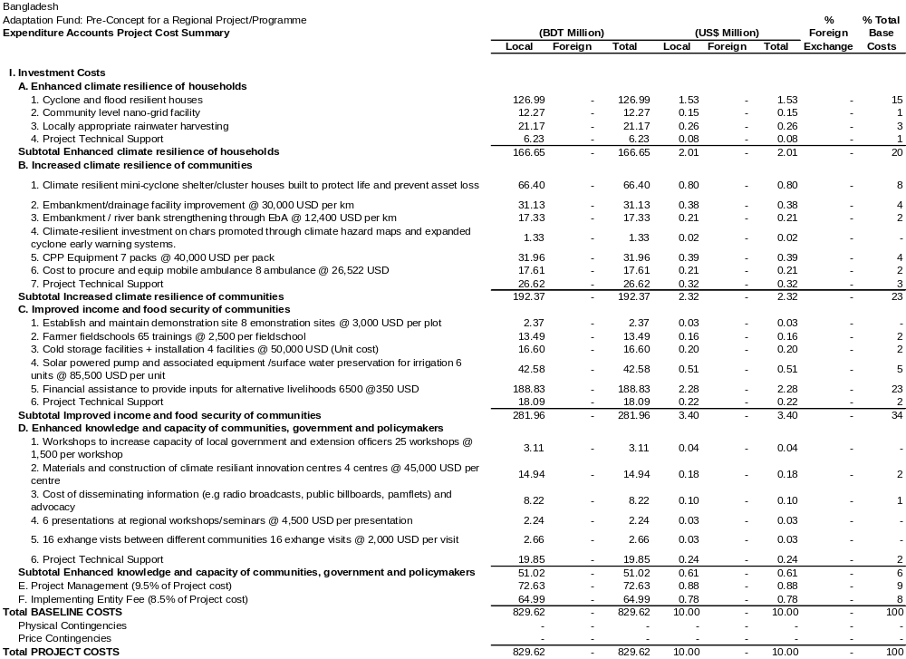
Source: Consultant’s Estimates and Calculations using COSTAB package
Total investment cost at economic prices is estimated as BDT 636.77 Million. Economic Costs used in the analysis are given in Table-2 and detailed in Annex AVI.

Table 2: Year wise Economic Investment Cost
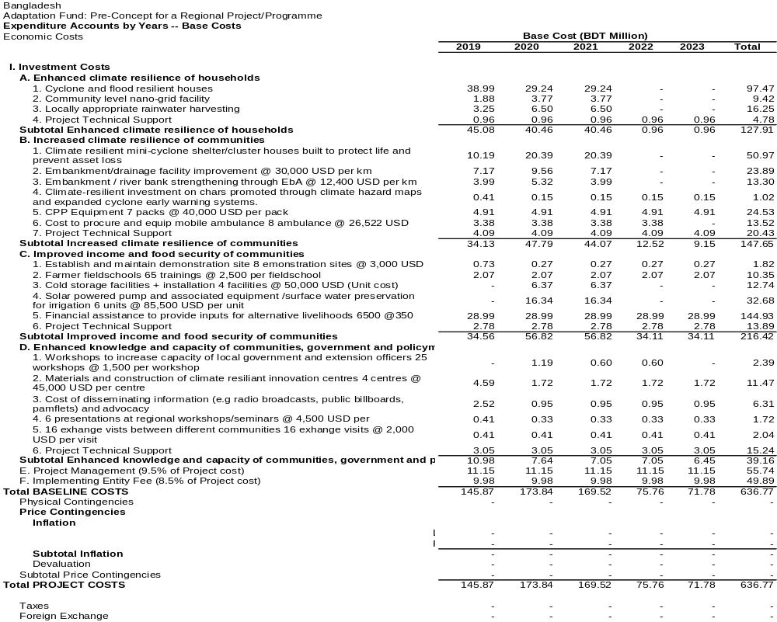
Source: Consultant’s Estimates and Calculations using COSTAB package
Project Cost Phasing: Each project component has its own schedule for implementation. This has been incorporated in the COSTAB calculation of costs. The overall project cost phasing is shown in Table 8.3.

Table 3: Overall Project Cost Phasing (Million BDT)
Year | Financial Costs | In Percentage
1 | 190.05 | 22.91
2 | 226.48 | 27.30
3 | 220.86 | 26.62
4 | 98.70 | 11.90
5 | 93.52 | 11.27
Total | 829.62 | 100
Source: Consultant’s Estimates and Calculations using COSTAB package.

Project O&M Costs
The estimated annual Operation and Maintenance (O&M) Financial costs of the project facilities stand at Tk. 37.69 Million. The economic value of O&M cost is calculated on economic prices and stands at Tk. 28.83 Million. O&M cost is shown in Table 8.4

Table 4: Operation & Maintenance Cost (Million BDT)
Description |  | Investment Cost | % | O&M Cost
 |  | Investment Cost | % | Financial | C.F | Economic
1 | Enhanced climate resilience of households | 166.65 | 5% | 8.33 | 0.765 | 6.37
2 | Increased climate resilience of communities | 192.37 | 5% | 9.62 | 0.765 | 7.36
3 | Improved income and food security of communities | 281.96 | 7% | 19.74 | 0.765 | 15.10
4 | Enhanced knowledge and capacity of communities, government and policymakers | 51.02 | 0% | 0.00 | 0.765 | 0.00
 | Total | 692.00 |  | 37.69 |  | 28.83

Project Benefits

Identification of Economic Benefits
The project will be bringing both the direct & indirect benefits for the Community. The direct and indirect benefits which are discussed briefly below:
- Ecosystem based adaptation
- Social Protection and Health
- Climate Information System
- Knowledge Management &Research
- Capacity Building and Institutional Reformation
These incremental benefits have been considered in the benefit stream of the project for the economic and financial analysis. Total incremental benefit is 215.05 Million BDT and detailed in the Benefit Analysis.

Financial and Economic Cost – Benefit and Cost-Effective Analysis
The Financial and Economic Cost – Benefit and Cost-Effective Analysis are computed for the Project to judge its economic and financial viability. These indicators include are shown in Table 8.5.;

Table 5: Results of Financial and Economic Cost-Benefit (Million BDT)
Viability Indicator |  | Financial | Economic
1. Capital Cost |  | 829.62 | 636.77
2. Operation and Maintenance Cost |  | 37.69 | 28.83
3. Benefit Cost Ratio (BCR @ 12%) |  | 1.21 | 1.58
4. Net Present Value ( NPV @ 12%) |  | 166 | 350
5. Internal Rate Return (IRR %) |  | 14.70% | 18.72%
The analytical results of economic and financial Internal Rate of Return (EIRR and FIRR) are shown in Table 8.6 and Table 8.7. Details of analytical computations are presented in Annex-AVII and Annex-AVIII

Table 6: Economic Internal Rate of Return (EIRR) (Million BDT)
Year | Cost |  |  | Total Incremental Benefits | Cash flow
Year | Investment Cost | O & M | Total Cost | Total Incremental Benefits | Cash flow
1 | 145.87 | 0.00 | 145.87 | 0.00 | -145.87
2 | 173.84 | 0.00 | 173.84 | 0.00 | -173.84
3 | 169.52 | 0.00 | 169.52 | 0.00 | -169.52
4 | 75.76 | 0.00 | 75.76 | 0.00 | -75.76
5 | 71.78 | 0.00 | 71.78 | 0.00 | -71.78
6 | 0.00 | 28.83 | 28.83 | 215.07 | 186.24
7 | 0.00 | 28.83 | 28.83 | 215.07 | 186.24
8 | 0.00 | 28.83 | 28.83 | 215.07 | 186.24
9 | 0.00 | 28.83 | 28.83 | 215.07 | 186.24
10 | 0.00 | 28.83 | 28.83 | 215.07 | 186.24
11 | 0.00 | 28.83 | 28.83 | 215.07 | 186.24
12 | 0.00 | 28.83 | 28.83 | 215.07 | 186.24
13 | 0.00 | 28.83 | 28.83 | 215.07 | 186.24
14 | 0.00 | 28.83 | 28.83 | 215.07 | 186.24
15 | 0.00 | 28.83 | 28.83 | 215.07 | 186.24
16 | 0.00 | 28.83 | 28.83 | 215.07 | 186.24
17 | 0.00 | 28.83 | 28.83 | 215.07 | 186.24
18 | 0.00 | 28.83 | 28.83 | 215.07 | 186.24
19 | 0.00 | 28.83 | 28.83 | 215.07 | 186.24
20 | 0.00 | 28.83 | 28.83 | 215.07 | 186.24
21 | 0.00 | 28.83 | 28.83 | 215.07 | 186.24
22 | 0.00 | 28.83 | 28.83 | 215.07 | 186.24
23 | 0.00 | 28.83 | 28.83 | 215.07 | 186.24
24 | 0.00 | 28.83 | 28.83 | 215.07 | 186.24
25 | 0.00 | 28.83 | 28.83 | 215.07 | 186.24
26 | 0.00 | 28.83 | 28.83 | 215.07 | 186.24
27 | 0.00 | 28.83 | 28.83 | 215.07 | 186.24
28 | 0.00 | 28.83 | 28.83 | 215.07 | 186.24
29 | 0.00 | 28.83 | 28.83 | 215.07 | 186.24
30 | 0.00 | 28.83 | 28.83 | 215.07 | 186.24
NPV @12% | 478.36 | 128.31 | 606.68 | 957.15 | 350.47
All calculations are based on project period of 30 years
EIRR base case |  |  | 18.72%
Benefit Cost Ratio |  |  | 1.58
NPV @12% (Million BDT) |  |  | 350.47

Table 7: Financial Internal Rate of Return (FIRR) (Million BDT)
Year | Cost |  |  | Total Incremental Benefits | Cash flow
Year | Investment Cost | O & M | Total Cost | Total Incremental Benefits | Cash flow
1 | 190.05 | 0.00 | 190.05 | 0.00 | -190.05
2 | 226.48 | 0.00 | 226.48 | 0.00 | -226.48
3 | 220.86 | 0.00 | 220.86 | 0.00 | -220.86
4 | 98.70 | 0.00 | 98.70 | 0.00 | -98.70
5 | 93.52 | 0.00 | 93.52 | 0.00 | -93.52
6 | 0.00 | 37.69 | 37.69 | 215.07 | 177.38
7 | 0.00 | 37.69 | 37.69 | 215.07 | 177.38
8 | 0.00 | 37.69 | 37.69 | 215.07 | 177.38
9 | 0.00 | 37.69 | 37.69 | 215.07 | 177.38
10 | 0.00 | 37.69 | 37.69 | 215.07 | 177.38
11 | 0.00 | 37.69 | 37.69 | 215.07 | 177.38
12 | 0.00 | 37.69 | 37.69 | 215.07 | 177.38
13 | 0.00 | 37.69 | 37.69 | 215.07 | 177.38
14 | 0.00 | 37.69 | 37.69 | 215.07 | 177.38
15 | 0.00 | 37.69 | 37.69 | 215.07 | 177.38
16 | 0.00 | 37.69 | 37.69 | 215.07 | 177.38
17 | 0.00 | 37.69 | 37.69 | 215.07 | 177.38
18 | 0.00 | 37.69 | 37.69 | 215.07 | 177.38
19 | 0.00 | 37.69 | 37.69 | 215.07 | 177.38
20 | 0.00 | 37.69 | 37.69 | 215.07 | 177.38
21 | 0.00 | 37.69 | 37.69 | 215.07 | 177.38
22 | 0.00 | 37.69 | 37.69 | 215.07 | 177.38
23 | 0.00 | 37.69 | 37.69 | 215.07 | 177.38
24 | 0.00 | 37.69 | 37.69 | 215.07 | 177.38
25 | 0.00 | 37.69 | 37.69 | 215.07 | 177.38
26 | 0.00 | 37.69 | 37.69 | 215.07 | 177.38
27 | 0.00 | 37.69 | 37.69 | 215.07 | 177.38
28 | 0.00 | 37.69 | 37.69 | 215.07 | 177.38
29 | 0.00 | 37.69 | 37.69 | 215.07 | 177.38
30 | 0.00 | 37.69 | 37.69 | 215.07 | 177.38
NPV @12% | 623.23 | 167.73 | 790.96 | 957.15 | 166.19
All calculations are based on project period of 30 years
FIRR base case |  |  | 14.70%
Benefit Cost Ratio |  |  | 1.21
NPV @12% (Million BDT) |  |  | 166.19

The results indicate that the Project is economically and financial viable, as it secures a rate of return that exceeds 12%, i.e. the opportunity cost of capital, presently used by all sectors of the economy in Bangladesh

Financial & Economic Risk Assessment, Sensitivity and Switching Values

The Financial & Economic Risk Assessment and Switching Values analysis of projects is generally based on uncertain future events and imperfect data. Also certain risks are inherent in project planning and implementation. So a Risk Assessment, Sensitivity Indicator and Switching Values of the project, EIRR has been conducted for the Project, based on variations in the level of costs and benefits, due to various uncertainties and risks involved in the project investment. By switching values it can be indicate that EIRR will remain same for the opportunity cost of capital (12%) if the cost increases up to the indicated percent in the Table 8.8 and Table 8.9, and IRR will remain same for the opportunity cost of capital (12%) if the benefit decreases up to the indicated percent in the Table 8.8.and Table 8.9.

The findings of Risk Assessment and Switching Values are summarized in Table 8.8 and Table 8.9. Details of analytical computations are presented in Appendix-AIX to Appendix-AXIV

Table 8: Results of Financial Risk Assessment and Switching Values
Sl no. | Variables | Variance | FIRR | NPV (Million BDT) | Sensitivity Indicator (SI) | Switching Values (SV) %
1 | Base Case | - | 14.70% | 166 | - | -
2 | Investment Cost Increased by + 10% | 10% | 13.58% | 104 | 3.75 | 26.67
3 | O & M Cost Increased by + 10% | 10% | 14.44% | 149 | 1.01 | 99.08
4 | Total Project Cost Increased by + 10% | 10% | 13.33% | 87 | 4.76 | 21.01
5 | Climate-resilient households Benefit decreased by -10% | -10% | 14.12% | 129 | 2.25 | 44.39
6 | Community-level adaptation interventions decreased by -10% | -10% | 14.28% | 139 | 1.64 | 60.81
7 | Climate-resilient livelihoods promoted decreased by -10% | -10% | 14.52% | 155 | 0.69 | 144.79
8 | Capacity Building and Knowledge Management decreased by -10% | -10% | 14.40% | 147 | 1.17 | 85.35
11 | Total Benefit decreased by -10% | -10% | 13.19% | 70 | 5.76 | 17.36
12 | Both Total Project Cost Increased by + 10% and Total Benefit decreased by -10% | Both | 11.86% | -9 | 10.52 | 9.51

Table 9: Results of Economic Risk Assessment and Switching Values
Sl no. | Variables | Variance | EIRR | NPV (Million BDT) | Sensitivity Indicator (SI) | Switching Values (SV) %
1 | Base Case | - | 18.72% | 350 | - | -
2 | Investment Cost Increased by + 10% | 10% | 17.44% | 303 | 1.36 | 73.27
3 | O & M Cost Increased by + 10% | 10% | 18.51% | 338 | 0.37 | 273.14
4 | Total Project Cost Increased by + 10% | 10% | 17.23% | 290 | 1.73 | 57.77
5 | Climate-resilient households Benefit decreased by -10% | -10% | 18.09% | 313 | 1.07 | 93.62
6 | Community-level adaptation interventions decreased by -10% | -10% | 18.26% | 323 | 0.78 | 128.24
7 | Climate-resilient livelihoods promoted decreased by -10% | -10% | 18.53% | 339 | 0.33 | 305.35
8 | Capacity Building and Knowledge Management decreased by -10% | -10% | 18.39% | 331 | 0.56 | 180.00
11 | Total Benefit decreased by -10% | -10% | 17.08% | 255 | 2.73 | 36.62
12 | Both Total Project Cost Increased by + 10% and Total Benefit decreased by -10% | Both | 15.64% | 194 | 4.46 | 22.41

The results of sensitivity analysis presented above, show that in all cases, the Project is not sensitive to any of the above assumptions, as the calculated EIRR is above 12 percent. Based on the results of the sensitivity analysis, it can be concluded that the Project is economically viable, and therefore, recommended for implementation.

Annex-AI: Year wise Financial Investment Base Cost (BDT Million)
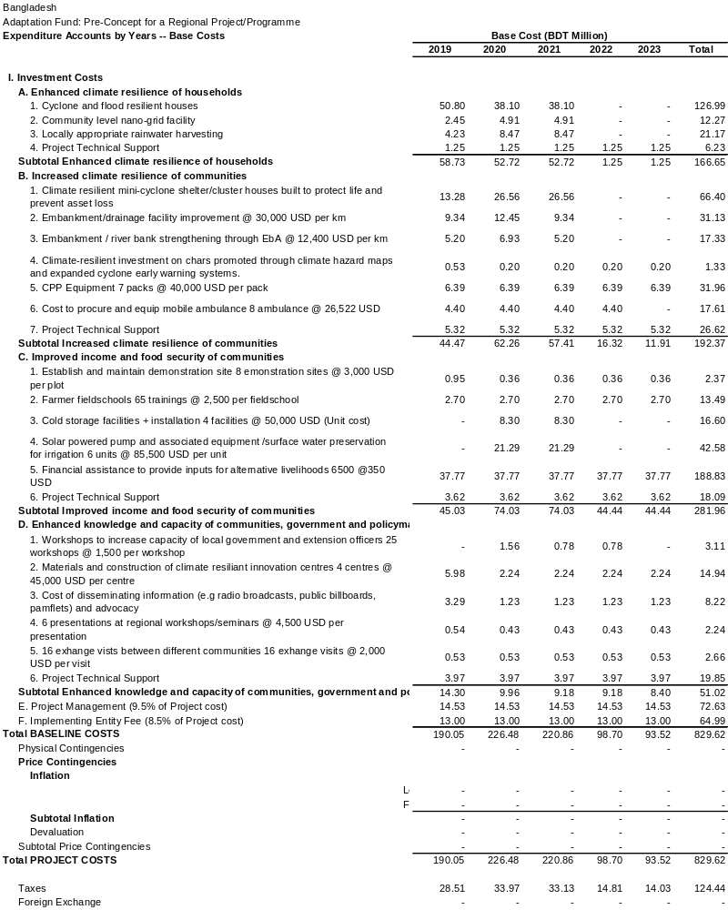
Annex-AII: Year wise Investment Base Cost (US$ Million))
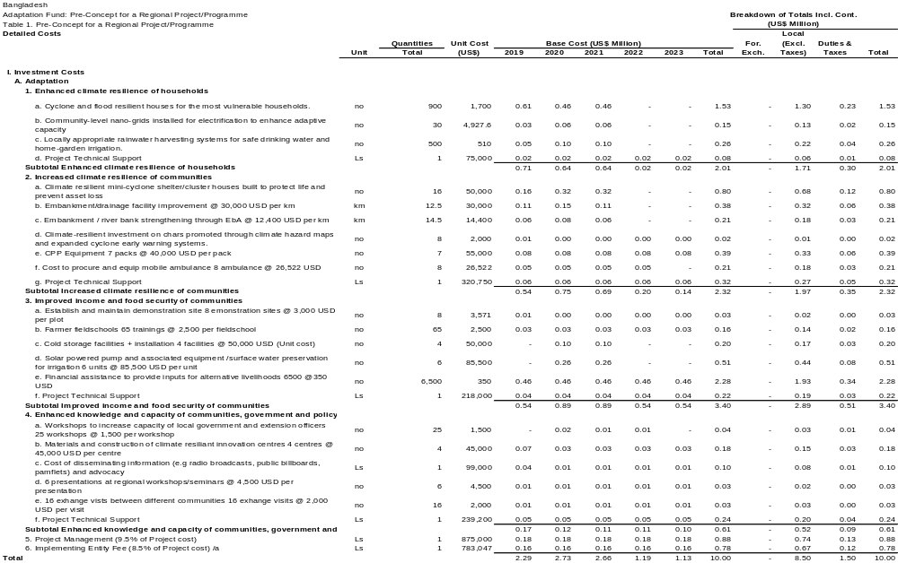
Annex-AIII: Detailed Financial Investment Cost (Million BDT)

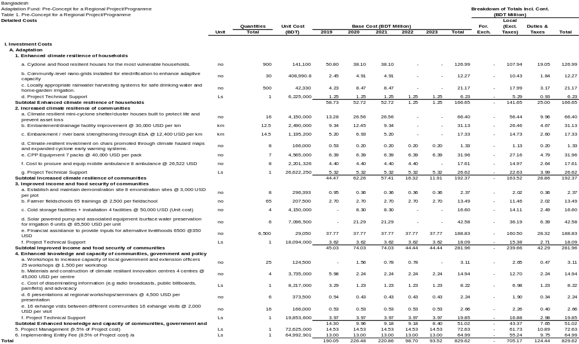
Annex-AIV: Detailed Economic Investment Cost (Million BDT)

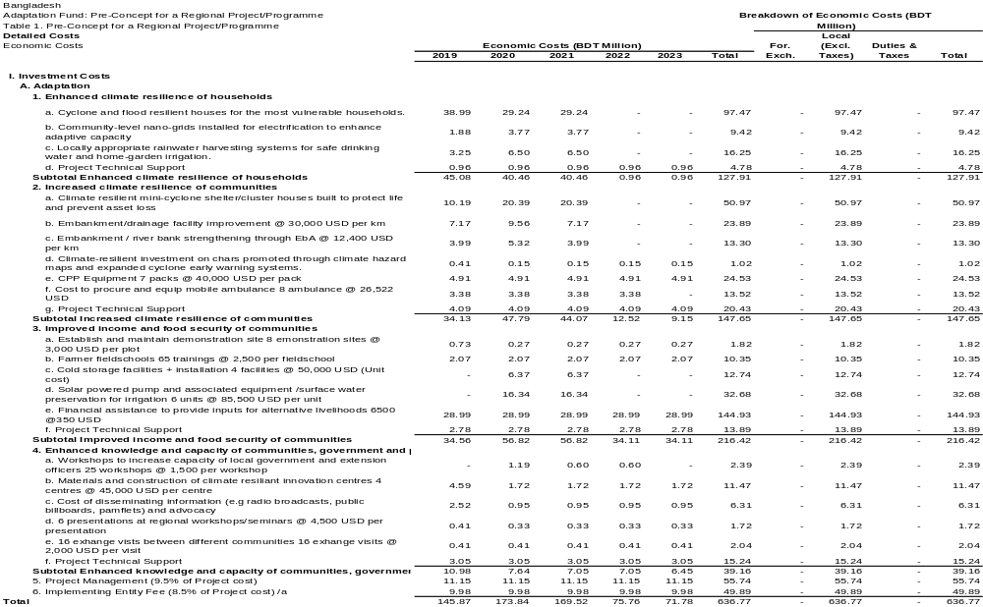
Annex-AV: Detailed Economic Internal Rate of Return (EIRR) Calculation (Base case)
(Million BDT)
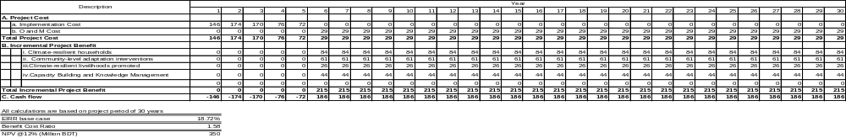
Annex-AVI: Detailed Financial Internal Rate of Return (FIRR) Calculation (Base case)
(Million BDT)
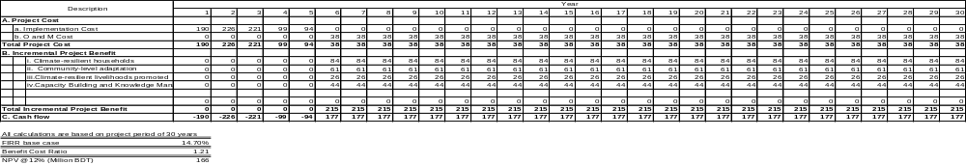
Annex-AVII: Financial Risk Assessment (Total project Cost Increased by 10%)
(Million BDT)
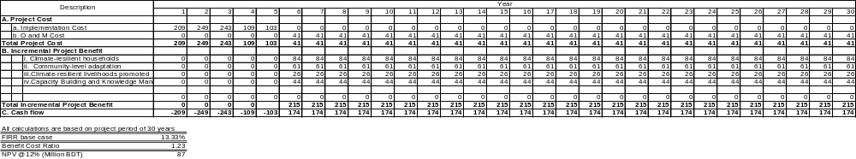

Annex-AVIII: Financial Risk Assessment (Total Benefit decreased by -10%)
(Million BDT)
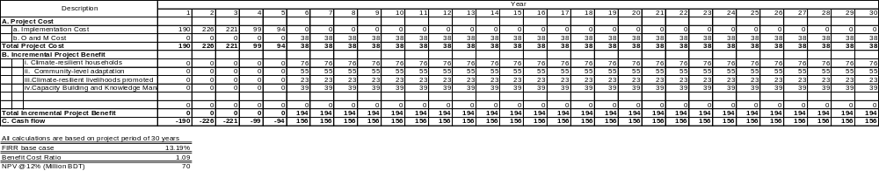
Annex-AIX: Financial Risk Assessment (Both Total Project Cost Increased by + 10% and Total Benefit decreased by -10%)
(Million BDT)
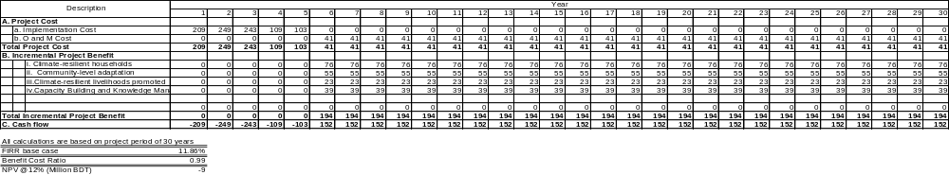
Annex-AX: Economical Risk Assessment (Total project Cost Increased by 10%)
(Million BDT)
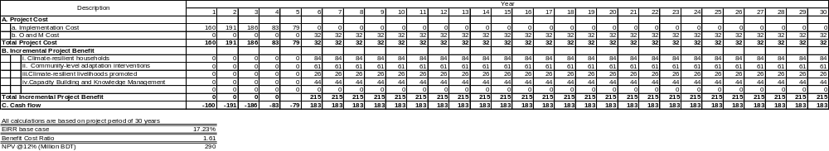
Annex-AXI: Economical Risk Assessment (Total Benefit decreased by -10%)
(Million BDT)
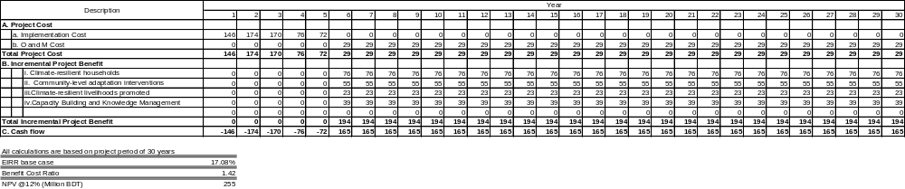
Annex-AXII: Economical Risk Assessment (Both Total Project Cost Increased by + 10% and Total Benefit decreased by -10%)
(Million BDT)
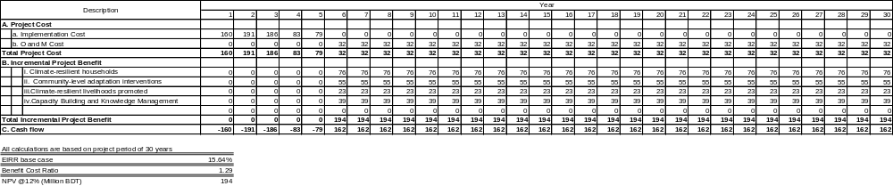

Annex-XIII: Estimation of Standard Conversion Factor (SCF)
SCF = M+X/(M+Tm)+(X-Tx)
where Tm and Tx are the revenue from taxes on imports and exports, respectively
(BDT. Crore)

Items | 2012-13 | 2013-14 | 2014-15 | 2015-16 | 2016-17 | 5 years average
1. Value of Total Imports ( M) | 268380 | 284240 | 284640 | 310810 | 223120 | 274238
2. Value of Total Exports ( X) | 212350 | 231340 | 238970 | 261710 | 175250 | 223924
3. M + X (1+2) | 480730 | 515580 | 523610 | 572520 | 398370 | 498162
4. Import Duty | 14528 | 13433 | 15103 | 17119 | 22450 | 16527
5. VAT on Imports & Supp. Duty | 28326 | 32114 | 34701 | 37739 | 50935 | 36763
6. Total Tax on Imports (4+5)Tm | 42854 | 45547 | 49804 | 54858 | 73385 | 53290
7. Average Tax on Imports (6/1) | 0.160 | 0.160 | 0.175 | 0.177 | 0.329 | 0.194
8. Export Duty | 40 | 41 | 31 | 34 | 44 | 38
9. Sales Tax/VAT on Exports | 0 | 0 | 0 | 0 | 0 | 0
10. Total Tax on Exports(8+9)Tx | 40 | 41 | 31 | 34 | 44 | 38.000
11. Average Tax on Exports (10/2) | 0.0002 | 0.0002 | 0.0001 | 0.0001 | 0.0003 | 0.0002
12. SCF (3/(3+6-10)) | 0.918 | 0.919 | 0.913 | 0.913 | 0.845 | 0.903

B: Benefits Analysis
Summary of Benefits
Project Components | Expected Outputs | Expected Outcomes | Assessed Benefits per year (US$)
Output 1.1. Cyclone and flood resilient houses for the most vulnerable households. | Output 1.1. Cyclone and flood resilient houses for the most vulnerable households. | 900 families are resilient in terms of reduced exposure from flood/storm surge | 259,861.45
 | Output 1.2. Community-level nano-grids installed for electrification to enhance adaptive capacity | 450 no of households are covered by the renewable energy option | 27,325.30
 | Output 1.3. Locally appropriate rainwater harvesting systems for safe drinking water and home-garden irrigation. | 5000 household are connected to safe water supply network | 726,265.06
Sub Total Value of Component 1 (US$) |  |  | 1,013,451.81
Sub Total Value of Component 1 (Million BDT) |  |  | 84.12
2. Community-level adaptation interventions | Output 2.1. Climate resilient infrastructure built to protect life and prevent asset loss | 16 raised plinth cluster houses that will support 64 households and act as emergency shelter to support 200 families | 2,136.67
2. Community-level adaptation interventions | Output 2.2. Embankments repaired and innovative model for community embankment management introduced. |  | 172,891.57
2. Community-level adaptation interventions | Embankment/drainage facility improvement @ 30,000 USD per km | 50 hector land protected by coastal embankment | 172,891.57
2. Community-level adaptation interventions | Embankment / river bank strengthening through EbA @ 14,400 USD per km | 50 hector land protected by coastal embankment | 172,891.57
2. Community-level adaptation interventions | Output 2.3. Climate-resilient investment on chars promoted through climate hazard maps and expanded cyclone early warning systems. | 8 climate hazard and vulnerability maps covering selected islands in the Bay of Bengal | 362,123.49
2. Community-level adaptation interventions | Output 2.4. Cyclone Preparedness Programme (CPP) modernized and expanded to provide timely cyclone early warning and response at scale. |  | 32,820.78
2. Community-level adaptation interventions | CPP Equipment 7 packs @ 55,000 USD per pack | 8500 CPP volunteers trained (increase female representation in CPP by at least 25%)  108,965 beneficiaries will be affected under CPP activity | 32,820.78
2. Community-level adaptation interventions | Cost to procure and equip mobile ambulance 8 ambulance @ 26,522 USD | 8 mobile floating medical unit procured and provisioned | 169,879.52
Sub Total Value of Component 2 (US$) |  |  | 737,715.36
Sub Total Value of Component 2 (Million BDT) |  |  | 61.41
3. Climate-resilient livelihoods promoted | Output 3.1 Climate-resilient agriculture implemented, and diversified livelihoods supported at the village level. |  | 82,228.92
3. Climate-resilient livelihoods promoted | Establish and maintain climate resilient livelihood demonstration site 8 demonstration sites @ 3,000 USD per plot | Quarterly field school trainings held in Mujibnagar and Lakshmitari for a total of 64 field school trainings. (include at least 25% female representation, but aim is for minimum of 50%) | 82,228.92
3. Climate-resilient livelihoods promoted | Farmer field schools 65 trainings @ 2,500 per field school | ~7,500 farmers trained on climate-resilient agricultural practices. | 82,228.92
3. Climate-resilient livelihoods promoted | Cold storage facilities + installation 4 facilities @ 50,000 USD (Unit cost) | 2 cold storage units installed in Mujibnagar and 2 cold storage units installed in Lakshmitari | 82,228.92
3. Climate-resilient livelihoods promoted | Solar powered pump and associated equipment /surface water preservation for irrigation 6 units @ 85,500 USD per unit | 80 hectares of land irrigated in Lakshmitari | 82,228.92
3. Climate-resilient livelihoods promoted | Financial assistance to provide inputs for alternative livelihoods 6500 @350 USD | ~6,500 people provided with technology, skills and materials to make their livelihood climate resilient. (minimum 50% female beneficiaries) | 228,433.73
Sub Total Value of Component 3 (US$) |  |  | 310,662.65
Sub Total Value of Component 3 (Million BDT) |  |  | 25.79
4. Capacity Building and Knowledge Management | Output 4.1. Local government institutions are capable of climate risk informed planning and implementation. |  | 527,057
4. Capacity Building and Knowledge Management | Workshops to increase capacity of local government and extension officers 20 workshops @ 2,500 per workshop | 250 staff from local government institutions, Bangladesh Water Board and Department of Agriculture trained to incorporate climate risk into their decisions and activities. | 527,057
4. Capacity Building and Knowledge Management | Output 4.2. Knowledge and awareness generated to promote climate resilient approaches and strategies. |  | 527,057
4. Capacity Building and Knowledge Management | Materials and construction of climate resilient innovation centres 4 centres @ 45,000 USD per centre | 4 Adaptation innovation centres established in each of the project locations | 527,057
4. Capacity Building and Knowledge Management | Cost of disseminating information (e.g radio broadcasts, public billboards, pamphlets) and national level advocacy | 75% of the population in the target areas reached by awareness campaigns (minimum 50% women) | 527,057
4. Capacity Building and Knowledge Management | 6 presentations at regional workshops/seminars @ 4,500 USD per presentation | 200 people trained on climate change information, impacts and adaptive strategies | 527,057
4. Capacity Building and Knowledge Management | 16 exchange visits between different communities 16 exchange visits @ 2,000 USD per visit |  | 527,057
Sub Total Value of Component 4 (US$) |  |  | 527,057
Sub Total Value of Component 4 (Million BDT) |  |  | 43.75
Grand Total Value of the Project (US$) |  |  | 2,588,886.45
Grand Total Value of the Project (Million BDT) |  |  | 215.05

Detailed description of benefits
Output 1.1. Cyclone and flood resilient houses for the most vulnerable households are supported.
Sl. | Contents |  | Loss (BDT) |  | Damage Adjustment (%) | Benefit (BDT)
i) | House Construction |  | 30,000 |  | 60 | 18,000.00
ii) | House Assets
ii) |  | Bed | 1000 |  | 20 | 200.00
ii) |  | Bed Items | 1000 |  | 70 | 700.00
ii) |  | Stove (mud) | 200 |  | 100 | 200.00
ii) |  | Utensils | 2000 |  | 20 | 400.00
ii) |  | Cloths | 500 * 5 (avg. HH) = 2500 |  | 30 | 750.00
ii) |  | Furniture | Cloths rack | 800 | 50 | 400.00
ii) |  | Furniture | Table | 300 | 50 | 150.00
ii) |  | Furniture | Chair | 450 | 50 | 225.00
ii) |  | Furniture | Almirah | 2000 | 20 | 400.00
iii) | Homestead Gardening |  | 1000 |  | 50 | 500.00
iv) | Livestock/Poultry |  | 2,000 |  | 20 | 400.00
v) | Sanitation |  | 2000 |  | 50 | 1,000.00
vi) | Tube well |  | 2,000 |  | 20 | 400.00
ii) | Rainwater Harvesting (health benefit) |  | 1,200 |  | 20 | 240.00
Total Benefit Derived per family (BDT) |  |  |  |  |  | 23,965.00
Total Benefit Derived per 900 family (BDT) |  |  |  |  |  | 21,568,500.00
Total Benefit Derived per 900 family (USD) |  |  |  |  |  | 259,861.45
Output 1.2. Community-level nano-grids installed for electrification to enhance adaptive capacity.
Sl. | Contents | Total Household | Adjustment (%) | Total Benefitted HH | Per unit Cost | Benefit (BDT)
i) | Fuel (kerosene) | 450 | 100 | 450 | 4800 | 2,160,000.00
ii) | Mobile charge | 450 | 40 | 180 | 600 | 108,000.00
Total Benefit (BDT) |  |  |  |  |  | 2,268,000.00
Total Benefit (USD) |  |  |  |  |  | 27,325.30
Output 1.3. Locally appropriate rainwater harvesting systems for safe drinking water and home-garden irrigation installed.
Sl. | Contents | No. of household | No. of Working People | Adjustment (%) | Total Benefitted People | Per unit Benefit (BDT) | Benefit (BDT)
i) | Health Benefit | 5000 | - | 20 | 1000 | 280.00 | 280,000.00
ii) | Income support | 0 | 5,000 | 20 | 1000 | 60,000.00 | 60,000,000.00
Total Benefit (BDT) |  |  |  |  |  |  | 60,280,000.00
Total Benefit (USD) |  |  |  |  |  |  | 726,265.06
Output 2.1. Climate-resilient infrastructure built to protect life and prevent asset loss.
Sl. | Contents |  |  | Loss (BDT) | Damage Adjustment (%) | Benefit (BDT)
ii) | House Assets
 |  | Bed |  | 1000 | 20 | 200.00
 |  | Bed Items |  | 1000 | 70 | 700.00
 |  | Stove(mud) |  | 200 | 100 | 200.00
 |  | Utensils |  | 2000 | 20 | 400.00
 |  | Cloths |  | 320 | 30 | 96.00
 |  | Furniture | Cloths rack | 800 | 50 | 400.00
 |  |  | Table | 300 | 50 | 150.00
 |  |  | Chair | 450 | 50 | 225.00
 |  |  | Almirah | 2000 | 20 | 400.00
Total Benefit Derived per family (BDT) |  |  |  |  |  | 2,771.00
Total Benefit Derived per 64 family (BDT) |  |  |  |  |  | 177,344.00
Total Benefit Derived per 64 family (USD) |  |  |  |  |  | 2,136.67
Output 2.2. Embankments repaired and innovative model for community embankment management introduced.
Sl. | Contents | Total lands (hectare) | Cost of crop per hectare (BDT) | Benefit (BDT)
ii) | Crop loss protection from river bank erosion | 50 | 40,000 | 2,000,000.00
iii) | Land loss | 50 | 247,000 | 12,350,000.00
Total Benefit (BDT) |  |  |  | 14,350,000.00
Total Benefit (USD) |  |  |  | 172,891.57
Output 2.3. Climate-resilient investment on chars promoted through climate hazard maps and expanded cyclone early warning systems.
Sl. | Contents | No. of household | Per HH Loss (BDT) | Total loss (BDT) | Adjustment (%) | Total Benefit Derived
i) | Housing | 5000 | 22,325 | 111,625,000 | 25 | 27,906,250.00
ii) | Sanitation | 5000 | 1,000 | 5,000,000 | 25 | 1,250,000.00
iii) | Water source | 5000 | 240 | 1,200,000 | 25 | 300,000.00
iv) | Health | 5000 | 1200 | 6,000,000 | 10 | 600,000.00
Total Benefit (BDT) |  |  |  |  |  | 30,056,250.00
Total Benefit (USD) |  |  |  |  |  | 362,123.49
Output 2.4. Cyclone Preparedness Programme (CPP) modernised, made gender-responsive, and expanded to provide timely cyclone early-warning and response at scale.
Sl. |  | Contents | No. of people |  | Per capita Benefit/month (BDT) |  | Benefit (BDT) |  | Adjustment (%) |  | Total Benefit Derived (BDT)/year
iii) |  | Early Warning and Response | 108,965 |  | 500 |  | 54,482,500 |  | 5% |  | 2,724,125.00
Total Benefit (BDT) |  |  |  |  |  |  |  |  |  |  | 2,724,125.00
Total Benefit (USD) |  |  |  |  |  |  |  |  |  |  | 32,820.78
Sl. | Contents |  |  | Total Household |  | Adjustment (%) |  | Total Benefitted Household/People |  | Benefit per unit (BDT) |  | Total Benefit per year (BDT)
i) | Health benefit |  |  | 5000 |  | 10 |  | 500 |  | 1200 |  | 600,000.00
ii) | Labor cost |  |  | 5000 |  | 30 |  | 1500 |  | 9000 |  | 13,500,000.00
Total Benefit (BDT) |  |  |  |  |  |  |  |  |  |  |  | 14,100,000.00
Total Benefit (USD) |  |  |  |  |  |  |  |  |  |  |  | 169,879.52
Output 3.1 Climate-resilient agriculture implemented and supported at a community level.
Sl. | Contents | Total land (acre) | Amount of crops per acre (m.ton) |  | Cost per m.ton (BDT) |  | Adjustment (%) |  | Total Benefit (BDT)
i) | Production benefit (paddy mainly) | 5000 | 1.82 |  | 2500 |  | 10 |  | 2,275,000.00
ii) | Crop diversification | 5000 | 1.82 |  | 2500 |  | 10 |  | 2,275,000.00
iii) | Market Linkage | 5000 | 1.82 |  | 2500 |  | 10 |  | 2,275,000.00
Total Benefit (BDT) |  |  |  |  |  |  |  | 6,825,000.00
Total Benefit (USD) |  |  |  |  |  |  |  | 82,228.92
Output 3.2 Diversified livelihoods developed and supported for the most vulnerable households.
Sl. | Contents | No. of benefitted woman | Benefit per woman/year (BDT) | Total Benefit derived (BDT)
i) | Sewing machine | 150 | 75,000 | 11,250,000.00
ii) | Handicrafts | 150 | 15,000 | 2,250,000.00
iii) | Livestock | 200 | 3000 | 600,000.00
iv) | Poultry | 100 | 30,000 | 3,000,000.00
v) | Shop | 100 | 10,000 | 1,000,000.00
vi) | Homestead gardens | 100 | 3,600 | 360,000.00
vii) | Net making | 50 | 10,000 | 500,000.00
Total Benefit (BDT) |  |  |  | 18,960,000.00
Total Benefit (USD) |  |  |  | 228,433.73
Output 4.2. Knowledge and awareness generated to promote climate resilient approaches and strategies.
Sl. | Contents | No. of people | Per capita Benefit/month (BDT) | Benefit (BDT) | Adjustment (%) | Total Benefit Derived (BDT)/year
i) | Employment benefit | 30 | 12,000 | - | - | 360,000
ii) | Time saving benefit | 30 | 6000 | - | - | 180,000
iii) | Awareness campaign | 144019 | 3,000 | 432,057,000 | 10% | 43,205,700
Total Benefit (BDT) |  |  |  |  |  | 43,745,700
Total Benefit (USD) |  |  |  |  |  | 527,057

Annex N: UNDP Fees for Support to Adaptation Fund Project

Category | Services Provided by UNDP | UNDP Fee (8.5%)
Identification, Sourcing and Screening of Ideas | Provide information on substantive issues in adaptation associated with the purpose of the Adaptation Fund (AF).  Engage in upstream policy dialogue related to a potential application to the AF.  Verify soundness & potential eligibility of identified idea for AF. | $ 39,152
Feasibility Assessment / Due Diligence Review | Provide up-front guidance on converting general idea into a feasible project/programme.  Source technical expertise in line with the scope of the project/programme.  Verify technical reports and project conceptualization.  Provide detailed screening against technical, financial, social and risk criteria and provide statement of likely eligibility against AF requirements.  Determination of execution modality and local capacity assessment of the national executing entity.  Assist in identifying technical partners. Validate partner technical abilities. Obtain clearances from AF. | $ 117,457
Development & Preparation | Provide technical support, backstopping and troubleshooting to convert the idea into a technically feasible and operationally viable project/programme.  Source technical expertise in line with the scope of the project/programme needs.  Verify technical reports and project conceptualization.  Verify technical soundness, quality of preparation, and match with AF expectations.  Negotiate and obtain clearances by AF. Respond to information requests, arrange revisions etc. | $ 156,609
Implementation | Technical support in preparing TORs and verifying expertise for technical positions.  Provide technical and operational guidance project teams.  Verification of technical validity / match with AF expectations of inception report.  Provide technical information as needed to facilitate implementation of the project activities.  Provide advisory services as required.  Provide technical support, participation as necessary during project activities.  Provide troubleshooting support if needed. Provide support and oversight missions as necessary.  Provide technical monitoring, progress monitoring, validation and quality assurance throughout.  Allocate and monitor Annual Spending Limits based on agreed work plans.  Receipt, allocation and reporting to the AFB of financial resources.  Oversight and monitoring of AF funds.  Return unspent funds to AF. | $ 352,371
Evaluation and Reporting | Provide technical support in preparing TOR and verify expertise for technical positions involving evaluation and reporting.  Participate in briefing / debriefing.  Verify technical validity / match with AF expectations of all evaluation and other reports  Undertake technical analysis, validate results, and compile lessons.  Disseminate technical findings | $ 117,457
Total |  | $783,047

Annex O: Letter of Endorsement from Bangladesh Government

Technical specifications were provided by disaster shelter specialists at the UNDP Bangladesh country office.
The beneficiary selection process is included in a following annex (Annex B)
Vacant government-owned land
Examples of retrofitted houses or tentative designs for plinth raising are attached (Annex A-1)
A tentative design is attached (Annex A-2). Approx. Floor size: 1800-2100 ft². Estimated cost per unit is US$ 40,000.
Standard Guideline for Rural Housing in Disaster Prone Areas of Bangladesh
Prohibited grounds of discrimination include race, ethnicity, gender, age, language, disability, sexual orientation, religion, political or other opinion, national or social or geographical origin, property, birth or other status including as an indigenous person or as a member of a minority. References to “women and men” or similar is understood to include women and men, boys and girls, and other groups discriminated against based on their gender identities, such as transgender people and transsexuals.
In regard to CO_{2,} ‘significant emissions’ corresponds generally to more than 25,000 tons per year (from both direct and indirect sources). [The Guidance Note on Climate Change Mitigation and Adaptation provides additional information on GHG emissions.]
Forced evictions include acts and/or omissions involving the coerced or involuntary displacement of individuals, groups, or communities from homes and/or lands and common property resources that were occupied or depended upon, thus eliminating the ability of an individual, group, or community to reside or work in a particular dwelling, residence, or location without the provision of, and access to, appropriate forms of legal or other protections.
Standard guideline for rural housing in disaster prone areas of Bangladesh, February 2018
WaterAid Bangladesh, Step by Step IMPLEMENTATION GUIDELINES for RWHSs, http://www.wateraid.org/~/media/Publications/rainwater-harvesting-systems-implementation-rural.pdf,2006
https://www.dhakatribune.com/tribune-supplements/tribune-climate/2017/08/12/solar-powered-irrigation-revolutionising-bangladeshi-agriculture
IDCOL, Technical Standard for Solar Irrigation Pump (SIP) Projects
Global Climate Risk Index 2017, Germanwatch
ISPAN (Irrigation Support Project for Asia and Near East), (2003). Char Land Study Overview: Summary Report (Draft). Flood Plain Coordination Organization, Ministry of Irrigation, Water Development and Flood Control, Dhaka
WFP, (2002). The coping strategies index, a tool for rapidly measuring food security and the impact of food aid programmes in emergencies. Accessed 22nd September 2011, Retrieved from ftp://ftp.fao.org/docrep/fao/meeting/009/ae513e.pdfWorld Bank, (2008). World Development Report 2008. (Washington, DC).
Mohammed, K. et al., 2017: Extreme flows and water availability of the Brahmaputra River under 1.5 and 2°C global warming scenarios. Climatic Change, 145(1–2), 159–175, doi:10.1007/s10584-017-2073-2.
Salem, G.S.A., S. Kazama, S. Shahid, and N.C. Dey, 2017: Impact of temperature changes on groundwater levels and irrigation costs in a groundwater dependent agricultural region in Northwest Bangladesh. Hydrological Research Letters, 11(1), 85–91, doi:10.3178/hrl.11.85.
Brown, S. et al., 2018b: What are the implications of sea-level rise for a 1.5, 2 and 3°C rise in global mean temperatures in the Ganges-Brahmaputra- Meghna and other vulnerable deltas? Regional Environmental Change, 1–14, doi:10.1007/s10113-018-1311-0.
IPCC, 2014. Fifth assessment report, South Asia summary. Available at: https://cdkn.org/wp-content/uploads/2014/04/CDKN-IPCC-Whats-in-it-for-South-Asia-AR5.pdf
Range of flooded area 50,000-57,000 sq. km and range of % inundation 34%-38.5%, as classified by Mirza (2001)
Rashid, M. B., Mahmud, A., Ahsan, M. K., Khasru, M. H., Islam, M. A., 2013a. Drainage Congestion and Its Impact on Environment in the South-Western Coastal Part of Bangladesh. Bangladesh Journal of Geology, v. 31-32, pp. 43-55.
Rahaman KM, Ahmed FRS, Islam MN (2016) Modeling on climate induced drought of north-western region, Bangladesh. Model Earth Syst Environ 2(1):45. Available at: https://doi.org/10.1007/s40808-016-0089-7
Davies, R. (2014). Floods in 20 Bangladesh Districts after Rivers Overflow - FloodList. FloodList. Retrieved 15 December 2016, from http://floodlist.com/asia/floods-bangladesh-rivers-overflow
Rahaman KM, Ahmed FRS, Islam MN (2016) Modeling on climate induced drought of north-western region, Bangladesh. Model Earth Syst Environ 2(1):45. Available at: https://doi.org/10.1007/s40808-016-0089-7
Islam, Shakibul. (2017). Assessment of the Impact and Management of Flood, Drought and River Bank Erosion: A Case Study of Char Land Peoples of Gangachara Upazila, Rangpur District, Bangladesh. Imperial Journal of Interdisciplinary Research (IJIR) Vol-3, Issue-4, 2017 ISSN: 2454-1362.
Rahaman KM, Ahmed FRS, Islam MN (2016) Modeling on climate induced drought of north-western region, Bangladesh. Model Earth Syst Environ 2(1):45. Available at: https://doi.org/10.1007/s40808-016-0089-7
Asaduzzaman, M. (2015). Livelihood Vulnerability of Women in the context of Climate Change Impacts: Insights from Coastal Bangladesh, Unpublished PhD thesis, The University of Newcastle
ActionAid. 2007. We know what we need: South Asian women speak out on climate change adaptation. ActionAid and Institute of Development Studies. Johannesburg, South Africa and London.
Lal, A. K. (1995). Hand book of low cost housing. New Age International
Haque, M. S., & Yamao, M. (2008). Can microcredit alleviate rural poverty? A case study of Bangladesh. World Acad Sci Eng Tech, 46, 648-656.
National Plan for Disaster Management 2010-2015 (2010), Ministry of Food and Disaster Management, Government of the People’s Republic of Bangladesh
Pender, J.S., 2008. What is climate change? And how will it affect Bangladesh? Briefing Paper. Dhaka, Bangladesh: Church of Bangladesh Social Development Programme.
Shamsuddoha, M., & Chowdhury, R. K. (2009). Climate Change Induced Forced Migrants: in need of dignified recognition under a new Protocol. EquityBd, Bangladesh.
Davis, P., & Ali, S. (2014). Exploring local perceptions of climate change impact and adaptation in rural Bangladesh. Chicago
World Bank, Featured Article: ("Building Resilience of the Coastal Population of Bangladesh to Climate Change" Retrieved from: http://www.worldbank.org/en/news/feature/2013/06/26/bangladesh-building-resilience-coastal-population-climate-change Last Accessed: January, 2017
Edenhofer, O., Pichs-Madruga, R., Sokona, Y., Farahani, E., Kadner, S., Seyboth, K., & Kriemann, B. (2014). IPCC, 2014: summary for policymakers. Climate change.

