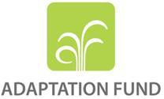

Application for a Grant to facilitate learning and knowledge sharing

Submission Date: 20 January2020

Adaptation Fund Grant ID: Country/ies: Senegal
National Implementing Entity: Centre de Suivi Ecologique

- Timeframe of Activity

Expected start date | June 2020
Completion date | December 2021

- Proposed learning activities

The Centre de Suivi Ecologique (CSE) is a national entity in Senegal, whose core activities include environmental monitoring, natural resources management, support for land use planning and urban management, scientific and technical support for sustainable land management support for the decentralized management of natural resources, environmental and social assessments, monitoring of efforts to combat poverty, support for combating the negative effects of climate change, etc. One of its key activities has been improving the access of vulnerable populations and local stakeholders to information required to strengthen their resilience to and capacity to adapt to climate change variability and impacts, such as droughts and desertification.
CSE is involved in several research programmes and initiatives dealing with climate change and its impacts on food security (AGRICAB, EU FP7 project) and health (AMMA, QWECI, etc. The Centre accounts more than 25-year continuous records of data related to food security: fodder production, crop production, bush fire, livestock, etc. It has also developed significant capacities in monitoring of coastal zones. Thanks to its experience in this regard, CSE was entrusted to coordinate of the West African Coast Observation Mission (WACOM), which is a regional cooperation mechanism for the monitoring of the coastline and for the reduction of coastal risks in West Africa. This Observation Mission aims to disseminating quality information to existing consultative and decision-making bodies (Territories and Local authorities, Governments, WAEMU and ECOWAS Commission, Convention of Abidjan, Development Partners, Secretariats of Guinea and Canary Current). The Centre is contributing to the establishment of scientific services centers for climate change in Ghana and Burkina Faso.

CSE had the privilege to receive the first grant from the Adaptation Fund, also the first through the innovative direct access modality. The project entitled "Adaptation to coastal erosion in vulnerable areas" started in January 2011 with a budget of US$8,619,000 and was completed in January 2015. The objective of the project was to develop the adaptive capacities of the communities most vulnerable to coastal erosion and rising sea levels in three sites in Senegal (Rufisque, Saly and Joal).
In the framework of the AF’s South-South Cooperation Programme, CSE has provided technical assistance to nine (9) African countries for activities ranging from self-assessment to the preparation of their application for accreditation with the Adaptation Fund. One of these institutions has been accredited (BAGRI), two of them have submitted their file which is being reviewed by the Panel, the others are completing their application folder. During this support, the CSE has developed several tools.

The Centre is also serving as Delivery Partner for six (6) African countries through the GCF Readiness Programme.

In a nutshell, CSE has established itself as an engine for learning and innovation. Backed by the experience it has acquired, CSE has a strong ambition and potential to be a vehicle of transformation for a paradigm shift towards low carbon and climate resilient development pathways. This will be done through the development of projects and programs that are aligned with national development strategies while taking into consideration the needs of the most vulnerable communities. To do so, CSE will take advantage of its network of partnerships at national as well as at international level and of its profound knowledge of national, regional and global strategies, namely those which are based on actions with a demonstrative value in terms of promoting low carbon investments and adaptation. In this regard, CSE has established a Climate Finance Unit and more recently, thanks to a grant funding from the Grand Duché of Luxembourg, a Reference Desk on Climate Change and Adaptation and Mitigation Strategies (BRCCAA) which aims to develop a process of knowledge management and capitalization of good practices in order to better inform and influence adaptation policies with regard to the impacts of climate change in the context of National Determined Contributions (NDCs) and National Adaptation Plans (NAPs) implementation. Through the capitalization and dissemination of good practices on climate change adaptation actions, project formulation and implementation, accreditation (…), the Climate Finance Unit is actively involved in efforts to help bridge the gap between National Implementing Entities for better improve the resources mobilization. Based on CSE’s experience, this request is focus to concrete actions that will contribute to achieving the three Expected Results (ERs) of the Medium-Term Strategy (MTS) learning and sharing through:

- Set up an information and knowledge management system for adaptation projects implemented by CSE focus on coastal erosion;
- Develop tools (good practices, policy briefs and lessons learnt) on adaptation project formulation, implementation and completion;
- Exchange visits with two (02) adaptation NIEs about its Information and Knowledge Management system.

Describe the activities to be undertaken to share knowledge with other NIEs or the wider climate adaptation community or to develop knowledge/guidelines through partnerships

The activities mentioned below will be implemented under this grant:

Output 1: An Information and Knowledge Management System (IKMS) for adaptation projects implemented by CSE

The project will establish a IKMS in which all adaptation projects (coastal erosion, sea level rise etc.) implemented by CSE including all data, documents, studies reports, reports, maps.

The mains objectives of IKMS are:

1. Build on the learning of the project;
2. Platform generate with the project;
3. Generate lessons helping National Implementing Entities (NIEs) in their mission.

  - Activity 1.1. Design of IKMS contents in close collaboration with programs and projects officers at CSE.

A rapid needs assessment will be conducted by the communication unit and climate finance unit of CSE, to identify relevant information to be integrated in IKMS
Sub-activities include:

    - Rapid needs assessment of users conducted by the Climate Finance Unit and communication unit of CSE taking into account gender specific needs (Q1/Yr1);
    - Design of the IKMS by workshop (Q3/Yr1).

  - Activity 1.2. Establish the IKMS, and train the technical support staff

The establishment of the IKMS will be followed by capacity development training workshops. This IKMS manager will be the main physical interface with users, who will be able to send their requests by email, or by phone.

Sub-activities include:

    - Establishment of the IKMS, including the creation of a knowledge and database to allow users to get information about CSE adaptation projects
    - Organization of one workshop on the IKMS content, use, and update, targeting technical staff and all CSE partners(of which 50% of women), (Q1/Yr2)

  - Activity 1.3. Update regularly, and evaluate the help desk systemIKMS

The help desk IKMS technical staff will be in charge of updating regularly the web-based platform, with the contributions of CSE’s climate finance unit. This unit will also produce every three months a bulletin on climate finance status, and opportunities, to be shared with users, through the IKM platform help desk platform.

Sub-activities include:

Web-based IKM platform updated every month from Q2-Q3/Yr2

    - Elaboration of a bulletin on climate finance projects status, and related opportunities by the CFU (every three months) Q2-Q3-Q4/Yr2.
    - Online survey of the platform use, and level of satisfaction evaluated (Q3-Q4/Yr2

Output2: A solid knowledge-base (tools, guidelines, and factsheets) is developed in support to the IKMS implementation

All the achievements will be highlighted in CSE’s experiences in monitoring adaptation work. Moving from the process of implementing technical execution studies, the essential data for carrying out coastal protection works, good practices in terms of monitoring works, specific tools developed or used in conducting the evaluation process (budget involved, external stakeholders involved), tools used for capturing, managing and disseminating knowledge in the evaluation process, key factors and tools that NIEs are to go to make project implementation more successful.

Activity 2.1. Develop tools (good practices, policy briefs/note and lessons learned)
Sub-activities include:

Production of communication tools Q4/Yr1;

Activity 2.2. Dissemination of communication tools Q1/Yr2

Activity 3. Exchange visits with two (02) adaptation NIEs about its Information and Knowledge Management system

Proposed Learning Activities | Description of activities | Expected Output of the Activities | Country/Institution to share/transfer knowledge with/to or to develop guidelines for, including NIE(s) | Requested budget (USD) | Tentative timeline (Completion date)
1. Development of a knowledge management system on direct access | 1.1. Design of IKMS contents in close collaboration with programs et projects officers at CSE  1.2. Establish the IKMS, and train the technical support staff  1.3 Update regularly, and evaluate the IKMS | 1.1. Needs in terms of material, tools and services are identified  Deliverable: Needs analysis report  1.2 Online platform for collecting and sharing knowledge  Deliverable: User guide of the platform  1.3 IKMQ is regularly updated and evaluated  Deliverables: Updated Report | Republic of Senegal and any person interest by CSE activities | 6,000  50,000  12,000 | June 2021
2. A solid knowledge-base (tools, guidelines, factsheets) is developed in support to the IKMS implementation | 2.1. Finalizing and validating the tools, guidelines, factsheets  2.2 Disseminating the communication tools | 2.1 communication tools produced  Deliverable: Communication materials  2.2 the communication tools are disseminated  Deliverable: Communication materials | Republic of Senegal and any person interest by CSE activities | 25,000 | September 2021
3. Experience sharing with two NIEs in Africa | 3.1 Exchange visits with two (02) adaptation NIEs about its Information and Knowledge Management system | 3.1 Mission Report | Any NIE’s interested to received CSE for exchange visit | 25,000 | June 2021
Translation |  |  |  | 10,000 | September 2021
Audits Costs |  |  |  | 6,000 | December 2021
Management Costs 8,5% |  |  |  | 11390 | December 2021
Total Grant Requested (USD) 145,390

- Implementing Entity

This request has been prepared in accordance with the Adaptation Fund Board’s procedures

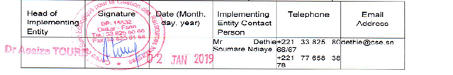

- Record of endorsement on behalf of government

Provide the name and position of the government official, Designated Authority (DA) of the Adaptation Fund, and indicate date of endorsement. The DA endorsement letter must be attached as an annex to the request.

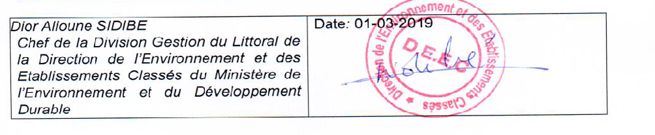

Endorsement letter by Designated Authority
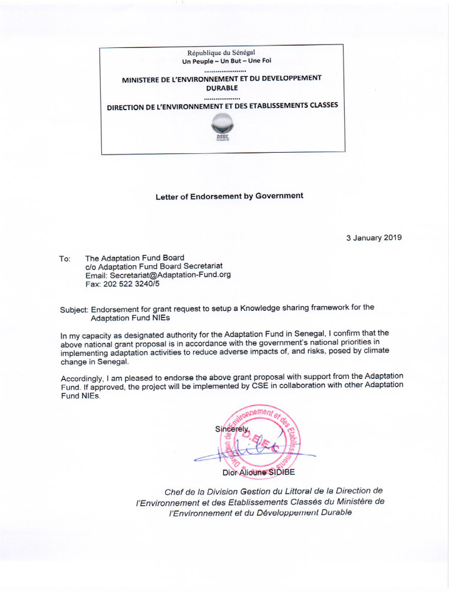

A framework for enhancing earth observation capacity for agriculture and forest management in Africa
African Monsoon Multidisciplinary Analysis
Quantifying Weather and Climate Impacts on Health in Developing Countries

