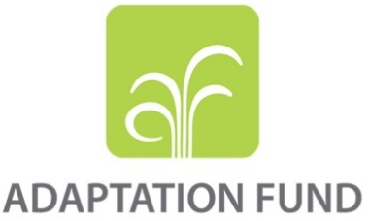
REGIONAL PROJECT/PROGRAMME PROPOSAL

PART I: PROJECT/PROGRAMME INFORMATION

Title of Project/Programme : Community Adaptation for Forest-Food Based Management in Saddang Watershed Ecosystem
Countries : Indonesia
Thematic Focal Area : Food Security
Type of Implementing Entity : National Implementing Entity
Implementing Entity : Kemitraan (Partnership)
Executing Entity : Environmental and Climate Change Adaptation Consortium (Konsorsium Adaptasi Perubahan Iklim dan Lingkungan/KAPABEL)
Amount of Financing Requested : 835,465 (in U.S Dollars Equivalent)

Project / Programme Background and Context
Provide brief information on the problem the proposed project/programme is aiming to solve, including both the regional and the country perspective. Outline the economic social, development and environmental context in which the project would operate in those countries.
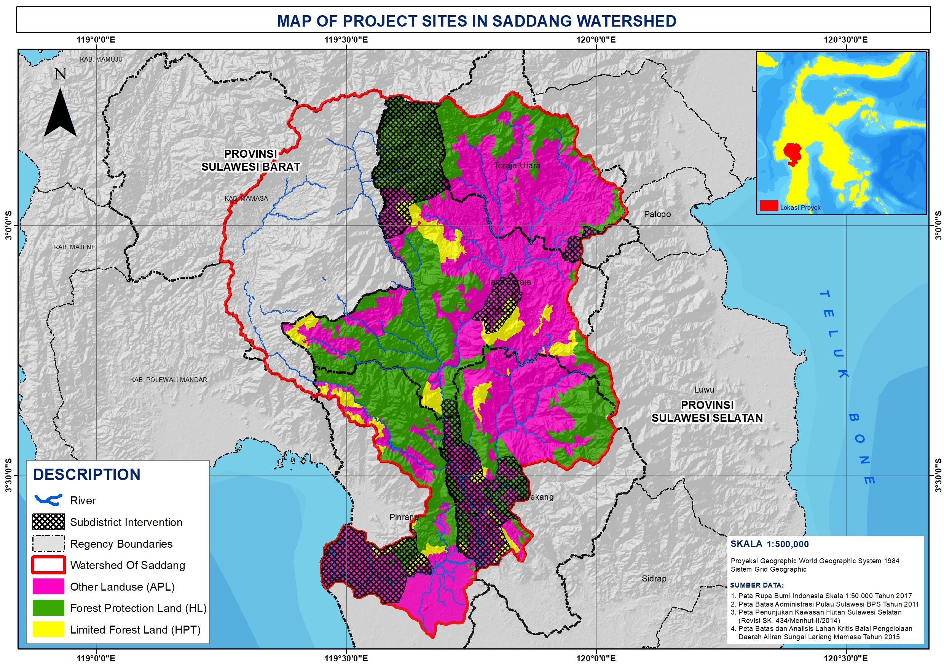
Figure 1. Map of Saddang Watershed

Based on the 2015-2019 Strategic Plan of the Ministry of Environment and Forests, Saddang Sawah Watershed (DAS) is a “Priority Watershed in Indonesia”. The Saddang Watershed itself is a watershed that flows into four districts in South Sulawesi Province and a small portion of the area is located in West Sulawesi Provinces, with an area of 661,932 ha, which makes the Saddang Watershed the second largest watershed in South Sulawesi. Today almost 1 million people depend on the available resources of the Saddang Watershed ecosystem. (See Appendix 1. Map of Saddang Watershed).
Particularly in South Sulawesi, this watershed is located in the administrative area of Tana Toraja District and North Toraja District (upstream area), Enrekang District (upstream area), and Pinrang District (downstream area. Saddang Watershed area in the four districts amounted to 504,313 Ha, of which 39.57% in the Tana Toraja District, 18.07% in the North Toraja District, 22.07% in the Enrekang District, and 20.29% in the Pinrang District. In terms of forest area, Saddang Watershed area consists of protected forest area of 199,875.91 ha (39.63%), limited production forest of 32,030.38 ha (6.35%), and other usage area of 272.407.62 ha (54.02%). For the development of social forestry scheme, 33,935.76 ha are indicated and prioritized for the development of social forestry in watershed areas based on indicative maps of social forestry areas (PIAPS) issued by the Ministry of Environment and Forestry.
- Environmental Context and Climate Change Impact
The level of area risk due to climate change associated with the disaster level in the Saddang Watershed area shows that 93% of villages in the watershed are vulnerable to climate change. There are 16 highly vulnerable villages scattered in the Tana Toraja and North Toraja areas, 126 villages are in fairly vulnerable condition and 306 villages are in relatively vulnerable conditions scattered throughout the basin (based on analysis of exposure and sensitivity index with index adaptability).
Figure 2. Graph of Climate Change Vulnerability

The results analysis of rainfall and temperature graphs obtained from Global Weather Data as baseline data through http://globalweather.tamu.edu/ using 27 Global Weather stations located around the area of Saddang watershed, obtained an average increase in rainfall by 4.2% (average increase of 208.52 mm / year) while average temperature change -4ºC is still in normal category in period 1981-2013.Increased rainfall data caused various disasters has been occurred in watershed area recorded as many as 342 times starting from 2009-2014 in form of landslides and floods. (See Figure 3. and Figure 4.)

Figure 3. Graph of Rainfall Change

--Period of 1981-2013—
Figure 4. Graph of Temperature Change
--Change of Actual Rainfall--

Changes in land cover occurring from 1995 – 2014 were recoded as 31.32% or about 31,066.15 ha, the reduction of forested land in the Saddang watershed area was from 99,165.11 ha to 68,098.96 ha. The change of forest area into agricultural land reaches 59.27% or about 18,416 Ha, the rest is converted into settlement, rice field, and shrub.

The average change in rainfall is in line with the increase of river flow in the rainy season by 8.56% in 2004 – 2013 which indicates an increase in the potential disasters due to surface flows. Meanwhile, the decrease of river flow in the dry season which amounted to 12.74% caused drought in the watershed area.
Topographic conditions of the mountains and hills in the upper watershed of North Toraja District, Tana Toraja District and Enrekang District, the rate of change of land cover from upstream to downstream, and supported by climatology condition caused a number of natural disaster incidents in every District, the occurrence of natural disaster that often happened at project intervention location is flood and landslide, as can be seen in table 1.

Table 1. Intensity of Disaster Based on Type
Type of Disaster | Location of Disaster (District) | Intensity of Disaster Incident
Landslide | North Toraja | 49 Times
Landslide | Tana Toraja | 72 Times
Landslide | Enrekang | 83 Times
Landslide | Pinrang | 35 Times
Flood | North Toraja | 14 Times
Flood | Tana Toraja | 10 Times
Flood | Enrekang | 44 Times
Flood | Pinrang | 35 Times
Source: Village Potential Data, Central Bureau of Statistics (2015)
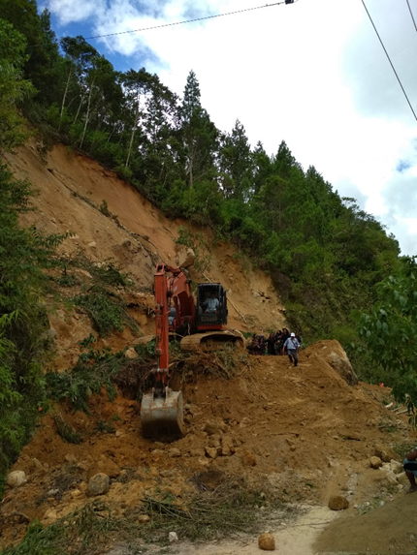
In the table 1 above, it is recorded that Enrekang District has the most frequent flood and landslide events. Therefore, the project will be implemented at the location of the intervention based on the intensity of the disaster occurring during the last 5 years. In Enrekang District, the project was implemented in 4 (four) villages i.e. Palladang, Pundilemo, Tungka and Ranga. Since 2013 in Enrekang District, there has been a catastrophic flood that resulted in submerged farmland and plantations. This made the income of the people decreased and uncertain. In the other six villages, in addition to floods, landslides also occurred.
In Tana Toraja District, which is the locus of 3 (three) intervention villages i.e. Lembang Randan Batu, Lembang Pakudan Lembang Sese Salu. Every month in early 2016, each village took turns reporting a landslide. The landslide material has stockpiled several bridges and access to roads people pass through which hamper the economic activities of local communities.
The Regional Disaster Management Agency of North Toraja District received information on landslide disaster that occurred in 2017. Areas that become project intervention in North Toraja District are 3 (three) villages i.e. Lembang Karre Limbong, Lembang Sapan Kua-Kua Paniki, and Bokin. Those villages in 2015 experienced forest fire caused by negligence of citizens. The landslide and flood disaster that occurred resulted in the destruction of community land. Farmland and community rice fields that were inundated by water made people suffer huge losses due to crop failure.
Figure 5. Landslide Portrait in one of the Saddang Watershed areas
Natural disaster factors and human negligence in land management that ignored soil conservation, illegal logging and natural disasters added to the critical land area in the Saddang watershed. Critical land is defined as a land that is inside and outside the forest area which the function has declined (degradation). The function intended in that definition is element of production and watershed regulatory system. As a result of the presence of critical land along the Saddang watershed, it affects the quality of river water. The decrease in quality inflict in silting the river flow. Besides that critical land has threatened food and energy security in the Saddang watershed buffer zone.
The result of socio-ecology survey on the identification of Disaster Risk in the Saddang Watershed recorded a decrease in food productivity of 66% of the commodities of rice crops. The harvest period was usually done 3 times a year, now it is only done 1 time a year due to frequent landslides and floods. The productivity of agricultural and plantation products also decreased due to the decreasing of land carrying capacity and high level of critical land in the area of Saddang Watershed.
The landslide disaster also caused further impacts that occurred in the downstream watershed area, i.e. the increase in sedimentation in the watershed. An increase of 21.13% of the total average sedimentation from 2004 to 2013 by 29,493,442 ton per year resulted in a decrease in river flow. At he downstream area, this project is conducted in Pinrang Regency in 5 (five) villages, i.e. Baba Binanga, Katomporang, Massewae, Paria and Salipolo. Natural disasters that occurred in the villages include floods, strong winds, hurricanes, and forest sires. In the year of 2013-2016, floods occurred in every January to April. The flood that occurred in 2014 took casualties up to 182 households. In addition to floods, strong winds and hurricanes also occurred in January. The decrease of land quality due to natural disaster has impact on various sectors especially agriculture, fishery, marine, plantation and forestry sector.
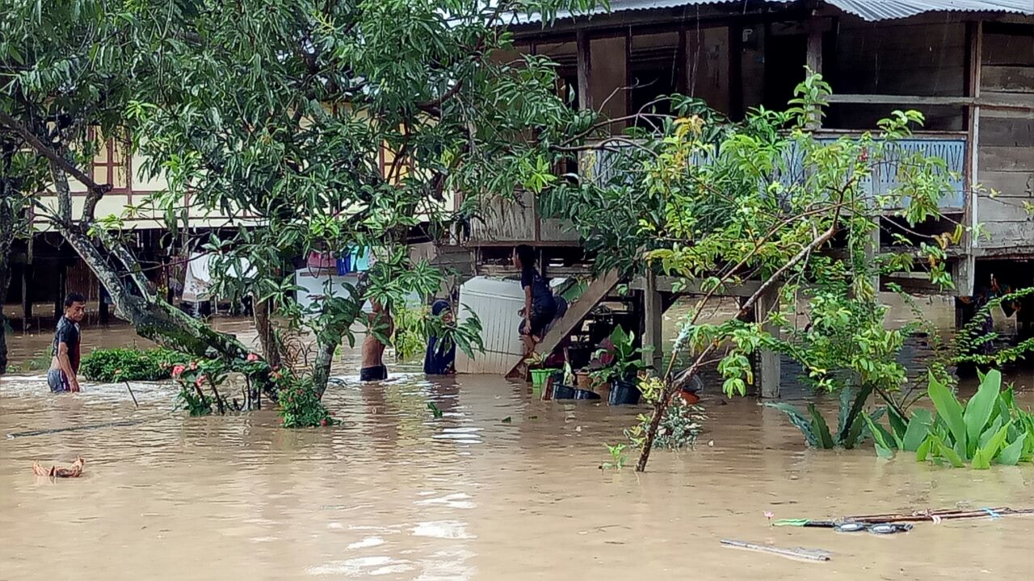
The climate change project scenario for 2018 – 2050 shows that there is an average increase in rainfall of 217.19 mm per year, up 8% over the next 33 years from the average actual rainfall in 1981 – 2013. Increased rainfall in the GFDL-CM3 model is consistent with baseline rainfall climate data that continues to increase on average by tenths of a year. This condition will have a significant impact on upstream areas especially in areas susceptible to erosion due low forest cover. Further impacts can be an increase in downstream sedimentation, thus resulting in flooding in agricultural areas. This indicates that in the next 33 years, the disadvantages of climate change in the watershed will be greater especially considering that the Saddang Watershed is a Priority Watershed in Indonesia. This indicates that the future level of disaster risk due to climate change will increase and people who are classified as a pre-prosperous society will be increasingly disadvantaged, especially resistance to food. So the choice of action to adapt the food security through the diversification of food based on forest food is a strategic adaptation to the impact of climate change that will occur.
Figure 6. Rainfall Increase of 8%, affecting the flood and land incidents due to low land cover
Figure 7, Projection of average rainfall in the Saddang Watershed
The results of annual average temperature projection analysis of the GFDL-CM3 model with the IPCC tools use indicators of changes in population growth in the watershed area, land cover changes, and strengthening of greenhouse gas concentration which gives different patterns of temperature increase from year to year when compared to baseline temperature increase pattern 1981-2013) that are still normally categorized around the watershed, where temperature climate has increased on average by 5.4% in 2018-2050. Temperature increases in future projections will aggravate environmental conditions due to climate change such as causing the extinction of some species of wildlife and plants, increasing the frequency of floods and droughts, and decreasing food productivity in both local and regional scales

Figure 8. Projection of average temperature in a period of 2018-2050

- Socio-Economic Context
The community of the Saddang Watershed ecosystem in South Sulawesi is directly dependent and utilizes the watershed for daily life and the economy with as many as 835,710 people consisting of 417,660 men and 418,050 women spread over with 228,574 people in Tana Toraja District, 215,418 people in North Toraja District, 174,994 people in Enrekang District, and 216,724 people in Pinrang District. The number of head of household (HH) in the watershed area is 644,026 HHs, consisting of 518,000 heads of household who work as farmers and 165,496 HHs who are classified as poor families.
The main livelihood of the community in Saddang Watershed is farmers. The area of agricultural land in this region reaches 113,167 ha or 22.44 % of the total area of Saddang Watershed (504,313 ha). Paddy fields as a food producer of 16,113 ha in watershed area spread with 9,027 ha downstream and 7,086 ha upstream.
The impacts of climate change have implications for the decline in incomes of people who use land in the fulfillment of their lives. The average income of the community in the 4 project intervention districts is $115,9875 per person per month, below the Regional Minimum Wage (UMR) of South Sulawesi Province of $175,6120 per month. It was recorded that there was a decrease in food productivity especially rice in the watershed area. The decline in rice productivity in 2013 amounted to 29,047 Ton or about 9.6% decrease of rice production from the previous year, which amounted to 304,913 Ton in 2012. The Enrekang District is still placing rice as their flagship food product. In 2013, the growth of planted area increased by 19% from the previous year, but it was inversely proportional to the amount of production. In 2012, Enrekang District was able to harvest rice up to 70,021 ton/year, but in 2013, production decreased by 9.4%.
Rice productivity and production during the last 5 years (2011-2015) in North Toraja District experienced a fluctuating condition. In 2014, North Toraja District was able to produce 134,937 ton, but in 2015, production decreased to 19%. Rice productivity decreased from 2013 to 2015 ranging from 10-15%.
The area of rice planting in Tana Toraja District decreased significantly in 2013 as the impact of landslide. In 2014 then the community was able to increase crop production by 33% from the previous year, but crop productivity still decreased every year. Increasing people’s income became the locus of activities by applying the forest food as a pattern of food diversification. Tana Toraja District also has local wisdom that influences the socio-economic context, i.e. “Kuang & Alang” or in brief, we know it as “integrated farming” which is now starting to erode. This local wisdom sees that rice farming has no primary purpose in growing rice commodities but it is an integrated cultivation system (rice, fish, gardens, livestock) based on local knowledge. The people of Tana Toraja also generally emphasize the principle of togetherness/mutual cooperation in working the fields. This is very good to strengthen the project scheme in order to run and sustain.
In the Downstream Area in Pinrang District, creative business will be pursued by making seaweed chips and the utilization of salak seeds into coffee. Making seaweed chips as creative business choice is because the production value of seaweed in 2009-2013 has increased productivity up to 8.05%. For creative business in the management of salak seeds into coffee will target Duampanua Sub-district in 2 villages, i.e. Massewae and Katomporang. The growth potential of salak commodity in 2016 is an average of 65,266 trees/clumps that productively produced fruit.
Upstream food development and creative potentials in the coastal areas are perceived by communities to be constrained on the quality, quantity and marketing sections. Sales of managed food are still sold in traditional markets and by selling on the roadside. This process often makes farmers experience loss since many foods that is sold is damaged before getting buyers. In addition, a constraint experienced by farmers is the suboptimal cultivation of agricultural land due to climate change that occurred, thus the income obtained is below the UMR of South Sulawesi Province.

- Project Context
In line with the main objectives of Indonesia’s 2014 Climate Change Adaptation National Action Plan (RAN - API), through a series of interventions from this project, “watershed ecosystem communities” will be able to increase resilience to climate change impacts both in food security through the development of forest food and food diversification, as well as ecosystem resilience through enhancement of forest cover quality in the Priority Watershed, as well as resilience through integrated coastal management.
This is a serious undertaking in addressing vulnerability to climate change that has major and sustained impacts. High vulnerability to climate change causes communities in the watershed to be vulnerable to the impacts. Increased rainfall, temperature, and land cover changes resulted in higher intensity of landslides and floods in the watershed area. The landslide disaster in the upstream area causes further impacts such as high sedimentation in the downstream areas and reduced watershed functions as Water Catchment Areas.
This is exacerbated by the uncontrolled upstream forest area conversion activity to an increasingly high potential for disasters. Communities in the watershed area, which mostly live as farmers with poor economic conditions, suffered heavy losses due to climate change. In addition, the Locla Government will face increasing difficulties in solving the problem, if the capacity of human resources is not yet qualified. The effects on natural resources damage will be more severe, and will trigger a slowdown in economic and regional development. The project approach path can be seen in the following milestone at figure 9.

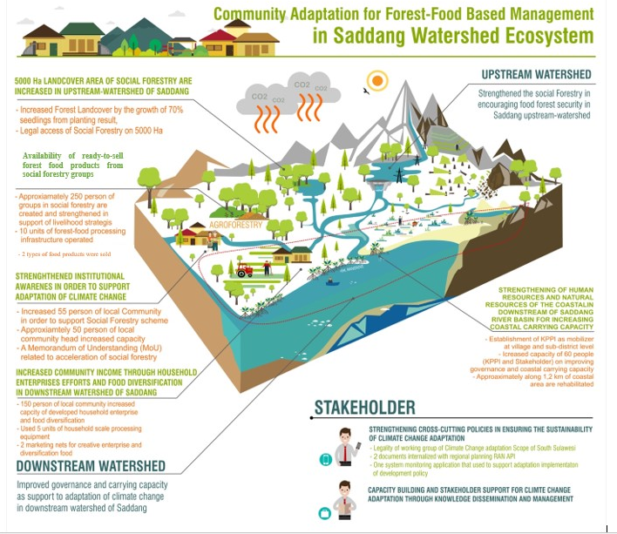

Figure 9. Milestone Project

Based on the above project flow, the “Community Adaptation for Forest-Food Based Management in Saddang Watershed Ecosystem” project will focus on 4 objectives, i.e. Social Forestry Strengthening in encouraging forest food in Upstream Saddang Watershed, Improvement of coastal governance and carrying capacity in support of climate change adaptation in downstream of Saddang Watershed, Strengthening of cross-cutting policies in ensuring the sustainability of climate change adaptation and Capacity building and stakeholder support through knowledge management. This will be achieved through 7 outcomes and 19 outputs, in details as follows:
  - Increased extent of the Social Forestry scheme covering an area of 5,000 ha in the upstream of Saddang Watershed
Supported by 2 outputs: Existing legal access to Community Forest or Village Forest; Increased forest land cover
  - Strengthened actors and institution of Social Forestry schemes in support of climate change adaptation
Supported by 3 outputs: Increased capacity of facilitators and local communities in Social Forestry scheme; Increased capacity of stakeholders in sustainable forest management; Increased support from the stakeholders in encouraging Social Forestry scheme.
  - Availability of forest food products that are ready for sale from social forestry groups
Supported by 3 outputs: Increased skills of Forest Farmer, Women and Vulnerable Group in managing sustainable forest food; Available facilities and infrastructure of forest food processing technology; Absorbed forest food products to the market.
  - Strengthened costal human resources and natural resources in the downstream of Saddang watershed in increasing coastal carrying capacity
Supported by 3 outputs: Established and running Climate Change Care Group (KPPI) as the driving force at the village and sub-district levels; Increased capacity and skills of KPPI and stakeholders in improving costal governance and carrying capacity downstream of watershed; Rehabilitated coastal areas downstream of Saddang Watershed.
  - Increased community income in the Downstream of Saddang Watershed through environmentally friendly creative businesses and food diversification
Supported by 3 outputs: Improved skills of KPPI, forest farmer, women and vulnerable groups in the development of creative business and food diversification; Available technology facilities and infrastructure in encouraging creative business and food diversification; Existing marketing network for creative business and food diversification.
  - Strengthened cross-cutting policies in ensuring the sustainability of climate change adaptation
Supported by 3 outputs: Established and operating Climate Change Adaptation Working Group Team (POKJA-API); Internalized Climate Change Adaptation Plans to Local Government policies, as well as existing adaptation action plan documents at the regional level; Existing Climate Change Adaptation monitoring system that supports the strengthening of policies implemented by the stakeholders.
  - Strengthened capacity and understanding of stakeholders through dissemination process and early warning system of climate change adaptation
Supported by 2 outputs: Disseminated program to strengthen and encourage policies and alignments; Existing early warning system platform for Climate Change Adaptation among Saddang Watershed Ecosystem Community.
Each output will support outcome by targeting a total of 27,143 beneficiaries in the Saddang Watershed. The total number of beneficiaries as a whole can be seen in table 2.
Table 2. Number of Beneficiaries in the Saddang Watershed
District | Sub-district | Villages | Total Population
District | Sub-district | Villages | Men | Women | Total
North Toraja | Nanggala | Karre Limbong | 615 | 591 | 1206
North Toraja | Rantebua | Bokin | 1051 | 1031 | 2082
North Toraja | Buntao | Sapan Kua-Kua Paniki | 1107 | 1083 | 2190
Tana Toraja | Makale Selatan | Randan Batu | 1129 | 1091 | 2220
Tana Toraja | Masanda | Paku | 443 | 412 | 855
Tana Toraja | Masanda | Sese Salu | 602 | 578 | 1180
Enrekang | Cendana | Pundilemo | 770 | 803 | 1573
Enrekang | Maiwa | Palladang | 446 | 426 | 872
Enrekang | Enrekang | Ranga | 535 | 500 | 1035
Enrekang | Enrekang | Tungka | 794 | 806 | 1600
Pinrang | Duampanua | Baba Binanga | 735 | 791 | 1526
Pinrang | Duampanua | Katomporang | 1194 | 1285 | 2479
Pinrang | Duampanua | Massewae | 1664 | 1791 | 3455
Pinrang | Duampanua | Paria | 1527 | 1644 | 3171
Pinrang | Cempa | Salipolo | 856 | 843 | 1699
TOTAL | 10 | 15 | 13.468 | 13.675 | 27.143
Source: Secondary Data Processing
The “Community Adaptation for Forest-Food Based Management in Saddang Watershed Ecosystem” program is an effort that will encourage community adaptation in the watershed area and can be replicated easily. The development of forest food and food diversification will be able to become a pattern of livelihood adaptation of farmers by utilizing forest areas packed in a Social Forestry scheme to ensure sustainable forest management in the upper watershed. Improving coastal governance and carrying capacity in downstream areas of Saddang watershed through mangrove forest rehabilitation, creative industry development, and strengthening local, women and vulnerable groups in supporting climate change adaptation are also important components of project interventions. To ensure the sustainability of adaptation action in the watershed area, strengthening crosscutting policies related to climate change adaptation action is done, where policy directions will be designed to be jointly monitored by stakeholders. Furthermore, capacity building and stakeholder support on climate change adaptation through dissemination and knowledge management is conducted to capture and disseminate learning gained from the project, so that project outcomes can then be replicated in the future.
If this adaptation program is not implemented, then the percentage of reduction of forested land will significantly increase. If this condition is followed by increased rainfall, then the risk of flood disaster is higher. The impact of flood disaster acts as a trigger for other disasters such as the occurrence of landslides. Natural disasters that occur will affect the damage to community land. The decline in agricultural productivity due to the destruction of cultivated land further reduces the income of people who have been in poor condition. If coastal watershed governance in downstream area is not implemented, costal communities will have more impact from rising sea levels and disasters due to unsustainable watershed governance. Economic pressures will also increase the rate of crime, economic slowdown and regional development and changes in landscapes and their carrying capacity.

Project / Programme Objectives
List the main objectives of the project/programme.

The main objective of this program is to increase resilience to food security of the community of Saddang Watershed ecosystem as an effort to adapt to climate change that focuses on:

- Strengthened Social Forestry in encouraging forest food in the upstream of Saddang Watershed which has implications for the improvement of the environment and the increase of people’s income.
- Improved coastal governance and carrying capacity in support of climate change adaptation downstream of Saddang Watershed.
- Strengthened crosscutting policies in ensuring the sustainability of climate change adaptation.
- Capacity building and stakeholder support on climate change adaptation through knowledge dissemination and management.

Project / Programme Components and Financing:
Fill in the table presenting the relationships among project components, outcomes, outputs and countries in which activities would be executed, and the corresponding budgets.
For the case of a programme, individual components are likely to refer to specific sub-sets of stakeholders, regions and/or sectors that can be addressed through a set of well-defined interventions / projects.

Project/Programme Components | Expected Concrete Outputs | Expected Outcomes | Amount (US$)
- Strengthening of Social Forestry in encouraging forest food in the upstream of Saddang Watershed | - Existing legal access to Community Forest or Village Forest  - Increased forest land cover | - Increased extent of the Social Forestry Scheme of 5,000 ha in the upstream of Saddang Watershed | $344,069
 | - Increased capacity of facilitators and local communities in Social Forestry scheme  - Increased capacity of stakeholders in sustainable forest management.  - Increased support from the stakeholders in encouraging Social Forestry scheme | - Strengthened actors and institution of Social Forestry schemes in support of climate change adaptation | $344,069
 | - Increased skills of Forest Farmer, Women and Vulnerable Group in managing sustainable forest food.  - Available facilities and infrastructure of forest food processing technology  - Absorbed forest food products to the market | - Availability of forest food products that are ready for sale from social forestry groups | $344,069
- Improvement of coastal governance and carrying capacity in support of climate change adaptation downstream of Saddang Watershed | - Established and running Climate Change Care Group (KPPI) as the driving force at the village and sub-district levels  - Increased capacity and skills of KPPI and stakeholders in improving costal governance and carrying capacity downstream of watershed  - Rehabilitated coastal areas downstream of Saddang Watershed | - Strengthened costal human resources and natural resources in the downstream of Saddang watershed in increasing coastal carrying capacity | $176,843
 | - Improved skills of KPPI, forest farmer, women and vulnerable groups in the development of creative business and food diversification  - Available technology facilities and infrastructure in encouraging creative business and food diversification.  - Existing marketing network for creative business and food diversification | - Increased community income in the downstream of Saddang Watershed through environmentally friendly creative businesses and food diversification | $176,843
- Strengthening of institutional system and capacity to reduce climate risk including socio-economic and environmental degradation | - Established and operating Climate Change Adaptation Working Group Team (POKJA-API).  - Internalized Climate Change Adaptation Plans to Local Government policies, as well as existing adaptation action plan documents at the regional level  - Existing Climate Change Adaptation monitoring system that supports the strengthening of policies implemented by the stakeholders | - Strengthened cross-cutting policies in ensuring the sustainability of climate change adaptation | $90,504
- Strengthening of capacity and support of the parties through knowledge management | - Disseminated program to strengthen and encourage policies and alignments  - Existing early warning system platform for Climate Change Adaptation among Saddang Watershed Ecosystem Community | - Strengthened stakeholder capacity and understanding through the process of dissemination and early warning system for climate change adaptation | $90,918
4. Project/Programme Execution cost |  |  | $68,373
5. Total Project/Programme Cost |  |  | $702,334
6. Project/Programme Cycle Management Fee charged by the Implementing Entity (if applicable) |  |  | $64,758
Amount of Financing Requested |  |  | $835,465

Projected Calendar
Indicate the dates of the following milestones for the proposed project/programme
Milestones | Expected Dates
Start of Project/Programme Implementation | 1 March 2019
Mid-term Review (if planned) | 1 November 2019
Project/Programme Closing | 25 August2020
Terminal Evaluation | 30 August 2020

PART II: PROJECT / PROGRAMME JUSTIFICATION

Project Component
Describe the project / programme components, particularly focusing on the concrete adaptation activities, how these activities would contribute to climate resilience, and how they would build added value through the regional approach, compared to implementing similar activities in each country individually. For the case of a programme, show how the combination of individual projects would contribute to the overall increase in resilience.

Component 1. Strengthening of Social Forestry in promoting food security in the upstream of Saddang Watershed which has implications for the improvement of the environment and the increase of people’s income.

Strengthening of social forestry provides legality of forest food development with agroforestry system in forest area as a process of adaptation in climate change in the upstream of Saddang Watershed. The implemented program internalizes local types of forest food in the Social Forestry scheme. The areas that are targeted in the upstream of Saddang Watershed include North Toraja, Tana Toraja and Enrekang Districts.

Outcome 1.1 Increased extent of the Social Forestry scheme covering an area of 5,000 ha in the upstream of Saddang Watershed

This outcome has targets 5,000 ha for the Social Forestry scheme in the upstream of Saddang Watershed. The establishment of legal Social Forestry access for 5,000 ha in all upstream areas through forest food commodities. The adaptation effort will be done through rehabilitation of Agroforestry model pattern. Agroforestry systems can contribute greatly to climate change through improved microclimate to food security. Lariang Mamasa Watershed Management released information on critical land area in the intervention villages in Saddang Watershed which was 16,357.14 Ha. To minimize the condition of critical land, increased forest land cover become one of ouput from this outcome. As other supporting programs are the internalization of climate change adaptation action in the institutional design of Social Forestry. Forests as catchment areas have an important role in anticipating increased rainfall due to climate change impacts. Community-based forest management will contribute to increased land cover, as it will also reduce community land conversion activities. forest and land rehabilitation will be done, among others using agroforestry method. Through the agroforestry method, there is an increase in resilience, namely the mixing of species that have different resistance to temperature, if there is an increase in temperature, the species that used to grow at higher temperatures will be more numerous, while other types of growth will decrease, but the amount of carbon absorbed will be the same.

Rehabilitation will take place at social forest sites with planting Arthocarpus communis (breadfruit) and Colocasia esculenta (taro). Community-based rehabilitation efforts support the increase of people’s income through forest food. One of the government’s achievements in adaptation is the upstream rehabilitation of the watershed. This was measured by the Social Forestry scheme, which could be seen in the 2014 RAN-API that the target of establishing legal access to social forestry schemes for the rehabilitation of the national watershed reached 500,000 ha for all forest areas adjacent to priority watersheds. Therefore, efforts should be made to extend social forestry in the upstream areas to ensure sustainable forest management and prosperity of forest communities in the upstream of Saddang Watershed. This rehabilitation activity is also an effort to reduce greenhouse gas (GHG) emissions. In line with RAN-API 2014, climate change adaptation can be implemented by means of rehabilitation of critical land, especially on land with a very critical and critical status. In addition, the increase in resistance (resistance), if or the absorption of the system will against CO will not be disrupted because there are adjustments caused by various mixed plants that have relatively different physiological characteristics.

Outcome 1.2 Strengthened actors and institution of Social Forestry schemes in support of climate change adaptation

Based on P.83 of Year 2016 regarding Social Forestry in its implementation, the community will establish a Forest Farmer Group (KTH) to gain legal access. Group formation will take place in the third month of the project, and then it will be processed to get legal access. The existence of such legal access will be facilitated in the preparation of legal documents for legal access to social forestry and petition to the Provincial Government and Minister of EF. Such legal access can provide space for participatory management interventions in a participatory manner. Communities can then take existing forest benefits legally.

Empowerment of forest farmer, women, and vulnerable groups in forest product management is to be developed in project-intervened villages. Empowerment activities will be undertaken through a number of training activities, workshops, and comparative studies. The activity will involve the entire target group members formed. Following the formation of forest farmer, women and vulnerable groups, field facilitators will seek to collaborate and conduct regular assistance by transforming knowledge and changing the target community’s mindset about the mission and vision of the project.

Outcome 1.3 Available of forest food products that are ready for sale from social forestry groups

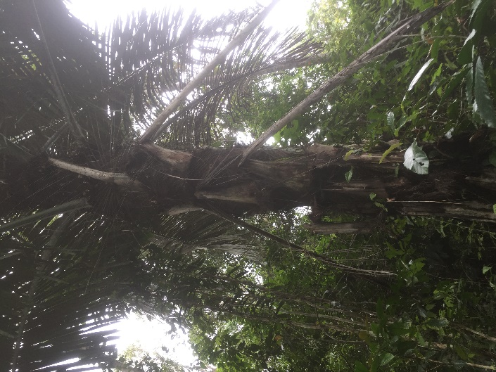
This outcome sees the availability of forest food that can be developed at each project location. The sugar palm forest commodity will be utilized into palm sugar, in addition to harvesting forest honey. The management of palm sugar and honey products will be carried out until the packaging that will become an additional income for the community within the Saddang Watershed ecosystem. Palm sugar products will be marketed to industries in some places in Indonesia. Likewise, with honey products, they will be distributed directly to supermarkets or pharmacies. The development of forest food products is one of the methods in increasing the income of the community, so in this case the community will not encroach on the forest area.

The cultivation and development of forest food crops by linking to appropriate market networks will be a means of ensuring the sustainability of the Social Forestry scheme, s the targeted increase in people’s income through the sale of two kinds of food products that were managed and developed.

Based on the potential of commodities in each project location, NTFPs-based forest food is grouped according to EF Ministerial Regulation No. P.35/Menhut-II/2007 and the Decree of the Minister of Agriculture No. 511/Kpts/PD.310/9/2006 regarding the types of commodities crops managed by the Directorate General of Plantation, Directorate General of Food Crops, and Directorate General of Horticulture, the grouping of commodities can be seen in the following table:
Figure 10. Portrait of forest food, the sugar palm (Arenga pinnata) in project intervention area

Table 3. Grouping of Potential Commodities in Project Areas
No | Sub-district | Commodity | Commodity Group | Priority Food | Agroforestry Pattern | Product Result | Target | Remarks
1 | Rantebua, Buntao,  Nanggala, Makale Selatan, Masanda, Cendana,  Enrekang | Sugar Palm, Bamboo, Candlenut | Fatty oil and starch producer | Sugar Palm | Arenga pinata + Coffee robusta (Robusta coffee) / Theobroma cacao (Cocoa) | Palm Sugar | Commercial Products | This product has potential buyer as follows:  UD. Berkah Avrilla Bone Bolongo District, Gorontalo
2 | Buntao,  Nanggala, Makale Selatan, Masanda | Corn, Peanuts, Taro | Secondary crop (palawija), Nuts & Tubers | Taro | Causarina junghuhniana (Mountain Ru) Elmeria sp (Magnolia) + Colocasia esculenta (Taro) | Taro | Rehabilitation, Household Consumption | Taro seeds will be planted in the Social Forestry area in each Sub-District (Rehabilitation). These commodities will also be used as household consumption
3 | Cendana, Enrekang, Maiwa | Sugar Palm, Tamarind, Durian, Rambutan, Breadfruit, Rose Apple, Mangosteen, Coffee | Fruit producers | Breadfruit | Arthocarpus communis (Breadfruit) + Coffee +Leucaena leucocephala (White Leadtree) | Breadfruit | Rehabilitation, Household Consumption | Breadfruit seeds will be planted in the Social Forestry area in each Sub-District (Rehabilitation). These commodities will also be used as household consumption
4 | Buntao,  Nanggala, Rantebua, Masanda,  Cendana | Bee | Animal products | Honey | Elmeria sp (Magnolia) +Albizia chinensis (Chinese Albizia) + Apis cerana (Bee) | Honey | Commercial products | Direct supply to consumers/cooperation with Supermarket and Pharmacy

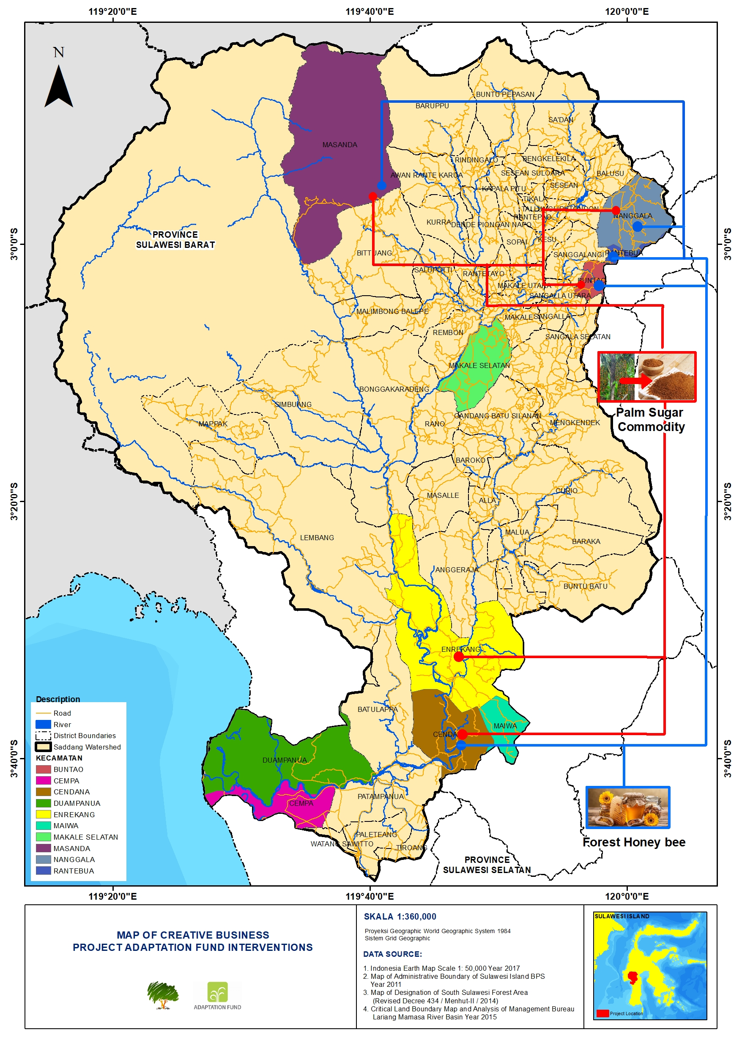
Figure 11. Location Map of Creative Businesses in the downstream of the Adaptation Fund project intervention area
Component 2. Improvement of coastal governance and carrying capacity in supporting climate change adaptation in the downstream Saddang watershed

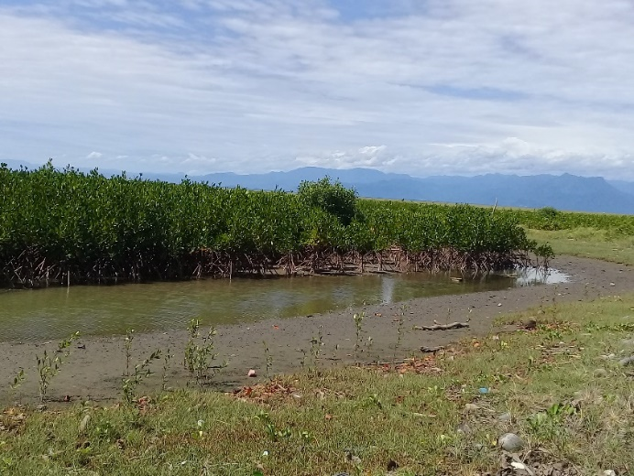
Improved governance and coastal carrying capacity will contribute to the improvement of coastal functions due to the effects of climate change. Through rehabilitation mangroves will contribute directly in preventing flooding, erosion of ponds along the river's lips, can also restore the pattern of river flow that has been changed. On the other hand, with the rehabilitation of mangroves, it will become a sedimentary adhesive so that the large effect of the discharge can be minimized. Other efforts can increase the supply of fish food in the coastal pond area.
Figure 12. Mangrove Rehabilitation Area

This is very important, given that in these areas frequent conversion of coastal land into ponds and agricultural land often results in a decrease in the mangrove ecosystem area. On the other hand, there are also frequent floods in the region caused by increased rainfall, and also the silting of the river due to the effects of climate change through sedimentation that descends from the upstream region.

Outcome 2.1. Strengthened costal human resources and natural resources in the downstream of Saddang watershed in increasing coastal carrying capacity

This outcome begins by forming a climate change care group (KPPI) as the driving force for the response of rehabilitation of 1.2 km of mangrove forests, also supported by facilities and infrastructure such as the construction of seed houses in 3 coastal villages and the provision of mangrove rehabilitation tools, which will provide sustainable rehabilitation during the project period.

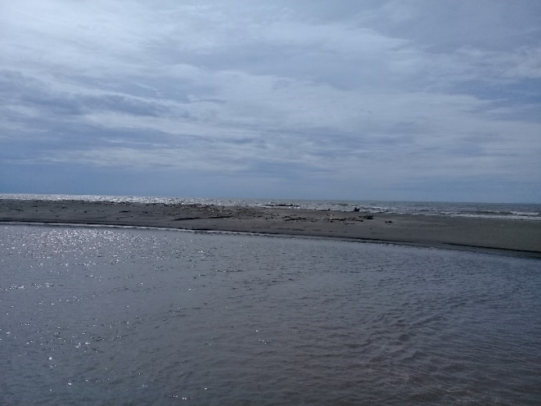
Downstream areas are part of the areas impacted from increased sedimentation due to natural disasters occurring in the upstream areas. 8,071,688.89-ton sedimentation per year was recorded, causing downstream area to be very susceptible to flood. The increase of rainfall and the influence of upstream flow discharge also contribute to the destruction of coastal ecosystem. In addition, the loss of some mangrove ecosystems leads to a decrease in groundwater quality due to coastal abrasion. Referring to the 2018 – 2050 climate change scenario that indicates an average increase in rainfall of 8% over the next 33 years, it will also impact the rise of sea level, and drastic climate change will affect wind speed. Therefore, mangrove forest rehabilitation must be done.
Figure 13. Increased Sedimentation

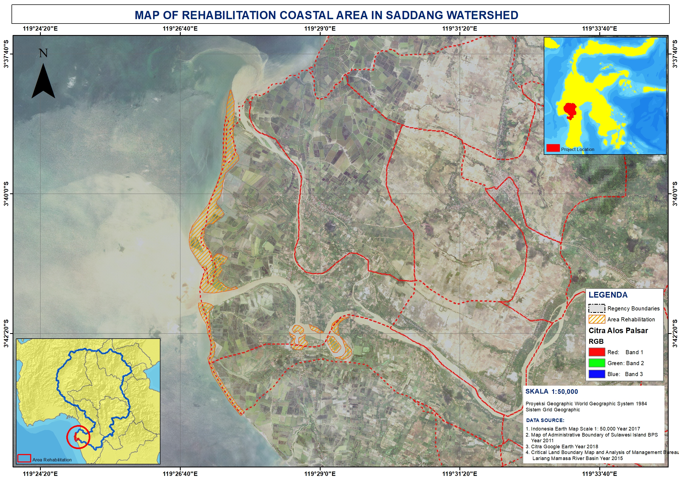

Figure 14. Map of Mangrove Rehabilitation

Outcome 2.2. Increased community income in the downstream of Saddang Watershed through environmentally friendly creative businesses and food diversification

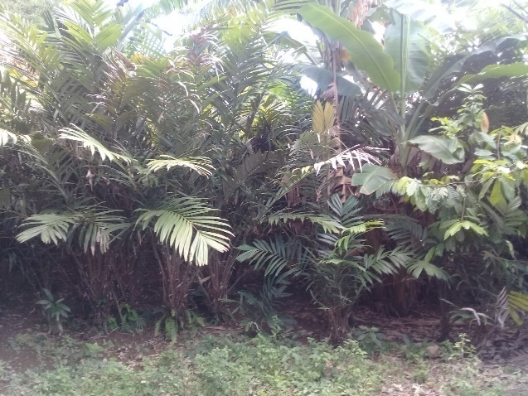
In addition, this outcome will contribute to improving food security and capacity of local groups. Increased food security is done through the development of creative businesses and the development of food diversification by encouraging superior commodities in intervention villages such as seaweed and business development from salak⁴, which will have a positive impact on the income of coastal communities. Capacity building of local groups is carried out with climate change adaptation training, mangrove cultivation training, creative business creation training, entrepreneurship training, and coastal community assistance. The commodities that will be developed to increase the income of local communities in the intervention village in the downstream of Saddang Watershed are as follows:
Figure 15. Salak Plantation Area

Table 4. Enhanced Commodity for Local Community Revenue
No | Sub-district | Commodity | Group | Priority Food | Product | Type of Product | Potential Buyer
1 | Duampanua,  Cempa | Seaweed | Fisheries and Marine | Seaweed | Sea Chips and Raw Materials | Commercial products | - PT. Kima Makassar (Indomaret and AlfaMart)  - Indonesian Seaweed Association (ARLI)
2 | Duampanua | Salak | Farmers | Salak | Coffee from salak seeds | Commercial products | PT. Kima Makassar (Indomaret and AlfaMart)

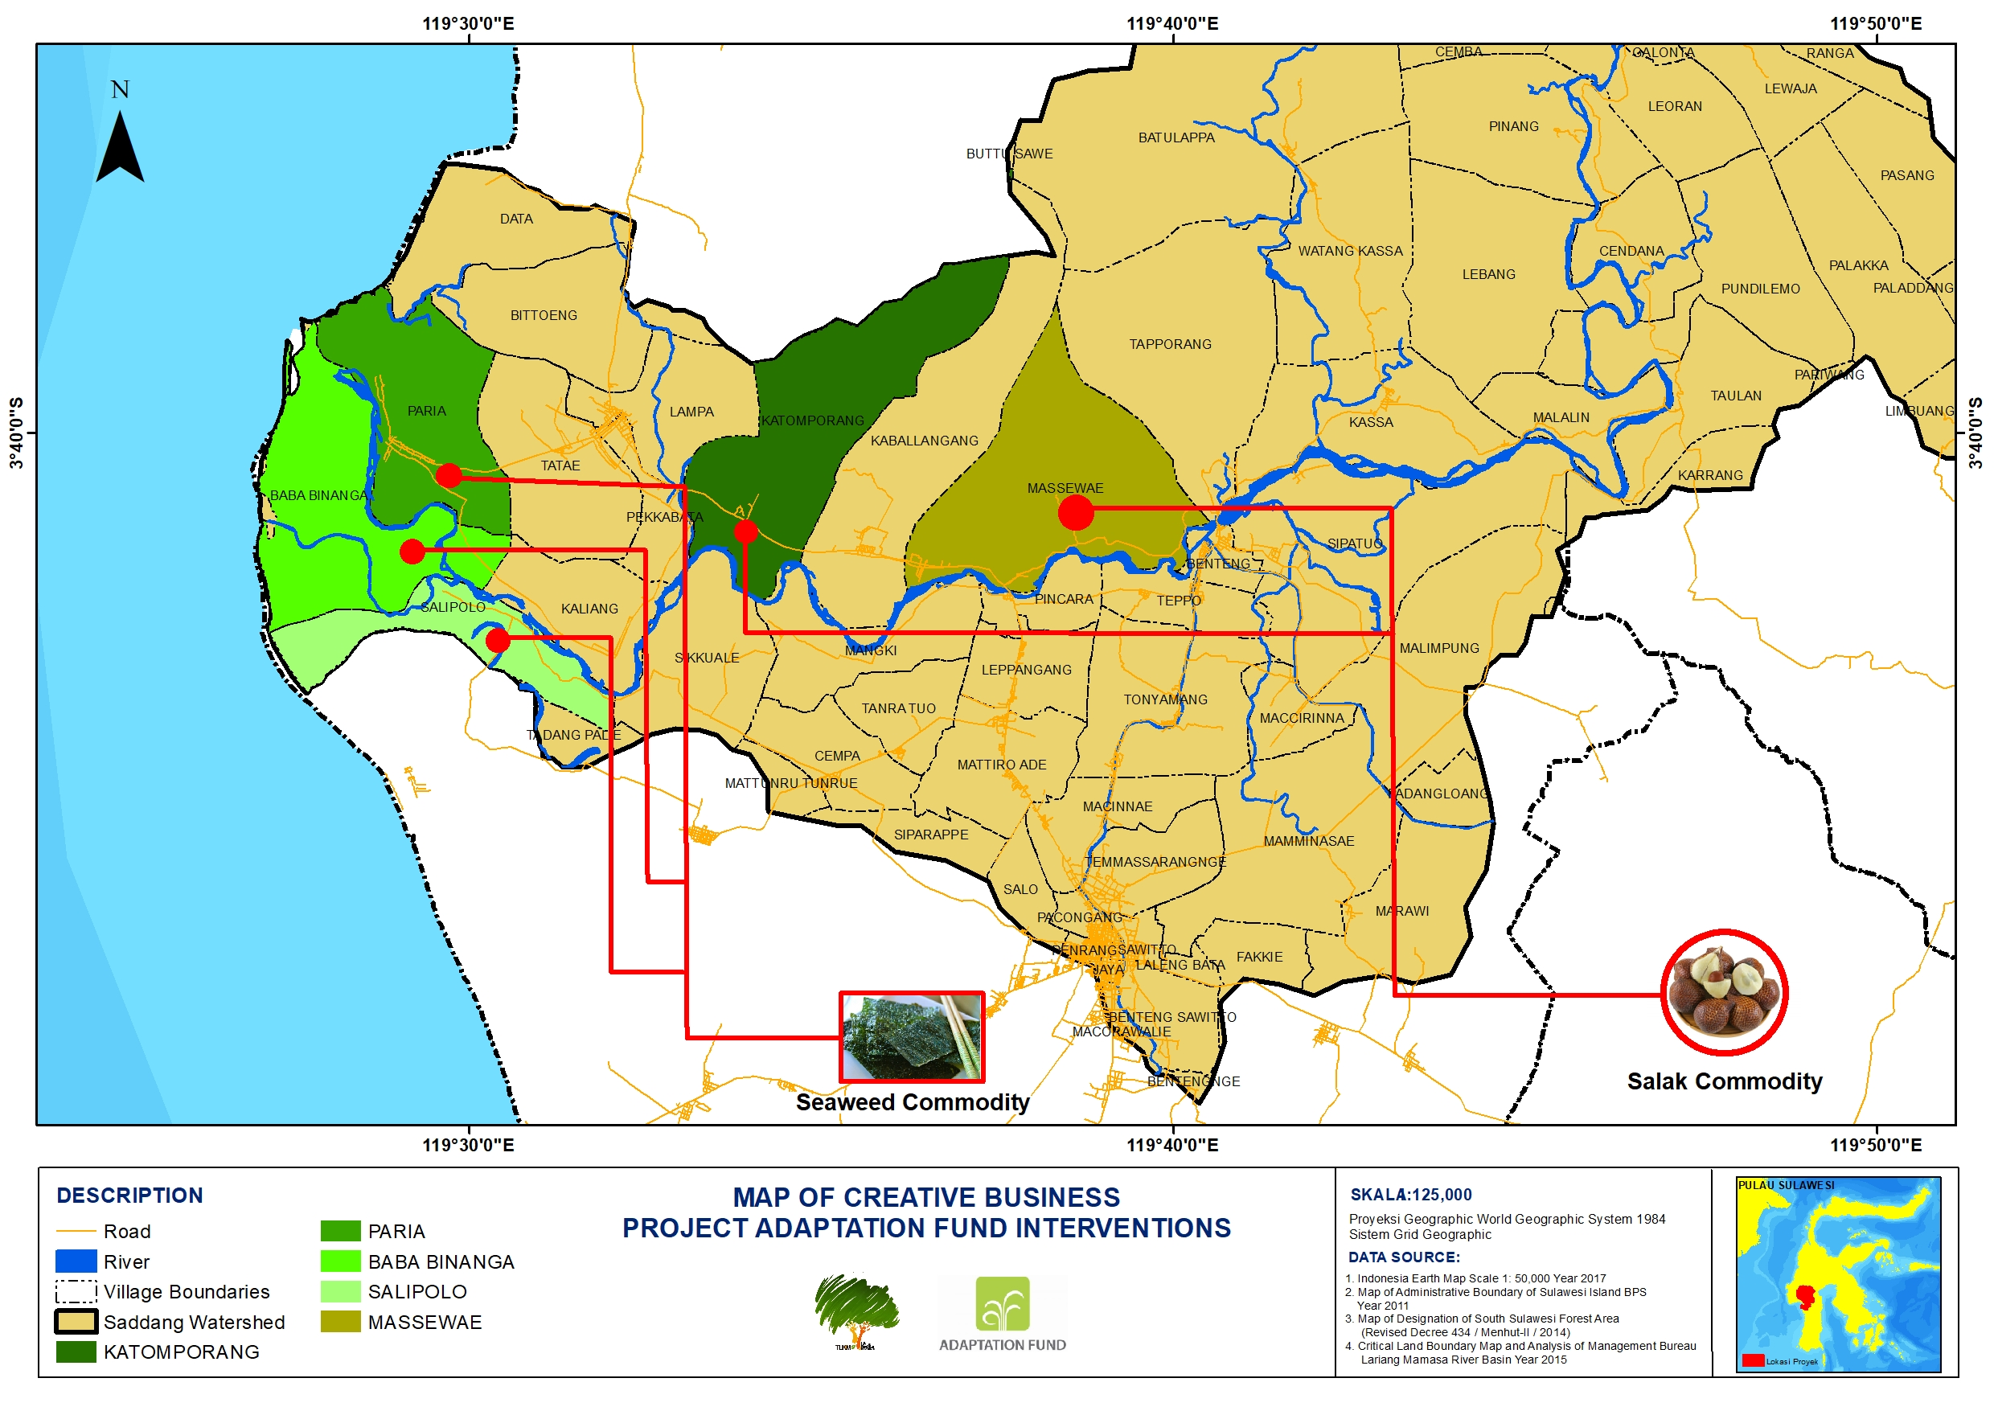

Figure 16. Location Map of Creative Business in the downstream of the Adaptation Fund project intervention area

Component 3. Strengthening of institutional system and capacity to reduce climate risk including socio-economic and environmental degradation

Outcome 3.1. Strengthening of institutional system and capacity to reduce climate risk including socio-economic and environmental degradation
The outcome will be carried out by strengthening regional and cross-sector policies, providing legal certainty in the sustainability of adaptation action in the watershed area. Stakeholders that have an important role to play in the sustainability of climate change adaptation action in the watershed area the local governments. Certainty of sustainability is translated in the form of regional policies that are in line with the government’s national policy. The regional policy in the preparation of climate change adaptation action is guided by the Minister of Environment and Forestry Regulation No. P.33/Menlhk/Setjen/Kum.1/3/2016 regarding guidelines for the preparation of climate change adaptation actions synchronized with RAN - API by the National Development Planning Agency (BAPPENAS). The RAN API Working Group (Pokja) is one of the forums to implement climate change adaptation plan so that each program can be integrated in the development of national and regional development plans. To develop the sustainability of the climate change adaptation plan, the project management unit (PMU) will facilitate the ongoing process at each stage of implementation during the project.
The condition of community in Saddang Watershed Ecosystem is in disaster prone areas, such condition is influenced by climate change. Agricultural sector becomes a matter that must be considered because it is very vulnerable to climate change. Food security can be one of the methods offered for the climate change adaptation process. This is also one of the goals in Sustainable Development Goals (SDGs).
At the district level, every local government unit on environmental, agricultural and climate change, local NGOs, and several experts from universities will be involved in each process of the regional action plan (RAD API). At this stage, there will be formulation of risks and constraints to climate change that have occurred in the Saddang Watershed ecosystem. The grouping of issues will then become the main foundation for the RAD POKJA-API in developing adaptation plans which are then integrated into RPJMN in 2020-2025. The activities of the RAD POKJA-API will also be initiated to become part of the draft local regulations (ranperda) and the strategic plan (renstra) in each regional unit will also be a benchmark for integrating the strategies and action plans that will be formulated. The short-term progress can be monitored in the local government action plan (RKPD) that will be revised once a year. With this project activity can be utilized optimally by the stakeholders. The target program focuses on the level of disaster risk reduction and enhances community preparedness against the threat of climate change and future development of food land, for which the resulting program can contribute to the Saddang watershed community
Each activity agreed with stakeholders will be monitored directly through monitoring applications. The application platform will make it easier to monitor and measure the extent of the impact and constraints of project interventions while it is ongoing. This application becomes a system that ensures program sustainability in climate change adaptation.

Component 4. Strengthening of capacity and support of the parties through knowledge management

All knowledge management and learning activities in this project component are undertaken to ensure the sustainability of climate change adaptation goals and ensure that any learning elements in the project can be replicated in the future. Knowledge dissemination and management are conducted with technology basis so that the scope of the project will be wider in the future, not only in Saddang Watershed, but also in several areas with similar context of issues throughout Indonesia. The POKJA-API that has been formed in synergy with government officials in each project intervention area through climate change adaptation forum becomes a forum for coordination and monitoring of information networks both at regional and national levels.

Outcome 4.1. Strengthened stakeholder capacity and understanding through the process of dissemination and early warning system for climate change adaptation
Dissemination in this project is aimed at all the project target parties so they can obtain information, arise awareness, accept and finally utilize the information. For the focus on dissemination, the main activities are publications by launching documentary films, lessons learned books, research journals, and policy briefs related to Climate Change Adaptation action. The documentary films will documenting all components of the project, and capture the experience and learning stories for each of the project activities that have been done. The publication of the lessons learned book is created to document climate change adaptation actions, and to raise public awareness about climate change. Policy briefs are developed as an advocacy tool to encourage stakeholders to embrace climate change adaptation strategies. In addition, other digital promotional media such as infographics/videographics, as well as physical ones such as leaflets, posters, banners and billboards are also created to encourage accelerated dissemination of lessons learned.
To better ensure that all information is conveyed to the target, we also encourage news media both nationally and locally or print and online media that will actively participate to cover and blow-up the topic of climate adaptation. Management and strengthening of knowledge through social media are also carried out to ensure the sustainability of knowledge management related to climate change adaptation, so that the learning process does not stop if this project has ended.
The technology platform of the early warning system for Climate Change Adaptation is a new idea in this project that can be used by stakeholders as a means to facilitate monitoring, and ensure the dissemination of information about climate situation and conditions in Saddang Watershed in the context of Climate Change Adaptation in the future. Elements of this early warning system include disaster alert, provision of information related to food security and special slots for forest food security, provision of information on river water discharge, and coverage conditions for forest and mangrove in the Saddang Watershed. The technology platform is built with a system that is easier to be accessed by different parties, and will make the transform program much easier for the parties in reaching the technology platform.

New and Innovative Approach, Technology, and Mechanism
Describe how the project /programme would promote new and innovative solutions to climate change adaptation, such as new approaches, technologies and mechanisms.

The program’s key components will promote new solutions and innovations in climate change adaptation efforts through several activities that focus on new approaches, with the technology and mechanisms used are as follows.
- Internalizing Climate Adaptation in forest governance through Social Forestry
The new innovation in climate change adaptation through this program is forest governance through social forestry program. It is driven through a series of program on Legal access for community-based forest management Scheme. The scheme is to prepare a social forestry document through advocacy of legal access to the parties of 5,000 ha. Social forestry is seen as one of the community solutions in climate change adaptation especially forest food security. It is expected that the community can manage forests independently and comprehensively. It is based on a change of forestry paradigm which assumes that humans are a component part of an inseparable ecosystem, so that sustainable forest management and realizing forest food security must involve the human component as the most important component. The social forestry approach is considered to be one of the solutions for long-term tenure conflicts. It is expected that the new approach to social forestry can be modeled in climate change adaptation.

- Managing Nursery as Seedbank Native Species
One of the innovations that will be highlighted in the program activities is the making of nursery as seed bank, especially for food forests such as sugar palm, breadfruit, and taro which are the local native species/type to the area. On the other hand, these activities will also increase the income of the community in the provision of sustainable forest food stock. It is pursued through a series of activities in the form of nursery management technical training, facilitation of food seeds home management module, regular discussion and entrepreneurship training. The seed bank management is done with participatory approach, or through cooperation with local government. This can have an impact on the conservation of native species biodiversity.
- Diversification of forest food products
This activity will introduce forest food products as alternative staple food. The goal is to diversify the forest food so that the surrounding community does not depend on yield/raw material. This activity will be supported through a series of activities in the form of community and institutional capacity building through the Internalized the Action Plan on Climate Change Adaptation in Local Government policies, as well as their planning documents local level adaptation action plans.
- Institutional Strengthening Mechanism for KPPI model
As an effort to adapt to climate change at the institutional level at the Village level, the KPPI (Climate Change Care Group) will be introduced. There will be 5 groups of KPPI formed in each village. These groups will take on the role of disaster response groups at the site/downstream level. The sustainability of mangrove rehabilitation in coastal areas becomes the main task of KPPI. KPPI consists of 10 members of the community who are directly elected by deliberation and will have their capacity enhanced through a series of trainings such as training on coastal natural resources conservation, disaster response, cadre assessment planning, regular discussion, preparation of institution statute-bylaw and system. KPPI will serve as a driving force at the village level in climate change adaptation. KPPI will also perform its duties in collaboration with BNPB, Village Apparatus, Fisheries and Maritime Office, and related stakeholders.
- Technology
New technology will be introduced to the public especially related to the processing of forest food products such Energy-efficient stoves to process palm sap into palm sugar. In addition, it will also use crystallization machine to accelerate the sap processing into palm sugar. Other activities that use a new technology approach are related to honey products obtained from the forest. The community will be introduced with an environmentally friendly honey harvesting technology. The honey harvesting tools will be in the form of safety tools for bees harvesting used by the community when harvesting honey in the forest. It can contribute to sustainable harvest of honey, because people can start leaving traditional ways with curing techniques. In an effort to support disaster preparedness information system, the program will also introduce an Application platform for early warning (disaster alert). This application is web-based/ android-based and contains the database and recent information related to disaster alert. The targets are all beneficiaries in the Saddang Watershed ecosystem. The main components of the application contain information on potential forest food in watershed ecosystem, disaster preparedness, weather information and land cover changes over a period of time. In line with the above, a joint monitoring system related to Climate Change Adaptation monitoring systems will be developed, that support the strengthening of policies implemented by stakeholders.

Economic, Social, and Environmental Benefits
Describe how the project / programme would provide economic, social and environmental benefits, with particular reference to the most vulnerable communities, and vulnerable groups within communities, including gender considerations. Describe how the project / programme would avoid or mitigate negative impacts, in compliance with the Environmental and Social Policy of the Adaptation Fund.

The project will bring various economic, social, and environmental benefits to all stakeholders. The most dominant (economic, social and environmental) impacts of the gains are the people (mainly farmers) as the recipients of the greatest impacts of climate change.

In macro terms, the project defines vulnerable communities as entities prone to receiving climate change impacts. In this case, the group is the community who works as farmers. Provision of legal access is important because communities in the project intervention area are dominated by famers who manage their land for crops and plantations. A high degree of dependence on land is not followed by high community land holdings. Farmers’ land in the project area is dominated by average land tenure of one hectare. Consequently, the average income level of the people who work as farmers is IDR 1,651,282 IDR (below the minimum wage standard). Low revenues eventually trigger the community to enter the state forest area to conduct production process illegally. Through the provision of social forestry permits, community activities can be controlled as well as contribute income to the community. The contribution is contained in the above-mentioned forest food management and development schemes in the social forestry areas. Through the project, the management is strengthened not only through the provision of legal access, but also through the establishment and strengthening of local institutions, including capacity building of the community. Not only that, this project also facilitates local institutional synchronization with national institutions so as to establish an “integrated system” in sustainable development in Saddang watershed ecosystem.

In micro terms, the project also pays attention to vulnerable groups in the project area, dominated by women and elders, through the involvement of forest food management and marketing activities. The involvement of women in every “project objective” is a priority so the gap between genders can be minimized or even no longer exists. More specifically, the project has designed a program for these vulnerable groups through a program to develop creative businesses and diversify food development.

The above provides information that the project is able to provide economic benefits to all areas of the project intervention and financial benefits and knowledge to communities in the project intervention area. The basis to justify this benefit is obtained through the addition or diversification of products for the land-managing community. To support the assessment on the importance of project investment, an analysis team involving academic institutions performs an analysis on the Economic Rate of Return (ERR). An ERR provides a convenient metric to compare the economic costs and benefits of a public investment, program, or policy measure (or “project”). The analysis results show that the ERR value of this project is 47.71% and has passed the minimum standard of the World Bank.

All project activities have also been analyzed for the significance of potential impacts that may occur due to project interventions. The results of the analysis are then developed into a strategy for managing the project intervention known as the Environmental Social Management Plan (ESMP), which is a management preventive step in the process of incorporating the program into a region. The details of ESMP are presented in table 9 in this proposal.

Therefore, preventive measures are dominated by intensive dissemination of information by the management to key figures, recruitment of experienced facilitators and experts as well as selection of experts or writers who have the competence and experience of at least five years in their field. The ease of entering the project into the project area is also reinforced by the various programs undertaken by the Yayasan Tim Layanan Kehutanan Masyarakat (TLKM) as the lead consortium starting from 2011 to date. This process has built the trust of community and key figures for each stakeholder in the project intervention area.

Programs under this project have followed the national and international law which is a prerequisite for the assessment of “Environmental and Social Impact Risk Principles 1. Compliance with Law”. The programs have also followed the principles of sustainable development in the effort of strengthening Sustainable Development Goals (SDG’s) and following the draft of the Government of Indonesia’s international agreement through the Republic of Indonesia’s “Nationally Determined Condition (NDC)”. At the national level, the project also integrates the vision of President Joko Widodo contained in the Nawacita on point 7, Law No. 18/ 2012, Law No. 1/ 2014, Government Regulation No. 28/2004, Presidential Regulation No. 121/2012, Regulation of the Minister of Environment and Forestry No. 33/2016, Regulation of the Minister of Environment and Forestry No. 83/2016, the 2015-2019 Strategic Plan of Ministry of Environment and Forestry, the 2015-2019 Strategic Plan of Food Security Agency, the Strategic Plan of Local Environmental Agency of South Sulawesi Province, Local Regulation No. 12/2011, the 2016-2021 Local Mid-Term Development Plan of Tana Toraja, the 2010-2030 Local Mid-Term Development Plan of North Toraja, the 2013-2018 Local Mid-Term Development Plan of Enrekang, and the 2014-2019 Local Mid-Term Development Plan of Pinrang.

The 2nd principle of Access and Equity does not require follow up because the macro process of program allocation has involved all areas that are part of the Saddang Watershed area. In micro terms, the program area has also been discussed in a participatory manner involving key figures for each stakeholder. These key figures have been mapped in previous TLKM projects. The stakeholder mapping is done in fair and equitable manner regardless of gender, race and religion (without favoritism and discrimination). Through key figures, marginalized parties can also participate in the project’s programs. Another condition related to this 2nd principle is not to carry out physical development activities so that the impacts related to various pollution will not happen.

The 3rd principle of Marginalized and Vulnerable Groups will provide low potential impacts and risks in the future as their projects will be accommodated since the planning, implementation, and monitoring of activities. Generally the project approach uses a "group" approach and is based on "forest-dependent communities", which aims to be active involvement and ensure protection for marginalized and vulnerable groups. The project will involve the majority of beneficiaries who are from marginalized and vulnerable groups.

The 4th principle of Human Rights has no potential negative impact in this project. The existing programs have strengthened civil society’s rights in managing (not taking) state land for their welfare.

The 5th principle of Gender Equality and Womens empowerment has low potential negative impact. Through the project, the involvement of women is further encouraged in the management of KTH. In addition, the programs offered provide women with special opportunities to develop their skill and capacity in managing forests or forest products sustainably. The principle of gender equality and women's empowerment in project activities is designed using an integrated gender engagement system plan (integrated gender plan) as a safeguards that sees as much as possible the proportion of involvement between men and women in all project activities.

The 6th principle of Core Labor Rights is not an important issue. This is due to the project intention that emphasizes the principle of participation of interested parties, especially farmers as landowners. Through the project, farmers have the opportunity to manage state forest areas and act as leaders/managers of their respective fields, not as labors. These conditions make the farmers as a determinant of land management decision-making, which is limited only by state laws.

The 7th principle of Indigenous People is not a problem for all project sites. This is because there is no “Indigenous People” found in the project intervention area.

The 8th principle of Involuntary Resettlement is not a problem because the project does not concern any taking or using of assets derived from the project intervention area. Activities such as land rehabilitation are conducted on state forest areas that are unoccupied vacant land. In addition, there is no activity of building/procurement of buildings/physical goods that can lead to follow up on this principle.

The 9th principle is Protection of Natural Habitats. This project is not linked to the destruction of natural habitats for biodiversity and does not include state-conserved lands. The community forestland management process is aimed at managing land through social forestry schemes so as to create balance between the environment and community welfare.

The 10th principle is Conservation of Biological Diversity. The project supports the creation of biodiversity conservation areas through the strengthening of the surrounding area with social forestry schemes so that it can become a buffer zone for the conservation area.

The 11th principle is Climate Change. The project does not produce greenhouse gas emissions or other climate change drivers in program activities.

Prinsip ke-12 yaitu Pollution Prevention and Resource Efficiency. There is no activity at all in project activities that can cause pollutants and resource efficiency that can damage the surrounding environment.
The 13th principle is Public Health. The project does not focus on public health conditions and project implementation does not create any potential negative impact on public health in the intervention area.

The 14th principle is Physical and Cultural Heritage. The project team’s identification results found no physical and cultural heritage within the project intervention area so it does not require special attention and handling.

The 15th principle is Lands and Soil Conservation. The project directive relating to land management are through the management of forest crops and diversification of forest food. This provides a positive advantage for soil and water conservation in the region

Based on all the above analyses and principles, the conclusion indicates that the project is highly feasible to be implemented economically, socially and environmentally as it can provide benefits and not put negative risks particularly in the context of the 15 principles required by the Adaptation Fund. Table of economically, socially and environmentally can be seen:

Output |  | Expected Benefits
 |  | Social | Economy | Environment
Output 1.1.1. | Legal access for Community Forest, Forest Village Scheme, or Partnership Scheme | As general, a legal scheme for the Community Forestry will trigger Principle 1. KAPABEL commit will compliance with all local, national and international law.  This project involves people who are vulnerable to law enforcement. Without legal access, people who enter the forest area are considered illegal loggers by the government.  This project will endorse behavioral change for the community, from the illegal loggers become forest farmer. Forest farmer will serve conservation while they gain their income | Financially, it will affect the maximum number of households: 2.500 households. The number is based on the assumption that the average capability of people manage land is 2 hectares per households. As information, this number will change according to the effective conditions in the field. This project took the number 185 households as a "pioneer model" for the development of forest food in reaching a total area of 5,000 ha of social forestry scheme.  The 185 families mentioned above will focused on forest food production while maintained food stability in the upstream areas where access to facilities and infrastructure is inadequate.  The results showed that with the change in the current land management, from a monoculture to an agroforestry system (10-year forestry crop rotation), the community could experience an increase in average income of $11,5625 per month per hectare equivalent to a 10% increase in income. This condition applies in a ceteris paribus condition and based on the condition’s farmers sell their raw products to middlemen. This basis is one of the baseline analysis of the Economic Rate of Return.  Increased income is even better if forest food inputs are simulated on land management patterns that can increase by an average of $28,9750 per month per hectare, equivalent to 25% increase in income assuming commercial crops are commercial types such as corn (Zea mays) , peanuts (Arachis hypogaea), cassava (Manihot esculenta), sweet potato (Ipomea batatas), chocolate (Theobroma cacao), and coffee (Coffea arabica). | Legal acces will affect the structure of land:  - Illegal loggers will change their pattern from “just” cut the trees into cut and growth  - The land pattern will change from the monoculture into agroforestry.
Output 1.1.2. | Increased forest land cover | - | In achieving output, the project targets the success of seedling growth by 70%.  This growth can be harvest in 10 years and bring financial impact. As result it can bring approximately $920,31359 / yr / ha | Increasing land cover in the upstream area will strengthen the protection function of a forest area. The protection function in the Saddang watershed ecosystem is, among others, regulating the water system, preventing erosion and preventing flooding.  If the forest land cover effectively used, it can have increased Carbon Reserves  649,850 tons / ha / yr
Output 1.2.1. | Increased capacity of escort and local communities in the scheme of Social Forestry | The project program will strengthen the social forestry scheme in each project target village. The first step is strengthening the capacity of facilatators who will intensively communicate and mediate the farmer groups or its member. This step will train field officers (field facilitators) how to assist community, how to operate the project program in the field level and socialize the Environmental and Social Policy of Adaptation Fund.  The second step is strengthening the capacity of farmer groups. It will include groups dynamics and groups knowledge. So, both individually and institutionally will be upgraded.  In this output will accommodate vulnerable people such as women and elder. At this point we will not mention any numbers of women or elder that we must accommodate. We must considerate first the condition and cultural based on the village. Participatory approach will conduct this. | - | -
Output 1.2.2. | Increased capacity of stakeholders in sustainable forest management | The project program intervense knowledge not only to the community but also to the other stakeholders especially key person in the district governance.  This program will adjust same vision to all stakeholders how to conduct sustainable forest management based on their own problem. | - | -
Output 1.2.3. | Increased stakeholders involved in order to support of the Social Forestry scheme | Full supported from all stakeholders will increase acceleration of social forestry scheme | Appointed the right stakeholders, especially in marketing, will increase the price of the community product (Forest-Food). As ratio, if we cut value-chain it will 10%-20% cost less and if we can find the right price, likes the price in Java, the price will increase 20%-25%.
Output 1.3.1. | Increased skills of Forest Farmers, Women and Vulnerable Groups in Managing Sustainable Forest | Involving vulnerable groups will increase community trust to the project. | As many as 250 people in vulnerable groups will increase their income. The productivity will be 100% (from none ($0) into available income (approximately $35,0937-$105,2811/ month)
Output 1.3.2. | Availability of infrastructure, processing technology of forests-food |  | Technology processing will increase the price of the product and it is estimated into 10%-15%. | The availability of 10 units of forest food processing facilities and infrastructure is built using the concept of environmentally friendly so that it cannot trigger damage around it
Output 1.3.3. | Initiating forest food products to the market | The trickle-down effect on establishing market will provide another job opportunity in the village. | The project is not only endorsing community to change their paradigm to conserve forest, but also help farmers selling their product to the market. If we can find the right market it  and if we can find the right price, additional income to the community will take $28,9824
Output 2.1.1. | Concern Group on Climate Change (KPPI) are created as a mover in the village and sub-district level. | 5 concern group on Climate Change (KPPI) in each village will increase responsibility of their community concern to climate change impact. | - | -
Output 2.1.2. | Increased capacity and skills KPPI as well as the stakeholders in the improvement of governance and the carrying capacity of the downstream coastal watershed | There are 60 people (45 men and 15 women) will increase their capacity and become role model for the improvement of coastal carrying capacities. | This project will include 60 45 men and 15 women) people. So, these people will increase their income in management activities and coastal carrying capacity. | Environment will get the impact from the project because there are planting scheme in location.
Output 2.1.3. | Rehabilitation of coastal areas in the downstream of Saddang watershed | - | The rehabilitation of coastal areas will affect 3% of th current income from communities around. | Increased land cover of coastal areas of 1.2 km with an estimated purchase of carbon 855,600 CO2 Ton / ha / yr
Output 2.2.1. | KPPI skills enhancement, women and vulnerable groups in the development and diversification of household enterprises | KPPI will not affect nenefits directly to the communities but endorse vunerable people (especially vulnerable people such as women, eldely and disabled) to enhance their capacity to make an income. | There is financial income, from nothing become available. The household enterprises will take around $52,6594 - $105,3277 net income per person per month.  There 150 vulnerable people will include in this program.
Output 2.2.2. | Infrastructure technologies are available in encouraging household enterprises and diversification |  | Technology processing will increase the price of the product and it is estimated into 10%-15%. | The availability of 5 units of household-scale processing tools used in creative business and food diversification is built using the concept of environmentally friendly so that it cannot trigger damage around it
Output 2.2.3. | Connect marketing for household enterprises and food diversification | These schemes will support household enterprises. | These schemes will support household enterprises. | -
Output 3.1.1. | Team on Climate Change Adaptation Working Group (Working Group-API) has been formed | As downstream Climate Change institutional, these working group will become a pioneer.  There are no directly impact to the communities in this institutional program. | There are no directly impact to the communities in this institutional program.
Output 3.1.2. | Internalized the Action Plan on Climate Change Adaptation in Local Government policies, as well as their planning documents local level adaptation action plans | There are no directly impact to the communities in this institutional program.  It will affect especially in policies in local governemnt | There are no directly impact to the communities in this institutional program. | We cannot mention how much the impact but these action plan wil conduct several changes in infrastructure mechanism or some act mechanism.
Output 3.1.3. | Climate Change Adaptation monitoring systems that support the strengthening of policies implemented stakeholders | There are no directly impact to the communities in this institutional program.  It will affect especially in stakeholders who approve to change their policies and action plans | There are no directly impact to the communities in this institutional program.  Undirectly, if the preventive steps success by the policies and action plans people will not pay for the damage they get from their actitivities like flood.  There are no real measures to this problem. | -
Output 4.1.1. | Disseminating best practice and lesson learn among all program’s stakeholder at local and national level | People can learn about the holistic mechanism through socialitation and give a feedback to get the best mechanism.  This program will targetting local and national police makers as stakeholders. | There are no directly impact to the communities.  Undirectly, if the preventive steps success by the policies and action plans people will not pay for the damage they get from their actitivities like flood.  There are no real measures to this problem. | -
Output 4.1.2. | Existing early warning system platform for Climate Change Adaptation among Saddang Watershed Ecosystem Community | Social behavioral will change. Community will easier to check the warning, easier to receive information, and undirectly concern about climate change. | - | -

Cost Effectiveness
Describe or provide an analysis of the cost-effectiveness of the proposed project / programme and explain how the regional approach would support cost-effectiveness.

The “Community Adaptation for Forest-Food Based Management in Saddang Watershed Ecosystem” project also analyzes the cost effectiveness of project interventions. The scope of the analysis involves the process of adaptation to ecosystem climate change. The analysis was conducted by comparing two alternatives: the current management of the Saddang Watershed ecosystem and the management of the Saddang Watershed ecosystem through project interventions. This comparison was then sharpened with a 10-year approach whereby if all government allocations annually to all areas of project intervention, then the adaptation process can be achieved. The analytical approach is also undertaken during the life of the project so that the differentiation can be visible.

Table 5. Cost Effectiveness Analysis with 10-Year Operational Cost Approach
Alternative Intervention | Cost Effectiveness Ratio for 10 Year Projection  ($) | Cost Effectiveness Ratio during Project Period  ($) | Cost Effectiveness Incremental Ratio for 10 Year Projection  ($) | Cost Effectiveness Incremental Ratio during Project Period  $.)
Without Project | 549,451 | 549,451 | 117,625 | 588,123
With Project AF | 268,764 | 766,117 | 117,625 | 588,123

The results of the analyses show that during the project period, cost efficiency without project is better then the project. This is because expenditures are made primarily to develop integrated policies and to build institutional social forestry schemes that at the time of the project will not be able to provide a real level of income to the community.

The results showed that with the change in the current land management, from a monoculture to an agroforestry system (10-year forestry trees rotation), the community could experience an increase in average income of $11,5950 per month per ha, equivalent to a 10% increase in income. This condition applies in a ceteris paribus condition and based on the condition’s farmers sell their raw products to middlemen. Low increase affects the impact of the project during project period.

Availability of forest protection function (regulating the water system, preventing erosion and preventing flooding) from trees growth will not serve effectively during the project period. It will take also 10 years to bring the result. The consequences, the value of effectivenss from the disaster management less than the project scheme. The difference will take to 40% of effectiveness.

The value of cost-effectiveness will be very different when we analyze the project over a 10-year period, so with project intervention, cost-effectiveness will be more comparable to that of no project. This is because the preventive steps at the project stage would have had a positive impact in subsequent years to the intervention areas.

Increased income is even better if forest food inputs are simulated on land management patterns that can increase by an average of $28,9462 per month per ha, equivalent to 25% increase in income assuming commercial crops are commercial types such as corn (Zea mays), peanuts (Arachis hypogaea), cassava (Manihot esculenta), sweet potato (Ipomea batatas), chocolate (Theobroma cacao), and coffee (Coffea arabica). This condition applies in a ceteris paribus condition and based on the condition’s farmers sell their raw products to middlemen. Furthermore, if we provide the value of the trees it will take 68% profitability estimated $78,83322/per month/ha.

The above points out that the “Community Adaptation for Forest-Food Based Management in Saddang Watershed Ecosystem” project has a very important urgency in the process of improving governance and sustainable land management in the climate change adaptation process. This project has a better cost-effectiveness compared to the current process, thus it is worth doing.

Alignment with National and Sub-National Sustainable Development Strategies
Describe how the project / programme is consistent with national or sub-national sustainable development strategies, including, where appropriate, national or sub-national development plans, poverty reduction strategies, national communications, or national adaptation programs of action, or other relevant instruments, where they exist. If applicable, please refer to relevant regional plans and strategies where they exist.
- National Development Strategies
National Development is based on the problems of weak joints of the nation’s economy, as it is evident from the many levels of poverty, social inequalities, regional disparities, due to lack of productivity in various regions as a result of striking natural disasters. Thus, the project is based on the Indonesian government’s international agreements contained in the Republic of Indonesia’s Nationally Determined Contributions (NDC) that Indonesia aims to reduce risks to all development sectors through strengthening local capacity, enhanced knowledge management, convergent policies on climate change adaptation and disaster risk reduction, and adaptive implementation of technology. In addition, the project will support the National Action Plan on Climate Change Adaptation (RAN-API) which states that Indonesia will reduce the risk of climate change through local food-based food diversification to reduce the level of risk and yield loss due to diversity and climate change. So, the project will focus on strengthening social forestry in encouraging forest food in the upstream watershed, improved coastal governance and carrying capacity and strengthening crosscutting polices. This project will also be integrated into the national government’s “nawacita” development plan point (7) that the government will manifest economic self-sufficiency by mobilizing strategic domestic economic sectors which include food sovereignty. It is also supported by Law No. 18/2012 regarding food, food independence, and food security. The goal is integrated into the 2015-2019 Strategic Plan of Food Security Agency regarding improvement of food diversification and security for the people and the 2015-2019 Strategic Plan of the Ministry of Environment and Forestry, on addressing climate change and providing climate and disaster information by increasing community involvement in restoration of priority watershed areas of 12.7 million Ha through the development of social forestry in the form of Community Forest, Village Forest, Community Plantation Forest and People’s Forest.
- Regional and Sub-Regional Development Strategies
The project supports and accelerates the 2013-2018 Strategic Plan of Local Environmental Agency of South Sulawesi Province on improving environmental support and climate change adaptation and mitigation with the goal of increasing vegetation cover, and rehabilitation of coastal areas and small islands. At regional level, the project interventions are in line with the 2016-2021 Mid Term Development Plan of Tana Toraja on points of increasing agricultural, plantation, livestock, fishery and food crops production, with efforts to improve the handling of critical land conservation.
The program component also supports the Tana Toraja Local Government’s operational steps related to improving food security, such as the Acceleration of Food Consumption Diversification through dissemination of information and promotional activities to change the food culture that has not been diverse, nutritious, balanced and safe. Program Component 1 on Social Forestry extension refers and supports Local Regulation No. 12/2011 on Spatial Planning of Tana Toraja District for Year 2011 – 2030, where one of the spatial planning policy points on increasing production forest resources with a development strategy of Community Plantation Forest management.
The project supports and accelerates the 2013-2018 Strategic Plan of Local Environmental Agency of South Sulawesi Province on the enhancement of environmental carrying capacity and climate change adaptation and mitigation with the goal of increasing vegetation cover, and rehabilitation of coastal areas and small islands. This is in line with the project approach by increasing land cover in upstream watershed areas by planting 5,000 Ha of forest food seedlings in accordance with the location of social forestry interventions, as well as on costal area through rehabilitation of 5,000 Ha mangroves.
At the sub-regional level, project interventions are in line with the 2016-2021 Mid Term Development Plan of Tana Toraja on points of increasing agricultural, plantation, livestock, fishery production and food security, with efforts to improve the conservation of critical land. The program component also supports the Tana Toraja Local Government’s operational activities related to efforts to improve food security, such as the Acceleration of Food Consumption Diversification through dissemination of information and promotional activities to change the food culture that has not been diverse, nutritious, balanced and safe.
Component 1 of the program related to the expansion of Social Forestry refers and supports Local Regulation No. 12/2011 on Spatial Planning of Tana Toraja District for Year 2011 – 2030, where one point of spatial policy is on the increase of production forest resources with the development strategy of Community Plantation Forest (HTR) management, and the development of agroforestry as a buffer zone. In other areas such as in North Toraja District, the project interventions support the 2010-2030 Mid Term Development Plan of North Toraja in the management, utilization and conservation of natural resources by taking into account environmental aspects through skills-enhancing approaches in processing forest resources, especially forest food, and the exposure of appropriate technology to process forest food.
While in Enrekang District, the project’s idea is to accelerate the 2013-2018 Mid Term Development Plan of Enrekang on the manifestation of the development and acceleration of diversification of local food-based food consumption, as well as the Strategic Plan of Enrekang Forestry Office on the development of Social Forestry in Enrekang District, which is in line with the project component of 5,000 ha of forestry expansion and the utilization of forest area in the development of forest food.
For the downstream area of Saddang Watershed, the project intervention, particularly in Pinrang District, is expected to be able to develop the 2014-2019 Mid Term Development Plan of Pinrang with priorities for regional development, such as efforts to strengthen governance and bureaucracy reform, and to develop science and technology for innovation of potential management and local natural resources, in line with project component 2 i.e. managing and supporting coastal districts in supporting climate change adaptation and strengthening governance in supervision, structuring and utilization of Saddang Watershed through the formation of API WG.

Compliance with National Technical Standard
Describe how the project / programme meets relevant national technical standards, where applicable, such as standards for environmental assessment, building codes, etc., and complies with the Environmental and Social Policy of the Adaptation Fund.
The project will propose a Social Forestry scheme in the Upstream of Saddang Watershed of 5,000 ha. The technical proposal of social forestry scheme refers to P.83/ 2016 on Social Forestry based on community decisions through the Forest Farmer Group (KTH) and other village institutions. In the process, extension agents in each district will be involved in the program. While the process of forming the Forest Farmer Group (KTH) will refer to P.57/2014 on Guideline for Forest Farmer Group Development, of which 15 groups will be formed in the upstream of Saddang watershed.
At the coastal or downstream area of Saddang watershed, coastal management will be carried out with reference to the technical governance standards in Law No. 1/2014 on Coastal Areas Management with the main objective of coastal rehabilitation. It is also based on Presidential Regulation No. 121/2012 on Rehabilitation of Coastal Areas and Small Islands, that rehabilitation of coastal areas contains planning documents during the rehabilitation efforts.
To ensure the sustainability of Climate Change Adaptation Action at the local level, regional institutions will be facilitated to develop Local Climate Change Adaptation Action Plans as well as the establishment of POKJA-API. The technical implementation of the drafting refers to the Regulation of the Minister of Environment and Forestry No.33/2016 on Guidelines for Climate Change Adaptation Action Preparation by involving various sectors in its planning. In addition, the team of experts recruited based on their respective capacities, the support of the Center for Research and Development of Natural Heritage, Biodiversity and Climate Change, Hasanuddin University will also direct the implementation of all project activities in accordance with relevant and applicable national standards in Indonesia.
In addition, the project will also focus on improving people’s incomes through the development of household-scale industries by referring to Government Regulation No. 28/2004 on food safety, quality and nutrition which mandates that processed food produced by home industry is required to have certificates of Home Industry Food Production (SPP-IRT).

Duplication of Project
Describe if there is duplication of project / programme with other funding sources, if any.

Currently, there is no duplication of this project with other funding sources. Future, however, will be driven by small projects conducted through other funding sources to continue outputs. Synergy with stakeholders who also have an interest in this project by building a collective agreement related to the roles. This is intended to avoid overlapping in role, rights and responsibilities.

Learning and Knowledge Management
If applicable, describe the learning and knowledge management Component to capture and disseminate lessons learned.

The essential elements of each program component in the project are oriented towards knowledge management, communication strategies, and appropriate learning systematics. This is important because adaptation efforts will not be achieved if the knowledge capacity of the parties sis not yet qualified and not in one frequency. Achievements will progress slowly if the communication strategy is not appropriate. Appropriate knowledge dissemination patterns and learning systematics will accelerate and support project sustainability, so they can be replicated in the future. This knowledge management process can be seen in in component 3 and component 4 of the project. Several specific and linear activities supporting this are as follows:
- Promoting POKJA-API
In project component 3, it is evident how to capture knowledge through the establishment of POKJA-API in each District. It is intended to be a forum for coordination and knowledge management, updating issues that are developing at the village level to the district level, and saving data and information on the lessons learned. The POKJA-API then will create a joint plan, conduct joint monitoring, and update information periodically. To facilitate communication between members of POKJA-API, a chat group is formed from a chatting platform commonly used as a means of efficient communication path.
- Dissemination and Publication
Component 4 of the project focus on how to disseminate learning, and campaign climate change adaptation actions at the local, national, and even global level. It provides media for climate change adaptation campaigns on social media and websites, campaigns in documentary, infographic/videographic, and other printed publications such as leaflet, posters and banners. In addition, the output of this learning also produces knowledge products/assets such as best practice and lessons learned book and the Climate Change Adaptation journal, as well as advocacy materials for policy briefs. Learning will also be obtained and disseminated through a series of studies to support the adaptation of climate change based on food security. The results of the study are then disseminated in the form of a research paper or scientific journal.

- Monitoring and Early Warning System of Climate Change Adaptation
Encouraging monitoring system and technological platform of early warning system for Climate Change Adaptation that can be used by the parties to ensure continuity of support and programs. Through this system the parties can measure the extent to which changes occur in the context of climate change adaptation in the area of project intervention.

- Capacity Building
Improving the capacity of stakeholders in documenting and disseminating project activities and photographing the changes. Encouraging participation of the stakeholders in the project dissemination will also encourage greater involvement and enthusiasm of the stakeholders. In addition, capacity building of field facilitators, program officers, and extension workers in building communication strategies, encouraging the achievement of targets and significant project changes may occur. To maintain the sustainability of knowledge and learning, module and or technical guidance on program elements is developed such as the cultivation of forests in the upstream of Saddang Watershed and the land and coastal rehabilitation in the downstream of Saddang Watershed.
In addition to the program components, a series of strategies are also undertaken to ensure knowledge management processes are running optimally, such as engaging several experts from universities and research institutes focusing on the climate change adaptation, which are incorporated into POKJA-API and the team of experts in the project implementation group structure. In addition, to reach out to indigenous peoples and/or vulnerable communities, project management will consider the diversity of languages to avoid missed delivery of learning. The recruitment of local personnel as field facilitators can be a strategy to anticipate this problem, to ensure that there is no communication gap at the community level, especially for indigenous and vulnerable communities.

Consultative Process
Describe the consultative process, including the list of stakeholders consulted, undertaken during project / programme preparation, with particular reference to vulnerable groups, including gender considerations, in compliance with the Environmental and Social Policy of the Adaptation Fund.
The implementation strategy of the consultative process at the site level, i.e. in the early stages of the project, carried out the process of stakeholder mapping and identification of vulnerable persons or groups to be involved by considering the distance, the impact of the project, and the results of the analysis of the expert or specialist team assigned to handle this. Key figures who have high influence at the community level were selected as partners in the implementation of the program, such as customary leaders, local youth, women group leaders, and other community leaders. The consultative process involved all key figures, whether in form of Focus Group Discussion (FGD) or other multistakeholder meetings to identify the interests of each beneficiary, so that the interests of each beneficiary can be maximally accommodated in the project implementation. Specifically, especially for vulnerable groups and gender issues, the start of the project will identify the vulnerable persons or families who will be involved by considering the distance, the impact of the project, and the results of the analysis of the expert or specialist team assigned to handle this. The consultation process that has been done can be seen in the following table:

Table 6. Consultation Process in Saddang Watershed
No | Stakeholder | Date | Issue/Key Point
Enrekang District
1 | Central Bureau of Statistics (BPS) | 27 November 2017 | Baseline data, Beneficiaries & Project Intervention Site
2 | Regional Disaster Management Agency (BPBD) | 27 November 2017 | Disaster vulnerability  Disaster baseline 2013-2016  Documentation  Beneficiaries
3 | Development Planning Agency at Sub-National Level (BAPPEDA) | 27 November 2017 | Enrekang District Planning  Project Intervention Site  Social Forestry
4 | Settlement and Spatial Planning Office | 27 November 2017 | Spatial Plan  Project Intervention Site
5 | Village Community Empowerment Office | 27 November 2017 | Project Intervention Site  Village Planning
6 | Industry Office | 27 November 2017 | Small & Medium Industry, SMME  Site Intervention
7 | Environment Office | 28 November 2017 | Environmental Status  Project Intervention Site  Project Components
8 | Agriculture Office | 28 November 2017 | Beneficiaries  Commodity of project intervention site  Land
9 | Social Office | 28 November 2017 | Poverty  Beneficiaries  Project Intervention Site
10 | Tungka Village | 25 November 2017 | Status of Forest Farmer Groups, Women Groups and Vulnerable Groups  Community Dynamics  Community Income  Project Component
11 | Ranga Village | 25 November | Status of Forest Farmer Groups, Women Groups and Vulnerable Groups  Community Dynamics  Community Income  Project Component
12 | Pundilemo Village | 26 November 2017 | Status of Forest Farmer Groups, Women Groups and Vulnerable Groups  Community Dynamics  Community Income  Project Component
13 | Palladang Village | 27 November 2017 | Status of Forest Farmer Groups, Women Groups and Vulnerable Groups  Community Dynamics  Community Income  Project Component
Tana Toraja District
1 | Central Bureau of Statistics (BPS) | 28 November 2017 | Baseline Data  Beneficiaries
2 | Regional Disaster Management Agency (BPBD) | 28 November 2017 | Disaster vulnerability  Disaster baseline  Documentation  Beneficiaries
3 | Agriculture Office | 27 November 2017 | Commodity of project intervention site  Site Project Intervensi
4 | Environment Office | 27 November 2017 | Environmental Status  Componen Project
5 | Development Planning Agency at Sub-National Level (BAPPEDA) | 27 November 2017 | District Planning  Project Intervention Site  Social Forestry
6 | Lembang Randan Batu VIllage | 25 November 2017 | Status of Forest Farmer Groups, Women Groups and Vulnerable Groups  Community Dynamics  Community Income  Project Component
7 | Lembang Paku VIllage | 28 November 2017 | Status of Forest Farmer Groups, Women Groups and Vulnerable Groups  Community Dynamics  Community Income  Project Component
8 | Lembang Sesesalu VIllage | 29 November 2017 | Status of Forest Farmer Groups, Women Groups and Vulnerable Groups  Community Dynamics  Community Income  Project Component
North Toraja District
1 | Central Bureau of Statistics (BPS) | 27 November 2017 | Baseline Data  Beneficiaries
2 | Regional Disaster Management Agency (BPBD) | 28 November 2017 | Disaster vulnerability  Disaster baseline  Documentation  Beneficiaries
3 | Development Planning Agency at Sub-National Level (BAPPEDA) | 27 November 2017 | District Planning  Componen Project  Site Project Intervensi  Beneficiaries
4 | Environment Office | 27 November 2017 | Environmental Status  Componen Project
5 | agriculture and livestock office | 27 November 2017 | Baseline  Commodity of project intervention site  Site Project Intervensi
6 | Forestry and Plantation office | 28 November 2017 | Poverty  Beneficiaries
7 | Bokin Village | 24 November 2017 | Status of Forest Farmer Groups, Women Groups and Vulnerable Groups  Community Dynamics  Community Income  Project Component
8 | Lembang Sapan Kua-Kua Paniki Village | 28 Mei 2018 | Status of Forest Farmer Groups, Women Groups and Vulnerable Groups  Community Dynamics  Community Income  Project Component
9 | Lembang Karre Limbong Village | 28 Mei 2018 | Status of Forest Farmer Groups, Women Groups and Vulnerable Groups  Community Dynamics  Community Income  Project Component
Pinrang District
1 | Environment Office of Pinrang District | 29 November 2017 | Environment  Project Component
2 | Agriculture Office of Pinrang District | 29 November 2017 | Food Production and Productivity  Project Component  Project Intervention Site
3 | Development Planning Agency at Sub-National Level (BAPPEDA) | 29 November 2017 | Regional Planning  Spatial Plan  Project Component  Project Intervention Site  Beneficiaries
4 | Marine and Fisheries Office of Pinrang District | 29 November 2017 | Coastal Zoning Plan  Production of coastal ecosystem  Cultivation center
5 | Central Bureau of Statistics (BPS) | 29 November 2017 | Baseline Data  Project Intervention Site
6 | Regional Disaster Management Agency (BPBD) | 30 November 2017 | Disaster  Project Intervention Site
7 | Water Resources Management office (PSDA) | 30 November 2017 | Climate  Project Intervention Site  Project Component
8 | Baba Binanga Village | 25 November 2017 | Status of Forest Farmer Groups, Women Groups and Vulnerable Groups  Community Dynamics  Community Income  Project Component
9 | Katomporang Village | 26-27 November 2017 | Status of Forest Farmer Groups, Women Groups and Vulnerable Groups  Community Dynamics  Community Income  Project Component
10 | Massewae Village | 28 November 2017 | Status of Forest Farmer Groups, Women Groups and Vulnerable Groups  Community Dynamics  Community Income  Project Component
11 | Sali Polo Village | 29-30 November 2017 | Status of Forest Farmer Groups, Women Groups and Vulnerable Groups  Community Dynamics  Community Income  Project Component
12 | Paria Village | 1 December 2017 | Status of Forest Farmer Groups, Women Groups and Vulnerable Groups  Community Dynamics  Community Income  Project Component

The focus of activity in this project is “Sustainable Forest Food-Based Adaptation of Saddang Watershed Ecosystem Community”, i.e. on Strengthening Social Forestry in pushing for forest food in the upstream of Saddang Watershed, Improving coastal governance and carrying capacity in support of climate change adaptation in the downstream of Saddang Watershed, Strengthening cross-cutting policies in ensuring the sustainability of climate change adaptation and Strengthening the stakeholder’s capacity and support through knowledge management.

The Strengthening of Social Forestry in pushing the forest food in the Upstream of Saddang Watershed which has implications for the improvement of the environment and the increase of people’s income is expected to create sustainable forest and improve the welfare of the community. The achievement can be done by involving several stakeholders to work together and synergize directly or indirectly. The target of achievement in strengthening social forestry scheme is increasing the scheme area in the upstream of Saddang Watershed up to 5,000 ha. In consultation on the strategy of strengthening and proposing the Saddang watershed forestry scheme, the team could involve a team from the South Sulawesi social forestry work group (POKJA PPS), South Sulawesi BAPPEDA, Social Forestry and Environmental Partnership (BPSKL) and Forest Management Units (KPH). Each activity to strengthen the social forestry (PS) scheme in the upstream Saddang watershed will refer to the work target and identification of the indicative map area and social forestry area (PIAPS) that has been formulated by each stakeholder.

In the indicative map of the social forestry area (PIAPS) issued by BPSKL in 2017, the 53 ha forest area in Enrekang District includes reserved areas for social forestry. This forest area is located in Pundilemo Village. Tana Toraja District has a forest area covered by PIAPS of 420.24 ha which can be proposed at Lembang Randan Batu. The forest area that can be reserved for social forestry in North Toraja District is located in Bokin Village covering an area of 267.53 ha. Proposal of social forestry schemes can also be proposed in forest areas linked to project intervention villages. This is supported by the information presented by the head of the social forestry and environmental center (BPSKL) regarding Paladdang Village as one of the intervention villages of this project which has been issued PAK license for CF scheme of 3,200 ha. Similar to Enrekang District, the North Toraja District has obtained determination of Work Areas (PAK) license covering 4,338 ha located in Bokin Village. At the intervention site, the project has a potential area of 10,409.93 ha of protected forest and a production forest of 962.01 ha. Details for the forest area of each intervention village in the upstream area can be seen in the picture below:

Table 7. Forest Area at Project Intervention Area
LOCATION OF INTERVENTION |  | Protection Forest (HL) |  | Total HL | Limited Production Forest (HPT) |  | Total HPT | GRAND TOTAL
 |  | PIAPS | Non PIAPS | Total HL | PIAPS | Non PIAPS | Total HPT | GRAND TOTAL
TOTAL ENREKANG |  |  | 2526.91 | 2526.91 | 53.00 | 463.48 | 516.48 | 3043.39
ENREKANG | Tungka |  | 878.55 | 878.55 |  |  |  | 878.55
ENREKANG | Pundilemo |  |  |  | 53.00 | 463.48 | 516.48 | 516.48
ENREKANG | Ranga |  | 1319.47 | 1319.47 |  |  |  | 1319.47
ENREKANG | Paladdang |  | 328.89 | 328.89 |  |  |  | 328.89
Total Tana Toraja |  |  | 7055,8 | 7055,8 | 420,24 | 25,29 | 445,53 | 7501,33
TANA TORAJA | Lembang Randan Batu |  |  | 0 | 420.24 | 25.29 | 445.53 | 445.53
TANA TORAJA | Lembang Paku |  | 1152.59 | 1152.59 |  |  |  | 1152.59
TANA TORAJA | Lembang Sese Salu |  | 5903.21 | 5903.21 |  |  |  | 5903.21
Total North Toraja |  | 557.52 | 269.7 | 827.22 |  |  |  | 827.22
TORAJA UTARA | Lembang Karre Limbong | 289.99 | 90.2 | 380.19 |  |  |  | 380.19
TORAJA UTARA | Lembang Sapan Kua-Kua Paniki |  | 35.03 | 35.03 |  |  |  | 35.03
TORAJA UTARA | Bokin | 267.53 | 144.47 | 412 |  |  |  | 412
GRAND TOTAL |  | 557.52 | 9,852.41 | 10,409.93 | 473.24 | 488.77 | 962.01 | 11,371.94

Social forestry schemes are the legal access of communities to manage forest areas. The ongoing consultation process with the team of the Social Forestry Acceleration Working Group (Pokja-PPS) of South Sulawesi will be ready to guard the implementation of the SF scheme at project intervention sites. Several schemes that can be managed in intervention villages include Village Forest (HD) schemes whose management rights are imposed on village institutions for village welfare. Another scheme that can be developed is the Community Forestry (CF) scheme aimed at community empowerment. In the CF scheme, the management permit is granted to a group of local communities to utilize forests in protected forest areas and/or production forest areas. The Regulation of the Minister of Environment and Forestry No P.83/MENLHK/SETJEN/KUM.1/10/2016 also stipulates the partnership scheme, i.e. cooperation between the local community and the forest manager, the holder of forest utilization/forest service license, concession of forest area or holder of industry permit for primary forest products.

One of the permits for forest area utilization in social forestry scheme is by applying agroforestry pattern. The study of growth conformity analysis and the application of agroforestry is consulted to experts belonging to the Center for Research and Development of Natural Heritage, Biodiversity and Climate Change, Hasanuddin University, who proposed on the project scheme that there are several agroforestry systems that can be applied, i.e. agrisilviculture system and complex agroforestry system. Implementation of the system is supported with the existing condition in each project location.

Improving coastal governance and carrying capacity in support of climate change adaptation at the downstream of Saddang Watershed is directed at strengthening the capacity of communities in action to respond to climate change. Stakeholders of the Saddang Watershed ecosystem can be consulted through Center for Management of Watersheds and Protected Forests in Jeneberang-Saddang (BPDAS-HL) and Natural Resources Conservation Center (BKSDA). In the downstream area of Saddang Watershed there are 10,681.99 Ha of critical areas in the intervention villages. In disaster-prone areas, rehabilitation programs will be undertaken. The ongoing coordination process will involve provincial forestry service, district government to village level government. In consultation with Marine and Fisheries Office of Pinrang District, it was known that seaweed production in the last 5 years is still not able to reach the targeted value by the government. Seaweed developed in South Sulawesi by the cultivator consists of 2 (two) types, i.e. Eucheuma spp and Gracillaria spp.

Strengthening the institutional system and capacity to reduce climate risk including socio-economic and environmental degradation begins with the creation of a Working Group on Climate Change Adaptation (POKJA-API). The POKJA-API team is an early stage of local community coordination related to sustainable development planning. Each coordination and consultation is directed to the planning stages discussed and budgeted Regional Development Planning Agency (BAPPEDA), Ministry of Environment and Forestry (KLHK), regional Environmental Agency (BLHD) and several regional device work units (SKPD) and relevant local government units to the Saddang Watershed ecosystem. The participatory approach and two-way communication pattern will explore and identify specifically vulnerable groups and their issues. The results will be integrated into the program and have monitoring and evaluation indicators, and separate portions. In the context of environmental studies, technological science, especially climate and disaster studies and other environmental studies, the project will involve the Center for Research and Development of Natural Heritage, Biodiversity and Climate Change, Hasanuddin University.

Strengthening the capacity and support of stakeholders through knowledge management will involve academics as experts in documenting each activity undertaken within the Saddang Watershed ecosystem which s presented in a publishable form. During project implementation, consultation is still implemented to the Meteorology, Climatology and Geophysics Agency (BMKG) of South Sulawesi Province on the platform of early warning applications. This application will become a warning for potential disaster that will occur.

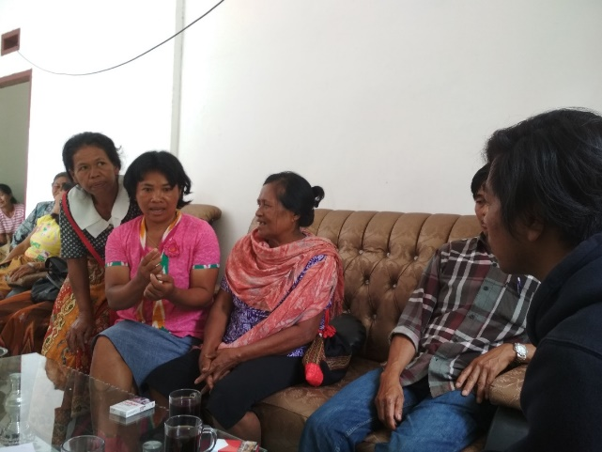
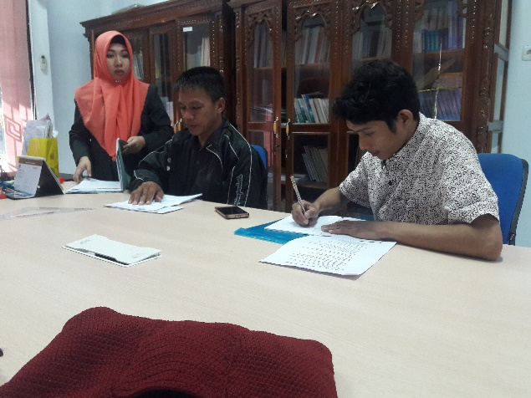
In the context of marketing studies, market assessment will include a process of identifying potential buyers, who will become market partners of processed products from both upstream and downstream of watershed. The stage of identification, analysis, until the efforts to strengthen marketing network is conducted in a participatory way, involving the community who will become entrepreneurs in each commodity managed. This stage will also involve experts as expert consultants in each area of expertise based on commodity products to be sold. In addition, there will be a product-marketing workshop to strengthen the market network, as well as to exhibit the creative products of the community in order to attract potential buyers. Furthermore, there will be a process of hearing to potential market partners, which will be accompanied until the cooperation is established in the form of MoU with market partners to ensure the establishment and maintenance of marketing network for the products. In an effort to strengthen the marketing of creative business products from coastal resources in the form of processed seaweed products, the project will involve seaweed experts as expert consultants to improve product quality to strengthen marketing network.
Figure 17. Consultation Process with Women’s Group in Tana Toraja DIstrict
Figure 18. Consultation Process in Government Agency

In addition, a multistakeholder engagement process continues, one of which was through a Workshop:” Climate Change Impacts” on 3-4 July 2018. This activity was conducted with the aim of sharpening ideas to be achieved through Climate Change Adaptation project involving all community stakeholders from the Saddang Watershed ecosystem community in participatory manner, at village, district and provincial level, as well as at the relevant Ministry of Environment and Forestry such as BPSKL of Sulawesi Region, BPDAS-HL Jeneberang Saddang, BPPIKHL of Sulawesi Region.

The results obtained from the Workshop underscored the importance of climate change adaptation in Saddang Watershed. This is due to the impact of climate change in the upstream of Saddang Watershed has been greatly felt by the community, marked by the increase of river water discharge to floods due to rain even though for only two days. In addition, when the dry season comes even though only for two weeks, it reduces the water flow significantly. For downstream communities, they have great concerns when water level rises upstream. In addition to the impact on increasing sedimentation in the coastal areas, it also poses threat of damaged dam in Pinrang District. If the dam is destroyed, it could drown thousands of hectares of rice fields in some of the largest rice supplier districts in South Sulawesi, one of which is Pinrang District. In the ongoing discussions, the unity of understanding was obtained that the impacts of climate change must be able to be addressed jointly from site level to provincial policy and budget levels.
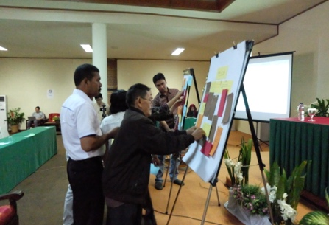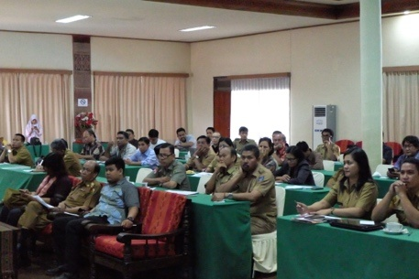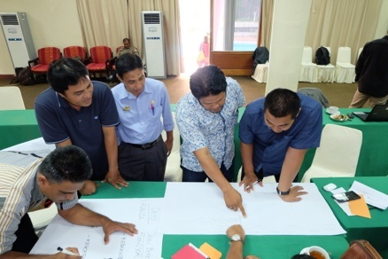
Figure 19. Discussion Process Involving Communities, Local Government Agencies and Provincial Governments

The role of Government, NGOs and Communities was the focus of discussion in the activity. This can be seen in the following table:

Government | NGOs | Communities
Inventorying sectors and regions in vulnerable areas affected by climate change | Initiating project proposals that encourage community independence in climate change adaptation | Participating in maintaining and preserving local wisdom
Developing adaptation strategies and priority programs for addressing climate change impacts and putting them into planning documents (RPJP, RPJM, Renstra, Renja) | Developing training programs for capacity building in climate change adaptation | Taking an active role in any climate change adaptation actives undertaken by government and NGOs
Strengthening the budget on climate change adaptation programs | Advocating and engaging provincial, district and village governments in guarding the alignment of climate change adaptation programs | Implementing changes in income generating efforts by maintaining environmental sustainability
Improving coordination and cooperation between regions and related agencies in the region in order to overcome the impacts of climate change | Establishing cooperation with relevant governments on environment and climate change as outlined in a legally binding form of cooperation | Increasing awareness on climate change impacts
Strengthening facilities and infrastructure to support climate change adaptation program | Serving as facilitator and catalyst in community’s independence to face the impact of climate change | Acting wisely in consuming resources in order to maintain environmental sustainability

Justification for Funding Requested
Provide justification for funding requested, focusing on the full cost of adaptation reasoning.

This project intervenes forest and coastal areas, to policy reforms as they key components that will be intervened in efforts to improve climate change adaptation in Saddang Watershed ecosystem. In terms of biophysics, topography and the large and scattered investment areas, the support of AF in the form of grant funds will greatly help achieve the planned project objectives. The funds will be allocated to all major project activities to realize climate change adaptation actions in the Saddang Watershed ecosystem.

No. | Program Component | Baseline | Additionally (with AF)
1 | Strengthening Social Forestry in pushing for forest food in the Upstream of Saddang Watershed | Lack of socio-forestry concept in encouraging forest food in the Upstream of Saddang Watershed | - Proposed IUP and strengthening of social forestry schemes in 5,000 ha of forest area  - Establishment of 10 institutions/groups n the Social Forestry Scheme and increased capacity to support climate change adaptation  - Increased people’s income through the development of forest food business
2 | Improving coastal governance and carrying capacity in support of climate change adaptation downstream of Saddang Watershed | The underdeveloped Saddang Watershed management will trigger continuous disaster | - Rehabilitation of 1.2 km of land and coastal areas  - Establishment and functioning of 5 KPPIs
3 | Strengthening institutional system and capacity to reduce climate risk including socio-economic and environmental degradation | - Weak institutional system and capacity to reduce climate risk including socio-economic and environmental degradation  - Absence of integrated national action plans for climate change adaptation to the extent of explicit technical actions in the region | - 1 adaptation monitoring application system is used to support policy implementation  - 1 Decree of POKJA-API for South Sulawesi Scope  - 3 policy products that support climate change adaptation  - 2 regional planning documents that have internalized RAN API
4 | Strengthening capacity and support of stakeholders through knowledge management | Public awareness of climate change threats is very low, in the absence of publications | Filming, video, books and other campaign media

Component 1: Without support from AF, the implantation of the Social Forestry Scheme in the target area will be difficult to achieve by looking at the achievements of the government and the district to date, and the internalization of the social forestry model in encouraging forest food will not occur. Constraints in the scaling up of the Social Forestry scheme are among others the size of the communication gap, the lack of good biophysical information, budget, the capacity of the stakeholders and the socio-economic conditions in the target areas, resulting in the lack of social forestry schemes. With funding from AF, opportunities for Social Forestry will be more visible and can increase people’s income through the development of forest food, with a plus value of being able to internalize forest food in sustainable forest governance which will create a much better management of the upstream of Saddang Watershed. Funds will be allocated to each set of activities to achieve the big goals of 5,000 ha of social forestry schemes and the establishment of 10 social forestry groups. Assessment, biophysical and socioeconomic cultural surveys, and mapping are conducted to enrich information resources in climate change adaptation planning. Meanwhile, institutional capacity building activities are carried out to ensure that the plan will be implemented in accordance with expectations and continue to run in the assigned corridor.

Component 2: Without support from AF, the suboptimal downstream management of Saddang Watershed will trigger the occurrence of continuous disaster. With the support of funds from AF, the upstream coastal management of the watershed will be oriented towards the improvement and enhancement of environmental capacity, and empowerment of downstream communities who are heavily affected by climate change, so that ultimately there will be no increase of potential risks that will occur due to climate change in the downstream area of Saddang Watershed. The formation and strengthening of the Climate Change Care Group (KPPI) will be the driving force in efforts to enhance coastal governance and carrying capacity to promote climate change adaptation downstream of Saddang Watershed.

Component 3: Without the realization of the project from AF support, the realization of the implementation of adaptation plans at the local level wall not work by looking at the weak institutional system and capacity to reduce climate risk including socio-economic and environmental degradation. And the absence of integrated national climate change adaptation action plans to region regarding explicit technical actions. With funding support from AF, the sustainability of adaptation plans for the Saddang Watershed ecosystem area will be ensured. Capacity building, and involvement of experts in the formation of POKJA-API in ensuring the realization of local climate change adaptation actions will contribute to sustainability of adaptation efforts in each region of the Saddang Watershed ecosystem, as well as some policy products that support climate change adaptation.

Component 4: Without support from AF, the process of dissemination, knowledge management and systematic learning in support of previous activity will not work optimally. The level of public awareness of climate change threats will remain at a low level, with no publication of this project. AF support for film, video, books and other campaign media production is a dissemination effort to ensure program alignment and expand the scope of benefits from the adaptation program.

Sustainability
Describe how the sustainability of the project / programme outcomes has been taken into account when designing the project / programme.

No. | Program Component | Sustainability Purpose | Treatment or Planning | Measurement
1 | Strengthening of Social Forestry in pushing for forest food in the Upstream of Saddang Watershed | - Sustainability of Social Forestry Institution  - Sustainability of Sustainable Forest Management  - Sustainability of Forest Food Business | - Institutional capacity building and development of the Social Forestry Group business so that groups can be independent and can be organized properly. Capacity building was carried out through several main trainings: 1. Financial Management Training, 2. Forest food quality improvement, Entrepreneurship Training, 4. Forest Management Technical Training Agroforestry Model, 5. Regular group meetings / FGDs in improving trust and norms applies between group members.  - Land rehabilitation activities in upstream areas with MPTS plants also, besides increasing land cover, also increase land productivity, this is to achieve sustainable management, economy and groups.  - Internalization of the Climate Change Adaptation Plan into this social forestry group plan to ensure the sustainability of forest management based on climate change adaptation. Business work plan (RKU) is an obligation of social forestry groups with a management duration of 10 years. So that a minimum of 10 years of climate change adaptation plans have been planned and will be carried out by the group. RKU is also a reference for the government in providing assistance (physical and non-physical) to groups. So that the government will indirectly support climate change adaptation activities carried out by groups after the project has finished. | Measurment:  - 10 farmer groups will be upgraded to capacity through training in managing forest areas through a social forestry scheme with an area of 5,000 hectares. To ensure that farmer groups experience increased capacity, a pre-test before training and post-training after training will be carried out, so that the objectives of capacity building are able to be measured. In addition, it can be seen by the existence of food management activities carried out by the community.  - Land rehabilitation will be carried out on a social forest area of 5,000 hectares with a presentation growing by 70%. With the rehabilitation of land to ensure the sustainability of food crops in the intervention area. This can be seen through remote sensing and ground check in the field after the project is completed to measure the presentation of food crop growth.  - The annual Work Plan (RKT) or business work plan (RKU) document will be created by each farmer group in accordance with the direction of the Climate Change Adaptation Action Plan. Overall, the number of RKT / RKU was 20 documents with the distribution of 10 RKT documents and 10 RKU documents. The process of preparing RKT / RKU will be carried out through a facilitation and mentoring process
2 | Improved coastal governance and carrying capacity in support of climate change adaptation downstream of Saddang Watershed | - Sustainability of KPPI Institution  - Sustainability of Coastal Ecosystem  - Sustainability of Business Management and Food Diversification | - Increased institutional capacity for KPPIs in the downstream region so that groups can be independent and well-organized. The main trainings in the group include 1) Facilitation and monitoring training, 2) Training on mangrove planting, 3) Entrepreneurship training, 4) Technical training on the use of equipment, and 5) FGD / Routine meetings in increasing the prevailing trust and norms between members of the group.  - Activities to rehabilitate coastal areas through planting mangroves along the coastline, this is to achieve sustainable management, economy and groups.  - The Supply Chain and Value Chain economic studies will be carried out as a basis for the preparation of the community product business strategy. In addition, through training in the preparation of business plans, as well as meetings with business people with the aim of establishing cooperation to ensure the economic sustainability of the community | - - 5 KKPI whose capacity will be increased through training in escorting and managing coastal areas. To ensure that KPPI has increased capacity, a pre-test before training and post-test after training will be carried out, so that the objectives of capacity building are able to be measured. In addition, it can be seen from the presence of monitoring activities and others after the training.  - Rehabilitation of 1.2 km of coastal areas by planting mangroves. the achievement of this rehabilitation can be seen through remote sensing and direct monitoring in the field.  - 1 document of Supply Chain and Value Chain studies as a basis for developing business strategies, as well as the MoU between communities and business people as a basis for cooperation and market certainty for community products
3 | Strengthening of institutional system and capacity to reduce climate risk including socio-economic and environmental degradation | - Sustainability of Monitoring System  - Sustainability of Climate Change Adaptation/Financing Program | - Institutional capacity building for government institutions and POKJA-API in order to ensure the sustainability of the climate change adaptation monitoring system, the main trainings made include 1) Adaptation Action Plan Preparation Training, 2) Training on the preparation of climate change adaptation monitoring systems, 3) Training Use of climate change adaptation monitoring system applications  - To ensure the sustainability of the program / financial change adaptation action, meetings will be held with relevant stakeholders to integrate the adaptation action plan into the SKPD strategic plan. In addition, facilitation will be made to propose climate change adaptation action plans into village and regional regulations. | Measurement:  - 8 regional government institutions and POKJA-API will be enhanced in their capacity to develop and operate a climate change adaptation monitoring system. this is intended to monitor and provide information to the public regarding the latest weather conditions.  - 2 product regulations and 1 planning document integrated with climate change adaptation action programs. This is done to ensure that at the government level there is sufficient budget allocation to continue the climate change adaptation action program
4 | Strengthening of capacity and support of stakeholder through knowledge management | - Sustainability of Knowledge Management | - Activities of documentary film making, book and journal making, policy briefs, flyers, posters and banners, web and social media, and rental of billboards to ensure the continuity of knowledge and dissemination of knowledge in the wider community. | Measurment:  1 film, 1 lesson learned / best practice book, 1 Journal, 1 Leaflet / poster / banner, 1 Digital Media that will be published through the media and seminars directly, to ensure that knowledge products exist and are able to be known by the wider community.

At the policy level, integrating adaptation plans into each of the regional development plans and encouraging the Local Action Plans in Climate Change Adaptation into areas of project interventions that are expected to become wagons for greater climate change adaptation. The strong element of capacity building for stakeholders, adaptation-monitoring systems built, management that have an impact on economic and environmental sustainability and lessons learned during the project period, will ensure sustainable results. A strong emphasis on monitoring and evaluation activities will ensure ongoing impact and outcomes.
Furthermore, the involvement of local communities in decision-making is important tot increase their commitment to make solutions, and to ensure responsibility after project completion. The aim is that at the end of the project duration, the selected communities/groups will be able to adapt to climate change independently, supported by an open and participatory government. Here are the main elements in the sustainability of the project to be achieved:
- Financial Sustainability
Financial Sustainability in questions the sustainability of funding from Local Governments in promoting climate change adaptation programs even though the project is over, as well as the sustainability of beneficiaries’ finance from forest food and creative businesses from this project. Funding in favor of climate change adaptation programs will be encouraged through POKJA and District or Provincial Regulations, so that the relevant Local Government Units (SKPD) have legal umbrella in implementing strategic programs and climate change adaptation action programs. Financial sustainability at the level of beneficiaries will be done through the use of technology in processing the results, improving the financial and business management capacity and connecting the processed products to the appropriate market, while prioritizing gender mainstreaming. Aside from that, businesses of forest food pattern to be encouraged will benefit from the local wisdom of Toraja tribe, “Kuang & Alang”, or in brief, we know it as “integrated farming” which has been described previously in the socio-economic context.

- Institutional Sustainability
Institutional sustainability is undertaken by forming climate change care groups and social forestry groups, in which the cadres involved are vulnerable or other target communities that have been strengthened by capacity in institutional governance. Active community engagement with the collaborative process model, as a manager in the institutional sub-system is an adaptive effort in ensuring managed institutions that will support the achievement of long-term climate change adaptation. In addition, the presence of POKJA-API with the support of several other policies can make POKJA-API work continuously even though this project has been completed.

- System Sustainability
The availability of monitoring systems in climate change adaptation programs encouraged through Partnership funding will continue and be used by POKJA-API and the wider community. It will also be related to the knowledge management in order to strengthen project sustainability.
In the initial phase, the regional government must prepare the supporting infrastructure for the system such as: server room, electricity, and internet access. As for the continuity of the EWS System, the regional government will be encouraged to prepare operators and operational, maintenance and maintenance costs. It will be communicated verbally beforehand and a formal legal letter will be made, that the regional government will treat and operationalize it as it should.

Environmental and Social Impact and Risk
Provide an overview of the environmental and social impacts and risks identified as being relevant to the project / programme
This project does not have a significant environmental and social impact, so it is categorized as Category C based on OPG Annex 3-Environmental and Social Policy.
Some categories that have low impact are related to the principles of A and B, where all kinds of complaints mechanisms will be prepared through a series of meetings to accommodate complaints. The Project Complaints Handling Mechanism forms a mechanism for receiving and facilitating problem solving, and complaints of affected local communities. The complaint handling mechanism must have a scale comparable to the impact of the project and be able to answer problems and complaints quickly by using a process that is understandable and transparent that is in harmony with culture, gender sensitive, and can be directly reached by local communities affected without spending costs. The mechanism must not prevent access to legal or administrative settlement in an area. Affected local communities will be informed about the mechanism accordingly. Projects can also be filed with the secretariat at the following address:
Adaptation Fund Board secretariat
Mail stop: MSN P-4-400
1818 H Street NW
Washington DC
20433 USA
Tel: 001-202-478-7347
afbsec@adaptation-fund.org
The following explains the potential impacts and risks to the various outputs of program activities:

Table 8. Program output and identification of trigger for social and environmental impacts
Checklist of environmental and social principles | No further assessment required for compliance | Potential impacts and risks – further assessment and management required for compliance
Compliance with the Law | √
Access and Equity | √
Marginalized and Vulnerable Groups |  | √
Human Rights | √
Gender Equity and Women’s Empowerment |  | √
Core Labor Rights | √
Indigenous Peoples | √
Involuntary Resettlement | √
Protection of Natural Habitats | √
Conservation of Biological Diversity | √
Climate Change | √
Pollution Prevention and Resource Efficiency | √
Public Health | √
Physical and Cultural Heritage | √
Lands and Soil Conservation | √

Principle 1. Compliance with Law
The Implementing Entitles will ensure that all activities comply with the law, and in principle IE will ensure that all licensing components are to be implemented in compliance with applicable legislation. Especially in ensuring legal access to social forestry. The licensing scheme that will be pursued through the social forestry scheme is based on the prevailing government regulation as:
- PERMENLHK No.83/2016 on Social Forestry. Social Forestry based on community decisions through the Forest Farmer Group (KTH) and other village institutions. In the process, extension agents in each district will be involved in the program
- The regional policy in the preparation of climate change adaptation action is guided by the Minister of Environment and Forestry Regulation No. P.33/Menlhk/Setjen/Kum.1/3/2016 regarding guidelines for the preparation of climate change adaptation actions synchronized with RAN - API by the National Development Planning Agency (BAPPENAS).
- While the process of forming the Forest Farmer Group (KTH) will refer to P.57/2014 on Guideline for Forest Farmer Group Development, of which 15 groups will be formed in the upstream of Saddang watershed.
- At the coastal or downstream area of Saddang watershed, coastal management will be carried out with reference to the technical governance standards in Law No. 1/2014 on Coastal Areas Management with the main objective of coastal rehabilitation.
- It is also based on Presidential Regulation No. 121/2012 on Rehabilitation of Coastal Areas and Small Islands, that rehabilitation of coastal areas contains planning documents during the rehabilitation efforts.
- The technical implementation of the drafting refers to the Regulation of the Minister of Environment and Forestry No.33/2016 on Guidelines for Climate Change Adaptation Action Preparation by involving various sectors in its planning.
- In addition, the team of experts recruited based on their respective capacities, the support of the Center for Research and Development of Natural Heritage, Biodiversity and Climate Change, Hasanuddin University will also direct the implementation of all project activities in accordance with relevant and applicable national standards in Indonesia.
- the project will also focus on improving people’s incomes through the development of household-scale industries by referring to Government Regulation No. 28/2004 on food safety, quality and nutrition which mandates that processed food produced by home industry is required to have certificates of Home Industry Food Production (SPP-IRT).
Therefore, no risks or negative impacts are identified regarding compliance with law.
Principe 2. Access and Equity
This project/program does not impede access to basic health services, clean water and sanitation, energy, education, housing, safe and proper working conditions and land rights. The project also does not exacerbate existing injustices, particularly with respect to marginalized or vulnerable groups. The project has been designed in a way that would not impede the access of any group to the services and important rights mentioned in the Principle so that it does not require any further assessment on compliance.
Principle 3: Marginal and Vulnerable Groups
Low impact. So it is categorized as Category C. The project will involve the majority of beneficiaries who are from marginalized and vulnerable groups. Assessments of vulnerable groups who will be involved in the project are identified by several categories such as age, work, income and family dependents. The data will then be fairly chosen for group involvement in each project activity. This activity will also ensure that children and the elderly will not be involved in every activity of training program which will then be included in periodic monitoring and evaluation.
In this project, the participation of vulnerable groups who are beneficiaries is not fully approved, so that it will trigger uneven social impacts. However, monitoring will have an impact on this will be carried out as scheduled during the project carried out through monitoring and evaluation on each project activity.
The results of monitoring and evaluation will ensure that vulnerable groups around project location also feel same benefits.
Principle 4: Human Rights
The project/program should respect and if possible, promote international human rights. The promotion of human rights in the project/program will be achieved by creating awareness with everyone involved in project/program operations, including design, implementation, monitoring and evaluation, regarding the Universal Declaration of Human Rights as the overall principle of project. So that it does not require any further assessment on compliance.
Principle 5: Gender Equality and Women’s Empowerment
Low impact. So it is categorized as Category C .This project/program has been designed in such a way that women and men have equal opportunity to participate in accordance with gender policy and receive comparable social and economic benefits. The project will actively involve equal participation in project/program activities and stakeholder consultations. The project also ensures that positions in the project/program are effectively accessed by men and women, and that women are encouraged to implement and take positions, which in essence, the design and implementation of the project/program will ensure equal access to both male and female beneficiaries. Gender involvement is assessed through the proportion of work in household so that it can support their livelihoods. The beneficiary related activities, e.g. training and capacity building were 27% of women. The interventions planned would have positive impact on women empowerment and would ensure gender equity due to certain livelihoods. The principle of gender equality and women's empowerment in project activities is designed using an integrated gender engagement system plan (integrated gender plan) as a safeguard that sees as much as possible the proportion of involvement between men and women in all project activities.
Principle 6: The Rights of Core Workers.
This project/program meets core labor standards as identified by the International Labor Organization. The ILO’s core labor standards. The ILO’s core labor standards are contained in the LO’s Declaration of Principles and Fundamental Rights in 1998. The Declaration includes four fundamental principles and rights, developed further in eight human rights conventions:
- Freedom of association and protection of the right to organize and collective bargaining convention (ILO convention 87 and 98);
- Abolition of forced labor convention (ILO convention 29 and 105);
- Worst forms of child labor convention (ILO convention 138 and 182);
- Discrimination (employment and occupation) convention (ILO convention 100 and 111).
The project/program will incorporate the ILO’s core labor standards in the design and implementation of the project/program and create awareness with all involved on how the standard is implemented. The whole programming is not related to violations of core labor rights.
Principle 7: Indigenous Peoples
The project is not related to Indigenous Peoples or the Rights of Indigenous Peoples and other international instruments applicable to indigenous peoples. The project also does not concern involvement of indigenous people in the design and implementation of the project/program so that it does not require any further assessment on compliance.
Principle 8. Involuntary Resettlement
The project is not subject to resettlement or relocation or loss of shelter and or economic displacement (loss of assets or access to assets that result in loss of income or other means of subsistence) so that no further assessment is required on compliance.
Principle 9: Natural Habitat Protection
This project is not subject to the conversion or relation of unjustifiable critical habitat degradation, including those protected by law so as not to require further assessments on compliance.
Principle 10: Biodiversity Conversion
This project is not related to activities that impact on the reduction of loss of biodiversity or the introduction of known invasive species or unjustifiable and thus require no further assessment of compliance. Precisely this activity will encourage efforts to conserve biodiversity through the cultivation of forest food crops.
Principle 11: Climate Change
The project is basically for enhancing the adaptive capacity of community who lives arround Saddang Watershed Ecosystem and livelihoods against adverse impact of climate change and is not expected to contribute to GHG emissions. No further assesment required for compliance.
Principle 12: Pollution Prevention and Resource Efficiency
The project is not focused on waste production and release of pollutants (including greenhouse gases) so as not to require further assessments for compliance.
Principle 13: Public Health
The project is not focused on activities related to efforts to avoid significant negative impacts on public health, access to medical care and health facilities so that it does not require further assessment of compliance.
Principle 14: Physical and Cultural Heritage
The project is also not subject to efforts to alter, destruct or delete physical cultural resources, cultural sites and locations with unique nature such as at the community, national or international levels that are World Cultural and Natural Heritage so no further assessment on compliance is needed.
Principle 15: Soil and Land Conversation
In project implementation, all activities will not have any impact on soil damage and other activities that could lead to land loss and land degradation, so no further assessment of compliance is required.

PART III: IMPLEMENTATION ARRANGEMENTS

Arrangements for Project Implementation
Describe the arrangements for project / programme management at the regional and national level, including coordination arrangements within countries and among them. Describe how the potential to partner with national institutions, and when possible, national implementing entities (NIEs), has been considered, and included in the management arrangements.
The Climate Change and Environmental Adaptation Consortium (Konsorsium Adaptasi Perubahan Iklim dan Lingkungan/KAPABEL) consists of 5 organizations including: (1) Community Forest Service Team (Tim Layanan Kehutanan Masyarakat/TLKM) Foundation, as Lead Consortium, and Consortium members: (2) Natural Heritage, Biodiversity and Climate Change, (3) AKU Foundations, (4) Kanopi Hijau – Enrekang, (5) Bumi Lestari - Pinrang. The Community Forestry Service Team (Tim Layanan Kehutanan Masyarakat/TLKM) is an institution engaged in sustainable natural resource management, which has been established since 2010, certified by a notary institution in 2011, and incorporated as a foundation in 2017. Since 2010, 2010 TLKM has been involved in issues of social forestry and natural resource management sustainability (Bantaeng, Maros, Sinjai, Gowa, Enrekang, Toraja and Barru), conflict forest issues, especially in Bantimurung Bulusarung National Park, Maros District, and particularly related studies of disaster around forest areas (Enrekang, Toraja, North Toraja, Pinrang, and Mamasa). With the motto “Communiversity For Sustainable Forest”, TLKM has been a successful initiator and played a major role in the Mamuju Community-Based Natural Resource Consortium (PSDABM-M) in the Millennium Challenge Account Indonesia (MCAI-I) Window II program in West Sulawesi Province with total budget managed of ±$750.000. Several TLKM partners at national and international levels today include: Recoft, MCAI, Shamdana Institute, Community Forestry Communication Form (Forum Komunikasi Kehutanan Masyarakat/FKKM), Sulawesi Community Foundation (SCF), Perkumpulan Inisiatif, and WWF.
The project component will ensure that gender mainstreaming is implemented effectively from the planning stage to the implementation stage, and ensures gender responsive sustainability even after the project is completed. in this project, it highly respects the gender competencies of PMU. In the staff selection process, the program will include adequate gender understanding as criteria for selecting team members. The team will be assessed for gender related competencies. Furthermore, to improve their understanding of gender issues and understand the content of the proeject component, workshops and training sessions will be conducted for each facilitator that supports PMU's performance during the program planning phase. From the workshop, it is expected that staff will be equipped with adequate knowledge about the consideration of gender mainstreaming in the program and adequate capacity to support the implementation of gender responsive programs.
The Consortium pattern will be governed through the PMU (Project Management Unit) Structure where the structure will be established in accordance with program needs. Furthermore, each member of the consortium will fill in accordance with its capacity and required criteria. In addition, strategic policies will be taken at the Steering Committee level where all institutions have a steering committee member who is not involved in the project implementation structure. This is to avoid conflict of interest, especially on the people involved in the project implementation.
The Steering Committee (SC) will oversee the entire program implementation to ensure that the facilities and mechanisms have run the program effectively so as to achieve the desired results, while also representing the voices of stakeholders who are not directly responsible for the project. In the process of running the project, SC will provide technical guidance for each PMU for the implementation of the program, including guidance on the policy advocacy process at the national level. The frequency of meetings will be scheduled for each quarter of the activity. Figure 20 the Institutional Structure for the Program will illustrate, including the Project Management Structure of the PMU

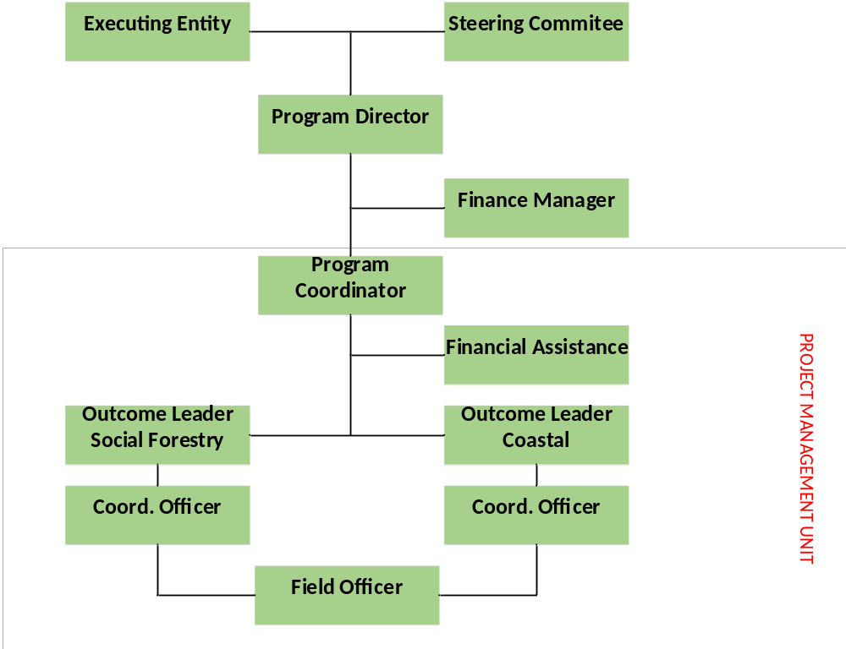
Figure 20. Project Management Unit (PMU) Structure

PMU is led by the Program Coordinator responsible to the NIE. In delivering work progress, the Program Coordinator will be assisted by a Downstream Program Manager, Upstream Program Manager, Downstream Program Officer, Upstream Program Officer, Financial Assistant and village assistants. The Project Coordinator is responsible for ensuring that the project activities in the targeted villages are running. PMs, POs, Village Assistants are responsible for the implementation of activities in each targeted area, and they will report to the Project Coordinator and will be assisted by the Financial Assistant who will handle the administrative and financial issues at the local level, while the Finance Manager is responsible for the financial issues in the overall project activity.
In conducting its work, the PMU will receive technical assistance from a group of experts from different backgrounds and expertise including: Forest and Environmental Management Specialist, monitoring & Evaluation Specialist, Social gender Specialist, Food and Diversification Specialist, and Climate Change Spatial Adaptation Specialist. These experts will provide inputs for technical inputs in other relevant programs at both the provincial and district levels: Agriculture and Food Crops Office, Forestry Office, Environment Office, Social Affairs Office, Fisheries and Marine Office, Universities, Regional Disaster Management Agency, Health Office, and Cooperative and Industry Office. All relevant agencies will be incorporated into TIM POKJA API at the district level, and in addition there are several capacity building activities related to climate change adaptation, both from technical point of view, preparation of action plan, and monitoring and supervision system. Aside from that, the support of social media to blow up issue of climate change adaptation will encourage the alignment and enthusiasm of the parties involved.
With Kemitraan as the National Implementing Entity, if possible, Kemitraan will also be included in TIM POKJA API to ensure that the direction of policy, program and action plan in the project are in accordance with the target at the National Implementing Entity level. The pattern of coordination, reporting, monev will of course be conducted regularly with the National Implementing Entity. To facilitate communication flow and mutual strengthening, the implementation team will specially make a mailing list and a WA group.
The role of each institution involved can be seen in the table below:

Table 9. The Part of PSC and PMU to be involved and their roles

Steering Committee | The Steering Committee (SC) will oversee the entire program implementation to ensure that the facilities and mechanisms have run the program effectively so as to achieve the desired results, while also representing the voices of stakeholders who are not directly responsible for the project. In the process of running the project, SC will provide technical guidance for each PMU for the implementation of the program, including guidance on the policy advocacy process at the national level. The frequency of meetings will be scheduled for each quarter of the activity | Steering Committees that will be involved include: National Governments, Provincial Governments, Local Governments, Village Governments, Academics, and civil society.  National governments, they are:  1. Ministry of Environment and Forestry (KLHK)  2. Social Forestry and Environmental Partnership (BPSKL)  3. Forest Plant Seedling Center (BPTH)  Provincial Governments:  1. Center for Management of Watersheds and Protected Forests in Jeneberang-Saddang (BPDAS-HL)  2. the planning stages discussed and budgeted Regional Development Planning Agency (BAPPEDA)  3. forestry Service  Local Governments:  1. Environment service  2. agriculture and livestock service  3. Marine and Fisheries service  4. Office of Cooperatives and SMEs  5. public health Office  6. Regional Disaster Management Agency  7. Development Planning Agency at Sub-National Level  8. Water Resources Management office
Executing Entity | Consortium will be responsible for supervising, supporting and providing technical guidelines for the following activities:  1. Program preparation, including selecting PMU and linking the Steering Committee to the project  2. Program implementation, including communication and coordination with the Steering Committee  3. Program monitoring and evaluation of PMU  4. Financial monitoring and assessment of project implementation | As the executing entity, Consortium will ensure the running of the program is in accordance with the Partnership policy and the AF Policy
Program Director | The Program Director will direct PMU in implementing the Program  1. Together with the Executing Entity in selecting PMU  2. Together with PMU, the Program Implementation Plan will be prepared as a guide for implementing the program  3. Ensure that the program is carried out in accordance with the objectives  4. Together with the Partnership in monitoring progress and results of achievement  5. Coordination Program progress and program problems to the Steering Committee | The Program Director is the Program leader who will be responsible for the National Implementing Entity through reporting results
Team Expert | Will be responsible for studies:  1. Forest and Environmental Management Specialist,  2. monitoring & Evaluation Specialist,  3.Social gender Specialist,  4. Food and Diversification Specialist, and  5.Climate Change Spatial Adaptation Specialist | Is a team of experts in their respective fields that are tailored to the Program Plan
Finance Manager | The Finance Manager will be responsible for financial and administrative management for the overall implementation of the program
Program Coordinator | Will lead the PMU in implementing the program as a whole in day-to-day basis. Among the specific responsibilities are:  1. coordination with Outcome Leader Forest Social dan Outcome Leader Coastel in preparing the Program Implementation Plan as a guide in implementing the program  2. coordination with provincial and district governments  3. Ensuring the course of the program is in accordance with the goals and results to be achieved  4. Report the program results in the Program Director
Financial Assistance | Financial Assistance will be responsible for financial and administrative management for program implementation in accordance with the direction of the Program Coordinator
Outcome Leader Social Forestry | Will be responsible for implementing the program in the upstream section.  1. Together with the Coordinator Officer, the program implementation plan is planned as a guideline for implementation  2. ensure that the program is carried out in accordance with the objectives  3. coordination of program progress and program problems with the Program Coordinator  4. Coordination with the District Government
Outcome Leader Coastel | Will be responsible for implementing the program in the downstream section.  1. Together with the Coordinator Officer, the program implementation plan is planned as a guideline for implementation  2. ensure that the program is carried out in accordance with the objectives  3. coordination of program progress and program problems with the Program Coordinator  4. Coordination with the District Government
Coordinator Officer | Will be responsible for the Field Officers.  1. will coordinate the Field Officers  2. Provide reports to each Outcome Leader  3. Coordination with each Outcome Leader  4. Coordination with the village government
Field Officer | Will come in direct contact with the beneficiaries  1. communication with the community  2. provide a report to the Coordinator Officer | The intended beneficiaries include: Farmer Groups, Women and Vulnerable

Table 10. Stakeholder involvement by output or activity
Output | Stakeholders
1.1.1. Existing legal access to Community Forest or Village Forest | TLKM, YAKU, Kanopi Hijau, BPSKL, Partnership and village government
1.1.2. Increased forest land cover | TLKM, YAKU, Kanopi Hijau, Natural Heritage, Biodiversity and Climate Change Farmer Groups, Women and Vulnerable, BPTH, BPDAS-HL
1.2.1. Increased capacity of facilitators and local communities in Social Forestry scheme | TLKM, BPSKL, YAKU
1.2.2. Increased capacity of stakeholders in sustainable forest management. | TLKM, YAKU Farmer Groups, Women and Vulnerable
1.2.3. Increased support from the stakeholders in encouraging Social Forestry scheme | TLKM, YAKU, Kanopi Hijau, BPSKL
1.3.1. Increased skills of Forest Farmer, Women and Vulnerable Group in managing sustainable forest food. | TLKM, YAKU, Farmer Groups, Women and Vulnerable
1.3.2. Available facilities and infrastructure of forest food processing technology | TLKM
1.3.3. Absorbed forest food products to the market | TLKM, YAKU, NHBCC, Kanopi Hijau, Farmer Groups, Women and Vulnerable, Health Office, Cooperative and Small and Medium Enterprises
2.1.1. Established and running Climate Change Care Group (KPPI) as the driving force at the village and sub-district levels | TLKM, Farmer Groups, Women and Vulnerable
2.1.2. Increased capacity and skills of KPPI and stakeholders in improving costal governance and carrying capacity downstream of watershed | TLKM, YAKU, Bumi Lesari, Farmer Groups, Women and Vulnerable
2.1.3. Rehabilitated coastal areas downstream of Saddang Watershed | TLKM, YAKU, Bumi Lestari, BPDAS-HL Fisheries and Marine Service, Farmer Groups, Women and Vulnerable.
2.2.1. Improved skills of KPPI, forest farmer, women and vulnerable groups in the development of creative business and food diversification | TLKM, YAKU, Bumi Lestari, Health Service, Agriculture and Food Crop Service, University, Farmer Groups, Women and Vulnerable
2.2.2 Available technology facilities and infrastructure in encouraging creative business and food diversification. | TLKM, YAKU, Bumi Lestari
2.2.3. Existing marketing network for creative business and food diversification | TLKM, YAKU, Bumi Lestari, University
3.1.1. Established and operating Climate Change Adaptation Working Group Team (POKJA-API). | TLKM, YAKU, NHBCC, Kanopi Hijau, Bumi Lestari, Environmental Agency, Forestry Service, Environment Agency, Agriculture and Food Crop Service, BPBD, University
3.1.2. Internalized Climate Change Adaptation Plans to Local Government policies, as well as existing adaptation action plan documents at the regional level | TLKM, YAKU, NHBCC, Kanopi Hijau, Bumi Lestari, Office of Environment, Forest Service, Agriculture and Food Crop Service, BPBD, University
3.1.3. Existing Climate Change Adaptation monitoring system that supports the strengthening of policies implemented by the stakeholders | TLKM, YAKU, NHBCC, Kanopi Hijau, Bumi Lestari, Office of Environment, Forest Service, Agriculture and Food Crop Service, BPBD, University
4.1.1 Disseminated program to strengthen and encourage policies and alignments | TLKM, YAKU, Media
4.1.2 Existing early warning system platform for Climate Change Adaptation among Saddang Watershed Ecosystem Community | TLKM, YAKU, NHBCC, BPBD, Universitas

Financial and Project Risk Management
Describe the measures for financial and project / programme risk management.

All risks in project implementation are analyzed during the design phase with the participation of all relevant stakeholders. A mitigation strategy is established to ensure that the risk is well managed. The table below presents the types of risks, description of risk and risk level and the strategies that have been and will be done to minimize them.
Type of Risk | Description of Risk | Risk category (H/M/L) | Risk Mitigation Strategy
Institutional | Weak commitment built by project implementers with central/provincial/local government due to changes in government structure and lack of coordination and communication. | Medium | This project has a specific work component of community strengthening, so that the change of government structure has no major impact on the direct beneficiaries of the project.  To ensure project achievement will be achieved, the PMU will continue to build active coordination and communication with the local government.
Institutional | Changes in project personnel can affect the availability of qualified staff | Low | In establishing working relationships with the PMU, the Consortium implements a recruitment system with output of work contracts during the project. With this mechanism, the personnel attachment with the consortium in achieving the project goal will be the legal basis.
Financial | Delays in disbursement of funds, procurement and institutional efficiency (long approval process and others) that delay project implementation. | Medium | Building active communication with the grantor and fulfilling all forms of financial procedures in budget disbursement. The roles and responsibilities of the Community for Sustainable Forest Foundation (TLKM Foundation) as a contortium lead to anticipate if at any time a delay in disbursement of funds can hamper the course of activities through the pre fund.
Social | Lack of community (direct beneficiaries) support to the project | Medium | - Building good relationships with local government (village level), community and the community leaders (direct beneficiaries) before the project starts  - The formation of groups at the village level can gather all people/levels that are in target community  - Utilization of activities in the form of training/workshops/group discussions to provide understanding of the project
Social | Communities are less aware of climate change and have lack of enthusiasm to respond to disasters. If beneficiaries are not fully aware of the impacts of climate change, it is difficult to gain their commitment in forest food development and climate change adaptation | Low | This project will implement and introduce participatory methods to the communities so that they can be provided with understanding on the impacts of climate change. In addition, the mentoring process will be undertaken at the village level by utilizing field facilitators in each of the project target village.
Social | Conflict of community interest in land use by PMI in nursery development | Medium | This project will build trust with stakeholders in the utilization of nursery land. In addition, it will create land use mechanisms for the development of nursery that can be the basis of the PMU in selecting or determining nursery development lands.
Social | Low technical knowledge of farmers and communities to use modern forest food mining technology. | Low | This project will provide technical support to project beneficiaries in the use of forest food development technologies in the form of training, counseling and discussion room to transfer knowledge.

Environmental and Social Risk Management
Describe the measures for environmental and social risk management, in line with the Environmental and Social Policy of the Adaptation Fund.

Project/program preparation has identified environmental or social risks, where the proposal should include environmental and social management plans that identify actions necessary to avoid, minimize, or mitigate potential environmental and social risks. The table below describes the environmental and social risk management, in accordance with the Adaptation Fund’s Environmental and Social Policy.

Table 9. Environmental and Social Management Plan
Environmental and Social Principles | Description of Risks | Risk category (H/M/L) | Risk Mitigation Strategy
Compliance with the Law | Political dynamics in 2018-2019 resulting in weak commitment that has been built together with PMU from the local/provincial/central government | Medium | This project has activity component that can be used as a space in building follow-up communication to local/provincial/central government concerning matters which has become an agreement in the realization of the project.
Compliance with the Law | Conflicts on the use of land that will become social forest areas n the community | Medium | This project has a space in the activity that will identify the prospective community and the land that becomes the area of legal access to social forestry scheme
Compliance with the Law | Low technical knowledge of farmers and communities in legal access to social forestry | Medium | This project is full of village and group level facilitation throughout the project, so the facilitator has room to provide assistance in handling legal access to social forestry

Monitoring and Evaluation
Describe the monitoring and evaluation arrangements and provide a budgeted M&E plan.
In a project management cycle, monitoring and evaluation is an integral part of achieving the objectives of the program/project implementation. Monitoring and Evaluation will provide the information needed to assess and guide the project strategy, to ensure effectiveness, to meet the needs of reporting requirements and to inform future planning. M&E as an integral part of the Project management cycle is described as follow:

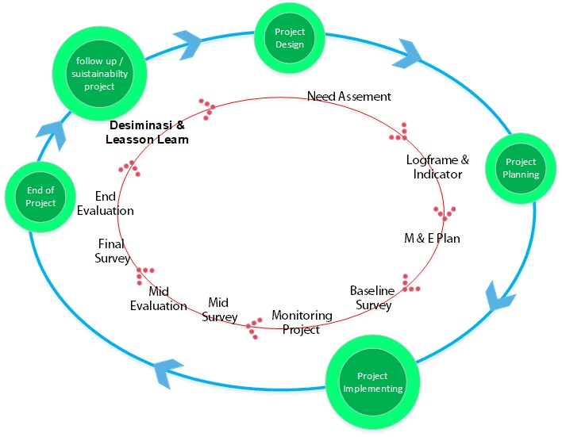

Figure 21. Monitoring Evaluation in Project Cycle
Monitoring is defined as a routine observation and recording of activities occurring within a program. This is a routine process of gathering information on all aspects of the program. To get an overview of the progress of the program implementation and ensure that the information obtained is used and useful both for the program implementation and other stakeholders. The monitoring and evaluation plan is prepared taking into account the Program Context, Institutional Capacity, Information Needs and Grant Requirements.
In this Program, Monitoring will be conducted by the monev expert responsible for monitoring evaluation. Monitoring will be carried out in 1-month, 3-month, 6-month and mid-program stage to see the process (activity) and program outcomes (Output, Outcome) as planned. Monitoring is done using Document Review method, Field Survey, Interview or Discussion of the parties. Monitoring is directed to see Efficiency, Effectiveness and Results.
The results of monitoring and evaluation can be a learning material used for improvement or development elsewhere so the results of monitoring and evaluation obtained will be reported periodically to the relevant parties: Adaptation Fund, Kemitraan, and Stakeholders in the region.
The Monitoring and Evaluation Implementation Flow that will be implemented in this program is as described in the figure below:
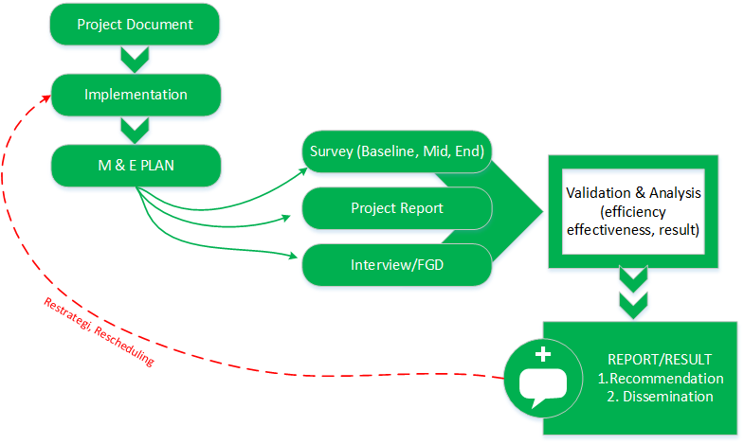

Figure 22. Monitoring and Evaluation Implementation Flow
From the result of validation and analysis conducted by the monev expert, monitoring and evaluation reports will then be produced. The reports will take form of recommendations for strategic direction of the project, as well as some important matters to be disseminated in order to reinforce the project’s achievements or increase the impact of the project.

Monitoring and Evaluation Activities and Budget

Activities | Targets | Cost ($) | Time
Baseline Survey | Outcome, output indicator targets | $ 2,000 | Start of Project
Mid Survey | Outcome, output indicator targets | $ 2,000 | Mid of Project
Final Project Survey | Target indicator outcome, output | $ 2,000 | End of Project
Report reviews, interviews, PMU FGD | Process, milestones, efficiency, effectiveness, results | $ 800 | 1 time in a month
Monev workshop | Process, milestones, efficiency, effectiveness, results | $ 1,200 | Six months
Internal Audit | Management | $ 5,000 | Annual

Project Monitoring and Evaluation Plan

Project Results | Indicators | Target | Sort by | Monitoring Methods & Tools | Frequency | Responsibility
Project Component 1. Strengthening of Social Forestry in pushing for forest food in the Upstream of Saddang Watershed which has implications for improving the environment and increasing the community’s income
Outcome 1.1  Increased extent of the Social Forestry scheme covering an area of 5,000 ha in the upstream of Saddang Watershed | 5,000 ha of forest area using social forestry scheme (proposal/IUP/scheme strengthening) | Month 1-18 | none | Proposal review  Map review  Permit/IUP review  Quarterly Report review | Quarterly | Monev Expert
Outcome 1.2  Strengthened actors and institution of Social Forestry schemes in support of climate change adaptation | 10 Institutions/Groups in the Social Forestry Scheme are formed and increase their capacity to support climate change adaptation | Month 1-18 | none | Quarterly Report review  Review on List Of farmer/community | Quarterly | Monev Expert
Outcome 1.3  Availability of forest food products that are ready for sale from social forestry groups | Sold 2 types of food products from the social forestry group | Month 3-17 | Village/sub district  gender | Baseline Survey  Mid Survey  Final Survey  Quarterly Report review | Quarterly | Monev Expert
Output Level:
1.1.1. Existing legal access to Community Forest or Village Forest | 5,000 Ha of social forestry area obtaining Legal Access/reinforcement | Month 1-18 | Village/sub district | Proposal review  Map review  Permit/IUP review  Quarterly Report review | Quarterly | Monev Expert
1.1.2. Increased forest land cover | 70% of seedlings grown from cultivation | Month 4-9 | Forest area | Documentation  Quarterly Report review | Quarterly | Monev Expert
1.2.1. Increased capacity of facilitators and local communities in Social Forestry scheme | 55 people have increased capacity to encourage social forestry. (40 men and 15 women) | Month 1-18 | Village/sub district  gender | Activity report review | Quarterly | Monev Expert
1.2.2. Increased capacity of stakeholders in sustainable forest management. | 50 people have increased capacity in sustainable forest management. (40 men and 10 women) | Month 2-4 | Village/sub district  gender | Activity report review  Interview/FGD | Quarterly | Monev Expert
1.2.3. Increased support from the stakeholders in encouraging Social Forestry scheme | 1 MoU on Social Forestry Acceleration | Month 1-18 | none | Quarterly Report review | Quarterly | Monev Expert
1.3.1. Increased skills of Forest Farmer, Women and Vulnerable Group in managing sustainable forest food. | 250 people from 10 Social Forestry, women and vulnerable groups have increased capacity to manage sustainable forest food | Month 3-17 | Village/sub district  gender | Activity report review  Interview/FGD | Quarterly | Monev Expert
1.3.2. Available facilities and infrastructure of forest food processing technology | 10 units of forest food processing facilities | Month 6-9 | none | Activity report review  Documentation  Interview/FGD | Quarterly | Monev Expert
1.3.3. Absorbed forest food products to the market | The sale of two types of food products | Month 3-7 | none | Activity report review  Quarterly Report review | Quarterly | Monev Expert
Project Component 2. Improved coastal governance and carrying capacity in support of climate change adaptation downstream of Saddang Watershed
Outcome 2.1  Strengthened costal human resources and natural resources in the downstream of Saddang watershed in increasing coastal carrying capacity | 60 people have increased capacity and 1.2 km of land and coastal areas are rehabilitated | Month 1-18 | none | Quarterly report review  Map review  Baseline Survey  Mid Survey  Final Survey | Quarterly | Monev Expert
Outcome 2.2  Increased community income in the downstream of Saddang Watershed through environmentally friendly creative businesses and food diversification | 100 people have increased income from creative businesses and food diversification | Month 1-18 | none | Baseline Survey  Mid Survey  Final Survey  Quarterly Report review | Quarterly | Monev Expert
Output Level:
2.1.1. Established and running Climate Change Care Group (KPPI) as the driving force at the village and sub-district levels | 5 KPPIs are established and running | Month 1-18 | Village | Activity report review  Interview/FGD | Quarterly | Monev Expert
2.1.2. Increased capacity and skills of KPPI and stakeholders in improving costal governance and carrying capacity downstream of watershed | 60 people have increased skills in improving coastal governance and carrying capacity (45 men and 15 women) | Month 1-18 | Village Gender | Activity report review  Interview/FGD | Quarterly | Monev Expert
2.1.3. Rehabilitated coastal areas downstream of Saddang Watershed | 1,2 Km coastal land is rehabilitated | Month 3-10 | none | Map review  Documentation  Quarterly Report review | Quarterly | Monev Expert
2.2.1. Improved skills of KPPI, forest farmer, women and vulnerable groups in the development of creative business and food diversification | 150 people have increased capacity in development of creative business and food (105 men and 45 women) | Month 1-18 | Gender | Activity report review  Interview/FGD | Quarterly | Monev Expert
2.2.2 Available technology facilities and infrastructure in encouraging creative business and food diversification. | 5 units of household-scale processing tools used in creative business and food diversification | Month 5-8 | none | Activity report review  Documentation Interview/FGD | Quarterly | Monev Expert
2.2.3. Existing marketing network for creative business and food diversification | 2 marketing networks for creative business and food diversification | Month 9-15 | none | Quarterly Report review  Interview/FGD | Quarterly | Monev Expert
Project Component 3. Strengthening of cross-cutting policies in ensuring the sustainability of climate change adaptation
Outcome 3.1  Strengthened cross-cutting policies in ensuring the sustainability of climate change adaptation | 3 policy products that support climate change adaptation | Month 4-15 | none | Quarterly Report review | Quarterly | Monev Expert
Output Level :
3.1.1. Established and operating Climate Change Adaptation Working Group Team (POKJA-API). | 1 Decree on Pokja API for Scope of South Sulawesi | Month 4-14 | gender | Quarterly Report review | Quarterly | Monev Expert
3.1.2. Internalized Climate Change Adaptation Plans to Local Government policies, as well as existing adaptation action plan documents at the regional level | 2 regional planning documents that have RAN API internalized within | Month 3-15 | none | Quarterly Report review  Document review  Regional planning | Quarterly | Monev Expert
3.1.3. Existing Climate Change Adaptation monitoring system that supports the strengthening of policies implemented by the stakeholders | 1 adaptation monitoring application system used in supporting the implementation of the policy | Month 7 - 12 | none | Quarterly Report review  Documentation Interview/FGD | Quarterly | Monev Expert
Project Component 4. Strengthening of capacity and support of stakeholder through knowledge management
Outcome 4.1  Strengthened stakeholder capacity and understanding through the process of dissemination and early warning system for climate change adaptation | 27,143 people received information from the dissemination process | Month 11-16 | Village/sub district | Semester Report review  Documentation Interview/FGD | Semester | Monev Expert
Output Level:
4.1.1 Disseminated program to strengthen and encourage policies and alignments | 1 film  1 lesson learned/best practice book  1 Journal  1 Leaflet/poster/banner  1 Digital Media | Month 13-16 | none | Quarterly Report review  Documentation Interview/FGD | Quarterly | Monev Expert
4.1.2 Existing early warning system platform for Climate Change Adaptation among Saddang Watershed Ecosystem Community | 1 early warning system platform | Month 8 -16 | none | Activity report review  Documentation | Quarterly | Monev Expert

Result Framework
Include a results framework for the project / programme proposal, including milestones, targets and indicators.

Outcome/  Output | Indicator | Baseline | Target |  |  | Source of Verification | Risk & Assumption
Outcome/  Output | Indicator | Baseline | 2018 | 2019 | 2020 | Source of Verification | Risk & Assumption
Component 1. Strengthening of Social Forestry in pushing for forest food in the Upstream of Saddang Watershed in the climate change adaptation scheme
Outcome 1.1  Increased extent of the Social Forestry scheme covering an area of 5,000 ha in the upstream of Saddang Watershed | 5,000 ha of forest area using social forestry scheme (proposal/IUP/scheme strengthening) | 5.000 ha of forest area including those that have been declared as social forestry scheme but not yet managed through Social Forestry Management Permit |  | 5,000 |  | Social Forestry Management Permit, and reports | If there is no change in social forestry regulations
Output 1.1.1.  Existing legal access to Community Forest or Village Forest | 5,000 Ha of social forestry area obtaining Legal Access/reinforcement | 0 |  | 10 |  | Copy of Social Forestry Scheme Management Permit | The length of time for issuance of permits, social forestry working group and advocacy for permit management should be regularly done
Output 1.1.2. Increased forest land cover | 70% of seedlings grown from cultivation | Condition of land cover before the project starts |  |  | 70% | Activity Report, Documentation | There is no certainty of maintenance
Outcome 1.2  Strengthened actors and institution of Social Forestry schemes in support of climate change adaptation | 10 Institutions/Groups in the Social Forestry Scheme are formed and increase their capacity to support climate change adaptation | Local institutions have no understanding of social forestry in climate change adaptation |  | 10 |  | Activity Report, Documentation | -
Output 1.2.1.  Increased capacity of facilitators and local communities in Social Forestry scheme | 55 people have increased capacity to encourage social forestry | 0 | 15 | 40 |  | Activity Report, Documentation | -
Output 1.2.2.  Increased capacity of stakeholders in sustainable forest management. | 50 people have increased capacity in sustainable forest management | 0 |  | 50 |  | Activity Report, Documentation | -
Output 1.2.3.  Increased support from the stakeholders in encouraging Social Forestry scheme | 1 MoU on Social Forestry Acceleration | 0 |  | 1 |  | Copy of MoU on the Acceleration of Social Forestry, Activity Report | -
Outcome 1.3  Available of forest food products that are ready for sale from social forestry groups | Sold by 2 kind of forest food products from the social forestry group | Community income by not implementing a pattern within the area that has CF/HD management permits |  |  | 30 | Activity Report, Documentation | There are differences in the direction of development between the agriculture, forestry and livestock sectors  The difficulty of changing the pattern of community livestock maintenance management
Output 1.3.1.  Increased skills of Forest Farmer, Women and Vulnerable Group in managing sustainable forest food. | 250 people from 10 Social Forestry, women and vulnerable groups have increased capacity to manage sustainable forest food | 0 |  | 200 | 50 | Activity Report, Documentation | The farmer groups reject the project’s new approach to skills upgrading because it differs from the customary pattern
Output 1.3.2.  Available facilities and infrastructure of forest food processing technology | 10 units of forest food processing facilities | 0 |  | 10 |  | Handover documents, Documentation, Activity Report | Engine specifications are not in accordance with product specifications from market demand
Output 1.3.3.  Absorbed forest food products to the market | 2 kind of food products are sold | 0 |  |  | 75 | Purchase Documents/ Contract | -
Component 2. Improved coastal governance and carrying capacity in support of climate change adaptation downstream of Saddang Watershed
Outcome 2.1  Strengthened costal human resources and natural resources in the downstream of Saddang watershed in increasing coastal carrying capacity | 60 people have increased capacity and 1.2 km of land and coastal areas are rehabilitated | Critical/open land and costal areas that need to be rehabilitated |  | 1.2 |  | Activity Report, Documentation | The number of plant seeds swept by the waves
Output 2.1.1.  Established and running Climate Change Care Group (KPPI) as the driving force at the village and sub-district levels | 5 KPPIs are established and running | 0 |  | 5 |  | Activity Report, Documentation | -
Output 2.1.2.  Increased capacity and skills of KPPI and stakeholders in improving costal governance and carrying capacity downstream of watershed | 60 people have increased skills in improving coastal governance and carrying capacity | 0 |  | 60 |  | Activity Report, Documentation | -
Output 2.1.3.  Rehabilitated coastal areas downstream of Saddang Watershed | 1,2 km coastal land is rehabilitated | 0 |  | 1.2 |  | Activity Report, Documentation | Land location is not on the fishing boat entrance
Outcome 2.2  Increased community income in the downstream of Saddang Watershed through environmentally friendly creative businesses and food diversification | 100 people have increased income from creative businesses and food diversification | Community income is not gained through creative businesses and food diversification |  | 100 |  | Activity Report, Documentation | Changes in the pattern of financial management
Output 2.2.1.  Improved skills of KPPI, forest farmer, women and vulnerable groups in the development of creative business and food diversification | 150 people have increased capacity in development of creative business and food | 0 |  | 150 |  | Activity Report, Documentation | -
Output 2.2.2  Available technology facilities and infrastructure in encouraging creative business and food diversification. | 5 units of household-scale processing tools used in creative business and food diversification | 0 |  | 5 |  | Handover documents, Documentation, Activity Report | -
Output 2.2.3.  Existing marketing network for creative business and food diversification | 2 marketing networks for creative business and food diversification | 0 |  |  | 75% | Purchase Documents/ Contract | Engine specifications are not in accordance with market demand
Component 3. Strengthened system and institutional capacity to reduce risk associated with climate induced socio-economic and environmental
Outcome 3.1  Strengthened cross-cutting policies in ensuring the sustainability of climate change adaptation | 3 policy products that support climate change adaptation | Policy products that support climate change adaptation before the project starts |  | 1 | 2 | Copy of Policy documents, Activity Report | There are conflicting development acceleration and economic policies
Output 3.1.1.  Established and operating Climate Change Adaptation Working Group Team (POKJA-API). | 1 Decree on Pokja API for Scope of South Sulawesi | 0 |  | 1 |  | Copy of Decree on Pokja, Work Plan | -
Output 3.1.2.  Internalized API to Local Government policies within regional plan | 2 regional planning documents that have RAN API internalized within | 0 |  |  | 2 | Copy of policy documents | -
Output 3.1.3.  Existing Climate Change Adaptation monitoring system that supports the strengthening of policies implemented by the stakeholders | 1 adaptation monitoring application system used in supporting the implementation of the policy | 0 |  | 1 |  | Purchase Documents/ Contracts,  Activity Report | Input data is not optimal  The measurement system and measurement indicator are not implemented
Component 4. Strengthening of capacity and support of stakeholder through knowledge management
Outcome 4.1  Strengthened stakeholder capacity and understanding through the process of dissemination and early warning system for climate change adaptation | 27,143 people received information from the dissemination process | 0 |  |  | 27,143 | Activity Report, Documentation
Output 4.1.1  Disseminated program to strengthen and encourage policies and alignments | 1 film  1 lesson learned/best practice book  1 Journal  1 Leaflet/poster/banner  1 Digital Media | 0 |  | 3 | 2 | Documentation
Output 4.1.2  Existing early warning system platform for Climate Change Adaptation among Saddang Watershed Ecosystem Community | 1 early warning system platform | 0 |  | 1 |  | Activity Report, Documentation

Alignment with Adaptation Fund Result Framework
Demonstrate how the project / programme aligns with the Results Framework of the Adaptation Fund

Project Objective(s) | Project Objective  Indicator(s) | Fund Outcome | Fund Outcome Indicator | Grant Amount (USD)
1. Strengthened Social Forestry scheme in developing forest food in climate change adaptation in the upstream of Saddang watershed | 5,000 ha Social Forestry Area in 1 (one) watershed ecosystem (upstream) which expands its vegetation cover | Outcome 5.  Increased ecosystem resilience in response to climate change and variability-induced stress | 5. Ecosystem services and natural assets  maintained or improved under climate change and  variability-induced stress | $344,069
 | 185 heads of household who develop forest food through social forestry schemes  (5% of households  having more secure (increased) access to livelihood assets) | Outcome 6.  Diversified and strengthened livelihoods  and sources of income for vulnerable people in  targeted areas | 6.1 Percentage of households and communities  having more secure (increased) access to livelihood  assets | $344,069
2. Improved coastal governance and carrying capacity in support of climate change adaptation downstream of Saddang watershed | 5 Climate Change Care Groups encourage improvement of coastal carrying capacity in adaptation to climate change  (10% targeted population aware of  predicted adverse impacts of climate change, appropriate responses, and modification in behavior) | Outcome 3: Strengthened awareness and ownership  of adaptation and climate risk reduction processes at  local level | 3.1. Percentage of targeted population aware of  predicted adverse impacts of climate change, and of  appropriate responses  3.2. Percentage of targeted population applying appropriate adaptation responses | $176,843
 | Over 1.2 km of land and coastal areas in 1 (one) watershed ecosystem (downstream) that expands its vegetation cover | Outcome 5.  Increased ecosystem resilience in response to climate change and variability-induced stress | 5. Ecosystem services and natural assets  maintained or improved under climate change and  variability-induced stress | $176,843
 | 80 heads of household who develop creative businesses and food diversification in the context of climate change adaptation  (3% of households  having more secure (increased) access to livelihood  assets) | Outcome 6.  Diversified and strengthened livelihoods  and sources of income for vulnerable people in  targeted areas | 6.1 Percentage of households and communities  having more secure (increased) access to livelihood  assets
3. Strengthened cross-cutting policies and climate early warning systems in ensuring the sustainability of climate change adaptation | 3 policy products and systems that will drive climate change adaptation  (3 integrated climate change adaptation policy products in the National Strategy for Climate Change Adaptation)  (53 Institutions from Provincial, District, and Village Governments, with increased capacity to minimize exposure to climate  variability risks) | Outcome 7. Improved policies and regulations that  promote and enforce resilience measures | 7. Climate change priorities are integrated into  national development strategy | $90,504
 |  | Outcome 2: Strengthened institutional capacity to  reduce risks associated with climate-induced  socioeconomic and environmental losses | 2.1. Capacity of staff to respond to, and mitigate impacts of, climate-related events from targeted institutions increased | $90,504
4. Strengthened stakeholder capacity and support through knowledge management | 27,143 people received information from the dissemination process  (3% targeted population aware of predicted adverse impacts of climate change, appropriate responses, and modification in behavior) | Outcome 3: Strengthened awareness and ownership  of adaptation and climate risk reduction processes at  local level | 3.1. Percentage of targeted population aware of  predicted adverse impacts of climate change, and of  appropriate responses  3.2. Percentage of targeted population applying appropriate adaptation responses | $81,154
Project Outcome(s) | Project Outcome Indicator(s) | Fund Output | Fund Output Indicator | Grant Amount (USD)
- Increased extent of the Social Forestry scheme covering an area of 5,000 ha in the upstream of Saddang Watershed | 5,000 ha of forest area using social forestry scheme (proposal/IUP/scheme strengthening) | Output 5:  Vulnerable physical, natural, and social  assets strengthened in response to climate change  impacts, including variability | 5.1. No. and type of natural resource assets  created, maintained or improved to withstand  conditions resulting from climate variability and  change (by type of assets) | $93,369
- Strengthened actors and institution of Social Forestry schemes in support of climate change adaptation | 10 Institutions/Groups in the Social Forestry Scheme are formed and increase their capacity to support climate change adaptation | Output 6: Targeted individual and community  livelihood strategies strengthened in relation to climate  change impacts, including variability | 6.1.1.No. and type of adaptation assets (physical as well as knowledge) created in support of individual-or community livelihood strategies | $135,412
- Available of forest food products that are ready for sale from social forestry groups | Sold by 2 kind of forest food products from the social forestry group | Output 6: Targeted individual and community  livelihood strategies strengthened in relation to climate  change impacts, including variability | 6.1.2. Type of income sources for households generated under climate change scenario | $115,288
- Strengthened costal human resources and natural resources in the downstream of Saddang watershed in increasing coastal carrying capacity | 60 people have increased capacity and 1.2 km of land and coastal areas are rehabilitated | Output 3:  Targeted population groups participating in  adaptation and risk reduction awareness activities  Output 5:  Vulnerable physical, natural, and social  assets strengthened in response to climate change  impacts, including variability | 3.1.1 No. and type of risk reduction actions or strategies introduced at local level  5.1. No. and type of natural resource assets  created, maintained or improved to withstand  conditions resulting from climate variability and  change (by type of assets) | $112,258
- Increased community income in the downstream of Saddang Watershed through environmental friendly creative businesses and food diversification | 80 households who have increased income from creative businesses and food diversification | Output 6:  Targeted individual and community  livelihood strategies strengthened in relation to climate  change impacts, including variability | 6.1.2. Type of income sources for households  generated under climate change scenario | $64,585
- Strengthened cross-cutting policies in ensuring the sustainability of climate change adaptation | 3 policy products that support climate change adaptation  (25 staff trained to respond and mitigate impacts of climate related events) | Output 2.1: Strengthened capacity of national and  regional centers and networks to respond rapidly to  extreme weather events  Output 7:  Improved integration of climate-resilience  strategies into country development plans | 2.1.1 No. of staff trained to respond to, and mitigate  impacts of, climate-related events  7.1. No., type, and sector of policies introduced or  adjusted to address  climate change risks | $90,504
- Strengthened stakeholder capacity and understanding through the process of dissemination and early warning system for climate change adaptation | 27,143 people received information from the dissemination process  (5 of news outlets in the local press and media that have covered the topic) | Output 3: Targeted population groups participating adaptation and risk reduction awareness activities | 3.1.2 No. of news outlets in the local press and  media that have covered the topic | $81,154

Budget
Include a detailed budget with budget notes, broken down by country as applicable, a budget on the Implementing Entity management fee use, and an explanation and a breakdown of the execution costs.

Description Item |  |  | Cost
Total Project/Programme Cost |  |  | $702,334
Component 1: Strengthening of Social Forestry in pushing for forest food |  |  | $344,069
Outcome | 1.1 | Increased extent of the Social Forestry scheme covering an area of 5,000 ha in the upstream of Saddang Watershed | $93,369
Output | 1.1.1 | Existing legal access to Community Forest or Village Forest | $53,942
Activity | 1.1.1.1 | Multistakeholder meetings proposing social forestry schemes | $1,558
Activity | 1.1.1.2 | Facilitation of document preparation and legal advocacy for Social Forestry | $42,000
Activity | 1.1.1.3 | Operationalization of Social Forestry Outcome Leader | $10,385
Output | 1.1.2 | Increased forest land cover | $39,426
Activity | 1.1.2.1 | Need assessment of forest land rehabilitation area | $3,288
Activity | 1.1.2.2 | Rehabilitation of forest land with agroforestry pattern | $24,599
Activity | 1.1.2.3 | Nursery development | $11,538
Outcome | 1.2 | Strengthened actors and institution of Social Forestry schemes in support of climate change adaptation | $135,412
Output | 1.2.1 | Increased capacity of facilitators and local communities in Social Forestry scheme | $105,958
Activity | 1.2.1.1 | Field Officer Training | $5,785
Activity | 1.2.1.2 | Facilitation of Field Officer operationalization | $91,385
Activity | 1.2.1.3 | Dissemination of information on social forestry in each project target village | $4,173
Activity | 1.2.1.4 | Regular meetings in each village to strengthen group capacity | $4,615
Output | 1.2.2 | Increased capacity of stakeholders in sustainable forest management. | $12,088
Activity | 1.2.2.1 | Facilitation of KTH establishment | $2,442
Activity | 1.2.2.2 | Workshop on the management and utilization of sustainable forest resources | $2,846
Activity | 1.2.2.3 | POKJA-PPS training in supporting climate change adaptation | $2,396
Activity | 1.2.2.4 | Multistakeholder meetings to internalize climate change adaptation actions | $1,558
Activity | 1.2.2.5 | Workshop on climate change adaptation actions | $2,846
Output | 1.2.3 | Increased support from the stakeholders in encouraging Social Forestry scheme | $17,365
Activity | 1.2.3.1 | Multistakeholder meeting on Social Forestry acceleration in each intervention area | $2,577
Activity | 1.2.3.2 | Workshop on Social Forestry Acceleration and MoU signing | $2,096
Activity | 1.2.3.3 | Regular FGDs to monitor the achievements of the POKJA PPS | $3,692
Activity | 1.2.3.4 | Operationalization of Officer Coord. in the upstream area | $9,000
Outcome | 1.3 | Available of forest food products that are ready for sale from social forestry groups | $115,288
Output | 1.3.1 | Increased skills of Forest Farmer, Women and Vulnerable Group in managing sustainable forest food | $45,792
Activity | 1.3.1.1 | Technical training on agroforestry model forest processing | $6,500
Activity | 1.3.1.2 | Product packaging training | $6,192
Activity | 1.3.1.3 | Facilitation of module preparation for forest food cultivation | $5,186
Activity | 1.3.1.4 | Regular discussions among forest farmer, women’s and vulnerable groups | $3,654
Activity | 1.3.1.5 | Comparative study of flagship forest food management | $17,846
Activity | 1.3.1.6 | Entrepreneurship training | $6,413
Output | 1.3.2 | Available facilities and infrastructure of forest food processing technology | $56,471
Activity | 1.3.2.1 | Facilitation of processing permits for household products | $7,692
Activity | 1.3.2.2 | Provision of forest food processing equipment | $43,131
Activity | 1.3.2.3 | Facilitation of technical module preparation for operation and maintenance of equipment | $5,648
Output | 1.3.3 | Absorbed forest food products to the market | $13,026
Activity | 1.3.3.1 | Study of supply chain and value chain of forest food products | $8,643
Activity | 1.3.3.2 | Dissemination of supply chain and value chain study results | $2,325
Activity | 1.3.3.3 | Meetings of business actors at the supply and demand level | $2,058
Component 2: Improved coastal governance and carrying capacity in support of climate change adaptation downstream of Saddang Watershed |  |  | $176,843
Outcome | 2.1 | Strengthened costal human resources and natural resources in the downstream of Saddang watershed in increasing coastal carrying capacity | $112,258
Output | 2.1.1 | Established and running Climate Change Care Group (KPPI) as the driving force at the village and sub-district levels | $47,360
Activity | 2.1.1.1 | Dissemination of information and meetings on group formation | $3,033
Activity | 2.1.1.2 | Facilitation of regular KPPI meetings | $6,250
Activity | 2.1.1.3 | Operationalization of Downstream Field Officer | $38,077
Output | 2.1.2 | Increased capacity and skills of KPPI and stakeholders in improving costal governance and carrying capacity downstream of watershed | $33,718
Activity | 2.1.2.1 | Leadership training for climate change care cadres | $2,922
Activity | 2.1.2.2 | Training on facilitation and mentoring | $2,092
Activity | 2.1.2.3 | Mangrove cultivation training | $2,915
Activity | 2.1.2.4 | Regular consultation meetings | $5,250
Activity | 2.1.2.5 | Study of pond aquaculture | $11,538
Activity | 2.1.2.6 | Operationalization of Downstream Fled Officer Coord | $9,000
Output | 2.1.3 | Rehabilitated coastal areas downstream of Saddang Watershed | $31,181
Activity | 2.1.3.1 | Provision of coastal land rehabilitation equipment | $15,857
Activity | 2.1.3.2 | Facilitation of technical guidelines preparation for the operation and maintenance of equipment | $6,177
Activity | 2.1.3.3 | Planting area distribution meeting for each group | $1,827
Activity | 2.1.3.4 | Procurement of mangrove seeds | $397
Activity | 2.1.3.5 | Mangrove plantings | $6,923
Outcome | 2.2 | Increased community income in the downstream of Saddang Watershed through environmental friendly creative businesses and food diversification | $64,585
Output | 2.2.1 | Improved skills of KPPI, forest farmer, women and vulnerable groups in the development of creative business and food diversification | $24,632
Activity | 2.2.1.1 | Entrepreneurship training | $4,291
Activity | 2.2.1.2 | Creative business training from coastal resources products | $5,794
Activity | 2.2.1.3 | Cultivation and post-harvest training | $4,163
Activity | 2.2.1.4 | Operationalization of coastal outcome leader | $10,385
Output | 2.2.2 | Available technology facilities and infrastructure in encouraging creative business and food diversification. | $29,792
Activity | 2.2.2.1 | Procurement of processing equipment for coastal natural resources | $13,577
Activity | 2.2.2.2 | Procurement of diversified food processing equipment (on-farm and off farm) | $11,731
Activity | 2.2.2.3 | Facilitation of technical module preparation for operation and maintenance of equipment | $4,485
Output | 2.2.3 | Existing marketing network for creative business and food diversification | $10,160
Activity | 2.2.3.1 | Study of supply chain and value chain of forest food products | $5,615
Activity | 2.2.3.2 | Dissemination of supply chain and value chain study results | $2,673
Activity | 2.2.3.3 | Meetings of business actors at the supply and demand level | $1,872
Component 3: Strengthened cross-cutting policies in ensuring the sustainability of climate change adaptation |  |  | $90,504
Outcome | 3.1 | Strengthened cross-cutting policies in ensuring the sustainability of climate change adaptation | $90,504
Output | 3.1.1 | Established and operating Climate Change Adaptation Working Group Team (POKJA-API) | $12,704
Activity | 3.1.1.1 | Multistakeholder meeting for the formation of POKJA API for the Saddang Watershed Ecosystem | $2,829
Activity | 3.1.1.2 | Workshop on the establishment of POKJA AP for the Saddang Watershed Ecosystem | $2,565
Activity | 3.1.1.3 | Training on preparing climate change adaptation action plans | $2,387
Activity | 3.1.1.4 | Facilitation of regular meetings with POKJA API for the Saddang Watershed Ecosystem | $4,923
Output | 3.1.2 | Internalized API to Local Government policies, as well as existing adaptation action plan documents at the regional level | $48,100
Activity | 3.1.2.1 | Multistakeholder meetings in climate change adaptation action plan of Saddang Watershed ecosystem | $4,154
Activity | 3.1.2.2. | Vulnerability and risk assessment of climate change | $15,385
Activity | 3.1.2.3. | Facilitation of regular meetings of POKJA-API in preparing the Climate Change Adaptation Action Plan at the Regional Level | $4,892
Activity | 3.1.2.4 | Facilitation of proposed climate change adaptation action plan into Village Regulations | $11,769
Activity | 3.1.2.5 | Facilitation of proposed Climate Change Adaptation Action Plan into Local Regulations | $4,246
Activity | 3.1.2.6 | Multistakeholder meetings in integrating the Climate Change Adaptation Action Plan into the Strategic Plan of the Local Government Unit (Renstra SKPD) | $7,654
Output | 3.1.3 | Existing Climate Change Adaptation monitoring system usable by stakeholders to ensure sustainability | $29,700
Activity | 3.1.3.1 | Training on preparing climate change adaptation monitoring system | $5,665
Activity | 3.1.3.2 | Facilitation in developing climate change adaptation action monitoring application | $15,385
Activity | 3.1.3.3 | Dissemination of climate change adaptation monitoring system | $2,154
Activity | 3.1.3.4 | Training on operationalizing the application to stakeholders | $6,496
Component 4: Strengthening of capacity and support of stakeholder through knowledge management |  |  | $90.918
Outcome | 4.1 | Strengthened stakeholder capacity and understanding through the process of dissemination and early warning system for climate change adaptation | $90,918
Output | 4.1.1 | Disseminated program to strengthen and encourage policies and alignments | $54,362
Activity | 4.1.1.1 | Making and launching of documentary film related to climate change adaptation action | $11,708
Activity | 4.1.1.2 | Development and launching of best practice and lessons learned book on climate change adaptation and climate change adaptation journal | $23,646
Activity | 4.1.1.3 | Development of policy brief related to the climate change adaptation strategy based on sustainable forest food security | $4,419
Activity | 4.1.1.4 | Development of leaflets, posters, banners | $4,519
Activity | 4.1.1.5 | Development of website and social media on climate change adaptation in Saddang watershed ecosystem | $3,846
Activity | 4.1.1.6 | Facilitation of partnership with providers in publication of climate change adaptation action | $2,762
Activity | 4.1.1.7 | Rental of promotional billboard on climate change adaptation in Saddang watershed ecosystem | $3,462
Output | 4.1.2 | Existing early warning system platform for Climate Change Adaptation among Saddang Watershed Ecosystem Community | $36,557
Activity | 4.1.2.1 | Facilitation of multistakeholder cooperation for the application of disaster response early warning system | $3,658
Activity | 4.1.2.2 | Development of application and supporting tools for disaster response early warning system | $11,872
Activity | 4.1.2.3. | Training on the use of applied technology for disaster response early warning system | $6,496
Activity | 4.1.2.4. | Dissemination of information/Workshop on the application of disaster response early warning system | $3,531
Activity | 4.1.2.5 | Monitoring dan Evaluation | $11,000
A. Project/Program Execution Cost |  |  | $68,373
 | A.1 | Spatial Adaptation to Climate Change Specialist | $3,462
 | A.2 | Forest management and Environmental Specialist | $3,462
 | A.3 | Monev Specialist | $4,154
 | A.4 | Social Gender Specialist | $3,462
 | A.5 | Food and Disversification Specialist | $3,462
 | A.6 | Program Director | $8,308
 | A.7 | Project Coordinator | $13,846
 | A.8 | Finance Manager | $6,923
 | A.9 | Assistant to Finance Manager | $5,538
 | A.10 | Office boy | $1,938
 | A.11 | Office Rent | $7,200
 | A.12 | Stationary | $489
 | A.13 | Communication | $208
 | A.14 | Electricity, WIFI, Water | $2,077
 | A.15 | Program audit | $3,846
B. Project Cycle management Services |  |  | $64,758
 | B.1 | Project identification and Development | $3,238
 | B.2 | Project Implementation and Supervision | $48,569
 | B.3 | Evaluation | $12,952
Amount of Financing Requested |  |  | $835,645

Disbursement Schedule
Include a disbursement schedule with time-bound milestones.

Disbursement Milestones

 | Upon signature of Agreement | One Year after Project Start ^{a)} | Total
Scheduled date | 1 Januari 2019 | 1 januari 2020
Project Funds | $539,494.90 | $231,212.10 | $770,707.00
Implementing Entity Fees |  |  | $ 64,758
Total | 0 | 0 | $835,465.00
^{a)} Use projected start date to approximate first year disbursement
^{b)} Subsequent dates will follow the year anniversary of project start
^{c)}Add columns for years as needed

Time-bound project activities

Component | Outputs | Activities | Timeframe/Months
Component | Outputs | Activities | 1 | 2 | 3 | 4 | 5 | 6 | 7 | 8 | 9 |  | 10 |  | 11 |  | 12 |  | 13 |  | 14 |  | 15 |  | 16 |  | 17 |  | 18
1. Strengthening of Social Forestry in pushing for forest food in the upstream of Saddang watershed | 1.1.1. Existing legal access to Community Forest or Village Forest | 1.1.1.1. Multistakeholder meetings proposing social forestry schemes
 |  | 1.1.1.2. Facilitation of document preparation and legal advocacy for Social Forestry
 |  | 1.1.1.3. Operationalization of Social Forestry Outcome Leader
 | 1.1.2. Increased forest land cover | 1.1.2.1. Need assessment of forest land rehabilitation area
 | 1.1.2. Increased forest land cover | 1.1.2.2. Rehabilitation of forest land with agroforestry pattern
 | 1.1.2. Increased forest land cover | 1.1.2.3. Nursery development
 | 1.2.1. Increased capacity of facilitators and local communities in Social Forestry scheme | 1.2.1.1. Field Officer Training
 |  | 1.2.1.2. Facilitation of Field Officer operationalization
 |  | 1.2.1.3. Dissemination of information on social forestry in each project target village
 |  | 1.2.1.4. Regular meetings in each village to strengthen group capacity
 | 1.2.2. Increased capacity of stakeholders in sustainable forest management | 1.2.2.1. Facilitation of KTH establishment
 |  | 1.2.2.2. Workshop on the management and utilization of sustainable forest resources
 |  | 1.2.2.3. POKJA-PPS training in supporting climate change adaptation
 |  | 1.2.2.4. Multistakeholder meetings to internalize climate change adaptation actions
 |  | 1.2.2.5. Workshop on climate change adaptation actions
 | 1.2.3 Increased support from the stakeholders in encouraging Social Forestry scheme | 1.2.3.1. Multistakeholder meeting on Social Forestry acceleration in each intervention area
 |  | 1.2.3.2. Workshop on Social Forestry Acceleration and MoU signing
 |  | 1.2.3.3. Regular FGDs to monitor the achievements of the POKJA PPS
 |  | 1.2.3.4. Operationalization of Officer Coord. in the upstream area
 | 1.3.1 Increased skills of Forest Farmer, Women and Vulnerable Group in managing sustainable forest food | 1.3.1.1. Technical training on agroforestry model forest processing
 |  | 1.3.1.2. Product packaging training
 |  | 1.3.1.3. Facilitation of module preparation for forest food cultivation
 |  | 1.3.1.4. Regular discussions among forest farmer, women’s and vulnerable groups
 |  | 1.3.1.5. Comparative study of flagship forest food management
 |  | 1.3.1.6. Entrepreneurship training
 | 1.3.2. Available facilities and infrastructure of forest food processing technology | 1.3.2.1. Facilitation of processing permits for household products
 |  | 1.3.2.2. Provision of forest food processing equipment
 |  | 1.3.2.3. Facilitation of technical module preparation for operation and maintenance of equipment
 | 1.3.3. Absorbed forest food products to the market | 1.3.3.1. Study of supply chain and value chain of forest food products
 | 1.3.3. Absorbed forest food products to the market | 1.3.3.2. Dissemination of supply chain and value chain study results
 | 1.3.3. Absorbed forest food products to the market | 1.3.3.3. Meetings of business actors at the supply and demand level
2. Improved coastal governance and carrying capacity in support of climate change adaptation downstream of Saddang Watershed | 2.1.1 Established and running Climate Change Care Group (KPPI) as the driving force at the village and sub-district levels | 2.1.1.1 Dissemination of information and meetings on group formation
 |  | 2.1.1.2 Facilitation of regular KPPI meetings
 |  | 2.1.1.3 Operationalization of Downstream Field Officer
 | 2.1.2 Increased capacity and skills of KPPI and stakeholders in improving costal governance and carrying capacity downstream of watershed | 2.1.2.1 Leadership training for climate change care cadres
 |  | 2.1.2.2 Training on facilitation and mentoring
 |  | 2.1.2.3 Mangrove cultivation training
 |  | 2.1.2.4 Regular consultation meetings
 |  | - Study of pond aquaculture
 |  | - Operationalization of Downstream Fled Officer Coord
 | 2.1.3 Rehabilitated coastal areas downstream of Saddang Watershed | 2.1.3.1 Provision of coastal land rehabilitation equipment r
 |  | 2.1.3.2 Facilitation of technical guidelines preparation for the operation and maintenance of equipment
 |  | 2.1.3.3 Planting area distribution meeting for each group
 |  | 2.1.3.4 Procurement of mangrove seeds
 |  | 2.1.3.5 Mangrove plantings
 | 2.2.1 Improved skills of KPPI, forest farmer, women and vulnerable groups in the development of creative business and food diversification | 2.2.1.1 Entrepreneurship training
 |  | 2.2.1.2 Creative business training from coastal resources products
 |  | 2.2.1.3 Cultivation and post-harvest training
 |  | 2.2.1.4 Operationalization of coastal outcome leader
 | 2.2.2 Available technology facilities and infrastructure in encouraging creative business and food diversification. | 2.2.2.1 Procurement of processing equipment for coastal natural resources
 |  | 2.2.2.2 Procurement of diversified food processing equipment (on-farm and off farm)
 |  | 2.2.2.3 Facilitation of technical module preparation for operation and maintenance of equipment
 | 2.2.3 Existing marketing network for creative business and food diversification | 2.2.3.1 Study of supply chain and value chain of forest food products
 |  | 2.2.3.2 Dissemination of supply chain and value chain study results
 |  | 2.2.3.3 Meetings of business actors at the supply and demand level
3. Strengthened cross-cutting policies in ensuring the sustainability of climate change adaptation | 3.1.1. Established and operating Climate Change Adaptation Working Group Team (POKJA-API) | 3.1.1.1. Multistakeholder meeting for the formation of POKJA API for the Saddang Watershed Ecosystem
 |  | 3.1.1.2. Workshop on the establishment of POKJA AP for the Saddang Watershed Ecosystem
 |  | 3.1.1.3. Training on preparing climate change adaptation action plans
 |  | 3.1.1.4. Facilitation of regular meetings with POKJA API for the Saddang Watershed Ecosystem
 | 3.1.2. Internalized API to Local Government policies, as well as existing adaptation action plan documents at the regional level | 3.1.2.1. Multistakeholder meetings in climate change adaptation action plan of Saddang Watershed ecosystem
 |  | 3.1.2.2. Vulnerability and risk assessment of climate change
 |  | 3.1.2.3. Facilitation of regular meetings of POKJA-API in preparing the Climate Change Adaptation Action Plan at the Regional Level
 |  | 3.1.2.4. Facilitation of proposed climate change adaptation action plan into Village Regulations
 |  | 3.1.2.5. Facilitation of proposed Climate Change Adaptation Action Plan into Local Regulations
 |  | 3.1.2.6. Multistakeholder meetings in integrating the Climate Change Adaptation Action Plan into the Strategic Plan of the Local Government Unit (Renstra SKPD)
 | 3.1.3. Existing Climate Change Adaptation monitoring system usable by stakeholders to ensure sustainability | 3.1.3.1. Training on preparing climate change adaptation monitoring system
 |  | 3.1.3.2. Facilitation in developing climate change adaptation action monitoring application
 |  | 3.1.3.3. Dissemination of climate change adaptation monitoring system
 |  | 3.1.3.4. Training on operationalizing the application to stakeholders
4. Strengthening of capacity and support of stakeholder through knowledge management | 4.1.1. Disseminated all stories from program components to strengthen and encourage policies and alignments | 4.1.1.1. Making and launching of documentary film related to climate change adaptation action
 |  | 4.1.1.2. Development and launching of best practice and lessons learned book on climate change adaptation and climate change adaptation journal
 |  | 4.1.1.3. Development of policy brief related to the climate change adaptation strategy based on sustainable forest food security
 |  | 4.1.1.4. Development of leaflets, posters, banners
 |  | 4.1.1.5. Development of website and social media on climate change adaptation in Saddang watershed ecosystem
 |  | 4.1.1.6. Facilitation of partnership with providers in publication of climate change adaptation action
 |  | 4.1.1.7. Rental of promotional billboard on climate change adaptation in Saddang watershed ecosystem
 | 4.1.2. Existing early warning system platform for Climate Change Adaptation among Saddang Watershed Ecosystem Community | 4.1.2.1. Facilitation of multistakeholder cooperation for the application of disaster response early warning system
 |  | 4.1.2.2. Development of application and supporting tools for disaster response early warning system
 |  | 4.1.2.3. Training on the use of applied technology for disaster response early warning system
 |  | 4.1.2.4. Dissemination of information/Workshop on the application of disaster response early warning system

PART IV: ENDORSEMENT BY GOVERNMENTS AND CERTIFICATION BY THE IMPLEMENTING ENTITY

Record of Endorsement on Behalf of the Government
Provide the name and position of the government official and indicate date of endorsement for each country participating in the proposed project / programme. Add more lines as necessary. The endorsement letters should be attached as an annex to the project/programme proposal. Please attach the endorsement letters with this template; add as many participating governments if a regional project/programme:

Dr. Kalatiku Paembonan, M.Si  Regent of Toraja Utara District | Date: March, 31, 2017
Dr. H. Muslimin Bando, M. Pd  Regent of Enrekang District | Date: March, 23, 2017
Aslan Patonangi  Regent of Pinrang District | Date: April, 04, 2017
Ir. H. Muhammad Tamzil, MP  Head of Forestry Department South Sulawesi Province | Date: April, 04, 2017
Ir. Andi Hasmi, M.T  Head of Environment Management Department South Sulawesi Department | Date: March, 24, 2017
Daud Balalmbang, S.STP  Head of Environment Department Tana Toraja District | Date: March, 03, 2017

Implementing Entity certification
Provide the name and signature of the Implementing Entity Coordinator and the date of signature. Provide also the project/programme contact person’s name, telephone number and email address

I certify that this proposal has been prepared in accordance with guidelines provided by the Adaptation Fund Board, and prevailing National Development and Adaptation Plans (President Decree No. 16 year 2015; P.13/Menlhk/Setjen/OTL.0/1/2016; P.33/Menlhk/Setjen/Kum.1/3/2016; Indonesia Intended Nationally Determined Contribution/INDC; COP 21 Paris Agreement signed by Government of Indonesia; Book and Map of Information System of Vulnerability Index Data (SIDIK); Permen-KP No. 2 year 2013; Climate Change Adaptation National Action Plan) and subject to the approval by the Adaptation Fund Board, commit to implementing the project/programme in compliance with the Environmental and Social Policy of the Adaptation Fund and on the understanding that the Implementing Entity will be fully (legally and financially) responsible for the implementation of this project/programme.


Monica Tanuhandaru
Executive Director of Partnership for Governance Reform in Indonesia (Kemitraan)
Implementing Entity Coordinator
Date: August, 6, 2018 | Tel. and email: +62-21-7279 9566; Monica.Tanuhandaru@kemitraan.or.id
Project Contact Person: Dewi Rizki
Tel. And Email: +62-21-7279 9566; Dewi.Rizki@kemitraan.or.id

The Endorsement Letter

The Endorsement Letter from Municipal Environmental Agency of South Sulawesi

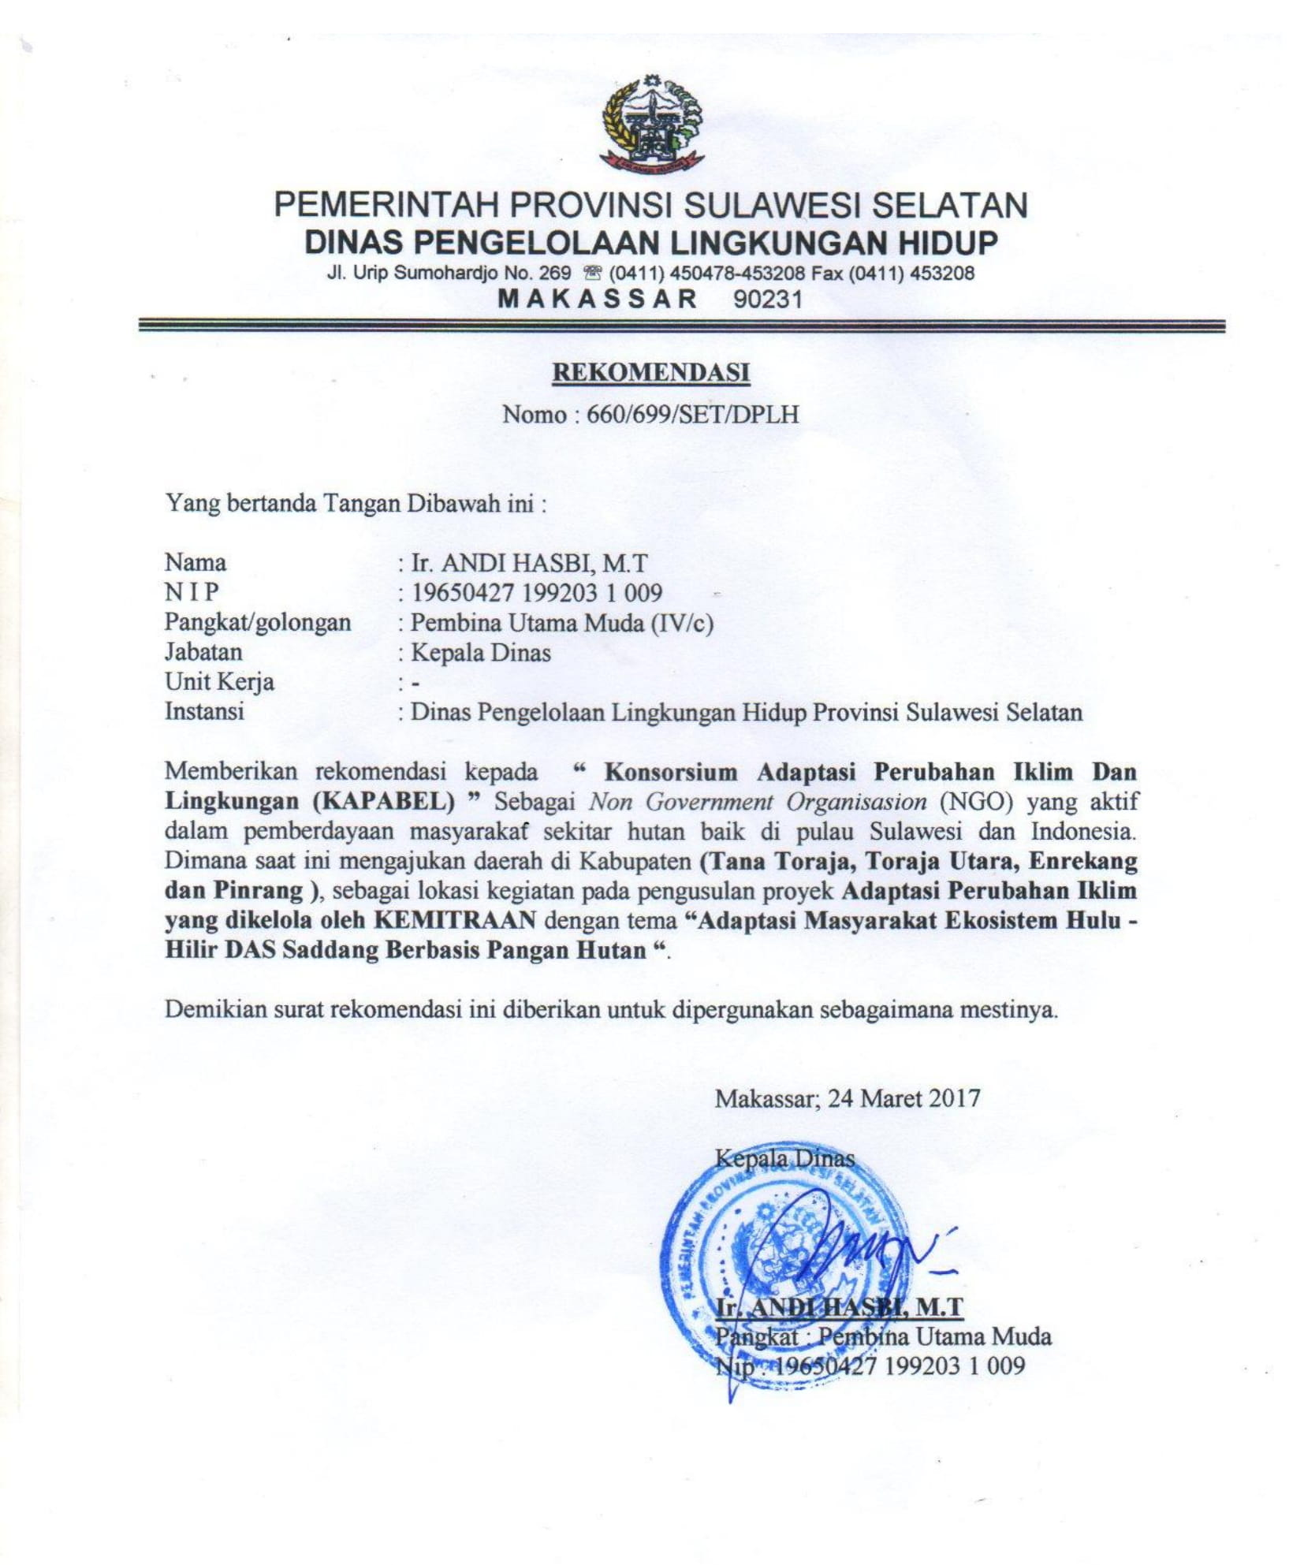

The Endorsement Letter from Forestry Service of South Sulawesi

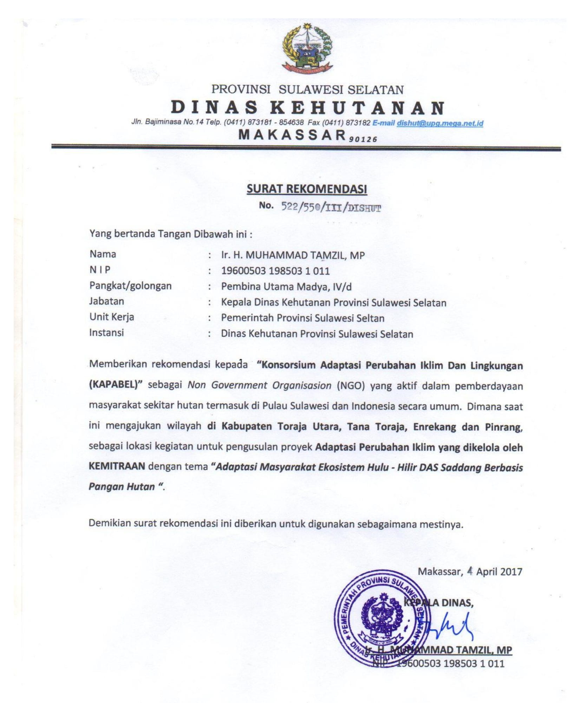

The Endorsement Letter from The Regent of North Toraja Regency, South Sulawesi

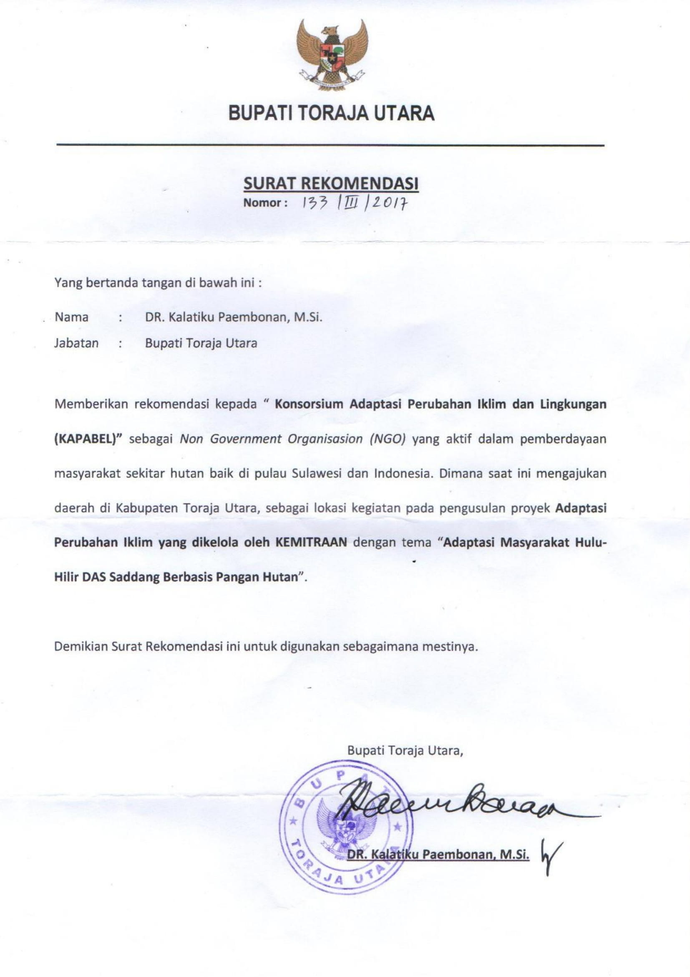

The Endorsement Letter from The Regent of Enrekang Regency, South Sulawesi

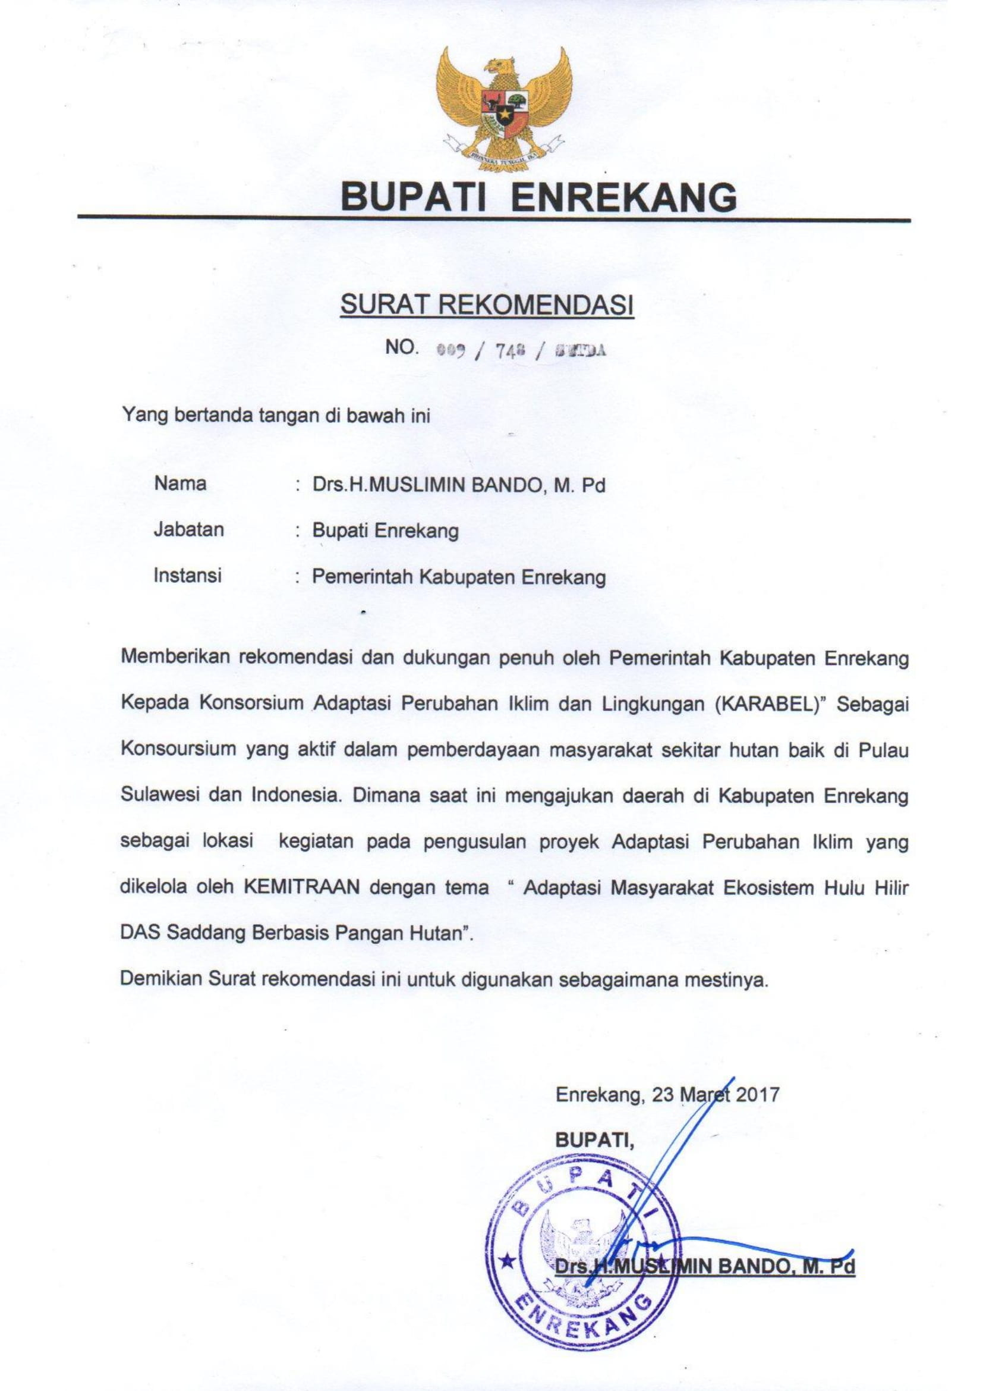

The Endorsement Letter from The Regent of Pinrang Regency, South Sulawesi

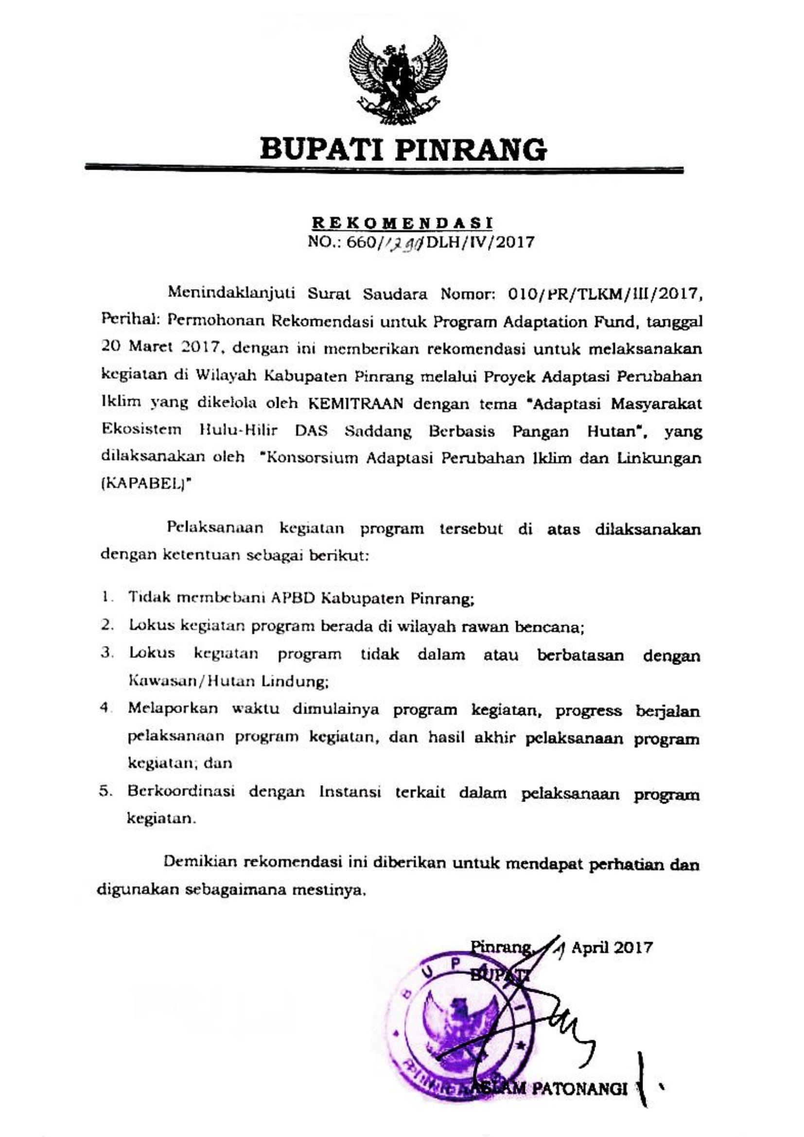

The Endorsement Letter from The Regional environment Agency of Tana Toraja Regency, South Sulawesi

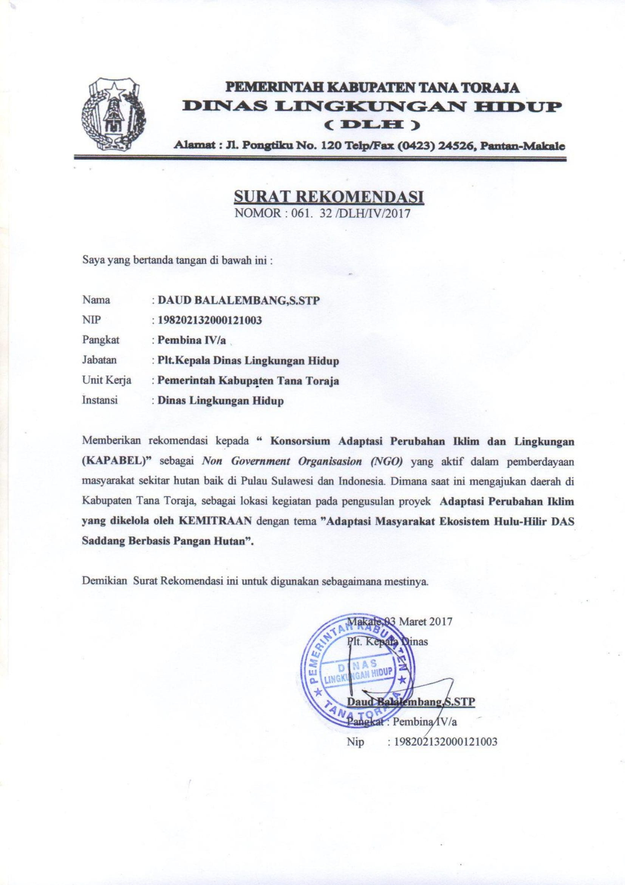

Lariang Mamasa Watershed Management
Forest Area Stewardship Center VII, 2014
Regional Vulnerability Data is obtained from the Vulnerability Index Data Information System developed by MEF in 2015
The result of the Global Weather Data Analysis as baseline/observation data (http://globalweather.tamu.edu/), using 27 Global Weather stations around the area affecting the Saddang Watershed, 2017
Forest Area Stabilization Agency, Land Cover Data Year 1998-2014
Data from Soil and Water Assessment To (SWAT) Model of Saddang Watershed, 2017
Central Bureau of Statistics, 2016, Table of Natural Disasters that occurred in Watershed Areas for Period of 2009 – 2014
Regional Disaster Management Agency of Enrekang, 2013-2016
Regional Disaster Management Agency of Tanah Toraja, 2013-2016
Regional Disaster Management Agency of Toraja Utara, 2013-2016
Regulation of The Director General Of Control Of River Flow And Protective Forest Number P.8 / Pdashl / Set / Kum.1 / 11/2016 Concerning Technical Instructions For Implementing Forest And Land Rehabilitation Activities
Central Bureau of Statistics, 2016 and Jeneberang Saddang Watershed Management, Results of Socio-ecological Survey of Saddang Watershed, 2014
Regional Disaster Management Agency of Pinrang District, 2017
Average Annual Rainfall Projection (mm) for 2018-2050 period based on RCF 4.5 Scenario Model GFDL-CM3
Central Bureau of Statistics, 2016
Saddang Watershed Management, Result of Identification Report on the Characteristics of Saddang Watershed, 2015
Field Survey Analysis Results (2017)
Central Bureau of Statistics, 2016 (Tana Toraja, Toraja Utara, Enrekang, Pinrang)
Agricultural Service of North Toraja District, 2017
2016-2021 RPJMD of Tana Toraja District
Marine and Fisheries Service of Pinrang District, 2017
Agricultural Service of Pinrang District, 2017
Central Bureau of Statistics (2017)
Analysis on Soil and Water Assessment To (SWAT) from Saddang Watershed, 2017 ⁴ Data from field survey results by direct interviews of coastal community, 2017
The AF utilized OECD/DAC terminology for its results framework. Project proponents may use different terminology but the overall principle should still apply

