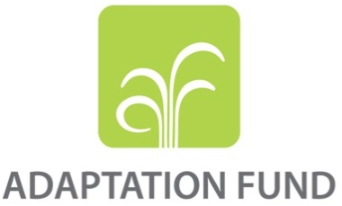

REQUEST FOR PROJECT
FUNDING FROM THE ADAPTATION FUND

The annexed form should be completed and transmitted to the Adaptation Fund Board Secretariat by email or fax.

Please type in the responses using the template provided. The instructions attached to the form provide guidance to filling out the template.

Please note that a project/programme must be fully prepared (i.e., fully appraised for feasibility) when the request is submitted. The final project/programme document resulting from the appraisal process should be attached to this request for funding.

Complete documentation should be sent to:

The Adaptation Fund Board Secretariat
1818 H Street NW
MSN P4-400
Washington, D.C., 20433
U.S.A
Fax: +1 (202) 522-3240/5
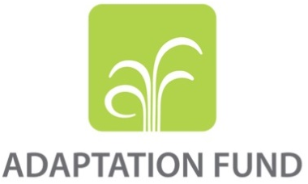
Email: afbsec@adaptation-fund.org

PROJECT PROPOSAL TO THE ADAPTATION FUND

Table of content
PART I: PROJECT INFORMATION 4
1. PROJECT BACKGROUND AND CONTEXT 4
1.1. Natural resources and climate 4
1.2. Natural Resource Management (NRM) 4
1.3. Climate change 5
1.4. Economy 9
1.5. Key issues identified for the project 11
1.6. Lessons learnt from the IFAD past projects 12
2. PROJECT OBJECTIVES 13
3. PROJECT COMPONENTS AND FINANCING 14
4. Projected Calendar 16
PART II: PROJECT JUSTIFICATION 17
1. PROJECT COMPONENTS 17
2. Project benefits 23
3. Cost effectiveness 24
4. Strategic alignment 32
5. Standards 34
6. Duplication 34
7. Learning and knowledge management 34
8. Consultative process 35
9. Justification for funding 35
10. Project sustainability 36
11. Environmental and social impacts and risks 37
PART III: IMPLEMENTATION ARRANGEMENTS 40
1. Implementation arrangements 40
2. Financial risK management 41
3. Environment and social risk management 44
4. Monitoring and Evaluation 45
5. Results Framework 48
6. Alignment with Adaptation Fund 51
7. Project budget 53
8. Disbursement schedule 58
PART IV: ENDORSEMENT BY GOVERNMENT AND CERTIFICATION BY THE IMPLEMENTING ENTITY 60
ANNEXES 61
Annex 1 List of Participants 61
Annex 2 : Social, Environmental and Climate Assessment Procedure (SECAP) review note - IFAD 67

PART I: PROJECT INFORMATION

PROJECT CATEFORY: | REGULAR
COUNTRY: | SIERRA LEONE
TITLE OF PROJECT: | PROMOTING CLIMATE RESILIENCE IN THE COCOA AND RICE SECTORS AS ADAPTATION STRATEGY IN SIERRA LEONE
TYPE OF IMPLEMENTING ENTITY: | MULTILATERAL IMPLEMENTING ENTITY (MIE)
IMPLEMENTING ENTITY: | INTERNATIONAL FUND FOR AGRICULTRUAL DEVELOPMENT (IFAD)
EXECUTING ENTITY: | MINISTRY OF AGRICULTURE AND FORESTRY (MAF)
AMOUNT OF FINANCING REQUESTED: | USD 9,916,925
MAIN PARTNER: | ENVIRONMENTAL PROTECTION AGENCY (EPA)

PROJECT BACKGROUND AND CONTEXT

Natural resources and climate
- Sierra Leone is a relatively small country, it has a land mass of about 72,000 km2 and is located within the Upper Guinean Rainforest, ecoregion. According to the Koppen climate classification, the climate of Sierra Leone is described as a tropical monsoon climate at the exception of the northern part of the territory characterized by a tropical wet climate. Sierra Leone has nine major river systems from north to south including the Great Scarcies, Little Scarcies, Rokel, Jong, Sewa, Moa and Mano Rivers. The country is divided into four main relief regions: coastline, interior lowland plains, interior plateau and mountains, each of which can be subdivided into a number of ecosystems. The coastline or coastal plains is relatively gentle and comprises estuarine swamps, terraces, alluvial plains and beach ridges. The interior lowland plains extend from the coastal terraces in the west to the east of Sierra Leone, occupying approximately 43% of the land area. At the edge of the lowland plains are the interior plateaus, made up of granite that runs from the northeast of the country to the southeast. The integrity of all these natural ecosystems and also the various agro-ecosystems are vital to ensure the ecosystem services upon which the population of Sierra Leone depend.
- The country is characterised predominantly by a hot and humid climate with distinct wet and dry seasons. The wet season from May to October sees an average of 3000mm of precipitation with coastal areas receiving as much as 5000mm, with temperature ranging between 22-25°. The dry season is characterised by dusty, hot Harmattan winds and dry conditions, with temperatures ranging between 25-27°. Seasonal rainfall in West Africa varies considerably on inter-annual and inter-decadal timescales, due in part to variations in the movements and intensity of the Inter Tropical Climatic Zone (ITCZ). Current mean annual rainfall however has decreased to its lowest levels since the 1960s.

Economy , Population and agriculture
- The Sierra Leone economy has grown since the end of the civil war in 2002 although has suffered two major recent shocks, the Ebola epidemic and the collapse of iron ore commodity price and consequently GDP growth shrinking to -21 per cent in 2015. Economic growth resumed following new investments in mining, agriculture and fisheries, with a GDP growth of 4.3 per cent in 2016. Sierra Leone’s Human Development Index (HDI) was 0.420 in 2015, ranking 179th out of 188 countries. In August 2017, the country suffered a mudslide and flooding incident in Freetown which left 1,114 people dead or missing. Agriculture, the largest sector in the economy, accounted for 59 per cent of GDP in 2016, 62 per cent of the labour force, and 22 per cent of export earnings. Cash crops produced for export include cocoa and coffee, while oil palm is produced for domestic consumption and limited export.
- Sierra Leone’s population is around 7.4 million (40 per cent youth) and growing at 2.2 per cent annually. About 59 per cent of Sierra Leoneans live in the rural areas, where the poverty headcount of over 66 percent is double that of the urban areas. Of the former 14 districts, 11 were below the national poverty headcount of 52.9 per cent (figure 3). Poverty rates (US$ 2 a day) vary from 18.3 per cent in Koinadugu District to 83.7 per cent in Moyamba District. Women and youth are particularly vulnerable due to challenges associated with access to land, skills and capital, as well as customary practices.
Figure 6 Poverty headcount by district (2011)
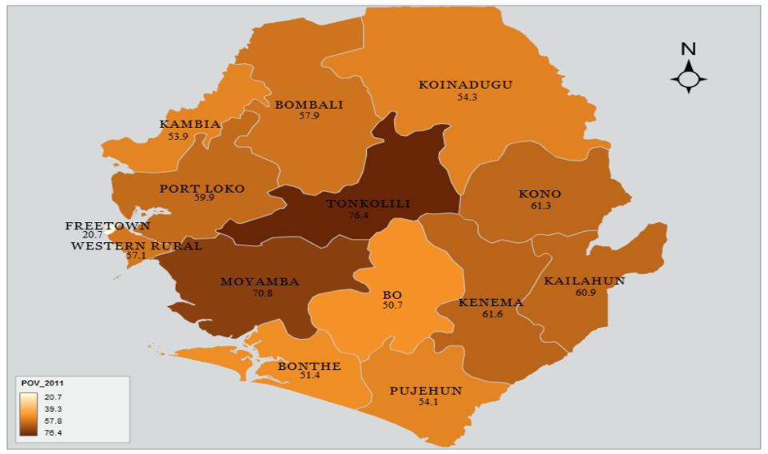
- The country’s land sector is described as chaotic and increasingly unsustainable, with the main problems including inequitable access and shortage of accessible land. The absence of a registration system, cadastral mapping and information, overlapping jurisdictions for statutory and customary law undermine rights and access to land. Customary practices for land ownership and inheritance discriminate against women and the lack of defined women’s rights to land under communal ownership mean that women are not consulted in management, purchase or selling of land. Women are also not sufficiently represented in institutions that deal with land and the international conventions dealing with women’s rights have not been translated into law or national policies. Violent conflict relating to land is not uncommon, but conflicts and competition over land also extend to between line ministries, local authorities and chiefdom institutions.
- About 59.7 per cent of rural households in Sierra Leone are food insecure, compared with 25.1 per cent in urban areas. Expenditure on food for the rural household averages 63 per cent of total household expenditures. Food insecurity is highest in households living in livelihood zones dominated by food crop production. A 2016 survey (table 1) indicates that only an average of 43.5 per cent of the households in the country had some food stocks. Food insecurity is more visible in households headed by women, and during the leanest months of August to October, rural married women bear the brunt of caring for the home when the husbands migrate to the diamond mines in search of employment. Two staple crops, rice and cassava, along with oil palm account for 60 per cent of the diet. Domestic rice production (801,000 MT) is below domestic consumption resulting in an annual rice importation (280,000 MT) at about US$ 110 million. Acute malnutrition prevalence is about 4.7 per cent, with most districts going far beyond this figure, apart from the Western Area Urban and Western Area Rural districts.
Table 1 : Households with stocks of food (2016)
District | Per cent households
Kailahun | 40.9
Kenema | 40.5
Kono | 84.2
Bombali | 22.3
Kambia | 50.0
Koinadugu | 40.7
Port Loko | 30.7
Tonkolili | 59.9
Bo | 47.0
Bonthe | 4.4
Moyamba | 53.4
Pujehun | 45.1
Western Area Rural | 43.3
Total | 43.5

Natural Resource Management (NRM)
- Biodiversity loss is one of the major problems undermining sustainable development in Sierra Leone. Total forest cover in Sierra Leone amounts to 38% of total land area although only 5% is original forest cover. Deforestation between 1990 and 2010 has been at a rate of 20,000ha per year. Agriculture comprises 59% of GDP (World Bank, 2017) and sustainable management of biodiversity has important implications for food security and poverty reduction. The main direct causes of land degradation in Sierra Leone are logging, firewood collection, mining, charcoal production, tree crop plantation, settlement expansion and the slash and burn practice used in shifting cultivation. The primary indirect causes are extreme poverty, corruption, low public awareness and weak institutions.
- Forestry protection in Sierra Leone is very weak and facing constant threats posed by corruption, weak governance structures both at the legislative level as well as on the ground monitoring and sanctioning of illegal logging and general lack of awareness among farmers. MAFFS reported during the formulation mission, that protected areas and the 1km buffers are under constant threat from slash and burn practices and plantations. Slash and burn is a standard practice carried out by extremely poor farmers to clear land typically around 2ha for the cultivation of rice, vegetables, and the production of firewood and charcoal.

Climate change
1.4.1. Current climate hazards and variability and their impacts
- Sierra Leone is one of the most vulnerable countries to climate change in West Africa and among the Least Developed Countries (LDC), least able to adapt to the adverse effects of climate change.According to the Sierra Leone’s Second National Communication to the UNFCCC, climate change will lead to severe consequences including: decreased agricultural productivity, degradation of the coastline and damage to coastal structures, a shift from tropical rain forest to dry forest, food and nutrition insecurity, water stress and severe economic impacts that will undermine decades of development gains (Sierra Leone Climate Action Report, 2015).
- Farmers’ high dependence on rain-fed agriculture and natural resource-based livelihoods are key influencing factors of their vulnerability. However, while unaware of the meaning of climate change, farmers have already consciously started to adapt their farming practices to changing climate patterns. Farmers have reported experiencing changes in rainfall patterns characterized by rainfall in the dry season and dry periods in the rainy season. Climatic changes have manifested in more intense rainfall patterns with more frequent severe floods and seasonal droughts, late onset of rains, rising temperatures, particularly in the dry season, stronger winds including reports of local tornadoes, more intense thunderstorms and more frequent landslides. The IPCC predicts that without adaptation, tropical regions will experience negative impacts in the production of wheat, rice and maize due to temperature increases. Agriculture is Sierra Leone’s second largest economic sector after mining contributing 59% to the GDP and is therefore facing long-term, high-risk exposure to climate change.
- The seasonal rainfall in West Africa varies considerably on inter-annual and inter-decadal timescales, due in part to variations in the movements and intensity of the Inter Tropical Climatic Zone (ITCZ). Precipitation patterns in the Sierra Leone are affected by a large decadal variability, with decades showing above average and below average levels compared to the historical mean. For example, the period around the 1980s was characterized by below average precipitation levels, while the 1970s and 1990s were on average wetter than during the period (Agricultural value-added still represents the largest share of Sierra Leone's GDP. Cocoa is one of the main export and cash crop of the country. The future consequences of the changing precipitation and temperature patterns could significantly affect the production of the subsector. ).
1.4.2. Anticipated climate change and its impacts
- Climate change is projected to change precipitation and temperature patterns. Using an ensemble of GCMs from the CMIP3 database, McSweeney et al., (2010) project an increase in annual precipitation over the period between 2010 and 2050 in all warming scenarios studied (A2, B1 and A1B). However, even though precipitation are projected to increase the inter-annual variability is also significantly increasing, particularly in the A2 scenario (the global mean temperature increase in the A2 scenario is comparable to the warming in the RCP8.5 scenario) in comparison to the B1 scenario (which is itself comparable to the RCP2.6 scenario, leading to about 1.6 degrees of warming by the end of the century) (Sylla, Nikiema, et al., 2016). The intra-annual variability of precipitation in Sierra Leone is also projected to increase, with an increase from 5 to 10 percent of precipitation in the wet season (May-September) in the 2036-2065 period in both RCP4.5 and RCP8.5 scenarios (Sylla, Nikiema, et al., 2016). Even though precipitation is projected to increase in the May to September season, the length of the dry spells could also increase by up to 15 percent compared to the historical period, in the 2036-2065 period – primarily in the RCP4.5 scenario. Finally, heavy precipitation events could also significantly increase over Sierra Leone, particularly in the Northern part of the country, with possible increase up to 15 percent in the intensity of the extreme rainfall events (Sylla, Nikiema, et al., 2016) in the 2036-2065 period in both scenarios. This trend of increasing intensity of extreme rainfall further accentuates in the century.

Figure 1 Precipitation anomaly to the mean in the period 1970-1999 expressed in mm per month for the historical (yellow), A2 scenario (dark blue), B1 scenario (grey) and A1B (orange). Source: McSweeney et al., (2010)
- Temperature patterns are also projected to change as a consequence of climate change. Mean temperature increase for Sierra Leone could range from about 1.2 degrees to above 1.5 degrees by 2050, in the scenario B1 and A2 respectively. This increase in temperature is measured compared to the reference period 1970-1999 mean temperature over the country. The warming over the country is projected rather uniform even though the coastal zones could warm at a slower rate (about 1.1 degrees in the 2030s) than the interior of the country particularly in the North-eastern part (about 1.4 degrees). By the 2050s, the number of hot days per year and season could significantly increase as a consequence of climate change and in all warming scenarios. The largest increase in the number of hot days would be observed in the July, August and September months with an increase ranging from 60 percent (B1 scenario) and 80 percent (A2 scenario).

Figure 2 Temperature anomaly to the mean temperature in the period 1970-1999 expressed in degrees for the historical (yellow), A2 scenario (dark blue), B1 scenario (grey) and A1B scenario (orange). Source: McSweeney et al., (2010)
- As a consequence of the changing precipitation and temperature patterns, the main climates of Sierra Leone are projected to progressively shift throughout the 21st century. As of the current period, Sierra Leona has two dominating climate, following the Koppen classification: a tropical monsoon climate at the exception of the northern part of the territory characterized by a tropical wet climate. According to Sylla, Elguindi, et al., (2016), the monsoon climate (hot wet in the figure below) could progressively reduce its geographical extent to the Southern coastal zone being replaced by the tropical wet (hot moist in the figure below) climate prevailing in the North-eastern part of the country. The figure below (Figure 3 ) shows this progressive shift in climates in Sierra Leona compared to current days in the RCP4.5 and RCP8.5 scenarios.
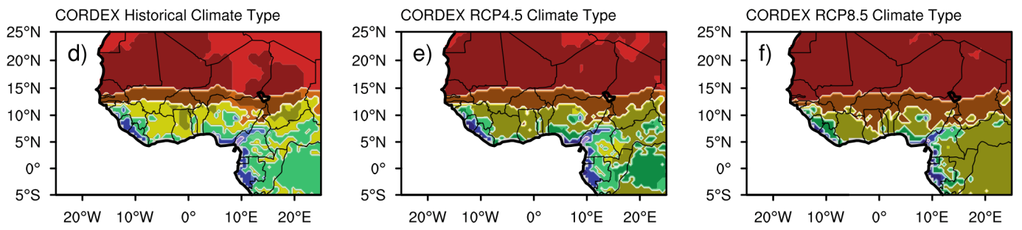
Figure 3 Distribution of climate types for reference period (1985–2004; left panel), future RCP4.5 (2080–2099; middle panel) and RCP8.5 (2080–2099; right panel) for CORDEX (d, e and f) ensemble using all models. Abbreviations definition: T Torrid, H Hot, W Warm, Cl Cool, Cd cold, F Frigid. Source: Sylla et al., 2016)
- Agricultural value-added still represents the largest share of Sierra Leone's GDP. Cocoa is one of the main export and cash crop of the country. The future consequences of the changing precipitation and temperature patterns could significantly affect the production of the subsector. The International Center for Tropical Agriculture (CIAT) projects a reduction in climate suitability for cocoa production by up to 20% in the southern districts and up to 40% in the north-eastern upland districts by the 2050s (Figure 4 ). As a consequence of this risk on cocoa production to changing temperature and precipitation patterns investments in the subsector could face productivity challenges, particularly in the context of IFAD baseline investment.
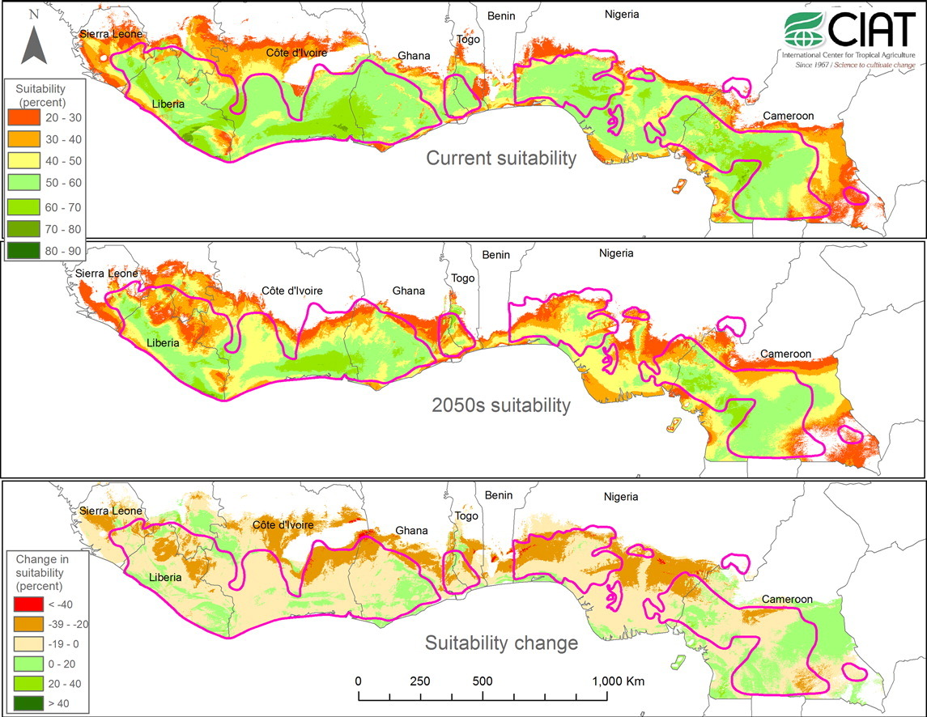
Figure 4 Relative climatic suitability (in percent) for cocoa of the West Africa cocoa belt under current and projected 2050s climate conditions, as well as suitability change, according to the Maxent model based on 24 climate variables.
- Detailed projections on the effects of climate change on rice and cassava production in Sierra Leone are lacking. It is however possible to draw some possible implications for rice production on the basis of studies investigating the effects of climate change on other crops in Sierra Leone and rice production in the other countries of the region, which present similar climatic characteristics. A study on millet, sorghum and maize projects that by the 2050s, the yield of these crops could severely decrease as a consequence of climate change. While maize currently yields about 700kg per hectare (in the period 1980-1998), it could decrease between 300 and 600kg per hectare in the 2050s in the high warming scenario (RCP8.5). Sorghum is projected to follow a similar downward trend from about 1000kg per hectare to yield ranging from 500 to 900kg per hectare in the same scenario and time period. Finally, Millet is even more vulnerable to future climate change with a potential decrease from 900kg per hectare to as little as 400kg (Ahmed et al., 2015).
- Only limited evidence for rice is available, primarily investigating the region as whole. In Western Africa, irrigated rice yield could decrease between 21 and 45 percent in the 2050s in the high warming scenario (RCP8.5) compared to the 2000s; for rain-fed rice, with already lower yields than irrigated rice, the decrease could range from -22 to -18 percent – both in the absence of adaptation. With the implementation of adaptation options, such as rice varieties able to withstand heat, the region could see both irrigated and rain-fed rice increase their productivity from 4 percent (rain-fed, upland rice) to 7 percent (irrigated) (Oort & Zwart, 2017).
- Hitherto, Cassava production and the impacts of climate change have benefited from a limited amount of studies, despite its importance in the food system in Sierra Leone and African countries. In Sub-Saharan Africa, cassava yield could decrease from -5 to -15 percent by the 2050s compared to yields in the 1961-2000 period in a high-warming scenario (SRES A1B)(Schlenker & Lobell, 2010).
- In the absence of adequate climate change adaptation options, both Sierra Leone’s staples could be severely affected by future climate change, limiting population’s self-sufficiency which would therefore need to rely on other crops and exported commodities. Furthermore, cocoa production, the main source of income in rural areas, could also be reduced as a consequence of decrease climatic suitability. Decreasing food supply and possibly reduced income from cocoa production could limit the ability of rural and urban households to attain food and nutrition security.
- Left unchecked, climate change could have detrimental economic development consequences. Under both a low and a high warming scenario, climate variability and change could lead to decreasing GDP per capita compared to a scenario without climate change. The decrease could be up to -5% in 2030 and growing up to -20% by 2050. The below figure presents GDP per capita risk for Sierra Leona in both low (RCP2.6) and high (RCP8.5) scenarios.
Figure 5 Risks to GDP per capita in the low and high warming scenarios. Source: Baarsch et al, in press.
- Food security is composed of four distinct components: availability, access, utilization and stability. In Sierra Leone, and particularly in the regions where IFAD’s interventions are planned, all four dimensions of food security are threatened. Availability, through production, could be decreased as a consequence of increased temperature and more frequent precipitation extremes. The projected increase in dry spells could also lead to reduced available water for irrigation during the dry months of the year. Access could also be limited as smallholders could see their incomes from cocoa production decreasing as a consequence of the decreased cocoa suitability. Access could also be threatened by the projected higher frequency of heavy precipitation events, which could further disrupt road connection. Finally, as a consequence of changing patterns and more frequent extreme events, the overall stability of production and external supply, as well as incomes from agricultural activities could be reduced by future climate change. Key issues identified and addressed by the project, root causes, barriers and preferred solutions
The project seeks to address the vulnerability of the cocoa and rice sector to climate change and climate variability in order to sustain continued and increased agricultural productivity and growth for poverty reduction in Sierra Leone. It addresses the multiple and combined impacts of climate change especially the anticipated modification of rainfall patterns and decreased water availability and increases in temperatures.
- The project intends to address four key issues identified which is already impacting the productivity of both cocoa and rice sector
- The decreasing climatic suitability for cocoa production, which could lead to reduced incomes and in some cases the reduced ability of smallholder farmers to access food on the local market.
- The increased frequency of heat waves as well as the extension of dry spells could also lead to a reduction in the production of subsistence crops, particularly rice and to some extent cassava.
- The increased frequency of extreme precipitation events could lead an increased disruption of market services and infrastructures such as roads and water services.
- Combined, these key issues could lead to an increase in poverty, particularly for transient poor and therefore an increased vulnerability to future climate change impacts in smallholder farmers’ households.
- Women make up 70 percent of agricultural business in Sierra Leone but realize little or no benefit
- Degradation of natural resources as a result of unsustainable agricultural practices ( slash and burn, firewood collection, logging) and recent conflict and Ebola crisis

- The project intends to address the underlying constraints that further exacerbate the projected climate change impacts and that represent major barriers to adaptation and resilience in the cocoa and rice sector. Amongst the key constraints : Unsustainable or inadequate agricultural practices ( e.g traditional slash and burn land preparation, land preparation for rice cultivation, inefficient use of water , erosion, diseases of cocoa trees due to increased temperatures. In addition, absence or inadequate of infrastructures to withstand to climate change impacts. Deforestation and land clearing in the cocoa plantations is also a key problem and is a result of growing energy needs, with fuelwood ( and charcoal) . The direct consequence is the country is losing hectares of lands of top soil due to deforestation and old cocoa trees affected by diseases.
- These barriers are preventing the country from achieving optimal yield in the cocoa and rice sector, to generate surpluses to respond to food security and nutrition while improving household incomes. As a post conflict countries, the country needs to upgrade its infrastructure including earth dams , adapted storages and warehouses, climate resilient roads along the agricultural value chain , improve capacity of small holder farmers to access to climate knowledge at technical information in order to shift from inadapted and in many ways unsustainable cultivation methods ( e.g slash and burn ) that provide short term gains but deplete soil fertility and degrade the natural capital and environment. Low yields prevent farmers to generate surpluses and income to be able to acquire inputs such as drought resilient seeds or improved fertilizers . As climate risks and climate risks management is new, it was proven by previous IFAD projects that well targeted support to smallholder farmers leads to increase yields in the rice and cocoa sector. For instance, smallholder farmers supported by an IFAD climate focused project have double and triple cropping of rice using NERICA rice over the paddy varieties as a result of the earth dams . However , more effort need to be done to help farmers have access to timely and relevant agro meteorological information to better decide on cultivation practices and cropping calendars. Early warning systems are no well in place yet . Accelerated erosion and siltation of drainage , irrigation systems could lead to a very heavy dire situation in rice producing areas where flooding is an issue.

Lessons learnt from the IFAD past projects on climate resilience in the agricultural sector
- IFAD’s experience in Sierra Leone offers the following results and lessons that will inform the design of this climate resilient development project which will scale up and replicate many activities of the Rehabilitation and Community-Based Poverty Reduction Project (RCPRP) and the GEF grant -funded component. This project will also take advantage of the new IFAD baseline investment under formulation on cocoa to enhance or develop the climate resilience of the entire value chain (supply, production, processing, marketing) building on lessons learnt. In summary of these lessons are:
- Income Generation: The evaluation of the RCPRP indicated that the NERICA rice introduced as part of the climate adaptation strategy has had a positive impact on income generation. Research has shown that farmers have been able to double profit margins, which is very positive for prospects of future sustainability. Reports have also been received of double and triple cropping of rice as a result of the earth dams but it was not possible to quantify this in numerical terms or to what degree they improved the yields of the NERICA rice over the paddy rice varieties (IFAD, GEF evaluation report, Sierra Leonne).
- Institutions and policies: The project carryout capacity building exercises directly impacting MAFFS by the training of 12 staff members in statistics and applied climatology. The project also directly assisted the Meteorological Department in developing the network of AWS’s as well as in developing its technical capacity, both of which are central to a nation’s ability to adapt to climate shocks and were seriously impaired as a result of the war. Eight stations were installed throughout the four regions (two per region) Three staff members were trained at the Nigerian Meteorological Agency in a year-long course both as senior and medium level meteorological technicians. The overall objective however to gather and disseminate meteorological data to enable farmers better adapt to climate shocks, has not yet been achieved and a number of technical and financial sustainability challenges remain with regards to the Meteorological Department’s ability to carry on after project closure
- Climate change Adaptation : RCPRP+ and IACCAPFS (GEF component) carried out a number of activities specifically aimed at reducing climate shocks, these include a climate vulnerability mapping exercise and subsequent construction of earth dams to enable a perennial supply of water in climate change vulnerable, non-perennial rain-fed swamps. 3.2 metric tons of NERICA rice suited to rain-fed upland ecosystems were also procured, and multiplied to an estimated 72mt. This was then re-distributed to farmers on a total of 120 ha and is expected to greatly improve food security as beneficiaries are able to double and triple crop rice. The project also piloted innovative sustainable land and water harvesting techniques to collect, concentrate and store water at the crop root zones (tied ridging, moon ridges) as well as soil conservation methods that control erosion (mulching, terracing). This innovative pilot, aimed to demonstrate that in-situ agriculture can be more productive than the destructive practice of slash and burn and has been largely accepted. The project also demonstrated great signs of soil regeneration in soil structure, nutrient and moisture content and the university is set to continue the activities after project completion. 180 women, youth and vulnerable households attended workshops on climate change adaptation; training on how to carry out capacity building workshops on climate change adaptation was also delivered.
- Capacity Building: The capacity building targeted the meteorological services by re-establishing weather stations, and providing climate data to support decision-making processes at all levels. The ability of the Meteorological Department to fulfil its mandate and related weather monitoring tasks, data collection, data analysis, dissemination to end-users and storage was greatly affected by the ten-year war (1992-2002). Some staff members died while others retired from service and others left the country. The effective adoption and design of climate adaptation responses are dependent on coherent national weather data and natural disasters records. The GEF/LDCF activities aimed to address the identified capacity building and weather data collection gaps at national and institutional level by investing in both human resources and equipment. However, further capacity building exercises are likely to consolidate the results gained from past projects.
- Scaling up: This project will scale up and amplify the results obtained by RCPRP+ and IACCAPFS putting mechanisms, methodologies and the necessary resources in place to disseminate and scale up successful experiences on climate resilient agriculture for food security and nutrition. This an integrated approach where the IFAD past experiences and baseline investments serve as entry point and lessons learnt for this additional climate financing on larger beneficiaries.

2011-2010
RCPRP Reformulation
Infrastructures,
Community based Institutions

2006-2010
RCPRP Post War
Recapitalisation and Farming Activities Development
2011-2017
RCPRP +
Agricultural production and commercialisation

2018-23
RCPRP +

Agricultural Value Chain Development

AF

GEF

Climate finance for Adaptation measures

PROJECT APPROCH AND OBJECTIVES
- Climate change and climate variability is expected to affect rainfall patterns, temperatures and to decrease water availability. Adaptation measures must address key challenges posed by climate change. The project will address key climate vulnerabilities in agriculture and water resources management in the rice and cocoa value chain, and hence contribute to immediate and longer-term development and resilience needs of poor vulnerable small holder farmers in Sierra Leone. The resilience of the cocoa and rice sector can only be achieved by identifying and implementing a comprehensive set of agricultural practices and agricultural diversification strategy through integrated farming systems designed to increase yields, minimize environmental degradation while maintaing the ecological functions and the rice and cocoa production value chains.
- The current project proposal will follow the existing intervention framework closely, putting emphasis on scaling-up IFAD successful initiatives and capacity building in Sierra Leone. The general objective of this project is to strengthen the resilience of the GoSL development investments on cocoa and rice sector. This AF project are complementary to other IFAD investments on g food security and livelihood opportunities which is being supported by the IFAD-funded Agricultural Value Chain Development Project (AVDP) with adaptation to climate change. The AVDP was approved by IFAD's Executive Board in December 2018, and build on past IFAD and GEF financed projects in the country such as the Rehabilitation and Community-Based Poverty Reduction Project (RCPRP). IFAD investment has benefited to 1.1 million people (Final Evaluation of the RCPRP). Adaptation interventions proposed for the support of the Adaptation Fund are fully aligned with the AVDP and build on past IFAD investments baselines.
- The project intends to provide Integrated solutions to the key issues from climate change in Lofa County, the breadbasket of the country by testing integrated climate resilient rice and cocoa in partnership with all actors sitting along the value chain. This approach will draw from existing technologies ( varieties, cropping systems ) as well the integration of new dimensions climate change resilience on rice and cocoa value chains. The model includes: environmental management, integrated farming systems and diversification, integrated pest management and water management, climate proofing infrastructures to access to markets and reduce post-harvest losses.
- Targeted people are smallholder farmers and communities that are the most vulnerable to climate change. They are direct beneficiaries of the project are 35,000 smallholder farmers and 10,000 rice proceder, 5000 cocoa producers, of which at least, 40 percent will be women and 40% young people. To benefit from project services, farmers must be active, resident smallholder farmers in the project locality, already engaged in producing one of the target crops, and must be a member of an FBO (or willing to join one).
- The project will also promote policy dialogue on potential maladaptation's and policy gap in both sector, in the view of achieving strong policy on rice and cocoa sector and to be replicated in the whole country and the West Africa region

- The overall objective of this additional climate finance for adaptation is to reduce vulnerability and increase adaptive capacity to respond to the impacts of climate change, including variability at local and national levels as well as on natural resources critical for sustaining agricultural production and increasing food security and nutrition of vulnerable poor communities.
- The AVDP focusses on three value chains, i.e.: (i) Cocoa, (ii) Nerica Rice, and Paddy rice,. Additionally, the project aims at improve the organisation and performance of the selected value chains which includes the resilience of rural infrastructure to climate change impacts such as feeder road rehabilitation to connect producers to markets. Climate change could reduce crop yield especially rice and cocoa and disrupt connexions to markets.
- Greenhouse gas (GHG) emissions are projected to increase to about 6.6 MtCO2eq in 2030. The major greenhouse gas emitted is Methane (CH4) with projected emissions of 3.7 MtCO2eq in 2015 and about 5.0 MtCO2eq in 2030 and the largest emitting sectors are Agriculture and Waste and between (95-98%).
- Reflecting the key development challenges and adaptation needs as well as fully aligned with the three components of the AVDP, the project will deliver the stated objective through three components:
- Component 1: Climate-proofed agricultural production and post-harvest combined with livelihood diversification
- Component 2: Climate-resilient rural transportation and water infrastructure
- Component 3: Institutional capacity building and policy engagement

PROJECT COMPONENTS AND FINANCING
Table 2 Project Components and Financing
AVDP components | CRDP Components | Expected concrete outputs | Expected outcome | Amount
Component 1: Climate Resilient and Smart Agricultural Production | Component 1: Climate-proofed agricultural production and post-harvest combined with livelihood diversification | Output 1.1. Best available technologies and integrated resilient rice and cocoato foster the resilience of cocoa and rice production and post-harvest are implemented  ( cropping calendar and climate early warning systems and vulnerability and crop modelling, climate resilient varieties, multiplication and dissemination, integrated pest management, soil management, energy for production and post harvest and processing, water pumping, reforestation and agro forestry) | - Set of proven best practices on climate resilient rice and cocoa value chain drawing from local and international research and sustainable increase in rice and cocoa production  - Adaptation strategy of smallholder farmers improved because of diversified livelihood strategy | 6,564,140
 |  | Output 1.2. Income-generating activities (fish farming, gardening) are promoted as livelihood diversification measures |  | 6,564,140
Component 2: Agricultural Market Development | Component 2: Climate resilient rural infrastructure | Output 2.1. Rural transportation and storage infrastructures have been rehabilitated and upgraded to withstand weather extremes ( climate resilient feeder roads, drainages systems, culverts; climate proofed storage and warehouses, equipment and processing units, post-harvest storage facilities with phytosanitary control and serving as integrated trading and markets points) | Enhanced and secure access to potable water supply, post-harvest losses reduced and improved access to market access by beneficiary communities through climate-proofed rural road network | 1,599,282
Component 2: Agricultural Market Development | Component 2: Climate resilient rural infrastructure | Output 2.2: Water supply increased and sanitation infrastructure built accounting for current and future climate risks (watershed rehabilitation, water efficiency and management, training and extension and infrastructure rehabilitation and construction – irrigation systems boreholes, water quality assessment, toilets, sanitation and drainages systems ) |  | 1,599,282
Component 3:  Project Coordination and Management | Component 3: Institutional capacity building and policy engagement | Output 3.1. Capacity of the government (esp. EPA) in managing climate risk is strengthened | Technical norms and international standards reviewed and upgraded in rice and cocoa production  Environment for resilient rice and cocoa value chain improved as EPA and the government capacities enhancement on adaptation to climate change in these sectors | 625,969 (excluding below project execution costs)
Component 3:  Project Coordination and Management |  | Output 3.2: Activities are adequately coordinated, monitored and evaluated. |  | 625,969 (excluding below project execution costs)
 | Project execution cost |  |  | 288,816
 | Project Management Fees (8.5%) |  |  | 776,902
 | Total |  |  | 9,916,925

Table 2 Project Cycle management fee charged by the Implementing Entity (8.5%).
Project Cycle Management Fee over 6 years | Percentage | Amount
- Development and Preparation | 20% | $ 155,380.40
- Overall Coordination and Management | 30% | $ 233,070.60
- Financial Management and Legal Support | 20% | $ 155,380.40
- Evaluation and Knowledge Management Support including Reporting | 20% | $ 155,380.40
- Overall Administration and Support Costs | 10% | $ 77,690.20
Total | 100% | $ 776,902.00

Projected Calendar
Milestones | Expected Dates
Start of Project Implementation | 2019
Mid-term Review | 2022
Project Closing | 2025
Terminal Evaluation | 2025

PART II: PROJECT JUSTIFICATION

PROJECT JUSTIFICATION AND COMPONENTS
- The project proposes the implementation of a set of concrete adaptation options in tow targeted and profitable agricultural sector ( rice and cocoa). A set of enabling actions designed to strengthen national capacities and institutions is interlinked to the concrete adaptation measures which will lead to building the resilience of the cocoa and rice value chains in the most vulnerable areas to climate change in Sierra Leone. Concrete adaptation measures are direct application of integrated climate resilient production, post-harvest and marketing systems. New technologies and best knowledge aim at promoting the paradigm shift and behavioural change in the rice and cocoa production and linkages to markets.
- To project is structured around three components:
- Component 1: Climate-proofed agricultural production and post-harvest combined with livelihood diversification;
- Component 2: Climate resilient rural infrastructures ; and
- Component 3: Institutional capacity building and policy engagement
- Each component is described in more details below.
Component 1: Climate-proofed agricultural production and post-harvest combined with livelihood diversification.

- This component focuses on household-/village-level interventions in climate resilient and sustainable agriculture in order to reduce the negative impacts from climate change and climate variability, as well as to contribute to agricultural and rural livelihood development through income diversification. Along the agricultural value chain, key vulnerability issues which call for adaptation practices are the low productivity and high vulnerability of the agricultural sector mainly cocoa and rice highly dependent on rainwater, which is the sole water source for a large majority of small farms; the increased recurrence of extreme weather events such as floods, droughts and climate-induced vegetable diseases, which reduce productivity levels; and changes and variations in climate conditions from one year to another. With regards to post harvesting in the cocoa sector, the lack of adequate equipment for drying and processing to maintain a high-quality product of outputs is still a challenge to stabilize and increase farmers’ income in the face of climate change. To support the shift towards climate-resilient production and post-harvest systems combined with livelihood diversification in the targeted areas, the project will focus on the following outputs and activities
Output 1.1: Adaptation measures to foster the resilience of cocoa and rice production and post-harvest are implemented
Cocoa value Chain :
- Establishment of cocoa clonal garden at SLARI to facilitate the introduction of drought- and temperature-resistant cocoa seedlings; including resistance to emerging pests and extreme events.
- Best reforestation and agro forestry techniques
- Support to cocoa clonal garden operation. This activity will ensure the long-term functioning of the clonal garden and will also support the establishment of a sustainable business model;
- Development of cocoa farms, which include resilient practices such as vulnerability-informed land use, tree shading and agroforestry.
- Climate weather information's to local cocoa producers specifically for droughts, floods and humidity
- Improvement on crop modelling and assessment of climate vulnerability
- Use of modern technologies with a particular focus on solar based pumping systems, solar based post-harvest and processing and equipment's to attract more youth in agriculture
- Under this output, the project will engage with national and Western African expertise on cocoa production, the national expertise of the Sierra Leone Agricultural Research Institute (SLARI) at the Kenema Crop Resource Centre (KFTCRC), and at the regional level, the Ghana Cocoa Board (Cocobod) and the Cocoa Research Institute of Ghana (CRIG).
Rice value Chain :
- Selection of pest resistant varieties and cultural practices (distance between plants, irrigation management, and weeding
- Support to MAF to run Farmer Field School and provide other technical support. The FFS will showcase specific approaches to facilitate the introduction and uptake of resilient practices for farmers in the cocoa and rice sectors.
- Bore holes irrigation schemes, to cope with the consequences of drought and heat extreme events, bore holes will be rehabilitated and irrigation schemes will be deployed. The increasing needs for irrigation induced by future climate change will be integrated in the design of the schemes.
- Development of new Inland Valley Swamps for rice production to increase the production of smallholder farmers and diversify and expand their revenue sources.
- Watershed rehabilitation, water efficiency and management,
- Training and extension and infrastructure rehabilitation and construction including drainage systems
- Water quality assessment, toilets, sanitation
Output 1.2. Income-generating activities (fish farming and gardening) are promoted as livelihood diversification measures
- The Midterm review of the GEF project recommended to use the earth dam reservoirs to develop fish farming activities as alternative adaption measures. The contribution of fish farming to food and nutrition security in Sierra Leone has been underplayed due to its low priority in the food production systems, however FAO reports that it contributes significantly to national protein intake. As a source of irrigation water, pond water is also richer in nutrients than well water as it contains nitrogen-fixing algae which improves soil fertility.
- With regard to this output, the actions to be taken include:
- Construction of 30 earth dams for fish farming activities.
- Establishment of fish farms, including the creation of value-chain services (fingerling, etc.).

- As a new activity still under development in the country, technical services for the stocking and management of the earth dams and fish farming activities will be provisioned throughout the project. Trained personal will be trained and placed in support to MAFFS regional extensions (depending on the number of communities practising fish farming). The targets are the Farmer-based organizations and directly the smallholder farmers engaging in fish farming.
- With fingerling production centres in Bo and Makali, the project will work in collaboration with MAFFS, FAO and the Ministry of Fisheries and Marine Resources. Service providers, MAFFS and FAO will support to train farmers through the FFS in fish farming.
- In addition to fish farming, the project will support the establishment of integrated resilient kitchen and community gardens powered by solar applied on integrated resilient farming systems with alternance of climate resilient crops, with high nutritional values.
Component 2: Climate resilient rural infrastructure

Output 2.1 – Rural transportation and storage infrastructure have been rehabilitated and upgraded to withstand weather extremes
- Fostering productivity and production is not sufficient to ensure that smallholder farmers sustain and increase their revenues. Poor road and transportation infrastructure leads to a depreciation of the quality of the production and hence its value on the market therefore smallholders' revenues. The already observed and projected intensification of extreme weather events could lead to more value chain disruptions, affecting the capacity of smallholders to gain sufficient incomes from their production. As a consequence, two key actions will be undertaken by the project: (1) improving the usability of road infrastructure all-year round and for all-weather conditions; (2) in the same areas rehabilitating existing warehouses to withstand wetter climatic conditions will also support the development of the cocoa and rice value chains.
- With regards to infrastructure, based on the lessons learned exercise from the RCPRP+, road construction has previously overlooked the construction of culverts that enable IVS drainage, resulting in water-logged fields during the rainy season. Depending on the ESIA outcome, this project will help finance culverts that will allow for natural drainage, and it will also support the EPA in its supervision functions. Should the allocated budget permit, the project will support the reinforcing of bridges against increased peak fluvial discharges resulting from increased deforestation, increased surface water runoff and increased rainfall intensity.
- Activities under this output are :
- Warehouse rehabilitation to withstand wetter climatic conditions. With an increasing recurrence of extreme wet events, it is essential to ensure that existing warehouses (1) preserve low humidity level to preserve the produce and (2) are rehabilitated outside floodable areas and are not exposed to extreme flood events that could adversely affect the stored produce.
- Climate-proofing feeder roads and farm tracks to ensure the year-round and all-weather usability. The climate-proofing includes the studies and surveys, the works, the construction of bridges and culverts where necessary, routine and periodic maintenance.
- To sustain the climate-proofed investment over a longer period of time, activities aiming at their maintenance by local public authorities and Farmer-based organizations will also include: (1) Support to districts for development of Feeder Roads Maintenance Plans and (2) Support to Farmer-based Organizations (Road gangs formation, distribution of maintenance tools, development of Farm Tracks Maintenance Plans)

Output 2.2 – Potable water supply increased and sanitation infrastructure built accounting for current and future climate risks
- Agricultural and domestic water management in Sierra Leone is becoming more complex due to climate change. Key barriers to agriculture production involve drought (acute and seasonal) and flooding of villages and swamp rice and cocoa fields due to intense periods of rain. In the targeted areas, availability of water, in both quantity and quality, is being severely affected by climate variability and climate change. Constraints identified at the local level include lack of water infrastructure both for agriculture and human consumption. The low productivity in agriculture and livestock is linked to water availability. Addressing the risks of current and future climate change to water supply and agricultural productivity is therefore critical in enhancing resilience. Frequent drought or erratic rainfall results in crop damage, loss of livestock and pastures, water shortage (for humans and livestock), malnutrition (due to lack of food), and migration of households and wild animals. The unsustainable management of water resources is the major factors aggravating the impacts of climate change in the targeted areas. Crop pests and water-borne diseases are common, often caused by poor farm management and the absence of water and sanitation infrastructures. Therefore, the following expected outputs are expected to improve the baseline scenario
- Based on the lessons learned from the IACCAFPS IFAD/GEF pilot, on the vulnerability mapping output 1.1.2, and capacity building output 1.2.3 water availability, control and management under climatic stresses remain a big challenge. Activities under this output will improve and upscale water harvesting small earth dams infrastructure with up to 40 new dams (from 4 under GEF) for perennial rice and vegetables in seasonal and climate vulnerable IVSs. The project will also tender a contract for a capable NGO or institution to carryout water quality testing as part of the site selection process to ensure the water is suitable for agriculture. As poor sanitation leads to water borne diseases, which are responsible for of all deaths of the labour force, the project will also built latrines in the villages.
- Climate-proofed construction and rehabilitation of drinking water supply and sanitation to withstand the consequences of extreme dry and wet events that could disrupt the quantity and quality of water available to the population and its economic activities.
- The construction and rehabilitation will be complemented by capacity building for potable water management.

Component 3: Institutional capacity development and policy engagement.
Output 3.1: Governmental capacities are strengthened for climate change adaptation .
- Enabling the implementation of the project will necessitate to further develop the capacities of the relevant government agencies in charge of climate change adaptation from the policy to the implementation levels. The component 3 therefore focuses on strengthening the capacity of key government institutions (3.1) and ensuring the adequate M&E of the project combined with the recruitment and training of the relevant staff to facilitate the implementation of adaptation to climate change activities.
- The original aim of this activity under the GEF/IACCPFS project, that was significantly hampered by the Ebola Virus Disease outbreak, was to develop the capacity of the Meteorological Department and the Environmental Protection Agency of Sierra Leone to facilitate the implementation of climate change adaptation. This support will consist in targeted capacity development for both institutions and the recruitment and training of key project staff to foster the quality and implementation of climate change adaptation. .
- The activities will consist in :
- Strengthening of EPA's capacities and staff on climate change adaptation. This could include: Capacity building through technological enhancement, Training to enhance institutional capacity, Exchange visits for EPA staff. The detailed trainings will be decided in collaboration with the staff of the Meteorological Department at project start-up.
- Strengthening of the Meteorological Department, including capacity building through technology enhancement and training to enhance institutional capacity. The detailed trainings will be decided in collaboration with the staff of the Meteorological Department at project start-up.
- Technical Assistance for improved policy frameworks to mainstream climate risks in into sectoral strategies and policies.
Output 3.2 – Monitoring and Evaluation and Coordination of the Adaptation Activities
- This final output intends to facilitate the monitoring and evaluation of the project as well as support the project team in accessing the necessary resources to plan and implement adaptation measures. This sub-component supports the critically underfunded Meteorological Department and Environmental Protection Agency, both institutions in charge of climate change adaptation. Under this output , activities to be undertaken are :
- Support to the development of MRV system of climate response programmes.
- Support to the improved monitoring & evaluation and knowledge management activities, which will include: Additional baseline survey costs (related to climate change adaptation) and additional terminal survey costs (related to climate change adaptation).
- Project management and coordination, including the recruitment of Climate change adaptation specialist for the duration of the project and Staff training on adaptation-related issues.
- The project will leverage climate information's for cropping calendars from existing project that have supported the installation of rain gauges and automatic weather stations in the regions.

Project benefits
- The main focus of this project is to build climate resilience and address the vulnerability of the cocoa and rice sector to climate change and climate variability in order to sustain continued and increased agricultural productivity and growth for poverty reduction in Sierra Leone. As stated above It addresses the multiple and combined impacts of climate change especially the anticipated modification of rainfall patterns and decreased water availability and increases in temperatures
- The project will contribute to Sierra Nationally Determined Contributions (NDCs) and for the country to fulfil its international commitment with the Paris Climate Agreement and the Sustainable Development Goals (SDGs) mainly the SDG1 ( no poverty); SDG 2( zero hunger); SDG 13( climate action). This project will contribute to IFAD's objectives on environment and climate as described in its Environment and Climate Strategy 2019-2025
- The most vulnerable populations as determined by the IFAD targeting strategy have been targeted to receive significant economic and social benefits from this project. They will receive capacity building on the implementation of best climate resilience business models in rice and coca value chains and , climatic good and services . Good and services include: climate resilient infrastructures as described above ( technologies, equipment's, climate proofed roads, storage and warehouses…).
- Other socio economic benefits will come from the all activities related to resilient post-harvest with a potential side benefit of increasing both rice and cocoa yields, it is expected to have beneficial impacts on local food security and nutrition including through the creation of reserves in case of climate shocks. Sustainable land and water management techniques and sanitation facilities , along with water quality monitoring, are also expected to have benefits for local health, while the diversification and sustainable management of non-rice and cocoa crops, such fish farming and gardening will also have benefits on overall nutrition and improved income.
Environmental and social considerations.

- The potential environmental are Increased technical data on climate and water projections, the maintenance of ecosystem services (soil fertility, nutrient cycling, carbon sinks, biodiversity, water), increase in water use efficiency through adapted and resilient rice and cocoa production. In cocoa plantations, the project will also contribute to reforestation, reductions of in the use of pesticides and fertilisers, leading to reduced water pollution . Sustainable Land and Water Management and ecosystem-based adaptation promoted through 32 targeted pilots demonstrating the benefits of in-situ climate smart agriculture. Climate smart agriculture techniques such as mulching, terracing, tied ridges, moon ridges and organic composting will improve soil fertility through reduced leaching, moisture and nutrient retention .
- Other environmental benefits include: Nationwide climate risk mapping that will help in the identification of climate safer areas for cocoa production, SLARI staff will receive training in best practices for climate change adaptation; Climate vulnerability and slash-and-burn mapping exercises will inform project site locations for cocoa plantations, climate-smart agriculture and earth dam locations. Farmers will receive training in correct fertiliser use to reduce unnecessary waste and indirect GHG emissions.
- ESIAs will be carried out on the environmental impact of the feeder roads and the likely negative impact climate change will have. Depending on the result of the ESIA and available budget, culverts will be built and bridges reinforced against increased river erosion. The EPA will be invited to monitor ESIA compliance .
- The project intends to build capacities of low and upland communities involved in rice and cocoa production and technical support delivered to participating farmers will percolate to other producers in the region, and that demonstrations of increased yields will help convince other farmers to adopt better technologies for the selected value chains.
- Women and youth are key actors of the rice and cocoa value chain. Hence , the project targets the entire food production chain and as such, is expected to equally benefit men and women as vulnerable communities. A total of 34,000 households will be targeted by the project and . aims at reaching at least 40% women and 40% youth. The project will work with 10,000 rice farmers and 5000 cocoa producers
- Beyond the increase of yields and income, the project will help increase knowledge on rice and cocoa resilience and best practice through the definition of an integrated climate resilient rice and cocoa business model. Through this project , it is expected an increased data on crop vulnerability and water-related future stresses, water and sanitation infrastructures, improved roads to access to markets, post-harvest and processing facilities to add value on raw materials, better health for local populations through enhanced nutrition, reduced erosion and pollution. Participatory and collaborative processes for both rice and cocoa event and policy making will increase the awareness and understanding of climate risks and potential policy gaps. The trained EPA staff will support climate change awareness raising activities for all actors of the value chain platforms

Economic benefits.
- It is expected through this project the following economic benefits : Decreased economic losses due to drought/ flooding through crops calendars and early warning systems; increased productivity through the timely application of agro-meteorological information ; Resilient increase in rice yields (1 to 2 tons per hectare, for an average targeted yield of 5 Tons per hectare), leading to increases in household incomes; increase yield in cocoa will lead to the same outcome
- More specifically, the project will partner with SLARI to develop a clonal seed garden, the grafting of high yielding varieties of cocoa and develop the capacity to distribute 1 million seedlings (Output 1.1).
- The provision of climate resilient foundation Nerica rice will allow for the cultivation of 240ha of land. The project is expected to increase yields by up to 3.22mt per hectare compared to 2.03mt per hectare of the paddy rice on an average farm size of 4ha, hereby doubling net profit margins from US$ 1,500 to US$ 3,000 (Output 1.1).
- 40 earth dams will be constructed supporting 5,000 farmers with around 22,000 m³ of water to double or triple water availability for rice and vegetable production. The dams will also function as fish farms providing additional income and act as additional fertilising agent for the IVS and gardens (Output 1.2).
- Based on the GEF pilot the upscaling of the climate smart agriculture, to two 2ha plots from 0.5 are expected to generate a Net Present Value (NPV) of around US$ 4,000 with an internal rate of return of around 70% (Output 1.1).
- Transportation from production to storage sites is faster reducing the losses incurred by farmers and therefore increasing their incomes. The warehouses are also rehabilitated to improve the storage conditions, also contributing to reduce losses along the value chain (Output 2.1).
- Thanks to the improved domestic water access, health conditions of the targeted populations improve, women in charge of domestic water supply also experience an improvement in terms of time availability.
- Targeting (social/gender). The target groups will be fully aligned with the AVDP targeting approach. The project target groups are smallholder farmers through FBOs, ABCs including cooperatives, it will partner with financial institutions, small scale rural entrepreneurs and women and rural youth (18 – 35 years). Female-headed households with recognised land access entitlement will comprise 40% of the targeted beneficiaries and youth consisting of 40% with granted inheritance rights. The Adaptation Fund will also target the training of illiterate rural women in setting up small businesses in rural solar electrification.

Cost effectiveness
- The activities proposed in this project form a collection of low-regret or no-regret strategies and activities that can be easily managed and that will lead to easily identifiable benefits for local communities. As the Adaptation Fund project will be a blended project, fully integrated into the IFAD supported “Agriculture and Value Chain Development Project (AVDP)” it will benefit from sharing resources and structures. This partnership will boost the cost-effectiveness of both interventions, particularly as there will be a common management structure and a linked M&E framework. Other benefits expected are improved coordination and communication, the application of common procurement and supervision procedures (reducing costs); also, the implementation of complementary project interventions in the project districts. Furthermore, lessons learnt of the combined IFAD/RCPRP+ and GEF/IACCAPFS will be integrated in the course of project implementation.
- The proposed AF operation focuses on investment and impact on the ground; as such, the project has been carefully designed to attain an optimum level of investment that ensures maximum impact per AF dollar. The project will particularly work towards targeted capacity building and improving the necessary elements (i.e. data collection, impact mapping, and vulnerability assessment at key investment sites) to better focus the investment.
- The project will use proven mechanisms for community participation, FFS and other capacity building exercises (for farmers, staff of the EPA, Meteorology Department and MAFFS extension staff, also skilled youth), government’s involvement and technology transfer.
- Adaptation Fund funding for Sierra Leone is designed to also be a catalytic for scaling-up adaptation to climate change using sustainable land and natural resources management including reducing use of bush fallow systems; improved water management in uplands and IVS; improving access to weather and climate information - through targeted technical and institutional capacity development and on the ground activities (including demonstrations). The project will work with existing community structures such as the Farmers Business Organisations (FBOs) and FFS, which are being strengthened by MAFFS and AVDP in the AF project areas to promote community-based activities.
Approaches to make the rice and cocoa sector more productive have so far been focused either on the production chain - technical production standards (inputs) and management cycle, or the marketing issues that regulate prices (outputs). To date few efforts have tackled all rice and cocoa production issues in an integrated manner, which could have led to the perpetuation incentives in these sub-sectors. However, it is increasingly recognized that a single adaptive action on a select element of the rice or cocoa cultivation cycle (for example, seed enhancement alone) will be less effective than if accompanied by adaptive actions in all other elements of the cultivation cycle. Therefore maximum resilience impact can only be achieved through the implementation of adaptations in each of the aspects of the rice and cocoa cycle (input management, cultivation practices, and harvest management).
- With regards to water management, the proposed interventions are cost effective but also because the proposed interventions are expected to have side benefits in terms of health, environmental integrity and biodiversity conservation, and poverty reduction. The approach taken is also to rehabilitate existing water infrastructure, to ensure appropriate flows and conservation, while at the same time halting the erosion that is leading to the infrastructure’s degradation
- In the absence of available economic alternative, seeking the adaptation of the rice and cocoa sub-sectors are more cost efficient than other options in the agriculture sector, for example to re-orient agricultural production towards other crops as this would have a high opportunity costs as farmers would lose a few years in the transition (absence of systems, markets, technical inputs, etc…), and yields would remain low unless technical constraints are also addressed
- As proven in previous IFAD pilot projects, in terms of cost-effectiveness, interventions designed to target the rice and cocoa combined with sustainable use of natural resources and climate resilience measures have a significant chance of generating impact on rural poverty, environmental degradation and ecosystem services, thereby potentially multiplying benefits in the long term.

- The cost-effectiveness of the project components is further elaborated below.

 | Cost  US$ | Number of Beneficiaries | Benefits generated | Alternatives to project
Component 1: Climate-proofed agricultural production and post-harvest combined with livelihood diversification.
Outcome 1.1. Adaptation measures to foster the resilience of cocoa and rice production and post-harvest are implemented | 6,149,140 | 2 SLARI staff will be trained in Ghana and develop a climate change best practices guide for cocoa farmers. This will be used in the training of 12,000 farmers through the FFS. | Up to date knowledge on climate change adaptation for cocoa production. A best practices guide developed for cocoa production to adapt to the adverse impact of climate change. This will be distributed and form part of the training programmes through the FFS of 12,000 farmers. | A best practices guide is an important vehicle through which farmers are able to learn about climate change and how to adapt to it, but also about environmental best practices. Without it environmental management and climate change adaptation will not be mainstreamed into the FFS training programme.
 | 6,149,140 | The project will support the training of 9000 FBO members of on agrochemical best practices. Community focal points for each of the 300 FBOs will also be trained to monitor post-training. | As part of the AVDP training the Adaptation Fund will train 9000 beneficiaries (300FBOs), through the FFS and the training of community leaders of each of the FBOs on correct agrochemical usage. | Unless trained, there is a risk that farmers will continue to over-apply fertilisers and apply them at the wrong time. For example, on already green rice instead of growing shoots in the mistaken belief that this will further improve rice productivity, instead of damaging it.
 | 6,149,140 | The project will work with the EPA to raise environmental and climate change awareness through the value chain platforms targeting input suppliers, producers, transporters, buyers, processors, ABCs and cooperatives. | The Value Chain (VC) platforms which will be held twice a year will be a prime opportunity to raise awareness of all the VC players on environmental best practices and the impact of climate change. The project will partner with the EPA to deliver the awareness raising workshops. | Without the EPA involvement it will miss out on an opportunity to increase its visibility across a nationwide platform. Equally farmers will not benefit from the EPA’s added value in environmental management and climate change adaptation. Farmers will not learn about the importance of sustainable NRM, the impact that climate change will likely have on their businesses and livelihoods, but also how they are best able to best adapt.
 | 6,149,140 | MAFFS extension workers will be trained who in turn will train around 6,140 in climate-resilient agriculture. | The project will work with Njala University, MAFFS and FAO to use the curriculum currently under development as part of FAOs component of the IFAD GAFSP project. The curriculum will build on the GEF pilot that was carried out under the IACCAPFS, and form the foundation of the FFS training programme to train around 6,140 farmers. | Without the upscaling of the climate smart agriculture approach, farmers will continue with inefficient and destructive rotational slash and burn agriculture. Continued slash and burn agriculture leads to unsustainable biodiversity management through deforestation, erosion, soil leaching, general soil impoverishment, reduced livelihoods, ability to adapt to climate change and reduced food security.
 |  | 1 clonal seed garden and grafting of seedlings with capacity to produce 1 million seedlings. | It is important for the sustainability of the cocoa sectors that clonal seed gardens are supported. Climate change adaptation in cocoa production and helping farmers increase their yields and food security go hand in hand. Farmers will be trained on environmental best practices and climate change adaptation but also the Sierra Leone cocoa production facilities will also be supported to ensure greater food security and mainstreaming of environmental and climate change best practices. | Currently farmer viability is weak owing to a history of neglect and preponderance of low yields associated with unimproved agronomic practices and lack of environmental and climate change best practices knowledge. Without the combined support of providing environmental and climate change adaptation training as well as production support, the prevailing productivity weaknesses will remain.
 |  | 6MT of Nerica rice will be procured and multiplied to 144MT and applied to 240 ha of IVS. | Supporting the procurement of climate resilient rice, the Adaptation Fund will support the AVPD in improving food security and climate resilience. Nerica rice yields 59% more per ha. and farmers can double their profits over traditional rice. Nerica rice also has a consistent 98% germination rate compared to a highly variable germination rate for local rice between 20 and 90%. | Without continued support in providing climate resilient rice varieties, farmers will continue to be dependent on reduced yields, reduced capacity to adapt to the vagaries of climate change and ultimately reduced food security.
Output 1.2. Income-generating activities (fish farming) are promoted as alternative adaptation measures | 414,761 | The 5,000 beneficiaries benefitting from the earth dams will also receive training for fish farming and post production support. | To add extra value to the earth dam investment and provide further climate resilient capacity, the project will train the same earth dam beneficiaries with fish farming and post-production and marketing support. The activity will also develop a best practice training manual. | Without this activity farmers will miss out on additional food security but also economic empowerment. More fertilisers would be needed in the IVS as there would be no nitrogen fixing from the earth dam aquaculture leading to reduced economic and environmental benefits.
 |  | Around 5,000 earth dam farmers will be supported with additional fish farming capacity. | The 40 earth dams will be stocked with high yielding fingerlings for additional income and food security. Fish farming is also a source of irrigation water; pond water is usually richer in nutrients than well water and also contains nitrogen-fixing blue-green algae, which can improve soil fertility, reducing the amounts of fertilisers required. | With the infrastructure already in place in the form of the earth dams, it would be a waste not to make use of the fish preceding possibilities. Without which farmers will have reduced protein, reduced incomes, and will need greater support in the form of fertilisers for their IVS fields.
Sub-total | 6,564,140
Component 2: Climate resilient rural infrastructure
Output 2.1. Rural transportation and storage infrastructures have been rehabilitated and upgraded to withstand weather extremes | 758,014 | 120 km of rural feeder roads and farm tracks are climate proofed | Lessons have been learned from the RCPRP project to focus more on the environmental impact to avoid obstructing IVS drainage areas, which cause water logging of otherwise arable land. The project will support the carrying out of Environmental Social Impact Assessments that will be conducted in accordance with EPA procedures to ensure planned activities such as culverts are included in the design and implementation of the feeder roads. Depending on funding bridges will also be strengthened against storm water. The EPA will also be invited and supported to conduct supervision of construction to ensure ESIA compliance. | If environmental and climate change adaptive requirements are not identified and implemented, the project will be in violation of national environmental procedures. The overall Sierra Leone investment will also be at risk from increased vulnerabilities to the adverse effects of climate change, but it also risks to inflict negative impacts on the livelihoods of the IVS owners.
 |  | 100 warehouses will be rehabilitated to withstand extreme weather conditions and increasing air humidity content. 10,000 farmers will benefits from the improved storage conditions. | The quality and the storage will be improved, leading to higher farmers' incomes encouraging them to further invest in the development of their production and economic activities | Storage quality and capacity is a recurring issue in the development of the cocoa value chain. The improvement of the usability of roads also planned in this project will contribute to ensure the quality of the produce.
Output 2.2: Water supply increased and sanitation infrastructure built accounting for current and future climate risks | 841,268 | 10000 households will have access to potable water, latrines and sanitations facilities | Rehabilitation and extension of 50 drinking water supply facilities and protection of catchment areas  Construction of 50 simplified networks, HOP boreholes and standalone water points in surrounding rural villages  Construction of 10 public and 150 individual sanitation facilities in the project area. | Water access is a big challenge in the rural areas and climate change has contributed to reduce the water availably. Additionally, Safe drinking water, sanitation, and hygiene (WASH) were essential for Ebola treatment and preventing the transmission of Ebola as well as other type of diseases
Sub-total | 1,599,282
Component 3: Institutional capacity development and policy engagement
Output 3.1: Governmental capacities are strengthened for climate change adaptation | 625,969 | The EPA and the Meteorological Department's staff and equipment will be strengthened | The activities of EPA and the MD are more efficient and the services rendered by them is more adequately designed to support farmers face climate change consequences. | Without institutional. Staff and equipment support the Meteorological Department and EPA will continue to struggle to provide adequate services to farmers.
 |  | The project will train 2 staff from EPA at postgraduate level. 2 technicians from MD to repair the AWS, and 24 MAFFS. | To ensure operational sustainability of the EPA, advanced post-graduate training will be supported for two staff members. Technicians form the MD will be trained by the AWS supplier in repairing weather stations. Meteorological and MAFFS staff will receive online training from an accredited university on the importance of weather forecasting on farmer agricultural productivity in planting, disease and pest management as well as developing low-cost mobile phone text message based early warning systems. | The Meteorological Department and EPA are chronically underfunded and under capacitated. It is currently receiving some assistance from UNDP however this is not focused on agriculture. A functional Meteorological Department providing forecasting and early warning services for pest and disaster management is essential for agriculture planning but also Disaster Risk Reduction (DRR). Without further support the Meteorological Department will not be able to operationalize the previous GEF AWS investments and make sustainable impacts towards climate change adaptation.
Output 3.2: Monitoring & Evaluation and Coordination of the Adaptation Activities | 350,632 | EPA staff member and newly recruited adaptation expert at EPA are trained for CC adaptation | The information and services provided by EPA are improved and the resilience of the population is progressively strenghtened | EPA as focal point of environment and climate-related activities in the country has to be supported to ensure its mandate.
Sub-total | 967,601
Total | 9,140,023
Execution costs | ???
Implementing agency Fee 8.5% | 776,901.96
Overall total | 9,916,924.96

Strategic alignment
- Fifteen years ago, Sierra Leone emerged from a decade long civil war, but in many ways the country is still on the path of post-conflict development, and governance and good NRM are critical to sustained national recovery. The provision of water services strengthens the social contract between a government and its citizens by re-establishing the government’s credibility and accountability and also between communities, provided that users have equitable access to and control over the resources. By building climate resilience into water-reliant sectors like agriculture, the Adaptation Fund is supporting the largest source of rural employment. Investments in water infrastructure, governance, and management will promote more sustainable poverty eradication, support broader economic recovery, and enhance livelihoods.
- The project is designed within the overall framework of the National Programme of Adaptation (NAPA) and the recently developed Intended Nationally Determined Contribution (INDC), National Climate Change Policy (NCCP) and National Climate Change Strategy and Action Plan (NCCS&AP). Efforts are currently under way in Sierra Leone to convert the NCCP into a climate change act, to establish and strengthen the high-level National Climate Change Council (NCCC) in the office of the President and to support the National Climate Change Secretariat (NCCS) as the primary national government agency for Climate Change response. The longer-term aim is for Sierra Leone to also further develop adaptation and mitigation measures through the development of the NAP and NAMA.
- The government of Sierra Leone has recognized the importance of agriculture in the reduction of rural poverty in both the PRSP-II “Agenda for Change” (2007-12) and the PRSP-III “Agenda for Prosperity” (2013-18) during which time crop production has increased. The National Sustainable Agriculture Development Plan (NSADP) through the Smallholder Commercialization Program (SCP) has been the key government strategy for sector development. The national institutions relevant to this project are: The Ministry of Agriculture, Forestry and Food Security (MAFFS); Land and Water Development Department; Environmental Protection Agency (EPA); the Meteorological Department; Ministry of Lands, Country Planning and Environment (MoLCPE); Ministry of Transport and Aviation; Meteorology Department; Government Office of National Security; Disaster Management Department; Sierra Leone Agricultural Research Institute (SLARI).
- The project is aligned to IFADs Country Strategy Note (CSN) by directly aiming to increase the incomes and food security of the target groups. IFAD has a long record of supporting development in Sierra Leone. Since 1980 IFAD has financed US$ 250 million over seven loans and three grants. Its operations were suspended during the 10-year civil war, but resumed in cooperation with the African Development Bank (AfDB) once the war ended in 2002. IFAD resumed direct supervision in 2008 and recently completed the 11-year and US$ 50.3 million Rehabilitation and Community Based Poverty Reduction Project (RCPRP). It was supported during its second financing phase (2011-2017) by the Global Environment Facility (GEF) Least Developed Countries Fund (LDCF) with a US$ 2.6 million project on Integrating Adaptation to Climate Change into Agricultural Production and Food Security in Sierra Leone (IACCAPFS). The latter provided food security through climate resilient rice varieties, but also piloted small-scale agricultural irrigation systems and raised public awareness on the impact of an increasingly variable climate on the livelihoods of the rural poor.
Project and funder | Main activity | Synergies | Duplication
UNDP - Strengthening Climate Information and Early Warning Systems for Climate Resilient Development and Adaptation to Climate Change | - Transfer of technologies for climate and environmental monitoring infrastructure  - Integration of climate information | Same partners and type of activities, basis for continuation. | Investment in synoptic station will be in different areas
GEF/IFAD - Integrating Adaptation to Climate Change into Agricultural Production and Food Security (IACCAPFS) | - Installation of synoptic weather stations  - Meteorological institute capacity building | Same partners and type of activities, basis for continuation. | Investment in synoptic station will be in different areas. The AF-proposed project is intended to continue and scale-up the activities of the GEF-funded project.
IFAD - Rural Finance and Community Improvement  Programme | - Rural finance support to smallholder farmers | AF-proposed project does not address rural finance | None
IFAD – Smallholder commercialization Programme (SCP) Global Agriculture and Food Security Programme | - Small-scale irrigation development | Lessons learnt from the IFAD project will be used to improve the outcome of AF-proposed project. | None

Standards
- Relevant national technical standards required by the Government of Sierra Leone, including environmental impact assessments, regulations that guide construction and infrastructure development, water related regulations, land management and land use regulations, and agricultural codes and guidelines will be taken into account.
- Moreover, all IFAD supported projects are appraised before approval. During appraisal, appropriate experts and stakeholders ensure that the project has been designed with a clear focus on agreed results. The appraisal is conducted through the formal meeting of the Quality Evaluation Committee established by IFAD. The committee members are independent in that they should not have participated in the formulation of the project and should have no vested interest in the approval of the project. Appraisal is based on a detailed quality programming checklist which ensures, amongst other issues, that necessary safeguards have been addressed and incorporated into the project design.

Duplication
- UNDP is in the process of closing a second phase of a 2013 project in partnership with the Meteorological Department to procure and install eight synoptic weather stations, which are different to the agricultural weather stations procured through GEF/IFAD. The Adaptation Fund design mission met with UNDP, which confirmed that eight weather stations have been installed in Freetown, Rokuli, Kenema and Kailahun and one is being procured for the International Lungi Airport. The mission has verified that there is no overlap with UNDP for the proposed efforts to build the capacity of the Meteorological Department. In view of the changing status of the Meteorological Department into an agency with an independent budget, UNDP is in the process of conducting an assessment of what the potential revenue streams can be, the results of which should be included in the proposed management plan. As the only other major partner to the Metrological Department, UNDP has been consulted and agreed that there was a need for the Adaptation Fund initiative to hire an external consultant to design a management plan and have requested to be kept informed in the process.
- Another potential area of overlap was identified by the design mission as being the climate smart agriculture activities originally piloted by GEF in partnership with Njala University. These are now also being implemented by other agencies namely WFP in support of the EPA. They are however small in scale and do not pose a significant overlap as the upscaling proposed by the AF is significantly different with small mechanisation and a newly developed curriculum in partnership with FAO, MAFFS and IFAD/GAFSP project. MAFFS is also continuing with the community forestry plans with other funding sources, which was also implemented under the GEF IACCAPFS, however the Adaptation Fund would introduce an innovative low-cost and low-emission charcoal kiln. There is limited overlap and an added value to the Adaptation Fund proposed project.

Learning and knowledge management
- Learning and knowledge management are integrated throughout the project starting from integrating the lessons learned from the pilot IFAD/GEF IACCAPFS project into the Adaptation Fund project, but also applying and building upon knowledge generated from other projects and agencies such the IFAD/GAFPS and FAO. The project will generate knowledge through conducting vulnerability mapping and climate research, this research will focus on assessing the future geographical suitability for cocoa production in Sierra Leone by looking at maximum dry temperatures that are projected to be limiting for cocoa; understand what the differentiation of climate vulnerability is within the cocoa producing regions; what the implications are for future shifts in cocoa production; and recommend adaptation measures. The project will work with FAO, MAFFS and NPAA to contribute to the development of the first map of protected forests in Sierra Leone. These maps will made available to MAFFS, and the NPAA but also be used to map cocoa and oil palm cash crop farms supported by IFAD as well as FAO projects. The vulnerability mapping of areas most susceptible to slash and burn will also be mapped adding to knowledge of the scale of the problem at a national scale.
- As well as researching crop failure, weather index insurance and exploring the viability of green rural finance to support energy efficient technologies, the project will also design tools for knowledge dissemination to the farmer level. This will be in the form of best practices manuals and guides for tree crop production, fish farming, a curriculum developed for climate smart agriculture that will be implemented through the FFS and an early warning system tool to disseminate agriculturally related meteorological data and pest management warnings.

Consultative process
- In response to the request from the Government of Sierra Leone’s Ministry of Agriculture Forestry and Food Security (MAFFS), IFAD is continuing its financing of rural development projects in Sierra Leone. A draft project concept note was developed by IFAD for the Adaptation Fund project in the agricultural sector in Sierra Leone based on upscaling key previous GEF/IFAD project activities. A joint IFAD/AF formulation mission has been carried out and this draft concept note was shared and discussed with the main government institutions. The proposed project proposal is the result of this process.
- Individual meetings were held with MAFFS, the Meteorological Department, Njala University, the Environmental Protection Agency (EPA), Sierra Leone Agricultural Research Institute (SLARI), NGOs cooperatives, FBOs and service providers. As the executing entity for the proposed IFAD AVDP project, MAFFS is a primary stakeholder, the EPA has been consulted in this process. UNDP and UNWOMEN have also been consulted.
- Consultations at the local level have been conducted in the two districts where the project will be operating. The consultations focused on farmer groups and implementing partners to identify challenges, their needs and type of technical support to be provided by the project partners to support their capacity in adapting to climate change. Lessons learned from the previous IFAD/RCPRP+ and GEF/IACCAPFS projects have been integrated into the project design. The findings and recommendations have been verified through the joint formulation mission and successful activities identified for upscaling, activities that have remained incomplete due to the EVD and budgetary constraints have also been included to ensure continued and committed developmental support.
- The list of persons met is presented in Annex 1.

Justification for funding
- This project is considered as an additional climate financing to climate-proof and mainstream climate considerations in IFAD-Sierra Leone baseline investment on cocoa and rice value chain. The project aims at providing direct support to35,000 smallholder farmers most vulnerable smallholder cocoa and rice farmers in their transition to more sustainable agricultural production practices and adaption to climate change while facilitating their access to markets. Additionally, the project will target 10,000 rice producers and 5000 cocoa, of which at least, 40 percent will be women and 40% young people involved in the rice and cocoa value chains.
- To further raise the technical capacity of the main governmental organizations involved, a training needs assessment will be carried out to identify required capacity developments for effective and efficient implementation of the project and adaptation planning capacity, with a focus on climate resilience in the cocoa agricultural and water sectors.
- The AF IFAD-Sierra Leone PROMOTING CLIMATE RESILIENCE IN THE COCOA AND RICE SECTOR AS ADAPTATION STRATEGY IN SIERRA LEONE identifies three main components
- Component 1: Climate-proofed agricultural production and post-harvest combined with livelihood diversification measures;
- Component 2: Climate-resilient rural infrastructure; and
- Component 3: Institutional capacity development and policy engagement.
- planned activities under the Adaptation Fund on climate adaptation and sustainable management of natural resources will contribute to mitigate climate risks on the cocoa and rice value chain development while reducing GHG emissions and complement the IFAD baseline investment in Sierra Leone Best practices from this AF will be replicated at national and regional level.

Project sustainability
- The project proposes measures for adapting to climate change through rice and cocoa production climate proofing, along with intensification and sustainable expansion; proposes actions to reduce climate risks and to sustainably manage the cocoa production ; supports institutional strengthening for organizations and smallholder farmers as well as all actors affected by climate change along the entire value chains; favours the development of national markets and consolidation of international markets for certified cocoa, through a strategy of quality improvements; and (v) takes actions to ensure a preeminent role to small farmers. By doing so, the project will promote a paradigm shift towards sustainable climate resilient rice and cocoa value chain and low carbon emissions. The project will work through national institutions and will strengthen national capacities on climate resilient cocoa value chain. This new approach will be also mainstreamed into the country national policies, county local plans, agricultural sector plan and agricultural investments to ensure a scaling up.

Environmental and social impacts and risks
Checklist of environmental and social principles | No further assessment required for compliance | Potential impacts and risks – further assessment and management required for compliance
Compliance with the Law | No further assessment required for compliance  . | No project component or activity contravenes any laws or regulations currently in force in Sierra Leone. The project complies with the country’s legal framework for agriculture, water and environmental protection
Access and Equity | No further assessment required for compliance. However, depending on activities developed, compliance assessment during implementation may be required | The intervention logic of the project is to provide potential beneficiaries in the target region with fair and equitable access to project activities and equipment throughout both planning and implementation phases.  As per IFAD's projects, IFAD's targeting approach will be used. As such direct beneficiaries of the project are 10,000 smallholder farmers ( rice producers) and 5,000 cocoa producers of which at least, 40 percent will be women and 40% young people
Marginalized and Vulnerable Groups | No further assessment required for compliance. However depending on activities developed, compliance assessment during implementation may be required | The project focuses on smallholder farmers. IFAD's targeting give a special attention to women and youth in its intervention. As such the project is not expected to have any negative impact on these groups.
Human Rights | No further assessment required for compliance. | The project aligns with the Constitution of the country and Human Rights.
Gender Equity and Women’s Empowerment | Compliance assessment during implementation may be required as this is a core aspect of IFAD intervention and project. | Progress with regards to women’s participation and equity will be measured through the project’s M&E framework, but compliance is not a problem.  The logical framework of the project foresees direct participation for women and women’s associations so they can benefit directly from the project. In particular, the project proposes to support women to develop sustainable income generating activities and improve thereby their living conditions, therefore also empowering.
Core Labour Rights | Further assessment required due to the particularity of the cocoa sector with respect to child labour | Core labour rights concern gender aspects, respect for workers; maximum work hours; child labour; etc. The project will ensure that national working standards are respected on production sites. The project will also ensure that appropriate wages will be paid per assigned task, and that no child labour will be employed.
Indigenous Peoples | No further assessment required for compliance. | The social impact assessment conducted for IFAD in the implementation areas of the project did not identify indigenous communities.
Involuntary Resettlement | Initial screening and compliance assessment required, during implementation even though no roads for more that 10 km which may lead to involuntary resettlements planned | Involuntary resettlement due to project activities is not planned as the project will not construct roads longer that 10 km each However to anticipate , , the project will use the ESMP to avoid involuntary resettlement . ( see attached)
Protection of Natural Habitats | Initial screening and compliance assessment required, during implementation. | ESIA and M&E activities in order to identify potentially adverse risks and impacts on natural habitats. All project activities will be carried out on areas already under production by farmers. The Environmental and Social Management Plan (ESMP) and M&E framework will focus on assessing potential risks and impacts on natural habitats.
Conservation of Biological Diversity | Initial screening and compliance assessment required, during implementation. | Weak. ESMP and M&E activities in order to identify potentially adverse risks and impacts on biodiversity.  The project will adopt agricultural practices that increase biodiversity compared to the baseline scenario, including conservation agriculture and agroforestry. Furthermore, the project will not introduce any exotic or invasive species of crops in the intervention areas.  Small-scale dams may impact biodiversity particularly when areas need to be cleared or by disrupting river flows.
Climate Change | No further assessment required for compliance | Focus of the project is climate change adaptation through climate-smart agriculture, which from a climate perspective incorporates resilience (adaptation) and reduction or removal of greenhouse gases (GHG) (mitigation). All adaptation ac-ions undertaken under the umbrella of this project will need to be assessed periodically in order to monitor and evaluate their contribution to resilience and low carbon development..
Pollution Prevention and Resource Efficiency | Compliance assessment during implementation may be required. | Water resources are currently exposed to various forms of pollution associated with the use of fertilizers and pesticides and manure. The project will periodically monitor the environmental incidence of the activities implemented and modify them accordingly..
Public Health | No further assessment required for compliance
Physical and Cultural Heritage | No further assessment required for compliance | No adverse impacts on physical and cultural heritage of the people in the intervention areas were identified. A public consultation was conducted in the project areas. The chances of damage to physical assets are extremely low.
Lands and Soil Conservation | No further assessment required for compliance

PART III: IMPLEMENTATION ARRANGEMENTS

Implementation arrangements
- The implementation arrangements for the project will build on the current thrust for a country programme approach to the coordination and management of all IFAD-assisted projects in Sierra Leone. Accordingly, the MAFFS remains the lead implementing agency and the National Steering Committee (NSC) chaired by the Minister of MAFFS shall provide oversight, direction and advice for project implementation, and in particular, approve the annual work plan and budget (AWPB) of the project as well its periodic progress reports. The Ministry of Land, Country Planning and the Environment (MLCPE) will be co-implementing agency especially on activities related to climate adaptation. The NSC will be broadened to include representation of the MLCPE, key public-sector stakeholders as well as farmers associations and the private sector. The National Programme Coordination Unit (NPCU) will be responsible for the day-to-day coordination of project activities in coordination with the MLCPE. At the district level, the District Agricultural Officer (DAO) of MAFFS will be responsible for coordinating the implementation of project activities, and will be supported by a dedicated M&E Assistant as the focal point for the collation of data and reporting on project-specific activities at the district level. A range of public and private sector service providers and implementation partners will be engaged by AVDP to facilitate project implementation and build the capacity of the project target groups.
- The MAFFS National Steering Committee (NSC) will provide oversight, direction and advice for project implementation, and in particular, approve the AWPB of the project as well as its periodic progress reports. The NSC will include representation of key stakeholders including, The Ministry of Land , Country Planning and the Environment (MLCPE),the ministries for Finance, Economic Development and Planning, Trade and Industry, Local Government, Community Development, Social Welfare, Gender and Children Affairs, Lands, Country Planning and Environment, EPA, Youth and Sports, Directorate of Feeder Roads of SLRA, the Chief Agricultural Officer/Technical Head of MAFFS, two members of Farmers Associations (one for staple crops and one for tree crops), and two private sector representatives (one for staple crops, especially rice, and the other for tree crops). The National Programme Coordinator of NPCU shall be the Secretary of the NSC.
- The existing IFAD NPCU will implement the project in partnership with the District Government/ District MAFFS, partner private sector entities and FBOs/Cooperatives. This responsibility includes project planning, financial management, contracting implementing partners for specific activities and tasks, M&E, communication and knowledge management (C/KM), supervision of project activities at the district level, facilitating linkage with governmental, private sector and development institutions, and integrating project experience into policy dialogue. A small complement of Social Mobilization staff would be added to the NPCU and district level to lead the farmer organization (FO) and mobilization process, facilitate business planning, as well as the interface between the FOs and private sector and extension service providers. A matching grant (MG) steering committee will also be established to manage the funds. Staff implementing the project will have opportunity for training to enhance their performance. At the district level, the DAO of MAFFS will be responsible for coordinating the implementation of project activities, and is expected to lead the market linkage platforms at the initial stage of development. S/He will be supported by the team of subject matter specialists and extension agents.
- IFAD will supervise the project directly and the IFAD Country Office will provide continuous back support and guidance. A baseline study will be carried out in the first year of project implementation to establish future monitoring and impact assessment benchmarks. A Mid-Term review will be carried out jointly with the government to evaluate project progress, identify areas for further improvement and revise project approach, activities and budgets on the basis of MTR findings.
- Other potential partnerships. The World Food Programme (WFP) and Food and Agriculture Organization (FAO) have a long history of working with GoSL and engagement with previous IFAD funded projects. FAO engagement will be sought in institutional strengthening of FOs and government agencies, production technology transfer and FO based business and production planning. WFP engagement will be sought for farmer-based supply contracts for its Food for Work initiatives, and nutrition and food security interventions. Closer engagement will be pursued with the World Bank (discussions having been held between the design team and the Smallholder Commercialization and Agribusiness Development Project (SCADeP) regarding the adaptation of the matching grant manual, and the non-duplication of community-level infrastructure and other interventions with AVDP), African Development Bank (AfDB), and Islamic Development Bank (IsDB) for alignment of approaches, policy engagement with Government and possibilities of co-financing. Partnership possibilities with bilateral agencies engaged in agriculture sector (JICA, GIZ, EU, USAID) would also be actively explored. A range of public and private sector service providers and implementation partners will be engaged by the project to facilitate project implementation at different stages of the value chains and build the capacity of the project target groups towards agriculture as a business.

Financial risK management
Risk | Initial risk assessment (H = high, M = moderate, L = low) | Proposed mitigation measure | Final risk assessment
Insufficient capacities to appropriately manage the day-to-day implementation of the project | M | - A National Country Programme Unit (NPCU) with administrative and financial management autonomy that assumes the fiduciary management functions of the project.  - Recruitment of experts with specific experiences in development project management and financial management procedures of the lessors and mastery of an accounting software.  - IFAD country office will participate as an observer in all stages of the recruitment process.  - The staff of the NPCU will be linked to the project by renewable annual contracts based on a performance evaluation,  - Start-up support takes into account training in financial management. | L
The project budgeting process doesn’t respect procedures and doesn’t allow for a good implementation of project activities | M | - The budget preparation process will be carried out by the NPCU staff and the AWPB will then be submitted to the steering committee for approval. The AWPB will provide details of activities, their unit and overall costs, expected results and monitoring indicators, and their implementation modalities including procurement procedures.  - The budgeting process will be defined in the project procedures manual, and should be harmonized with the budgeting process of other IFAD projects.  - The approved AWPB must be entered into the accounting and financial management software to monitor its implementation.  - Quarterly financial reports including information on budget monitoring should be submitted to the ministries of guardianship, steering committee and IFAD. | L
Project financial flows and disbursement processes are not timely and jeopardize the implementation of activities on the ground | M | - Availability of funds will be made through the standard circuit planned and already tested by other IFAD projects including replenishment of the designated account, direct payment and reimbursement.  - The use of Certified Statement of Expenditures in support of expenses incurred by the Project is also planned.  - As regards the implementing partners and public services, the resources will be transferred in accordance with the signed agreements and service contracts, which will have to provide mechanisms for the provision of funds based on the work plan and budget of the convention/contract, and disbursements based on a quarterly / semi-annual report of the activities carried out by the beneficiary/provider/partner. | M
Project implementation and financial management procedures do not guarantee sufficient transparency and accountability | H | - Three (3) levels of security ensure transparency and control of operations and also mitigate the risk of distortion and dysfunction related to management:  (i) The fact that only one person cannot conduct an operation in its entirety (from beginning to end, from execution to final control);  (ii) the implementation of accounting self-audits;  (iii) Implementation of the IFAD Representation's proximity monitoring in Sierra Leone and joint Government/IFAD support and supervision missions and an annual audit of the accounts. | L
The project accounting system and financial procedures are not sufficiently formalized | H | - The Project will be equipped with management software covering all financial aspects: accounting, commitment, financial statements, budget monitoring, contracts, etc. The staff will have to master the software in order to be able to correctly parameterize it to meet the needs of management.  - The monitoring of financial commitments and financial achievements will be based on the use of accounting and financial management software as well as the production of financial dashboards for use by the NPCU, SC and IFAD.  -The financial statements of the Project will be drafted according to the principles in force and by respecting the minimum information required by the lessor.  -The annual financial statements of the Project for the year N will be established no later than the end of February of the year N + 1. The unaudited annual financial statements will be submitted to the SC and IFAD for review.  -The Procedures Manual will provide a detailed phasing of all the stages leading to the closing of the accounts (monthly / quarterly / annual) and the preparation of the financial statements  - The accounting system used in the framework of the Project should allow the registration of tax exemptions obtained from the government | L
The project financial procedures do not allow for proper and regular monitoring | M | Financial monitoring based on:  a) regular preparation of withdrawal requests, based on rolling quarterly cash plans, and bank monitoring of the designated account and the account of operations; (b) budget monitoring; c) accounting monitoring; d) technical and economic monitoring provided by the administrative and financial officer  b) The administrative and financial officer will prepare quarterly financial and accounting reports (interim financial reports) which he will submit to the Coordinator for signature and send for review to the Steering Committee and IFAD. | L

Environment and social risk management
Table 3: Summary of potential negative social and environmental impacts and mitigation measures
Anticipated negative environmental impacts. | Proposed mitigation measures.
The construction of feeder roads has been found to have overlooked their environmental impacts and obstructed IVS drainage areas, causing waterlogging of rice fields. | ESIAs will be conducted in accordance with EPA procedures to ensure planned activities such as culverts are included in the design and implementation of the feeder roads. The EPA will also be invited and supported to conduct supervision of construction to ensure EIA compliance.
Expanding tree crop plantations as a result of project activities could result in direct or indirect deforestation. | The project will build in safeguards through carrying out regular mapping of plot sites and monitoring of land use and forest cover by third party contractors.
The focus on high yielding cocoa will risk greater environmental trade-offs. | Special attention will be paid to local environmental impacts from agrochemical inputs, soil exhaustion, reduction of soil moisture capacity and excessive de-shading of natural forest trees. Rather than the pursuit of maximum yields, the AVDP will temper this approach with climate resilient planting materials and intercropping.
IVS rice farmers are still over-applying fertilisers and applying them at the wrong time hereby increasing waste and negative environmental impacts. | A lead farmer per community will be trained to educate and monitor his or her community members on how to correctly apply fertilisers to reduce crop damage and fertiliser waste, reduce indirect GHG emissions and improve productivity.
Earth dam structural problems include: overflow due to bad design causing flood damage; dams running dry during the dry season; dams being located too far from the IVS. | Through a lesson learned exercise problems have been identified and will be incorporated into the new AVDP design through the usage of improved materials and improved site selection and design processes. Previously constructed dams that require corrective adjustments will be prioritised.
Anticipated negative social impacts. | Proposed mitigation measures.
Gender inequality in Sierra Leone is one of the worst globally. Women have no land rights and tree crops are typically managed by men. There is a risk of gender and youth exclusion. | - Female-headed households with recognised access entitlement to farm tree crops as primary farmers should comprise 30 per cent of the selected beneficiaries.  - 10% of the female quota should be for vulnerable women without recourse to necessary land security needed for tree crop farming  - Youth inclusion should be 20 per cent of the selected community beneficiaries and they should be granted inheritance rights to be recognised as primary tree crops farmers. Their roles should be as primary farmers, not as assistants or as paid casual labour, and the youth farmers should be designated by their families as the farm owners.
Increased labour demand could result in the inappropriate use of child labour. | The youth target group is 18-34 years. Children younger than 18 will be excluded from taking part in project activities.
Farmers are frequently displaced by landowners after land becomes profitable. | All farmers will need to be able to demonstrate land ownership rights.

- The potential environmental and social risks posed by the project are limited and constrained to feeder road rehabilitation, rice production, small-scale irrigation and drainage, fertiliser usage and agricultural rehabilitation of cocoa and oil palm. The project will not have any negative impacts such as the involuntary taking or restriction on the use of land resulting in physical or economic displacement or negatively affect indigenous peoples or sites of historic, religious or cultural significance. The project is rated as a ‘category B’ project according to IFAD’s Social, Environmental and Climate Assessment Procedures (SECAP), which means that no formal Environmental and Social Impact Assessment (ESIA) will be required. Further analysis and environmental management plans will however be mainstreamed throughout project design and implementation and be largely covered by the Adaptation Fund funded activities.

Monitoring and Evaluation
- Project Monitoring and Evaluation (M&E) will be under the oversight of the NPCU, and led by the M&E officer who will work closely with the implementing partners. The M&E system should: (i) produce, organize and disseminate the information needed for the strategic management of the Project, (ii) document the results and lessons learned for internal use and for public dissemination on the achievements and (iii) respond to the information needs of Adaptation Fund, IFAD and the Government on the activities, immediate outcomes and impact of the Project. A monitoring and evaluation manual that will describe a simple and effective system for collecting, processing, analysing and disseminating data will be prepared in the first year of the Project.
- A computerized database will be developed that will enable the generation of dashboards used in IFAD projects. The system will be regularly fed from data collected in the field by the implementing partners and the various studies carried out as part of the projects’ implementation. The monitoring and evaluation system will be coupled with a geo-localized information system (GIS) that will allow mapping and spatial-temporal analyses. Trainings will be organized to strengthen the capacities of the various stakeholders involved in the monitoring and evaluation system.
- Project M&E activities will be guided by the following key considerations:
a) Data will be disaggregated by poverty, livelihood group and gender;
b) Each implementing or partner agency will have clear M&E responsibilities with specific reporting deadlines and a forum for presenting and discussing the findings of the monitoring exercise; and
c) M&E will be linked to the project rationale, log frame, and annual work plans and budgets. M&E findings will be used to take corrective or enhancing measures at the level of project management.
- The project key M&E activities will include the following:
- Project Inception Workshop. A Project Inception Workshop will be conducted within two months of project start up with the full project team, relevant government counterparts and IFAD. The Inception Workshop is crucial to building ownership for the project results and to plan the first-year annual work plan. A fundamental objective of the Inception Workshop will be to present the modalities of project implementation and execution, and assist the project team to understand and take ownership of the project’s goals and objectives. An Inception Workshop Report will be prepared and shared with participants.
- Reporting. In the first and sixth year of the Project, a MPAT/SYGRI+ survey that also incorporates the information needs of the project logical framework will be conducted. MPAT, a multidimensional poverty assessment tool, is a recently developed IFAD tool that assesses poverty in ten dimensions that are at the heart of rural livelihoods.
- Semi-annual and Annual Project Reports will be prepared by the NPCU and verified by the PSC to monitor progress made since project start and in particular for the previous reporting period.
- These reports include, but are not limited to, reporting on the following:
- Progress made toward project objective and project outcomes - each with indicators, baseline data and end-of-project targets (cumulative);
- Project outputs delivered per project outcome (annual);
- Lessons learned/good practices;
- Annual expenditure reports; and
- Reporting on project risk management.
- Quarterly Progress Reports will also be prepared by project implementing partners in the field, and submitted to the NPCU to ensure continuous monitoring of project activities and identify challenges to adopt necessary corrective measures in due time.
- Technical reports – such as a best practices and lessons learned report - will also be completed, as determined during the project inception report.
- A Terminal project report will also be completed at least two months before project closure.
- Financial Reporting. In terms of financial monitoring, the project team will provide IFAD with certified periodic financial statements, and with an annual audit of the financial statements relating to the status of funds according to the established procedures.
- External Evaluations. The project will undergo an independent external Mid-Term Evaluation at the mid-point of project implementation, which will determine progress being made toward the achievement of outcomes and identify course correction if needed. It will focus on the effectiveness, efficiency and timeliness of project implementation; will highlight issues requiring decisions and actions; and will present initial lessons learned about project design, implementation and management. Findings of this review will be incorporated as recommendations for enhanced implementation during the final half of the project term.
- A Final Evaluation will be conducted 3 months before project closure.
- Field visits. Government authorities, members of PSC and IFAD staff will conduct regular field visits to project sites based on the agreed schedule in the project's Inception Report/Annual Work Plan to assess first hand project progress.
- The proposed M&E budget is as follows:

Table 4 Breakdown of how IE fees will be utilised in the supervision and M&E function
IE Fees Breakdown of M&E Supervision | Responsibility | Budget (USD) | Timeframe
Supervision visits | IFAD, NPCU, Government | 23,000 | bi-annually
Training workshops on M&E | IFAD, NPCU | 21,000 | 2018
Baseline survey/ MPAT/SYGRI+ survey | NPCU | 40,000 | First Year (2018)  Sixth Year (2024)
Mid-Term Evaluation | IFAD, External consultants | 36,000 | 2021
Final Evaluation | IFAD, External consultants | 36,000 | 2024
Knowledge Management Activities and Publications | IFAD, NPCU | 17,793 | bi-annually
Total |  | 173,793 | 6 years

Results Framework
Project Objective(s) | Project Objective Indicator(s) | Baseline |  | Target |  | Means of Verification | Risks and Assumptions
Overall objective: Enhancing smallholder farmers and rural population's resilience to climate change
Enhancing smallholder farmers and rural population's resilience to climate change | - Number of smallholder farmers living below poverty line. | TBD |  | 35,000 |  | - Project M & E reports  - Progress reports  - Mid-term and final project evaluations | Political and economic stability in Sierra Leone.
 | - Number of smallholder farmers reporting improvements in their living conditions. | to be determined |  | 35,000 |  | - Project M & E reports  - Progress reports  Mid-term and final project evaluations | Political and economic stability in Sierra Leone.
Project Outcome(s) | Project Outcome Indicator(s) | Baseline |  | Target |  | Means of Verification | Risks and Assumptions
Component 1: Climate-proofed agricultural value-chain and climate-resilient livelihood diversification
The cocoa and rice value-chains are resilient to future climate change impacts and smallholders' incomes are diversified | - Number of farmers reporting more diverse income sources. | 0 | 60% of farming households (in project area) |  | - Project M & E reports  - Progress reports  - Mid-term and final project evaluations |  | Political and economic stability in Sierra Leone.
 | - Number of farmers reporting an increase in cocoa productivity. | 0 | 85% of farming households (in project area)
 | - Number of farmers reporting an increase in rice productivity. | 0 | 85% of farming households (in project area)
 | - Number of farmers adopting climate-resilient farming practices | 0 | 60% of farming households (in project area)
 | - Number of cocoa and improved rice nurseries established | 0 | 100
 | - Number of cocoa and improved rice seeds distributed | 0 | 100
 | - Number of earth dams constructed | 0 | 40
Component 2: Climate resilient rural transportation and water infrastructure
Climate-proofed rural transportation, water and storage infrastructures | - Number of farming households having access to a potable water supply | To be determined | 20,000 |  | - Project M & E reports  - Progress reports  - Mid-term and final project evaluations |  | Political and economic stability in Sierra Leone.
 | - Number of kilometers or rural roads and feed roads climate proofed | 0 | ??120
 | - Number of hectares of land irrigated from earth dams | 0 | 1000ha
 | - Number of warehouses rehabilitated | 0 | 100
 | - Number of water user groups adopting sustainable irrigation practices | 0 | 60% of farming households (in project area)
Component 3: Institutional capacity development and policy engagement
Supported meteorological institutions provide improved climate services to smallholder farmers and rural populations | - Number of staff of the EPA and meteorological department trained. | 0 | Two technicians trained by PY1.  Two meteorologists trained by PY3.  24 staff completed the training (12 by PY 1 and 12 by PY3). |  |  | - Project M & E reports  - Progress reports  - Mid-term and final project evaluations |  | Political and economic stability in Sierra Leone.
 | - Number of sectoral policies integrating climate change risks (thanks to the training provided by the project) | 0 | At least 1 |  |  |  |  | Political and economic stability in Sierra Leone.

Alignment with Adaptation Fund
- The table below demonstrates how the project aligns with the Results Framework of the Adaptation Fund.
Table 5: Project alignment with the result framework of the Adaptation Fund
Project Objective(s) | Project Objective Indicator(s) | Fund Outcome | Fund Outcome Indicator | Grant Amount (USD)
Overall objective: Enhancing smallholder farmers and rural population's resilience to climate change
Enhancing smallholder farmers and rural population's resilience to climate change | - Number of smallholder farmers living below poverty line.  - Number of smallholder farmers reporting improvements in their living conditions. | Outcome 1: Reduced exposure to climate-related hazards and threats | 1.2.1. Percentage of target population covered by adequate risk-reduction systems | 9,916,925
Project Outcome(s) | Project Outcome Indicator(s) | Fund Output | Fund Output Indicator | Grant Amount (USD)
Component 1: Climate-proofed agricultural production and post-harvest combined with livelihood diversification
The cocoa and rice production and post-harvest are resilient to future climate change impacts and smallholders' incomes are diversified | - Number of farmers reporting more diverse income sources.  - Number of earth dams constructed | Output 6: Targeted individual and community  livelihood strategies strengthened in relation to climate change impacts, including variability | 6.2. Percentage of targeted population with sustained climate-resilient alternative livelihoods | 414,761
 | - Number of farmers reporting an increase in cocoa productivity.  - Number of farmers reporting an increase in rice productivity.  - Crop yield change in target areas No of target farmers adopting climate resilient farming practices  - Number of cocoa and improved rice nurseries established  - Number of cocoa and improved rice seeds distributed | Output 5: Vulnerable ecosystem services and natural resource assets strengthened in response to climate change impacts, including variability | 5. Ecosystem services and natural resource assets  maintained or improved under climate change and variability-induced stress | 6,149,379
Component 2: Water control, security and management measures
Rural transportation and water infrastructure designed and developed to withstand climate change | - Number of farming households having access to a potable water supply  - Number of elevated reservoirs constructed  - Number of hectares of land irrigated from earth dams  - Number of water user groups adopting sustainable irrigation practices.  - Number of latrines constructed  - Number of warehouses rehabilitated | Output 4: Vulnerable development sector services and infrastructure assets strengthened in response to climate change impacts, including variability | 4.2. Physical infrastructure improved to withstand climate change and variability-induced stress  4.1.2. No. of physical assets strengthened or constructed to withstand conditions resulting from  climate variability and change (by sector and scale) | 1,613,352
Component 3: Institutional capacity development and policy engagement
Supported meteorological institutions provide improved climate services to smallholder farmers and rural populations | - Number of meteorological stations installed.  - Number of staff of the EPA and meteorological institute trained.  - Number of sectoral policies integrating climate change risks (thanks to the training provided by the project) | Output 2: Strengthened capacity of national and subnational  centres and networks to respond rapidly to extreme weather events | 2.1.1. No. of staff trained to respond to, and mitigate  impacts of, climate-related events (by gender)  2.1.2 No. of targeted institutions with increased  capacity to minimize exposure to climate variability risks (by type, sector and scale) | 967,035

Project budget
The table below presents the detailed budget of the project per activity.

Component 1: Climate-proofed agricultural production and post-harvest combined with livelihood diversification
Sub-component 1.1: Climate-proofing agricultural production and post-harvest
1. Support to MAF to run Farmer Field School (FFS) | $ 1.613.102
2. Establishment of Cocoa Clonal Garden at SLARI | $ 481.950
3. Support to Cocoa Clonal Garden Operation | $ 160.650
4. Development of Cocoa farms | $ 979.072
5. Bore holes irrigation scheme | $ 309.162
6. Development of new IVS (rice) | $ 2.605.443
Sub-total (1.1) | $ 6.149.379
Sub-component 1.2 : Promotion of income-generating activities as livelihood diversification measures
1. Construction of the Earth Dams | $ 304.342
2. Establishment of fish farms | $ 110.419
Sub-total (1.2) | $ 414.761
Cost for Component 1 | $ 6.564.140
Component 2: Climate resilient rural transportation, storage and water infrastructure
Sub-component 2.1: Climate resilient rural transportation and storage infrastructure
1. Warehouse rehabilitation to withstand weather extremes | $ 57.124
2. Climate proofing of feeder roads | $ 593.046
· Studies and surveys for rehabilitation | $ 19.619
· Rehabilitation works | $ 446.503
· Construction of bridges (for rehabilitation) | $ 45.226
· Routine maintenance | $ 11.579
· Periodic maintenance | $ 70.119
3. Climate proofing of farm tracks: Studies and surveys for construction | $ 31.596
4. Support to districts for development of Feeder Road Maintenance Plans | $ 30.466
5. Support to FBOs | $ 45.782
· Road gangs formation (distribution of maintenance tools) | $ 30.848
· Development of Farm Tracks Maintenance Plans | $ 14.934
Sub-total (2.1) | $ 758.014
Sub-component 2.2: Climate-resilient water supply & sanitation infrastructure
· Climate proofing of water supply and sanitation infrastructure | $ 726.026
· Capacity building for potable water management | $ 115.242
Sub-total (2.2) | $ 841.268
Cost for Component 2 | $ 1.599.282
Component 3: Institutional capacity development and policy engagement
Sub-component 3.1: Strengthening of governmental capacities for climate change adaptation
1. Strengthening of EPA | $ 406.076
· Capacity building through technology enhancement | $ 232.227
· Training to enhance institutional capacity | $ 89.335
· Exchange visits for EPA staff | $ 84.514
2. Development MRV system of climate response programmes | $ 89.318
3. Strengthening of Meteorological Department | $ 75.920
· Capacity building through technology enhancement | $ 44.659
· Training to enhance institutional capacity | $ 31.261
4. Technical Assistance for improved policy frameworks | $ 54.655
· TA to mainstream climate risk into sectorial strategies | $ 54.655
Sub-total (3.1) | $ 625.969
Sub-component 3.2: Monitoring and evaluation and coordination of the adaptation activities
1. Monitoring and Evaluation | $ 63.816
· Baseline survey costs (related to CC adaptation) | $ 10.508
· Terminal survey costs (related to CC adaptation) | $ 10.508
· Case studies | $ 42.800
2. Personnel | $ 286.816
· Adaptation Specialist (transversal) | $ 182.233
· Staff training - adaptation issues | $ 104.583
Sub-total (3.2) | $ 350.632
Cost for Component 3 | $ 976.601
Total project cost | $ 9.140.023
Project cycle management fee (8.5%)
Total project cycle management fee | $ 776.901,96
Amount of Financing requested | $ 9.916.924,96

Disbursement schedule
Table: Disbursement Schedule

Outputs | Year 1 |  |  |  | Year 2 |  |  |  | Year 3 |  |  |  | Year 4 |  |  |  | Year 5 |  |  |  | Year 6
Outputs | Q1 | Q2 | Q3 | Q4 | Q1 | Q2 | Q3 | Q4 | Q1 | Q2 | Q3 | Q4 | Q1 | Q2 | Q3 | Q4 | Q1 | Q2 | Q3 | Q4 | Q1 | Q2 | Q3 | Q4
Component 1: Climate-proofed agricultural production and post-harvest combined with livelihood diversification.
Output 1.1: Adaptation measures to foster the resilience of cocoa and rice production and post-harvest are implemented |  |  |  | 10 |  |  |  | 30 |  |  |  | 60 |  |  |  | 80 |  |  |  | 90 |  |  |  | 100
Output 1.2. Income-generating activities (fish farming) are promoted as alternative adaptation measures |  |  |  | 10 |  |  |  | 30 |  |  |  | 60 |  |  |  | 80 |  |  |  | 90 |  |  |  | 100
Component 2: Climate resilient rural infrastructure
Output 2.1. Rural transportation and storage infrastructures have been rehabilitated and upgraded to withstand weather extremes |  |  |  |  |  |  |  | 20 |  |  |  | 60 |  |  |  | 100
Output 2.2 – Water supply increased and sanitation infrastructure built accounting for current and future climate risks |  |  |  |  |  |  |  | 20 |  |  |  | 70 |  |  |  | 100
Component 3: Institutional capacity development and policy engagement
Output 3.1: Governmental capacities are strengthened for climate change adaptation |  |  |  | 40 |  |  |  | 100
Output 3.2: Monitoring & Evaluation and Coordination of the Adaptation Activities |  |  |  | 20 |  |  |  | 40 |  |  |  | 50 |  |  |  | 70 |  |  |  | 90 |  |  |  | 100
Project execution costs |  |  |  | 30 |  |  |  | 50 |  |  |  | 65 |  |  |  | 80 |  |  |  | 90 |  |  |  | 100
Project Cycle Management Fee (8.5%) |  |  |  | 9 |  |  |  | 31 |  |  |  | 64 |  |  |  | 88 |  |  |  | 94 |  |  |  | 100

Table: Disbursement Matrix

 |  | 2019 | 2020 | 2021 | 2022 | 2023 | 2024 | Total
Component 1 | Output 1.1 | 380,000 | 760,000 | 1,140,000 | 760,000 | 380,000 | 380,000 | 3,800,000
Component 1 | Output 1.2 | 120,000 | 240,000 | 360,000 | 240,000 | 120,000 | 120,000 | 1,200,000
Component 2 | Output 2.1 | - | 400,000 | 800,000 | 800,000 | - | - | 2,000,000
Component 2 | Output 2.2 | - | 211,200 | 528,000 | 316,800 | - | - | 1,056,000
Component 3 | Output 3.1 | 80,000 | 120,000 | - | - | - | - | 200,000
Component 3 | Output 3.2 | 120,000 | 160,000 | 120,000 | - | - | - | 400,000
Execution costs |  | 150,000 | 100,000 | 75,000 | 75,000 | 50,000 | 50,000 | 500,000
Project cost |  | 850,000 | 1,991,200 | 3,023,000 | 2,191,800 | 550,000 | 550,000 | 9,156,000
IE fee (8.5%) |  | 72,250 | 169,252 | 256,955 | 186,303 | 46,750 | 46,750 | 778,260
Total |  | 922,250 | 2,160,452 | 3,279,955 | 2,378,103 | 596,750 | 596,750 | 9,934,260

PART IV: ENDORSEMENT BY GOVERNMENT AND CERTIFICATION BY THE IMPLEMENTING ENTITY

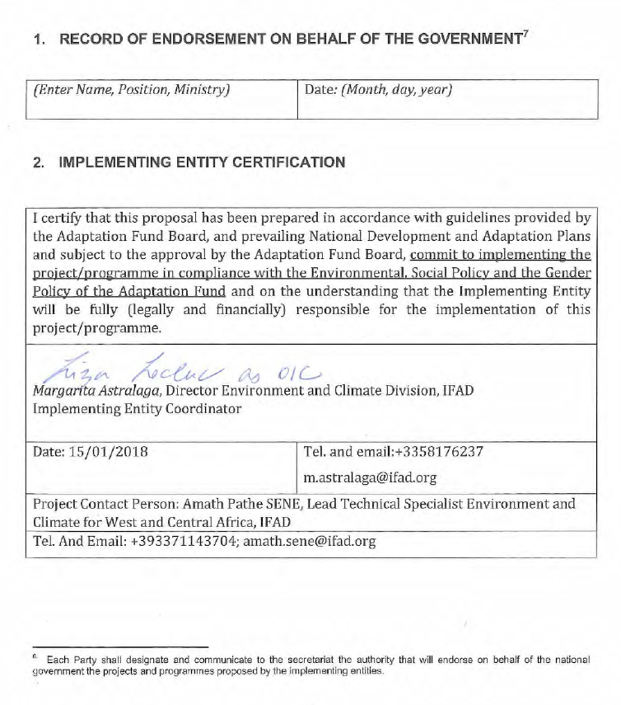

ANNEXES

Annex 1 List of Participants

Name | Position | Organization | Location | Contact
Mohamed M. Gbassa | National Trainer and Manager | Hagdi, Service Provider | Kenema | +232 76650915  gbassa56@gmail.com
Mohamed Alpha Bah | Director  Livestock /Veterinary Services Division | District Agricultural Office  Agricultural Department  MAFFS | Bombali | +232 78354828  medalphabah@gmail.com
Mohamed Sissokor | District Forestry Officer | District Agricultural Office  MAFFS | Bombali | +232 78615220  medisissokor@gmail.com
Joseph Brima | Assistant Representative | FAO | Freetown | +232 79250150  joseph.brima@fao.org
Baindu P. Massaquoi | Programme Specialist | UNWOMEN | Freetown | +232 76602214  baindu.massaquoi@unwomen.org
Marbey Sartie | Programme Specialist | UNWOMEN | Freetown | +232 78822311  marbey.sartie@unwomen.org
Dr A.B. Rashid-Noah | Senior Lecturer | University of Njala  Agricultural Engineering Department |  | +232 77800525  rashidnoah@yahoo.com
Patrick Sawyerr | Lecturer | University of Njala  Soils Department |  | +232 76656398  patrick.sawyerr@gmail.com
Andrew A. Mansomey | Field Extension Worker | MAFFS | Kenema | +232 78406322  herenkaiman@yahoo.com
Beintu T. Keifala | Regional Head Northern Region | Environment Protection Agency |  | +232 076617167  abeintu@yahoo.co.uk
Ibrahim S. Kamara | Director | Meteorological Department | Freetown | sinneh71@gmail.com
Gabriel Eugen Watson Kpaka | Deputy Director | Meteorological Department | Freetown | +23279667742  gabrielkpaka@gmail.com

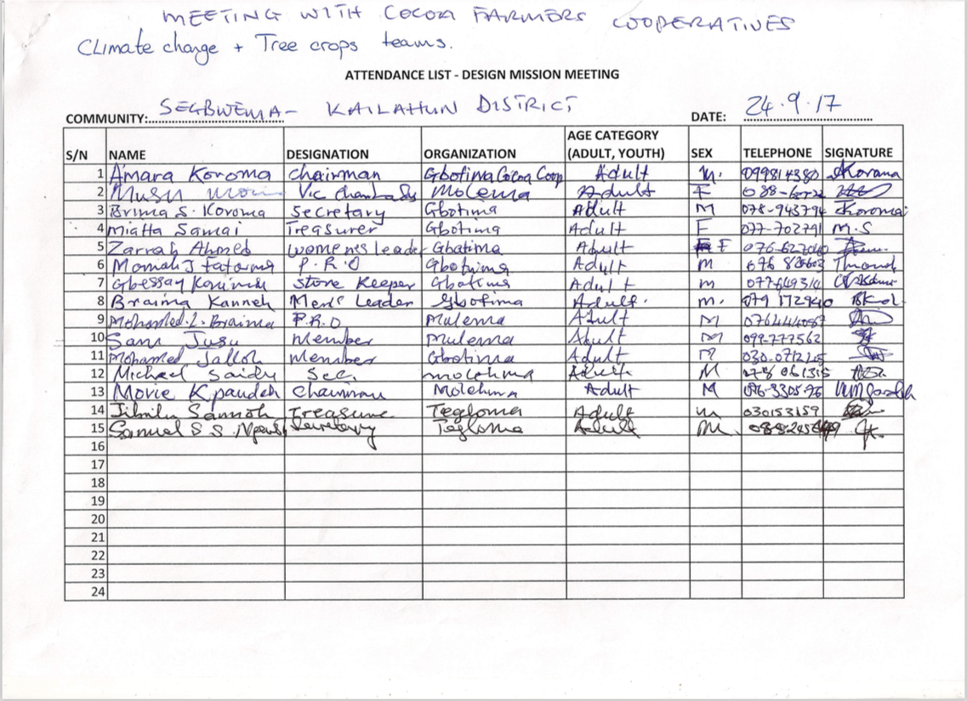
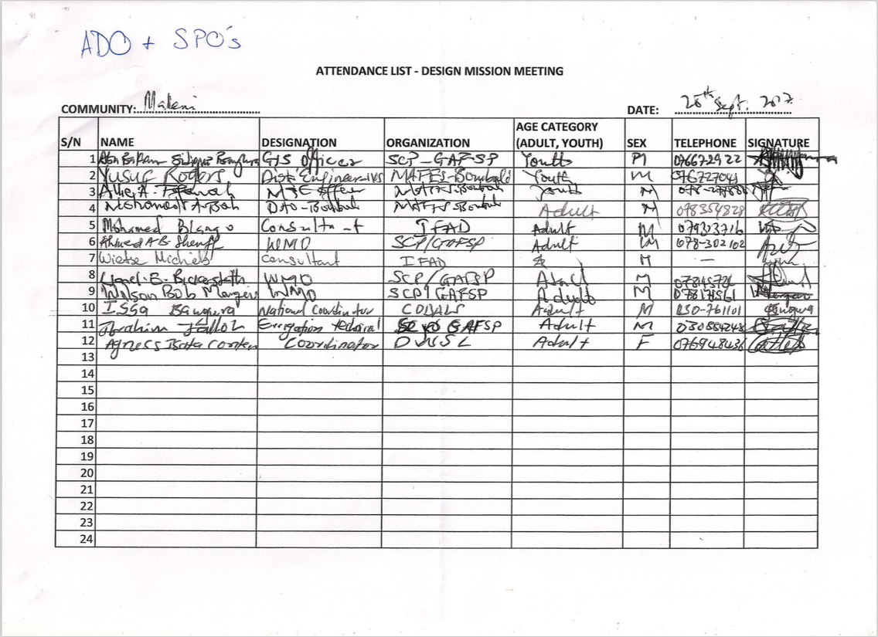
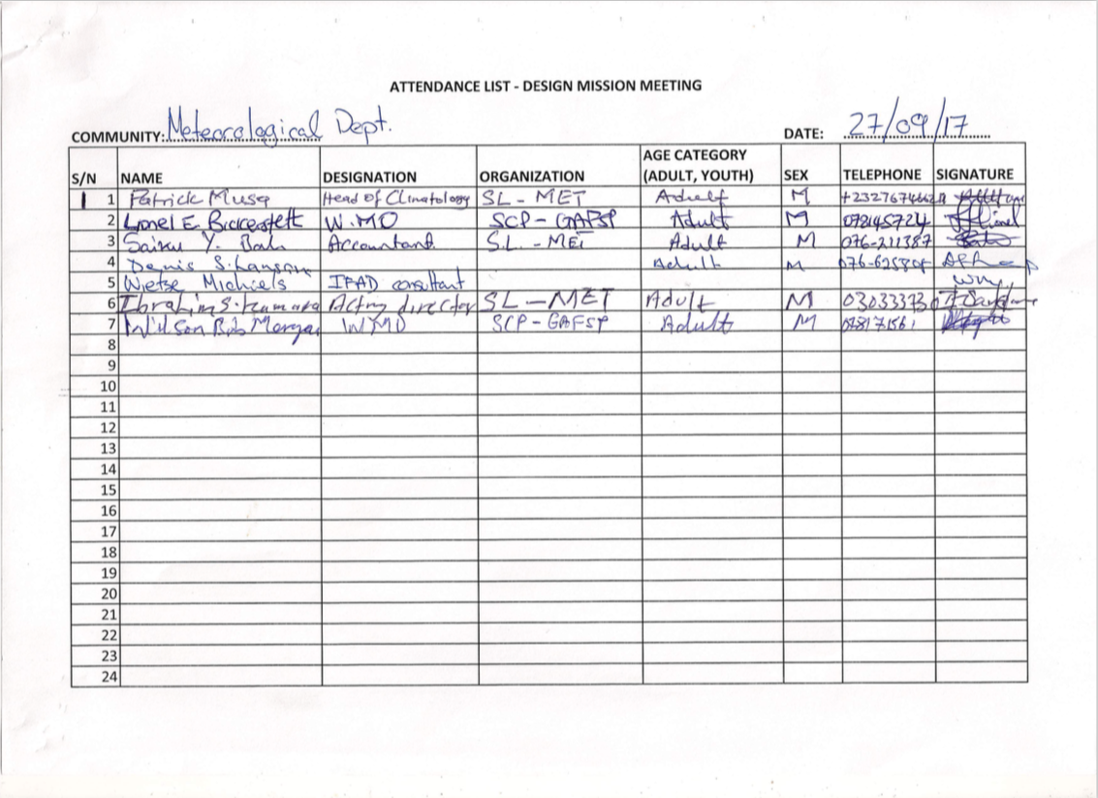
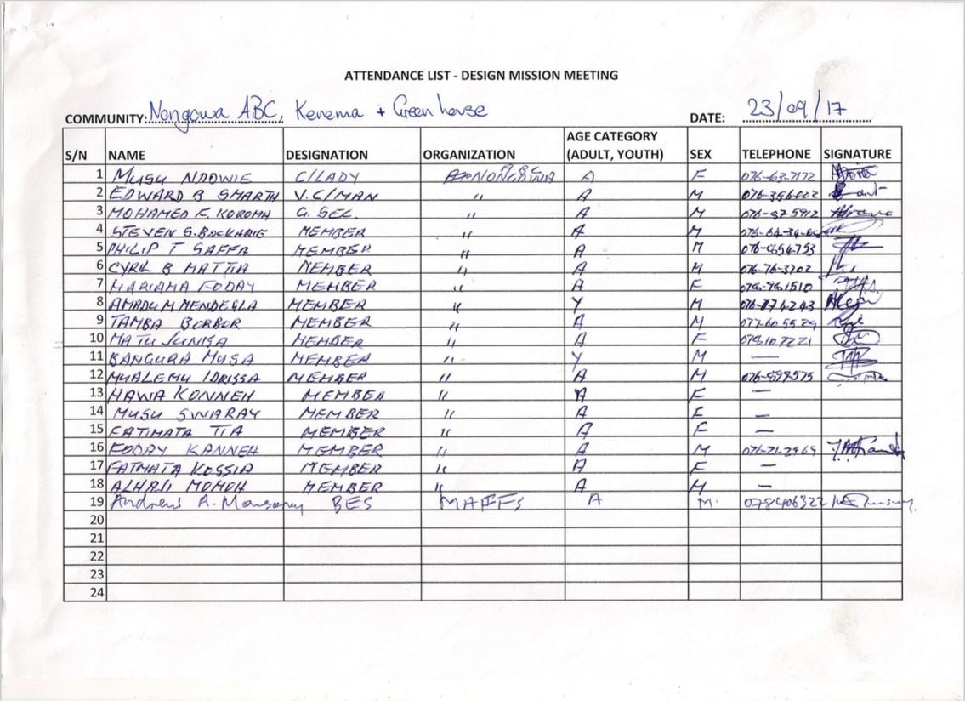

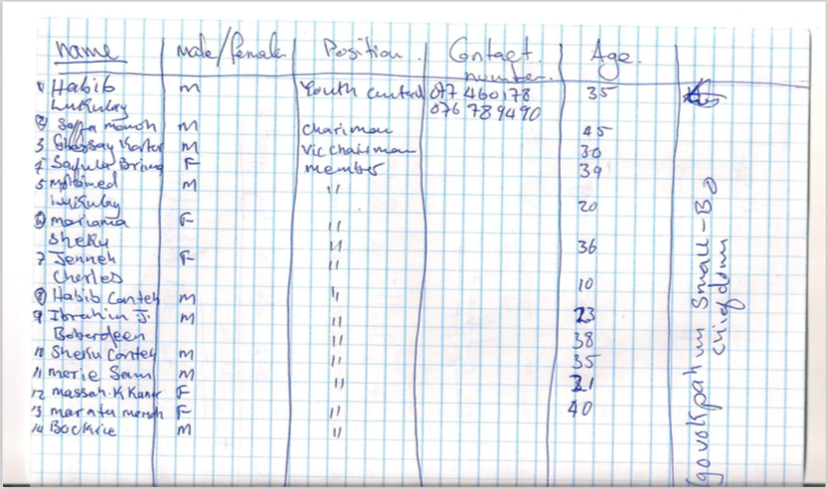

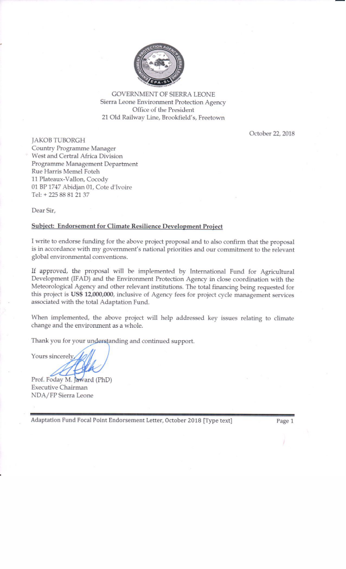

Maplecroft, 2017, Climate Change Vulnerability Index 2017
http://www.fao.org/fishery/countrysector/naso_sierraleone/en
http://www.fao.org/docrep/003/x7156e/x7156e03.htm
Vulnerable households, women and youth.
The AF utilized OECD/DAC terminology for its results framework. Project proponents may use different terminology but the overall principle should still apply
The AF utilized OECD/DAC terminology for its results framework. Project proponents may use different terminology but the overall principle should still apply

