Results tracker guidance document

This document:
- Briefly explains the Adaptation Fund’s results tracker tool that is part of the Project Performance Report (PPR) template;
- Explains how the tracker fits into the Fund’s RBM procedures;
- Clarifies when and how the results tracker needs to be completed;
- Provides practical tips for using the Results tracker;
- Complements rather than replaces the existing M&Erelated guidelines (i.e. results framework and baseline guidance – project level (http://www.adaptationfund.org/wpcontent/ uploads/2015/01/Results%20Framework%20a nd%20Baseline%20Guidance%20final%20compressed.pdf), and core indicator methodologies
(https://www.adaptation-fund.org/wpcontent/uploads/2016/

This document does not:
- Include the results tracker itself – please refer to the latest version of the PPR template: https://www.adaptation-fund.org/page/project-performance-and-reporting.

This guidance document is intended to help implementing entities of the Adaptation Fund (AF) fill the AF’s results tracker, as part of their reporting requirements. The results tracker is a reporting tool included in the Project Performance Report template (currently available at: https://www.adaptation-fund.org/page/project-performance-and-reporting) requested annually by any AF-funded projects/programmes. This guidance document is structured as follow:

- Section 1: Overview of the results tracker;
- Section 2: Context of the results tracker with the Fund’s RBM system;
- Section 3: Structure of the tracker and how to fill the necessary information;
- Section 4: Frequently asked questions about the use of the Excel file.

Section 1: Overview of the Adaptation Fund Results tracker

The Adaptation Fund’s results tracker is a core part of the annual Project Performance Report (PPR) that AF-funded projects/programmes have to submit to the secretariat yearly, for the disbursement of the next tranches of funding.

The results tracker allows the Adaptation Fund to track specific indicators across its portfolio. It includes indicators from both (i) the Adaptation Fund Strategic Results Framework, and (ii) the Fund’s five core indicators.

- The Adaptation Fund Strategic Results Framework includes long-term goal, outcome, outputs, and a small set of indicators for the Fund as a whole. The AF works toward the achievement of the overall goal and outcomes. Consequently, any project or programme funded through the AF must align with the Fund’s results framework and directly contribute to the overall objective and outcomes outlined. The Fund’s strategic results framework guidance document is available online at https://www.adaptation-fund.org/sites/default/files/Results%20Framework%20and%20Baseline%20Guidance%20final%20compressed.pdf. This framework has been slightly amended (see AFB/EFC.24/4/Rev.1 https://www.adaptation-fund.org/wp-content/uploads/2019/03/AFB.EFC_.24.4.Rev1_Review-of-the-Strategic-Results-Framework-and-Fund-Level-Efficiency-Framework.pdf. The latest version of the framework is summarized in Table 1 below.

Table 1 : The Adaptation Fund Strategic Results Framework
Expected results | Indicators
Goal: Assist developing country Parties to the Kyoto Protocol and the Paris Agreement that are particularly vulnerable to the adverse effects of climate change in meeting the costs of concrete adaptation projects and programmes in order to implement climate-resilient measures.

Impact: Increased resiliency at the community, national, and regional levels to climate variability and change.
Outcome 1: Reduced exposure to climate-related hazards and threats | 1. Relevant threat and hazard information generated and disseminated to stakeholders on a timely basis
Output 1.1: Risk and vulnerability assessments conducted and updated | 1.1. No. of projects/programmes that conduct and update risk and vulnerability assessments (by sector and scale)
 | 1.2 No. of early warning systems (by scale) and no. of beneficiaries covered
Output 1.2: Targeted population groups covered by adequate risk reduction systems | 1.2.1. Percentage of target population covered by adequate risk-reduction systems
Outcome 2: Strengthened institutional capacity to reduce risks associated with climate-induced socioeconomic and environmental losses | 2.1. Capacity of staff to respond to, and mitigate impacts of, climate-related events from targeted institutions increased
Output 2.1: Strengthened capacity of national and sub-national centers and networks to respond rapidly to extreme weather events | 2.1.1. No. of staff trained to respond to, and mitigate impacts of, climate-related events (by gender)
 | 2.1.2 No. of targeted institutions with increased capacity to minimize exposure to climate variability risks (by type, sector and scale)
Output 2.2: Increased readiness and capacity of national and sub-national entities to directly access and program adaptation finance | 2.2.1 No. of targeted institutions benefitting from the direct access and enhanced direct access modality
Outcome 3: Strengthened awareness and ownership of adaptation and climate risk reduction processes at local level | 3.1. Percentage of targeted population aware of predicted adverse impacts of climate change, and of appropriate responses
 | 3.2. Percentage of targeted population applying appropriate adaptation responses
Output 3.1: Targeted population groups participating in adaptation and risk reduction awareness activities | 3.1.1 No. of news outlets in the local press and media that have covered the topic
Output 3.2: Strengthened capacity of national and subnational stakeholders and entities to capture and disseminate knowledge and learning | 3.2.1 No. of technical committees/associations formed to ensure transfer of knowledge
 | 3.2.2 No. of tools and guidelines developed (thematic, sectoral, institutional) and shared with relevant stakeholders
Outcome 4: Increased adaptive capacity within relevant development sector services and infrastructure assets | 4.1. Responsiveness of development sector services to evolving needs from changing and variable climate
 | 4.2. Physical infrastructure improved to withstand climate change and variability-induced stress
Output 4: Vulnerable development sector services and infrastructure assets strengthened in response to climate change impacts, including variability | 4.1.1. No. and type of development sector services modified to respond to new conditions resulting from climate variability and change (by sector and scale)
 | 4.1.2. No. of physical assets strengthened or constructed to withstand conditions resulting from climate variability and change (by sector and scale)
Outcome 5: Increased ecosystem resilience in response to climate change and variability-induced stress | 5. Ecosystem services and natural resource assets maintained or improved under climate change and variability-induced stress
Output 5: Vulnerable ecosystem services and natural resource assets strengthened in response to climate change impacts, including variability | 5.1. No. of natural resource assets created, maintained or improved to withstand conditions resulting from climate variability and change (by type and scale)
Outcome 6: Diversified and strengthened livelihoods and sources of income for vulnerable people in targeted areas | 6.1 Percentage of households and communities having more secure access to livelihood assets
 | 6.2. Percentage of targeted population with sustained climate-resilient alternative livelihoods
Output 6: Targeted individual and community livelihood strategies strengthened in relation to climate change impacts, including variability | 6.1.1.No. and type of adaptation assets (tangible and intangible) created or strengthened in support of individual or community livelihood strategies
 | 6.2.1. Type of income sources for households generated under climate change scenario
Outcome 7: Improved policies and regulations that promote and enforce resilience measures | 7. Climate change priorities are integrated into national development strategy
Output 7: Improved integration of climate-resilience strategies into country development plans | 7.1. No. of policies introduced or adjusted to address climate change risks (by sector)
 | 7.2. No. of targeted development strategies with incorporated climate change priorities enforced
Outcome 8: Support the development and diffusion of innovative adaptation practices, tools and technologies | 8. Innovative adaptation practices are rolled out, scaled up, encouraged and/or accelerated at regional, national and/or subnational level.
Output 8: Viable innovations are rolled out, scaled up, encouraged and/or accelerated. | 8.1. No. of innovative adaptation practices, tools and technologies accelerated, scaled-up and/or replicated
 | 8.2. No. of key findings on effective, efficient adaptation practices, products and technologies generated

- The AF five core indicators allow the Fund to aggregate quantitative indicators for a portfolio that is, by nature, diverse (spanning from agriculture to water management, coastal management, rural development, food security, and Disaster Risk Reduction, among others). To increase transparency and demonstrate value for money, the Board has approved two impact-level results and five associated indicators to track under these impacts. These five indicators, summarized in Table 2 below, and their associated methodologies are available publicly at: (https://www.adaptation-fund.org/sites/default/files/AF%20Core%20Indicator%20Methodologies.pdf).

Table 2 : AF Core Indicators
Impact-level results | Core indicators
Increased adaptive capacity of communities to respond to the impacts of climate change | Number of beneficiaries (direct and indirect)
 | Number of Early warning systems
 | Assets produced, developed, improved, or strengthened
 | Increased income, or avoided decrease in income
Increased ecosystem resilience in response to climate change-induced stresses | Natural habitats protected or rehabilitated

The current results tracker is based on the Fund Strategic Results Framework and to the five core indicators. It is an integral part of the Project Performance Report Excel template. This tracker includes most of the indicators from the strategic results framework and the five core indicators, with certain exceptions, as the approved “core” indicators already capture indicators in the strategic results framework. In fact:
- Indicators 1.2 and 1.2.1 from the Strategic Results Framework are captured under the core indicator 1.2 included in the tracker;
- Indicators 4.2 and 4.1.2 from the Strategic Results Framework are captured under the core indicator 4.2 included in the tracker;
- Indicator 5.1 from the Strategic Results Framework is captured under the core indicator 5.1 included in the tracker;
- Indicator 6.2.1 from the Strategic Results Framework is captured under the core indicator 6.1.2 included in the tracker.

The list of indicators that are included in the results tracker are summarized in table 3.

Table 3 : List of Indicators Included in the Results Tracker
Indicators from the results tracker
Core Indicator: No. of beneficiaries
Indicator 1: Relevant threat and hazard information generated and disseminated to stakeholders on a timely basis
Indicator 1.1: No. of projects/programmes that conduct and update risk and vulnerability assessments
Core Indicator 1.2: No. of Early Warning Systems
Indicator 2: Capacity of staff to respond to, and mitigate impacts of, climate-related events from targeted institutions increased
Indicator 2.1.1: No. of staff trained to respond to, and mitigate impacts of, climate-related events
Indicator 2.1.2: No. of targeted institutions with increased capacity to minimize exposure to climate variability risks
Indicator 2.2.1: No. of people benefitting from the direct access and enhanced direct access modality
Indicator 3.1: Increase in application of appropriate adaptation responses
Indicator 3.1.1: Percentage in targeted population awareness of predicted adverse impacts of climate change, and of appropriate responses
Indicator 3.2.1: No. of technical committees/associations formed to ensure transfer of knowledge
Indicator 3.2.2: No. of tools and guidelines developed (thematic, sectoral, institutional) and shared with relevant stakeholders
Indicator 4.1: Increased responsiveness of development sector services to evolving needs from changing and variable climate
Core Indicator 4.2: Assets produced, developed, improved or strengthened
Indicator 4.1.1: No. and type of development sector services to respond to new conditions resulting from climate variability and change
Indicator 5: Ecosystem services and natural resource assets maintained or improved under climate change and variability-induced stress
Core Indicator 5.1: Natural Assets protected or rehabilitated
Indicator 6.1: Increase in households and communities having more secure access to livelihood assets
Indicator 6.2: Increase in targeted population's sustained climate-resilient alternative livelihoods
Indicator 6.1.1: No. and type of adaptation assets created or strengthened in support of individual or community livelihood strategies
Core Indicator 6.1.2: Increased income, or avoided decrease in income
Indicator 7: Climate change priorities are integrated into national development strategy
Indicator 7.1: No. of policies introduced or adjusted to address climate change risks
Indicator 7.2: No. of targeted development strategies with incorporated climate change priorities enforced
Indicator 8: Innovative adaptation practices are rolled out, scaled up, encouraged and/or accelerated at regional, national and/or subnational level
Indicator 8.1: No. of innovative adaptation practices, tools and technologies accelerated, scaled-up and/or replicated
Indicator 8.2: No. of key findings on effective, efficient adaptation practices, products and technologies generated.

Section 2: How does the results tracker fit into the RBM procedures of the AF?

The results tracker is an integral part of the Project Performance Reports (PPR) that AF-funded projects/programmes have to submit annually to the AF Secretariat, for the disbursement of the next tranches of funding. The results tracker fits within a broader series of reporting requirements that projects have to comply with, as per the Fund’s Results Based Management and Monitoring and Evaluation policies. These requirements are summarized in the Figure 1 below, and can be synthesized as follow:

- Step 1: During project/programme design, project-level results framework should reflect outputs/outcomes included in the AF Strategic Results Framework. In particular, project/programme proponents should:
  - Fill the table “Alignment of Project Objectives/Outcomes with Adaptation Fund Results Framework“(available at https://www.adaptation-fund.org/page/results-framework-alignment-table), and submit it to the Board as part of the project/programme proposal. Not every project/programme outcome will align directly with the Fund’s framework but at least one outcome and output indicator from the Framework must be included at the project design stage. In addition, project specific indicators would also be selected to reflect country specific objectives and reporting requirements.
  - Provide indicative target figures for each of the five core indicators that are relevant to the particular project.

- Step 2: Once the project/programme is approved and the first funds allocated, proponents should monitor projects continually, and:
  - Submit a PPR each year to chart progress. The PPR includes, among others, information related to financial data, procurement, risk assessment, rating, project indicators, lessons learned. In addition, it includes the results tracker that needs to be filled:
    - at inception: baseline-related information needs to be informed, as well as planned targets at project/programme completion;
    - at mid-term;
    - at project/programme completion.
  - For projects over three years in duration, perform a mid-term evaluation

- Step 3: At project/programme completion, each project/programme should provide:
  - final PPR;
  - project completion summary;
  - final evaluation report;
  - final audited financial statements.

These different requirements are summarized in the Figure 1 below. The requirements vis-à-vis the results tracker are underlined in this figure.

Figure 1 : AF M&E Procedures

Section 3: How to Complete the Results Tracker?
The Excel spreadsheet is composed of three different sections (see figure 2 below):

Figure 2 : Overall Structure of the Results Tracker
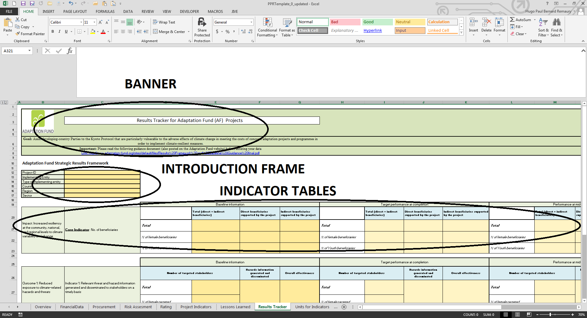

It is made of the following three sub-sections:
- A large green banner (see figure 3 below) that include basics instructions about the tracker, and gives a link to the appropriate guidance document (see screenshot below);

Figure 3: The Results Tracker Banner
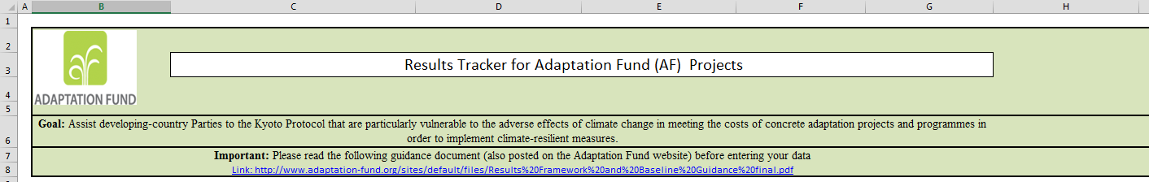
- A green and orange introduction frame (see figure 4 below) that requires project/programme-related information, namely project ID, implementing entity, type of Implementing entity, country, region, sector;

Figure 4: The Introduction Frame

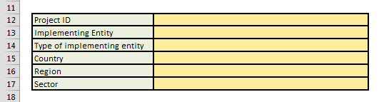
- A series of green and orange indicator tables (see figure 5) that include the different indicators listed in table 3, Section 1 of this document. Columns B and C list the indicators, whereas columns D to G request baseline-related information (to be filled at project/programme inception), H to K request target at completion (to be filled at project/programme inception), L to O request performance at mid-term, and P to S request performance at completion.

Figure 5: The indicators Tables
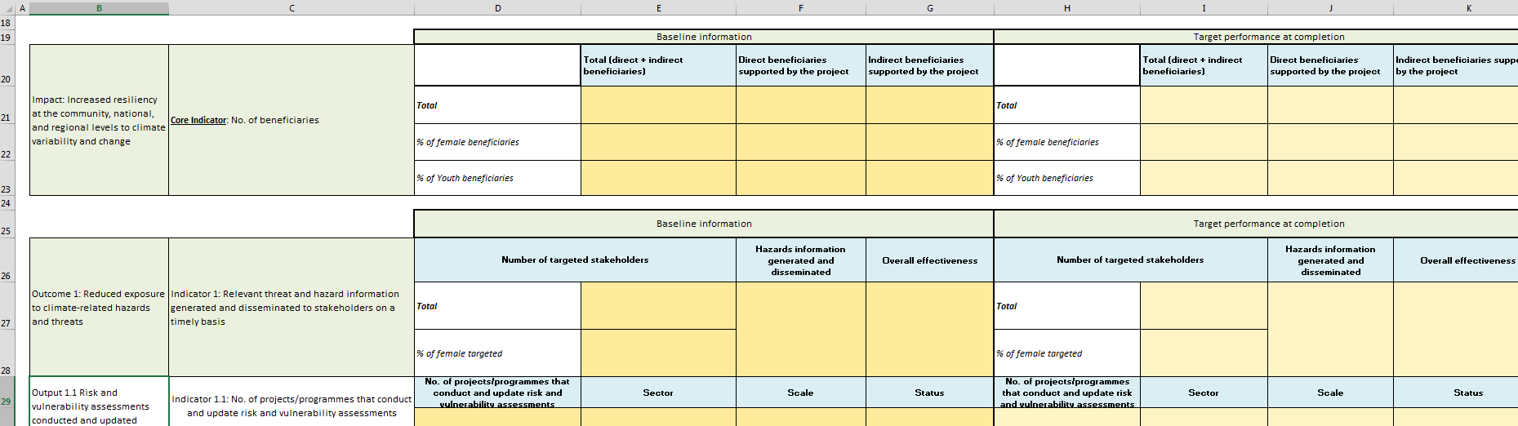

Orange fields should be filled out by the Implementing Entities. They may include drop-down lists, normal cells where qualitative/quantitative information can be entered, and cells where “data validation” is in place (and in which values can be restricted to a range of numbers, a percentage, or a specific quantitative measure for instance). When hovering and clicking on orange cells, some input messages may guide the user to what action is expected from him/her.

Section 4: Frequently Asked Questions

General questions about the tracker

Where can I find the Results Tracker?
The results tracker is part of the Project Performance Report Excel spreadsheet that is available on the AF website at: https://www.adaptation-fund.org/page/project-performance-and-reporting

When are users expected to fill the Results Tracker tab of the Project Performance Reports?
Projects and programmes are required to fill in the results tracker three times: at project approval, midterm, and terminal evaluation (see figure 1, section 2).

What sections need to be filled in the results tracker?
Depending on the stage of the project/programme (i.e., inception phase, mid-term, completion), cells filled with orange color are expected to be filled by users. Core indicators (underlined and bold) are mandatory, when relevant and applicable to the project/programme. In addition, other indicators reported to align with the projects outcomes need to be filled as well.

Introduction frame

How do I know my project ID/type of Implementing Entity (IE) and sector?
A project ID (“AF project ID” below) has been assigned by the AF Secretariat to your project/programme during the proposal review cycle. Please refer to the technical review document to get this information. 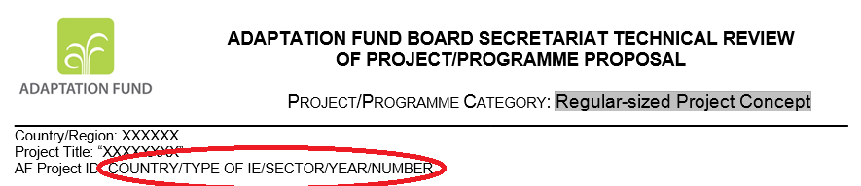

What are the different types of Implementing Entity?
The Implementing Entity can be classified as Regional Implementing Entity (RIE), National Implementing Entity (NIE), or Multilateral Implementing Entity (MIE).

Indicators tables

How do I know what type of information I am supposed to enter into the cells?
For most of the cells, a message will let you know what sort of data is expected from you (i.e. percentage, number, item in a drop-down list etc.).

I want to enter additional information in the cells, what should I do?
For certain cells, when applicable, users can enter different items. For instance, in the case of the Core Indicator 1.2. No of Early Warning System (EWS), some projects/programmes may be implementing different types of EWS. In that case, please click on the “plus” sign on the left-hand side of the table such as illustrated below on the screenshot:
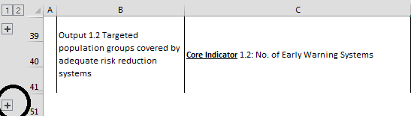

Additional lines will appear (see screenshot below). This will allow you entering additional information about other EWS (or other indicators that allow multiple lines of information).
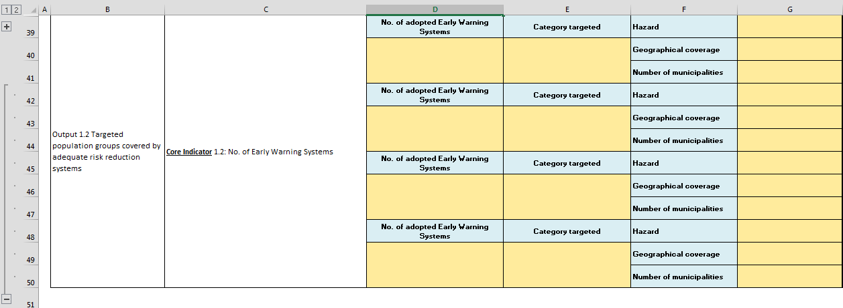

Please note that you can also collapse these lines if you wish by clicking the “minus” sign, as illustrated in the screenshot below:
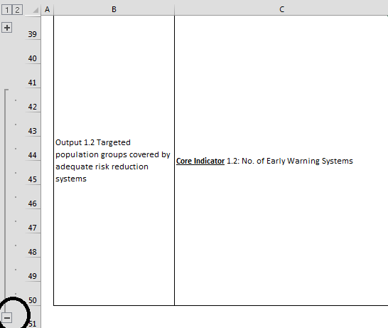

Troubleshooting

I encounter the following message: “The value you entered in not valid. A user has restricted values that can be entered into this cell”. What should I do?
Most of the cells have been configured to allow only specific data to be entered (i.e. from a drop-down list, percentage, number within a specific range etc.). Make sure that the data you entered comply with these requirements.

This is to reflect COP 24 CMA Decision that the “Adaptation Fund shall serve the Paris Agreement under the guidance of, and be accountable to, the Conference of the Parties serving as the meeting of the Parties to the Paris Agreement with respect to all matters relating to the Paris Agreement effective 1 January 2019.”

