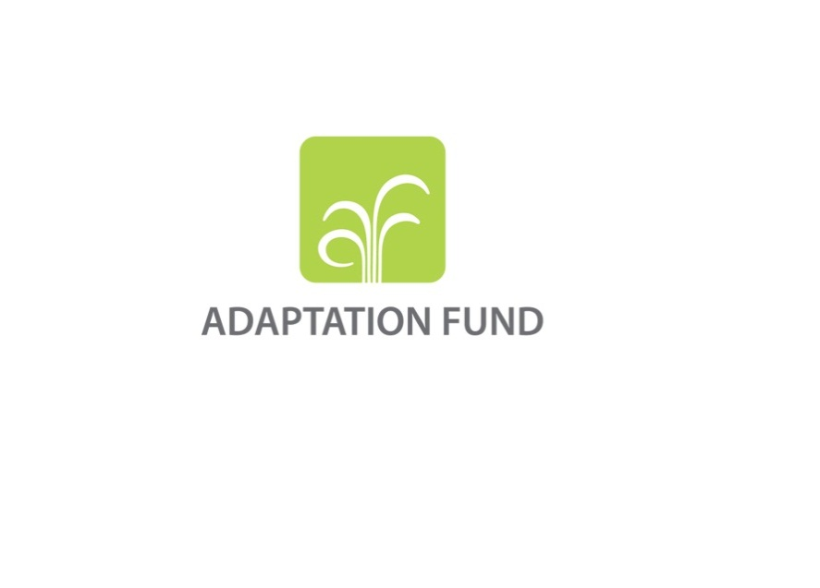

**APPLICATION FOR A GRANT TO FACILITATE LEARNING AND KNOWLEDGE SHARING**

The application template should be completed and transmitted to the Adaptation Fund Board Secretariat by email or fax.

The overall goal of learning grants is to help encourage a culture of learning across institutions and help build the capacities of national implementing entities (NIEs).

Please type in the responses using the template provided. The instructions in the annex to the template provide guidance to filling out the template.

Complete documentation should be sent to:

The Adaptation Fund Board Secretariat

1818 H Street NW

MSN N7-700

Washington, D.C., 20433

U.S.A

Fax: +1 (202) 522-3240/5

Email: afbsec@adaptation-fund.org

1. **PROJECT INFORMATION**

Date of receipt:

Adaptation Fund Grant ID:

Country/ies:

National Implementing Entity:

Amount of Financing Requested (in U.S Dollars Equivalent):

**B.** **Timeframe of Activity**

|  |  |
| --- | --- |
| Expected start date |  |
| Completion date |  |

**C. Proposed learning activities**

**C1. Describe the** **purpose of the learning grant (Maximum 100 words)**

**C2.** Using the table below, describe the activities to be undertaken to share knowledge with other NIEs or the wider climate adaptation community or to develop knowledge/guidelines through partnerships (Maximum 100 words for each activity)

|  |  |  |  |  |  |  |
| --- | --- | --- | --- | --- | --- | --- |
| Proposed Learning Activities | Description of activities (please provide short description) | Expected output of the activities | Country/Institution to share/transfer knowledge with/to or to develop guidelines for, including NIE(s) | Requested budget (USD)* | Tentative timeline (Completion date) | |
|  |  |  |  |  |  | |
|  |  |  |  |  |  | |
|  |  |  |  |  |  | |
|  |  |  |  |  |  | |
| Total project costs |  |  |  |  |  | |
| Implementing entity management fee requested**\*\*** |  |  |  |  |  | |
| **Total Grant Requested (USD)** | | | | | |  |

*Please also provide a detailed budget with budget notes, indicating the break-down of costs at the output level. Where an Implementing Entity (IE) management fee has been requested, the budget must include a budget with budget notes of the IE management fee

**The Implementing Entity Management Fee requested should be at or below 8.5 per cent of the total project/programme budget before the fee.

**E. Implementing Entity**

This request has been prepared in accordance with the Adaptation Fund Board’s procedures

|  |  |  |  |  |  |
| --- | --- | --- | --- | --- | --- |
| Head of Implementing Entity | Signature | Date (Month, day, year) | Implementing Entity Contact Person | Telephone | Email Address |
|  |  |  |  |  |  |
|  |  |  |  |  |  |

1. **Record of endorsement on behalf of the government**

Provide the name and position of the government official, Designated Authority (DA) of the Adaptation Fund, and indicate date of endorsement. The DA endorsement letter must be attached as an annex to the request.

|  |  |
| --- | --- |
| *(Enter Name, Position, Ministry)* | Date*: (Month, day, year)* |

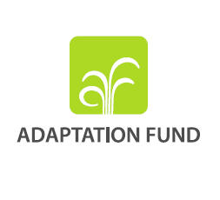

**Letter of Endorsement by Government**

[Government Letter Head]

[Date of Endorsement Letter]

To: The Adaptation Fund Board

c/o Adaptation Fund Board Secretariat

Email: afbsec@adaptation-fund.org

Fax: 202 522 3240/5

Subject: Endorsement for Learning Grant

In my capacity as designated authority for the Adaptation Fund in [country], I confirm that the above project proposal is in accordance with the government’s national priorities in implementing adaptation activities to reduce adverse impacts of, and risks, posed by climate change in (select country).

Accordingly, I am pleased to endorse the above Learning Grant proposal with support from the Adaptation Fund. If approved, the project will be implemented by [national implementing entity].

Sincerely,

[Name of Designated Government Official]

[Position/Title in Government]