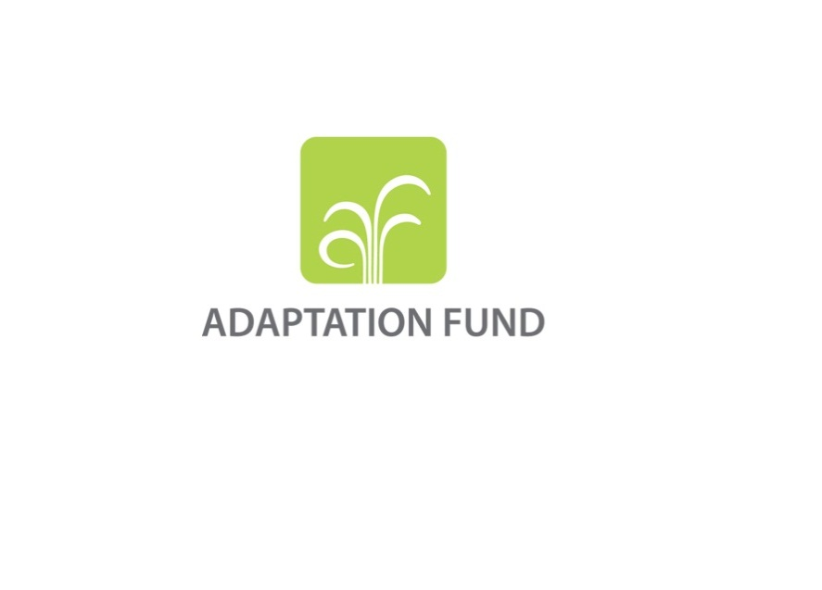

**INSTRUCTIONS FOR PREPARING A REQUEST**

**FOR LEARNING GRANT FUNDING**

**FROM THE ADAPTATION FUND**

The objective of the Learning Grants is to transfer knowledge from one NIE to another, transfer knowledge from NIEs to the wider climate finance adaptation community or to develop knowledge and guidelines through partnerships.

Learning grant proposals must be clear on the expected output from use of the grant, the goal for learning and the rationale for the proposed learning activities.

**Part A: Project Information**

**DATE OF RECEIPT.** Please leave this space blank. The Adaptation Fund Board Secretariat (the Secretariat) will fill in the date on which the proposal is received at the Secretariat.

**Adaptation Fund GRANT ID.** Please leave this space blank. The Secretariat will assign a number to your project internally.

**Country.** Please insert the name of the country requesting the grant.

**NATIONAL Implementing Entity.** Please specify the name of the National Implementing Entity

**Amount of Financing Requested.** Please fill the grant amount (in US Dollars equivalent) requested from the Adaptation Fund for this proposal.

**Part B: Timeframe of Activity**

Project start and completion dates help with monitoring of progress towards the target. Enter the expected project start date and completion dates in month and year format (DD/MM/YYYY). For learning grants, the date of first disbursement by the National Implementing Entity towards an activity related to the grant is considered the start date of the project.

**Part C: PROPOSED LEARNING ACTIVITIES**

**c1: PURPOSE of the LEARNING GRANT.** In 100 words or less, briefly explain the main objective of the learning grant. The project should be able to provide a clear description of the benefits of the proposed learning activities to the most vulnerable communities.

**c2: LEARNING GRANT ACTIVITY BREAKDOWN.** Using the provided table, provide a breakdown of activities. The table should present a logic flow of activities that will be implemented.

**Include a detailed budget with budget notes, a budget on the Implementing Entity management fee use.**

The proposal should include a detailed budget with budget notes indicating the break-down of costs at the activity level. In accordance with the Gender Policy of the Fund, the proposal should ensure that adequate resources are allocated in the project/programme budget for gender-responsive implementation. Examples of gender responsive budgets include provision for the involvement and capacity-building of women stakeholders as important actors in implementation.

Where an Implementing Entity management fee has been requested, the budget must include a simple budget breakdown of the Implementing Entity management fee.

The Implementing Entity Management Fee requested should be at or below 8.5 per cent of the total project/programme budget before the fee.

The total grant requested should not exceed US$150,000 per project/programme.As per the features and implementation arrangements for learning grants outlined in document AFB/B.32/9 approved by the Adaptation Fund Board through decision B.32/38, national implementing entities may request learning grants up to a maximum of US$ 150,000 per project/programme. The grants do not count against the country cap.

**PART E: Implementing Entity Certification.**

Provide the name and signature of the National Implementing Entity Coordinator and the date of signature. Provide also the project contact person’s name, telephone number.

**PART F: LETTER OF ENDORSEMENT**

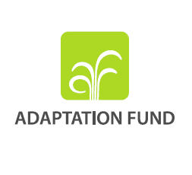

**Letter of Endorsement by Government**

[Government Letter Head]

[Date of Endorsement Letter]

To: The Adaptation Fund Board

c/o Adaptation Fund Board Secretariat

Email: afbsec@adaptation-fund.org

Fax: 202 522 3240/5

Subject: Endorsement for Learning Grant

In my capacity as designated authority for the Adaptation Fund in [country], I confirm that the above project proposal is in accordance with the government’s national priorities in implementing adaptation activities to reduce adverse impacts of, and risks, posed by climate change in (select country).

Accordingly, I am pleased to endorse the above Learning Grant proposal with support from the Adaptation Fund. If approved, the project will be implemented by [national implementing entity].

Sincerely,

[Name of Designated Government Official]

[Position/Title in Government]