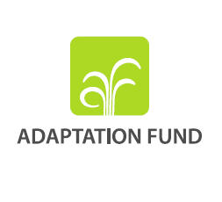

**Letter of Endorsement by Government**

[Government Letter Head]

[Date of Endorsement Letter]

To: The Adaptation Fund Board

c/o Adaptation Fund Board Secretariat

Email: afbsec@adaptation-fund.org

Fax: 202 522 3240/5

Subject: Endorsement for Project Scale-Up Grant for the project/programme [Title of Project/Programme]

In my capacity as designated authority for the Adaptation Fund in [country], I confirm that the above project proposal is in accordance with the government’s national priorities in implementing adaptation activities to reduce adverse impacts of, and risks, posed by climate change in (select country).

Accordingly, I am pleased to endorse the above Project Scale-Up Grant proposal with support from the Adaptation Fund. If approved, the project will be implemented by [implementing entity] and executed by [national or local executing entity].

Sincerely,

[Name of Designated Government Official]

[Position/Title in Government]