**United Nations COP 25 Climate Change Conference, Madrid, Spain**

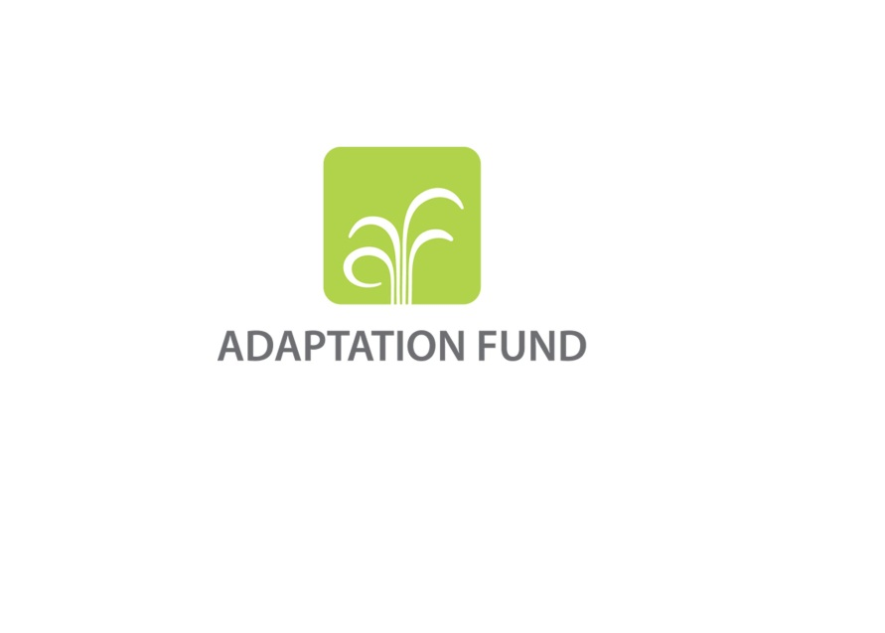

Adaptation Fund Side Event:

*Advancing Gender Equality and Women’s Empowerment in Climate Finance*

Date & Time: Tuesday, 03 Dec. 2019, 13:15-14:45

Venue: GEF/GCF Pavilion

The three climate funds of AF, GEF and GCF have strived to contribute to addressing the challenges posed by climate change while strengthening their gender mainstreaming efforts throughout their operations. All three funds have policies and action plans in place to further their commitments and share the common understanding that attaining the goal of gender equality and women’s empowerment is the key to achieving more effective, sustainable and equitable climate actions outcome and impact.

This is the first UNFCCC COP side event where the AF, the GEF and the GCF (three climate funds) gather together to share their experiences, knowledge, challenges and lessons learned related to gender with a view to uncovering the potentials that the funds have in leveraging and learning from each-other’s strengths and challenges. This session will demonstrate both the progress made and key challenges toward enhancing gender equality and women’s empowerment in the funds’ efforts to address climate change, from policy to planning, and to financing, implementation and monitoring and evaluation.

Expanding beyond acknowledging gender inequalities, this forward-looking session also invites the funds’ implementing partners and stakeholders to speak to their experiences, challenges, and lessons learned from working on advancing gender equality and women’s empowerment and any suggestions or ideas on further support from the climate funds. The session aims not only to broaden understanding on the progress on gender and available support on gender existing within the three climate funds, but also to have interactive session between the speakers and audiences through Q&A sub-session to exchange views and suggestions with speakers to further the goal of gender equality in climate finance.

Agenda

* Moderator: **UNFCCC Secretariat,** Ms. Fleur Newman,*Lead- Gender and Climate Change*
* **Chair of the Adaptation Fund Board**, Ms. Sylviane Bilgischer (Belgium, Annex I Parties), *Opening Remarks*

**Three climate funds’ representatives**

*Representatives of AF and GEF and GCF will briefly introduce the funds’ work on gender and progress*.

* **Green Climate Fund:** Mr. Pa Ousman Jarju,*Director, Division of County Programming*
* **Global Environmental Facility:** Ms. Gabriella Richardson Temm,*Senior Gender Specialist*
* **Adaptation Fund:** Ms. Young Hee Lee*, Gender Focal Point*

**Implementing Partner/Stakeholders of the climate funds**

*The representatives will speak to their experiences, challenges, and lessons learned from working on advancing gender equality and women’s empowerment and any suggestions or ideas on further support from the climate funds*

* **Department of Environment of Antigua & Barbuda** **(National Implementing Entity of AF and GCF**):Ms. Rashauna Adams-Matthew, *Project consultant*
* **Fundecooperación, Costa Rica (National Implementing Entity of AF)**:Ms. Marianella Feoli,*Executive Director*

**Q&A**

*interactive session between the speakers and audiences to exchange views and suggestions with speakers to further the goal of gender equality in climate finance.*