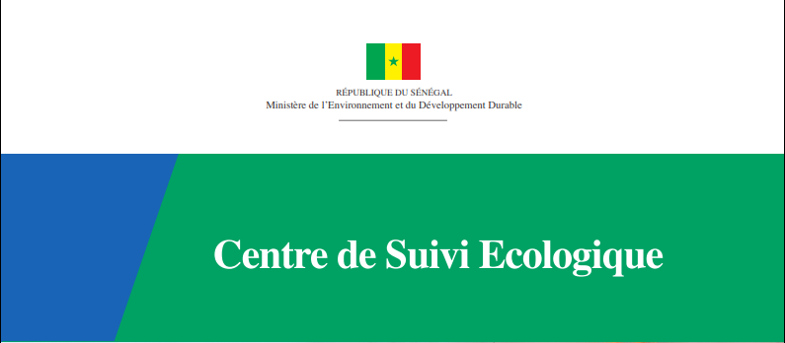

*National Implementing Entity of the Adaptation Fund (AF)*

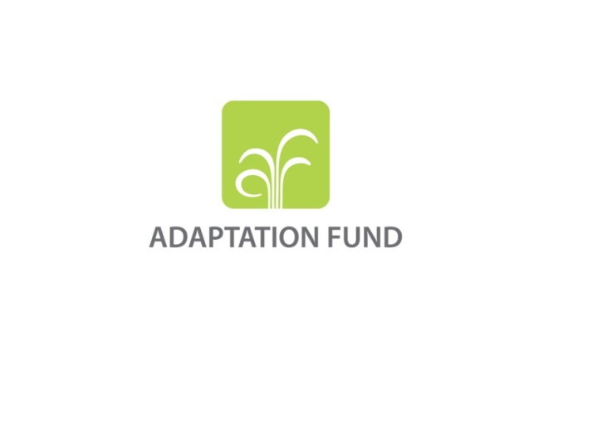

**ADAPTATION FUND 2020 NIE VIRTUAL COUNTRY EXCHANGE VISIT IN SENEGAL**

**Report of session 1**

**Introduction meeting of the 2020 NIE virtual country exchange visit in Senegal**

30 November 2020

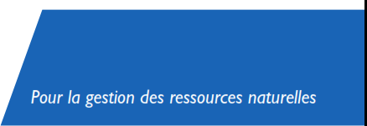

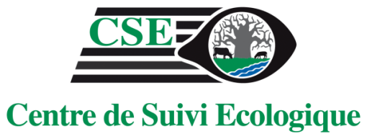

**www.cse.sn**

# Introduction

At its thirtieth meeting, the Adaptation Fund board approved the Fund's medium-term strategy (MTS) by decision B.30 / 42. The medium-term strategy should be implemented within the framework of 3 strategic axes: Action, Innovation and Learning.

The objective of the country exchange visits within the framework of the readiness program is to strengthen the capacity of accredited National Implementing Entities (NIEs) to design, develop and implement projects by facilitating interaction and engagement with project stakeholders, and facilitating the benchmarking of these NIEs for an Adaptation Fund project in a sector or model of interest.

It is in this context that Senegal hosted the second country exchange visit. In the context of the health crisis due to the Covid-19 pandemic, the exchange visit was held virtually in the premises of the Ecological Monitoring Center (CSE) as a webinar.

The objective of this virtual exchange visit was to share Senegal's experience in the fight against coastal erosion and disaster risk reduction.

In order to deal with these two issues as exhaustively as possible, the webinar sessions were subdivided into three days (Please see the Agenda in the appendix). In addition to these live sessions with the various representatives of the national implementing entities which included discussion and question and answer session, a documentary film was produced. This film looked back on Senegal's experience through the CSE in their fight against erosion and the construction of works to rehabilitate the beaches in Saly, and, protect housing and socio-cultural infrastructure in *Rufisque Thiawlène Est* through the Adaptation Fund funded project: Adaptation to coastal erosion in vulnerable areas and a second project titled: Coastal risk monitoring and soft solutions in Benin, Senegal and Togo which was financed by the World Bank with a contribution from France through the French Environment Fund.

# Course of session 1

## Opening speeches

Monday, November 30, 2020 marked the start of the webinar sessions. The webinar started at 12 p.m. GMT for one hour. The purpose of the webinar was presenting the objectives of the virtual exchange visit to the participating NIEs and partners, and presenting the projects which were the subject of case studies.

The opening of the session was made by Ms. SYLLA Aissata B. Sall, Head of the Climate Finance Unit at CSE. She recalled the general objective of the virtual exchange visit and reviewed the activities planned for this first day.

This opening was followed by the address of Dr Assize Touré, Director General of the CSE. He thanked all the participants for their availability, and especially, the Adaptation Fund for the confidence placed in CSE to organize the event. He recalled that the chosen theme was of the greatest consequence to climate change in Senegal and that many resources had been put to use in order to contain this phenomenon.

After the CSE, Mr. Mattias Broman, Vice-Chairman of the Adaptation Fund (AF) Board spoke to thank the CSE for accepting to host this second edition of the exchange visits.

## Presentation of the projects

### After introductory speeches from CSE and the AF, CSE presented the two projects that are the subject of the case study in this virtual discussion visit. Presentation of the first project financed by the AF

Ms. SYLLA Aissata B. Sall presented the project entitled “**Adaptation to coastal erosion in vulnerable areas**” funded by the AF and implemented between 2010 and 2014. During her presentation, she recalled the context of the project, which is that with more than 700km of coast, Senegal faces an overwhelming advance of the sea. The project was implemented by three executing agencies: The Directorate of the Environment and Classified Establishments (DEEC), the NGO Green Senegal and the Association Dynamique Femmes de Joal. The main achievements of the project were:

* the construction of a 730m dike walk in Rufisque (located on the Cape Verde peninsula 25km east of Dakar);
* the construction of breakwaters in Saly (seaside resort located on the Petite Côte south of Dakar);
* the rehabilitation of the Saly-Coulang processing area (in the commune of Saly);
* the construction of an anti-salt dike in Joal (located at the end of the Petite Côte in the south-east of Dakar);
* rehabilitation of the Khelcom processing area in Joal;
* the rehabilitation and protection of the Joal fishing dock;
* the implementation of a training, awareness and communication program in the three municipalities of Rufisque, Joal and Saly;

Ms. Sylla then screened a film showing the achievements made on the different project sites.

|  |  |
| --- | --- |
|  |  |
|  |  |

Photo 1 : Some of the project’s achievements

**Questions & Answers :**

|  |  |
| --- | --- |
| **Questions** | **Answers** |
| Abdoul Razak Baraze (BAGRI Niger): How did the project integrate the gender dimension (participation of women's groups and impacts of the project on local communities) in its activities? | As the integration of the gender dimension is an obligation of the accredited entity, this element was integrated from the formulation of the project. This explains why many activities are dedicated to women transformers. Also, the project in its implementation worked with a women's association which is the association Dynamique Femmes de Joal. This made it possible to monitor the gender-sensitive indicators that have been formulated and ensure that the gender dimension is taken into account throughout the life of the project. |

### Presentation of the project financed by the FFEM and the World Bank (WACA-FFEM)

The second project presented during this virtual exchange visit was the project titled: **« Coastal risk monitoring and soft solutions Benin, Senegal and Togo » f**inanced by the World Bank with a contribution from France through the French Environment Fund, Global (FFEM). This project was presented by Ms. Marième Soda DIALLO, Coordinator of the Environmental Assessment and Disaster Risk Management Program. She recalled the project's objectives, which were to consolidate and perpetuate the coastal observation mechanisms to influence public policies on coastal risks and to initiate a series of pilot activities for the implementation of soft coastal protection solutions. The main achievements of this project are as follows:

* Training of market gardeners on sustainable agriculture in fragile areas;
* Capacity building for managers of the Marine Protected Area of Saint-Louis (located at the mouth of the Senegal River, 264km north of Dakar near the border with Mauritania);
* The construction of 1 linear km of coastline protected by Typhavelles (device for fixing sediments by palisades made with Typha australis) for the rehabilitation of the dune ridge;
* Reforestation of 10 Ha of casuarinas;
* The production of scientific content;
* Development and maintenance of a website with a tab dedicated to soft solutions[1] ;
* Reforestation of Chrysobalanus icaco (about 1 ha) in addition to the breakwaters, to fix the sand in the village of Dionewar (located in the west of the country in Sine-Saloum).

|  |  |
| --- | --- |
|  |  |
|  |  |

Photo 2 : Some of the project’s achievements

**Questions & answers:**

* Intervention by Mr. Emmanuel SECK, ENDA who contributed to the presentation by confirming the positive impacts of the use of soft solutions.

|  |  |
| --- | --- |
| **Questions** | **Answers** |
| M. Emmanuel Seck (ENDA Energie) :  How did the project build on the achievements of other projects to ensure the sustainability of the intervention and confirm the positive impacts of the use of soft solutions? | The WACA-FFEM project built on previous achievements including the first AF project but also the second project funded by the AF in the Dionewar area. This capitalization allows for the sustainability of the interventions and especially their appropriation by the communities. |

# Conclusion

Ms. SYLLA Aissata B. Sall returned to the common points of these two projects implemented by the CSE and reiterated the important role of partners and executing agencies for the success of these projects.

The first session was closed at 13:00 GMT by Dr. Assize TOURE, Director General of the CSE. Dr Touré thanked all the participants and partners who attended this virtual meeting

# Appendix

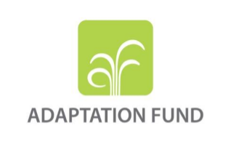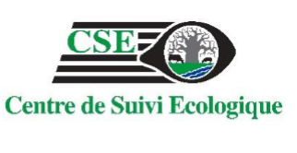

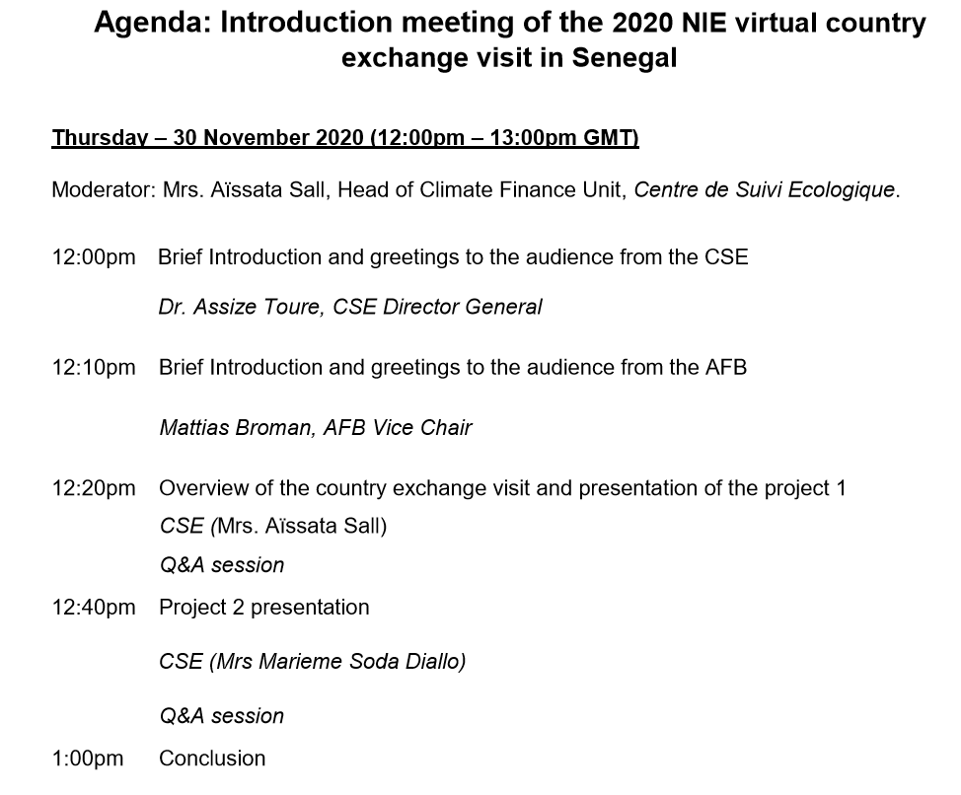

1. <https://www.arcgis.com/apps/MapSeries/index.html?appid=6f504022c36a4f468ec6c780ff586351>