**Funding Proposal Template**

Application Template for Fully-Developed Proposal and Project Concept Proposal[1]

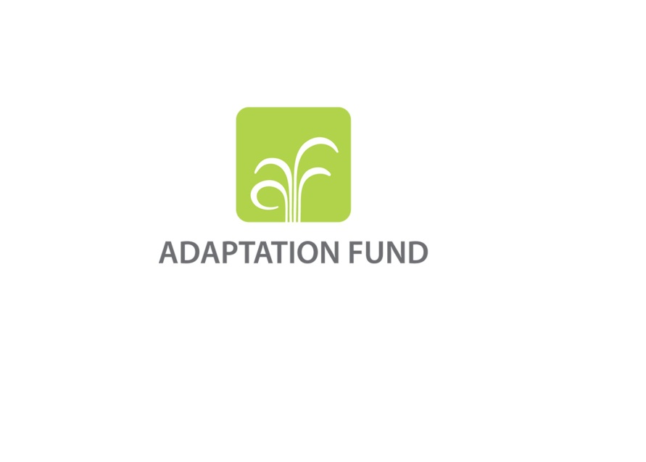

**PROGRAMME ON INNOVATION:**

**LARGE GRANTS PROJECTS**

**REQUEST FOR PROJECT FUNDING FROM THE ADAPTATION FUND**

The annexed form should be completed and transmitted to the Adaptation Fund Board Secretariat by email.

Please type in the responses using the template provided. The instructions attached to the form provide guidance to filling out the template.

Please note that a project must be fully prepared when the request is submitted.

Complete documentation should be sent to:

The Adaptation Fund Board Secretariat

1818 H Street NW

MSN N7-700

Washington, D.C., 20433

U.S.A

Fax: +1 (202) 522-3240/5

Email: afbsec@adaptation-fund.org

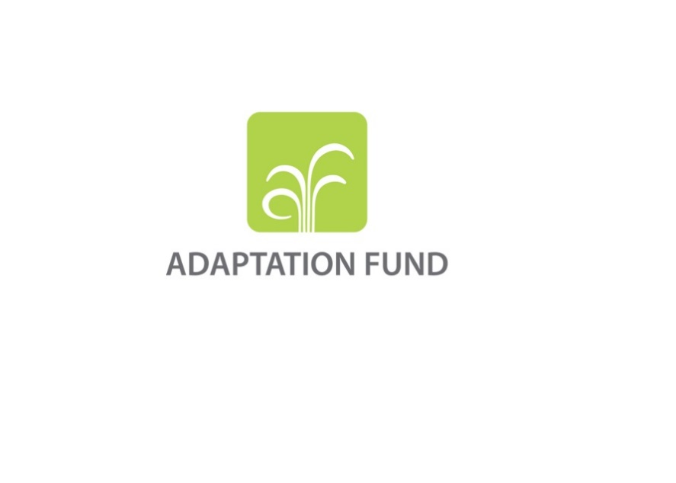

**SINGLE COUNTRY/ REGIONAL INNOVATION PROJECT/PROGRAMME PROPOSAL**

**PART I: PROJECT/PROGRAMME INFORMATION**

Title of Project/Programme:

Country/ Countries:

Thematic Focal Area[2]: Choose an item.

Type of Implementing Entity:

Implementing Entity:

Executing Entities:

Amount of Financing Requested:       (in U.S Dollars Equivalent)

**Project / Programme Background and Context:**

*Provide brief information on the problem the proposed project/programme is aiming to solve,* *including both the regional and the country perspective. Outline the economic social, development and environmental context in which the project would operate in those countries.*

*Describe the problem the proposed project/programme is aiming to solve. Write this as a concise problem statement: The current situation, the desired future, and the gap between the two. Provide brief further information on the current situation including both the regional and the country perspective. Outline the economic social, development and environmental context in which the project would operate in those countries. Describe the climate change vulnerabilities impacting the country/region as well clearly explain the problem area that would be the focus of the innovation.*

**Project / Programme Objectives:**

*List the main objectives of the project/programme.*

**Project / Programme Components and Financing:**

*Fill in the table presenting the relationships among project components, outcomes, outputs,* *and countries in which activities would be executed, and the corresponding budgets.*

*For the case of a programme, individual components are likely to refer to specific sub-sets of stakeholders, regions and/or sectors that can be addressed through a set of well-defined interventions / projects.*

|  |  |  |  |  |  |
| --- | --- | --- | --- | --- | --- |
| **Project/Programme Components** | **Expected Outcomes** | **Expected Outputs** | **Countries** | | **Amount (US$)** |
| 1. |  |  |  | |  |
| 2. |  |  |  | |  |
| 3. |  |  |  | |  |
| 4. |  |  |  | |  |
| 5. |  |  |  | |  |
| 6. Project/Programme Execution cost  7. Total Project/Programme Cost  8. Project/Programme Cycle Management Fee charged by the Implementing Entity (if applicable) | | | | |  |
|  |
|  |
| **Amount of Financing Requested** | | | |  |  |

**Projected Calendar:**

*Indicate the dates of the following milestones for the proposed project/programme*

|  |  |
| --- | --- |
| **Milestones** | **Expected Dates** |
| Start of Project/Programme Implementation |  |
| Mid-term Review (if planned) |  |
| Project/Programme Closing |  |
| Terminal Evaluation |  |

**pART ii: Project / programme JUSTIFICATION**

1. Describe the project / programme components, particularly focusing on the concrete adaptation activities, how these activities would contribute to climate resilience. For regional projects describe also how they would build added value through the regional approach, compared to implementing similar activities in each country individually. For the case of a programme, show how the combination of individual projects would contribute to the overall increase in resilience.

1. Describe how the project /programme would promote new and innovative solutions to climate change adaptation, such as new approaches, technologies, and mechanisms.
2. Describe how the project/programme aims to roll out successful innovative adaptation practices, tools, and technologies and/or describe how the project aims to scale up viable innovative adaptation practices, tools, and technologies.

1. Describe how the project / programme would provide economic, social, and environmental benefits, with particular reference to the most vulnerable communities, and vulnerable groups within communities, including gender considerations. Describe how the project / programme would avoid or mitigate negative impacts, in compliance with the Environmental and Social Policy and Gender Policy of the Adaptation Fund.

1. Describe or provide an analysis of the cost-effectiveness of the proposed project / programme and explain how the regional approach would support cost-effectiveness.

1. Describe how the project / programme is consistent with national or sub-national sustainable development strategies, including, where appropriate, national or sub-national development plans, poverty reduction strategies, national communications, or national adaptation programs of action, or other relevant instruments, where they exist. If applicable, please refer to relevant regional plans and strategies where they exist.

1. Describe how the project / programme meets relevant national technical standards, where applicable, such as standards for environmental assessment, building codes, etc., and complies with the Environmental and Social Policy of the Adaptation Fund.

1. Describe if there is duplication of project / programme with other funding sources, if any.

1. Describe the learning and knowledge management component to capture and disseminate lessons learned.

1. Describe the consultative process, including the list of stakeholders consulted, undertaken during project / programme preparation, with particular reference to vulnerable groups, including gender considerations, in compliance with the Environmental and Social Policy of the Adaptation Fund.

1. Describe how the project/programme draws on multiple perspectives on innovation from e.g., communities that are vulnerable to climate change, research organizations, or other partners in the innovation space, in the context in which the project/programme would take place.
2. Provide justification for funding requested, focusing on the full cost of adaptation reasoning.

1. Describe how the sustainability of the project / programme outcomes has been taken into account when designing the project / programme.

1. Provide an overview of the environmental and social impacts and risks identified as being relevant to the project / programme.

|  |  |  |
| --- | --- | --- |
| **Checklist of environmental and social principles** | **No further assessment required for compliance** | **Potential impacts and risks – further assessment and management required for compliance** |
| *Compliance with the Law* |  |  |
| *Access and Equity* |  |  |
| *Marginalized and Vulnerable Groups* |  |  |
| *Human Rights* |  |  |
| *Gender Equity and Women’s Empowerment* |  |  |
| *Core Labour Rights* |  |  |
| *Indigenous Peoples* |  |  |
| *Involuntary Resettlement* |  |  |
| *Protection of Natural Habitats* |  |  |
| *Conservation of Biological Diversity* |  |  |
| *Climate Change* |  |  |
| *Pollution Prevention and Resource Efficiency* |  |  |
| *Public Health* |  |  |
| *Physical and Cultural Heritage* |  |  |
| *Lands and Soil Conservation* |  |  |

**pART iiI: Implementation arrangements**

1. Describe the arrangements for project / programme management at the regional and national level, including coordination arrangements within countries and among them. Describe how the potential to partner with national institutions, and when possible, national implementing entities (NIEs), has been considered, and included in the management arrangements.

1. Describe the measures for financial and project / programme risk management.

1. Describe the measures for environmental and social risk management, in line with the Environmental and Social Policy of the Adaptation Fund.

1. Describe the monitoring and evaluation arrangements and provide a budgeted M&E plan.

1. Include a results framework for the project / programme proposal, including milestones, targets, and indicators.

1. Demonstrate how the project / programme aligns with the Results Framework of the Adaptation Fund

|  |  |  |  |  |
| --- | --- | --- | --- | --- |
| **Project Objective(s)[3]** | **Project Objective Indicator(s)** | **Fund Outcome** | **Fund Outcome Indicator** | **Grant Amount (USD)** |
|  |  |  |  |  |
|  |  |  |  |  |
|  |  |  |  |  |
| **Project Outcome(s)** | **Project Outcome Indicator(s)** | **Fund Output** | **Fund Output Indicator** | **Grant Amount (USD)** |
|  |  |  |  |  |
|  |  |  |  |  |
|  |  |  |  |  |

1. Include a detailed budget with budget notes, broken down by country as applicable, a budget on the Implementing Entity management fee use, and an explanation and a breakdown of the execution costs.

1. Include a disbursement schedule with time-bound milestones.

**part iV: endorsement by governmentS and certification by the Implementing Entity**

1. **Record of endorsement on behalf of the government[4]** *Provide the name and position of the government official and indicate date of endorsement for each country participating in the proposed project / programme.* *Add more lines as necessary. The endorsement letters should be attached as an annex to the project/programme proposal. Please attach the endorsement letters with this template; add as many participating governments if a regional project/programme:*

|  |  |
| --- | --- |
| *(Enter Name, Position, Ministry)* | Date*: (Month, day, year)* |
| *(Enter Name, Position, Ministry)* | Date*: (Month, day, year)* |
| *(Enter Name, Position, Ministry)* | Date*: (Month, day, year)* |

**B. Implementing Entity certification** *Provide the name and signature of the Implementing Entity Coordinator and the date of signature. Provide also the project/programme contact person’s name, telephone number and email address*

|  |  |
| --- | --- |
| I certify that this proposal has been prepared in accordance with guidelines provided by the Adaptation Fund Board, and prevailing National Development and Adaptation Plans (……list here…..) and subject to the approval by the Adaptation Fund Board, commit to implementing the project/programme in compliance with the Environmental and Social Policy of the Adaptation Fund and on the understanding that the Implementing Entity will be fully (legally and financially) responsible for the implementation of this project/programme. | |
| *Name & Signature*  Implementing Entity Coordinator | |
| Date: *(Month, Day, Year)* | Tel. and email: |
| Project Contact Person: | |
| Tel. And Email: | |

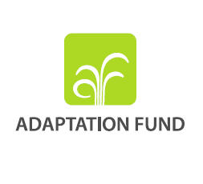

**Letter of Endorsement by Government**

[Government Letter Head]

[Date of Endorsement Letter]

To: The Adaptation Fund Board

c/o Adaptation Fund Board Secretariat

Email: Secretariat@Adaptation-Fund.org

Fax: 202 522 3240/5

Subject: Endorsement for [Title of Project/Programme]

In my capacity as designated authority for the Adaptation Fund in [country], I confirm that the above (select national or regional) project/programme proposal is in accordance with the government’s (select national or regional) priorities in implementing adaptation activities to reduce adverse impacts of, and risks, posed by climate change in the (select country or region).

Accordingly, I am pleased to endorse the above project/programme proposal with support from the Adaptation Fund. If approved, the project/programme will be implemented by [implementing entity] and executed by [national or local executing entity].

Sincerely,

[Name of Designated Government Official]

[Position/Title in Government]

1. Single Country and Regional Concept proposals should complete Part I and Part II of the Project Proposal Template.
2. Thematic areas are: Agriculture, Coastal Zone Management, Disaster risk reduction, Food security, Forests, Human health, Innovative climate finance , Marine and Fisheries, Nature-based solutions and ecosystem based adaptation, Protection and enhancement of cultural heritage, Social innovation, Rural development, Urban adaptation, Water management, Wildfire Management. 
3. The AF utilized OECD/DAC terminology for its results framework. Project proponents may use different terminology but the overall principle should still apply
4. 6. Each Party shall designate and communicate to the secretariat the authority that will endorse on behalf of the national government the projects and programmes proposed by the implementing entities.