**Funding Proposal Template**

Application Template for Pre-Concept Proposal

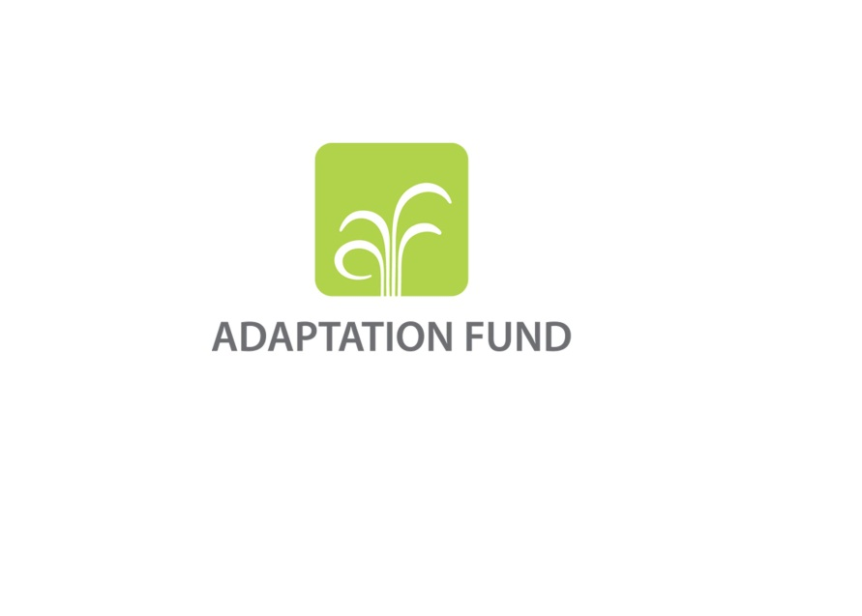

**PROGRAMME ON INNOVATION:**

**LARGE GRANTS PROJECTS**

**REQUEST FOR PROJECT FUNDING FROM THE ADAPTATION FUND**

The annexed form should be completed and transmitted to the Adaptation Fund Board Secretariat by email.

Please type in the responses using the template provided. The instructions attached to the form provide guidance to filling out the template.

Please note that a project must be fully prepared when the request is submitted.

Complete documentation should be sent to:

The Adaptation Fund Board Secretariat

1818 H Street NW

MSN N7-700

Washington, D.C., 20433

U.S.A

Fax: +1 (202) 522-3240/5

Email: afbsec@adaptation-fund.org

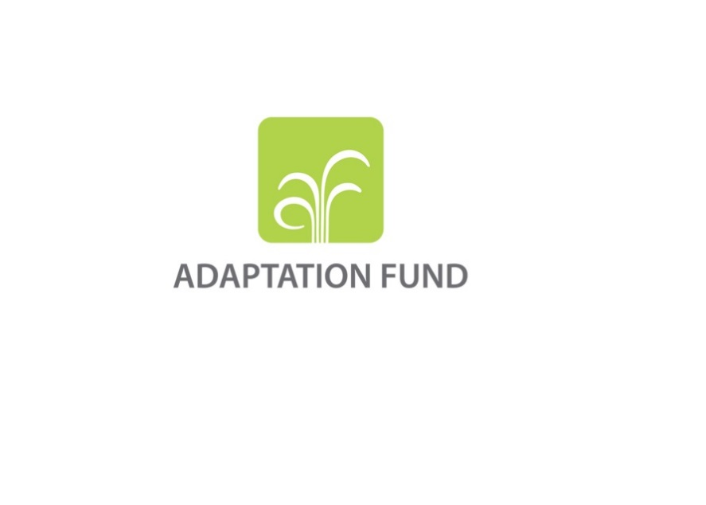

**PRE-CONCEPT FOR A REGIONAL INNOVATION PROJECT/PROGRAMME**

**PART I: PROJECT/PROGRAMME INFORMATION**

Title of Project/Programme:

Countries:

Thematic Focal Area: Choose an item.

Type of Implementing Entity:

Implementing Entity:

Executing Entities:

Amount of Financing Requested:       (in U.S Dollars Equivalent)

**Project / Programme Background and Context:**

*(Provide brief information on the problem the proposed project/programme is aiming to solve, including both the regional and the country perspective.)*

**Project / Programme Objectives:**

*(List the main objectives of the project/programme.)*

**Project / Programme Components and Financing:**

*(Fill in the table presenting the relationships among project components, outcomes, outputs and countries in which activities would be executed, and the corresponding budgets.)*

|  |  |  |  |  |  |
| --- | --- | --- | --- | --- | --- |
| **Project/Programme Components** | **Expected Outcomes** | **Expected Outputs** | **Countries** | | **Amount (US$)** |
| 1. |  |  |  | |  |
| 2. |  |  |  | |  |
| 3. |  |  |  | |  |
| 4. |  |  |  | |  |
| 5. |  |  |  | |  |
| 6. Project/Programme Execution cost  7. Total Project/Programme Cost  8. Project/Programme Cycle Management Fee charged by the Implementing Entity (if applicable) | | | | |  |
|  |
|  |
| **Amount of Financing Requested** | | | |  |  |

**Project Duration:** *(In years and months)*

**pART ii: Project / programme JUSTIFICATION**

*(Provide a brief description of the proposed regional project/programme including, as a minimum[1], the following aspects:*

* *The project / programme components, particularly focusing on the concrete adaptation activities, how these activities would contribute to climate resilience, and how they would build added value through the regional approach, compared to implementing similar activities in each country individually.*
* *How the project would promote new and innovative solutions to climate change adaptation, such as new approaches, technologies and mechanisms.*
* *How does the project/programme aim to roll out successful innovative adaptation practices, tools and technologies and/or how the project aims to scale up viable innovative adaptation practices, tools and technologies.*
* *The cost-effectiveness of the proposed project / programme, explaining how the regional approach would support cost-effectiveness.*
* *How the project / programme would be consistent with national or sub-national sustainable development strategies, including, where appropriate, national or sub-national development plans, poverty reduction strategies, national communications, or national adaptation programs of action, or other relevant instruments, where they exist. If you wish and if applicable, you can also refer to regional plans and strategies where they exist.*
* *The learning and knowledge management component to capture and disseminate lessons learned.*
* *The consultative process, planned to be undertaken during project preparation, with particular reference to vulnerable groups, including gender considerations, in compliance with the Environmental and Social Policy of the Adaptation Fund.*
* *How the sustainability of the project/programme outcomes would be taken into account when designing the project / programme.)*

*(You may also want to provide brief information on the following aspects:*

* *How the project / programme would provide economic, social and environmental benefits, with particular reference to the most vulnerable communities, and vulnerable groups within communities, including gender considerations, and how it would avoid or mitigate negative impacts, in compliance with the Environmental and Social Policy of the Adaptation Fund.*
* *How the project / programme would meet relevant national technical standards, where applicable, such as standards for environmental assessment, building codes, etc., and comply with the Environmental and Social Policy of the Adaptation Fund.*
* *Duplication of project / programme with other funding sources.*
* *Justification for funding requested, focusing on the full cost of adaptation reasoning.*
* *The environmental and social impacts and risks identified as being relevant to the project / programme.)*

**pART iiI: Implementation arrangements**

*(At the pre-concept stage, this section should only briefly explain which organizations would be involved in the proposed regional project/programme at the regional and national/sub-national level, and how coordination would be arranged. The involvement of national institutions, and when possible, national implementing entities (NIEs), partnering in the project should be explained.)*

**part iV: endorsement by governments and certification by the Implementing Entity**

1. **Record of endorsement on behalf of the government[2]** *Provide the name and position of the government official and indicate date of endorsement for each country participating in the proposed project/programme. Add more lines as necessary. The endorsement letters should be attached as annexes to the project/programme proposal.*

|  |  |
| --- | --- |
| *(Enter Name, Position, Ministry)* | Date*: (Month, day, year)* |
| *(Enter Name, Position, Ministry)* | Date*: (Month, day, year)* |
| *(Enter Name, Position, Ministry)* | Date*: (Month, day, year)* |

**B. Implementing Entity certification** *Provide the name and signature of the Implementing Entity Coordinator and the date of signature. Provide also the project/programme contact person’s name, telephone number and email address*

|  |  |
| --- | --- |
| I certify that this proposal has been prepared in accordance with guidelines provided by the Adaptation Fund Board, and prevailing National Development and Adaptation Plans (……list here…..) and subject to the approval by the Adaptation Fund Board, commit to implementing the project/programme in compliance with the Environmental and Social Policy of the Adaptation Fund and on the understanding that the Implementing Entity will be fully (legally and financially) responsible for the implementation of this project/programme. | |
| *Name & Signature*  Implementing Entity Coordinator | |
| Date: *(Month, Day, Year)* | Tel. and email: |
| Project Contact Person: | |
| Tel. And Email: | |

**Letter of Endorsement by Government**

[Government Letter Head]

[Date of Endorsement Letter]

To: The Adaptation Fund Board

c/o Adaptation Fund Board Secretariat

Email: Secretariat@Adaptation-Fund.org

Fax: 202 522 3240/5

Subject: Endorsement for [Title of Project/Programme]

In my capacity as designated authority for the Adaptation Fund in [country], I confirm that the above (select national or regional) project/programme proposal is in accordance with the government’s (select national or regional) priorities in implementing adaptation activities to reduce adverse impacts of, and risks, posed by climate change in the (select country or region).

Accordingly, I am pleased to endorse the above project/programme proposal with support from the Adaptation Fund. If approved, the project/programme will be implemented by [implementing entity] and executed by [national or local executing entity].

Sincerely,

[Name of Designated Government Official]

[Position/Title in Government]

1. Please note that subsequent proposal stages (concept and fully-developed proposal) would require further information on these criteria, as well as additional criteria.
2. Each Party shall designate and communicate to the secretariat the authority that will endorse on behalf of the national government the projects and programmes proposed by the implementing entities.