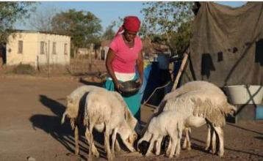
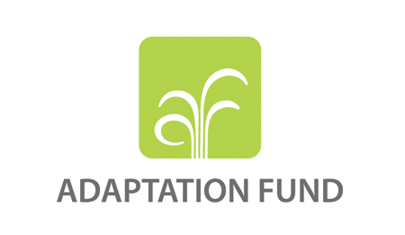

Adaptation Fund Side Event - UNFCCC COP26
Date & time: November 6, 2021, 18:30-19:45
Location: Loch Lomond
Live Webcast
Adaptation Fund: Adapting to Climate Change through Locally-led Action
Objective: the objective of the side event is to raise awareness among stakeholders of the role of local leadership in pursuing effective action on climate change adaptation. The event will include a presentation of findings from a study produced by the Adaptation Fund titled “Local Leadership in Adaptation Finance”, including a discussion on common challenges that local actors have faced in converting the promise of local empowerment into effective action in practice. The session will also include a discussion of concrete examples by the implementing entities representatives related to flow and effects of adaptation finance at community level. The session will also discuss some of the common challenges that local actors have faced in converting the promise of local empowerment into effective action in practice.
AF leaders, country implementers and representatives of the AF NGO network will speak about the importance of local leadership in pursuing effective climate adaptation.
Target audience: Adaptation Fund Designated Authorities, National Implementing Entities’ (NIEs) focal points and prospective NIEs, executing entities, practitioners in climate finance and other stakeholders.

Agenda
18:30-18:35 pm…Opening by Mr. Mahamat Abakar Assouyouti, Sr. Climate Change Specialist, Adaptation Fund Board Secretariat
Welcoming remarks and also will also share some findings from the AF study “Local Leadership in Adaptation Finance” which presents the AF experience in promoting locally-led action on adaptation from 6 Case studies.
18:35-18:40 pm… Mr. Mattias Broman, Adaptation Fund Board Chair
AF’s strategic focus on Action, Innovation and Learning & Sharing, cross-cutting actions that support most vulnerable groups, including youth and the elderly, advance gender equality, build national capacities, and complement other climate funds.
18:40-18:45… Ms. Patience Damptey, Adaptation Fund Board member
Importance of locally-led adaptation action in empowering communities
PRESENTATIONS
18:45-18:52… Mr. Keriako Tobiko, Cabinet Secretary, Ministry of Environment and Forestry, Kenya
Statement from the Cabinet Secretary of Kenya on importance of locally-led action
18:53-19:00 pm …Ms. Marianella Feoli, Executive Director, Fundecooperacion para el Desarrollo Sostenible, Costa Rica
Ms. Feoli will present findings from the AF-funded project in Costa Rica titled “Reducing Vulnerability by focusing on critical sectors in order to reduce the negative impacts of climate change and improve resilience”
19:01-19:08 pm … Mr. Laode M Syarif, Ph.D, Executive Director, The Partnership for Governance Reform (KEMITRAAN)
Mr. Syarif will present findings from the AF-funded project in Indonesia titled, “Community Adaptation for Forest-Food Based Management in Saddang Watershed Ecosystem”
19:09-19:16…Mr. Callist Tindimugaya, Ministry of Water and Environment, Uganda
Mr. Tindimugaya will present findings from the AF-funded project in Uganda titled “Enhancing Resilience of Communities to Climate Change through Catchment-based Integrated Management of Water and related Resources”.
19:17-19:22 pm… Ms. Rashauna Adams-Matthew, Environmental and Social Safeguard Officer, Department of Environment, Ministry of Health, Wellness and the Environment, Antigua & Barbuda
Ms. Adams-Matthew will present findings from the AF-funded project in Antigua & Barbuda titled “An Integrated Approach to Physical Adaptation and Community Resilience in Antigua and Barbuda’s northwest McKinnon Watershed”
19:23- 19:30…Ms. Mariam Devidze, Green Alternative, Georgia, Representative AF NGO network
Role of CSOs in AF projects, locally-led adaptation action; 227-member Network’s role in capturing lessons of effective AF projects, raising awareness and providing localized input.
19:30-19:45 pm…QUESTIONS and ANSWERS

