**Knowledge generation on resilience building solutions in Uttarakhand, India**

**Supported by,**

**International Center for Integrated Mountain Development (ICIMOD)**

**Lalitpur, Nepal**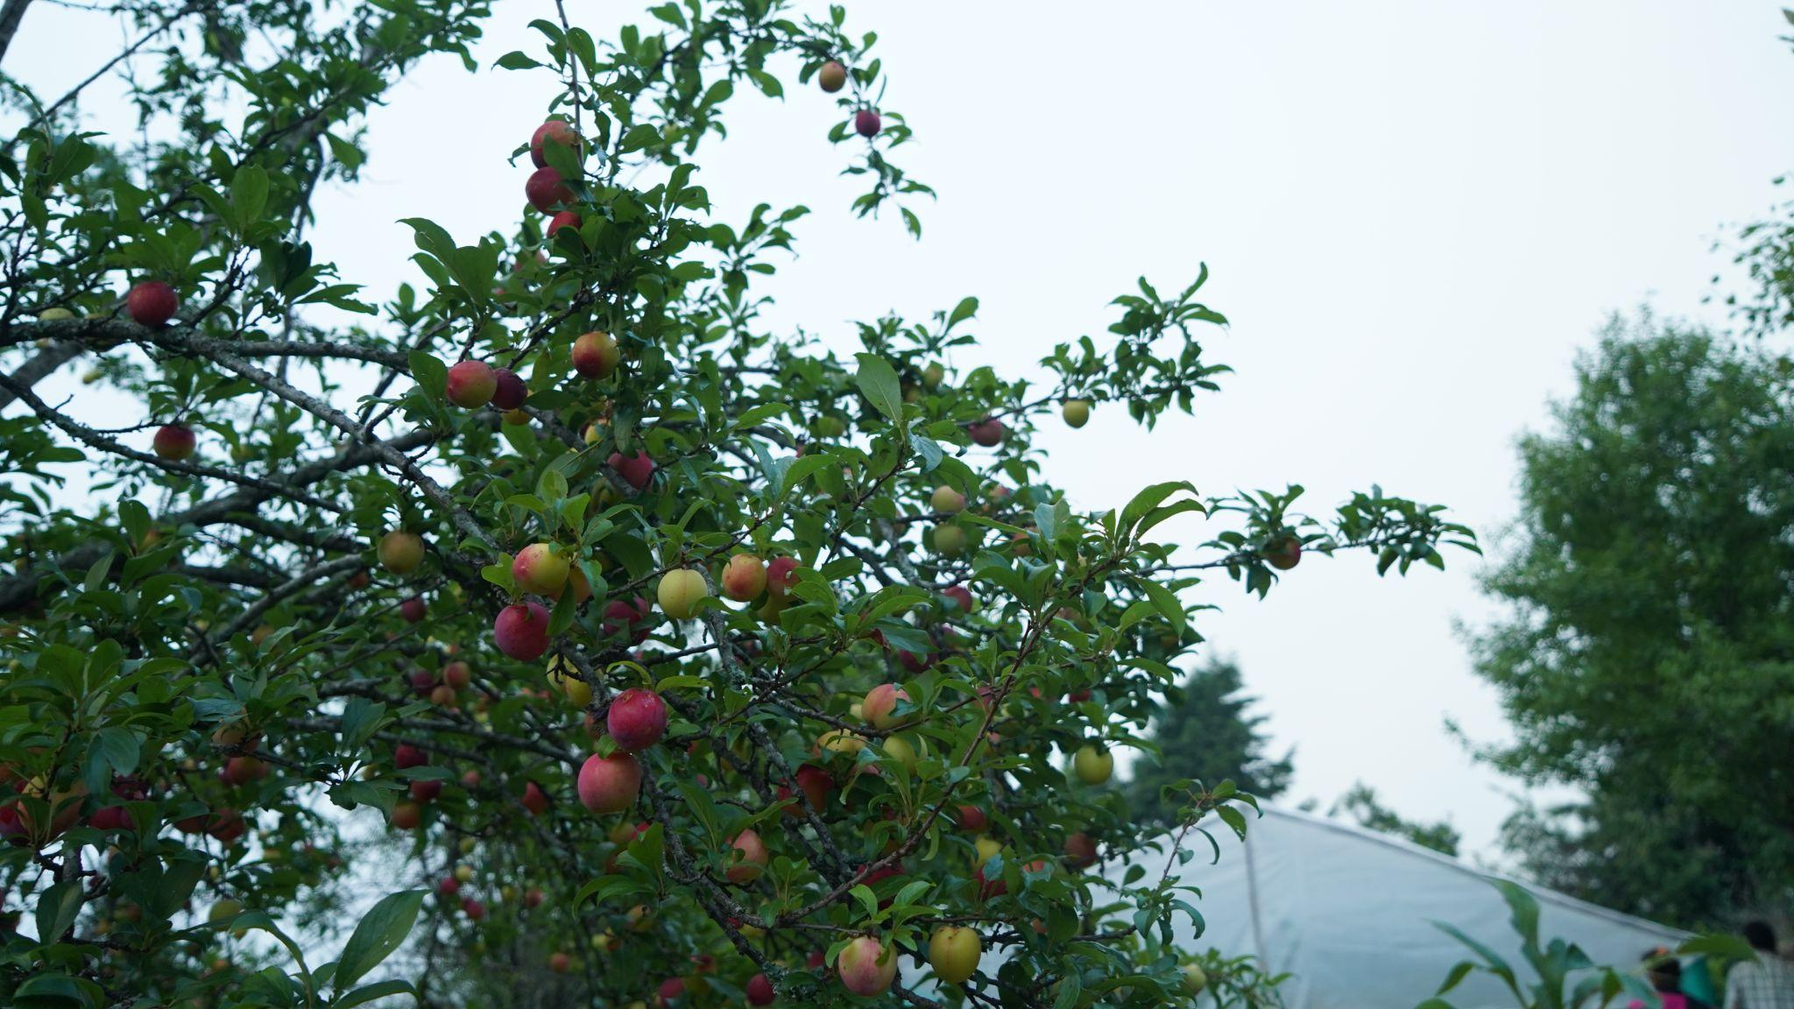

**Implemented by,**

**BAIF Development Research Foundation**

**Dr. Manibhai Desai Nagar, Warje, Pune 411058, India**

**Phone: +91-20-25231661-9 Mobile: +91-9075002912-5**

**E-mail:** [**baif@baif.org.in**](https://mail.google.com/mail/?view=cm&fs=1&to=baif@baif.org.in) **Website:** [**www.baif.org.in**](http://www.baif.org.in/)

1. **Backdrop:**

Climate change is one of the most pressing issues in today’s time. While the whole world is facing the consequences of changing climatic conditions, the hills are the most vulnerable. For instance, the Himalayan regions have recorded the highest temperatures in recent times. Studies by the Ministry of Environment and Forests (MoEF) have shown the change in rainfall pattern, long spells of droughts and increasing temperatures have led to an alarming loss of natural resources. Regular events like flash floods and landslides have hampered the lives of millions living in the Himalayan region.

For the past 5 years, BAIF Development Research Foundation is implementing a Project “Climate-smart actions and strategies in the North Western Himalayan region for sustainable livelihoods of agriculture-dependent hill communities” with support from NABARD and Adaptation Fund Board (an institution constituted by UNFCCC).

Working on a small model focused on 800 vulnerable families of 10 villages spread across the district, the main objective of the project is to introduce region-specific, multi-sectoral, climate-smart interventions and help the communities to adapt to the changing climate and sustain livelihoods

1. **The setting:**

**T**he project is ongoing in a cluster of 10 villages of District Champawat, Uttarakhand, India

A vulnerability assessment has been carried out in the 10 villages of Champavat, Uttarakhand to understand the effect of climate change in the area and how adopted measures can be carried out to minimize the effects. Resource mapping, livelihood activities, various problems faced by villagers due to climate change and what type of efforts need to be taken by communities and BAIF has been studied during this process.

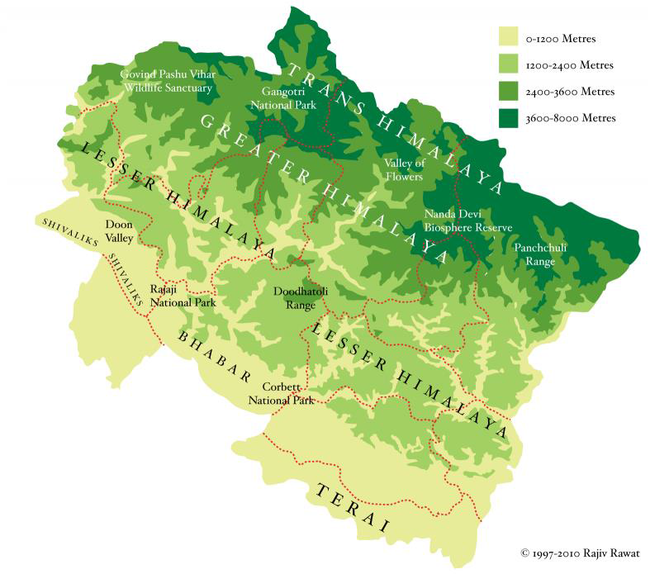

Information was collected on the community’s perceptions of change in climate over the period of years. From the group meetings and detailed interviews, reduced agriculture activities was seen as the most important issue prevalent in the region. Firstly, their crops were damaged by frequent animal attacks. Secondly, water was seen as the most important resource required for agriculture but it was depleting. Champawat is dependent on water from the forest springs which are eroding drastically. Approximately 90 per cent of the land is rainfed and irrigated agriculture lands were very few. Winter precipitation, which is the most important for recharging the water table, is decreasing every passing year. Though the rain days have increased, most of the showers are non-seasonal. These periods of high-intensity rainfall has instead caused flash floods, landslides, and soil erosion. The very obvious change in weather pattern as observed by locals was the erratic winter precipitation. The elders from the community claim that the region witnessed abundant snowfall (at least 3-4 feet) until the early 90s. “In the past 15-20 years, snowfall has drastically reduced. It is almost negligible now. The last time we had an average snowfall was in 2014,” said Shankar Dutt Oli (70), ex Gram Pradhan of Goshni Gram Panchayat. Due to the lack of precipitation in the winter, the dry season has increased. Community members have mentioned frequent instances of dry spells, forest fires, and crop failures. A common finding in all the Gram Panchayats was a significant increase in temperature during summers and a higher frequency of hot days as compared to the weather a decade ago.

The measure problems suggested by local communities are as follows:

1. Communities had suggested that the natural water resources are gradually drying. The effect is most severe on the natural springs. Deforestation is one of the most important reasons behind this effect. Due to the loss of tree cover, there is a high runoff in the area and also a lot of soil errors as there is no support available for surface soil.

2. Due to high runoff and no seepage of water in the hilly area, villagers are facing water scarcity even in the winter seasons. And villages are now depending on the water tankers.

3. Scarcity of irrigation water and irregular rainfall has reduced agricultural production. The productive lands are becoming barren due to water scarcity.

4. The agricultural areas have been affected by increased attacks of wild animals. Wild boars are raiding the farms as their wild habitat is reduced and they get easy food in the farms.

5. Due to rising temperatures, apple trees are not bearing fruits and hence now there are no apple orchards in the region.

6. There is a reduction in the fodder available in the community forest lands and hence the livestock production has been decreasing.

7. Frequency of hazards such as forest fire, hail storms, cloud bursts has increased in the area.

8. Due to reduced income, villagers are now migrating to cities for livelihood options.

9. There is an increase in the drudgery of women.

To reduce the effect and overcome these problems, BAIF has started working with local communities. A project was conceived to focus on the diversification of production systems and improving the institutional capacities to adapt climate-smart technologies and practices in hilly regions. As a strategy, linkages and partnerships are planned to be developed with relevant technical and scientific institutes in the region for required technology backstopping. The collaborative areas include strategic research, technology demonstrations and transfer, applied field-based research, capacity building and improved outreach. The Project also strive to complement ongoing government programs and thereby try to achieve an objective of convergence for effective adaptation.

BAIF has various ongoing activities in the area for the past 5-6 years. The key interventions include , Spring rejuvenation, Bamboo based Polyhouses, cultivation under protected conditions , Rooftop rainwater harvesting, Mini apple tree promotion , Silvi pasture/Fodder development on degraded community pasture lands , Wadi- fruit tree promotion , Solar water lifting , scientific management of Livestock, Agro-biodiversity/ Seed bank promotion, use of Biopesticides and ensuring women centrality in the entire program .

**The Partnership of BAIF and ICIMOD was planned in view of the above context . The scope of partnership included following key areas /actions :**

**Scope of the Assignment**

To Take up two major assignments in Uttarakhand, India within the ICIMOD’s Resilient Mountain Solutions initiative. These assignments are briefly described below-

1. Assess resilience building with an illustrative case study
2. Assess the ecosystem services from a community forest and design a suitable PES mechanism.
3. Establish Knowledge Park to demonstrate simple, affordable and proven resilient mountain solutions and technologies.

**I) ACTIVITY 1 : KNOWLEDGE GENERATION**

**A.** **Assess resilience building with an illustrative case study**

Climate change adaptation and resilience building have been a major focus in developing countries providing opportunities to leverage global finance in designing and implementing project interventions. However, measuring resilience in a complex socio-ecological context is a challenge and had led to inconsistencies although different tools, approaches and frameworks have been proposed for its assessment (Resilience Alliance 2010; ECHO 2014; Levine 2014; CARE 2018; Ospina and Heeks 2016). In this context, to understand adaptive management and resilience of mountain communities as well as the ecosystems in Hindu Kush Himalaya (HKH) region, ICIMOD is adopting a Socio-Ecological System (SES) thinking approach. The SES approach aims to unpack complex interactions and understand nature of feedbacks within a system using context specific topics that resonate to illustrative case studies. The illustrative case studies will be mainly based on common regional issues emerging across the HKH region and thus, help us to identify recurring patterns of SES behavior for generalization.

Further, as SES behavior from each case study is linked to complex processes and feedbacks of the system so, that the most sensitive pathways to external shocks and stresses can be identified for resilience building. The sensitive pathways are termed as resilience markers, and they can provide long term monitoring indicators to capture processes and strengthen the M&E framework, and design the decision support tools for building long term resilience for the policy-makers.

This work was expected to help validation of existing knowledge and generation of new knowledge to improve the effectiveness of resilient solutions

The second work included

**B.** **Assessing forest ecosystem services and design a suitable PES (Payment for Ecosystem Services) mechanism**

As forest ecosystem provides several provisioning, regulating, cultural and supporting services, they need to be quantified and valued by those who are benefitting from utilizing these services. Payment for Ecosystem Service (PES) is one of the instruments increasingly used and recognized as a tool to sustain ecosystem services flow while contributing to local livelihoods of the resource dependent communities. PES aims to conserve ecosystem services, by providing economic incentive to those who contribute to conservation of specific resources, mainly by managing the ecosystem services and encouraging protection and conservation of the ecosystems (Khanal and Poudel, 2012).

A women managed community forest in Uttarakhand is able to restore degraded forest land handed over to them some 10-15 years ago. It is now important to assess the forest ecosystem services and the potential willingness to pay by the downstream communities for the rate of changes in water provisioning services or other services due to the protection and management of the community forest upstream. There are nevertheless, some arguments that purely market based economic incentives may not be applicable in mountain context, and in-kind incentives would be more practical since the buyers of services in the mountain might be cash-poor but, they may offer resources in kind as a proposed payment mechanism (Rai et al. 2016; Bhatta et al. 2017; Patterson et al. 2017). Thus, this assessment will help to design and recommend a suitable PES mechanism that can be operationalized at a local level.

**II) ACTIVITY 2: ESTABLISH KNOWLEDGE PARK** for training, cross learning and sharing on resilient mountain solutions amongst stakeholders and likeminded organizations:

The impacts of climate change on agriculture, forest and water sector have been evident across the world. To cope with the impacts of climate change especially in the mountains, simple and affordable solutions that can be customized depending on a context are required. There are several such solutions which are based on traditional knowledge and backed by scientific evidence but these are not largely replicated or scaled due to several reasons. Knowledge Park is proposed as a common learning platform which demonstrates simple, affordable, and evidence based mountain solutions and technologies at one place, and thus helps in knowledge sharing, learning and wider replication/scaling.

It is proposed as a hub for peer to peer learning involving farmers, villagers, Project implementing entities. This is also proposed as a display of proven technology interventions in Himalayan Context to influence policy makers. All these efforts would help creating a visibility, facilitate cross learning and sharing amongst likeminded organizations and hill communities

**Key Achievements under each action area:**

1. **Achievements under resilience building with an illustrative case study (Resilience Marker Methodology to assess the effectiveness of BAIF Led Interventions )** 
   1. **Introduction:**

A Resilience Marker study design and framework gives an opportunity to researchers to look at the interventions using Systems Perspective. A system’s analysis and understanding is required as solutions that address individual problems as they arise may be successful in the short term, but they may also set into motion feedback and interactions among the different parts of a system that can come into play later. Piecemeal interventions do not prepare a system for dealing with ongoing change and future disruptions. It is agreed that an approach to managing natural resource systems that takes into account social and ecological influences at multiple scales, incorporates continuous change, and acknowledges a level of uncertainty has the potential to increase a system’s resilience to disturbance and its capacity to adapt to change.

In view of this, BAIF led adaptation interventions of various types are seen. Through this Resilience Marker framework , system’s perspective and use of Vensim Model, effort is made to understand the interactions between various resources , understood human, socio- political , economic and ecological forces as acting /influencing each other in the long term

Various interventions, drivers, necessary conditions, and interactions are mapped. Stock and flow diagrams are prepared. Various loops (Reinforcing and balancing have been identified) Based on this data a Model is created. The running model is now expected to provide more insights into the system's functioning and future scope of expansion or curtailment of suggested activities.

The villages of Champawat, Uttarakhand where BAIF is already implementing the livelihood development project area selected for the study. Manar, Narsinghdanda, Khalkandiya, Dingdai, Suyalkhark, Goshani, Bhagana Bhandari, Tyarshun, Banj Gaon and Tapnipal are the villages where the study has been planned. As BAIF staff is working for 5-6 years in these villages, they have good knowledge of the past and current conditions of the area. Based on their experience and after discussing with the ICIMOD team, a few parameters were shortlisted for the resilient marker study. Livestock production, Agricultural production, availability of water, the effect of climatic factors on spring water availability, plantation carried out in the area etc have been considered while planning the resilient markers’ study.

Various model parameters had been considered while designing the model. Water availability, livestock production, agricultural production, and income were the main parameters. The BAIF’s various interventions directly or indirectly affect these parameters. These dependencies have been considered to check the effect of interventions and how they should be planned to achieve maximum results in the area. A CLD has been created (Figure 1).

Data for a few of the parameters such as flow of various springs, Artificial insemination number, Number of polyhouses, crops taken in the playhouse, their approximate production etc have been already collected by the staff. For other datasets, a detailed household-level survey has been carried out. The required data for running the model has been collected from 150 Households of the project area which is available in the [Google sheet](https://docs.google.com/spreadsheets/d/1ntS2rLWB8fGZUbpLvKp8bPMqfC4LfAIp/edit?usp=sharing&ouid=114126305692170634338&rtpof=true&sd=true). This data is analyzed to get some representative variables that will be used for running the Vensim Model.

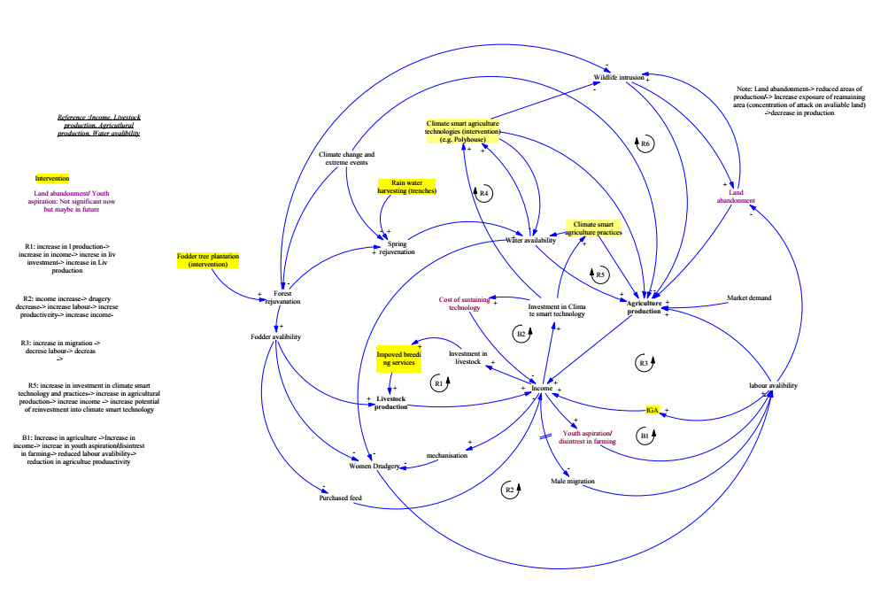**Figure 1: CLD showing the various interventions, drivers, necessary conditions, and interactions considered for the RMS.**

* 1. **Results:**

Few Reinforcing loops have been identified in the CLD as follows:

1. increase in l production-> increase in income-> increase in liv investment-> increase in Liv production
2. income increase-> drugery decrease-> increase labor-> increase productivity-> increase income
3. increase in migration -> decrease labor-> decrease in income ->
4. increase in investment in climate-smart technology and practices-> increase in agricultural production-> increase income -> increase potential of reinvestment into climate-smart technology

Balancing loop has been identified in the CLD as follows:

1. Increase in agriculture ->Increase in income-> increase in youth aspiration/disinterest in farming-> reduced labor availability-> reduction in agriculture productivity

The model will be run for the years 2005,2010,2016,2019 and 2021 for which data has been collected.

The overall analysis suggests that

1. There is an increase in the number of hybrid cattle in the area. The number of houses owning the hybrid female castle has been increased from ~ 37 to ~99% from 2005 to 2021.
2. The total number of hybrid cattle has increased from ~97 to ~355 for the houses from which data has been collected.
3. The number of houses owning the local female cattle has decreased from ~61 to ~3% from 2005 to 2021.
4. The number of houses owning buffalo has decreased from ~12 to ~2% from 2005 to 2021.
5. The survey suggests that local cattle produce 2-3 lit per day while hybrid cattle produce 6-12 lit mil per day.
6. Average milk production has increased from 4 to 9 litres during 2005-2021. Therefore, milk sold per house per day has increased from 2 to 7 lit per day.
7. The average monthly income from milk has increased from 1900 to 14000 during this period.
8. Green fodder is now available for 3 more months compared to 2005 when it was available for only 5 months in a year. The available quantity has almost doubled
9. The average potato production has decreased from ~3000 kg to 88 kgs from 2005 to 2021
10. Tomatoes were not grown in the area before 2005. Now there is the production of 161 kgs tomatoes per house.
11. Malta and Lemon production has increased in the area while production of Mandava, Rajma, Soybean and pear has decreased.
12. From ~15% house people used to migrate for work to the town and cities. Now ~37% of families have members who migrate for work.
13. The average annual income from agriculture has gone up from ~ Rs 8900 to ~Rs 11011 from 2005 to 2021
14. The average annual income from animal husbandry has increased from ~Rs 2000 to ~Rs 17000.
15. Initially (2005) only 5% of households have adopted BAIF’s interventions. However, now 100% of households are taking advantage of BAIF’s activities.
16. Currently, ~78% of households have polyhouses and ~41% of families have rainwater harvesting tanks
    1. **Discussions:**

BAIF has been working in Champawat, Uttarakhand for the last 10+ years. Various activities suitable for the areas will help in combating climate change and help in the sustainable development of natural resources as well as improve the income and livelihood of villagers. Though BAIF’s activities had positive impacts in the region, the type of activities which will have the greatest impacts and the limitation of activities depending on the available resources and climatic factors were not studied. The study will help in estimating, which activity and to what extent should be promoted to get the maximum impact. Though the production of vegetables such as tomatoes and capsicum has gone up, the future growth will depend on the water variability in the area in near future. This will limit the increasing income from the agricultural sector. Similarly, the household income, livestock production, water availability, migration of villagers and labor availability will change depending on the availability of resources, climate change and their interdependence on other factors.

* 1. **Summary & Conclusion**

The resilient marker study is the first of its kind study adopted by BAIF to apply in Champawat, Uttarakhand. Though there is a positive impact on the projects, this study will help in focusing the efforts on key activities depending on their effects and limitations.

1. **The payment for Ecosystem Service (PES):** 
   1. **Introduction:**

BAIF has worked in Lohaghat, Champawat in 10 villages. Due to the water storage and conservation efforts of the villagers, villagers from downstream areas have benefited. To understand whether the downstream communities know about these efforts and whether they will be agreeing to pay monetarily or help in further development in the upstream area in kind, a PES study was planned.

* 1. **Methodology:**

BAIF has carried out development in 3 spring-sheds with the help of local villagers. This has improved the quantity and quality of water available for drinking, irrigation and other purposes. To see whether the downstream communities are ara aware of the work carried out, whether they value the work and ready to contribute to the further development, a payment for Ecosystem Service (PES)study has been carried out. A choice Experiment was carried out to check the requirements of downstream communities and the approximate amount they are willing to pay or willing to work in the upstream areas for further developments. For the choice experiment, the questionnaire had been developed in two formats A and B. The sequence of questions of the choice experiment part was altered. A format was asked to 56 households while B format was asked to 57 households.

The results will be analyzed to decide the contribution of downstream communities in developing their respective spring sheds.

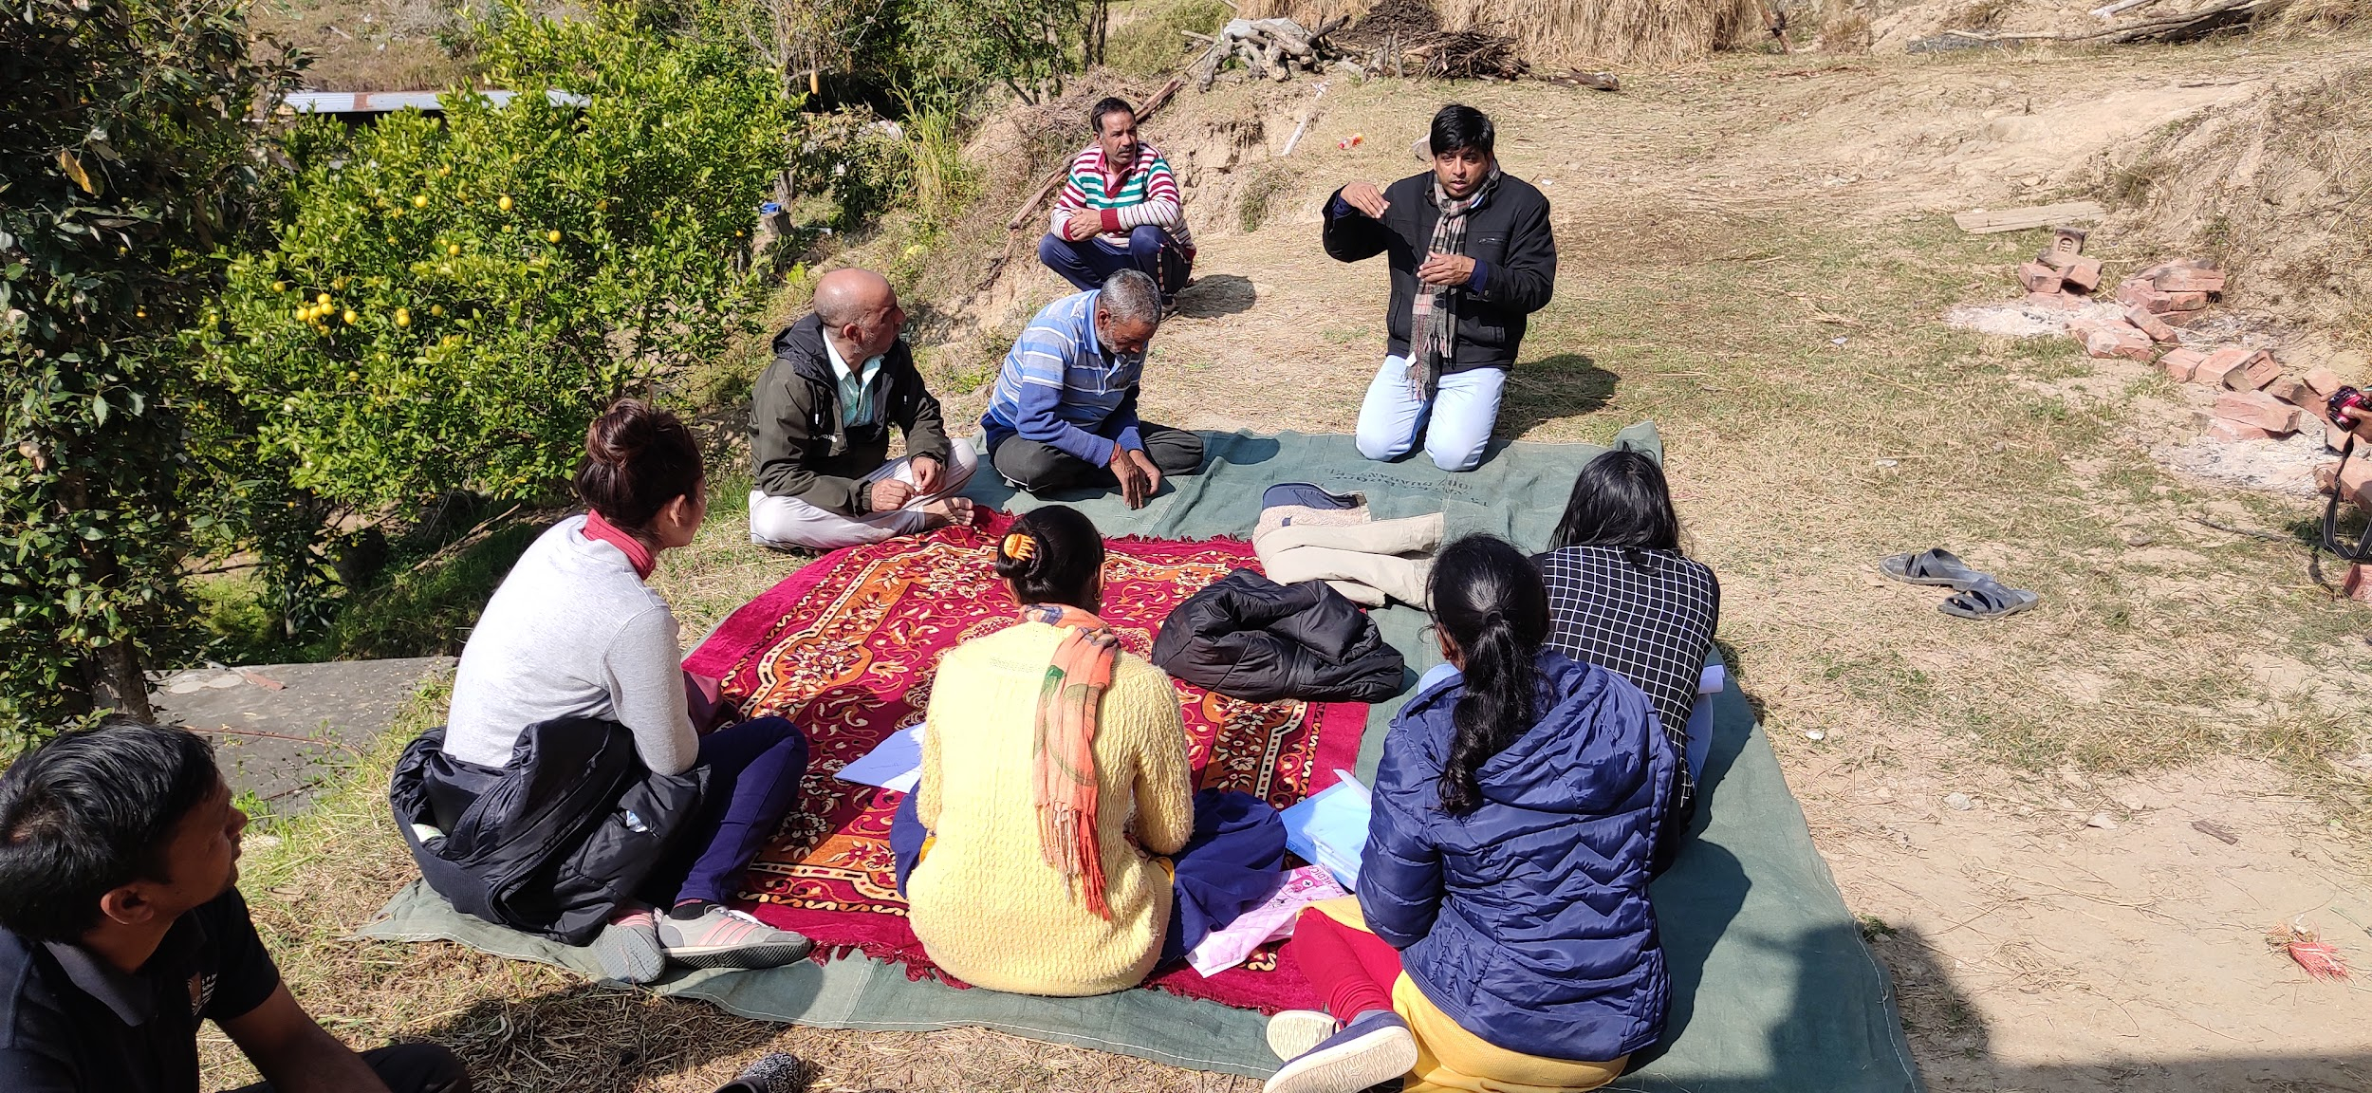

**Field survey carried out to understand perspectives of downstream communities**

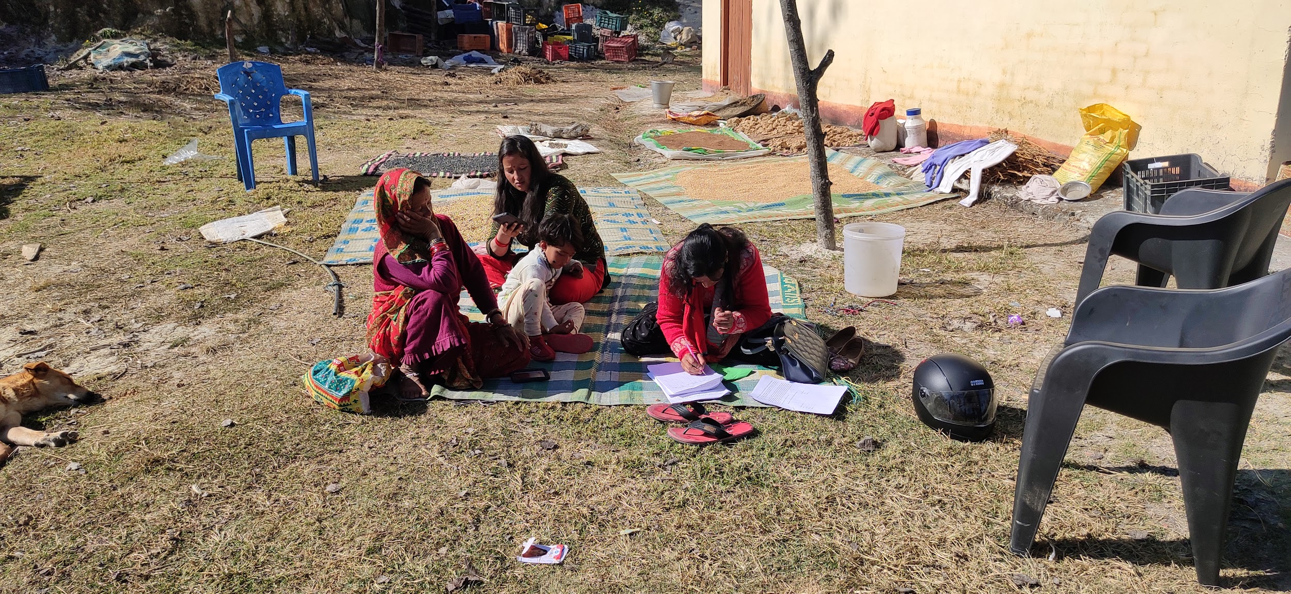

**The families staying downstream of Tyarson Springshed shared their experience regarding water quality and quantity in the past 5 years and their expectations for the future.**

* 1. **Results:**

1. The survey was carried out in 9 villages as follows

Khetikhan 26

Bhagana Bhandari 25

Jankande 18

Sirtoli 13

Dingdwalgaon 10

Kaknoula 10

Salna 8

Dhanmatta 2

Paduva 1

1. There were three watersheds. 53 households were from Manhar, 39 from Saniya and 21 were from Tyarson spring sheds.
2. The detail analysis of collected data is available in the [Google sheet](https://docs.google.com/spreadsheets/d/1PC4Q1GggIq2qt-XZmJZWd0AXSO6PbnRHjC0Tu3XR4yo/edit?usp=sharing). The number represents the %of respondents providing the particular information.
3. The survey suggests that 47 responded suggests that drinking water availability has increased in the last 5 years, 42 suggest that it has decreased while 24 suggest that there is no change.
4. Springshed wise analysis has been carried out to check how the response varies from spring shed to spring shed. In Manhar 45% said that water availability has decreased, 28% suggested that it has increased. While 26% suggested that there is no change in the last 5 years. In the case of Tyarson 48% suggested that water availability has decreased, 48% suggested that it has increased while 4% suggested that there is no change. for Saniya sping shed, 56% suggested that water availability has decreased, 21% suggested that it has increased while 21% suggested that there is no change.
5. In Manhar, 68% responded suggested that the quality of drinking water has improved in the last 5 years. 2 % suggested that it has worsened. While 30 % suggested that there is no change. For Tyrsonm, 48% suggested that the quality of drinking water has improved while 52% suggested that there is no change. In Saniya, 77% suggested that the quality of drinking water has improved in the last 5 years. 5% suggested that it has worsened. While 18 % suggested that there is no change.
6. In Manhar 45% suggested that there is a decrease in irrigation water availability in the last 5 years. 45% suggested that there is no change while 10% suggested that there is increase in the water availability. In Saniaya majority (62% suggested that there is increase in the irrigation water availability in the last 5 years. While in Tyrson majority (48%) suggested that there is no change.
7. In case of forest cover and conditions, the majority (49%) of Mahnar have suggested that there is improvement. In Saniya 87% suggested that there is improvement. While all the rescinded from Tyarson suggested that there is incsea in forest cover.
8. Firewood has increased in all the spingsheds. 47% from Mahnar, 82% from Saniya and 67% from Tyrason suggested that Firewood availability has increased in the last 5 years.

The primary analysis suggests that most of the villagers are ready to pay an additional amount for the improvement in the quantity and quality of available water.

* 1. **Discussions:**

Using the analysis and results of the PES survey, a rough plan will be prepared to implement a pilot project to collect the additional contribution from downstream communities. After discussing with all the stakeholders, the exact amount, the detailed procedure and the plan for using the collected amount will be finalized.

1. **Establishing a Knowledge Park and Technology Display, capturing various resilient mountain technology interventions , climate smart interventions , technologies and services for wider dissemination of best practices :**

Climate change is at present one of the most demanding problems across the world. Champawat district in the Himalayan Hindu Kush region is no different. A region that was known for its large exports of vegetables and was considered to be one of the prominent apple belts, has witnessed acres of land going barren due to the change in weather patterns. In the last 5 years alone, Champawat district region has witnessed over 90% reduction in farming practices due to erratic rainfalls and drastic change in the temperatures. From being one of the largest exporters, this region of Hindu Kush has become the importer of the very vegetables and fruits this area was famous for.The Kumaon side of Uttarakhand is also going through a critical water crisis. The dried up river streams, the prolonged dry spells without monsoon showers result in months of water shortage for even household chores. With extreme water shortages, the farmers are discouraged to continue agriculture. The heavy losses in farming has been felt immensely on the already lean financial state of our marginalized communities.The local communities have witnessed a clear shift in the temperate belt. Crops that were indigenous to this region has perished and given way to new set of crops. With such an alarming shift in agricultural practices and the visible impact on the flora, BAIF have taken up projects to support the communities of the Kumaon Range.

In order to address an issue of growing vulnerability of Hill communities in Himalayan Region , BAIF team( [www.baif.org.in](http://www.baif.org.in)) with financial support from Adaptation Fund Board and NABARD has introduced ,multi sectoral , region specific ,climate smart actions and strategies in the cluster of District Champavat in Uttarakhand in northwestern Himalayan region for sustainable livelihoods of agriculture-dependent hill communities. BAIF team has strenuously worked on various Climate Change Resilient interventions to tackle the immediate livelihood losses the communities were facing. With close to 800 families on board, the interventions introduced by BAIF has been a soaring success story in Uttarakhand. The experiences of coping with climate change by local communities in Champawat region, will prove to be a fore-runner for entire Indian Himalayan Region (IHR).

Under the project, many multi sectoral climate smart interventions, technologies and services

have been introduced in, 10 villages, reaching to up to 800 vulnerable households, among which <number> are woman headed households. The hill climate change adaptation model so introduced includes multi sectoral interventions like –

(a) **Water Resource Development:** Natural Spring Rejuvenation and recharge measures, Rooftop rainwater harvesting, Drip and Sprinklers for water use efficiency, Water

channelization for improved access to water near houses and water lifting using solar

pumps, Protected irrigation and water security for critical stage of crop growth.

(b) **Climate Resilient Farming Practices:** Vegetable Cultivation under protected condition

using low-cost bamboo-based polyhouses, Conservation and revival of Niche, native crops

In Himalayan region, Promotion of Temperate and subtropical fruit species for horticulture plantation, Participatory fodder, feed promotion and silvi-pasture development on degraded community pasture lands known as Vanpanchayats in Uttarakhand

**(c) Scientific management of livestock resource:** Through Improved breeding using cross bred and sorted semen technology, Feed and Nutrition care, Fodder access, Climate Proof Housing for cattle

All these efforts have project has resulted in to several socio- economic and ecological outcomes. This has also helped reducing vulnerability of the communities due to climate change. The key achievements under the project are:

* Project reach out to 800 plus families directly and to additionally 400 families through Indirect benefits.
  + 252 Families have been engaged with gainful employment and sustained income through Polyhouse farming.
  + 136 ha. Area has been developed with Silvi-pasture interventions
  + 120000 trees have been planted in the region under agroforestry and horticulture.
* 10 Village Councils (Van panchayats) restored community pasture lands in an ecologically sound manner
  + 1500 Million litres water capacity created through rejuvenation of 15 natural springs.
  + 650 Families have been associated with crop and weather advisory services.
* 25 Land races or local native crops of indigenous food crops are being conserved by community and local seed bank established . Total 72 landraces of 22 crops from 4 types.
* The average additional income that families involved in polyhouses have earned is up to Rs. 25000 to 35000 in a year, the income ranges from Rs. 25000 to Rs. 1lakhs.

These interventions designed and scientifically implemented under the project have potential to be implemented across the state and the whole of the mountainous region. Various researches are being undertaken on the same Climate Change Resilient Interventions by institutions such as IIT-Bombay,GBPHID –TISS –etc

**In view of the above backdrop,** BAIF in collaboration with ICIMOD –Nepal under the Resilient Mountain Initiative has planned setting up of Knowledge Park. It is a Physical Site which will act as a one-stop platform for Climate Change Related education, it demonstrates the Climate Smart Interventions and Practices for a chosen region. It is meant to help communities, spread awareness and educate visitors about various aspects of climate change in Himalayas

* 1. **Location:**

The Knowledge Park is set up as a display on the community land of Manar Village, which is one of the project village of AFB- Supported project. It is in Champawat district of Uttrakhand state in Kumao region. The area of the campus is estimated to be 12 Ha. The site is chosen in such a way that visitors can visit this display center, understand project interventions , technologies at a glance and then plan and visit specific technology demonstrations in villages surrounding this Knowledge Park ( Within the radius of 3 -5 km )

* 1. **Objectives:**

The Knowledge Park has various display boards and live demonstrations on many climate resilient interventions . Visitors can visit technology demonstrations at farmer’s level and understand the positive impact on their farmlands. The knowledge park team would facilitate exchange of traditional knowledge and other affordable innovative techniques and technologies.

Flex prepared for the demonstration are available in [Google drive](https://drive.google.com/drive/folders/15geIcvR5hphTPNxYNZLLwbDqiTNk8Ce-?usp=sharing).

Currently it is fulfilling following objectives:

1. Demonstration of resilient mountain solutions in one place

2. Dissemination of indigenous traditional knowledge through various practices

3. Provide a common learning platform to villagers and which demonstrate simple and affordable solutions.

4. Sharing of peer to peer traditional knowledge

5. Demonstration of climate smart interventions in one place

6. Demonstration of adaptive measures of climate change

7. Live demo of indigenous traditional knowledge that has elements of resilience building

The exhibits in Knowledge Park has informative display boards, giving detailed breakdown of the concept, its impact and the technology aspects of many climate smart interventions . It is proposed that this site and training programs would be managed by the local village level committees that have been set up under the project by BAIF

It is gradually plan to explore possibility of having a virtual tour on Climate Smart Practices in Himalayan region

The knowledge park will prove useful to likeminded NGO staffs, villagers and researchers to understand more on climate smart adaptation practices, services and technologies as required in North Western Himalayan region

BAIF team has identified progressive farmers and trained them to talk about the technologies, processes, practices. They are themselves the adopters of these technologies, services, practices. They are thus good promoters

Slowly, it is planned to add on many newer climate smart, region specific, need based technologies involving multiple stakeholders and likeminded originations. It is also planned to create this as a virtual training module for interested community groups. Efforts are also planned to sensitize the next generation of hill communities (Youth and School Children)