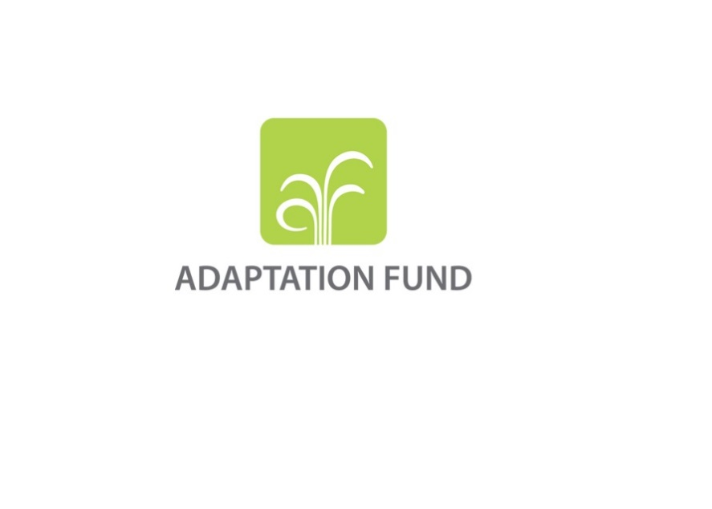

**CONCEPT NOTE FOR REGIONAL PROJECT/PROGRAMME**

**PART I: PROJECT/PROGRAMME INFORMATION**

**Title of Project/Programme:**

**Countries:**

**Thematic Focal Area[1]:** Choose an item.

**Type of Implementing Entity:** Choose an item.

**Implementing Entity:**

**Executing Entities:**

**Amount of Financing Requested:**       (in U.S Dollars Equivalent)

**Project Formulation Grant Request:** Yes  No

**Amount of Requested financing for PFG:**       (in U.S Dollars Equivalent)

**Letters of Endorsement (LOE) signed for all countries:** Yes   No

*NOTE: LOEs should be signed by the Designated Authority (DA). The signatory DA must be on file with the Adaptation Fund. To find the DA currently on file check this page:*[*https://www.adaptation-fund.org/apply-funding/designated-authorities*](https://www.adaptation-fund.org/apply-funding/designated-authorities)

**Stage of Submission:**

This proposal has been submitted before including at a different stage (pre-concept, concept)

This is the first submission ever of the proposal at any stage

In case of a resubmission, please indicate the last submission date: Click or tap to enter a date.

**Please note that the Concept note proposal document should not exceed 50 pages, including annexes.**

**Project/Programme Background and Context:**

*Provide brief information on the problem the proposed project/programme is aiming to solve,* *including both the regional and the country perspective. Outline the economic social, development and environmental context in which the project would operate in those countries.*

**Project/Programme Objectives:**

*List the main objectives of the project/programme.*

**Project/Programme Components and Financing:**

*Fill in the table presenting the relationships among project components, outcomes, outputs* *and countries in which activities would be executed, and the corresponding budgets.*

*For the case of a programme, individual components are likely to refer to specific sub-sets of stakeholders, regions and/or sectors that can be addressed through a set of well-defined interventions / projects.*

|  |  |  |  |  |  |
| --- | --- | --- | --- | --- | --- |
| **Project/Programme Components** | **Expected Outcomes** | **Expected Outputs** | **Countries** | | **Amount (US$)** |
| 1. |  |  |  | |  |
| 2. |  |  |  | |  |
| 3. |  |  |  | |  |
| 4. |  |  |  | |  |
| 5. |  |  |  | |  |
| 6. Project/Programme Execution cost  7. Total Project/Programme Cost  8. Project/Programme Cycle Management Fee charged by the Implementing Entity (if applicable) | | | | |  |
|  |
|  |
| **Amount of Financing Requested** | | | |  |  |

**Projected Calendar:**

*Indicate the dates of the following milestones for the proposed project/programme*

|  |  |
| --- | --- |
| **Milestones** | **Expected Dates** |
| Start of Project/Programme Implementation |  |
| Mid-term Review (if planned) |  |
| Project/Programme Closing |  |
| Terminal Evaluation |  |

**pART ii: Project / programme JUSTIFICATION**

1. **Describe the project/programme components, particularly focusing on the concrete adaptation activities, how these activities would contribute to climate resilience, and how they would build added value through the regional approach, compared to implementing similar activities in each country individually. For the case of a programme, show how the combination of individual projects would contribute to the overall increase in resilience.**

1. **Describe how the project /programme would promote new and innovative solutions to climate change adaptation, such as new approaches, technologies and mechanisms.**

1. **Describe how the project/programme would provide economic, social and environmental benefits, with particular reference to the most vulnerable communities, and vulnerable groups within communities, including gender considerations. Describe how the project/programme would avoid or mitigate negative impacts, in compliance with the Environmental and Social Policy of the Adaptation Fund.**

1. **Describe or provide an analysis of the cost-effectiveness of the proposed project/programme and explain how the regional approach would support cost-effectiveness.**

1. **Describe how the project/programme is consistent with national or sub-national sustainable development strategies, including, where appropriate, national or sub-national development plans, poverty reduction strategies, national communications, or national adaptation programs of action, or other relevant instruments, where they exist. If applicable, please refer to relevant regional plans and strategies where they exist.**

1. **Describe how the project/programme meets relevant national technical standards, where applicable, such as standards for environmental assessment, building codes, etc., and complies with the Environmental and Social Policy of the Adaptation Fund.**

1. **Describe if there is duplication of project/programme with other funding sources, if any.**

1. **If applicable, describe the learning and knowledge management component to capture and disseminate lessons learned.**

1. **Describe the consultative process, including the list of stakeholders consulted, undertaken during project/programme preparation, with particular reference to vulnerable groups, including gender considerations, in compliance with the Environmental and Social Policy of the Adaptation Fund.**

1. **Provide justification for funding requested, focusing on the full cost of adaptation reasoning.**

1. **Describe how the sustainability of the project/programme outcomes has been taken into account when designing the project/programme.**

1. **Provide an overview of the environmental and social impacts and risks identified as being relevant to the project/programme.**

|  |  |  |
| --- | --- | --- |
| **Checklist of environmental and social principles** | **No further assessment required for compliance** | **Potential impacts and risks – further assessment and management required for compliance** |
| *Compliance with the Law* |  |  |
| *Access and Equity* |  |  |
| *Marginalized and Vulnerable Groups* |  |  |
| *Human Rights* |  |  |
| *Gender Equity and Women’s Empowerment* |  |  |
| *Core Labour Rights* |  |  |
| *Indigenous Peoples* |  |  |
| *Involuntary Resettlement* |  |  |
| *Protection of Natural Habitats* |  |  |
| *Conservation of Biological Diversity* |  |  |
| *Climate Change* |  |  |
| *Pollution Prevention and Resource Efficiency* |  |  |
| *Public Health* |  |  |
| *Physical and Cultural Heritage* |  |  |
| *Lands and Soil Conservation* |  |  |

**pART iiI: Implementation arrangements**

**Demonstrate how the project/programme aligns with the Results Framework of the Adaptation Fund**

|  |  |  |  |  |
| --- | --- | --- | --- | --- |
| **Project Objective(s)[2]** | **Project Objective Indicator(s)** | **Fund Outcome** | **Fund Outcome Indicator** | **Grant Amount (USD)** |
|  |  |  |  |  |
|  |  |  |  |  |
|  |  |  |  |  |
| **Project Outcome(s)** | **Project Outcome Indicator(s)** | **Fund Output** | **Fund Output Indicator** | **Grant Amount (USD)** |
|  |  |  |  |  |
|  |  |  |  |  |
|  |  |  |  |  |

**part iV: endorsement by governmentS and certification by the Implementing Entity**

1. **Record of endorsement on behalf of the government[3]** *Provide the name and position of the government official and indicate date of endorsement for each country participating in the proposed project/programme.* *Add more lines as necessary. The endorsement letters should be attached as an annex to the project/programme proposal. Please attach the endorsement letters with this template; add as many participating governments if a regional project/programme:*

|  |  |
| --- | --- |
| *(Enter Name, Position, Ministry)* | Date*: (Month, day, year)* |
| *(Enter Name, Position, Ministry)* | Date*: (Month, day, year)* |
| *(Enter Name, Position, Ministry)* | Date*: (Month, day, year)* |

**B. Implementing Entity certification** *Provide the name and signature of the Implementing Entity Coordinator and the date of signature. Provide also the project/programme contact person’s name, telephone number and email address*

|  |  |
| --- | --- |
| I certify that this proposal has been prepared in accordance with guidelines provided by the Adaptation Fund Board, and prevailing National Development and Adaptation Plans (……list here…..) and subject to the approval by the Adaptation Fund Board, commit to implementing the project/programme in compliance with the Environmental and Social Policy of the Adaptation Fund and on the understanding that the Implementing Entity will be fully (legally and financially) responsible for the implementation of this project/programme. | |
| *Name & Signature*  Implementing Entity Coordinator | |
| Date: *(Month, Day, Year)* | Tel. and email: |
| Project Contact Person: | |
| Tel. And Email: | |

1. Thematic areas are: Food security; Disaster risk reduction and early warning systems; Transboundary water management; Innovation in adaptation finance.
2. The AF utilized OECD/DAC terminology for its results framework. Project proponents may use different terminology but the overall principle should still apply
3. 6. Each Party shall designate and communicate to the secretariat the authority that will endorse on behalf of the national government the projects and programmes proposed by the implementing entities.