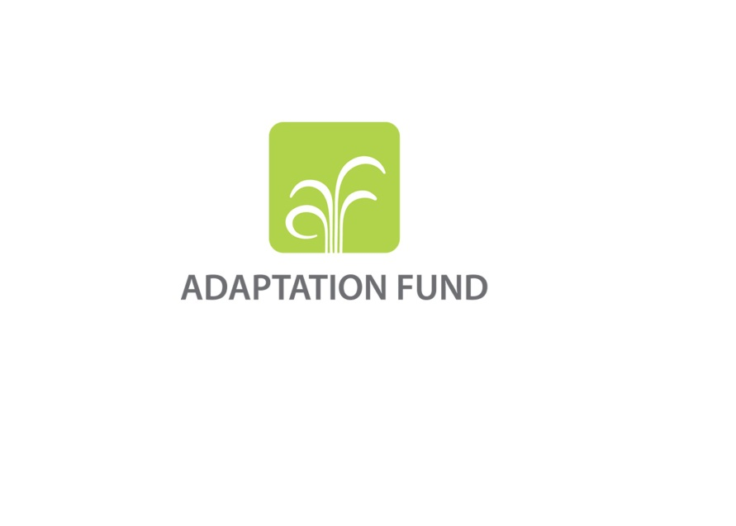

**PROGRAMME ON INNOVATION:**

**SMALL GRANTS PROJECTS THROUGH DIRECT ACCESS MODALITY**

**REQUEST FOR PROJECT FUNDING FROM THE ADAPTATION FUND**

The annexed form should be completed and transmitted to the Adaptation Fund Board Secretariat by email or fax.

Please type in the responses using the template provided. The instructions attached to the form provide guidance to filling out the template.

Please note that a project must be fully prepared when the request is submitted.

Complete documentation should be sent to:

The Adaptation Fund Board Secretariat

1818 H Street NW

MSN P4-400

Washington, D.C., 20433

U.S.A

Fax: +1 (202) 522-3240/5

Email: afbsec@adaptation-fund.org



**PROGRAMME ON INNOVATION: SMALL GRANT PROJECT PROPOSAL**

**PART I: PROJECT INFORMATION**

Country:

Title of Project:

National Implementing Entity:

Executing Entity/ies:

Amount of Financing Requested:       (in U.S Dollars Equivalent)

**Project Background and Context:**

*Provide brief information on the problem the proposed project is aiming to solve. Outline the economic social, development and environmental context in which the project would operate. If also applying for the innovation-learning bundled funding modality option, please briefly describe, how the proposed learning activities efficiently support the project’s objectives.*

**Project Objectives:**

*List the main objectives of the project.*

**Project Components and Financing:**

*Fill in the table presenting the relationships among project components, activities, expected concrete outputs, and the corresponding budgets. If necessary, please refer to the INSTRUCTIONS FOR PREPARING A REQUEST FOR*

*PROGRAMME ON INNOVATION WITH THE OPTION OF BUNDLING INNOVATION WITH LEARNING GRANTS: SMALL GRANTS PROJECTS THROUGH DIRECT ACCESS for a detailed description of each term.*

|  |  |  |  |  |
| --- | --- | --- | --- | --- |
| **Project Component** | **Expected Concrete Outputs** | **Expected Outcomes** | **Amount**  **(US$)** | **Sources of funding (specify if innovation or learning)\*** |
| 1. |  |  |  |  |
| 2. |  |  |  |  |
| 3. |  |  |  |  |
| 4. |  |  |  |  |
| 5. |  |  |  |  |
| Project Execution cost | | | | |
| Total Project Cost | | | | |
| Project Cycle Management Fee charged by the Implementing Entity (if applicable) | | | | |
| **Amount of Financing Requested** | | | | |

**Projected Calendar:**

*Indicate the dates of the following milestones for the proposed project/programme*

|  |  |
| --- | --- |
| **Milestones** | **Expected Dates** |
| Start of Project Implementation |  |
| Project Closing |  |
| Terminal Evaluation |  |

**pART ii: Project JUSTIFICATION [1]**

1. Describe the project components, particularly focusing on the concrete adaptation activities of the project, and how these activities contribute to climate resilience.

1. Describe how the project provides economic, social and environmental benefits, with reference to the most vulnerable communities, and vulnerable groups within communities, including gender considerations. Describe how the project will avoid or mitigate negative impacts, in line with the Environmental and Social Policy of the Adaptation Fund.

1. Describe how the project encourages or accelerates development of innovative adaptation practices, tools or technologies and/or describe how the project helps generate evidence base of effective, efficient adaptation practices, products or technologies, as a basis for potential scaling up.

1. Please confirm whether the project meets relevant national technical standards, where applicable, such as standards for environmental assessment, building codes, etc., and is in line with the Environmental and Social Policy of the Adaptation Fund.

1. If applying for the innovation-learning bundled funding modality, please describe the rationale and how the proposal meets the criteria set for this type of funding.

**E1: LEARNING ACTIVITIES:** Briefly describe how the proposed activities contribute to learning about adaptation.

**E2: CONTINOUS INNOVATION CYCLE:** Describe how evidence based generated innovation will be shared and made available to NIEs and the broader adaptation community and ensure a continuous cycle of innovation and knowledge sharing.

1. Provide an overview of the environmental and social impacts and risks identified as being relevant to the project. Describe how the project will engage, empower and/or benefit the most vulnerable communities and social groups, including gender considerations, in line with the Environmental and Social Policy of the Adaptation Fund.

1. Provide justification for funding requested, focusing on the full cost of adaptation reasoning.

**pART iiI: Implementation arrangements**

1. Describe the arrangements for project / programme implementation.

1. Describe the monitoring and evaluation arrangements and provide a budgeted M&E plan.

1. Include a simple results framework for the project proposal, including milestones, targets and indicators.

1. Demonstrate how the project / programme aligns with the Results Framework of the Adaptation Fund

|  |  |  |  |  |
| --- | --- | --- | --- | --- |
| **Project Objective(s)[2]** | **Project Objective Indicator(s)** | **Fund Outcome** | **Fund Outcome Indicator** | **Grant Amount (USD)** |
|  |  |  |  |  |
|  |  |  |  |  |
| **Project Outcome(s)** | **Project Outcome Indicator(s)** | **Fund Output** | **Fund Output Indicator** | **Grant Amount (USD)** |
|  |  |  |  |  |
|  |  |  |  |  |

1. Include a budget, including a budget on the Implementing Entity management fee use, and an explanation and a breakdown of the execution costs.

1. Include a disbursement schedule with time-bound milestones.

**part iV: endorsement by government and certification by the Implementing Entity**

1. **Record of endorsement on behalf of the government[3]** *Provide the name and position of the government official and indicate date of endorsement. If this is a regional project/programme, list the endorsing officials all the participating countries. The endorsement letter(s) should be attached as an annex to the project/programme proposal. Please attach the endorsement letter(s) with this template; add as many participating governments if a regional project/programme:*

|  |  |
| --- | --- |
| *(Enter Name, Position, Ministry)* | Date*: (Month, day, year)* |

**B. Implementing Entity certification** *Provide the name and signature of the Implementing Entity Coordinator and the date of signature. Provide also the project/programme contact person’s name, telephone number and email address*

|  |  |
| --- | --- |
| I certify that this proposal has been prepared in accordance with guidelines provided by the Adaptation Fund Board, and prevailing National Development and Adaptation Plans (……list here…..) and subject to the approval by the Adaptation Fund Board, commit to implementing the project/programme in compliance with the Environmental and Social Policy of the Adaptation Fund and on the understanding that the Implementing Entity will be fully (legally and financially) responsible for the implementation of this project/programme. | |
| *Name & Signature*  Implementing Entity Coordinator | |
| Date: *(Month, Day, Year)* | Tel. and email: |
| Project Contact Person: | |
| Tel. And Email: | |

1. Parts II and III should jointly not exceed 10 pages.
2. The AF utilized OECD/DAC terminology for its results framework. Project proponents may use different terminology but the overall principle should still apply
3. 6. Each Party shall designate and communicate to the secretariat the authority that will endorse on behalf of the national government the projects and programmes proposed by the implementing entities.