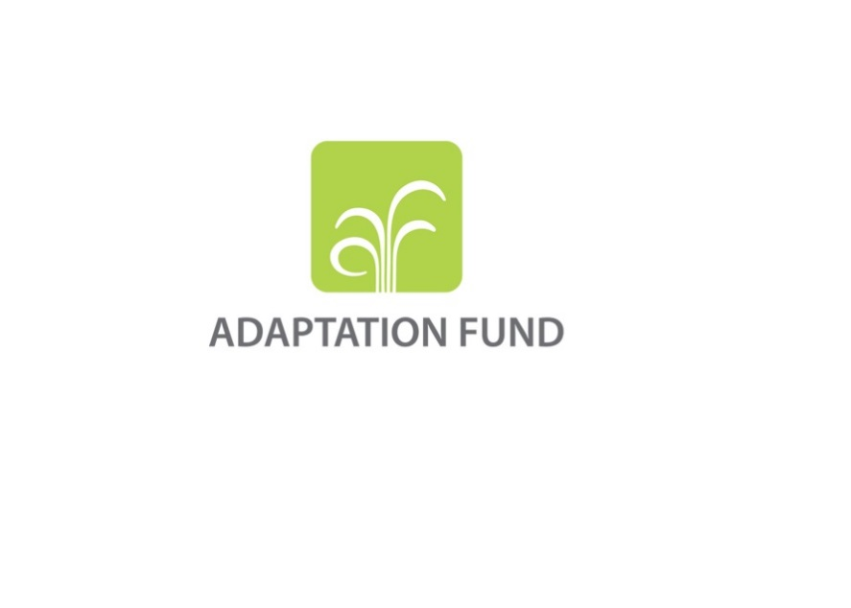

**FULLY DEVELOPED PROPOSAL FOR REGIONAL LLA PROJECT/PROGRAMME**

**PART I: PROJECT/PROGRAMME INFORMATION**

**Title of Project/Programme:**

**Countries:**

**Thematic Focal Area:**

**Type of Implementing Entity:** Choose an item.

**Implementing Entity:**

**Executing Entities:**

**Amount of Financing Requested:**       (in U.S Dollars Equivalent)

**Letters of Endorsement (LOE) signed for all countries:** Yes   No

*NOTE: LOEs should be signed by the Designated Authority (DA). The signatory DA must be on file with the Adaptation Fund. To find the DA currently on file check this page:*[*https://www.adaptation-fund.org/apply-funding/designated-authorities*](https://www.adaptation-fund.org/apply-funding/designated-authorities)

**Stage of Submission[1]:**

This proposal has been submitted before including at a different stage (pre-concept, concept, fully-developed proposal)

This is the first submission ever of the proposal at any stage

In case of a resubmission, please indicate the last submission date: Click or tap to enter a date.

**Please note that fully-developed proposal documents should not exceed 100 pages for the main document, and 100 pages for the annexes.**

**Project/Programme Background and Context:**

*Provide brief information on the problem the proposed project/programme is aiming to solve,* *including both the regional and the country perspective. Outline the economic social, development and environmental context in which the project would operate in those countries.*

**Project/Programme Objectives:**

*List the main objectives of the project/programme.*

**Project/Programme Components and Financing:**

*Fill in the table presenting the relationships among project components, outcomes, outputs* *and countries in which activities would be executed, and the corresponding budgets.*

*For the case of a programme, individual components are likely to refer to specific sub-sets of stakeholders, regions and/or sectors that can be addressed through a set of well-defined interventions/projects.*

|  |  |  |  |  |  |
| --- | --- | --- | --- | --- | --- |
| **Project/Programme Components** | **Expected Outcomes** | **Expected Outputs** | **Countries** | | **Amount (US$)** |
| 1. |  |  |  | |  |
| 2. |  |  |  | |  |
| 3. |  |  |  | |  |
| 4. |  |  |  | |  |
| 5. |  |  |  | |  |
| 6. Project/Programme Execution cost  7. Total Project/Programme Cost  8. Project/Programme Cycle Management Fee charged by the Implementing Entity (if applicable) | | | | |  |
|  |
|  |
| **Amount of Financing Requested** | | | |  |  |

**Projected Calendar:**

*Indicate the dates of the following milestones for the proposed project/programme*

|  |  |
| --- | --- |
| **Milestones** | **Expected Dates** |
| Start of Project/Programme Implementation |  |
| Mid-term Review (if planned) |  |
| Project/Programme Closing |  |
| Terminal Evaluation |  |

**pART ii: Project/programme JUSTIFICATION**

1. **Describe the programme components, particularly focusing on the concrete adaptation activities, how these activities would contribute to climate resilience. Describe also how they would build added value through the regional or multi-regional approach, compared to implementing similar activities in each country individually. Futhermore, show how the combination of individual projects would contribute to the overall increase in resilience.**

As relevant describe how the programme can leverage regional platforms to influence regional and international climate policies Specify how the project/programme will devolve decision-making to the lowest appropriate level, giving local institutions and communities more direct access to finance and decision-making power over defining, prioritizing, designing, and implementing adaptation actions. Detail the mechanisms for monitoring progress and evaluating success. Outline the granting mechanisms and proposed review processes, emphasizing innovative options for facilitating proposal submissions by local actors.

1. **Describe how the programme would contribute to comprehensive application of all eight of the Principles of LLA together[2]. Furthermore, where relevant, promote new and innovative solutions to climate change adaptation, including new approaches, technologies, and mechanisms that are particularly suited to a regional, locally-led context.**

Describe how the proposal will ensure comprehensive application of the 8 principles for LLA together, rather than recommend actions for each principle in isolation. Describe how proposal will recognize the value of local knowledge and expertise, leverage the strengths of existing local systems, address historical power imbalances to contribute to more effective and equitable climate adaptation and also advance locally led development across sectors. Explain how drawing on the collective expertise capacities of multiple countries, regional initiatives can accelerate the development and deployment of cutting-edge adaptation solutions that are grounded in local realities. If there is/are a principle/principle that are less relevant for the project/programme, please explain why. Please provide justifications if a principle is not being applied in the project/programme.

1. **Describe how the project/programme will source locally-led small grant proposals, and screen them for the potential to support concrete adaptation actions to assist the participating countries in addressing the adverse effects of climate change and build in climate resilience.**

The proposal should provide details on the planned outreach efforts and sourcing process of LLA proposals, taking into account structural barriers to access face by local actors at different levels. The proposals should include details on the process for awarding small grants, such as the approach, criteria, and timeline, how the proposal aims to improve the quality of finance by making it more flexible and adjusting the governance and decision-making processes to ensure that local actor have agency in adaptation planning and implementation.

Details on the proposed monitoring and evaluation arrangements of the small grants, results management, and, very importantly, the learning and sharing aspect of the programme. Provision of technical assistance should also be detailed in the design.

1. **Describe how the project/programme provides economic, social and environmental benefits.**

In particular, describe how the project / programme would screen LLA grant proposals for their potential to provide economic, social and environmental benefits, particularly to vulnerable communities, including gender considerations, while avoiding or mitigating negative impacts, in compliance with the Environmental and Social Policy and Gender Policy of the Fund

In particular, specify how the project/programme is addressing structural inequalities faced by women, youth, children, people with disabilities, people who are displaced, Indigenous Peoples and marginalized ethnic groups.

1. **Describe or provide an analysis of the cost-effectiveness of the proposed project/programme and explain how the regional approach would support cost-effectiveness.**

Explain how the regional approach will support cost-effectiveness, highlighting efficiencies gained through regional collaboration. As relevant describe how by pooling knowledge and technical resources, countries can strengthen and enhance the effectiveness of their individual and collective adaptation efforts, leading to more resilient communities and ecosystems.

1. **Describe how the project/programme is consistent with national, sub-national and local sustainable development strategies, including, where appropriate, national, sub-national or local development plans, poverty reduction strategies, national communications, or national adaptation programs of action, or other relevant instruments, where they exist. If applicable, please refer to relevant regional plans and strategies where they exist.**

Please also explain efforts to mainstream climate resilience into other locally led development or social justice efforts to better align with local priorities.

1. **Describe how the project/programme meets relevant national technical standards, where applicable, such as standards for environmental assessment, building codes, etc., and complies with the Environmental and Social Policy of the Adaptation Fund.**

Also describe, as needed, how the project/programme will provide support to local actors and build their capacities to comply with the standards.

1. **Describe if there is duplication of project/programme with other funding sources, if any.**

Describe how coordinated funding mechanisms and financial planning at the regional level, can enable countries to achieve greater financial stability and ensure that adaptation investments are directed where they are most needed. Explain how the regional initiative will enhance national capacities to address climate change through access to shared resources, expertise, and funding.

1. **Describe how the learning and knowledge management components designed to capture and disseminate lessons learned, particularly in a regional and locally led context.**

Describe how the programme will engage in active learning and research on LLA processes, outcomes, and impacts with the aim to fill knowledge and evidence gaps and improve collective understanding of good practices for equitable and effective LLA.

The learning and sharing knowledge management mechanism developed should be useful, accessible, sustainable, and, to the extent possible, minimize inefficiencies and duplication. The LLA Aggregator MIEs and RIEs are expected to coordinate closely to help bring about the optimal solution that would best serve the eligible recipient countries’ LLA adaptation knowledge needs.

Describe, if relevant, innovative models that help engage local stakeholders and countries make informed decisions and implement adaptation activities. Specify systems to enhance the capacity of countries to respond to climate events and foster a culture of knowledge exchange and best practices across borders. Describe how improving countries’ climate monitoring and response capabilities, can lead to more timely and effective interventions.

1. **Describe the consultative process that would take place, and how will it involve all key stakeholders, and vulnerable groups, including gender considerations the consultative process, with particular reference to vulnerable groups, including gender considerations, in compliance with the Environmental and Social Policy of the Adaptation Fund.**

Provide details on how the consultative process considered and addressed gender-based, economic and other inequalities and encouraged vulnerable and marginalized individuals to meaningfully participate in and lead adaptation decisions.

1. **Provide justification for funding requested, focusing on the full cost of adaptation reasoning.**

Neither the programme, nor the individual small grant projects will be required to provide co-financing, in line with the Fund’s mandate to finance the full cost of adaptation. However, co-financing would be considered a positive addition to the initiative, including top-ups of the programme.

1. **Describe how the sustainability of the project/programme outcomes has been taken into account when designing the project/programme.**

In particular, describe how the project/programme supports long-term development of local governance processes, and improves the capacity of local institutions (including through simpler access modalities), and how it can ensure that communities can effectively implement adaptation actions, facilitate and manage adaptation initiatives over the long term without being dependent on project-based donor funding.

1. **Provide an overview of the environmental and social impacts and risks identified as being relevant to the project/programme.**

|  |  |  |
| --- | --- | --- |
| **Checklist of environmental and social principles** | **No further assessment required for compliance** | **Potential impacts and risks – further assessment and management required for compliance** |
| *Compliance with the Law* |  |  |
| *Access and Equity* |  |  |
| *Marginalized and Vulnerable Groups* |  |  |
| *Human Rights* |  |  |
| *Gender Equity and Women’s Empowerment* |  |  |
| *Core Labour Rights* |  |  |
| *Indigenous Peoples* |  |  |
| *Involuntary Resettlement* |  |  |
| *Protection of Natural Habitats* |  |  |
| *Conservation of Biological Diversity* |  |  |
| *Climate Change* |  |  |
| *Pollution Prevention and Resource Efficiency* |  |  |
| *Public Health* |  |  |
| *Physical and Cultural Heritage* |  |  |
| *Lands and Soil Conservation* |  |  |

**pART iiI: Implementation arrangements**

1. **Describe the arrangements for project/programme management at the regional and national level, including coordination arrangements within countries and among them. Describe how the potential to partner with national institutions, and when possible, national implementing entities (NIEs), has been considered, and included in the management arrangements.**

Please describe how the implementation modalities enable giving local institutions and communities more direct access to finance and decision-making power over how adaptation actions are defined, prioritized, designed and implemented.

As per Document AFB/B.25/6/Rev.2, regional project and programme proposals are allowed a higher and more flexible maximum level for administration costs, to help ensure regional cooperation, and, as such, the maximum level for the implementing entity management fee. For regional projects/programmes, the administrative costs (Implementing Entity Management Fee and Project/ Programme Execution Costs) at or below 10 % of the project/programme for implementing entity (IE) fees and at or below 10 % of the project/programme cost for the execution. In case the IE is serving as EE, which is acceptable AFB/PPRC.24/4 9 only under exceptional circumstances and must be well-justified, the execution cost should be limit to 1.5% of the part of the project/programme executed by the implementing entity. If the actual execution costs of the IE exceed the 1.5% cap a justification should be provided. As with regional projects and programmes, proposals for LLA regional projects/programmes need to provide budgets for these two categories.

1. **Describe the measures for financial and project/programme risk management.**

Explain how local stakeholders are involved in the design and management of project risk management, highlighting their roles and contributions.

1. **Describe the measures for environmental and social risk management, in line with the Environmental and Social Policy of the Adaptation Fund.**

The safeguard policies of the Fund will apply to the programmes. The small grant can be considered unidentified subprojects (USP) and, as such, the Fund policies regarding USPs, namely as per the “Guidance document for Implementing Entities on compliance with the Adaptation Fund Environmental and Social Policy” and “Updated Guidance for Implementing Entities on the Use of Unidentified Sub-Projects” (Document AFB/PPRC.30/54) will apply. This includes, for example, that, “for projects/programmes with activities/sub-projects unidentified at the time of submitting a proposal for funding, the IE will develop an Environmental and Social Management System (ESMS) for the project/programme and describe it with details in the proposal. In such cases, the project/programme ESMS will contain a process for identifying environmental and social risks for the unidentified activities/sub-projects and, when needed, the development of commensurate environmental and social management elements that will complement and be integrated in the overall ESMP. The project/programme ESMS will specify any other related procedures, roles, and responsibilities.”

Describe the role of local actors in developing and managing these measures, emphasizing their participation and influence.

1. **Describe the monitoring and evaluation arrangements and provide a budgeted M&E plan.**

Describe how innovative tools and approaches will be deployed to enable community and local actor involvement in monitoring. Please explain how regional approach is expected to enhance knowledge, tools and approaches for monitoring, reporting and verification (MRV)

1. **Include a results framework for the project/programme proposal, including milestones, targets and indicators.**

1. **Demonstrate how the project/programme aligns with the Results Framework of the Adaptation Fund**

|  |  |  |  |  |
| --- | --- | --- | --- | --- |
| **Project Objective(s)**[3] | **Project Objective Indicator(s)** | **Fund Outcome** | **Fund Outcome Indicator** | **Grant Amount (USD)** |
|  |  |  |  |  |
|  |  |  |  |  |
|  |  |  |  |  |
| **Project Outcome(s)** | **Project Outcome Indicator(s)** | **Fund Output** | **Fund Output Indicator** | **Grant Amount (USD)** |
|  |  |  |  |  |
|  |  |  |  |  |
|  |  |  |  |  |

1. **Include a detailed budget with budget notes, broken down by country as applicable, a budget on the Implementing Entity management fee use, and an explanation and a breakdown of the execution costs.**

1. **Include a disbursement schedule with time-bound milestones.**

**part iV: endorsement by governmentS and certification by the Implementing Entity**

1. **Record of endorsement on behalf of the government**[4]

Provide the name and position of the government official and indicate date of endorsement for each country participating in the proposed project/ programme. Add more lines as necessary. The endorsement letters should be attached as an annex to the project/programme proposal. Please attach the endorsement letters with this template; add as many participating governments if a regional project/programme:

|  |  |
| --- | --- |
| *(Enter Name, Position, Ministry)* | Date*: (Month, day, year)* |
| *(Enter Name, Position, Ministry)* | Date*: (Month, day, year)* |
| *(Enter Name, Position, Ministry)* | Date*: (Month, day, year)* |

**B. Implementing Entity certification** *Provide the name and signature of the Implementing Entity Coordinator and the date of signature. Provide also the project/programme contact person’s name, telephone number and email address*

|  |  |
| --- | --- |
| I certify that this proposal has been prepared in accordance with guidelines provided by the Adaptation Fund Board, and prevailing National Development and Adaptation Plans (……list here…..) and subject to the approval by the Adaptation Fund Board, commit to implementing the project/programme in compliance with the Environmental and Social Policy of the Adaptation Fund and on the understanding that the Implementing Entity will be fully (legally and financially) responsible for the implementation of this project/programme. | |
| *Name & Signature*  Implementing Entity Coordinator | |
| Date: *(Month, Day, Year)* | Tel. and email: |
| Project Contact Person: | |
| Tel. And Email: | |

1. At the concept note stage only Section I and II are needed.
2. Principles for locally led adaptation: <https://www.flickr.com/photos/iied/52100485111/> ; chrome-extension://efaidnbmnnnibpcajpcglclefindmkaj/https://www.iied.org/sites/default/files/pdfs/2021-01/10211IIED.pdf
3. The AF utilized OECD/DAC terminology for its results framework. Project proponents may use different terminology but the overall principle should still apply
4. 6. Each Party shall designate and communicate to the secretariat the authority that will endorse on behalf of the national government the projects and programmes proposed by the implementing entities.