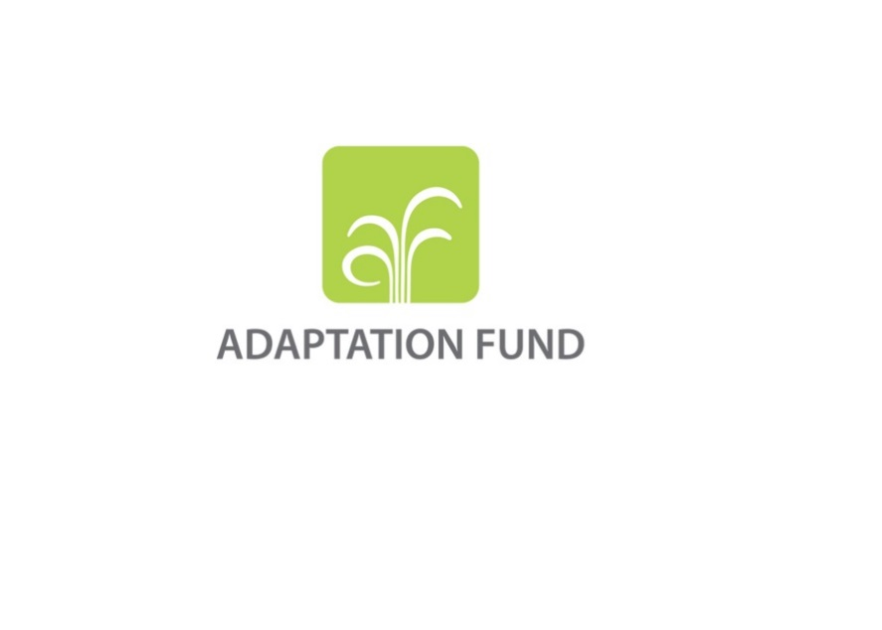

**PRE-CONCEPT FOR A REGIONAL PROJECT/PROGRAMME**

**PART I: PROJECT/PROGRAMME INFORMATION**

**Title of Project/Programme:**

**Countries:**

**Thematic Focal Area[1]:**

**Type of Implementing Entity:** Choose an item.

**Implementing Entity:**

**Executing Entity/Entities:**

**Amount of Financing Requested:**       (in U.S Dollars Equivalent)

**Project Formulation Grant Request:** Yes  No

**Amount of Requested financing for PFG:**       (in U.S Dollars Equivalent)

**Letters of Endorsement (LOE) signed for all countries:** Yes   No

*NOTE: LOEs should be signed by the Designated Authority (DA). The signatory DA must be on file with the Adaptation Fund. To find the DA currently on file check this page:*[*https://www.adaptation-fund.org/apply-funding/designated-authorities*](https://www.adaptation-fund.org/apply-funding/designated-authorities)

**Stage of Submission:**

This pre-concept has been submitted before

This is the first submission ever of the pre-concept

In case of a resubmission, please indicate the last submission date: Click or tap to enter a date.

**Please note that pre-concept should not exceed 5 pages (in addition to this first cover page)**

**Project/Programme Background and Context:**

*(Provide brief information on the problem the proposed project/programme is aiming to solve, including both the regional and the country perspective.)*

**Project/Programme Objectives:**

*(List the main objectives of the project/programme.)*

**Project/Programme Components and Financing[2]:**

*(Fill in the table presenting the relationships among project components, outcomes, outputs and countries in which activities would be executed, and the corresponding budgets.)*

|  |  |  |  |  |  |
| --- | --- | --- | --- | --- | --- |
| **Project/Programme Components** | **Expected Outcomes** | **Expected Outputs** | **Countries** | | **Amount (US$)** |
| 1. |  |  |  | |  |
| 2. |  |  |  | |  |
| 3. |  |  |  | |  |
| 4. |  |  |  | |  |
| 5. |  |  |  | |  |
| 6. Project/Programme Execution cost  7. Total Project/Programme Cost  8. Project/Programme Cycle Management Fee charged by the Implementing Entity (if applicable) | | | | |  |
|  |
|  |
| **Amount of Financing Requested** | | | |  |  |

**Project Duration:** *(In years and months)*

**pART ii: Project/programme JUSTIFICATION**

*(Provide a brief description of the proposed LLA project/programme including, as a minimum[3], the following aspects:*

* *Explain how the project/programme facilitates decision-making at the lowest appropriate level, empowering local institutions and communities with direct access to finance and control over the definition, prioritization, design, and implementation of adaptation actions, as well as monitoring progress.*
* *Describe the main components of the project/programme, with a focus on specific adaptation activities. Discuss how these activities will enhance climate resilience and add value through the LLA approach .*
* *Assess the cost-effectiveness of the proposed project/programme, particularly highlighting the implementation and execution arrangements. Detail the mechanisms that will ensure direct access to finance for local communities.*
* *Demonstrate how the project/programme aligns with national, sub-national, and local sustainable development strategies. Include references to relevant documents such as the National Adaptation Plan (NAP), local development plans, poverty reduction strategies, national communications, or other.*
* *Outline the learning and knowledge management strategies that will be employed to capture and disseminate lessons learned. Explain how these efforts will contribute to building local capabilities in a sustainable manner.*
* *Describe the consultative process planned for project preparation, with an emphasis on involving vulnerable groups, including gender considerations. Describe how this process aligns with the Environmental and Social Policy of the Adaptation Fund and enables meaningful participation and leadership in adaptation decisions.*
* *Explain how the sustainability of project/programme outcomes will be incorporated into the design. Discuss measures to ensure long-term benefits and impact.*

*(You may also want to provide brief information on the following aspects:*

* *Highlight the economic, social, and environmental benefits of the project/programme, with a particular focus on the most vulnerable communities and groups, including gender considerations. Describe how the project will avoid or mitigate negative impacts in compliance with the Environmental and Social Policy of the Adaptation Fund.*
* *Explain how the project/programme will meet relevant national technical standards, such as those for environmental assessment and building codes, and ensure compliance with the Environmental and Social Policy of the Adaptation Fund.*
* *Provide information on how the project/programme avoids duplication with other funding sources and efforts.*
* *Justification for funding requested, focusing on the full cost of adaptation reasoning.*
* *The environmental and social impacts and risks identified as being relevant to the project/programme.)*

**pART iiI: Implementation arrangements**

*(At the pre-concept stage, this section should only briefly explain which organizations would be involved in the proposed LLA project/programme at the national/sub-nationa/locall level, and how coordination would be arranged. The involvement of national institutions, and when possible, national implementing entities (NIEs), partnering in the project should be explained.)*

**part iV: endorsement by governments and certification by the Implementing Entity**

1. **Record of endorsement on behalf of the government[4]**

*Provide the name and position of the government official and indicate date of endorsement for the countries participating in the proposed project/programme. The endorsement letter should be attached as an annex to the project/programme proposal.*

|  |  |
| --- | --- |
| *(Enter Name, Position, Ministry)* | Date*: (Month, day, year)* |

**B. Implementing Entity certification** *Provide the name and signature of the Implementing Entity Coordinator and the date of signature. Provide also the project/programme contact person’s name, telephone number and email address*

|  |  |
| --- | --- |
| I certify that this proposal has been prepared in accordance with guidelines provided by the Adaptation Fund Board, and prevailing National Development and Adaptation Plans (……list here…..) and subject to the approval by the Adaptation Fund Board, commit to implementing the project/programme in compliance with the Environmental and Social Policy of the Adaptation Fund and on the understanding that the Implementing Entity will be fully (legally and financially) responsible for the implementation of this project/programme. | |
| *Name & Signature*  Implementing Entity Coordinator | |
| Date: *(Month, Day, Year)* | Tel. and email: |
| Project Contact Person: | |
| Tel. And Email: | |

1. Thematic areas: Nonprescriptive
2. IE and EE fees calculator: <https://www.adaptation-fund.org/document/ie-and-ee-fees-calculator/>
3. Please note that subsequent proposal stages (concept and fully-developed proposal) would require further information on these criteria, as well as additional criteria.
4. The Party shall designate and communicate to the secretariat the authority that will endorse on behalf of the national government the projects and programmes proposed by the implementing entities.